English – Stage 1 – Unit 31
Contents
Unit overview and instructions for use 3
Teacher notes 4
Outcomes and content – Component A 5
Outcomes and content – Component B 7
Week 1 10
Component A teaching and learning 10
Component B teaching and learning 11
Lesson 1: Identifying perspective 12
Lesson 2: Exploring perspective 14
Lesson 3: Writing a perspective paragraph 15
Lesson 4: Understanding perspective and vocabulary 16
Lesson 5: Deconstructing an exemplar text 18
Week 2 20
Component A teaching and learning 20
Component B teaching and learning 21
Lesson 6: Comparing perspective 22
Lesson 7: Composing a paragraph 22
Lesson 8: Using creative word play 24
Lesson 9: Editing and publishing 25
Lesson 10: Sharing student work 26
Resource 1: Question matrix 27
Resource 2: Exploring perspectives 28
Resource 3: Exploring perspectives example 29
Resource 4: Deconstructed paragraph 30
Resource 5: Word mat 31
Resource 6: Exemplar text 32
Resource 7: Writing scaffold 33
Resource 8: Publishing template 34
References 35

Unit overview and instructions for use
This two-week unit is comprised of Component A and Component B. Connecting learning across both components is encouraged.
Teaching and learning | Component A | Component B
Suggested duration | 60 minutes | 45 minutes
Explicit teaching focus areas | - Phonic knowledge  - Reading fluency  - Reading comprehension  - Spelling  - Handwriting | - Oral language and communication  - Vocabulary  - Reading comprehension  - Creating written texts  - Understanding and responding to literature
To prepare for teaching and learning: | - Refer to Outcomes and content – Component A, K-2 – Instructional sequence – grapheme–phoneme correspondences [PDF 825 KB], and the teaching advice documents (hyperlinked in Component A teaching and learning table).  - Based on student needs identified through ongoing assessment data, plan and document how you will sequence teaching and learning in whole class and targeted teaching groups across the two-week cycle. | - Familiarise yourself with Outcomes and content – Component B, Textual concepts information and videos, English Textual Concepts and Learning Processes (2016), and the teaching and learning sequence.  - Based on student needs identified through ongoing assessment data, determine how you will support students in whole class and targeted teaching groups across the two-week cycle as required.
English K–10 Syllabus © 2022 NSW Education Standards Authority (NESA) for and on behalf of the Crown in right of the State of New South Wales.

Teacher notes
- Perspective is a lens through which we learn to see the world. It can clarify, magnify, distort or blur what we see. By adopting different perspectives, a responder can bring to light the underlying values in the text and construct meanings that may challenge, confirm or modify the original reading of a text. Argument is using persuasion to produce a position or resolution supported by evidence. It can have a range of purposes including to clarify ideas, search for truth, resolve disputes, defend a point of view, or for entertainment. – English Textual Concepts and Learning Processes (2016).
- Understanding of perspective and argument can be supported through watching the department’s videos: Understanding perspective (3:37) and Understanding argument (3:17).
- While ‘perspective’ and ‘argument’ are the mentor concepts for the conceptual component of this unit, the supporting concept of ‘representation’ can be explored using the mentor text The True Story of the Three Little Pigs by Jon Scieszka.
- Point of view is also explored throughout this unit. When writing to convey an opinion, a particular point of view is expressed. The text usually begins by identifying an issue, topic, or point of view. A personal stance is then presented with supporting examples or elaborations to justify and strengthen the opinion expressed.
- For information on argument, perspective, complex sentences, clauses, wordplay refer to the NESA Glossary.
- Idioms are a commonly used phrase or expression particular to a specific language that cannot be taken literally. For example, ‘at the drop of a hat.’
- Consider prior student knowledge of traditional fairy tales.
- Reflect on student learning and engagement in activities and record differentiation and adjustments within the unit to inform future teaching and learning. One way of doing this could be to add comments to the digital file.
- Content points are linked to the National Literacy Learning Progression version (3).
Levels and indicators sourced from National Literacy Learning Progression © Australian Curriculum, Assessment and Reporting Authority (ACARA), (accessed 2 February 2023) and was not modified. See references for more information.

Outcomes and content – Component A
The table below outlines the focus outcomes and content. Content is linked to the National Literacy Learning Progression version (3).
Focus area and outcome | Content points and National Literacy Learning Progression
Phonic knowledge  EN1-PHOKW-01 – uses initial and extended phonics, including vowel digraphs, trigraphs to decode and encode words when reading and creating texts | - decode words with less common consonant digraphs and apply this when reading texts  - decode words with trigraphs and quadgraphs and apply this when reading texts
Reading fluency  EN1-REFLU-01 – sustains reading unseen texts with automaticity and prosody and self-corrects errors | - read aloud with an easy speech rhythm  - vary pace when reading according to the audience and purpose
Reading comprehension  EN1-RECOM-01 – comprehends independently read texts that require sustained reading by activating background and word knowledge, connecting and understanding sentences and whole text, and monitoring for meaning | - monitor understanding to ensure meaning is sustained and expanded through the whole text  - identify when meaning is not complete and/or contradicts prior understanding  - re-read words, phrases or sentences to check and clarify precise meaning
Spelling  EN1-SPELL-01 – applies phonological, orthographic and morphological generalisations and strategies when spelling words in a range of writing contexts | - use extended phonic code for taught consonant phonemes  - use common prefixes such as un–, re– and dis–
Handwriting  EN1-HANDW-01 – uses a legible, fluent and automatic handwriting style, and digital technology, including word-processing applications, when creating texts | - use word-processing program functions, including text-editing applications  - recognise and use keys to show more complex punctuation or symbols

Outcomes and content – Component B
The table below outlines the focus outcomes and content. Content is linked to the National Literacy Learning Progression version (3).
Focus area and outcome | Content points and National Literacy Learning Progression
Oral language and communication  EN1-OLC-01 – communicates effectively by using interpersonal conventions and language to extend and elaborate ideas for social and learning interactions | - use a range of strategies for effective dialogue and manage digression from a topic (InT3, InT5)  - deliver a planned narrative to an audience for specific contexts and purposes (SpK4)
Vocabulary  EN1-VOCAB-01 – understands and effectively uses Tier 1, taught Tier 2 and Tier 3 vocabulary to extend and elaborate ideas | - understand and use words that have different meanings in different contexts  - understand and communicate jokes and riddles that play on words
Reading comprehension  EN1-RECOM-01 – comprehends independently read texts that require sustained reading by activating background and word knowledge, connecting and understanding sentences and whole text, and monitoring for meaning | - draw on sources to seek clarification for unknown words  - understand vocabulary that signals humorous wordplay in texts  - recognise how the position of a clause in a complex sentence influences the important idea for the reader  - ask a clarifying question when more background knowledge is needed to make an inference  - interpret patterns in texts to enhance understanding
Creating written texts  EN1-CWT-01 – plans, creates and revises texts written for different purposes, including paragraphs, using knowledge of vocabulary, text features and sentence structure | - group sentences into paragraphs commencing with a topic sentence, followed by other sentences with related ideas (CrT7)  - use visual elements to expand meaning in own texts  - experiment with writing complex sentences which include a clause for the main message and dependent clause to elaborate or modify the message (GrA5)  - use quotation marks for simple dialogue (PuN5)  - use possessive apostrophes in own writing (PuN4)  - use modifying and qualifying words to indicate quantity  - use creative wordplay to affect the reader  - use knowledge of similarities and differences between imaginative, informative and persuasive texts when planning for writing
Understanding and responding to literature  EN1-UARL-01 – understands and responds to literature by creating texts using similar structures, intentional language choices and features appropriate to audience and purpose | - identify arguments and the intended audience  - create paragraphs that contain a single idea, beginning with a topic sentence and including supporting evidence with elaborations (CrT7)  - adapt a well-known text for a different audience and/or purpose

Week 1

Component A teaching and learning
The table below can be used to plan and document lessons that address Component A outcomes and content. Both the detailed example [DOC 529KB] of a two-week teaching and learning cycle and brief example [DOC 66KB] may support you in your planning.
Focus Areas | Lesson 1 | Lesson 2 | Lesson 3 | Lesson 4 | Lesson 5
Phonic knowledge
15 minutes
Spelling and Handwriting
15 minutes
Reading comprehension and Reading fluency
30 minutes

Component B teaching and learning
The following teaching and learning sequence has been designed to address Component B outcomes and content. Adapt the sequence as required to best meet the needs of your students.

Learning intention and success criteria
Learning intentions and success criteria are best co-constructed with students.

Learning intention
Students are learning to understand how arguments can be presented from different perspectives.

Success criteria
Students can:
- identify different perspectives and arguments presented in texts
- explore perspectives of main characters in texts
- write a paragraph with a topic sentence, examples or elaborations and a concluding statement
- understand the meaning of words in different contexts
- deconstruct an exemplar text to co-construct success criteria.

Resources
- Scieszka J (2004) The True Story of the Three Little Pigs (Smith L, illus) Picture Puffin, Great Britain. ISBN: 9780140544510
- Forward T (2006) The Wolf’s Story (Cohen I, illus) Walker Books Australia, Australia. ISBN: 9781406301625
- Resource 1: Question matrix
- Resource 2: Exploring perspectives
- Resource 3: Exploring perspectives example (optional)
- Resource 4: Deconstructed paragraph
- Resource 5: Word mat
- Resource 6: Exemplar text
- Coloured markers
- Enlarged T-chart (one copy).

Lesson 1: Identifying perspective
- Display the front cover of the text The True Story of the Three Little Pigs by Jon Scieskzka. Encourage students to make careful observations and interpretations about the text using the See-Think-Wonder routine. For example, ‘I see a wolf blowing’, ‘I think the text is written by the wolf’, ‘I wonder if it really is a true story.’
- Discuss the front cover and explain that it is presented as a newspaper article. Allow time for students to observe and analyse details. Discuss the purpose of a newspaper article (writing to give an opinion) and identify its main features (name of newspaper, headline, illustrations, paragraph).
- Read the text. Pause reading to clarify the meaning of new or unknown phrases. For example, ‘dead as a doornail’, ‘wolf’s honour’, ‘what a pig’. Discuss ways the author used wordplay, such as similes and idioms to create humour in the text. Explain that some words have different meanings in different contexts. For example, ‘he wasn’t too bright’, ‘food will spoil’, ‘what a pig’. Discuss the meaning of the phrase within the context of the story.
- Revise the concept of perspective. Explain that perspective is someone’s point of view and is what people may think or believe to be true. It is a lens through which people see the world and can be shaped by their personal experiences. Discuss the purpose of the text and how the author has conveyed an opinion from a different perspective. In pairs, students discuss whose perspective the story is told from and use examples from the text to explain their reasoning.
- Explain that students will compose questions to build a deeper understanding of the wolf’s perspective. Model using Resource 1: Question matrix to compose a higher order question to ask the wolf. For example, ‘Why might people believe the pigs?’ Use think-alouds to compare the higher order question to a lower order question. For example, ‘What did the wolf do first?’ Explain that this is a literal question and does not build a deeper understanding of the character.
Note: The question matrix is a grid that builds layers of complexity in questions as students move from crafting simple to higher order questions.
- Students use Resource 1: Question matrix to compose questions to ask the wolf. Encourage students to compose higher order questions to develop a deeper understanding of the character’s perspective.
- In pairs, students use Hot seat to explore the perspective of the wolf. Students take turns asking their questions from activity 7. Encourage students to respond using vocabulary from the text.
Stage 1 Assessment task 1 – Observations from this lesson allow students to demonstrate achievement towards the following syllabus outcomes and content points:
EN1-OLC-01 – communicates effectively by using interpersonal conventions and language to extend and elaborate ideas for social and learning interactions
- use a range of strategies for effective dialogue and manage digression from a topic.
EN1-VOCAB-01 – understands and effectively uses Tier 1, taught Tier 2 and Tier 3 vocabulary to extend and elaborate ideas
- understand and use words that have different meanings in different contexts.

Lesson 2: Exploring perspective
- Explain that stories can be told from different perspectives. Read a version of the traditional fairy tale, The Three Little Pigs. Identify who is telling the story and discuss how the wolf is portrayed in the story. For example, the wolf is described as big and bad. He is angry, roaring and growling at the pigs to let him in.
- Revise the concept of ‘argument’. Ask students what arguments the pigs presented to convince the reader of their perspective. For example, the wolf was big and bad and wanted to eat the pigs. Students Think-Pair-Share the similarities and differences between the arguments presented from the pigs in The Three Little Pigs and the wolf in The True Story of the Three Little Pigs. For example, the wolf only wanted to borrow a cup of sugar, but the pigs believed he was hungry and wanted to eat them.
- Display an enlarged copy of Resource 2: Exploring perspectives. Revise the concept of perspective and explain that students will be viewing the texts through the lens of the pigs and the wolf to gain a deeper understanding of their perspective.
- In pairs, students complete Resource 2: Exploring perspective. Optional: use Resource 3: Exploring perspective example to support student ideas.
- Share student responses and discuss the different perspectives and arguments presented.

Lesson 3: Writing a perspective paragraph
- Revise the different perspectives and arguments presented in the texts The Three Little Pigs and The True Story of the Three Little Pigs.
- Place a large piece of paper with the text ‘The wolf is big and bad’ on one side of the classroom. Place a large piece of paper with the text ‘The wolf has been framed’ on the other side of the classroom. Ask students to move to the side they believe to be true. In groups, students share their reasoning. Create an enlarged T-chart of student responses to use in activity 7.
- Revise the purpose of a paragraph. Explain that paragraphs break up large blocks of text (visually as well as for meaning) so that the reader can easily follow and process the information or ideas contained in persuasive, informative and imaginative texts.
- Display Resource 4: Deconstructed paragraph. Read the paragraph and identify the purpose of the text. Discuss if it is written from the wolf or pigs’ perspective and how students know.
- Re-read and identify the structure of the paragraph. Discuss the purpose of the topic sentence, supporting examples or elaborations and the concluding statement.
- Revise complex sentences. Ask students to identify the complex sentences in the paragraph by circling the subordinating conjunctions and labelling the dependent and independent clauses. Re-read the sentence, ‘While the wolf is a kind and caring grandson, the pigs are selfish and impolite.’ Ask students to identify the most important idea in the complex sentence (the pigs are selfish and impolite). Discuss how the position of a clause in a complex sentence influences the important idea for the reader.
- Students write their own paragraph from the perspective of the pigs or the wolf using the enlarged T-chart and their ideas from activity 2. Encourage students to use evidence from the text to support their ideas.
- Revise the purpose and structure of a paragraph. Students deconstruct their own paragraph from activity 7, identifying the topic sentence, supporting examples or elaborations and the concluding statement.
Too hard? Co-construct another paragraph from the wolf’s perspective.
Too easy? Students write a paragraph to compare the differing perspectives of the wolf and the pigs.
Stage 1 Assessment task 2 – Observations from this lesson allow students to demonstrate achievement towards the following syllabus outcome and content point:
EN1-RECOM-01 – comprehends independently read texts that require sustained reading by activating background and word knowledge, connecting and understanding sentences and whole text, and monitoring for meaning
- recognise how the position of a clause in a complex sentence influences the important idea for the reader.

Lesson 4: Understanding perspective and vocabulary
Note: Students may need to read the traditional fairy tale, Little Red Riding Hood.
- Display the front cover of the text, The Wolf’s Story by Toby Forward and allow time for students to observe and analyse details. Encourage students to recognise patterns in the text and ask if this text reminds them of a story they have read and what could be similar or different about the 2 texts.
- Students See-Think-Wonder to infer meaning and make predictions about the text. Encourage students to use visual cues to support their thinking. For example, ‘I see Little Red Riding Hood walking down the path’, ‘I think the wolf will give reasons why he isn’t a bad wolf’, ‘I wonder how the story might be different to the traditional fairy tale.’
- Read the text and provide students an opportunity to ask clarifying questions when more background knowledge is needed to make an inference. Pause reading to clarify the meaning of new or unknown words. For example, versatile, altered, speciality. Support students to use context clues and/or sources such as dictionaries and online tools to clarify meaning.
- Using one of the words identified in activity 3, students complete Resource 5: Word mat. Display in the classroom to support students writing in Week 2.
- Discuss ways the author creates humour using wordplay and ask students to identify phrases from the text. For example, ‘I won’t make a meal out of it’. Discuss the intentional word choices and meaning of the phrase within the context of the story. Ask students to think of any other examples they may know that use a play on words.
- Explain that students will view the texts through the lens of Little Red Riding Hood and the wolf to gain a deeper understanding of their perspective. Students Think-Pair-Share the differences between Little Red Riding Hood and the wolf’s perspectives.
- Students complete Resource 2: Exploring perspectives from the perspective of Little Red Riding Hood and the wolf.
- Share student responses and discuss if they believe Little Red Riding Hood or the wolf’s story. Encourage students to use examples and evidence from the text to justify their opinion.
Stage 1 Assessment task 3 – Observations from this lesson allow students to demonstrate achievement towards the following syllabus outcomes and content points:
EN1-VOCAB-01 – understands and effectively uses Tier 1, taught Tier 2 and Tier 3 vocabulary to extend and elaborate ideas
- understand and communicate jokes and riddles that play on words.
EN1-RECOM-01 – comprehends independently read texts that require sustained reading by activating background and word knowledge, connecting and understanding sentences and whole text, and monitoring for meaning
- draw on sources to seek clarification for unknown words
- understand vocabulary that signals humorous wordplay in texts
- ask a clarifying question when more background knowledge is needed to make an inference
- interpret patterns in texts to enhance understanding.

Lesson 5: Deconstructing an exemplar text
- Revise the perspective of the wolf from the text, The Wolf’s Story. Ask students if the wolf was trying to help or harm Grandma. Share student responses.
- Jointly deconstruct Resource 6: Exemplar text. Read the text aloud, pausing to clarify any unknown words or phrases. Discuss the purpose of the text; to convey an opinion or express a particular point of view.
- Using coloured markers, highlight the topic sentence, supporting examples or elaborations and the concluding statement.
- Identify and discuss:
- the visual elements of the text (presented as a newspaper article, with the name of newspaper, headline, text and illustrations)
- the purpose of the headline (to engage the reader and capture the main idea of the paragraph)
- examples of wordplay (alliteration: helpful/harmful, gentle/generous, idiom: sticky situation)
- modifying and qualifying words to indicate quantity and how they add detail to a sentence (for example, many)
- use of quotation marks for dialogue
- possessive apostrophes to indicate possession.
- In pairs, students reflect on the exemplar text to develop their own success criteria. As a class, students share their thinking and describe what success looks like.
- Co-construct success criteria for students writing using responses from activity 5. Display in the classroom to use in Lesson 7.

Week 2

Component A teaching and learning
The table below can be used to plan and document lessons that address Component A outcomes and content. Both the detailed example [DOC 529KB] of a two-week teaching and learning cycle and brief example [DOC 66KB] may support you in your planning.
Focus Areas | Lesson 6 | Lesson 7 | Lesson 8 | Lesson 9 | Lesson 10
Phonic knowledge
15 minutes
Spelling and Handwriting
15 minutes
Reading comprehension and Reading fluency
30 minutes

Component B teaching and learning
The following teaching and learning sequence has been designed to address Component B outcomes and content. Adapt the sequence as required to best meet the needs of your students.

Learning intention and success criteria
Learning intentions and success criteria are best co-constructed with students.

Learning intention
Students are learning to adapt a well-known text and present a different perspective.

Success criteria
Students can:
- compare the perspectives of familiar characters
- compose a paragraph with a topic sentence, examples or elaborations and a concluding statement
- use creative wordplay to add impact to writing
- use feedback to edit and improve writing
- deliver a planned narrative.

Resources
- Scieszka J (2004) The True Story of the Three Little Pigs (Smith L, illus) Picture Puffin, Great Britain. ISBN: 9780140544510
- Forward T (2006) The Wolf’s Story (Cohen I, illus) Walker Books Australia, Australia. ISBN: 9781406301625
- A range of traditional fairy tales such as Jack and the Beanstalk, Goldilocks and the Three Bears, The Three Billy Goats Gruff, Hansel and Gretel
- Resource 2: Exploring perspective
- Resource 7: Writing scaffold
- Resource 8: Publishing template (optional)

Lesson 6: Comparing perspective
- Display a range of traditional fairy tales around the classroom. For example, Jack and the Beanstalk, Goldilocks and the Three Bears, The Three Billy Goats Gruff, Hansel and Gretel.
- Students choose a traditional fairy tale they are familiar with. In groups, students retell the story and brainstorm another perspective the story could be told from. For example, in Jack and the Beanstalk, the story could be told from the giant’s perspective.
- Explain that students will adapt a well-known narrative and create a text from the perspective of another character in their chosen fairy tale.
- Students identify the different perspectives of the 2 characters and plan their ideas using Resource 2: Exploring perspective. For example, Jack and the giant.
- In groups, students share their ideas.

Lesson 7: Composing a paragraph
- Revise the co-constructed success criteria from Lesson 5.
- Students use their planned ideas from Lesson 6 and Resource 7: Writing scaffold to draft a paragraph from the perspective of another character in their chosen fairy tale. Encourage students to incorporate new vocabulary and word play into their writing from Lesson 4.
Stage 1 Assessment task 4 – Collecting work samples from this lesson allow students to demonstrate achievement towards the following syllabus outcomes and content points:
EN1-CWT-01 – plans, creates and revises texts written for different purposes, including paragraphs, using knowledge of vocabulary, text features and sentence structure
- group sentences into paragraphs commencing with a topic sentence, followed by other sentences with related ideas
- experiment with writing complex sentences which include a clause for the main message and dependent clause to elaborate or modify the message
- use quotation marks for simple dialogue
- use possessive apostrophes in own writing
- use modifying and qualifying words and words to indicate quantity
- use knowledge of similarities and differences between imaginative, informative and persuasive texts when planning for writing.
EN1-UARL-01 – understands and responds to literature by creating texts using similar structures, intentional language choices and features appropriate to audience and purpose
- identify arguments and the intended audience
- create paragraphs that contain a single idea, beginning with a topic sentence and including supporting evidence with elaborations.

Lesson 8: Using creative word play
- Use the text, The True Story of the Three Little Pigs as a model to identify the key visual elements and text features of a newspaper article. Discuss the purpose of the text; to convey an opinion or express a particular point of view.
- Display the front cover of the text The True Story of the Three Little Pigs and the page that shows the newspaper article with the headline ‘The Big Bad Wolf!’ Ask students to compare and contrast the 2 images. Share student responses.
- Identify the title of the 2 newspapers, ‘The Daily Pig’ and ‘Daily Wolf’. Discuss how the name of the newspaper helps the reader identify whose perspective it is told from.
- Discuss the purpose of a headline (to summarise and capture the main idea of the text and convey the author’s perspective). Re-read the headlines of the 2 newspaper articles and identify similarities. For example, use of illustrations, capitals, bold text and exclamation marks.
- Display the headline ‘Big Bad Wolf!’ Identify the use of alliteration and the use of exclamations marks. As a class, co-construct other examples of a headline from the pig’s perspective using creative wordplay. For example, Dangerous Deadly Wolf, Arooow! Wolf on the Loose. Use think-alouds to identify the examples of wordplay used.
- Display the headline ‘The True Story of the Three Little Pigs!’ As a class, co-construct other examples of a headline from the wolf’s perspective using creative wordplay. For example, ‘Porky Lies, Friendly Wolf Framed’. Ask students to identify the examples of wordplay used. Explain how wordplay adds impact for the reader.
- Explain that students will create a headline to capture the main idea of their paragraph from Lesson 7. Encourage students to experiment using different types of wordplay to engage the reader.
- In groups, students share their headlines. Students discuss the different types of wordplay used to engage the reader.
Stage 1 Assessment task 5 – Observations and work samples from this lesson allow students to demonstrate achievement towards the following syllabus outcome and content point:
EN1-CWT-01 – plans, creates and revises texts written for different purposes, including paragraphs, using knowledge of vocabulary, text features and sentence structure
- use creative wordplay to affect the reader.

Lesson 9: Editing and publishing
- Select a peer feedback protocol for students to use. In pairs, students provide feedback using the co-constructed success criteria from Lesson 5. Encourage students to ask clarifying questions if necessary.
- Provide time for students to apply feedback to edit and improve their writing.
- Revise the intended audience and purpose of writing (to convey an opinion from a different perspective or point of view) and discuss the importance of using visual elements such as headlines and images to expand meaning in texts.
- Students publish their newspaper article as a multimodal text. Optional: Students use Resource 8: Publishing template or an online tool such as Canva for Education.
Stage 1 Assessment task 6 – Collecting work samples from this lesson allow students to demonstrate achievement towards the following syllabus outcomes and content points:
EN1-CWT-01 – plans, creates and revises texts written for different purposes, including paragraphs, using knowledge of vocabulary, text features and sentence structure
- use visual elements to expand meaning in own texts.
EN1-UARL-01 – understands and responds to literature by creating texts using similar structures, intentional language choices and features appropriate to audience and purpose
- adapt a well-known text for a different audience and/or purpose.

Lesson 10: Sharing student work
- Display students published newspaper articles around the classroom. Discuss how students adapted a well-known narrative for a different purpose and audience.
- In pairs, students discuss the intended audience and purpose for writing then plan how they will share their work. Prompt students to think about how the newspaper article will be read.
- In small groups, students orally share their writing from the perspective of another character in their chosen fairy tale. Students identify the arguments presented and provide feedback on how convincing they were.
Stage 1 Assessment task 7 – Observations from this lesson allow students to demonstrate achievement towards the following syllabus outcome and content point:
EN1-OLC-01 – communicates effectively by using interpersonal conventions and language to extend and elaborate ideas for social and learning interactions
- deliver a planned narrative to an audience for specific contexts and purposes.

Resource 1: Question matrix
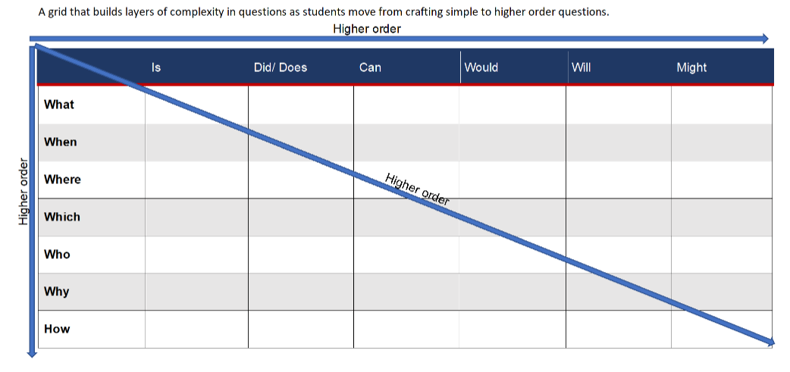

Resource 2: Exploring perspectives
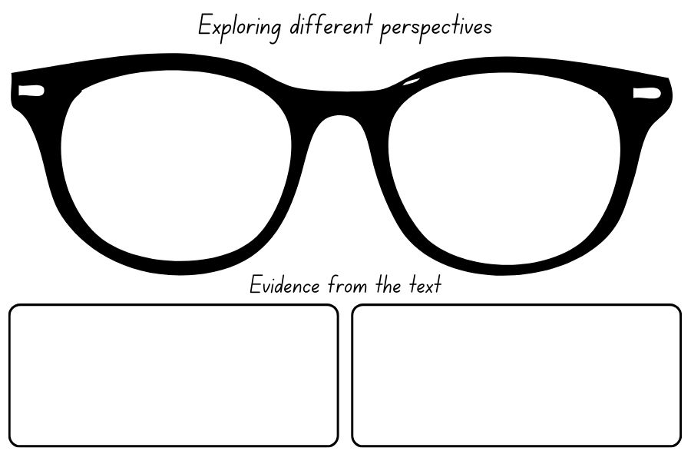
Images sourced from Canva and used in accordance with the Canva Content License Agreement.

Resource 3: Exploring perspectives example
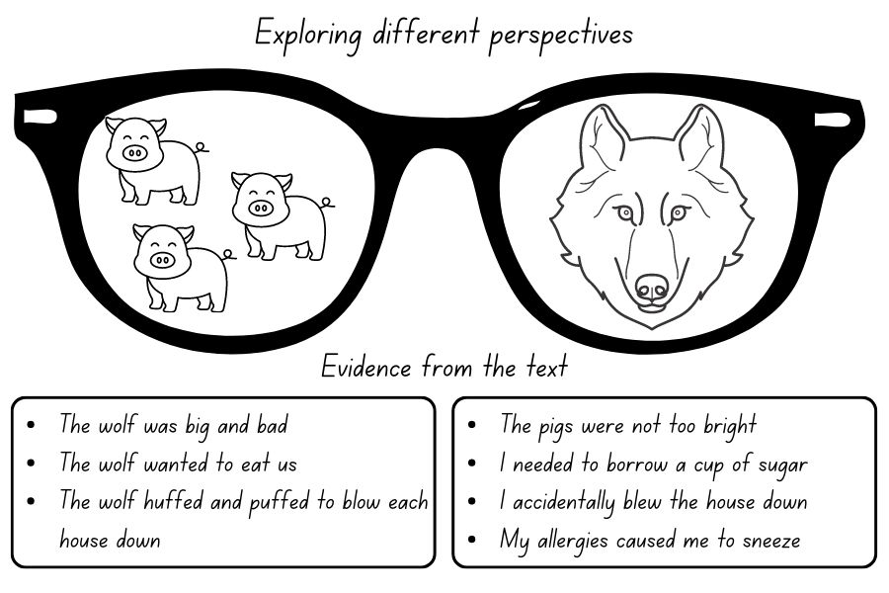
Images sourced from Canva and used in accordance with the Canva Content License Agreement.

Resource 4: Deconstructed paragraph
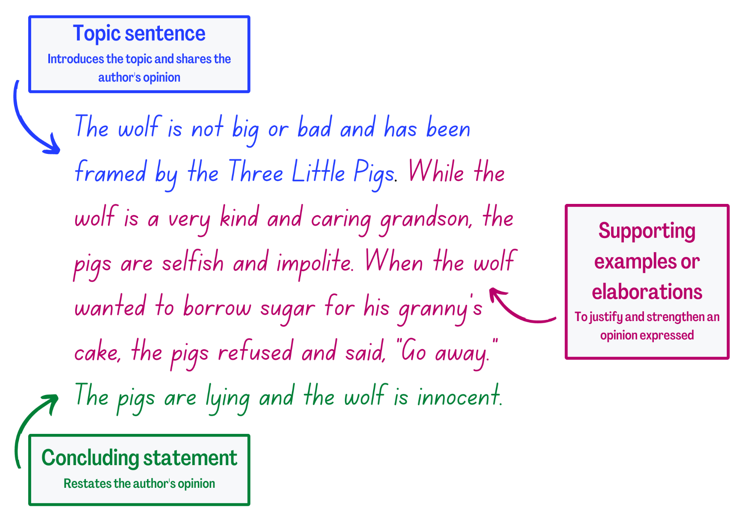

Resource 5: Word mat
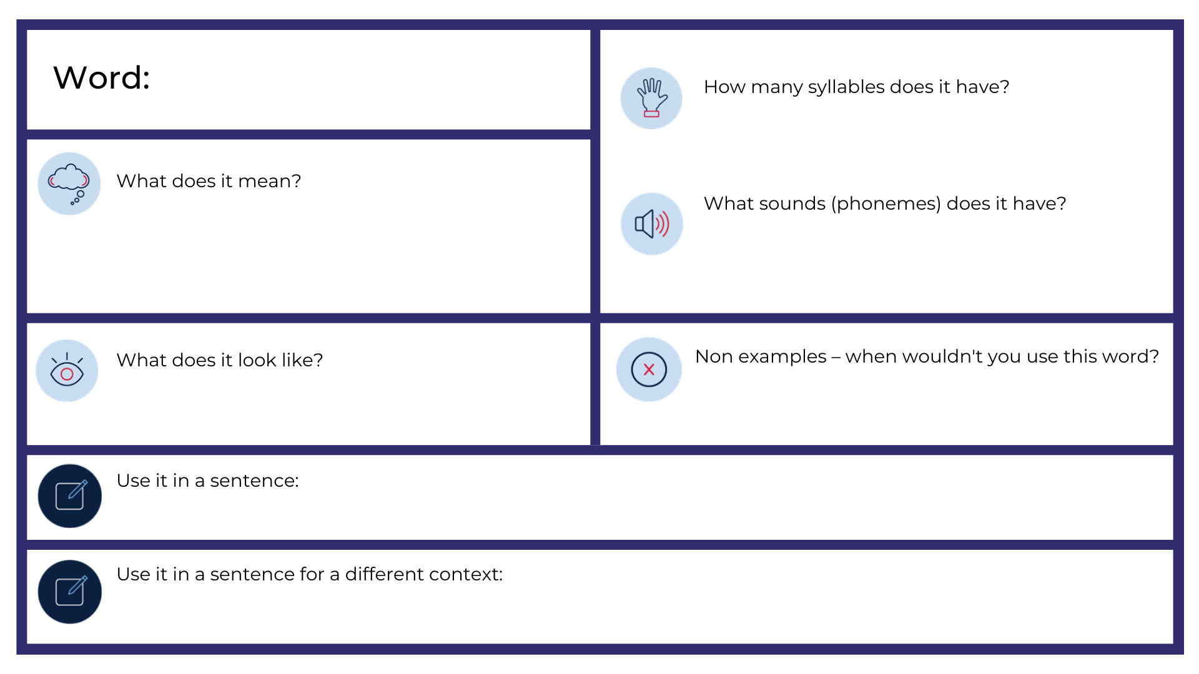

Resource 6: Exemplar text
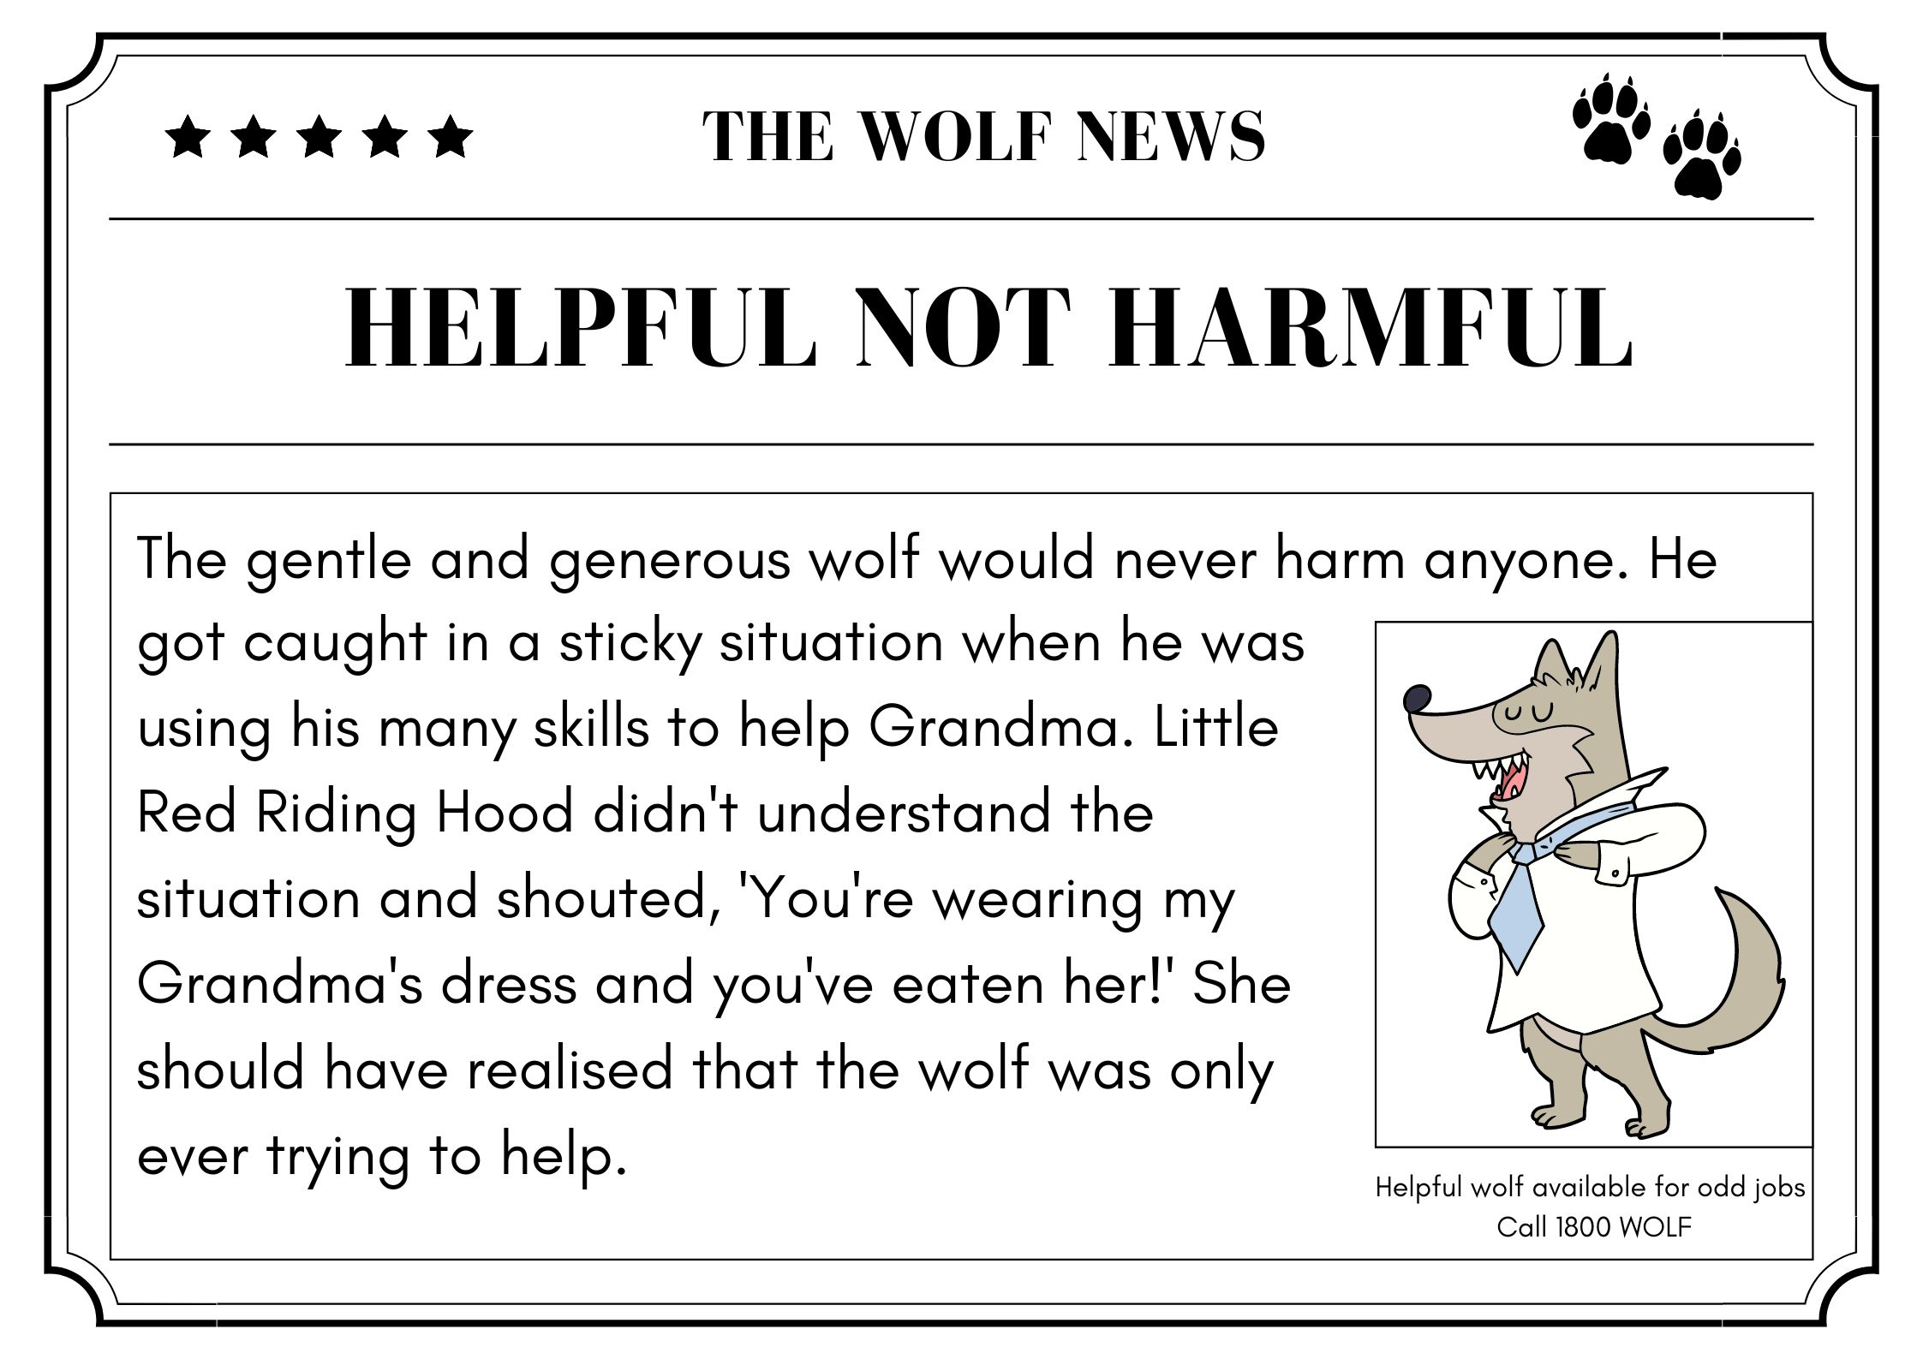
Images sourced from Canva and used in accordance with the Canva Content License Agreement.

Resource 7: Writing scaffold
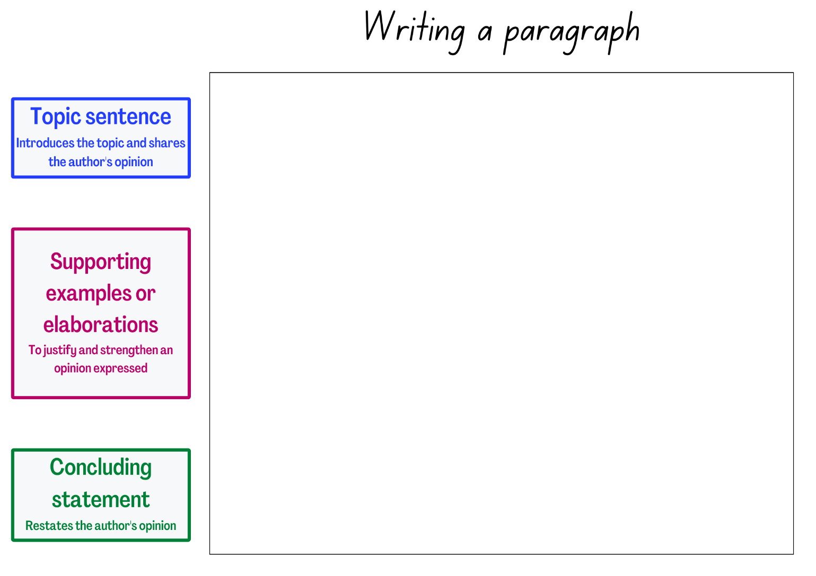

Resource 8: Publishing template
Images sourced from Canva and used in accordance with the Canva Content License Agreement.

References
Links to third-party material and websites
Please note that the provided (reading/viewing material/list/links/texts) are a suggestion only and implies no endorsement, by the New South Wales Department of Education, of any author, publisher, or book title. School principals and teachers are best placed to assess the suitability of resources that would complement the curriculum and reflect the needs and interests of their students.
If you use the links provided in this document to access a third-party's website, you acknowledge that the terms of use, including licence terms set out on the third-party's website apply to the use which may be made of the materials on that third-party website or where permitted by the Copyright Act 1968 (Cth). The department accepts no responsibility for content on third-party websites.
Except as otherwise noted, all material is © State of New South Wales (Department of Education), 2023 and licensed under the Creative Commons Attribution 4.0 International License. All other material (third-party material) is used with permission or under licence. Where the copyright owner of third-party material has not licensed their material under a Creative Commons or similar licence, you should contact them directly for permission to reuse their material.
English K–10 Syllabus © 2022 NSW Education Standards Authority (NESA) for and on behalf of the Crown in right of the State of New South Wales.
© 2022 NSW Education Standards Authority. This document contains NSW Curriculum and syllabus content. The NSW Curriculum is developed by the NSW Education Standards Authority. This content is prepared by NESA for and on behalf of the Crown in right of the State of New South Wales. The material is protected by Crown copyright.
Please refer to the NESA Copyright Disclaimer for more information.
NESA holds the only official and up-to-date versions of the NSW Curriculum and syllabus documents. Please visit the NSW Education Standards Authority (NESA) website and the NSW Curriculum website.
National Literacy Learning Progression © Australian Curriculum, Assessment and Reporting Authority (ACARA) 2010 to present, unless otherwise indicated. This material was downloaded from the Australian Curriculum website (National Literacy Learning Progression) (accessed 3 February 2023) and was not modified. The material is licensed under CC BY 4.0. Version updates are tracked in the ‘Curriculum version history’ section on the 'About the Australian Curriculum' page of the Australian Curriculum website.
ACARA does not endorse any product that uses the Australian Curriculum or make any representations as to the quality of such products. Any product that uses material published on this website should not be taken to be affiliated with ACARA or have the sponsorship or approval of ACARA. It is up to each person to make their own assessment of the product, taking into account matters including, but not limited to, the version number and the degree to which the materials align with the content descriptions and achievement standards (where relevant). Where there is a claim of alignment, it is important to check that the materials align with the content descriptions and achievement standards (endorsed by all education Ministers), not the elaborations (examples provided by ACARA).
This resource contains images and content obtained from Canva, and their use outside of this resource is subject to Canva’s Content License Agreement. If you wish to use them separately from the resource, please go to Canva.
ETA (English Teachers Association) and NSW Department of Education (2016) The Textual Concepts and Processes resource, English Textual Concepts website, accessed 3 February 2023.
Forward T (2006) The Wolf’s Story (Cohen I, illus) Walker Books Australia, Australia.
Scieszka J (2004) The True Story of the Three Little Pigs (Smith L, illus) Picture Puffin, Great Britain. ISBN: 9780140544510

