English – Stage 1 – Unit 30
Contents
Unit overview and instructions for use 3
Teacher notes 4
Outcomes and content – Component A 5
Outcomes and content – Component B 6
Week 1 10
Component A teaching and learning 10
Component B teaching and learning 11
Lesson 1: Recounting key components of a narrative 12
Lesson 2: Exploring metaphors 14
Lesson 3: Using metaphors to convey emotion 15
Lesson 4: Complex sentences 18
Lesson 5: Using verbs and images to convey meaning 20
Week 2 22
Component A teaching and learning 22
Component B teaching and learning 23
Lesson 6: Making meaning from visual features 24
Lesson 7: Summarising 26
Lesson 8: Using word play and figurative language 27
Lesson 9: Building on sentences 28
Lesson 10: Creating, editing and sharing 29
Resource 1: Narrative retell cards 31
Resource 2: Exploring metaphors 32
Resource 3: Emotional response 33
Resource 4: Layered inference 34
Resource 5: Creating written text 35
References 36

Unit overview and instructions for use
This two-week unit is comprised of Component A and Component B. Connecting learning across both components is encouraged.
Teaching and learning | Component A | Component B
Suggested duration | 60 minutes | 45 minutes
Explicit teaching focus areas | - Phonic knowledge  - Reading fluency  - Reading comprehension  - Spelling  - Handwriting | - Oral language and communication  - Vocabulary  - Reading comprehension  - Creating written texts  - Understanding and responding to literature
To prepare for teaching and learning: | - Refer to Outcomes and content – Component A, K-2 – Instructional sequence – grapheme–phoneme correspondences [PDF 825 KB], and the teaching advice documents (hyperlinked in Component A teaching and learning table).  - Based on student needs identified through ongoing assessment data, plan and document how you will sequence teaching and learning in whole class and targeted teaching groups across the two-week cycle. | - Familiarise yourself with Outcomes and content – Component B, Textual concepts information and videos, English Textual Concepts and Learning Processes (2016), and the teaching and learning sequence.  - Based on student needs identified through ongoing assessment data, determine how you will support students in whole class and targeted teaching groups across the two-week cycle as required.
English K–10 Syllabus © 2022 NSW Education Standards Authority (NESA) for and on behalf of the Crown in right of the State of New South Wales.

Teacher notes
- Imagery, symbol and connotation extend words and symbols beyond their literal meaning. They are used to provide deeper meaning, evoke emotion and enhance enjoyment in texts – English Textual Concepts and Learning Processes (2016).
- Understanding of imagery, symbol and connotation can be supported through watching the department’s video: Understanding connotation, imagery and symbol video (6:06).
- While ‘imagery, symbol and connotation’ is the mentor concept for the conceptual component of this unit, the supporting concept of ‘narrative’ can be explored using the mentor text I Talk Like a River by Jordan Scott.
- For information on complex sentences, clauses, and subordinating conjunctions, refer to the NESA Glossary.
- For information on sentence structure, refer to the Sentence structure teaching strategies.
- Lesson 7 requires students to create a word cloud which can be accessed via the Digital Learning Selector’s Mentimeter. All staff can create a free account. To access a word cloud, select Mentimeter Overview then Features.
- For information, definitions, and terminology related to communication and language disorders, refer to the Inclusive Practice Hub.
- Consider prior student knowledge of figurative language.
- Reflect on student learning and engagement in activities and record differentiation and adjustments within the unit to inform future teaching and learning. One way of doing this could be to add comments to the digital file.
- Content points are linked to the National Literacy Learning Progression version (3).
Levels and indicators sourced from National Literacy Learning Progression © Australian Curriculum, Assessment and Reporting Authority (ACARA), (accessed 22 December 2022) and was not modified. See references for more information.

Outcomes and content – Component A
The table below outlines the focus outcomes and content. Content is linked to the National Literacy Learning Progression version (3).
Focus area and outcome | Content points and National Literacy Learning Progression
Phonic knowledge  EN1-PHOKW-01 – uses initial and extended phonics, including vowel digraphs, trigraphs to decode and encode words when reading and creating texts | - decode words with trigraphs and quadgraphs and apply this when reading texts
Reading fluency  EN1-REFLU-01 – sustains reading unseen texts with automaticity and prosody and self-corrects errors | - self-correct when fluency and/or meaning is interrupted  - vary pace when reading according to the audience and purpose (FlY4)
Reading comprehension  EN1-RECOM-01 – comprehends independently read texts that require sustained reading by activating background and word knowledge, connecting and understanding sentences and whole text, and monitoring for meaning | - register a break in comprehension when reading (UnT5)  - confirm meaning by sequencing and explaining events and information
Spelling  EN1-SPELL-01 – applies phonological, orthographic and morphological generalisations and strategies when spelling words in a range of writing contexts | - segment multisyllabic words into syllables and phonemes as a strategy for spelling (SpG5)  - explain that the consonant trigraphs, -tch and -dge, can end a base word immediately following a short vowel and apply this when spelling
Handwriting  EN1-HANDW-01 – uses a legible, fluent and automatic handwriting style, and digital technology, including word-processing applications, when creating texts | - type up to 5 familiar words per minute

Outcomes and content – Component B
The table below outlines the focus outcomes and content. Content is linked to the National Literacy Learning Progression version (3).
Focus area and outcome | Content points and National Literacy Learning Progression
Oral language and communication  EN1-OLC-01 – communicates effectively by using interpersonal conventions and language to extend and elaborate ideas for social and learning interactions | - understand that oral language can be used in combination with nonverbal communication  - recount narratives with key components (SpK3)
Vocabulary  EN1-VOCAB-01 – understands and effectively uses Tier 1, taught Tier 2 and Tier 3 vocabulary to extend and elaborate ideas | - understand and intentionally choose subject-specific vocabulary to enhance precision and for effect
Reading comprehension  EN1-RECOM-01 – comprehends independently read texts that require sustained reading by activating background and word knowledge, connecting and understanding sentences and whole text, and monitoring for meaning | - know that a complex sentence includes a clause for expressing a main message and one or more clauses that elaborate on that message  - identify how creative visual features are used to expand meaning  - use visual and/or auditory features in multimodal texts to build meaning (UnT5)  - recount relevant ideas from texts in the form of a written, visual or oral summary (UnT6)
Creating written texts  EN1-CWT-01 – plans, creates and revises texts written for different purposes, including paragraphs, using knowledge of vocabulary, text features and sentence structure | - write texts that describe, explain, give an opinion, recount an event, tell a story (CrT7)  - use subject–verb agreement across a text (GrA5)  - make intentional word choices to enhance precision of meaning and ideas in a text (CrT5)  - use action, saying, relating and sensing verbs to add detail and precision to writing  - experiment with writing complex sentences which include a clause for the main message and dependent clause to elaborate or modify the message  - use commas to separate ideas, lists and/or dependent clauses in a sentence (PuN4) (PuN6)  - use a variety of planning strategies and tools for creating texts
Understanding and responding to literature  EN1-UARL-01 – understands and responds to literature by creating texts using similar structures, intentional language choices and features appropriate to audience and purpose | - identify symbols and images in texts, and how they bring deeper meaning  - identify figurative language and wordplay in texts  - innovate from studied texts using wordplay and figurative language  - create and re-create narratives using understanding of narrative features (CrT5)

Week 1

Component A teaching and learning
The table below can be used to plan and document lessons that address Component A outcomes and content. Both the detailed example [DOC 529KB] of a two-week teaching and learning cycle and brief example [DOC 66KB] may support you in your planning.
Focus Areas | Lesson 1 | Lesson 2 | Lesson 3 | Lesson 4 | Lesson 5
Phonic knowledge
15 minutes
Spelling and Handwriting
15 minutes
Reading comprehension and Reading fluency
30 minutes

Component B teaching and learning
The following teaching and learning sequence has been designed to address Component B outcomes and content. Adapt the sequence as required to best meet the needs of your students.

Learning intention and success criteria
Learning intentions and success criteria are best co-constructed with students.

Learning intention
Students are learning to explore how imagery, symbol and connotation can be used to create rich descriptions.

Success criteria
Students can:
- recount narratives with key components
- identify figurative language in a text
- explain the impact of figurative language on the reader
- identify dependent and independent clauses in a complex sentence
- use action verbs to add detail and precision to writing.

Resources
- Scott J (2021) I Talk Like a River (Smith S, illus.) Holiday, Walker Books Australia. ISBN: 9781406397222
- Resource 1: Team retell cards – one set per group
- Resource 2: Exploring metaphors
- Resource 3: Emotional response
- Harvard Graduate School of Education - I Used to Think... Now I Think...
- Art materials, such as watercolours and crayons
- Coloured markers
- Colour paper, scissors, glue
- Mini whiteboards

Lesson 1: Recounting key components of a narrative
- Display the front cover of the text I Talk Like a River by Jordan Scott and Sydney Smith. Allow time for students to observe and analyse details. Read the title of the text aloud. Guide students to make predictions about the text using their understanding of narrative structure, the title, and illustrations.
- Revise the definition of a simile and ask students to identify what 2 things are being compared in the title. Prompt students to think about and discuss what it might mean to ‘talk like a river’. Students use the sentence prompt, ‘I think the book is called I Talk Like a River because…’ to record their prediction. Students’ predictions will be revisited in activity 11.
- Read the text. Ask students what type of text it is and how they know.
- Turn to the first double page spread with the text ‘I wake up each morning with the sounds of words all around me.’ Ask students to turn to a partner and talk about what they see and what the page layout makes them think about. For example, the boy knows the words he wants to say but has difficulty saying them.
- Ask guiding questions such as:
- How does the boy feel when he communicates? How do you know?
- Why do you think the boy stays quiet in school?
- How do the boy’s classmates respond when he has difficulty communicating?
- What does the boy’s dad say and do to try to make the boy feel better?
- How do the boy’s feelings change throughout the narrative?
- What lessons can we learn from the text?
- Discuss what students know about communication disorders such as stuttering. Explain that stuttering is when the flow of speech is stopped or interrupted. People with a communication disorder such as stuttering have difficulty producing sounds or words. Explain that I Talk Like a River is about a boy who stutters and has difficulty communicating in the way he would like.
- Revise how authors use imagery, symbol and connotation to represent actions and ideas in a non-literal way. Discuss how the author has used imagery and symbols to create additional layers of meaning and evoke feelings or emotions. For example, the river is used to symbolise how the boy speaks.
- Ask students to identify some of the ways the author describes how the boy feels about speaking. Display the double page spread with the text ‘They don’t see a pine tree sticking out from my lips instead of a tongue.’ Revise how the relationship between words, pictures, and layout is very important in picture books. Discuss how the author has used figurative language and creative visual features such as illustrations, page layout, and colour to create imagery, engage readers’ senses, and expand meaning.
- In groups of 3 or 4, students use Resource 1: Narrative retell cards to recount the key components of the narrative, I Talk Like a River. Students select a card and take turns to orally retell or describe that component of the story. For example, if the student selects the card ‘Solution’, they might recount how the boy’s father helped him to embrace his stuttering and ‘talk like a river’.
- Students write a short summary to recount relevant ideas from the text using the information discussed in activity 9.
- Ask students to reflect on their responses about the meaning of the title of the text from activity 2 and use the routine I Used to Think... Now I Think... to explore how and why their thinking has changed. For example, ‘I used to think that the text was about a boy who liked to swim in a river. Now, I think that the river symbolises how the boy feels about the way he speaks.’
Stage 1 Assessment task 1 – Observations from this lesson allow students to demonstrate achievement towards the following syllabus outcomes and content points:
EN1-OLC-01 – communicates effectively by using interpersonal conventions and language to extend and elaborate ideas for social and learning interactions
- recount narratives with key components.
EN1-RECOM-01 – comprehends independently read texts that require sustained reading by activating background and word knowledge, connecting and understanding sentences and whole text, and monitoring for meaning
- use visual and/or auditory features in multimodal texts to build meaning
- recount relevant ideas from texts in the form of a written, visual or oral summary.

Lesson 2: Exploring metaphors
- Review the definition of a simile as an example of figurative language that compares 2 unlikely things using the word ‘like’ or ‘as’. Record an example of a simile and a metaphor from the text. For example, ‘I stay as quiet as a stone’ and ‘My eyes fill with rain’. Ask students to discuss the similarities and differences between the 2 examples. Identify the subject and verb in each sentence. Highlight how the author has used action verbs to add precision and enhance imagery.
- Read aloud the metaphor example from activity 1, ‘My eyes fill with rain’. Ask students if the boy’s eyes are really filling with rain. Discuss what the author means. Students turn to a partner and talk about the 2 things that are being compared and what the author wants readers to understand from the metaphor. For example, the author is comparing the boy’s tears with rain. He wants readers to understand how the boy is feeling and the emotions he is experiencing. Highlight how the author used figurative language to represent the character’s emotions in a non-literal way.
- Co-construct a definition for a metaphor. For example, a metaphor is a figure of speech that compares 2 unlikely things in a non-literal way. Metaphors do not use the words ‘like’ or ‘as’. Keep this for Lesson 3.
- Discuss how the use of similes and metaphors enhance imagery by appealing to the senses of the reader.
- Re-read the text, pausing when a metaphor is read. Students complete Resource 2: Exploring metaphors to identify how figurative language has been used to create additional layers of meaning.
Stage 1 Assessment task 2 – Observations from this lesson allow students to demonstrate achievement towards the following syllabus outcome and content point:
EN1-UARL-01 – understands and responds to literature by creating texts using similar structures, intentional language choices and features appropriate to audience and purpose
- identify figurative language and wordplay in texts.

Lesson 3: Using metaphors to convey emotion
- Review the text I Talk Like a River, its main message, and how the author and illustrator used imagery, colour, and figurative language to convey emotion and expand meaning.
- Discuss how the text was inspired by the author, Jordan Scott’s personal experience with a communication disorder. Explain that students will describe their feelings during a time they experienced something challenging using figurative language.
- Display the page of the boy sitting by the river with the text ‘I feel a storm in my belly; my eyes fill with rain.’ Explain that connotation is an idea or feeling that readers connect to a word. Ask students to think about their emotional response and what feeling they connect with the metaphor. For example, the feeling of sadness. Discuss how the author used figurative language to create imagery, symbol and connotation.
- Ask students to think about a time in their life when they have experienced something challenging. For example, performing in front of a crowd, starting a new school, hearing someone say something that is not true, learning a new skill. Share and record student ideas. For each idea, brainstorm and record different sensing verbs that may be experienced. For example, scared, worried, angry, frustrated.
- Explore how feelings can be expressed through non-verbal and verbal communication. In pairs, students use role-play to express different feelings without speaking. Students take turns guessing the feeling expressed and discuss how they know. For example, the feeling of fear might be expressed using body language and facial expressions such as heavy breathing, darting eyes, quivering lip.
- On an enlarged copy of Resource 3: Emotional response, record an example of a challenging experience from activity 4, such as performing in front of a crowd. Identify and record a feeling experienced. Model writing words or phrases to describe how a person could convey that feeling through verbal and non-verbal communication. For example, cold body, frozen feet, sweaty palms, fast breathing, trembling fingers.
- Students complete Resource 3: Emotional response. In pairs, students share their ideas.
- Revise the co-constructed definition of a metaphor from Lesson 2.
- Model writing a metaphor using the ideas recorded in activity 6. For example, ‘I feel frozen inside. My blood turns to ice.’ Discuss how the metaphor helps the reader to see and visualise the feeling of fear.
- Students use their planned ideas in Resource 3: Emotional response to write a metaphor that compares their feeling to something else.
Too hard? Record commonly used metaphors for students. For example, ‘I am boiling with anger’, ‘He feels drained’, ‘She is crying a river’. Students illustrate the metaphor and identify what 2 things are being compared.
Stage 1 Assessment task 3 – Observations and work samples from this lesson allow students to demonstrate achievement towards the following syllabus outcomes and content points:
EN1-OLC-01 – communicates effectively by using interpersonal conventions and language to extend and elaborate ideas for social and learning interactions
- understand that oral language can be used in combination with nonverbal communication.
EN1-CWT-01 – plans, creates and revises texts written for different purposes, including paragraphs, using knowledge of vocabulary, text features and sentence structure
- use a variety of planning strategies and tools for creating texts.

Lesson 4: Complex sentences
- Revise complex sentences and subordinating conjunctions and how authors use them to express and connect ideas. Explain that complex sentences are formed by adding one or more dependent (subordinate) clauses to a main (independent) clause using a conjunction. Revise that the purpose of a subordinating conjunction is to link a dependent clause to an independent clause.
Note: Complex sentences contain a main (or independent) clause and one or more subordinate (or dependent) clauses. The subordinate clause is joined to the main clause through subordinating conjunctions such as when, while, and before. For example, ‘We all went outside when the sun came out.’
- Record the sentence ‘When the words around me are hard to say, I think of the proud river’ from the text I Talk Like a River. Explain that the independent clause holds the main message and can stand alone in the sentence. Ask students to identify the independent clause in the sentence (‘I think of the proud river’). Discuss how the dependent clause (‘When the words around me are hard to say’) elaborates on the main message.
- Deconstruct the sentence using different coloured markers. Circle the subordinating conjunction ‘when’ and underline the dependent and independent clauses. Discuss how the subordinating conjunction has been used at the beginning of the sentence and a comma has been used to separate the clauses. Experiment swapping the dependent and independent clauses in the sentence. For example, ‘I think of the proud river when the words around me are hard to say.’ Discuss whether the sentence still makes sense or if the meaning has changed.
- Use the text to revisit how the boy had a difficult time communicating with other people. Re-read the sentence ‘When the words around me are hard to say, I think of the proud river.’ Discuss how the boy thought of the proud river to support and calm him when the words around his were hard to say.
- In pairs, students use their challenging experience from Lesson 3 to discuss different things they could think of to support or calm them. For example, a happy memory, special place, or an enjoyable activity. Share and record student responses.
- Using responses recorded in activity 5, model writing a complex sentence. For example, ‘When I perform in front of a crowd, I think of a warm campfire.’ Display the sentence in the classroom to use in Lesson 5.
- Students experiment writing complex sentences about their challenging experience. Students use the subordinating conjunction ‘when’ and a comma to separate the clauses. Using different colours, students deconstruct their sentence by circling the subordinating conjunction and underlining the dependent and independent clauses.
Too hard? Co-construct a complex sentence using the subordinating conjunction ‘when’.
Too easy? Students experiment using a variety of subordinating conjunctions, such as ‘while’ or ‘where’.
Stage 1 Assessment task 4 – Observations and work samples from this lesson allow students to demonstrate achievement towards the following syllabus outcome and content point:
EN1-RECOM-01 – comprehends independently read texts that require sustained reading by activating background and word knowledge, connecting and understanding sentences and whole text, and monitoring for meaning
- know that a complex sentence includes a clause for expressing a main message and one or more clauses that elaborate on that message.

Lesson 5: Using verbs and images to convey meaning
- Display the double page spread from I Talk Like a River with the text ‘When the words around me are hard to say, I think of the proud river.’ Identify the action verbs, ‘bubbling’, ‘churning’, ‘whirling’, ‘crashing’. Discuss how the author chose subject-specific vocabulary about the river to add detail and precision to writing.
- In small groups, students revise their complex sentence from Lesson 4. On mini whiteboards, students brainstorm action verbs related to their sentence. For example, warm campfire: burning, crackling, roaring, flickering. Share student responses and create an anchor chart of action verbs.
- Select one of the words from the anchor chart in activity 2 that is new or unfamiliar, such as ‘flickering’. Discuss the meaning of the word and ask students to identify other words with a similar meaning, such as ‘twinkling’ or ‘flashing’. Explain that action verbs create an image for the reader and add detail and precision to writing. Discuss the meaning of some other words from the anchor chart.
- Model adding actions verbs to the complex sentence from Lesson 4, using commas to list. For example, ‘When I stand in front of a crowd, I think of a warm campfire, burning, crackling, roaring, and flickering.’
- Students add their list of actions verbs to their complex sentence from Lesson 4.
- Explain that illustrator Sydney Smith used watercolours and inks to create the images. Flick through the text and discuss different ways Sydney Smith used visual features to expand meaning. For example:
- shape: familiar shapes, geometric shapes
- line: curved, straight, wavy
- colour: extreme close-ups, silhouette images
- space: background, foreground, fading images, framing, text layout
- symbols: river, water, crow, pine trees
- relationships: extreme close-ups, gaze, facial expressions, and body language, the distance between people and objects.
- Students re-create the illustration and text from the double page spread from the text I Talk Like a River. Students use art materials such as watercolours and crayons to create an artwork about what they imagine during their challenging experience. For example, a warm campfire. Encourage students to use visual features such as colour, space, size, and layout to convey emotion and expand meaning.
- Students record their expanded complex sentence from activity 5 on coloured pieces of paper and stick them around their artwork. Encourage students to carefully consider the layout of their text around their artwork.

Week 2

Component A teaching and learning
The table below can be used to plan and document lessons that address Component A outcomes and content. Both the detailed example [DOC 529KB] of a two-week teaching and learning cycle and brief example [DOC 66KB] may support you in your planning.
Focus Areas | Lesson 6 | Lesson 7 | Lesson 8 | Lesson 9 | Lesson 10
Phonic knowledge
15 minutes
Spelling and Handwriting
15 minutes
Reading comprehension and Reading fluency
30 minutes

Component B teaching and learning
The following teaching and learning sequence has been designed to address Component B outcomes and content. Adapt the sequence as required to best meet the needs of your students.

Learning intention and success criteria
Learning intentions and success criteria are best co-constructed with students.

Learning intention
Students are learning to interpret visual features to re-create a narrative.

Success criteria
Students can:
- make meaning of a wordless text by examining the key visual features
- recount and summarise relevant ideas from texts
- use word play and figurative language
- use vocabulary and figurative language to build sentences
- create, edit, and share writing.

Resources
- Blackwood F (2021) The Boy and the Elephant, HarperCollins Publishers, Australia. ISBN: 9781460759998
- Resource 4: Layered inference
- Resource 5: Creating written text
- Sticky notes
- Mini whiteboards

Lesson 6: Making meaning from visual features
- View the front and back cover of the text The Boy and the Elephant. Read the text on the back cover aloud. Ask students to close their eyes and visualise what is happening.
- Flick through the text and ask students what they notice. Guide students to identify that it is a wordless text and make connections to other wordless texts they have read. Explain that in this text, images and symbols are used to communicate feelings, emotions, and ideas.
- Silently view the text. Allow time for students to observe the visual features and details on each double page. Discuss ways students made meaning from the text. For example, using background knowledge and prior experiences, using visual features such as colour, size, character’s facial expressions, or body language.
- Display the double page spread with the large elephant and the boy touching the trunk. Discuss how symbols and images are used to bring deeper meaning. Ask guiding questions to support discussion. For example:
- What feelings does this image convey? How did the author achieve this?
- What feelings or qualities do trees symbolise or evoke? What makes you think that?
- What feelings or qualities do elephants symbolise or evoke? What makes you think that?
- Continue to display the double page spread from activity 4. Provide students with a copy of Resource 4: Layered inference. Explicitly model how to analyse the image to build meaning. Discuss what students can see in the image and model recording a response in the square ‘What can I see?’ For example, ‘I can see a boy touching a tree trunk.’ Students use Resource 4: Layered inference to record what they can see.
- Discuss what students can infer from the image. Remind students that making an inference is the process of using clues from the text and background knowledge to draw conclusions and make predictions. Model recording a response in the square ‘What can I infer?’ For example, ‘I think the elephant symbolises friendship because the boy seems lonely.’ Students record their inferences on the resource. Encourage students to provide reasons using a ‘because’ statement.
- Read aloud the final question in the layered inference, ‘What questions do I have?’ Prompt students to ask clarifying questions about the image. For example:
- Why are the trees represented as an elephant?
- Is the boy the only one who can see the elephant?
- How does the boy feel about the elephant?
- Why is the boy lonely?
- Students record their questions about the image on the resource.
- As a class, discuss and respond to student questions from activity 7.
Stage 1 Assessment task 5 – Observations from this lesson allow students to demonstrate achievement towards the following syllabus outcomes and content points:
EN1-RECOM-01 – comprehends independently read texts that require sustained reading by activating background and word knowledge, connecting and understanding sentences and whole text, and monitoring for meaning
- identify how creative visual features are used to expand meaning.
EN1-UARL-01 – understands and responds to literature by creating texts using similar structures, intentional language choices and features appropriate to audience and purpose
- identify symbols and images in texts, and how they bring deeper meaning.

Lesson 7: Summarising
- Walk through each page of the text The Boy and the Elephant. Pause at each page and provide time for students to use the visual features to engage in a shared oral retell about what is happening. As students engage in an oral retell of the narrative, add subject-specific vocabulary to an anchor chart.
- Ask prompting questions to support understanding and meaning of the text. For example:
- What do you see?
- What is happening?
- What might the boy hear, smell, or feel?
- What time of day is it? How do you know?
- What is the boy doing?
- How might the character be feeling? What makes you think this?
- On each page, students use sticky notes to record a word or phrase they feel captures the most important elements. For example, school, elephant, friendship, lonely, caring for the environment, imagination. Encourage students to use words from the anchor chart to support their thinking. Repeat this process for each page. Students keep their sticky notes for activity 4.
- In pairs or small groups, students review and discuss their sticky notes from each page and identify what words or phrases capture the main ideas of the text. Encourage students to move their sticky notes around, grouping words or phrases that may have been repeated or that mean the same thing.
- Students use the ideas on their sticky notes to create a word cloud that summarises the main ideas of the text. (See Teacher notes for access to word cloud).
- Students share their word cloud summaries with the class.

Lesson 8: Using word play and figurative language
- Review how the author of I Talk Like a River has used imagery and symbols to create additional layers of meaning and evoke feelings or emotions. Discuss how the author has used visual features such as layout and colour, and intentional word choices such as similes, metaphors, and onomatopoeia to engage the senses and expand meaning. Highlight the author’s use of varied sentence structure, such as simple, compound, and complex sentences to engage the reader.
- Explain that students will create the written text to accompany the wordless text The Boy and the Elephant. Display the double page spread at the beginning of the book that shows the boy getting ready for school. Use Think-alouds to orally describe what is happening and model writing the text to accompany the illustrations. Students imagine they are the character in the book. For example, ‘Each morning after I get out of bed, I get ready for school. I put on my shirt, tie up my shoes, straighten my tie, and pack my bag.’
- Deconstruct the sentence from activity 2. Highlight the subject-verb agreement, explaining how a consistent tense has been used. Identify the action verbs and discuss how commas are used to list the character’s actions.
- Turn to the next double page that shows the boy leaving home and walking through the city. Students Think-Pair-Share what is happening in the image. Jointly construct a text to accompany the illustrations. For example, ‘I step out into the hustle and bustle of a concrete jungle. When I make my way through the crowds, no one notices me.’
- Deconstruct the sentences from activity 4. Discuss the impact of figurative language and wordplay. Underline the metaphor and rhyming words. Identify the complex sentence, circling the subordinating conjunction ‘when’ and underlining the dependent and independent clauses. Discuss the importance of making intentional word choices to enhance precision of meaning and ideas in a text.
- Turn to the next double page that shows the boy sitting in the playground. Students Think-Pair-Share what is happening in the image. On mini whiteboards, students write the text to accompany the illustrations. For example, ‘A new school day begins. At lunch, sneakers squeak, balls bounce and there are squeals of laughter. I sit alone. Beep! Beep! It’s home time again. The loneliness feels heavy as I walk.’
- In pairs, students deconstruct their sentence from activity 6. Share student ideas and discuss the different vocabulary choices and language features used.
- Display sentences in the classroom to use in Lesson 9.

Lesson 9: Building on sentences
- Revise the audience and purpose of a narrative. Discuss how narratives can evoke feelings through the author’s use of imagery, symbol and connotation. In pairs or small groups, students will create the written text to accompany the wordless text The Boy and the Elephant.
- Discuss the importance of vocabulary choices to add detail and precision to writing. Display the modelled sentence, ‘I wake up each morning, get dressed, brush my teeth, and pack my bag without any help’ from Lesson 8. Re-read the sentence and ask students to brainstorm other words for ‘without any help’. For example, independent, solo, unaccompanied, alone. Discuss how different words can be used to enhance precision and effect.
- Use the modelled and jointly constructed sentences from Lesson 8 to co-construct a success criteria.
- In pairs or small groups, students use Resource 5: Creating written text to create the text for The Boy and the Elephant. Students sketch the events from selected double page spreads and create the written text to accompany the illustrations. Prompt students to include figurative language to enhance imagery, symbol and connotation.

Lesson 10: Creating, editing and sharing
- Students complete Resource 5: Creating written text.
- Students reflect on their writing using the success criteria. Provide time for students to edit and refine their writing.
- Students share their written text with another group. Discuss whether the written text or wordless picture book had greater impact on them as a reader and why.
Stage 1 Assessment task 6 – Observations and work samples from this lesson allow students to demonstrate achievement towards the following syllabus outcomes and content points:
EN1-VOCAB-01 – understands and effectively uses Tier 1, taught Tier 2 and Tier 3 vocabulary to extend and elaborate ideas
- understand and intentionally choose subject-specific vocabulary to enhance precision and for effect.
EN1-CWT-01 – plans, creates and revises texts written for different purposes, including paragraphs, using knowledge of vocabulary, text features and sentence structure
- write texts that describe, explain, give an opinion, recount an event, tell a story
- use subject–verb agreement across a text
- make intentional word choices to enhance precision of meaning and ideas in a text
- use action, saying, relating and sensing verbs to add detail and precision to writing
- use commas to separate ideas, lists and/or dependent clauses in a sentence
- experiment with writing complex sentences which include a clause for the main message and dependent clause to elaborate or modify the message.
EN1-UARL-01 – understands and responds to literature by creating texts using similar structures, intentional language choices and features appropriate to audience and purpose
- innovate from studied texts using wordplay and figurative language
- create and re-create narratives using understanding of narrative features.

Resource 1: Narrative retell cards
Complication  What is the problem that the character encounters? Is it one that can be easily solved? | Setting  Introduce the who, what, when, where of the text. | Events  Describe the series of events in the sequence in which they occurred.
Resolution  How is the problem solved and describe how each character felt. | Character  Identify the main character’s key traits and describe how the character’s feelings change. | Audience and purpose  What type of text is it? Who is the intended audience? Why do you think the author wrote the text?

Resource 2: Exploring metaphors
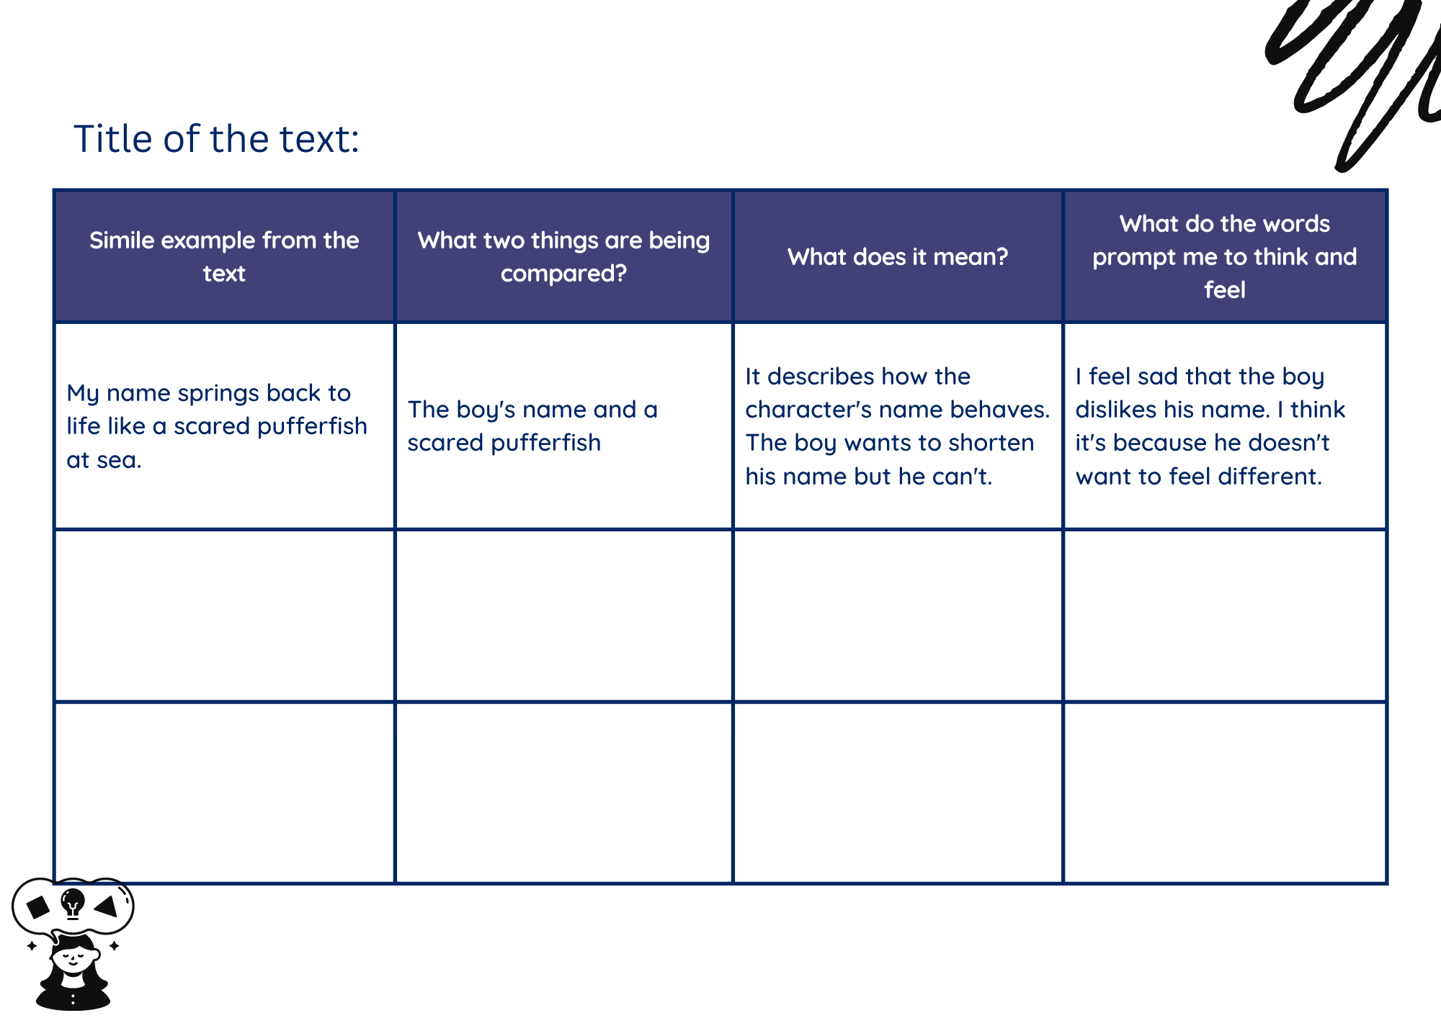
Images sourced from Canva and used in accordance with the Canva Content License Agreement.

Resource 3: Emotional response
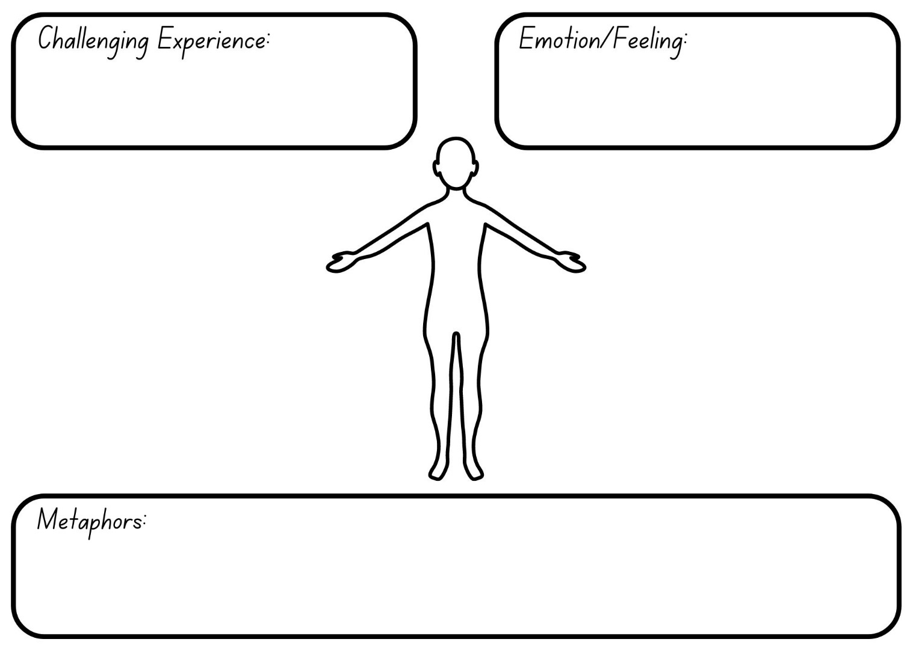
"human body figure" by Giuseppe Ramos – VEC sourced from Canva and used in accordance with the Canva Content License Agreement.

Resource 4: Layered inference
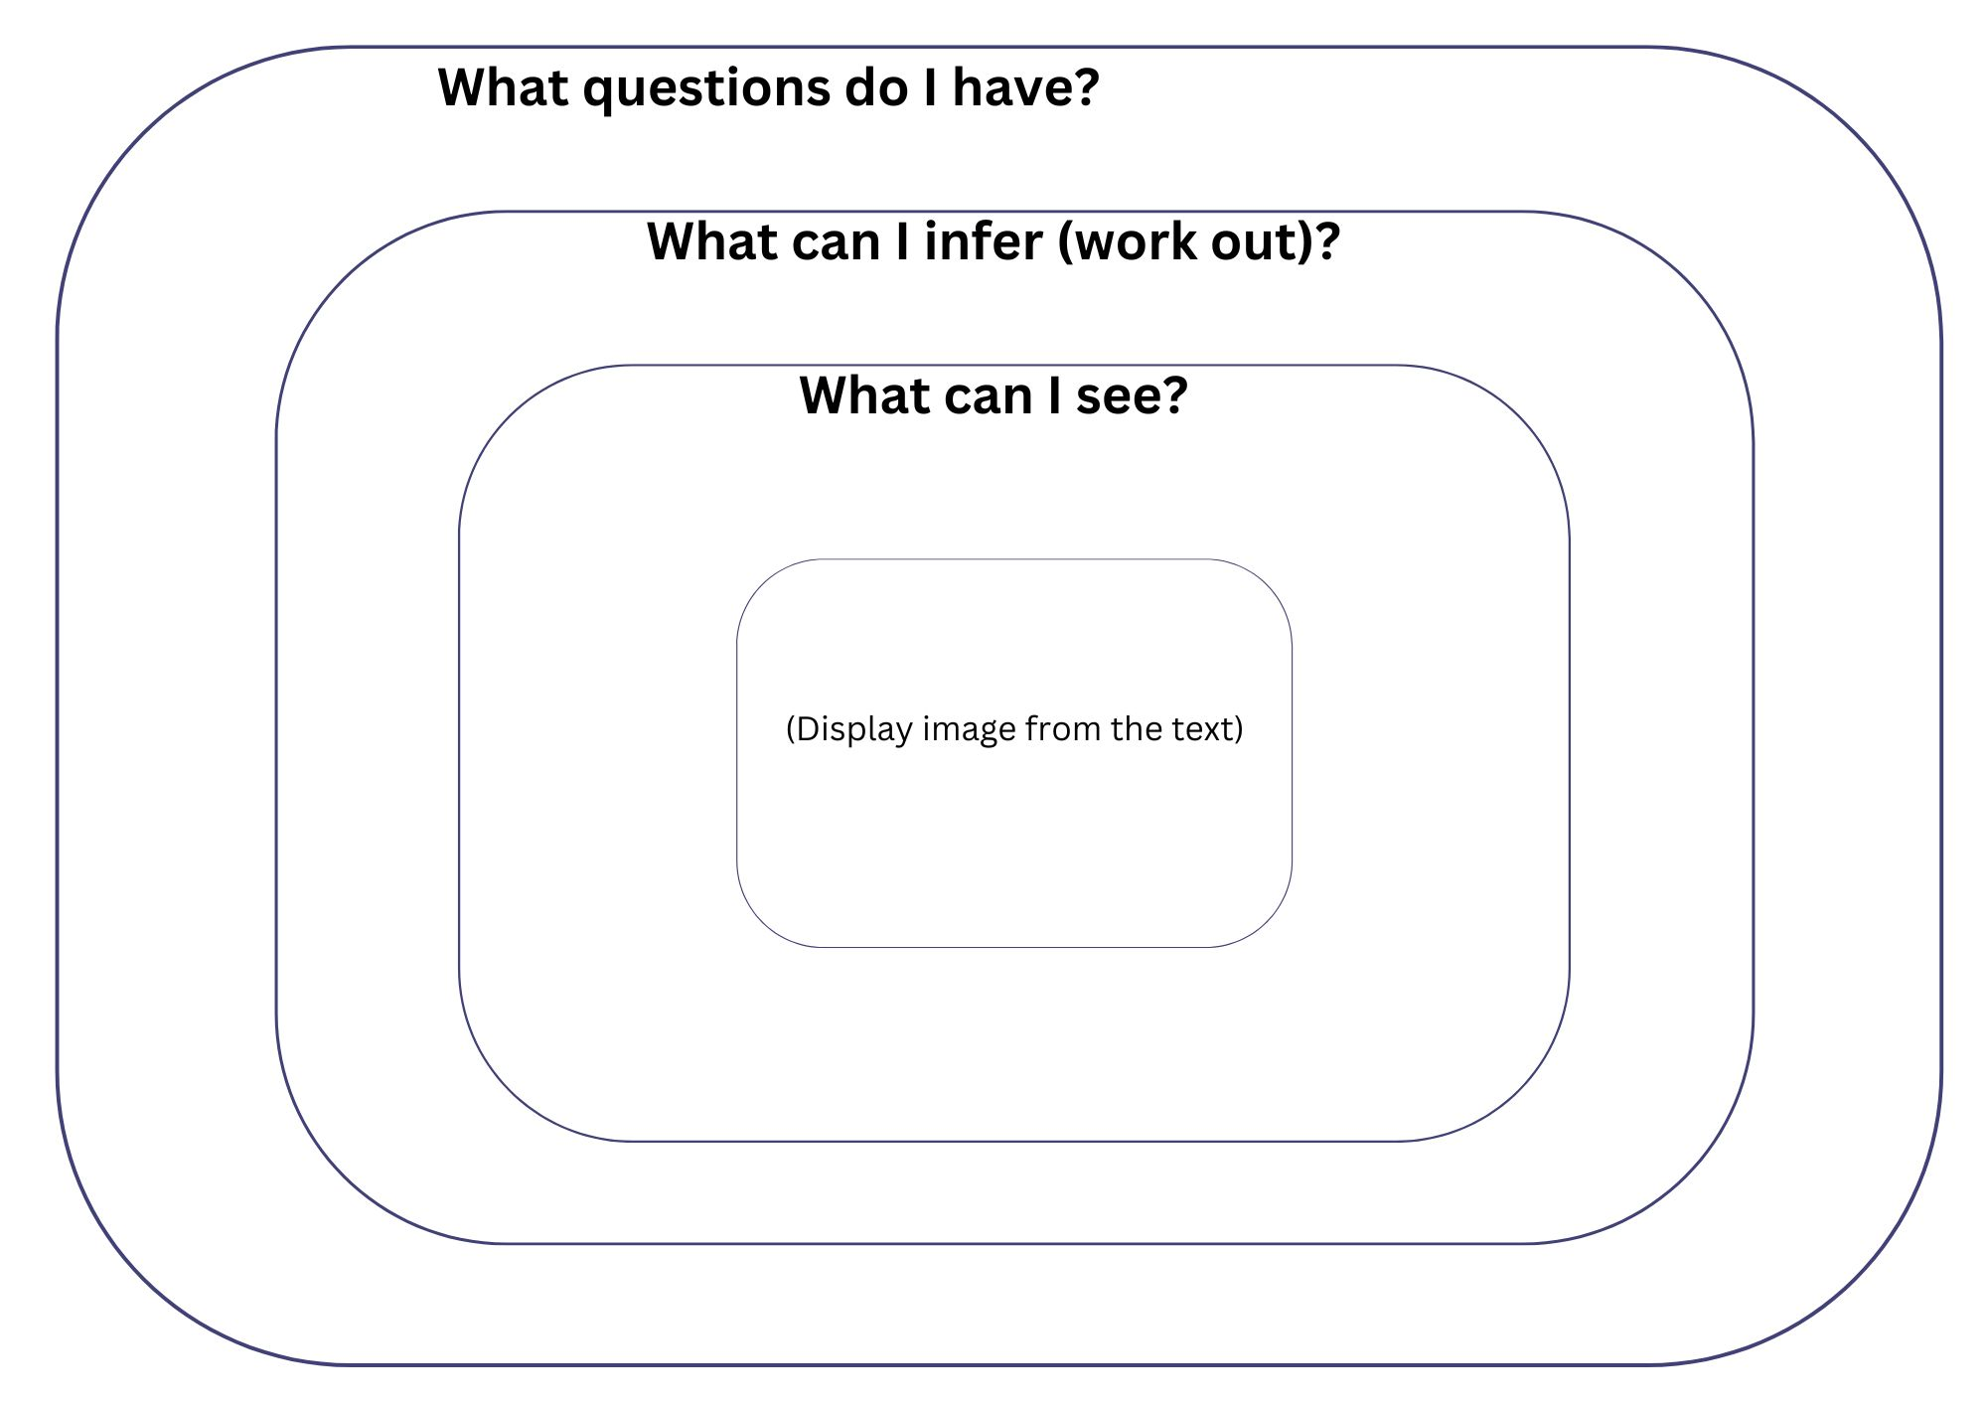

Resource 5: Creating written text
Sketch the events on each page. Create the text to accompany relevant pages from the text The Boy and the Elephant.
Sketch | Record the written text

References
Links to third-party material and websites
Please note that the provided (reading/viewing material/list/links/texts) are a suggestion only and implies no endorsement, by the New South Wales Department of Education, of any author, publisher, or book title. School principals and teachers are best placed to assess the suitability of resources that would complement the curriculum and reflect the needs and interests of their students.
If you use the links provided in this document to access a third-party's website, you acknowledge that the terms of use, including licence terms set out on the third-party's website apply to the use which may be made of the materials on that third-party website or where permitted by the Copyright Act 1968 (Cth). The department accepts no responsibility for content on third-party websites.
Except as otherwise noted, all material is © State of New South Wales (Department of Education), 2023 and licensed under the Creative Commons Attribution 4.0 International License. All other material (third-party material) is used with permission or under licence. Where the copyright owner of third-party material has not licensed their material under a Creative Commons or similar licence, you should contact them directly for permission to reuse their material.
English K–10 Syllabus © 2022 NSW Education Standards Authority (NESA) for and on behalf of the Crown in right of the State of New South Wales.
© 2022 NSW Education Standards Authority. This document contains NSW Curriculum and syllabus content. The NSW Curriculum is developed by the NSW Education Standards Authority. This content is prepared by NESA for and on behalf of the Crown in right of the State of New South Wales. The material is protected by Crown copyright.
Please refer to the NESA Copyright Disclaimer for more information.
NESA holds the only official and up-to-date versions of the NSW Curriculum and syllabus documents. Please visit the NSW Education Standards Authority (NESA) website and the NSW Curriculum website.
National Literacy Learning Progression © Australian Curriculum, Assessment and Reporting Authority (ACARA) 2010 to present, unless otherwise indicated. This material was downloaded from the Australian Curriculum website (National Literacy Learning Progression) (accessed 22 December 2022) and was not modified. The material is licensed under CC BY 4.0. Version updates are tracked in the ‘Curriculum version history’ section on the 'About the Australian Curriculum' page of the Australian Curriculum website.
ACARA does not endorse any product that uses the Australian Curriculum or make any representations as to the quality of such products. Any product that uses material published on this website should not be taken to be affiliated with ACARA or have the sponsorship or approval of ACARA. It is up to each person to make their own assessment of the product, taking into account matters including, but not limited to, the version number and the degree to which the materials align with the content descriptions and achievement standards (where relevant). Where there is a claim of alignment, it is important to check that the materials align with the content descriptions and achievement standards (endorsed by all education Ministers), not the elaborations (examples provided by ACARA).
ETA (English Teachers Association) and NSW Department of Education (2016) The Textual Concepts and Processes resource, English Textual Concepts website, accessed 22 December 2022.
Blackwood F (2021) The Boy and the Elephant, HarperCollins Publishers, Australia.
President and Fellows of Harvard College and Harvard Graduate School of Education (2015) ‘I Used to Think... Now I Think...’, Thinking Routine Toolbox, Project Zero website, accessed 22 December 2022.
Scott J (2021) I Talk Like a River (Smith S, illus.), Walker Books Australia.

