English – Stage 1 – Unit 29
Contents
Unit overview and instructions for use 3
Teacher notes 4
Outcomes and content – Component A 5
Outcomes and content – Component B 7
Week 1 10
Component A teaching and learning 10
Component B teaching and learning 11
Lesson 1: The Boy Who Tried to Change His Name 12
Lesson 2: Exploring similes 15
Lesson 3: Exploring character using imagery and connotation 16
Lesson 4: Creating descriptions using noun groups 17
Lesson 5: Comparing characters 19
Week 2 22
Component A teaching and learning 22
Component B teaching and learning 23
Lesson 6: Deconstructing an exemplar text 24
Lesson 7: Planning a character description 25
Lesson 8: Composing a character description 25
Lesson 9: Using feedback to edit and improve writing 26
Lesson 10: Publishing a character description 27
Resource 1: Layered inference 28
Resource 2: Exploring similes 29
Resource 3: Character Y-chart 30
Resource 4: Venn diagram 31
Resource 5: Exemplar text 32
Resource 6: Writing scaffold 33
References 34

Unit overview and instructions for use
This two-week unit is comprised of Component A and Component B. Connecting learning across both components is encouraged.
Teaching and learning | Component A | Component B
Suggested duration | 60 minutes | 45 minutes
Explicit teaching focus areas | - Phonic knowledge  - Reading fluency  - Reading comprehension  - Spelling  - Handwriting | - Oral language and communication  - Vocabulary  - Reading comprehension  - Creating written texts  - Understanding and responding to literature
To prepare for teaching and learning: | - Refer to Outcomes and content – Component A, K-2 – Instructional sequence – grapheme–phoneme correspondences [PDF 825 KB], and the teaching advice documents (hyperlinked in Component A teaching and learning table).  - Based on student needs identified through ongoing assessment data, plan and document how you will sequence teaching and learning in whole class and targeted teaching groups across the two-week cycle. | - Familiarise yourself with Outcomes and content – Component B, Textual concepts information and videos, English Textual Concepts and Learning Processes (2016), and the teaching and learning sequence.  - Based on student needs identified through ongoing assessment data, determine how you will support students in whole class and targeted teaching groups across the two-week cycle as required.
English K–10 Syllabus © 2022 NSW Education Standards Authority (NESA) for and on behalf of the Crown in right of the State of New South Wales.

Teacher notes
- ‘Character is traditionally viewed as a description of a fictional identity. It is made up of verbal and visual statements about what a character does, says and thinks and what other fictional characters and the author of the text say about them. Analysis of characters can contribute to our own personal judgements about self, morals and values.’ – English Textual Concepts and Learning Processes (2016).
- Understanding of character can be supported through watching the department’s video: Understanding character video (2:31).
- While ‘character’ is the mentor concept for the conceptual component of this unit, the supporting concept of ‘imagery, symbol and connotation’ can enrich a text by making words and images mean more than one thing. This is explored using the mentor text The Boy Who Tried to Shrink His Name by Sandhya Parappukkaran. For further information on imagery, symbol and connotation visit English Textual Processes (2016).
- For information on figurative language refer to the NESA Glossary.
- This unit could enhance student learning towards achievement of outcomes from the Creative Arts syllabus regarding drama and visual arts.
- Consider prior student knowledge of figurative language and word play in texts.
- The Draw, Talk, Write (and Share) strategy for emergent writers includes drawing as part of a meaning making process, while talking and sharing allows children to make sense of their ideas and to develop their vocabulary and oral language skills. Writing provides an opportunity to apply phonic and word knowledge into another context. Best practice in this strategy is modelled by Australian researcher Noella Mackenzie. For further information, refer to the public domain website Draw, Talk, Write (and Share).
- Reflect on student learning and engagement in activities and record differentiation and adjustments within the unit to inform future teaching and learning. One way of doing this could be to add comments to the digital file.
- Content points are linked to the National Literacy Learning Progression version (3).
Levels and indicators sourced from National Literacy Learning Progression © Australian Curriculum, Assessment and Reporting Authority (ACARA), (accessed 28 November 2022) and was not modified. See references for more information.

Outcomes and content – Component A
The table below outlines the focus outcomes and content. Content is linked to the National Literacy Learning Progression version (3).
Focus area and outcome | Content points and National Literacy Learning Progression
Phonic knowledge  EN1-PHOKW-01 – uses initial and extended phonics, including vowel digraphs, trigraphs to decode and encode words when reading and creating texts | - decode words with less common consonant digraphs and apply this when reading texts  - decode words with trigraphs and quadgraphs and apply this when reading texts.
Reading fluency  EN1-REFLU-01 – sustains reading unseen texts with automaticity and prosody and self-corrects errors | - read aloud with an easy speech rhythm (FIY3)  - use sentence punctuation to enhance reading in a conversational manner (FIY3) (FIY4)
Reading comprehension  EN1-RECOM-01 – comprehends independently read texts that require sustained reading by activating background and word knowledge, connecting and understanding sentences and whole text, and monitoring for meaning | N/A
Spelling  EN1-SPELL-01 – applies phonological, orthographic and morphological generalisations and strategies when spelling words in a range of writing contexts | - segment multisyllabic words into syllables and phonemes as a strategy for spelling (SpG5)  - use extended phonic code for taught consonant phonemes
Handwriting  EN1-HANDW-01 – uses a legible, fluent and automatic handwriting style, and digital technology, including word-processing applications, when creating texts | - recognise and use keys to show more complex punctuation or symbols (HwK5)

Outcomes and content – Component B
The table below outlines the focus outcomes and content. Content is linked to the National Literacy Learning Progression version (3).
Focus area and outcome | Content points and National Literacy Learning Progression
Oral language and communication  EN1-OLC-01 – communicates effectively by using interpersonal conventions and language to extend and elaborate ideas for social and learning interactions | - interact to evaluate ideas and refine meaning (InT4) (InT5)  - use adjectives and adverbs to elaborate and/or provide some supporting details or justifications and express causal relationships (SpK3)
Vocabulary  EN1-VOCAB-01 – understands and effectively uses Tier 1, taught Tier 2 and Tier 3 vocabulary to extend and elaborate ideas | N/A
Reading comprehension  EN1-RECOM-01 – comprehends independently read texts that require sustained reading by activating background and word knowledge, connecting and understanding sentences and whole text, and monitoring for meaning | - draw on sources to seek clarification for unknown words  - identify pronouns linked to nouns within and across sentences and/or paragraphs  - ask a clarifying question when more background knowledge is needed to make an inference
Creating written texts  EN1-CWT-01 – plans, creates and revises texts written for different purposes, including paragraphs, using knowledge of vocabulary, text features and sentence structure | - write texts that describe, explain, give an opinion, recount an event, tell a story (CrT7)  - use noun/pronoun-referencing across a text (CrT7)  - use subject–verb agreement across a text (GrA5)  - use noun groups to build descriptions of people and things (CrT6)  - use action, saying, relating and sensing verbs to add detail and precision to writing (GrA2) (GrA5)  - use adverbs to modify the meaning of verbs and adjectives (GrA3)  - accurately use articles and pronouns in own writing (GrA3)  - use commas to separate ideas, lists and/or dependent clauses in a sentence (PuN4) (PuN6)  - understand that their own texts can be improved by incorporating feedback and editing  - re-read and edit their own texts after receiving feedback
Understanding and responding to literature  EN1-UARL-01 – understands and responds to literature by creating texts using similar structures, intentional language choices and features appropriate to audience and purpose | - identify how a character reflects their own or other lived experiences  - compare and contrast characters in text  - create and re-create characters in texts that demonstrate understanding of character traits  - innovate from studied texts using wordplay and figurative language  - identify figurative language and wordplay in texts

Week 1

Component A teaching and learning
The table below can be used to plan and document lessons that address Component A outcomes and content. Both the detailed example [DOC 529KB] of a two-week teaching and learning cycle and brief example [DOC 66KB] may support you in your planning.
Focus Areas | Lesson 1 | Lesson 2 | Lesson 3 | Lesson 4 | Lesson 5
Phonic knowledge
15 minutes
Spelling and Handwriting
15 minutes
Reading comprehension and Reading fluency
30 minutes

Component B teaching and learning
The following teaching and learning sequence has been designed to address Component B outcomes and content. Adapt the sequence as required to best meet the needs of your students.

Learning intention and success criteria
Learning intentions and success criteria are best co-constructed with students.

Learning intention
Students are learning to explore character using imagery, symbol, and connotation.

Success criteria
Students can:
- use background knowledge to make an inference
- identify figurative language in a text
- explain the impact of figurative language on the reader
- identify a character’s actions, feelings and traits
- use noun groups to build descriptions of people and things
- use subject–verb agreement across a text
- compare and contrast characters in texts.

Resources
- Parappukkaran S (2021) The Boy Who Tried to Shrink His Name (Pereira M, illus.), Hardie Grant Children's Publishing, Australia. ISBN: 9781760509361
- Shanahan L (2017) Hark, It’s Me, Ruby Lee! (Binny, illus.), Lothian Children's Books, Australia. ISBN: 9780734416568
- Resource 1: Layered inference – one enlarged copy
- Resource 2: Exploring similes – one enlarged copy, one copy per student
- Resource 3: Character Y chart
- Resource 4: Venn diagram – one copy per student
- Individual whiteboards

Lesson 1: The Boy Who Tried to Change His Name
- Display the front cover of the text The Boy Who Tried to Shrink His Name by Sandhya Parappukkaran and allow time for the students to observe and analyse details.
- Use an enlarged copy of Resource 1: Layered inference to explicitly model how to analyse the front cover to infer meaning and make predictions about the text. Read aloud the first question at the centre of the layered inference. Use think-alouds to identify different visual details. For example, ‘I can see a boy holding string. The string weaves and wraps around the title of the book. He wants to shrink his name’. Model writing responses in the space labelled, ‘what can I see?’
- Read aloud the next question in the layered inference, ‘what can I infer?’ (work out). Remind students that making an inference is the process of using clues from the text and background knowledge to draw conclusions and make predictions. Use think-alouds to make an inference and provide reasons to support the inference using a because statement. For example, ‘I predict that the character has a long name because he wants to shrink it.’
- Prompt students to make inferences about the text. Ask questions to elicit student reasoning to support their inferences. For example:
- What makes you say that?
- How do you know?
- Why do you think that?
- Record student thinking in the space labelled, ‘what can I infer?’
- Read aloud the final question in the layered inference, ‘what questions do I have?’ Prompt students to ask clarifying questions about the text. For example:
- Why is the visual image of the string an important feature?
- How can you shrink a name?
- Why might he want to?
- Discuss and record student questions in the space labelled, ‘what questions do I have?’
- Read the text. Ask guiding questions such as:
- Why do you think Zimdalamashkermishkada wants to change his name? Have you ever wanted to change something about yourself to fit in?
- Elly isn’t the only one to learn something new in the story. What new things does Zimdalamashkermishkada learn?
- Why does Zimdalamashkermishkada’s Mum tell him to give Elly a chance to get his name right?
- Should you ever have to shrink something about yourself in order to fit in?
- Display the word ‘imagery’. Underline the root word ‘image’ and reinforce that an ‘image’ is a picture or something you might see or imagine in your head. Point out that the word ‘imagine’ has the same root word, image.
- Discuss how the author has used words and images to create additional layers of meaning. For example, the symbolism of the ball of string across different pages and the use of onomatopoeia. Highlight and discuss how the author has used figurative language to represent character, actions, and ideas in a non-literal way to create images in the mind of the reader. For example, ‘It unfolds to its original size, like origami in reverse.’
- Discuss how authors often give clues rather than tell the reader exactly what is happening. Ask students why they think the author has slowly revealed what the character, Zimdalamashkermishkada, is thinking and feeling using figurative language, rather than just telling. Prompt students to consider how the author has used figurative language to represent the character’s thoughts and feelings about his name. Discuss how the descriptions appeal to the reader, help build interest and create imagery.
- Ask students to write a short response to explain how Zimdalamashkermishkada felt about his name and use evidence from the text to support their reasoning.
- Revisit, discuss, and answer student questions from activity 5.
Stage 1 Assessment task 1 – Observations from this lesson allows students to demonstrate achievement towards the following syllabus outcome and content point:
EN1-RECOM-01 – comprehends independently read texts that require sustained reading by activating background and word knowledge, connecting and understanding sentences and whole text, and monitoring for meaning
- ask a clarifying question when more background knowledge is needed to make an inference.

Lesson 2: Exploring similes
- Display the first double page spread from The Boy Who Tried to Shrink His Name that reads ‘It trips me up every morning, like long shoelaces that always come undone.’ Ask students to identify the pronoun ‘it’ linked to the noun. Ask what ‘it’ is referring to and how they know. Discuss reasons why the author used the pronoun ‘it’ rather than writing the noun, and the impact this has on the reader.
- Review the definition of a simile as an example of figurative language that compares 2 unlikely things using the word ‘like’ or ‘as’. Display the page from the text with the simile ‘My name springs back to life like a scared pufferfish at sea.’ Ask students if the example displayed is a simile and how they know. Record the simile on an enlarged copy of Resource 2: Exploring similes.
- Highlight how the author has used an action verb to add precision and enhance imagery. Re-read the simile example from activity 2. Identify the subject and verb. Discuss how the verb ‘springs’ helps the reader to imagine how the name (subject) behaves.
- Re-read the simile, substituting the verb ‘springs’ with a different one. For example, ‘My name crawls back to life like a scared pufferfish at sea.’ Ask students how the verb changes how the name behaves.
- Ask students to identify what 2 things the author is comparing and record the answer on Resource 2: Exploring similes. For example, the author is comparing the boy’s name with a scared pufferfish.
- Discuss what the author wants the reader to understand. Record student suggestions on Resource 2: Exploring Similes. For example, the simile is describing how the boy wants to hide his name, but he can’t. It keeps springing back to life.
- Ask students to consider the impact the author’s description has on them as the reader. Discuss what the words prompt them to think and feel. Record student responses on Resource 2: Exploring similes. For example, I feel sad because the boy wants to have a different name, I think it’s because he wants to fit in.
- Re-read the text, stopping as a simile is read. In pairs, students complete Resource 2: Exploring similes to explore meaning and impact.
Stage 1 Assessment task 2 – Observations and work samples from this lesson allows students to demonstrate achievement towards the following syllabus outcomes and content points:
EN1-OLC-01 – communicates effectively by using interpersonal conventions and language to extend and elaborate ideas for social and learning interactions
- interact to evaluate ideas and refine meaning.
EN1-RECOM-01 – comprehends independently read texts that require sustained reading by activating background and word knowledge, connecting and understanding sentences and whole text, and monitoring for meaning
- identify pronouns linked to nouns within and across sentences and/or paragraphs.
EN1-UARL-01 – understands and responds to literature by creating texts using similar structures, intentional language choices and features appropriate to audience and purpose
- identify figurative language and wordplay in texts.

Lesson 3: Exploring character using imagery and connotation
- Revise the concept of character and how authors enhance the readers understanding of a character’s actions, feelings and traits through their use of descriptive and figurative language. Explain that imagery and connotation enrich a text by making words and images mean more than one thing. Connotation evokes feelings in a reader.
- Display the part of the text The Boy Who Tried to Shrink His Name that reads ‘“Yes”, I say firmly, finally shrinking my name. “My name is Zim.”’ Identify the adverbs (firmly, finally), and the verbs they modify (say, shrinking). Discuss how they add precision and enhance meaning. Ask students to read aloud the sentence without adverbs and discuss how it changes the meaning. Discuss what the author wants the reader to understand about the character and how Zimdalamashkermishkada feels about his name.
- Display an enlarged copy of Resource 3: Character Y-chart. Explain that to gain a deeper understanding of a character, it is important to analyse their actions, feelings and traits. Students Think-Pair-Share what Zimdalamashkermishkada is feeling using examples from the text to support their ideas. Model using Resource 3: Character Y-chart. For example, Zimdalamashkermishkada feels embarrassed because his name is too long. He feels frustrated that people find it hard to pronounce.
- Discuss the actions Zimdalamashkermishkada takes to shrink his name in a non-literal way and how the author uses figurative language to describe these actions. Model recording an example on the Character Y-chart. For example, Zimdalamashkermishkada shrinks his name in the dryer on super-hot double cycle; he crumples it into a tight ball; he folds his name horizontally, then vertically a million times. Ask students to explain how they feel when Zimdalamashkermishkada takes these actions.
- As a class, brainstorm Zimdalamashkermishkada’s character traits. Model recording an example on the Character Y-chart. For example, anxious, shy, persistent, friendly.
- Provide students with their own copy of Resource 3: Character Y-chart to complete. Keep this for Lesson 7.
- Students take turns to adopt the persona of Zimdalamashkermishkada and hot seat with a partner.

Lesson 4: Creating descriptions using noun groups
- Display the text, Hark, It’s Me, Ruby Lee! Guide students to make predictions about the type of text using the front and back covers, title, and illustrations.
- Read the text. Revisit the text predictions and provide an opportunity for students to make text-to-self connections.
- Flick through the text and list some new or unfamiliar vocabulary Ruby uses to describe the type of messenger that is needed to pass the imagined characters in the text. For example, valiant, intrepid, ingenious. Support students to use context clues and/or sources such as dictionaries and online tools to clarify meaning.
- Revisit the pages of the text where Ruby Lee is walking through the school with imagined creatures. Model writing a noun group to describe Ruby as she passes one of the imagined characters. Use a new or unfamiliar word from activity 3 to model writing a noun group to describe Ruby. For example, Ruby is a valiant, ingenious messenger who confidently passes the Spockled Frocklewockle. Revisit that a comma is used to break up a list of words.
- Use the modelled sentence to identify the noun group and highlight the article (a), adjectives, and noun.
- Explain that students will write a character description about one of the imagined creatures from the text. Model drawing a Spockled Frocklewockle. In pairs, students brainstorm adjectives, verbs, and adverbs to describe the animal’s appearance, traits, and behaviour. For example, devious eyes, sneakily hides, slowly creeps.
- Co-construct a short description about a Spockled Frocklewockle using noun groups. For example, ‘A Spockled Frocklewockle is a clever, sneaky animal with devious eyes. It has a long, red body that is covered with large, white spots. It lurks behind the tall bushes waiting to slowly creep up on its prey.’
- Discuss the use of noun groups to build descriptions in activity 7. Identify and underline the subject and verb in the sentence.
- Using the text and the Draw, Talk, Write (and Share) strategy, students compose a character description about a Squinker or Shlurgle using noun groups and correct subject–verb agreement across the text.
- Students identify and circle subject–verb agreement and underline the noun groups in their character description.
Too hard? Students label their drawing with noun groups.
Too easy? Students experiment using figurative language to represent character actions or ideas in a non-literal way.
Stage 1 Assessment task 3 – Observations and work samples from this lesson allows students to demonstrate achievement towards the following syllabus outcomes and content points:
ENE-OLC-01 – communicates effectively by using interpersonal conventions and language with familiar peers and adults
- use adjectives and adverbs to elaborate and/or provide some supporting details or justifications and express causal relationships.
ENE-RECOM-01 – comprehends independently read texts using background knowledge, word knowledge and understanding of how sentences connect
- draw on sources to seek clarification for unknown words.
ENE-CWT-01 – creates written texts that include at least 2 related ideas and correct simple sentences
- use subject–verb agreement across a text
- use noun groups to build descriptions of people and things.

Lesson 5: Comparing characters
- Revise Zimdalamashkermishkada’s character traits and discuss how his feelings changed throughout the text.
- Display the front cover of the text, Hark, It’s Me, Ruby Lee! On individual whiteboards, students brainstorm Ruby Lee’s character traits. For example, confident, persistent, brave, determined, courageous, enthusiastic, imaginative. Discuss and record student ideas on an anchor chart. Display in the classroom to use in Lesson 7.
- Students use Resource 4: Venn diagram to record similarities and differences between the 2 characters.
Too easy? Students write sentences using comparative language to describe how the characters are the same or different.
- In small groups, students share their Venn diagram and discuss which character they relate to the most and why. Encourage students to consider how the lives of the characters in the book are similar or different to their own.
- Revise the definition of a simile. Discuss why authors use figurative language. For example, to convey messages, create imagery, provide deeper meaning and make a text more enjoyable to read.
- Share commonly used similes. For example, as fast as a cheetah, as tough as nails, as cool as a cucumber. Discuss reasons why authors may choose to not use these similes in their writing. For example, it does not create a vivid image in the reader’s mind or could cause the reader to lose interest.
- Explain that students will use Zimdalamashkermishkada and Ruby Lee’s character traits to create their own similes. Select a character trait for each character and model writing a simile. For example, ‘Zimdalamashkermishkada is as anxious as a baby deer taking its first steps; Like an enthusiastic sunflower bursting to life, Ruby Lee accepted the special job of class messenger.’
- De-construct the simile examples from activity 7. Circle the character trait (uncertain, excited). Discuss what is being compared and how the verb group (taking its first steps, bursting to life) adds detail and enhances imagery.
- In pairs, students use the character’s traits to compose a simile for Zimdalamashkermishkada and one for Ruby Lee. This will be used in Lesson 8.
Too hard? Co-construct a simile for each of the characters.
- In small groups, students share their similes and discuss how they used figurative language to enhance imagery and understanding of the characters in the texts.
Stage 1 Assessment task 4 – Observations and work samples from this lesson allows students to demonstrate achievement towards the following syllabus outcome and content points:
ENE-UARL-01 – understands and responds to literature read to them
- identify how a character reflects their own or other lived experiences
- compare and contrast characters in text.

Week 2

Component A teaching and learning
The table below can be used to plan and document lessons that address Component A outcomes and content. Both the detailed example [DOC 529KB] of a two-week teaching and learning cycle and brief example [DOC 66KB] may support you in your planning.
Focus Areas | Lesson 6 | Lesson 7 | Lesson 8 | Lesson 9 | Lesson 10
Phonic knowledge
15 minutes
Spelling and Handwriting
15 minutes
Reading comprehension and Reading fluency
30 minutes

Component B teaching and learning
The following teaching and learning sequence has been designed to address Component B outcomes and content. Adapt the sequence as required to best meet the needs of your students.

Learning intention and success criteria
Learning intentions and success criteria are best co-constructed with students.

Learning intention
Students are learning to use their understanding of a character’s actions, feelings and traits to compose a character description.

Success Criteria
Students can:
- deconstruct a text exemplar to co-construct success criteria
- identify a character’s actions, feelings and traits
- apply their understanding of character to plan, draft and publish a character description
- use adverbs to modify the meaning of verbs
- use similes to enhance imagery
- use feedback to edit and improve writing.

Resources
- Parappukkaran S (2021) The Boy Who Tried to Shrink His Name (Pereira M, illus.), Hardie Grant Children's Publishing, Australia. ISBN: 9781760509361
- Shanahan L (2017) Hark, It’s Me, Ruby Lee! (Binny, illus.), Lothian Children's Books, Australia. ISBN: 9780734416568
- Resource 3: Character Y-chart
- Resource 5: Exemplar text
- Resource 6: Writing scaffold

Lesson 6: Deconstructing an exemplar text
- Students review their completed Character Y chart of Zimdalamashkermishkada from Lesson 3. As a class, discuss the character’s traits, feelings and actions.
- Jointly deconstruct Resource 5: Exemplar text. Read the text aloud, pausing to clarify any unknown words or phrases. Ask students to identify the audience and purpose of the text. Identify and discuss:
- the purpose of each paragraph, and how they support the reader
- examples of figurative language such as similes
- noun groups to build descriptions
- where the author has used action, sensing, or relating verbs to add detail to the description
- pronouns linked to nouns
- adverbs used to modify the meaning of verbs
- commas used for lists and dependent clauses.
- In pairs, students reflect on the exemplar text and develop their own success criteria. As a class, students share their thinking and describe what success looks like.
- Use student responses from activity 3 to co-construct success criteria for a character description to display in the classroom. This will be used in Lesson 8.

Lesson 7: Planning a character description
- Re-read the text, Hark, It’s Me, Ruby Lee! Display the anchor chart of character traits from Lesson 5.
- Use the completed Character Y-chart of Zimdalamashkermishkada from Lesson 3 to revise the importance of analysing a character’s feelings, actions, and traits to gain a deeper understanding about them. Explain that students will plan, write, edit, and publish a character description about Ruby Lee in Lessons 8-10.
- In pairs, students brainstorm Ruby Lee’s feelings, actions and character traits using examples from the text to support their thinking. As a class, students share their thinking.
- Students record Ruby Lee’s feelings, actions and character traits on Resource 3: Character Y-chart.

Lesson 8: Composing a character description
- Revise the co-constructed success criteria from Lesson 6.
- Students draft their character description of Ruby Lee on Resource 6: Writing scaffold using their completed Character Y-chart from Lesson 7 and simile from Lesson 5.
Too hard? Co-construct descriptive sentences about Ruby Lee.
Stage 1 Assessment task 5 – Collecting work samples from this lesson allows students to demonstrate achievement towards the following syllabus outcomes and content points:
ENE-CWT-01 – creates written texts that include at least 2 related ideas and correct simple sentences
- write texts that describe, explain, give an opinion, recount an event, tell a story
- use noun/pronoun-referencing across a text
- use action, saying, relating and sensing verbs to add detail and precision to writing
- accurately use articles and pronouns in own writing
- use commas to separate ideas, lists and/or dependent clauses in a sentence
- use adverbs to modify the meaning of verbs and adjectives.
ENE-UARL-01 – understands and responds to literature read to them
- create and re-create characters in texts that demonstrate understanding of character traits
- innovate from studied texts using wordplay and figurative language.

Lesson 9: Using feedback to edit and improve writing
- Discuss the importance of giving constructive, direct feedback to reflect on and improve student work.
- Select a peer feedback protocol for students to use. Students provide feedback using the co-constructed success criteria from Lesson 6. Encourage students to ask clarifying questions if necessary.
- Provide time for students to apply feedback to edit and improve their writing.
Stage 1 Assessment task 6 – Observations and work samples from this lesson allows students to demonstrate achievement towards the following syllabus outcome and content points:
ENE-CWT-01 – creates written texts that include at least 2 related ideas and correct simple sentences
- understand that their own texts can be improved by incorporating feedback and editing
- re-read and edit their own texts after receiving feedback.

Lesson 10: Publishing a character description
- Students publish their character description as a multimodal text. Examples of multimodal texts include combining student writing with an artwork or illustration or using online tools such as Canva for Education.

Resource 1: Layered inference
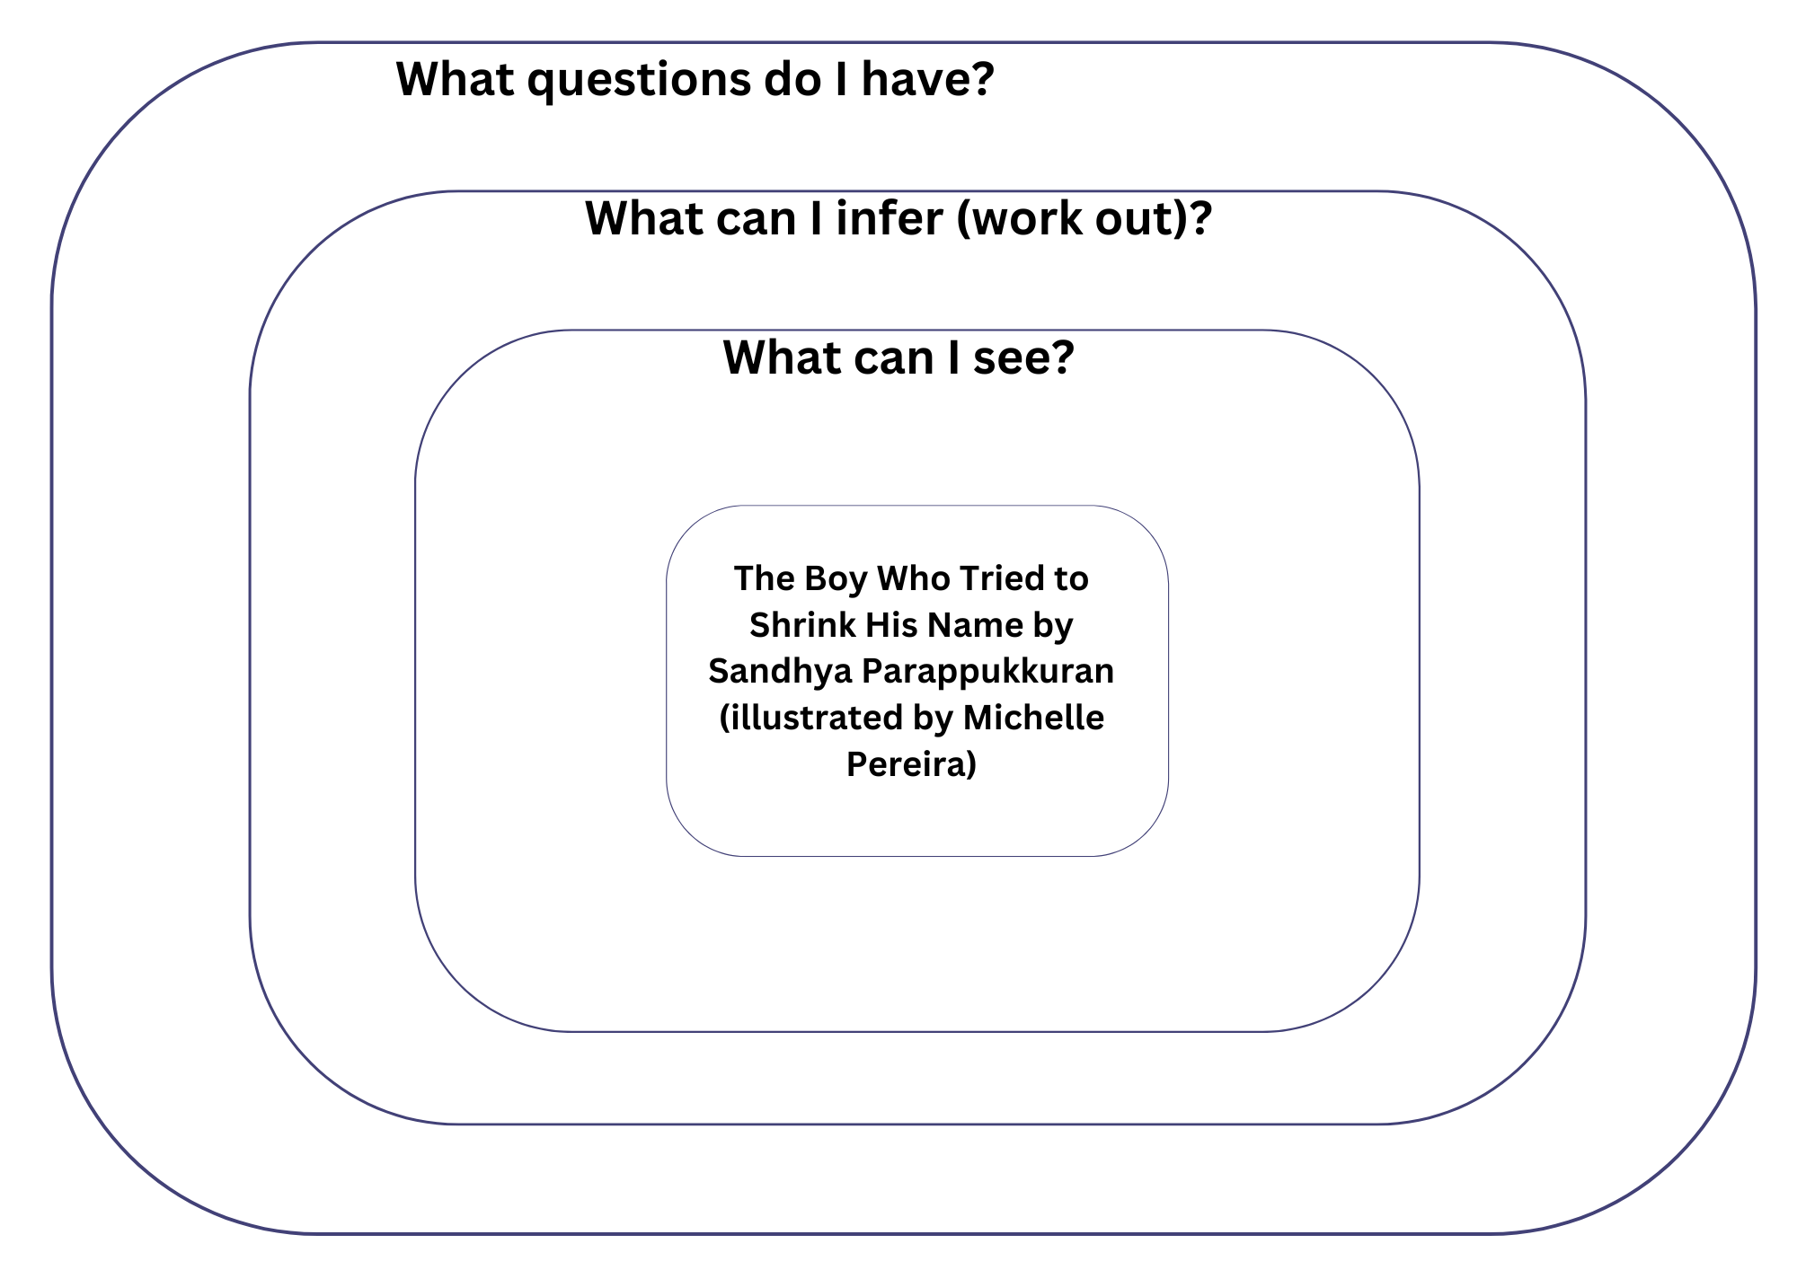

Resource 2: Exploring similes
Title of the text:
Simile example from the text | What 2 things are being compared? | What does it mean? | What do the words prompt me to think and feel?
My name springs back to life like a scared pufferfish at sea. | The boy's name and a scared pufferfish | It describes how the character's name behaves. The boy wants to shorten his name but he can't. | I feel sad that the boy dislikes his name. I think it's because he doesn't want to feel different.

Resource 3: Character Y-chart
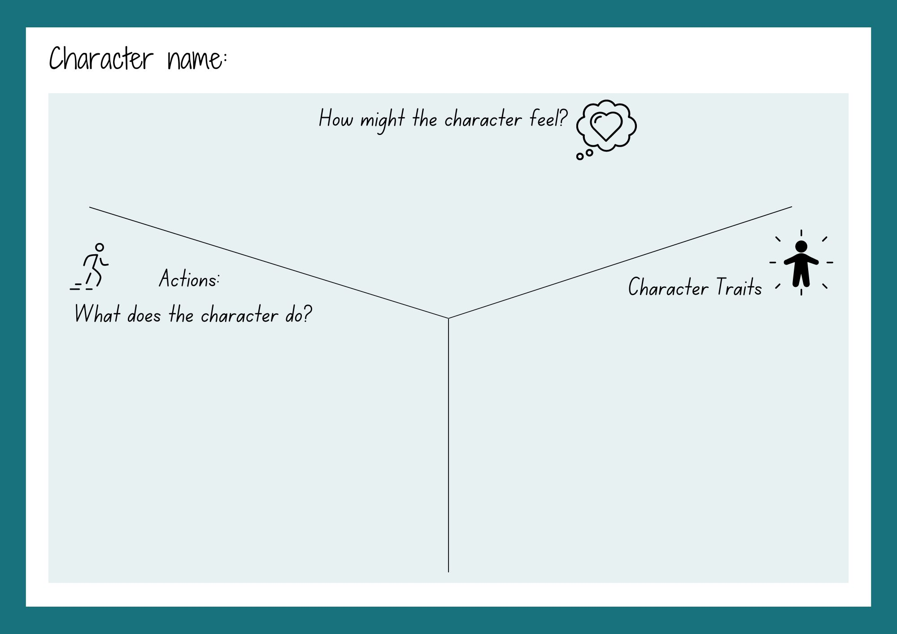
Images sourced from Canva and used in accordance with the Canva Content License Agreement.

Resource 4: Venn diagram
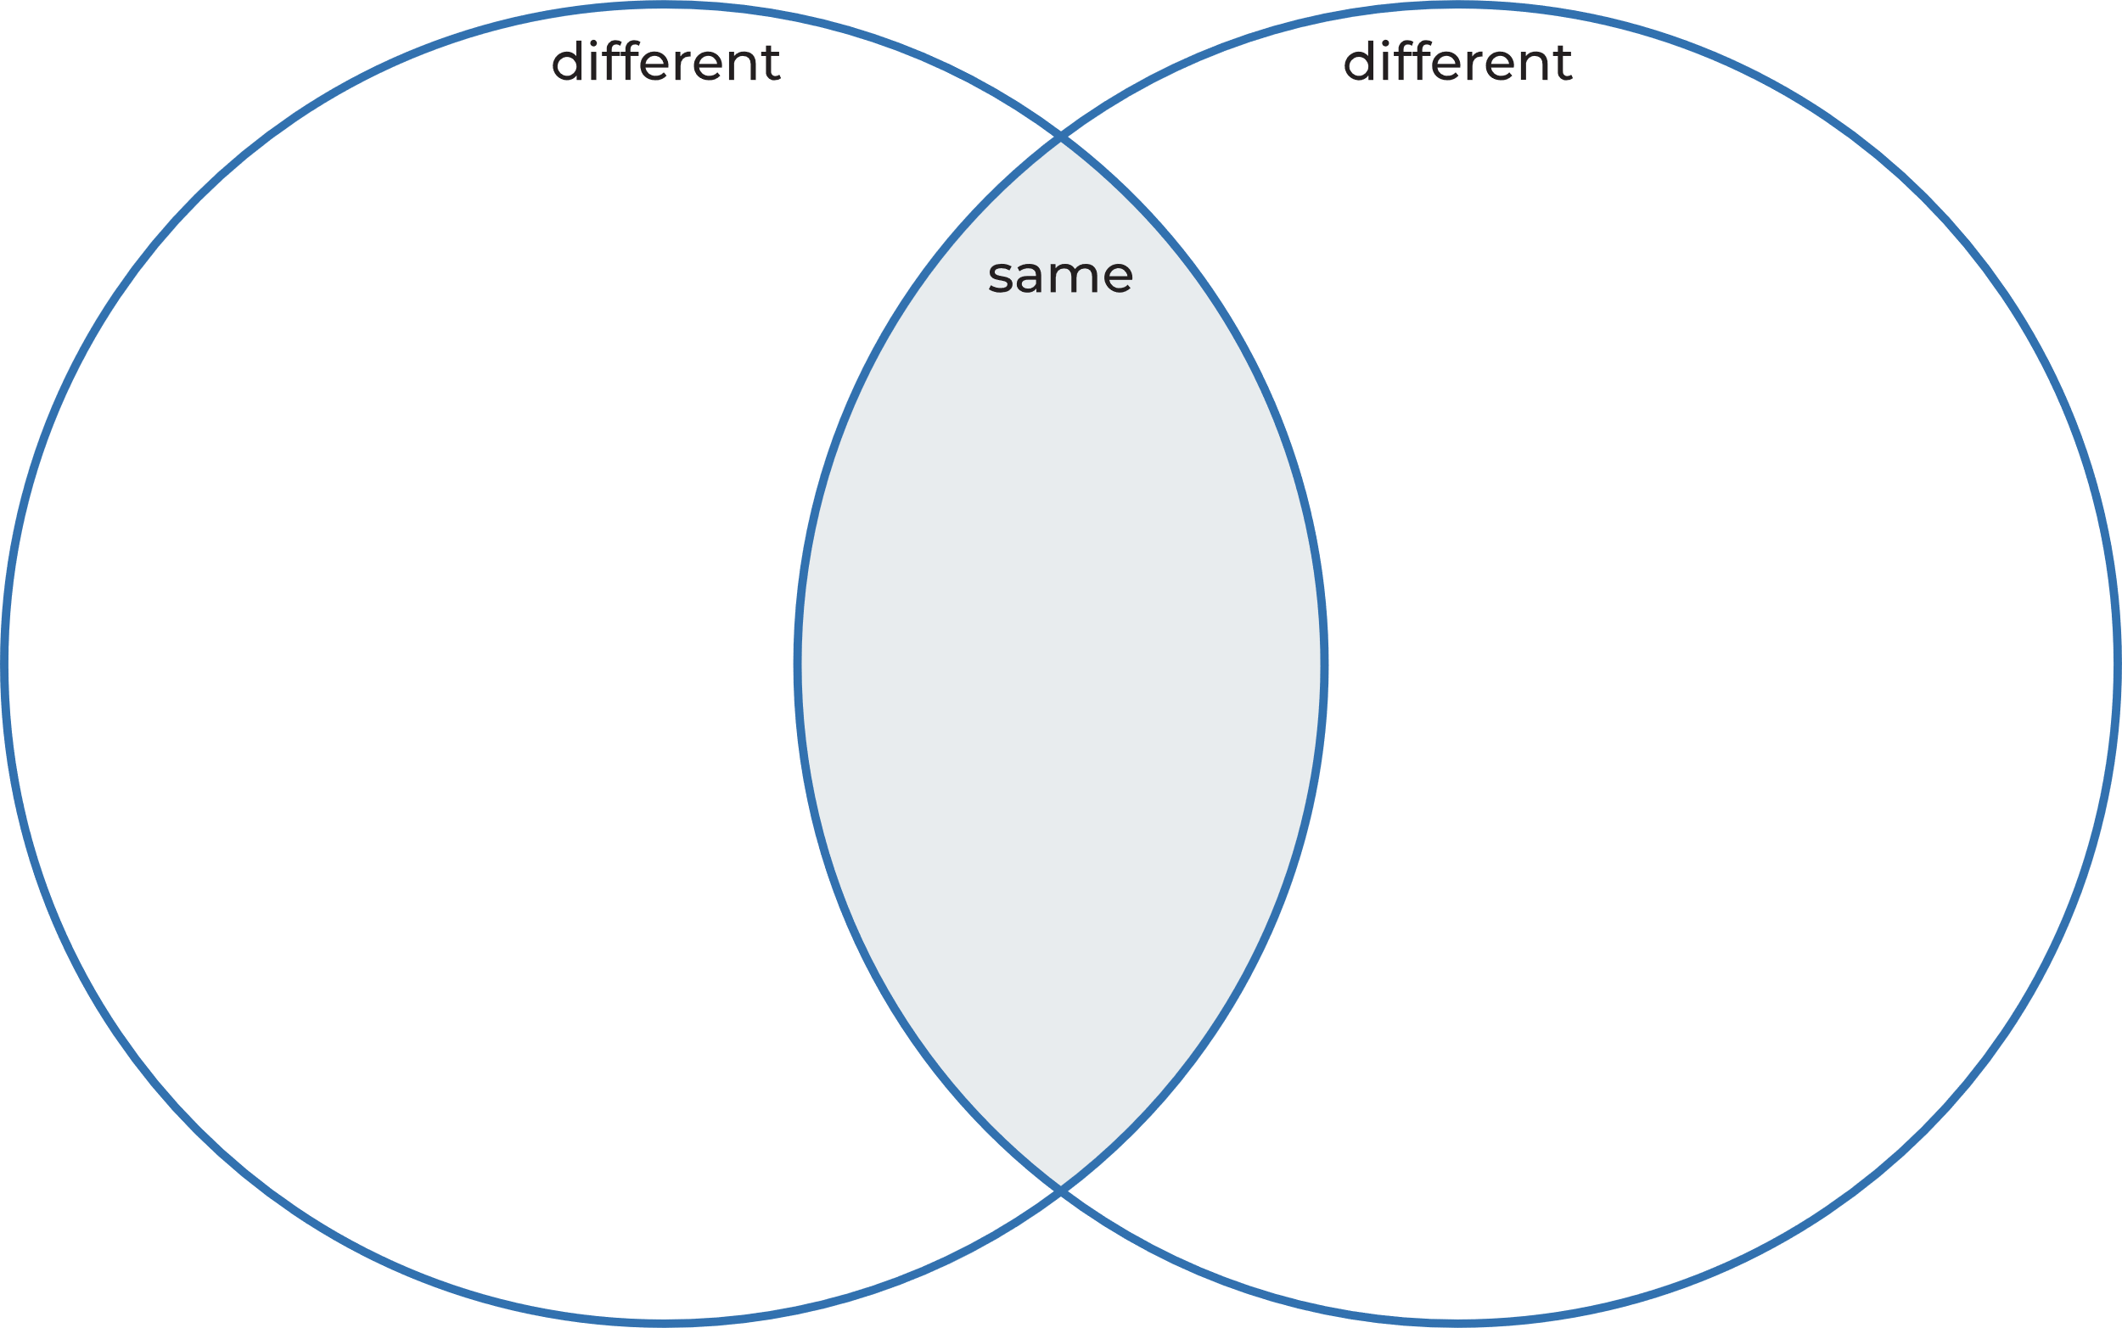

Resource 5: Exemplar text
Text structure | Zimdalamashkermishkada
Introduction: who and where | Zimdalamashkermishkada is a little boy with a huge name that trips him up every morning, like shoelaces that have come undone. He lives with his mother in a house surrounded by banana trees with stripy, green leaves. His mother named him after the coconut trees that stretch high and hold up the sky while sheltering all underneath.
1st paragraph: Character traits | Zimdalamashkermishkada is a shy and thoughtful boy. He loves learning to skate at the local park with his new friend Elly. Elly would describe Zimdalamashkermishkada as persistent and brave.
2nd paragraph: Describes the character’s feelings | Zimdalamashkermishkada feels like he doesn’t fit in because his name is too long. He feels embarrassed when people can't say his name. He wants a shorter name that other people can easily say.
3rd paragraph: Describes the character’s actions | Zimdalamashkermishkada tries to shrink his name. He crumples it into a tight ball, folds it horizontally, then vertically a million times like origami. But no matter what he does, his name always explodes like a crack of thunder.
Conclusion | Zimdalamashkermishkada’s friendship with Elly gives him the confidence he needs to proudly accept his name.

Resource 6: Writing scaffold
Text structure | Title:
Paragraph 1:
Introduction – Who and where
Paragraph 2:
Describe the character’s traits
Paragraph 3:
Describe the character’s feelings
Paragraph 4:
Describe the character’s actions
Paragraph 4:
Conclusion

References
Links to third-party material and websites
Please note that the provided (reading/viewing material/list/links/texts) are a suggestion only and implies no endorsement, by the New South Wales Department of Education, of any author, publisher, or book title. School principals and teachers are best placed to assess the suitability of resources that would complement the curriculum and reflect the needs and interests of their students.
If you use the links provided in this document to access a third-party's website, you acknowledge that the terms of use, including licence terms set out on the third-party's website apply to the use which may be made of the materials on that third-party website or where permitted by the Copyright Act 1968 (Cth). The department accepts no responsibility for content on third-party websites.
Except as otherwise noted, all material is © State of New South Wales (Department of Education), 2021 and licensed under the Creative Commons Attribution 4.0 International License. All other material (third-party material) is used with permission or under licence. Where the copyright owner of third-party material has not licensed their material under a Creative Commons or similar licence, you should contact them directly for permission to reuse their material.
English K–10 Syllabus © 2022 NSW Education Standards Authority (NESA) for and on behalf of the Crown in right of the State of New South Wales.
Creative Arts K-6 Syllabus © 2006 NSW Education Standards Authority (NESA) for and on behalf of the Crown in right of the State of New South Wales.
© 2021 NSW Education Standards Authority. This document contains NSW Curriculum and syllabus content. The NSW Curriculum is developed by the NSW Education Standards Authority. This content is prepared by NESA for and on behalf of the Crown in right of the State of New South Wales. The material is protected by Crown copyright.
Please refer to the NESA Copyright Disclaimer for more information.
NESA holds the only official and up-to-date versions of the NSW Curriculum and syllabus documents. Please visit the NSW Education Standards Authority (NESA) website and the NSW Curriculum website.
National Literacy Learning Progression © Australian Curriculum, Assessment and Reporting Authority (ACARA) 2010 to present, unless otherwise indicated. This material was downloaded from the Australian Curriculum website (National Literacy Learning Progression) (accessed 1 December 2022) and was not modified. The material is licensed under CC BY 4.0. Version updates are tracked in the ‘Curriculum version history’ section on the 'About the Australian Curriculum' page of the Australian Curriculum website.
ACARA does not endorse any product that uses the Australian Curriculum or make any representations as to the quality of such products. Any product that uses material published on this website should not be taken to be affiliated with ACARA or have the sponsorship or approval of ACARA. It is up to each person to make their own assessment of the product, taking into account matters including, but not limited to, the version number and the degree to which the materials align with the content descriptions and achievement standards (where relevant). Where there is a claim of alignment, it is important to check that the materials align with the content descriptions and achievement standards (endorsed by all education Ministers), not the elaborations (examples provided by ACARA).
ETA (English Teachers Association) and NSW Department of Education (2016) The Textual Concepts and Processes resource, English Textual Concepts website, accessed 28 November 2022.
Mackenzie N (22 October 2019) ‘Draw, Talk, Write (and Share)’, Noella’s Blog, accessed 1 December 2022.
Parappukkaran S (2021) The Boy Who Tried to Shrink His Name (Pereira M, illus.), Hardie Grant Children's Publishing, Australia.
Shanahan L (2017) Hark, It’s Me, Ruby Lee! (Binny, illus.), Lothian Children's Books, Australia.

