English – Stage 1 – Unit 27
Contents
Unit overview and instructions for use 3
Teacher notes 4
Outcomes and content – Component A 5
Outcomes and content – Component B 6
Week 1 10
Component A teaching and learning 10
Component B teaching and learning 11
Lesson 1: Introducing Great White Shark and hybrid texts 12
Lesson 2: Vocabulary in a hybrid text 14
Lesson 3: Writing informative sentences – Sharks 17
Lesson 4: Building subject-specific knowledge – Seals 19
Lesson 5: Using websites to find information 21
Week 2 24
Component A teaching and learning 24
Component B teaching and learning 25
Lesson 6: Writing informative sentences – Seals 26
Lesson 7: Understanding and writing storytelling sentences 28
Lesson 8: Understanding context and representation through illustrations 30
Lesson 9: The author and paragraphs 34
Lesson 10: Publishing a mini book 35
Resource 1: Visual glossary – ‘Serrated’ 37
Resource 2: Great white shark tooth 38
Resource 3: Visual glossary 39
Resource 4: Great white shark – Concept map 40
Resource 5: Sentence examples 41
Resource 6: Seal audio transcript 43
Resource 7: Seal diagram 45
Resource 8: Seals – Concept map 46
Resource 9: Hybrid text planning template 47
Resource 10: Traffic light paragraphs 48
References 49

Unit overview and instructions for use
This two-week unit is comprised of Component A and Component B. Connecting learning across both components is encouraged.
Teaching and learning | Component A | Component B
Suggested duration | 60 minutes | 45 minutes
Explicit teaching focus areas | - Phonic knowledge  - Reading fluency  - Reading comprehension  - Spelling  - Handwriting | - Oral language and communication  - Vocabulary  - Reading comprehension  - Creating written texts  - Understanding and responding to literature
To prepare for teaching and learning: | - Refer to Outcomes and content – Component A, K-2 – Instructional sequence – grapheme–phoneme correspondences [PDF 825 KB], and the teaching advice documents (hyperlinked in Component A teaching and learning table).  - Based on student needs identified through ongoing assessment data, plan and document how you will sequence teaching and learning in whole class and targeted teaching groups across the two-week cycle. | - Familiarise yourself with Outcomes and content – Component B, Textual concepts information and videos, English Textual Concepts and Learning Processes (2016), and the teaching and learning sequence.  - Based on student needs identified through ongoing assessment data, determine how you will support students in whole class and targeted teaching groups across the two-week cycle as required.
English K–10 Syllabus © 2022 NSW Education Standards Authority (NESA) for and on behalf of the Crown in right of the State of New South Wales.

Teacher notes
- ‘Context refers to factors that impinge on meaning. To understand Context, we need to look beyond the text and consider the world in which it was produced and the worlds of its reception.’ – English Textual Concepts and Learning Processes (2016).
- Understanding of context can be supported through watching the department’s video: Context (5:23).
- While ‘context’ is the mentor concept for the conceptual component of this unit, the supporting concept of ‘representation’ can be explored using the mentor text, Great White Shark by Claire Saxby.
- For information on ‘context’ and ‘representation’ refer to the NESA Glossary.
- This unit could enhance student learning towards the Science and Technology K-6 Syllabus.
- Reflect on student learning and engagement in activities and record differentiation and adjustments within the unit to inform future teaching and learning. One way of doing this could be to add comments to the digital file.
- Content points are linked to the National Literacy Learning Progression version (3).
Levels and indicators sourced from National Literacy Learning Progression © Australian Curriculum, Assessment and Reporting Authority (ACARA), (accessed 6 December 2022) and was not modified. See references for more information.

Outcomes and content – Component A
The table below outlines the focus outcomes and content. Content is linked to the National Literacy Learning Progression version (3).
Focus area and outcome | Content points and National Literacy Learning Progression
Phonic knowledge  EN1-PHOKW-01 – uses initial and extended phonics, including vowel digraphs, trigraphs to decode and encode words when reading and creating texts | - decode words with less common consonant digraphs and apply this when reading texts  - blend and decode 2-syllable words with taught vowel graphs, digraphs, trigraphs and quadgraphs, including graphemes for r-controlled vowels and diphthongs and apply this when reading texts (PKW6), (PKW7).
Reading fluency  EN1-REFLU-01 – sustains reading unseen texts with automaticity and prosody and self-corrects errors | - self-correct when fluency and/or meaning is interrupted  - adjust phrasing, intonation, volume or rate to maintain fluency when reading aloud (FlY4).
Reading comprehension  EN1-RECOM-01 – comprehends independently read texts that require sustained reading by activating background and word knowledge, connecting and understanding sentences and whole text, and monitoring for meaning | - identify when meaning is not complete and/or contradicts prior understanding.
Spelling  EN1-SPELL-01 – applies phonological, orthographic and morphological generalisations and strategies when spelling words in a range of writing contexts | - segment multisyllabic words into syllables and phonemes as a strategy for spelling (SpG5)  - use extended phonic code for taught consonant phonemes.
Handwriting  EN1-HANDW-01 – uses a legible, fluent and automatic handwriting style, and digital technology, including word-processing applications, when creating texts | - type up to 5 familiar words per minute.

Outcomes and content – Component B
The table below outlines the focus outcomes and content. Content is linked to the National Literacy Learning Progression version (3).
Focus area and outcome | Content points and National Literacy Learning Progression
Oral language and communication  EN1-OLC-01 – communicates effectively by using interpersonal conventions and language to extend and elaborate ideas for social and learning interactions | - respond to information by asking relevant questions to extend their own and others' knowledge (LiS4), (LiS6)  - link or compare ideas when interacting.
Vocabulary  EN1-VOCAB-01 – understands and effectively uses Tier 1, taught Tier 2 and Tier 3 vocabulary to extend and elaborate idea | - understand and intentionally choose subject-specific vocabulary to enhance precision and for effect.
Reading comprehension  EN1-RECOM-01 – comprehends independently read texts that require sustained reading by activating background and word knowledge, connecting and understanding sentences and whole text, and monitoring for meaning | - draw on sources to seek clarification for unknown words  - know the meaning and purpose of coordinating and subordinating conjunctions and identify them in a complex sentence  - use navigation pathways, including hyperlinks, to extract essential information to support reading fluency and enhance meaning when reading digital texts  - use knowledge of text structure, type of text, author, and forms of writing to predict and confirm meaning (UnT6)  - make text-to-self, text-to-text or text-to-world connections when reading (UnT6)  - use information read in texts to enhance learning across key learning areas.
Creating written texts  EN1-CWT-01 – plans, creates and revises texts written for different purposes, including paragraphs, using knowledge of vocabulary, text features and sentence structure | - group sentences into paragraphs commencing with a topic sentence, followed by other sentences with related ideas (CrT7)  - use appropriate tense across a text (CrA4)  - write compound sentences using coordinating conjunctions (GrA4), (CrT5)  - recognise compound sentences in own writing, knowing that each clause has meaning by itself (CrT5), (CrT7)  - experiment with writing complex sentences which include a clause for the main message and dependent clause to elaborate or modify the message (GrA5)  - use a combination of simple and compound sentences to engage the reader when creating written texts (CrT6), (GrA4)  - make intentional word choices to enhance precision of meaning and ideas in a text (CrT5)  - use knowledge of similarities and differences between imaginative, informative and persuasive texts when planning for writing  - use different modes and media to enhance the presentation of texts they have created (CrT5), (CrT6).
Understanding and responding to literature  EN1-UARL-01 – understands and responds to literature by creating texts using similar structures, intentional language choices and features appropriate to audience and purpose | - identify how the language and form of a text vary according to purpose, audience and mode (UnT5)  - recognise ways that settings and situations are represented within texts  - create and re-create texts in a range of modes and media using understanding of context (CrT5)  - express personal responses to the real and imagined worlds that are represented in texts.

Week 1

Component A teaching and learning
The table below can be used to plan and document lessons that address Component A outcomes and content. Both the detailed example [DOC 529KB] of a two-week teaching and learning cycle and brief example [DOC 66KB] may support you in your planning.
Focus Areas | Lesson 1 | Lesson 2 | Lesson 3 | Lesson 4 | Lesson 5
Phonic knowledge
15 minutes
Spelling and Handwriting
15 minutes
Reading comprehension and Reading fluency
30 minutes

Component B teaching and learning
The following teaching and learning sequence has been designed to address Component B outcomes and content. Adapt the sequence as required to best meet the needs of your students.

Learning intention and success criteria
Learning intentions and success criteria are best co-constructed with students.

Learning intention
Students are learning to understand that texts are created in different ways depending on their purpose, audience and context.

Success criteria
Students can:
- identify the features of a hybrid text
- compose a variety of informative sentences
- use subject-specific vocabulary in writing
- identify and use navigational pathways on websites to gather information.

Resources
- Saxby C (2021) Great White Shark (Lane C, Illus.). Walker Books Australia, Newtown, Australia. ISBN: 9781760651848
- Resource 1: Visual glossary – 'Serrated'
- Resource 2: Great white shark tooth
- Resource 3: Visual glossary
- Resource 4: Great white shark – Concept map
- Resource 5: Sentence examples
- Resource 6: Seal audio transcript
- Resource 7: Seal diagram
- Resource 8: Seals – Concept map
- Australian Antarctic Program Seals and Sea Lions
- Audio episode: Seals (3:42)
- Sticky notes

Lesson 1: Introducing Great White Shark and hybrid texts
- Display the front and back cover of Great White Shark. Identify and discuss:
- the author and illustrator – note the convention that the author’s name is always first and the illustrator’s name is listed second
- the publisher – discuss location and importance
- the blurb – discuss purpose and importance.
- Ask students to predict the:
- type of text – informative, imaginative, persuasive
- content of the text
- type of illustrations or images
- audience for the text.
- Provide pairs of students with an individual whiteboard. Students talk with a partner to share their background knowledge on great white sharks. Students can represent their prior knowledge through words and images. Explain that through activating ‘what they already know’ on a topic prior to reading, students can enhance their understanding.
- Model creating questions that may be answered through reading the text. For example, ask students where great white sharks live and how they breathe. Distribute sticky notes to pairs of students to record questions they have about great white sharks. Explain that asking questions about a text can extend students’ knowledge.
- Collate the questions on a retrieval chart, grouping with sub-headings as appropriate.
- Read Great White Shark.
- Review students’ predictions of:
- text type – for example, both informative and descriptive storytelling text
- content – for example, a series of events about a character, combined with facts about sharks
- illustrations/images – for example, coloured illustrations with life-like details of great white sharks and their habitat
- audience – for example, anyone with a general interest in sharks.
A hybrid text is made from a mix of stylistic elements from different types of texts. For example, infotainment, creative nonfiction.
- Outline that this is a hybrid text. Explain that the author has written the text in a mix of 2 different styles – descriptive storytelling and informative factual style. Ask students why they think the text has been created in this way.
- Read the book again, focusing on each format separately.
- Discuss the impact on the text’s purpose and audience. Students talk with a partner to consider which style they prefer.
- Identify the format and layout that shows the type of text, noting key elements. For example:
- the different fonts for the descriptive storytelling and informative factual style
- the last double page of the text titled, ‘Information about great white sharks.’ Discuss why the author added this information.
- the index, which can be used to locate multiple sources of information within the text.
- Demonstrate how to use an index and provide time for text-to-text connections to be made with other texts that contain an index. For example, non-fiction books, recipe books.
- Revisit student questions. Add sticky notes that match answered questions to the referral chart. Determine which part of the text, informative or descriptive, answered more of the students’ questions. Consider how this relates to an understanding of a text’s context and purpose.

Lesson 2: Vocabulary in a hybrid text
- Display the text, Great White Shark, and review hybrid texts. Recall that the author has written the text in a mix of 2 different text styles: descriptive storytelling and informative factual style.
- To gain an understanding of the 2 styles of text, read the first double page. Explicitly identify:
- the relationship between the text types. For example:
- Descriptive storytelling – From above, her charcoal skin blends with the dark depths of the ocean.
- Informative text – Female great white sharks grow about as long as a giraffe is tall, and may weigh more than a large car. They have a strong lightweight skeleton and tiny tooth-like scales.
- the content is the same in both styles of text – both describe what sharks look like
- the relationship between the text and the image – for example, the illustration of the shark exemplifies its colour and size and the shark’s ocean setting is also represented.
- Ask students to identify the orientation elements that are represented in these pages. For example, who, what, when and where.
- Explore the language features of the text, including its use of pronouns, vocabulary and verb tense. For example:
- Descriptive storytelling – a personal pronoun is used to refer to the great white shark (her); dark depths (alliteration); verbs are present tense (blends)
- Informative text – noun groups and general pronouns are used (female great white sharks/they); subject-specific vocabulary (skeleton); verbs are in perfect present tense (grow, weigh, have).
- Provide groups of students with other double pages from the text. Collaboratively, students identify the shared content, how the illustrations represent and extend understanding, where the event occurs within the ‘descriptive story’, subject-specific vocabulary, use of reference words (noun groups/pronouns) and tense.
- Share responses as a class.
- List the subject-specific vocabulary on an anchor chart that is divided into 2 columns labelled ‘informative’ and ‘descriptive’. For example, electroreception, light-weight skeleton, serrated, carcass. Consider which style of writing includes the most subject-specific language. Discuss why the author has included this vocabulary. For example, to add precision and credibility.
- Model selecting a subject-specific word from the text. For example, the word ‘serrated’ in the sentence, ‘When they are about three metres in length, their teeth become wider, with serrated edges’. Display Resource 1: Visual glossary – 'Serrated' and point to the word as you read it. Have students repeat the word and clap out the syllables. Provide a student friendly definition and show an image. Use the word in several sentences.
- Display an enlarged copy of Resource 2: Great white shark tooth and point out the serrated edges.
- Demonstrate how the sentence would read if a less specific word choice, such as ‘bumpy’, was included. Discuss the impact this would have on the text’s audience and purpose.
- Use subject-specific words from the text and repeat activity 11 with each word, recording them on a copy of Resource 3: Visual glossary.
- Provide students with a copy of Resource 3: Visual glossary. Individually or in pairs, students select a word and complete the visual glossary.
- In groups, students share targeted vocabulary and their definitions. Student responses can be collated to create a visual glossary that can be referred to in future lessons.
Stage 1 Assessment task 1 – Observations and work samples from this lesson allow students to demonstrate achievement towards the following syllabus outcomes and content points:
EN1-VOCAB-01 – understands and effectively uses Tier 1, taught Tier 2 and Tier 3 vocabulary to extend and elaborate ideas
- understand and intentionally choose subject-specific vocabulary to enhance precision and for effect.
EN1-RECOM-01 – comprehends independently read texts that require sustained reading by activating background and word knowledge, connecting and understanding sentences and whole text, and monitoring for meaning
- draw on sources to seek clarification for unknown words
- make text-to-self, text-to-text or text-to-world connections when reading
- use knowledge of text structure, type of text, author and forms of writing to predict and confirm meaning.

Lesson 3: Writing informative sentences – Sharks
- Display an enlarged copy of Resource 4: Great white shark – Concept map. Explain that the purpose of a concept map is to record key information on a topic in an organised way. A concept map can be used to support the reading of texts, as well as when planning for writing. Explain that each sub-concept can be used as a focus for paragraphs when writing.
- Review note taking on the concept map by using the:
- sub-concept bubbles to organise the information
- empty bubbles for noting key information or main ideas
- white space around the map for adding questions or comments about the information.
- Model writing notes about what a shark looks like using information from pages 8-11. For example, charcoal skin; strong, tiny tooth-like scales; white belly.
- Model adding information into other sub-concepts. For example, diet – can smell prey from far away.
- Distribute student copies of Resource 4: Great white shark – Concept map and re-read the text.
- Students use the entire text, including the images and descriptive story, to complete their concept map.
Too hard? Students work in a small group, recording information on an enlarged concept map.
- Identify how the author has used a range of sentence types and the consistent use of present tense verbs when writing informative sentences about great white sharks. For example:
- Simple sentence: ‘Sharks have charcoal skin.’
- Compound sentence: ‘Sharks have a lightweight skeleton, and their skin has tiny tooth-like scales.’
- Complex sentence: ‘When they are about three metres in length, their teeth become wider, with serrated edges.’
- Identify each sentence type, including the coordinating or subordinating conjunction. Describe the purpose and meaning of the conjunctions used. Highlight how both clauses can remain independent in the compound sentence examples; whereas the complex sentence includes a clause for the main message and a dependent clause to elaborate its meaning.
- Highlight the present tense verbs used in each clause. Additional examples are provided in Resource 5: Sentence examples.
- Model writing informative sentences about sharks using present tense verbs.
- Students refer to their concept map and the subject-specific language anchor chart from Lesson 2 to write their own informative sentences about great white sharks.
- Students share their writing with a partner. Partners identify each sentence type, including the coordinating or subordinating conjunctions, clause structure (dependent/independent) and use of present tense verbs.
Too hard? Students write simple sentences and illustrate to enhance meaning.
Too easy? Students create a complete paragraph with an appropriate topic sentence and Tier 3 vocabulary.
Stage 1 Assessment task 2 – Observations and work samples from this lesson allow students to demonstrate achievement towards the following syllabus outcomes and content points:
EN1-CWT-01 – plans, creates and revises texts written for different purposes, including paragraphs, using knowledge of vocabulary, text features and sentence structure
- use appropriate tense across a text
- write compound sentences using coordinating conjunctions
- recognise compound sentences in own writing, knowing that each clause has meaning by itself
- experiment with writing complex sentences which include a clause for the main message and dependent clause to elaborate or modify the message
- use a combination of simple and compound sentences to engage the reader when creating written texts
- make intentional word choices to enhance precision of meaning and ideas in a text.
EN1-UARL-01 – understands and responds to literature by creating texts using similar structures, intentional language choices and features appropriate to audience and purpose
- identify how the language and form of a text vary according to purpose, audience and mode.

Lesson 4: Building subject-specific knowledge – Seals
- Recall the hybrid text structure of Great White Shark. Explain that students will create their own hybrid text about seals in the style of Claire Saxby and Cindy Lane.
- Complete same process of activating prior knowledge and asking questions prior to listening to the podcast.
- Explain that students will listen to an audio episode about seals. To support active listening and comprehension, students will visualise and draw a seal, noting its features.
Note: Visualisation is a comprehension strategy used by learners to create a mental image from a text read, viewed or heard. To visualise is to bring the text to life, engage the imagination and use a person’s senses.
- Explore diagram conventions that can be used to create their text. For example, labels for distinct features written in a straight line with key words only; short straight lines connect labels with the correct position on the animal’s body; simple, descriptive heading in larger font. Display example diagrams from online source or books available in the classroom.
- Play the audio episode on Seals (3:42). Resource 6: Seal audio transcript is also available if required.
- Students use Resource 7: Seal diagram to draw and label a seal as they listen to the audio episode.
- Students turn and talk to share their understandings.
- Display and distribute Resource 8: Seals – Concept map.
- Recall note taking from Lesson 3, including the use of:
- key words/phrases
- subject-specific vocabulary.
- Divide students into 4 ‘expert groups’ and assign each group one category from the concept map. Students will use a modified jigsaw strategy to complete their concept maps.
- Play the audio episode several times to allow students to record notes on their concept map.
- In expert groups, students share their information to ensure all group members have relevant information for their expert area.
- Each expert group reports back to the class to share their information. Provide the opportunity for students to ask expert groups questions to supplement and clarify information.
- Students complete their concept maps ensuring they have adequate information for every category.
Too hard? Students work in a small group, recording information on an enlarged concept map.

Lesson 5: Using websites to find information
Note: By engaging in learning about seals and sharks, students are working towards Science and Technology K-6 outcomes.
- Brainstorm additional sources where students could get information about seals. For example, books, videos, web pages.
- Display the Seals and sea lions web page on the Australian Antarctic Program website.
- Ask students what they can see on the web page that tells them this is a reliable source of information. For example, the ‘.gov’ domain name and the Australian Government logo.
- Discuss the navigation pathways on the webpage. Ask:
- How is the webpage organised?
- How are hyperlinks used to take you to additional information sources? (underlined words, images, headings, icons, next page/previous page arrows, information in top and bottom banner)
- How do you know when something on the screen will take you to a different page? (the cursor changes from an arrow into a hand)
- Which parts of this webpage are useful for gaining information about seals and which parts are a distraction?
- How might you find specific information? (use a key word search at the top of the page).
- Select the image of the fur seal and click on the hyperlink, displaying the navigational pathway. Explain that this page provides information only about fur seals. Consider if this is essential information, or if a different part of the website may meet students’ current needs as a reader.
- Ask students to identify the style of images used on the webpage. Compare these images with those used in the text, Great White Shark. Make text-to-text connections by asking students what other visuals they might see in informative texts. For example, diagrams and maps. Discuss why some images are better suited to either informative or descriptive storytelling texts.
- Return to the Seals and sea lions webpage. Read through the information one paragraph at a time. After each paragraph, ask students to identify the topic of the paragraph. If the content matches a category on their concept map, students can add any relevant information.
Too hard? Write key words on a retrieval chart for students to record information.
Too easy? Students complete task independently. Alternatively, students can select and use a broader range of informative texts to gather information for their concept map.
- Model the process of asking and answering relevant questions that will extend student knowledge on the topic of seals. If necessary, provide a range of sentence stems to scaffold learning.
- In small groups, students take turns using the hot seat method to be the expert about seals. Students ask questions and the experts respond using the information from their concept map. Encourage students to ask a range of questions from each category on their concept map.
Stage 1 Assessment task 3 – Observations from this lesson allow students to demonstrate achievement towards the following syllabus outcomes and content points:
EN1-OLC-01 – communicates effectively by using interpersonal conventions and language to extend and elaborate ideas for social and learning interactions
- respond to information by asking relevant questions to extend their own and others' knowledge
- link and compare ideas when interacting.
EN1-RECOM-01 – comprehends independently read texts that require sustained reading by activating background and word knowledge, connecting and understanding sentences and whole text, and monitoring for meaning
- use navigation pathways, including hyperlinks, to extract essential information to support reading fluency and enhance meaning when reading digital texts
- use information read in texts to enhance learning across key learning areas.

Week 2

Component A teaching and learning
The table below can be used to plan and document lessons that address Component A outcomes and content. Both the detailed example [DOC 529KB] of a two-week teaching and learning cycle and brief example [DOC 66KB] may support you in your planning.
Focus Areas | Lesson 6 | Lesson 7 | Lesson 8 | Lesson 9 | Lesson 10
Phonic knowledge
15 minutes
Spelling and Handwriting
15 minutes
Reading comprehension and Reading fluency
30 minutes

Component B teaching and learning
The following teaching and learning sequence has been designed to address Component B outcomes and content. Adapt the sequence as required to best meet the needs of your students.

Learning intention and success criteria
Learning intentions and success criteria are best co-constructed with students.

Learning intention
Students are learning to compose texts using their knowledge of text purpose, subject-specific vocabulary and differences between imaginative and informative writing.

Success criteria
Students can:
- identify and use the features of a hybrid text
- use subject-specific vocabulary in writing
- use different modes and media to enhance the presentation of texts
- use a variety of sentences in writing
- create a paragraph using the correct structure.

Resources
- Saxby C (2021) Great White Shark (Lane C, Illus.). Walker Books Australia, Newtown, Australia. ISBN: 9781760651848
- Resource 3: Visual glossary
- Resource 5: Sentence examples
- Resource 8: Seals – Concept map
- Resource 9: Hybrid text planning template (1 enlarged copy and student copies)
- Resource 10: Traffic light paragraphs
- Glue
- Pre-prepared blank mini-book (3 sheets of A4 paper folded in half and stapled at the fold)

Lesson 6: Writing informative sentences – Seals
- Display and skim the text Great White Shark to revise hybrid text elements.
- Remind students that they will be creating their own hybrid text about seals that will include both descriptive storytelling and informative writing.
- Co-create success criteria for writing the hybrid text. For example:
- use knowledge of the features of descriptive storytelling and informative texts
- include a variety of sentences to inform
- consistently use tense across the text
- include compound sentences using coordinating conjunctions
- make intentional word choices when selecting subject-specific vocabulary.
- Students review their seals concept map from Lesson 4 and Lesson 5. Highlight or circle any subject-specific vocabulary.
- Divide students into groups to create definitions for subject specific vocabulary on seals using Resource 3: Visual glossary.
- Display an enlarged copy of Resource 9: Hybrid text planning template. Refer to the success criteria and the seals concept map to model writing a series of informative sentences. For example:
- Simple sentence: ‘Seals are pinnipeds. This means they have front and rear flippers.’
- Compound sentence: ‘Seals can move gracefully in the ocean, but they are very clumsy on land.’
- Complex sentence: ‘When a seal is in the ocean, they use their front flippers to paddle and the back fins for propulsion.’
- Distribute student copies of Resource 9: Hybrid text planning template.
- Students write 4 informative sentences using Resource 9: Hybrid text planning template.
- Students provide feedback using the success criteria and TAG feedback:
- Tell something that you liked and why you liked it
- Ask a question (to extend their own or others’ knowledge)
- Give a suggestion for improvement.
- Students re-read and edit their writing, applying feedback where necessary.
Too hard? Students write sentences from less categories.
Too easy? Students write elaborating sentences related to their informative sentences.

Lesson 7: Understanding and writing storytelling sentences
- Re-read the descriptive storytelling section of Great White Shark.
- Bring attention to the language and form of the text in relation to its purpose and audience. Highlight structural features, including the:
- orientation that introduces the who, what, when, where of the event to be described
- series of events presented in the sequence in which they occurred
- related information that is grouped or organised together
- conclusion that poses the provocative question and answer, for example, ‘Is she looking for you? No. Never.’
- Discuss how the language differs from the informative section of the text. For example:
- use of personal pronouns to refer to the character (she, her) rather than a generalised noun/noun group and pronoun (great white shark/they)
- less subject-specific vocabulary
- descriptive and/or figurative language used. For example, ‘her white belly floats pale in the sky’; ‘she is a silent and powerful submarine and follows her own maps’.
- Display pages 12 and 13 to identify how the author has used a range of sentence types and the consistent use of present tense verbs when writing the descriptive sentences about the female shark that is the main character. For example:
- Simple sentence: ‘In her belly, seven pups grow.’
- Compound sentence: ‘There are other sharks here, but she mostly ignores them.’
- Complex sentence: ‘She circles an island where this year’s fur seal pups are learning to swim.’
- Identify each sentence type, including the coordinating or subordinating conjunction. Describe the purpose and meaning of the conjunctions used. Highlight how both clauses can remain independent in the compound sentence example, whereas the complex sentence includes a clause for the main message and a dependent clause to elaborate or add to the meaning.
- Highlight the present tense verbs used in each clause. Additional descriptive sentences are provided in Resource 5: Sentence examples.
- Explicitly make connections between the content in the descriptive sentences and the informative text that is included on these pages. Determine that the overarching concept is about where great white sharks give birth to their pups.
- Review the success criteria created in Lesson 6 and how it relates to the descriptive component of their text.
- Revisit the informative sentences on Resource 9: Hybrid text planning template. Model writing a descriptive storytelling text that complements the informative sentences on how seals move. For example, ‘He flops awkwardly along the sand on his four flippers. But, as he plunges into the waves, his powerful flippers rapidly propel him deeper into the ocean.’
- Select a range of informative sentences students have written and brainstorm complementary storytelling ideas.
- In pairs or targeted writing groups, students use their planning template to:
- discuss the content of their 4 informative sentences
- plan their descriptive storytelling sentences orally
- write 4 descriptive storytelling sentences.
- Students provide feedback using the success criteria and TAG feedback as outlined in Lesson 6.
- Students re-read and edit their writing, applying feedback where necessary.
Too hard? Facilitate use of text-to-speech technology or audio or video recording to produce the text.
Too easy? Students use figurative language, such as similes and metaphors, in their writing.
Stage 1 Assessment task 4 – Observations and work samples from this lesson allow students to demonstrate achievement towards the following syllabus outcomes and content points:
EN1-CWT-01 – plans, creates and revises texts written for different purposes, including paragraphs, using knowledge of vocabulary, text features and sentence structure
- know the meaning and purpose of coordinating and subordinating conjunctions and identify them in a complex sentence
- use knowledge of similarities and differences between imaginative, informative and persuasive texts when planning for writing.

Lesson 8: Understanding context and representation through illustrations
Note: Mini book preparation for this lesson – see Week 2 Resources.
Representation is the way a thing, person or idea is depicted (shown) in written, visual, digital, performed or spoken language and conventions.
- Discuss how the author, Claire Saxby, and the illustrator, Cindy Lane, have worked together to bring rich meaning to the text through descriptive language and detailed images. Note how this supports readers to build a mental model of great white sharks and gain an understanding of their behaviours and environment.
- Refer to the page in the text that shows information about the author and the illustrator. Share that the illustrator, Cindy Lane, has created detailed illustrations based on her context. She grew up by the sea and loves the ocean. She has used her knowledge of the sea waters around Australia to represent the ocean where the female great white shark lives.
- Review context as a concept – noting that where someone lives, what they have done, and what they know about affects what they can speak and write about. Ask students to consider if they like sharks and are interested in them, or if they dislike them and think they are scary creatures. Students discuss how their viewpoint may be impacted by where they live, their experiences and what they know about sharks. Students may also consider if learning about great white sharks has altered their view.
- Display the picture of the great white shark as it swims across the front cover, and the image on the end paper (at the start of the book) that shows the shark looking menacingly at the reader. Discuss the mood that the illustrator represents in these images. Ask if there are other illustrations that add to the viewpoint of sharks being scary and dangerous creatures.
- Read the final page of the story, ‘Is she looking for you? No. Never.’ Discuss what this means, and how it relates to the information written at the end of the book, ‘Despite widespread fear, humans are more likely to be struck by lightning than attacked by a great white shark. Sharks have much more to fear from humans: ocean pollution, illegal hunting, commercial fishing and shark nets.’ Ask if there are illustrations in the text that show sharks as less threatening sea creatures. Draw attention to the end paper (at the end of the book), making comparisons with the forward-facing image at the start of the book.
- Watch the clip Claire Saxby and Cindy Lane on Great White Shark (2:29) to understand the illustrator’s context and artistic techniques.
- Select illustrations from the text to closely look at the way that the great white shark and its environment is represented. For example:
- pages 6-7 – show a bird’s eye view with the shark in its environment; the ocean looks large and shows a reef; the mountains look distant; the shark looks relatively close to the beach
- pages 8-9 – show the shark from below and is a close-up; details of the coral reef are shown; the water looks clear and still with the shark appearing to float calmly
- pages 14-15 – close-up of the face of the shark with razor teeth displayed; only the shark and fur seal pup are in view which adds to the rising tension
- pages 20-21 – the whole shark is shown in a close up; the power of the shark’s powerful movements are displayed through the movement of the water
- pages 24-25 – there is a rear shot of the shark as she swims in calm waters with her newly born pups nearby
- pages 26-27 – calmness is represented both above and below the waterline, as well as in the skyline, the small glimpse of the shark’s dorsal fin is the only indication that the uninterested shark is nearby.
- Provide opportunities for students to share their personal responses to the representations by the illustrator, discussing their interpretations of the words that have been represented.
- Outline that, for students to create their own hybrid text, they will need to carefully consider the illustrations that will match each page of their text.
- Model creating a page for the mini book by:
- cutting a Resource 9: Hybrid text planning template into descriptive storytelling and informative writing sentence segments
- arranging complementary sentences on the page in a similar style to that used in Great White Shark
- creating a plan for illustrating the text.
- Students complete the same process with their own text.
- Working in pairs, students read each other's texts and provide feedback using the success criteria and TAG feedback as outlined in Lesson 6.
- Students apply feedback where necessary.
- Distribute pre-prepared mini books. Using the style in Great White Shark, students plan the layout of their text, arranging their descriptive storytelling sentences and informative sentences on pages.
- Students glue their sentences into their mini book.
- Students begin illustrating their mini book, ensuring that illustrations match their text. For example, when describing features of a seal, illustrations show features of a seal.
Too hard? Students write and illustrate a descriptive text only.
Too easy? Students copy their sentences in fonts to differentiate between text styles.
Stage 1 Assessment task 5 – Observations and work samples from this lesson allow students to demonstrate achievement towards the following syllabus outcomes and content points:
EN1-CWT-01 – plans, creates and revises texts written for different purposes, including paragraphs, using knowledge of vocabulary, text features and sentence structure
- use knowledge of similarities and differences between imaginative, informative and persuasive texts when planning for writing
- use different modes and media to enhance the presentation of texts they have created.
EN1-UARL-01 – understands and responds to literature by creating texts using similar structures, intentional language choices and features appropriate to audience and purpose
- recognise ways that settings and situations are represented within texts
- create and re-create texts in a range of modes and media using understanding of context
- express personal responses to the real and imagined worlds that are represented in texts.

Lesson 9: The author and paragraphs
- Explain that students will be writing a paragraph about themselves as the author of their mini book.
- Display page 29 of Great White Shark and read the section ‘About the illustrator’.
- Display an enlarged copy of Resource 10: Traffic light paragraphs and deconstruct the paragraph. For example:
- topic sentence – Green: ‘Cindy Lane is an award-winning artist and illustrator who loves the ocean.’
- related ideas – Orange: ‘She was born and grew up by the sea in Sydney, lived by the Great Barrier Reef in Far North Queensland and has her studio by the Indian Ocean in Perth. Cindy loves to make her own paints with materials she finds in nature and collects waters from all over the world to use in her paintings.’
- closing sentence – Red: ‘Sea waters from across Australia were used in Great White Shark, her first picture book.’
- Model writing an autobiographical paragraph using descriptive language and a variety of sentences. For example, Mrs Brown lives in Bondi. She is a hard-working teacher. She enjoys reading exciting adventure books and walking on the beach near her home. Mrs Brown has had an interest in seals since seeing them on the coast of Victoria when she was a child. This is Mrs Brown’s first hybrid picture book on an Australian animal. She hopes to write and illustrate more in the future.
- Students write an ‘About the Author’ page for the final page of their mini book.
- Students add the paragraph to their mini book.
Too hard? Facilitate use of text-to-speech technology or audio or video recording to produce this text.
Too easy? Students write an additional paragraph providing further biographical details as the illustrator.
Stage 1 Assessment task 6 – Observations and work samples from this lesson allow students to demonstrate achievement towards the following syllabus outcome and content point:
EN1-CWT-01 – plans, creates and revises texts written for different purposes, including paragraphs, using knowledge of vocabulary, text features and sentence structure
- group sentences into paragraphs commencing with a topic sentence, followed by other sentences with related ideas.

Lesson 10: Publishing a mini book
- Students finalise mini book by:
- designing a front and back cover
- finishing illustrations.
- Students share their writing with an authentic audience. For example, reading the created text to a peer from another class, recording a reading of the text to be digitally shared with family member, or reading their text to another adult within the school.
Too hard? Continue to facilitate use of text-to-speech technology or audio or video recording to produce this text.
Too easy? Students create a one paragraph blurb for the back of their hybrid mini book. An index with reference to subject-specific vocabulary could also be created.
Stage 1 Assessment task 7 – Observations and work samples from this lesson allow students to demonstrate achievement towards the following syllabus outcomes and content points:
EN1-CWT-01 – plans, creates and revises texts written for different purposes, including paragraphs, using knowledge of vocabulary, text features and sentence structure
- use different modes and media to enhance the presentation of texts they have created.
EN1-UARL-01 – understands and responds to literature by creating texts using similar structures, intentional language choices and features appropriate to audience and purpose
- create and re-create texts in a range of modes and media using understanding of context.

Resource 1: Visual glossary – ‘Serrated’
Visual glossary
Word:  serrated | Definition:  An object with lots of sharp pointy bits along the side.
Picture: | Word in a sentence:  Sharks have rows of sharp serrated teeth.
“Hand Saw Silhouette” by harismustofa sourced from Canva and used in accordance with the Canva Content License Agreement.

Resource 2: Great white shark tooth
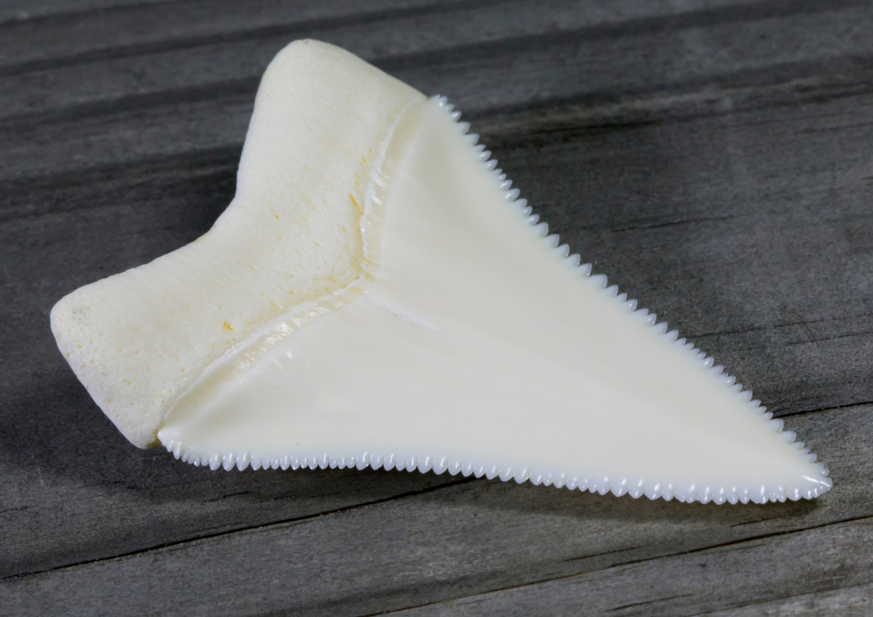
“Large Serrated Modern Great White Shark Tooth 2.2 Inches” by Mark Kostich sourced from Canva and used in accordance with the Canva Content License Agreement.

Resource 3: Visual glossary
Visual glossary
Word: | Definition:
Picture: | Word in a sentence:

Resource 4: Great white shark – Concept map
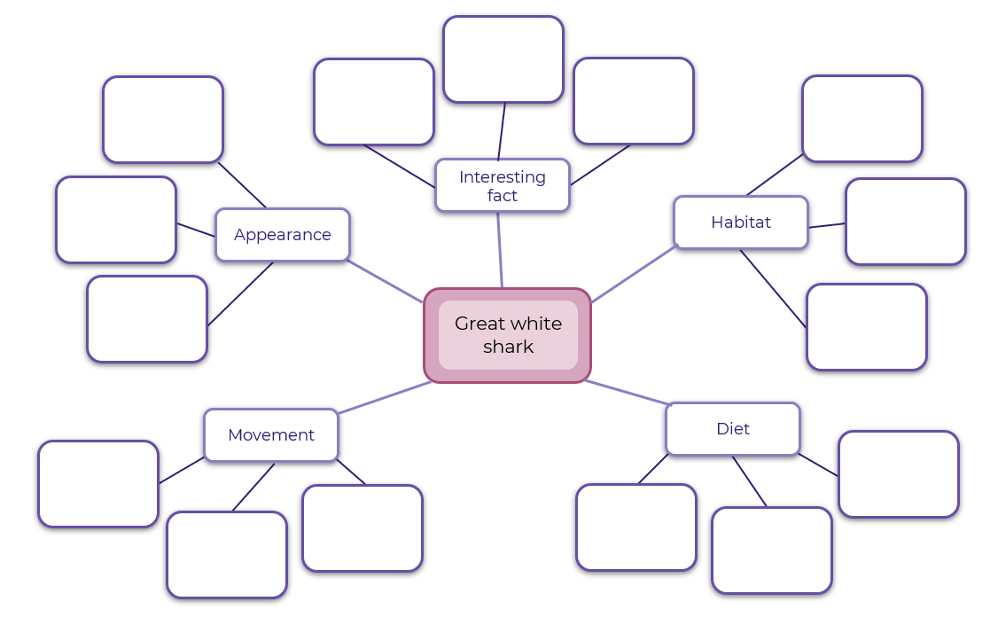

Resource 5: Sentence examples
Type | Informative sentence examples | Descriptive sentence examples
Simple sentences | They have a strong lightweight skeleton and tiny tooth-like scales. (p. 7)  Great white sharks have a sixth sense called electroception. (p. 11)  This allows them to detect prey and to navigate. (p. 11)  They can travel up to eighty kilometres per day. (p. 17) | From above, her charcoal skin blends with the dark depths of the ocean. (p. 6)  From below, her white belly floats pale in the sky. (p. 8)  She’s looking for food. (p. 11)  In her belly, seven pups grow. (p. 12)  She surges. (p. 14)
Compound sentences | Great white sharks are mostly loners and roam widely across the seas. (Note: the pronoun ‘they’ in the second clause is ellipsed or inferred). (p. 9)  They have many rows of sharp, serrated teeth but cannot chew. (p. 19) | Her tail sways side-to-side; her fins keep her balanced. (p. 10)  There are other sharks here but she mostly ignores them. (p. 13)  The water is cooler and her body temperature adjusts so she stays warm. (p. 13)  It’s a long journey, but she remembers the way. (p. 16)
Complex sentences | Great white sharks are the largest ocean predators, though there are larger sharks. (p. 28)  When they are about three metres in length, their teeth become wider, with serrated edges. (p. 28) | She circles an island where this year’s fur seal pups are learning to swim. (p. 13)  Too fast for the pup to see her until it is too late. (p. 14)  As the fur seals grow faster and smarter, she travels north. (p. 16)  She digests her meal as she journeys on. (p. 22)  When she is done, she vomits what she can’t use. (p. 22)

Resource 6: Seal audio transcript
Have you ever seen a seal? Perhaps you might have seen one at the zoo, or on TV. They move fast in the water and they love to bask in the sun when they are on the land.
Seals are mammals just like us. This means that females give birth to live young, they are warm-blooded and they drink milk from their mum when they are babies.
A baby seal is called a pup just like a baby dog. Did you know that a baby shark is also called a pup?
A seal is a special kind of mammal called a pinniped. Pinniped means fin- or flipper-footed and refers to mammals that have front and rear flippers. Seals have 4 flippers. Sea lions and walruses are also pinnipeds.
Seals have layers of fat, and some have a coat of thick fur to keep them warm in the cooler waters where they swim. The fur seals have coats made of woolly underfur with long, coarse outer hairs that trap air and help them to glide easily through the water.
Most seals are dark grey to brown in colour and their underbelly is usually a paler colour. They have large eyes, a pointed face with bear-like whiskers and teeth.
Seals are very fast swimmers, skilful hunters, and they can dive up to 150 metres in search of prey – that's about as deep as the length of one and a half football fields put together. They use their VERY sensitive whiskers to help them hunt. Scientists have found that seals use their whiskers to detect the movements of their prey.
Seals are carnivores – which means they eat meat. Seals like to eat fish, squid, octopus, seabirds, crustaceans, and even other seals. Some seals have even learnt how to take fish straight out of fishing nets before they are hauled up on to the deck of the fishing trawler.
Fur seals are the prey of large sharks and killer whales, which are also called orcas.
Seals are semi-aquatic which means that they sometimes live on the land and sometimes in the water. When they are on land, they live in very noisy groups or colonies. It sounds like lots of dogs barking, or sometimes cows mooing!
Across the world, there are about 33 different species of seals. But the only seals that live around Australia are Australian and New Zealand fur seals. These fur seals Iike to stay in the colder waters around southern Australia and the islands of New Zealand.
So the next time you’re at the beach, see if you can spot a seal swimming in the ocean.

Resource 7: Seal diagram
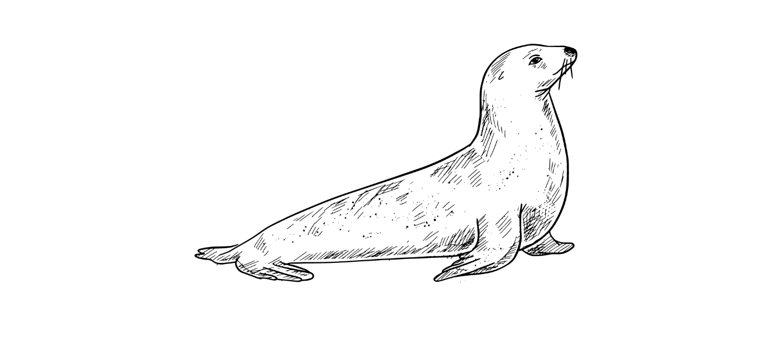
“Hand Drawn Seal Sketch” by Sketchify sourced from Canva and used in accordance with the Canva Content License Agreement.

Resource 8: Seals – Concept map
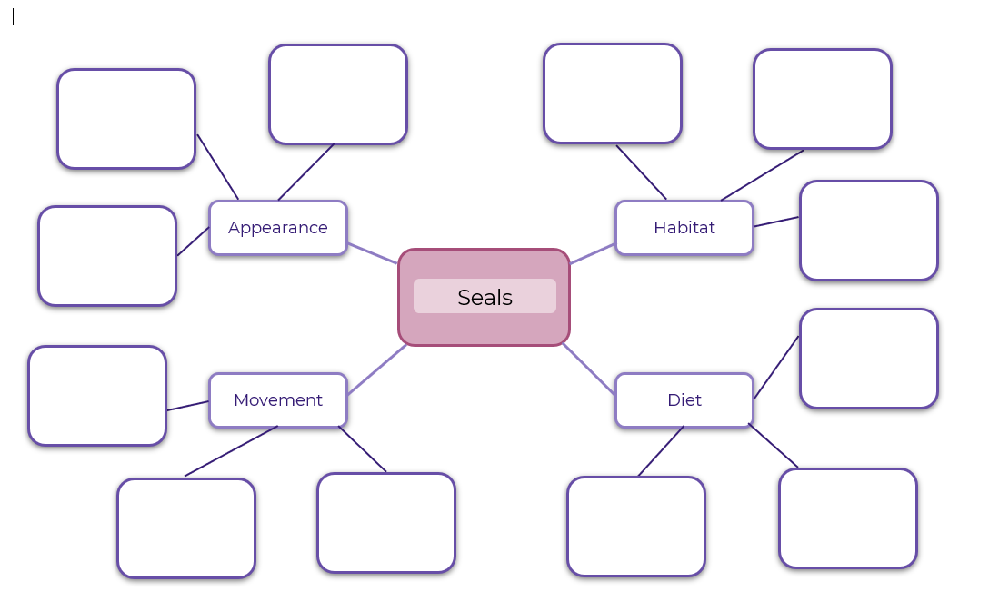

Resource 9: Hybrid text planning template
Informative writing | Descriptive storytelling
Paragraph 1: Movement  Seals are pinnipeds. This means they have front and rear flippers. Seals can move gracefully in the ocean, but they are very clumsy on land. When a seal is in the ocean, they use their front flippers to paddle and the back fins for propulsion. | He flops awkwardly along the sand on his 4 flippers. But, as he plunges into the waves, his powerful flippers rapidly propel him deeper into the ocean.
Paragraph 2: Appearance
Paragraph 3: Habitat
Paragraph 4: Diet

Resource 10: Traffic light paragraphs
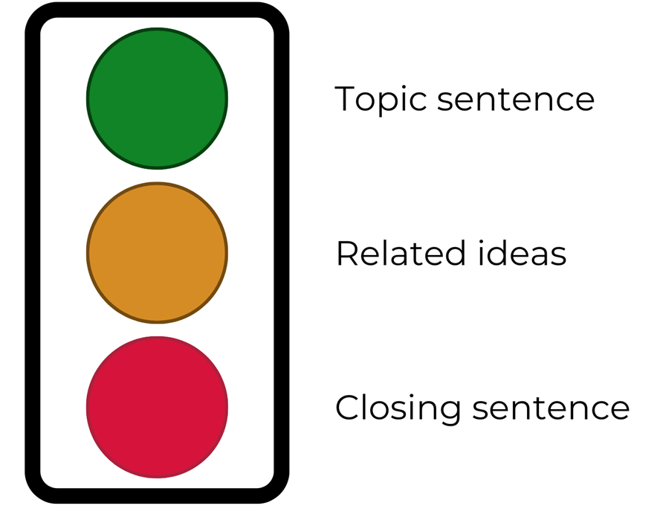

References
Links to third-party material and websites
Please note that the provided (reading/viewing material/list/links/texts) are a suggestion only and implies no endorsement, by the New South Wales Department of Education, of any author, publisher, or book title. School principals and teachers are best placed to assess the suitability of resources that would complement the curriculum and reflect the needs and interests of their students.
If you use the links provided in this document to access a third-party's website, you acknowledge that the terms of use, including licence terms set out on the third-party's website apply to the use which may be made of the materials on that third-party website or where permitted by the Copyright Act 1968 (Cth). The department accepts no responsibility for content on third-party websites.
Except as otherwise noted, all material is © State of New South Wales (Department of Education), 2021 and licensed under the Creative Commons Attribution 4.0 International License. All other material (third-party material) is used with permission or under licence. Where the copyright owner of third-party material has not licensed their material under a Creative Commons or similar licence, you should contact them directly for permission to reuse their material.
English K–10 Syllabus © 2022 NSW Education Standards Authority (NESA) for and on behalf of the Crown in right of the State of New South Wales.
Science and Technology K-6 Syllabus © 2017 NSW Education Standards Authority (NESA) for and on behalf of the Crown in right of the State of New South Wales.
© 2021 NSW Education Standards Authority. This document contains NSW Curriculum and syllabus content. The NSW Curriculum is developed by the NSW Education Standards Authority. This content is prepared by NESA for and on behalf of the Crown in right of the State of New South Wales. The material is protected by Crown copyright.
Please refer to the NESA Copyright Disclaimer for more information.
NESA holds the only official and up-to-date versions of the NSW Curriculum and syllabus documents. Please visit the NSW Education Standards Authority (NESA) website and the NSW Curriculum website.
National Literacy Learning Progression © Australian Curriculum, Assessment and Reporting Authority (ACARA) 2010 to present, unless otherwise indicated. This material was downloaded from the Australian Curriculum website (National Literacy Learning Progression) (accessed 6 December 2022) and was not modified. The material is licensed under CC BY 4.0. Version updates are tracked in the ‘Curriculum version history’ section on the 'About the Australian Curriculum' page of the Australian Curriculum website.
ACARA does not endorse any product that uses the Australian Curriculum or make any representations as to the quality of such products. Any product that uses material published on this website should not be taken to be affiliated with ACARA or have the sponsorship or approval of ACARA. It is up to each person to make their own assessment of the product, taking into account matters including, but not limited to, the version number and the degree to which the materials align with the content descriptions and achievement standards (where relevant). Where there is a claim of alignment, it is important to check that the materials align with the content descriptions and achievement standards (endorsed by all education Ministers), not the elaborations (examples provided by ACARA).
Australian Antarctic Program, Commonwealth of Australia (2020) ‘Seals and Sea Lions’, Animals, accessed 6 December 2022.
ETA (English Teachers Association) and NSW Department of Education (2016) The Textual Concepts and Processes resource, English Textual Concepts website, accessed 6 December 2022.
Saxby C (2021) Great White Shark (Lane C., Illus.). Walker Books Australia, Newtown, Australia. ISBN: 9781760651848.

