English – Stage 1 – Unit 26
Contents
Unit overview and instructions for use 3
Teacher notes 4
Outcomes and content – Component A 5
Outcomes and content – Component B 7
Week 1 10
Component A teaching and learning 10
Component B teaching and learning 11
Lesson 1: Introducing Nian, the Chinese New Year Dragon 12
Lesson 2: Exploring context and representation 15
Lesson 3: Understanding context through characters 18
Lesson 4: Planning for writing 22
Lesson 5: Expressing time in writing 24
Week 2 25
Component A teaching and learning 25
Component B teaching and learning 26
Lesson 6: Exploring context 27
Lesson 7: Storytelling and written texts 29
Lesson 8: Planning a written text 30
Lesson 9: Writing and revising 31
Lesson 10: Sharing student learning 33
Resource 1: Narrative mountain 34
Resource 2: Subordinating conjunctions 35
Resource 3: Muddled up creature 36
Resource 4: Storyboard 37
Resource 5: Storytelling poster 38
Resource 6: Storytelling table 39
References 40

Unit overview and instructions for use
This two-week unit is comprised of Component A and Component B. Connecting learning across both components is encouraged.
Teaching and learning | Component A | Component B
Suggested duration | 60 minutes | 45 minutes
Explicit teaching focus areas | - Phonic knowledge  - Reading fluency  - Reading comprehension  - Spelling  - Handwriting | - Oral language and communication  - Vocabulary  - Reading comprehension  - Creating written texts  - Understanding and responding to literature
To prepare for teaching and learning: | - Refer to Outcomes and content – Component A, K-2 – Instructional sequence – grapheme–phoneme correspondences [PDF 825 KB], and the teaching advice documents (hyperlinked in Component A teaching and learning table).  - Based on student needs identified through ongoing assessment data, plan and document how you will sequence teaching and learning in whole class and targeted teaching groups across the two-week cycle. | - Familiarise yourself with Outcomes and content – Component B, Textual concepts information and videos, English Textual Concepts and Learning Processes (2016), and the teaching and learning sequence.  - Based on student needs identified through ongoing assessment data, determine how you will support students in whole class and targeted teaching groups across the two-week cycle as required.
English K–10 Syllabus © 2022 NSW Education Standards Authority (NESA) for and on behalf of the Crown in right of the State of New South Wales.

Teacher notes
- Representation is the depiction of a thing, person, or idea in written, visual, performed or spoken language. In representing, we make choices from the language offered by these modes. Representation may aim to reflect the natural world as realistically as possible or may aim to convey the essence of people, objects, experiences, and ideas in a more abstract way. There are different ways of seeing the world as our view is framed by context and culture. This means that representation cannot mirror actual reality, but each representation offers a different construction of the world and of experience in it. – English Textual Concepts and Learning Processes (2016).
- Understanding of representation can be supported through watching the department’s video: Representation (2:46).
- While representation is the mentor concept for the conceptual component of this unit, the supporting concept of context can be explored using the mentor text Nian, the Chinese New Year Dragon by Virginia Loh-Hagan.
- For information on context refer to the NESA Glossary.
- Sand drawings, referred to in this unit, are a story-telling method used by some First Nations’ people. Using sand or the earth as the drawing surface, a stick as the drawing implement, and symbols to represent people, animals, places, and events, traditional stories are retold and handed down from generation to generation. To support the lesson, teachers may source footage of First Nations’ people sharing stories through sand drawings. All footage needs to be reviewed for cultural and age appropriateness according to the needs of the learners and the context of the school.
- This unit could enhance student learning towards achievement of outcomes from the Creative Arts K-6 Syllabus regarding Drama.
- Reflect on student learning and engagement in activities and record differentiation and adjustments within the unit to inform future teaching and learning. One way of doing this could be to add comments to the digital file.
- Content points are linked to the National Literacy Learning Progression version (3).
Levels and indicators sourced from National Literacy Learning Progression © Australian Curriculum, Assessment and Reporting Authority (ACARA), accessed 21 November 2022 and was not modified. See references for more information.

Outcomes and content – Component A
The table below outlines the focus outcomes and content. Content is linked to the National Literacy Learning Progression version (3).
Focus area and outcome | Content points and National Literacy Learning Progression
Phonic knowledge  EN1-PHOKW-01 – uses initial and extended phonics, including vowel digraphs, trigraphs to decode and encode words when reading and creating texts | - decode words with less common consonant digraphs and apply this when reading texts
Reading fluency  EN1-REFLU-01 – sustains reading unseen texts with automaticity and prosody and self-corrects errors | - read aloud with an easy speech rhythm (FlY3)  - vary pace when reading according to the audience and purpose (FlY4)
Reading comprehension  EN1-RECOM-01 – comprehends independently read texts that require sustained reading by activating background and word knowledge, connecting and understanding sentences and whole text, and monitoring for meaning | - use known morphemes and known vocabulary in the text to work out or refine the meaning of unknown words (UnT4)  - register a break in comprehension when reading (UnT5)
Spelling  EN1-SPELL-01 – applies phonological, orthographic and morphological generalisations and strategies when spelling words in a range of writing contexts | - use extended phonic code for taught consonant phonemes  - spell nouns ending in the suffix –er to indicate a person (SpG9)
Handwriting  EN1-HANDW-01 – uses a legible, fluent and automatic handwriting style, and digital technology, including word-processing applications, when creating texts | - use word-processing program functions, including text-editing applications (HwK5)

Outcomes and content – Component B
The table below outlines the focus outcomes and content. Content is linked to the National Literacy Learning Progression version (3).
Focus area and outcome | Content points and National Literacy Learning Progression
Oral language and communication  EN1-OLC-01 – communicates effectively by using interpersonal conventions and language to extend and elaborate ideas for social and learning interactions | - listen to or engage with texts for enjoyment and recognise that their own experience can shape their ideas and opinions of texts  - recount narratives with key components (SpK3)
Vocabulary  EN1-VOCAB-01 – understands and effectively uses Tier 1, taught Tier 2 and Tier 3 vocabulary to extend and elaborate ideas | - understand and intentionally choose subject-specific vocabulary to enhance precision and for effect
Reading comprehension  EN1-RECOM-01 – comprehends independently read texts that require sustained reading by activating background and word knowledge, connecting and understanding sentences and whole text, and monitoring for meaning | - make text-to-self, text-to-text or text-to-world connections when reading (UnT6)  - interpret patterns in texts to enhance understanding
Creating written texts  EN1-CWT-01 – plans, creates and revises texts written for different purposes, including paragraphs, using knowledge of vocabulary, text features and sentence structure | - select and use a range of conjunctions to create cohesive texts (GrA5)  - write compound sentences using coordinating conjunctions (GrA4), (CrT5)  - use noun groups to build descriptions of people and things (CrT6)  - use contextually precise prepositional phrases when creating texts (GrA4)  - use time connectives to sequence information and events in texts (GrA4)  - experiment with writing complex sentences which include a clause for the main message and dependent clause to elaborate or modify the message (GrA5)  - use commas to separate ideas, lists and/or dependent clauses in a sentence  - use a variety of planning strategies and tools for creating texts (PuN4), (PuN6)  - re-read and edit their own texts after receiving feedback
Understanding and responding to literature  EN1-UARL-01 – understands and responds to literature by creating texts using similar structures, intentional language choices and features appropriate to audience and purpose | - identify cultural representations in a range of texts  - express personal responses to the real and imagined worlds that are represented in texts  - identify representations of groups and cultures in a range of texts

Week 1

Component A teaching and learning
The table below can be used to plan and document lessons that address Component A outcomes and content. Both the detailed example [DOC 529KB] of a two-week teaching and learning cycle and brief example [DOC 66KB] may support you in your planning.
Focus Areas | Lesson 1 | Lesson 2 | Lesson 3 | Lesson 4 | Lesson 5
Phonic knowledge
15 minutes
Spelling and Handwriting
15 minutes
Reading comprehension and Reading fluency
30 minutes

Component B teaching and learning
The following teaching and learning sequence has been designed to address Component B outcomes and content. Adapt the sequence as required to best meet the needs of your students.

Learning intention and success criteria
Learning intentions and success criteria are best co-constructed with students.

Learning intention
Students are learning to recognise how culture, including traditions and histories, can be represented and shared through stories.

Success criteria
Students can:
- recognise patterns in texts
- use noun groups to add meaning to descriptions
- write using a variety of sentences
- share personal thoughts and feelings about a text
- identify and use time connectives.

Resources
- Loh-Hagan V (2019) Nian, the Chinese New Year Dragon (Banks T, illus.), Sleeping Bear Press, Michigan. ISBN: 9781585364138
- Resource 1: Narrative mountain
- Resource 2: Subordinating conjunctions
- Resource 3: Muddled up creature
- Resource 4: Storyboard
- A4 paper
- Individual whiteboards
- Markers
- Sticky notes

Lesson 1: Introducing Nian, the Chinese New Year Dragon
- Display and discuss the front and back cover of Nian, the Chinese New Year Dragon (pronounced ‘nee-anne’). Display the inside front cover title page and read the title, ‘Nian, The Chinese New Year Dragon – A Beastly Tale – Adapted from a Chinese Legend’.
- Use the strategy of skim and scan to assist students to gain a general overview of the text.
- Support students to make predictions and ask why the tale might be a ‘beastly tale’.
- Read Nian, the Chinese New Year Dragon. Students turn and talk to share what they enjoyed about the story.
- Read the phrase ‘adapted from a Chinese legend’ from the title page. Read the author’s notes at the end of the text explaining that this legend is:
- written in narrative style
- shared in different versions
- passed down from generation to generation
- telling the story of the origins of Chinese New Year traditions and celebrations
- a cultural story
- explaining why Chinese people take 15 days to prepare for the New Year, and how and why they celebrate.
- Note how the author has adapted the legend:
- Nian is often depicted as a beast, monster or dragon, but Chinese dragons are often seen as lucky. In this version, Nian is an evil dragon
- The hero of the legend is usually depicted as a traveller or villagers. In this version, the hero is a clever girl called Mei (pronounced ‘may’).
- Ask students to describe what a narrative is. Revisit and discuss concepts and key vocabulary previously taught. For example, narrative, orientation, series of events presented in sequence, conclusion, imagined, feelings, prediction, cause, effect.
- Display Nian, the Chinese New Year Dragon. Support students to identify the narrative structure of the text:
- orientation – introducing who, what, when and where – Mei, Nian the fierce dragon is hungry, in the Springtime, in a mountain under the sea, in the village
- series of events – Mei visited by the warrior, cycle of complication and resolution repeated 3 times including Nian coming to the village, being defeated by Mei and the villagers, and then a celebration – 5 days, 10 days and 15 days
- resolution and conclusion – the dragon being defeated by the warrior, both being turned to stone, Mei is the hero, new tradition of Chinese New Year being celebrated.
- Discuss the series of events and how the pattern of repetition supports the reader to understand the story. For example, the dragon is defeated 3 times, the villagers celebrate 3 times.
- Display an enlarged copy of Resource 1: Narrative mountain. Model plotting the orientation and first 2 events of the narrative structure of Nian, the Chinese New Year Dragon by writing key words. Model providing an oral recount of the text using the narrative mountain.
- In small groups, students collaboratively retell sections of Nian, the Chinese New Year Dragon based on their narrative mountain.
- Provide students with their own copy of Resource 1: Narrative mountain. Students identify and plot the remaining series of events and conclusion by writing key words.
Too hard? Students work in pairs to complete the narrative mountain.
Stage 1 Assessment task 1 – Observations and work samples from this lesson allow students to demonstrate achievement towards the following syllabus outcomes and content points:
EN1-OLC-01 – communicates effectively by using interpersonal conventions and language to extend and elaborate ideas for social and learning interactions
- listen to or engage with texts for enjoyment and recognise that their own experience can shape their ideas and opinions of texts
- recount narratives with key components.
EN1-RECOM-01 – comprehends independently read texts that require sustained reading by activating background and word knowledge, connecting and understanding sentences and whole text, and monitoring for meaning
- interpret patterns in texts to enhance understanding.

Lesson 2: Exploring context and representation
- Explain that representation (2:46) is how we show and describe things or ideas, when we create a text. Explain that representations are influenced by our experiences, beliefs, and cultural backgrounds.
- Reread Nian, the Chinese New Year Dragon. Focus on the illustrations and discuss the rich information they provide. For example:
- front cover – the cultural representation of the dragon
- first double page – the setting of the text: mountain area with trees, near the sea, an underwater mountain with a dragon
- the celebrations – cultural representations including clothing, the gong and its structural support
- the village – cultural representations of the curved roofs, lanterns and red scarves
- the scarecrows – cultural representations of the bamboo hat.
- Review context as a concept. Explain that where someone lives, what they have done, and what they know about affects what they can speak and write about. Share that Virginia Loh-Hagan lives in the USA and likes to write about her Chinese-American heritage. She was born in the Year of the Dragon.
- Discuss how the author, Virginia Loh-Hagan, and the illustrator, Timothy Banks, work together to bring rich meaning to the story by providing descriptive text and illustrations to represent one part of Chinese culture.
- Note that the illustrator has created the settings through his drawings. The author has not described the setting, with the exception of the village scene including the red banners on windows and doors. Discuss why the author wrote a description for this page only.
- Review noun groups and how they add meaning to the text by building descriptions. A noun group usually consists of a determiner, plus one or more adjectives.
- Students close their eyes and listen to the text that describes the village and the red banners on their windows and doors. Show the matching illustration to students. Ask students to describe the differences between their mental image and the illustration. Identify the noun groups on this page and discuss their relationship with the illustration.
- Identify other noun groups in the text, for example:
- his long, slimy tongue
- Nian’s mighty jaws
- the magical warrior
- a wonderfully noisy idea
- a beautiful red silk robe
- a wonderfully bright idea
- a wonderfully tricky idea.
- Model drawing a dragon flying through the sky (setting). Model writing noun groups on sticky notes to describe the setting. For example:
- the clear, blue sky
- the towering clouds
- the bright, golden sun.
- Provide students with A4 paper and sticky notes; students draw a dragon in a setting of their choice. Students write noun groups on sticky notes to describe the setting.
Too hard? Teacher scribes a referral list of adjectives.
- Discuss how authors make their writing more precise (indicating how, where, or when something happens) by including prepositional phrases. Identify examples within the text:
- in a mountain under the sea (where)
- in the Year of the Golden Dragon (when)
- next to her pillow (where)
- into the barn (where)
- with his large mouth (how).
- Model writing prepositional phrases by adding prepositions to the sticky note noun groups from activity 9. For example:
- into the clear, blue sky
- through the towering clouds
- close to the bright, golden sun.
- Students add prepositions to their noun groups on their sticky notes. Students share their phrases with a partner.
- Students write a detailed description of their dragon drawing from activity 10 to include descriptive noun groups and prepositional phrases.
Too hard? Scaffold the description using sentence starters, for example, my dragon is flying (where).
Too easy? Students use prepositional phrases at different points of their sentences – beginning and middle.
Stage 1 Assessment task 2 – Observations and work samples from this lesson allow students to demonstrate achievement towards the following syllabus outcomes and content points:
EN1-CWT-01 – plans, creates and revises texts written for different purposes, including paragraphs, using knowledge of vocabulary, text features and sentence structure
- use noun groups to build descriptions of people and things
- use contextually precise prepositional phrases when creating texts.
EN1-UARL-01 – understands and responds to literature by creating texts using similar structures, intentional language choices and features appropriate to audience and purpose
- identify cultural representations in a range of texts
- identify representations of groups and cultures in a range of texts.

Lesson 3: Understanding context through characters
- Ask students how their context compares with the context of this story. For example:
- the text is imagined; my world is real
- the characters have magical powers and experiences; I have real-world understanding and relationships
- both worlds have problems and power struggles.
- List the characters from the text and adjectives to describe them. For example:
- Mei – scared, brave, leader, clever, creative
- the warrior – strong, brave
- the villagers – scared, obedient.
- Read sentences with varying structures from the text that describe the characters. For example:
- simple sentence – ‘Mei was scared.’
- compound sentence – ‘Nian was the fierce dragon that used to rule the land until a magical warrior put a spell on him.’
- complex sentences – ‘When Mei woke up in the morning, the magical warrior's walking cane was next to her pillow,’ ‘When he got to Mei's scarecrow, he choked on the cane.’
- Identify and display the compound sentence ‘Nian was the fierce dragon that used to rule the land until a magical warrior put a spell on him.’ Revise that compound sentences are formed by joining 2 or more independent clauses with a coordinating conjunction. Review that each independent clause in the displayed sentence can stand alone as a complete sentence.
- Identify and display the complex sentence ‘When Mei woke up in the morning, the magical warrior's walking cane was next to her pillow.’ Revise that a complex sentence is formed by adding one or more dependent clauses to an independent clause using a subordinating conjunction.
- Identify and review the placement of the comma to separate the dependant clause.
- In pairs, students select a character from the text, for example, Mei, Nian, the warrior, or a villager. Using individual whiteboards, and the adjectives list from activity 2, students write an independent clause that describes the character, for example, The warrior was brave.
- Display Resource 2: Subordinating conjunctions. In pairs, students select a subordinating conjunction and write a dependent clause to add more meaning to the sentence. Note the placement of the comma. For example:
- Although the dragon was fierce, the warrior was brave.
- Since his magic was strong, the warrior was brave.
- Students share their writing with the class.
- Display the dragon drawing from Lesson 2 and discuss the effect of writing using a variety of sentences. For example, reader engagement increases because the texts are more interesting, and the variety of sentence structures add rhythm to the text.
- Model writing a paragraph about the dragon using a variety of sentences that include prepositional phrases and the correct use of the comma. For example:
- simple sentence – Dierdre was a flying dragon.
- compound sentence – Her favourite celebration was Chinese New Year where she could dance with her friends and fly in the sky.
- complex sentence – As she led the Dragon dance, Dierdre would swoop into the village and flick her fantastic tail.
- Students write a paragraph about their dragon.
- Students share their writing with a partner and provide feedback focusing on the effective use of a variety of interesting sentences.
Too hard? Facilitate use of text-to-speech technology or audio or video recording to produce the text.
Stage 1 Assessment task 3 – Observations and work samples from this lesson allow students to demonstrate achievement towards the following syllabus outcomes and content points:
EN1-CWT-01 – plans, creates and revises texts written for different purposes, including paragraphs, using knowledge of vocabulary, text features and sentence structure
- select and use a range of conjunctions to create cohesive texts
- write compound sentences using coordinating conjunctions
- use commas to separate ideas, lists and/or dependent clauses in a sentence
- experiment with writing complex sentences which include a clause for the main message and dependent clause to elaborate or modify the message.
EN1-UARL-01 – understands and responds to literature by creating texts using similar structures, intentional language choices and features appropriate to audience and purpose
- identify cultural representations in a range of texts
- identify representations of groups and cultures in a range of texts.

Lesson 4: Planning for writing
- Display the word ’powerful’ and discuss its meaning, for example, having great strength. Refer to the text, Nian, the Chinese New Year Dragon, and discuss why each character is powerful. For example, Mei is powerful because she has clever ideas and she is brave. The warrior is powerful because he has magic.
- Discuss the interaction between characters and the ‘power struggles’ in the text. For example, Nian attacking the villagers or Mei and the villagers making loud noises to scare Nian.
- In groups, students select an event from the text that shows a power struggle and develop a tableau. Groups present these moments as a freeze-frame, focussing on how they portray the power of the characters.
- Ask students to express a personal response to the imagined world represented in the tableau. For example:
- How do you feel about the power the dragon has over the village?
- How do you feel about the way the characters work together to defeat the dragon?
- Why do you think the author turned both the dragon and the warrior into stone? How do you feel about this ending to the story?
- Discuss how, in the Chinese culture, Nian the dragon is a fictional character used to represent the story of Chinese New Year.
- Share that, traditionally, Nian is a creature made up of parts from a lion, a bull, and a unicorn. Discuss how each real and imagined animal that makes up Nian could be seen as powerful. For example, the lion is mighty and strong.
- Students draw a muddled-up creature with the head, body, and tail of 3 different animals using Resource 3: Muddled up creature that can be used to convey a powerful character in a story.
- Display Resource 4: Storyboard. Model writing key words and drawing illustrations to plan a series of 3 events for a muddled-up creature with powerful traits.
- Students use Resource 4: Storyboard to plan a series of events using key words and phrases. This will be used in Lesson 5 to write.
- In pairs, students share their completed muddled up creature and storyboard plan to provide feedback and discuss their personal responses.
Too hard? Students draw a series of events; co-construct labels.
Too easy? Students write sentences to describe their creature.
Stage 1 Assessment task 4 – Observations and work samples from this lesson allow students to demonstrate achievement towards the following syllabus outcomes and content points:
EN1-UARL-01 – understands and responds to literature by creating texts using similar structures, intentional language choices and features appropriate to audience and purpose
- express personal responses to the real and imagined worlds that are represented in texts.
EN1-CWT-01 – plans, creates and revises texts written for different purposes, including paragraphs, using knowledge of vocabulary, text features and sentence structure
- use a variety of planning strategies and tools for creating texts.

Lesson 5: Expressing time in writing
- Display an anchor chart of time connectives including before, first, then, after, next. Review time connectives as words that sequence information and events.
- Read the following pages from the text. Students identify the time connectives. Add students’ examples to the anchor chart. For example:
- barn page – ‘But then she remembered the warrior’s cane.’
- page where Nian choked on the cane – ‘Now I’ll fulfil mine.’
- final page – ‘From then on, at the start of every Spring, the villagers celebrated Mei chasing out Nian.’
- Display the page where Mei sees the dragon for the first time. Refer to the list and orally recreate the sentences using time connectives. For example:
- ‘First, she heard a terrible roar, then she smelled a terrible smell.’
- ‘Finally, she yelled to the other villagers “Make a lot of noise.”’
- Students review their storyboard plan from Lesson 4 and add appropriate time connectives from the anchor chart to their planning notes.
- Model writing a series of events for a muddled-up creature using time connectives.
- Students write their series of events for their muddled-up creature from Lesson 4.
- In small groups, students share their writing. Group members ask clarifying questions and provide peer feedback.

Week 2

Component A teaching and learning
The table below can be used to plan and document lessons that address Component A outcomes and content. Both the detailed example [DOC 529KB] of a two-week teaching and learning cycle and brief example [DOC 66KB] may support you in your planning.
Focus Areas | Lesson 6 | Lesson 7 | Lesson 8 | Lesson 9 | Lesson 10
Phonic knowledge
15 minutes
Spelling and Handwriting
15 minutes
Reading comprehension and Reading fluency
30 minutes

Component B teaching and learning
The following teaching and learning sequence has been designed to address Component B outcomes and content. Adapt the sequence as required to best meet the needs of your students.

Learning intention and success criteria
Learning intentions and success criteria are best co-constructed with students.

Learning intention
Students are learning to recognise how culture and experiences influence the way texts are created.

Success criteria
Students can:
- recognise that stories are shared in different ways
- retell a narrative using the key components
- recognise that stories provide cultural information and histories
- use planning strategies to create texts
- edit their own texts after receiving feedback
- identify and describe an author’s context.

Resources
- Goonak C (2010) Scaly-tailed Possum and Echidna (Goonack K, Goonack M & Goonack M, illus.), Magabala Books, Australia. ISBN: 9781921248160
- Resource 1: Narrative mountain
- Resource 5: Storytelling poster
- Resource 6: Storytelling table
- Cathy Goonack profile
- Talking piece for a yarning circle
- Paper
- Pencils

Lesson 6: Exploring context
- Discuss the importance of storytelling for First Nations people and why storytelling is important to share culture and history. Ask students to share any stories that they may know have been handed down within their own family.
- Display Resource 5: Storytelling poster and discuss the different ways stories are shared. Students identify texts they know that fit into these categories. Remind students of the text they read in Week 1 and ask what kind of story they think it was.
- Introduce the text Scaly-tailed Possum and Echidna. Display the front cover, read the title, and focus on the cover illustration.
- Students make predictions about the text, the groups or cultures represented, and the intended audience.
- Read the opening page of the text where the author explains the story has been passed down through generations. Explain that the story was originally an oral story and has now been written to share with a wider audience.
- Discuss the concept of context by highlighting the context of the author and her family. They are descendants of the Wunambul people and part of the Kandiwal tribe from Ngauwudu land. Explain that they have a deep understanding of their culture, traditions and Dreamtime stories as they have:
- lived in the same region of Australia
- shared the same life experiences
- heard the same stories passed down from generation to generation.
- Read Scaly-tailed Possum and Echidna.
- Introduce or review the concept of a yarning circle. Establish or review the protocols required for a yarning circle, for example, everyone sits in a circle, a talking piece (stick, stone, shell) is shared, listening is active and respectful.
- Facilitate a class yarning circle. Begin by inviting students to share a response to Scaly-tailed Possum and Echidna using the yarning circle protocols.
- If culturally appropriate, students retell the story of Scaly-tailed Possum and Echidna in a sand drawing with symbols. In pairs, students take turns to retell the story using sand or a dirt patch. Alternatively, students use paper and pencils or individual whiteboards and markers to complete this activity. Refer to Teacher notes regarding sand drawings.
- Students write a description of the scene that they drew in activity 10.
Stage 1 Assessment task 5 – Observations from this lesson allow students to demonstrate achievement towards the following syllabus outcomes and content points:
EN1-RECOM-01 – comprehends independently read texts that require sustained reading by activating background and word knowledge, connecting and understanding sentences and whole text, and monitoring for meaning
- make text-to-self, text-to-text or text-to-world connections when reading.
EN1-UARL-01 – understands and responds to literature by creating texts using similar structures, intentional language choices and features appropriate to audience and purpose
- identify cultural representations in a range of texts
- identify representations of groups and cultures in a range of texts.
EN1-OLC-01 – communicates effectively by using interpersonal conventions and language to extend and elaborate ideas for social and learning interactions
- listen to or engage with texts for enjoyment and recognise that their own experience can shape their ideas and opinions of texts
- recount narratives with key components.

Lesson 7: Storytelling and written texts
- Discuss that Dreaming stories and storytelling provide an insight to the First Nations’ rich culture. Display Resource 6: Storytelling table and identify the traditional story-telling methods. Discuss how these stories provide opportunities for teaching lessons of behaviour, culture and beliefs to younger generations.
- Recall the storytelling from Lesson 6 and discuss where this story may have been told or shared. Read the information on the final pages of the book, ‘Kandiwal Story’, to understand the location of this storytelling.
- Share with the students a life story where a lesson may have been learnt, a story handed down, or how a tradition began in a family. Ideally this would be a personal story but could also be recalled from another source. The purpose is to share a narrative in oral form. Ask students to sit in a circle and adhere to the yarning circle protocols.
- Explain to students that they will be sharing a story with a small group and will use it to plan a written text in Lesson 8.
- Ask students to think of a story they would like to share with the class. Providing students with ideas may be needed. For example, ‘How I felt starting my new class’. Display Resource 1: Narrative mountain to support students as they begin to think about the story they will share.
- In pairs, students discuss and orally plan the story they will share. Some students may prefer quiet reflection time as they mentally plan their story. Students draw illustrations to support their story telling. Where appropriate students may choose to include First Nations symbols or art.
- In groups of 4, student make a yarning circle and share their story, using their illustrations or symbols as a prompt. A time limit for the story telling may be needed.
- Students write key words from the story that was shared and keep this along with their illustrations to support writing in Lesson 8.

Lesson 8: Planning a written text
- Revisit Lesson 7 and explain that students will plan a written text for their story.
- Co-construct success criteria for writing a narrative including:
- a variety of sentences (simple, compound, complex)
- commas
- subject specific language
- time connectives
- prepositional phrases
- narrative structure.
- Use an enlarged copy of Resource 1: Narrative mountain to model planning a written narrative using the shared story from activity 3 Lesson 7.
- Using individual copies of Resource 1: Narrative mountain, students plan their writing using their story and illustrations or symbols from Lesson 7 as well as the agreed success criteria.
- Students share their plan with a partner who provides feedback on the structure of the narrative.
- Students review and refine their plan based on feedback then begin writing.

Lesson 9: Writing and revising
- Remind students of the importance of the co-constructed success criteria from Lesson 8.
- Students continue writing their narrative with reference to the criteria.
- Organise students into pairs and describe the book-on-book feedback strategy: students sit in pairs, with one student’s writing on top of the other. The writer talks about their own writing with reference to the success criteria, telling what they think they did well, and what they could improve on. Their partner then provides feedback following the same structure. The students swap which book is on top and the process repeats.
- Students use the book-on-book strategy to provide feedback to a partner.
- Provide time for students to apply feedback to complete their writing.
Stage 1 Assessment task 6 – Observations and work samples from this lesson allow students to demonstrate achievement towards the following syllabus outcomes and content points:
EN1-UARL-01 – understands and responds to literature by creating texts using similar structures, intentional language choices and features appropriate to audience and purpose
- identify representations of groups and cultures in a range of texts.
EN1-OLC-01 – communicates effectively by using interpersonal conventions and language to extend and elaborate ideas for social and learning interactions
- listen to or engage with texts for enjoyment and recognise that their own experience can shape their ideas and opinions of texts.
EN1-CWT-01 – plans, creates and revises texts written for different purposes, including paragraphs, using knowledge of vocabulary, text features and sentence structure
- write compound sentences using coordinating conjunctions
- use contextually precise prepositional phrases when creating texts
- use time connectives to sequence information and events in texts
- experiment with writing complex sentences which include a clause for the main message and dependent clause to elaborate or modify the message
- use commas to separate ideas, lists and/or dependent clauses in a sentence
- use a variety of planning strategies and tools for creating texts
- re-read and edit their own texts after receiving feedback.
EN1-VOCAB-01 – understands and effectively uses Tier 1, taught Tier 2 and Tier 3 vocabulary to extend and elaborate ideas
- understand and intentionally choose subject-specific vocabulary to enhance precision and for effect.

Lesson 10: Sharing student learning
- Model writing a brief biographical paragraph titled ‘About the author’, describing the author’s context and the reason for some choices in the narrative. As an example, view the profile of Cathy Goonack. Alternatively, read the page after the title page in Scaly-tailed Possum and Echidna.
- Students write their own ‘About the author’ paragraph, describing their context and including a personal response to their own text.
- Read several students’ biographical writing without identifying the student.
- Students use what they know about their peers to guess the author.
Too hard? Facilitate use of text-to-speech technology or audio or video recording to produce the text.
- Students share their writing with an authentic audience. Some examples include reading the created text to a peer from another class, record a reading of the text to be digitally shared with a family member or read their text to another adult within the school.
- Students use an exit ticket to reflect on their learning.

Resource 1: Narrative mountain
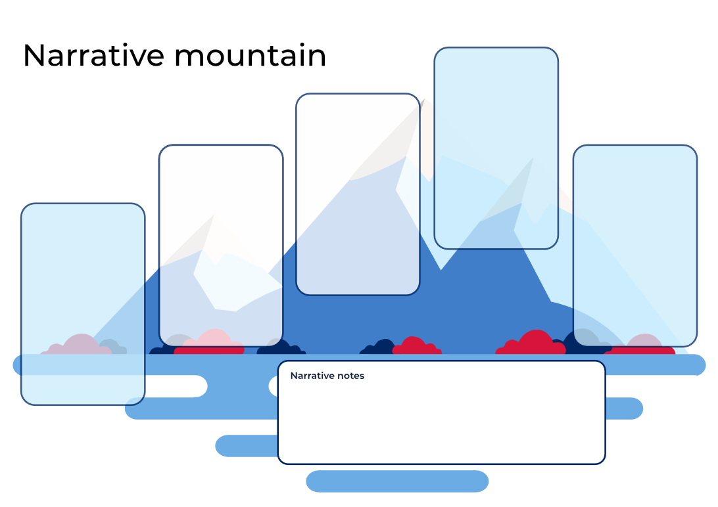

Resource 2: Subordinating conjunctions
after | before | so long as | when
although | if | though | whenever
as | once | unless | where
because | since | until | while

Resource 3: Muddled up creature
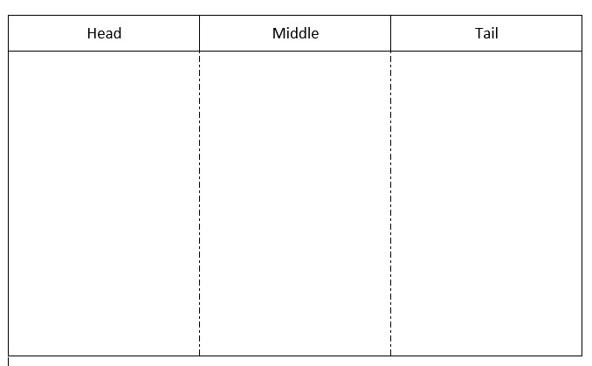

Resource 4: Storyboard
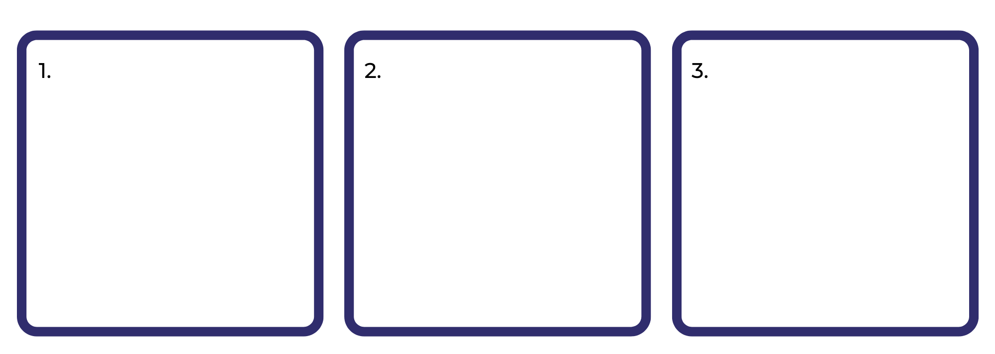

Resource 5: Storytelling poster
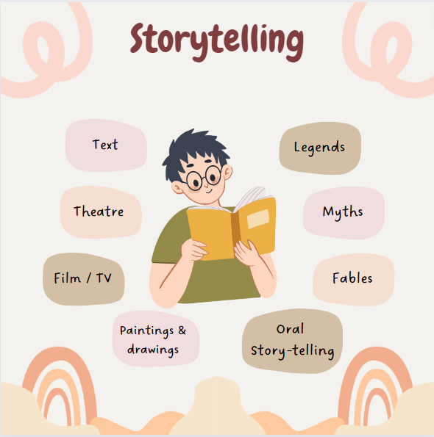
Images sourced from Canva and used in accordance with the Canva Content License Agreement.

Resource 6: Storytelling table
Text | Legends | Myths | Fables | Oral Storytelling | Paintings & Drawings | Film/  Television | Theatre
Storytelling through texts has been developed and adapted over time since it was created | A historical story told to show bravery and courage. Stories are usually based on real people but are often exaggerated to show a hero or major event. | Story of creation with mythical creatures and characters. Myths originate from Ancient Greek times. They have no truth to them. They are an opinion on the creation and existence of the world. | A short, simple story, often told to children that is told to teach some sort of moral lesson. | The tradition of orally telling a story, often one that has been passed down from generation to generation, changing and adapting over time. | A very early form of storytelling. Tells stories of long ago. They could be stories of warning, special moments that happened or simple stories for entertainment or education. | This is the most recent form of storytelling. First came around in the 1880’s and allowed for things to be filmed, creating a story, and shown to a large audience. | Theatre is an audience-based form of storytelling. It was the move from just an oral retell to vocally acting it out.

References
Links to third-party material and websites
Please note that the provided (reading/viewing material/list/links/texts) are a suggestion only and implies no endorsement, by the New South Wales Department of Education, of any author, publisher, or book title. School principals and teachers are best placed to assess the suitability of resources that would complement the curriculum and reflect the needs and interests of their students.
If you use the links provided in this document to access a third-party's website, you acknowledge that the terms of use, including licence terms set out on the third-party's website apply to the use which may be made of the materials on that third-party website or where permitted by the Copyright Act 1968 (Cth). The department accepts no responsibility for content on third-party websites.
Except as otherwise noted, all material is © State of New South Wales (Department of Education), 2021 and licensed under the Creative Commons Attribution 4.0 International License. All other material (third-party material) is used with permission or under licence. Where the copyright owner of third-party material has not licensed their material under a Creative Commons or similar licence, you should contact them directly for permission to reuse their material.
English K–10 Syllabus © 2022 NSW Education Standards Authority (NESA) for and on behalf of the Crown in right of the State of New South Wales.
Creative Arts K-6 Syllabus © 2006 NSW Education Standards Authority (NESA) for and on behalf of the Crown in right of the State of New South Wales.
© 2021 NSW Education Standards Authority. This document contains NSW Curriculum and syllabus content. The NSW Curriculum is developed by the NSW Education Standards Authority. This content is prepared by NESA for and on behalf of the Crown in right of the State of New South Wales. The material is protected by Crown copyright.
Please refer to the NESA Copyright Disclaimer for more information.
NESA holds the only official and up-to-date versions of the NSW Curriculum and syllabus documents. Please visit the NSW Education Standards Authority (NESA) website and the NSW Curriculum website.
National Literacy Learning Progression © Australian Curriculum, Assessment and Reporting Authority (ACARA) 2010 to present, unless otherwise indicated. This material was downloaded from the Australian Curriculum website (National Literacy Learning Progression) (accessed 21 November 2022) and was not modified. The material is licensed under CC BY 4.0. Version updates are tracked in the ‘Curriculum version history’ section on the 'About the Australian Curriculum' page of the Australian Curriculum website.
ACARA does not endorse any product that uses the Australian Curriculum or make any representations as to the quality of such products. Any product that uses material published on this website should not be taken to be affiliated with ACARA or have the sponsorship or approval of ACARA. It is up to each person to make their own assessment of the product, taking into account matters including, but not limited to, the version number and the degree to which the materials align with the content descriptions and achievement standards (where relevant). Where there is a claim of alignment, it is important to check that the materials align with the content descriptions and achievement standards (endorsed by all education Ministers), not the elaborations (examples provided by ACARA).
Copyright Agency and contributors (2022) Cathy Goonack, Reading Australia website, accessed 21 November 2022.
ETA (English Teachers Association) and NSW Department of Education (2016) The Textual Concepts and Processes resource, English Textual Concepts website, accessed 21 November 2022.
Farmer D (n.d) ‘Tableaux’, Drama Strategies, Drama Resource website, accessed 21 November 2022.
Goonak C (2010) Scaly-tailed Possum and Echidna (Goonack K, Goonack M & Goonack M, illus.), Magabala Books, Australia.
Loh-Hagan V (2019) Nian, the Chinese New Year Dragon (Banks T, illus.), Sleeping Bear Press, Michigan.

