English – Stage 1 – Unit 25
Contents
Unit overview and instructions for use 3
Teacher notes 4
Outcomes and content – Component A 5
Outcomes and content – Component B 7
Week 1 10
Component A teaching and learning 10
Component B teaching and learning 11
Lesson 1: Mallee Sky 12
Lesson 2: Feelings, imagery and connotations 15
Lesson 3: Cause and effect and alliteration 17
Lesson 4: Prepositional phrases and sentences 19
Lesson 5: Action verbs and personification 20
Week 2 23
Component A teaching and learning 23
Component B teaching and learning 24
Lesson 6: A Passing Storm and riddles 25
Lesson 7: Commas and cinquain 28
Lesson 8: Acrostic poem plan 29
Lesson 9: Publish an acrostic poem 31
Lesson 10: Poetry party 33
Resource 1: Venn diagram – Drought and rain 35
Resource 2: Venn diagram – The Mallee 36
Resource 3: Traffic light paragraphs 37
Resource 4: Personification 38
Resource 5: A Passing Storm 39
Resource 6: Text analysis 41
Resource 7: Riddle 42
Resource 8: Punctuation detective 43
Resource 9: Cinquain poem – Mallee Sky 44
Resource 10: Cinquain poem – student copy 45
Resource 11: Acrostic poem 46
References 47

Unit overview and instructions for use
This two-week unit is comprised of Component A and Component B. Connecting learning across both components is encouraged.
Teaching and learning | Component A | Component B
Suggested duration | 60 minutes | 45 minutes
Explicit teaching focus areas | - Phonic knowledge  - Reading fluency  - Reading comprehension  - Spelling  - Handwriting | - Oral language and communication  - Vocabulary  - Reading comprehension  - Creating written texts  - Understanding and responding to literature
To prepare for teaching and learning: | - Refer to Outcomes and content – Component A, K-2 – Instructional sequence – grapheme–phoneme correspondences [PDF 825 KB], and the teaching advice documents (hyperlinked in Component A teaching and learning table).  - Based on student needs identified through ongoing assessment data, plan and document how you will sequence teaching and learning in whole class and targeted teaching groups across the two-week cycle. | - Familiarise yourself with Outcomes and content – Component B, Textual concepts information and videos, English Textual Concepts and Learning Processes (2016), and the teaching and learning sequence.  - Based on student needs identified through ongoing assessment data, determine how you will support students in whole class and targeted teaching groups across the two-week cycle as required.
English K–10 Syllabus © 2022 NSW Education Standards Authority (NESA) for and on behalf of the Crown in right of the State of New South Wales.

Teacher notes
- Component B of this unit explores the textual concept of imagery, symbol and connotation. Words and images can signify more than what they denote, extending us beyond their literal everyday meanings to understand and experience one thing in terms of another. This extension of meaning may, through connotation, evoke associated feelings or, through imagery and symbol, lay down new traces of images, sounds, senses and ideas – English Textual Concepts and Learning Processes (2016).
- Understanding of imagery, symbol and connotation can be supported through watching the department’s video: Connotation, imagery and symbol (6:07).
- This unit could enhance student learning towards achievement of outcomes from the Geography K-10 Syllabus (2015).
- Reflect on student learning and engagement in activities and record differentiation and adjustments within the unit to inform future teaching and learning. One way of doing this could be to add comments to the digital file.
- Content points are linked to the National Literacy Learning Progression version (3).
Levels and indicators sourced from National Literacy Learning Progression © Australian Curriculum, Assessment and Reporting Authority (ACARA), (accessed 18 October 2022) and was not modified. See references for more information.

Outcomes and content – Component A
The table below outlines the focus outcomes and content. Content is linked to the National Literacy Learning Progression version (3).
Focus area and outcome | Content points and National Literacy Learning Progression
Phonic knowledge  EN1-PHOKW-01 – uses initial and extended phonics, including vowel digraphs, trigraphs to decode and encode words when reading and creating texts | - decode words with less common consonant digraphs and apply this when reading texts  - blend and decode 2-syllable words with taught vowel graphs, digraphs, trigraphs and quadgraphs, including graphemes for r-controlled vowels and diphthongs and apply this when reading texts (PKW7), (PKW7)  - decode 2-syllable base words with common double consonants when reading texts
Reading fluency  EN1-REFLU-01 – sustains reading unseen texts with automaticity and prosody and self-corrects errors | - self-correct when fluency and/or meaning is interrupted  - adjust phrasing, intonation, volume or rate to maintain fluency when reading aloud (FlY4)
Reading comprehension  EN1-RECOM-01 – comprehends independently read texts that require sustained reading by activating background and word knowledge, connecting and understanding sentences and whole text, and monitoring for meaning | - make an inference by connecting the meaning of words across sentences and/or paragraphs  - make text-to-self, text-to-text or text-to-world connections when reading (UnT6)  - monitor understanding to ensure meaning is sustained and expanded through the whole text (UnT6)
Spelling  EN1-SPELL-01 – applies phonological, orthographic and morphological generalisations and strategies when spelling words in a range of writing contexts | - segment multisyllabic words into syllables and phonemes as a strategy for spelling (SpG5)  - explain when to use double consonants to spell 2-syllable base words and apply this when spelling (SpG6)  - use spelling conventions when adding tense-marking suffixes (SpG9)
Handwriting  EN1-HANDW-01 – uses a legible, fluent and automatic handwriting style, and digital technology, including word-processing applications, when creating texts | - form all letters with consistent size and slope in NSW Foundation Style from memory (HwK5)

Outcomes and content – Component B
The table below outlines the focus outcomes and content. Content is linked to the National Literacy Learning Progression version (3).
Focus area and outcome | Content points and National Literacy Learning Progression
Oral language and communication  EN1-OLC-01 – communicates effectively by using interpersonal conventions and language to extend and elaborate ideas for social and learning interactions. | - respond to information by asking relevant questions to extend their own and others' knowledge (LiS4) (LiS6)  - incorporate extended sentences (simple, compound, complex) during dialogue (SpK3)  - use adjectives and adverbs to elaborate and/or provide some supporting details or justifications and express causal relationships (SpK3)
Vocabulary  EN1-VOCAB-01 – understands and effectively uses Tier 1, taught Tier 2 and Tier 3 vocabulary to extend and elaborate ideas | - understand and intentionally choose subject-specific vocabulary to enhance precision and for effect
Reading comprehension  EN1-RECOM-01 – comprehends independently read texts that require sustained reading by activating background and word knowledge, connecting and understanding sentences and whole text, and monitoring for meaning | - use known morphemes and known vocabulary in the text to work out or refine the meaning of unknown words (UnT4)  - know that a complex sentence includes a clause for expressing a main message and one or more clauses that elaborate on that message  - make an inference by connecting the meaning of words across sentences and/or paragraphs  - identify how creative visual features are used to expand meaning  - make text-to-self, text-to-text or text-to-world connections when reading (UnT6)
Creating written texts  EN1-CWT-01 – plans, creates and revises texts written for different purposes, including paragraphs, using knowledge of vocabulary, text features and sentence structure | - use a combination of simple and compound sentences to engage the reader when creating written texts (CrT6) (GrA4)  - use noun groups to build descriptions of people and things (CrT6)  - use action, saying, relating and sensing verbs to add detail and precision to writing (GrA2) (GrA5)  - use contextually precise prepositional phrases when creating texts (GrA4)  - experiment with writing complex sentences which include a clause for the main message and dependent clause to elaborate or modify the message (GrA5)  - use commas to separate ideas, lists and/or dependent clauses in a sentence (PuN4) (PuN6)  - use a variety of planning strategies and tools for creating texts  - re-read and edit their own texts after receiving feedback
Understanding and responding to literature  EN1-UARL-01 – understands and responds to literature by creating texts using similar structures, intentional language choices and features appropriate to audience and purpose | - create texts that include symbols, wordplay and figurative language  - identify figurative language and wordplay in texts  - innovate from studied texts using wordplay and figurative language  - express personal responses to the real and imagined worlds that are represented in texts

Week 1

Component A teaching and learning
The table below can be used to plan and document lessons that address Component A outcomes and content. Both the detailed example [DOC 529KB] of a two-week teaching and learning cycle and brief example [DOC 66KB] may support you in your planning.
Focus Areas | Lesson 1 | Lesson 2 | Lesson 3 | Lesson 4 | Lesson 5
Phonic knowledge
15 minutes
Spelling and Handwriting
15 minutes
Reading comprehension and Reading fluency
30 minutes

Component B teaching and learning
The following teaching and learning sequence has been designed to address Component B outcomes and content. Adapt the sequence as required to best meet the needs of your students.

Learning intention and success criteria
Learning intentions and success criteria are best co-constructed with students.

Learning intention
Students are learning to understand the use of wordplay and figurative language and write using these techniques.

Success criteria
Students can:
- use noun groups in writing to add detail
- understand and use wordplay
- identify and use subject-specific vocabulary
- use adjectives and alliteration when writing
- use prepositional phrases when writing
- write complex sentences
- understand personification using action verbs.

Resources
- Toering J (2021) Mallee Sky (Harricks T, illus.), Walker Books Australia, ISBN: 9781760652166
- Resource 1: Venn diagram – Drought and rain
- Resource 2: Venn diagram – The Mallee
- Resource 3: Traffic light paragraphs
- Resource 4: Personification

Lesson 1: Mallee Sky
- Source and display 2 pictures, one of the sky during sunset and one of the sky during the night.
- Prompt students to identify the nouns in each picture. For example, sun, sunset, clouds, sky, stars, moon. Record responses.
- Review noun groups. Refer to recorded responses from activity 2. Using Think-Pair-Share, students build noun groups. For example:
- pointer: the, a, an, this, that, my
- nouns: sun, sunset, clouds, sky, stars, moon
- adjectives: pink, orange, fluffy, grey, starry, shining
- noun group: the pink, cloudy sky, the grey, fluffy cloud, an orange sunset, the starry night, the shining moon.
Note: A noun group is a group of words relating to, or building on, a noun. Noun groups usually consist of a pointer, plus one or more adjectives and are used to build descriptions.
- Display the front cover of Mallee Sky. Ask students to provide a description using noun groups.
- Using the front cover, guide students to make predictions about events that might happen in the story. Students may use clues and any prior knowledge they have.
- Read Mallee Sky. Revisit the text predictions and confirm any accurate responses. Encourage students to make text-to-self connections and share these using a mix of simple, compound, and complex sentences. Record some and revise the features of each sentence type.
- Display the back cover of Mallee Sky and discuss the last sentence, ‘Drought and rain – life under a Mallee Sky’. Using an enlarged version Resource 1: Venn diagram – Drought and rain, explore the features, differences, and similarities between drought and rain. Prompt students to consider any real or imagined experiences they might have with drought or rain. Encourage students to respond to information provided by asking questions to expand their knowledge of living through drought. Record responses.
- Display a map of Australia and locate the Mallee. Using Resource 2: Venn diagram – The Mallee, compare the area of the Mallee with the local area, encouraging text-to-world connections.
- Model writing a short description of the local area using noun groups, compound sentences and a complex sentence.
- Students use Resource 2: Venn diagram – The Mallee to support writing a description of the Mallee. Remind students to use noun groups and compound sentences in their writing.
Too hard? Students write a simple sentence to describe the Mallee or the local area.
Too easy? Students write a description including detailed noun groups and complex sentences.
Stage 1 Assessment task 1 – Observations and work samples from this lesson allow students to demonstrate achievement towards the following syllabus outcomes and content points:
EN1-OLC-01 – communicates effectively by using interpersonal conventions and language to extend and elaborate ideas for social and learning interactions
- respond to information by asking relevant questions to extend their own and others' knowledge
- incorporate extended sentences (simple, compound, complex) during dialogue.
EN1-RECOM-01 – comprehends independently read texts that require sustained reading by activating background and word knowledge, connecting and understanding sentences and whole text, and monitoring for meaning
- make text-to-self, text-to-text or text-to-world connections when reading.
EN1-UARL-01 – understands and responds to literature by creating texts using similar structures, intentional language choices and features appropriate to audience and purpose
- express personal responses to real and imagined worlds.

Lesson 2: Feelings, imagery and connotations
- Take students through a tour of Mallee Sky, displaying and discussing the illustrations. Identify how creative visual features are often used to expand meaning in a text. Draw attention to the contrasting colours that reflect the change in mood and emotion throughout the book. For example, the use of dull pinks, browns and blues to depict the dry, dusty landscape when in drought, contrasted with bright greens once the rains arrive and bring life back to the Mallee.
Note: Imagery is the use of figurative language to represent objects, characters, actions, or ideas to appeal to the senses of the reader or viewer. Connotation refers to the feelings that images and words evoke. Inference is the process of using background knowledge and the evidence in a text to draw conclusions.
- Explain imagery, connotation, and inference. Use the text to explore these concepts, for example, ‘The whole school stops and runs outside to dance in the hot wet rain; teachers too.’ Ask students to infer how the students in the text are feeling and ask how this sentence makes them feel. Responses might include, happy, relieved, excited.
- Students play the game ‘What the phrase makes me feel’. Present a selection of phrases from the text. For example, ‘The sun beats down, relentless.’ Students explain how the phrase makes them feel, using adjectives to describe their feelings and providing a justification. For example, the idea of the hot sun beating down makes me feel sweaty and tired.
- Display and read the page showing the night sky and the page showing Dad standing on the verandah. Prompt students to infer how each character is feeling in those moments. Ask:
- How are the characters feeling?
- What clues from the illustrations and words in the text helped you to decide how each character was feeling?
- How do these images make you feel?
- Display an enlarged copy Resource 3: Traffic light paragraphs. Review the features of a paragraph. Explain that a paragraph starts with a topic sentence, which is followed by other sentences to elaborate on the topic and provide details. Sometimes, a closing sentence is evident. Model deconstructing a paragraph from the text using Resource 3: Traffic light paragraphs.
- Co-construct a topic sentence using an illustration from Mallee Sky as a stimulus. Include the use of figurative language. For example, ‘The boy and the dog counted many twinkling stars in the inky night sky that blanketed the Mallee’.
- Students Think-Pair-Share related ideas about what else the boy and the dog might see in the night sky and how this makes them feel. In pairs, students record sentences on mini whiteboards.
- Discuss, select and record sentences with related ideas, adding to the topic sentence. Co-construct the closing sentence.
- Read and review the paragraph using Resource 3: Traffic light paragraphs. Prompt students to identify figurative language, noun groups and adjectives.
Stage 1 Assessment task 2 – Observations from this lesson allow students to demonstrate achievement towards the following syllabus outcome and content points:
EN1-RECOM-01 – comprehends independently read texts that require sustained reading by activating background and word knowledge, connecting and understanding sentences and whole text, and monitoring for meaning
- make an inference by connecting the meaning of words across sentences and/or paragraphs
- identify how creative visual features are used to expand meaning.

Lesson 3: Cause and effect and alliteration
- Re-read Mallee Sky. During reading, students list subject-specific vocabulary on mini whiteboards. For example, vast, eerie, parched, wither, unrelenting, leaden, absent, bitumen, eucalyptus.
- Students share vocabulary. List vocabulary on an anchor chart and further explore unknown words.
- Explain how the author has used this vocabulary to add detail and evoke emotions. The author wants the reader to relate to her real-life circumstances.
- Revise cause and effect.
- Discuss the following situations and the effect drought can have on communities. Note the cause and the effect for each.
- How is the land different from when it rains to when it does not rain?
- Why do we need to farm?
- Why does Mum want the crops to grow?
- What might happen if crops don’t grow?
- Students divide a page in half and label one side ‘no rain’ and the other side ‘rain’.
- Students record words/phrases and draw ideas from Mallee Sky that represent ‘no rain’. For example, ‘summer sky is big and blue’, ‘the bitumen melts’, ‘the wind is too hot and tired’, ‘baths are short and the dams drop’.
- In pairs, students share ideas.
- Students list words and draw ideas from Mallee Sky that represent ‘rain’. For example, ‘smell of the long-awaited rain’, ‘paddocks turn to carpets of green’, ‘crops grow again, tall and thick’.
- In pairs, students share ideas.
- Explicitly teach alliteration: the repetition of the consonant sound at the beginning of words.
- Revise adjectives and adverbs. Underline adjectives and adverbs on the anchor chart and explain how these words add detail.
- Model writing alliterative phrases to describe Mallee Sky, using the vocabulary anchor chart and student ‘no rain’ and ‘rain’ work samples. For example, parched paddocks, withering wheat, burning black bitumen.
- Students write alliterative phrases to describe Mallee Sky, using the vocabulary anchor chart and student ‘no rain’ and ‘rain’ work samples.
Too hard? Provide students with a small bank of nouns and adjectives that can be matched to make alliterative phrases.
Too easy? Students write descriptive sentences including alliterative phrases.
- As a class, students share alliterative phrases.
Stage 1 Assessment task 3 – Observations and work samples from this lesson allow students to demonstrate achievement towards the following syllabus outcomes and content points:
EN1-OLC-01 – communicates effectively by using interpersonal conventions and language to extend and elaborate ideas for social and learning interactions
- use adjectives and adverbs to elaborate and/or provide some supporting details or justifications and express causal relationships.
EN1-VOCAB-01 – understands and effectively uses Tier 1, taught Tier 2 and Tier 3 vocabulary to extend and elaborate ideas
- understand and intentionally choose subject-specific vocabulary to enhance precision and for effect.
EN1-RECOM-01 – comprehends independently read texts that require sustained reading by activating background and word knowledge, connecting and understanding sentences and whole text, and monitoring for meaning
- use known morphemes and known vocabulary in the text to work out or refine the meaning of unknown words.
EN1-UARL-01 – understands and responds to literature by creating texts using similar structures, intentional language choices and features appropriate to audience and purpose
- identify figurative language and wordplay in texts.

Lesson 4: Prepositional phrases and sentences
- Explicitly teach what a preposition is and list some that indicate a circumstance such as time, place, manner, or causality. For example, in, on, after, before, by, under, over, of. Provide an example of a prepositional phrase from the mentor text, for example, ‘along the lonely highways.’ This refers to where the silos are.
- Select 2 students and ask them to stand on the carpet, sit under the desk, stand next to each other, one walks before the other. Ask remaining students to identify the prepositional phrase in each instruction.
- Repeat activity 2 with all students joining in. Ask them to identify each prepositional phrase.
- Revisit Mallee Sky and identify the prepositional phrases in the text. For example, ‘When the sun goes down…’, ‘As days pass…’, ‘Day after day…’, ‘through the eucalypts’. Support students to identify if phrases indicate time or place.
- Revise simple, compound, and complex sentences.
- Highlight different sentence structures used in Mallee Sky. For example:
- simple sentence – ‘The summer sky is big and blue.’
- compound sentence – ‘Baths are short and the dam drops.’
- complex sentence – ‘When the sun goes down, the red heat of the day bleeds into the sky and sets it on fire.'
- Discuss how authors use a variety of sentences to engage the reader. This technique makes the text more inviting, giving it life and rhythm.
- Revise complex sentences and subordinating conjunctions. Revise that a complex sentence is formed by adding one or more dependent clauses to an independent clause using conjunctions. Review that an independent clause can stand alone as a complete sentence.
- Model writing a complex sentence using a prepositional phrase. For example, ‘While the children play, the birds whistle in the trees’. Identify the prepositional phrase, the independent and dependent clause, and the subordinating conjunction.
- Provide students with the sentence starter, ‘While the,’. Students write a complex sentence including a prepositional phrase.
Too hard? Provide students with a sentence stem. For example, While his mother cleans, the boy__.
Too easy? Students write 2 different complex sentences using a different sentence starter.
- Students write a second sentence using the sentence starter, ‘When the sun goes down,’.
- In pairs, students share their sentences and underline the prepositional phrases, independent clause and the subordinating conjunctions.

Lesson 5: Action verbs and personification
- Revise, brainstorm, and list action verbs. For example, dance, sit, twirl, crouch, beg.
- Students stand around the room and demonstrate the action verb as you call it out.
- Identify and record action verbs from the text. For example, bleeds, sets, shine, croak.
- Browse Mallee Sky and discuss how the author uses imagery, specifically personification, to create a picture for the reader. Find examples in the text and explain the meaning. For example:
- ‘Dry gums gasp, drinking deeply.’
- ‘…the inky sky comes alive with stars.’
- ‘…bleeds into the sky and sets it on fire.’
Note: Personification is when human characteristics are given to something that is not human. For example, the wind grabbed at my clothes.
- Discuss and identify the use of action verbs used in these examples. For example, gasp, drinking, comes alive, bleeds.
- Revise and list nouns and items that are not human. For example, ball, sandwich, book, shoe, flowers.
- Explain to students that they will change a noun by giving it human qualities or actions.
- Model selecting a noun from the list created in activity 6. For example, flowers. Select a verb (ensuring it is a human action) from the list made in activity 3. For example, beg. Connect the 2 and discuss what the flowers might beg for, to create a sentence using personification. For example, Flowers beg for water.
- Display Resource 4: Personification. Model completing the template. Write the sentence, ‘Flowers beg for water.’ in the sentence box. Jointly describe what it means. For example, they are thirsty and wilting because they need water to survive. Illustrate the sentence, noting that visual features are used to expand meaning in a text.
- Students select and write nouns and verbs that are human actions on mini whiteboards. Using these, students write sentences including personification.
- Students complete Resource 4: Personification using the sentences on their mini whiteboard.
Too hard? Co-construct sentences with students.
- As a class, students share sentences and discuss the meaning.

Week 2

Component A teaching and learning
The table below can be used to plan and document lessons that address Component A outcomes and content. Both the detailed example [DOC 529KB] of a two-week teaching and learning cycle and brief example [DOC 66KB] may support you in your planning.
Focus Areas | Lesson 6 | Lesson 7 | Lesson 8 | Lesson 9 | Lesson 10
Phonic knowledge
15 minutes
Spelling and Handwriting
15 minutes
Reading comprehension and Reading fluency
30 minutes

Component B teaching and learning
The following teaching and learning sequence has been designed to address Component B outcomes and content. Adapt the sequence as required to best meet the needs of your students.

Learning intention and success criteria
Learning intentions and success criteria are best co-constructed with students.

Learning intention
Students are learning to understand the use of wordplay and figurative language and write using these techniques.

Success criteria
Students can:
- identify and use figurative language
- use commas to separate ideas in a sentence and when creating lists
- identify and write prepositional phrases
- create a range of poetry, including cinquain, riddles and acrostic poems.

Resources
- Toering J (2021) Mallee Sky (Harricks T, illus.), Walker Books Australia, ISBN: 9781760652166
- Resource 5: A Passing Storm
- Resource 6: Text analysis
- Resource 7: Riddle
- Resource 8: Punctuation detective
- Resource 9: Cinquain poem – Mallee Sky
- Resource 10: Cinquain poem – student copy
- Resource 11: Acrostic poem
- Whiteboard markers, modelling clay, or counters with commas drawn on them

Lesson 6: A Passing Storm and riddles
- Revise the meaning of imagery and figurative language.
- Do not share the title or the image of the poem, but read Resource 5: A Passing Storm. Ask students to identify what type of text it is. Assist them to identify the text as a poem.
- Read the poem a second time. Students close their eyes, listen to the poem, and visualise. Students illustrate their visualisation and share what they ‘see’, using adjectives and adverbs to elaborate on their description.
Note: Visualisation is a strategy used to create a mental image from a text that has been read, viewed, or heard. It brings the text to life, and engages the imagination and the senses to support understanding.
- Re-read the poem, prompting students to listen for important components. For example, rhyme and the use of figurative language, such as personification and onomatopoeia. Students add any interesting vocabulary to their illustrations.
- Explain that poets use figurative language to create imagery and connotations (evoke emotions). Discuss the use of figurative language in the poem, specifically personification. Encourage students to make text-to-text connections between the poem and Mallee Sky, highlighting the use of personification. For example, ‘Tell me Storm Cloud, are you mad? Disappointed? Scared or sad?’ and ‘Grey gums gasp, drinking deeply’.
- Explain that there are many examples of figurative language and adjectives used throughout Mallee Sky. For example:
- ‘the unforgiving sun’
- ‘the inky sky’.
- Display and read a few select pages of Mallee Sky. Ask students to identify figurative language and personification.
- Ask students how the use of figurative language and adjectives enhance the text. Responses might include that it makes the text more interesting and engaging and helps the reader to make meaning. Identify other adjectives in the text and brainstorm new and interesting adjectives that could be used in their place.
- Display an enlarged copy of Resource 6: Text analysis. Model analysing text from A Passing Storm to explore and understand figurative language. For example, ‘I hear a BOOM! A crack of thunder! Hug my blanket– cuddle under.’ Discuss what the text says and what the illustration shows. Students turn and talk to discuss what it means. Record responses on Resource 6: Text analysis. For example:
- What it says – I hear a BOOM! A crack of thunder! Hug my blanket – cuddle under.
- What it shows – A picture of grey storm clouds with a bolt of lightning.
- What it means – There is a storm passing over during the night and a person is in bed cuddling under a blanket. The storm is loud.
- Ask students to identify what each text might be about. For example: A Passing Storm – a loud storm passing over during the night; Mallee Sky – drought. Explain that neither text identifies the main topic directly.
- Introduce riddles. Identify and explain that writing a riddle is the reverse of solving a puzzle, where you start with the answer. Explain that riddles do not identify the main topic directly and they can also rhyme. Source and read examples of riddles that rhyme and do not rhyme. Students provide answers to the riddles. Explain that authors would have decided on their item or answer prior to writing the riddle.
- Brainstorm items to write a riddle about, for example, an animal or object. Record responses.
- Select one item from the list and brainstorm descriptive words and phrases. Record responses.
- Using an enlarged copy of Resource 7: Riddle, model writing the riddle. Use figurative language and adjectives. For example:
I look like a big, blue blanket making things look dry and parched
I sound like a whisper
I have dust storms swirling all around
I feel sweaty, hot and I’m sometimes wet
You can find me high and low. You can find me all over!
- Ask: What am I? Answer: The Mallee sky.
- Provides students with copies of Resource 7: Riddle. In pairs, students create a riddle.
- Students share their riddles with the class. Prompt the audience to identify the subject, use of figurative language and interesting adjectives.

Lesson 7: Commas and cinquain
- Students work in small groups to become ‘Punctuation detectives’, identifying different types of punctuation in the texts Mallee Sky and A Passing Storm. For example, commas, capital letters, full stops, apostrophes, question marks and quotation marks. Students use Resource 8: Punctuation detective to record the punctuation found. Students share their findings.
Too easy? Students name the purpose of punctuation identified.
- Review the purpose and importance of commas. Explain that a comma marks a break between the different parts of a sentence and makes the meaning of sentences clear by grouping and separating words, phrases, and clauses. Commas can also tell the reader when to pause while reading or to separate items in a list.
- Discuss the use of commas in Mallee Sky and A Passing Storm. For example:
- ‘On a clear night, the inky sky comes alive with stars’ – the comma marks a break between the dependent and independent clauses.
- ‘I too get grumpy, grouchy, grey’ – the comma is used to list feelings.
- Using whiteboard markers, modelling clay or counters with commas drawn on them, model placing commas in the correct place. Read the sentences aloud, pausing where the commas have been placed.
- Using a range of selected sentences without punctuation from both texts, students work in pairs to place commas in the correct place using whiteboard markers, modelling clay or counters with commas drawn on them. Students re-read sentences to ensure correct placement.
- Introduce cinquain poems. Explain that a cinquain poem has 5 lines. The:
- first line is a single word that is the title and the subject of the poem
- second line uses 2 adjectives that describe the title/subject of the poem
- third line has 3 words that tell more about the subject or show an action
- fourth line has 4 words that show emotion or attitude. They tell more about the subject. They can be a phrase or a list of words. Sometimes these words end in –ing
- fifth line can be a synonym, or a word related to the title.
- Using Mallee Sky as a stimulus and Resource 9: Cinquain poem – Mallee Sky, model writing a cinquain poem. Place commas in the correct place if using a list for the fourth line.
- Students use Resource 10: Cinquain poem – student copy to write their own cinquain poem, using an image from Mallee Sky as a stimulus.
Too hard? Provide students with a list of nouns, adjectives, verbs and feeling words to choose from.
Too easy? Students choose their own topic to be the subject of their cinquain poem.

Lesson 8: Acrostic poem plan
- Revisit Mallee Sky and The Passing Storm. Browse through both texts and discuss the types of weather represented.
- Brainstorm and list words used to describe the weather discussed. For example, thunderstorm, drought, summer heat, hot, wet rain, storm cloud, precipitation.
- Display Resource 11: Acrostic poem. Discuss the vertical structure, how each sentence begins with the letter in the vertical word, each line does not need to rhyme, and the length of each sentence does not matter.
- Revise and develop success criteria for writing an acrostic poem. For example, students use:
- subject-specific vocabulary
- noun groups
- action verbs
- prepositional phrases
- personification
- commas when creating a list or to separate ideas in a sentence
- a variety of sentences (simple, compound and complex).
- Model writing an acrostic poem using one of the ‘weather’ words, and refer to Resource 11: Acrostic poem and identify examples of the success criteria within the poem. For example:
- Subject-specific vocabulary – precipitation, hail, clouds
- Noun group – the dim, dense clouds
- Action verbs – drizzles, roars
- Prepositional phrase – drizzles down…, shatters underneath…
- Personification – hoping for the toasty sun to hug me
- Commas to separate an idea – Nervously watching, I wait in my sheltered house, hoping…
- Variety of sentences – simple sentence: ‘A significant gust of wind hit me.’ Compound sentence: ‘Icy hail roars at the cement and it shatters underneath the dim, dense clouds.’ Complex sentence: ‘Nervously watching, I wait in my sheltered house, hoping for the toasty sun to hug me once again.’
- Students write an acrostic poem using one of the ‘weather’ words, referring to the success criteria.
Too hard? Provide students with the vertical word and subject-specific words. For example: Vertical word – rain. Subject specific words – wet, drops, steamy, heavy.
- Students read their poem aloud to themselves and edit. Students refer to the success criteria and Resource 11: Acrostic poem to assist with this process.

Lesson 9: Publish an acrostic poem
- Students re-read their poem with ‘fresh eyes’ and make additional edits if required.
- Students share their poem with a partner and provide feedback using the success criteria and a feedback sandwich:
- a positive comment
- constructive criticism – HTI: How to Improve your work
- a positive comment.
- Students re-read, apply feedback, and edit their poem.
- Students publish their poem and add an illustration. The published work will be added to a poem-tree display at the conclusion of the unit.
- Explain that students will have the opportunity to recite their poems to the class. Model reciting a poem to engage the audience using techniques such as:
- eye contact
- adjust phrasing
- intonation
- volume.
- Students practise reciting their poem.
Stage 1 Assessment task 4 – Observations and work samples from this lesson allow students to demonstrate achievement towards the following syllabus outcomes and content points:
EN1-VOCAB-01 – understands and effectively uses Tier 1, taught Tier 2 and Tier 3 vocabulary to extend and elaborate ideas
- understand and intentionally choose subject-specific vocabulary to enhance precision and for effect.
EN1-RECOM-01 – comprehends independently read texts that require sustained reading by activating background and word knowledge, connecting and understanding sentences and whole text, and monitoring for meaning
- know that a complex sentence includes a clause for expressing a main message and one or more clauses that elaborate on that message.
EN1-CWT-01 – plans, creates and revises texts written for different purposes, including paragraphs, using knowledge of vocabulary, text features and sentence structure
- use a combination of simple and compound sentences to engage the reader when creating written texts
- use noun groups to build descriptions of people and things
- use action, saying, relating and sensing verbs to add detail and precision to writing
- use contextually precise prepositional phrases when creating texts
- experiment with writing complex sentences which include a clause for the main message and dependent clause to elaborate or modify the message
- use commas to separate ideas, lists and/or dependent clauses in a sentence
- use a variety of planning strategies and tools for creating texts
- re-read and edit their own texts after receiving feedback.
EN1-UARL-01 – understands and responds to literature by creating texts using similar structures, intentional language choices and features appropriate to audience and purpose
- create texts that include symbols, wordplay and figurative language
- innovate from studied texts using wordplay and figurative language.

Lesson 10: Poetry party
- Students collate the poems they have written throughout the unit – cinquain poem, riddle, and acrostic poem.
- Students practise reciting their poems using the techniques modelled in Lesson 9.
- As a class, students have a ‘poetry party’. In groups, students recite their poems to their peers. Peers ask 2 relevant questions to extend their own and others’ knowledge about the student’s poem. For example, the meaning of a word used or if they have been in/seen that weather form before.
- After groups have shared their poems, arrange students’ poems around the classroom for a gallery walk.
- Outline the requirements for completing the gallery walk. Students are provided with 3 sticky notes to apply peer feedback to 3 of their peers. On each sticky note, students write something they:
- liked about the poem
- learned by reading the poem.
- Students move around the classroom writing responses for their peers.
- Students return to their poem and review peer responses.
- Students celebrate their successes and plant a poem-tree. Create a tree trunk wall display and add student poems as the branches and leaves to create a tree.

Resource 1: Venn diagram – Drought and rain
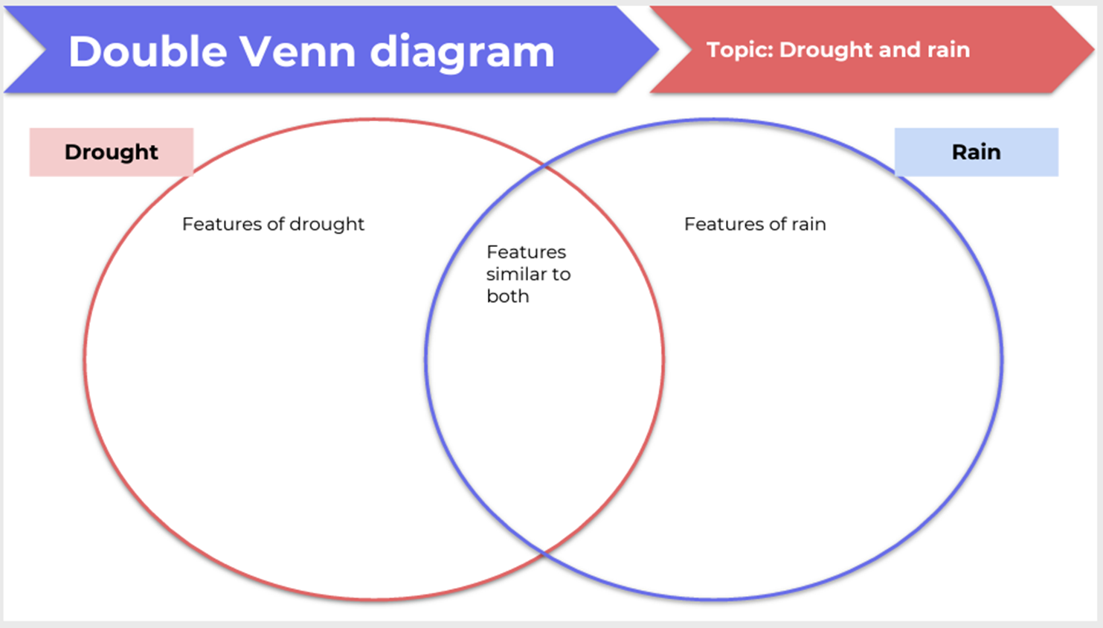

Resource 2: Venn diagram – The Mallee
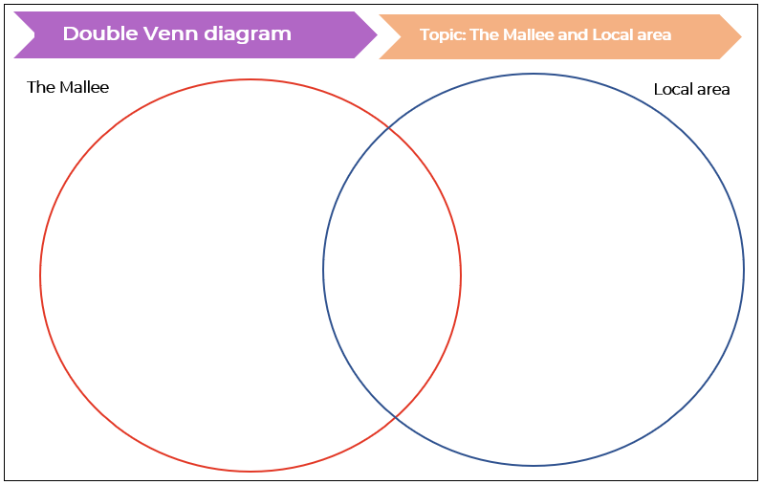

Resource 3: Traffic light paragraphs
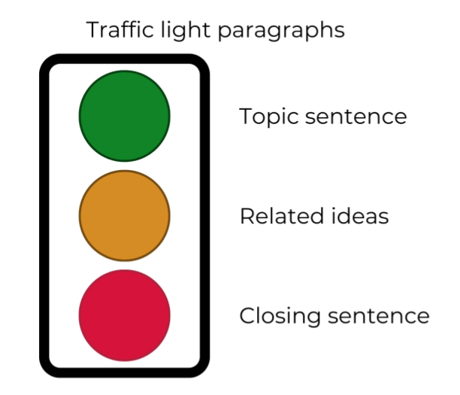
Images sourced from Canva and used in accordance with the Canva Content License Agreement.

Resource 4: Personification
Sentence | What it means? | Drawing
Flowers beg for water. | The flowers are thirsty and wilting. They are drooping. The flowers need water to survive. | 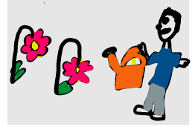

Resource 5: A Passing Storm
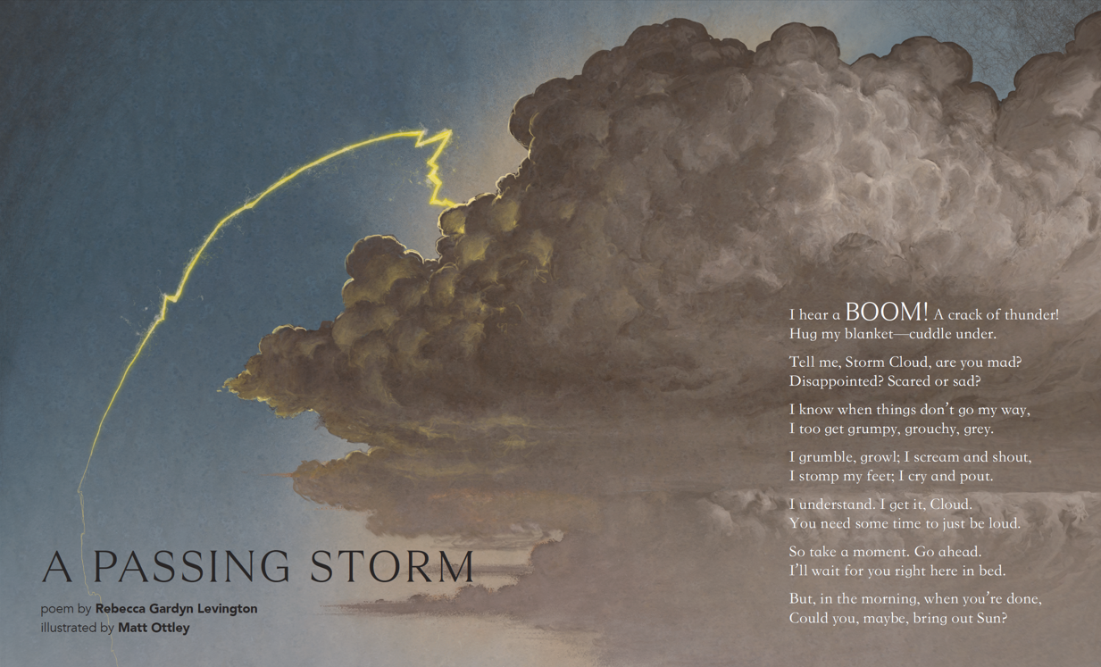

Transcript:
I hear a BOOM! A crack of thunder!
Hug my blanket – cuddle under.
Tell me, Storm Cloud, are you mad?
Disappointed? Scared or sad?
I know when things don't go my way,
I too get grumpy, grouchy, grey.
I grumble, growl; I scream and shout,
I stomp my feet; I cry and pout.
I understand. I get it, Cloud.
You need some time to just be loud.
So take a moment. Go ahead.
I'll wait for you right here in bed.
But, in the morning, when you're done,
Could you, maybe, bring out Sun?
Gardyn Levington R (2022) ‘A Passing Storm’

Resource 6: Text analysis
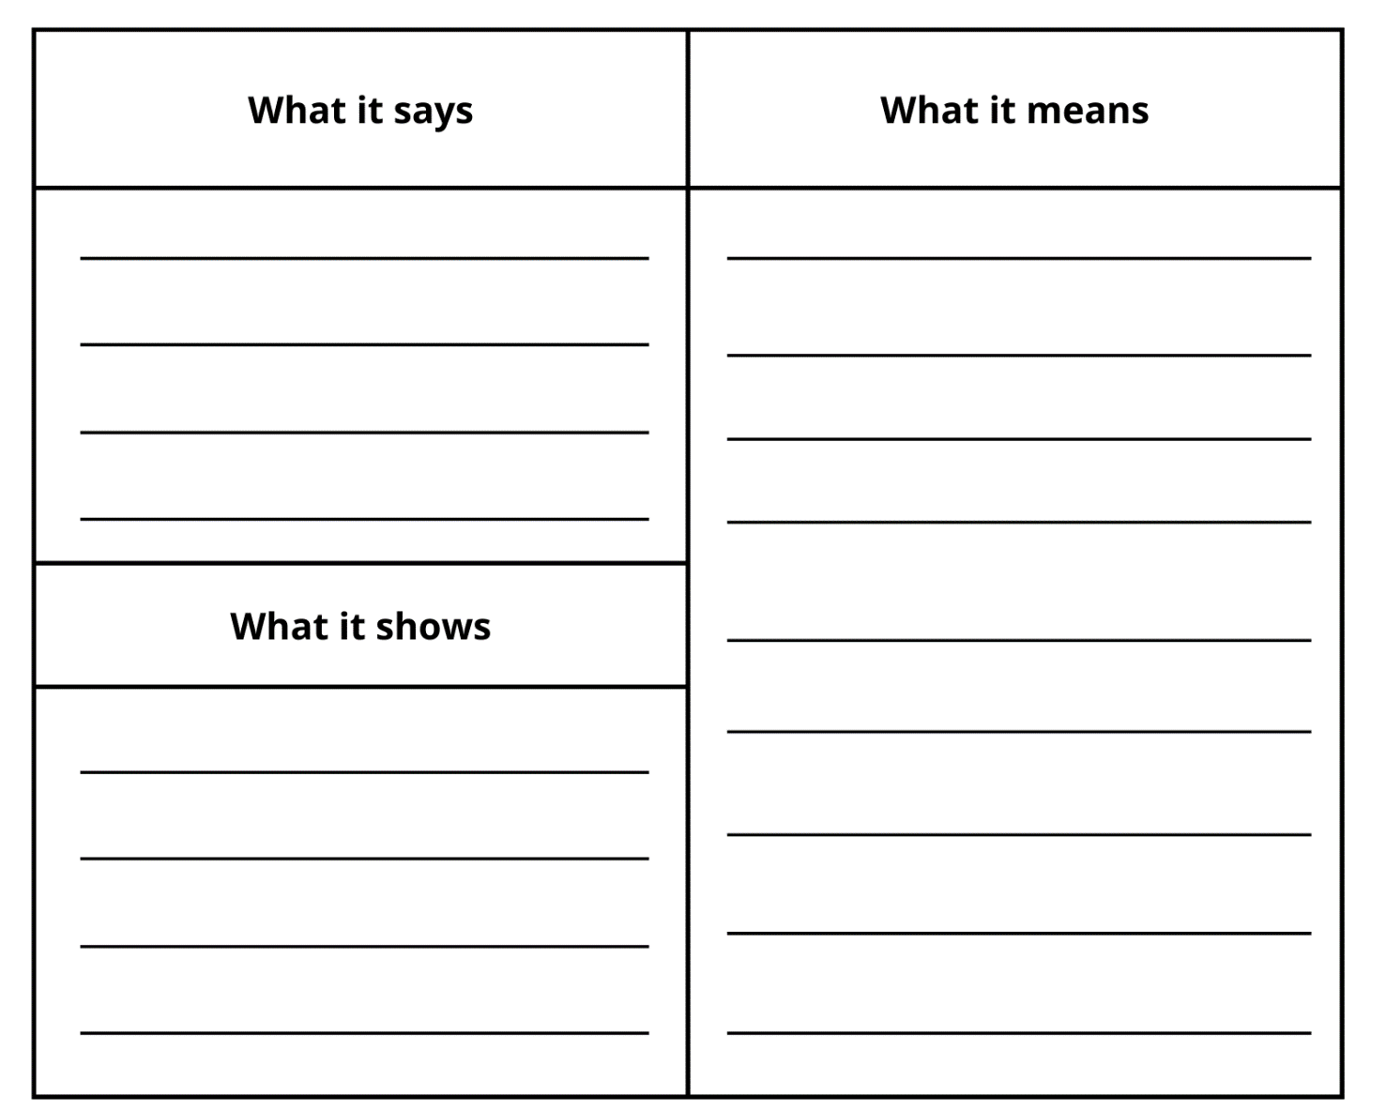

Resource 7: Riddle
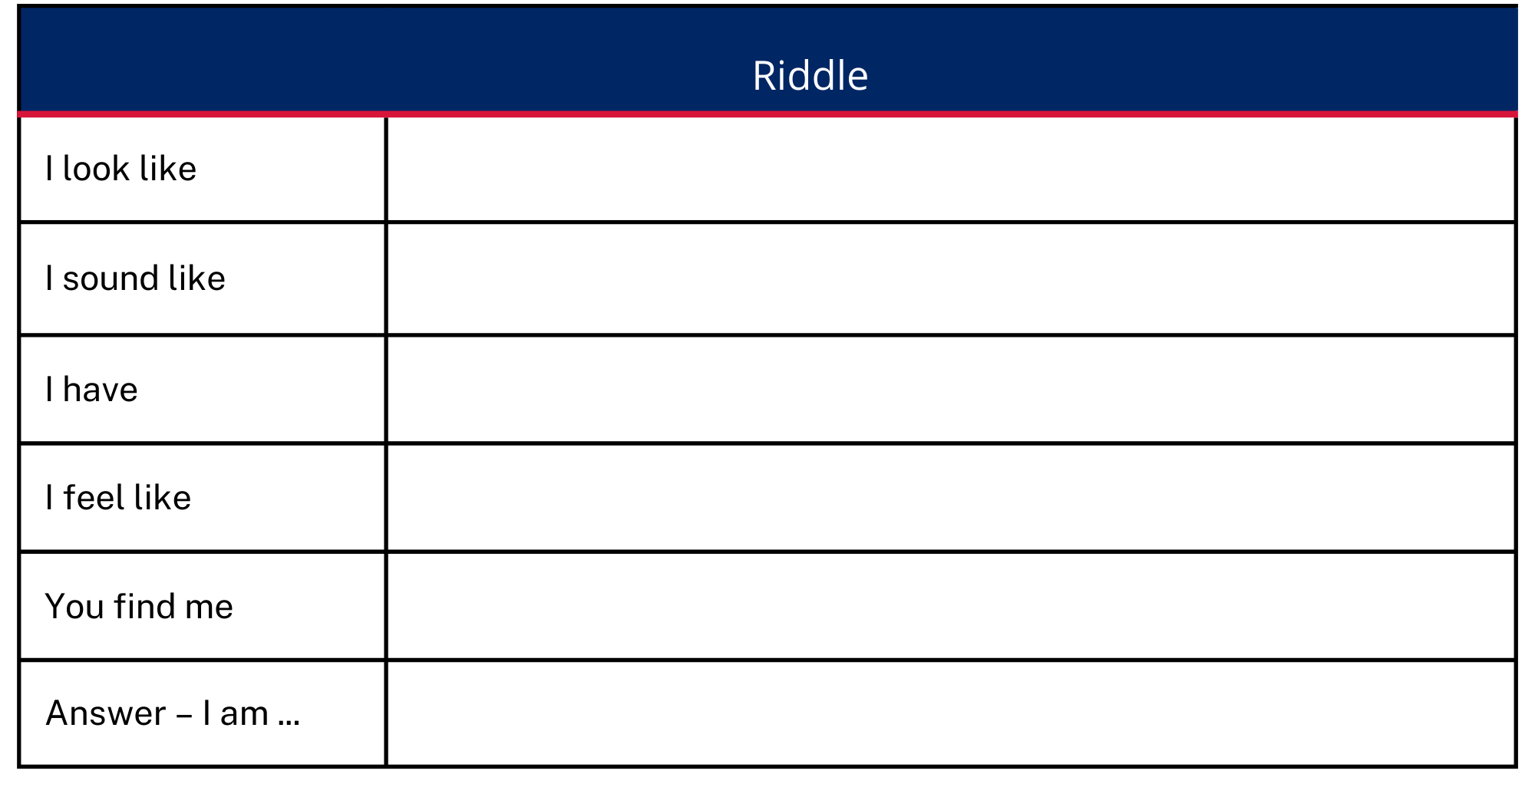

Resource 8: Punctuation detective
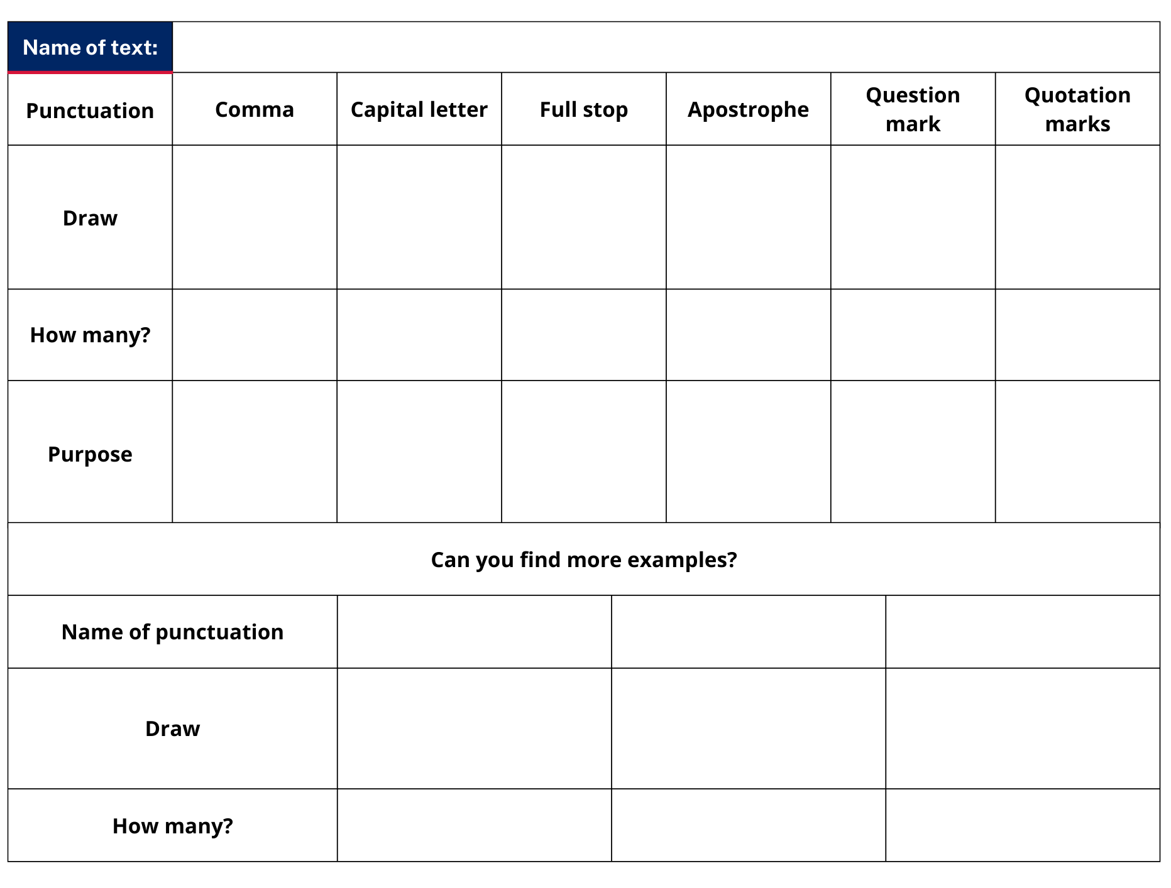

Resource 9: Cinquain poem – Mallee Sky
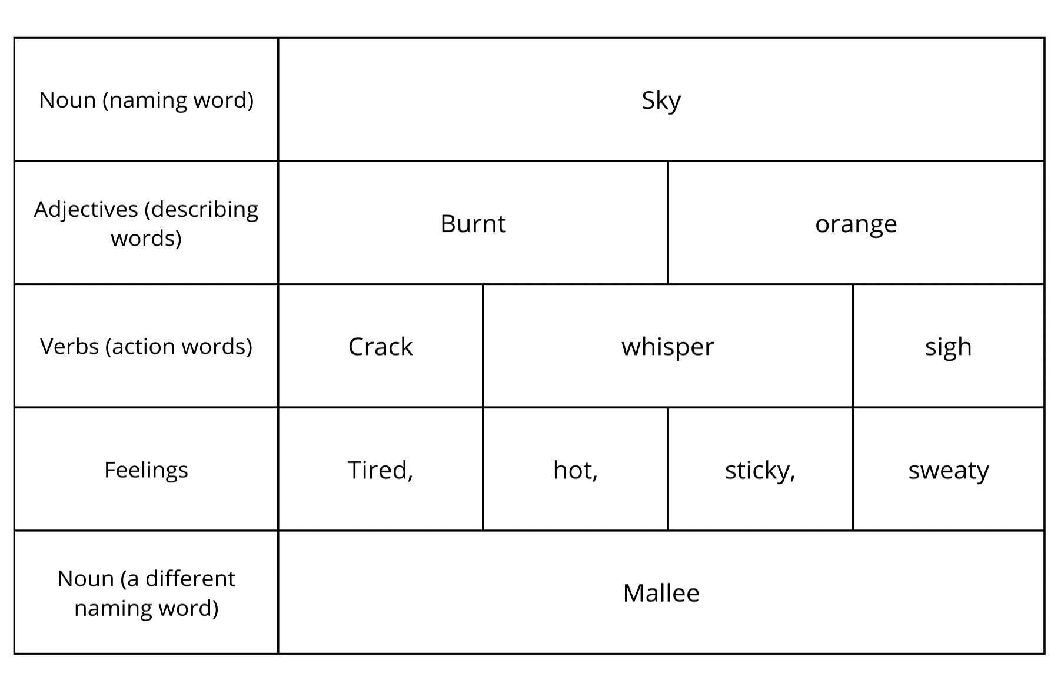

Resource 10: Cinquain poem – student copy
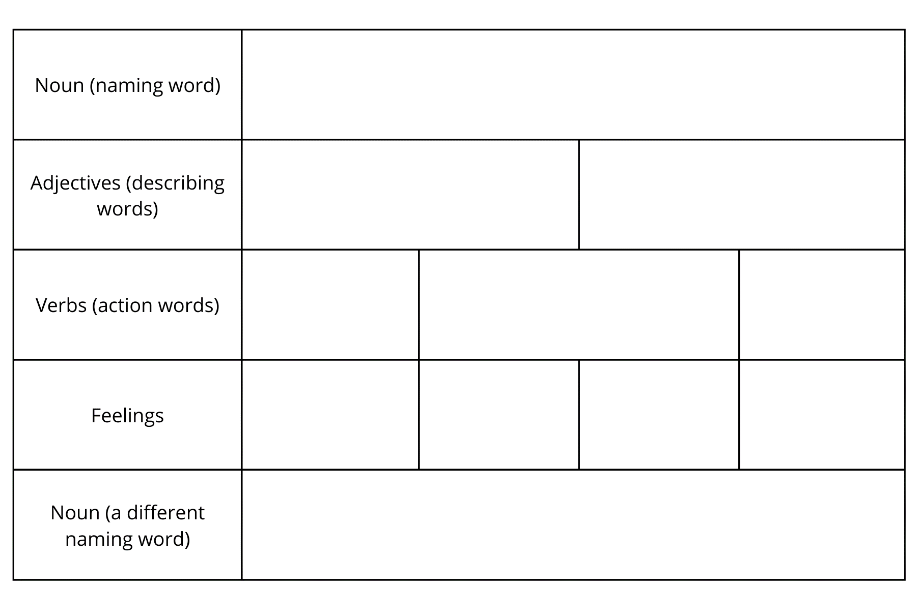

Resource 11: Acrostic poem
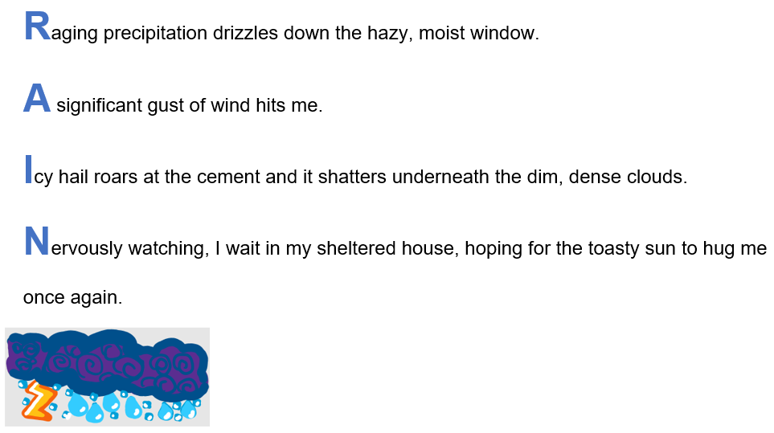

References
Links to third-party material and websites
Please note that the provided (reading/viewing material/list/links/texts) are a suggestion only and implies no endorsement, by the New South Wales Department of Education, of any author, publisher, or book title. School principals and teachers are best placed to assess the suitability of resources that would complement the curriculum and reflect the needs and interests of their students.
If you use the links provided in this document to access a third-party's website, you acknowledge that the terms of use, including licence terms set out on the third-party's website apply to the use which may be made of the materials on that third-party website or where permitted by the Copyright Act 1968 (Cth). The department accepts no responsibility for content on third-party websites.
Except as otherwise noted, all material is © State of New South Wales (Department of Education), 2021 and licensed under the Creative Commons Attribution 4.0 International License. All other material (third-party material) is used with permission or under licence. Where the copyright owner of third-party material has not licensed their material under a Creative Commons or similar licence, you should contact them directly for permission to reuse their material.
English K–10 Syllabus © 2022 NSW Education Standards Authority (NESA) for and on behalf of the Crown in right of the State of New South Wales.
Geography K–10 Syllabus © 2015 NSW Education Standards Authority (NESA) for and on behalf of the Crown in right of the State of New South Wales.
© 2021 NSW Education Standards Authority. This document contains NSW Curriculum and syllabus content. The NSW Curriculum is developed by the NSW Education Standards Authority. This content is prepared by NESA for and on behalf of the Crown in right of the State of New South Wales. The material is protected by Crown copyright.
Please refer to the NESA Copyright Disclaimer for more information.
National Literacy Learning Progression © Australian Curriculum, Assessment and Reporting Authority (ACARA) 2010 to present, unless otherwise indicated. This material was downloaded from the Australian Curriculum website (National Literacy Learning Progression) (accessed 18 October 2022) and was not modified. The material is licensed under CC BY 4.0. Version updates are tracked in the ‘Curriculum version history’ section on the 'About the Australian Curriculum' page of the Australian Curriculum website.
ACARA does not endorse any product that uses the Australian Curriculum or make any representations as to the quality of such products. Any product that uses material published on this website should not be taken to be affiliated with ACARA or have the sponsorship or approval of ACARA. It is up to each person to make their own assessment of the product, taking into account matters including, but not limited to, the version number and the degree to which the materials align with the content descriptions and achievement standards (where relevant). Where there is a claim of alignment, it is important to check that the materials align with the content descriptions and achievement standards (endorsed by all education Ministers), not the elaborations (examples provided by ACARA).
ETA (English Teachers Association) and NSW Department of Education (2016) The Textual Concepts and Processes resource, English Textual Concepts website, accessed 18 October 2022.
ETA (English Teachers Association) and NSW Department of Education (2016) Connotation, imagery and symbol, English Textual Concepts website accessed 18 October 2022.
Gardyn Levington R (2022) ‘A Passing Storm’ (Ottley M, illus.), The School Magazine, Launchpad (Pilot Magazine).
Toering J (2021) Mallee Sky (Harricks T, illus.), Walker Books Australia.

