English – Stage 1 – Unit 24
Contents
Unit overview and instructions for use 3
Teacher notes 4
Outcomes and content – Component A 5
Outcomes and content – Component B 7
Week 1 11
Component A teaching and learning 11
Component B teaching and learning 12
Lesson 1: Introducing Koala Ark 13
Lesson 2: Characters and layout 16
Lesson 3: Complex Sentences and important ideas 18
Lesson 4: Narrative retell, prepositional phrases and time connectives 22
Lesson 5: Anthropomorphism and heroes 24
Week 2 27
Component A teaching and learning 27
Component B teaching and learning 28
Lesson 6: Audio episode 1 and vocabulary 29
Lesson 7: Audio episode 2 and 3 and vocabulary 30
Lesson 8: Planning to persuade 32
Lesson 9: Writing and revising a persuasive text 33
Lesson 10: Publish persuasive text 35
Resource 1: Adjectives and noun groups 37
Resource 2: Subordinating conjunctions 39
Resource 3: Sentence frames 40
Resource 4: Prepositional phrase strips 42
Resource 5: Billabong 43
Resource 6: Koala Venn diagram 44
Resource 7: Audio episodes – Koala 45
Resource 8: Persuasive example 46
Resource 9: Planning scaffold 47
Resource 10: Audio Transcript 48
Episode 1 48
Episode 2 49
Episode 3 50
References 52
Further reading 54

Unit overview and instructions for use
This two-week unit is comprised of Component A and Component B. Connecting learning across both components is encouraged.
Teaching and learning | Component A | Component B
Suggested duration | 60 minutes | 45 minutes
Explicit teaching focus areas | - Phonic knowledge  - Reading fluency  - Reading comprehension  - Spelling  - Handwriting | - Oral language and communication  - Vocabulary  - Reading comprehension  - Creating written texts  - Understanding and responding to literature
To prepare for teaching and learning: | - Refer to Outcomes and content – Component A, K-2 – Instructional sequence – grapheme–phoneme correspondences [PDF 825 KB], and the teaching advice documents (hyperlinked in Component A teaching and learning table).  - Based on student needs identified through ongoing assessment data, plan and document how you will sequence teaching and learning in whole class and targeted teaching groups across the two-week cycle. | - Familiarise yourself with Outcomes and content – Component B, Textual concepts information and videos, English Textual Concepts and Learning Processes (2016), and the teaching and learning sequence.  - Based on student needs identified through ongoing assessment data, determine how you will support students in whole class and targeted teaching groups across the two-week cycle as required.
English K–10 Syllabus © 2022 NSW Education Standards Authority (NESA) for and on behalf of the Crown in right of the State of New South Wales.

Teacher notes
- ‘Argument is using persuasion to produce a position or resolution supported by evidence. Argument doesn’t need to be combative; it can build collaboration to solve complex problems’. – English Textual Concepts and Learning Processes (2016).
- Enhance understanding of argument by watching: Argument (3:17).
- ‘Argument’ is the mentor concept, supported by ‘perspective’ which can be explored using the audio episodes embedded throughout this unit.
- The Fire Wombat by Jackie French is:
- an additional text with similar content and events providing opportunities to explore the concepts of narrative and concept.
- based on events witnessed by the author in the 2020 bushfires
- a story of courage, compassion, and survival, which saw people across Australia come together to save our wildlife from devastation.
- Lesson 2 incorporates an optional art lesson to paint a watercolour landscape to demonstrate how settings are represented within texts to enhance meaning. Additional time of 30 minutes will be needed.
- This unit could enhance student learning towards achievement of outcomes from the Creative Arts syllabus regarding visual arts.
- Reflect on student learning and engagement in activities and record differentiation and adjustments within the unit to inform future teaching and learning. One way of doing this could be to add comments to the digital file.
- Content points are linked to the National Literacy Learning Progression version (3).
Levels and indicators sourced from National Literacy Learning Progression © Australian Curriculum, Assessment and Reporting Authority (ACARA), (accessed 4 October 2022) and was not modified. See references for more information.

Outcomes and content – Component A
The table below outlines the focus outcomes and content. Content is linked to the National Literacy Learning Progression version (3).
Focus area and outcome | Content points and National Literacy Learning Progression
Phonic knowledge  EN1-PHOKW-01 – uses initial and extended phonics, including vowel digraphs, trigraphs to decode and encode words when reading and creating texts | - blend and decode 2-syllable words with taught vowel graphs, digraphs, trigraphs and quadgraphs, including graphemes for r-controlled vowels and diphthongs and apply this when reading texts (PKW6, PKW7)  - decode 2-syllable base words with common double consonants when reading texts (PKW7)
Reading fluency  EN1-REFLU-01 – sustains reading unseen texts with automaticity and prosody and self-corrects errors | - self-correct when fluency and/or meaning is interrupted
Reading comprehension  EN1-RECOM-01 – comprehends independently read texts that require sustained reading by activating background and word knowledge, connecting and understanding sentences and whole text, and monitoring for meaning | - register a break in comprehension when reading (UnT5)
Spelling  EN1-SPELL-01 – applies phonological, orthographic and morphological generalisations and strategies when spelling words in a range of writing contexts | - segment multisyllabic words into syllables and phonemes as a strategy for spelling (SpG5)  - explain when to use double consonants to spell 2-syllable base words and apply this when spelling (SpG6)  - use extended phonic code for taught consonant phonemes  - use spelling conventions when adding tense-marking suffixes (SpG9)
Handwriting  EN1-HANDW-01 – uses a legible, fluent and automatic handwriting style, and digital technology, including word-processing applications, when creating texts | - form all letters with consistent size and slope in NSW Foundation Style from memory (HwK5)  - position all letters correctly on the line with appropriate spacing between words (HwK5)

Outcomes and content – Component B
The table below outlines the focus outcomes and content. Content is linked to the National Literacy Learning Progression version (3).
Focus area and outcome | Content points and National Literacy Learning Progression
Oral language and communication  EN1-OLC-01 – communicates effectively by using interpersonal conventions and language to extend and elaborate ideas for social and learning interactions. | - listen to or engage with texts for enjoyment and recognise that their own experience can shape their ideas and opinions of texts  - use adjectives and adverbs to elaborate and/or provide some supporting details or justifications and express causal relationships (SpK3)
Vocabulary  EN1-VOCAB-01 – understands and effectively uses Tier 1, taught Tier 2 and Tier 3 vocabulary to extend and elaborate ideas | - understand and intentionally choose subject-specific vocabulary to enhance precision and for effect
Reading comprehension  EN1-RECOM-01 – comprehends independently read texts that require sustained reading by activating background and word knowledge, connecting and understanding sentences and whole text, and monitoring for meaning | - use known vocabulary to build a mental model of the content of the text  - know that a complex sentence includes a clause for expressing a main message and one or more clauses that elaborate on that message  - make an inference by connecting the meaning of words across sentences and/or paragraphs  - make text-to-self, text-to-text or text-to-world connections when reading (UnT6)  - recount relevant ideas from texts in the form of a written, visual or oral summary (UnT6)  - recognise how the position of a clause in a complex sentence influences the important idea for the reader
Creating written texts  EN1-CWT-01 – plans, creates and revises texts written for different purposes, including paragraphs, using knowledge of vocabulary, text features and sentence structure | - write texts that describe, explain, give an opinion, recount an event, tell a story (CrT7)  - select and use a range of conjunctions to create cohesive texts (GrA5)  - experiment with writing complex sentences which include a clause for the main message and dependent clause to elaborate or modify the message (GrA5)  - use contextually precise prepositional phrases when creating texts (GrA4)  - use time connectives to sequence information and events in texts  - use commas to separate ideas, lists and/or dependent clauses in a sentence  - make intentional word choices to enhance precision of meaning and ideas in a text (CrT5)  - use a variety of planning strategies and tools for creating texts  - re-read and edit their own texts after receiving feedback
Understanding and responding to literature  EN1-UARL-01 – understands and responds to literature by creating texts using similar structures, intentional language choices and features appropriate to audience and purpose | - identify and share how their own experience and interests influence opinions and/or interpretations of texts  - express preferences for specific texts and authors and recognise the opinions of others (UnT5)  - recognise ways that settings and situations are represented within texts

Week 1

Component A teaching and learning
The table below can be used to plan and document lessons that address Component A outcomes and content. Both the detailed example [DOC 529KB] of a two-week teaching and learning cycle and brief example [DOC 66KB] may support you in your planning.
Focus Areas | Lesson 1 | Lesson 2 | Lesson 3 | Lesson 4 | Lesson 5
Phonic knowledge
15 minutes
Spelling and Handwriting
15 minutes
Reading comprehension and Reading fluency
30 minutes

Component B teaching and learning
The following teaching and learning sequence has been designed to address Component B outcomes and content. Adapt the sequence as required to best meet the needs of your students.

Learning intention and success criteria
Learning intentions and success criteria are best co-constructed with students.

Learning intention
Students are learning to respond to settings and situations within texts and how these text interpretations influence the audience’s opinions.

Success criteria
Students can:
- engage with texts for enjoyment and make text-to-self connections
- write a text to describe using adjectives
- identify the visual features and their purpose
- use adjectives and adverbs to give more meaning
- use complex sentences in writing
- orally recount the text
- use time connectives and prepositional phrases appropriately.

Resources
- King SM (2022) Koala Ark, Scholastic Australia Pty Ltd. ISBN: 9781761128257
- Stephen Michael King website – Books
- Resource 1: Adjectives and noun groups – enlarged teacher copy and one for each student
- Resource 2: Subordinating conjunctions – enlarged teacher copy
- Resource 3: Sentence frames – enlarged teacher copy and one for each student
- Resource 4: Prepositional phrase strips – enlarged teacher copy (cut up)
- Resource 5: Billabong
- Resource 6: Koala Venn diagram
- Y-chart
- Sticky notes
- Teacher resources – Lesson 4: rectangular plastic container, small plastic toys, blue paper
- Small group resources – Lesson 4: rectangular plastic container, small plastic toys, blue paper

Lesson 1: Introducing Koala Ark
- Display and discuss the front cover of the text Koala Ark by Stephen Michael King.
- Ask students:
- What can you tell about the book from the front cover?
- What animals can you identify? What do you notice about them?
- What is the setting of this text?
- Why are there no leaves on the trees?
- Read the blurb on the back cover and encourage text predictions.
- Students Think-Pair-Share to discuss their responses. Record responses to questions and predictions.
- Read Koala Ark. Revisit the Think-Pair-Share answers and confirm predictions.
- Display the ‘Koala Ark’ page on the Stephen Michael King website. Read the author’s experiences in the 2019 and 2020 bushfires. Explain that Koala Ark is based on his experience, noting that the characters are imagined.
- Make text-to-self connections by discussing students’ real-life experiences and how this affects the way they interpret the text. For example, students may have visited a koala rescue centre.
- Make text-to-text connections with other books by Stephen Michael King including Rainbow Bear and Leaf. Explain that these books are written from real life experiences and include characters that are a combination of real or imagined.
- Ask if Koala is a real or imagined character, or a combination of both. Students state their opinion and justify. For example, Koala is a combination of both real and imagined because he is a koala who fights fires.
Note: Anthropomorphism (Scan, 40(4):11) refers to the practice of attributing human qualities to animals.
- Review the characters and identify their human behaviours. For example, standing up, steering a boat, riding a push bike, drinking tea, helping each other, building a community. Explain that this is ‘anthropomorphism’, which is when the author gives animals human qualities.
- Review noun groups and note that a noun group is a group of words relating to, or building on, a noun. Noun groups usually consist of a pointer plus one or more adjectives. They build descriptions.
- Display the page with the sentence ‘The scaly lorikeets and black cockatoos flew ahead to search for food’. Deconstruct the descriptive noun group by identifying the:
- article – the
- adjectives – scaly, black
- nouns – lorikeets, cockatoos. Refer to completed Resource 1: Adjectives and noun groups.
- Display the wordless double page in Koala Ark and blank Resource 1: Adjectives and noun groups. Model writing the components of the noun group – article, adjectives, and noun. Examples include:
- article – the
- adjectives – brown and grey spotted
- noun – dog
- Model writing a compound sentence using the noun group. For example, ‘The brown and grey spotted dog felt safe and the other rescued animals were in the boat’.
- Students draw a character and write a descriptive compound sentence using blank Resource 1: Adjectives and noun groups.
Too hard? Students write a simple sentence to describe their character.
Too easy? Students draw a character and setting from the text, including multiple adjectives and noun groups in their writing to create complex sentences.
- Students share their work with a partner and identify adjectives and noun groups within the compound sentence. Partners determine if the sentence provides effective detail and describes the character.

Lesson 2: Characters and layout
Note: This lesson incorporates an (optional) art activity to paint a watercolour landscape to demonstrate how settings are represented within texts to enhance meaning.
- Display the first double page of Koala Ark. Discuss the visual features and how they add meaning to the text. For example:
- size – flames are large, koalas are small
- colour – dominance of red and yellow
- text – a sentence without a referring noun ‘It came fast and without warning’.
- Display and browse the text to compare the colours used in the illustrations and discuss the meaning. For example:
- title page – brown, yellow landscape: dry, drought conditions; big, yellow sun: hot day; small green leaves on the plant in the truck: hope that things will still grow; small, pale blue billabong with rowboat: the water level is low.
- second double page – grey, smoky colours, glow of red in the clouds: fire receding
- tawny frogmouth, river turtles – brighter blue water; brown, grey, red landscape: effect of the fire
- the first drops of rain – blue and white: characters are looking up and smiling
- the earth would renew – small green leaf in the title; the plant in the truck on the title page, final page: the earth is healing.
- Make text-to-text connections by recalling the colour palettes from recent texts. For example, Sophie Scott goes South – the colour palette of blue and white for the Antarctic; Where the Wild Things Are – the colour palette of greens for the jungle; Welcome to Country – the colour palettes of red, brown and greens for the earth.
- Display the word, ‘billabong’ and discuss its meaning: a small pond left over when a river changes its course. Make text-to-text connections to ‘Waltzing Matilda’. Discuss the connotation of the billabong being a safe, calm environment amongst the burnt, damaged landscape.
- Display the page showing Bowerbird, Dog and Fox. Focus on:
- Bowerbird: Ask why Bowerbird has a blue ring in its beak. Share background information on the Satin Bowerbird and their habit of collecting blue objects. Students make text-to-world connections to infer why Bowerbird may have carried the blue ring onto the boat.
- Dog: Ask how Dog would have ‘called out to be rescued’. Students make text-to-self connections to infer the dog’s behaviour, for example, the dog howled or barked.
- Fox: Ask why Fox is wearing a mask. Students make text-to-text connections to infer why Fox ‘didn’t want to leave his treasures behind’. For example, Fantastic Mr Fox.
- Display a Y-chart and label a section for each character. Brainstorm and list adjectives that describe each characteristic and adverbs to describe the actions. For example, Bowerbird – blue feathers, loudly called; Dog – spotty fur, very scared; Fox – sneaky disguise, quietly tiptoed.
Variation: Students select a colour palette and paint a simple landscape using watercolours.
- When paintings are dry, students draw the characters from the text using felt pens.
- Students write a description on sticky notes of the characters using adverbs and adjectives from the Y-chart. Add sticky notes to the paintings and display.
Stage 1 Assessment task 1 – Observations and work samples from this lesson allow students to demonstrate achievement towards the following syllabus outcomes and content points:
EN1-OLC-01 – communicates effectively by using interpersonal conventions and language to extend and elaborate ideas for social and learning interactions
- use adjectives and adverbs to elaborate and/or provide some supporting details or justifications and express causal relationships.
EN1-RECOM-01 – comprehends independently read texts that require sustained reading by activating background and word knowledge, connecting and understanding sentences and whole text, and monitoring for meaning
- make text-to-self, text-to-text or text-to-world connections when reading.
EN1-UARL-01 – understands and responds to literature by creating texts using similar structures, intentional language choices and features appropriate to audience and purpose
- recognise ways that settings and situations are represented within texts.

Lesson 3: Complex Sentences and important ideas
- Read text from Koala Ark that demonstrates a range of sentence structures. For example:
- simple sentence – ‘Echidna was found first’.
- compound sentence – ‘Dog was lost and called out to be rescued’.
- complex sentence – ‘Bowerbird kept watch as he made a makeshift home on top of the mast’.
- Discuss how authors use a variety of sentences to engage the reader. This technique makes the text more inviting and gives life and rhythm to the text.
- Revise complex sentences and subordinating conjunctions. Note that a complex sentence is formed by adding one or more dependent clauses to an independent clause using conjunctions. Review that each (independent) clause can stand alone as a complete sentence.
- Display Resource 2: Subordinating conjunctions. Explain that subordinating conjunctions are words that bind a dependent clause to an independent clause. For example, when, because, although, unless.
- Display the complex sentence ‘When the little boat returned to shore, Joey’s mum was waiting for them’. Identify the independent clauses (also known as main clause).
- Display the double page where Koala returns to the shore and read the sentence ‘When the little boat returned to the shore, Joey’s mum was waiting for them’. Note the location of the first clause. Explain that the author has deliberately selected the position of the clause to influence this important idea for the reader.
- Explain that a subordinating conjunction can also be used at the beginning of a complex sentence. Compare the following sentences and identify the subordinating conjunction and separate the clauses in each sentence:
- ‘When the little boat returned to shore,
- Joey’s mum was waiting for them’. (when)
- ‘Bowerbird kept watch as
- he made a makeshift home on top of the mast’. (as)
- Browse the text and identify the important ideas and subordinating conjunctions. For example:
- ‘Even though Bandicoot and her family still had their home, they felt safest with their friends’.
- ‘As dusk arrived … the first drops of rain began to fall’.
- ‘The crew made a driftwood raft and shuffled everyone around so that Baby Possum could be cradled’.
- Display the sentence ‘Bowerbird kept watch as he made the makeshift home on top of the mast’. Explain that when the subordinating conjunction is used between clauses, a comma is not used.
- Display the complex sentence ‘As the little boat drifted by, the river turtles said they were fine’. Model the use of Resource 3: Sentence frames to deconstruct the sentence:
- identify the independent clause
- identify the placement of the comma and explain that they are used to separate clauses where there is no conjunction.
- identify the placement of the subordinating conjunction at the beginning of the dependent clause.
Note: The author has used the subordinating conjunction ‘as’ to indicate the time (or ‘when’) the boat drifted by at the same time the river turtles said they were fine. To change when this event happens, the author could have used 'after' or 'before'.
- To support understanding, model drawing an illustration to match the dependent and independent clauses in the clause boxes in Resource 3: Sentence frames.
- Co-construct success criteria for writing complex sentences with the correct structure and punctuation.
- Refer to the double page with all the animals and the sentence ‘As dusk arrived …’ To innovate on the text, students choose a character and write a complex sentence using Resource 3: Sentence frames. For example, ‘Even though Koala felt like a cup of tea, he had to take the first aid box and a blanket to Wombat’.
Too hard? Provide students with sentence starters with a limited number of subordinating conjunctions.
Too easy? Write a combination of compound and complex sentences to expand on their chosen character’s experience.
- In small groups, students share and discuss their complex sentences using the success criteria.
Stage 1 Assessment task 2 – Observations and work samples from this lesson allow students to demonstrate achievement towards the following syllabus outcomes and content points:
EN1-RECOM-01 – comprehends independently read texts that require sustained reading by activating background and word knowledge, connecting and understanding sentences and whole text, and monitoring for meaning
- know that a complex sentence includes a clause for expressing a main message and one or more clauses that elaborate on that message
- recognise how the position of a clause in a complex sentence influences the important idea for the reader.
EN-CWT-01 – plans, creates and revises texts written for different purposes, including paragraphs, using knowledge of vocabulary, text features and sentence structure
- select and use a range of conjunctions to create cohesive texts
- experiment with writing complex sentences which include a clause for the main message and dependent clause to elaborate or modify the message
- use commas to separate ideas, lists and/or dependent clauses in a sentence.

Lesson 4: Narrative retell, prepositional phrases and time connectives
- Display the front endpaper of Koala Ark and map the sequence of Koala’s search and rescue using the text. For example, starting at Koala Village, the first rescue is from Echidna Island and then to Wombat’s jetty.
- Discuss how the setting of the billabong provides the link between the key events.
- Reread the text, noting the punctuation of the ellipsis to show that some words have been deliberately left out. Discuss that its function within the text is to indicate to the reader that a pause is required for effect. For example, ‘Koala searched … and searched... and searched’; ‘As dusk arrived ... Tomorrow the sky would be blue, and soon …’
- Students sit in a circle. To model retelling Koala Ark, make the billabong using blue paper and use a rectangular plastic container to represent the ark. Retell the text using small plastic toys to represent the rescued animals. During the retell, display cut up Resource 4: Prepositional phrase strips (or write the phrases on the blank strips) to revise prepositional phrases that locate where events happen. For example:
- The fire was in the bush
- Koala searched and found Echidna next to a burnt tree
- Koala and Mr Wombat lifted his son into the boat
- Galah flew in the sky
- Donkey carried Chicken on his back
- Bowerbird was on top of the mast
- The raft was pulled behind the boat
- As dusk arrived, the little boat returned to shore.
- In small groups, students retell the narrative using resources such as a rectangular plastic container to represent the ark, small plastic toys to represent the rescued animals and blue paper to represent the billabong. Students use phrases to indicate where the characters are located.
- Explain the barrier game activity. Using Resource 5: Billabong, students draw 5 animals from the text in various locations.
- In pairs, Student A describes their drawing using prepositional phrases without showing Student B. For example, ‘Wombat is next to the tree near the bottom of the page; Koala is in his boat in the middle of the billabong’. Student B draws the scene as described. Students compare the scenes and discuss the accuracy of the prepositional phrases.
- Discuss and list time connectives. For example, first, second, then, next, before, after, later, finally. Explain that their purpose is to sequence information and events.
- Browse Koala Ark and identify time connectives. For example, first, tomorrow.
- Model writing sentences using time connectives and prepositional phrases to sequence Koala’s journey to rescue the friends. For example, ‘First Koala rescued Echidna who was next to the tree. Next, they found Wombat under the truck. After that, they collected Mouse from inside the tent. Finally, they found Donkey on top of the rocks’.
- Students write sentences using time connectives and prepositional phrases to sequence Koala’s journey to rescue the friends.
- Students share their sentences with their peers.
Stage 1 Assessment task 3 – Observations and work samples from this lesson allow students to demonstrate achievement towards the following syllabus outcomes and content points:
EN1-OLC-01 – communicates effectively by using interpersonal conventions and language to extend and elaborate ideas for social and learning interactions
- listen to or engage with texts for enjoyment and recognise that their own experience can shape their ideas and opinions of texts.
EN1-RECOM-01 – comprehends independently read texts that require sustained reading by activating background and word knowledge, connecting and understanding sentences and whole text, and monitoring for meaning
- recount relevant ideas from texts in the form of a written, visual or oral summary.
EN-CWT-01 – plans, creates and revises texts written for different purposes, including paragraphs, using knowledge of vocabulary, text features and sentence structure
- use contextually precise prepositional phrases when creating texts
- use time connectives to sequence information and events in texts.

Lesson 5: Anthropomorphism and heroes
- Review anthropomorphism from Lesson 1, activity 9.
- Discuss the actions of the animals in the text that display human behaviours. For example:
- animals standing and fighting the fire
- Koala steering a boat and rescuing the animals in need
- Echidna helping a family into the boat
- Donkey carrying Chicken a long distance to get help.
Note: The animals reflect what the author observed people doing during the bushfires – refer to Stephen Michael King’s website for further details.
- Use a web search to locate and display a picture of a koala being rescued from a bushfire. Discuss the similarities and differences between Koala in the text and the koala in the image. Note a key difference, for example, Koala can rescue animals after the bushfire; the koala in the image needs human intervention to be rescued from the bushfire.
- Students use Resource 6: Koala Venn diagram or digital Venn diagram to compare Koala in the text and the koala in the image.
- Revisit the idea of Koala being an imagined character who displays human behaviours. For example, Koala is a combination of both a real and imagined character because he is a koala who can steer a boat to rescue the animals.
- Discuss the character of Koala. Share that Stephen Michael King made Koala the hero of his story to represent the ‘bravery and humanity’ observed during the bushfires (Koala Ark 2022).
- Discuss the relationships between the characters and identify the human values they display. For example:
- responsibility – care for and help each other through unity (example page ‘It came fast and without warning’.)
- care – supporting each other (example page ‘Echidna helps Mr Wombat and his son’.)
- friendship – a strong bond (example page ‘Bandicoot and her family felt safest with her friends’.)
- respect for self and others – Koala and animals in the boat (example page textless)
- resilience – adapt and recover from difficult situations (example page ‘As dusk arrived...’)
- Display the pages of Koala Ark showing Echidna. Identify and discuss Echidna’s human behaviours. Ask if Echidna could be considered a hero too.
- Brainstorm a list of Echidna’s activities that are examples of anthropomorphism. For example, standing up, bandaging Mr. Wombat’s son and lifting him gently into the boat, cradling Baby Possum. List student suggestions.
- Select a character from the text and model writing a complex sentence that shows their human behaviours and values. For example, ‘After Echidna bandaged Baby Possum, he was gently lifted into the boat’.
- Students write complex sentences about other characters from Koala Ark using anthropomorphism.
Too hard? Students write a compound sentence. For example, ‘Horse carried Koala, so he didn’t have to walk’.
Too easy? Students write a combination of compound and complex sentences to make their writing more engaging.

Week 2

Component A teaching and learning
The table below can be used to plan and document lessons that address Component A outcomes and content. Both the detailed example [DOC 529KB] of a two-week teaching and learning cycle and brief example [DOC 66KB] may support you in your planning.
Focus Areas | Lesson 6 | Lesson 7 | Lesson 8 | Lesson 9 | Lesson 10
Phonic knowledge
15 minutes
Spelling and Handwriting
15 minutes
Reading comprehension and Reading fluency
30 minutes

Component B teaching and learning
The following teaching and learning sequence has been designed to address Component B outcomes and content. Adapt the sequence as required to best meet the needs of your students.

Learning intention and success criteria
Learning intentions and success criteria are best co-constructed with students.

Learning intention
Students are learning to create persuasive texts that use intentional language choices and a variety of sentences.

Success criteria
Students can:
- listen to audio texts for enjoyment and information
- identify and use subject-specific vocabulary
- use tools to plan writing
- write a paragraph to persuade using a variety of sentences
- provide and apply effective feedback
- publish a persuasive text.

Resources
- King SM (2022) Koala Ark, Scholastic Australia Pty Ltd. ISBN: 9781761128257
- Resource 7: Audio episodes – Koalas
- Resource 8: Persuasive example
- Resource 9: Planning scaffold
- Resource 10: Audio transcript
- Audio episodes 1: Koalas, 2: Threats to koalas, 3: Helping koalas
- Class set of whiteboards

Lesson 6: Audio episode 1 and vocabulary
- Re-read Koala Ark. Students list subject-specific vocabulary on mini whiteboards. For example: smouldering, embers, billabong, signalled, makeshift, driftwood, cradled, dusk, renew.
- Students share vocabulary. List vocabulary on a ‘Koala Ark’ anchor chart and clarify unknown words.
- Identify and define the descriptive vocabulary in Koala Ark that has been used. For example, without warning, great concern, smouldering embers, to the edge of collapse. Discuss that its purpose is to give extra information.
- Discuss why authors use subject-specific and descriptive vocabulary when writing, for example, to inform or persuade the reader.
Note: Visualise is a comprehension strategy used by learners to create a mental image from a text read, viewed or heard. To visualise is to bring the text to life, engage the imagination and use a person’s senses.
- Explain that students will listen to an audio episode about koalas, visualise and draw a koala and note its features.
- Display and model how to use Resource 7: Audio episodes – Koala.
- Students listen to Audio episode 1: Koalas and draw their koala visualisations using Resource 7: Audio episodes – Koala.
- Students turn and talk to a partner and share their koala drawing. Students review and add additional features.
- Students relisten to Audio episode 1: Koalas and note subject-specific vocabulary on mini whiteboards. For example: marsupial, eucalyptus, native, vulnerable, extinct.
- Clarify and add listed vocabulary to an ‘audio episode’ anchor chart.
- Students label their koala drawing using relevant vocabulary from the ‘audio episode’ anchor chart to provide information about the koala.
- Students share their labelled drawing with a partner.

Lesson 7: Audio episode 2 and 3 and vocabulary
- Recall the key information from Audio episode 1: Koalas.
- Revise the ‘audio episode’ anchor chart from Lesson 6.
- Explain that students will write and draw while listening to Audio episodes 2 and 3.
- Students listen to Audio episode 2: Threats to koalas. Students draw the threats and write subject-specific vocabulary using Resource 7: Audio episodes – Koala.
Too hard? Students draw threats to koalas. Teacher scribes subject-specific vocabulary.
- As a class, discuss the threats to koalas and add subject-specific vocabulary to the ‘audio episode’ anchor chart.
- Students review and add additional information to Resource 7: Audio episodes – Koala.
- Students listen to Audio episode 3: Helping koalas. Students draw how koalas can be helped and write subject-specific vocabulary using Resource 7: Audio episodes – Koala.
Too hard? Students draw threats to koalas. Teacher scribes subject-specific vocabulary.
- As a class, discuss how koalas can be helped and add subject-specific vocabulary to the ‘audio episode’ anchor chart.
- Students review and add additional information to Resource 7: Audio episodes – Koala.
- Display the ‘Koala Ark’ anchor chart and the ‘audio episode’ anchor chart. Discuss the variation in vocabulary between the 2 charts. For example, Koala Ark has descriptive vocabulary whereas the audio episode has informative vocabulary.
- Explain that, when writing a persuasive text, it is important to use informative vocabulary to build an argument.
- Ask guiding questions to compare the audio episode to the text. In pairs, students discuss and respond to prompts, such as:
- How is a book different to an audio episode?
- What did you like? What did you dislike?
- Which style of text is your preference? For example, narrative or informative. Why? Persuade your partner,
- Which source is your preference? For example, written text or audio text. Why? Persuade your partner,
- Which source strengthens your argument?
- Discuss the importance of recognising the opinions of others. Students share their preferences with the class using a persuasive argument to support their choice.
Stage 1 Assessment task 4 – Observations and work samples from this lesson allow students to demonstrate achievement towards the following syllabus outcomes and content points:
EN1-OLC-01 – communicates effectively by using interpersonal conventions and language to extend and elaborate ideas for social and learning interactions
- listen to or engage with texts for enjoyment and recognise that their own experience can shape their ideas and opinions of texts.
EN1-VOCAB-01 – understands and effectively uses Tier 1, taught Tier 2 and Tier 3 vocabulary to extend and elaborate ideas
- understand and intentionally choose subject-specific vocabulary to enhance precision and for effect.
EN1-RECOM-01 – comprehends independently read texts that require sustained reading by activating background and word knowledge, connecting and understanding sentences and whole text, and monitoring for meaning
- use known vocabulary to build a mental model of the content of a text
- make an inference by connecting the meaning of words across sentences and/or paragraphs.
EN1-UARL-01 – understands and responds to literature by creating texts using similar structures, intentional language choices and features appropriate to audience and purpose
- express preferences for specific texts and authors and recognise the opinions of others.

Lesson 8: Planning to persuade
- Display and discuss Resource 8: Persuasive example. Explain that a persuasive text:
- expresses a point of view
- provides supporting evidence
- may conclude with a call to action.
- Revisit the vocabulary used when writing a persuasive text. Identify vocabulary within Resource 8: Persuasive example.
- Explain that students will plan and write a persuasive text for the school newsletter. Students will write a persuasive text about ways to help the koala using information from the audio episodes.
- Brainstorm and list the key ideas of the audio episodes referring to Resource 7: Audio episodes – Koala. For example:
- Episode 1 – marsupial, where they live, diet
- Episode 2 – bush fires, land clearing
- Episode 3 – rescue organisations, people that help, released.
- Model completing Resource 9: Planning scaffold using koala sentences starters with information about the koala from Step 4.
- Students complete Resource 9: Planning scaffold.

Lesson 9: Writing and revising a persuasive text
- If relevant, teachers or students share a time when they have been influenced or had a personal connection with threats to koalas. For example, media coverage of the 2019/2020 Black Summer bushfires.
- Remind students that they are writing a persuasive text about ways to help the koala for the school newsletter. Ask students who is the appropriate audience for their writing. For example, peers, parents, school community.
- Brainstorm words or phrases that could be used to express perspective and to persuade the selected audience. For example, I believe, we should, it is necessary, certainly, definitely.
- Display the sentence, ‘Koalas eat special leaves, so we need to protect the trees’. Refer to the brainstormed persuasive words and the ‘audio episode’ anchor chart. Explain that by adding persuasive and subject-specific vocabulary, students can improve their writing.
- Rewrite the sentence from Step 5 of Lesson 8 using persuasive and subject-specific vocabulary. For example, ‘Koalas eat special eucalyptus leaves so we must protect the trees.’
- Co-construct success criteria for writing a persuasive text such as – Have I used:
- a variety of sentences
- prepositional phrases
- subject-specific vocabulary
- persuasive language.
- Revisit modelled Resource 9: Planning scaffold from Lesson 8.
- Model writing a persuasive paragraph about helping the koala population using the success criteria.
- Students write a persuasive text about helping the koala for the newsletter using Resource 9: Planning scaffold. Students refer to the success criteria.
Too hard? Facilitate use of text-to-speech technology or audio recording to produce the text.
Too easy? Students scaffold and write their persuasive text without sentence starters.
- Students share their writing with a partner and provide feedback using the success criteria and a feedback sandwich:
- a positive comment
- constructive criticism – HTI: How to improve your work
- a positive comment.
- Students re-read and edit their writing and apply feedback.
Stage 1 Assessment task 5 – Observations and work samples from this lesson allow students to demonstrate achievement towards the following syllabus outcome and content points:
EN1-CWT-01 – plans, creates and revises texts written for different purposes, including paragraphs, using knowledge of vocabulary, text features and sentence structure
- write texts that describe, explain, give an opinion, recount an event, tell a story
- make intentional word choices to enhance precision of meaning and ideas in a text
- use a variety of planning strategies and tools for creating texts
- re-read and edit their own texts after receiving feedback.
EN1-UARL-01 – understands and responds to literature by creating texts using similar structures, intentional language choices and features appropriate to audience and purpose
- identify and share how their own experience and interests influence opinions and/or interpretations of texts.

Lesson 10: Publish persuasive text
- Discuss the features of effective published writing. Examples include:
- appropriate title for writing
- handwriting has consistent size and slope
- visual features that add meaning to a text including the size of images and the colour palette selection.
- Students publish their writing.
- Students read their writing with appropriate emphasis to persuade their peers.
- Publish students’ persuasive texts in the school newsletter.

Resource 1: Adjectives and noun groups
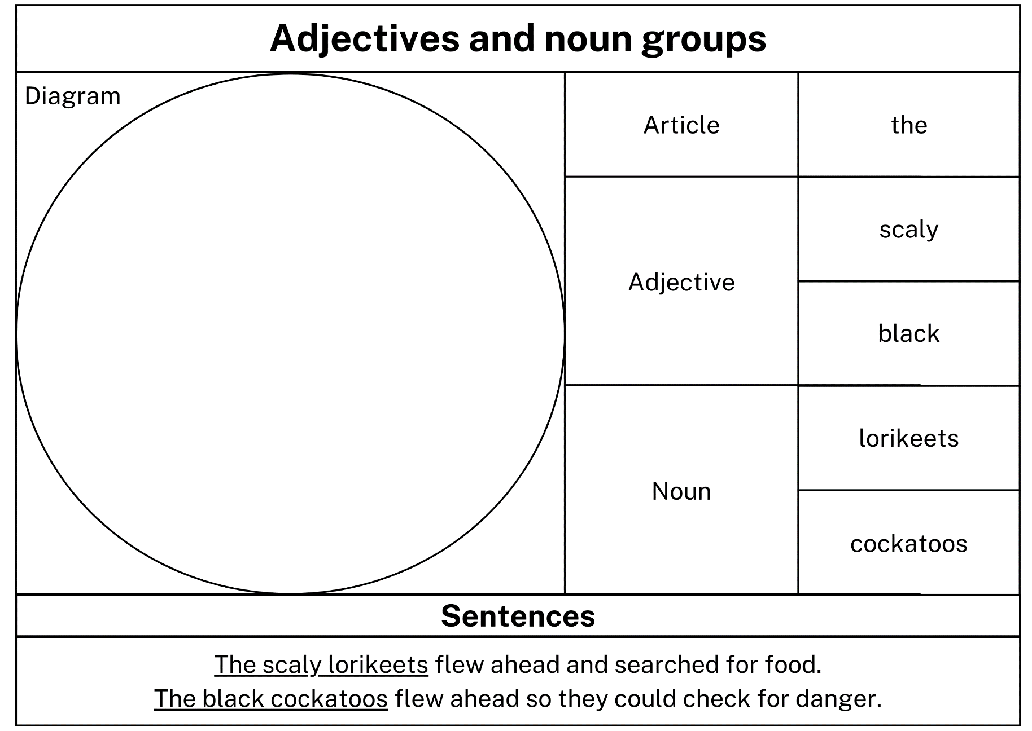
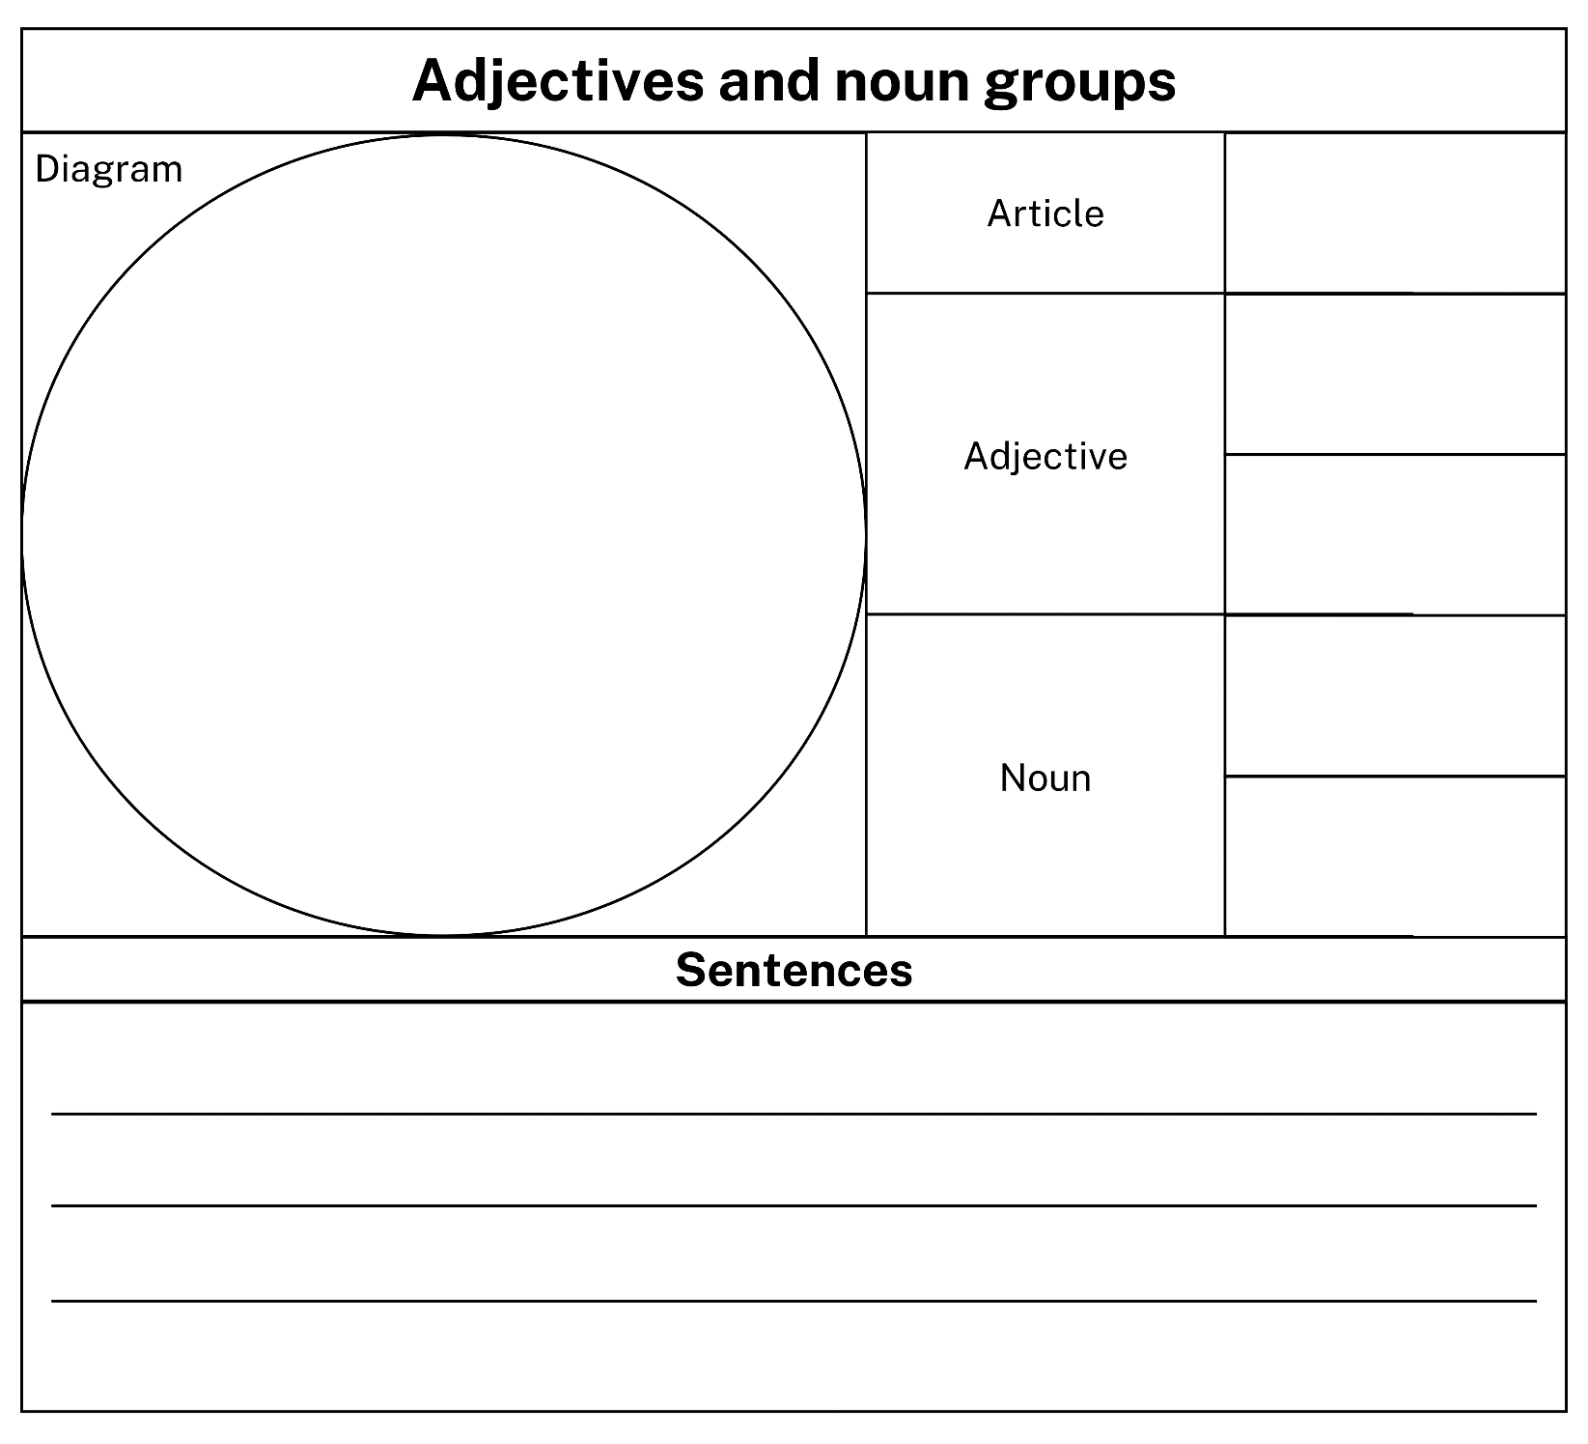

Resource 2: Subordinating conjunctions
after | than
although | that
as | unless
because | where
before | when
if | which
Once | while
so that

Resource 3: Sentence frames
Example:
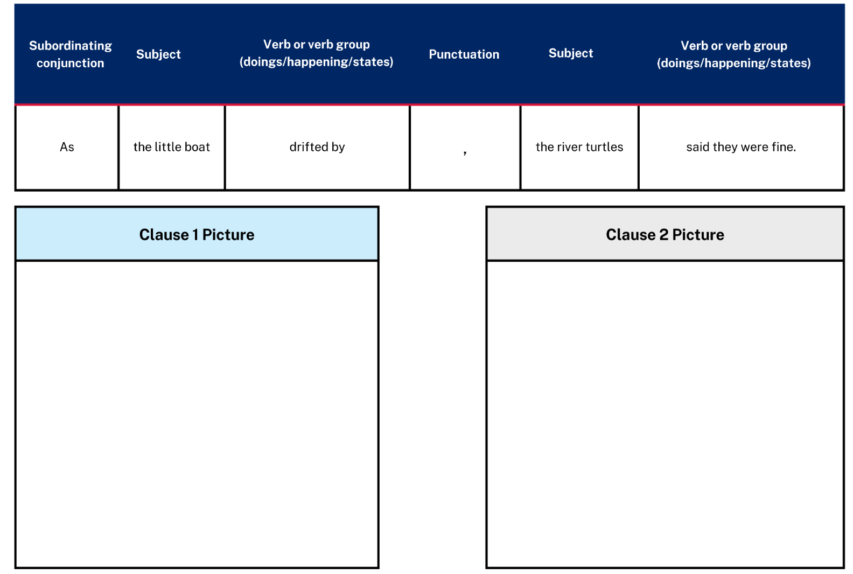
Write ‘As dusk arrived...’ sentences in the frame.
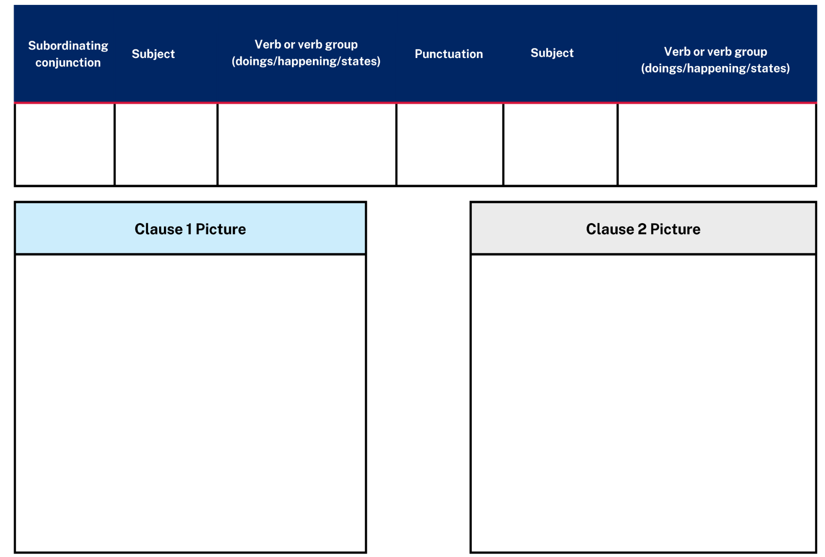

Resource 4: Prepositional phrase strips
in the bush | in the sky | with their friends
next to a burnt tree | as dusk arrived | into a smoky mist
as the little boat drifted by | into a small space on the bow | all the way from Blueberry Farm
on Donkey’s back | into the boat | on the bow
on top of the mast | behind the boat | to shore

Resource 5: Billabong
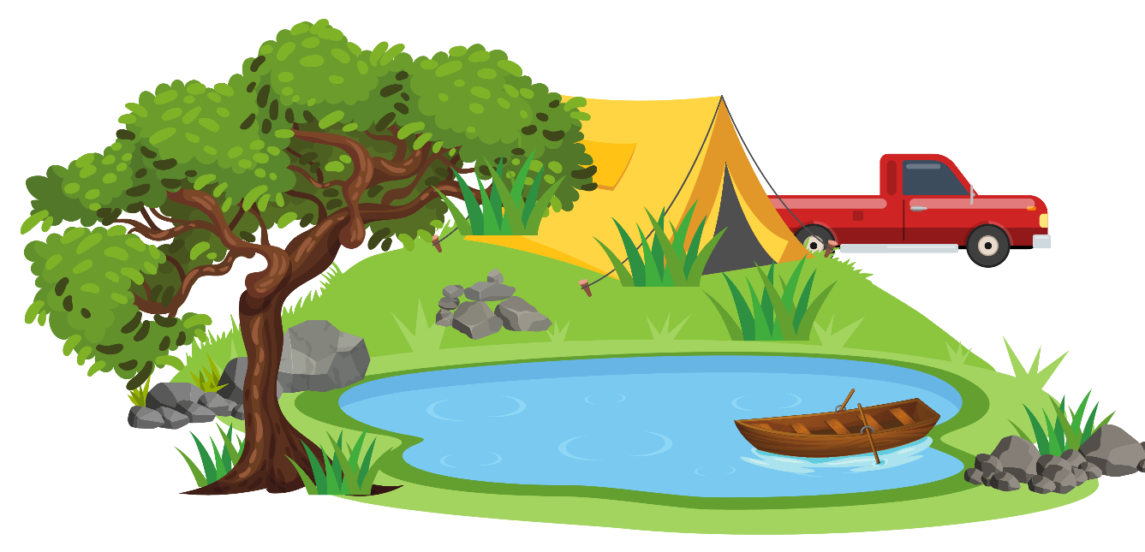
First,
Next,
After that,
Finally,
Images sourced from Canva and used in accordance with the Canva Content License Agreement.

Resource 6: Koala Venn diagram
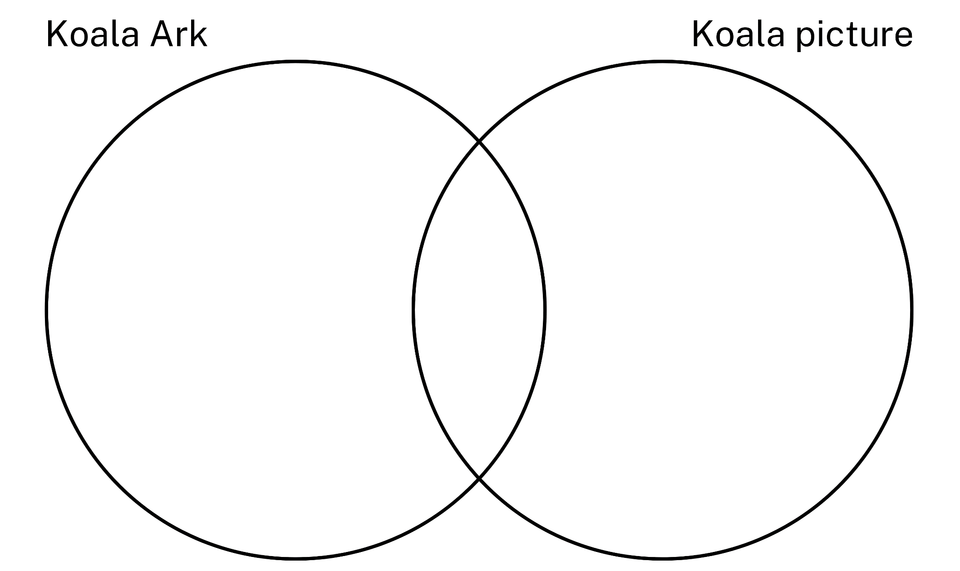

Resource 7: Audio episodes – Koala
Audio episodes – Koala visualisations
Episode 1: Koalas | Episode 2: Threats to koalas | Episode 3: Helping koalas

Resource 8: Persuasive example
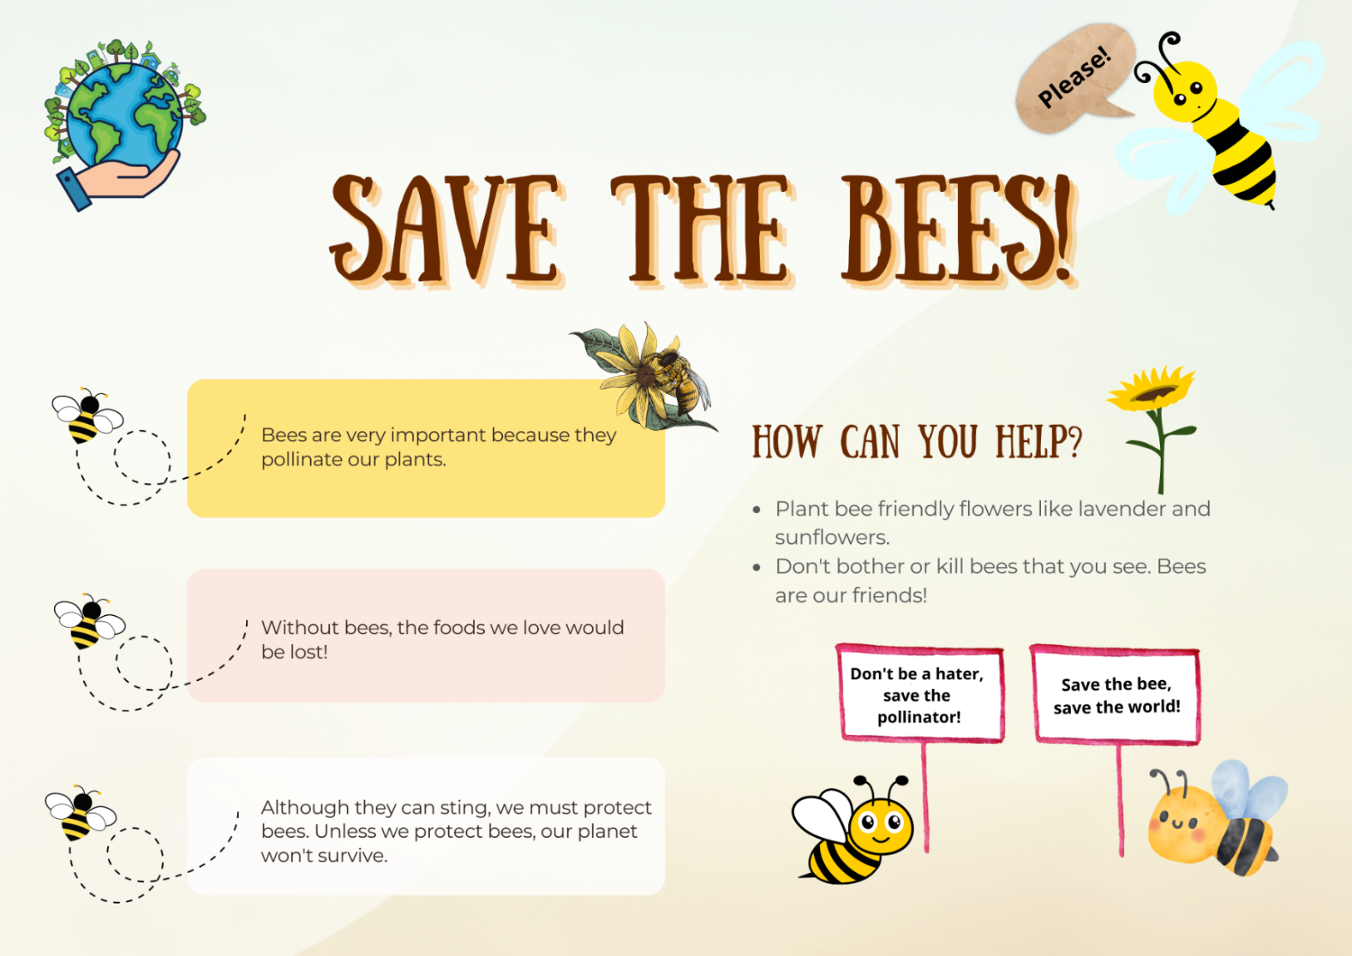
Images sourced from Canva and used in accordance with the Canva Content License Agreement.

Resource 9: Planning scaffold
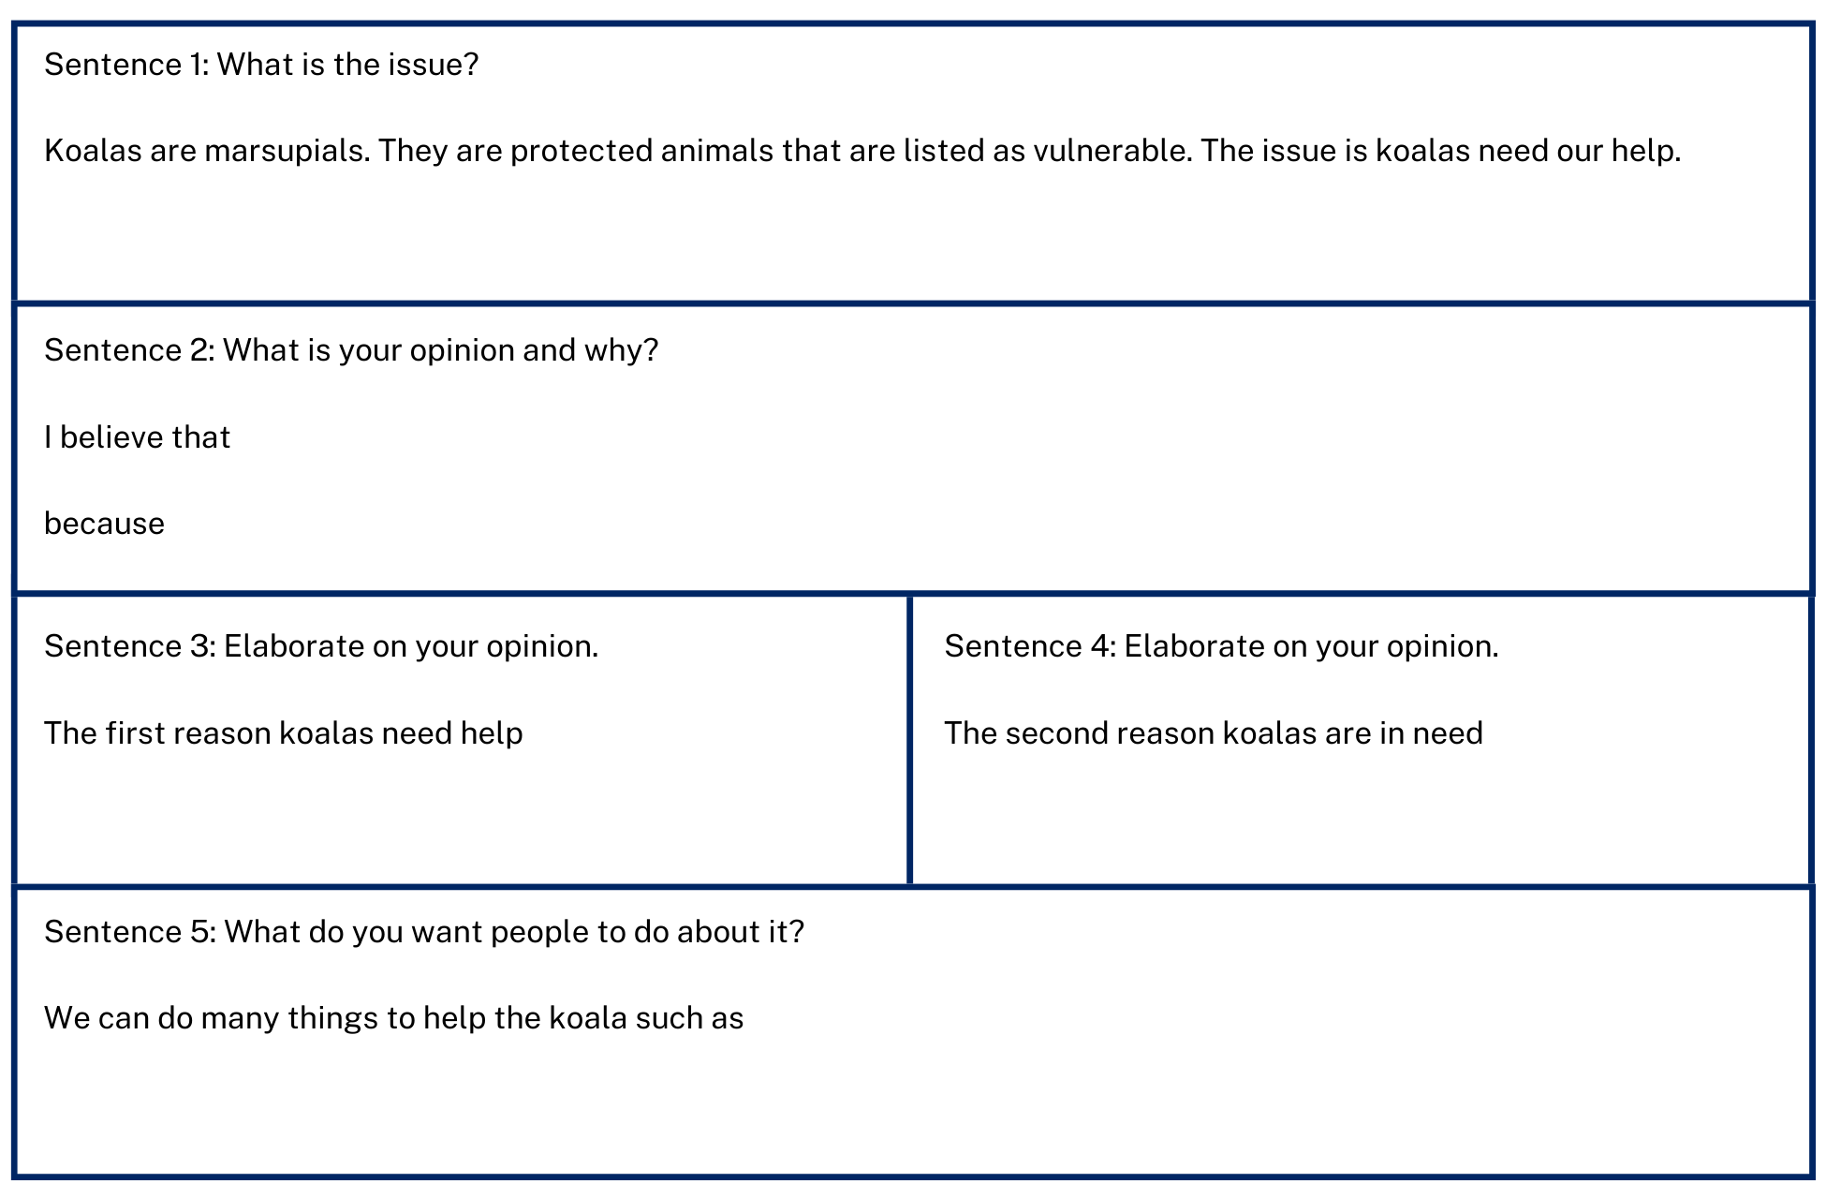

Resource 10: Audio Transcript

Episode 1
Koalas are an Australian native animal. They live in the forests that are found on the eastern and southern coasts of Australia – all the way from South Australia, through Victoria, New South Wales and even up to the tropical regions of Queensland.
Koalas are marsupials. A marsupial is a type of mammal that carries their baby in a pouch, just like a kangaroo, wallaby, wombat, or possum.
Koalas have thick grey-brown fur over their body with white fur on their chest, inner arms, ears, and bottom. They have large furry ears, a rounded, leathery nose, and small brown eyes. They also have very sharp claws and strong arms and legs that help them to climb trees and hold on tight to branches – even while they sleep!
Koalas have a very special diet – they mostly eat leaves from eucalyptus (or gum) trees. Some koalas are also known to eat the flowers, fruit, and bark from a small number of eucalyptus trees.
Did you know that koalas very rarely drink water? They usually get all the water they need from the leaves they eat and from the dew that may be on the leaves.
A baby koala is called a joey – just like other marsupial babies. When a joey is born, it is tiny – about the size of a bee and lives in their mother’s pouch for about 13 weeks. By this stage it is usually big enough to cling to the mother’s back. A joey must hold on tight though because the mother has to spend a lot of her time climbing eucalyptus trees in search of food. When koalas aren’t looking for or eating food, they are usually asleep. In fact, they sleep about 19 hours every day. This is because eucalyptus leaves do not provide a lot of nutrients.
Koalas are a protected animal. In fact, all Australian native animals are protected by Australian government environmental laws. Unfortunately, koalas that live in New South Wales and Queensland have been listed in 2022 as a species that is vulnerable. This means that, unless they are cared for properly, the koalas in these areas may become extinct.
Listen to the next audio recording to understand why koalas need more care and protection.

Episode 2
Last episode, we learnt about koalas – what they look like, what they eat and where they live.
The koala is an iconic Australian animal. This means that people across the world can recognise the koala and know that it lives only in Australia.
During the bushfires of 2019 and 2020, koala habitats were devastated and koala populations across the country suffered badly. News reports spoke about the impact on koalas, and people from around the world made generous donations to help.
Bushfires are not the only problem that impact on koala populations.
Koalas are also threatened by:
- land clearing
- motor vehicles
- dogs, and
- certain diseases.
Let’s talk about land clearing.
People clear land of trees for lots of different reasons. Sometimes this is to build new houses, or new roads. Sometimes land is cleared by farmers to plant crops to feed everyone.
Whatever the reason, every time land is cleared, we risk destroying the habitat of the animals that live there. Some animals can adapt and quite easily move to other areas. But this is much harder for koalas because they have a very specialised diet – made up of mostly eucalyptus, or gum, leaves.
Australia has almost 1,000 native species of gum trees but the koala will only eat from 5 of these:
- in the northern areas of Australia, they only eat from the Forest Gum and the Red Gum, and
- in the southern areas, they only eat from the Manna Gum, the Grey Gum and Swamp Gum.
This means that if people continue to clear the land where these special species of trees are found, koalas will not have anything to eat, and their future will be in great danger.
Listen to the next audio recording to hear about how koala populations are being helped by organisations and individuals.

Episode 3
Last episode, we learnt about the problems that koalas face when land and trees are cleared.
In this episode, we are going to understand how we can help the koala.
There are lots of different rescue organisations across NSW that look after sick and injured koalas. Each of these centres rescue hundreds of koalas every year. When there is a bush fire season, there are a lot more koalas to care for. Koalas can stay in a rescue centre for as little time as a couple of hours, but most take a couple of months to recover before they can be returned to the habitat where they were found.
At each rescue centre, veterinarians – also known as ‘vets’ - check koalas to diagnose their injuries or illness. They treat the koala’s wounds or illness and monitor their recovery.
To help the vets, many volunteers take on jobs, such as caring for orphan joeys, preparing fresh leaves each day, cleaning enclosures, and taking special care of koalas that require a care plan.
When koalas are healthy, they can be released, but before this happens, they are microchipped, and ear tagged so that they can be tracked. Rescued koalas are released back to the same tree where they were found. If that tree is not safe for the koala to return to, then the wildlife carers find another safe area for them.
So, how can you help koalas? Firstly, you can tell others about threats to koalas.
Remember, they are…
- bush fires
- land clearing
- motor vehicles
- dogs, and
- certain disease.
You can also visit koala centres to learn more about this vulnerable, protected Australian marsupial. If you can’t visit a centre, there are plenty of websites you can explore.
You could research different species of eucalyptus trees in your area and plant a koala-friendly food tree.
If you see a sick or injured koala, you must not touch it. Instead, tell an adult and ask them to report it to a koala centre nearby so that the koala can get the special help that they need.
So, what do you think you will do to help koalas?

References
Links to third-party material and websites
Please note that the provided (reading/viewing material/list/links/texts) are a suggestion only and implies no endorsement, by the New South Wales Department of Education, of any author, publisher, or book title. School principals and teachers are best placed to assess the suitability of resources that would complement the curriculum and reflect the needs and interests of their students.
If you use the links provided in this document to access a third-party's website, you acknowledge that the terms of use, including licence terms set out on the third-party's website apply to the use which may be made of the materials on that third-party website or where permitted by the Copyright Act 1968 (Cth). The department accepts no responsibility for content on third-party websites.
Except as otherwise noted, all material is © State of New South Wales (Department of Education), 2021 and licensed under the Creative Commons Attribution 4.0 International License. All other material (third-party material) is used with permission or under licence. Where the copyright owner of third-party material has not licensed their material under a Creative Commons or similar licence, you should contact them directly for permission to reuse their material.
English K–10 Syllabus © 2022 NSW Education Standards Authority (NESA) for and on behalf of the Crown in right of the State of New South Wales.
Creative Arts K–6 Syllabus © 2006 NSW Education Standards Authority (NESA) for and on behalf of the Crown in right of the State of New South Wales.
© 2021 NSW Education Standards Authority. This document contains NSW Curriculum and syllabus content. The NSW Curriculum is developed by the NSW Education Standards Authority. This content is prepared by NESA for and on behalf of the Crown in right of the State of New South Wales. The material is protected by Crown copyright.
Please refer to the NESA Copyright Disclaimer for more information.
NESA holds the only official and up-to-date versions of the NSW Curriculum and syllabus documents. Please visit the NSW Education Standards Authority (NESA) website and the NSW Curriculum website.
National Literacy Learning Progression © Australian Curriculum, Assessment and Reporting Authority (ACARA) 2010 to present, unless otherwise indicated. This material was downloaded from the Australian Curriculum website (National Literacy Learning Progression) (accessed 4 October 2022 and was not modified. The material is licensed under CC BY 4.0. Version updates are tracked in the ‘Curriculum version history’ section on the 'About the Australian Curriculum' page of the Australian Curriculum website.
ACARA does not endorse any product that uses the Australian Curriculum or make any representations as to the quality of such products. Any product that uses material published on this website should not be taken to be affiliated with ACARA or have the sponsorship or approval of ACARA. It is up to each person to make their own assessment of the product, taking into account matters including, but not limited to, the version number and the degree to which the materials align with the content descriptions and achievement standards (where relevant). Where there is a claim of alignment, it is important to check that the materials align with the content descriptions and achievement standards (endorsed by all education Ministers), not the elaborations (examples provided by ACARA).
ETA (English Teachers Association) and NSW Department of Education (2016) The Textual Concepts and Processes resource, English Textual Concepts website, accessed 4 October 2022.
Australian Museum (2022) ‘Satin Bowerbird’, Birds, Australian Museum website, accessed 4 October 2022.
King SM (2022) Books, Stephen Michael King website, accessed 4 October 2022.
King SM (2022) ‘Koala Ark’, Books, Stephen Michael King website, accessed 4 October 2022.
King SM (2022) Koala Ark, Scholastic Australia Pty Ltd.
King SM (2022) ‘Leaf’, Books, Stephen Michael King website, accessed 4 October 2022.
King SM (2022) ‘Rainbow Bear’, Books, Stephen Michael King website, accessed 4 October 2022.
King SM (2022) Stephen Michael King [website], accessed 4 October 2022.

Further reading
Cowan M and Paterson AB (1905) ‘Waltzing Matilda’ [music]: song/words by Paterson AB; music arranged by Cowan M.
Dahl R (2016) Fantastic Mr Fox (Blake Q, illus.), Penguin UK (original work published 1970).
French J (2021) The Fire Wombat (Snell D, illus.), HarperCollins Publishers, Australia.
Lester A (2017) Sophie Scott Goes South, Penguin Australia Pty Ltd.
Sendak M (2012) Where the Wild Things Are, HarperCollins, United States (original work published 1963).

