English – Stage 1 – Unit 23
Contents
Unit overview and instructions for use 3
Teacher notes 4
Outcomes and content – Component A 5
Outcomes and content – Component B 6
Week 1 10
Component A teaching and learning 10
Component B teaching and learning 11
Lesson 1: Previewing Sophie Scott 12
Lesson 2: Text layout, visual features and noun groups 14
Lesson 3: Describing the Aurora Australis 17
Lesson 4: Sophie’s excited exclamations 20
Lesson 5: Understanding how text purpose impacts on tense 21
Week 2 25
Component A teaching and learning 25
Component B teaching and learning 26
Lesson 6: Internet navigation and concept mapping 27
Lesson 7: Adding information and writing paragraphs 30
Lesson 8: Be the expert and digression 31
Lesson 9: Information page 33
Lesson 10: Gallery walk 35
Resource 1: Walk-through words 36
Resource 2: Timeline dates (for display) 37
Resource 3: Note-taking template 38
Resource 4: Online text features and navigation pathways 39
Resource 5: Penguin concept map (Teacher resource) 41
Resource 6: Research topic cards 42
Resource 7: Blank concept map 43
Resource 8: Traffic light paragraphs 44
References 45

Unit overview and instructions for use
This two-week unit is comprised of Component A and Component B. Connecting learning across both components is encouraged.
Teaching and learning | Component A | Component B
Suggested duration | 60 minutes | 45 minutes
Explicit teaching focus areas | - Phonic knowledge  - Reading fluency  - Reading comprehension  - Spelling  - Handwriting | - Oral language and communication  - Vocabulary  - Reading comprehension  - Creating written texts  - Understanding and responding to literature
To prepare for teaching and learning: | - Refer to Outcomes and content – Component A, K-2 – Instructional sequence – grapheme–phoneme correspondences [PDF 825 KB], and the teaching advice documents (hyperlinked in Component A teaching and learning table).  - Based on student needs identified through ongoing assessment data, plan and document how you will sequence teaching and learning in whole class and targeted teaching groups across the two-week cycle. | - Familiarise yourself with Outcomes and content – Component B, Textual concepts information and videos, English Textual Concepts and Learning Processes (2016), and the teaching and learning sequence.  - Based on student needs identified through ongoing assessment data, determine how you will support students in whole class and targeted teaching groups across the two-week cycle as required.
English K–10 Syllabus © 2022 NSW Education Standards Authority (NESA) for and on behalf of the Crown in right of the State of New South Wales.

Teacher notes
- Character is viewed as a description of a fictional person or can reflect lived experience. Characters are ‘made up of verbal or visual statements about what that fictional person does, says and thinks’ – English Textual Concepts and Learning Processes (2016).
- Understanding of character can be supported through watching the department’s video: Character (2:31).
- While ‘character’ is the mentor concept for the conceptual component of this unit, the supporting concept of ‘context’ can be explored using the mentor text Sophie Scott Goes South by Alison Lester.
- A class Resource 2: Timeline dates is displayed and developed throughout this unit.
- Throughout the unit, each student will store all completed tasks in their own plastic sleeve/sheet protector. At the completion of the unit, students will use aspects of their completed tasks to create an A3 poster.
- Reflect on student learning and engagement in activities and record differentiation and adjustments within the unit to inform future teaching and learning. One way of doing this could be to add comments to the digital file.
- Content points are linked to the National Literacy Learning Progression version (3).
Levels and indicators sourced from National Literacy Learning Progression © Australian Curriculum, Assessment and Reporting Authority (ACARA), accessed 9 September 2022 and was not modified. See references for more information.

Outcomes and content – Component A
The table below outlines the focus outcomes and content. Content is linked to the National Literacy Learning Progression version (3).
Focus area and outcome | Content points and National Literacy Learning Progression
Phonic knowledge  EN1-PHOKW-01 – uses initial and extended phonics, including vowel digraphs, trigraphs to decode and encode words when reading and creating texts | - blend and decode 2-syllable words with taught vowel graphs, digraphs, trigraphs and quadgraphs, including graphemes for r-controlled vowels and diphthongs and apply this when reading texts (PKW6, PKW7)  - decode 2-syllable base words with common double consonants when reading texts (PKW7)
Reading fluency  EN1-REFLU-01 – sustains reading unseen texts with automaticity and prosody and self-corrects errors | - self-correct when fluency and/or meaning is interrupted
Reading comprehension  EN1-RECOM-01 – comprehends independently read texts that require sustained reading by activating background and word knowledge, connecting and understanding sentences and whole text, and monitoring for meaning | - register a break in comprehension when reading (UnT5)  - recount relevant ideas from texts in the form of a written, visual or oral summary (UnT6)
Spelling  EN1-SPELL-01 – applies phonological, orthographic and morphological generalisations and strategies when spelling words in a range of writing contexts | - segment multisyllabic words into syllables and phonemes as a strategy for spelling (SpG5)  - explain when to use double consonants to spell 2-syllable base words and apply this when spelling (SpG6)  - use extended phonic code for taught consonant phonemes
Handwriting  EN1-HANDW-01 – uses a legible, fluent and automatic handwriting style, and digital technology, including word-processing applications, when creating texts | - form all letters with consistent size and slope in NSW Foundation Style from memory (HwK5)  - position all letters correctly on the line with appropriate spacing between words (HwK5)

Outcomes and content – Component B
The table below outlines the focus outcomes and content. Content is linked to the National Literacy Learning Progression version (3).
Focus area and outcome | Content points and National Literacy Learning Progression
Oral language and communication  EN1-OLC-01 – communicates effectively by using interpersonal conventions and language to extend and elaborate ideas for social and learning interactions | - respond to information by asking relevant questions to extend their own and others' knowledge (LiS4, LiS6)  - use a range of strategies for effective dialogue and manage digression from a topic (InT3, InT5)
Vocabulary  EN1-VOCAB-01 – understands and effectively uses Tier 1, taught Tier 2 and Tier 3 vocabulary to extend and elaborate ideas | - understand and intentionally choose subject-specific vocabulary to enhance precision and for effect
Reading comprehension  EN1-RECOM-01 – comprehends independently read texts that require sustained reading by activating background and word knowledge, connecting and understanding sentences and whole text, and monitoring for meaning | - use known morphemes and known vocabulary in the text to work out or refine the meaning of unknown words (UnT4)  - draw on sources to seek clarification for unknown words  - use navigation pathways, including hyperlinks, to extract essential information to support reading fluency and enhance meaning when reading digital texts  - combine multiple sources of information within a text to make meaning  - identify how creative visual features are used to expand meaning  - use knowledge of text structure, type of text, author, and forms of writing to predict and confirm meaning (UnT6)  - ask a clarifying question when more background knowledge is needed to make an inference  - recount relevant ideas from texts in the form of a written, visual or oral summary (UnT6)
Creating written texts  EN1-CWT-01 – plans, creates and revises texts written for different purposes, including paragraphs, using knowledge of vocabulary, text features and sentence structure | - write texts that describe, explain, give an opinion, recount an event, tell a story (CrT7)  - group sentences into paragraphs commencing with a topic sentence, followed by other sentences with related ideas (CrT7)  - use appropriate tense across a text (GrA4)  - use noun groups to build descriptions of people and things (CrT6)  - use punctuation, including question marks and exclamation marks, accurately and for effect (PuN3)  - make intentional word choices to enhance precision of meaning and ideas in a text (CrT5)  - use different modes and media to enhance the presentation of texts they have created (CrT5, CrT6)  - use knowledge of similarities and differences between imaginative, informative and persuasive texts when planning for writing
Understanding and responding to literature  EN1-UARL-01 – understands and responds to literature by creating texts using similar structures, intentional language choices and features appropriate to audience and purpose | - identify how the language and form of a text vary according to purpose, audience and mode (UnT5)  - identify how characters are constructed through different modes and media and through a combination of modes  - identify how a character reflects their own or other lived experiences

Week 1

Component A teaching and learning
The table below can be used to plan and document lessons that address Component A outcomes and content. Both the detailed example [DOC 529KB] of a two-week teaching and learning cycle and brief example [DOC 66KB] may support you in your planning.
Focus Areas | Lesson 1 | Lesson 2 | Lesson 3 | Lesson 4 | Lesson 5
Phonic knowledge
15 minutes
Spelling and Handwriting
15 minutes
Reading comprehension and Reading fluency
30 minutes

Component B teaching and learning
The following teaching and learning sequence has been designed to address Component B outcomes and content. Adapt the sequence as required to best meet the needs of your students.

Learning intention and success criteria
Learning intentions and success criteria are best co-constructed with students.

Learning intention
Students are learning to explore real and imagined characters and engage with multiple text forms.

Success criteria
Students can:
- make predictions about a text
- identify features of texts and use noun groups to describe them
- use Tier 2 and Tier 3 words when writing
- understand the use of exclamations in texts and correctly use them when writing
- use correct tense when writing.

Resources
- Lester A (2012) Sophie Scott Goes South, Puffin, Australia. ISBN13: 9780143786337
- Resource 1: Walk-through words for teacher reference
- Resource 2: Timeline dates (for classroom display)
- Resource 3: Note-taking template
- Video: Icebreaker Tour: Aurora Australis (3:06)
- Blank paper/plastic sleeves for each student
- Blank flashcards to record events
- Coloured copies of Day 2 double page for pairs or small groups
- Mini whiteboards and markers
- Sticky notes

Lesson 1: Previewing Sophie Scott
Note: Throughout the unit, each student will store all completed tasks in their own plastic sleeve/sheet protector. At the completion of the unit, students will use aspects of their completed tasks to create an A3 poster.
- Introduce the text Sophie Scott Goes South. Display the front and back covers. Students Think-Pair-Share to discuss:
- what they can see
- what they can predict from the covers
- what they think the text is about.
- Display the first endpaper (double page at the beginning of the text) and read a selection of the information.
- Read the publisher’s page with the photograph of Alison Lester. Discuss:
- that the text is based on real experiences when the author, Alison Lester, travelled to Antarctica
- that Sophie is a fictional character, but her name is based on fact; the surname Scott is the same as the Antarctic explorer, Robert Falcon Scott
- that the text is written from Sophie’s perspective.
- Ask why the author chose to write from the perspective of Sophie Scott, instead of her own.
- Students fold a page in half. Label one side ‘prediction 1’ and the other side ‘prediction 2’.
- Students draw a picture and write 5 words on the ‘prediction 1’ side.
- Distribute 5 additional words to each student from the text using Resource 1: Walk-through words.
Note: A book walk is a preview of the text before reading. It allows students to build a mental model of the content.
- Preview Sophie Scott Goes South with a book walk. While previewing the text:
- Conduct a scavenger hunt where students respond by putting their hands on their head if they notice a walk-through word, or one of their prediction words, or a picture. For example, turn to the first double page of the text and look at the picture of the animals in the ocean. If a student drew one of them, they indicate their predication was correct by placing their hands on their head. When appropriate, students can explain the reasoning behind their prediction.
- Display the glossary on the last double page. Review students’ understanding of a glossary and define the term if necessary. Read 2 to 3 words and their definitions. Compare the glossary to a dictionary. Discuss the subject-specific purpose of a glossary.
- Students review their picture and words from ’prediction 1’. Students write and draw ‘prediction 2’. This second prediction can get students to think more deeply about the content, characters and setting that may be explored throughout the text. Students may also write a variety of sentences on what they would like to learn while reading this text.
Too hard? Students annotate their picture with labels and additional words.
Too easy? Students include appropriate words from the glossary to enhance the use of subject-specific vocabulary in their writing.
- In pairs, students share their writing.

Lesson 2: Text layout, visual features and noun groups
- Read the text on pre-departure and Day 1 of Sophie Scott Goes South.
- Discuss key events and summarise on flashcards. Key event flashcards will be created throughout the unit and can be added to a classroom display of Resource 2: Timeline dates. This will support students to understand how to recount key events and present them in a written and visual summary.
Note: Quick, write involves students writing rapidly and without stopping in response to a prompt or open-ended question. It provides an opportunity to informally assess students' thinking, supports students to develop writing fluency, creates a habit of reflection, and encourages critical thinking.
- Students select either pre-departure or Day 1 to complete a ‘Quick, write’ answering:
- What would you see if you were Sophie?
- What would be the most interesting thing? Why?
Too hard? Use ‘Quick, draw’ to support students’ visualisation; add labels.
- Display pre-departure and Day 1 of Sophie Scott Goes South. Model reading the visual features and discuss how they add meaning to the text. For example, read and discuss:
- labels – identify Mum, Dad, Alfie and Sophie
- tick and cross symbols – identify items found in Antarctica and exclude the polar bear
- images next to the text – provide Sophie’s point of view from the bunk and from the ship; stamps add authenticity
- labels and collage of photographs – add detailed information about the Aurora Australis.
- Display the blue and white iceberg drawing; compare to the red Aurora Australis photographs. Explore the repetitive use of shades of blue and white, and red and black colour palettes throughout the text. Make text-to-text connections by recalling the colour palettes from recent texts. For example, Where the Wild Things Are – the colour palette of greens for the jungle; Welcome to Country – the colour palettes of red, brown and greens for the earth; Mr Huff – the colour palette of greys for the clouds.
- Students turn and talk to share ideas about why authors use different colours, and the meaning they convey. Share ideas with the class. Review the features and colours that may be most appropriate when students are illustrating a variety of texts. For example, an information text about your school, a narrative set at a beach, a persuasive text about the effects of rubbish pollution.
- Read the final paragraph from Day 1: ‘As we left Hobart, a big moon reflected on the water and lights twinkled along the hills. I felt like an astronaut, heading into outer space, a bit scared, but very excited.’ Discuss the figurative language and how Sophie felt as she left Hobart.
- Discuss times when students may have had mixed feelings like Sophie. For example, on their first day at school, they may have felt ‘a bit scared’ because everything was new, and ‘a bit excited’ because they may have made new friends and played with them.
- Students adopt the role of illustrator and create a drawing in the style of Alison Lester to pair with Sophie’s description of Day 1. Students use appropriate colours, style, and labelling features.
- Revise and identify noun groups as a group of words that:
- build descriptions of people and things
- create a picture to help readers visualise the scene
- contain an article and a noun plus one or more adjectives or adjectival phrases.
- Display examples of noun groups from the text: ‘a reading light just above my pillow’; ‘the lolly-coloured streamers’; ‘the big, orange lifeboats’. Share the pen to deconstruct the noun groups. Highlight the articles, underline the adjectives, circle the nouns. Read sections of the text with the noun groups removed. Discuss the impact.
- Students write a description including noun groups to match the visuals they have created in activity 9.
- Students share their texts with the class.
Too hard? Students label their pictures using noun groups.
Too easy? Students write a description that contains noun groups with adjectival phrases.

Lesson 3: Describing the Aurora Australis
- Read the text for Day 2 and Day 5 of Sophie Scott Goes South.
- Discuss key events and summarise on flashcards. Add flashcards to a classroom display of Resource 2: Timeline dates.
Note: Tier 2 words are of high utility for mature language users and are found across a variety of domains. Tier 3 words are used rarely (low frequency) and only in highly specific situations.
- Students identify Tier 2 and Tier 3 vocabulary used in the text so far. For example, Aurora Australis, icebreaker, blizzards, transducer, helideck, expedition, berth. List on an anchor chart.
- In small groups or pairs, distribute a colour copy of Day 2 for students to examine.
- Students list Tier 2 and Tier 3 vocabulary on mini whiteboards.
- Add the words that students have written to the anchor chart.
- Display the glossary in Sophie Scott Goes South and identify words on the anchor chart that have glossary meanings.
- Read the first paragraph on the second page of Day 2 which provides information on different parts of the ship. Explain that known vocabulary helps to refine the meaning of unknown words. For example, students know the word ‘kitchen’ but may not know the subject-specific word ‘galley’ without making the explicit connection between the 2 words.
- Students refer to a copy of Day 2 and identify items on the ship using their subject-specific name. For example, bunk becomes berth, window becomes porthole.
- Individually or in pairs, students are allocated a word from the Tier 2 and Tier 3 vocabulary anchor chart. Students write the word on a sticky note and use the text, glossary, or dictionary to find the meaning. Add a definition to the sticky note.
- Collate into Tier 2 and Tier 3 words to make a word wall. Discuss and clarify unknown words.
- To develop an understanding of the setting, Aurora Australis, students view a video and take notes.
- Explicitly teach that note-taking is a quick process and includes:
- only key information/main ideas – spelling is not a focus
- questions or comments about the information
- organised information
- pictures or diagrams.
- View the cross section of the Aurora Australis on Day 2 and list spaces on the ship. For example, the bridge, the helideck, the expedition cabin, the trawl deck, the mess/restaurant/galley, and cargo hold.
- View Icebreaker Tour: Aurora Australis (3:06) and model taking notes about the trawl deck. For example, airtight door so water cannot get through, scientists throw nets out, scientists throw other equipment into the ocean.
- Model re-writing the notes to form sentences. For example, Scientists use the trawl deck for their experiments. They throw nets and equipment into the ocean to collect fish.
- Students select a space from activity 14. Provide Resource 3: Note-taking template. Students write notes and draw images from the text.
- View Icebreaker Tour: Aurora Australis (3:06) and write video content notes on Resource 3: Note-taking template.
- After watching the video, add new Tier 2 and Tier 3 vocabulary to the word wall and clarify the meaning of unknown words.
- Model combining information from all sources to write an informative text using Tier 2 and Tier 3 vocabulary.
Too hard? Students are provided with words specific to their space to include in their writing.
- Students share their writing with a partner.
Stage 1 Assessment task 1 – Observations and work samples from this lesson allow students to demonstrate achievement towards the following syllabus outcomes and content points:
EN1-VOCAB-01 – understands and effectively uses Tier 1, taught Tier 2 and Tier 3 vocabulary to extend and elaborate ideas
- understand and intentionally choose subject-specific vocabulary to enhance precision and for effect.
EN1-RECOM-01 – comprehends independently read texts that require sustained reading by activating background and word knowledge, connecting and understanding sentences and whole text, and monitoring for meaning
- use known morphemes and known vocabulary in the text to work out or refine the meaning of unknown words
- draw on sources to seek clarification for unknown words
- combine multiple sources of information within a text to make meaning
- identify how creative visual features are used to expand meaning.
EN1-CWT-01 – plans, creates and revises texts written for different purposes, including paragraphs, using knowledge of vocabulary, text features and sentence structure
- make intentional word choices to enhance precision of meaning and ideas in a text
- character reflects their own or other lived experiences.

Lesson 4: Sophie’s excited exclamations
- Read the text on Day 7 and Day 10 of Sophie Scott Goes South.
- Discuss key events and summarise on flashcards. Add flashcards to the class timeline.
- Students use the ‘Quick, write’ strategy and listed key events as prompts:
- Sophie says, ‘As we head towards Antarctica it feels as though we are entering an icy kingdom and the icebergs are guarding it.’ Students look at the pictures and describe the icy kingdom.
- Describe Sophie’s feelings.
- Recall from Lesson 2 that Sophie described her feelings using figurative language, for example, ‘felt like an astronaut, heading into outer space’. Compare to the language ‘entering an icy kingdom and the icebergs are guarding it’. Sophie has again described the scene using descriptive language. Discuss the personification of the icebergs ‘guarding’ the ‘icy kingdom’.
- Display Day 7 and Day 10 of Sophie Scott Goes South and note punctuation. For example, capital letters, full stops, commas, apostrophes, exclamation marks.
- Explicitly teach that exclamations are sentences that contain a strong emotion and often contain an exclamation mark. Identify examples in the text, for example, ‘Woohoo!’ ‘I can’t wait!’ ‘My first icebergs!’ Consider why the author has used so many exclamations from the character Sophie. Think about if all members of the ship would speak in the same way. Discuss what this tells us about the character Sophie Scott.
- Model saying one of the exclamations in normal tone and then with enthusiasm. Discuss the difference.
- Read scenarios selected from the text (examples listed below). Students act out each Freeze Frame scenario and respond with an exclamation that demonstrates Sophie’s strong feelings. For example, read from Day 5:
Last night the ship was rocking and rolling like crazy. Anything that’s not tied down goes flying and I have to hold on all the time. Sometimes a wave bashes the ship so hard that it feels as though we’ve hit a rock.
- Teacher says ‘Freeze’. In pairs, each student responds with an exclamation that demonstrates Sophie’s strong feelings. Repeat with different scenarios. For example:
- Day 7 – ‘When I looked out my porthole this morning there were two big icebergs on the horizon! My first icebergs!’
- Day 10 – ‘I’m so cold I can hardly type.’
- Day 10 – ‘I loved looking at the ice cracking as the Aurora pushed through it, and while I was watching, A SEAL POKED ITS HEAD THROUGH THE ICE!’
- Discuss and list student exclamation responses. For example, ‘Wow! Oh no!’
- Students select an event from the story, or one that they think could have occurred on Day 7 or Day 10 and draw a picture. Students add an exclamation and sentences to show how the character Sophie would react. For example, students may draw a seal popping its head out of the ice and write ‘Oh wow! I saw a seal that had the biggest eyes and super long whiskers. It was so cute!’
Too easy? Students add multiple exclamation reactions.

Lesson 5: Understanding how text purpose impacts on tense
- Read the text on Day 12, Day 13 and Day 14 of Sophie Scott Goes South.
- Discuss key events and summarise on flashcards. Add flashcards to the class timeline.
- Review the timeline to recount ideas from the text. Select students to demonstrate their understanding of the events by providing an oral summary.
- Students use the ‘Quick, write’ strategy and listed key events to answer:
- Why did Sophie feel proud?
- Imagine standing on Antarctica. What would you see and how would you feel?
- Recall details of Sophie’s character from Lesson 1. For example, Sophie is fictional although the activities are based on Alison Lester’s own experiences. Discuss known characters from other texts or media that are real or imagined, or a combination of both.
- Brainstorm ideas about the character of Sophie Scott. For example:
- she is a girl who likes to draw and learn new things
- she is adventurous and based on a real person and real events
- she writes about her experiences in a diary.
- Discuss the features of diaries:
- Purpose: to recount or recall the events over time
- Organisation: chronological; Sophie’s diary uses numbered days
- Tense: diary entries are usually written in past tense; they recount events that have happened
- Content: details and description of activities/actions; personal observations, thoughts, and feelings.
- Display the entry for Day 12. Identify the past tense verbs, for example, thought, worried, stopped, crossed.
- Revise and discuss regular and irregular past tense verbs.
- List the base words when the suffix -ed is removed and the tense is changed (from past tense to present tense). For example, ‘stopped’ changes to ‘stop’; ‘excited’ changes to ‘excite’; ‘shifted’ changes to ‘shift’.
- Identify irregular past tense verbs. For example, thought, blew. Students identify the regular present tense for each verb – think, blow.
- Explain that information texts are often written in present tense because their purpose is to inform the reader about a specific subject that has information that is consistent over time, unlike diaries which are in past tense because their purpose is to record events that have happened.
- Brainstorm information about icebergs using text, images, and students’ general knowledge.
- Share the pen to write an informative text about icebergs. For example, ‘Icebergs are large pieces of ice made from fresh water. We cannot see the whole iceberg because it is mostly below sea level. As they melt and break apart, icebergs can be dangerous because they can flip over’.
- Students circle the verbs and identify the tense.
- Students draw an iceberg and write an informative text using present tense, noun groups and a variety of sentences.
Too hard? Students draw and label their illustration using present tense verbs and noun groups.
Too easy? Students make intentional word choices to enhance the precision of information about icebergs. Extended information on the topic can be included in short paragraphs.
- Students identify a descriptive noun group from their writing to share with the class.
Stage 1 Assessment task 2 – Observations and work samples from this lesson allow students to demonstrate achievement towards the following syllabus outcomes and content points:
EN1-CWT-01 – plans, creates and revises texts written for different purposes, including paragraphs, using knowledge of vocabulary, text features and sentence structure
- write texts that describe, explain, give an opinion, recount an event, tell a story
- use appropriate tense across a text
- use noun groups to build descriptions of people and things
- use knowledge of similarities and differences between imaginative, informative and persuasive texts when planning for writing.
EN1-UARL-01 – understands and responds to literature by creating texts using similar structures, intentional language choices and features appropriate to audience and purpose
- identify how characters are constructed through different modes and media and through a combination of modes.

Week 2

Component A teaching and learning
The table below can be used to plan and document lessons that address Component A outcomes and content. Both the detailed example [DOC 529KB] of a two-week teaching and learning cycle and brief example [DOC 66KB] may support you in your planning.
Focus Areas | Lesson 6 | Lesson 7 | Lesson 8 | Lesson 9 | Lesson 10
Phonic knowledge
15 minutes
Spelling and Handwriting
15 minutes
Reading comprehension and Reading fluency
30 minutes

Component B teaching and learning
The following teaching and learning sequence has been designed to address Component B outcomes and content. Adapt the sequence as required to best meet the needs of your students.

Learning intention and success criteria
Learning intentions and success criteria are best co-constructed with students.

Learning intention
Students are learning to engage with multiple text forms and use a range of strategies to extend their own and others’ knowledge.

Success criteria
Students can:
- use navigation pathways to find information and write on a concept map
- write informative paragraphs
- use strategies to stay on topic
- create and annotate an information page
- respond to and celebrate the work of peers.

Resources
- Resource 4: Online text features and navigation pathways
- Resource 5: Penguin concept map (Teacher resource)
- Resource 6: Research topic cards
- Resource 7: Blank concept map
- Resource 8: Traffic light paragraphs
- Website: Australian Antarctic Program – About Antarctica
- Lester A (2012) Sophie Scott Goes South, Puffin, Australia. ISBN13: 9780143786337
- Blank flashcards to record events
- A3 paper, scissor, glue, pencils, markers
- Mini whiteboards
- Sticky notes

Lesson 6: Internet navigation and concept mapping
- Read the text on Day 15 and Day 16 of Sophie Scott Goes South.
- Discuss key events and summarise on flashcards. Add flashcards to the class timeline.
- Review the timeline to recount ideas from the text. Select students to demonstrate their understanding of the events by providing an oral summary.
- Revise that Sophie Scott Goes South is based on Alison Lester’s adventure through the eyes of a fictional character, Sophie.
- Display Australian Antarctic Program – About Antarctica. Discuss key content on the page.
- Compare printed texts to digital texts and discuss the similarities and differences.
- Explore the navigation pathways and tools on the webpage, including the use of embedded images and captions. Model how to click on images, which direct you to another page. Explain that the Australian Antarctic Program is a trusted source and that the website’s ‘About us’ page, located on the navigation band at the top of the page, indicates that it is part of the Australian Government’s Department of Climate Change, Energy, the Environment and Water.
Note: For support in reading and viewing digital texts, see Digital and multimodal texts and Resource 4: Online text features and navigation pathways.
- Model how to find information about chinstrap penguins using the search function.
- Define the metalanguage of the subheadings and list alternate words. For example:
- Physical description and related species – appearance or description
- Distribution and abundance – location and number.
- List features of the webpage. For example, photos, headings, information.
- Review notetaking information from Lesson 3. Display the Chinstrap penguin webpage and read the section ‘Physical description and related species’. During reading, students take notes using keywords, sentences, or questions on mini whiteboards.
- Explain that students will be organising their notes using a Concept map. Display the concept maps (Slide 7 including ‘main’ and ‘subconcepts’). Compare the language of ‘subconcept’ with ‘subheading’. Note that a subheading is used to categorise information.
- Refer to the Chinstrap penguin webpage and brainstorm titles for the ‘subheading’ boxes. Model adding the subheadings to the map. For teacher support, refer to Resource 5: Penguin concept map.
- Read other sections of the Chinstrap penguin webpage while students take notes.
- Model adding extra information to the concept map using student whiteboard notes.
- Individually or in small groups, students:
- select an Antarctic animal from Resource 6: Research topic cards.
- write the name of the animal and add subheadings to a printed copy of Resource 7: Blank concept map or the Concept map digital version
- research information about their animal from the webpage and from the images and text in Sophie Scott Goes South
- add information to complete the concept map.
Too hard? Students work in pairs.
Too easy? Students individually research a topic from Resource 6: Research topic cards ‘Additional topics’ table.
Stage 1 Assessment task 3 – Observations and work samples from this lesson allow students to demonstrate achievement towards the following syllabus outcomes and content points:
EN1-RECOM-01 – comprehends independently read texts that require sustained reading by activating background and word knowledge, connecting and understanding sentences and whole text, and monitoring for meaning
- use navigation pathways, including hyperlinks, to extract essential information to support reading fluency and enhance meaning when reading digital texts
- use knowledge of text structure, type of text, author, and forms of writing to predict and confirm meaning.
EN1-UARL-01 – understands and responds to literature by creating texts using similar structures, intentional language choices and features appropriate to audience and purpose
- identify how the language and form of a text vary according to purpose, audience and mode.

Lesson 7: Adding information and writing paragraphs
- Read the text on Day 17 and Day 18 of Sophie Scott Goes South.
- Discuss key events and summarise on flashcards. Add flashcards to the class timeline.
- Students turn and talk to a partner to share their concept map from Lesson 6.
- Explain that information can be gathered from numerous sources. Students review their concept map and add relevant information from Sophie Scott Goes South.
- Display Resource 8: Traffic light paragraphs. Review the features of paragraphs, drawing attention to:
- groups of sentences
- topic sentences – noting that these usually occur at the start of a paragraph and indicate the main idea
- sentences with related ideas
- the closing sentence.
- Co-construct success criteria for writing an informative text.
- Model writing an informative paragraph in present tense using Resource 5: Penguin concept map and Resource 8: Traffic light paragraphs. For example, a paragraph about the subheading of appearance: A chinstrap penguin is a bird that cannot fly. It has a black band of feathers below its chin that looks like a strap. It weighs between 3.5 kg to 5.5 kg. Males are bigger and heavier than females.
- Students write an informative paragraph about the appearance to describe their animal using present tense.
Too hard? Facilitate use of text-to-speech technology or audio recording to produce the text.
Too easy? Students edit their writing to include more complex information.
- Model drawing a labelled picture of the chinstrap penguin. Explain how adding diagrams and pictures to writing can give detailed information that is specific to the topic. For example, when labelling a chinstrap penguin, instead of using a general label such as ‘chin’, an arrow towards the chin and a short description such as ‘strap-like band of feathers’ can be used.
- Students add labelled pictures to their paragraph to provide more information.

Lesson 8: Be the expert and digression
- Read the text on Day 19 and Day 22 of Sophie Scott Goes South.
- Discuss key events and summarise on flashcards. Add flashcards to the class timeline.
- Review the paragraph writing from Lesson 7. Share the pen to model writing a paragraph about another subheading. For example, ‘diet’: A chinstrap penguin eats mainly krill or fish. They dive for food at midday and midnight.
- Students write paragraphs about their selected animal for each subheading using their completed concept map from Lesson 6 and Resource 8: Traffic light paragraphs.
- Students share their writing with a partner and provide feedback using the success criteria and TAG feedback proforma. Students review their writing and apply feedback.
- Students publish their writing.
Stage 1 Assessment task 4 – Collecting work samples from this lesson allows students to demonstrate achievement towards the following syllabus outcome and content points:
EN1-CWT-01 – plans, creates and revises texts written for different purposes, including paragraphs, using knowledge of vocabulary, text features and sentence structure
- write texts that describe, explain, give an opinion, recount an event, tell a story
- group sentences into paragraphs commencing with a topic sentence, followed by other sentences with related ideas
- use punctuation, including question marks and exclamation marks, accurately and for effect
- use different modes and media to enhance the presentation of texts they have created.
- Explain that students are going to have the chance to share information from their research. Model sharing information in a conversation. For example, as teacher-in-role, ask a student to ‘join you for a chat’, and model:
- facing your partner and giving eye contact
- using keywords as a prompt to the conversation instead of reading information word-for-word
- avoiding digression
- asking questions.
- Review the ‘conversation’ and discuss the important features. Model examples of questions students could ask, for example, ‘Is a chinstrap penguin like a fairy penguin?’
- Students write key ideas for their conversation on sticky notes.
- Students in the role of expert, discuss their topic with a partner or small group.
Stage 1 Assessment task 5 – Observations and work samples from this lesson allow students to demonstrate achievement towards the following syllabus outcomes and content points:
EN1-OLC-01 – communicates effectively by using interpersonal conventions and language to extend and elaborate ideas for social and learning interactions
- respond to information by asking relevant questions to extend their own and others' knowledge
- use a range of strategies for effective dialogue and manage digression from a topic.
EN1-RECOM-01 – comprehends independently read texts that require sustained reading by activating background and word knowledge, connecting and understanding sentences and whole text, and monitoring for meaning
- recount relevant ideas from texts in the form of a written, visual or oral summary
- ask a clarifying question when more background knowledge is needed to make an inference.

Lesson 9: Information page
- Read the text on Day 25 and Day 30 of Sophie Scott Goes South.
- Discuss key events and summarise on flashcards. Add flashcards to the class timeline.
- Review the timeline to recount ideas from the text. Discuss why there is a four-day gap in the diary entries. Review other gaps between the diary entries and discuss the reasons. For example:
- Days 3 and 4 – The author noted that the sea was too rough.
- Days 20 and 21 – The author noted that ‘the ice was so thick it has taken 3 days to get this far’.
- Day 6, Days 8 and 9, Day 11, Days 23 and 24, Days 25, 26, 27, 28, 29 – There is no author explanation. Discuss.
- Revisit Day 7 from Sophie Scott Goes South. Display the page and note the layout and features used to present the information. For example, words, pictures, diagrams, photographs, and labels. Discuss the purpose and effect of the layout.
- Explain that students will be compiling an A3 information page that highlights their completed tasks and their understanding of text layout. Explain how to:
- annotate samples with sticky notes
- add small drawings.
- Display a student’s plastic sleeve/sheet protector with completed tasks and discuss that students will need to select samples:
- Lesson 1: picture prediction and sentences
- Lesson 2: noun group pictures and description
- Lesson 3: drawn and labelled Aurora Australis space
- Lesson 4: exclamation pictures
- Lesson 6: concept map
- Lesson 8: published information.
- Compare to Alison Lester’s decision to include the most interesting events in Sophie Scott Goes South.
Note: Students may need additional time to complete tasks prior to arranging their information page.
- Students arrange and glue work samples on an A3 page.
- Students annotate using sticky notes, labels, and small drawings to add meaning to the information page.

Lesson 10: Gallery walk
- Review the class timeline display to recount ideas from the text. Select students to demonstrate their understanding of the events by providing an oral summary.
- Provide time for students to finalise their A3 information page.
- Arrange and display students’ A3 information pages around the classroom for a gallery walk.
- Outline the response requirements for completing the gallery walk – students attach sticky note responses to their peers’ A3 information page, noting:
- a question about the topic
- something they liked about the information page
- something they learned about the topic.
- Students move around the classroom writing responses for their peers.
- Students return to their information page and review peer responses.

Resource 1: Walk-through words
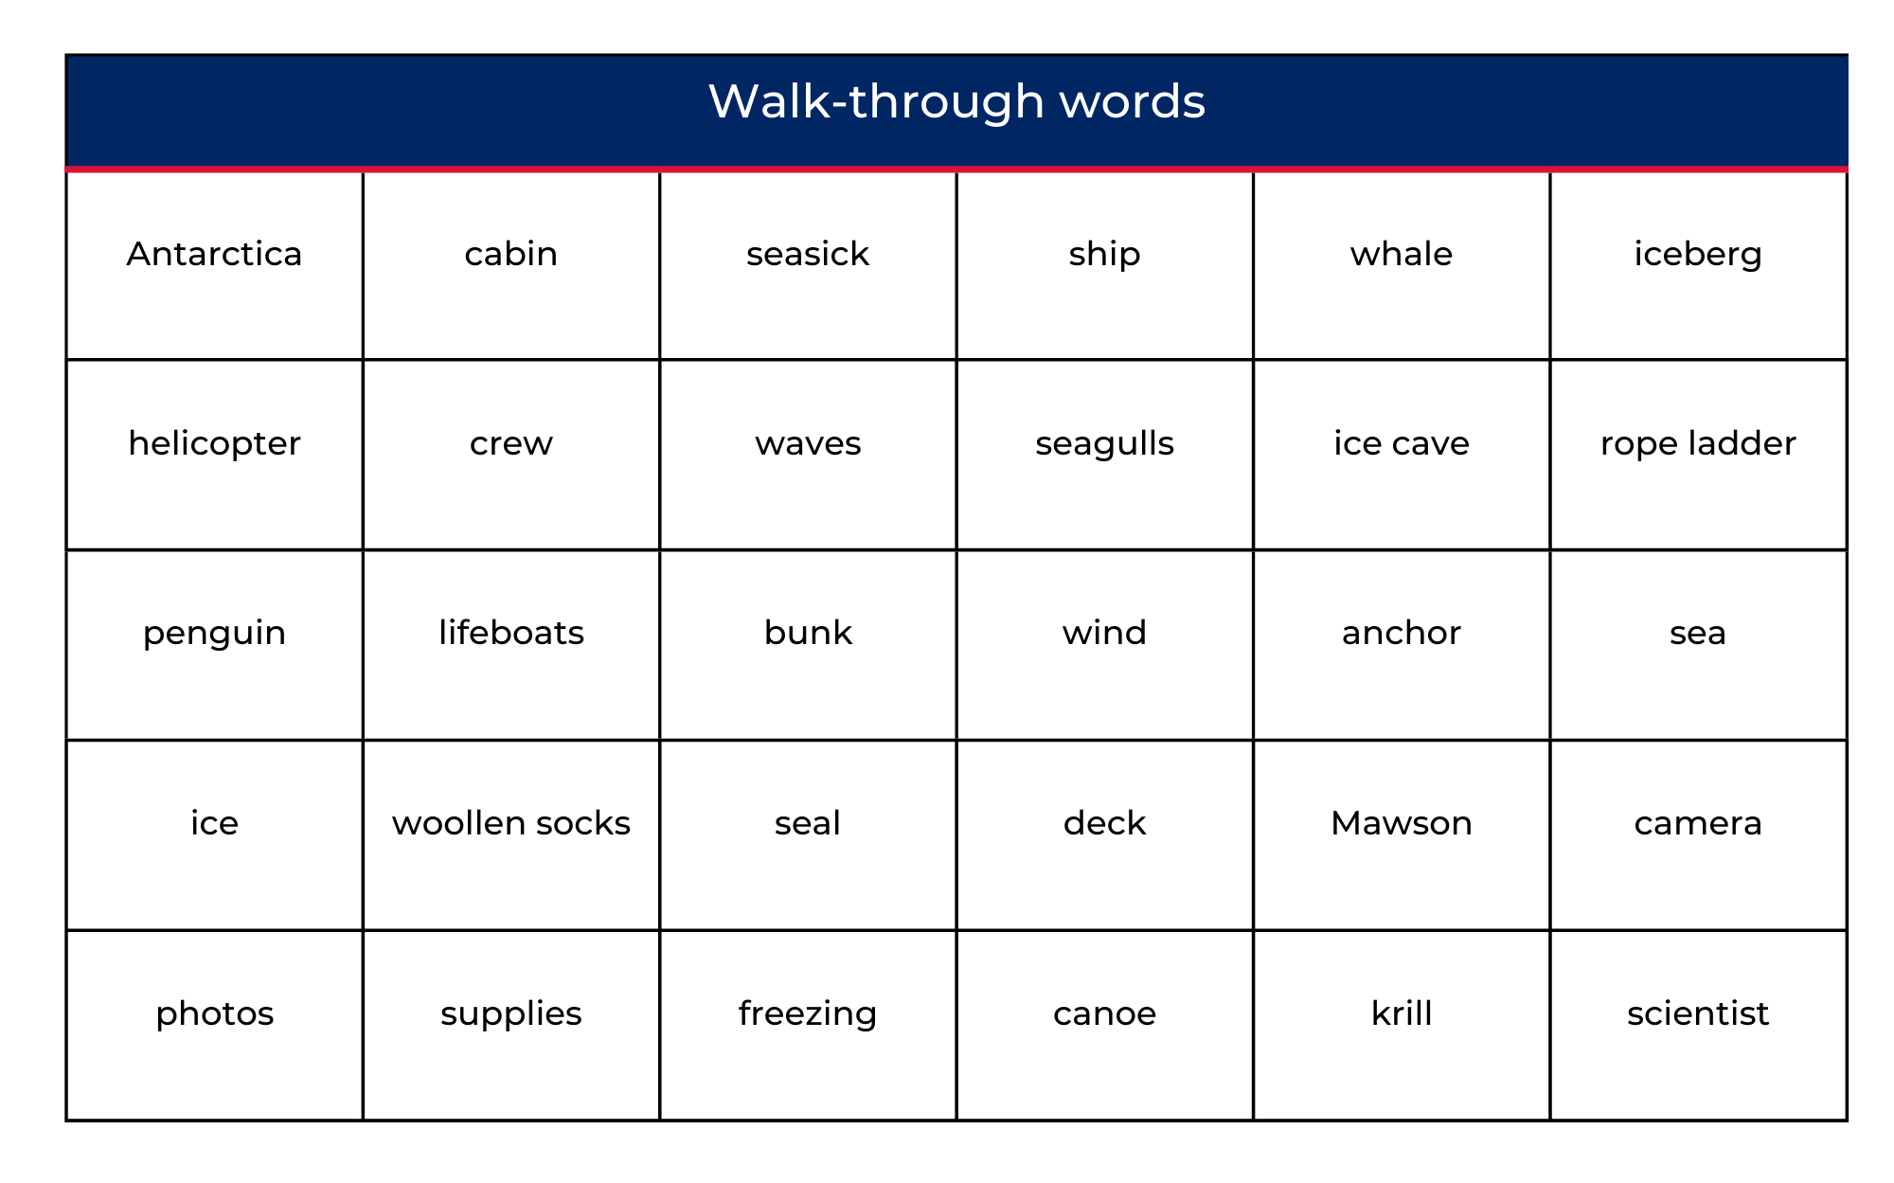

Resource 2: Timeline dates (for display)
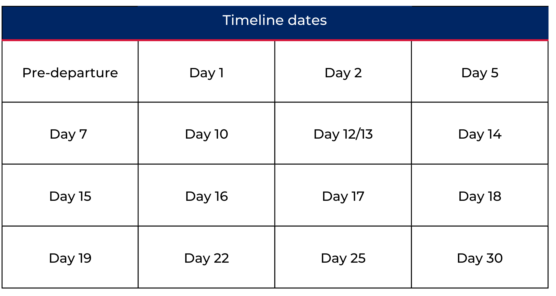

Resource 3: Note-taking template
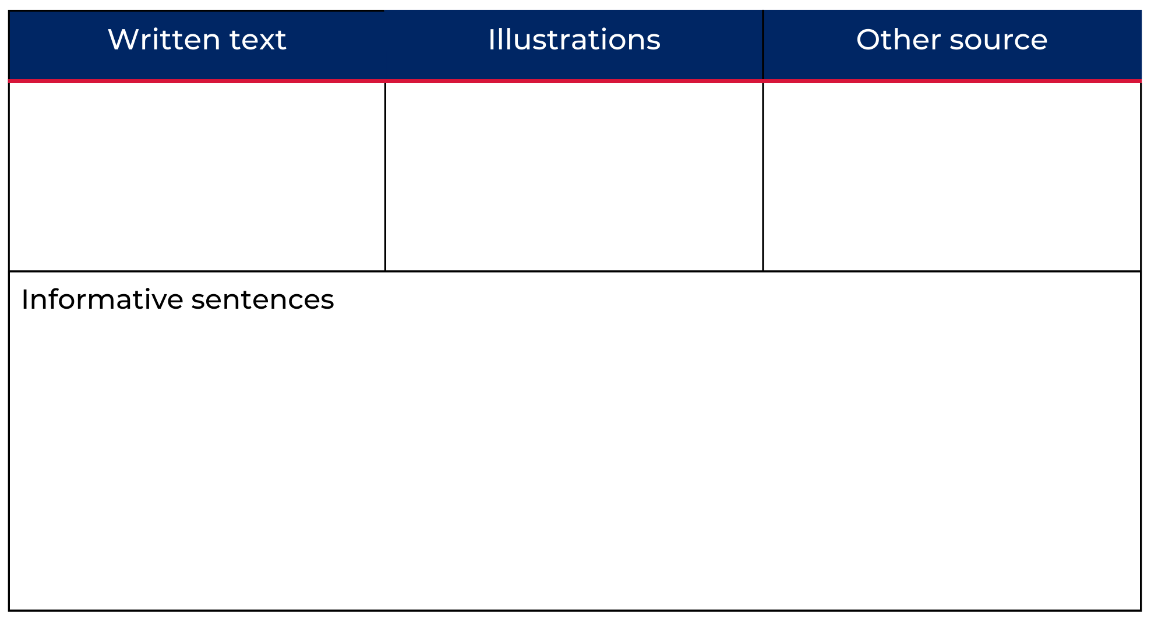

Resource 4: Online text features and navigation pathways
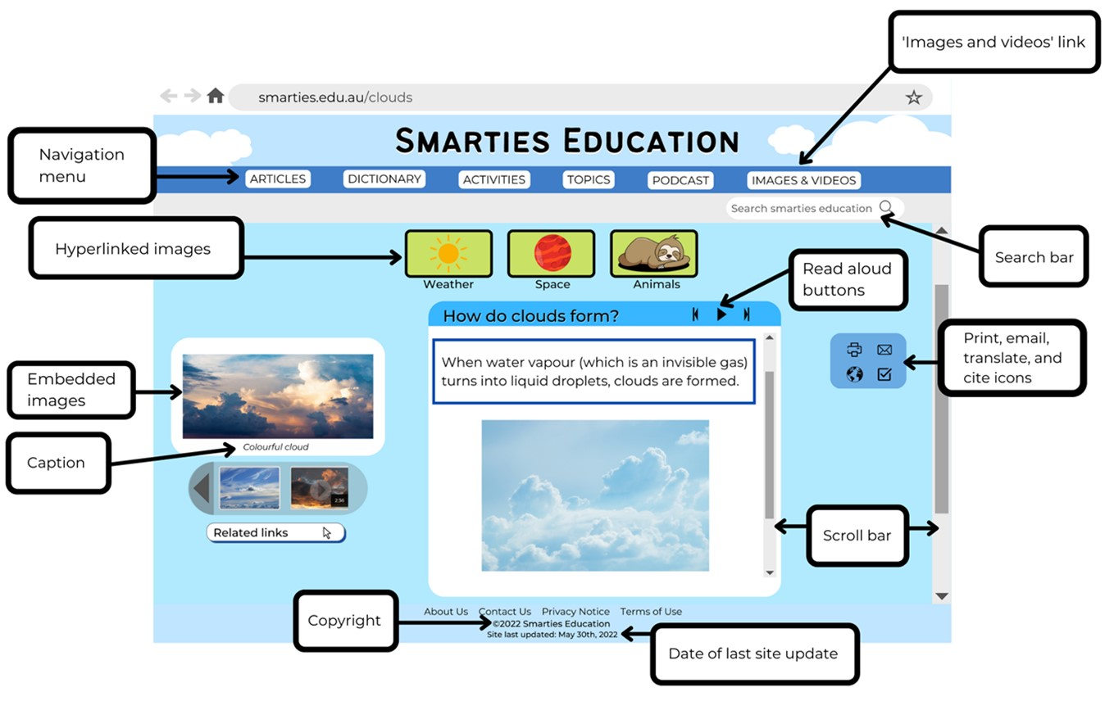
Images sourced from Canva and used in accordance with the Canva Content License Agreement.
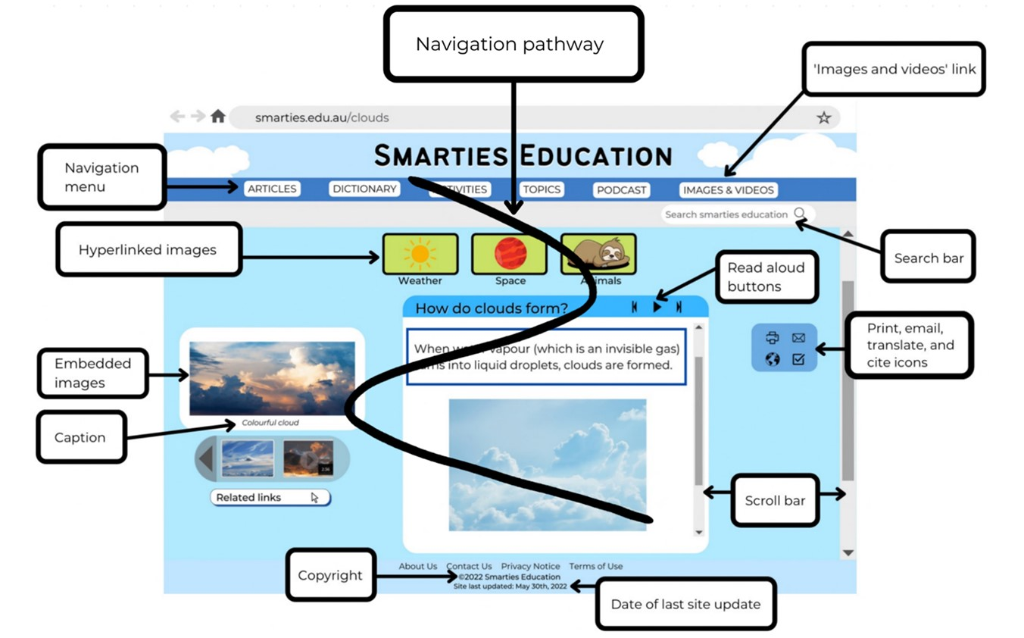
Images sourced from Canva and used in accordance with the Canva Content License Agreement.

Resource 5: Penguin concept map (Teacher resource)
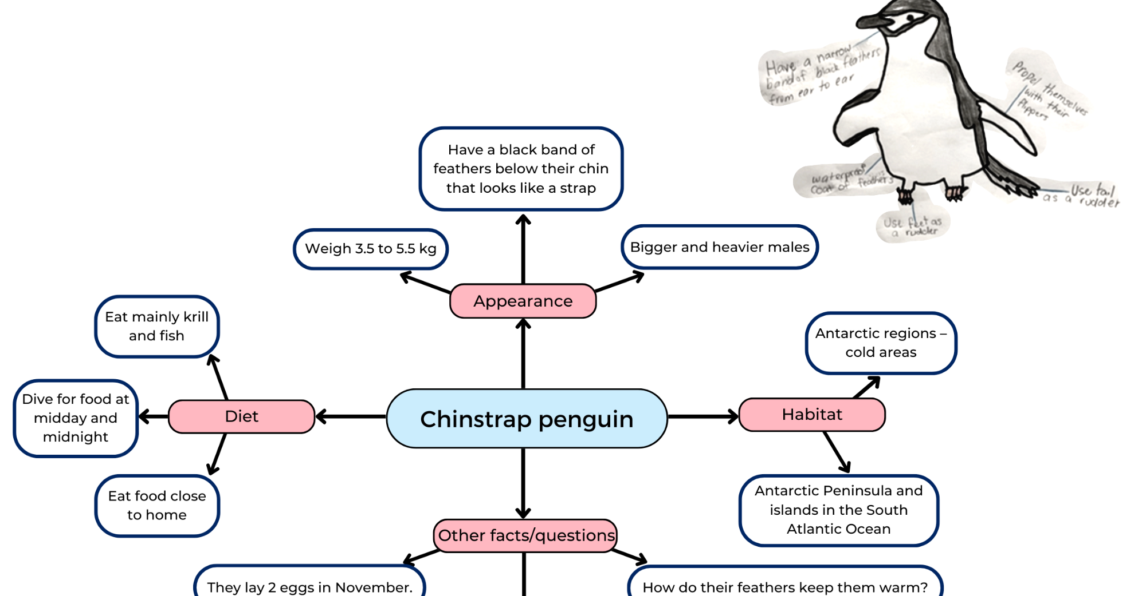
Images sourced from Canva and used in accordance with the Canva Content License Agreement.

Resource 6: Research topic cards
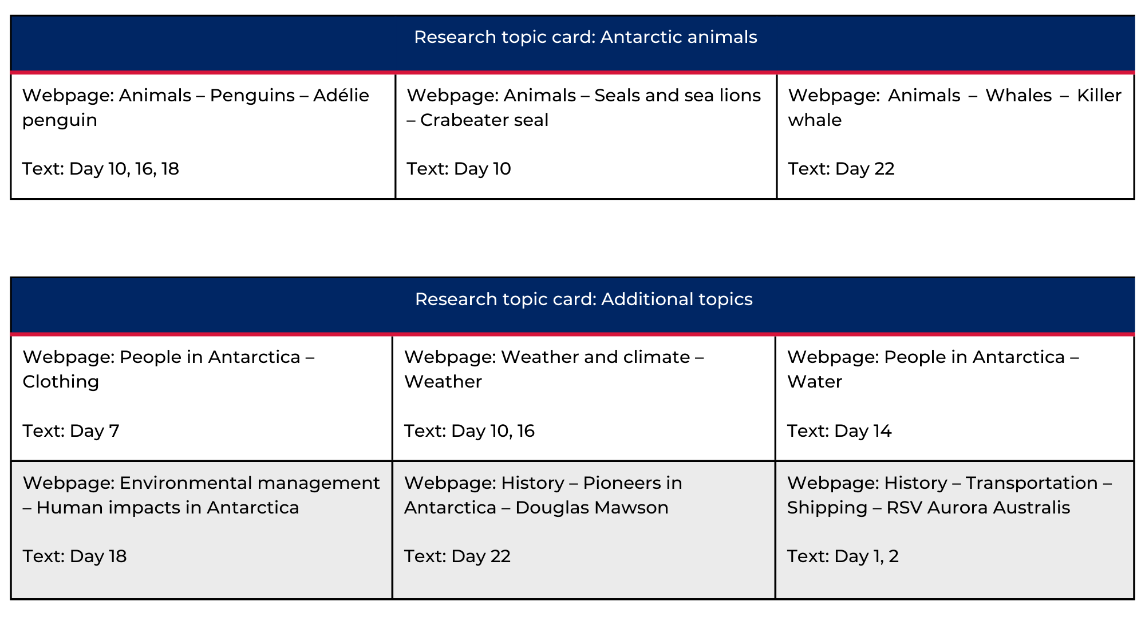

Resource 7: Blank concept map
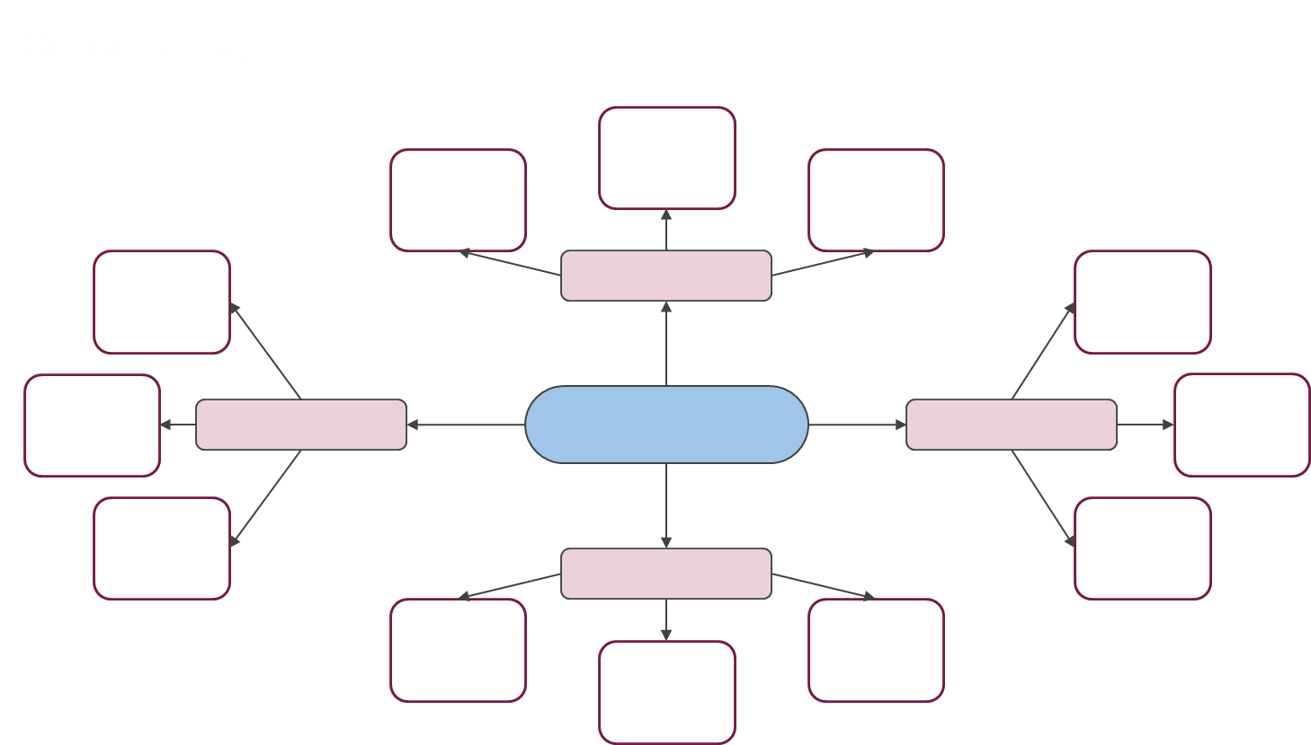

Resource 8: Traffic light paragraphs
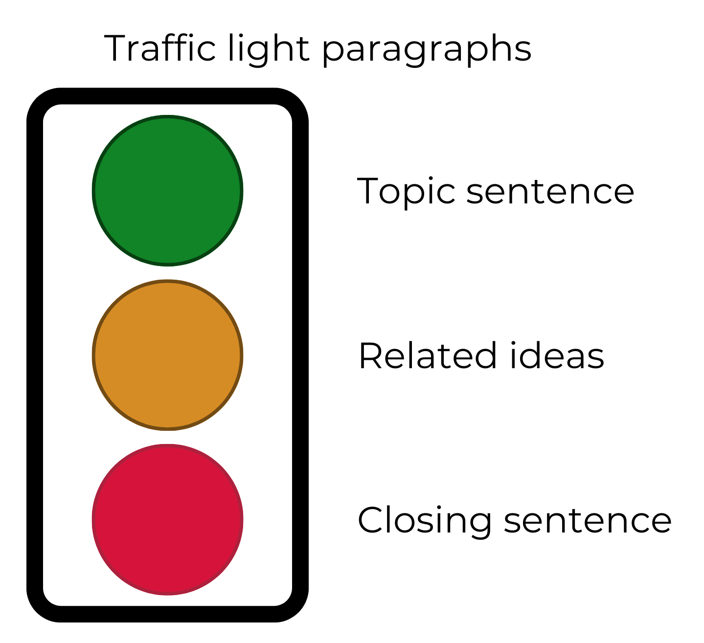

References
Links to third-party material and websites
Please note that the provided (reading/viewing material/list/links/texts) are a suggestion only and implies no endorsement, by the New South Wales Department of Education, of any author, publisher, or book title. School principals and teachers are best placed to assess the suitability of resources that would complement the curriculum and reflect the needs and interests of their students.
If you use the links provided in this document to access a third-party's website, you acknowledge that the terms of use, including licence terms set out on the third-party's website apply to the use which may be made of the materials on that third-party website or where permitted by the Copyright Act 1968 (Cth). The department accepts no responsibility for content on third-party websites.
Except as otherwise noted, all material is © State of New South Wales (Department of Education), 2021 and licensed under the Creative Commons Attribution 4.0 International License. All other material (third-party material) is used with permission or under licence. Where the copyright owner of third-party material has not licensed their material under a Creative Commons or similar licence, you should contact them directly for permission to reuse their material.
English K–10 Syllabus © 2022 NSW Education Standards Authority (NESA) for and on behalf of the Crown in right of the State of New South Wales.
© 2021 NSW Education Standards Authority. This document contains NSW Curriculum and syllabus content. The NSW Curriculum is developed by the NSW Education Standards Authority. This content is prepared by NESA for and on behalf of the Crown in right of the State of New South Wales. The material is protected by Crown copyright.
Please refer to the NESA Copyright Disclaimer for more information.
NESA holds the only official and up-to-date versions of the NSW Curriculum and syllabus documents. Please visit the NSW Education Standards Authority (NESA) website and the NSW Curriculum website.
National Literacy Learning Progression © Australian Curriculum, Assessment and Reporting Authority (ACARA) 2010 to present, unless otherwise indicated. This material was downloaded from the Australian Curriculum website (National Literacy Learning Progression) (accessed 9 September 2022) and was not modified. The material is licensed under CC BY 4.0. Version updates are tracked in the ‘Curriculum version history’ section on the 'About the Australian Curriculum' page of the Australian Curriculum website.
ACARA does not endorse any product that uses the Australian Curriculum or make any representations as to the quality of such products. Any product that uses material published on this website should not be taken to be affiliated with ACARA or have the sponsorship or approval of ACARA. It is up to each person to make their own assessment of the product, taking into account matters including, but not limited to, the version number and the degree to which the materials align with the content descriptions and achievement standards (where relevant). Where there is a claim of alignment, it is important to check that the materials align with the content descriptions and achievement standards (endorsed by all education Ministers), not the elaborations (examples provided by ACARA).
ETA (English Teachers Association) and NSW Department of Education (2016) The Textual Concepts and Processes resource, English Textual Concepts website, accessed 9 September 2022.
Australian Antarctic Science TV (5 December 2018) 'Icebreaker Tour: Aurora Australis' [video], @AusAntarcticScienceTV, YouTube, accessed 9 September 2022.
Department of Climate Change, Energy, the Environment and Water and Australian Antarctic Division (2020) Australian Antarctic Program, antarctica.gov.au, accessed 9 September 2022.
Department of Climate Change, Energy, the Environment and Water and Australian Antarctic Division (2020) ‘Chinstrap penguin’, About Antarctica, antarctica.gov.au, accessed 9 September 2022.
Lester A (2012) Sophie Scott Goes South, Puffin, Australia.

