English – Stage 1 – Unit 21
Contents
Unit overview and instructions for use 4
Teacher notes 5
Outcomes and content – Component A 7
Outcomes and content – Component B 9
Week 1 11
Component A teaching and learning 11
Component B teaching and learning 12
Lesson 1: Yarning circle and welcome display 13
Lesson 2: Vocabulary 15
Lesson 3: Building contextual knowledge and planning for writing 17
Lesson 4: Writing a description of Country 18
Lesson 5: Writing an Acknowledgement of Country 19
Week 2 21
Component A teaching and learning 21
Component B teaching and learning 22
Lesson 6: Making connections 24
Lesson 7: Inferencing 25
Lesson 8: Planning for writing 26
Lesson 9: Writing personal stories 27
Lesson 10: Publishing a multimodal or digital text 28
Resource 1: Tiered words 30
Resource 2: Student self-assessment tool 31
Resource 3: Word mat 32
Resource 4: Inferencing table 33
Resource 5: Writing scaffold 34
References 35

Unit overview and instructions for use
This two-week unit is comprised of Component A and Component B. Connecting learning across both components is encouraged.
Teaching and learning | Component A | Component B
Suggested duration | 60 minutes | 45 minutes
Explicit teaching focus areas | - Phonic knowledge  - Reading fluency  - Reading comprehension  - Spelling  - Handwriting | - Oral language and communication  - Vocabulary  - Reading comprehension  - Creating written texts  - Understanding and responding to literature
To prepare for teaching and learning: | - Refer to Outcomes and content – Component A, K-2 – Instructional sequence – grapheme–phoneme correspondences [PDF 825 KB], and the teaching advice documents (hyperlinked in Component A teaching and learning table).  - Based on student needs identified through ongoing assessment data, plan and document how you will sequence teaching and learning in whole class and targeted teaching groups across the two-week cycle. | - Familiarise yourself with Outcomes and content – Component B, Textual concepts information and videos, English Textual Concepts and Learning Processes (2016), and the teaching and learning sequence.  - Based on student needs identified through ongoing assessment data, determine how you will support students in whole class and targeted teaching groups across the two-week cycle as required.
English K–10 Syllabus © 2022 NSW Education Standards Authority (NESA) for and on behalf of the Crown in right of the State of New South Wales.

Teacher notes
Aboriginal and Torres Strait Islander people should be aware that this resource may contain images, voices or names of deceased persons in photographs, film, audio recordings or printed material.
At the NSW Department of Education, we recognise the traditional custodians of the lands and waterways where we work and live. We celebrate Aboriginal and Torres Strait Islander Peoples' unique cultural and spiritual relationship to Country and acknowledge the significance of their cultures in Australia. We pay respect to Ancestors and Elders past, present and future.
The department recognises that by acknowledging our past, we are laying the groundwork for a future that embraces all Australians; a future based on mutual respect and shared responsibility.
- Context is defined as ‘a culturally or socially situated circumstance that may give rise to a particular register’ (NESA Glossary).
- While context is the mentor concept for the conceptual component of this unit, the supporting concept of narrative can be explored using the mentor text Welcome to Country by Aunty Joy Murphy and Lisa Kennedy.
- This unit could enhance student learning towards achievement of outcomes from the History, Geography and Creative Arts syllabuses.
- For more information about acknowledging Country and the difference between a Welcome to Country and an Acknowledgement of Country, guidelines and protocols refer to the department’s Reconciliation Action Plan.
- For information, definitions and terminology related to Aboriginal education, refer to the NSW Aboriginal Education Consultative Group (AECG), Aboriginal Outcomes and Partnerships and Diversity of learners resources, and to the Australian Government’s Style Manual.
- Engage with local Elders and community where possible.
- For information on Tier 1, 2 and 3 words, refer to the NESA Glossary.
- For information about vocabulary and reading comprehension skills, including using background knowledge and making
- inferences, refer to the NESA Stage 1 Teaching and learning support.
- Reflect on student learning and engagement in activities and record differentiation and adjustments within the unit to inform future teaching and learning. One way of doing this could be to add comments to the digital file.
- Content points are linked to the National Literacy Learning Progression version (3).
Levels and indicators sourced from National Literacy Learning Progression © Australian Curriculum, Assessment and Reporting Authority (ACARA), (accessed 16 August 2022) and was not modified. See references for more information.

Outcomes and content – Component A
The table below outlines the focus outcomes and content. Content is linked to the National Literacy Learning Progression version (3).
Focus area and outcome | Content points and National Literacy Learning Progression
Phonic knowledge  EN1-PHOKW-01 – uses initial and extended phonics, including vowel digraphs, trigraphs to decode and encode words when reading and creating texts | - decode words with less common consonant digraphs and apply this when reading texts  - decode words with trigraphs and quadgraphs and apply this when reading texts  - blend and decode 2-syllable words with taught vowel graphs, digraphs, trigraphs and quadgraphs, including graphemes for r-controlled vowels and diphthongs and apply this when reading texts (PKW6, PKW7)  - decode 2-syllable base words with common double consonants when reading texts (PKW7)
Reading fluency  EN1-REFLU-01 – sustains reading unseen texts with automaticity and prosody and self-corrects errors | - self-correct when fluency and/or meaning is interrupted
Reading comprehension  EN1-RECOM-01 – comprehends independently read texts that require sustained reading by activating background and word knowledge, connecting and understanding sentences and whole text, and monitoring for meaning | - register a break in comprehension when reading (UnT5)
Spelling  EN1-SPELL-01 – applies phonological, orthographic and morphological generalisations and strategies when spelling words in a range of writing contexts | - segment multisyllabic words into syllables and phonemes as a strategy for spelling (SpG5)  - explain when to use double consonants to spell 2-syllable base words and apply this when spelling (SpG6)  - use spelling conventions when adding plural-marking suffixes (SpG9)  - use the comparative and superlative suffixes -er and -est (SpG9)
Handwriting  EN1-HANDW-01 – uses a legible, fluent and automatic handwriting style, and digital technology, including word-processing applications, when creating texts | - form all letters with consistent size and slope in NSW Foundation Style from memory (HwK5)  - position all letters correctly on the line with appropriate spacing between words (HwK5)

Outcomes and content – Component B
The table below outlines the focus outcomes and content. Content is linked to the National Literacy Learning Progression version (3).
Focus area and outcome | Content points and National Literacy Learning Progression
Oral language and communication  EN1-OLC-01 – communicates effectively by using interpersonal conventions and language to extend and elaborate ideas for social and learning interactions | - initiate, listen and/or respond in partner and group conversations (InT3, Int5)  - organise key ideas in logical sequence  - recount narratives with key components (SpK3)  - adapt a narrative for a particular audience.
Vocabulary  EN1-VOCAB-01 – understands and effectively uses Tier 1, taught Tier 2 and Tier 3 vocabulary to extend and elaborate ideas | - understand and use words that have different meanings in different contexts
Reading comprehension  EN1-RECOM-01 – comprehends independently read texts that require sustained reading by activating background and word knowledge, connecting and understanding sentences and whole text, and monitoring for meaning | - use known vocabulary to build a mental model of the content of the text  - draw on sources to seek clarification for unknown words  - make an inference by connecting the meaning of words across sentences and/or paragraphs  - make text-to-self, text-to-text or text-to-world connections when reading (UnT6)  - recount relevant ideas from texts in the form of a written, visual or oral summary (UnT6)
Creating written texts  EN1-CWT-01 – plans, creates and revises texts written for different purposes, including paragraphs, using knowledge of vocabulary, text features and sentence structure | - write texts that describe, explain, give an opinion, recount an event, tell a story (CrT7)  - use a combination of simple and compound sentences to engage the reader when creating written texts (CrT6, GrA4)  - use punctuation, including question marks and exclamation marks, accurately and for effect (PuN3)
Understanding and responding to literature  EN1-UARL-01 – understands and responds to literature by creating texts using similar structures, intentional language choices and features appropriate to audience and purpose | - identify representations of groups and cultures in a range of texts  - create and re-create texts in a range of modes and media using understanding of context (CrT5)

Week 1

Component A teaching and learning
The table below can be used to plan and document lessons that address Component A outcomes and content. Both the detailed example [DOC 529KB] of a two-week teaching and learning cycle and brief example [DOC 66KB] may support you in your planning.
Focus Areas | Lesson 1 | Lesson 2 | Lesson 3 | Lesson 4 | Lesson 5
Phonic knowledge
15 minutes
Spelling and Handwriting
15 minutes
Reading comprehension and Reading fluency
30 minutes

Component B teaching and learning
The following teaching and learning sequence has been designed to address Component B outcomes and content. Adapt the sequence as required to best meet the needs of your students.

Learning intention and success criteria
Learning intentions and success criteria are best co-constructed with students.

Learning intention
Students are learning to apply their understanding of context to write an Acknowledgment of Country.

Success criteria
Students can:
- recognise how different groups and cultures are represented in texts
- initiate, listen and/or respond in partner and group conversations
- identify the differences between a Welcome to Country and an Acknowledgment of Country
- understand and use words that have different meanings in different contexts
- check the meaning of unknown words
- plan, draft and edit own writing
- write a descriptive text.

Resources
- Resource 1: Tiered words (Enlarged)
- Resource 2: Self-assessment tool
- Resource 3: Word mat
- Video: Aunty Joy Murphy Wurundjeri Welcome to Country (1:10)
- Video: Welcome to Country Bundjalung Welcome to Country (0.40)
- Yarning Circle
- Venn diagram or T-chart
- Murphy J (2016) Welcome to Country (Kennedy L, illus.) Walker Books Australia. ISBN 13: 9781921977077
- A talking piece (stick, stone, shell) for a yarning circle
- Dictionaries
- Large piece of cardboard, enlarged text ‘Welcome to our (name of class)’ and A4 paper for the class welcome display
- Map of Aboriginal Languages and Nations in NSW and ACT
- Materials for collage artwork. For example, coloured and textured paper, pencils, paint and natural materials such as leaves, sand and feathers.

Lesson 1: Yarning circle and welcome display
- To start the lesson, recognise the traditional owners of the land by giving an Acknowledgement of Country.
- Introduce the text Welcome to Country. Invite students to share what they know about a Welcome to Country. Discuss when they might have heard a Welcome to Country and who performed it.
- Initiate a class discussion about the differences between a Welcome to Country and an Acknowledgement of Country. Use a Venn diagram or T-chart to record the differences.
- Read the author and illustrator biographies at the back of the book. Ask students to predict what they think the text will be about, the groups or cultures represented and the intended audience.
- Read Welcome to Country. Discuss why Aunty Joy Murphy, Aboriginal Elder of the Wurundjeri People, wrote the text and why she can give a Welcome to Country on Wurundjeri land.
- Introduce the concept of a yarning circle. Set up the protocols required for a yarning circle. For example, everyone sits in a circle, a talking piece (stick, stone, shell) is shared, listening is active and respectful.
- Facilitate a class yarning circle. Begin by inviting students to introduce themselves and share what makes them feel welcome in a new environment.
- Use student feedback from the yarning circle to construct a class definition for ‘Welcome’.
- Create a space large enough for a collaborative class welcome display. Prepare a large piece of cardboard with the words ‘Welcome to our (name of class)’ in the centre. Provide each student with an A4 piece of paper folded in half. On the outside half of the paper, students write their name and decorate it to reflect their identity. On the inside half of the paper, students write a short statement that reflects the ways that everyone will be made to feel welcome in the class. Glue student responses onto the class display.
- View Aunty Joy Murphy’s Wurundjeri Welcome to Country (1:10). Reflect on the importance of feeling welcome and making others feel welcome.
Stage 1 Assessment task 1 – Observations and work samples from this lesson allow students to demonstrate achievement towards the following syllabus outcomes and content points:
EN1-OLC-01 – communicates effectively by using interpersonal conventions and language to extend and elaborate ideas for social and learning interactions
- initiate, listen and/or respond in partner and group conversations.
EN1-UARL-01 – understands and responds to literature by creating texts using similar structures, intentional language choices and features appropriate to audience and purpose
- identify representations of groups and cultures in a range of texts.

Lesson 2: Vocabulary
- Explain that vocabulary helps writers to extend and elaborate on ideas. In turn, good readers need to have a deep understanding of what words mean so that they can fully comprehend a text.
- Explain how words are categorised as Tier 1, 2 or 3 words. Refer to NESA Glossary for the definition of these.
- Re-visit the text Welcome to Country to identify and record Tier 1, 2 and 3 words on an enlarged copy of Resource 1. Draw attention to words that are contextually important. For example, Country, welcome, traditional, ancestors, Elders, community, Aunty. Discuss the capitalisation of some words.
- Using a word from the completed resource in activity 3, model the use of the self-assessment tool in Resource 2. In pairs, students reflect on their understanding of selected tiered words.
- Clarify the meaning of unknown or unfamiliar words from Resource 1. Discuss how the meaning of words can change in different contexts. For example, the use of ‘Country’ and ‘acknowledge’ in the text, compared to how these words can be used differently in other contexts.
- Select a tiered word, such as ‘Country’ and model how to use Resource 3.
- Students complete Resource 3 independently using Tier 2 or 3 words from the text. Encourage students to select a word/s that they self-assessed as being less familiar with in activities 4 and 5. Students may need access to a dictionary.
Too hard? Modify Resource 3 and co-construct sentences.
Too easy? Students write sentences with words that have different meanings in different contexts.
- Re-visit the self-assessment tool in activity 4. Invite students to compare their understanding of a word before and after completing the word mat activity. Students reflect on whether their vocabulary knowledge has improved and if they now are able to use the word in different contexts.
- View Bundjalung Welcome to Country (0:40) and ask students to identify the same words used in the video and the text. Discuss why these words are culturally significant in a Welcome to Country.
Stage 1 Assessment task 2 – Observations and work samples from this lesson allow students to demonstrate achievement towards the following syllabus outcomes and content points:
EN1-RECOM-01 – comprehends independently read texts that require sustained reading by activating background and word knowledge, connecting and understanding sentences and whole text, and monitoring for meaning
- use known vocabulary to build a mental model of the content of the text
- draw on sources to seek clarification for unknown words.
EN1-VOCAB-01 – understands and effectively uses Tier 1, taught Tier 2 and Tier 3 vocabulary to extend and elaborate ideas
- understand and use words that have different meanings in different contexts.

Lesson 3: Building contextual knowledge and planning for writing
- Explain and discuss that Aboriginal and Torres Strait Islander Peoples have a unique cultural and spiritual relationship to Country. Ceremonies and protocols are a fundamental part of Aboriginal and Torres Strait Islander cultures, including when giving a Welcome to Country or an Acknowledgment of Country.
- Read the blurb on the back cover of text Welcome to Country. Focus on the opening sentence, ‘Welcome to the traditional lands of the Wurundjeri People.’ View the webpage with information about the Wurundjeri People, take note of the etymology of the word Wurundjeri, wurun meaning the manna gum (Eucalyptus viminalis) which is common along Birrarung (Yarra River), and djeri, the grub found in or near the tree.
- View the Aboriginal Languages and Nations in NSW and ACT to highlight the diverse language groups of Aboriginal and Torres Strait Islander Peoples. Discuss how some Countries are made up of different language groups and the context of this influences how people communicate.
- Display the first double-page spread of the text. Ask students to identify what they notice about the setting from the illustration. Discuss how the connections between land and people are represented. For example, the manna gums running along the river, the djeri that would be living in the manna gums, the person by the campfire living off what the land provides and the presence of the creator spirit Bunjil.
- Model labelling the illustration using descriptive language. For example, shimmering, winding river; bravely soaring eagle; tall, twisting manna gums. Keep this labelled page for Lesson 4.
- Students select a different page from the text and write descriptive sentences about the illustrations.
- Use the Aboriginal Languages and Nations in NSW and ACT map to identify the school’s location. Gather information to focus on local community and language/s to build further understanding of context. Engage with local Elders and community where possible.
- Discuss the natural landforms, waterways and animals unique to the school’s local community/Country. Explore the local community/Country using photos, Google Earth or by walking around the local area. Compare and contrast the natural features of Wurundjeri Country with the Country the school is on.
- In small groups, students discuss the features they would include in an artwork representing the school’s Country. Students create a collage to represent Country.
- Students label their artwork, as modelled in activity 5. The labelled artworks will be used as the planning stimulus in Lesson 4.

Lesson 4: Writing a description of Country
- Students complete a gallery walk of artworks completed in Lesson 3 and provide feedback on the descriptive language and visual detail.
- Explain that students will use their labelled artwork to write a detailed description. Display the labelled page from activity 5 in Lesson 3 and the tiered words from Lesson 2 to model and support students to write a detailed descriptive text.
- Co-construct a writing success criteria. Include the use of descriptive language, a range of punctuation, and simple and compound sentences.
- Use the labelled page to model writing simple and compound sentences that describe the illustration. Use ‘think alouds’ to refer and incorporate some of the vocabulary explored in Lesson 2. For example, ‘This is Wurundjeri Country. The crackling campfire sizzles and Bunjil bravely soars high above. The djeri grow deep inside the manna gums because the river flows generously.’
- Deconstruct the modelled description using the success criteria.
- Students use their labelled artworks to write their own descriptive text.
- In pairs, students use the success criteria to provide feedback and edit their work.

Lesson 5: Writing an Acknowledgement of Country
- Revise student understanding of the difference between a Welcome to Country and an Acknowledgement of Country.
- Write the word acknowledgement. Ask students to identify other words they can see in it. For example, acknowledge, knowledge, know. Discuss whether these other words provide clues about the word’s meaning, and situations when the word, or variations of it, might be used. Discuss when the word is capitalised.
- View the Callaghan College Acknowledgement of Country (1:52) or one from the school’s Country. Acknowledge that all communities are different and diverse.
- Discuss how a mental model of context is created through the vocabulary used to describe the land, waterways or animals. Ask students to think about any new vocabulary that can be added to Resource 1. This will be used to support student writing.
- Explain that students will write a class Acknowledgement of Country that can be shared at assemblies and other such events. If appropriate, engage local community members and use the local language/s within the Acknowledgement of Country.
- View the NSW AECG Acknowledgement of Country protocols to co-construct a success criteria for an Acknowledgement of Country.
- Use an anchor chart to brainstorm the keywords that might be included in an Acknowledgement of Country.
- Co-construct the first and second paragraphs of the Acknowledgment using the structure:
- Paragraph 1: Protocols, what must be included
- Paragraph 2: Contextualisation of Country the school is on using descriptions from Lesson 4.
- Students write a third paragraph to personalise the Acknowledgement of Country. This may include their feelings and connection to Country. Students may also use local language/s and/or Auslan.
- Provide opportunities for students to record and/or present their Acknowledgement of Country. Where appropriate, invite local community Elders and families into the school to share student learning.
Stage 1 Assessment task 3 – Collecting work samples from this lesson allow students to demonstrate achievement towards the following syllabus outcomes and content points:
EN1-OLC-01 – communicates effectively by using interpersonal conventions and language to extend and elaborate ideas for social and learning interactions
- adapt a narrative for a particular audience.
EN1-CWT-01 – plans, creates and revises texts written for different purposes, including paragraphs, using knowledge of vocabulary, text features and sentence structure
- write texts that describe, explain, give an opinion, recount an event, tell a story.
EN1-UARL-01 – understands and responds to literature by creating texts using similar structures, intentional language choices and features appropriate to audience and purpose
- create and re-create texts in a range of modes and media using understanding of context.

Week 2

Component A teaching and learning
The table below can be used to plan and document lessons that address Component A outcomes and content. Both the detailed example [DOC 529KB] of a two-week teaching and learning cycle and brief example [DOC 66KB] may support you in your planning.
Focus Areas | Lesson 6 | Lesson 7 | Lesson 8 | Lesson 9 | Lesson 10
Phonic knowledge
15 minutes
Spelling and Handwriting
15 minutes
Reading comprehension and Reading fluency
30 minutes

Component B teaching and learning
The following teaching and learning sequence has been designed to address Component B outcomes and content. Adapt the sequence as required to best meet the needs of your students.

Learning intention and success criteria
Learning intentions and success criteria are best co-constructed with students.

Learning intention
Students are learning to use their understanding of context to write a personal story.

Success criteria
Students can:
- identify how different groups and cultures are represented in texts
- organise the main ideas in a text
- identify and explain self, text and world connections to a text
- make and explain inferences by using background knowledge and clues in a text
- plan, draft and edit own writing
- use punctuation, including question marks and exclamation marks
- write simple and compound sentences
- write a text that tells a story
- use understanding of context to create a multimodal or digital text.

Resources
- Resource 4: Inferencing table
- Resource 5: Writing scaffold
- Video: I am Australian in Yawuru language (1:15)
- Yarning Circle
- Y-chart
- Fox M (2017) I’m Australian Too (Ronojoy G, illus.), Scholastic Australia. ISBN: 9781742995786
- Strips of paper for class paper chain
- World map and student photos for optional class display
- Aboriginal artwork to model how personal stories can be represented. For example, artworks by artist, Ian Abdulla
- A talking piece (stick, stone, shell) for a yarning circle
- Materials and/or technology to create a multimodal or digital text.

Lesson 6: Making connections
- View I am Australian in Yawuru language (1:15). Ask questions to identify the inferred meaning from phrases in the song. For example, ask what the phrases ‘We are one, but we are many’ and ‘We sing with one voice’ mean. Share student responses and discuss how our own knowledge and experiences help build our understanding when reading or responding to texts.
- Write the question, ‘What does it mean to be Australian?’ Students write a response on a strip of paper. A paper chain could be created to symbolise the connectedness between students and highlight how personal context can shape people’s thinking.
- Students use a Yarning Circle to share their cultural backgrounds. If students are from Australia, have them locate the Country where they were born using the Aboriginal Languages and Nations in NSW and ACT. A world map with students’ photos could be used to create a class display. Students will re-visit this in Lesson 8.
- Brainstorm strategies that good readers use to support their understanding of a text and record these on an anchor chart. Ensure that making connections is recorded.
- Students make predictions about the text I’m Australian Too. Read the text.
- Students use a Y-chart to describe how the text relates to their own experiences, the world and other texts by making text-to-self, text-to-text, or text-to-world connections.
- Students take turns to share the text connections they have made. Discuss why it is important that everyone, including those who come from different countries, feel welcome in the class, school, community and country. Refer to the class welcome display from Lesson 1 and discuss how our class values can help everyone feel welcome and celebrate diversity.
Stage 1 Assessment task 4 – Collecting work samples from this lesson allow students to demonstrate achievement towards the following syllabus outcome and content point:
EN1-RECOM-01 – comprehends independently read texts that require sustained reading by activating background and word knowledge, connecting and understanding sentences and whole text, and monitoring for meaning
- -make text-to-self, text-to-text or text-to-world connections when reading.

Lesson 7: Inferencing
- Display the anchor chart from Lesson 6 and revise reading strategies listed.
- Explain that good readers use clues in sentences and their background knowledge to infer meaning. Add inferencing to the chart.
- Recount and order the main ideas within the text I’m Australian Too.
- Display and read the text, ‘We open doors to strangers. Yes, everyone’s a friend. Australia Fair is ours to share, where broken hearts can mend.’ Use ‘think alouds’ to annotate the sentences, circling key clues and recording student’s background knowledge on an enlarged copy of Resource 4.
- Provide students with sentence strips or chunks of text from I’m Australian Too to complete Resource 4 and show their understanding of the inferred messages.
- Ask students to summarise the main messages in the text.
Too hard? Students use Resource 4 to draw and label pictures.
Too easy? Refer to the page in the text I’m Australian Too with the girl who is a refugee. Students identify the key clues and write to describe the inferred message/s.
Stage 1 Assessment task 5 – Collecting work samples from this lesson allow students to demonstrate achievement towards the following syllabus outcomes and content points:
EN1-OLC-01 – communicates effectively by using interpersonal conventions and language to extend and elaborate ideas for social and learning interactions
- organise key ideas in logical sequence.
EN1-RECOM-01 – comprehends independently read texts that require sustained reading by activating background and word knowledge, connecting and understanding sentences and whole text, and monitoring for meaning
- write texts that describe, explain, give an opinion, recount an event, tell a story
- make an inference by connecting the meaning of words across sentences and/or paragraphs
- recount relevant ideas from texts in the form of a written, visual or oral summary.

Lesson 8: Planning for writing
- Explain that students will use their understanding of context to write a personal story. These stories will be published and collated as a multimodal or digital text in Lesson 10 to create a resource for students to learn about and celebrate each other’s unique stories and differences.
- Use I’m Australian Too to model how each character shares part of their personal story with the audience. Discuss how the images support our understanding of their personal story.
- Explore how Indigenous Australian art is centred on storytelling. Use an example of an Indigenous Australian artwork to model how personal stories can be represented and how the audience infers meaning from the artist’s use of colour, shape and symbol. For example, artworks by Ngarrindjeri artist, Ian Abdulla. Explain that many of his artworks tell the story of his life growing up on the Riverland of South Australia. Swimming and fishing for pondi (Murray cod) occur regularly in his work.
- Discuss the artist’s use of colour, shape and symbol within a selected artwork to infer meaning. Model writing simple and compound sentences to explain the inferences in the artwork.
- Students use colour, shape and symbol to draw a special memory, experience or family tradition that is part of their personal story. Students share their personal stories in small groups and ask clarifying questions.
- Model using Resource 5 to plan for writing.
- Students use their drawing and Resource 5 to plan their writing. They may add more detail to their drawing as they plan. Students’ illustrations will be used in their published text in Lesson 10.
Stage 1 Assessment task 6 – Collecting work samples from this lesson allow students to demonstrate achievement towards the following syllabus outcome and content point:
EN1-OLC-01 – communicates effectively by using interpersonal conventions and language to extend and elaborate ideas for social and learning interactions
- recount narratives with key components.

Lesson 9: Writing personal stories
- Revisit the text I’m Australian Too. The text will be used to support the structure of the students’ written personal stories.
- Display a selection of text from the book. Discuss and annotate the structure of the text, including the use of simple and compound sentences and types of punctation. Ask students to identify parts that require the reader to infer meaning.
- Co-construct a success criteria to guide student writing. For example, use of simple and compound sentences, and punctuation including question marks and exclamation marks.
- Students draft their personal story using their planning from Lesson 8 and the text as a model.
Stage 1 Assessment task 7 – Collecting work samples from this lesson allow students to demonstrate achievement towards the following syllabus outcome and content points:
EN1-CWT-01 – plans, creates and revises texts written for different purposes, including paragraphs, using knowledge of vocabulary, text features and sentence structure
- write texts that describe, explain, give an opinion, recount an event, tell a story
- use a combination of simple and compound sentences to engage the reader when creating written text
- use punctuation, including question marks and exclamation marks, accurately and for effect.

Lesson 10: Publishing a multimodal or digital text
- In pairs, students share their draft writing from Lesson 9 and provide feedback using the success criteria.
- Students apply feedback to their writing and edit.
- Students publish and present their story and artwork from Lesson 8 and Lesson 9 as a multimodal or digital text. Suggestions include collating students’ writing and illustration to create a class book, or using a digital tool, such as Book Creator, to create a digital text that can be shared.
Stage 1 Assessment task 8 – Collecting work samples from this lesson allow students to demonstrate achievement towards the following syllabus outcome and content point:
EN1-UARL-01 – understands and responds to literature by creating texts using similar structures, intentional language choices and features appropriate to audience and purpose
- create and re-create texts in a range of modes and media using understanding of context.

Resource 1: Tiered words
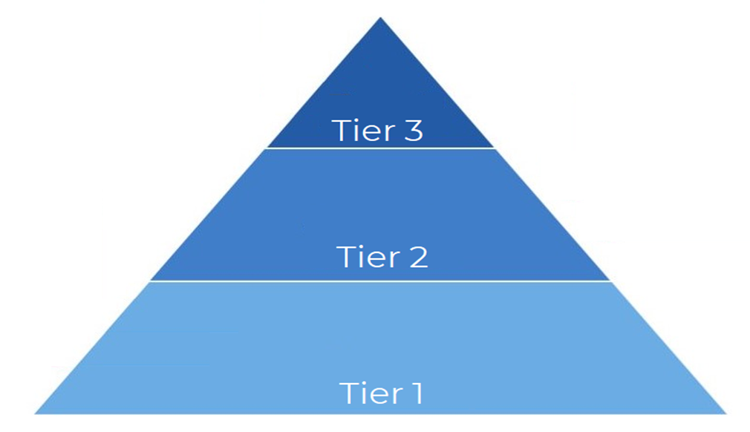

Resource 2: Student self-assessment tool
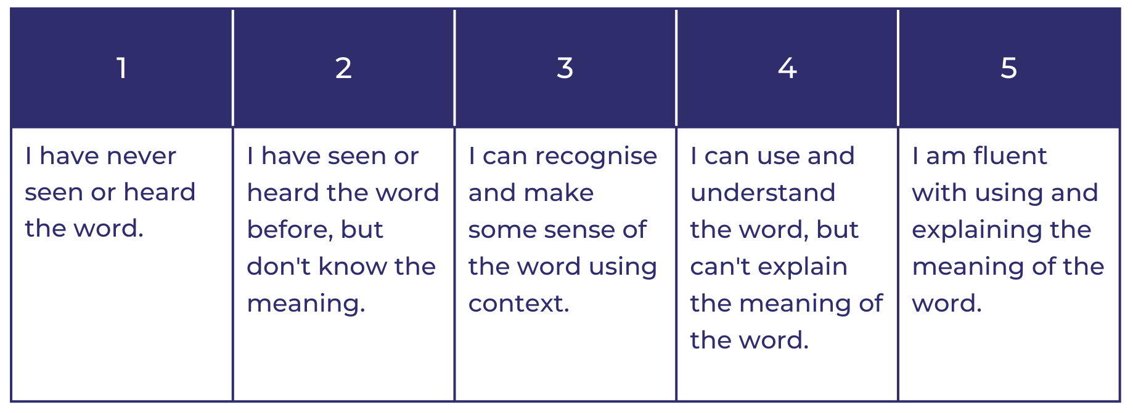

Resource 3: Word mat
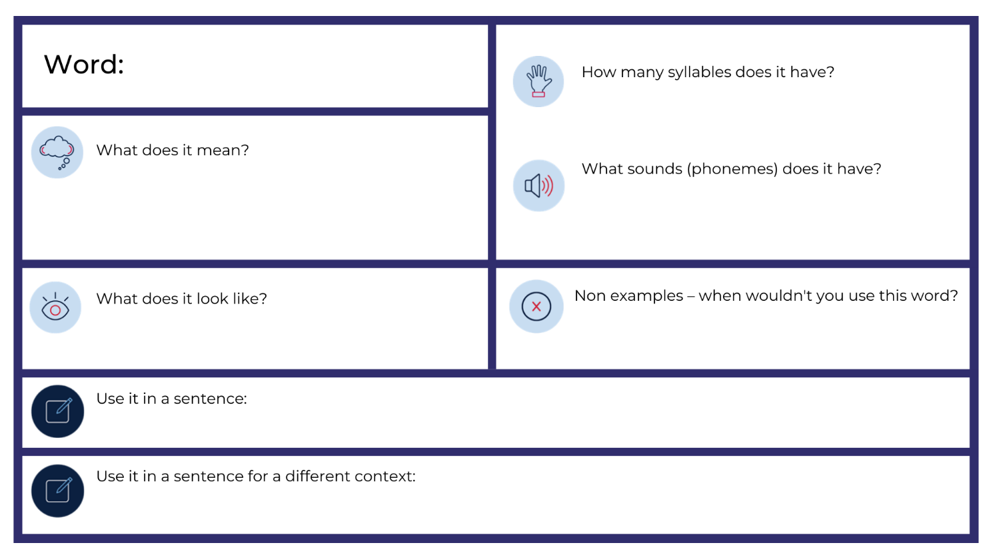

Resource 4: Inferencing table
Clues in the text | + | What I know (my background knowledge) | = | Inference

Resource 5: Writing scaffold
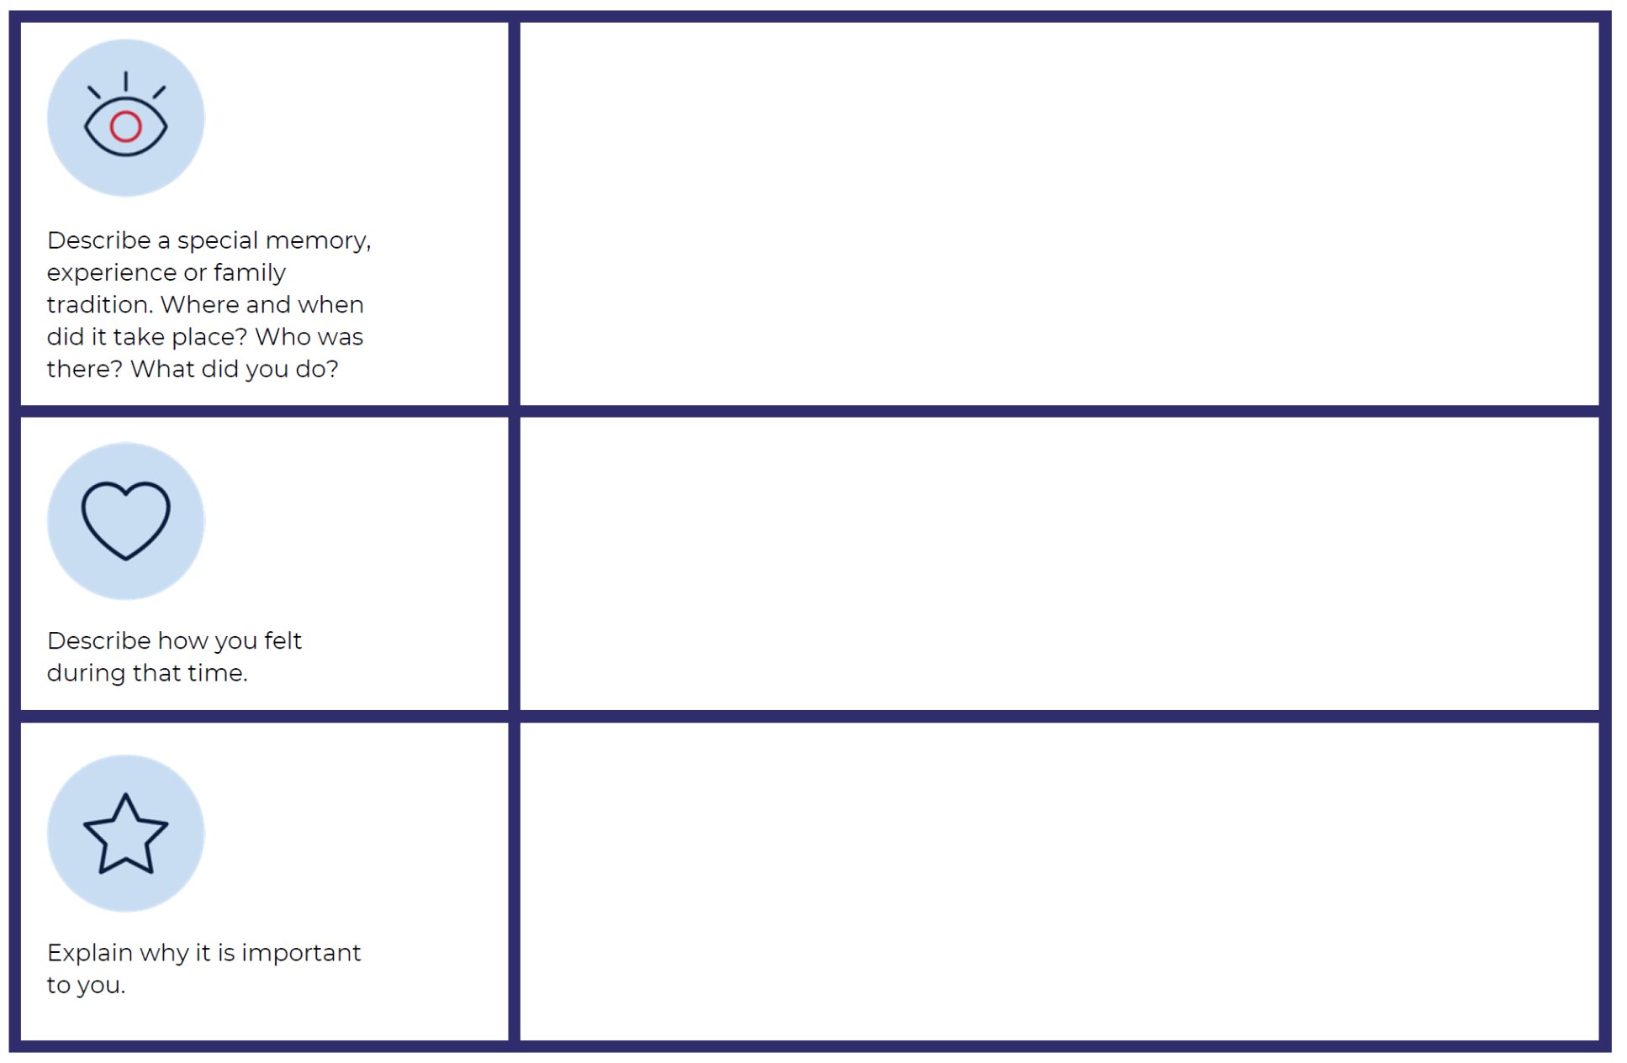

References
Links to third-party material and websites
Please note that the provided (reading/viewing material/list/links/texts) are a suggestion only and implies no endorsement, by the New South Wales Department of Education, of any author, publisher, or book title. School principals and teachers are best placed to assess the suitability of resources that would complement the curriculum and reflect the needs and interests of their students.
If you use the links provided in this document to access a third-party's website, you acknowledge that the terms of use, including licence terms set out on the third-party's website apply to the use which may be made of the materials on that third-party website or where permitted by the Copyright Act 1968 (Cth). The department accepts no responsibility for content on third-party websites.
Except as otherwise noted, all material is © State of New South Wales (Department of Education), 2021 and licensed under the Creative Commons Attribution 4.0 International License. All other material (third-party material) is used with permission or under licence. Where the copyright owner of third-party material has not licensed their material under a Creative Commons or similar licence, you should contact them directly for permission to reuse their material.
English K–10 Syllabus © 2022 NSW Education Standards Authority (NESA) for and on behalf of the Crown in right of the State of New South Wales.
Creative Arts K–6 Syllabus © 2006 NSW Education Standards Authority (NESA) for and on behalf of the Crown in right of the State of New South Wales.
Geography K–10 Syllabus © 2015 NSW Education Standards Authority (NESA) for and on behalf of the Crown in right of the State of New South Wales.
History K–10 Syllabus © 2012 NSW Education Standards Authority (NESA) for and on behalf of the Crown in right of the State of New South Wales.
© 2021 NSW Education Standards Authority. This document contains NSW Curriculum and syllabus content. The NSW Curriculum is developed by the NSW Education Standards Authority. This content is prepared by NESA for and on behalf of the Crown in right of the State of New South Wales. The material is protected by Crown copyright.
Please refer to the NESA Copyright Disclaimer for more information.
NESA holds the only official and up-to-date versions of the NSW Curriculum and syllabus documents. Please visit the NSW Education Standards Authority (NESA) website and the NSW Curriculum website.
National Literacy Learning Progression © Australian Curriculum, Assessment and Reporting Authority (ACARA) 2010 to present, unless otherwise indicated. This material was downloaded from the Australian Curriculum website (National Literacy Learning Progression) (accessed 20 July 2022) and was not modified. The material is licensed under CC BY 4.0. Version updates are tracked in the ‘Curriculum version history’ section on the 'About the Australian Curriculum' page of the Australian Curriculum website.
ACARA does not endorse any product that uses the Australian Curriculum or make any representations as to the quality of such products. Any product that uses material published on this website should not be taken to be affiliated with ACARA or have the sponsorship or approval of ACARA. It is up to each person to make their own assessment of the product, taking into account matters including, but not limited to, the version number and the degree to which the materials align with the content descriptions and achievement standards (where relevant). Where there is a claim of alignment, it is important to check that the materials align with the content descriptions and achievement standards (endorsed by all education Ministers), not the elaborations (examples provided by ACARA).
ABC Australia (20 August 2018) ‘I am Australian’ in Yawuru Language [video], ABC Australia, YouTube, accessed 15 August 2022
Australia Day Victoria (29 January 2021) 'Welcome, by Aunty Joy Murphy AO, Wurundjeri Woi Wurrung Elder' [video], Australia Day Victoria, YouTube, accessed 15 August 2022.
Callaghan College (22 June 2021) ‘Acknowledgment of Country’ [video], Callaghan College, YouTube, accessed 15 August 2022.
Deadly Story (n.d.) Wurundjeri, Deadly Story website, accessed 15 August 2022.
ETA (English Teachers Association) and NSW Department of Education (2016) The Textual Concepts and Processes resource, English Textual Concepts website, accessed 15 August 2022.
Fox M (2007) I’m Australian Too (Ghosh R, illus.), Scholastic Australia, Australia.
Google (n.d.) Google Earth, accessed 15 August 2022.
Murphy AJ (2017) Welcome To Country (Kennedy L, illus.), Black Dog Books, Australia.
Welcome To Country (27 May 2015), ‘Bundjalung Welcome to Country’ [video], WelcomeToCountry, YouTube, accessed 15 August 2022.

