English – Stage 1 – Unit 20
Contents
Unit overview and instructions for use 3
Teacher notes 4
Outcomes and content – Component A 5
Outcomes and content – Component B 6
Week 1 9
Component A teaching and learning 9
Component B teaching and learning 10
Lesson 1: Connotations 11
Lesson 2: Vocabulary and morphemic knowledge 12
Lesson 3: Exploring Similes 14
Lesson 4: Comparing characters 15
Lesson 5: Responding to characters with similes 17
Week 2 19
Component A teaching and learning 19
Component B teaching and learning 20
Lesson 6: Creative retell of Nop 21
Lesson 7: Prepositional phrases in complex sentences 22
Lesson 8: Using personal experience to write 24
Lesson 9: Publishing writing and creating a multimodal text 25
Lesson 10: Multimodal presentation and unit reflection 26
Resource 1: Stimulus image – Hot air balloon 27
Resource 2: Stimulus image – Rollercoaster 28
Resource 3: Positive, negative, and neutral images 29
Resource 4: Vocabulary self-assessment tool 30
Resource 5: Morphology teacher model chart 31
Resource 6: Story map 32
References 33

Unit overview and instructions for use
This two-week unit is comprised of Component A and Component B. Connecting learning across both components is encouraged.
Teaching and learning | Component A | Component B
Suggested duration | 60 minutes | 45 minutes
Explicit teaching focus areas | - Phonic knowledge  - Reading fluency  - Reading comprehension  - Spelling  - Handwriting | - Oral language and communication  - Vocabulary  - Reading comprehension  - Creating written texts  - Understanding and responding to literature
To prepare for teaching and learning: | - Refer to Outcomes and content – Component A, K-2 – Instructional sequence – grapheme–phoneme correspondences [PDF 825 KB], and the teaching advice documents (hyperlinked in Component A teaching and learning table).  - Based on student needs identified through ongoing assessment data, plan and document how you will sequence teaching and learning in whole class and targeted teaching groups across the two-week cycle. | - Familiarise yourself with Outcomes and content – Component B, Textual concepts information and videos, English Textual Concepts and Learning Processes (2016), and the teaching and learning sequence.  - Based on student needs identified through ongoing assessment data, determine how you will support students in whole class and targeted teaching groups across the two-week cycle as required.
English K–10 Syllabus © 2022 NSW Education Standards Authority (NESA) for and on behalf of the Crown in right of the State of New South Wales.

Teacher notes
- This unit explores how imagery, symbol and connotation can be used to enhance meaning and enjoyment of texts. It explores how words and images can extend beyond their literal meaning and focuses on a broadening understanding of texts and purposes, including multimodal texts. – English Textual Concepts and Learning Processes (2016).
- Understanding of imagery, symbol and connotation can be strengthened by watching the department’s video: Connotation, imagery and symbol (6.08).
- While connotation, imagery and symbol is the mentor concept for the conceptual component of this unit, the supporting concept of character can be explored using the text Nop by Caroline Magerl.
- For more examples of similes used in texts, Crazy Like a Fox by Loreen Leedy could be used.
- Refer to the NESA Glossary for information on similes, prepositional phrases, time connectives, multimodal texts.
- This unit could enhance student learning towards achievement of outcomes from the Creative Arts, and PDHPE syllabuses.
- Reflect on student learning and engagement in activities and record differentiation and adjustments within the unit to inform future teaching and learning. One way of doing this could be to add comments to the digital file.
- Content points are linked to the National Literacy Learning Progression version (3).
Levels and indicators sourced from National Literacy Learning Progression © Australian Curriculum, Assessment and Reporting Authority (ACARA), (accessed 19 September 2022) and was not modified. See references for more information.

Outcomes and content – Component A
The table below outlines the focus outcomes and content. Content is linked to the National Literacy Learning Progression version (3).
Focus area and outcome | Content points and National Literacy Learning Progression
Phonic knowledge  EN1-PHOKW-01 – uses initial and extended phonics, including vowel digraphs, trigraphs to decode and encode words when reading and creating texts | - blend and decode one-syllable words with taught extended vowel graphs and digraphs, including graphemes for r-controlled vowels and diphthongs, and apply this when reading texts (PKW6, PKW7)  - decode words with less common consonant digraphs and apply this when reading texts  - decode words with trigraphs and quadgraphs and apply this when reading texts
Reading fluency  EN1-REFLU-01 – sustains reading unseen texts with automaticity and prosody and self-corrects errors | - self-correct when fluency and/or meaning is interrupted  - vary pace when reading according to the audience and purpose (FIY4)
Reading comprehension  EN1-RECOM-01 – comprehends independently read texts that require sustained reading by activating background and word knowledge, connecting and understanding sentences and whole text, and monitoring for meaning | - draw on sources to seek clarification for unknown words  - identify when meaning is not complete and/or contradicts prior understanding  - monitor understanding to ensure meaning is sustained and expanded through the whole text (UnT6)
Spelling  EN1-SPELL-01 – applies phonological, orthographic and morphological generalisations and strategies when spelling words in a range of writing contexts | - segment single-syllable words into phonemes as a spelling strategy (SpG6)  - use extended phonic code for taught consonant phonemes
Handwriting  EN1-HANDW-01 – uses a legible, fluent and automatic handwriting style, and digital technology, including word-processing applications, when creating texts | - use taught software functions to create texts in a range of modes for different contexts, audiences and purposes

Outcomes and content – Component B
The table below outlines the focus outcomes and content. Content is linked to the National Literacy Learning Progression version (3).
Focus area and outcome | Content points and National Literacy Learning Progression
Oral language and communication  EN1-OLC-01 – communicates effectively by using interpersonal conventions and language to extend and elaborate ideas for social and learning interactions | - organise key ideas in logical sequence  - recount narratives with key components (SpK3)
Vocabulary  EN1-VOCAB-01 – understands and effectively uses Tier 1, taught Tier 2 and Tier 3 vocabulary to extend and elaborate ideas | - use taught morphemic knowledge to create word families
Reading comprehension  EN1-RECOM-01 – comprehends independently read texts that require sustained reading by activating background and word knowledge, connecting and understanding sentences and whole text, and monitoring for meaning | - use known vocabulary to build a mental model of the content of the text  - ask a clarifying question when more background knowledge is needed to make an inference  - make text-to-self, text-to-text or text-to-world connections when reading (UnT6)  - recount relevant ideas from texts in the form of a written, visual or oral summary (UnT6).
Creating written texts  EN1-CWT-01 – plans, creates and revises texts written for different purposes, including paragraphs, using knowledge of vocabulary, text features and sentence structure | - use a logical order to sequence ideas and events in sentences across a text (GrA4)  - use contextually precise prepositional phrases when creating texts (GrA4)  - use time connectives to sequence information and events in texts (GrA4)  - experiment with writing complex sentences which include a clause for the main message and dependent clause to elaborate or modify the message (GrA5)  - use different modes and media to enhance the presentation of texts they have created (CrT5, CrT6)
Understanding and responding to literature  EN1-UARL-01 – understands and responds to literature by creating texts using similar structures, intentional language choices and features appropriate to audience and purpose | - identify symbols and images in texts, and how they bring deeper meaning  - innovate from studied texts using wordplay and figurative language  - identify the language, dialogue, actions, images or music that create a reader response to a character  - identify how characters can invite positive and negative responses

Week 1

Component A teaching and learning
The table below can be used to plan and document lessons that address Component A outcomes and content. Both the detailed example [DOC 529KB] of a two-week teaching and learning cycle and brief example [DOC 66KB] may support you in your planning.
Focus Areas | Lesson 1 | Lesson 2 | Lesson 3 | Lesson 4 | Lesson 5
Phonic knowledge
15 minutes
Spelling and Handwriting
15 minutes
Reading comprehension and Reading fluency
30 minutes

Component B teaching and learning
The following teaching and learning sequence has been designed to address Component B outcomes and content. Adapt the sequence as required to best meet the needs of your students.

Learning intention and success criteria
Learning intentions and success criteria are best co-constructed with students.

Learning intention
Students are learning to respond to narrative picture books that represent characters through vocabulary, figurative language and imagery, symbol, and connotation.

Success criteria
Students can:
- identify symbols and images in texts and recognise how they bring deeper meaning
- use morphemic knowledge to create word families
- experiment with figurative language (similes)
- explore the use of language, dialogue, actions, and images that describe characters in a text
- share positive and negative responses to characters in a text.

Resources
- Magerl C (2019) Nop, Walker Books, Newtown. ISBN: 9781760651251.
- Waddell M (1995) Farmer Duck (Oxenbury H, illus), Walker Books Ltd, London. ISBN: 9780744536607
- Resource 1: Stimulus image – Hot air balloon (enlarged)
- Resource 2: Stimulus image – Rollercoaster (enlarged)
- Resource 3: Positive, negative, and neutral images (student copies)
- Resource 4: Vocabulary self-assessment tool (enlarged)
- Resource 5: Morphology teacher model chart
- Video: Connotation, imagery and symbol (6:08)
- Image of Nop (enlarged)
- Venn Diagram (enlarged and student copies)
- Powerhouse Collection: Tin toys or an old toy
- Sticky notes

Lesson 1: Connotations
- Display an enlarged copy of Resource 1: Stimulus image – Hot air balloon. Give students time to think about how the image makes them feel. As a class, brainstorm and record the emotions associated with the image. Examples include: excited, euphoric, ecstatic, giddy, nervous, afraid, petrified.
- Explain that connotations are emotions, feelings, or moods that a word or image makes people feel. Connotations may be positive, neutral, or negative. View Connotation, Imagery and Symbol (6:08).
- Display an enlarged copy of Resource 2: Stimulus image – Rollercoaster. Write 3 columns on the whiteboard with the headings: positive, neutral, and negative. Invite students to Think-Pair-Share different words that the image makes them feel. Record responses in the appropriate columns. Discuss how the same image can make people feel different emotions.
- Using Resource 3: Positive, negative, and neutral images, students work independently to sort images into positive, neutral, and negative piles.
- Discuss the differences and similarities between student responses to the images. Ask why they think images and words evoke different feelings in people.
Too hard? In small groups, students share their responses to some of the images, using the sentence stem ‘This made me feel __because __’ to explain their thinking.
Too easy? Students compose a written response explaining how an image can connote different responses from different people.

Lesson 2: Vocabulary and morphemic knowledge
- Share an old toy with the class or one from a website, such as the Powerhouse Collection: Tin toys. Invite students to share how the chosen toy makes them feel (connotation).
- Using think alouds, describe the toy in detail using some of the vocabulary from the text Nop. For example: plush, rumpled, woolly, tassels, tufted. Record these on a word wall.
- Prior to reading Nop, examine the front cover and illustrations of the book. Ask students to share how the image of the character Nop makes them feel and to make predictions about the text based on their connotations. Give a brief overview of the book.
- Read the text, pausing at different points to make more predictions and inferences.
- Identify a range of Tier 2 words. Record these on the word wall. Make note of the words already on the wall word from activity 2.
- Select 3 Tier 2 words from the word wall. For example, billowed, gnawed, trilled. Ask students to scale their understanding of these words using Resource 4: Vocabulary self-assessment tool. Discuss the meaning of these words. In pairs or small groups, students practise using them in spoken sentences.
- Explain that students will be using morphemic knowledge to create word families. Revise that morphemes are the smallest meaningful unit in a word. This could be a base word, prefix, or suffix. When a prefix or suffix is added to a base word it can make a new word. For example, the base word happy can be changed to unhappy, happier, or happiest. Refer to Resource 5: Morphology teacher model chart.
- Co-create an anchor chart with the terms: morphemes, base word, prefix, and suffix.
- Model how to add prefixes and suffixes to base words using words from the text on the word wall. For example, billow, billows, billowed, billowing, billowy. Discuss the creation of word families using different suffixes.
- Students create their own word families by selecting the base word or words from the word wall and experimenting with adding different prefixes and suffixes to change the meaning and tense of the word.
Too hard? Pre-prepare cut out words from the book and simple suffixes, such as -s, -ed and -ing. Students experiment with adding different suffixes to words and practise using the words in spoken sentences.
Too easy? Students write sentences to demonstrate their understanding of tense. For example, Nop watched the litter tumble. Nop is watching the litter tumble.
Stage 1 Assessment task 1 – Observations and work samples from this lesson allow students to demonstrate achievement towards the following syllabus outcome and content point:
EN1-VOCAB-01 – understands and effectively uses Tier 1, taught Tier 2 and Tier 3 vocabulary to extend and elaborate ideas
- use taught morphemic knowledge to create word families.

Lesson 3: Exploring Similes
- Re-read the text Nop.
- Display the simile in the text, ‘landed like a feather’. Discuss the phrase and unpack what it means. Ask students to think about how it builds an image in the reader’s mind. Explain that it is a simile.
- Explain that similes are a type of figurative language. Similes describe something by comparing it to something else using ‘like’ or ‘as’, usually in an interesting or imaginative way. Give another example of a simile using ‘like’. For example, moves like a snail. Discuss this phrase and what it means.
- Display the simile in the text, ‘as light as dandelion fluff’. Ask what the author means by this. Give another example of a simile using ‘as’ and discuss its interpretation. For example, as brave as a lion.
- Ask students to think about when they have heard similes used. For example, conversation, books, or movies. Brainstorm other similes they know or can think of. For example, sings like an angel and as fast as a cheetah. Students may need visuals to support their thinking.
- Develop a class definition for the word simile. Write the definition on an anchor chart. Record and display the student similes from activity 5.
- Display an enlarged image of the character Nop. Brainstorm adjectives that best describe Nop. For example, ragged, old, tattered. Model using these words to create a simile to describe Nop. For example, Nop is rumpled like an old man. Discuss how similes add layers of meaning and create imagery for readers.
- Using the adjectives brainstormed, students write a description of Nop using as many similes as they can.
Too hard? Provide sentence stems for students to create their simile. For example, ‘Nop is like __’ or ‘Nop is as __ as __’.
- Create a class display of similes for Nop.

Lesson 4: Comparing characters
- Ask students to think about and name characters from books and movies they know. Ask why characters are important in a narrative and if all characters are human.
- Display the front cover of the text Farmer Duck. Make predictions about the text. Ask students what they notice about the setting and discuss connections to other texts explored in previous units. For example, A Year on our Farm and Rosie’s Walk.
- Read the text.
- Discuss the main characters, Duck and Farmer. Brainstorm and record Duck and Farmer’s characteristics. Encourage students to ask each other clarifying questions about the characters if responses are limited.
- Display the second double page of the text with the watercolour illustration of Duck leading the cow. Ask what students notice about the colour of the illustrations. Discuss the connotations of the image. Highlight how the use of beige and brown colours evoke gloomy or sad emotions.
- Using the same double page, ask students if they can see any lines and what effect these lines have. Discuss how the raindrops lead readers’ eyes to Duck at the bottom of the page. Discuss how the position of the characters symbolise power and oppression.
- Re-introduce the text Nop. Have students turn and talk to a partner to discuss Nop’s personality traits. Share responses with the class.
- Display the third page of Nop that shows him sitting on the arm of a chair. Compare this illustration with the one in activities 5 and 6 from Farmer Duck. Discuss the use of angles and the size of both Duck and Nop in these illustrations. Highlight how the images give clues about the characters and bring deeper meaning to the texts.
- Using an enlarged Venn Diagram, discuss and record the similarities and differences between the characters Nop and Duck. Students write a similar and different character trait on sticky notes and place these on the Venn diagram.
- Students choose a character from either Nop or Farmer Duck and another character from a text used in a previous unit. They compare and contrast the 2 characters and record their responses in a Venn diagram.
Too hard? Students record their responses in the Venn diagram by drawing.
Too easy? Students write sentences using comparative language to describe how the characters are the same or different.
Stage 1 Assessment task 2 – Observations and work samples from this lesson allow students to demonstrate achievement towards the following syllabus outcomes and content points:
EN1-RECOM-01 – comprehends independently read texts that require sustained reading by activating background and word knowledge, connecting and understanding sentences and whole text, and monitoring for meaning
- ask a clarifying question when more background knowledge is needed to make an inference
- make text-to-self, text-to-text or text-to-world connections when reading.
EN1-UARL-01 – understands and responds to literature by creating texts using similar structures, intentional language choices and features appropriate to audience and purpose
- identify symbols and images in texts, and how they bring deeper meaning
- identify the language, dialogue, actions, images or music that create a reader response to a character.

Lesson 5: Responding to characters with similes
- Revise learning about connotations from Lesson 1.
- Display the front cover of Farmer Duck. Model responses of how the image of Duck might make a person feel. Include positive and negative connotations. Examples might include:
- This image makes me feel sad because Duck does not look like he’s having a fun time.
- This image makes me feel hopeful because it looks like Duck’s hard work will mean that something will grow in the field.
- Model writing a description of Duck using similes. For example, Duck works like a dog. Duck is as strong as an ox.
- Display the double page of the farmer in bed eating chocolate. Invite students to share their responses to the image and discuss whether these are positive or negative. Use a T-chart to record and categorise responses as positive or negative.
- Invite students to engage in a Think-Pair-Share of how the image of the farmer makes them feel. Encourage students to respond verbally using a simile. Responses might include:
- This makes me feel as dirty as a pig in mud because there is rubbish all over the bed.
- This makes me feel as hungry as a hippo because I love eating chocolate.
- This makes me feel as relaxed as the ocean because I enjoy spending time in bed.
- This makes me feel as lazy as a sloth because it looks like Farmer hasn’t left the bed in a long time.
- Students compose a written response using the sentence stem ‘This picture makes me feel as __ as a __ because __’ Students then continue to write a paragraph justifying their opinions.
Too hard? Students create simple similes to describe the farmer. For example, Farmer is as lazy as a sloth.
- Provide opportunities for students to share their written responses with the class.
Stage 1 Assessment task 3 – Observations and work samples from this lesson allow students to demonstrate achievement towards the following syllabus outcomes and content points:
EN1-UARL-01 – understands and responds to literature by creating texts using similar structures, intentional language choices and features appropriate to audience and purpose
- innovate from studied texts using wordplay and figurative language
- identify how characters can invite positive and negative responses.

Week 2

Component A teaching and learning
The table below can be used to plan and document lessons that address Component A outcomes and content. Both the detailed example [DOC 529KB] of a two-week teaching and learning cycle and brief example [DOC 66KB] may support you in your planning.
Focus Areas | Lesson 6 | Lesson 7 | Lesson 8 | Lesson 9 | Lesson 10
Phonic knowledge
15 minutes
Spelling and Handwriting
15 minutes
Reading comprehension and Reading fluency
30 minutes

Component B teaching and learning
The following teaching and learning sequence has been designed to address Component B outcomes and content. Adapt the sequence as required to best meet the needs of your students.

Learning intention and success criteria
Learning intentions and success criteria are best co-constructed with students.

Learning intention
Students are learning to create multimodal texts using precise vocabulary and imagery, symbol, and connotation.

Success criteria
Students can:
- recall main events of a story
- experiment with complex sentences
- use time connectives to sequence events when recounting a narrative text orally
- create a short text that includes prepositional phrases
- use figurative language (similes) to express connotation and evoke imagery
- create a multimodal text.

Resources
- Magerl C (2019) Nop, Walker Books, Newtown. ISBN: 9781760651251
- Waddell M (1995) Farmer Duck (Oxenbury H, illus), Walker Books Ltd, London. ISBN: 9780744536607
- Resource 6: Story map
- T-chart
- Craft materials for creating characters and setting in Lesson 6
- Art materials for creating illustrations in Lesson 8
- Craft materials for creating puppets or 3D models in Lesson 9

Lesson 6: Creative retell of Nop
- Re-read the text Nop with a focus on identifying the sequence of events in the narrative. Explain that students will describe the most relevant details from the text, in order, using time connectives to sequence.
- Review and discuss time connectives, recording some on an anchor chart. This will be used again in Lesson 8.
- Using an enlarged copy of Resource 6: Story map, jointly record the sequence of events from the text using time connectives. Remind students that only key information needs to be recorded (who, what, when, where).
Too hard? Co-construct the story map using visuals from the text.
- In pairs, students present an oral retell of Nop using the story map. To enhance this activity and support oral language skill development, students create characters and the setting using craft materials. Examples include, craft sticks, felt, paper plates and pipe cleaners.
- Students present their retell to the class using the characters and settings they have made. Discuss the similarities and differences between presentations.
Too easy? Students also summarise the narrative using the vocabulary identified in Lesson 2 and Lesson 4 in written sentences.
Stage 1 Assessment task 4 – Observations and work samples from this lesson allow students to demonstrate achievement towards the following syllabus outcomes and content points:
EN1-OLC-01 – communicates effectively by using interpersonal conventions and language to extend and elaborate ideas for social and learning interactions
- organise key ideas in logical sequence
- recount narratives with key components.
EN1-RECOM-01 – comprehends independently read texts that require sustained reading by activating background and word knowledge, connecting and understanding sentences and whole text, and monitoring for meaning
- recount relevant ideas from texts in the form of a written, visual or oral summary.

Lesson 7: Prepositional phrases in complex sentences
- Brainstorm a list of prepositions and record on an anchor chart. For example, in, on, down, over.
- Explain that a prepositional phrase indicates when or where. For example, the girl hid under the table. Ask students to verbalise sentences including prepositional phrases.
- Revisit the text Nop and identify prepositional phrases used in the text. For example, ‘over the jumbled roof tops for mile upon mile’.
- Display the page with the simple sentence ‘Nop was soon a speck in the great march of clouds.’ Model how to write a complex sentence with a prepositional phrase. For example, Nop swirled and twisted over the wispy treetops, although he did not know where his adventure would take him.
- Jointly construct a complex sentence with a prepositional phrase. Deconstruct the modelled sentence, identifying the main (independent clause), the subordinating conjunction and the dependent (subordinate) clause/s and highlight the prepositional phrase.
- In pairs, students use illustrations from the text to verbalise a complex sentence including a prepositional phrase.
- Co-construct a success criteria for writing, using the model in activity 5.
- Students write complex sentences that include a prepositional phrase. Encourage students to refer to the anchor chart and success criteria.
Too hard? Write simple or compound sentences including a prepositional phrase.
Too easy? Students experiment with writing a paragraph that features a number of prepositional phrases and a variety of sentence structures, including simple, compound, and complex.

Lesson 8: Using personal experience to write
- Prompt students to think about the texts Nop and Farmer Duck. Ask students if they think any of the characters were treated unfairly, prompting them to explain how they know. Students share their responses using a ‘because’ statement.
- In pairs, ask students to think about a time when they have felt they were treated unfairly. Ask how it made them feel, what they did, if it was resolved and how so. Record student responses in a T-chart under the headings ‘Positive feelings’ and ‘Negative feelings’. Discuss how words connotate different emotions in people.
- Co-construct success criteria for writing a personal response about being treated unfairly. Include time connectives, prepositional phrases, and similes.
- Explain that students will be writing a personal response about a time they have been treated unfairly. Model planning for writing using think alouds and Resource 6: Story map and use this plan to write. Refer to the success criteria, asking students to identify elements of the criteria in the modelled writing.
- Students independently plan and write their own paragraph, recounting their personal experience about they were treated unfairly.
- Students create a watercolour image of the scene using colour, line, angle, size, and mood to add connotation, imagery, and symbol to the text.
Too hard? Use Resource 6: Story map to draw their experience. Label or write a simple sentence to match each of the illustrations.
Too easy? Students use different subordinating conjunctions to start at least 3 sentences in their paragraph. Use Tier 2 and Tier 3 words to add precision and for effect.
Stage 1 Assessment task 5 – Observations and work samples from this lesson allow students to demonstrate achievement towards the following syllabus outcomes and content points:
EN1-CWT-01 – plans, creates and revises texts written for different purposes, including paragraphs, using knowledge of vocabulary, text features and sentence structure
- use a logical order to sequence ideas and events in sentences across a text
- use contextually precise prepositional phrases when creating text
- use time connectives to sequence information and events in texts.

Lesson 9: Publishing writing and creating a multimodal text
- Using the success criteria developed in Lesson 8, students provide peer feedback on the paragraphs they wrote and make edits to their writing.
- Edited work can be re-written or typed to publish.
- Students create a finger puppet or 3D model of themselves as the main character of their text, considering how they can use imagery to evoke feelings. This will be used to engage the audience and enhance meaning as part of the multimodal text creation.
- In pairs, students work together to publish their multimodal texts. Suggested examples include:
- recording a slideshow with narration using PowerPoint
- creating a short video using stop motion animation, Seesaw or Flipgrid
- performing a live show.

Lesson 10: Multimodal presentation and unit reflection
- Provide opportunities for students to complete and share their multimodal texts.
- Students reflect on their learning throughout the unit and complete an exit ticket. For example:
- How did you add deeper meaning to your text through the use of imagery or symbol?
- What connotations do you think your text might evoke?
- I used to think __. Now I know__.
Stage 1 Assessment task 6 – Observations and work samples from this lesson allow students to demonstrate achievement towards the following syllabus outcomes and content points:
EN1-CWT-01 – plans, creates and revises texts written for different purposes, including paragraphs, using knowledge of vocabulary, text features and sentence structure
- use different modes and media to enhance the presentation of texts they have created.

Resource 1: Stimulus image – Hot air balloon
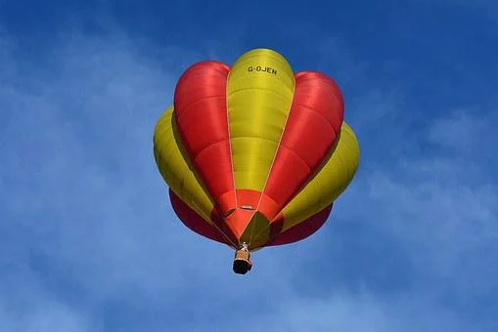
"Hot Air Balloon flying sky" by hazelw90 is used in accordance with the Pixabay License.

Resource 2: Stimulus image – Rollercoaster
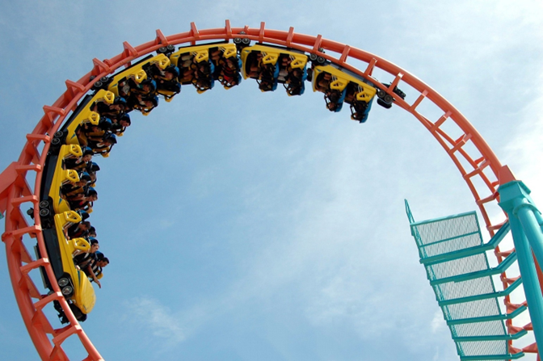
"Roller Coaster" by Paul Brennan is used in accordance with the Pixabay License.

Resource 3: Positive, negative, and neutral images
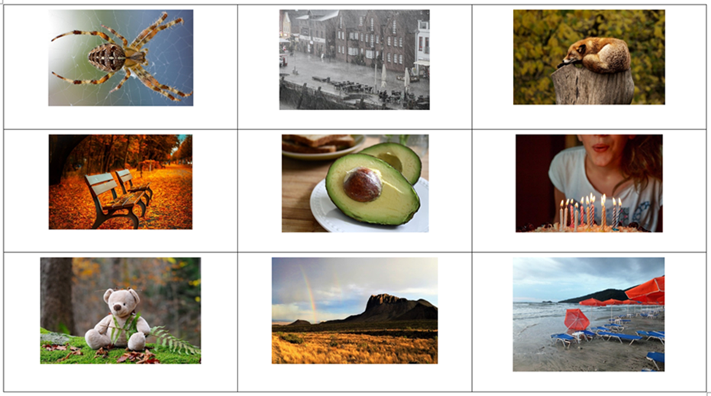
Images sourced from Pixabay and used in accordance with the Pixabay License.

Resource 4: Vocabulary self-assessment tool
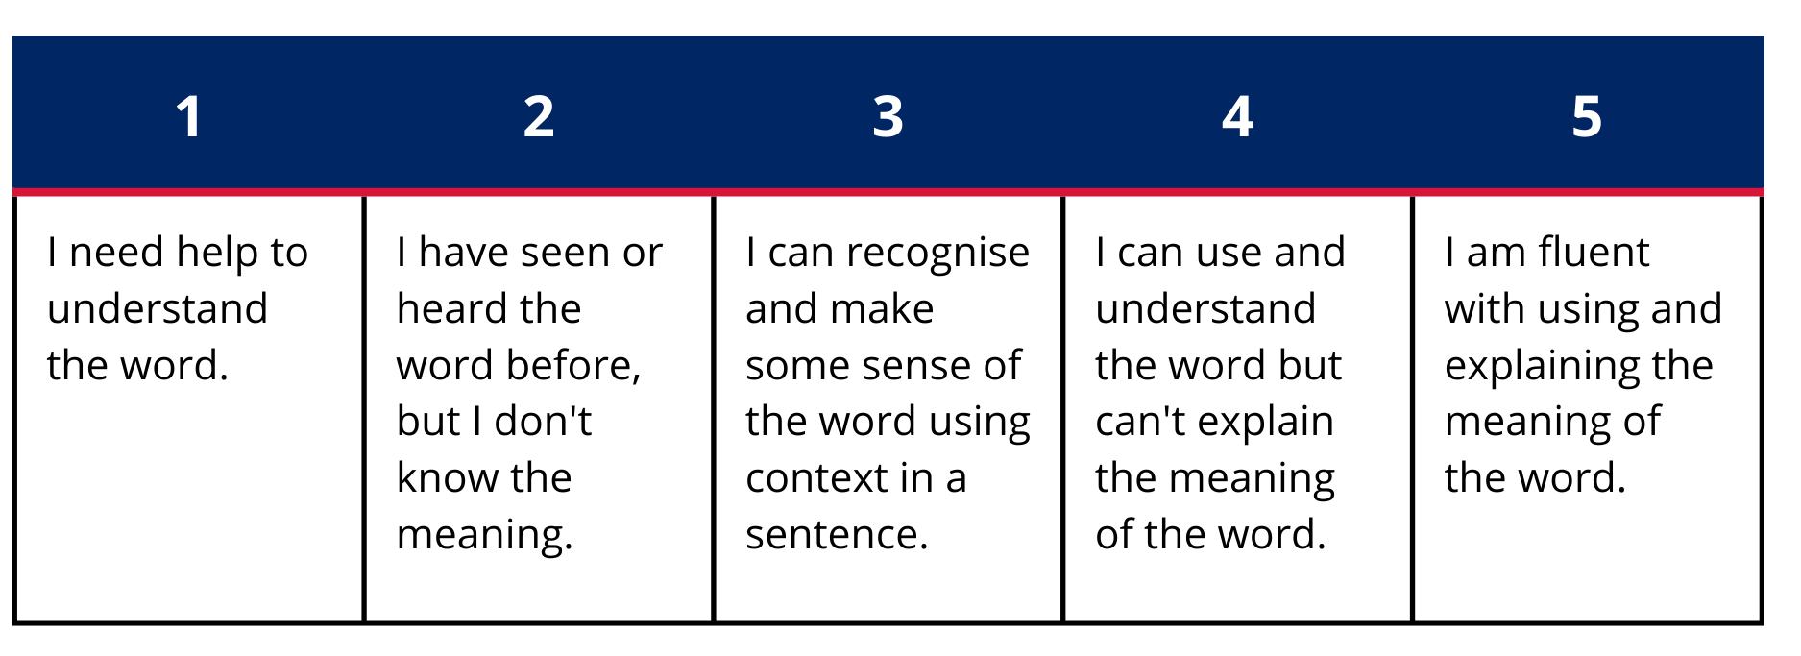

Resource 5: Morphology teacher model chart
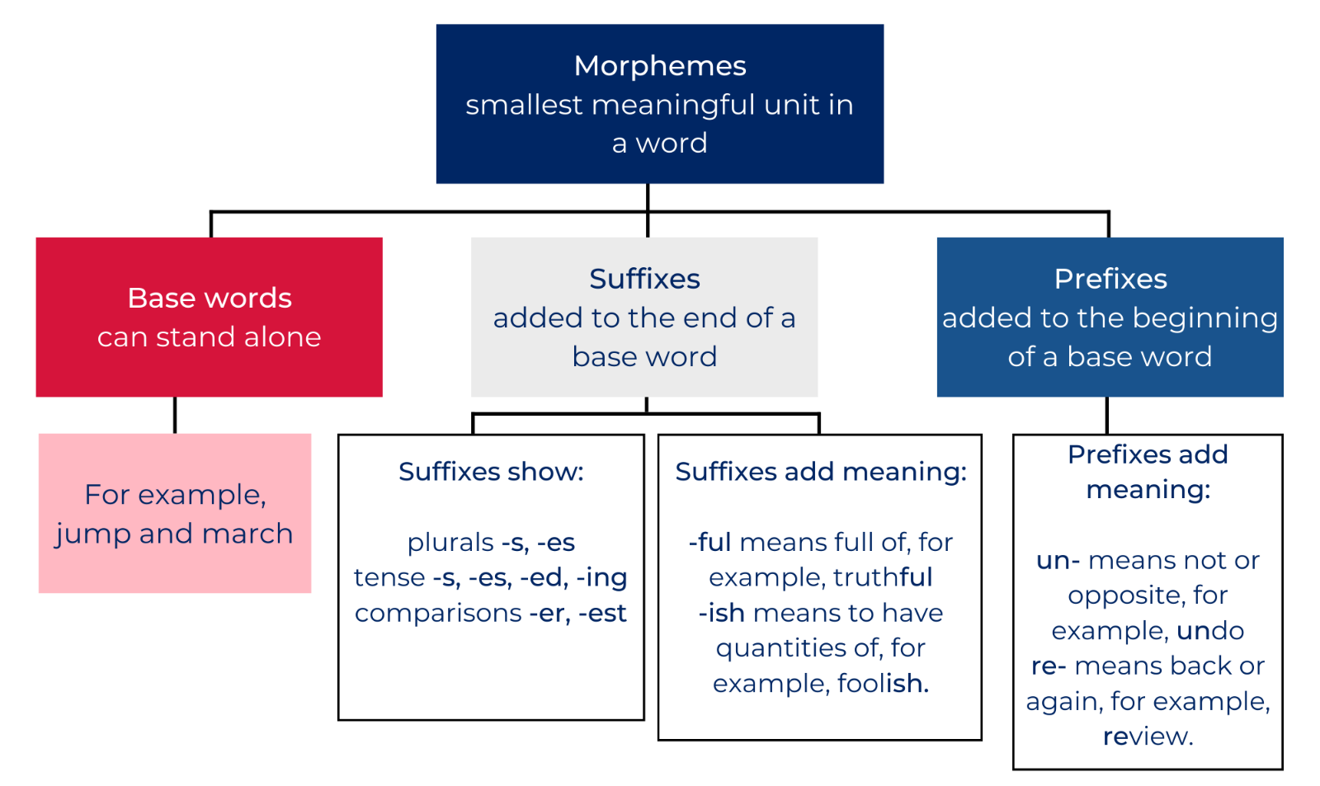

Resource 6: Story map
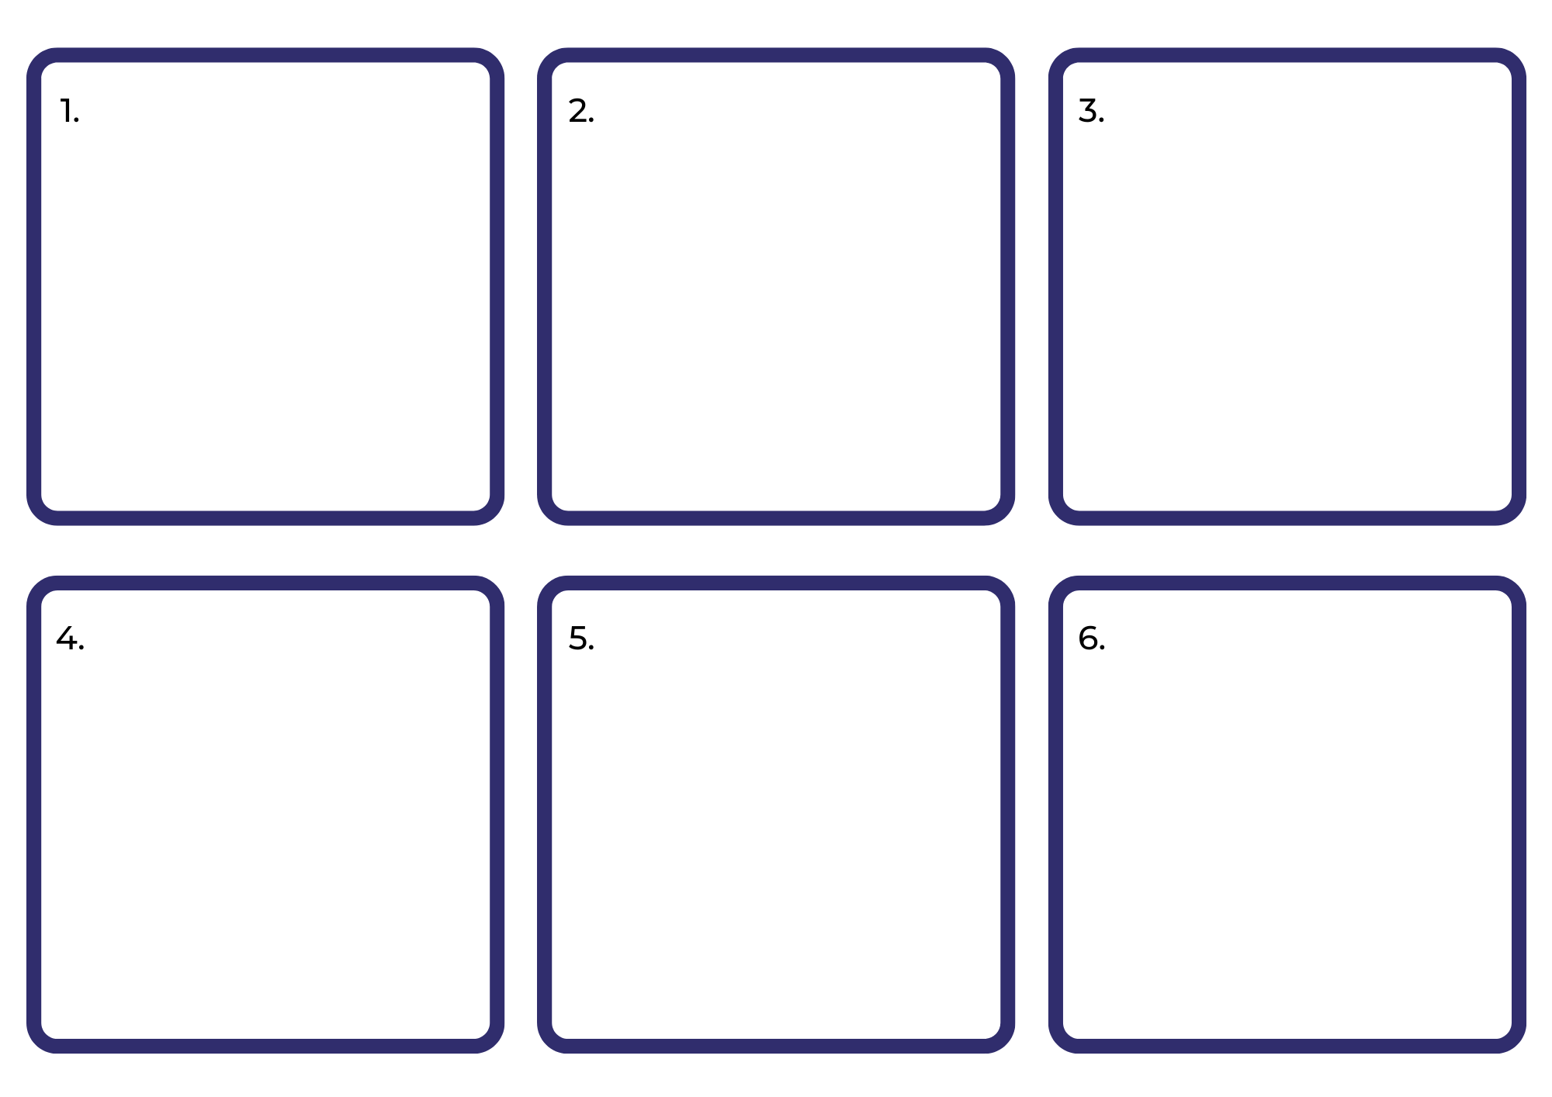

References
Links to third-party material and websites
Please note that the provided (reading/viewing material/list/links/texts) are a suggestion only and implies no endorsement, by the New South Wales Department of Education, of any author, publisher, or book title. School principals and teachers are best placed to assess the suitability of resources that would complement the curriculum and reflect the needs and interests of their students.
If you use the links provided in this document to access a third-party's website, you acknowledge that the terms of use, including licence terms set out on the third-party's website apply to the use which may be made of the materials on that third-party website or where permitted by the Copyright Act 1968 (Cth). The department accepts no responsibility for content on third-party websites.
Except as otherwise noted, all material is © State of New South Wales (Department of Education), 2023 and licensed under the Creative Commons Attribution 4.0 International License. All other material (third-party material) is used with permission or under licence. Where the copyright owner of third-party material has not licensed their material under a Creative Commons or similar licence, you should contact them directly for permission to reuse their material.
English K–10 Syllabus © 2022 NSW Education Standards Authority (NESA) for and on behalf of the Crown in right of the State of New South Wales.
Creative Arts K–6 Syllabus © 2006 NSW Education Standards Authority (NESA) for and on behalf of the Crown in right of the State of New South Wales.
PDHPE K–10 Syllabus © 2018 NSW Education Standards Authority (NESA) for and on behalf of the Crown in right of the State of New South Wales.
© 2022 NSW Education Standards Authority. This document contains NSW Curriculum and syllabus content. The NSW Curriculum is developed by the NSW Education Standards Authority. This content is prepared by NESA for and on behalf of the Crown in right of the State of New South Wales. The material is protected by Crown copyright.
Please refer to the NESA Copyright Disclaimer for more information.
NESA holds the only official and up-to-date versions of the NSW Curriculum and syllabus documents. Please visit the NSW Education Standards Authority (NESA) website and the NSW Curriculum website.
National Literacy Learning Progression © Australian Curriculum, Assessment and Reporting Authority (ACARA) 2010 to present, unless otherwise indicated. This material was downloaded from the Australian Curriculum website (National Literacy Learning Progression) (accessed 20 September 2022) and was not modified. The material is licensed under CC BY 4.0. Version updates are tracked in the ‘Curriculum version history’ section on the 'About the Australian Curriculum' page of the Australian Curriculum website.
ACARA does not endorse any product that uses the Australian Curriculum or make any representations as to the quality of such products. Any product that uses material published on this website should not be taken to be affiliated with ACARA or have the sponsorship or approval of ACARA. It is up to each person to make their own assessment of the product, taking into account matters including, but not limited to, the version number and the degree to which the materials align with the content descriptions and achievement standards (where relevant). Where there is a claim of alignment, it is important to check that the materials align with the content descriptions and achievement standards (endorsed by all education Ministers), not the elaborations (examples provided by ACARA).
ETA (English Teachers Association) and NSW Department of Education (2016) The Textual Concepts and Processes resource, English Textual Concepts website, accessed 20 September 2022.
ETA (English Teachers Association) and NSW Department of Education (2016) Connotation, imagery and symbol, English Textual Concepts website accessed 20 September 2022.
Leedy L (2009) Crazy Like a Fox, Holiday House Inc, New York.
MAAS (Museum of Applied Arts & Sciences) (n.d) Collection of tin toys, MAAS website, accessed 20 September 2022.
Magerl C (2019) Nop, Walker Books, Newtown.
Seesaw Learning Inc (2022) Seesaw [website], accessed 20 September 2022.
Waddell M (1995) Farmer Duck (Oxenbury H, illus), Walker Books Ltd, London.

