English – Stage 1 – Unit 19
Contents
Unit overview and instructions for use 3
Teacher notes 4
Outcomes and content – Component A 5
Outcomes and content – Component B 7
Week 1 10
Component A teaching and learning 10
Component B teaching and learning 11
Lesson 1: The basket 13
Lesson 2: What is that? 15
Lesson 3: Where is that? 16
Lesson 4: Connecting colour 18
Lesson 5: Fascinating fans 20
Week 2 22
Component A teaching and learning 22
Component B teaching and learning 23
Lesson 6: Model writing 24
Lesson 7: Joint construction 25
Lesson 8: Planning 26
Lesson 9: Composing 26
Lesson 10: Editing and publishing 27
Resource 1: Basket photos 29
Resource 2: Picture and word cards 30
Resource 3: Pandanus palms 32
Resource 4: Fascinating fans 33
Resource 5: Fan template 34
References 35
Further reading 37

Unit overview and instructions for use
This two-week unit is comprised of Component A and Component B. Connecting learning across both components is encouraged.
Teaching and learning | Component A | Component B
Suggested duration | 60 minutes | 45 minutes
Explicit teaching focus areas | - Phonic knowledge  - Reading fluency  - Reading comprehension  - Spelling  - Handwriting | - Oral language and communication  - Vocabulary  - Reading comprehension  - Creating written texts  - Understanding and responding to literature
To prepare for teaching and learning: | - Refer to Outcomes and content – Component A, K-2 – Instructional sequence – grapheme–phoneme correspondences [PDF 825 KB], and the teaching advice documents (hyperlinked in Component A teaching and learning table).  - Based on student needs identified through ongoing assessment data, plan and document how you will sequence teaching and learning in whole class and targeted teaching groups across the two-week cycle. | - Familiarise yourself with Outcomes and content – Component B, Textual concepts information and videos, English Textual Concepts and Learning Processes (2016), and the teaching and learning sequence.  - Based on student needs identified through ongoing assessment data, determine how you will support students in whole class and targeted teaching groups across the two-week cycle as required.
English K–10 Syllabus © 2022 NSW Education Standards Authority (NESA) for and on behalf of the Crown in right of the State of New South Wales.

Teacher notes
- During Week 2, students will be asked to bring in an artefact or object that is significant to their culture or family. The artefact could represent something from their own culture. For example, a teapot, a piece of cultural clothing, cultural food, a cultural decoration. It could also be a photograph or picture of something, including a cultural celebration, tradition, or family event.
- Representation is the depiction of a thing, person, or idea in written, visual, performed or spoken language. It can reflect the natural world realistically or convey people, objects, experiences and ideas in a more abstract way – English Textual Concepts and Learning Processes (2016).
- Understanding of representation can be supported through watching the department’s video: Understanding representation video (2:46).
- Other texts to supplement this unit could include: New Year Surprise! by Christopher Cheng and Di Wu, Going to the Footy by Debbie Coombes, The Color Collector by Nick Solis and Renia Metallinou, The Katha Chest by Radhiah Chowdhury and Lavanya Naidu.
- For information on noun groups, prepositions and conjunctions refer to the NESA Glossary.
- A noun group is a group of words relating to, or building on, a noun. Noun groups usually consist of a pointer (the, a, an, this, that, these, those, my, your, his, her, its, our, mum’s, Mr Smith’s) plus one or more adjectives or adverbs. They are an important language resource for building descriptions.
- Eye-to-Eye, Knee-to-Knee is an oral language strategy where students sit and face each other and share ideas, opinions, or knowledge about a topic.
- Reflect on student learning and engagement in activities and record differentiation and adjustments within the unit to inform future teaching and learning. One way of doing this could be to add comments to the digital file.
- Content points are linked to the National Literacy Learning Progression version (3).
Levels and indicators sourced from National Literacy Learning Progression © Australian Curriculum, Assessment and Reporting Authority (ACARA), (accessed 15 September 2022) and was not modified. See references for more information.

Outcomes and content – Component A
The table below outlines the focus outcomes and content. Content is linked to the National Literacy Learning Progression version (3).
Focus area and outcome | Content points and National Literacy Learning Progression
Phonic knowledge  EN1-PHOKW-01 – uses initial and extended phonics, including vowel digraphs, trigraphs to decode and encode words when reading and creating texts | - blend and decode one-syllable words with taught extended vowel graphs and digraphs, including graphemes for r-controlled vowels and diphthongs, and apply this when reading texts (PKW6, PKW7)  - segment and encode CCVCC words, CCCVC words and CCCVCC words and apply this when creating texts (SpG8)  - decode words with less common consonant digraphs and apply this when reading texts  - decode words with trigraphs and quadgraphs and apply this when reading texts
Reading fluency  EN1-REFLU-01 – sustains reading unseen texts with automaticity and prosody and self-corrects errors | - self-correct when fluency and/or meaning is interrupted  - vary pace when reading according to the audience and purpose (FlY4)
Reading comprehension  EN1-RECOM-01 – comprehends independently read texts that require sustained reading by activating background and word knowledge, connecting and understanding sentences and whole text, and monitoring for meaning | - draw on sources to seek clarification for unknown words  - monitor understanding to ensure meaning is sustained and expanded through the whole text (UnT6)
Spelling  EN1-SPELL-01 – applies phonological, orthographic and morphological generalisations and strategies when spelling words in a range of writing contexts | - segment single-syllable words into phonemes as a strategy for spelling (SpG4) (Year 1)  - use extended phonic code for taught consonant phonemes
Handwriting  EN1-HANDW-01 – uses a legible, fluent and automatic handwriting style, and digital technology, including word-processing applications, when creating texts | - use taught software functions to create texts in a range of modes for different contexts, audiences and purposes

Outcomes and content – Component B
The table below outlines the focus outcomes and content. Content is linked to the National Literacy Learning Progression version (3).
Focus area and outcome | Content points and National Literacy Learning Progression
Oral language and communication  EN1-OLC-01 – communicates effectively by using interpersonal conventions and language to extend and elaborate ideas for social and learning interactions | - listen to or engage with texts for enjoyment and recognise that their own experiences can shape their ideas and opinions of texts  - understand when a message is not clear and ask questions and/or gesture to elicit support and/or seek clarification  - use adjectives and adverbs to elaborate and/or provide some supporting details or justifications (SpK3)  - link or compare ideas when interacting
Vocabulary  EN1-VOCAB-01 – understands and effectively uses Tier 1, taught Tier 2 and Tier 3 vocabulary to extend and elaborate ideas | - understand and use words that have different meanings in different contexts
Reading comprehension  EN1-RECOM-01 – comprehends independently read texts that require sustained reading by activating background and word knowledge, connecting and understanding sentences and whole text, and monitoring for meaning | - use known vocabulary to build a mental model of the content of the text  - ask a clarifying question when more background knowledge is needed to make an inference  - make text-to-self, text-to-text or text-to-world connections when reading (UnT6)  - recount relevant ideas from texts in the form of a written, visual or oral summary (UnT6)
Creating written texts  EN1-CWT-01 – plans, creates and revises texts written for different purposes, including paragraphs, using knowledge of vocabulary, text features and sentence structure | - use noun groups to build descriptions of people and things (CrT6)  - use contextually precise prepositional phrases when creating texts (GrA4)  - understand that their own texts can be improved by incorporating feedback and editing
Understanding and responding to literature  EN1-UARL-01 – understands and responds to literature by creating texts using similar structures, intentional language choices and features appropriate to audience and purpose | - identify cultural representations in a range of texts  - express personal responses to the real and imagined worlds that are represented in texts

Week 1

Component A teaching and learning
The table below can be used to plan and document lessons that address Component A outcomes and content. Both the detailed example [DOC 529KB] of a two-week teaching and learning cycle and brief example [DOC 66KB] may support you in your planning.
Focus Areas | Lesson 1 | Lesson 2 | Lesson 3 | Lesson 4 | Lesson 5
Phonic knowledge
15 minutes
Spelling and Handwriting
15 minutes
Reading comprehension and Reading fluency
30 minutes

Component B teaching and learning
The following teaching and learning sequence has been designed to address Component B outcomes and content. Adapt the sequence as required to best meet the needs of your students.

Learning intention and success criteria
Learning intentions and success criteria are best co-constructed with students.

Learning intention
Students are learning to understand cultural representations in a range of texts and describe significant objects or things from their own culture or family.

Success criteria
Students can:
- identify personal connections with texts
- identify cultural representations in a range of texts
- verbalise adjectives and adverbs to extend their ideas
- identify noun groups and prepositional phrases in texts
- use noun groups and prepositional phrases to create texts.

Resources
- Dunstan K (2009) Collecting Colour, Lothian Children's Books. ISBN: 9780734411181
- Lo R (2020) Chinese New Year Colors, Random House. ISBN: 9780823443710
- Resource 1: Basket photos
- Resource 2: Picture and word cards
- Resource 3: Pandanus palms
- Resource 4: Fascinating fans
- Resource 5: Fan template – one copy for each student (printed A4 double sided)
- Video: How is Chinese New Year Celebrated? (4:28)
- Venn diagram – one enlarged copy and one copy for each student
- Sticky notes
- Map of Australia
- A3 paper
- Coloured pieces of paper

Lesson 1: The basket
- Display Resource 1: Basket photos. Discuss the different types of baskets and what they are made from. Using the Eye-to-Eye, Knee-to-Knee strategy, students discuss when or how they have seen or used a basket. For example, ‘Little Red Riding Hood carried a basket in the forest’, or ‘My family uses a basket to collect vegetables from the garden.’
- On a sticky note, students draw or write when they have used a basket or how they have used it. Students share their ideas and place their sticky note onto an anchor chart or around Resource 1: Basket photos.
- Explain that good viewers use their background knowledge combined with the clues from a text to make inferences about what is happening. Explain that students will use the 5W question stems (who, what, where, when, why) to make inferences about an object. Display the text Collecting Colour by Kylie Dunstan and highlight the image of the 2 children holding the basket on the front cover.
- Ask students:
- Who does the basket belongs to?
- What might the basket be used for?
- Where might the basket be used?
- When might the basket be used?
- Why might the basket be used?
- Read the text and stop at the page where the basket is used to collect bush food, carry shopping, and hold small babies. Discuss how the uses of baskets are similar or different to the experiences of students.
- Continue reading the text. Provide opportunities for students to make inferences and ask questions when more background knowledge is needed. Discuss new vocabulary, such as ceremonies, pandanus, and ferocious, and create a word wall using words and pictures.
- Revise the concept of representation. Explain that representation is the depiction of a thing, person, or idea in written, visual, performed or spoken language. It can reflect the natural world realistically or convey people, objects, experiences, and ideas. Explain that Aboriginal culture is represented in the text Collecting Colour. Examples include making baskets, mats and bags using natural materials or catching fish and collecting berries for food. Explain that students’ personal or cultural experiences may be similar or different to the characters in the text.
- Display an enlarged Venn diagram with the headings ‘My experiences’ and ‘Rose and Olive’s experiences’. Model writing words or phrases to highlight the similarities, for example, going fishing or playing with friends. Model writing words or phrases to highlight the differences, for example, ‘The children weave baskets using natural materials’ and ‘I buy bags from the shops.’
- Provide students with their own Venn diagram to draw or write the similarities between the text and their personal or cultural experiences.
Stage 1 Assessment task 1 – Observations from this lesson allow students to demonstrate achievement towards the following syllabus outcomes and content points:
EN1-OLC-01 – communicates effectively by using interpersonal conventions and language to extend and elaborate ideas for social and learning interactions
- listen to or engage with texts for enjoyment and recognise that their own experiences shape their ideas and opinions of texts.
EN1-RECOM-01 – comprehends independently read texts that require sustained reading by activating background and word knowledge, connecting and understanding sentences and whole text, and monitoring for meaning
- ask a clarifying question when more background knowledge is needed to make an inference
- make text-to-self, text-to-text or text-to-world connections when reading.

Lesson 2: What is that?
- Reintroduce students to the text Collecting Colour by Kylie Dunstan. Discuss where the story is set and use clues from the text to support students’ thinking. Re-read the sentence ‘Their families live in the Top End of the Northern Territory of Australia.’ Display a map of Australia and locate the Northern Territory. Ask students to discuss the term ‘Top End’ and why the author used it to describe the setting of the book. Identify students' location on the map and compare and contrast it to the setting of the text.
- Display the picture cards from Resource 2: Picture and word cards. Ask students what they think each picture is. Discuss student responses. Encourage students to respond using language from the text. For example, ‘That is a picture of a magpie goose that Karrang and Aunty packed for lunch’.
- Provide each student with a picture or word from Resource 2: Picture and word cards. Students walk around the classroom and match the picture and word cards. Encourage students to ask questions using clues about their object rather than showing or using the name of the object or thing. For example, they could ask if you have the object that is used to catch fish, or if you have the picture of a large reptile that lives in a river. Encourage students to ask clarifying questions if a clue is not clear.
- Glue pictures from Resource 2: Picture and word cards onto A3 paper. Revise adjectives. In small groups, students brainstorm adjectives that describe the picture. Students move around the room and add new adjectives to each picture. As a class, discuss the different adjectives used and display in the classroom.
- Revise noun groups and identify examples from the text. For example, little hot pink berries, murky green water, and bright yellow roots. Select one of the picture cards and model writing a description using noun groups. Use think alouds to highlight the significance of the object or image to Aboriginal culture. For example, the beautiful, coloured baskets, mats, and bags are made from pandanus leaves. They are used in special ceremonies, to collect bush food or carry babies.
- Students choose an image from Resource 2: Picture and word cards. Students draw their object and write a description using noun groups. Encourage students to include information about why it is significant to Aboriginal culture.
Too hard? Co-construct sentences using noun groups.
Too easy? Students use a thesaurus to find synonyms and include more complex adjectives in their writing.
Stage 1 Assessment task 2 – Observations from this lesson allow students to demonstrate achievement towards the following syllabus outcome and content points:
EN1-OLC-01 – communicates effectively by using interpersonal conventions and language to extend and elaborate ideas for social and learning interactions
- understand when a message is not clear and ask questions and/or gesture to elicit support and/or seek clarification
- use adjectives and adverbs to elaborate and/or provide some supporting details or justifications.

Lesson 3: Where is that?
- Ask students what happened in the story Collecting Colour by Kylie Dunstan. Students retell the story in their own words. Students could draw a storyboard, create a freeze frame, or write a summary of the text.
- Display Resource 3: Pandanus palms. Look at the features of the trees and discuss if any students have seen them before and where they may have seen them. Explain that Pandanus palms are native to Australia and grow from Cape York down the East coast to Port Macquarie. They are used a lot in Aboriginal culture in Northern parts of Australia.
- Re-read the description of the pandanus tree from Collecting Colour and highlight the noun groups and prepositional phrases. For example, ‘tall thick trunks’ and ‘at the top’. Create a list of prepositional phrases from the text.
- Encourage students to explore where items are around the classroom. For example, the pencils are on top of the table. Record student responses on the board and highlight the prepositional phrases used. Continue to add prepositional phrases to the list from activity 3.
- Using one of the examples provided by the students, model using noun groups to enhance a sentence. For example, ‘The sharp pencils are inside the sparkly, pink tin’.
- Students write sentences using noun groups and prepositional phrases about objects in the classroom.
Too hard? Students draw and label a picture of an object.
Too easy? Experiment using prepositional phrases in different parts of sentences. For example, Inside the sparkly, pink pencil tin there are six, sharp pencils.
- In pairs, students share their work.
Stage 1 Assessment task 3 – Observations and work samples from this lesson allow students to demonstrate achievement towards the following syllabus outcome and content point:
EN1-RECOM-01 – comprehends independently read texts that require sustained reading by activating background and word knowledge, connecting and understanding sentences and whole text, and monitoring for meaning
- recount relevant ideas from texts in the form of a written, visual or oral summary.

Lesson 4: Connecting colour
- Display a blue piece of paper. Explain that colour can be used to connect emotions and experiences. For example, you could say that the colour blue reminds you of your weekend trips to the beach or river and swimming in the crystal-clear water. Place different pieces of coloured paper around the classroom. Students walk around and record ideas and connections on the coloured pieces of paper. As a class, discuss the similarities and differences between student responses and how different colours make them feel.
- Ask students what they know about the celebration of Chinese New Year and share student responses. Display the text Chinese New Year Colors by Richard Lo and discuss how the word ‘colour’ is spelt differently in different countries. Discuss the different languages students use and how the author Richard Lo has created a bilingual text to represent different cultural objects seen during the Chinese New Year. Read the text and stop before the final page. Ask students if any of the objects they had seen in the text are significant to their culture or family and share responses as a class. For example, firecrackers are used during Chinese New Year and my family watches fireworks every New Year’s Eve.
- Read the last page of the text about cultural objects seen during Chinese New Year. Discuss how the meaning of objects can be different between contexts or cultures. For example, in European culture, people give desserts as housewarming gifts, while in Chinese culture people give tangerines. Encourage students to share personal experiences and make connections to the text.
- Focus on the picture of the chrysanthemum and read the description again. Ask students what the meaning of the chrysanthemum is during Chinese New Year. Ask students to consider the significance of chrysanthemums in Australia or their own culture. Explain that chrysanthemums are a symbol of friendship and family, and it is the most popular flower on Mother's Day because they are abundantly available during May.
- Students design and draw their own chrysanthemum using a variety of colours, then write sentences to describe the meaning of their chrysanthemum and explain their colour choice. For example, ‘My chrysanthemum is yellow. The yellow symbolises the happiness I feel when I am with my family and friends’.
Too hard? Students label their drawing with adjectives to describe colours and feelings.
Too easy? Students use a variety of simple, compound, and complex sentences to write their description.
Stage 1 Assessment task 4 – Observations from this lesson allow students to demonstrate achievement towards the following syllabus outcomes and content points:
EN1-VOCAB-01 – understands and effectively uses Tier 1, taught Tier 2 and Tier 3 vocabulary to extend and elaborate ideas
- understand and use words that have different meanings in different contexts.
EN1-RECOM-01 – comprehends independently read texts that require sustained reading by activating background and word knowledge, connecting and understanding sentences and whole text, and monitoring for meaning
- use known vocabulary to build a mental model of the content of the text.
EN1-UARL-01 – understands and responds to literature by creating texts using similar structures, intentional language choices and features appropriate to audience and purpose
- identify cultural representations in a range of texts
- express personal responses to the real and imagined worlds that are represented in texts.

Lesson 5: Fascinating fans
- Refer to the text Chinese New Year Colors by Richard Lo. Discuss the colours used in the text and how they represent different cultural objects seen during Chinese New Year. Focus on the picture of the paper fan and read the description again. Discuss the symbolism of the fan in Chinese culture. For example, it is a symbol of happiness, success, and good fortune. Display Resource 4: Fascinating fans and discuss the different colours, symbols and patterns used.
- View How is Chinese New Year Celebrated? (4:28). Ask students:
- How did Chinese New Year celebrations begin?
- What are some of the traditions people participate in? For example, round table feast, firecrackers, certain foods such as dumplings, mandarins, and rice-balls.
- Why is the colour red used? For example, it is believed that red represents good fortune and brings happiness.
- Ask students to think about a special celebration or event that is significant to them. Create a class poster of favourite celebrations, for example, birthday, Christmas, Diwali, Easter, Ramadan. Students Think-Pair-Share about a celebration or event that is significant to them and discuss the colours and objects that are associated with that celebration. For example, a Christmas tree and the colours green and red could be associated with the celebration of Christmas. Record student responses on a chart to display in the classroom.
- Provide students with Resource 5: Fan template. Students decorate their fan with colours, symbols and patterns that are significant to them and their celebration or event.
- In pairs, students share their ideas and provide details about why they included specific symbols or patterns and how they represented them.
- On the other side of their fan template, students write a description of their significant celebration or event.
Too hard? Students label their fan using adjectives.
Too easy? Students write a detailed paragraph about their celebration or event.
- Students fold their piece of paper into a fan. Decorate the classroom by displaying the fans around the room.

Week 2

Component A teaching and learning
The table below can be used to plan and document lessons that address Component A outcomes and content. Both the detailed example [DOC 529KB] of a two-week teaching and learning cycle and brief example [DOC 66KB] may support you in your planning.
Focus Areas | Lesson 6 | Lesson 7 | Lesson 8 | Lesson 9 | Lesson 10
Phonic knowledge
15 minutes
Spelling and Handwriting
15 minutes
Reading comprehension and Reading fluency
30 minutes

Component B teaching and learning
The following teaching and learning sequence has been designed to address Component B outcomes and content. Adapt the sequence as required to best meet the needs of your students.

Learning intention and success criteria
Learning intentions and success criteria are best co-constructed with students.

Learning intention
Students are learning to understand cultural representations in a range of texts and describe significant objects or things from their own culture or family.

Success criteria
Students can:
- verbally elaborate on ideas by using adjectives and adverbs
- co-construct success criteria and apply it to assess and improve written texts
- use noun groups and prepositional phrases to create texts
- use feedback to improve writing.

Resources
- Dunstan K (2009) Collecting Colour, Lothian Children's Books. ISBN: 9780734411181
- Lo R (2020) Chinese New Year Colors, Random House. ISBN: 9780823443710
- Personal artefact or object – teacher and students provide an artefact or object significant to their culture or family

Lesson 6: Model writing
- Explain that students will be writing an informative text about an artefact or object that is significant to their culture or family. Present a personal artefact or object and explain what it is, the significance of it and make connections to personal experiences. The artefact could represent something from your own culture, or a connection to a special event experienced. For example, a billy can, a vase or a cultural headdress.
- Explain that students will need to bring an artefact or object from home to use in Lesson 8. The artefact could represent something from their own culture. For example, a teapot, a piece of cultural clothing, cultural food, or a cultural decoration. It could also be a photograph of something, including a cultural celebration, tradition, or family event.
- Explicitly model how to write an informative text that describes the artefact and explains its importance. For example, ‘The blackened, tin billy can is placed on top of the crackling campfire. It is perfect for brewing bubbling hot tea in the great outdoors. During the school holidays, my family and I stay in a large cosy tent and play card games by the campfire’.
- Display the modelled text in the classroom. Ask students what they like about the text. In pairs, students turn and talk to explain their reasoning. For example, it uses noun groups to describe the object, it includes prepositional phrases to explain where and when the object is used, and it uses personal experiences to explain its importance.
- Use student responses to co-construct success criteria. Display in the classroom.
- Write the sentences ‘Paper fans are a Chinese New Year wall decoration. They are colourful’. Ask students if the sentences meet the success criteria. Encourage students to explain their reasoning. For example, the sentence does not include noun groups, prepositional phrases or personal experiences and connections to culture or family.
- In pairs, students write an informative paragraph about paper fans using descriptive sentences. Students edit their work to meet the success criteria.
Too hard? Students label an image of a fan using noun groups and prepositional phrases.
Too easy? Students write an informative paragraph about a different object from the text Chinese New Year Colors.
- Strategically select student work samples that effectively meet the success criteria and use examples from the text to highlight how or why it does.

Lesson 7: Joint construction
- Display a picture of an artefact or object from Collecting Colour by Kylie Dunstan or Chinese New Year Colors by Richard Lo. For example, a pandanus mat, gold coin or tangerine.
- Ask students how they could describe the object. Provide students with independent thinking time before discussing with a partner. Students record noun groups on sticky notes. Select students to share their responses with the class and add sticky notes to an anchor chart with the heading ‘Noun groups’.
- Repeat activity 2 with prepositional phrases. Add ideas to the anchor chart under the heading ‘Prepositional phrases’.
- As a whole class, discuss which noun groups and prepositional phrases are most effective and why. Draw attention to noun groups that are interesting and provide more information to build understanding.
- Display the co-constructed success criteria from Lesson 6. Use student responses to construct a whole class informative text about the artefact or object used in activity 1. Encourage students to describe the object, use a variety of simple, compound, and complex sentences and explain the significance of the object using personal experiences. Use student responses to guide the joint construction. Display the text in the classroom.
Too easy? Students independently write a paragraph about the object from the text.
- In pairs, students evaluate the text against the success criteria. Model using a strategy for peer feedback, such as the feedback bun or weather gauge. Identify ways the text could be improved to meet the success criteria. Explicitly model how to go back and edit the text to improve writing.

Lesson 8: Planning
- Revise the purpose of students’ writing, to write an informative text about an artefact or object that is significant to their culture or family. Students should have brought in an artefact or object from home that represents something significant to their own culture or family. For example, a teapot, a piece of cultural clothing, a photograph, or a cultural decoration.
- In pairs, students describe their artefact or object and explain its significance to their culture or family. Encourage students to share personal experiences or how the artefact or object is used during special events, celebrations, or ceremonies.
- Revise the success criteria from Lesson 6. Strategically select students to share their descriptions of objects with the class. Highlight when students use language that meets the success criteria.
- Explain that planning is an important part of creating texts. Students use a concept map to plan their ideas. Encourage students to draw a picture of their artefact or object in the middle of their concept map and write their ideas around the outside.

Lesson 9: Composing
- Revise the co-constructed success criteria from Lesson 6.
- Students use their concept map plan to write an informative text about their artefact or object. Remind them that they must include a description of the artefact or object, information about how their object reflects their own culture or family and why it is significant. For example, how the object represents important cultural experiences or a significant event, celebration, or ceremony.
- Encourage students to use descriptive language (noun groups and precise prepositional phrases) and varied sentence structures.
Too hard? Co-construct sentences about an artefact or object.
Too easy? Students separate their ideas into paragraphs.

Lesson 10: Editing and publishing
- Revise and display the co-constructed success criteria from Lesson 6. In pairs, students provide peer feedback on writing produced in Lesson 9.
- Provide time for students to apply feedback and publish their writing. Optional: students create an artwork using colour to represent the importance of their artefact or object.
- Students share their text with an authentic audience. For example, reading their text to a peer from another class, someone with the same cultural background or to inform someone about their own culture.
Stage 1 Assessment task 5 – Work samples from this lesson allow students to demonstrate achievement towards the following syllabus outcome and content points:
EN1-CWT-01 – plans, creates and revises texts written for different purposes, including paragraphs, using knowledge of vocabulary, text features and sentence structure
- use noun groups to build descriptions of people and things
- use contextually precise prepositional phrases when creating texts
- understand that their own texts can be improved by incorporating feedback and editing.

Resource 1: Basket photos
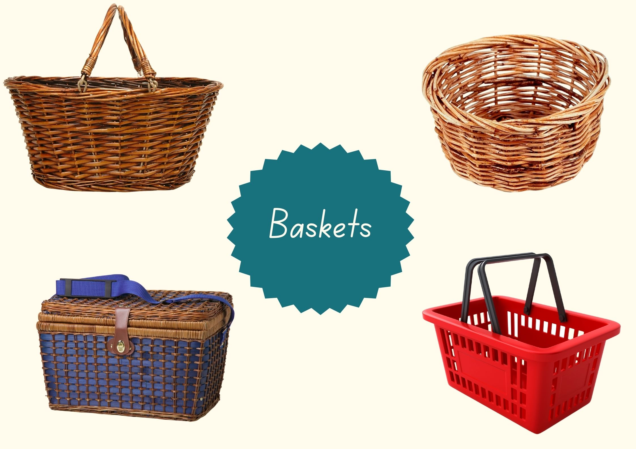
Images sourced from Canva and used in accordance with the Canva Content License Agreement.

Resource 2: Picture and word cards
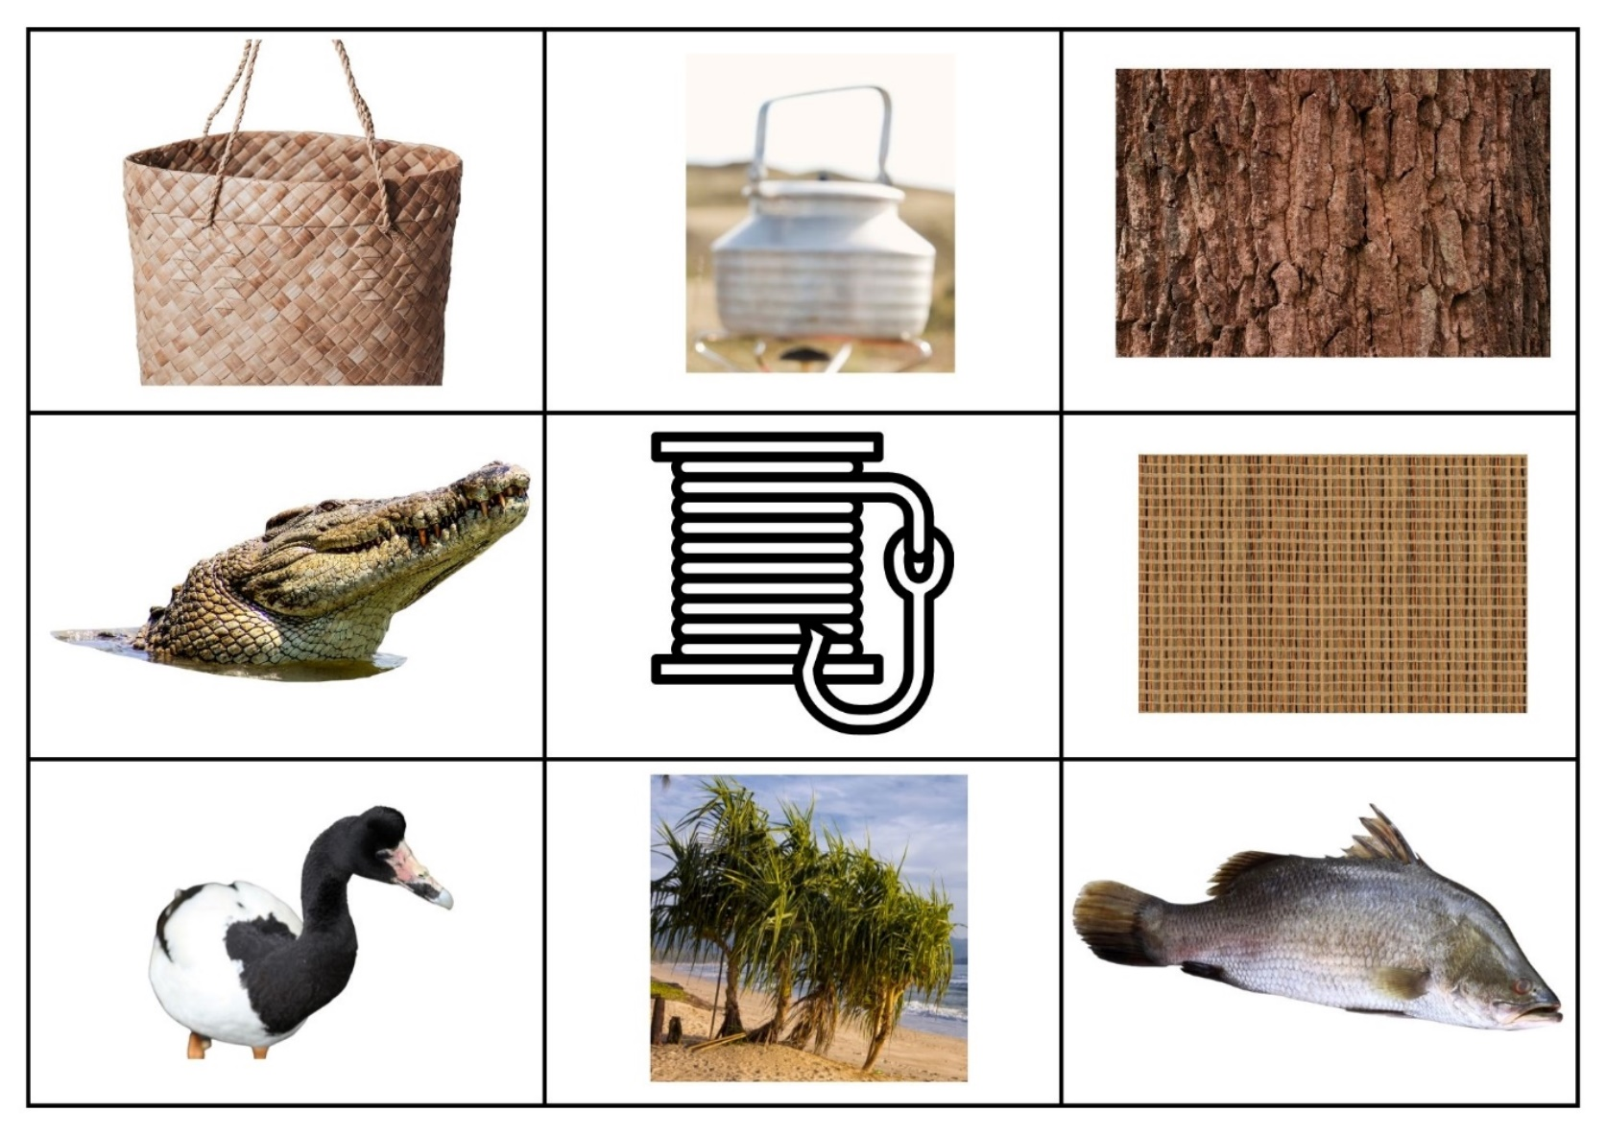
Images sourced from Canva and used in accordance with the Canva Content License Agreement.
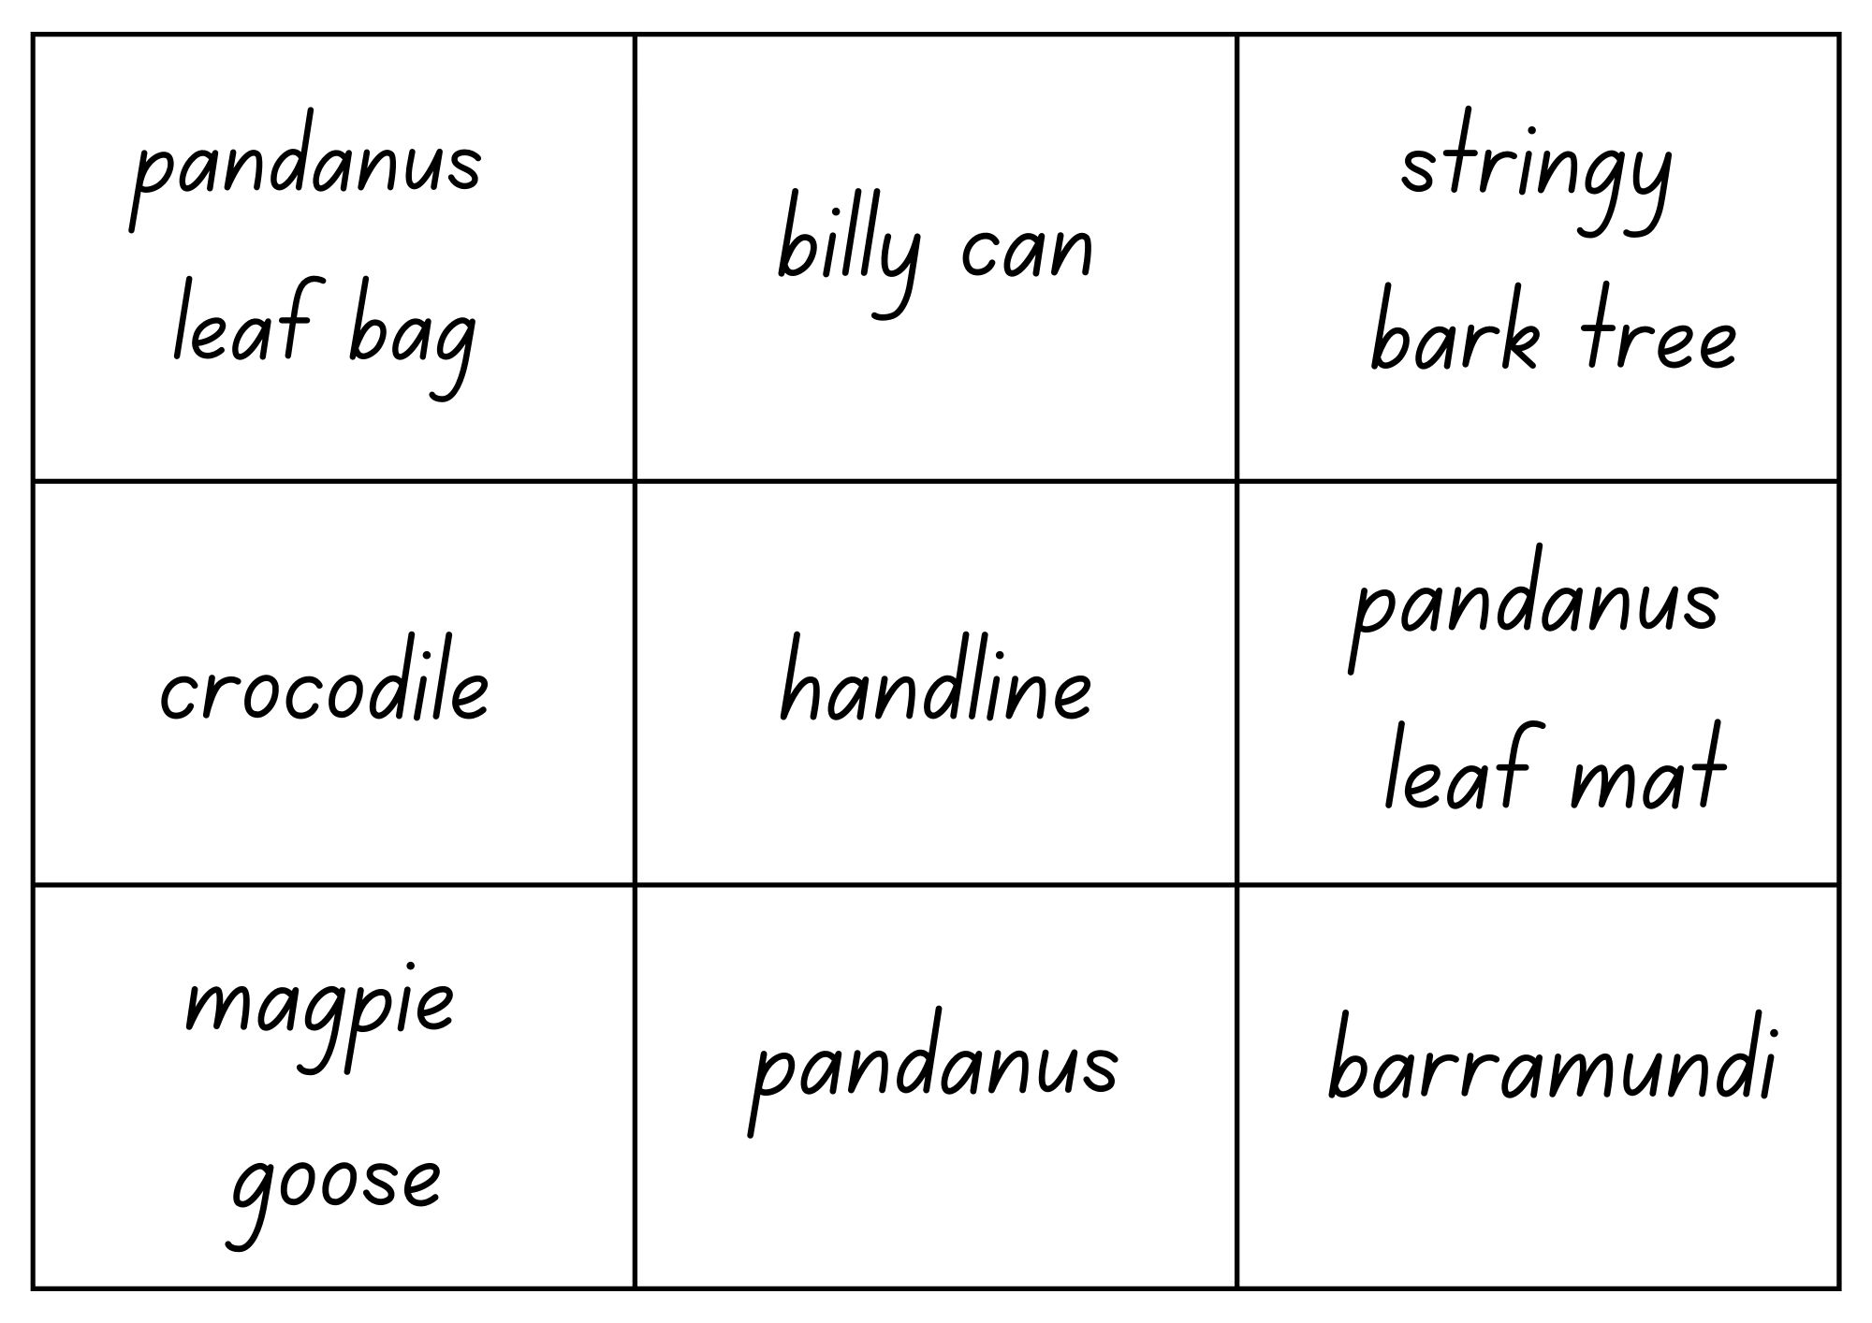

Resource 3: Pandanus palms
Images sourced from Canva and used in accordance with the Canva Content License Agreement.

Resource 4: Fascinating fans
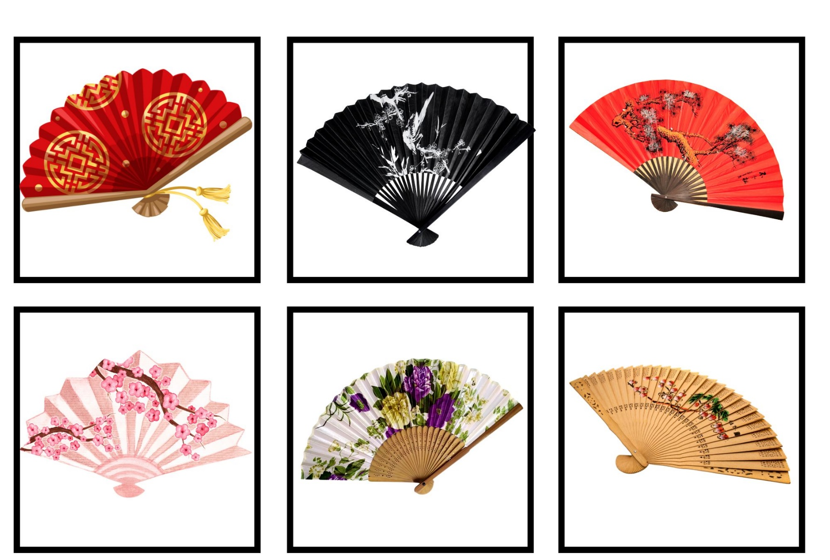
Images sourced from Canva and used in accordance with the Canva Content License Agreement.

Resource 5: Fan template
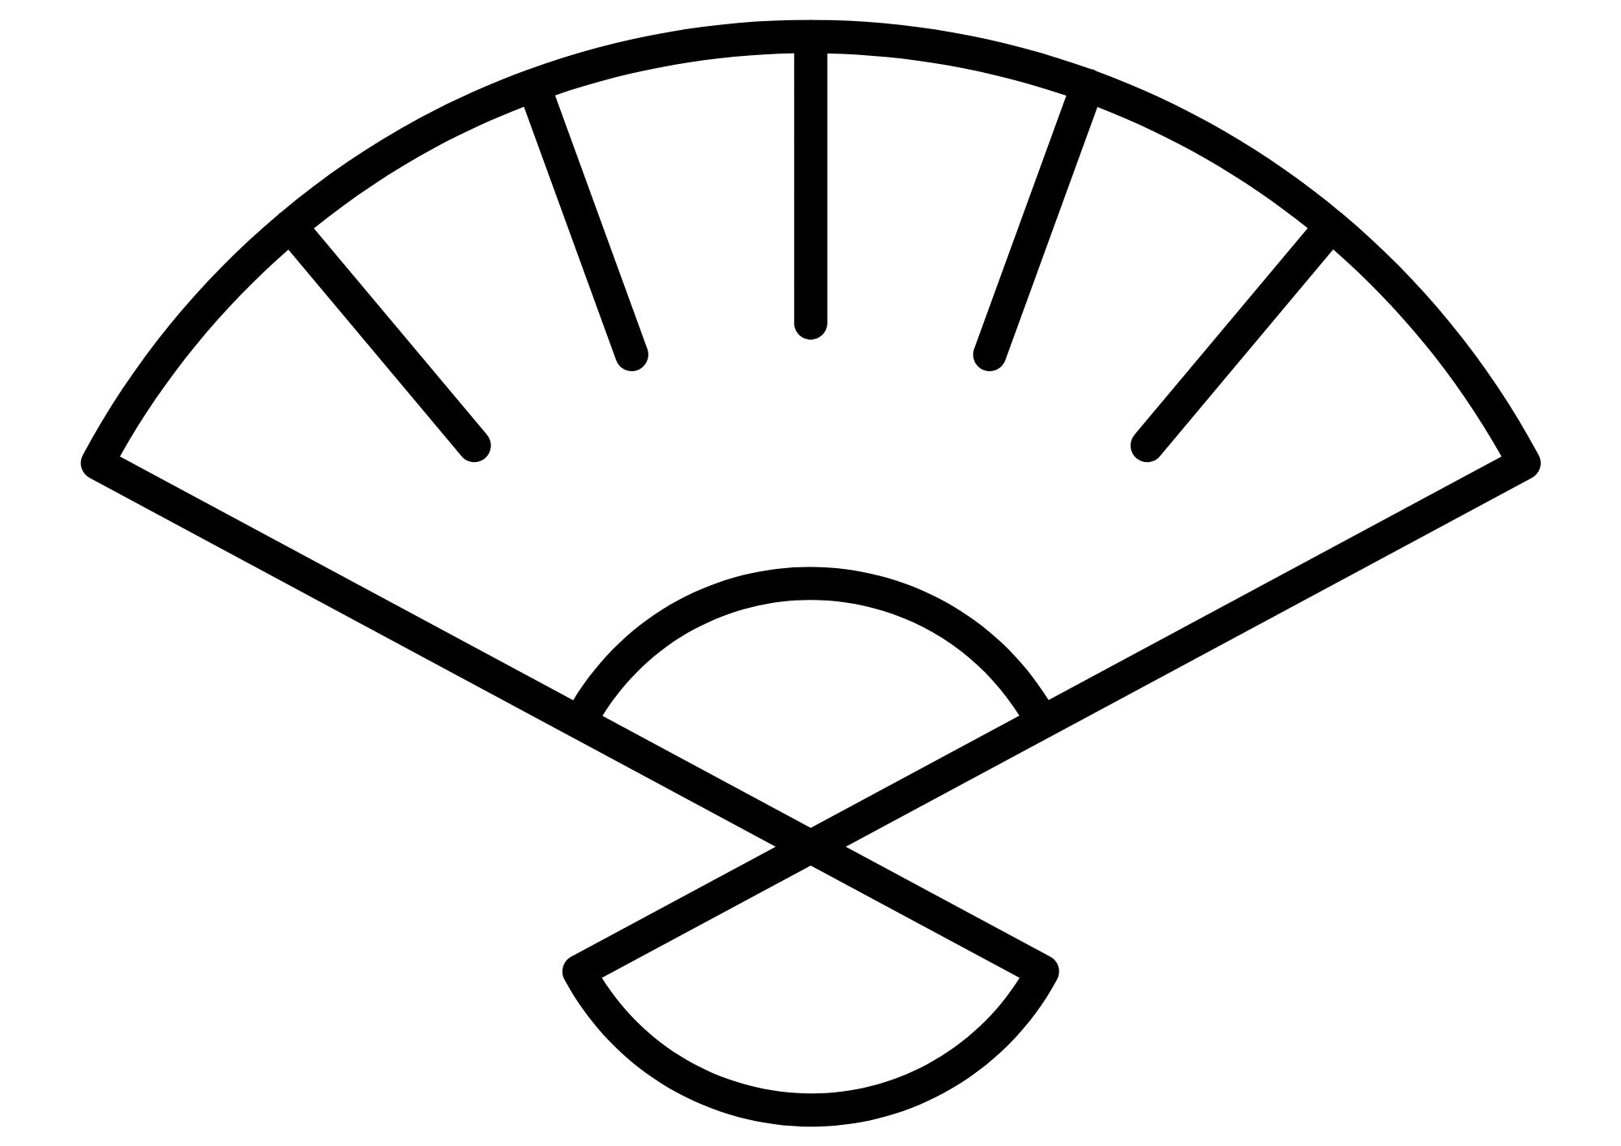
Image sourced from Canva and used in accordance with the Canva Content License Agreement.

References
Links to third-party material and websites
Please note that the provided (reading/viewing material/list/links/texts) are a suggestion only and implies no endorsement, by the New South Wales Department of Education, of any author, publisher, or book title. School principals and teachers are best placed to assess the suitability of resources that would complement the curriculum and reflect the needs and interests of their students.
If you use the links provided in this document to access a third-party's website, you acknowledge that the terms of use, including licence terms set out on the third-party's website apply to the use which may be made of the materials on that third-party website or where permitted by the Copyright Act 1968 (Cth). The department accepts no responsibility for content on third-party websites.
Except as otherwise noted, all material is © State of New South Wales (Department of Education), 2023 and licensed under the Creative Commons Attribution 4.0 International License. All other material (third-party material) is used with permission or under licence. Where the copyright owner of third-party material has not licensed their material under a Creative Commons or similar licence, you should contact them directly for permission to reuse their material.
English K–10 Syllabus © 2022 NSW Education Standards Authority (NESA) for and on behalf of the Crown in right of the State of New South Wales.
© 2022 NSW Education Standards Authority. This document contains NSW Curriculum and syllabus content. The NSW Curriculum is developed by the NSW Education Standards Authority. This content is prepared by NESA for and on behalf of the Crown in right of the State of New South Wales. The material is protected by Crown copyright.
Please refer to the NESA Copyright Disclaimer for more information.
NESA holds the only official and up-to-date versions of the NSW Curriculum and syllabus documents. Please visit the NSW Education Standards Authority (NESA) website and the NSW Curriculum website.
National Literacy Learning Progression © Australian Curriculum, Assessment and Reporting Authority (ACARA) 2010 to present, unless otherwise indicated. This material was downloaded from the Australian Curriculum website (National Literacy Learning Progression) (accessed 15 September 2022) and was not modified. The material is licensed under CC BY 4.0. Version updates are tracked in the ‘Curriculum version history’ section on the 'About the Australian Curriculum' page of the Australian Curriculum website.
ACARA does not endorse any product that uses the Australian Curriculum or make any representations as to the quality of such products. Any product that uses material published on this website should not be taken to be affiliated with ACARA or have the sponsorship or approval of ACARA. It is up to each person to make their own assessment of the product, taking into account matters including, but not limited to, the version number and the degree to which the materials align with the content descriptions and achievement standards (where relevant). Where there is a claim of alignment, it is important to check that the materials align with the content descriptions and achievement standards (endorsed by all education Ministers), not the elaborations (examples provided by ACARA).
ClickView (15 January 2021) 'How is Chinese New Year Celebrated?' [video], ClickView, YouTube, accessed 15 September 2022.
Dunstan K (2009) Collecting Colour, Lothian Children's Books, Australia.
ETA (English Teachers Association) and NSW Department of Education (2016) The Textual Concepts and Processes resource, English Textual Concepts website, accessed 15 September 2022.
Lo R (2020) Chinese New Year Colors, Random House, United States of America.

Further reading
Cheng C (2016) New Year Surprise! (Wu D, illus.), National Library of Australia.
Chowdhury R (2021) The Katha Chest (Naidu L, illus.), A&U Children's, Sydney.
Coombes D (2019) Going to the Footy, Magabala Books, Australia.
Solis N (2021) The Color Collector (Metallinou R, illus.), Sleeping Bear Press, United States.

