English – Stage 1 – Unit 16
Contents
Unit overview and instructions for use 3
Teacher notes 4
Outcomes and content – Component A 5
Outcomes and content – Component B 7
Week 1 10
Component A teaching and learning 10
Component B teaching and learning 11
Lesson 1: Text orientation 12
Lesson 2: Exploring vocabulary 14
Lesson 3: Exploring tense 15
Lesson 4: Comparing texts 17
Lesson 5: Comparing texts continued 19
Week 2 22
Component A teaching and learning 22
Component B teaching and learning 23
Lesson 6: Word choice and opinions 24
Lesson 7: Planning 25
Lesson 8: Composing 27
Lesson 9: Feedback and editing 28
Lesson 10: Publishing and presenting 30
Resource 1: Stimulus of pollution 31
Resource 2: T-chart 32
Resource 3: Tense table 33
Resource 4: Online text features and navigation pathways 34
Resource 5: Cause and effect 36
Resource 6: Word cards 37
Resource 7: 5 senses table 38
Resource 8: Planning template 39
Resource 9: Paragraph exemplar 40
References 41

Unit overview and instructions for use
This two-week unit is comprised of Component A and Component B. Connecting learning across both components is encouraged.
Teaching and learning | Component A | Component B
Suggested duration | 60 minutes | 45 minutes
Explicit teaching focus areas | - Phonic knowledge  - Reading fluency  - Reading comprehension  - Spelling  - Handwriting | - Oral language and communication  - Vocabulary  - Reading comprehension  - Creating written texts  - Understanding and responding to literature
To prepare for teaching and learning: | - Refer to Outcomes and content – Component A, K-2 – Instructional sequence – grapheme–phoneme correspondences [PDF 825 KB], and the teaching advice documents (hyperlinked in Component A teaching and learning table).  - Based on student needs identified through ongoing assessment data, plan and document how you will sequence teaching and learning in whole class and targeted teaching groups across the two-week cycle. | - Familiarise yourself with Outcomes and content – Component B, Textual concepts information and videos, English Textual Concepts and Learning Processes (2016), and the teaching and learning sequence.  - Based on student needs identified through ongoing assessment data, determine how you will support students in whole class and targeted teaching groups across the two-week cycle as required.
English Syllabus K–10 © 2022 NSW Education Standards Authority (NESA) for and on behalf of the Crown in right of the State of New South Wales.

Teacher notes
- Perspective is defined as a lens through which we learn to see the world; it shapes what we see and the way we see it. – English Textual Concepts and Learning Processes (2016).
- Argument is persuasion using the conventions of various forms, modes, and media. – English Textual Concepts and Learning Processes (2016).
- Understanding of perspective can be supported through watching the department’s Perspective (3:37).
- Understanding of argument can be supported through watching the department’s Argument (3:17).
- For information on visualising, tiered words, compound sentences, verbs, and tense refer to the NESA Glossary.
- Consider prior student learning about compound sentences, complex sentences, and paragraphs.
- Reflect on student learning and engagement in activities and record differentiation and adjustments within the unit to inform future teaching and learning. One way of doing this could be to add comments to the digital file.
- Content points are linked to the National Literacy Learning Progression version (3).
Levels and indicators sourced from National Literacy Learning Progression © Australian Curriculum, Assessment and Reporting Authority (ACARA), (accessed 13 September 2022) and was not modified. See references for more information.

Outcomes and content – Component A
The table below outlines the focus outcomes and content. Content is linked to the National Literacy Learning Progression version (3).
Focus area and outcome | Content points and National Literacy Learning Progression
Phonic knowledge  EN1-PHOKW-01 – uses initial and extended phonics, including vowel digraphs, trigraphs to decode and encode words when reading and creating texts | - blend grapheme–phoneme correspondences to read CCVCC words, CCCVC words and CCCVCC words and apply this when reading texts (PKW7)  - segment and encode one-syllable high-frequency base words with split digraphs and apply this when creating texts (SpG6)  - blend and decode one-syllable words with taught extended vowel graphs and digraphs, including graphemes for r-controlled vowels and diphthongs, and apply this when reading texts (PKW6, PKW7)  - blend and decode two-syllable words with taught extended vowel graphs and digraphs, including graphemes for r-controlled vowels and diphthongs, and apply this when reading texts (PKW6, PKW7)
Reading fluency  EN1-REFLU-01 – sustains reading unseen texts with automaticity and prosody and self-corrects errors | - self-correct when fluency and/or meaning is interrupted  - vary pace when reading according to the audience and purpose (FlY4)
Reading comprehension  EN1-RECOM-01 – comprehends independently read texts that require sustained reading by activating background and word knowledge, connecting and understanding sentences and whole text, and monitoring for meaning | - draw on sources to seek clarification for unknown words  - monitor understanding to ensure meaning is sustained and expanded through the whole text (UnT6)
Spelling  EN1-SPELL-01 – applies phonological, orthographic and morphological generalisations and strategies when spelling words in a range of writing contexts | - segment single-syllable words into phonemes as a strategy for spelling (SpG4)  - explain that the consonant trigraphs, -tch and -dge, can end a base word immediately following a short vowel and apply this when spelling (SpG6)
Handwriting  EN1-HANDW-01 – uses a legible, fluent and automatic handwriting style, and digital technology, including word-processing applications, when creating texts | - use taught software functions to create texts in a range of modes for different contexts, audiences and purposes

Outcomes and content – Component B
The table below outlines the focus outcomes and content. Content is linked to the National Literacy Learning Progression version (3).
Focus area and outcome | Content points and National Literacy Learning Progression
Oral language and communication  EN1-OLC-01 – communicates effectively by using interpersonal conventions and language to extend and elaborate ideas for social and learning interactions | - understand when a message is not clear and ask questions and/or gesture to elicit support and/or seek clarification (LiS4)  - interact to evaluate ideas and refine meaning (InT4, InT5)  - use tense correctly to discuss past, present and future events
Vocabulary  EN1-VOCAB-01 – understands and effectively uses Tier 1, taught Tier 2 and Tier 3 vocabulary to extend and elaborate ideas | - use taught morphemic knowledge to create word families  - use vocabulary to express cause and effect (SpK3)
Reading comprehension  EN1-RECOM-01 – comprehends independently read texts that require sustained reading by activating background and word knowledge, connecting and understanding sentences and whole text, and monitoring for meaning | - use navigation pathways, including hyperlinks, to extract essential information to support reading fluency and enhance meaning when reading digital texts  - coordinate information or events from different parts of the text to form an overall opinion  - make text-to-self, text-to-text or text-to-world connections when reading (UnT6)  - monitor understanding to ensure meaning is sustained and expanded through the whole text (UnT6)  - ask a clarifying question when more background knowledge is needed to make an inference
Creating written texts  EN1-CWT-01 – plans, creates and revises texts written for different purposes, including paragraphs, using knowledge of vocabulary, text features and sentence structure | - write texts that describe, explain, give an opinion, recount an event, tell a story (CrT7)  - use a logical order to sequence ideas and events in sentences across a text (GrA4)  - use appropriate tense across a text (GrA4)  - use visual elements to expand meaning in own texts  - use action, saying, relating and sensing verbs to add detail and precision to writing (GrA2, GrA5)  - use modifying and qualifying words and words to indicate quantity  - re-read and edit their own texts after receiving feedback  - use different modes and media to enhance the presentation of texts they have created (CrT5, CrT6)
Understanding and responding to literature  EN1-UARL-01 – understands and responds to literature by creating texts using similar structures, intentional language choices and features appropriate to audience and purpose | - identify phrases in texts that project opinions  - identify how structure and images reinforce ideas  - create and re-create texts that include persuasive arguments, using knowledge of text and language features  - identify and share how their own experience and interests influence opinions and/or interpretations of texts

Week 1

Component A teaching and learning
The table below can be used to plan and document lessons that address Component A outcomes and content. Both the detailed example [DOC 529KB] of a two-week teaching and learning cycle and brief example [DOC 66KB] may support you in your planning.
Focus Areas | Lesson 1 | Lesson 2 | Lesson 3 | Lesson 4 | Lesson 5
Phonic knowledge
15 minutes
Spelling and Handwriting
15 minutes
Reading comprehension and Reading fluency
30 minutes

Component B teaching and learning
The following teaching and learning sequence has been designed to address Component B outcomes and content. Adapt the sequence as required to best meet the needs of your students.

Learning intention and success criteria
Learning intentions and success criteria are best co-constructed with students.

Learning intention
Students are learning to compose multimodal texts that project opinions using appropriate structure and language features.

Success criteria
Students can:
- state an opinion based on information presented in a text
- correctly identify past, present, and future tense
- identify how images and word choices reinforce an author’s purpose
- use vocabulary to express cause and effect
- compare texts that present a similar perspective.

Resources
- Lord M (2020) The Mess That We Made (Blattman J, illus.), Flashlight Press, New York. ISBN: 9781947277144
- Godwin N (2020) Jelly-Boy (Nielsen C, illus.), Walker Books Australia, Newtown. ISBN: 9781760651237
- Resource 1: Stimulus of pollution
- Resource 2: T-chart
- Resource 3: Tense table
- Resource 5: Cause and effect
- National Geographic Kids – Kids vs Plastic

Lesson 1: Text orientation
- Ask students what they know about pollution, what it looks like and how it is made.
- View Resource 1: Stimulus of pollution. Ask what students can see, how it makes them feel, what it makes them think, and how they think the rubbish got there.
- Introduce the mentor text The Mess That We Made by Michelle Lord, illustrated by Julia Blattman. Read the front and back cover of the text. Ask students to make predictions about the book and discuss their predictions.
- Read The Mess That We Made. Ask students what they see, what it makes them think about and what it makes them wonder. Record responses on a class See-Think-Wonder chart.
- Discuss the purpose of the text and explore what opinion the author may have about pollution. Introduce the concept of perspective. Perspective is shaped by our personal experiences and can influence our opinions and choices. Students turn and talk to discuss to the following questions:
- Who is the ‘we’ in the title?
- What is ‘the mess’ the author is referring to?
- What is the author’s purpose?
- How do we know what the author’s perspective is?
- Has the text changed your opinion on pollution?
- Explain how visualising a text can support understanding. Students close their eyes and listen to the teacher read 2 pages of the text aloud. In pairs, students share what they ‘saw’ in their mind and draw a picture to represent this.
Note: Visualising is a comprehension strategy used by learners to create a mental image from a text read, viewed, or heard. To visualise is to bring the text to life, engage the imagination, and use a person’s senses.
- Using Resource 2: T-chart, ask students how they would feel about swimming in the ocean at the start of the story compared to the end of the story. Students draw pictures and write sentences using the T-chart and share their work in small groups.
Too hard? Students draw and verbally explain their drawings.
Too easy? Students write a paragraph to explain their opinion connecting to the text.
- Ask students if their opinion about pollution is the same as the characters in the text. Students use thumbs up/thumbs down to share their opinion on whether pollution is harmful to the environment.
Stage 1 Assessment task 1 – Observations and work samples from this lesson allow students to demonstrate achievement towards the following syllabus outcomes and content points:
EN1-RECOM-01 – comprehends independently read texts that require sustained reading by activating background and word knowledge, connecting and understanding sentences and whole text, and monitoring for meaning
- coordinate information or events from different parts of the text to form an overall opinion
- make text-to-self, text-to-text or text-to-world connections when reading
- monitor understanding to ensure meaning is sustained and expanded through the whole text.
EN1-UARL-01 – understands and responds to literature by creating texts using similar structures, intentional language choices and features appropriate to audience and purpose
- identify how structure and images reinforce ideas
- identify and share how their own experience and interests influence opinions and/or interpretations of texts.

Lesson 2: Exploring vocabulary
- Discuss the importance of learning new words with students. Explain that unfamiliar texts can present new vocabulary that can be used to add detail and precision to writing. Revise the 3 Tiers of vocabulary. Explain that Tier 1 words are basic, everyday words, and Tier 2 words are more precise and powerful. Tier 3 words are used rarely and are specific to a topic.
- Read The Mess That We Made, including the ‘Ocean pollution and calls to action’ pages. During reading, students put their hand up when they hear an unfamiliar word. Record words on an anchor chart.
- Examples of Tier 2 words include: landfill, growing, spills, delay, haul, protects, swirls, current, reduce, recycle.
- Examples of Tier 3 words include: marine, microplastics, gyroscope, oceanographers, decompose, dispose, biodegradable.
- Use a dictionary or online dictionary to find the meanings of some Tier 3 words that are interesting to students.
- Explain that authors use cause and effect to influence the reader and their emotions. Cause and effect are often used in texts that present perspective to show the direct link between 2 objects or events. For example, pollution in the ocean (cause) and its impact on animals (effect).
- Using vocabulary from the anchor chart, model composing a compound sentence that uses a Tier 2 word to show cause and effect. For example, ‘Landfill pollution spills into the ocean and animals can get sick’.
- Students use Tier 2 words from the text and anchor chart to compose compound sentences about the cause and effect of pollution.
Too hard? Students write simple sentences and draw a picture to enhance meaning.
Too easy? Students write compound sentences using Tier 3 words.
- Gauge student understanding of vocabulary from the text by playing a quick game. For this game, one side of the classroom represents Tier 2 vocabulary, the other side represents Tier 3 vocabulary. The teacher or a student calls out a word from the text, students move to the appropriate side of the room.

Lesson 3: Exploring tense
- Revise verbs including examples of action, saying, relating, and sensing verbs.
- Open The Mess That We Made to the double page with a container ship, the children in a dinghy on the left, and the landfill on the right.
- Students identify the verbs in the text. Record student responses. Explain that verbs can be grouped into different types.
- Students Think-Pair-Share and create a sentence that uses one of the action verbs found in the text.
- Revise the concept of tense. Model how the tense of base words can be changed by adding the suffixes -s, -ing, or -ed. Start with a base word from the text, for example, dump, spill, work, play, protest, and add a tense marking suffix to show the change in tense. Include further examples to strengthen student understanding. For example, when a verb ends in ‘e’ add -d with no change to base word or drop the ‘e’ and add -ing.
- Using Resource 3: Tense table, students independently complete a table of base words and create past and present verbs by adding the suffixes -s, -ing, or -ed.
Too hard? Provide a verbal model and students complete the table in pairs.
Too easy? Students complete the table and write verbs in sentences.
- Optional: Form 2 teams. Place 3 chairs in a row labelled with ‘past tense’, ‘present tense’ or ‘future tense’. Taking turns, students are provided (orally or written) a simple verb with a suffix of -s, -ing or -ed. Students sit on the chair that corresponds to the verb’s tense. Each correct choice earns one point for their team. The game can be made more challenging by providing students with irregular verbs. The highest scoring team wins.
Stage 1 Assessment task 2 – Observations and work samples from this lesson allow students to demonstrate achievement towards the following syllabus outcomes and content points:
EN1-OLC-01 – communicates effectively by using interpersonal conventions and language to extend and elaborate ideas for social and learning interactions
- use tense correctly to discuss past, present and future events.
EN1-VOCAB-01 – understands and effectively uses Tier 1, taught Tier 2 and Tier 3 vocabulary to extend and elaborate ideas
- use taught morphemic knowledge to create word families.

Lesson 4: Comparing texts
- Revise Michelle Lord’s purpose for writing The Mess That We Made. Discuss how illustrations, images, and symbols in texts can support the author’s purpose and perspective.
- View National Geographic Kids – Kids vs Plastic. Explore the navigation pathways and tools on the page, including the use of embedded images and captions, and the hyperlinked images to different areas on the website located at the top of the page. Explain that National Geographic Kids is a trusted source and that the website’s ‘Site last updated’ information, located at the bottom of the page, indicates that the information is recent.
Note: For support in reading and viewing digital texts, see Digital and multimodal texts and Resource 4: Online text features and navigation pathways.
- Read through the website using the think aloud strategy to support understanding and establish the author’s purpose. Prompt students to ask clarifying questions to assist in their comprehension of the website text.
- Discuss the purpose of National Geographic Kids – Kids vs Plastic (informative) and The Mess That We Made (narrative/informative) and how the texts convey a similar perspective. Explain how authors use different language features and images to support their purpose.
- Present images from the website and ask students if the pictures in this text align with the images from The Mess That We Made. Ask if the images make them feel the same way, if the images show the same message, and if the images support the author’s perspective.
- Students Think-Pair-Share about how each text made them feel. Discuss the key message within both texts, for example, humans need to clean up after themselves in order to protect the environment.
- Identify and discuss how each text demonstrates cause and effect and the way it influences the reader. For example, in The Mess That We Made, people threw their rubbish onto the beach (cause), it was swept into the ocean and made the aquatic life sick (effect); or On the Kids vs Plastic website, people left rubbish bags on the beach and in the water (cause) which could then be eaten by the turtles (effect).
- Model using Resource 5: Cause and effect, to plan vocabulary that shows cause and effect based on images from each text. Model writing a sentence about the impact pollution has on the environment, using the planned vocabulary to show cause and effect.
- Students plan vocabulary that shows cause and effect using Resource 5: Cause and effect. Students write sentences about the impact pollution has on the environment, using their planned vocabulary to show cause and effect. For example, ‘Pollution is bad because ghost nets are left in the ocean and trap seals’.
Stage 1 Assessment task 3 – Observations and work samples from this lesson allow students to demonstrate achievement towards the following syllabus outcomes and content points:
EN1-VOCAB-01 – understands and effectively uses Tier 1, taught Tier 2 and Tier 3 vocabulary to extend and elaborate ideas
- use vocabulary to express cause and effect.
EN1-RECOM-01 – comprehends independently read texts that require sustained reading by activating background and word knowledge, connecting and understanding sentences and whole text, and monitoring for meaning
- use navigation pathways, including hyperlinks, to extract essential information to support reading fluency and enhance meaning when reading digital texts
- coordinate information or events from different parts of the text to form an overall opinion
- monitor understanding to ensure meaning is sustained and expanded through the whole text
- ask a clarifying question when more background knowledge is needed to make an inference.

Lesson 5: Comparing texts continued
- Create and display a three-column table with the headings; ‘The Mess That We Made’, ‘Kids vs Plastic’ and ‘Jelly-Boy’.
- Revise the language features, structure and images in the texts The Mess That We Made and Kids vs Plastic. Highlight how each text contains phrases and images that project the opinion that pollution has a negative impact on the environment. Discuss and record student ideas under the first 2 headings on the table.
- Introduce the text Jelly-Boy. Look at the front and back cover of the text. Explain to students that this story is similar to the other texts as it focuses on pollution and how it impacts the environment. Read Jelly-Boy to identify how the author presents the perspective that pollution negatively impacts the environment.
- After reading the text, students Think-Pair-Share about how the author presented their opinion (or perspective) about pollution. Collate student responses in the table under the final heading, ‘Jelly-Boy’.
- Discuss with students the similarities in the perspectives presented in the texts. Focus on text and language features, structure, and images.
- Students write a paragraph explaining how the texts are similar and the perspective they each present about pollution and the environment. Provide sentence starters to support student writing, for example:
- The texts are similar because...
- The Mess That We Made explains...
- Kids vs Plastics teaches us...
- Jelly-Boy shows...
Too hard? Students write simple and compound sentences using appropriate cause and effect language.
- Students share their responses with the class.
Stage 1 Assessment task 4 – Collecting work samples from this lesson allows students to demonstrate achievement towards the following syllabus outcomes and content points:
EN1-RECOM-01 – comprehends independently read texts that require sustained reading by activating background and word knowledge, connecting and understanding sentences and whole text, and monitoring for meaning
- make text-to-self, text-to-text or text-to-world connections when reading.
EN1-CWT-01 – plans, creates and revises texts written for different purposes, including paragraphs, using knowledge of vocabulary, text features and sentence structure
- write texts that describe, explain, give an opinion, recount an event, tell a story
- use action, saying, relating and sensing verbs to add detail and precision to writing.
EN1-UARL-01 – understands and responds to literature by creating texts using similar structures, intentional language choices and features appropriate to audience and purpose
- identify phrases in texts that project opinions
- identify how structure and images reinforce ideas.

Week 2

Component A teaching and learning
The table below can be used to plan and document lessons that address Component A outcomes and content. Both the detailed example [DOC 529KB] of a two-week teaching and learning cycle and brief example [DOC 66KB] may support you in your planning.
Focus Areas | Lesson 6 | Lesson 7 | Lesson 8 | Lesson 9 | Lesson 10
Phonic knowledge
15 minutes
Spelling and Handwriting
15 minutes
Reading comprehension and Reading fluency
30 minutes

Component B teaching and learning
The following teaching and learning sequence has been designed to address Component B outcomes and content. Adapt the sequence as required to best meet the needs of your students.

Learning intention and success criteria
Learning intentions and success criteria are best co-constructed with students.

Learning intention
Students are learning to compose multimodal texts that project opinions using appropriate structure and language features.

Success criteria
Students can:
- use modifying and qualifying words in writing
- write texts that present information and give an opinion
- use a logical order to sequence ideas
- use verbs to add detail and precision
- use visual elements to expand meaning
- re-read and edit own texts after receiving feedback.

Resources
- Lord M (2020) The Mess That We Made (Blattman J, illus.), Flashlight Press, New York. ISBN: 9781947277144
- Resource 1: Stimulus of pollution
- Resource 6: Word cards
- Resource 7: 5 senses table (one per student and one enlarged class copy)
- Resource 8: Planning template
- Resource 9: Paragraph exemplar

Lesson 6: Word choice and opinions
- Re-read The Mess That We Made.
- Revise the author’s purpose and how phrases, structure, and images support their perspective and project the opinion that pollution is harmful to the environment.
- Explain that specific word choices can influence the strength of an opinion within a text. Explicitly teach how modifying and qualifying words can be used to indicate quantity. For example, very, every, many, some, a few, every, a lot, more. Create an anchor chart of modifying and qualifying words that indicate quantity.
- In small groups, provide students with Resource 6: Word cards. Students write sentences using the mentor text as a guide. For example:
- There are a few ways to help the environment.
- There are many ways to help the environment.
- There are a lot of ways to help the environment.
- Students share their sentences with the class.
- As a class, organise the sentences from those that have little impact, to those that have a greater impact.
- View Resource 1: Stimulus of pollution or illustrations from The Mess That We Made and ask students to visualise themselves standing on the beach.
- Discuss the different things the students may see, hear, smell, touch and taste while looking at the environment. Encourage students to consider the feelings they may have in this moment.
- Using an enlarged copy of Resource 7: 5 senses table, model writing key words or phrases that students shared under each heading.
- Students complete Resource 7: 5 senses table using their personal observations.
Too hard? Students complete the table in pairs or small groups.
Too easy? Students write a paragraph summarising the information written on their table.

Lesson 7: Planning
- Explain that students will be creating a multimodal text, for example a poster, that presents their opinion about pollution and how humans can reverse its impact on the environment. Students will use elements including images and content specific vocabulary to show cause and effect.
Note: Multimodal texts are texts that combine 2 or more communication modes. For example, printed words and images, or spoken words and sound effects.
- Recap prior learning, including how images, text structure, and vocabulary can be used to present an opinion or perspective.
- Review the completed Resource 7: 5 senses table from Lesson 6. Explain that the ideas planned will be used to support opinions to compose a text about pollution, its effect on the environment, and the ways that humans might reverse its impact.
- Model using Resource 8: Planning template to generate ideas about the impact pollution has on the environment and the ways in which humans can prevent or reverse its effects.
- Co-construct success criteria for the multimodal text. For example:
- use The Mess That We Made and Kids vs Plastic to support idea generation
- write 3 or 4 ideas within each paragraph
- write compound and complex sentences
- use cause and effect language
- use modifying and qualifying words to indicate quantity
- use correct tense in writing
- select or draw images to expand meaning.
- Students work in pairs to generate ideas and complete Resource 8: Planning template.

Lesson 8: Composing
- Revisit the co-constructed success criteria from Lesson 7. Ask students to describe the features of a successful multimodal text that projects an opinion.
- Reintroduce the task. Explain that students will compose a multimodal text that presents their opinion about pollution, including its impact on the environment and ways humans can prevent it. They should use a logical order to explain the cause of pollution and the effect it has on the environment. Students should also create or source images to support their ideas. Explain that the first section or paragraph of the text will focus on pollution and how it impacts the environment. The second section or paragraph will focus on preventing pollution and how this will help the environment.
- Model using Resource 8: Planning template and Resource 7: 5 senses table to compose a paragraph about pollution and its impact on the environment using the success criteria. See Resource 9: Paragraph exemplar. Ask students how the example meets the class success criteria.
- Students compose a paragraph about pollution and its impact on the environment using ideas, opinions, and vocabulary from their planning template and 5 senses table. Students create or source images that support their opinion.
- Model using planned ideas, opinions, and vocabulary to compose a paragraph about preventing pollution and how this might help the environment. See Resource 9: Paragraph exemplar. Ask students how the example meets the class success criteria.
- Students compose a paragraph about preventing pollution and how this might help the environment using ideas, opinions, and vocabulary from their planning template and 5 senses table. Students create or source images that support their opinion.
Too hard? Students write simple sentences showing cause and effect.
Too easy? Students use Tier 3 vocabulary to extend and elaborate their ideas.
- Allow students some time to reflect on their writing. Ask what strategies they used to compose their paragraphs and if they would use the same strategies again.
Stage 1 Assessment task 5 – Observations and work samples from this lesson allow students to demonstrate achievement towards the following syllabus outcomes and content points:
EN1-CWT-01 – plans, creates and revises texts written for different purposes, including paragraphs, using knowledge of vocabulary, text features and sentence structure
- write texts that describe, explain, give an opinion, recount an event, tell a story
- use a logical order to sequence ideas and events in sentences across a text
- use appropriate tense across a text
- use visual elements to expand meaning in own texts
- use action, saying, relating and sensing verbs to add detail and precision to writing
- use modifying and qualifying words and words to indicate quantity.
EN1-UARL-01 – understands and responds to literature by creating texts using similar structures, intentional language choices and features appropriate to audience and purpose
- create and re-create texts that include persuasive arguments, using knowledge of text and language features.

Lesson 9: Feedback and editing
- Revise the co-constructed success criteria from Lesson 7.
- Model how to re-read and identify cause and effect using a student’s written text or Resource 9: Paragraph exemplar. Demonstrate using the think aloud strategy to identify cause and effect. Use coloured pencils to underline or circle phrases or statements that show cause and effect.
- Model how to give and receive peer feedback in a respectful, constructive way.
- Students use the success criteria, as a checklist, to provide peer to peer feedback. Encourage students to ask questions to seek clarification from their peers.
- Provide time for students to apply feedback to edit and improve their writing.
Stage 1 Assessment task 6 – Observations and work samples from this lesson allow students to demonstrate achievement towards the following syllabus outcomes and content points:
EN1-OLC-01 – communicates effectively by using interpersonal conventions and language to extend and elaborate ideas for social and learning interactions
- understand when a message is not clear and ask questions and/or gesture to elicit support and/or seek clarification
- interact to evaluate ideas and refine meaning.
EN1-CWT-01 – plans, creates and revises texts written for different purposes, including paragraphs, using knowledge of vocabulary, text features and sentence structure
- re-read and edit their own texts after receiving feedback
- use different modes and media to enhance the presentation of texts they have created.
EN1-UARL-01 – understands and responds to literature by creating texts using similar structures, intentional language choices and features appropriate to audience and purpose
- create and re-create texts that include persuasive arguments, using knowledge of text and language features.

Lesson 10: Publishing and presenting
- Students publish their multimodal text and present it to the class or as part of a gallery walk.
- Suggested multimodal examples include:
- design a poster
- create a slide show with narration using PowerPoint
- use Google Slides in Google Workspace
- record a short video using Seesaw or Flipgrid
- script and present a drama performance.
- Students reflect on their learning throughout the unit and complete an exit ticket using one or more of these sentence starters:
- Perspective is…
- I believe pollution is...
- I used to think… now I know…

Resource 1: Stimulus of pollution
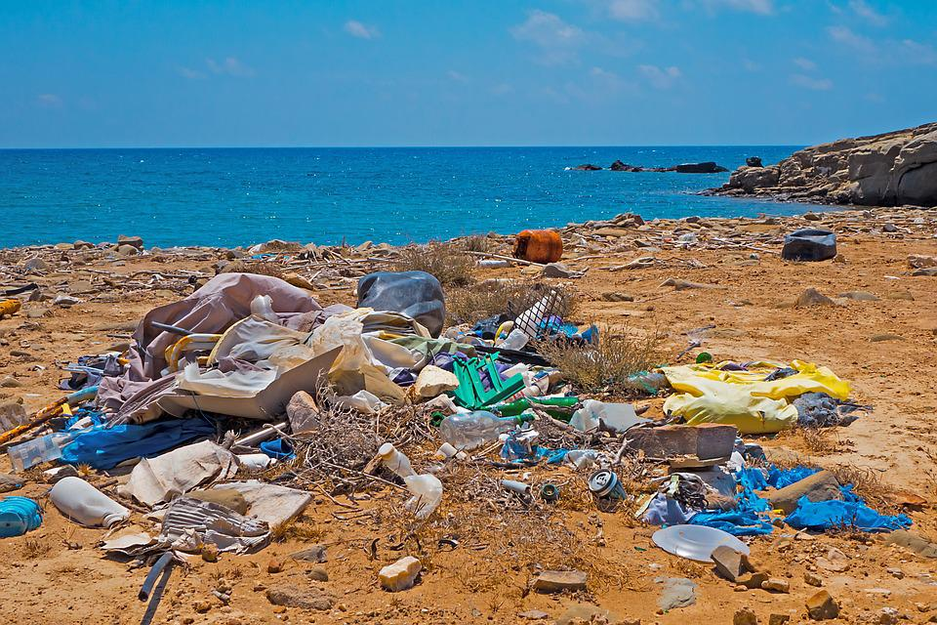
‘Garbage Plastic Waste Beach Environmental Sin’ by adege is used in accordance with the Pixabay License.

Resource 2: T-chart
Beginning of the story | End of the story

Resource 3: Tense table
Base word | -s | -ing | -ed

Resource 4: Online text features and navigation pathways
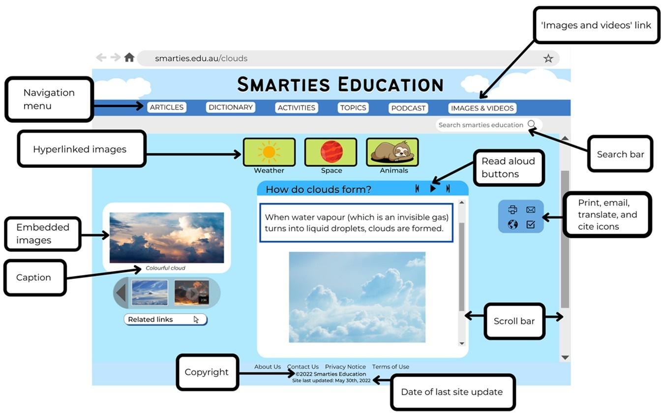
This image contains content obtained from Canva, and its use outside of this resource is subject to Canva’s Content License Agreement.
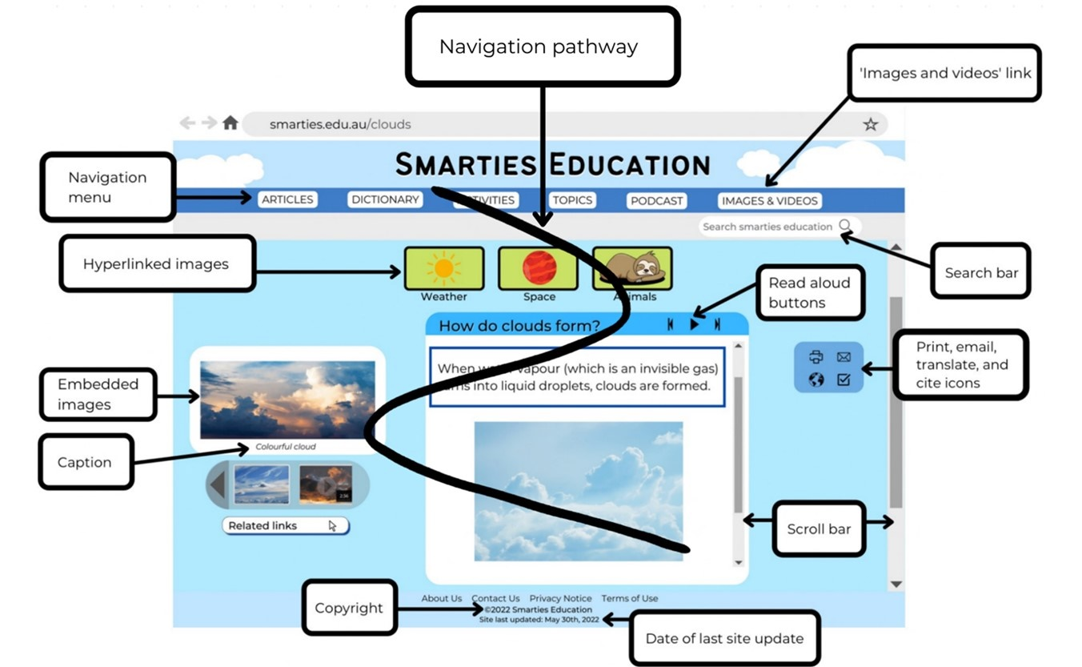
This image contains content obtained from Canva, and its use outside of this resource is subject to Canva’s Content License Agreement.

Resource 5: Cause and effect
Text | Cause | Effect
The Mess That We Made
Kids vs Plastic

Resource 6: Word cards
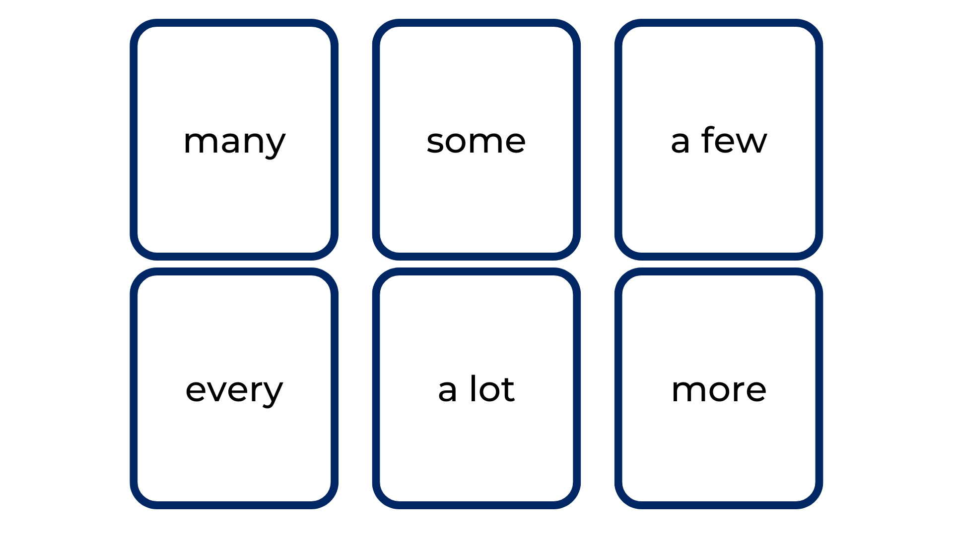

Resource 7: 5 senses table
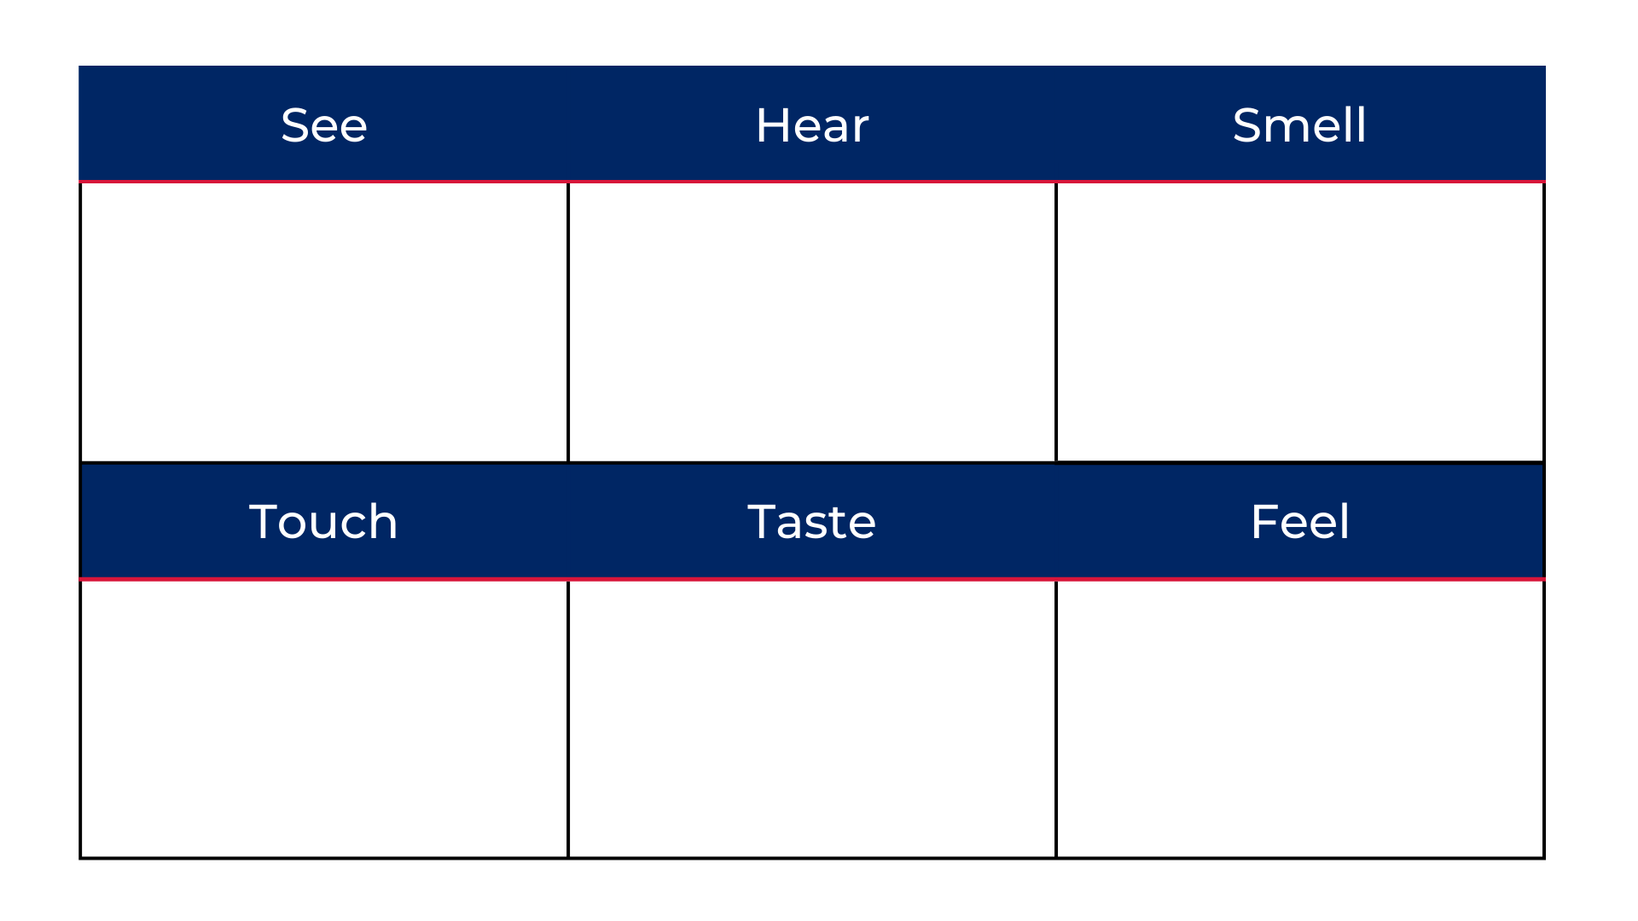

Resource 8: Planning template
Paragraph | Ideas/opinions | Impact | Images to support
Pollution
Prevention

Resource 9: Paragraph exemplar
Paragraph 1 – Pollution
Too many used plastic bags are thrown away and end up going down the drain. These horrible plastic bags make their way to the ocean and are then eaten by the beautiful green and grey turtles. This causes the magnificent creatures to be in horrific pain and can even stop them from being able to eat.
Paragraph 2 – Prevention
Recycling our old plastic bags is the answer. It will stop the dreaded bags spilling from the landfill and making their way into the majestic sea. The turtles will no longer need to swim through the many plastic items floating and polluting our ocean.

References
Links to third-party material and websites
Please note that the provided (reading/viewing material/list/links/texts) are a suggestion only and implies no endorsement, by the New South Wales Department of Education, of any author, publisher, or book title. School principals and teachers are best placed to assess the suitability of resources that would complement the curriculum and reflect the needs and interests of their students.
If you use the links provided in this document to access a third-party's website, you acknowledge that the terms of use, including licence terms set out on the third-party's website apply to the use which may be made of the materials on that third-party website or where permitted by the Copyright Act 1968 (Cth). The department accepts no responsibility for content on third-party websites.
Except as otherwise noted, all material is © State of New South Wales (Department of Education), 2023 and licensed under the Creative Commons Attribution 4.0 International License. All other material (third-party material) is used with permission or under licence. Where the copyright owner of third-party material has not licensed their material under a Creative Commons or similar licence, you should contact them directly for permission to reuse their material.
English K–10 Syllabus © 2022 NSW Education Standards Authority (NESA) for and on behalf of the Crown in right of the State of New South Wales.
© 2022 NSW Education Standards Authority. This document contains NSW Curriculum and syllabus content. The NSW Curriculum is developed by the NSW Education Standards Authority. This content is prepared by NESA for and on behalf of the Crown in right of the State of New South Wales. The material is protected by Crown copyright.
Please refer to the NESA Copyright Disclaimer for more information.
NESA holds the only official and up-to-date versions of the NSW Curriculum and syllabus documents. Please visit the NSW Education Standards Authority (NESA) website and the NSW Curriculum website.
National Literacy Learning Progression © Australian Curriculum, Assessment and Reporting Authority (ACARA) 2010 to present, unless otherwise indicated. This material was downloaded from the Australian Curriculum website (National Literacy Learning Progression) (accessed 13 September 2022) and was not modified. The material is licensed under CC BY 4.0. Version updates are tracked in the ‘Curriculum version history’ section on the 'About the Australian Curriculum' page of the Australian Curriculum website.
ACARA does not endorse any product that uses the Australian Curriculum or make any representations as to the quality of such products. Any product that uses material published on this website should not be taken to be affiliated with ACARA or have the sponsorship or approval of ACARA. It is up to each person to make their own assessment of the product, taking into account matters including, but not limited to, the version number and the degree to which the materials align with the content descriptions and achievement standards (where relevant). Where there is a claim of alignment, it is important to check that the materials align with the content descriptions and achievement standards (endorsed by all education Ministers), not the elaborations (examples provided by ACARA).
ETA (English Teachers Association) and NSW Department of Education (2016) The Textual Concepts and Processes resource, English Textual Concepts website, accessed 14 September 2022.
ETA (English Teachers Association) and NSW Department of Education (2016) Perspective, English Textual Concepts website, accessed 14 September 2022.
ETA (English Teachers Association) and NSW Department of Education (2016) Argument, English Textual Concepts website, accessed 14 September 2022.
Godwin N (2020) Jelly-Boy (Nielson C, illus.), Walker Books Australia, Newtown.
Lord M (2020) The Mess That We Made (Blattman J, illus.), Flashlight Press, New York.
National Geographic Society (2022) ‘Kids vs Plastic – Plastic Pollution’, Nature, National Geographic Kids website, accessed 13 September 2022.
Seesaw Learning Inc (2021) Seesaw [website], accessed 13 September 2022.

