English – Stage 1 – Unit 15
Contents
Unit overview and instructions for use 3
Teacher notes 4
Outcomes and content – Component A 5
Outcomes and content – Component B 7
Week 1 10
Component A teaching and learning 10
Component B teaching and learning 11
Lesson 1: Giraffes Can’t Dance 12
Lesson 2: Rhyme, noun groups, and verbs 14
Lesson 3: Subject–verb agreement and alliteration 16
Lesson 4: Comparing factual and fictional texts 17
Lesson 5: Writing a character description using multiple sources 18
Week 2 21
Component A teaching and learning 21
Component B teaching and learning 22
Lesson 6: Leroy the Lionhearted 23
Lesson 7: Researching lions 25
Lesson 8: Additional research and planning 26
Lesson 9: Composing a fact file about lions 27
Lesson 10: Publishing a fact file about lions 28
Resource 1: Rhyme and rhythm 30
Resource 2: Giraffe informative text 31
Resource 3: Giraffe diagram 33
Resource 4: Venn diagram example 34
Resource 5: Leroy the Lionhearted 35
Resource 6: Y–chart 37
Resource 7: Lion fact file 38
References 39

Unit overview and instructions for use
This two-week unit is comprised of Component A and Component B. Connecting learning across both components is encouraged.
Teaching and learning | Component A | Component B
Suggested duration | 60 minutes | 45 minutes
Explicit teaching focus areas | - Phonic knowledge  - Reading fluency  - Reading comprehension  - Spelling  - Handwriting | - Oral language and communication  - Vocabulary  - Reading comprehension  - Creating written texts  - Understanding and responding to literature
To prepare for teaching and learning: | - Refer to Outcomes and content – Component A, K-2 – Instructional sequence – grapheme–phoneme correspondences [PDF 825 KB], and the teaching advice documents (hyperlinked in Component A teaching and learning table).  - Based on student needs identified through ongoing assessment data, plan and document how you will sequence teaching and learning in whole class and targeted teaching groups across the two-week cycle. | - Familiarise yourself with Outcomes and content – Component B, Textual concepts information and videos, English Textual Concepts and Learning Processes (2016), and the teaching and learning sequence.  - Based on student needs identified through ongoing assessment data, determine how you will support students in whole class and targeted teaching groups across the two-week cycle as required.
English K–10 Syllabus © 2022 NSW Education Standards Authority (NESA) for and on behalf of the Crown in right of the State of New South Wales.

Teacher notes
- Character is a construct of verbal and visual statements about a fictional identity. Analysis of characters contribute to our own personal judgements about self, morals, and values. – English Textual Concepts and Learning Processes (2016).
- Understanding of character can be supported through watching the department’s video: Character (2:31).
- For information on figurative language, Tier 1, 2 and 3 words, rhyme, sentences, nouns, adjectives, word play, subject–verb agreement, adverbs, possessive apostrophes, pronouns, and paragraphs refer to the NESA Glossary.
- A noun group is a group of words relating to, or building on, a noun. Noun groups usually consist of a pointer (the, a, an, this, that, these, those, my, your, his, her, its, our, mum’s, Mr Smith’s) plus one or more adjectives or adverbs. They are an important language resource for building descriptions.
- Reflect on student learning and engagement in activities and record differentiation and adjustments within the unit to inform future teaching and learning. One way of doing this could be to add comments to the digital file.
- Content are points are linked to the National Literacy Learning Progression version (3).
Levels and indicators sourced from National Literacy Learning Progression © Australian Curriculum, Assessment and Reporting Authority (ACARA), (accessed 25 July 2022) and was not modified. See references for more information.

Outcomes and content – Component A
The table below outlines the focus outcomes and content. Content is linked to the National Literacy Learning Progression version (3).
Focus area and outcome | Content points and National Literacy Learning Progression
Phonic knowledge  EN1-PHOKW-01 – uses initial and extended phonics, including vowel digraphs, trigraphs to decode and encode words when reading and creating texts | - blend and decode one-syllable words with taught extended vowel graphs and digraphs, including graphemes for r-controlled vowels and diphthongs, and apply this when reading texts (PKW6, PKW7)  - segment and encode one-syllable words with taught vowel graphs, digraphs and trigraphs and apply this when creating texts (SpG8)  - decode words with trigraphs and quadgraphs and apply this when reading texts
Reading fluency  EN1-REFLU-01 – sustains reading unseen texts with automaticity and prosody and self-corrects errors | - adjust phrasing, intonation, volume or rate to maintain fluency when reading aloud (FIY4)  - vary pace when reading according to the audience and purpose (FIY4)
Reading comprehension  EN1-RECOM-01 – comprehends independently read texts that require sustained reading by activating background and word knowledge, connecting and understanding sentences and whole text, and monitoring for meaning | - understand vocabulary that signals humorous word play in texts  - combine multiple sources of information within a text to make meaning  - use a mental model to confirm predictions
Spelling  EN1-SPELL-01 – applies phonological, orthographic and morphological generalisations and strategies when spelling words in a range of writing contexts | - spell taught high-frequency contractions (SpG6)  - explain that the consonant trigraphs, –tch and –dge, can end a base word immediately following a short vowel and apply this when spelling  - use spelling conventions when adding tense-marking suffixes (SpG9)  - spell nouns ending in the suffix –er to indicate a person (SpG9)
Handwriting  EN1-HANDW-01 – uses a legible, fluent and automatic handwriting style, and digital technology, including word-processing applications, when creating texts | - position all letters correctly on the line with appropriate spacing between words (HwK5)  - use taught software functions to create texts in a range of modes for different contexts, audiences and purposes

Outcomes and content – Component B
The table below outlines the focus outcomes and content. Content is linked to the National Literacy Learning Progression version (3).
Focus area and outcome | Content points and National Literacy Learning Progression
Oral language and communication  EN1-OLC-01 – communicates effectively by using interpersonal conventions and language to extend and elaborate ideas for social and learning interactions | - respond to information by asking relevant questions to extend their own and others' knowledge (LiS4, LiS6)  - link or compare ideas when interacting
Vocabulary  EN1-VOCAB-01 – understands and effectively uses Tier 1, taught Tier 2 and Tier 3 vocabulary to extend and elaborate ideas | - identify, understand and use word play and rhyme in a range of texts
Reading comprehension  EN1-RECOM-01 – comprehends independently read texts that require sustained reading by activating background and word knowledge, connecting and understanding sentences and whole text, and monitoring for meaning | - understand vocabulary that signals humorous word play in texts  - combine multiple sources of information within a text to make meaning
Creating written texts  EN1-CWT-01 – plans, creates and revises texts written for different purposes, including paragraphs, using knowledge of vocabulary, text features and sentence structure | - group sentences into paragraphs commencing with a topic sentence, followed by other sentences with related ideas (CrT7)  - use noun/pronoun-referencing across a text (CrT7)  - use subject–verb agreement across a text (GrA5)  - use noun groups to build descriptions of people and things (CrT6)  - use adverbs to modify the meaning of verbs and adjectives (GrA3)  - use possessive apostrophes in own writing (PuN4)  - use creative word play to affect the reader  - use different modes and media to enhance the presentation of texts they have created (CrT5, CrT6)
Understanding and responding to literature  EN1-UARL-01 – understands and responds to literature by creating texts using similar structures, intentional language choices and features appropriate to audience and purpose | - identify how characters are constructed through different modes and media and through a combination of modes  - compare and contrast characters in text  - identify how a character reflects their own or other lived experiences

Week 1

Component A teaching and learning
The table below can be used to plan and document lessons that address Component A outcomes and content. Both the detailed example [DOC 529KB] of a two-week teaching and learning cycle and brief example [DOC 66KB] may support you in your planning.
Focus Areas | Lesson 1 | Lesson 2 | Lesson 3 | Lesson 4 | Lesson 5
Phonic knowledge
15 minutes
Spelling and Handwriting
15 minutes
Reading comprehension and Reading fluency
30 minutes

Component B teaching and learning
The following teaching and learning sequence has been designed to address Component B outcomes and content. Adapt the sequence as required to best meet the needs of your students.

Learning intention and success criteria
Learning intentions and success criteria are best co-constructed with students.

Learning intention
Students are learning to identify how authors construct characters in texts.

Success criteria
Students can:
- identify how characters change throughout a text
- identify and use rhyme and word play in own texts
- use noun groups to build descriptions of characters
- use subject–verb agreement, possessive apostrophes, and personal pronouns
- identify similarities and differences between fiction and non-fiction texts.

Resources
- Andreae G (2014) Giraffes Can’t Dance (Parker-Rees G, illus) Orchard Books, London. ISBN: 9781841215655
- Resource 1: Rhyme and rhythm
- Resource 2: Giraffe informative text
- Resource 3: Giraffe diagram
- Resource 4: Venn diagram example
- 2 different coloured markers
- Copies of a Venn diagram – one between 2 students
- Enlarged image of the character Gerald from Giraffes Can’t Dance
- Mini whiteboards
- Sticky notes
- Tapping sticks (if available).

Lesson 1: Giraffes Can’t Dance
- Introduce the text, Giraffes Can’t Dance. Guide students to make predictions about what type of text it is, using the front and back covers, title and illustrations. Discuss narrative elements and who the main character of the story may be. Revise the concept of character and how authors use descriptive and figurative language to help the audience build a deeper understanding of a character’s actions and emotions. Explain that a character can be a fictional person or idea, but they must always have an identity.
- Read Giraffes Can’t Dance. Revisit the text predictions and provide the opportunity for students to make text-to-self connections.
- Explain that authors choose their words very carefully because the words they use can help paint a picture in your mind and make the story come to life. They want to make sure the words they use help you understand what's happening and how the characters are feeling. Explain to students that there are words we use every day (Tier 1), such as ‘was’ and ‘came and words that are precise and powerful (Tier 2), such as ‘daft’ and ‘crept’. There are also words that are specific to a topic (Tier 3).
- Identify new vocabulary from the text and model how to re-read new words or phrases to check and clarify meaning. For example, bandy, daft, entranced. Encourage students to make inferences about how the character was feeling by drawing attention to specific moments and illustrations in the text. For example, ‘Oh, I feel like such a clot.’ Search for synonyms for the word ‘clot’ and use clues from the text to clarify meaning.
- Display the enlarged image of Gerald and discuss his physical and personal character traits. For example, tall, long neck, nervous, brave, flexible. On one side of the image, record his physical traits in blue, and on the other, record his personal traits in green. This image will be used in Lesson 3 and Lesson 6.
- Divide the class into 2 groups. Ask one group to think about Gerald at the beginning of the story and the second group to think about him at the end of the story. Prompt both groups to think about how Gerald might be feeling and why he felt that way. For example, Gerald felt sad at the beginning of the story because he thought he wasn’t good at dancing; Gerald was brave because he danced in front of the other animals at the end of the story.
- Students form 2 circles, an inner circle and outer circle, facing each other. Students in the outer circle will think about Gerald at the beginning of the story and the students in the inner circle are Gerald at the end of the story. Explain that each student will be sharing one idea with their partner about how Gerald felt and why. After both students have shared, the outer circle will take one step to the right to form a new partnership. Encourage students to share a new idea as they move around the circle.
- Students write sentences about how Gerald felt at the beginning compared to how he felt at the end. For example, At the beginning of the story, Gerald thought he was useless because he couldn’t dance like the other animals. After creating his own music and listening to the cricket’s violin, Gerald felt confident and excited that he was dancing and surprised the other animals.
Stage 1 Assessment task 1 – Observations from this lesson allow students to demonstrate achievement towards the following syllabus outcomes and content points:
EN1-OLC-01 – communicates effectively by using interpersonal conventions and language to extend and elaborate ideas for social and learning interactions
- respond to information by asking relevant questions to extend their own and others' knowledge
- link or compare ideas when interacting.
EN1-RECOM-01 – comprehends independently read texts that require sustained reading by activating background and word knowledge, connecting and understanding sentences and whole text, and monitoring for meaning
- combine multiple sources of information within a text to make meaning.

Lesson 2: Rhyme, noun groups, and verbs
- Re-read the first 2 pages of the text, Giraffes Can’t Dance. Ask students what they noticed about the language Giles Andreae used in the text. Highlight the use of rhyme throughout the text. Explain that rhyme is the repetition of similar speech sounds in the final syllable of words.
- Provide students with tapping sticks. If tapping sticks are unavailable, students can clap their hands to form the sound. Explain that the author uses syllables to create rhyme and rhythm. Using Resource 1: Rhyme and rhythm, identify and compare the syllable structure of 2 different paragraphs. Re-read the text while students clap along to the syllable structure on each page. Explain that the author has used the literary techniques of rhyme and rhythm to make the text have a musical pattern and more enjoyable for the reader.
- On mini whiteboards, students create a list of rhyming words from the text. Create a T–chart with the headings ‘sounds the same and spelt the same’ and ‘same sound but different spelling’. As a class, sort the words according to the spelling of the rime. For example, under the heading ‘sounds the same and spelt the same’ write trees/knees, ground/round and then under the heading ‘sounds the same but different spelling’ write, rolled/bold, laughed/daft. Compare and discuss the type of rhyming words used in the text.
- Create a list of the other animals from the text and list these under the heading ‘nouns’. This list will be referred to in Lesson 3. Ask students to think of describing words about the animals and create a list under the heading ‘adjectives’. Ask students to think of action words to suit the animals and create a list under the heading ‘verbs’.
- Explain that noun groups are a group of words that build on a noun. Authors use noun groups to create character descriptions. They include a pointer such as his, her, the, our, plus one or more adjective or adverb and a noun.
- Display the sentence, ‘The big, grey rhino was dancing in the sun.’ Using 2 different coloured pens, circle the pointer ‘The’, and underline the remainder of the noun group ‘big, grey rhino’.
- Display a picture of a chimp or another animal from the text. Model writing noun groups on the left side of the image. For example, small chimp, silly chimp, wise chimp.
- Select a verb from the list created in activity 4 and model using it in a phrase to describe the animal’s action on the right side of the image. For example, climbs up trees, swings on branches.
- Co-construct a sentence using a noun group and a verb to describe an action. For example, The silly chimp swings on branches. This sentence will be used in Lesson 3.
- Students choose a different animal from the text and draw a picture, listing noun groups and verbs to describe an action around the outside of their picture. Students write their own sentences using noun groups and verbs.

Lesson 3: Subject–verb agreement and alliteration
- Review the literary techniques of rhyme and rhythm and why the author, Giles Andreae used them in Giraffes Can’t Dance.
- Revise subject–verb agreement as when a writer or speaker selects the correct verb for the noun or noun group to which it is referring. Identify examples of subject–verb agreement throughout the text, highlighting the use of single subject and single verbs. For example, ‘Gerald was very good at standing still’, ‘Gerald felt so sad, he crept off.’
- Display the enlarged image of Gerald from Giraffes Can’t Dance from Lesson 1. Using mini whiteboards, students select physical and personal characteristics to write a series of sentences using a subject–verb agreement. For example, ‘Gerald was brave to dance’; ‘Gerald is very flexible’; ‘Gerald was shuffling and swaying.’
- Introduce the term ‘alliteration’ and explain that this is a different literary technique used by authors to create emotions and rhythm. Explain that alliteration is when words written together begin with the same letter or sound, and this creates rhyme and rhythm. Identify examples found in the text, ‘warthogs waltzing’, ‘rhinos rock'n’roll’, ‘chimps cha-cha’ and ‘cricket coughed’.
- Display the list of animals created in Lesson 2. In pairs, students choose an animal and brainstorm adjectives that begin with the same sound. For example, crazy cricket, zippy zebra, big, bossy baboon. Explain that when 2 or more adjectives are listed, they must be separated by a comma.
- Explain that students will create a text including two- or three-word alliteration. Display the image of the chimp from the previous lesson and the sentence, ‘The silly chimp swings on branches.’ Model changing words in the sentence to include alliteration and repetition. For example, ‘The cheeky chimp swings on branches.’ Explain that the repetition of the ‘ch’ sound creates alliteration and rhythm within the sentence.
- Students review their sentences from Lesson 2 and use their ideas to create a text about their animal including two- or three-word alliteration.
Too hard? Students create noun groups including two-word alliteration for different animals in the text.
Too easy? Students experiment using rhythm and rhyme in their text about an animal.
Stage 1 Assessment task 2 – Observations and work samples from this lesson allow students to demonstrate achievement towards the following syllabus outcome and content points:
EN1-CWT-01 – plans, creates and revises texts written for different purposes, including paragraphs, using knowledge of vocabulary, text features and sentence structure
- use subject–verb agreement across a text
- use creative word play to affect the reader.

Lesson 4: Comparing factual and fictional texts
- Present the factual text from Resource 2: Giraffe informative text. Ask students to predict what type of text it is. Display the image of Gerald from Giraffes Can’t Dance from Lesson 1 and place it next to the labelled diagram in Resource 3: Giraffe diagram. Discuss the differences between a drawing and a diagram and explain that the purpose of a diagram is to inform. Identify and list the key elements of a diagram. For example, diagrams are easy to read and include factual words or phrases, arrows or lines, and no punctuation. The list of key elements will be used in Lesson 10.
- Display an enlarged Venn diagram with the titles ‘Giraffes Can’t Dance’ and ‘Giraffe informative text’. Explain that students will compare and contrast the 2 texts. Ask students if they can see any similarities. For example, both texts have the word giraffe in the title. Model writing information on a sticky note and placing it in the middle of the Venn diagram. Ask students if they see any differences between the texts. For example, one text has a drawing of a giraffe and the other uses photos. Model writing ‘photos’ on a sticky note and placing it under the heading ‘Giraffe informative text’. Model writing ‘drawings’ and placing it under the heading ‘Giraffes Can’t Dance.’ Refer to Resource 4: Venn diagram example and add a few more ideas.
- In pairs, students complete their own Venn diagram, identifying additional similarities and differences between Giraffes Can’t Dance and Resource 2: Giraffe informative text. Share student responses.
- Ask:
- Is the book fiction or non-fiction? How do you know?
- What is the purpose of the text, Giraffes Can’t Dance?
- What is the purpose of the giraffe informative text?
- Did the texts have more similarities or differences? Were you surprised with the results?
- Explain that the author Giles Andreae created the character Gerald using information about giraffes. Discuss the importance of authors having background knowledge of a topic before creating characters. Compare the language from Giraffes Can’t Dance and Resource 2: Giraffe informative text. Highlight the informative language about giraffes that is similar in both texts. For example, long neck, hooves, and shoots from trees.

Lesson 5: Writing a character description using multiple sources
- Revise personal pronouns. Explore ways that nouns can be represented through pronouns, for example, he, she, they. Locate examples of personal pronouns used in Giraffes Can’t Dance.
- Revise possessive apostrophes and their purpose, which is to demonstrate a noun’s ownership of an object or quality. Brainstorm and list examples of ownership from the text, for example, Gerald’s long neck, Africa’s Jungle Dance, cricket’s cough, the lion’s tango.
- Explain that students will create a character description of Gerald using noun groups and creative word play such as alliteration, rhythm, and rhyme. Encourage students to include personal pronouns, possessive apostrophes and information from Giraffes Can’t Dance, Resource 2: Giraffe informative text and Resource 3: Giraffe diagram. Co-construct writing criteria to be used by students as they write their own character description.
- Model writing a character description about Gerald and ask students to identify examples of noun groups, alliteration, rhyme, personal pronouns, and possessive apostrophes. For example, ‘Gerald the giraffe lived in a giant jungle. He was very tall and had long thin legs. Gerald was a bit clumsy and shy. He wished he could prance and dance and wanted to be accepted by the animals. The cricket’s music helped him move and shuffle his hooves. Gerald danced up a storm and he felt confident to perform.’ Highlight how information about giraffes has been used to create the character of Gerald.
Note: The character name of ‘Gerald’ is also considered a noun group and could be used to support student understanding.
- Students draw an image of Gerald and brainstorm ideas around the outside. Students may describe Gerald’s appearance, personality, emotions, or background experiences. Using the writing criteria and their plan, students write a character description.
- Students provide peer feedback using the writing criteria. Allow time for students to apply feedback to their writing.
- Ask students to identify and explain how they included information about giraffes and characteristics of Gerald from Giraffes Can’t Dance in their character description.
Too hard? Students list words or phrases about Gerald around an image. Co-construct a character description.
Too easy? Students create a poem about Gerald’s character using noun groups, alliteration, rhythm, and rhyme.
Stage 1 Assessment task 3 – Observations and work samples from this lesson allow students to demonstrate achievement towards the following syllabus outcomes and content points:
EN1-VOCAB-01 – understands and effectively uses Tier 1, taught Tier 2 and Tier 3 vocabulary to extend and elaborate ideas
- respond to information by asking relevant questions to extend their own and others' knowledge
- identify, understand and use word play and rhyme in a range of texts.
EN1-CWT-01 – plans, creates and revises texts written for different purposes, including paragraphs, using knowledge of vocabulary, text features and sentence structure
- use noun/pronoun-referencing across a text
- use noun groups to build descriptions of people and things
- use possessive apostrophes in own writing
- use creative word play to affect the reader.
EN1-UARL-01 – understands and responds to literature by creating texts using similar structures, intentional language choices and features appropriate to audience and purpose
- identify how a character reflects their own or other lived experiences.

Week 2

Component A teaching and learning
The table below can be used to plan and document lessons that address Component A outcomes and content. Both the detailed example [DOC 529KB] of a two-week teaching and learning cycle and brief example [DOC 66KB] may support you in your planning.
Focus Areas | Lesson 6 | Lesson 7 | Lesson 8 | Lesson 9 | Lesson 10
Phonic knowledge
15 minutes
Spelling and Handwriting
15 minutes
Reading comprehension and Reading fluency
30 minutes

Component B teaching and learning
The following teaching and learning sequence has been designed to address Component B outcomes and content. Adapt the sequence as required to best meet the needs of your students.

Learning intention and success criteria
Learning intentions and success criteria are best co-constructed with students.

Learning intention
Students are learning to use multiple sources of information to create texts.

Success criteria
Students can:
- compare and contrast characters from texts
- use adverbs to describe a character
- use multiple sources of information to research
- use facts to create informative sentences
- group sentences into paragraphs
- create a labelled diagram.

Resources
- Andreae G (2014) Giraffes Can’t Dance (Parker-Rees G illus) Orchard Books, London. ISBN: 9781841215655
- Resource 5: Leroy the Lionhearted
- Resource 6: Y–chart
- Resource 7: Lion fact file
- National Geographic Kids – Lion
- Britannica Kids – lion or Taronga Conservation Society Australia – Lion
- 2 hula hoops
- One large photograph of a lion
- Sticky notes.

Lesson 6: Leroy the Lionhearted
- Introduce Resource 5: Leroy the Lionhearted, guiding students to make predictions about what type of text it is, its purpose, and its audience. Read the text and discuss the literary techniques used. Highlight the use of rhyming words. For example, coronation/celebration, king/sing, ready/steady, gave/brave.
- As a class, identify new language and create a list of topic words about lions from the text. For example, fangs, mane, pride. Explain that students will be researching lions in Lesson 7. Discuss the use of word play and identify phrases the author has used to create humour and emotion. For example, ‘roared up a storm’, ‘sang out with pride’, ‘liony voice’, and ‘royal performance’.
- Revise adverbs as a word that tells something about a verb, adjective or another verb to indicate manner (how), place (where) or time (when). Adverbs commonly end in -ly.
- Discuss the character Leroy and how he felt at the beginning compared to the end of the story. Display the image of Gerald from Giraffes Can’t Dance from Lesson 1 and discuss similarities and differences between the characters. Brainstorm and list adverbs that describe the characters’ actions and personality traits. For example, Leroy: awoke happily, arrived nervously, bravely sang; Gerald: simply froze, boldly danced, bowed gracefully. Highlight how each adverb contains a base word (free morpheme) that is built on by the suffix (bound morpheme) -ly.
- Place 2 hula hoops on the ground with the headings ‘Gerald’ and ‘Leroy’, crossing them over in the middle to create a Venn diagram. Provide students with sticky notes to write similarities and differences about the characters. For example, Leroy performed in a ballroom, Gerald performed bravely in the jungle, both characters were nervous about their performance. Students place their idea in the correct part of the Venn diagram. Encourage students to include adverbs from activity 4 in their writing.
- Students complete Resource 6: Y–chart, to write character traits in each section about Gerald, Leroy, and themselves.
- Compare and contrast the characters in the 2 texts, discussing how both Gerald and Leroy have been represented. For example, Gerald’s story is written as a narrative, whereas Leroy’s story is written as a poem. Explore how these different modes of storytelling impact how the audience understands a character’s traits and personal development. Ask students what other forms of media can be used for storytelling, for example, movies, songs, wordless books, websites.
Stage 1 Assessment task 4 – Observations and work samples from this lesson students to demonstrate achievement towards the following syllabus outcomes and content points:
EN1-RECOM-01 – comprehends independently read texts that require sustained reading by activating background and word knowledge, connecting and understanding sentences and whole text, and monitoring for meaning
- understand vocabulary that signals humorous word play in texts.
EN1-CWT-01 – plans, creates and revises texts written for different purposes, including paragraphs, using knowledge of vocabulary, text features and sentence structure
- use adverbs to modify the meaning of verbs and adjectives.
EN1-UARL-01 – understands and responds to literature by creating texts using similar structures, intentional language choices and features appropriate to audience and purpose
- identify how characters are constructed through different modes and media and through a combination of modes
- compare and contrast characters in text.

Lesson 7: Researching lions
- Explain that the author of Leroy the Lionhearted used information about lions to create the character in the text.
- Display a photograph of a lion. Ask:
- What type of animal is a lion?
- Where do they live?
- What do they eat?
- Do lions have any special features or characteristics?
- Explain that students will be creating an informative text about lions. Ask students if they learnt enough information about lions from Resource 5: Leroy the Lionhearted. Discuss reasons why/why not.
- Discuss the purpose of an informative text. Revise the topic words about lions identified in Lesson 6 and explain that students will be conducting research to help them create their own text.
- View National Geographic Kids – Lion and use the ‘think aloud’ strategy to describe how informative texts are read. Ask students to identify similarities and differences between digital texts and printed texts. Discuss key content from the page and navigate through it in any order. Explain that National Geographic is a trusted source and that the website’s ‘Site last updated’ information, located at the bottom of the page, indicates that the information is recent.
- Read through the information and watch the videos on the website, pausing to discuss key facts about lions.
- Display an enlarged copy of Resource 7: Lion fact file. Read through the headings and discuss new vocabulary. For example, appearance and diet. Model writing one fact about lions under each heading. For example, Lions are mammals; live in Africa; carnivores. Explain that students will write words or phrases rather than full sentences.
- Provide students with their own copy of Resource 7: Lion fact file. Students write one fact about lions under each heading using information sourced from the website. Students will add more information to their fact file in Lesson 8.
Too hard? Students verbalise facts about lions. Co-construct phrases and record them on an enlarged copy of the fact file.
Too easy? Students write detailed sentences using the facts from the website, rewriting information in their own words.

Lesson 8: Additional research and planning
- Revise information learnt about lions from the previous lesson. Students participate in a gallery walk to see what information their peers know about lions. Encourage students to identify one new fact that they could include in their fact file about lions.
- Explain that students will be using a different source of information to conduct more research about lions. Open Britannica Kids – lion or Taronga Conservation Society Australia – Lion and prompt students to consider the audience of the text. Read through the website, watch the videos, or discuss the ‘Fast facts’.
- Students discuss new information they learnt about lions. Display the enlarged copy of Resource 7: Lion fact file and model re-reading existing information and writing new facts about lions.
- Using their individual copy of Resource 7: Lion fact file, students re-read their information and write additional facts they have learnt from the website or videos.
- Ask students to share what they know about paragraphs. Explain that paragraphs are a group of sentences about a topic. Model writing an exemplar paragraph using information on one of the subheadings from Resource 7: Lion fact file. For example, ‘Lions are carnivores and hunt their prey. They usually eat large animals like zebras and water buffalos. The lionesses do most of the hunting and provide for their pride.’ Discuss the importance of grouping similar ideas together and using pronouns.
- Co-construct writing criteria to be used in Lesson 9.

Lesson 9: Composing a fact file about lions
- Display an exemplar paragraph and success criteria from Lesson 8 to highlight what should be included in a well-constructed paragraph. Revise fact files about lions and explain that students will use this information to create their own informative text.
- Students complete their informative text, writing paragraphs using information from Resource 7: Lion fact file.
Too hard? Co-construct sentences for each subheading about lions.
Too easy? Students include scientific names and topic specific vocabulary in their text.
- Using the success criteria developed in Lesson 8, students provide peer-to-peer feedback to edit their writing.

Lesson 10: Publishing a fact file about lions
- Students publish their writing from Lesson 9.
- Display Resource 3: Giraffe diagram and revise the key elements of a labelled diagram from Lesson 4. Co-construct success criteria for creating a labelled diagram. For example:
- factual words or phrases
- arrows or lines
- no punctuation
- clear and easy to read.
- Students use the success criteria to create a labelled diagram of a lion. For example, a digital diagram, an artwork, or label a printed image.
- Optional: Students create a multimodal text using visuals, written and/or spoken text together to create meaning. Suggested examples students can use to publish their work include:
- recording a slide show with narration using PowerPoint
- creating a short video using stop motion animation
- designing a poster.
Stage 1 Assessment task 5 – Collecting work samples from this lesson allows students to demonstrate achievement towards the following syllabus outcome and content points:
EN1-CWT-01 – plans, creates and revises texts written for different purposes, including paragraphs, using knowledge of vocabulary, text features and sentence structure
- group sentences into paragraphs commencing with a topic sentence, followed by other sentences with related ideas
- use different modes and media to enhance the presentation of texts they have created.

Resource 1: Rhyme and rhythm
Example 1 | Example 2
Now every year in Africa  They hold the Jungle Dance,  Where every single animal  Turns up to sing and prance.  Note: Lines 1 and 3 have 8 syllables, Lines 2 and 4 have 6 syllables | With that, the cricket smiled  And picked up his violin.  Then Gerald felt his body  Do the most amazing thing.  Note: Line 1 has 6 syllables and the rest have 7 syllables

Resource 2: Giraffe informative text
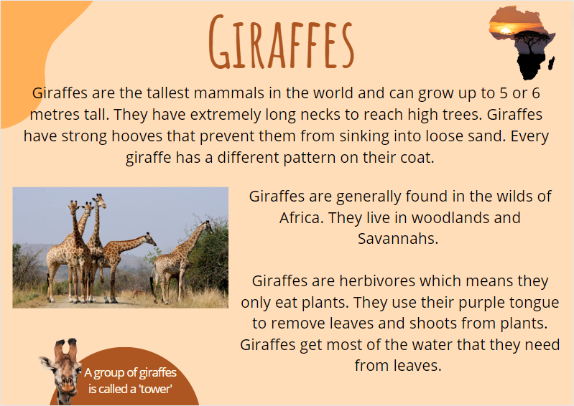
Images sourced from Canva and used in accordance with the Canva Content License Agreement.
Giraffe informative text transcript
Giraffes are the tallest mammal in the world and can grow up to 5 or 6 metres tall. They have extremely long necks to reach high trees. Giraffes have strong hooves that prevent them from sinking into loose sand. Every giraffe has a different pattern on their coat.
Giraffes are generally found in the wilds of Africa. They live in woodlands and Savannahs.
Giraffes are herbivores which means they only eat plants. They use their purple tongue to remove leaves and shoots from plants. Giraffes get most of the water that they need from leaves. A group of giraffes is called a 'tower'.

Resource 3: Giraffe diagram
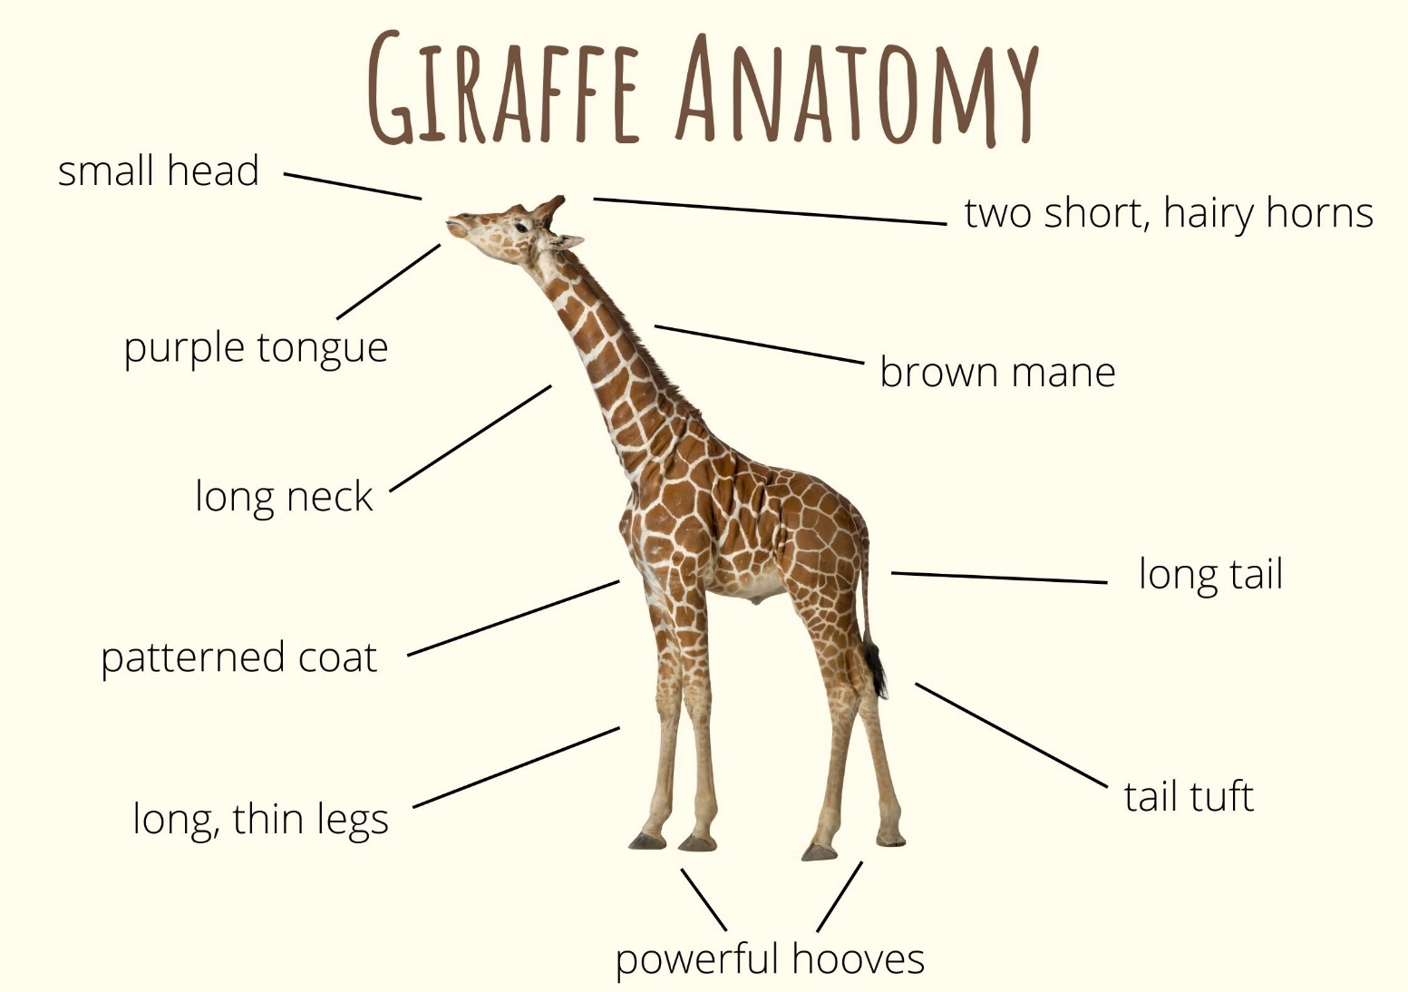
Images sourced from Canva and used in accordance with the Canva Content License Agreement.

Resource 4: Venn diagram example
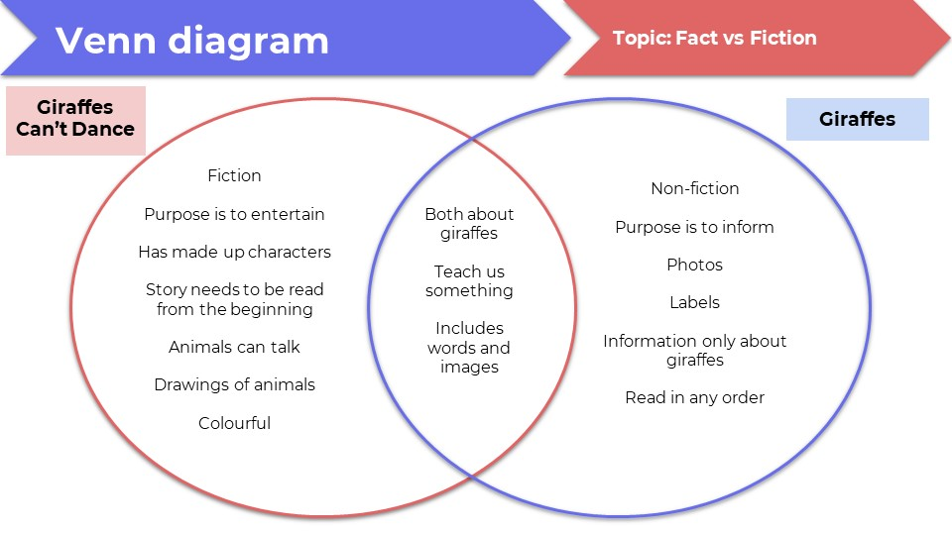

Resource 5: Leroy the Lionhearted
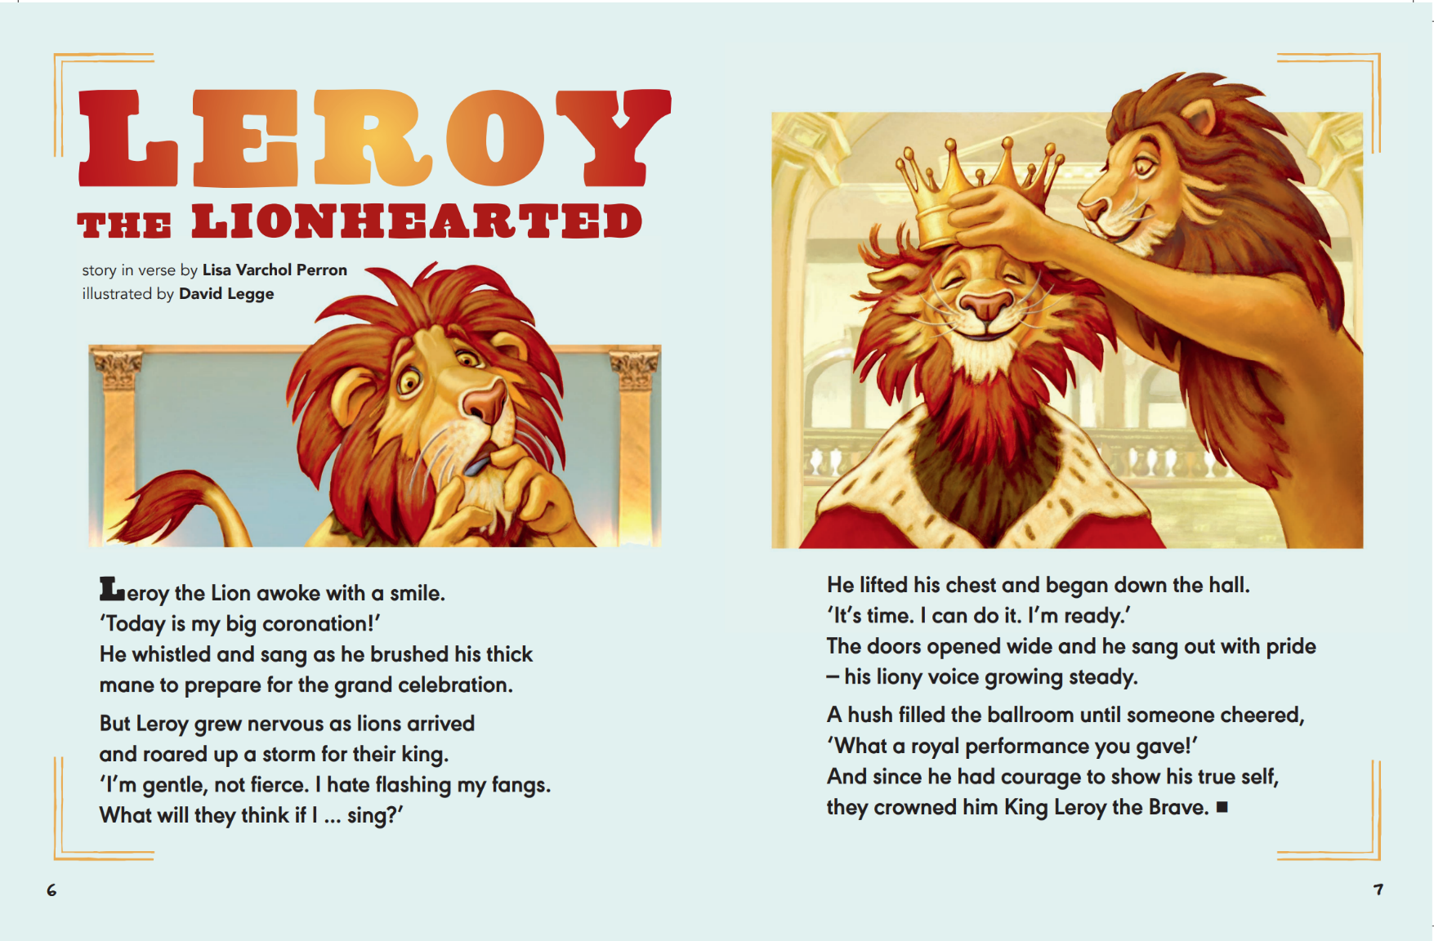
Varchol Perron L (2022) ‘Leroy the Lionhearted’ (Legge D, illus.), The School Magazine: Launchpad (Pilot Magazine).
Leroy the Lionhearted transcript
Leroy the Lion awoke with a smile.
‘Today is my big coronation!’
He whistled and sang as he brushed his thick mane
to prepare for the grand celebration.
But Leroy grew nervous as lions arrived
and roared up a storm for their king.
‘I’m gentle, not fierce. I hate flashing my fangs.
What will they think if I … sing?’
He lifted his chest and began down the hall.
‘It’s time, I can do it, I’m ready.’
The doors opened wide and he sang out with pride
– his liony voice growing steady.
A hush filled the ballroom until someone cheered,
‘What a royal performance you gave!’
And since he had courage to show his true self,
they crowned him King Leroy the Brave.

Resource 6: Y–chart
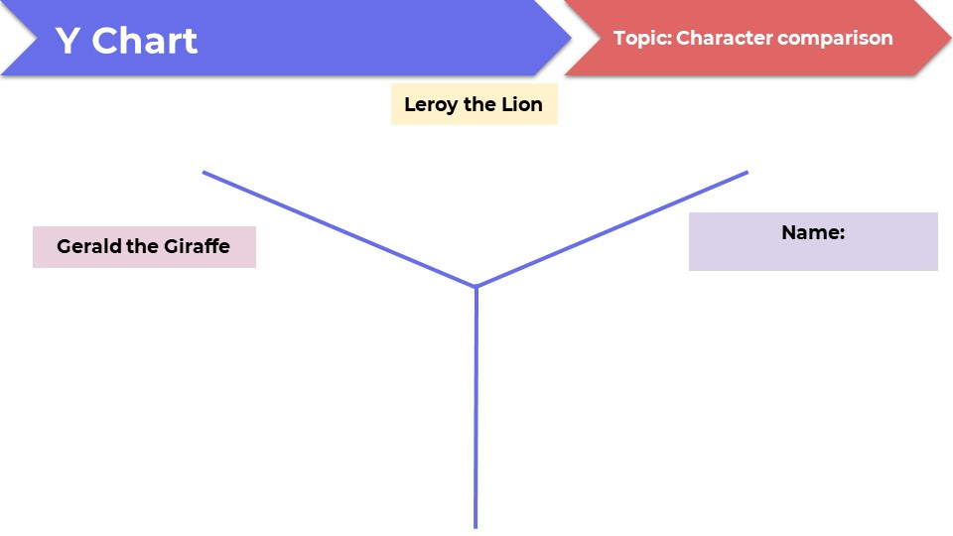

Resource 7: Lion fact file
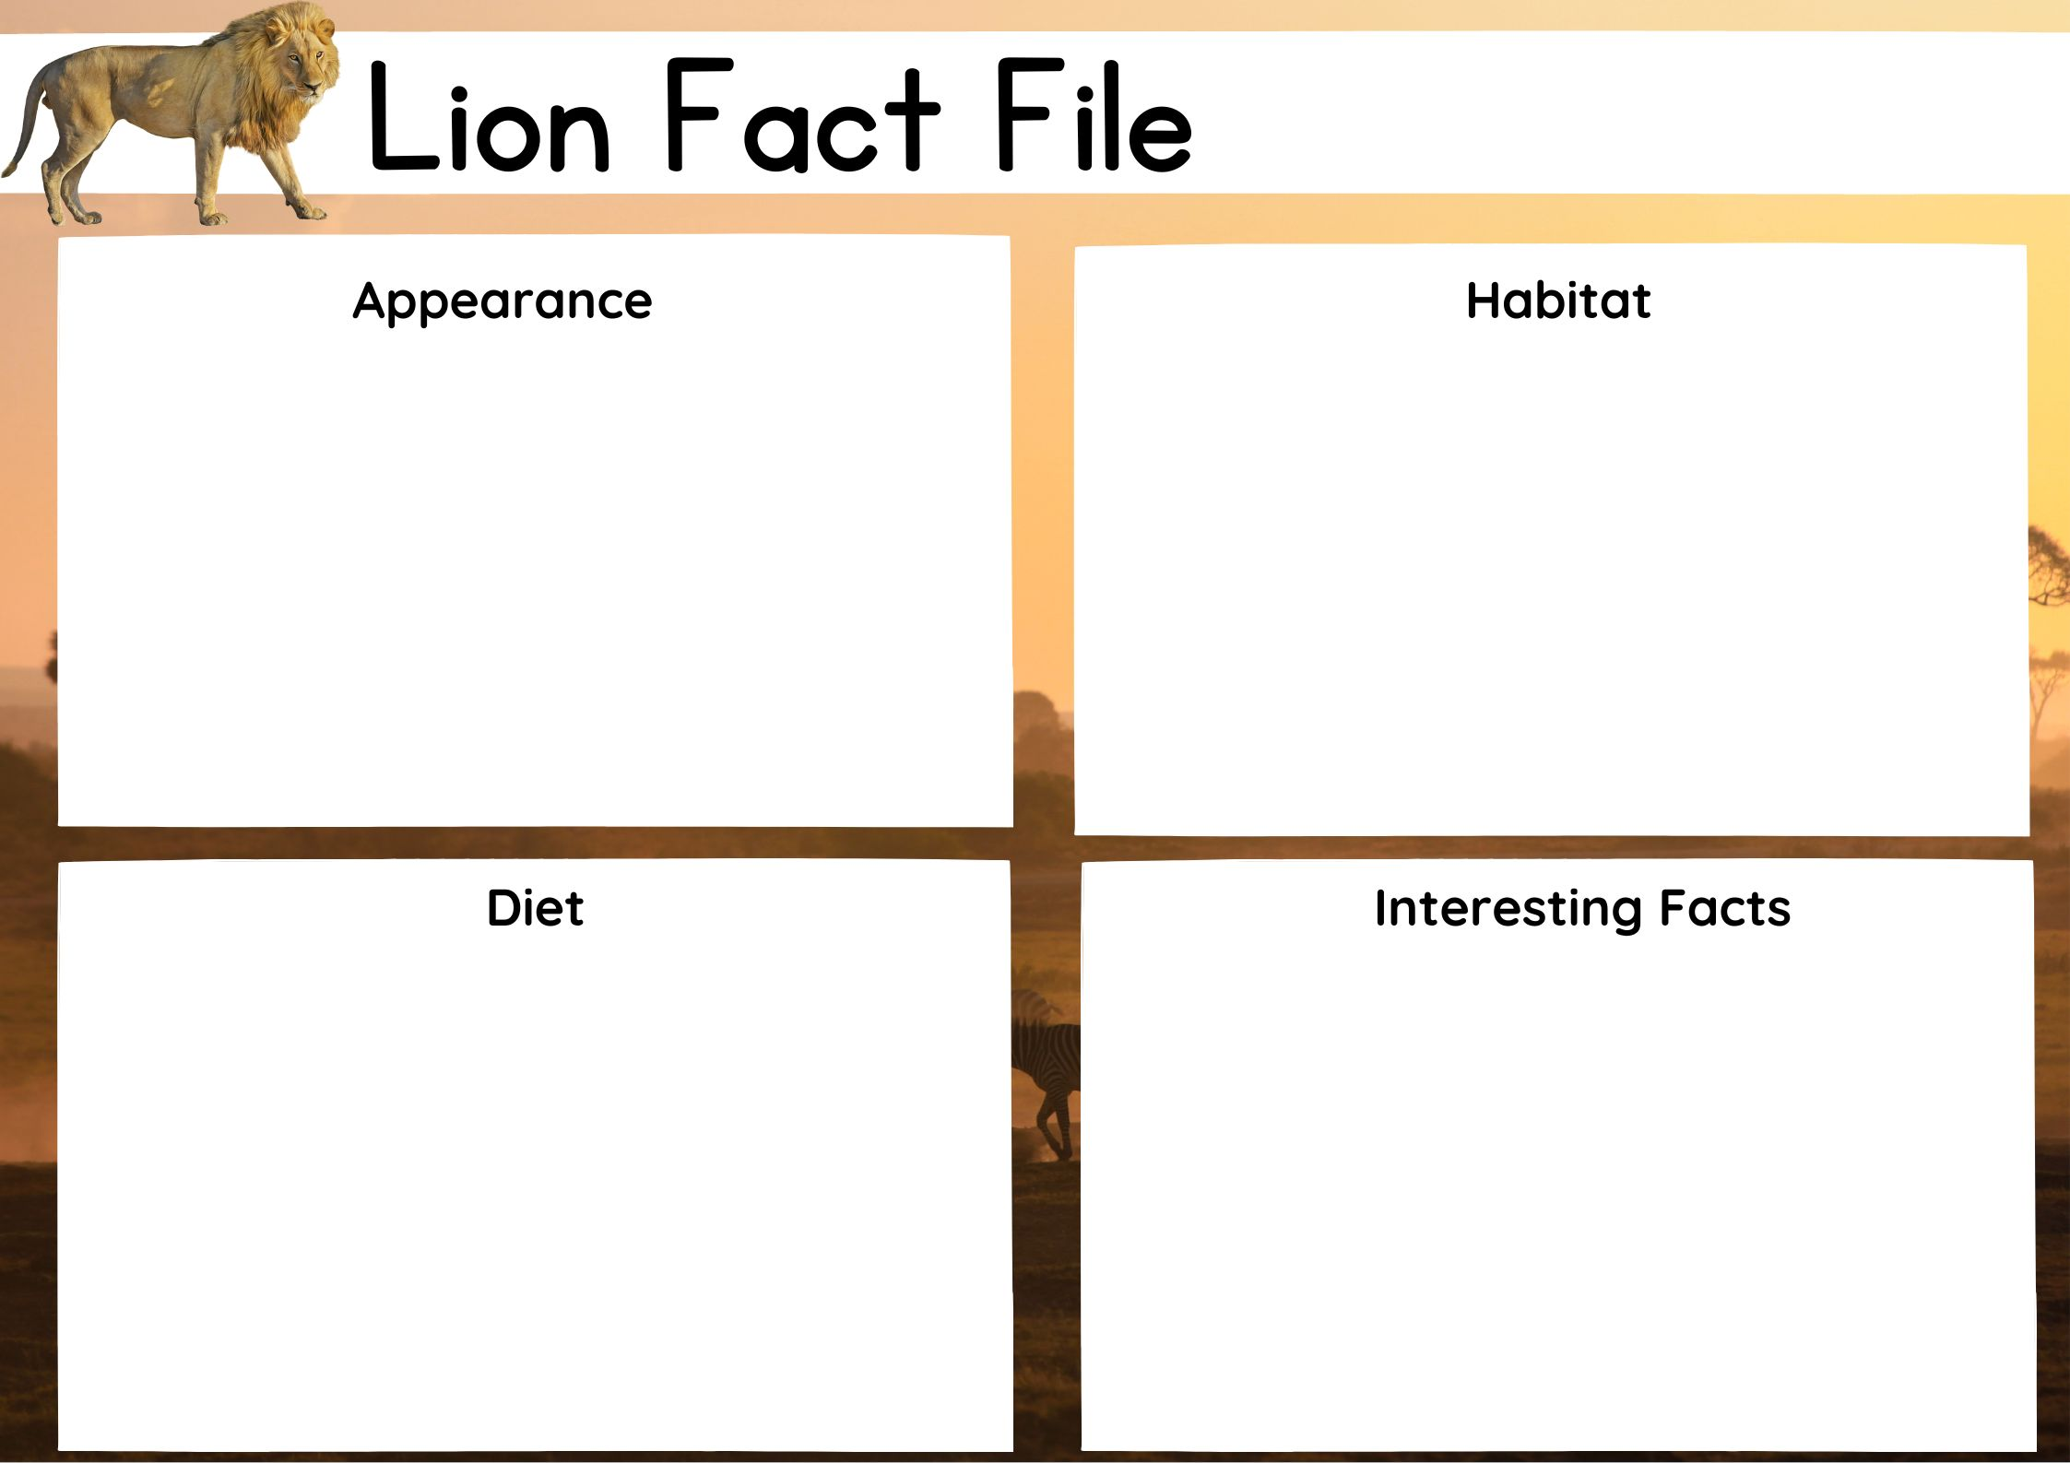
Images sourced from Canva and used in accordance with the Canva Content License Agreement.

References
Links to third-party material and websites
Please note that the provided (reading/viewing material/list/links/texts) are a suggestion only and implies no endorsement, by the New South Wales Department of Education, of any author, publisher, or book title. School principals and teachers are best placed to assess the suitability of resources that would complement the curriculum and reflect the needs and interests of their students.
If you use the links provided in this document to access a third-party's website, you acknowledge that the terms of use, including licence terms set out on the third-party's website apply to the use which may be made of the materials on that third-party website or where permitted by the Copyright Act 1968 (Cth). The department accepts no responsibility for content on third-party websites.
Except as otherwise noted, all material is © State of New South Wales (Department of Education), 2023 and licensed under the Creative Commons Attribution 4.0 International License. All other material (third-party material) is used with permission or under licence. Where the copyright owner of third-party material has not licensed their material under a Creative Commons or similar licence, you should contact them directly for permission to reuse their material.
English Syllabus K–10 © 2022 NSW Education Standards Authority (NESA) for and on behalf of the Crown in right of the State of New South Wales.
© 2022 NSW Education Standards Authority. This document contains NSW Curriculum and syllabus content. The NSW Curriculum is developed by the NSW Education Standards Authority. This content is prepared by NESA for and on behalf of the Crown in right of the State of New South Wales. The material is protected by Crown copyright.
Please refer to the NESA Copyright Disclaimer for more information.
NESA holds the only official and up-to-date versions of the NSW Curriculum and syllabus documents. Please visit the NSW Education Standards Authority (NESA) website and the NSW Curriculum website.
National Literacy Learning Progression © Australian Curriculum, Assessment and Reporting Authority (ACARA) 2010 to present, unless otherwise indicated. This material was downloaded from the Australian Curriculum website (National Literacy Learning Progression) (accessed 6 February 2023) and was not modified. The material is licensed under CC BY 4.0. Version updates are tracked in the ‘Curriculum version history’ section on the 'About the Australian Curriculum' page of the Australian Curriculum website.
ACARA does not endorse any product that uses the Australian Curriculum or make any representations as to the quality of such products. Any product that uses material published on this website should not be taken to be affiliated with ACARA or have the sponsorship or approval of ACARA. It is up to each person to make their own assessment of the product, taking into account matters including, but not limited to, the version number and the degree to which the materials align with the content descriptions and achievement standards (where relevant). Where there is a claim of alignment, it is important to check that the materials align with the content descriptions and achievement standards (endorsed by all education Ministers), not the elaborations (examples provided by ACARA).
This resource contains images and content obtained from Canva, and their use outside of this resource is subject to Canva’s Content License Agreement. If you wish to use them separately from the resource, please go to Canva.
Andreae G (2014) Giraffes Can’t Dance (Parker-Rees G illus.) Orchard Books, London
ETA (English Teachers Association) and NSW Department of Education (2016) The Textual Concepts and Processes resource, English Textual Concepts website, accessed 6 February 2023.
Varchol Perron L (2022) ‘Leroy the Lionhearted’ (Legge D, illus.), The School Magazine: Launchpad (Pilot Magazine).

