English – Stage 1 – Unit 14
Contents
Unit overview and instructions for use 3
Teacher notes 4
Outcomes and content – Component A 5
Outcomes and content – Component B 8
Week 1 11
Component A teaching and learning 11
Component B teaching and learning 12
Lesson 1: Text introduction – Tilly 13
Lesson 2: Exploring vocabulary to describe special objects 15
Lesson 3: Using noun groups and adverbs to describe memories 16
Lesson 4: Writing a character profile 19
Lesson 5: Organising sentences into paragraphs 20
Week 2 22
Component A teaching and learning 22
Component B teaching and learning 23
Lesson 6: Possessive apostrophes 24
Lesson 7: Oral language and descriptions 25
Lesson 8: Prepositional phrases and features of a letter 28
Lesson 9: Receiving and writing letters 29
Lesson 10: Providing feedback and editing letter writing 30
Resource 1: Tilly and me 32
Resource 2: Traffic light paragraphs 33
Resource 3: Treasure table 34
Resource 4: Character talking strips 35
Resource 5: Treasure talking strips 36
Resource 6: Sample letter 37
References 38

Unit overview and instructions for use
This two-week unit is comprised of Component A and Component B. Connecting learning across both components is encouraged.
Teaching and learning | Component A | Component B
Suggested duration | 60 minutes | 45 minutes
Explicit teaching focus areas | - Phonic knowledge  - Reading fluency  - Reading comprehension  - Spelling  - Handwriting | - Oral language and communication  - Vocabulary  - Reading comprehension  - Creating written texts  - Understanding and responding to literature
To prepare for teaching and learning: | - Refer to Outcomes and content – Component A, K-2 – Instructional sequence – grapheme–phoneme correspondences [PDF 825 KB], and the teaching advice documents (hyperlinked in Component A teaching and learning table).  - Based on student needs identified through ongoing assessment data, plan and document how you will sequence teaching and learning in whole class and targeted teaching groups across the two-week cycle. | - Familiarise yourself with Outcomes and content – Component B, Textual concepts information and videos, English Textual Concepts and Learning Processes (2016), and the teaching and learning sequence.  - Based on student needs identified through ongoing assessment data, determine how you will support students in whole class and targeted teaching groups across the two-week cycle as required.
English K–10 Syllabus © 2022 NSW Education Standards Authority (NESA) for and on behalf of the Crown in right of the State of New South Wales.

Teacher notes
- Distribute a note to parents and carers, outlining a request for students to each bring a small ‘treasure’ to school of low monetary but high personal value. Students bring their ‘treasure’ to school for Lesson 2. You may like to bring in a treasure to use as an example throughout the unit.
- Narrative is defined as the communication of a sequence of related events into a story. A narrative is usually structured in such a way to invite responder involvement. Narrative helps us make sense of our lives. – English Textual Concepts and Learning Processes (2016).
- While ‘narrative’ is the mentor concept for this unit, the supporting concept of ‘character’ can also be explored using the mentor text Tilly by Jane Godwin.
- For information on noun groups, sentences, adjectives, commas, adverbs, visualising, paragraphs, topic sentences, and apostrophes, refer to the NESA glossary.
- Suggested additional activity to complement this unit throughout Week 2: Students make and/or decorate a treasure box for their personal treasure and a published letter to take home.
- This unit could enhance student learning towards achievement of outcomes from the Creative Arts syllabus regarding visual arts and drama.
- This unit provides scope to explore various forms of drama. Act Ease, developed by the NSW Department of Education, provides teaching advice and learning sequences to explore quality children’s literature through drama.
- Reflect on student learning and engagement in activities and record adjustments, differentiation, and modifications within the unit to inform future teaching and learning. One way of doing this could be to add comments to the digital file.
- Content points are linked to the National Literacy Learning Progression version (3).
Levels and indicators sourced from National Literacy Learning Progression © Australian Curriculum, Assessment and Reporting Authority (ACARA), (accessed 31 January 2023) and was not modified. See references for more information.

Outcomes and content – Component A
The table below outlines the focus outcomes and content. Content is linked to the National Literacy Learning Progression version (3).
Focus area and outcome | Content points and National Literacy Learning Progression
Phonic knowledge  EN1-PHOKW-01 – uses initial and extended phonics, including vowel digraphs, trigraphs to decode and encode words when reading and creating texts | - blend and decode one-syllable words with taught extended vowel graphs and digraphs, including graphemes for r-controlled vowels and diphthongs, and apply this when reading texts (PKW6, PKW7)  - segment and encode one-syllable words with taught vowel graphs, digraphs and trigraphs and apply this when creating texts  - blend and decode 2-syllable words with taught vowel graphs, digraphs, trigraphs and quadgraphs, including graphemes for r-controlled vowels and diphthongs and apply this when reading texts (PKW6, PKW7)
Reading fluency  EN1-REFLU-01 – sustains reading unseen texts with automaticity and prosody and self-corrects errors | - read aloud with an easy speech rhythm (FlY4)
Reading comprehension  EN1-RECOM-01 – comprehends independently read texts that require sustained reading by activating background and word knowledge, connecting and understanding sentences and whole text, and monitoring for meaning | - use known morphemes and known vocabulary in the text to work out or refine the meaning of unknown words (UnT4)  - draw on sources to seek clarification for unknown words  - know that a complex sentence includes a clause for expressing a main message and one or more clauses that elaborate on that message  - coordinate information or events from different parts of the text to form an overall opinion  - use knowledge of text structure, type of text, author, and forms of writing to predict and confirm meaning (UnT6)  - use a mental model to confirm predictions  - confirm meaning by sequencing and explaining events and information
Spelling  EN1-SPELL-01 – applies phonological, orthographic and morphological generalisations and strategies when spelling words in a range of writing contexts | - spell high-frequency base words with taught vowel graphs, digraphs, split digraphs, trigraphs and quadgraphs (SpG6)  - explain that the consonant trigraphs, –tch and –dge, can end a base word immediately following a short vowel and apply this when spelling  - spell nouns ending in the suffix –er to indicate a person (SpG9)
Handwriting  EN1-HANDW-01 – uses a legible, fluent and automatic handwriting style, and digital technology, including word-processing applications, when creating texts | - use taught software functions to create texts in a range of modes for different contexts, audiences and purposes

Outcomes and content – Component B
The table below outlines the focus outcomes and content. Content is linked to the National Literacy Learning Progression version (3).
Focus area and outcome | Content points and National Literacy Learning Progression
Oral language and communication  EN1-OLC-01 – communicates effectively by using interpersonal conventions and language to extend and elaborate ideas for social and learning interactions | - use a range of strategies for effective dialogue and manage digression from a topic (InT3, InT5)  - organise key ideas in logical sequence  - use adjectives and adverbs to elaborate and/or provide some supporting details or justifications and express causal relationships (SpK3)  - adapt a narrative for a particular audience
Vocabulary  EN1-VOCAB-01 – understands and effectively uses Tier 1, taught Tier 2 and Tier 3 vocabulary to extend and elaborate ideas | - understand and intentionally choose subject-specific vocabulary to enhance precision and for effect
Reading comprehension  EN1-RECOM-01 – comprehends independently read texts that require sustained reading by activating background and word knowledge, connecting and understanding sentences and whole text, and monitoring for meaning | - draw on sources to seek clarification for unknown words  - use knowledge of text structure, type of text, author, and forms of writing to predict and confirm meaning (UnT6)  - use a mental model to confirm predictions  - confirm meaning by sequencing and explaining events and information
Creating written texts  EN1-CWT-01 – plans, creates and revises texts written for different purposes, including paragraphs, using knowledge of vocabulary, text features and sentence structure | - use a logical order to sequence ideas and events in sentences across a text (GrA4)  - group sentences into paragraphs commencing with a topic sentence, followed by other sentences with related ideas (CrT7)  - use noun groups to build descriptions of people and things (CrT6)  - use adverbs to modify the meaning of verbs and adjectives (GrA3)  - use contextually precise prepositional phrases when creating texts (GrA4)  - use commas to separate ideas, lists and/or dependent clauses in a sentence (PuN4, PuN6)  - use possessive apostrophes in own writing (PuN4)  - use a variety of planning strategies and tools for creating texts  - re-read and edit their own texts after receiving feedback
Understanding and responding to literature  EN1-UARL-01 – understands and responds to literature by creating texts using similar structures, intentional language choices and features appropriate to audience and purpose | - identify patterns in narratives that set up expectation and aid prediction of actions and attitudes  - identify and appreciate how key messages in narratives evoke feelings

Week 1

Component A teaching and learning
The table below can be used to plan and document lessons that address Component A outcomes and content. Both the detailed example [DOC 529KB] of a two-week teaching and learning cycle and brief example [DOC 66KB] may support you in your planning.
Focus Areas | Lesson 1 | Lesson 2 | Lesson 3 | Lesson 4 | Lesson 5
Phonic knowledge
15 minutes
Spelling and Handwriting
15 minutes
Reading comprehension and Reading fluency
30 minutes

Component B teaching and learning
The following teaching and learning sequence has been designed to address Component B outcomes and content. Adapt the sequence as required to best meet the needs of your students.

Learning intention and success criteria
Learning intentions and success criteria are best co-constructed with students.

Learning intention
Students are learning to respond to narrative picture books, and use commas, noun groups, and paragraphs when writing.

Success criteria
Students can:
- use noun groups to describe people and things
- use commas in a list
- use adjectives and adverbs to add details
- identify the feelings of the characters
- group sentences about the same topic into paragraphs.

Resources
- Godwin J (2019) Tilly (Walker A, illus) Scholastic Australia Pty Ltd, Sydney. ISBN: 9781760663728
- Resource 1: Tilly and me
- Resource 2: Traffic light paragraphs (enlarged copy)
- Website: Jane Godwin ‘Tilly’
- Mini whiteboards/paper
- Students’ personal treasures

Lesson 1: Text introduction – Tilly
- Introduce the text, Tilly. Refer to the second double-page spread that shows the stairs and Tilly sitting under the table. Students Think-Pair-Share to answer the following:
- What is happening?
- Which character do you think is Tilly? Why?
- What can we tell about the text by looking at these pages?
- Guide students to make predictions about the type of text, using the front and back covers, title, and illustrations. Discuss the relationship that may exist between the characters.
- Read Tilly. Revisit the Think-Pair-Share responses and confirm text predictions.
- Explain that Tilly is based on a true story. Read the true story of Tilly on Jane Godwin’s website.
- Provide opportunities for students to make text-to-self connections. Ask students if anything from Tilly’s house reminds them of something in their house. For example, the shoes in the hallway, family photos, scattered books, toys, and pets. Students share a description of their homes using noun groups for example, ‘the noisy pets’. List student responses on an anchor chart.
- Students draw a detailed picture of a scene from their home and label it, referring to the anchor chart as needed.
- Model writing sentences using noun groups to add more information to the labels. For example, ‘The smelly shoe is lying on the clean floor.’
- Students expand their labels to create a sentence including noun groups.
Too easy? Students write compound sentences to describe their drawing.
Stage 1 Assessment task 1 – Observations and work samples from this lesson allow students to demonstrate achievement towards the following syllabus outcomes and content points:
EN1-OLC-01 – communicates effectively by using interpersonal conventions and language to extend and elaborate ideas for social and learning interactions
- adapt a narrative for a particular audience.
EN1-RECOM-01 – comprehends independently read texts that require sustained reading by activating background and word knowledge, connecting and understanding sentences and whole text, and monitoring for meaning
- use knowledge of text structure, type of text, author, and forms of writing to predict and confirm meaning
- use a mental model to confirm predictions
- confirm meaning by sequencing and explaining events and information.
EN1-UARL-01 – understands and responds to literature by creating texts using similar structures, intentional language choices and features appropriate to audience and purpose
- identify patterns in narratives that set up expectation and aid prediction of actions and attitudes.

Lesson 2: Exploring vocabulary to describe special objects
- Revisit Tilly and discuss the structure of a narrative, referring to key vocabulary previously taught. For example, narrative, sequence of events, imagined, feelings, prediction, cause, and effect. Focus on ‘who, what, where’ and consider the messages of family, memories, and emotion.
- Display the page where Tilly is lying on her bed with her feet on the wall. Read the page and ask students what they think the word ‘precious’ means.
- Display the double-page spread where Tilly is looking at her hiding place under the newly laid carpet. Discuss the meaning of the word ‘treasure’.
- As a class, complete a Frayer diagram to explore the word ‘precious’. Label the quadrants ‘definition’, ‘similar words’, ‘opposite words’ and ‘sentence’. Record the definition of the word ‘precious’ and list students’ examples of similar and opposite words. Co-construct a sentence using the word ‘precious’. For example, ‘My teddy is precious because it was given to me by someone special.’
- Repeat activity 4 using the word ‘treasure’.
- Using the turn and talk strategy, students describe their treasure using the words ‘precious’ and ‘treasure’. For example, ‘My treasure is a colourful feather; it is precious because it came from my budgie.’
- Display the page with the list of Tilly’s treasures. Ask:
- What are Tilly’s treasures?
- What words have been used to describe them? For example, special, best, smooth, stripy, silver, little wooden. Review descriptive adjectives.
- Why might these treasures be important to Tilly?
- Refer to Tilly’s list of treasures. Explicitly teach writing lists using commas to separate items (words, phrases, or numbers) in a series. Model rewriting Tilly’s list using commas to separate the items. For example, ‘Tilly’s treasures were a special book of lists, her best drawing of a bird, a smooth stone she found by the sea, a silver ball with a tiny bell inside, stripy sweets, a letter she had never delivered and 4 little wooden dolls.’
- Students draw their treasures and write an accompanying list using adjectives and commas.
Too hard? Provide students with the anchor chart from Lesson 1, which references descriptive adjectives.
Too easy? Students list their treasures using extended noun groups.

Lesson 3: Using noun groups and adverbs to describe memories
- Discuss the concept of ‘memories’ and define a memory as something at a point of time that we remember. Discuss how the audience knows that Tilly has a lot of memories in her house. Refer to the illustrations showing family and baby photos and the children’s paintings on the walls. Discuss how these represent memories.
- Students turn and talk and describe a memory that Tilly has. Share memories as a class.
- Explain that an adverb is a word that tells something about a verb, adjective or another verb; they indicate things like manner (how), place (where) or time (when). Adverbs commonly end in -ly.
- Brainstorm and list adverbs to describe the way Tilly’s played with her treasures. For example, quietly, secretly, carefully, nicely, happily, calmly. Highlight how each adverb contains a base word (free morpheme) that is built on by the suffix (bound morpheme) -ly.
- Display the dark page where Tilly is in bed. Discuss the text and its meaning. Explain that Tilly’s treasures are also memories. When she makes pictures of her treasures in her mind and no one else can see them, Tilly is visualising. Explicitly teach the importance of using noun groups and adjectives to create a picture to help readers visualise the scene.
- Discuss words that could be used to describe Tilly’s treasures, for example, sweets: stripy, colourful; ball: silver, tiny bell inside. Add to the anchor chart from Lesson 1.
- Students close their eyes and visualise a memory of their own. To encourage deeper thinking ask:
- Who is in your memory?
- Where were you?
- What time was it?
- What happened?
- How does your memory make you feel?
Too hard? Provide students with topics to help them think of a memory. For example, a soccer game where they kicked a goal, a feather they found, their favourite book, a place they have been, a school memory, or a favourite toy.
- Model writing sentences about a personal memory using noun groups and adverbs, referring to the anchor chart from Lesson 1. For example, ‘I ran quickly and kicked the hard ball in the soccer goal’; ‘My mum sang loudly into the black microphone.’
- Students write sentences to describe their memory using noun groups, adjectives, and adverbs.
Too hard? Students illustrate their memories and add labels.
- In pairs, students read their sentences while their partner draws the memory. Students swap and repeat this process.
- Students provide feedback to each other on the connection between the writing and the drawing.
- As a class, review the pictures and discuss which ones had more detail and why. Draw attention to how some sentences created a clear picture of students’ memories.
Stage 1 Assessment task 2 – Observations and work samples from this lesson allow students to demonstrate achievement towards the following syllabus outcomes and content points:
EN1-OLC-01 – communicates effectively by using interpersonal conventions and language to extend and elaborate ideas for social and learning interactions
- use adjectives and adverbs to elaborate and/or provide some supporting details or justifications and express causal relationships.
EN1-CWT-01 – plans, creates and revises texts written for different purposes, including paragraphs, using knowledge of vocabulary, text features and sentence structure
- use noun groups to build descriptions of people and things
- use adverbs to modify the meaning of verbs and adjectives.

Lesson 4: Writing a character profile
- Revisit Tilly, focusing on the illustrations of Tilly, her appearance, and emotions. Explore Tilly’s secret and how her feelings, emotions and facial expressions about the secret change throughout the text.
- To build a mental model of the character and her emotions, students engage in the drama activity of mirroring. Organise students into pairs, facing each other. Read key sentences from the text and ask ‘Student A’ to respond using facial expressions and body language. Afterwards, ‘Student B’ mirrors their actions. For example, read:
- ‘Sometimes there was no room for Tilly’
- ‘Tilly liked to take these treasures out of the step, one by one’
- ‘But something was wrong’
- ‘How could she rescue them?’
- Students swap roles and repeat the activity with different key sentences.
- To further explore the character of Tilly, students complete Resource 1: Tilly and me. Students draw a picture of themselves and a separate picture of Tilly. Students identify similarities and differences between Tilly and themselves, writing noun groups and adjectives in the Venn diagram provided. For example, long, brown hair; a special secret; 2 brothers and a sister.
- Students write sentences to match the aspects of the Venn diagram. For example, ‘I wear shiny, silver glasses’; ‘Tilly has long hair’; ‘We both have a very special secret’.
Too hard? Students draw pictures in the Venn diagram.
Too easy? Students write compound sentences.
- Students identify memorable moments and related emotions within the text, for example:
- Collecting the treasures – excitement
- Hiding the treasures – secretive
- House/carpet renovation and lost treasures – sad
- Remembering treasures – wondering
- New treasures hidden – happy.
- In small groups, students engage in the drama activity, Let’s freeze. Allocate a memorable moment to each group. Students create frozen tableaus of moments from the text. Tell the students you have a magic remote control and, when you press the play button, the moment comes to life. Allow time for students to plan and rehearse their moment.
- Students present their moment to the class and discuss Tilly’s feelings.

Lesson 5: Organising sentences into paragraphs
- Introduce paragraphs. Explicitly teach that a paragraph is a sequence of sentences, grouped together and focused on a specific theme. A distinct section of writing indicated by a new line. Explain that a paragraph starts with a topic sentence, which is followed by other sentences that elaborate on the topic and include details that support a specific point or topic.
- Display the webpage which tells the true story of Tilly and read the first 3 paragraphs.
- Review the features of paragraphs, drawing attention to:
- groups of sentences
- topic sentences – noting that these usually occur at the start of a paragraph and indicate the main idea
- sentences with related ideas
- the idea that paragraphs can vary in length.
- Display an enlarged copy of paragraph one from the webpage Tilly. Display Resource 2: Traffic light paragraphs, highlighting the paragraph’s features:
- topic sentence – Tilly is based on true events: green
- sentences with related ideas – middle of the paragraph: orange
- closing sentence – red.
- Display and read the page where Tilly is in bed at night. Explain how the 3 sentences create a paragraph. Begin to co-construct a paragraph by writing the first 2 sentences on the board.
- Discuss how adding more sentences with related ideas will add more meaning to the paragraph. Display the sentence ‘She tried to remember everything about them.’ Students turn and talk to discuss what Tilly might remember about her treasures. Students record a sentence on mini whiteboards. Discuss, select, and record 3 responses that add meaning to the paragraph.
- As a class, sequence the sentences to create an extended paragraph. The closing sentence should be, ‘How could she rescue them?’
- Read and review the paragraph using Resource 2: Traffic light paragraphs. Ensure that the added responses support the topic.

Week 2

Component A teaching and learning
The table below can be used to plan and document lessons that address Component A outcomes and content. Both the detailed example [DOC 529KB] of a two-week teaching and learning cycle and brief example [DOC 66KB] may support you in your planning.
Focus Areas | Lesson 6 | Lesson 7 | Lesson 8 | Lesson 9 | Lesson 10
Phonic knowledge
15 minutes
Spelling and Handwriting
15 minutes
Reading comprehension and Reading fluency
30 minutes

Component B teaching and learning
The following teaching and learning sequence has been designed to address Component B outcomes and content. Adapt the sequence as required to best meet the needs of your students.

Learning intention and success criteria
Learning intentions and success criteria are best co-constructed with students.

Learning intention
Students are learning to respond to narrative picture books, use possessive apostrophes and paragraphs, and apply feedback when writing.

Success criteria
Students can:
- use possessive apostrophes accurately
- plan for speaking and writing
- identify and write prepositional phrases accurately
- write a paragraph that contains a simple idea, a topic sentence and supporting details
- use feedback to edit and improve own texts.

Resources
- Godwin J (2019) Tilly (Walker A, illus) Scholastic Australia Pty Ltd, Sydney. ISBN: 9781760663728
- Fox M (1984) Wilfrid Gordon McDonald Partridge (Vivas J, illus) Kane Miller, San Diego. ISBN: 9780140505863
- Resource 3: Treasure table
- Resource 4: Character talking strips
- Resource 5: Treasure talking strips
- Resource 6: Sample letter
- Mini whiteboards
- Students’ treasures
- Teacher’s treasure

Lesson 6: Possessive apostrophes
- Introduce the text, Wilfrid Gordon McDonald Partridge by Mem Fox. Guide students to make predictions about what type of text it is, using the front and back covers, title, and illustrations.
- Read Wilfrid Gordon McDonald Partridge. Revisit the text predictions and provide an opportunity for students to make text-to-self connections. Discuss the words ‘memory’ and ‘precious’ and prompt students to make text-to-text connections with Tilly.
- Display the pages that describe what Wilfrid had placed into the basket. Create a T-chart with the headings ‘Wilfrid Gordon McDonald Partridge’ and ‘Tilly’. List treasures Wilfrid placed in the basket for Miss Nancy.
- Display the pages that describe Tilly’s treasures. List treasures Tilly keeps in her secret step.
- Identify and record possessive apostrophes in Wilfrid Gordon McDonald Partridge. Explain they are used to show ownership and discuss where the apostrophe is placed.
- Model the use of possessive apostrophes, with relevant examples from your class, for example, ‘This is Bill’s pencil case.’
- Provide students with Resource 3: Treasure table. Students draw a treasure for Tilly, Wilfrid, and themselves and ask a friend to draw their treasure.
- Using the drawings, model writing a sentence using possessive apostrophes, for example, ‘Tilly’s treasure is some stripy sweets’; ‘The puppet on strings is Wilfrid’s treasure’.
- Students write sentences to accompany their treasure pictures using possessive apostrophes to describe each person's treasure.
- In groups, students share their writing.
Too hard? Students draw and label their pictures. For example, ‘Tilly’s sweets’.
Too easy? Students list multiple treasures in their sentences using commas to separate each item.

Lesson 7: Oral language and descriptions
- Display Wilfrid Gordon McDonald Partridge and refer to the page where Wilfrid is hanging from a bar in his backyard. Model describing Wilfrid’s physical features and personal characteristics. For example, ‘Wilfred is hanging from a bar in his backyard. He has fuzzy red hair and he’s wearing blue shorts and a light blue T-shirt. He looks like he’s having fun and he looks happy because he’s smiling.’
- Explain the importance of staying on topic, keeping to talking points and not digressing. Model an example of digressing when describing Wilfrid. For example, ‘Wilfrid is hanging from a bar in his backyard. When I was little, I had a swing set and I used to hang from the bar too. My little sister liked the small swing best.’ Students identify the digression.
- Display and discuss Resource 4: Character talking strips as a planning tool for an oral description.
- Display the page with Wilfrid and Miss Nancy both sitting in chairs. Students turn and talk to discuss the physical features and personal characteristics of Miss Nancy. In pairs, students record ideas on mini whiteboards and share their responses. Write responses to create a shared description of Miss Nancy, using Resource 4: Character talking strips, anchor chart from Lesson 1 and Frayer diagram from Lesson 2.
- Model organising student responses into a logical sequence to provide an accurate description of Miss Nancy. For example, ‘Miss Nancy has messy, grey hair. She is wearing a colourful dress and has a blanket around her shoulders. She is wearing baggy, pink socks with slippers.’
- Students close their eyes while you read the description of Miss Nancy. Students use ‘thumbs up/thumbs down’ to indicate how accurately they could visualise Miss Nancy. Discuss improvements that could be made to the description, for example, ‘Miss Nancy looks interested in Wilfrid’s basket.’
- Using Resource 5: Treasure talking strips, model planning an oral description of your treasure. For example, ‘This is my picture of a magpie. The picture is black and white, and it has been hand-painted. This was given to me as a gift and it’s special because the person who gave it to me knows how much I love magpies. I wanted to share this with you because it is my favourite picture.’
- Provide students with Resource 5: Treasure talking strips. Students develop their talking points to describe their treasure.
Too hard? Facilitate use of text-to-speech technology or audio or video recording to produce this text.
Too easy? Students write their text, using extended/complex noun groups to build the reader’s visualisation of the treasure.
- Students practise their talking points in pairs, ensuring they remain on topic. Students use ‘thumbs up/thumbs down’ to provide feedback about staying on topic, keeping to talking points and not digressing. Students apply this feedback as part of preparing their oral description.
- Students present their description to the class or in small groups.
Stage 1 Assessment task 3 – Observations and work samples from this lesson allow students to demonstrate achievement towards the following syllabus outcomes and content points:
EN1-OLC-01 – communicates effectively by using interpersonal conventions and language to extend and elaborate ideas for social and learning interactions
- use a range of strategies for effective dialogue and manage digression from a topic
- organise key ideas in logical sequence.
EN1-RECOM-01 – comprehends independently read texts that require sustained reading by activating background and word knowledge, connecting and understanding sentences and whole text, and monitoring for meaning
- draw on sources to seek clarification for unknown words.
EN1-CWT-01 – plans, creates and revises texts written for different purposes, including paragraphs, using knowledge of vocabulary, text features and sentence structure
- use noun groups to build descriptions of people and things
- use a variety of planning strategies and tools for creating texts.

Lesson 8: Prepositional phrases and features of a letter
- Refer to Tilly's list of treasures. Discuss:
- Who do you think Tilly wrote her letter to?
- What do you think was in the letter?
- Why do you think the letter wasn’t delivered?
- Display Resource 6: Sample letter. Discuss and label the basic features:
- salutation/beginning (Dear)
- content
- ending (Love).
- Review prior learning of prepositional phrases. Identify these phrases within Resource 6: Sample letter.
- Refer to Lesson 5 to revisit and identify paragraphs and topic sentences within the sample letter.
- Explain to students that they will be writing a letter about their personal treasure. Identify the topic of each paragraph of the letter using the completed Resource 5: Treasure talking strips from Lesson 7:
- This is my treasure (name, features, where it came from)
- This is why it is special
- This is why I want other people to know about my treasure.
- Discuss and record ideas for each paragraph, using your treasure to model student responses.
- Co-construct success criteria for writing a letter including letter format, paragraphs, commas, possessive apostrophes, and prepositional phrases.
- Share the pen to co-construct a letter about your treasure. Use the ‘think aloud’ strategy to model, referring to Resource 6: Sample letter, and applying the success criteria.

Lesson 9: Receiving and writing letters
- Share with the students a real or imagined story about receiving a letter. Explain who wrote the letter, what the letter was about and your feelings when you received the letter.
- Discuss alternate types of ‘letters’, for example, postcards, emails, or text messages; and methods of delivery, for example, hand-delivered, postal delivery, courier delivery, and digital delivery including text-to-voice.
- Students turn and talk with a partner about when they have received a letter. Ask:
- Who was the author?
- What was the letter about?
- How was it delivered?
- How did it make you feel?
- Model applying the success criteria from Lesson 8 to provide feedback on the co-constructed letter using the ‘think aloud’ strategy and the Two stars and a wish proforma.
- Students write a draft letter about their treasure with reference to the co-constructed success criteria.
Too hard? Facilitate use of text-to-speech technology or audio or video recording to produce this text.

Lesson 10: Providing feedback and editing letter writing
- In pairs, students provide feedback on their partner’s draft letter using the co-constructed success criteria.
- Provide time for students to apply feedback to their writing.
- Students publish their letter on a letter writing proforma.
Too hard? Facilitate use of text-to-speech technology or audio or video recording to produce this text.
- Students take home their treasure and published letter in their box (if created) to share with family members.
Stage 1 Assessment task 4 – Collecting work samples from this lesson allows students to demonstrate achievement towards the following syllabus outcomes and content points:
EN1-VOCAB-01 – understands and effectively uses Tier 1, taught Tier 2 and Tier 3 vocabulary to extend and elaborate ideas
- understand and intentionally choose subject-specific vocabulary to enhance precision and for effect.
EN1-CWT-01 – plans, creates and revises texts written for different purposes, including paragraphs, using knowledge of vocabulary, text features and sentence structure
- use a logical order to sequence ideas and events in sentences across a text
- group sentences into paragraphs commencing with a topic sentence, followed by other sentences with related ideas
- use contextually precise prepositional phrases when creating texts
- use commas to separate ideas, lists and/or dependent clauses in a sentence
- use possessive apostrophes in own writing
- re-read and edit their own texts after receiving feedback.
EN1-UARL-01 – understands and responds to literature by creating texts using similar structures, intentional language choices and features appropriate to audience and purpose
- identify and appreciate how key messages in narratives evoke feelings.

Resource 1: Tilly and me
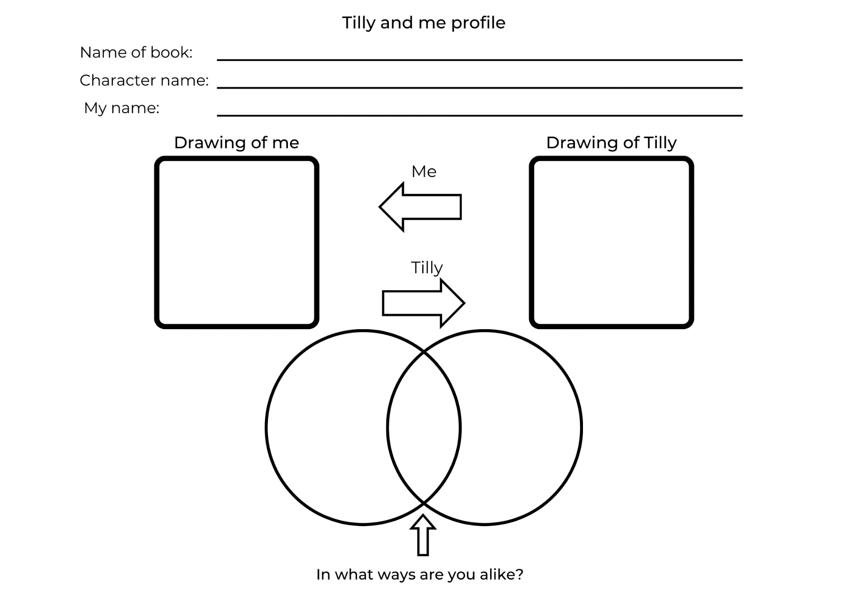

Resource 2: Traffic light paragraphs
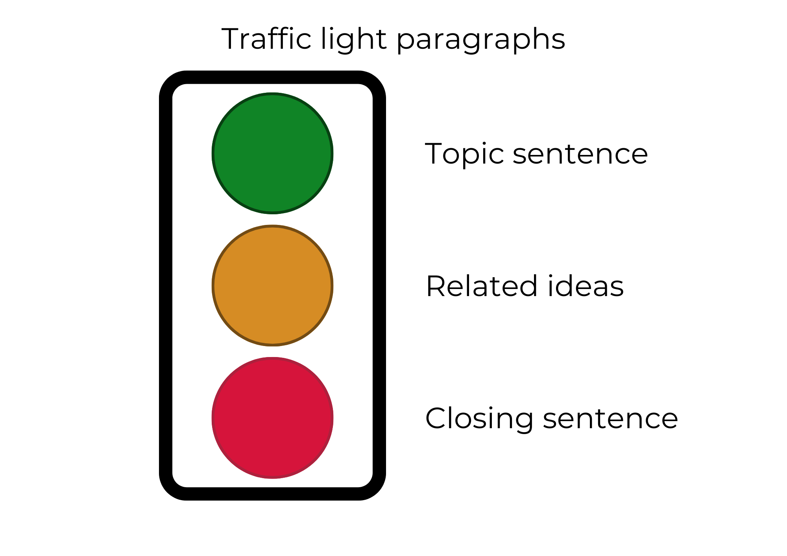

Resource 3: Treasure table
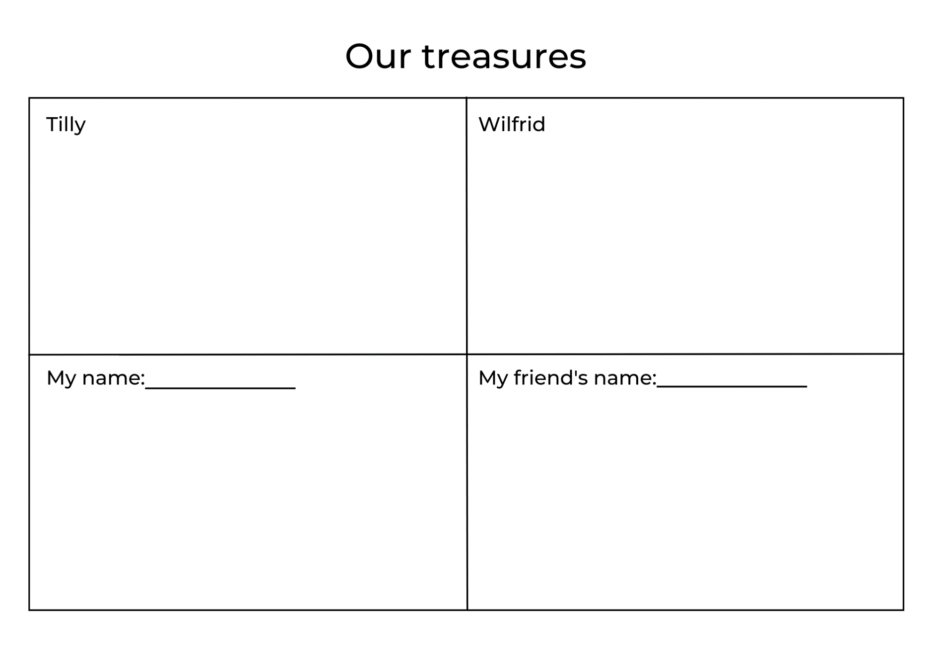

Resource 4: Character talking strips
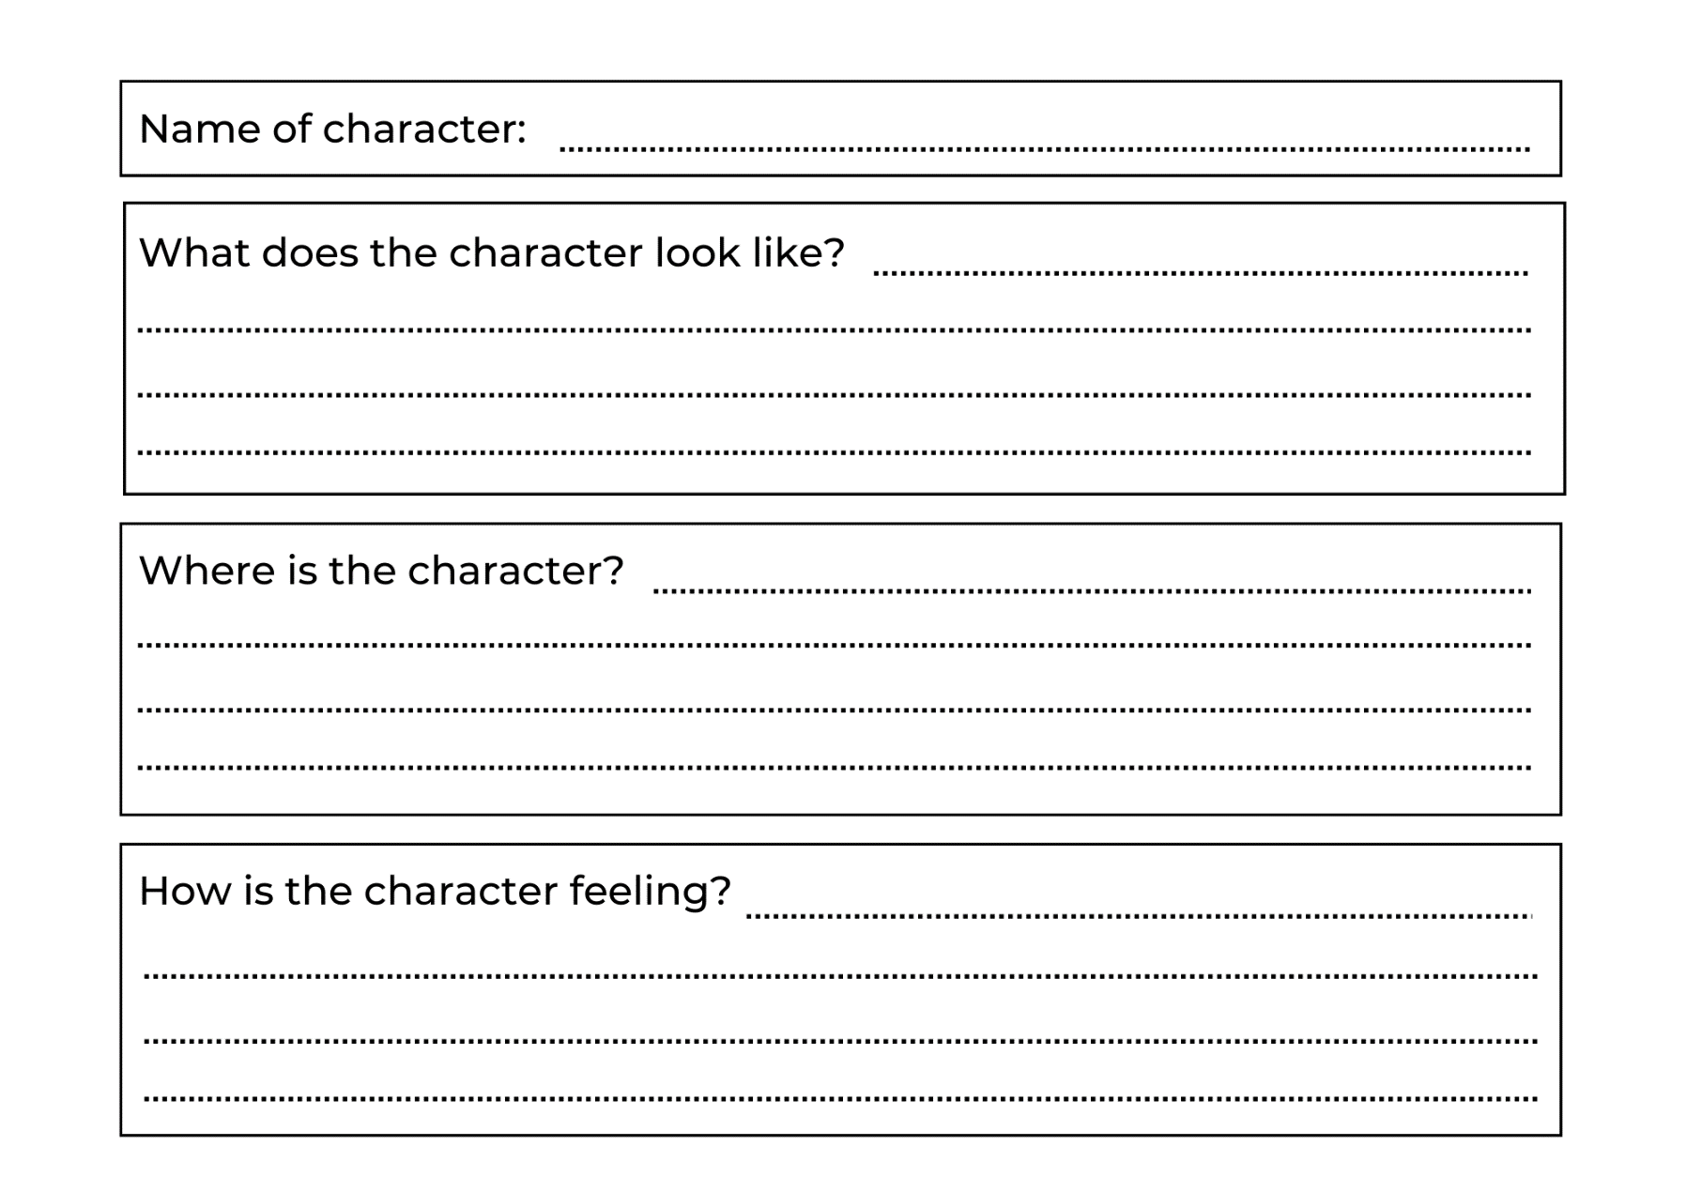

Resource 5: Treasure talking strips
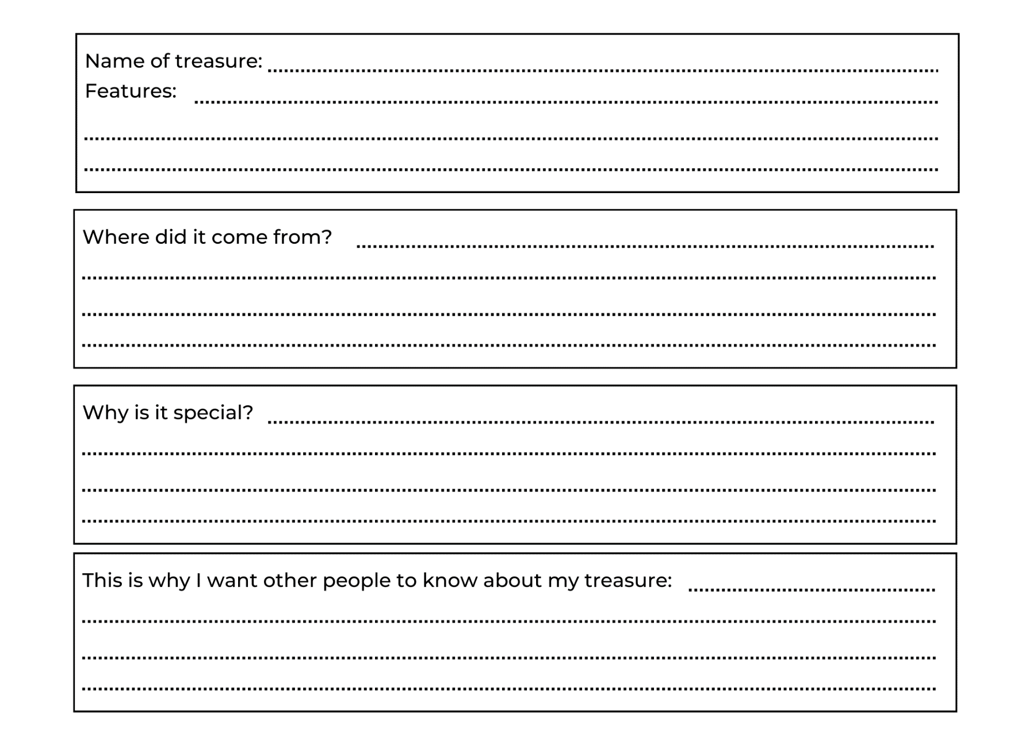

Resource 6: Sample letter
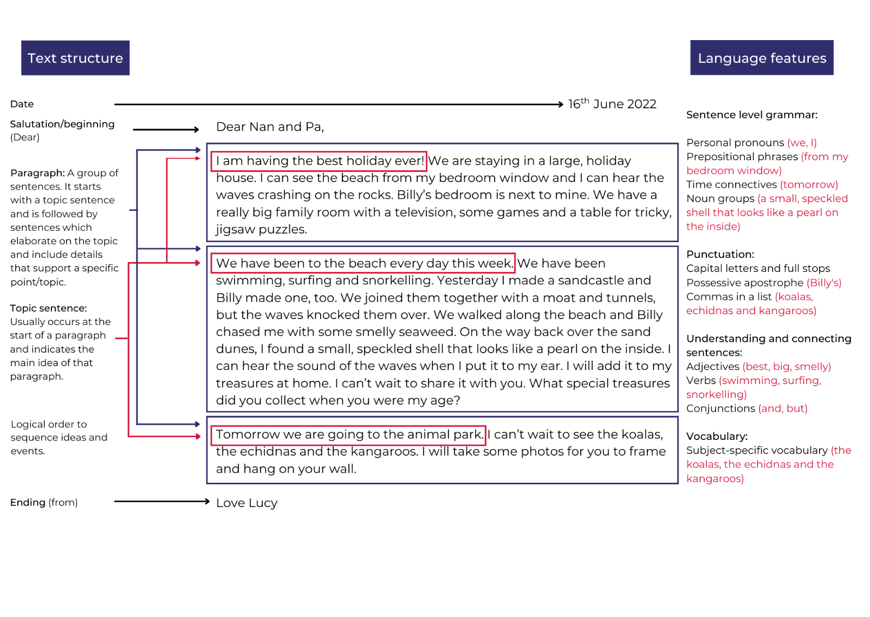

References
Links to third-party material and websites
Please note that the provided (reading/viewing material/list/links/texts) are a suggestion only and implies no endorsement, by the New South Wales Department of Education, of any author, publisher or book title. School principals and teachers are best placed to assess the suitability of resources that would complement the curriculum and reflect the needs and interests of their students.
If you use the links provided in this document to access a third party's website, you acknowledge that the terms of use, including licence terms set out on the third party's website, apply to the use which may be made of the materials on that third-party website or where permitted by the Copyright Act 1968 (Cth). The department accepts no responsibility for content on third-party websites.
Except as otherwise noted, all material is © State of New South Wales (Department of Education), 2023 and licensed under the Creative Commons Attribution 4.0 International License. All other material (third-party material) is used with permission or under licence. Where the copyright owner of third-party material has not licensed their material under a Creative Commons or similar licence, you should contact them directly for permission to reuse their material.
English K–10 Syllabus © 2022 NSW Education Standards Authority (NESA) for and on behalf of the Crown in right of the State of New South Wales.
Creative Arts K–6 Syllabus © 2006 NSW Education Standards Authority (NESA) for and on behalf of the Crown in right of the State of New South Wales.
© 2022 NSW Education Standards Authority. This document contains NSW Curriculum and syllabus content. The NSW Curriculum is developed by the NSW Education Standards Authority. This content is prepared by NESA for and on behalf of the Crown in right of the State of New South Wales. The material is protected by Crown copyright.
Please refer to the NESA Copyright Disclaimer for more information.
NESA holds the only official and up-to-date versions of the NSW Curriculum and syllabus documents. Please visit the NSW Education Standards Authority (NESA) website and the NSW Curriculum website.
National Literacy Learning Progression © Australian Curriculum, Assessment and Reporting Authority (ACARA) 2010 to present, unless otherwise indicated. This material was downloaded from the Australian Curriculum website (National Literacy Learning Progression) (accessed 31 January 2023) and was not modified. The material is licensed under CC BY 4.0. Version updates are tracked in the ‘Curriculum version history’ section on the 'About the Australian Curriculum' page of the Australian Curriculum website.
ACARA does not endorse any product that uses the Australian Curriculum or make any representations as to the quality of such products. Any product that uses material published on this website should not be taken to be affiliated with ACARA or have the sponsorship or approval of ACARA. It is up to each person to make their own assessment of the product, taking into account matters including, but not limited to, the version number and the degree to which the materials align with the content descriptions and achievement standards (where relevant). Where there is a claim of alignment, it is important to check that the materials align with the content descriptions and achievement standards (endorsed by all education Ministers), not the elaborations (examples provided by ACARA).
ETA (English Teachers Association) and NSW Department of Education (2016) The Textual Concepts and Processes resource, English Textual Concepts website, accessed 31 January 2023.
Fox M (1984) Wilfrid Gordon McDonald Partridge (Vivas J, illus.) Kane Miller, San Diego.
Godwin J (2019) Tilly (Walker A, illus.) Scholastic Australia Pty Ltd, Sydney.
Godwin J (n.d.) Tilly, Jane Godwin website, accessed 31 January 2023.

