English – Stage 1 – Unit 13
Contents
Unit overview and instructions for use 3
Teacher notes 4
Outcomes and content – Component A 5
Outcomes and content – Component B 7
Week 1 10
Component A teaching and learning 10
Component B teaching and learning 11
Lesson 1: Text orientation – Boy 12
Lesson 2: Verbs 14
Lesson 3: Tense 16
Lesson 4: Morphemic knowledge 17
Lesson 5: Navigation pathways 18
Week 2 20
Component A teaching and learning 20
Component B teaching and learning 21
Lesson 6: The Black Book of Colours – Context and text orientation 22
Lesson 7: Non-verbal communication modes 24
Lesson 8: Creating written texts 24
Lesson 9: Creating multimodal texts 25
Lesson 10: Showcasing student learning 27
Resource 1: Verbs from Boy 28
Resource 2: Verb dictionary template 29
Resource 3: Morphology chart teacher model 30
Resource 4: Planning scaffold 31
Resource 5: Storyboard 32
References 33

Unit overview and instructions for use
This two-week unit is comprised of Component A and Component B. Connecting learning across both components is encouraged.
Teaching and learning | Component A | Component B
Suggested duration | 60 minutes | 45 minutes
Explicit teaching focus areas | - Phonic knowledge  - Reading fluency  - Reading comprehension  - Spelling  - Handwriting | - Oral language and communication  - Vocabulary  - Reading comprehension  - Creating written texts  - Understanding and responding to literature
To prepare for teaching and learning: | - Refer to Outcomes and content – Component A, K-2 – Instructional sequence – grapheme–phoneme correspondences [PDF 825 KB], and the teaching advice documents (hyperlinked in Component A teaching and learning table).  - Based on student needs identified through ongoing assessment data, plan and document how you will sequence teaching and learning in whole class and targeted teaching groups across the two-week cycle. | - Familiarise yourself with Outcomes and content – Component B, Textual concepts information and videos, English Textual Concepts and Learning Processes (2016), and the teaching and learning sequence.  - Based on student needs identified through ongoing assessment data, determine how you will support students in whole class and targeted teaching groups across the two-week cycle as required.
English K–10 Syllabus © 2022 NSW Education Standards Authority (NESA) for and on behalf of the Crown in right of the State of New South Wales.

Teacher notes
- Context is defined as a culturally or socially situated circumstance that may give rise to a particular register (NESA Glossary). ‘To understand context, we look beyond the text to consider the world in which it was produced and the worlds of its reception.’ – English Textual Concepts and Learning Processes (2016).
- While context is the mentor concept for the conceptual component of this unit, the supporting concept of narrative can be explored using the mentor text Boy by Phil Cummings.
- This unit could enhance student learning towards achievement of outcomes from the Creative Arts syllabus regarding drama and visual arts. Digital technologies are also incorporated through the explicit teaching of website and digital text navigation.
- For information on morphemes, navigation pathways, and Australian sign language (Auslan), refer to the NESA Glossary.
- For information, definitions, and terminology related to Deaf, deaf and hard of hearing persons, refer to the Inclusive Practice Hub.
- For information, definitions, and terminology related to blind and low vision persons, refer to the Inclusive Practice Hub.
- Reflect on student learning and engagement in activities and record differentiation and adjustments within the unit to inform future teaching and learning. One way of doing this could be to add comments to the digital file.
- Content points are linked to the National Literacy Learning Progression version (3).
Levels and indicators sourced from National Literacy Learning Progression © Australian Curriculum, Assessment and Reporting Authority (ACARA), (accessed 25 January 2023) and was not modified. See references for more information.

Outcomes and content – Component A
The table below outlines the focus outcomes and content. Content is linked to the National Literacy Learning Progression version (3).
Focus area and outcome | Content points and National Literacy Learning Progression
Phonic knowledge  EN1-PHOKW-01 – uses initial and extended phonics, including vowel digraphs, trigraphs to decode and encode words when reading and creating texts | - blend and decode one-syllable words with taught extended vowel graphs, digraphs, including graphemes for r-controlled vowels and dipthongs, and apply this when reading texts (PKW6, PKW7)  - segment and encode one-syllable words with taught vowel graphs, digraphs and trigraphs and apply this when creating texts  - blend and decode two-syllable words with taught vowel graphs, digraphs, trigraphs and quadgraphs, including graphemes for r-controlled vowels and dipthongs, and apply this when reading texts (PKW6, PKW7)
Reading fluency  EN1-REFLU-01 – sustains reading unseen texts with automaticity and prosody and self-corrects errors | - use sentence punctuation to enhance reading in a conversational manner (FIY3, FIY4)
Reading comprehension  EN1-RECOM-01 – comprehends independently read texts that require sustained reading by activating background and word knowledge, connecting and understanding sentences and whole text, and monitoring for meaning | - use known morphemes and known vocabulary in the text to work out or refine the meaning of unknown words (UnT4)  - monitor understanding to ensure meaning is sustained and expanded through the whole text (UnT6)
Spelling  EN1-SPELL-01 – applies phonological, orthographic and morphological generalisations and strategies when spelling words in a range of writing contexts | - segment multisyllabic words into syllables and phonemes as a strategy for spelling (SpG5)  - spell high-frequency base words with taught vowel graphs, digraphs, split digraphs, trigraphs and quadgraphs (SpG6)  - use spelling conventions when adding tense-marking suffixes (SpG9)  - use the suffixes -ful, -y, and -ly to spell taught high-frequency words (SpG9).
Handwriting  EN1-HANDW-01 – uses a legible, fluent and automatic handwriting style, and digital technology, including word-processing applications, when creating texts | - recognise and use keys to show more complex punctuation or symbols (HwK5)  - type up to 5 familiar words per minute.

Outcomes and content – Component B
The table below outlines the focus outcomes and content. Content is linked to the National Literacy Learning Progression version (3).
Focus area and outcome | Content points and National Literacy Learning Progression
Oral language and communication  EN1-OLC-01 – communicates effectively by using interpersonal conventions and language to extend and elaborate ideas for social and learning interactions | - understand that oral language can be used in combination with nonverbal communication  - respond to information by asking relevant questions to extend their own and others' knowledge (LiS4, LiS6)  - initiate, listen and/or respond in partner and group conversations (InT3, InT5)  - use tense correctly to discuss past, present and future events
Vocabulary  EN1-VOCAB-01 – understands and effectively uses Tier 1, taught Tier 2 and Tier 3 vocabulary to extend and elaborate ideas | - use taught morphemic knowledge to create word families
Reading comprehension  EN1-RECOM-01 – comprehends independently read texts that require sustained reading by activating background and word knowledge, connecting and understanding sentences and whole text, and monitoring for meaning | - use known morphemes and known vocabulary in the text to work out or refine the meaning of unknown words (UnT4)  - draw on sources to seek clarification for unknown words  - make an inference by connecting the meaning of words across sentences and/or paragraphs  - combine multiple sources of information within a text to make meaning  - use navigation pathways, including hyperlinks, to extract essential information to support reading fluency and enhance meaning when reading digital texts  - coordinate information or events from different parts of the text to form an overall opinion  - confirm meaning by sequencing and explaining events and information
Creating written texts  EN1-CWT-01 – plans, creates and revises texts written for different purposes, including paragraphs, using knowledge of vocabulary, text features and sentence structure | - use appropriate tense across a text (GrA4)  - use action, saying, relating and sensing verbs to add detail and precision to writing (GrA2, GrA5)  - use quotation marks for simple dialogue (PuN5)  - make intentional word choices to enhance precision of meaning and ideas in a text (CrT5)  - identify the context, audience and purpose for own texts (CrT5, CrT6)  - re-read and edit their own texts after receiving feedback
Understanding and responding to literature  EN1-UARL-01 – understands and responds to literature by creating texts using similar structures, intentional language choices and features appropriate to audience and purpose | - identify how the language and form of a text vary according to purpose, audience and mode (UnT5)  - recognise ways that settings and situations are represented within texts  - create and re-create texts in a range of modes and media using understanding of context (CrT5).

Week 1

Component A teaching and learning
The table below can be used to plan and document lessons that address Component A outcomes and content. Both the detailed example [DOC 529KB] of a two-week teaching and learning cycle and brief example [DOC 66KB] may support you in your planning.
Focus Areas | Lesson 1 | Lesson 2 | Lesson 3 | Lesson 4 | Lesson 5
Phonic knowledge
15 minutes
Spelling and Handwriting
15 minutes
Reading comprehension and Reading fluency
30 minutes

Component B teaching and learning
The following teaching and learning sequence has been designed to address Component B outcomes and content. Adapt the sequence as required to best meet the needs of your students.

Learning intention and success criteria
Learning intentions and success criteria are best co-constructed with students.

Learning intention
Students are learning to collaboratively plan, create, and present inclusive multimodal texts using their understanding of context.

Success criteria
Students can:
- identify the context, purpose, audience, and mode of a text
- understand that oral language and non-verbal communication can be used to convey a message
- make inferences about a text
- describe how settings and situations are represented within texts
- identify morphemes in verbs
- use correct tense when speaking
- use consistent tense in own writing
- use navigation pathways to support meaning when reading digital texts.

Resources
- Cummings P (2022) Boy (Devries S, illus) Scholastic Australia Pty Ltd. ISBN: 9781761124891
- Resource 1: Verbs from Boy
- Resource 2: Verb dictionary template
- Resource 3: Morphology chart teacher model
- Resource 4: Tier 2 and Tier 3 words
- Y-chart
- Auslan Signbank Dictionary
- City of Sydney Library: Auslan and English storytime online
- Cardboard to create a chart for verb categories
- Dictionaries
- Sticky notes
- Student technology to access websites

Lesson 1: Text orientation – Boy
- View a text in Auslan from City of Sydney Library: Auslan and English storytime online.
- Scaffold and record student thinking about the video using the Think, Puzzle, Explore strategy:
- Think: What do you think you know about Auslan?
- Puzzle: What questions or puzzles do you have?
- Explore: How might you explore the questions or puzzles you have? Prompt students to consider what tools and resources they will need to explore their questions.
- Read Boy by Phil Cummings. Ask students what it means to be deaf or hard of hearing.
- Turn to the page with the text, ‘He spoke with dancing hands.’ Explain that Auslan is a language with its own culturally influenced phrases, grammatical rules, and features. Discuss the different ways people communicate.
- Use the text to model the author’s use of quotation marks as punctuation markers to indicate direct speech. Discuss how a reader’s voice changes when they read a conversation.
- Use questioning to scaffold student discussion about the text. For example:
- How did Boy know his parents didn’t like the fighting that was going on around them?
- Why did Boy run into the middle of the battle? What characteristics did this show?
- How did Boy’s actions change how the people in the village treated him?
- Use the text to revisit the textual concept, context. Discuss how groups and cultures are represented within and across texts. Ask students to identify the different groups represented in Boy. Explain that author Phil Cumming’s inspiration for writing Boy was based on his experiences with a deaf family member. Discuss how people’s experiences and knowledge influence how they create texts and how we respond to texts.
- In small groups, students use a Y-chart to explore what the world looks like, feels like, and sounds like for Boy.
Stage 1 Assessment task 1 – Observations and work samples from this lesson allow students to demonstrate achievement towards the following syllabus outcomes and content points:
EN1-RECOM-01 – comprehends independently read texts that require sustained reading by activating background and word knowledge, connecting and understanding sentences and whole text, and monitoring for meaning
- make an inference by connecting the meaning of words across sentences and/or paragraphs
- coordinate information or events from different parts of the text to form an overall opinion
- confirm meaning by sequencing and explaining events and information.
EN1-UARL-01 – understands and responds to literature by creating texts using similar structures, intentional language choices and features appropriate to audience and purpose
- recognise ways that settings and situations are represented within texts.

Lesson 2: Verbs
- Search the Auslan Signbank Dictionary for a simple greeting to teach the class.
- Compare the features and purpose of a hard copy and digital dictionary. Explain that students will co-create a dictionary of verbs from the text, Boy.
- Review students’ prior knowledge about verbs and discuss that they are action, saying, relating, and sensing words.
- Select students to act out different types of verbs. Students guess the word, write it, and use a dictionary to explore word meaning.
- Use the text Boy to identify verbs. Select a verb and identify the morphemes. For example, ‘pointed’ has 2 morphemes, the base word ‘point’ plus tense marking suffix ‘–ed’.
- Display Resource 1: Verbs from Boy. Model completing Resource 2: Verb dictionary template. Prepare a space large enough to display multiple copies of the completed resource in alphabetical order. Sticky notes with each letter of the alphabet may be helpful here.
- In pairs, students choose interesting or unfamiliar verbs from Resource 1: Verbs from Boy and use a dictionary to complete Resource 2: Verb dictionary template.
Too hard? Co-construct definitions for the verbs.
Too easy? Students compare the word meanings found in different dictionaries.
- Students collate Resource 2: Verb dictionary template in alphabetical order to create a class dictionary.
Stage 1 Assessment task 2 – Observations and collecting work samples from this lesson allow students to demonstrate achievement towards the following syllabus outcome and content points:
EN1-RECOM-01 – comprehends independently read texts that require sustained reading by activating background and word knowledge, connecting and understanding sentences and whole text, and monitoring for meaning
- use known morphemes and known vocabulary in the text to work out or refine the meaning of unknown words
- draw on sources to seek clarification for unknown words.

Lesson 3: Tense
- Search the Auslan Signbank Dictionary to locate a new sign to learn.
- Revisit the class dictionary created in Lesson 2 to revise the purpose of verbs.
- Explain that tense indicates when something is happening.
- Create a chart with the column headings ‘past’, ‘present’, and ‘future’. Select verbs from the class dictionary and add them to the appropriate column.
- Model identifying and modifying tense. In pairs, students select a verb from the chart to practise using the correct verb tense in oral sentences.
- Re-read Boy. While reading, pause to identify the use of verbs and tense-marking indicators, including suffixes -ed and -ing, throughout the text. Draw attention to the author’s consistent use of tense.
- Display the pages in the text where the characters are pointing at each other. Highlight the verbs and suffixes that indicate past tense.
- Using the same pages, discuss why the characters are all pointing at each other. Ask students if they have ever jumped to a conclusion and assumed something. Ask students what they learned from that experience. Students share their experiences with a partner.
- Students write an account of their experience, focusing on consistent use of tense (past).
- In pairs, students re-read and edit their texts.
Too hard? Co-construct sentences using past tense.
Stage 1 Assessment task 3 – Observations and work samples from this lesson allow students to demonstrate achievement towards the following syllabus outcomes and content points:
EN1-OLC-01 – communicates effectively by using interpersonal conventions and language to extend and elaborate ideas for social and learning interactions
- use tense correctly to discuss past, present and future events.
EN1-CWT-01 – plans, creates, and revises texts written for different purposes, including paragraphs, using knowledge of vocabulary, text features and sentence structure
- use appropriate tense across a text.

Lesson 4: Morphemic knowledge
- Search the Auslan Signbank Dictionary to locate a new sign to learn.
- Explain that the lesson focus will be to identify the morphology of a word and that morphemes are the smallest meaningful unit in a word. This could be a base word, prefix, or suffix. When a prefix or suffix is added to a base word, it can make a new word. For example, the base word ‘happy’ can be made into unhappy, happier, happiest. Refer to Resource 3: Morphology chart teacher model for support.
- Model how to add prefixes and suffixes to base words. Connect to prior learning by drawing attention to how some suffixes change the tense words.
- Students write new words by adding prefixes and suffixes to known base words.
- Co-construct an anchor chart with the terms morphemes, base word, prefix and suffix.
- Flick through Boy and find words that have a base word and suffixes. Add words to the co-created anchor chart.
- Students choose words from the anchor chart and write sentences to show the different meanings of a base word. For example, ‘The boy points at the dragon.’ ‘The boy pointed at the dragon.’ ‘The boy is pointing at the dragon.’
Too easy? Students use dictionaries to find the meaning of prefix and suffix.
Stage 1 Assessment task 4 – Observations and work samples from this lesson allow students to demonstrate achievement towards the following syllabus outcome and content point:
EN1-VOCAB-01 – understands and effectively uses Tier 1, taught Tier 2 and Tier 3 vocabulary to extend and elaborate ideas
- use taught morphemic knowledge to create word families.

Lesson 5: Navigation pathways
- Search the Auslan Signbank Dictionary to locate ‘please’ and ‘thank you’, to learn with students.
- Ask students what they know about online or digital texts and their purposes. Remind students that texts take many forms, including online and digital.
- Visit the Deaf Australia homepage. Explain that the website is a trusted source with the URL address ‘org.au’. Model the navigation pathways used to access information on the website. Pause to identify and discuss key terminology used when navigating the website. For example, hyperlinks, images, videos, and captions.
- Discuss why it is important to communicate information in different modes, including non-verbally. Use Boy to discuss some ways non-verbal modes of communication are used.
- Read the final page in the text Boy and ask students to sign ‘thank you’ to each other. Model rewriting the final sentence, explicitly teaching the use of quotation marks. Explain that a new paragraph and a new set of quotation marks are needed for each speaker.
- In pairs, students use the Auslan Signbank Dictionary to learn new words or phrases to teach each other.
- Students write each other’s newly learnt sign using quotation marks for dialogue. Students then read aloud to practise reading and signing in a conversational manner. For example:
- ‘Welcome,’ said Beau with dancing hands.
- ‘How are you?’ asked Keelan.
Stage 1 Assessment task 5 – Observations and work samples from this lesson allow students to demonstrate achievement towards the following syllabus outcomes and content points:
EN1-RECOM-01 – comprehends independently read texts that require sustained reading by activating background and word knowledge, connecting and understanding sentences and whole text, and monitoring for meaning
- combine multiple sources of information within a text to make meaning
- use navigation pathways, including hyperlinks, to extract essential information to support reading fluency and enhance meaning when reading digital texts.
EN1-CWT-01 – plans, creates and revises texts written for different purposes, including paragraphs, using knowledge of vocabulary, text features and sentence structure
- use quotation marks for simple dialogue.

Week 2

Component A teaching and learning
The table below can be used to plan and document lessons that address Component A outcomes and content. Both the detailed example [DOC 529KB] of a two-week teaching and learning cycle and brief example [DOC 66KB] may support you in your planning.
Focus Areas | Lesson 6 | Lesson 7 | Lesson 8 | Lesson 9 | Lesson 10
Phonic knowledge
15 minutes
Spelling and Handwriting
15 minutes
Reading comprehension and Reading fluency
30 minutes

Component B teaching and learning
The following teaching and learning sequence has been designed to address Component B outcomes and content. Adapt the sequence as required to best meet the needs of your students.

Learning intention and success criteria
Learning intentions and success criteria are best co-constructed with students.

Learning intention
Students are learning to collaboratively plan, create, and present inclusive multimodal texts using their understanding of context.

Success criteria
Students can:
- identify the context, purpose, audience, and mode of a text
- understand that oral language and non-verbal communication can be used to convey a message
- use navigation pathways to support meaning when reading digital texts
- use action, saying, relating, and sensing verbs to add detail to writing
- re-read and edit writing after receiving feedback
- ask questions to clarify inferred meaning.

Resources
- Cottin M (2010) The Black Book of Colours (Faria R, illus) Walker Books Australia, Newtown. ISBN:9781406322187
- Resource 4: Planning scaffold
- Resource 5: Storyboard
- Braille Translator and Braille Alphabet
- Y-chart or Five senses chart
- Push pins, paper, and thick cardboard to create braille
- Student copies of braille alphabet
- Student technology to access websites and create multimodal texts (optional).
- Teacher-created sensory stations for Lesson 6. Examples of items to include iced water, feathers, aromatic herbs such as rosemary, empty chip packets, liquorice, and bird seed. Students should not be able to see the objects in each station. Label each station with how students should interact with the object. For example, ‘Smell me’, ‘Feel me’, ‘Taste me’

Lesson 6: The Black Book of Colours – Context and text orientation
- Introduce The Black Book of Colours. Display the front and back cover. Use the See-Think-Wonder strategy to guide discussion. Ask:
- What can you see? What details stand out?
- What do you think this book will be about? What makes you think that?
- What does this text make you wonder? What questions do you have?
- Before reading, use questioning to scaffold student thinking and discussion. Ask:
- What does it mean to be blind or have low vision?
- What do you think the title The Black Book of Colours means?
- How might it feel to be blind? Explain that people who are blind or have low vision use their touch and other senses to navigate the world.
- How do our senses give us information?
- How do you understand and describe colours if you have never seen them with your eyes? How would you know what red looked like?
- Read The Black Book of Colours.
- After reading, ask students how Thomas understands and describes colour.
- Draw attention to the use of Braille throughout the text. Explain that Braille is a system of writing that allows people who are blind or have low vision to read and write using their fingers and sense of touch.
- Set up sensory stations for students to interact with. In pairs, students take turns interacting with the different objects and use their senses to describe them to their partner, without naming the object. Students guess the object described by their partner.
- In the text, Thomas ‘likes all the colours because he can hear them, smell them, touch them, and taste them’. Identify and display sentences from the text to show how the author describes how a colour feels, tastes, smells, and sounds.
- Model use of a graphic organiser, such as a Y-chart or Five senses chart to record words and phrases that describe how a colour feels, sounds, smells, and tastes. For example, ‘Yellow’ might include taste: frozen pineapple; feel: hot sand; smell: my sister's blonde hair after she washes it. Highlight that the senses are verbs. Keep for use in Lesson 7 and Lesson 8.
- Students choose a colour and use a graphic organiser to record words that describe how the colour looks, feels, sounds, smells, and tastes. Support students to make intentional word choices that enhance detail and precision. Their completed graphic organiser will be used in Lesson 7 and Lesson 8.

Lesson 7: Non-verbal communication modes
- Review the use of Braille as a system of writing that allows people who are blind or vision impaired to read and write using their fingers and sense of touch. Explain that a French man called Louis Braille invented a system of writing that allows blind people to read and write using their fingers and their sense of touch. Louis Braille became blind after he had an accident as a child, and this made him want to invent a way for blind people to read and write.
- Visit the Braille Translator website and revise student learning about navigation pathways. Use the ‘think-aloud’ strategy to identify the features and purpose of the digital text. Model how to type a word in the translator box. Discuss the braille representation of the word.
- Provide students with a copy of the Braille Alphabet or access to the Braille Translator website.
- Students use their graphic organiser from Lesson 6 to experiment with writing their colour in braille. Students could use the translator to create these words in braille with push pins and paper on card. Students could also learn the Auslan sign for the colour.

Lesson 8: Creating written texts
- Re-read The Black Book of Colours. Ask students to share their opinions and thoughts.
- Ask why colours make people feel differently. Discuss how different colours can create a range of feelings, memories, and emotions. Explain that people’s context is unique and is shaped by experiences and knowledge. Context affects the way people think, feel, speak, and write.
- Display the modelled graphic organiser from Lesson 6.
- Referring to the graphic organiser, model writing descriptive sentences about a colour. Focus on how the colour feels, smells sounds, and tastes. Use the ‘think aloud’ strategy to draw attention to use of action, relating and sensing verbs. For example, ‘Yellow tastes like perfect rings of frozen pineapple. It feels like hot sand under my feet on a summer’s day. It smells like my sisters freshly washed hair. It is the sun gently kissing my skin on a quiet spring morning.’
- Discuss how each students’ context, including their experiences and memories, will shape how they describe their colour.
- Students use ideas planned on the graphic organiser from Lesson 6 to write a descriptive text about their chosen colour, using action, saying, relating, and sensing verbs to add detail and precision to their writing.
Too hard? Provide students with a template to scaffold their writing.
Too easy? Students use similes and metaphor to describe their colour.
- Students provide peer to peer feedback to edit their writing.

Lesson 9: Creating multimodal texts
- Explain that students will apply their understanding of non-verbal communication to plan, create and deliver an inclusive multimodal text or presentation about their chosen colour. The multimodal text or presentation should include students’ writing, Auslan and a technique that will include people with low vision or who are blind.
- Discuss the specific context, audience and purpose of the multimodal text or presentation.
- Model use of Resource 4: Planning scaffold and Resource 5: Storyboard to plan ideas. Use the ‘think aloud’ strategy to make connections in learning. Draw attention to how colours can be represented with words, using Auslan and with Braille.
- Co-construct success criteria for the multimodal presentation. For example, an inclusive and engaging multimodal presentation includes:
- descriptive writing using the 5 senses
- words represented in Auslan
- a technique that will include people with low vision or who are blind.
- Students work in groups to plan and create an inclusive multimodal text or presentation about a chosen colour using Resource 4 and Resource 6.
- Model how to ask clarifying questions when giving and receiving feedback. Students pair up with another group and provide feedback using the co-constructed success criteria.
- Provide time for students to apply peer feedback to refine their presentation.
Stage 1 Assessment task 6 – Observations and work samples from this lesson allow students to demonstrate achievement towards the following syllabus outcomes and content points:
EN1-OLC-01 – communicates effectively by using interpersonal conventions and language to extend and elaborate ideas for social and learning interactions
- understand that oral language can be used in combination with nonverbal communication
- respond to information by asking relevant questions to extend their own and others' knowledge
- initiate, listen and/or respond in partner and group conversations.
EN1-CWT-01 – plans, creates and revises texts written for different purposes, including paragraphs, using knowledge of vocabulary, text features and sentence structure
- use action, saying, relating and sensing verbs to add detail and precision to writing
- make intentional word choices to enhance precision of meaning and ideas in a text
- identify the context, audience and purpose for own texts
- re-read and edit their own texts after receiving feedback.
EN1-UARL-01 – understands and responds to literature by creating texts using similar structures, intentional language choices and features appropriate to audience and purpose
- create and re-create texts in a range of modes and media using understanding of context
- identify how the language and form of a text vary according to purpose, audience and mode.

Lesson 10: Showcasing student learning
- Students share their multimodal texts or presentations. Invite a live audience to view, for example, another class, or record presentations to share.
- Encourage each group to invite the audience to ask clarifying questions.
- Support students to reflect on their learning.

Resource 1: Verbs from Boy
pointed | fighting | wrote | listening
chased | cried | looked | drew
chatting | laughing | waved | marched
shouting | dodging | weaving | hiding
roaring | walked | dancing | destroyed
spoke | fought | held | battling
move | ordered | hear | bellowed
watched | sneezed | replied | chorused

Resource 2: Verb dictionary template
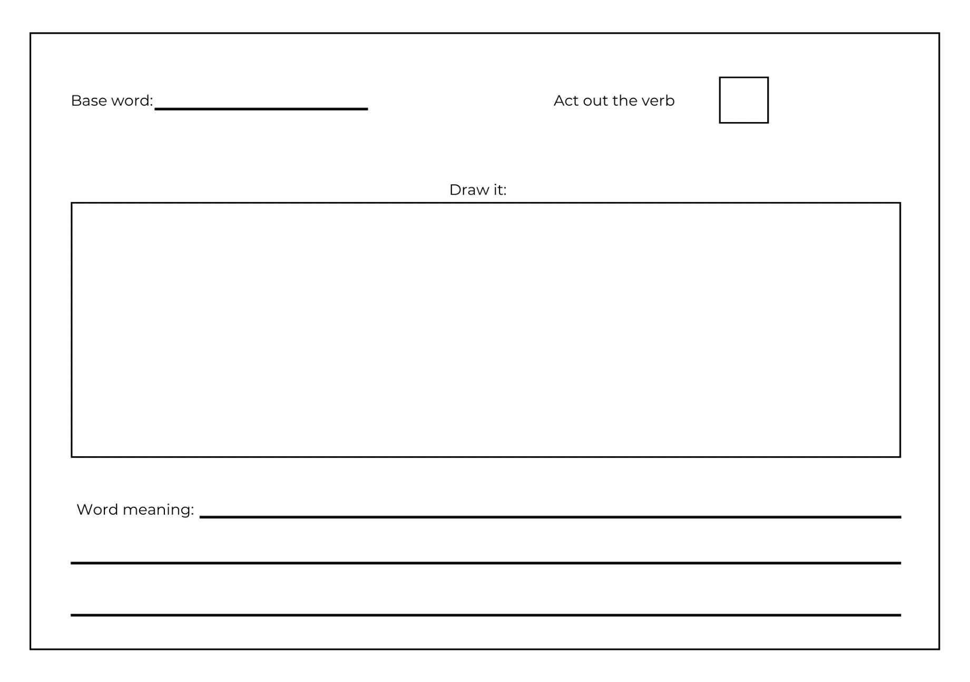

Resource 3: Morphology chart teacher model
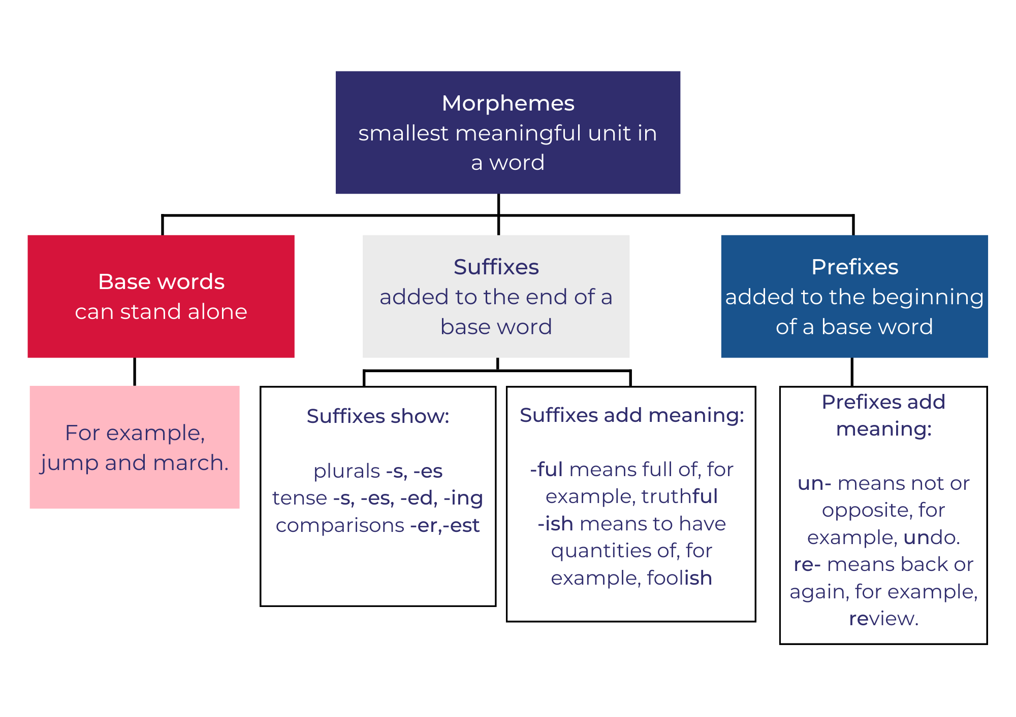

Resource 4: Planning scaffold
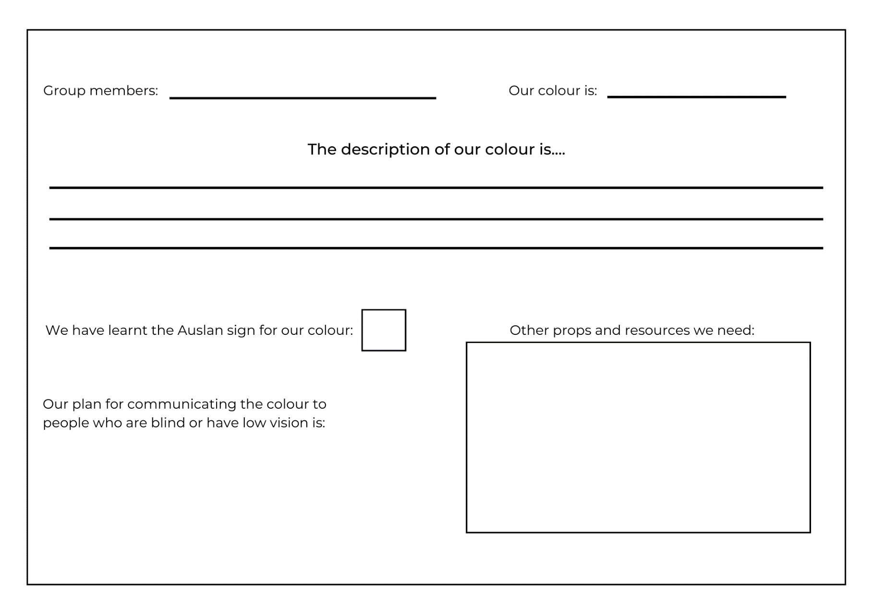

Resource 5: Storyboard
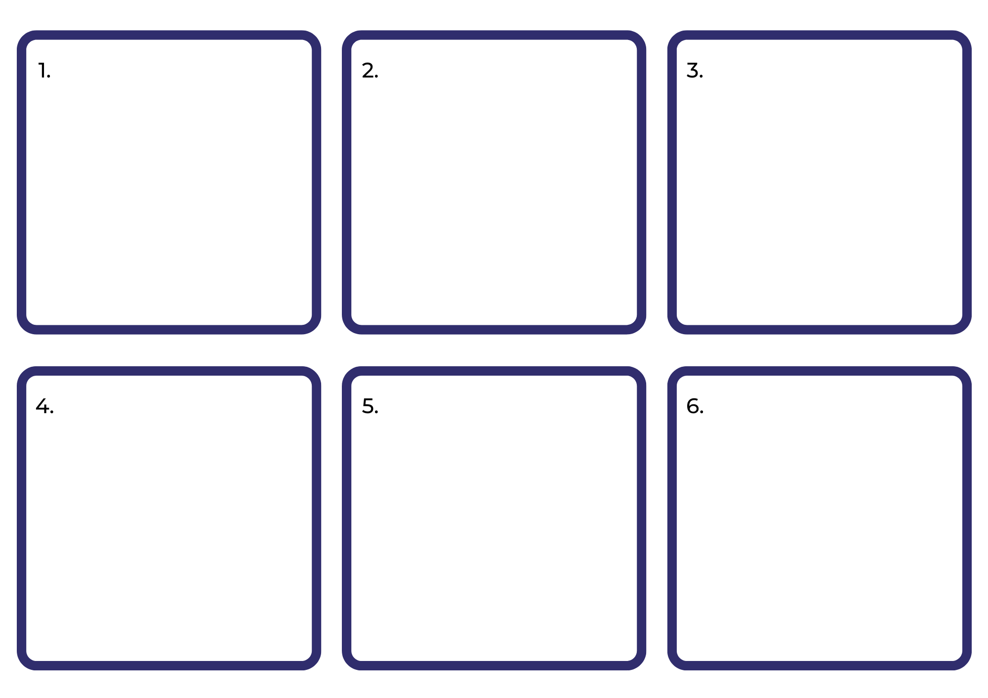

References
Links to third-party material and websites
Please note that the provided (reading/viewing material/list/links/texts) are a suggestion only and implies no endorsement, by the New South Wales Department of Education, of any author, publisher, or book title. School principals and teachers are best placed to assess the suitability of resources that would complement the curriculum and reflect the needs and interests of their students.
If you use the links provided in this document to access a third-party's website, you acknowledge that the terms of use, including licence terms set out on the third-party's website apply to the use which may be made of the materials on that third-party website or where permitted by the Copyright Act 1968 (Cth). The department accepts no responsibility for content on third-party websites.
Except as otherwise noted, all material is © State of New South Wales (Department of Education), 2023 and licensed under the Creative Commons Attribution 4.0 International License. All other material (third-party material) is used with permission or under licence. Where the copyright owner of third-party material has not licensed their material under a Creative Commons or similar licence, you should contact them directly for permission to reuse their material.
English K–10 Syllabus © 2022 NSW Education Standards Authority (NESA) for and on behalf of the Crown in right of the State of New South Wales.
Creative Arts K–6 Syllabus © 2006 NSW Education Standards Authority (NESA) for and on behalf of the Crown in right of the State of New South Wales.
© 2022 NSW Education Standards Authority. This document contains NSW Curriculum and syllabus content. The NSW Curriculum is developed by the NSW Education Standards Authority. This content is prepared by NESA for and on behalf of the Crown in right of the State of New South Wales. The material is protected by Crown copyright.
Please refer to the NESA Copyright Disclaimer for more information.
NESA holds the only official and up-to-date versions of the NSW Curriculum and syllabus documents. Please visit the NSW Education Standards Authority (NESA) website and the NSW Curriculum website.
National Literacy Learning Progression © Australian Curriculum, Assessment and Reporting Authority (ACARA) 2010 to present, unless otherwise indicated. This material was downloaded from the Australian Curriculum website (National Literacy Learning Progression) (accessed 25 January 2023) and was not modified. The material is licensed under CC BY 4.0. Version updates are tracked in the ‘Curriculum version history’ section on the 'About the Australian Curriculum' page of the Australian Curriculum website.
ACARA does not endorse any product that uses the Australian Curriculum or make any representations as to the quality of such products. Any product that uses material published on this website should not be taken to be affiliated with ACARA or have the sponsorship or approval of ACARA. It is up to each person to make their own assessment of the product, taking into account matters including, but not limited to, the version number and the degree to which the materials align with the content descriptions and achievement standards (where relevant). Where there is a claim of alignment, it is important to check that the materials align with the content descriptions and achievement standards (endorsed by all education Ministers), not the elaborations (examples provided by ACARA).
Auslan Signbank (n.d.) Dictionary, Auslan Signbank website, accessed 25 January 2023.
Cottin M (2010) The Black Book of Colours (Faria R, illus.), Walker Books Australia, Newtown.
Cummings P (2022) Boy (Devries S, illus.), Scholastic Australia Pty Ltd.
Deaf Australia Inc. (2022) Deaf Australia [website], accessed 25 January 2023.
ETA (English Teachers Association) and NSW Department of Education (2016) Context, English Textual Concepts website, accessed 25 January 2023.
ETA (English Teachers Association) and NSW Department of Education (2016) The Textual Concepts and Processes resource, English Textual Concepts website, accessed 25 January 2023.
Pierce R (2022) Braille Translator, Maths is Fun website, accessed 25 January 2023.
Pierce R (2022) Braille, Maths is Fun website, accessed 25 January 2023.
The Council of the City of Sydney (2022) City of Sydney Library: Auslan and English storytime online, City of Sydney website, accessed 25 January 2023.

