English – Stage 1 – Unit 12
Contents
Unit overview and instructions for use 4
Teacher notes 5
Outcomes and content – Component A 6
Outcomes and content – Component B 8
Week 1 12
Component A teaching and learning 12
Component B teaching and learning 13
Lesson 1: Text orientation – Pearl Barley and Charlie Parsley 14
Lesson 2: Representation of characters 15
Lesson 3: Complex sentences 17
Lesson 4: Subject-verb agreement 20
Lesson 5: Sentence structure and verb groups 21
Week 2 23
Component A teaching and learning 23
Component B teaching and learning 24
Lesson 6: Reader’s theatre 25
Lesson 7: Representing character 26
Lesson 8: Planning and composing a class text 28
Lesson 9: Composing and editing a class text 30
Lesson 10: Presenting a class text 31
Resource 1: Word cards 33
Resource 2: Sentence frame 34
Resource 3: Peace and Quiet – Ha! 35
Resource 4: Narrative mountain 39
Resource 5: Y-chart 40
Resource 6: Venn diagram example 41
Resource 7: Venn diagram 42
Resource 8: Text example 43
Resource 9: Writing template 44
References 45

Unit overview and instructions for use
This two-week unit is comprised of Component A and Component B. Connecting learning across both components is encouraged.
Teaching and learning | Component A | Component B
Suggested duration | 60 minutes | 45 minutes
Explicit teaching focus areas | - Phonic knowledge  - Reading fluency  - Reading comprehension  - Spelling  - Handwriting | - Oral language and communication  - Vocabulary  - Reading comprehension  - Creating written texts  - Understanding and responding to literature
To prepare for teaching and learning: | - Refer to Outcomes and content – Component A, K-2 – Instructional sequence – grapheme–phoneme correspondences [PDF 825 KB], and the teaching advice documents (hyperlinked in Component A teaching and learning table).  - Based on student needs identified through ongoing assessment data, plan and document how you will sequence teaching and learning in whole class and targeted teaching groups across the two-week cycle. | - Familiarise yourself with Outcomes and content – Component B, Textual concepts information and videos, English Textual Concepts and Learning Processes (2016), and the teaching and learning sequence.  - Based on student needs identified through ongoing assessment data, determine how you will support students in whole class and targeted teaching groups across the two-week cycle as required.
English K–10 Syllabus © 2022 NSW Education Standards Authority (NESA) for and on behalf of the Crown in right of the State of New South Wales.

Teacher notes
- Representation is defined as the depiction of a thing, person or idea in written, visual, digital, performed or spoken language and conventions. – English Textual Concepts and Learning Processes (2016).
- Understanding of representation can be supported through watching the department’s video: Representation (2:46).
- Idioms are an expression peculiar to a language that cannot be taken literally. For example, ‘at the drop of a hat’.
- Choral reading is the process of reading aloud in unison to promote fluency.
- For information on complex sentences, subordinating conjunctions, subject-verb agreement, and verb groups refer to the NESA glossary.
- This unit could enhance student learning towards achievement of outcomes from the Creative Arts syllabus regarding drama.
- Reflect on student learning and engagement in activities and record differentiation and adjustments within the unit to inform future teaching and learning. One way of doing this could be to add comments to the digital file.
- Content are points are linked to the National Literacy Learning Progression version (3).
Levels and indicators sourced from National Literacy Learning Progression © Australian Curriculum, Assessment and Reporting Authority (ACARA) (accessed 24 January 2023) and was not modified. See references for more information.

Outcomes and content – Component A
The table below outlines the focus outcomes and content. Content is linked to the National Literacy Learning Progression version (3).
Focus area and outcome | Content points and National Literacy Learning Progression
Phonic knowledge  EN1-PHOKW-01 – uses initial and extended phonics, including vowel digraphs, trigraphs to decode and encode words when reading and creating texts | - blend and decode one-syllable words with taught extended vowel graphs and digraphs, including graphemes for r-controlled vowels and diphthongs, and apply this when reading texts (PKW6, PKW7)  - segment and encode one-syllable words with taught vowel graphs, digraphs and trigraphs and apply this when creating texts  - decode words with trigraphs and quadgraphs and apply this when reading texts
Reading fluency  EN1-REFLU-01 – sustains reading unseen texts with automaticity and prosody and self-corrects errors | - read aloud with an easy speech rhythm (FlY3)  - adjust phrasing, intonation, volume or rate to maintain fluency when reading aloud (FlY4)
Reading comprehension  EN1-RECOM-01 – comprehends independently read texts that require sustained reading by activating background and word knowledge, connecting and understanding sentences and whole text, and monitoring for meaning | - use known vocabulary to build a mental model of the content of the text  - know that a complex sentence includes a clause for expressing a main message and one or more clauses that elaborate on that message  - know the meaning and purpose of coordinating and subordinating conjunctions and identify them in a complex sentence  - recognise how the position of a clause in a complex sentence influences the important idea for the reader  - identify how creative visual features are used to expand meaning  - make text-to-self, text-to-text or text-to-world connections when reading (UnT6)
Spelling  EN1-SPELL-01 – applies phonological, orthographic and morphological generalisations and strategies when spelling words in a range of writing contexts | - segment single-syllable words into phonemes as a strategy for spelling (SpG4)  - spell high-frequency base words with taught vowel graphs, digraphs, split digraphs, trigraphs and quadgraphs (SpG6)  - spell taught high-frequency contractions (SpG6)
Handwriting  EN1-HANDW-01 – uses a legible, fluent and automatic handwriting style, and digital technology, including word-processing applications, when creating texts | - form all letters with consistent size and slope in NSW Foundation Style from memory (HwK5)

Outcomes and content – Component B
The table below outlines the focus outcomes and content. Content is linked to the National Literacy Learning Progression version (3).
Focus area and outcome | Content points and National Literacy Learning Progression
Oral language and communication  EN1-OLC-01 – communicates effectively by using interpersonal conventions and language to extend and elaborate ideas for social and learning interactions | - listen to or engage with texts for enjoyment and recognise that their own experience can shape their ideas and opinions of texts  - incorporate extended sentences (simple, compound, complex) during dialogue (SpK3)  - link or compare ideas when interacting  - adapt a narrative for a particular audience
Vocabulary  EN1-VOCAB-01 – understands and effectively uses Tier 1, taught Tier 2 and Tier 3 vocabulary to extend and elaborate ideas | - use vocabulary to express cause and effect (SpK3)
Reading comprehension  EN1-RECOM-01 – comprehends independently read texts that require sustained reading by activating background and word knowledge, connecting and understanding sentences and whole text, and monitoring for meaning | - use known vocabulary to build a mental model of the content of the text  - know that a complex sentence includes a clause for expressing a main message and one or more clauses that elaborate on that message  - know the meaning and purpose of coordinating and subordinating conjunctions and identify them in a complex sentence  - recognise how the position of a clause in a complex sentence influences the important idea for the reader  - identify how creative visual features are used to expand meaning  - make text-to-self, text-to-text or text-to-world connections when reading (UnT6)
Creating written texts  EN1-CWT-01 – plans, creates and revises texts written for different purposes, including paragraphs, using knowledge of vocabulary, text features and sentence structure | - write texts that describe, explain, give an opinion, recount an event, tell a story (CrT7)  - use visual elements to expand meaning in own texts  - use subject–verb agreement across a text (GrA5)  - use a combination of simple and compound sentences to engage the reader when creating written texts (CrT6, GrA4)  - experiment with writing complex sentences which include a clause for the main message and dependent clause to elaborate or modify the message (GrA5)  - use action, saying, relating and sensing verbs to add detail and precision to writing (GrA2, GrA5)  - use commas to separate ideas, lists and/or dependent clauses in a sentence (PuN4, PuN6)  - use a variety of planning strategies and tools for creating texts  - identify the context, audience and purpose for own texts (CrT5, CrT6)  - use different modes and media to enhance the presentation of texts they have created (CrT5, CrT6)
Understanding and responding to literature  EN1-UARL-01 – understands and responds to literature by creating texts using similar structures, intentional language choices and features appropriate to audience and purpose | - express personal responses to the real and imagined worlds that are represented in texts  - adapt a well-known text for a different audience and/or purpose  - identify how characters can invite positive and negative responses

Week 1

Component A teaching and learning
The table below can be used to plan and document lessons that address Component A outcomes and content. Both the detailed example [DOC 529KB] of a two-week teaching and learning cycle and brief example [DOC 66KB] may support you in your planning.
Focus Areas | Lesson 1 | Lesson 2 | Lesson 3 | Lesson 4 | Lesson 5
Phonic knowledge
15 minutes
Spelling and Handwriting
15 minutes
Reading comprehension and Reading fluency
30 minutes

Component B teaching and learning
The following teaching and learning sequence has been designed to address Component B outcomes and content. Adapt the sequence as required to best meet the needs of your students.

Learning intention and success criteria
Learning intentions and success criteria are best co-constructed with students.

Learning intention
Students are learning to identify how authors use intentional language choices and illustrations to represent characters and ideas.

Success criteria
Students can:
- share text-to-self connections
- identify how characters have been represented using illustrations and text
- maintain fluency when reading aloud
- write complex sentences using subordinating conjunctions
- identify and use subject-verb agreement
- identify and use verbs and verb groups.

Resources
- Blabey A (2009) Pearl Barley and Charlie Parsley, Penguin Australia Pty Ltd. ISBN: 9780143503071
- Resource 1: Word cards
- Resource 2: Sentence frame
- Individual whiteboards
- Sticky notes

Lesson 1: Text orientation – Pearl Barley and Charlie Parsley
- Introduce Pearl Barley and Charlie Parsley. Encourage students to make predictions about the text using the front and back covers, title, and illustrations. Focus students’ attention on the body language between the 2 characters. Read the blurb. Provide time for students to share their ideas.
- Using the Think-Pair-Share strategy, ask students what friendship means to them. Encourage them to think about who their friends are, why they are friends, and what makes a good friend. Brainstorm and record different types of friendships. For example, school, sport, music group, and/or family friendships. Highlight that Pearl Barley and Charlie Parsley represent one type of friendship and there are many other types of friendships.
- Read Pearl Barley and Charlie Parsley. Discuss the purpose and intended audience of the text. Identify new vocabulary and model how to re-read new words or phrases to check and clarify meaning. For example, discuss the use of idioms such as ‘warm as toast’, ‘getting to the bottom of things’, and ‘dances up a storm’.
- Identify the use of ellipses in the text. Explain that an ellipsis is a punctuation mark consisting of 3 dots. It indicates that words have been left out, but the text still makes sense to the reader. Display a page from the text with an ellipsis. Write a comma on a small sticky note and place it over the ellipsis. Re-read the sentence using a comma for punctuation. Explain that, in this text, a comma can be used instead of an ellipsis to create a complex sentence. For example, ‘While Pearl Barley likes to run amok, Charlie Parsley likes to sit and think.’
- Ask students what they wonder after hearing the story. Model writing an ‘I wonder’ statement. For example, ‘I wonder how Pearl Barley and Charlie Parsley met.’ On individual whiteboards or sticky notes, students record their own ‘I wonder’ statements to share with the class.
- Ask students what they think the theme of the book is and why. Discuss how the author has used illustrations and text to represent the theme of friendship. Provide opportunities for oral language development through text-to-self connections. Support students to compare their own relationships with the friendship represented in the book.

Lesson 2: Representation of characters
- Revise the concept of representation. Explore that there may be different representations of the same objects, events, people, emotions, and ideas.
- Re-read Pearl Barley and Charlie Parsley.
- Ask students to consider how the illustrations help the audience develop a deeper understanding of the relationship between the characters. Display the pages that end with ‘she dances up a storm’ and ‘different in almost every way’. Discuss how the characters close friendship is represented in the illustrations. For example, ‘Pearl Barley and Charlie Parsley are holding hands, this shows how strong their friendship is. When they are not holding hands, the string represents their connection.’
- Identify and discuss how the author used colour to represent the character’s feelings. For example, grayscale represents when the characters feel scared or tired, warm colours show when they feel happy and supported.
- Ask:
- What kind of person is Pearl Barley? What kind of person is Charlie Parsley? How do you know?
- How are they different? How are they the same?
- How has colour been used to represent characters’ emotions?
- How do the illustrations represent friendship?
- How does the representation of the characters invite a positive or negative response from the audience?
- Ask students to think about words or phrases that describe the characters from the text. For example, Pearl Barley is fearless, Charlie Parsley is shy, both characters are kind and caring. Provide students with a sticky note to record their own words or phrases about the characters. Display a large Venn diagram with the headings ‘Pearl Barley’ and ‘Charlie Parsley’. Students consider whether their sticky note represents a similarity or difference and place their idea on the correct part of the Venn diagram.
- Using their own Venn diagram, students draw and write the similarities and differences between Pearl Barley and Charlie Parsley.
- Students Think-Pair-Share who their favourite character is and why. Provide opportunities for oral language development through text-to-self connections. Support students to compare their personality traits to the characters in the book.
Stage 1 Assessment task 1 – Observations and work samples from this lesson allow students to demonstrate achievement towards the following syllabus outcomes and content points
EN1-RECOM-01 – comprehends independently read texts that require sustained reading by activating background and word knowledge, connecting and understanding sentences and whole text, and monitoring for meaning
- identify how creative visual features are used to expand meaning
- make text-to-self, text-to-text or text-to-world connections when reading.
EN1-UARL-01 – understands and responds to literature by creating texts using similar structures, intentional language choices and features appropriate to audience and purpose
- express personal responses to the real and imagined worlds that are represented in texts
- identify how characters can invite positive and negative responses.

Lesson 3: Complex sentences
- Introduce the term ‘choral reading’. Explain that reading a text aloud can improve reading fluency (automaticity and prosody). Tell students that they will participate in choral reading using the text, Pearl Barley and Charlie Parsley.
Note: A dependent clause (also known as subordinate clause) is a group of words that cannot stand alone as a sentence. For example, ‘While I was waiting for you…’. An independent clause (also known as main or principal clause) is a clause that can stand alone as a complete sentence. For example, ‘You were skipping.’
- Revise complex sentences and subordinating conjunctions. Explicitly teach that a complex sentence is formed by adding one or more dependent (subordinate) clauses to a main (independent) clause using a subordinating conjunction. Explain that commas can be used to separate dependent and independent clauses in complex sentences.
- Display the complex sentence, ‘While Pearl Barley likes to run amok… Charlie Parsley likes to sit and think’. Replace the ellipsis with a comma and explain that it is a complex sentence. Identify the dependent and independent clauses in the sentence. For example, ‘While Pearl Barley likes to run amok’ is a dependent clause, and ‘Charlie Parsley likes to sit and think’ is an independent clause. Identify the subordinating conjunction, ‘while’.
- Display other complex sentences from the book. As a class, replace the ellipsis with a comma, and identify the subordinating conjunction, dependent and independent clauses. Record and display each complex sentence.
- Divide the class into 2 groups. One group will be Pearl Barley and the other will be Charlie Parsley. Display the deconstructed sentences from activities 4 and 5. Students read their character’s lines as a group. For example, Group 1 will say, ‘When Pearl Barley forgets her mittens on cold winter days…’ Group 2 will say, ‘Charlie Parsley holds her hands and makes them warm as toast’. Encourage students to experiment with phrasing, intonation, and volume when reading aloud.
- Explain that ‘while’ and ‘when’ are subordinating conjunctions and are used in the text to create 2 different types of sentences. The use of ‘while’ highlights the differences between the characters. For example, ‘While Pearl Barley is very loud, Charlie Parsley is very quiet.’ The use of ‘when’ highlights cause and effect. For example, ‘When Pearl Barley gets tired from running amok, Charlie Parsley tucks her into bed.’
- Discuss how subordinating conjunctions have been used at the beginning of the sentence and a comma has been used to separate the clauses. Experiment moving the subordinating conjunctions ‘while’ and ‘when’ to the middle of the sentence. For example, ‘Pearl Barley likes to talk, while Charlie Parsley is very shy’; ‘Charlie Parsley feels scared of scary things, when Pearl Barley makes him feel brave.’ Ask students if the sentences still make sense and if the meaning has changed. Highlight how ‘while’ can be used at the beginning or middle of the sentence and the meaning does not change.
- Explicitly teach that the position of a clause in a complex sentence influences the important idea for the reader. Change the position of clauses in a variety of modelled complex sentences to highlight how the most important idea can change based on clause position. Within the first part of the book, the first clause in each sentence highlights Pearl Barley’s characteristics and the second clause describes Charlie Parsley’s. Identify and discuss the changes in order that occur throughout the text and how this influences the reader. Invite students to identify the important ideas in complex sentences from the text.
- Display Resource 1: Word cards. Model using the subordinating conjunctions ‘while’ and ‘when’ to orally create complex sentences and actions. For example, ‘While Leroy is running around the paddock, Frank is sleeping on the couch’; ‘When Arlo feels cold and sad, Atlas tucks him into bed.’
- Provide students with Resource 1: Word cards. In pairs, students use the subordinating conjunctions ‘while’ and ‘when’ to orally brainstorm sentences and actions. For example, ‘While Amit is jumping up and down on the spot, Chen is lying on the floor.’ Provide time for students to share and perform their ideas.
- Students write complex sentences using the subordinating conjunctions ‘while’ and ‘when’.
Too hard? Co-construct complex sentences using the subordinating conjunctions ‘while’ and ‘when’.
Too easy? Students experiment using idioms in one or both sentence clauses.
Stage 1 Assessment task 2 – Observations and work samples from this lesson allow students to demonstrate achievement towards the following syllabus outcomes and content points
EN1-VOCAB-01 – understands and effectively uses Tier 1, taught Tier 2 and Tier 3 vocabulary to extend and elaborate ideas
- use vocabulary to express cause and effect.
EN1-RECOM-01 – comprehends independently read texts that require sustained reading by activating background and word knowledge, connecting and understanding sentences and whole text, and monitoring for meaning
- know that a complex sentence includes a clause for expressing a main message and one or more clauses that elaborate on that message
- know the meaning and purpose of coordinating and subordinating conjunctions and identify them in a complex sentence
- recognise how the position of a clause in a complex sentence influences the important idea for the reader.
EN1-CWT-01 – plans, creates and revises texts written for different purposes, including paragraphs, using knowledge of vocabulary, text features and sentence structure
- use commas to separate ideas, lists and/or dependent clauses in a sentence.

Lesson 4: Subject-verb agreement
- Discuss prior learning about verbs. Identify verbs from Pearl Barley and Charlie Parsley that help the audience deepen understanding of each character. For example, ‘solve mysteries’ and ‘dances up a storm’ describe Pearl Barley, whilst ‘be safe and sound’ and ‘sit and think’ describe Charlie Parsley. Ask students to close their eyes and think about how these verb groups create different images in their mind.
- Create a T-chart with the headings ‘action verbs’ and ‘sensing verbs’. Explain that action verbs show what characters do, and sensing verbs show what they think and feel.
- Re-read Pearl Barley and Charlie Parsley. While reading, identify action and sensing verbs from the text and record on the T-chart.
- Identify how subject-verb agreement has been used throughout the book. Draw attention to single subject and single verbs used in the text. For example, ‘she is’, ‘Charlie is’. Identify plural subject and plural verbs used in the text. For example, ‘they are’. Explain that subject-verb agreement must be considered when referring to an individual or a group.
- Revise complex sentences, subordinating conjunctions ‘while’ and ‘when’, and commas from Lesson 3.
- Explain that students will write complex sentences about their class and teacher using correct subject-verb agreement and subordinating conjunctions.
- Model writing a complex sentence about the class and teacher using correct subject-verb agreement. For example, ‘While Year 1 are running around at lunch, Mrs Bashar is marking work’; ‘While Mr Osaka is preparing lessons, Year 1 are getting ready for school.’ Explain that a plural subject and plural verb need to be used for ‘Year 1’ because they are a group. Explain how the subordinating conjunction ‘while’ highlights the contrast between what characters are doing.
- Students write complex sentences using subordinating conjunctions and subject-verb agreement about the teacher and class.
Too hard? Students draw their ideas and orally co-construct a sentence using the subordinating conjunction ‘while’ or ‘when’.
Too easy? Students write a paragraph using subordinating conjunctions and subject-verb agreement.

Lesson 5: Sentence structure and verb groups
- Revise complex sentences and subordinating conjunctions from Lesson 3, and subject-verb agreement from Lesson 4.
Note: A verb group is a group of words built around a verb. Verb groups may include auxiliary verbs (‘helping’ verbs used to indicate tense or modality), can contain 2 or more verbs, may include other words such as adverbs and prepositions, and are sometimes referred to as a complex verb or compound verb.
- Introduce the term ‘verb group’. Explain that a verb group is a group of words built around a verb.
- Re-read Pearl Barley and Charlie Parsley. Draw attention to how verb groups have been used in the text. For example, ‘When Charlie Parsley feels scared of scary things’ and ‘When Pearl Barley gets tired from running amok’. Explain that ‘of scary things’ and ‘from running amok’ provide more information about the verbs.
- Using the Think-Pair-Share strategy, students verbally experiment with verbs and verb groups about the teacher or class.
- Display Resource 2: Sentence frame. Revise the terms subordinating conjunction, subject, verb, and punctuation.
- Model using Resource 2: Sentence frame to sort the sentence, ‘While Pearl Barley likes to run amok, Charlie Parsley likes to sit and think’. Explain that ‘likes to run amok’ and ‘likes to sit and think’ are verb groups. Revise how verb groups include more information about the verb.
- Provide students with other sentences from the text. Using Resource 2: Sentence frame, students sort parts of the sentences. Students sort and write their sentences from the previous lesson/s into the sentence frame.
Too hard? Students sort sentences into ‘subject’ and ‘verb group’. For example, ‘Charlie Parsley (subject) likes to sit and think (verb group).’
Too easy? Students write their own sentences and label the parts of the sentence using the terms ‘subordinating conjunction’, ‘subject’, ‘verb’ and ‘punctuation’.

Week 2

Component A teaching and learning
The table below can be used to plan and document lessons that address Component A outcomes and content. Both the detailed example [DOC 529KB] of a two-week teaching and learning cycle and brief example [DOC 66KB] may support you in your planning.
Focus Areas | Lesson 6 | Lesson 7 | Lesson 8 | Lesson 9 | Lesson 10
Phonic knowledge
15 minutes
Spelling and Handwriting
15 minutes
Reading comprehension and Reading fluency
30 minutes

Component B teaching and learning
The following teaching and learning sequence has been designed to address Component B outcomes and content. Adapt the sequence as required to best meet the needs of your students.

Learning intention and success criteria
Learning intentions and success criteria are best co-constructed with students.

Learning intention
Students are learning to identify how authors use intentional language choices and illustrations to represent characters and ideas.

Success criteria
Students can:
- maintain fluency when reading aloud
- represent characters and themselves using illustrations and text
- adapt a well-known text for a different audience
- write complex sentences using subordinating conjunctions, subject-verb agreement and verb groups
- use simple, compound, and complex sentences during dialogue.

Resources
- Blabey A (2009) Pearl Barley and Charlie Parsley, Penguin Australia Pty Ltd. ISBN: 9780143503071
- Resource 3: Peace and Quiet – Ha!
- Resource 4: Narrative mountain
- Resource 5: Y-chart (enlarged copy and copies for each student)
- Resource 6: Venn diagram example
- Resource 7: Venn diagram
- Resource 8: Text example
- Resource 9: Writing template
- A4 paper

Lesson 6: Reader’s theatre
- Introduce Resource 3: Peace and Quiet – Ha!. Using the layout and illustrations, guide students to make predictions about what type of text it is, including its purpose and audience.
- Unpack the structure of the reader’s theatre, including the use of new line indicating a different character speaking. Explain that the term narrator refers to the storyteller and not a character within the narrative. Explain and model how a reader’s theatre should be read aloud, highlighting the importance of using appropriate expression and fluency. Note the use of exclamation marks to show where heightened expression is required.
- In small groups, provide students with Resource 3: Peace and Quiet – Ha! and assign each group a character from the text. Groups read their character’s lines and discuss how the character has been represented in the text.
- Ask students how they are similar or different to the characters. Discuss how the characters invite positive or negative responses.
- Using the Think-Pair-Share strategy, students imagine they are a character in the text and discuss how they would be represented. Encourage students to think about physical characteristics, personality traits and family dynamics.
- Read Peace and Quiet – Ha! with groups engaging in choral reading using their character’s lines. Encourage students to experiment with phrasing, intonation, and volume when reading aloud.
- Discuss the structure of the text. Ask students to sequence the key events. Ask students if they felt differently about their character at the beginning compared to the end of the text.
- Model the use of Resource 4: Narrative mountain. Draw the key events in the story and a write complex sentence to summarise each event. For example, ‘While Alice and Ted set up their picnic, kookaburras are watching.’ When drawing each event, consider colours that reflect the character’s feelings.
- Students use Resource 4: Narrative mountain to draw pictures representing each key event, then write complex sentences to summarise each. Encourage students to use colours that reflect how the main characters are feeling.
Too hard? Students label their drawings with simple sentences or key words.
Too easy? Students edit their writing to include more complex vocabulary and punctuation.

Lesson 7: Representing character
- Revisit Resource 3: Peace and Quiet – Ha!. Discuss the characters and how they are represented in the text. For example, the animals were all hungry and appeared to be forceful about eating the food. Identify the verbs and discuss verb groups from the text including ‘swoops in and snaps up Ali’s sandwich’, ‘snatch up the hot chips’, and ‘eat up all the food’. Discuss vocabulary in the text and model how to re-read words or phrases to check and clarify meaning. For example, ‘squawking’ and ‘squabbling’.
- Display enlarged Resource 5: Y-chart with the character ‘Ted’ written at the top.
- Discuss Ted’s qualities including what he looks like, sounds like, and acts like in the text. Take turns with students to add information to the different sections on the chart. Highlight that characters can be represented in many ways.
- In the same small groups from Lesson 6, students act out their character’s lines using expression and body language based on their understanding of the character. Encourage students to build a mental model of their character and discuss their features by what they look like, sound like, and act like. Students independently complete Resource 5: Y-chart about their character.
Too hard? Students complete Resource 5: Y-chart with a partner.
Too easy? Students complete Resource 5: Y-chart about a familiar character from a different story.
- Select students from each group to participate in a hot seat activity. Students act as a certain character from the reader’s theatre and answer questions from their peers.
- Provide opportunities for students to make text-to-self and text-to-world connections and discuss whether they enjoyed the texts. Prompt students to consider how their own experiences can shape their ideas and opinions of texts.
Stage 1 Assessment task 3 – Observations from this lesson allow students to demonstrate achievement towards the following syllabus outcomes and content points:
EN1-OLC-01 – communicates effectively by using interpersonal conventions and language to extend and elaborate ideas for social and learning interactions
- listen to or engage with texts for enjoyment and recognise that their own experience can shape their ideas and opinions of texts
- incorporate extended sentences (simple, compound, complex) during dialogue
- link or compare ideas when interacting.
EN1-RECOM-01 – comprehends independently read texts that require sustained reading by activating background and word knowledge, connecting and understanding sentences and whole text, and monitoring for meaning
- use known vocabulary to build a mental model of the content of the text.

Lesson 8: Planning and composing a class text
- Re-read Pearl Barley and Charlie Parsley. Draw attention to:
- the structure and layout of the text
- use of colour to expand meaning
- complex sentences
- subordinating conjunctions
- verbs and verb groups.
- Explain that students will adapt Pearl Barley and Charlie Parsley and write a short text to create a class book that represents friendship. Identify the purpose and audience for students’ writing. For example, to promote friendship with other classes in the school. In pairs, students publish their work over 3 pages, following the layout of the mentor text. For example:
- Page 1: ‘while’ or ‘when’ clause describing the first student ending in a comma
- Page 2: second clause about the second student
- Page 3: additional simple, compound or complex sentences about both students describing how they are great friends.
- Discuss strengths and qualities of students in the class and list these on a poster. For example, drawing, playing sport, dancing, singing, being kind, caring, thoughtful, and respectful.
- Display Resource 6: Venn diagram example. Discuss how words listed in the poster have been used to highlight the similarities and differences of the 2 students. In pairs, students identify their own strengths and qualities that are similar and different. Students record their ideas using Resource 7: Venn diagram.
- Display Resource 8: Text example to model the process of writing an exemplar text for the class book. Co-construct success criteria for students to refer to in Lesson 9. For example:
- write at least one complex sentence using the subordinating conjunction ‘while’ to highlight student differences
- write at least one complex sentence using the subordinating conjunction ‘when’ to highlight how students help each other
- use commas to separate key ideas
- include simple, compound, and complex sentences
- use subject-verb agreement
- use verbs and verb groups
- include colour and illustrations to represent friendships.
- Provide students with an opportunity to review their completed Resource 7: Venn diagram.
- Display Resource 9: Writing template. Explain that students will plan the first 2 pages of their text. Students will plan and create a third page in Lesson 9.
- Provide students with Resource 9: Writing template. Students write a complex sentence using the subordinating conjunction ‘while’ to highlight their differences.
Too easy? Students elaborate on their writing by adding idioms and adverbs to enhance their work.

Lesson 9: Composing and editing a class text
- Revise the purpose and audience for students’ writing. Co-construct a title page and blurb for the class book. For example, ‘There are 22 students in Year 1 and they all get along. Even though everyone is very different, they are great friends.’
- Display Resource 8: Text example, and the co-constructed success criteria from Lesson 8. Explain that students will write their third page for the class book, describing their friendship in more detail.
- In pairs, students use their completed Resource 7: Venn diagram and Resource 9: Writing template to write a short paragraph for the class book. Encourage students to refer to the success criteria.
- In pairs, students provide peer feedback to another group using the co-constructed success criteria.
- Provide time for students to apply feedback to their writing.
Stage 1 Assessment task 4 – Observations and work samples from this lesson allow students to demonstrate achievement towards the following syllabus outcomes and content points:
EN1-OLC-01 – communicates effectively by using interpersonal conventions and language to extend and elaborate ideas for social and learning interactions
- adapt a narrative for a particular audience.
EN1-CWT-01 – plans, creates and revises texts written for different purposes, including paragraphs, using knowledge of vocabulary, text features and sentence structure
- write texts that describe, explain, give an opinion, recount an event, tell a story
- use action, saying, relating, and sensing verbs to add detail and precision to writing
- use a combination of simple and compound sentences to engage the reader when creating written texts
- experiment with writing complex sentences which include a clause for the main message and dependent clause to elaborate or modify the message
- identify the context, audience and purpose for own texts
- use subject-verb agreement across a text
- use a variety of planning strategies and tools for creating texts.

Lesson 10: Presenting a class text
- Revise how authors make intentional choices about colours and images to represent their ideas and expand meaning.
- Explain that students will publish their writing for the class book and add illustrations. Encourage students to consider size, angle, and colour choice to represent the theme of friendship and convey different emotions.
- Provide time for each pair to publish and illustrate their section of the class text, then collate the published versions.
- Students participate in choral reading of the class book. Encourage students to consider how body language and facial expression can be used to represent different characters.
Optional: Produce the class text as a multimodal text or have students present it at a school assembly.
Stage 1 Assessment task 5 – Work samples from this lesson allow students to demonstrate achievement towards the following syllabus outcomes and content points:
EN1-CWT-01 – plans, creates and revises texts written for different purposes, including paragraphs, using knowledge of vocabulary, text features and sentence structure
- use visual elements to expand meaning in own texts
- use different modes and media to enhance the presentation of texts they have created.
EN1-UARL-01 – understands and responds to literature by creating texts using similar structures, intentional language choices and features appropriate to audience and purpose
- adapt a well-known text for a different audience and/or purpose.

Resource 1: Word cards
While
When

Resource 2: Sentence frame
Example:
Subordinating  conjunction | Subject | Verb group  (doings/happenings/states) | Punctuation | Subject | Verb group  (doings/happenings/states)
While | Pearl Barley | likes to run amok | , | Charlie Parsley | likes to sit and think.
Sort sentences from the text into the sentence frame.
Subordinating  conjunction | Subject | Verb group  (doings/happenings/states) | Punctuation | Subject | Verb group  (doings/happenings/states)

Resource 3: Peace and Quiet – Ha!
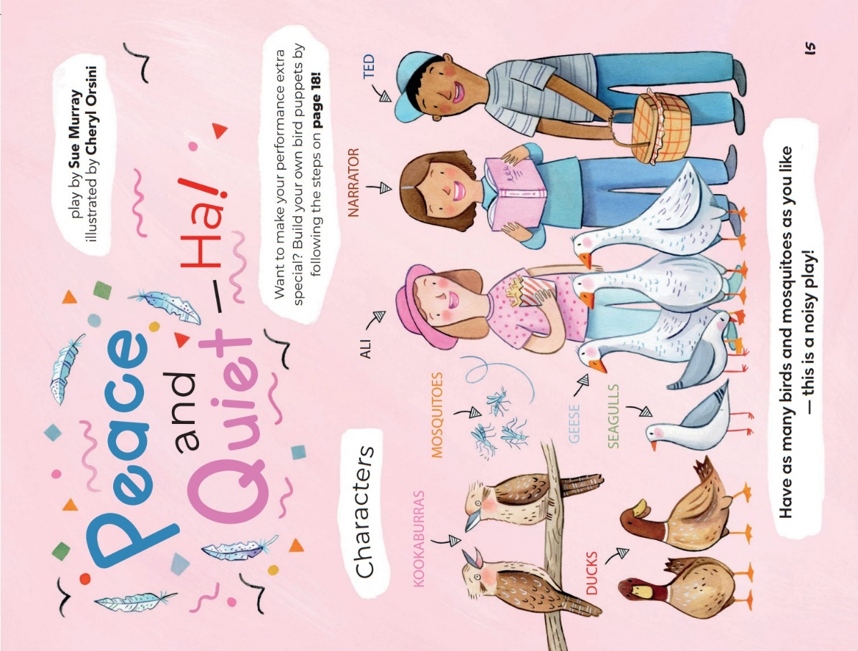
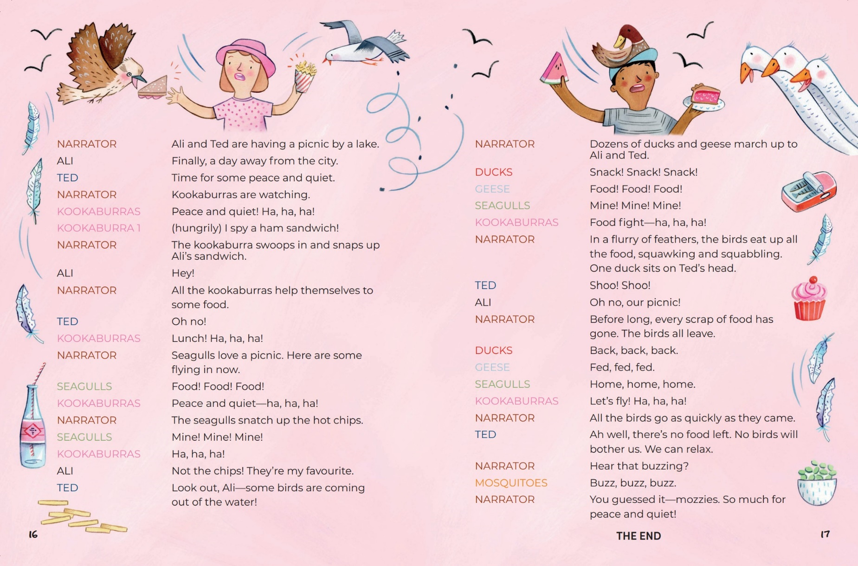
Peace and Quiet – Ha! transcript:
Narrator: Ali and Ted are having a picnic by a lake.
Ali: Finally, a day away from the city.
Ted: Time for some peace and quiet.
Narrator: Kookaburras are watching.
Kookaburras: Peace and quiet! Ha, ha, ha!
Kookaburra 1: (hungrily) I spy a ham sandwich!
Narrator: The kookaburra swoops in and snaps up Ali's sandwich.
Ali: Hey!
Narrator: All the kookaburras help themselves to some food.
Ted: Oh no!
Kookaburras: Lunch! Ha, ha, ha!
Narrator: Seagulls love a picnic. Here are some flying in now.
Seagulls: Food! Food! Food!
Kookaburras: Peace and quiet- ha, ha, ha!
Narrator: The seagulls snatch up the hot chips.
Seagulls: Mine! Mine! Mine!
Kookaburras: Ha, ha, ha!
Ali: Not the chips! They're my favourite.
Ted: Look out, Ali- some birds are coming out of the water!
Narrator: Dozens of ducks and geese march up to Ali and Ted.
Ducks: Snack! Snack! Snack!
Geese: Food! Food1 Food!
Seagulls: Mine! Mine! Mine!
Kookaburras: Food fight-ha, ha, ha! ,1
Narrator: In a flurry of feathers, the birds eat up all the food, squawking and squabbling. One duck sits on Ted's head.
Ted: Shoo! Shoo!
Ali: Oh no, our picnic!
Narrator: Before long, every scrap of food has gone. The birds all leave.
Ducks: Back, back, back.
Geese: Fed, fed, fed.
Seagulls: Home, home, home.
Kookaburras: Let's fly! Ha, ha, ha!
Narrator: All the birds go as quickly as they came.
Ted: Ah well, there's no food left. No birds will bother us. We can relax.
Narrator: Hear that buzzing?
Mosquitoes: Buzz. buzz, buzz.
Narrator: You guessed it-mozzies. So much for peace and quiet!
THE END

Resource 4: Narrative mountain
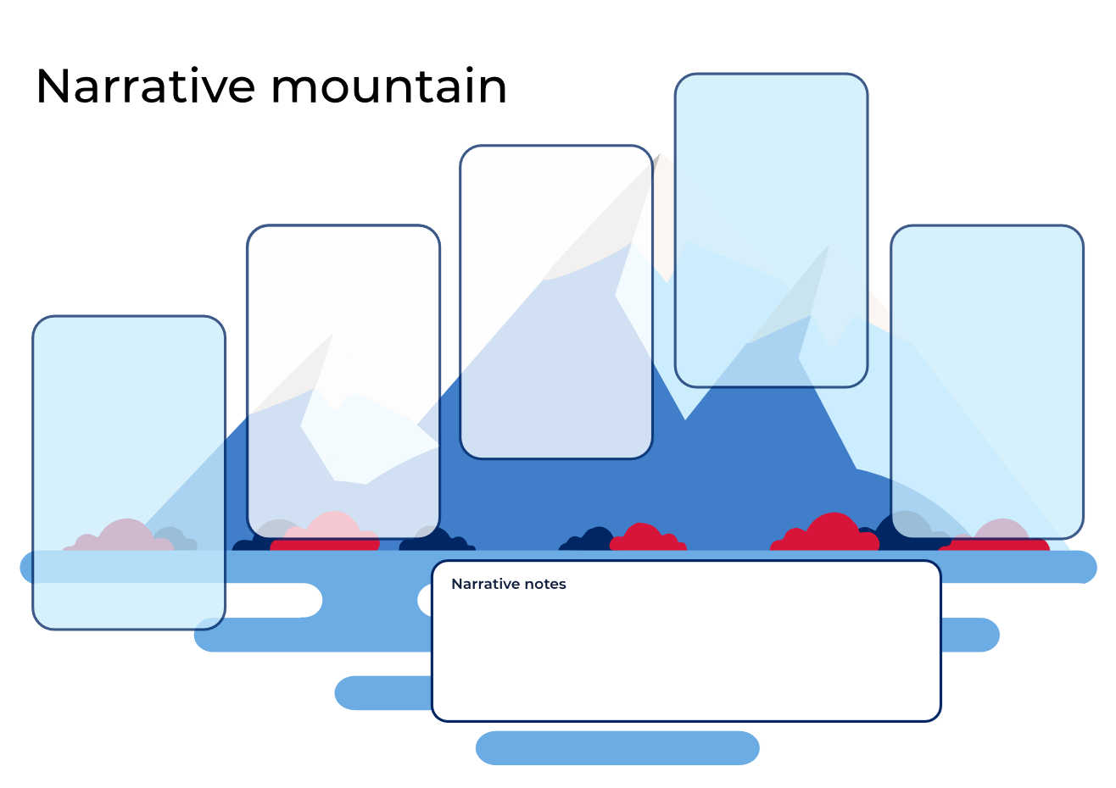

Resource 5: Y-chart
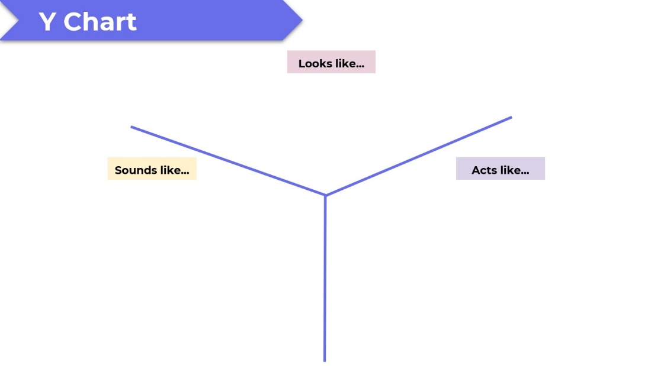

Resource 6: Venn diagram example
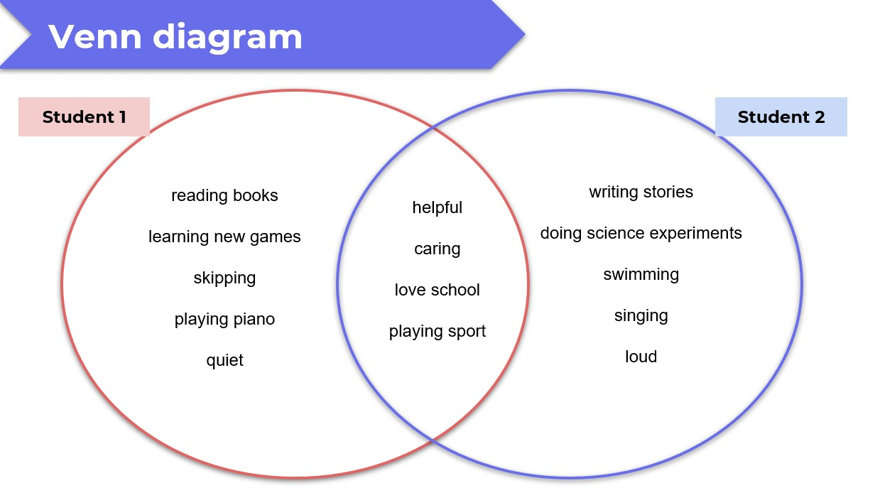

Resource 7: Venn diagram
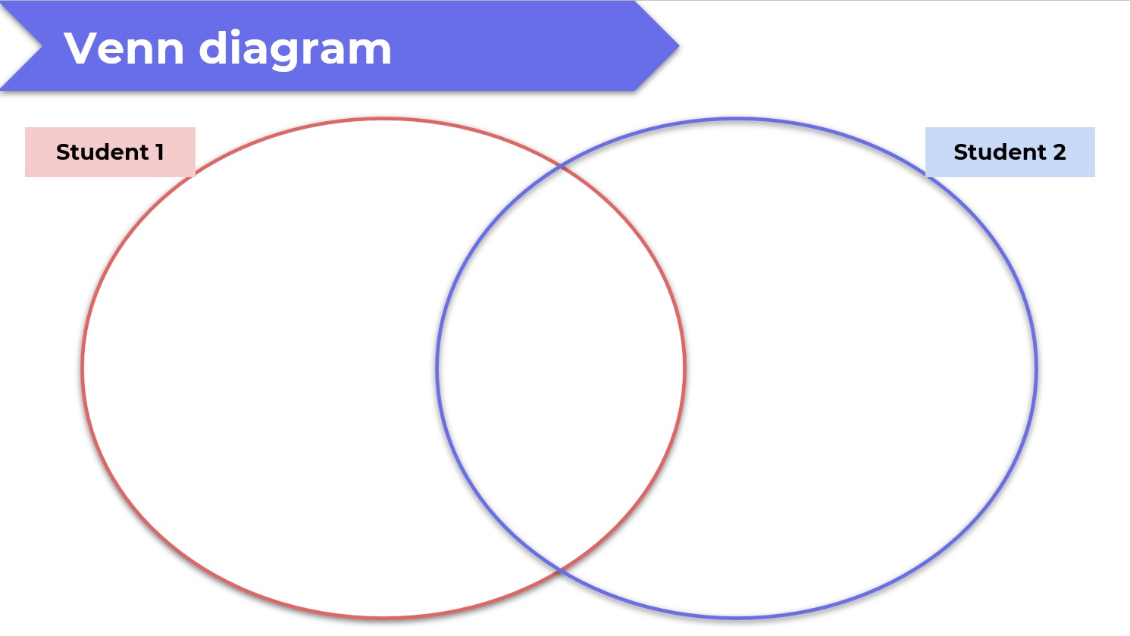

Resource 8: Text example
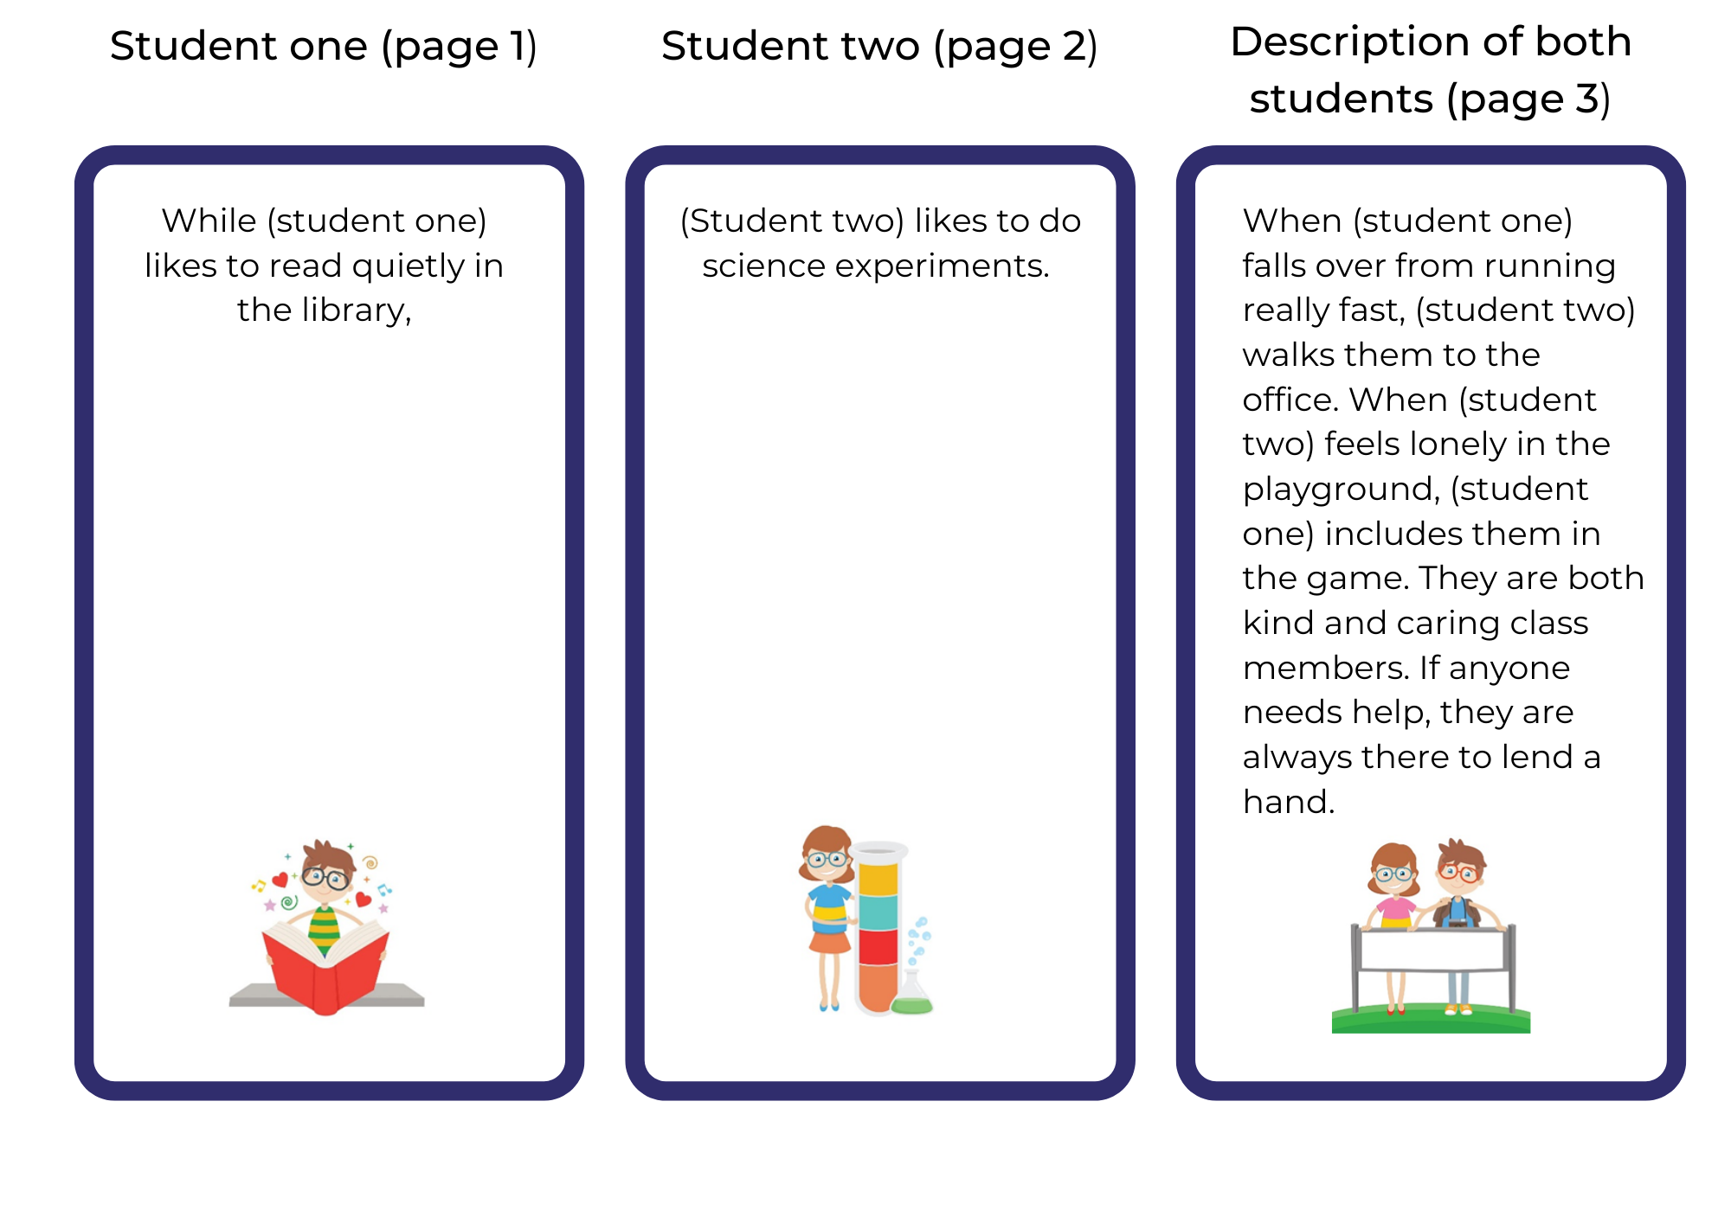
Images by Kidaha are used in accordance with the Pixabay license.

Resource 9: Writing template
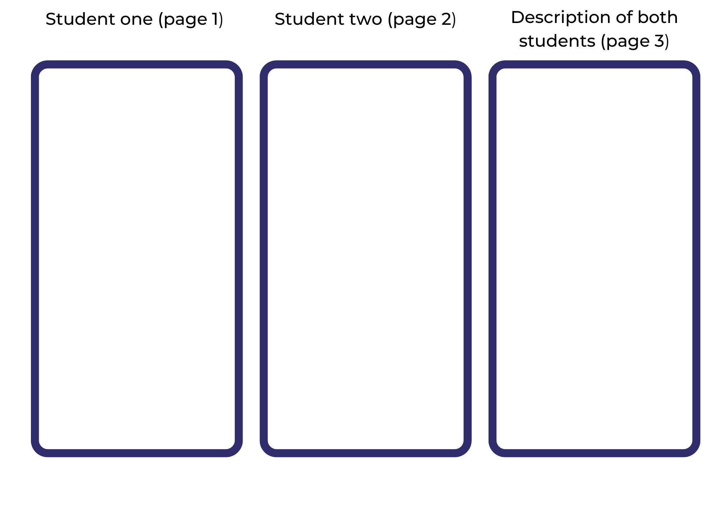

References
Links to third-party material and websites
Please note that the provided (reading/viewing material/list/links/texts) are a suggestion only and implies no endorsement, by the New South Wales Department of Education, of any author, publisher, or book title. School principals and teachers are best placed to assess the suitability of resources that would complement the curriculum and reflect the needs and interests of their students.
If you use the links provided in this document to access a third-party's website, you acknowledge that the terms of use, including licence terms set out on the third-party's website apply to the use which may be made of the materials on that third-party website or where permitted by the Copyright Act 1968 (Cth). The department accepts no responsibility for content on third-party websites.
Except as otherwise noted, all material is © State of New South Wales (Department of Education), 2023 and licensed under the Creative Commons Attribution 4.0 International License. All other material (third-party material) is used with permission or under licence. Where the copyright owner of third-party material has not licensed their material under a Creative Commons or similar licence, you should contact them directly for permission to reuse their material.
English K–10 Syllabus © 2022 NSW Education Standards Authority (NESA) for and on behalf of the Crown in right of the State of New South Wales.
Creative Arts K–6 Syllabus © 2006 NSW Education Standards Authority (NESA) for and on behalf of the Crown in right of the State of New South Wales.
© 2022 NSW Education Standards Authority. This document contains NSW Curriculum and syllabus content. The NSW Curriculum is developed by the NSW Education Standards Authority. This content is prepared by NESA for and on behalf of the Crown in right of the State of New South Wales. The material is protected by Crown copyright.
Please refer to the NESA Copyright Disclaimer for more information.
NESA holds the only official and up-to-date versions of the NSW Curriculum and syllabus documents. Please visit the NSW Education Standards Authority (NESA) website and the NSW Curriculum website.
National Literacy Learning Progression © Australian Curriculum, Assessment and Reporting Authority (ACARA) 2010 to present, unless otherwise indicated. This material was downloaded from the Australian Curriculum website (National Literacy Learning Progression) (accessed 25 January 2023) and was not modified. The material is licensed under CC BY 4.0. Version updates are tracked in the ‘Curriculum version history’ section on the 'About the Australian Curriculum' page of the Australian Curriculum website.
ACARA does not endorse any product that uses the Australian Curriculum or make any representations as to the quality of such products. Any product that uses material published on this website should not be taken to be affiliated with ACARA or have the sponsorship or approval of ACARA. It is up to each person to make their own assessment of the product, taking into account matters including, but not limited to, the version number and the degree to which the materials align with the content descriptions and achievement standards (where relevant). Where there is a claim of alignment, it is important to check that the materials align with the content descriptions and achievement standards (endorsed by all education Ministers), not the elaborations (examples provided by ACARA).
Blabey A (2009) Pearl Barley and Charlie Parsley, Penguin Australia Pty Ltd.
ETA (English Teachers Association) and NSW Department of Education (2016) Representation, English Textual Concepts website, accessed 25 January 2023.
ETA (English Teachers Association) and NSW Department of Education (2016) The Textual Concepts and Processes resource, English Textual Concepts website, accessed 25 January 2023.
Murray S and Orsini C (2022) ‘Peace and Quiet – Ha!’, The School Magazine: Launchpad (Pilot Magazine).

