English – Stage 1 – Unit 11
Contents
Unit overview and instructions for use 3
Teacher notes 4
Outcomes and content – Component A 6
Outcomes and content – Component B 8
Week 1 12
Component A teaching and learning 12
Component B teaching and learning 13
Lesson 1: Exploring argument 14
Lesson 2: Exploring perspective 17
Lesson 3: Vocabulary as a persuasive device 19
Lesson 4: Introduction to commas 21
Lesson 5: Complex sentences 23
Week 2 26
Component A teaching and learning 26
Component B teaching and learning 27
Lesson 6: Identifying arguments from different perspectives 28
Lesson 7: Paragraphs 29
Lesson 8: Using personal perspectives to write a paragraph 30
Lesson 9: Publishing writing 32
Lesson 10: Multimodal presentation and unit reflection 33
Resource 1: Persuasive poster 34
Resource 2: The 3 tiers of vocabulary 35
Resource 3: Tier 2 and Tier 3 vocabulary 36
Resource 4: Sentence strips teacher model 37
Resource 5: Sentence strips for students 38
Resource 6: Subordinating conjunctions 39
Resource 7: Exemplar paragraph 40
Resource 8: Ordering sentences in a paragraph 41
References 42

Unit overview and instructions for use
This two-week unit is comprised of Component A and Component B. Connecting learning across both components is encouraged.
Teaching and learning | Component A | Component B
Suggested duration | 60 minutes | 45 minutes
Explicit teaching focus areas | - Phonic knowledge  - Reading fluency  - Reading comprehension  - Spelling  - Handwriting | - Oral language and communication  - Vocabulary  - Reading comprehension  - Creating written texts  - Understanding and responding to literature
To prepare for teaching and learning: | - Refer to Outcomes and content – Component A, K-2 – Instructional sequence – grapheme–phoneme correspondences [PDF 825 KB], and the teaching advice documents (hyperlinked in Component A teaching and learning table).  - Based on student needs identified through ongoing assessment data, plan and document how you will sequence teaching and learning in whole class and targeted teaching groups across the two-week cycle. | - Familiarise yourself with Outcomes and content – Component B, Textual concepts information and videos, English Textual Concepts and Learning Processes (2016), and the teaching and learning sequence.  - Based on student needs identified through ongoing assessment data, determine how you will support students in whole class and targeted teaching groups across the two-week cycle as required.
English K–10 Syllabus © 2022 NSW Education Standards Authority (NESA) for and on behalf of the Crown in right of the State of New South Wales.

Teacher notes
- Perspective is defined as a lens through which we learn to see the world; it shapes what we see and the way we see it. – English Textual Concepts and Learning Processes (2016).
- Argument is persuasion using the conventions of various forms, modes, and media. Arguments can have a range of purposes including clarification of ideas, searching for truth, resolving disputes, defending a point of view or for entertainment. – English Textual Concepts and Learning Processes (2016).
- For information on argument, the 3 tiers of vocabulary, commas, compound sentences, complex sentences, independent clauses, dependent clauses, subordinating conjunctions, adjectives, adverbs, paragraphs, and multimodal texts refer to the NESA Glossary.
- The 3 tiers of vocabulary model described by Beck et al. (2013) classifies vocabulary according to complexity and use. Tier 1 words are basic level, everyday words, such as dog, baby, happy, pretty, was, come, said. While we need to teach students how to read and write these words, they rarely require instruction at school in terms of what they mean and how to use them. However, some learners will require explicit instruction in these words. Tier 2 words are general academic words that can be used across a variety of domains. They are of high utility for mature language users and are commonly used in written language, such as contradict, precede, stale, awful, snuggle. Tier 2 words add power and precision to written and spoken language. Tier 3 words are used rarely (low frequency) and only in highly specific situations. These are probably best learnt in a content area, domain, or discipline, for example: quaver, multiplication, decibel, cataclysm, atom.
- Consider students’ prior learning before introducing new grammatical terms.
- This unit could enhance student learning towards achievement of outcomes from the Creative Arts syllabus regarding drama and visual art.
- Reflect on student learning and engagement in activities and record differentiation and adjustments within the unit to inform future teaching and learning. One way of doing this could be to add comments to the digital file.
- Content points are linked to the National Literacy Learning Progression version (3).
Levels and indicators sourced from National Literacy Learning Progression © Australian Curriculum, Assessment and Reporting Authority (ACARA), (accessed 12 January 2023) and was not modified. See references for more information.

Outcomes and content – Component A
The table below outlines the focus outcomes and content. Content is linked to the National Literacy Learning Progression version (3).
Focus area and outcome | Content points and National Literacy Learning Progression
Phonic knowledge  EN1-PHOKW-01 – uses initial and extended phonics, including vowel digraphs, trigraphs to decode and encode words when reading and creating texts | - blend grapheme–phoneme correspondences to read CCVCC words, CCCVC words and CCCVCC words and apply this when reading texts (PKW7)  - segment and encode CCVCC words, CCCVC words and CCCVCC words and apply this when creating texts (SpG8)  - blend and decode one-syllable words with taught extended vowel graphs and digraphs, including graphemes for r-controlled vowels and diphthongs, and apply this when creating texts (PKW6, PKW7)
Reading fluency  EN1-REFLU-01 – sustains reading unseen texts with automaticity and prosody and self-corrects errors | - self-correct when fluency and/or meaning is interrupted  - vary pace when reading according to the audience and purpose (FIY4)
Reading comprehension  EN1-RECOM-01 – comprehends independently read texts that require sustained reading by activating background and word knowledge, connecting and understanding sentences and whole text, and monitoring for meaning | - know that a complex sentence includes a clause for expressing a main message and one or more clauses that elaborate on that message  - know the meaning and purpose of coordinating and subordinating conjunctions, and identify them in a complex sentence  - combine multiple sources of information within a text to make meaning  - coordinate information or events from different parts of the text to form an overall opinion  - use visual and/or auditory features in multimodal texts to build meaning (UnT5)  - monitor understanding to ensure meaning is sustained and expanded through the whole text (UnT6)
Spelling  EN1-SPELL-01 – applies phonological, orthographic and morphological generalisations and strategies when spelling words in a range of writing contexts | - spell taught high-frequency contractions (SpG6)  - use spelling conventions when adding plural-making suffixes (SpG9)  - use the suffixes –ful, –y and –ly to spell taught high-frequency words (SpG9)
Handwriting  EN1-HANDW-01 – uses a legible, fluent and automatic handwriting style, and digital technology, including word-processing applications, when creating texts | - use taught software functions to create texts in a range of modes for different contexts, audiences, and purposes.

Outcomes and content – Component B
The table below outlines the focus outcomes and content. Content is linked to the National Literacy Learning Progression version (3).
Focus area and outcome | Content points and National Literacy Learning Progression
Oral language and communication  EN1-OLC-01 – communicates effectively by using interpersonal conventions and language to extend and elaborate ideas for social and learning interactions | - follow extended instructions that contain connectives and conjunctions (LiS4)  - use a range of strategies for effective dialogue and manage digression from a topic (InT3, InT5)  - incorporate extended sentences (simple, compound, complex) during dialogue (SpK3)  - use adjectives and adverbs to elaborate and/or provide some supporting details or justifications and express causal relationships (SpK3)
Vocabulary  EN1-VOCAB-01 – understands and effectively uses Tier 1, taught Tier 2 and Tier 3 vocabulary to extend and elaborate ideas | - understand and intentionally choose subject-specific vocabulary to enhance precision and for effect
Reading comprehension  EN1-RECOM-01 – comprehends independently read texts that require sustained reading by activating background and word knowledge, connecting and understanding sentences and whole text, and monitoring for meaning | - know that a complex sentence includes a clause for expressing a main message and one or more clauses that elaborate on that message  - know the meaning and purpose of coordinating and subordinating conjunctions and identify them in a complex sentence  - combine multiple sources of information within a text to make meaning  - coordinate information or events from different parts of the text to form an overall opinion  - use a mental model to confirm predictions  - use visual and/or auditory features in multimodal texts to build meaning (UnT5)  - monitor understanding to ensure meaning is sustained and expanded through the whole text (UnT6)
Creating written texts  EN1-CWT-01 – plans, creates and revises texts written for different purposes, including paragraphs, using knowledge of vocabulary, text features and sentence structure | - group sentences into paragraphs commencing with a topic sentence, followed by other sentences with related ideas (CrT7)  - experiment with writing complex sentences which include a clause for the main message and dependent clause to elaborate or modify the message (GrA5)  - use commas to separate ideas, lists and/or dependent clauses in a sentence (PuN4, PuN6)  - make intentional word choices to enhance precision of meaning and ideas in a text (CrT5)  - use knowledge of similarities and differences between imaginative, informative, and persuasive texts when planning for writing  - use different modes and media to enhance the presentation of texts they have created (CrT5, CrT6)  - understand that their own texts can be improved by incorporating feedback and editing
Understanding and responding to literature  EN1-UARL-01 – understands and responds to literature by creating texts using similar structures, intentional language choices and features appropriate to audience and purpose | - identify phrases in texts that project opinions  - identify arguments and the intended audience  - create paragraphs that contain a simple idea, beginning with a topic sentence and including supporting evidence with elaborations (CrT7).

Week 1

Component A teaching and learning
The table below can be used to plan and document lessons that address Component A outcomes and content. Both the detailed example [DOC 529KB] of a two-week teaching and learning cycle and brief example [DOC 66KB] may support you in your planning.
Focus Areas | Lesson 1 | Lesson 2 | Lesson 3 | Lesson 4 | Lesson 5
Phonic knowledge
15 minutes
Spelling and Handwriting
15 minutes
Reading comprehension and Reading fluency
30 minutes

Component B teaching and learning
The following teaching and learning sequence has been designed to address Component B outcomes and content. Adapt the sequence as required to best meet the needs of your students.

Learning intention and success criteria
Learning intentions and success criteria are best co-constructed with students.

Learning intention
Students are learning to understand how authors persuade an audience using the textual concepts of argument and perspective.

Success criteria
Students can:
- identify the audience and purpose of persuasive texts
- identify opinions and arguments in a text
- use reasoning to support arguments
- reason using ‘because’ statements
- use modality to add greater certainty to what they say and write
- use commas to separate ideas and lists in a sentence
- experiment with writing complex sentences.

Resources
- Hoose P and Hoose H (1998) Hey, Little Ant (Tilley D, illus) Random House US. ISBN: 9781883672546
- Video: Bee Heroes: Meet the European honey bee (2:26)
- Resource 1: Persuasive poster
- Resource 2: The 3 tiers of vocabulary
- Resource 3: Tier 2 and Tier 3 vocabulary
- Resource 4: Sentence strips teacher model
- Resource 5: Sentence strips for students
- Resource 6: Subordinating conjunctions
- Mini whiteboards
- Sticky notes

Lesson 1: Exploring argument
- Discuss the term ‘persuasive’. Explain to students that persuasion involves convincing someone to agree with a particular point of view, opinion, or idea.
- Ask students to think about a time when they have tried to persuade someone. For example, trying to persuade a parent/carer that they shouldn’t have to complete a household chore, or convincing a friend to play a game. Ask students what the outcome was and why.
- Explain that when people share their opinion, they express their point of view. Opinions can be shared, developed, and questioned. Explain that when writing to persuade, arguments strengthen opinions. Strong arguments are supported by reasoning using examples, facts, and subject-specific language.
- Pose ‘Would you rather’ animal questions. For example:
- Would you rather have a dog or a cat?
- Would you rather have a lion or a giraffe?
- Would you rather have a spider or a snake?
- Students turn to a partner and give a reason for their opinion by asking what makes their partner say that.
- Discuss how authors use arguments to persuade their audience. These can be expressed through different types of texts, modes, and media, and may be spoken, visual, written, and performative. For example, a review, poem, story, documentary, poster, speech, or image.
- View and read Resource 1: Persuasive poster. Discuss the intended audience and purpose of the text. Ask students how the poster is similar and different to other texts they have read. Ask:
- What is the point of view of the author?
- What is the author trying to persuade you to do, think or feel?
- How is the author doing this?
- What arguments have they presented to persuade you?
- Identify the persuasive devices (call to action and the use of vocabulary) and discuss why the author may have included them.
- Write the words ‘fact’ and ‘opinion’ on the board. Ask students to share what they know about these words. Explain that a fact is something that is based on truth and can be proved, while an opinion is what someone may believe or think. When trying to persuade an intended audience, supporting an opinion using facts can help to strengthen an argument. Use the poster to model how the author has used facts to support their arguments.
- Write the sentence, ‘We should save bees because they are cute.’ Ask:
- What is the point of view presented in this sentence?
- What argument is given to support the point of view?
- Is this argument an example of a fact or an opinion? How do you know?
- Compare the sentence in activity 10 to those in the poster. Ask students which is more persuasive and why.
- Write the sentence starter, ‘I think we should plant a bee-friendly garden because…’ Identify the phrase in the text that projects an opinion. Ask students to suggest other ways they could start this sentence using a different phrase. For example, ‘I believe; It is important that we; Everyone should plant a bee-friendly garden because…’. Ask students to consider whether some phrases are more convincing than others and why.
- Using their sentence starter, students write an argument to persuade a targeted audience to plant a bee-friendly garden, for example, a school community. In pairs, or as part of a small group, students share their argument with the class. Prompt peer-to-peer discussion using the discussion prompts:
- What is your argument?
- Why did you choose that argument?
- What makes it persuasive?
- What could you add to or change in your argument to make it more convincing?
- Provide students with time to make any changes.
Stage 1 Assessment task 1 – Observations and work samples from this lesson allows students to demonstrate achievement towards the following syllabus outcome and content points:
EN1-UARL-01 – understands and responds to literature by creating texts using similar structures, intentional language choices and features appropriate to audience and purpose
- identify arguments and the intended audience
- identify phrases in texts that project opinions.

Lesson 2: Exploring perspective
- Read the front and back covers of the text, Hey, Little Ant by Phillip and Hannah Hoose. Encourage students to make careful observations and thoughtful interpretations about the text using the See-Think-Wonder routine. For example, ‘I can see a tiny ant; I think he may be talking to the boy; I wonder if the boy can hear him.’ Students draw or write their predictions about the text on mini whiteboards.
- Read Hey, Little Ant, confirming student predictions about the text.
- Discuss the purpose of the text and explore how the authors present the different perspectives of the characters. Say and write the word ‘perspective’ on the board. Ask students to re-state the word and clap the syllables. Discuss what students think the word perspective means. Explain that perspective is a point of view, it is what people may think or believe to be true. Perspective is shaped by personal experiences and can influence opinions and choices. Model examples of perspective using the text.
- In the text, the characters Kid and Ant share different perspectives on the issue of whether Ant should be squished. Provide opportunities for students to think about how the personal experiences of each character may have shaped their perspective on the issue. Discuss how the perspective of Kid is different to that of Ant.
- Use the text to explore Ant’s perspective. Read selected pages, pausing to discuss how text and illustrations are used to convey Ant’s perspective. Ask:
- What might Ant be thinking? How do you know?
- How do the images and text on these pages support your understanding of Ant’s perspective?
- Model how the author has used the images of Ant with his family to influence the reader to feel empathy for the ant who is about to be squished.
- Use the text to model writing a sentence that expresses Ant’s perspective and use a ‘because’ statement to support reasoning. For example, ‘Ant feels scared because Kid is so big.’
- Ask students to imagine how they would feel if they were Ant and write a sentence that expresses this perspective using a ‘because’ statement to support their reasoning. For example, ‘I feel brave because I can stand up to bullies.’
Stage 1 Assessment task 2 – Observations from this lesson allow students to demonstrate achievement towards the following syllabus outcome and content points:
EN1–RECOM–01 – comprehends independently read texts that require sustained reading by activating background and word knowledge, connecting and understanding sentences and whole text, and monitoring for meaning
- coordinate information or events from different parts of the text to form an overall opinion
- use a mental model to confirm predictions
- monitor understanding to ensure meaning is sustained and expanded through the whole text.

Lesson 3: Vocabulary as a persuasive device
- Open Hey, Little Ant to the double page spread of the character Kid, pausing to discuss how text and illustrations are used to convey Kid’s perspective. Ask:
- What might Kid be thinking? How do you know?
- How do the illustrations and text on these pages support your understanding of Kid’s perspective on whether to squish Ant?
- Discuss how, through careful word choice, an author has the power to influence the reader and enhance their understanding of meaning and ideas. Explicitly teach that, when writing to persuade, the author is trying to make the reader do something, think something, feel something or buy something. Explain how modality can be used to be more persuasive by adding greater certainty to what is said and written.
Note: Modal verbs give the reader information about the degree of obligation or certainty involved in the action. Modality can be demonstrated through careful word choice and may include selective use of verbs, adverbs, adjectives (especially with ‘existing verbs’, such as ‘is vital’, where ‘is’ is the existing verb), or nouns to strengthen or reduce potency. Low modality shows less certainty, obligation, probability, importance, frequency, extent, intensity, confidence, or emphasis. High modality shows a high degree of these.
- Draw a T-chart and label the left column ‘High modality words’ and the right column ‘Low modality words’. Give students examples of modal verbs. For example, must, won’t, might, could, would, think, should, will, can’t, can, may, need to, have to. Provide students with sticky notes to write a modal verb and add these to the T-chart under the correct heading.
- Using the modal verbs listed on the T-chart, role play how sentences can change depending on the use of high or low modality. Discuss how modality can influence an audience to add greater certainty to what is said.
- Use the text to model writing a sentence from Ant’s perspective. For example, ‘I must not die beneath your shoe’. Substitute the modal verb with another example from the T-chart to change the certainty of the statement.
- Ask students to re-write the sentence, ‘I should squish a crook like you’ using different modal verbs. For example, ‘I could squish a crook like you; I might squish a crook like you; I must squish a crook like you.’ In small groups, students order the sentences in terms of their modality and discuss how convincing they are.
Too hard? Make cards with the words ‘might’ and ‘must’. Write the sentence, ‘I __ squish a crook like you’, leaving a space for a modality word. Students physically place the word into the sentence, then read it aloud. Support students to write sentences with the highest modality words.
Too easy? Introduce more complex modality words for students to use in sentences. For example, ought to, absolutely, definitely.
- Explain that good authors carefully consider their vocabulary and language. Display Resource 2: The 3 tiers of vocabulary and identify what each tier represents. See Teacher notes for more information.
- Re-read Resource 1: Persuasive poster and draw students’ attention to the author’s use of Tier 2 words (survive, protect) and Tier 3 words (pollinate, pollinator, lavender, sunflowers). Explain that these words add precision and give the text some authority.
- Using Resource 3: Tier 2 and Tier 3 vocabulary, have students place Tier 2 and Tier 3 vocabulary from Hey, Little Ant and Save the Bees! (Resource 1) where they belong on the framework. Explain that without these language choices, the text would be less convincing.
Stage 1 Assessment task 3 – Observations and work samples from this lesson allows students to demonstrate achievement towards the following syllabus outcomes and content points:
EN1-OLC-01 – communicates effectively by using interpersonal conventions and language to extend and elaborate ideas for social and learning interactions
- use adjectives and adverbs to elaborate and/or provide some supporting details or justifications and express causal relationships.
EN1-VOCAB-01 – understands and effectively uses Tier 1, taught Tier 2 and Tier 3 vocabulary to extend and elaborate ideas
- understand and intentionally choose subject-specific vocabulary to enhance precision and for effect.
EN1-CWT-01 – plans, creates and revises texts written for different purposes, including paragraphs, using knowledge of vocabulary, text features and sentence structure
- make intentional word choices to enhance precision of meaning and ideas in a text.

Lesson 4: Introduction to commas
- Students Think-Pair-Share what they know about the use of commas in writing.
- Ask students what good readers do when they see a comma. For example, pause, taking a breath, or changing your tone/inflection. Model these skills by reading aloud the title on the front cover of the text Hey, Little Ant. Define what a comma is.
- Write the sentence, ‘Kid is bigger, stronger and smarter than Ant.’ Ask students what the punctuation marker is in the sentence and what its purpose is. Explicitly teach the use of commas as a punctuation mark that is used to separate ideas and lists.
- Write the sentence, ‘Ants are tiny, black, fast and strong’ with the commas omitted on the board. Encourage students to read the sentence aloud and explain what they notice about it. Ask if the sentence makes sense and why/why not. Select students to write the commas in the correct positions in the sentence. Explain that in this sentence, the adjectives form a list, and that commas are used to separate words in a list.
- The characters in the text Hey, Little Ant use arguments to persuade one another of their point of view. Use the text to identify 3 arguments Kid presents about why he should squish Ant. Model writing these as a list, using commas to separate each idea. For example, the ant should be squished because it is tiny, it can’t feel and it steals food.
- Explain the importance of staying on topic, keeping to talking points and not digressing. Model an example of digressing when listing arguments about why Ant should not be squished. For example, ‘Ant takes food because he is trying to feed his town. I love eating ice cream. Rainbow ice cream is my favourite flavour.’ Students identify the digression.
- Students work in pairs to identify and share 3 arguments Ant uses in the text to persuade Kid not to squish him, ensuring they remain on topic. Students use ‘thumbs up/thumbs down’ to provide feedback about staying on topic, keeping to talking points and not digressing.
- Students write their 3 arguments as a sentence, using commas to separate the ideas.
- Provide feedback to students and allow time for editing.
Stage 1 Assessment task 4 – Observations and work samples from this lesson allows students to demonstrate achievement towards the following syllabus outcomes and content points:
EN1-OLC-01 – communicates effectively by using interpersonal conventions and language to extend and elaborate ideas for social and learning interactions
- use a range of strategies for effective dialogue and manage digression from a topic.
EN1-CWT-01 – plans, creates and revises texts written for different purposes, including paragraphs, using knowledge of vocabulary, text features and sentence structure
- use commas to separate ideas, lists and/or dependent clauses in a sentence.

Lesson 5: Complex sentences
- Remind students that perspective is a point of view. It is shaped by personal experiences and can influence opinions and choices. Revisit Resource 1: Persuasive poster. Discuss the different perspectives people may have about bees. Watch Bee Heroes: Meet the European honey bee (2:26). Discuss the perspective shown in the video about bees and why honeybees are important.
- Explain how authors use language that can persuade a reader of a particular perspective. Discuss the vocabulary used in the poster and video and identify the text purpose and grammatical features.
- Review previous learning on sentences. Explain that a main (independent) clause makes sense on its own, while a dependent (subordinate) clause cannot stand alone. A compound sentence contains 2 main clauses separated by a conjunction. A complex sentence is formed by adding one or more dependent (subordinate) clauses to a main (independent) clause using a conjunction and sometimes a comma to separate the clauses. Sometimes a complex sentence begins with the conjunction.
- Identify sentences in the poster and discuss whether each sentence is simple, compound or complex.
- Read and deconstruct a complex sentence from the poster. Circle the conjunctions. Explain that some conjunctions can be used at the start of a sentence.
- Use Resource 4: Sentence strips teacher model to explicitly teach the use of subordinating conjunctions in complex sentences. Use one sentence strip to model how to identify and label the grammatical and punctuation features.
- Cut out each section from Resource 5: Sentence strips for students and jumble them up. Hand out one sentence strip at a time. Students work in small groups to manipulate, label, and discuss the sentence.
- Ask students to read the sentence aloud and explain its features.
- Ask questions to help students correct any errors. For example:
- What is a word that joins clauses together called?
- Where is a subordinating conjunction used?
- Repeat activities 7 and 8 with the remaining sentence strips from Resource 5: Sentence strips for students.
- Model how clause order can be changed in complex sentences with subordinating conjunctions. For example, ‘After the rain stops, we can go out to play’; ‘We can go out to play after the rain stops.’
- Jointly construct a complex sentence about bees. For example, ‘Everyone laughed when the bees chased me’; ‘Although it rained, the bees still buzzed about’; ‘Even though they sting, I will still protect the bees.’
- Students use Resource 1: Persuasive poster, the Bee Heroes (2:26) video and Resource 6: Subordinating conjunctions as a scaffold to write their own complex sentence about bees.
Too hard? Co-construct complex sentences.
Too easy? Students experiment with clause order.
- Model the use of complex sentences through dialogue by providing opportunities for students to follow instructions with conjunctions. Ask the students to identify the conjunctions. For example, ‘We can play a game, but the room must be tidy’; ‘Before the bell rings, we can have free time.’
Stage 1 Assessment task 5 – Observations and work samples from this lesson allows students to demonstrate achievement towards the following syllabus outcomes and content points:
EN1-OLC-01 – communicates effectively by using interpersonal conventions and language to extend and elaborate ideas for social and learning interactions
- follow extended instructions that contain connectives and conjunctions
- incorporate extended sentences (simple, compound, complex) during dialogue.
EN1–RECOM–01 – comprehends independently read texts that require sustained reading by activating background and word knowledge, connecting and understanding sentences and whole text, and monitoring for meaning
- know that a complex sentence includes a clause for expressing a main message and one or more clauses that elaborate on that message
- know the meaning and purpose of coordinating and subordinating conjunctions and identify them in a complex sentence
- combine multiple sources of information within a text to make meaning.
EN1-CWT-01 – plans, creates and revises texts written for different purposes, including paragraphs, using knowledge of vocabulary, text features and sentence structure
- experiment with writing complex sentences which include a clause for the main message and dependent clause to elaborate or modify the message.

Week 2

Component A teaching and learning
The table below can be used to plan and document lessons that address Component A outcomes and content. Both the detailed example [DOC 529KB] of a two-week teaching and learning cycle and brief example [DOC 66KB] may support you in your planning.
Focus Areas | Lesson 6 | Lesson 7 | Lesson 8 | Lesson 9 | Lesson 10
Phonic knowledge
15 minutes
Spelling and Handwriting
15 minutes
Reading comprehension and Reading fluency
30 minutes

Component B teaching and learning
The following teaching and learning sequence has been designed to address Component B outcomes and content. Adapt the sequence as required to best meet the needs of your students.

Learning intention and success criteria
Learning intentions and success criteria are best co-constructed with students.

Learning intention
Students are learning to understand how authors persuade an audience using the textual concepts of argument and perspective.

Success criteria
Students can:
- identify arguments from different perspectives
- support an argument with reasoning
- identify conjunctions, adverbs, and adjectives in own writing
- write a paragraph that begins with a topic sentence and includes supporting evidence and persuasive language
- create a multimodal text.

Resources
- Hoose P and Hoose H (1998) Hey, Little Ant (Tilley D, illus) Random House US. ISBN: 9781883672546
- Resource 7: Exemplar paragraph
- Resource 8: Ordering sentences in a paragraph
- Exit ticket

Lesson 6: Identifying arguments from different perspectives
- Open the text Hey, Little Ant to the double page spread with 4 kids’ faces and highlight the phrase, ‘squishing ants is a game we play’. Ask students if Kid should squish Ant just because his friends tell him to. Provide students with some quiet thinking time. Ask:
- How would you persuade someone to squish Ant or not?
- What arguments would you use?
- Remind students that strong arguments are supported by reasoning using examples, facts, and specific language. Students share their arguments with a partner and provide reasoning using a ‘because’ statement.
- Remind students that an argument needs to have a reason. Draw a T-chart on the board. In the first column, write the heading, ‘Kid’s reasons to squish the ant’, and in the second column, write the heading ‘Ant’s reasons he shouldn’t be squished’. Model writing reasons for Kid to squish Ant using a ‘because’ statement. For example, ‘Kid wants to squish Ant because he always steals food.’ Highlight any conjunctions, adjectives, and adverbs that are used in the argument.
- Students work in pairs and use the text to write arguments from the perspective of Ant. Bring the class back together and review the reasons that students have identified, adding the arguments to the chart.
- Select an argument from the T-chart and model writing a paragraph that projects a clear idea, begins with a topic sentence, and includes supporting evidence with elaborations.
- Deconstruct the paragraph to highlight the argument and supporting evidence. Underline the reasons, circle the conjunctions and modal verbs, and colour adjectives and adverbs.

Lesson 7: Paragraphs
- Explain the structure of a paragraph. Use Resource 7: Exemplar paragraph or a teacher-created alternative to model how ideas connect within a paragraph.
- Explain that students will identify and list features within a paragraph to create success criteria. Using Resource 8: Ordering sentences in a paragraph, students manipulate sentences to compose a paragraph. Select students to read the paragraph.
- Students glue the sentences onto a piece of paper or card.
- Deconstruct the paragraph to highlight the topic sentence, arguments, and grammatical features. Underline the arguments and discuss their persuasiveness. Circle the conjunctions, colour adjectives and adverbs, and draw a box around the commas.
- Use the paragraph to construct success criteria. Identify aspects of the paragraph that meet the criteria, as well as areas for improvement. Explain to students that a persuasive paragraph needs to begin with a topic sentence that identifies their argument and their point of view. It can be strengthened using a ‘because’ statement. For example, ‘I must not be squished because my nest mates need me.’
- Explain that, to strengthen an argument, the topic sentence needs to be followed by supporting evidence with elaborations. For example, ‘I dig our nest and feed baby ants too. I absolutely must not be squished beneath your shoe.’
- Demonstrate how to apply the success criteria to the exemplar paragraph through ‘think aloud' strategies.
- Students select an argument from the T-chart constructed in Lesson 6 and write a persuasive paragraph from the perspective of Ant using a ‘because’ statement. Remind students to refer to the success criteria as they write their paragraph.
Too hard? Students verbalise a sentence that expresses their own perspective using speech-to-text technology.
Too easy? Students write a paragraph using subordinating conjunctions to start 2 or 3 sentences.

Lesson 8: Using personal perspectives to write a paragraph
- In pairs, students use Hot seat to explore the perspectives of Kid and Ant. Have students use the T-chart from Lesson 6 to scaffold their thinking. Explain that students need to provide a reason to persuade their audience using a ‘because’ statement.
- Read the final page of the text Hey, Little Ant and ask students what they would do in this situation. Students move to one side of the room if they choose to squish Ant, and to the other side of the room if they choose not to. Ask students if their opinion has changed since the first page and to explain why/why not.
- Explain that students need to present their argument as a paragraph featuring a topic sentence, followed by other sentences outlining related ideas. Refer to the success criteria from Lesson 7 to highlight what should be included in a well-constructed paragraph.
- Students write an argument to persuade an audience of their perspective. This paragraph will be edited and published as a multimodal text in Lesson 9.
Note: Multimodal texts are texts that combine 2 or more communication modes. For example, printed words and images, or spoken words and sound effects.
Too hard? Write one sentence and underline the reason. Support students to write at least 2 sentences with connecting ideas. Highlight how the ideas in each sentence are connected.
Too easy? Students use different subordinating conjunctions to start at least 3 sentences in their paragraph. Use Tier 2 and Tier 3 words to add precision and for effect.
Stage 1 Assessment task 6 – Observations and work samples from this lesson allows students to demonstrate achievement towards the following syllabus outcomes and content points:
EN1-CWT-01 – plans, creates and revises texts written for different purposes, including paragraphs, using knowledge of vocabulary, text features and sentence structure
- group sentences into paragraphs connecting with a topic sentence, followed by other sentences with related ideas
- experiment with writing complex sentences which include a clause for the main message and dependent clause to elaborate or modify the message
- use commas to separate ideas, lists and/or dependent clauses in a sentence
- make intentional word choices to enhance precision of meaning and ideas in a text
- use knowledge of similarities and differences between imaginative, informative and persuasive texts when planning for writing.
EN1-UARL-01 – understands and responds to literature by creating texts using similar structures, intentional language choices and features appropriate to audience and purpose
- create paragraphs that contain a simple idea, beginning with a topic sentence and including supporting evidence with elaborations.

Lesson 9: Publishing writing
- Using the success criteria developed in Lesson 7, students provide peer-to-peer feedback on the paragraph they created in Lesson 8 and then edit their writing.
- Students create a finger puppet, illustration, or 3D model of themselves to support their paragraph text. This character will be used to engage the audience and enhance meaning as part of their multimodal text creation.
- Each student finds a partner who has created a text with a different perspective. In pairs, students use their finger puppet, illustration, or 3D model to publish their writing as a multimodal text. Suggested examples include:
- recording a slide show with narration using PowerPoint
- creating a short video using stop motion animation, Seesaw, or Flip
- devising a performance
- designing a poster.
Stage 1 Assessment task 7 – Observations and work samples from this lesson allows students to demonstrate achievement towards the following syllabus outcomes and content points:
EN1-RECOM-01 – comprehends independently read texts that require sustained reading by activating background and word knowledge, connecting and understanding sentences and whole text, and monitoring for meaning
- use visual and/or auditory features in multimodal texts to build meaning.
EN1–CWT–01 – plans, creates and revises texts written for different purposes, including paragraphs, using knowledge of vocabulary, text features and sentence structure
- use different modes and media to enhance the presentation of texts they have created
- understand that their own texts can be improved by incorporating feedback and editing.

Lesson 10: Multimodal presentation and unit reflection
- Provide an opportunity for students to complete and share their multimodal texts with an authentic audience.
- Students reflect on their learning throughout the unit and complete an exit ticket using one or more of these sentence starters:
- An argument is…
- Perspective is…
- I used to think… now I know…

Resource 1: Persuasive poster
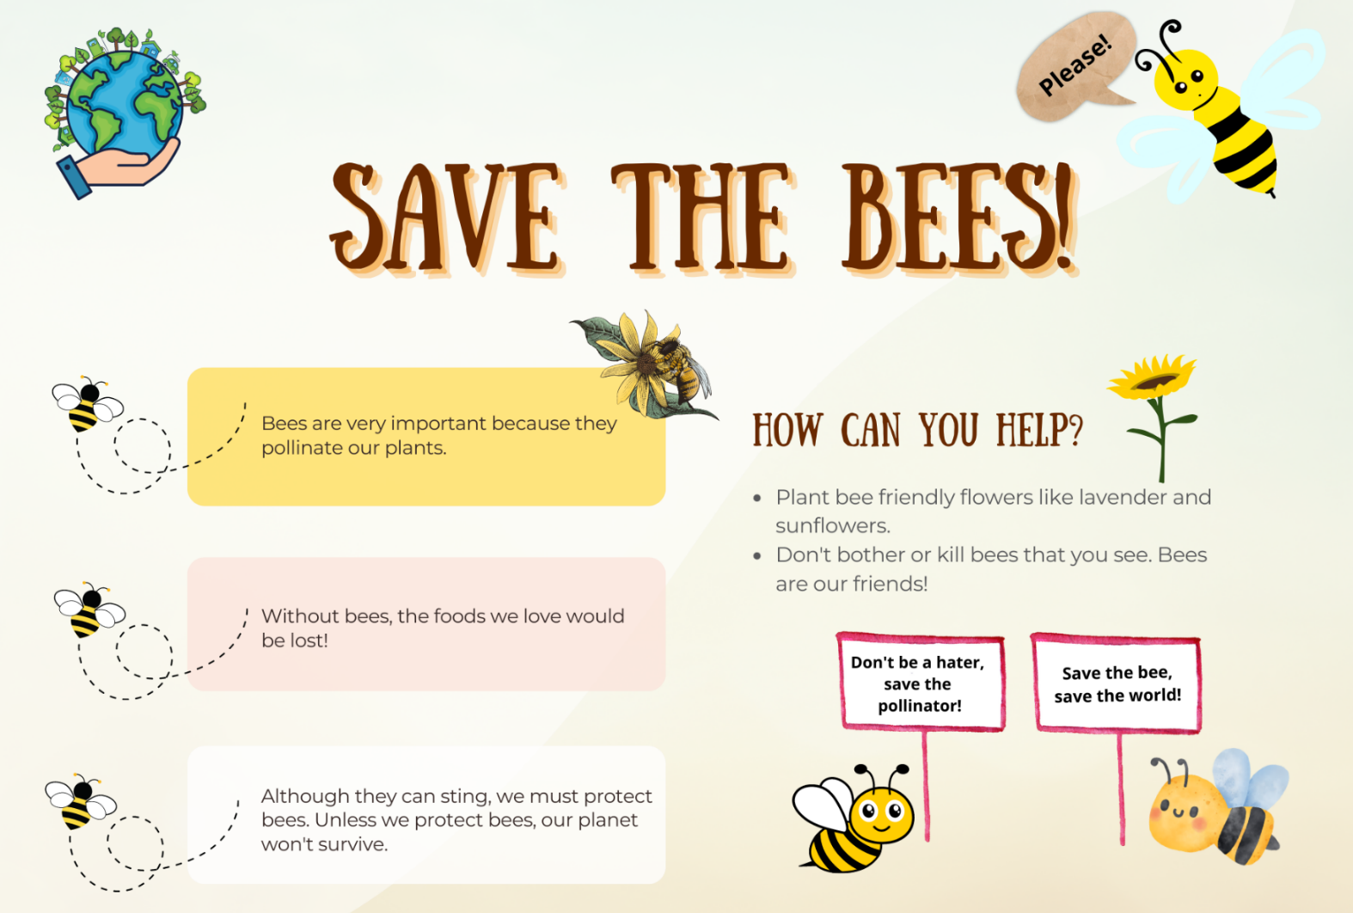
This image contains content obtained from Canva, and its use outside of this resource is subject to Canva’s Content License Agreement.

Resource 2: The 3 tiers of vocabulary
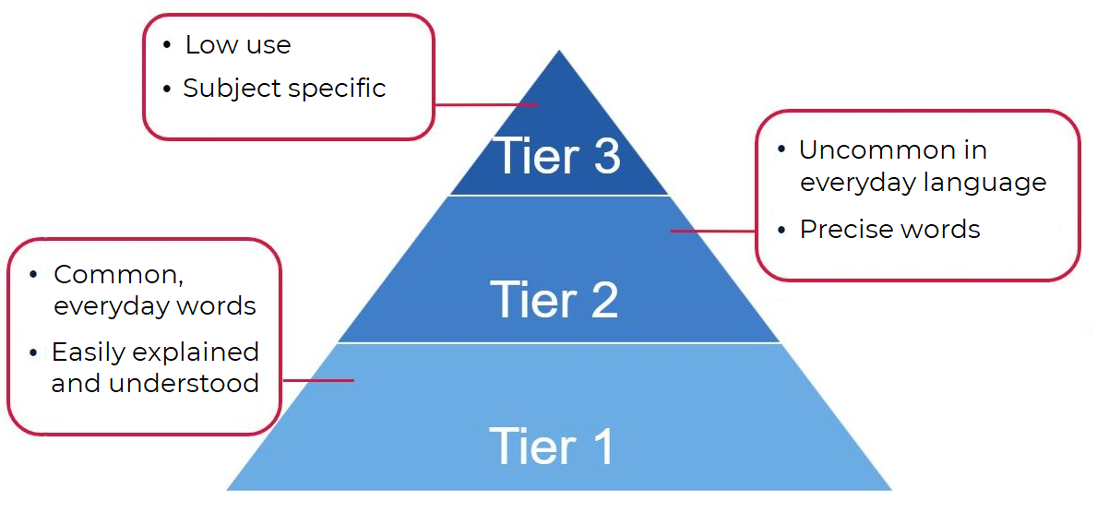

Resource 3: Tier 2 and Tier 3 vocabulary
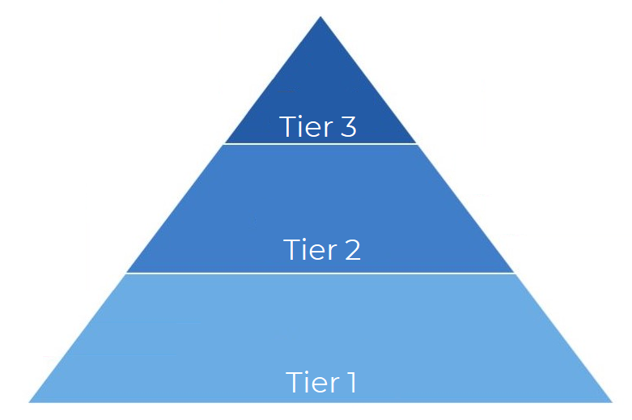

Resource 4: Sentence strips teacher model
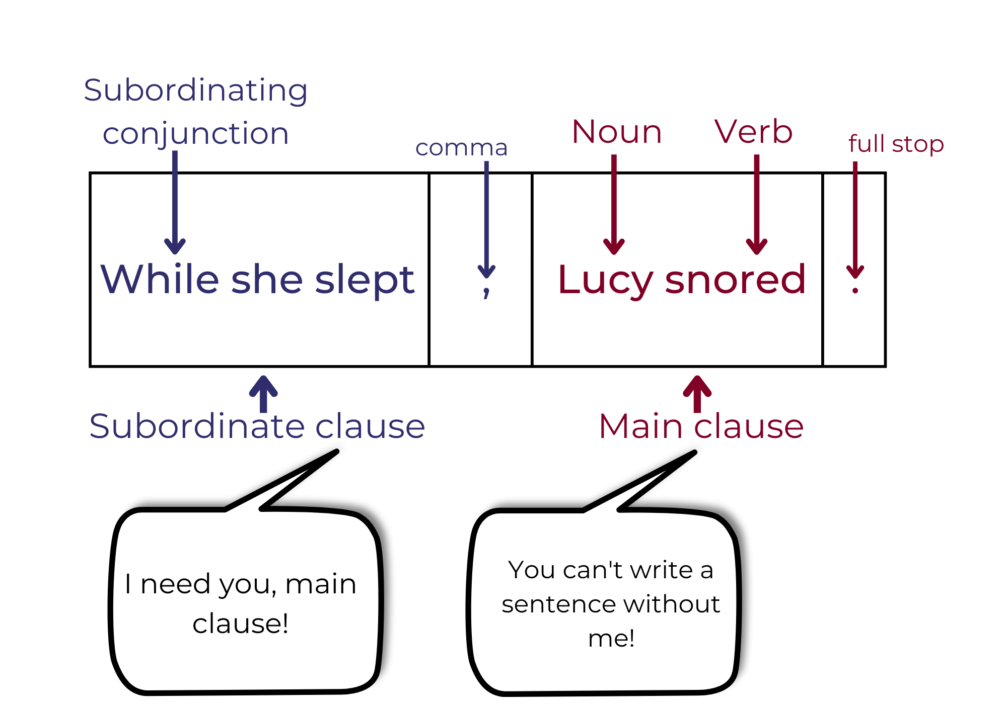

Resource 5: Sentence strips for students
Cut out each section and jumble up. Hand out one sentence at a time. Students deconstruct the sentence by labelling.
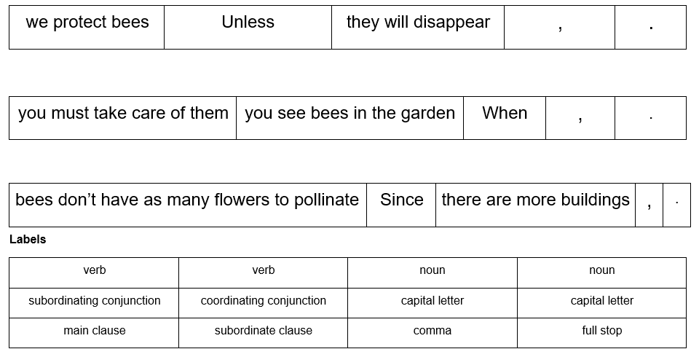

Resource 6: Subordinating conjunctions
after | even though | unless
although | if | until
as | since | whenever
because | that | wherever
before | though | while

Resource 7: Exemplar paragraph
Ants should not be squished because they are very important to the earth. Ants help keep the soil healthy. Whenever an ant is squished, it means they can’t do their job. Their job is to help our beautiful environment. Although ants may bite, they are interesting and helpful creatures. We must protect ants.

Resource 8: Ordering sentences in a paragraph
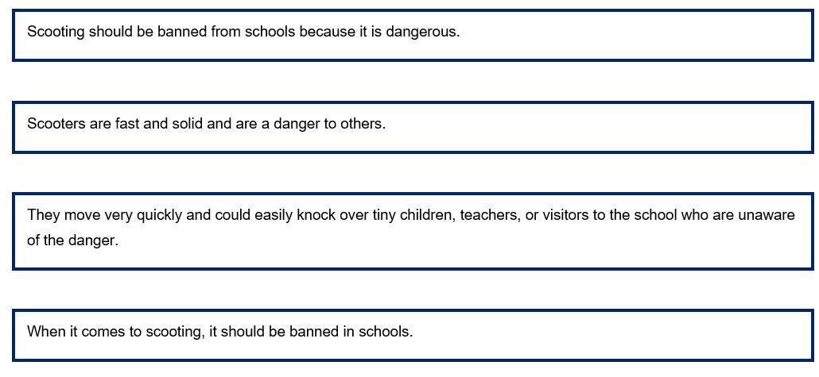

References
Links to third-party material and websites
Please note that the provided (reading/viewing material/list/links/texts) are a suggestion only and implies no endorsement, by the New South Wales Department of Education, of any author, publisher, or book title. School principals and teachers are best placed to assess the suitability of resources that would complement the curriculum and reflect the needs and interests of their students.
If you use the links provided in this document to access a third-party's website, you acknowledge that the terms of use, including licence terms set out on the third-party's website apply to the use which may be made of the materials on that third-party website or where permitted by the Copyright Act 1968 (Cth). The department accepts no responsibility for content on third-party websites.
Except as otherwise noted, all material is © State of New South Wales (Department of Education), 2023 and licensed under the Creative Commons Attribution 4.0 International License. All other material (third-party material) is used with permission or under licence. Where the copyright owner of third-party material has not licensed their material under a Creative Commons or similar licence, you should contact them directly for permission to reuse their material.
English K–10 Syllabus © 2022 NSW Education Standards Authority (NESA) for and on behalf of the Crown in right of the State of New South Wales.
Creative Arts K-6 Syllabus © 2006 NSW Education Standards Authority (NESA) for and on behalf of the Crown in right of the State of New South Wales.
© 2022 NSW Education Standards Authority. This document contains NSW Curriculum and syllabus content. The NSW Curriculum is developed by the NSW Education Standards Authority. This content is prepared by NESA for and on behalf of the Crown in right of the State of New South Wales. The material is protected by Crown copyright.
Please refer to the NESA Copyright Disclaimer for more information.
NESA holds the only official and up-to-date versions of the NSW Curriculum and syllabus documents. Please visit the NSW Education Standards Authority (NESA) website and the NSW Curriculum website.
National Literacy Learning Progression © Australian Curriculum, Assessment and Reporting Authority (ACARA) 2010 to present, unless otherwise indicated. This material was downloaded from the Australian Curriculum website (National Literacy Learning Progression) (accessed 12 January 2023) and was not modified. The material is licensed under CC BY 4.0. Version updates are tracked in the ‘Curriculum version history’ section on the 'About the Australian Curriculum' page of the Australian Curriculum website.
ACARA does not endorse any product that uses the Australian Curriculum or make any representations as to the quality of such products. Any product that uses material published on this website should not be taken to be affiliated with ACARA or have the sponsorship or approval of ACARA. It is up to each person to make their own assessment of the product, taking into account matters including, but not limited to, the version number and the degree to which the materials align with the content descriptions and achievement standards (where relevant). Where there is a claim of alignment, it is important to check that the materials align with the content descriptions and achievement standards (endorsed by all education Ministers), not the elaborations (examples provided by ACARA).
This resource contains images and content obtained from Canva, and their use outside of this resource is subject to Canva’s Content License Agreement. If you wish to use them separately from the resource, please go to Canva.
ABC (Australian Broadcasting Corporation) (15 December 2022) ‘Bee Heroes: Meet the European honey bee’ [video], ABC Education, ABC website, accessed 12 January 2023.
Beck IL, McKeown MG and Kucan L (2013) Bringing Words to Life: Robust Vocabulary Instruction, 2nd edn, Guilford Press, New York.
ETA (English Teachers Association) and NSW Department of Education (2016) The Textual Concepts and Processes resource, English Textual Concepts website, accessed 12 January 2023.
Hoose P and Hoose H (1998) Hey, Little Ant (Tilley D, illus) Random House US.

