# English – Stage 1 – Unit 10



Contents

Unit overview and instructions for use 3

Teacher notes 4

Outcomes and content – Component A 6

Outcomes and content – Component B 7

Week 1 10

Component A teaching and learning 10

Component B teaching and learning 11

Lesson 1: Understanding Amy & Louis 12

Lesson 2:Amy & Louis continued 15

Lesson 3: Mr Huff 17

Lesson 4: Planning and designing multimodal texts 18

Lesson 5: Composing and sharing multimodal texts 20

Week 2 22

Component A teaching and learning 22

Component B teaching and learning 23

Lesson 6: Introduction to tiny poems 24

Lesson 7: Creating tiny poems 26

Lesson 8: Navigation pathways and exploring vocabulary 28

Lesson 9: Multimodal informative texts 29

Lesson 10: Writing an informative text 30

Resource 1: Conversation bear 33

Resource 2: Amy & Louis text analysis 34

Resource 3: Blank– Image, symbol and emotion 36

Resource 4: Amy & Louis – Image, symbol and emotion teacher model 37

Resource 5: Pronoun cloze passage 39

Resource 6: FANBOYS 41

Resource 7: Mr Huff – Image, symbol and emotion teacher model 42

Resource 8: Multimodal text planning 44

Resource 9: Tiny poems by Sally Murphy 45

Resource 10: Online text features and navigation pathways 46

Resource 11: Visual glossary 48

References 49

## Unit overview and instructions for use

This two-week unit is comprised of Component A and Component B. Connecting learning across both components is encouraged.

|  |  |  |
| --- | --- | --- |
| Teaching and learning | Component A | Component B |
| Suggested duration | 60 minutes | 45 minutes |
| Explicit teaching focus areas | * Phonic knowledge * Reading fluency * Reading comprehension * Spelling * Handwriting | * Oral language and communication * Vocabulary * Reading comprehension * Creating written texts * Understanding and responding to literature |
| To prepare for teaching and learning: | 1. Refer to Outcomes and content – Component A, [K-2 – Instructional sequence – grapheme–phoneme correspondences [PDF 825 KB]](https://education.nsw.gov.au/content/dam/main-education/teaching-and-learning/curriculum/key-learning-areas/english/media/documents/english-k-2-GPC-instructional-sequence.pdf), and the teaching advice documents (hyperlinked in Component A teaching and learning table). 2. Based on student needs identified through ongoing assessment data, plan and document how you will sequence teaching and learning in whole class and targeted teaching groups across the two-week cycle. | 1. Familiarise yourself with Outcomes and content – Component B, [Textual concepts information and videos](https://education.nsw.gov.au/teaching-and-learning/curriculum/key-learning-areas/english/ES1S3/textual-concepts), [English Textual Concepts and Learning Processes (2016)](http://englishtextualconcepts.nsw.edu.au/content/textual-concepts-and-processes-resource), and the teaching and learning sequence. 2. Based on student needs identified through ongoing assessment data, determine how you will support students in whole class and targeted teaching groups across the two-week cycle as required. |

[English K–10 Syllabus](https://curriculum.nsw.edu.au/learning-areas/english/english-k-10) © 2022 NSW Education Standards Authority (NESA) for and on behalf of the Crown in right of the State of New South Wales.

### Teacher notes

1. Connotation, imagery and symbol are defined as words and images that extend beyond their literal meaning. – [English Textual Concepts and Learning Processes (2016)](http://englishtextualconcepts.nsw.edu.au/content/textual-concepts-and-processes-resource).
2. Understanding of connotation, imagery and symbol can be supported through watching the department’s video: [Connotation, imagery and symbol (6:07)](https://education.nsw.gov.au/teaching-and-learning/curriculum/english/textual-concepts#/asset15).
3. While connotation, imagery and symbol is the mentor concept for the conceptual component of this unit, the supporting concepts of narrative and character can be explored using the mentor text Amy & Louis by Libby Gleeson.
4. The text Cooee Mittigar: A Story on Darug Songlines by Jasmine Seymour and Leanne Mulgo Watson can be used to develop an understanding of the Aboriginal origins of the word ‘cooee’ and Dharug Country.
5. This unit could enhance student learning towards achievement of outcomes from the Creative Arts, Science and Technology, and PDHPE syllabuses. Online texts could be substituted to enhance student learning across key learning areas.
6. For information on Aboriginal English, Standard Australian English, nouns, pronouns, simple sentences, compound sentences, coordinating conjunctions, multimodal texts, fluency, prosody, rhyme, figurative language, wordplay, adjectives, navigation pathways, and Tier 1 to 3 words refer to the [NESA Glossary.](https://curriculum.nsw.edu.au/curriculum-support/glossary)
7. There are 3 articles in the English language: a, an, the. Articles are placed before nouns and form part of the noun group when referring to either a specific person or thing (the) or a non-specific person or thing (a, an). ‘The’ is a definite article; ‘a’ and ‘an’ are indefinite articles.
8. Reflect on student learning and engagement in activities and record differentiation and adjustments within the unit to inform future teaching and learning. One way of doing this could be to add comments to the digital file.
9. Content points are linked to the National Literacy Learning Progression version (3).

Levels and indicators sourced from [National Literacy Learning Progression](https://www.australiancurriculum.edu.au/resources/national-literacy-and-numeracy-learning-progressions/version-3-of-national-literacy-and-numeracy-learning-progressions/) © Australian Curriculum, Assessment and Reporting Authority (ACARA), (accessed 20 December 2022) and was not modified. See references for more information.

### Outcomes and content – Component A

The table below outlines the focus outcomes and content. Content is linked to the National Literacy Learning Progression version (3).

|  |  |
| --- | --- |
| Focus area and outcome | Content points and National Literacy Learning Progression |
| **Phonic knowledge**  **EN1-PHOKW-01 –** uses initial and extended phonics, including vowel digraphs, trigraphs to decode and encode words when reading and creating texts | * blend and decode one-syllable words with taught extended vowel graphs and digraphs, including graphemes for r-controlled vowels and diphthongs, and apply this when creating texts (PKW6, PKW7) * decode words with trigraphs and quadgraphs and apply this when reading texts |
| **Reading fluency**  **EN1-REFLU-01 –** sustains reading unseen texts with automaticity and prosody and self-corrects errors | * adjust phrasing, intonation, volume or rate to maintain fluency when reading aloud (FlY4) * vary pace when reading according to the audience and purpose (FlY4) |
| **Reading comprehension**  **EN1-RECOM-01 –** comprehends independently read texts that require sustained reading by activating background and word knowledge, connecting and understanding sentences and whole text, and monitoring for meaning | * use knowledge of text structure, type of text, author, and forms of writing to predict and confirm meaning (UnT6) * register a break in comprehension when reading (UnT5) * make text-to-self, text-to-text or text-to-world connections when reading (UnT6) * use information read in texts to enhance learning across key learning areas |
| **Spelling**  **EN1-SPELL-01 –** applies phonological, orthographic and morphological generalisations and strategies when spelling words in a range of writing contexts | * use suffixes –ful, –y and –ly to spell taught high-frequency words * use knowledge of morphemes to spell taught compound words and homophones with taught single-letter graphemes, digraphs, split digraphs, trigraphs and quadgraphs (SpG7) |
| **Handwriting**  **EN1-HANDW-01 –** uses a legible, fluent and automatic handwriting style, and digital technology, including word-processing applications, when creating texts | * type up to 5 familiar words per minute |

### Outcomes and content – Component B

The table below outlines the focus outcomes and content. Content is linked to the National Literacy Learning Progression version (3).

|  |  |
| --- | --- |
| Focus area and outcome | Content points and National Literacy Learning Progression |
| **Oral language and communication**  **EN1-OLC-01 – communicates effectively by using interpersonal conventions and language to extend and elaborate ideas for social and learning interactions** | * **initiate, listen and/or respond in partner and group conversations (InT3, InT5)** * **organise key ideas in a logical sequence (SpK3)** * **recite poems and rhymes** |
| **Vocabulary**  **EN1-VOCAB-01 –** understands and effectively uses Tier 1, taught Tier 2 and Tier 3 vocabulary to extend and elaborate ideas | * identify, understand and use wordplay and rhyme in a range of texts |
| **Reading comprehension**  **EN1-RECOM-01 –** comprehends independently read texts that require sustained reading by activating background and word knowledge, connecting and understanding sentences and whole text, and monitoring for meaning | * understand vocabulary that signals humorous wordplay in texts * use navigation pathways, including hyperlinks, to extract essential information to support reading fluency, and enhance meaning when reading digital texts (UnT7) * use knowledge of text structure, type of text, author, and forms of writing to predict and confirm meaning (UnT6) * use visual and/or auditory features in multimodal texts to build meaning (UnT5) * make text-to-self, text-to-text or text-to-world connections when reading (UnT6) * use information read in texts to enhance learning across key learning areas |
| **Creating written texts**  **EN1-CWT-01 –** plans, creates and revises texts written for different purposes, including paragraphs, using knowledge of vocabulary, text features and sentence structure | * write texts that describe, explain, give an opinion, recount an event, tell a story (CrT5) * use visual elements to expand meaning in own texts * accurately use articles and pronouns in own writing (CrT8) * use time connectives to sequence information and events in texts (GrA4) * use creative wordplay to affect the reader * identify the context, audience and purpose for own texts * use knowledge of similarities and differences between imaginative, informative and persuasive texts when planning for writing |
| **Understanding and responding to literature**  **EN1-UARL-01 –** understands and responds to literature by creating texts using similar structures, intentional language choices and features appropriate to audience and purpose | * identify figurative language and wordplay in texts (UnT7) * identify symbols and images in texts, and how they bring deeper meaning * create texts that include symbols, wordplay and figurative language |

## Week 1

### Component A teaching and learning

The table below can be used to plan and document lessons that address Component A outcomes and content. Both the [detailed example [DOC 529KB]](https://education.nsw.gov.au/content/dam/main-education/teaching-and-learning/curriculum/key-learning-areas/english/media/documents/english-K-2-multiage-foundational-teaching-and-learning-sample.docx) of a two-week teaching and learning cycle and [brief example [DOC 66KB]](https://education.nsw.gov.au/content/dam/main-education/teaching-and-learning/curriculum/key-learning-areas/english/media/documents/english-K-2-multiage-foundational-teaching-and-learning-sample-brief-example.docx) may support you in your planning.

|  |  |  |  |  |  |
| --- | --- | --- | --- | --- | --- |
| Focus Areas | Lesson 1 | Lesson 2 | Lesson 3 | Lesson 4 | Lesson 5 |
| [**Phonic knowledge**](https://education.nsw.gov.au/teaching-and-learning/curriculum/literacy-and-numeracy/teaching-and-learning-resources/literacy/lesson-advice-guides)  15 minutes |  |  |  |  |  |
| [**Spelling**](https://education.nsw.gov.au/teaching-and-learning/curriculum/literacy-and-numeracy/teaching-and-learning-resources/literacy/lesson-advice-guides) **and** [**Handwriting**](https://education.nsw.gov.au/teaching-and-learning/curriculum/literacy-and-numeracy/teaching-and-learning-resources/literacy/lesson-advice-guides)  15 minutes |  |  |  |  |  |
| [**Reading comprehension**](https://education.nsw.gov.au/teaching-and-learning/curriculum/literacy-and-numeracy/teaching-and-learning-resources/literacy/lesson-advice-guides) **and** [**Reading fluency**](https://education.nsw.gov.au/teaching-and-learning/curriculum/literacy-and-numeracy/teaching-and-learning-resources/literacy/lesson-advice-guides)  30 minutes |  |  |  |  |  |

### Component B teaching and learning

The following teaching and learning sequence has been designed to address Component B outcomes and content. Adapt the sequence as required to best meet the needs of your students.

#### Learning intention and success criteria

Learning intentions and success criteria are best co-constructed with students.

#### Learning intention

Students are learning to understand how images and symbols impact on a narrative and use these features when creating a multimodal text.

#### Success criteria

Students can:

* join in partner and group conversations
* identify symbols and images in texts, and describe how they make them feel
* accurately use pronouns in writing
* plan a text using written and visual elements
* use images or sounds in multimodal texts to show feelings.

#### Resources

* Gleeson L (2006) Amy & Louis (Blackwood F, illus.) Scholastic Australia Pty Ltd. ISBN: 9781865049366
* Walker A (2015) Mr Huff, Penguin Australia Pty Ltd. ISBN: 9780670078042
* Resource 1: Conversation bear (individual copy and counters for each student)
* Resource 2: Amy & Louis text analysis
* Resource 3: Blank – Image, symbol and emotion (enlarged copy and individual copies for students)
* Resource 4:Amy & Louis – Image, symbol and emotion teacher model
* Resource 5: Pronoun cloze passage
* Resource 6: FANBOYS
* Resource 7: Mr Huff – Image, symbol and emotion teacher model
* Resource 8: Multimodal text planning (enlarged copy and copies for student groups)
* Resources to support the production of multimodal texts, for example, tablets/computers with camera or audio recording capacity, and art supplies, including pencil and paper, print and sculpture materials

### Lesson 1: Understanding Amy & Louis

1. Mime the greeting ‘hello’ using a wave. Ask students to demonstrate other ways of greeting, for example, handshake, high five, hug. Discuss ways people greet or say hello to others, including home language and known languages other than Standard Australian English. Discuss the greeting ‘cooee’, derived from Dharug, which is used as a call over distances and means ‘come here’.
2. Introduce the text Amy & Louis. Guide students to make predictions about what type of text it is, using the front and back covers, title and illustrations. Discuss narrative elements and the relationship that may exist between the characters. Explain that the ampersand in the title is a logogram, which is a symbol representing a word. In this case, the word represented is ‘and’.
3. Read Amy & Louis. Revisit the text predictions and provide the opportunity for students to make text-to-self connections. Draw attention to the meaning of the word ‘cooee’ (come here) and its relevance to the story.
4. Explain how the reader can draw meaning from a text’s words and illustrations, as well as their own experiences (connotation). Highlight how symbols and images are sometimes used in texts to bring deeper meaning.
5. Organise students into small groups. Explain that students are going to engage in conversations about the text. As part of this, students will focus on developing their awareness of initiating and responding in conversations.
6. Provide students with a copy of Resource 1: Conversation bear. Model having a short conversation with 2 students. When each person contributes, show how to place a counter on the bear. Highlight the importance of including all people in a conversation.
7. Use Resource 2: Amy & Louis text analysis to guide group conversations on the symbols and images that are used throughout the mentor text and how they contribute to the overall meaning of the story. Provide direct feedback to students on skills and strategies they are using when initiating, listening and responding in their group.
8. As a class, explore how vocabulary is used to evoke happy and sad feelings. Create a [T-chart](https://app.education.nsw.gov.au/digital-learning-selector/LearningActivity/Card/599#.YilwIeS9J-E.link) with the headings ‘Happy’ and ‘Sad’. Using the mentor text, identify words and phrases that connote each emotion and take turns with students, using a pen or writing implement, to list words under each heading. For example:

* Happy: magical creatures; secrets to share; lovely dream; wild, wild dragons
* Sad: long, long way away; other side of the world; stopped; nowhere.

1. Display and discuss the meaning of the sequencing words: first, then, next, after that, in the end, finally. Retell *Amy & Louis* using only the images in the text. Students take turns to retell part of the story as each page is displayed. Support students to use time connectives to sequence events.
2. Display an enlarged copy of Resource 3: Blank – Image, symbol and emotion. A completed example is provided in Resource 4: Amy & Louis – Image, symbol and emotion teacher model. Model writing sentences retelling the beginning of the story. Include the emotions felt and the images/symbols used to convey them. Ask students to share ideas about the emotions, symbols/imagery, and key events in the text.
3. In guided groups or individually, students complete their own copy of Resource 3: Blank – Image, symbol and emotion.

**Too hard?** Complete the entire task as a class with varying degrees of scaffolded support.

**Stage 1 Assessment task 1 –** Observations and work samples from this lesson allow students to demonstrate achievement towards the following syllabus outcomes and content points:

**EN1-OLC-03 –** communicates effectively by using interpersonal conventions and language to extend and elaborate ideas for social and learning interactions

* initiate, listen and/or respond in partner and group conversations
* organise key ideas in a logical sequence.

**EN1-RECOM-01 –** comprehends independently read texts that require sustained reading by activating background and word knowledge, connecting and understanding sentences and whole text, and monitoring for meaning

* use knowledge of text structure, type of text, author, and forms of writing to predict and confirm meaning.

**EN1-CWT-01 –** plans, creates and revises texts written for different purposes, including paragraphs, using knowledge of vocabulary, text features and sentence structure

* use time connectives to sequence information and events in texts.

### Lesson 2:Amy & Louis continued

1. Revise articles and pronouns. Explain that an article is placed before a noun when referring to a specific person or thing, for example, a, an, the. Explain that a pronoun is a word used in place of a noun or proper noun. Explicitly teach the use of pronouns in relation to people or characters in a story, such as plural and singular pronouns.
2. Display the sentences ‘Louis sent a cloud to his friend Amy. She saw the cloud from her window.’ Ask students to identify the pronouns and articles and circle them. Students [turn and talk](https://education.nsw.gov.au/teaching-and-learning/curriculum/literacy-and-numeracy/teaching-and-learning-resources/numeracy/talk-moves) about the noun or proper noun that each pronoun refers to. Draw an arrow from the circled pronoun to the noun or proper noun it represents. For example, draw an arrow from the word ‘his’ to ‘Louis’.
3. In pairs, groups, or individually, students complete Resource 5: Pronoun cloze passage. Passages have been taken directly from the text for reference. Provide students with the opportunity to explain their word choices.

**Too hard?** Students complete cloze passage A.

**Too easy?** Students complete cloze passage B.

1. Students [turn and talk](https://education.nsw.gov.au/teaching-and-learning/curriculum/literacy-and-numeracy/teaching-and-learning-resources/numeracy/talk-moves) with a partner to describe additional activities Amy and Louis may have engaged in which made them feel happy.
2. Select student examples to model writing sentences that describe the activity. Highlight the vocabulary that evokes the characters’ emotions. Use circles and arrows to show the noun and pronoun relationships. For example:

* Sentence 1: Amy and Louis played hide and seek together until it was dinner time. (simple sentence)
* Sentence 2: They would run around and around the tree in the backyard laughing, and they made a secret cubby up in its beautiful branches. (compound sentence)

1. Revise that 2 simple sentences can be joined by a coordinating conjunction to form a compound sentence. Refer to Resource 6: FANBOYS as a scaffold for learning.
2. Students write simple and compound sentences describing additional activities that would fit into the beginning (orientation) of the story.
3. To review writing, students highlight emotive language and add arrows and circles to show noun and pronoun relationships. Students draw an image to represent their written text, using colour and symbols to expand meaning.

**Stage 1 Assessment task 2 –** Collecting work samples from this lesson allows students to demonstrate achievement towards the following syllabus outcomes and content points:

**EN1-CWT-01 –** plans, creates and revises texts written for different purposes, including paragraphs, using knowledge of vocabulary, text features and sentence structure

* accurately use articles and pronouns in own writing.

**EN1-UARL-01 – understands and responds to literature by creating texts using similar structures, intentional language choices and features appropriate to audience and purpose**

* **create texts that include symbols, wordplay and figurative language.**

### Lesson 3: Mr Huff

1. Introduce the text Mr Huff. Guide students to make predictions about what type of text it is, using the front and back covers, title, and illustrations. Discuss narrative elements and the type of relationship that may exist between the characters.
2. Read Mr Huff. Revisit the text predictions and provide the opportunity for students to make text-to-self connections. Discuss the term ‘huff’ and what it means to be ‘in a huff’. Ask:

* Is Mr Huff a character? Why or why not?
* Are the clouds in Amy & Louis characters? Why or why not?

1. Explore how vocabulary is used to evoke happy and sad feelings. Create a [T-chart](https://app.education.nsw.gov.au/digital-learning-selector/LearningActivity/Card/599#.YilwIeS9J-E.link) with the headings ‘Happy’ and ‘Sad’ or add to the one created in Lesson 1. Using Mr Huff, identify words and phrases that connote each emotion. With students, take turns to list words under each heading. For example:

* Happy: glistened, laughing, smiled, sunshine
* Sad: cloudy, stupid, soggy, frowned.

Consider the context of these words and phrases.

1. To develop an understanding of story elements, model completing the ‘Beginning’ row on an enlarged copy of Resource 3: Blank – Image, symbol and emotion. A completed example is provided in Resource 7: Mr Huff – Image, symbol and emotion teacher model. Ask students to share ideas about the emotions, symbols/imagery and key events in the text.
2. In pairs, groups, or individually, students complete a copy of Resource 3: Blank – Image, symbol and emotion.
3. Compare and contrast the deconstructions of Amy & Louis and Mr Huff. Discuss similarities and differences in how symbols and images are used in each text to convey different emotions.
4. Using the first 3 sentences of Mr Huff as a guide, model writing simple and compound sentences that describe additional situations Bill may have experienced in the morning that added to his sad emotions. For example:

* Sentence 1: Bill couldn’t find his favourite shoes. (simple sentence)
* Sentence 2: He slipped over his school bag and his homework fell in the dog bowl. (compound sentence)
* Sentence 3: He had a terrible feeling about the day. (simple sentence)

1. Students write simple and compound sentences to describe their own ‘imaginary’ bad morning and how it made them feel. Encourage students to refer to Resource 6: FANBOYS to support writing compound sentences.
2. Students draw an image to represent their writing, using colour and symbols to express emotions. Alternatively, students may complete the visual component first as a planning stimulus for their written text.

**Too hard?** Provide sentence starters, for example, I woke up and I felt __.

**Too easy?** Students write sentences describing multiple characters having a very bad morning. Students should include descriptions of how it made each person feel.

### Lesson 4: Planning and designing multimodal texts

1. Display the sequencing words: first, then, next, after that, in the end, finally. Retell Mr Huff using only the images in the text. Students take turns to retell part of the story as each page is displayed, using time connectives to sequence events.
2. Explain that students will be working in groups to plan a short multimodal text following a similar structure to Mr Huff. The multimodal text may include visual elements and auditory features. It could be a series of short videos that include colour and sepia tones, or drawings with audio recording or sound effects.

**Note:** A multimodal text combines 2 or more communication modes. For example, printed words and images, as in a picture book, or spoken words and sound effects, as in a film. Most texts that early readers encounter are multimodal.

1. Draw a three-column table with the headings ‘A sad thing happened’, ‘Something else happened’, and ‘I felt happy’. Model writing the first row of the table, for example:

* Yesterday I was going for a walk, and I dropped my chocolate ice cream on the ground. I nearly cried.
* Then I saw a clown pretend to drop his ice cream too.
* In the end, the clown made me laugh and I didn’t feel so bad anymore.

1. Students provide sentences about a sad thing that may have happened. Ask students to take turns to write ideas in the first column of the table. Continue developing the text with students contributing sentences under the heading ‘Something else happened’. Finally, students describe the feelings evoked and record these in the final column of the table.
2. Model using an enlarged copy of Resource 8: Multimodal text planning and write a sentence from each column on the table to make a new text. Draw or describe what the visual element will be for each sentence as a plan for text creation. For example, a brightly coloured, black and white, or darker toned image.
3. In small groups, students select sentences from the table and write them on Resource 8: Multimodal text planning. Students draw or describe a visual to accompany each sentence, for example, photographs.

**Too hard?** Support students in small groups to complete the storyboard.

**Too easy?** Students go beyond the table to produce a storyboard for a complete narrative.

### Lesson 5: Composing and sharing multimodal texts

1. Revisit the co-constructed multimodal text planning from Lesson 4. Model making minor changes, for example, if using staged photographs, update the storyboard to show that a brightly coloured photo could instead be taken in sepia tone.
2. Co-construct success criteria to further guide students’ text creation. For example:

* write simple and compound sentences
* include time connectives to sequence events
* use colour or visual elements to bring deeper meaning
* include 2 or more emotions
* use words and phrases to represent emotions.

1. In small groups, students review their planning. Provide prompts, including:

* How can colour be used to represent different emotions in this text?
* How could a line or a symbol, like the arrow in *Amy & Louis*, help to tell this story?

1. Student groups produce their multimodal text. Groups may need support to manage the technology being used.
2. Students reflect on and share their work with another group or as a [gallery walk](https://app.education.nsw.gov.au/digital-learning-selector/LearningActivity/Card/555).

**Stage 1 Assessment task 3 –** Observations and work samples from this lesson allow students to demonstrate achievement towards the following syllabus outcomes and content points:

**EN1-CWT-01 – plans, creates and revises texts written for different purposes, including paragraphs, using knowledge of vocabulary, text features and sentence structure**

* **write texts that describe, explain, give an opinion, recount an event, tell a story**
* **use visual elements to expand meaning in own texts.**

**EN1-UARL-01 – understands and responds to literature by creating texts using similar structures, intentional language choices and features appropriate to audience and purpose**

* **identify symbols and images in texts, and how they bring deeper meaning**
* **create texts that include symbols, wordplay and figurative language.**

## Week 2

### Component A teaching and learning

The table below can be used to plan and document lessons that address Component A outcomes and content. Both the [detailed example [DOC 529KB]](https://education.nsw.gov.au/content/dam/main-education/teaching-and-learning/curriculum/key-learning-areas/english/media/documents/english-K-2-multiage-foundational-teaching-and-learning-sample.docx) of a two-week teaching and learning cycle and [brief example [DOC 66KB]](https://education.nsw.gov.au/content/dam/main-education/teaching-and-learning/curriculum/key-learning-areas/english/media/documents/english-K-2-multiage-foundational-teaching-and-learning-sample-brief-example.docx) may support you in your planning.

|  |  |  |  |  |  |
| --- | --- | --- | --- | --- | --- |
| Focus Areas | Lesson 6 | Lesson 7 | Lesson 8 | Lesson 9 | Lesson 10 |
| [**Phonic knowledge**](https://education.nsw.gov.au/teaching-and-learning/curriculum/literacy-and-numeracy/teaching-and-learning-resources/literacy/lesson-advice-guides)  15 minutes |  |  |  |  |  |
| [**Spelling**](https://education.nsw.gov.au/teaching-and-learning/curriculum/literacy-and-numeracy/teaching-and-learning-resources/literacy/lesson-advice-guides) **and** [**Handwriting**](https://education.nsw.gov.au/teaching-and-learning/curriculum/literacy-and-numeracy/teaching-and-learning-resources/literacy/lesson-advice-guides)  15 minutes |  |  |  |  |  |
| [**Reading comprehension**](https://education.nsw.gov.au/teaching-and-learning/curriculum/literacy-and-numeracy/teaching-and-learning-resources/literacy/lesson-advice-guides) **and** [**Reading fluency**](https://education.nsw.gov.au/teaching-and-learning/curriculum/literacy-and-numeracy/teaching-and-learning-resources/literacy/lesson-advice-guides)  30 minutes |  |  |  |  |  |

### Component B teaching and learning

The following teaching and learning sequence has been designed to address Component B outcomes and content. Adapt the sequence as required to best meet the needs of your students.

#### Learning intention and success criteria

Learning intentions and success criteria are best co-constructed with students.

#### Learning intention

Students are learning to read and create a range of texts with attention to its purpose and audience.

#### Success criteria

Students can:

* read poetry aloud with appropriate expression
* identify rhyme in poems
* write poems that include wordplay
* navigate and read digital texts that use images, text and hyperlinks
* identify and use Tier 1, 2, and 3 vocabulary
* create diagrams and written text to explain facts.

#### Resources

* Resource 9: Tiny poems by Sally Murphy
* Resource 10: Online text features and navigation pathways
* Resource 11: Visual glossary (enlarged copy and copies for each student)
* Website: [NASA Climate Kids – How Do Clouds Form?](https://climatekids.nasa.gov/cloud-formation/)
* Website: [Britannica Kids – cloud](https://kids.britannica.com/kids/article/cloud/352973)
* Mini whiteboards
* Resources to support the production of multimodal texts, for example, tablets/computers with camera or audio recording capacity, and art supplies, including pencil and paper, print and sculpture materials

### Lesson 6: Introduction to tiny poems

1. Introduce Resource 9: Tiny poems by Sally Murphy. Discuss the rhyme and representation that has been used in each poem, for example, ‘bubbles’ and ‘balls of magic’. Students close their eyes, listen to the poems, and share what they ‘see’. Explain how visualising the text can help to support understanding.
2. Explicitly teach that some poems do not use punctuation, but the reader often pauses at the end of each line. Explain that poets use wordplay, rhyme, and figurative language for effect. Discuss the use of figurative language and symbols in the poems. For example, the use of ice cream and bubbles as symbols for clouds. Encourage students to make text-to-text connections between the tiny poems and the picture book, Amy & Louis, where the clouds were described as ‘strange seahorses’ and ‘wild, wild dragons’.
3. Re-read the poems several times with students, focusing on reading fluency, including prosody.

**Note:** Prosody is reading with expression using correct phrasing, intonation, and attention to punctuation.

1. Play a rhyming game where a word is provided, and students are asked to state words that rhyme. For example, ask students to tell you a word that rhymes with ‘four’.
2. Explicitly teach the ABCB rhyme scheme where the second and fourth lines rhyme. Refer to Resource 9: Tiny poems by Sally Murphy and explain that the tiny poem structure consists of:

* Line 1 (A) – 2 words describing an image or visualisation (noun)
* Line 2 (B) – phrase saying where the noun is, how it moves, or what it looks like
* Line 3 (C) – compares line 1 (the noun) with something else
* Line 4 (B) – links with line 3 and rhymes with line 2.

1. Take students outside to look at the clouds. Ask students to name the images and imaginative creatures they can ‘see’ by drawing them or writing words to describe them on mini whiteboards. Videos of clouds may provide an alternative opportunity to highlight the shapes in the clouds.
2. In the classroom, jointly create a list of words that may be used in a poem about clouds. Write these on an anchor chart which will be used in Lesson 7. For example, sky, rain, drop. Find rhyming pairs that may work semantically, such as sky/high, rain/drain, drop/stop. Discuss words that may rhyme but may not be useful in a poem on this topic, such as shoe/glue.

**Note: This activity can also provide opportunities for students to further develop spelling knowledge addressed in Component A, including changing nouns to adjectives by adding** -**y. For example, rain/rainy, sun/sunny, cloud/cloudy.**

### Lesson 7: Creating tiny poems

1. Revisit Resource 9: Tiny poems by Sally Murphy and the anchor chart of words to describe clouds created in Lesson 6.
2. Model writing tiny poems using the ABCB rhyme scheme, wordplay, rhyme, figurative language, and vocabulary from the anchor chart. For example:

Stormy clouds

Are dark and grey

Angry monsters

On a rainy day

Wispy clouds

Above my head

Fluffy pillows

On my bed.

1. In guided writing groups or pairs, students write a tiny poem about clouds using the modelled examples and anchor chart as a scaffold.

**Too hard?** Write 2 rhyming lines that describe a cloud.

**Too easy?** Write an ABAB poem, where the first and third lines rhyme, and the second and fourth lines rhyme.

1. Students add multimodal text elements by selecting a hand-drawn or online image to accompany their poem, or by making a sound or video recording.
2. Provide opportunities for students to recite their poem to a familiar audience.

**Stage 1 Assessment task 4 –** Observations and work samples from this lesson allow students to demonstrate achievement towards the following syllabus outcomes and content points:

**EN1-OLC-03 –** communicates effectively by using interpersonal conventions and language to extend and elaborate ideas for social and learning interactions

* **recite poems and rhymes.**

**EN1-VOCAB-01 –** understands and effectively uses Tier 1, taught Tier 2 and Tier 3 vocabulary to extend and elaborate ideas

* identify, understand and use wordplay and rhyme in a range of texts.

**EN1-RECOM-01 –** comprehends independently read texts that require sustained reading by activating background and word knowledge, connecting and understanding sentences and whole text, and monitoring for meaning

* understand vocabulary that signals humorous wordplay in texts.

**EN1-CWT-01 –** plans, creates and revises texts written for different purposes, including paragraphs, using knowledge of vocabulary, text features and sentence structure

* write texts that describe, explain, give an opinion, recount an event, tell a story
* use creative wordplay to affect the reader.

**EN1-UARL-01 –** understands and responds to literature by creating texts using similar structures, intentional language choices and features appropriate to audience and purpose

* identify figurative language and wordplay in texts.

### Lesson 8: Navigation pathways and exploring vocabulary

1. Ask students how digital texts are the same as printed texts and how they are different. List student responses.
2. View [NASA Climate Kids – How Do Clouds Form?](https://climatekids.nasa.gov/cloud-formation/) and use the ‘think aloud’ strategy to describe how informative texts are read. Discuss key content from the page.
3. Explore the navigation pathways and tools on the page, including the use of embedded images and captions, and the hyperlinked images to ‘Big Questions’ and ‘Weather & Climate’, located at the top of the page. Explain that NASA is a trusted source and that the website’s ‘Site last updated’ information, located at the bottom of the page, indicates that the information is recent.

**Note**: For support in reading and viewing online texts, see Resource 10: Online text features and navigation pathways.

1. Introduce a table with the headings ‘Tier 1 words’, ‘Tier 2 words’, and ‘Tier 3 words’. Explain that Tier 1 words are basic words that people use every day and Tier 2 words are more precise and powerful. Tier 3 words are used rarely and are specific to a topic. Write the examples ‘white’ and ‘cloud’ in the Tier 1 column, and the examples ‘billowy’ and ‘wispy’ in the Tier 2 column. Leave the Tier 3 column blank.
2. Re-read the website text from [NASA Climate Kids – How Do Clouds Form?](https://climatekids.nasa.gov/cloud-formation/), pausing to discuss targeted words and how the images support understanding. Add Tier 2 words from the online text to the table, for example, drifted, cools. Add Tier 3 words, for example, molecules, evaporated. Take turns with students to add individual words to the chart.
3. Explain the importance of understanding subject-specific vocabulary in factual texts. Model selecting a subject-specific word from the text. For example, the word ‘molecules’ in the sentence, ‘Liquid water changes into a gas when water molecules get extra energy from a heat source such as the Sun or from other water molecules running into them.’
4. To support the comprehension of key terms, explain the meaning of the word ‘molecules’. Have students repeat the word so they can learn the correct pronunciation. Provide an example of the word in a new context and have students create their own oral sentence using the word. Support students to construct sentences in present tense.
5. Co-construct a definition and example sentence on an enlarged copy of Resource 11: Visual glossary for ‘molecules’.
6. Students select a word that is new to them from the Tier 2 or Tier 3 column on the table. Individually or in pairs, students complete their own copy of Resource 11: Visual glossary about their chosen word.

**Too hard?** Identify key vocabulary and have students match definitions.

**Too easy?** Students explore the website to identify unfamiliar vocabulary and find definitions using a dictionary.

### Lesson 9: Multimodal informative texts

1. Display [NASA Climate Kids – How Do Clouds Form?](https://climatekids.nasa.gov/cloud-formation/) Demonstrate how to use the website’s search function by entering the word ‘cloud’. View different links on the site to see if useful information can be located.
2. Display the diagram that labels the formation of a cloud ([NASA Climate Kids – How Do Clouds Form?](https://climatekids.nasa.gov/cloud-formation/), image 3). Discuss what a diagram is and how it helps readers improve their understanding.
3. Model drawing and labelling a diagram showing the formation of a cloud. Discuss the different stages of a cloud’s formation using Tier 2 and Tier 3 vocabulary from the website and the table from Lesson 8.
4. In pairs or individually, students draw and label a diagram showing the formation of a cloud using words such as dust, water vapour, water drops, cloud droplets.
5. Explain that diagrams often include a caption with technical language to provide readers with more detailed information. As a class, discuss examples of sentences that could be used as a caption to support the cloud diagram, ensuring Tier 3 words are included. Model writing a caption to accompany the cloud diagram.
6. In pairs or individually, students write their own informative caption below their labelled cloud diagram.

**Too hard?** Jointly construct the caption using relevant tiered vocabulary.

**Too easy?** Write a caption that explains a cloud’s formation to a different audience, for example, to a younger sibling or a grandparent.

### Lesson 10: Writing an informative text

1. Open [Britannica Kids – cloud](https://kids.britannica.com/kids/article/cloud/352973). Prompt students to consider who the audience of this text might be. Ask students what features and vocabulary they would expect to see specific to the topic of clouds (Tier 2 and Tier 3 words). Discuss if an informative text could use wordplay.
2. Explore navigation pathways and tools including the scroll bar, image and video links, search bar, read aloud button, as well as icons to print, email, translate and cite. Discuss how the 2022 copyright shows Britannica is a trusted source of recent information. Ask:

* Who would use this text?
* How does it organise information?
* Does the heading or diagram help you find information?
* What is the most important image in the informative text?

1. Discuss how words and visual elements work together to build deeper meaning in both informative and imaginative texts. Make text-to-text connections with Amy & Louis, Mr Huff, and the ‘tiny poems’ to describe the different symbols, images, and written text that is used to build meaning for the reader.
2. Read the information in the final paragraph about the 3 different types of clouds: cirrus, cumulus, and stratus.
3. Students draw what they imagine each cloud type looks like, based on the written text alone. Ask students if it was easy to draw each cloud type and why/why not. Explain that information can sometimes be difficult to interpret and additional information may be needed to enhance it. Watch the video and examine the diagram on the [Britannica Kids – cloud](https://kids.britannica.com/kids/article/cloud/352973) webpage to build meaning. Make text-to-world connections to identify the types of clouds in the sky today.
4. Identify the context, audience and purpose for the creation of a text about cloud types. Model rewriting the information about cirrus clouds using words from the table created in Lesson 8. Discuss how words from each tier inform different audiences.
5. Students select an audience for a short informative text about a stratus or cumulus cloud. Using their understanding of informative texts, students write descriptive sentences that contain Tier 1, 2 and 3 vocabulary. To expand meaning, students add a multimodal element by creating a diagram, selecting a hand-drawn or online image, or making a sound or video recording.

**Too hard?** Write a caption or a sentence to describe a stratus or cumulus cloud.

**Too easy?** Students write several connected sentences in a logical order about each cloud type, or an informative tiny poem – see Lesson 6 – about one or more of the 3 main cloud types.

**Stage 1 Assessment task 5 –** Observations and work samples from this lesson allow students to demonstrate achievement towards the following syllabus outcomes and content points:

**EN1-VOCAB-01 –** understands and effectively uses Tier 1, taught Tier 2 and Tier 3 vocabulary to extend and elaborate ideas

* identify, understand and use wordplay and rhyme in a range of texts.

**EN1-RECOM-01 –** comprehends independently read texts that require sustained reading by activating background and word knowledge, connecting and understanding sentences and whole text, and monitoring for meaning

* use navigation pathways, including hyperlinks, to extract essential information to support reading fluency and enhance meaning when reading digital texts
* use visual and/or auditory features in multimodal texts to build meaning
* make text-to-self, text-to-text or text-to-world connections when reading
* use information read in texts to enhance learning across key learning areas.

**EN1-CWT-01 –** plans, creates and revises texts written for different purposes, including paragraphs, using knowledge of vocabulary, text features and sentence structure

* write texts that describe, explain, give an opinion, recount an event, tell a story
* identify the context, audience and purpose for own texts
* use knowledge of similarities and differences between imaginative, informative and persuasive texts when planning for writing.

## Resource 1**:** Conversation bear

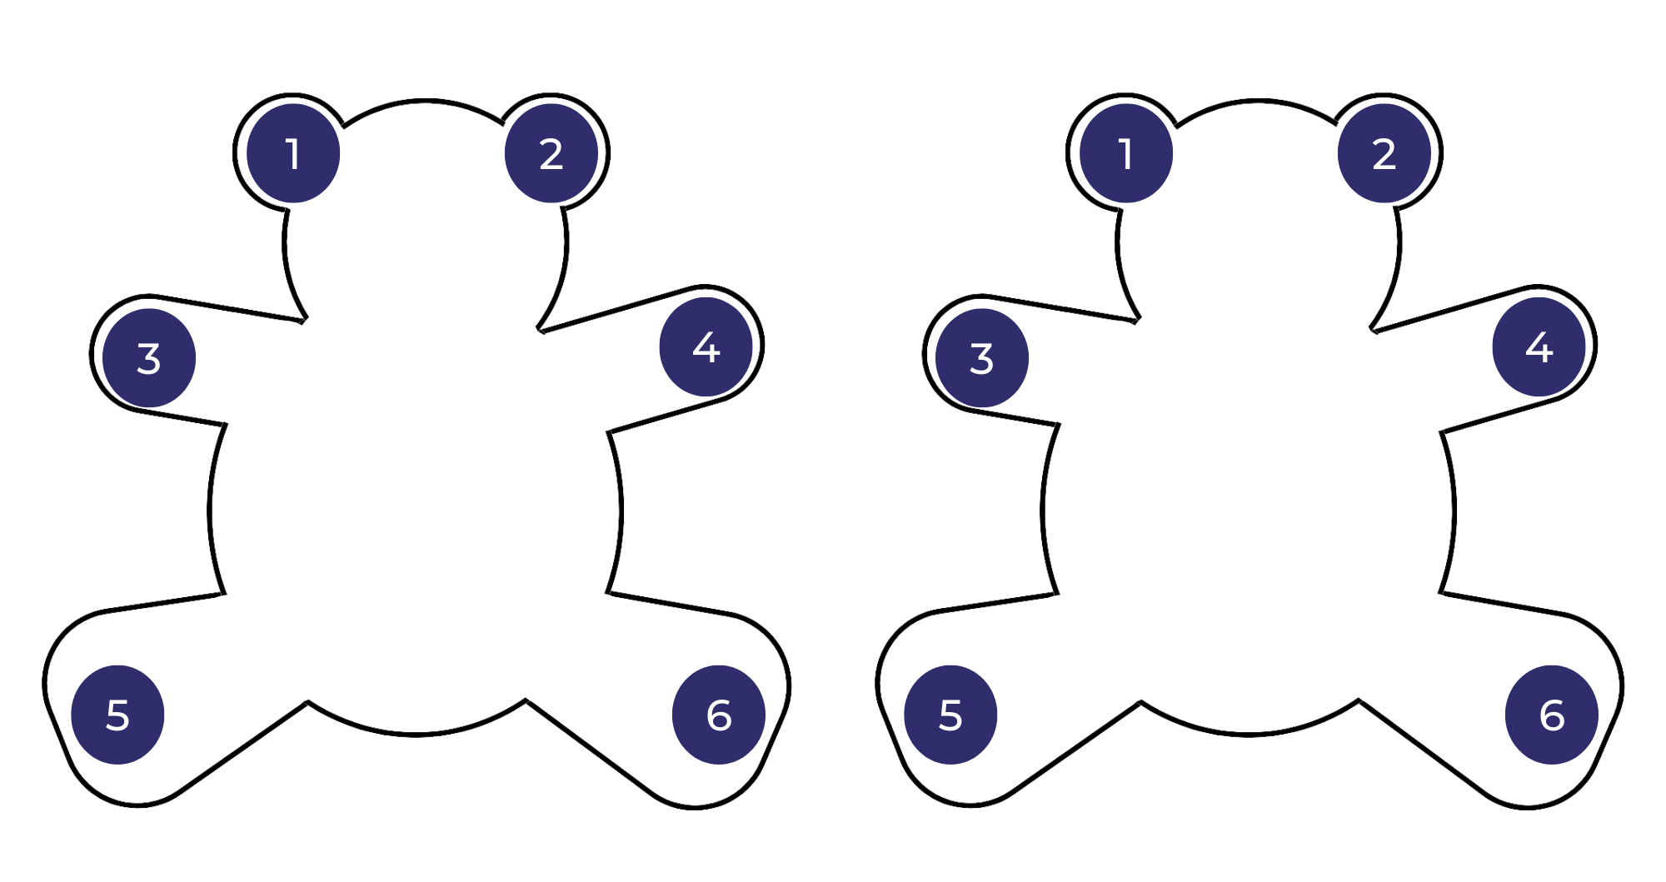

## Resource 2: Amy & Louis text analysis

|  |  |
| --- | --- |
| Page | Visual image, symbol and connotation |
| 1, 2, 3, 4 | The characters are positioned close together and they are often shown looking at each other. This shows a strong connection and friendship between Amy and Louis. |
| 1, 2, 3, 4 | Light, bright colours are used at the beginning of the text to depict the happiness and joy in the characters’ lives. |
| All | The colour red is often used to show love or affection. This colour has been used strategically on each double page and is always worn by both Amy and Louis. |
| 1 | The image shows Amy and Louis lying on the sea of green grass looking at the sky. This is foregrounding their shared connection with the sky and the clouds that are invisible, at this point, to the reader’s eye. |
| 5, 6, 8 | Sepia is used when Amy moves away to ‘the other side of the world’. Colour drains out of the lives of Amy and Louis. The darker tones symbolise sadness. |
| 5, 6 | The symbol of an arrow is used on the removals truck to show the impact of Amy moving away and the distance between the 2 friends. |
| 6 | A worm’s eye view is used when Amy is in the city, making the buildings seem taller and in stark contrast to her old home. This image is also very different to the earlier bird’s-eye view in the image of Amy and Louis lying on the grass looking up at the sky. |
| 6 | The long, vertical lines of the buildings in the 'place where Amy was’ contrast with the soft, rounded lines used in the story’s beginning. |
| 8 | The use of rain and clouds that ‘held only raindrops’ are symbolic of sadness and gloom. |
| All | Amy and Louis’ body language, facial expressions and gaze display their changing emotions throughout the text. |
| 10 | When Louis cries out to Amy, the text ‘Coo-ee Am-ee' overlays the illustration and becomes larger than the setting that separates the 2 friends. This is highlighted further through using a bird’s-eye view of Louis’ yard, street and then ‘the edge of the town’. |
| 12, 13, 14, 15 | The light colour of the blue sky with white clouds signifies a sense of hope. Louis’ gaze and the skyward angle provides an uplifting shift in mood. The stillness of the ocean that separates the friends also signifies calmness and the lighthouse gives a feeling of safety. |
| 12, 13, 14 | The clouds shaped like ‘strange seahorses’ and ‘wild, wild dragons’ are symbolic of creatures carrying a message from Louis to Amy. The clouds’ wispy movements and broad placement across the sky add to the whimsical, imaginative passing of the message between friends. |
| 15 | The light, bright colours that were part of Amy’s life in the beginning of the story have returned, symbolising the beauty of a memory. |
| 15 | The framing of Amy within her window, along with the reflection of the city, brings her back into reality. This time, however, the rain has cleared, and a dream has been carried through the clouds. |

## Resource 3: Blank **–** Image, symbol and emotion

**Title and authors of text**

|  |  |  |  |
| --- | --- | --- | --- |
| **Beginning (orientation)** | **Emotion** | **Image/symbol** | **Retell** |
| What is the setting?  Who are the characters? |  |  |  |
| **Middle (series of events)** | **Emotion** | **Image/symbol** | **Retell** |
| What happens?  How do the characters respond? |  |  |  |
| **End (resolution/conclusion)** | **Emotion** | **Image/symbol** | **Retell** |
| How is the problem solved? |  |  |  |

## Resource 4: Amy & Louis **–** Image, symbol and emotion teacher model

***Amy & Louis* by Libby Gleeson and Freya Blackwood**

|  |  |  |  |
| --- | --- | --- | --- |
| **Beginning (orientation)** | **Emotion** | **Image/symbol** | **Retell** |
| What is the setting?  Who are the characters? | happiness | bright colours  characters close together | Amy and Louis are best friends.  They play together and always go to each other when the other calls ‘Coo-ee’. |
| **Middle (series of events)** | **Emotion** | **Image/symbol** | **Retell** |
| What happens?  How do the characters respond? | sadness  loneliness | sepia tones  arrow on truck | But Amy moved a long way away. She felt lost in the new city.  Louis was left feeling lonely. He stopped doing all the things they used to do together. |
| **End (resolution/conclusion)** | **Emotion** | **Image/symbol** | **Retell** |
| How is the problem solved? | determination  hope | large ‘Coo-ee Am-ee’ text  creatures in the clouds | Louis asked if Amy could hear him if he shouted.  He called out with all his might. Louis saw creatures in the clouds that carried his message to Amy.  Amy heard his cry on the other side of the world. She saw the creatures in the clouds too. |

## Resource 5: Pronoun cloze passage

**A. Select a proper noun or pronoun from the list below and fill in the missing words.**

|  |  |  |  |  |  |
| --- | --- | --- | --- | --- | --- |
| Amy | Louis | she | he | they | them |

Amy was in the sandpit and _______________ called out to Louis.

Louis was on the swing and _______________ called out to Amy.

When they were at home _______________ called to each other across the fence.

One day _______________ and her family moved a long, long way away.

**B. Select a proper noun or pronoun from the list below and fill in the missing words.**

|  |  |  |  |  |  |
| --- | --- | --- | --- | --- | --- |
| Amy | Louis | she | he | they | them |
| me | I | her | his | you | grandma |

When Amy was in the dressing-up corner and Louis was with the playdough, _______________ called to _______________ across the room with the same special word.

‘If I call Amy loudly, she’ll hear _______________, won’t she?’

‘Maybe’, his grandma said, ‘______________ can only try.’

‘I had a lovely dream,’ she said. ‘I dreamt about ______________ and he called _____________.’

## Resource 6: FANBOYS

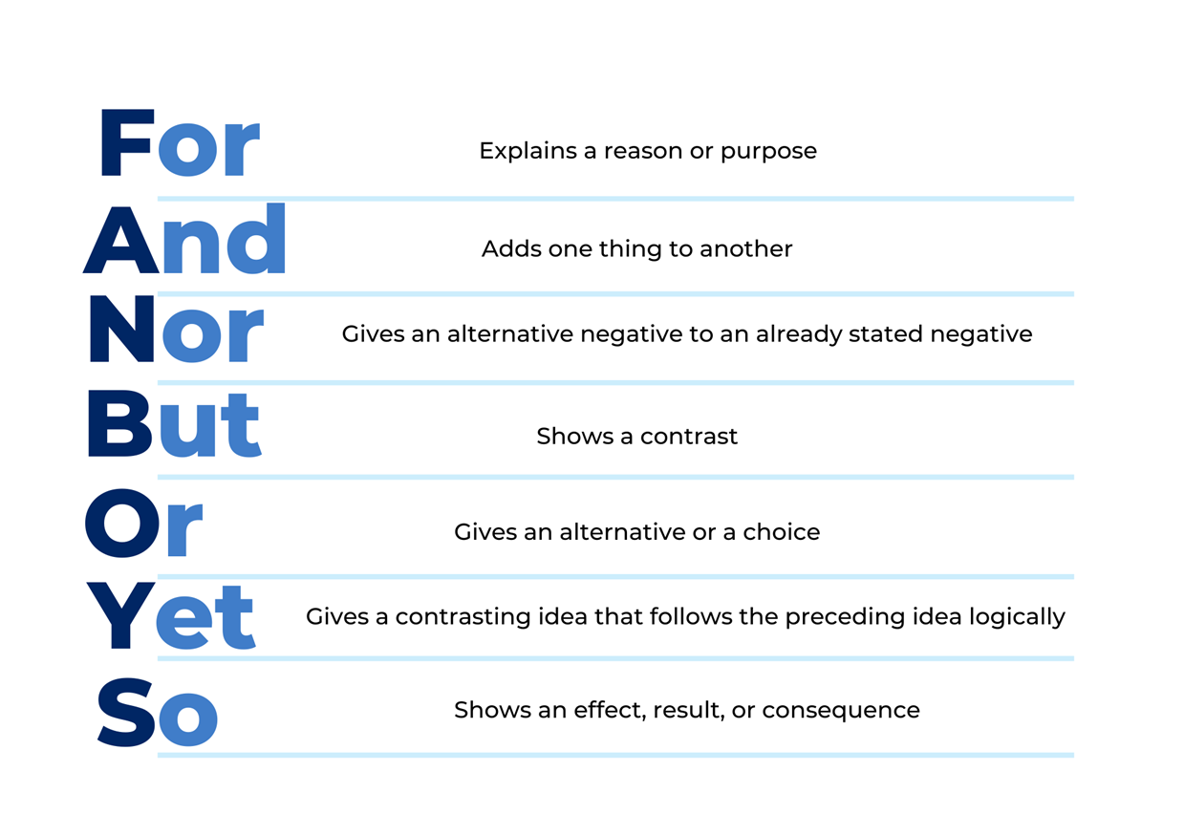

## Resource 7: Mr Huff **–** Image, symbol and emotion teacher model

***Mr Huff* by Anna Walker**

|  |  |  |  |
| --- | --- | --- | --- |
| **Beginning (orientation)** | **Emotion** | **Image/symbol** | **Retell** |
| What is the setting?  Who are the characters? | sadness | grey cloud  cloud growing larger with each negative event | Bill wakes up and looks outside to see it is raining.  He feels sad and frustrated with everything he tries to do. |
| **Middle (series of events)** | **Emotion** | **Image/symbol** | **Retell** |
| What happens?  How do the characters respond? | worry  fear  frustration  bravery | dark clouds and rain – trees without leaves  grey and brown buildings and background  other characters disappear | Bill goes about his day feeling gloomy.  Bill starts to see Mr Huff following him around.  Bill tries to be brave and tells Mr Huff to go away. |
| **End (resolution/conclusion)** | **Emotion** | **Image/symbol** | **Retell** |
| How is the problem solved? | understanding  acceptance  empathy  hopeful | large blue teardrop  Mr Huff gets smaller  characters hold hands  colour and sunshine | Bill notices his reflection in Mr Huff’s tears.  He becomes friends with Mr Huff and his bad mood begins to change.  Bill wakes up the next day feeling hopeful. |

## Resource 8: Multimodal text planning

|  |  |  |  |
| --- | --- | --- | --- |
| Element | A sad thing happens | Something else happened | I felt happy |
| Writing |  |  |  |
| Visual |  |  |  |

## Resource 9: Tiny poems by Sally Murphy

|  |  |  |
| --- | --- | --- |
| Blowing bubbles | Clouds | Rainbow |
| **Bubbles floating**  **In the air**  **Balls of magic**  **Everywhere** | Fluffy clouds  Are floating by  Mounds of ice cream  In the sky | Rainbow gleaming  In the sun  Bridge of joy  For everyone |

Tiny Poems from Teaching poetry for pleasure and purpose by Sally Murphy (2021).

This material has been copied and communicated to you in accordance with the educational use provisions of the *Copyright Act*. Any further reproduction or communication of this material by you may be the subject of copyright protection under the Act. Do not remove this notice – 17 May 2022.

## Resource 10: Online text features and navigation pathways

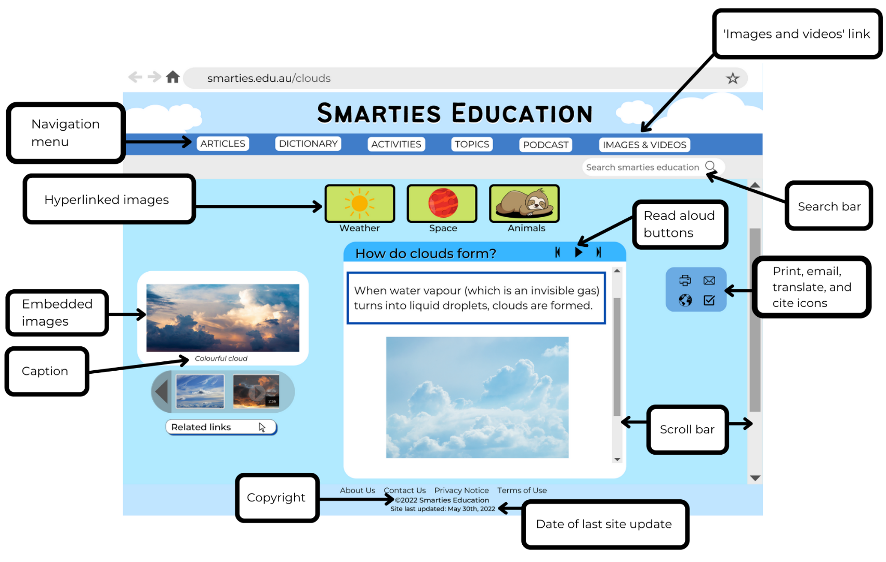

Images sourced from [Canva](https://www.canva.com/) and used in accordance with the [Canva Content License Agreement](https://www.canva.com/policies/content-license-agreement/).

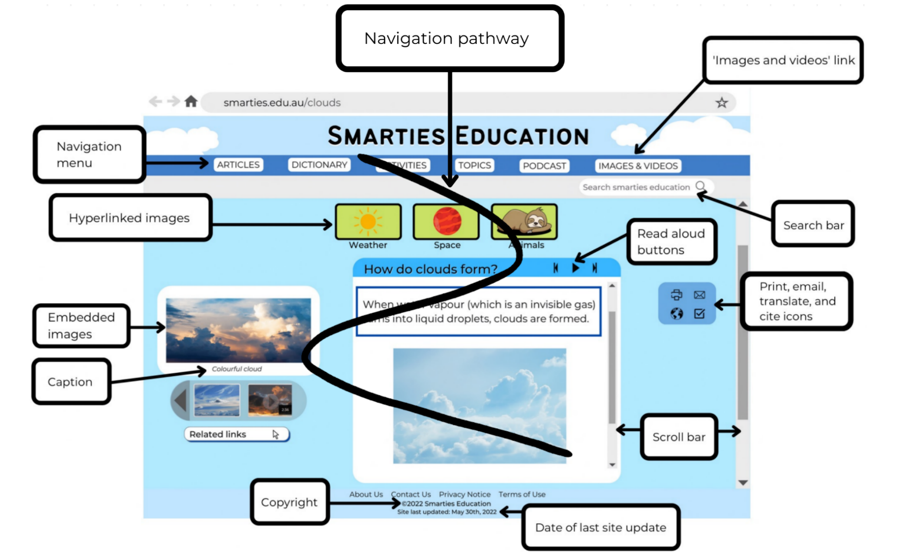

Images sourced from [Canva](https://www.canva.com/) and used in accordance with the [Canva Content License Agreement](https://www.canva.com/policies/content-license-agreement/).

## Resource 11: Visual glossary

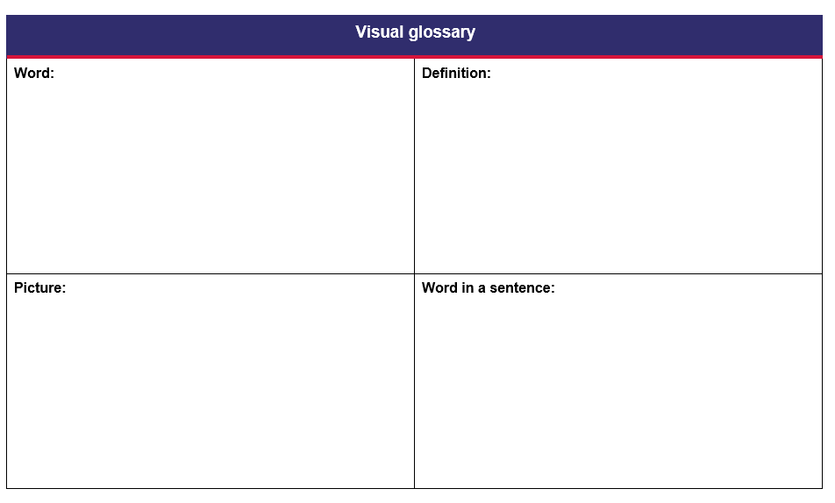

## References

**Links to third-party material and websites**

Please note that the provided (reading/viewing material/list/links/texts) are a suggestion only and implies no endorsement, by the New South Wales Department of Education, of any author, publisher, or book title. School principals and teachers are best placed to assess the suitability of resources that would complement the curriculum and reflect the needs and interests of their students.

If you use the links provided in this document to access a third-party's website, you acknowledge that the terms of use, including licence terms set out on the third-party's website apply to the use which may be made of the materials on that third-party website or where permitted by the *Copyright Act 1968* (Cth). The department accepts no responsibility for content on third-party websites.

Except as otherwise noted, all material is [© State of New South Wales (Department of Education), 2021](https://education.nsw.gov.au/about-us/copyright) and licensed under the [Creative Commons Attribution 4.0 International License](https://creativecommons.org/licenses/by/4.0/). All other material (third-party material) is used with permission or under licence. Where the copyright owner of third-party material has not licensed their material under a Creative Commons or similar licence, you should contact them directly for permission to reuse their material.



[English K–10 Syllabus](https://curriculum.nsw.edu.au/learning-areas/english/english-k-10) © 2022 NSW Education Standards Authority (NESA) for and on behalf of the Crown in right of the State of New South Wales.

[Creative Arts K-6 Syllabus © 2006](https://educationstandards.nsw.edu.au/wps/portal/nesa/k-10/learning-areas/creative-arts/creative-arts-k-6-syllabus) NSW Education Standards Authority (NESA) for and on behalf of the Crown in right of the State of New South Wales.

[PDHPE K–10 Syllabus © 2018](https://educationstandards.nsw.edu.au/wps/portal/nesa/k-10/learning-areas/pdhpe/pdhpe-k-10-2018) NSW Education Standards Authority (NESA) for and on behalf of the Crown in right of the State of New South Wales.

[Science and Technology K–6 Syllabus © 2017](https://educationstandards.nsw.edu.au/wps/portal/nesa/k-10/learning-areas/science/science-and-technology-k-6-new-syllabus) NSW Education Standards Authority (NESA) for and on behalf of the Crown in right of the State of New South Wales.

[© 2021 NSW Education Standards Authority](https://educationstandards.nsw.edu.au/wps/portal/nesa/mini-footer/copyright). This document contains NSW Curriculum and syllabus content. The NSW Curriculum is developed by the NSW Education Standards Authority. This content is prepared by NESA for and on behalf of the Crown in right of the State of New South Wales. The material is protected by Crown copyright.

Please refer to the [NESA Copyright Disclaimer](https://educationstandards.nsw.edu.au/wps/portal/nesa/mini-footer/copyright) for more information.

NESA holds the only official and up-to-date versions of the NSW Curriculum and syllabus documents. Please visit the [NSW Education Standards Authority (NESA)](https://educationstandards.nsw.edu.au/) website and the [NSW Curriculum](https://curriculum.nsw.edu.au/home) website.

[National Literacy Learning Progression](https://www.australiancurriculum.edu.au/resources/national-literacy-and-numeracy-learning-progressions/version-3-of-national-literacy-and-numeracy-learning-progressions/) © Australian Curriculum, Assessment and Reporting Authority (ACARA) 2010 to present, unless otherwise indicated. This material was downloaded from the [Australian Curriculum](http://www.australiancurriculum.edu.au/) website (National Literacy Learning Progression) (accessed 20 December 2022 and was not modified. The material is licensed under [CC BY 4.0](https://creativecommons.org/licenses/by/4.0). Version updates are tracked in the ‘Curriculum version history’ section on the ['About the Australian Curriculum'](http://australiancurriculum.edu.au/about-the-australian-curriculum/) page of the Australian Curriculum website.

ACARA does not endorse any product that uses the Australian Curriculum or make any representations as to the quality of such products. Any product that uses material published on this website should not be taken to be affiliated with ACARA or have the sponsorship or approval of ACARA. It is up to each person to make their own assessment of the product, taking into account matters including, but not limited to, the version number and the degree to which the materials align with the content descriptions and achievement standards (where relevant). Where there is a claim of alignment, it is important to check that the materials align with the content descriptions and achievement standards (endorsed by all education Ministers), not the elaborations (examples provided by ACARA).

ETA (English Teachers Association) and NSW Department of Education (2016) [*The Textual Concepts and Processes resource*](http://englishtextualconcepts.nsw.edu.au/content/textual-concepts-and-processes-resource), English Textual Concepts website, accessed 20 December 2022.

Encyclopaedia Britannica Inc (2022) [*cloud*](https://kids.britannica.com/kids/article/cloud/352973), Britannica Kids website*,* accessed 20 December 2022.

Gleeson L (2007) *Amy & Louis* (Blackwood F, illus.) Scholastic Australia Pty Ltd, Australia.

Murphy S (2021) *Teaching poetry for pleasure and purpose,* Primary English Teachers Association of Australia.

NASA Jet Propulsion Laboratory (2022) ‘[How Do Clouds Form?](https://climatekids.nasa.gov/cloud-formation/)’, NASA Climate Kids website, accessed 20 December 2022.

Seymour J (2019) *Cooee Mittigar: A Story on Darug Songlines* (Mulgo Watson L, illus.), Magabala Books, Australia.

Walker A (2015) *Mr Huff,* Penguin Australia Pty Ltd, Australia.