English – Stage 1 – Unit 6
Contents
Unit overview and instructions for use 3
Teacher notes 4
Outcomes and content – Component A 5
Outcomes and content – Component B 6
Week 1 9
Component A teaching and learning 9
Component B teaching and learning 10
Lesson 1: ‘Imagined world’ representation 11
Lesson 2: Retelling and sequencing 13
Lesson 3: Prepositions to describe the ant expedition 16
Lesson 4: Simple dialogue 17
Lesson 5: Representation in film 19
Week 2 22
Component A teaching and learning 22
Component B teaching and learning 23
Learning intention and success criteria 23
Lesson 6: Representation in factual texts 24
Lesson 7: Diagrams as factual representations 27
Lesson 8: Comparing representations 28
Lesson 9: Writing facts about ants 30
Lesson 10: Writing facts about ants (continued) 32
Resource 1: Dialogue checklist 34
Resource 2: Speech bubble 35
Resource 3: Ant factual photograph 36
Resource 4: Online text features and navigation pathways 37
Resource 5: Comparing texts 39
Resource 6: Ant description 40
Resource 7: Army ant facts 41
Resource 8: Ant habitats 42
References 43

Unit overview and instructions for use
This two-week unit is comprised of Component A and Component B. Connecting learning across both components is encouraged.
Teaching and learning | Component A | Component B
Suggested duration | 60 minutes | 45 minutes
Explicit teaching focus areas | - Phonic knowledge  - Reading fluency  - Reading comprehension  - Spelling  - Handwriting | - Oral language and communication  - Vocabulary  - Reading comprehension  - Creating written texts  - Understanding and responding to literature
To prepare for teaching and learning: | - Refer to Outcomes and content – Component A, K-2 – Instructional sequence – grapheme–phoneme correspondences [PDF 825 KB], and the teaching advice documents (hyperlinked in Component A teaching and learning table).  - Based on student needs identified through ongoing assessment data, plan and document how you will sequence teaching and learning in whole class and targeted teaching groups across the two-week cycle. | - Familiarise yourself with Outcomes and content – Component B, Textual concepts information and videos, English Textual Concepts and Learning Processes (2016), and the teaching and learning sequence.  - Based on student needs identified through ongoing assessment data, determine how you will support students in whole class and targeted teaching groups across the two-week cycle as required.
English K–10 Syllabus © 2022 NSW Education Standards Authority (NESA) for and on behalf of the Crown in right of the State of New South Wales.

Teacher notes
- Representation is defined as ‘the depiction of a thing, person, or idea in written, visual, digital, performed or spoken language and conventions’. – English Textual Concepts and Learning Processes (2016).
- Understanding of representation can be supported through watching the department’s video: Representation (2:46).
- While ‘representation’ is the mentor concept for the conceptual component of this unit, the supporting concept of ‘context’ can be explored using the mentor text The March of the Ants by Ursula Dubosarsky.
- For information on tense, dialogue, quotation marks, and prepositions refer to the NESA Glossary.
- Reflect on student learning and engagement in activities and record differentiation and adjustments within the unit to inform future teaching and learning. One way of doing this could be to add comments to the digital file.
- Content points are linked to the National Learning Progression version (3).
Levels and indicators sourced from National Literacy Learning Progression © Australian Curriculum, Assessment and Reporting Authority (ACARA), (accessed 14 November 2022) and was not modified. See references for more information.

Outcomes and content – Component A
The table below outlines the focus outcomes and content. Content is linked to the National Literacy Learning Progression version (3).
Focus area and outcome | Content points and National Literacy Learning Progression
Phonic knowledge  EN1-PHOKW-01 – uses initial and extended phonics, including vowel digraphs, trigraphs to decode and encode words when reading and creating texts | - blend and decode one-syllable words with taught extended vowel graphs and digraphs, including graphemes for r-controlled vowels and diphthongs, and apply this when reading texts (PKW6, PKW7)
Reading fluency  EN1-REFLU-01 – sustains reading unseen texts with automaticity and prosody and self-corrects errors | - adjust phrasing, intonation, volume or rate to maintain fluency when reading aloud (FlY4)  - vary pace when reading according to the audience and purpose (FlY4)
Reading comprehension  EN1-RECOM-01 – comprehends independently read texts that require sustained reading by activating background and word knowledge, connecting and understanding sentences and whole text, and monitoring for meaning | - identify how creative visual features are used to expand meaning  - use knowledge of text structure, type of text, author, and forms of writing to predict and confirm meaning (UnT6)  - confirm meaning by sequencing and explaining events and information
Spelling  EN1-SPELL-01 – applies phonological, orthographic and morphological generalisations and strategies when spelling words in a range of writing contexts | - segment single-syllable words into phonemes as a strategy for spelling (SpG4)  - use spelling conventions when adding tense-marking suffixes (SpG9)
Handwriting  EN1-HANDW-01 – uses a legible, fluent and automatic handwriting style, and digital technology, including word-processing applications, when creating texts | - form all letters with consistent size and slope in NSW Foundation Style from memory (HwK5)

Outcomes and content – Component B
The table below outlines the focus outcomes and content. Content is linked to the National Literacy Learning Progression version (3).
Focus area and outcome | Content points and National Literacy Learning Progression
Oral language and communication  EN1-OLC-01 – communicates effectively by using interpersonal conventions and language to extend and elaborate ideas for social and learning interactions | - use tense correctly to discuss past, present and future events  - incorporate extended sentences (simple, compound, complex) during dialogue (SpK3)  - recount narratives with key components (SpK3)
Vocabulary  EN1-VOCAB-01 – understands and effectively uses Tier 1, taught Tier 2 and Tier 3 vocabulary to extend and elaborate ideas | - use taught morphemic knowledge to create word families
Reading comprehension  EN1-RECOM-01 – comprehends independently read texts that require sustained reading by activating background and word knowledge, connecting, and understanding sentences and whole text, and monitoring for meaning | - use navigation pathways, including hyperlinks, to extract essential information to support reading fluency and enhance meaning when reading digital texts  - identify how creative visual features are used to expand meaning  - use knowledge of text structure, type of text, author, and forms of writing to predict and confirm meaning (UnT6)  - confirm meaning by sequencing and explaining events and information
Creating written texts  EN1-CWT-01 – plans, creates and revises texts written for different purposes, including paragraphs, using knowledge of vocabulary, text features and sentence structure | - use a logical order to sequence ideas and events in sentences across a text (GrA4)  - use contextually precise prepositional phrases when creating texts (GrA4)  - use quotation marks for simple dialogue (PuN5)  - identify the context, audience and purpose for own texts (CrT5, CrT6)  - use a variety of planning strategies and tools for creating texts
Understanding and responding to literature  EN1-UARL-01 – understands and responds to literature by creating texts using similar structures, intentional language choices and features appropriate to audience and purpose | - express personal responses to the real and imagined worlds that are represented in texts  - adapt a well-known text for a different audience and/or purpose  - identify how the language and form of a text vary according to purpose, audience and mode (UnT5)

Week 1

Component A teaching and learning
The table below can be used to plan and document lessons that address Component A outcomes and content. Both the detailed example [DOC 529KB] of a two-week teaching and learning cycle and brief example [DOC 66KB] may support you in your planning.
Focus Areas | Lesson 1 | Lesson 2 | Lesson 3 | Lesson 4 | Lesson 5
Phonic knowledge
15 minutes
Spelling and Handwriting
15 minutes
Reading comprehension and Reading fluency
30 minutes

Component B teaching and learning
The following teaching and learning sequence has been designed to address Component B outcomes and content. Adapt the sequence as required to best meet the needs of your students.

Learning intention and success criteria
Learning intentions and success criteria are best co-constructed with students.

Learning intention
Students are learning to understand how real and imagined characters can be represented using text structure, words and images.

Success criteria
Students can:
- describe how characters can be represented
- share personal responses to texts
- use morphemic knowledge to create word families
- use illustrations and words to represent characters
- sequence ideas and events in a logical order
- use quotation marks for simple dialogue.

Resources
- Dubosarsky U (2021) The March of the Ants (Riddle T, illus.), Book Trail Press, Australia. ISBN: 9780648498919
- Resource 1: Dialogue checklist (enlarged copy)
- Resource 2: Speech bubble
- Video: Flik Takes Flight | A Bugs Life | Disney Channel UK (1:10)
- A hoop
- A picture of an ant, or a rolled-up pair of socks or stockings shaped like an ant
- Large sticky notes

Lesson 1: ‘Imagined world’ representation
- Introduce the concept of representation. Explain that students will be reading and viewing texts to learn about how the same thing – an ant – can be represented for a range of purposes in a variety of modes.
Note: Representation is the depiction of a thing, person or idea in written, visual, digital, performed or spoken language and conventions.
- Display the text The March of the Ants. Encourage students to make predictions about the text using the front and back covers, title and illustrations.
- Read The March of the Ants. Identify the text’s audience (children) and purpose (to entertain). Highlight that this text is a narrative, and the ants are represented as characters in an ‘imagined world’.
- Look at the illustrations in the text and write on sticky notes, or slips of paper, information about how the ants are represented. Place each piece of information inside a large hoop that is labelled ‘imagined world’. Examples may include, the ants have 2 large eyes, they have 6 legs, the ants walk upright on 2 legs, they have 3 main parts to their bodies, the ants can carry things with their ‘arms’, they are black, they live with other ants, the ants walk in a line. Encourage students to make connections with the way the ants have been represented with human characteristics.
- Reread the written text to find additional information about how the ants are represented. Add to the previous examples. Points may include, the ants can talk; they have feelings such as hope, fear, sadness; the ants can read; they belong to an ant army; the ants march day and night; there is a chief ant.
- Review pages that show how different personality characteristics and feelings are represented through a range of creative visual features. Include examples such as:
- the chief ant is larger than the other ants and is standing on a rock pointing to show he is the leader
- drooped eyelids and a red squiggle above the littlest ant’s head are used to show she is unhappy
- the ants have slumped body language and fearful expressions on the page where it is explained that they are sad and want to give up hope; the background is also dark and there are large menacing grasshoppers in the background
- the ants are smiling on the final page to show they had hope in their hearts; the background is also light, and the sun is shining.
- Provide students with paper and drawing materials to create an ‘imagined world’ illustration of an ant in the same style as the illustrator Tohby Riddle. Encourage students to consider human characteristics such as how the ant’s emotions are represented, as well as features that are typical of ants in the ‘real world’.
- Students write short captions near their illustration to identify the features they are representing. Provide the opportunity for students to share their representations and the reflect on features they have included in small groups.
Too hard? Small group support may be provided to support the writing of captions.
Assessment task 1 – Observations from this lesson allow students to demonstrate achievement towards the following syllabus outcomes and content points:
EN1-RECOM-01 – comprehends independently read texts that require sustained reading by activating background and word knowledge, connecting, and understanding sentences and whole text, and monitoring for meaning
- identify how creative visual features are used to expand meaning
- use knowledge of text structure, type of text, author, and forms of writing to predict and confirm meaning.
EN1-UARL-01 – understands and responds to literature by creating texts using similar structures, intentional language choices and features appropriate to audience and purpose
- express personal responses to the real and imagined worlds that are represented in texts.

Lesson 2: Retelling and sequencing
- Explain that students are going to retell The March of the Ants including important words from the story. Write the sentence from the text, The ants were heading off on a very important expedition. Explain the meaning of the word ‘expedition’. Have students repeat the word so they can learn the correct pronunciation. Provide an example of the word in a new context and have students create their own oral sentence using the word. Write a jointly constructed definition and example sentence. Complete the same process for the words ‘destination’ and ‘determined’ or ‘dismayed’. Leave the vocabulary retrieval chart in a location that is easy to access and add to throughout this unit of learning.
- Model retelling The March of the Ants, moving through the text without reading word-for-word. Stop and show points where the author has used words to support sequencing. For example, until, one night, finally, after. Individual students can be involved by telling a part of the story as each page is displayed. Write a list of the sequencing words and phrases that were used during the retell for ongoing reference.
- Use a storyboard or story-map to draw the story sequence. Highlight how past tense verbs were used when retelling because the events have already occurred. Use an interactive writing strategy to construct sentences that describe the first 2 events. Highlight the past tense verbs. For example, each ant told the Chief Ant what they were going to bring. Explain how word families can be created with present and past tense verb forms, such as tell-told, was-were. Read out other verbs that are relevant to the text for students to orally change into past tense, such as march-marched, drink-drank, look-looked, eat-ate, open-opened, gather-gathered, listen-listened, close-closed, feel-felt.
- In small groups, students take turns to orally retell The March of the Ants, recounting key elements in past tense and ordering using sequencing words. Observe students use of the vocabulary and comprehension of the text.
Too hard? Limit the sequencing words to ‘first’, ‘then’ and ‘in the end’ to highlight the beginning, middle and end structure of the narrative.
Too easy? Students create their own story map as a basis for their oral retell.
- Explicitly teach the connection between oral language and written language, for example, people write in sentences but tend to speak in clauses; oral language uses filler sounds and words, like ‘um,’ and ‘er.’ Highlight how the use of sequencing words and a story-map supported more cohesive oral retells.
- Revisit the written retell sentences from activity 3. Divide the story board or story-map into sections and allocate to each group. Explain that each group will write sentences to match the events in the story.
- In small groups, students continue to write a summary of the key events from the text. This can be completed on strips of paper which can later be pasted near each image on the storyboard or story-map.
- As a class, read through each group’s retell in order. Discuss any changes that may be required to ensure the sequence of events across the text is correct and cohesive. Place sentences with the images for display in the classroom.
Too hard? Students write simple sentences to represent an event from the beginning, middle or end of the text.
Too easy? Students continue writing independently using sequencing words, innovating from the original story.
Assessment task 2 – Observations and work samples from this lesson allow students to demonstrate achievement towards the following syllabus outcomes and content points:
EN1-OLC-01 – communicates effectively by using interpersonal conventions and language to extend and elaborate ideas for social and learning interactions
- recount narratives with key components
- incorporate extended sentences (simple, compound, complex) during dialogue
- use tense correctly to discuss past, present and future events.
EN1-VOCAB-01 – understands and effectively uses Tier 1, taught Tier 2 and Tier 3 vocabulary to extend and elaborate ideas
- use taught morphemic knowledge to create word families.
EN1-RECOM-01 – comprehends independently read texts that require sustained reading by activating background and word knowledge, connecting and understanding sentences and whole text, and monitoring for meaning
- confirm meaning by sequencing and explaining events and information.
EN1-CWT-01 – plans, creates and revises texts written for different purposes, including paragraphs, using knowledge of vocabulary, text features and sentence structure
- use a logical order to sequence ideas and events in sentences across a text.

Lesson 3: Prepositions to describe the ant expedition
- Play a game called ‘Where is the ant?’ Using a picture of an ant, a rolled-up pair of socks or stockings shaped like an ant, place the ant into different positions and have students verbalise the position. For example, the ant is sitting near the door, the ant is in the box, the ant is climbing on the table.
Note: A preposition is a word that begins an adverbial phrase or an adjectival phrase to indicate a circumstance such as time, place, manner or causality, for example, in, on, after, before, by, under, over, of. A prepositional phrase consists of a preposition followed by a noun or pronoun, for example, in ‘The ant is crawling under the table’ – ‘under the table’ is the prepositional phrase.
- Refer to the first page in The March of the Ants. Write the sentence, ‘The ants were heading off on a very important expedition.’ Ask students to identify the phrase that has the preposition. Explain that ‘on’ is the preposition and ‘a very important expedition’ is the prepositional phrase that describes the ‘place’ where the action occurred. Asking the question ‘Where were they headed off?’ can help to identify the prepositional component of the sentence.
- Look through the illustrations in the text and list positional words and phrases that could be used to describe circumstances relayed to place. For example, the ants marched over the bridge, the littlest ant sat on the rock.
- Model how to write simple sentences with prepositional phrases describing the ants’ expedition. Reinforce how past tense verbs are being used throughout. Share the pen, allowing students to trace over the preposition in a different colour and underline the entire phrase. For example, one after the other, the ants marched past termite mounds and through the dusty sand; they trudged up hills and walked down the other side; they built bridges and jumped over crevices; on and on they marched.
- To plan for writing, students talk with a partner and draw a picture of the ants during one part of their expedition. Using the mentor text and modelled example as a guide, students write sentences containing prepositional language to describe place or position.
- Share writing as a class and place additional exemplars to the model created earlier in the lesson for ongoing reference.
Too hard? Students write simple sentences to represent an event from the beginning, middle or end of the text.
Too easy? Include prepositions which describe the circumstance of time.

Lesson 4: Simple dialogue
- Review the concept of representation and how the text creators of The March of the Ants have given the ants human-like characteristics, including being able to talk.
- Reread the text with a focus on identifying when character dialogue is used. This can be done by students placing their hands on their head each time a character speaks.
- Revise the first 2 pages of the text where each ant chooses something to bring on the expedition. Explain that when dialogue is included in texts, authors use a set of rules or conventions. Display an enlarged copy of Resource 1: Dialogue checklist. Model using the checklist to identify the dialogue conventions in the text.
- Ask students to imagine they are an ant in the story. Ask what special item they would take on the expedition and why it would be useful. Allow students time to generate ideas and respond using a ‘because’ statement. For example, ‘I would bring a torch because it would help me see at night.’
- Using the ideas generated, students act out a scene with the Chief Ant asking each ant what they are going to bring. Highlight why students do not need to say ‘said the first ant’ or ‘he said’ during the scenes.
- Draw a picture of an ant with a large speech bubble. Write an example of the spoken text inside the speech bubble. For example, I’m bringing my hat.
- Using Resource 2: Speech bubble, students write what item they would bring as an ant on the expedition.
- Students check their text with a partner. Discuss how orally constructing sentences and writing them in a speech bubble are both effective strategies to use when planning to write dialogue.
- Referring to Resource 1: Dialogue checklist, model writing direct speech, including quotation marks. For example, “I’m bringing my hat,” said Jacob the ant.
- Students use their writing plan to rewrite their dialogue in a sentence with quotation marks.
- Share work samples and provide feedback about the correct placement and formation of quotation marks.
Too hard? Provide students with sentences including direct speech and have them add quotation marks in the correct position.
Too easy? Students write dialogue showing a conversation between 2 or more characters.
Assessment task 3 – Collecting work samples from this lesson allows students to demonstrate achievement towards the following syllabus outcome and content point:
EN1-CWT-01 – plans, creates, and revises texts written for different purposes, including paragraphs, using knowledge of vocabulary, text features and sentence structure
- use quotation marks for simple dialogue
- use a variety of planning strategies and tools for creating texts.

Lesson 5: Representation in film
- Revise the concept of representation.
- Show students the video Flik Takes Flight | A Bugs Life | Disney Channel UK (1:10). Pause the video at (0.06). Students predict the type of text that this may be from, including its audience and purpose. Based on their understanding of narrative structure, encourage students to predict what event, or part of the story, this image may be from.
- View the video excerpt Flik Takes Flight | A Bugs Life | Disney Channel UK (1:10). Ask students what they noticed about how the ants have been represented in the animation. Highlight how the creators have given Flik a personality. For example, he was adventurous and resourceful because he had a problem and found a novel solution. Add information about the representation of ants, in a different colour, to the ‘imagined world’ list from Lesson 1.
- Brainstorm with students what may happen next in the Flik Takes Flight clip. Encourage students to consider where Flik may go and what he may say to the other characters.
- Model drawing Flik with a speech bubble. Write something Flik might say inside. For example, Wow! I made it. Students complete their own version.
- Add to the modelled example a description of what Flik does next with specific details about position using prepositional language. Include the dialogue as complete text with the correct conventions. For example, Flik looked up at his friends on the top of the cliff. “Wow! I made it,” he yelled. Next, Flik turned around, waved his hand in the air, and started walking between the canyons on his next big adventure.
- Provide the opportunity for students to create their own draft that represents Flik saying and doing something as a character.
- In targeted writing groups, students share drafts with a direct focus on the use of a logical order of events, the use of prepositional phrases and quotation marks.
- Students complete final draft of their text for sharing and display.
Too hard? Support small groups/individuals to verbalise sentences to be scribed. Cut up sentences for students to put in order with correct punctuation conventions.
Too easy? Students continue developing a series of events which includes dialogue from more than one character.
Assessment task 4 – Observations and work samples from this lesson allow students to demonstrate achievement towards the following syllabus outcomes and content points:
EN1-RECOM-01 – comprehends independently read texts that require sustained reading by activating background and word knowledge, connecting and understanding sentences and whole text, and monitoring for meaning
- use knowledge of text structure, type of text, author, and forms of writing to predict and confirm meaning.
EN1-CWT-01 – plans, creates, and revises texts written for different purposes, including paragraphs, using knowledge of vocabulary, text features and sentence structure
- use quotation marks for simple dialogue
- use a variety of planning strategies and tools for creating texts.
EN1-UARL-01 – understands and responds to literature by creating texts using similar structures, intentional language choices and features appropriate to audience and purpose
- express personal responses to the real and imagined worlds that are represented in texts
- adapt a well-known text for a different audience and/or purpose.

Week 2

Component A teaching and learning
The table below can be used to plan and document lessons that address Component A outcomes and content. Both the detailed example [DOC 529KB] of a two-week teaching and learning cycle and brief example [DOC 66KB] may support you in your planning.
Focus Areas | Lesson 6 | Lesson 7 | Lesson 8 | Lesson 9 | Lesson 10
Phonic knowledge
15 minutes
Spelling and Handwriting
15 minutes
Reading comprehension and Reading fluency
30 minutes

Component B teaching and learning
The following teaching and learning sequence has been designed to address Component B outcomes and content. Adapt the sequence as required to best meet the needs of your students.

Learning intention and success criteria
Learning intentions and success criteria are best co-constructed with students.

Learning intention
Students are learning to understand how real and imagined characters can be represented differently using text structure, words, and images.

Success criteria
Students can:
- navigate digital texts that use images, text, and hyperlinks
- represent real and imagined characters using words and images
- compare different representations of animals and characters
- use prepositional phrases when creating texts.

Resources
- Dubosarsky U (2021) The March of the Ants (Riddle T, illus.), Book Trail Press, Australia. ISBN: 9780648498919
- Resource 3: Ant factual photograph.
- Resource 4: Online text features and navigation pathways
- Resource 5: Comparing texts
- Resource 6: Ant description
- Resource 7: Army ant facts
- Resource 8: Ant habitats
- 10 Cool Facts About Ants!
- Video: Amazing Animals: Army Ant (1:46)
- A4 paper to be folded in half (one per student)
- Examples of labelled diagrams

Lesson 6: Representation in factual texts
- Show the image on Resource 3: Ant factual photograph. Students predict the type of text this may be from, including its audience and purpose. Make comparisons with the ant representations in The March of the Ants and A Bug’s Life. Ask how they are the same and different. Students write a sentence they predict would accompany the image. Share responses as a class.
- View 10 Cool Facts About Ants. Identify the text’s audience (children) and purpose (to inform). Highlight that this text is a factual description, and the ants are represented as creatures that live in the ‘real world’.
- Explore the navigation pathways and tools on the page, including the use of embedded images and captions, and the hyperlinked images located at the top of the page along with the search feature. Explain that National Geographic Kids is a trusted source, and that the website is updated regularly.
Note: For support in reading and viewing digital and online texts, see Digital and multimodal texts and Resource 4: Online text features and navigation pathways.
- Use the think-aloud strategy to describe how informative texts are read and how this differs from when we read or view ‘for a story’. Create a T-chart that displays the headings, ‘Reading for a story’ and ‘Reading for information’. In each column write the differences between how audiences read these types of texts. An example is provided in Resource 5: Comparing texts.
- On sticky notes or slips of paper, write information about ants and how they are represented on the website. Place each piece of information inside a large hoop that is labelled ‘real world’. Examples may include: a close-up photo of an ant is used, there is a heading at the top of the page, key information is written in bold, subject-specific vocabulary is used. Support students to find connections between the information in this text and observations made about ants in the previous ‘imagined’ texts.
- Revisit student predictions from activity 1.
- Explain that the text on the website 10 Cool Facts About Ants! uses present tense verbs because the information is not impacted by time. Select sentences from the text to illustrate. For example, ants have 6 legs; ants live in nests. As appropriate, include references to present tense relating verbs such as, is, are, have, has, can. Give students example sentences from the text to turn into past tense to recognise the difference. For example, ants are insects/ants were insects; ants live in colonies/ants lived in colonies.
- Identify the importance of understanding subject-specific vocabulary in factual texts. To support comprehension key terms, explain the meaning of the word ‘species’. Have students repeat the word so they can learn the correct pronunciation. Provide an example of the word in a new context and have students create their own oral sentence using the word. Support students to construct sentences in present tense.
- Write a jointly constructed definition and example sentence on the vocabulary retrieval chart introduced in Lesson 2. Complete the same process for other words such as ‘insect’, ‘colony’ and ‘vibrations’. Continue to add to the vocabulary chart as needed throughout the rest of this unit of learning.
Too hard? Identify key vocabulary and have students match definitions.
Too easy? Students explore the website to identify unfamiliar vocabulary and find definitions using a glossary or dictionary.
Assessment task 5 – Observations and work samples from this lesson allow students to demonstrate achievement towards the following syllabus outcomes and content points:
EN1-OLC-01 – communicates effectively by using interpersonal conventions and language to extend and elaborate ideas for social and learning interactions
- use tense correctly to discuss past, present and future events.
EN1-VOCAB-01 – understands and effectively uses Tier 1, taught Tier 2 and Tier 3 vocabulary to extend and elaborate ideas
- use taught morphemic knowledge to create word families.
EN1-RECOM-01 – comprehends independently read texts that require sustained reading by activating background and word knowledge, connecting and understanding sentences and whole text, and monitoring for meaning
- use navigation pathways, including hyperlinks, to extract essential information to support reading fluency and enhance meaning when reading digital texts
- identify how creative visual features are used to expand meaning
- use knowledge of text structure, type of text, author, and forms of writing to predict and confirm meaning.

Lesson 7: Diagrams as factual representations
- Find examples of labelled diagrams in books and on charts. As a class, look up images of ants on the internet and discuss why images are important in a factual text. Using the image from the 10 Cool Facts About Ants, highlight how it expands meaning to the written text.
- Display diagrams and draw attention to significant features. Explain that diagrams are graphic texts that:
- work together with written text to make meaning
- are clear and uncluttered drawings or images
- provide accurate information and specific details
- include lines or arrows connecting the labels with relevant parts of the image.
- Explain that students are going to create their own diagram of an ant based on their background knowledge, the information they have read on the website, and an additional text that will be read to them.
- Brainstorm features that students will include in their diagrams. For example, 3 body parts, 6 legs and 2 antennae on the ant’s head. Provide time for students to visualise their diagram based on the information shared.
- To extend students’ visualisations, read the information in Resource 6: Ant description. Pause and give time for students to visualise their diagram again and orally share how their mental image of an ant changed.
- Provide students with sheets of paper and pencils to create their diagram. Encourage students to draw as precisely as possible and in as much detail as possible. Refer students to the images displayed in the classroom.
- Give students opportunities to discuss and decide on labels for their drawings. These can be a combination of scientific terms and descriptive language. Students may decide to use single-word labels or short phrases to describe various features.
- Students share their labelled diagrams with each other and look at the range of features that were included by different students. Compare and contrast with the model diagrams and labels displayed in the classroom.
- Reflect on the use of detailed diagrams as a form of representation.
Assessment task 6 – Observations and work samples from this lesson allow students to demonstrate achievement towards the following syllabus outcomes and content points:
EN1-RECOM-01 – comprehends independently read texts that require sustained reading by activating background and word knowledge, connecting and understanding sentences and whole text, and monitoring for meaning
- identify how creative visual features are used to expand meaning.
EN1-UARL-01 – understands and responds to literature by creating texts using similar structures, intentional language choices and features appropriate to audience and purpose
- adapt a well-known text for a different audience and/or purpose.

Lesson 8: Comparing representations
- Watch Amazing Animals: Army Ant (1:46) and explain to students that they are going to watch the clip several times to learn about the techniques used to represent the subject – ants.
- During the first viewing, students look for the text features used. Discuss and add responses to the ‘real world’ hoop. These will include the title or heading at the beginning, a photograph (not illustration), the narrator (spoken) provides facts about ants, the close-up camera shots show fine-grain details about ant features, a map shows where ants live, key facts are written. Discuss the text creators use of ant dialogue. Ask how this feature relates to the audience and purpose of the text and how it relates to students’ understanding of ‘imaginary world’ and ‘real world’ representations.
- During the next viewing, students listen for facts that are provided. Give students the opportunity to write key words or draw quick images during and after the clip to support remembering. Record the facts that students recall. A sample list has been provided in Resource 7: Army ant facts. Watch the clip again for students to reidentify the facts that have been recalled collectively.
- Discuss how the information provided in Amazing Animals: Army Ant (1:46) relates to the representations that were included in the narrative The March of the Ants. Students discuss commonalities in small groups.
- Review The March of the Ants page by page and have students identify from the list of ‘army ant facts’, information that aligns with representations in the book. For example, ‘They marched and marched for days and nights (imaginative text)’; ‘Ants travel long distances at night (informative text)’.
- Fold a piece of paper in half. On one side, model selecting and drawing a section of the narrative. Include the matching written text. On the other side, model selecting and drawing a related factual piece of information.
- Students complete their own example that shows a similar piece of information represented in both imaginative and informative ways.
- Share work samples as a class and reflect on how there can be a cross over between ‘imaginative’ and ‘factual’ representations. Cross over hoops to create a Venn diagram out of the information collected during previous lessons as an illustration.
Too hard? Provide students with one section of the narrative and a small number of facts from the clip for students to select.
Too easy? Students add a new event to the narrative based on a fact they learnt when viewing Amazing Animals: Army Ant (1:46).
Assessment task 7 – Observations and work samples from this lesson allow students to demonstrate achievement towards the following syllabus outcomes and content points:
EN1-RECOM-01– comprehends independently read texts that require sustained reading by activating background and word knowledge, connecting and understanding sentences and whole text, and monitoring for meaning
- use navigation pathways, including hyperlinks, to extract essential information to support reading fluency and enhance meaning when reading digital texts
- identify how creative visual features are used to expand meaning.
EN1-UARL-01– understands and responds to literature by creating texts using similar structures, intentional language choices and features appropriate to audience and purpose
- express personal responses to the real and imagined worlds that are represented in texts.

Lesson 9: Writing facts about ants
- Revise prepositional phrases and their role in providing additional information about circumstances such as time and place. Remind students of how these were used in the previous week’s narrative texts to describe the characters’ journey.
- Outline that prepositional phrases are used in factual texts and are important in adding specific details about a topic. Show students the text in Resource 8: Ant habitats. Identify the prepositional language that has been used to describe ant habitats. Reinforce the use of present tense and how the information has been organised in a logical order.
- Explain that students will create their own version of the 10 Cool Facts About Ants and the Amazing Animals: Army Ant (1:46) ‘Fun Facts’ (which are presented at the end of the clip).
- Discuss the context and purpose of the texts that students will create and their target audience for sharing.
- Model writing a series of succinct facts about ants that incorporate background knowledge gained during previous lessons. Create a criterion for writing, including items such as a title, a logical order or sequence and prepositional phrases. For example:
- There are a lot of ants in the world. They live in all countries except for in Antarctica.
- Ants don’t have ears, and some of them don’t have eyes.
- Ants are very strong. They can carry heavy things on their neck.
- Ants hibernate under the ground during winter.
- Ants walk in lines along the ground. This is because they can smell each other.
- To plan for writing, organise students into small groups. Support students to orally provide facts in present tense, and to expand on ideas using a range of sentence types. Students may choose to quickly draft ideas or key words when participating in this planning activity.
- Students use their developing knowledge of ants to write 2-3 facts.
- To review writing, students work with a partner to read aloud each fact and identify if the text meets the criterion. Prepositional words and/or phrases can be identified in sentences.
Too hard? Support students in small groups as required.
Too easy? Students create extended facts with the use of Tier 3 vocabulary and a range of sentence types.

Lesson 10: Writing facts about ants (continued)
- Review the factual writing task from Lesson 9. Discuss and display student examples that will further support idea generation and the construction of factual sentences.
- Provide time for students to practise skills by adding one to two facts to their text. Repeat the use of reading facts aloud to a partner as a form of review and feedback.
- Students rewrite or type facts and add their diagram from Lesson 7.
Too hard? Support students in small groups as required.
Too easy? Students create extended facts with the use of Tier 3 vocabulary and a range of sentence types.
- Students share their work in small groups or as a gallery walk prior to sharing with their identified target audience.
Assessment task 8 – Observations and work samples from this lesson allow students to demonstrate achievement towards the following syllabus outcomes and content points:
EN1-CWT-01 – plans, creates, and revises texts written for different purposes, including paragraphs, using knowledge of vocabulary, text features and sentence structure
- use contextually precise prepositional phrases when creating texts
- identify the context, audience and purpose for own texts
- use a variety of planning strategies and tools for creating texts
EN1-UARL-01 – understands and responds to literature by creating texts using similar structures, intentional language choices and features appropriate to audience and purpose
- adapt a well-known text for a different audience and/or purpose
- identify how the language and form of a text vary according to purpose, audience and mode.

Resource 1: Dialogue checklist
Students can use a dialogue checklist to assess simple dialogue.
Dialogue Checklist | Dialogue Checklist
- Speech marks go around exactly what is spoken.  - A capital letter is used at the start of what is spoken.  - There is a piece of punctuation before the close of quotation marks.  - Saying verbs are used to describe how the speech is spoken.  - A new line is used when each new character speaks. | - Speech marks go around exactly what is spoken.  - A capital letter is used at the start of what is spoken.  - There is a piece of punctuation before the close of quotation marks.  - Saying verbs are used to describe how the speech is spoken.  - A new line is used when each new character speaks.

Resource 2: Speech bubble
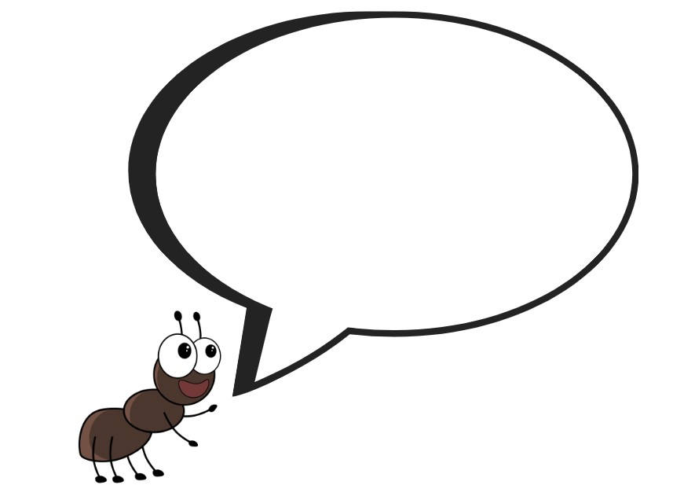
Images sourced from Canva and used in accordance with the Canva Content License Agreement.

Resource 3: Ant factual photograph
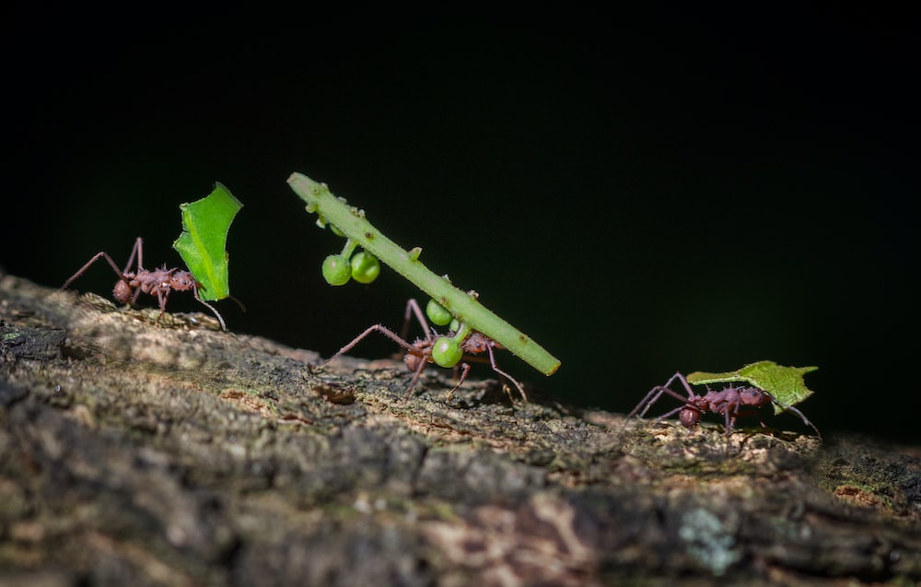
“HD photo” by Jorge Coromina is licensed under the Unsplash License.

Resource 4: Online text features and navigation pathways
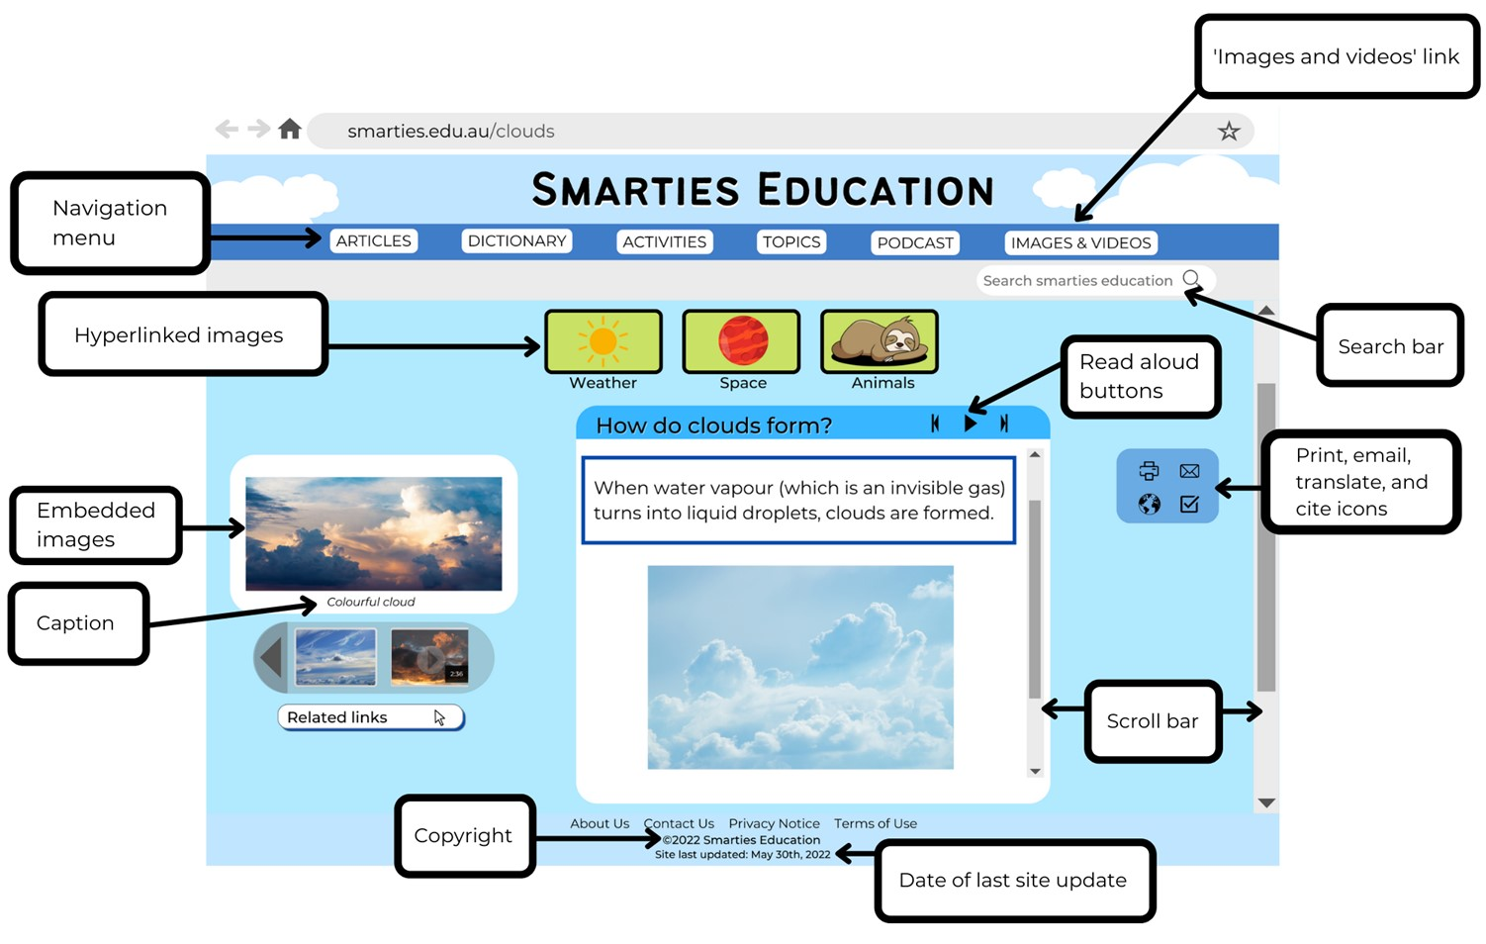
Images sourced from Canva and used in accordance with the Canva Content License Agreement.
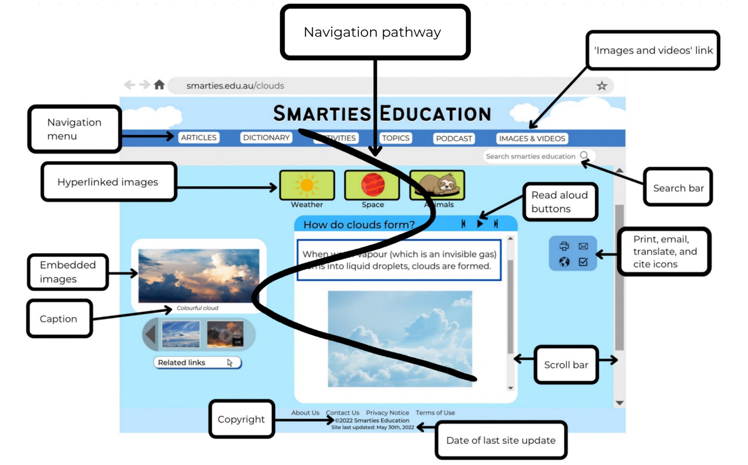
Images sourced from Canva and used in accordance with the Canva Content License Agreement.

Resource 5: Comparing texts
Reading for a story | Reading for information
- we read the whole text  - we start at the front and end at the back  - we read from top to bottom and left to right  - the first is where we enter the story  - illustrations can be used to add meaning to the story  - the story finishes at the end of the book | - we can choose to only read part of the text  - we can start at the front, the back or somewhere in-between  - we can enter the text through:  - the contents page  - index  - heading  - pictures or captions  - the photos, illustrations and diagrams can be used for meaning  - we might go backwards and forwards through the text

Resource 6: Ant description
An ant’s body is made up of 3 parts. They are the head, the thorax and the abdomen. The head is at the top, the thorax is in the middle and the abdomen is at the rear of the ant.
Ants have 2 eyes on the top of their head. They also have 2 antennae. One on each side of the head. The antennae help ants to hear, touch, taste and smell. Ants use their antennas to touch one another. This is how they ‘talk’ to each other. The head of an ant also has a strong pair of jaws called a mandible. The mandible grabs on to objects, to eat and to fight. An ant’s mouth is found between the 2 mandibles.
Ants have 6 joined legs. These are attached to each side of the thorax. Each leg has a small hook at the end that allows the any to climb over objects.
The abdomen is the last part of an ant's body. Some worker ants have a small sting at the end to which they use to spray acid to defend themselves.

Resource 7: Army ant facts
Facts taken from National Geographic Kids – Amazing Animals (Army Ant)
Ants can travel long distances at night.
Army ants march over the jungle floor killing everything in their path.
Ants talk to each other by leaving chemical trails.
Ants join their bodies together to build giant nests.
Ants don’t build permanent nests.
You will find army ants in tropical rainforests.
Ants have different jobs. These include, soldier ant, forager ant, nursery ants and queen ant.
Ants live in a colony.
Worker army ants are often blind

Resource 8: Ant habitats
Ants are found almost everywhere on the planet. They mostly live in nests that are made from soil, sand, wood and leaves.
Some ants build anthills. Anthills are made from the dirt that ants have dug underneath the ground for their nest. An ant’s nest has many tunnels. These tunnels link to chambers or rooms where the ants live.
Different species of ants dig chambers and passages in the ground. Others locate their nests under rocks, in trees, or in logs. The nests may be built of paper, twigs, sand, gravel, or other materials.
Ants like warmth and when it is sunny, they will swarm out of their nests into the sunshine. In winter when it is cold, some ants huddle together in tight bunches, others lie under plant roots or in shallow nests underground.

References
Links to third-party material and websites
Please note that the provided (reading/viewing material/list/links/texts) are a suggestion only and implies no endorsement, by the New South Wales Department of Education, of any author, publisher, or book title. School principals and teachers are best placed to assess the suitability of resources that would complement the curriculum and reflect the needs and interests of their students.
If you use the links provided in this document to access a third-party's website, you acknowledge that the terms of use, including licence terms set out on the third-party's website apply to the use which may be made of the materials on that third-party website or where permitted by the Copyright Act 1968 (Cth). The department accepts no responsibility for content on third-party websites.
Except as otherwise noted, all material is © State of New South Wales (Department of Education), 2021 and licensed under the Creative Commons Attribution 4.0 International License. All other material (third-party material) is used with permission or under licence. Where the copyright owner of third-party material has not licensed their material under a Creative Commons or similar licence, you should contact them directly for permission to reuse their material.
English K–10 Syllabus © 2022 NSW Education Standards Authority (NESA) for and on behalf of the Crown in right of the State of New South Wales.
© 2021 NSW Education Standards Authority. This document contains NSW Curriculum and syllabus content. The NSW Curriculum is developed by the NSW Education Standards Authority. This content is prepared by NESA for and on behalf of the Crown in right of the State of New South Wales. The material is protected by Crown copyright.
Please refer to the NESA Copyright Disclaimer for more information.
NESA holds the only official and up-to-date versions of the NSW Curriculum and syllabus documents. Please visit the NSW Education Standards Authority (NESA) website and the NSW Curriculum website.
National Literacy Learning Progression © Australian Curriculum, Assessment and Reporting Authority (ACARA) 2010 to present, unless otherwise indicated. This material was downloaded from the Australian Curriculum website (National Literacy Learning Progression) (accessed 11 November 2022) and was not modified. The material is licensed under CC BY 4.0. Version updates are tracked in the ‘Curriculum version history’ section on the 'About the Australian Curriculum' page of the Australian Curriculum website.
ACARA does not endorse any product that uses the Australian Curriculum or make any representations as to the quality of such products. Any product that uses material published on this website should not be taken to be affiliated with ACARA or have the sponsorship or approval of ACARA. It is up to each person to make their own assessment of the product, taking into account matters including, but not limited to, the version number and the degree to which the materials align with the content descriptions and achievement standards (where relevant). Where there is a claim of alignment, it is important to check that the materials align with the content descriptions and achievement standards (endorsed by all education Ministers), not the elaborations (examples provided by ACARA).
Disney Channel UK (23 January 2021) 'Flik Takes Flight | A Bugs Life | Disney Channel UK' [video], DisneyChannelUK, YouTube, accessed 14 November 2022.
Dubosarsky U (2021) The March of the Ants (Riddle T, illus.), Book Trail Press, Australia.
ETA (English Teachers Association) and NSW Department of Education (2016) The Textual Concepts and Processes resource, English Textual Concepts website, accessed 11 November 2022.
National Geographic Partners, LLC (2020) ‘10 Cool Facts About Ants!’, Animals, National Geographic Kids website, accessed 14 November 2022.
National Geographic Partners, LLC (2020) National Geographic Kids [website], accessed 14 November 2022.
Rigney E (producer) (2015) ‘Army Ant’ [television program], Amazing Animals (season 2, episode 10), National Geographic Studios, accessed 11 November 2022.

