English – Stage 1 – Unit 5
Contents
Unit overview and instructions for use 3
Teacher notes 4
Outcomes and content – Component A 5
Outcomes and content – Component B 7
Week 1 10
Component A teaching and learning 10
Component B teaching and learning 11
Lesson 1: Texts that talk to the reader 12
Lesson 2: Punctuating persuasive texts 14
Lesson 3: Character dialogue 16
Lesson 4: Pigeon’s perspective 18
Lesson 5: Following instructions 20
Week 2 22
Component A teaching and learning 22
Component B teaching and learning 23
Lesson 6: Text comparison 24
Lesson 7: Understanding sentences that persuade 26
Lesson 8: Being persuasive with words and actions 29
Lesson 9: Comic strip – Plan 32
Lesson 10: Comic strip - Publish 33
Resource 1: Contraction cards 35
Resource 2: Dialogue checklist 36
Resource 3: Saying verbs 37
Resource 4: Storyboard 38
Resource 5: Class book 39
Resource 6: Speech and thought bubbles 40
Resource 7: Sentences with punctuation teacher model 41
Resource 8: Sentences without punctuation 42
Resource 9: FANBOYS 43
Resource 10: Comic strip plan 44
Resource 11: Comic strip 45
References 46

Unit overview and instructions for use
This two-week unit is comprised of Component A and Component B. Connecting learning across both components is encouraged.
Teaching and learning | Component A | Component B
Suggested duration | 60 minutes | 45 minutes
Explicit teaching focus areas | - Phonic knowledge  - Reading fluency  - Reading comprehension  - Spelling  - Handwriting | - Oral language and communication  - Vocabulary  - Reading comprehension  - Creating written texts  - Understanding and responding to literature
To prepare for teaching and learning: | - Refer to Outcomes and content – Component A, K-2 – Instructional sequence – grapheme–phoneme correspondences [PDF 825 KB], and the teaching advice documents (hyperlinked in Component A teaching and learning table).  - Based on student needs identified through ongoing assessment data, plan and document how you will sequence teaching and learning in whole class and targeted teaching groups across the two-week cycle. | - Familiarise yourself with Outcomes and content – Component B, Textual concepts information and videos, English Textual Concepts and Learning Processes (2016), and the teaching and learning sequence.  - Based on student needs identified through ongoing assessment data, determine how you will support students in whole class and targeted teaching groups across the two-week cycle as required.
English K–10 Syllabus © 2022 NSW Education Standards Authority (NESA) for and on behalf of the Crown in right of the State of New South Wales.

Teacher notes
- ‘Argument is using persuasion to produce a position or resolution supported by evidence. Argument doesn’t need to be combative; it can build collaboration to solve complex problems.’ – English Textual Concepts and Learning Processes (2016).
- Understanding of argument can be supported through watching the department’s video: Argument (03:17).
- While argument is the mentor concept for the conceptual component of this unit, the supporting concept of perspective can be explored using the mentor text Do Not Open This Book by Andy Lee.
- For information on argument and perspective refer to the NESA Glossary.
- Reflect on student learning and engagement in activities and record differentiation and adjustments within the unit to inform future teaching and learning. One way of doing this could be to add comments to the digital file.
- Content points are linked to the National Literacy Learning Progression version (3).
Levels and indicators sourced from National Literacy Learning Progression © Australian Curriculum, Assessment and Reporting Authority (ACARA), (accessed 27 September 2022) and was not modified. See references for more information.

Outcomes and content – Component A
The table below outlines the focus outcomes and content. Content is linked to the National Literacy Learning Progression version (3).
Focus area and outcome | Content points and National Literacy Learning Progression
Phonic knowledge  EN1-PHOKW-01 – uses initial and extended phonics, including vowel digraphs, trigraphs to decode and encode words when reading and creating texts | - blend grapheme–phoneme correspondences to read CCVCC words, CCCVC words and CCCVCC words and apply this when reading texts  - segment and encode CCVCC words, CCCVC words and CCCVCC words and apply this when creating texts  - segment and encode one-syllable high-frequency base words with split digraphs and apply this when creating texts  - blend and decode one-syllable words with taught extended vowel graphs and digraphs, including graphemes for r-controlled vowels and diphthongs, and apply this when reading texts (PKW6, PKW7)  - segment and encode one-syllable words with taught vowel graphs, digraphs and trigraphs and apply this when creating texts
Reading fluency  EN1-REFLU-01 – sustains reading unseen texts with automaticity and prosody and self-corrects errors | - apply grapheme–phoneme correspondence to read words with automaticity  - use sentence punctuation to enhance reading in a conversational manner (FlY3, FlY4)
Reading comprehension  EN1-RECOM-01 – comprehends independently read texts that require sustained reading by activating background and word knowledge, connecting and understanding sentences and whole text, and monitoring for meaning | - make text-to-self, text-to-text or text-to-world connections when reading (UnT6)  - recount relevant ideas from texts in the form of a written, visual or oral summary (UnT6)
Spelling  EN1-SPELL-01 – applies phonological, orthographic and morphological generalisations and strategies when spelling words in a range of writing contexts | - segment single-syllable words into phonemes as a strategy for spelling  - spell high-frequency base words with taught vowel graphs, digraphs, split digraphs, trigraphs and quadgraphs (SpG6)  - use spelling conventions when adding tense-marking suffixes (SpG9)  - spell taught high-frequency contractions (SpG6)
Handwriting  EN1-HANDW-01 – uses a legible, fluent and automatic handwriting style, and digital technology, including word-processing applications, when creating texts | - position all letters correctly on the line with appropriate spacing between words (HwK5)

Outcomes and content – Component B
The table below outlines the focus outcomes and content. Content is linked to the National Literacy Learning Progression version (3).
Focus area and outcome | Content points and National Literacy Learning Progression
Oral language and communication  EN1-OLC-01 – communicates effectively by using interpersonal conventions and language to extend and elaborate ideas for social and learning interactions | - follow extended instructions that contain connectives and conjunctions  - listen to or engage with texts for enjoyment and recognise that their own experience can shape their ideas and opinions of texts  - incorporate extended sentences (simple, compound, complex) during dialogue
Vocabulary  EN1-VOCAB-01 – understands and effectively uses Tier 1, taught Tier 2 and Tier 3 vocabulary to extend and elaborate ideas | - use vocabulary to express cause and effect (SpK3)
Reading fluency  EN1-REFLU-01 – sustains reading unseen texts with automaticity and prosody and self-corrects errors | - use sentence punctuation to enhance reading in a conversational manner  - adjust phrasing, intonation, volume or rate to maintain fluency when reading aloud
Reading comprehension  EN1-RECOM-01 – comprehends independently read texts that require sustained reading by activating background and word knowledge, connecting and understanding sentences and whole text, and monitoring for meaning | - make an inference by connecting the meaning of words across sentences and/or paragraphs  - identify how creative visual features are used to expand meaning  - make text-to-self, text-to-text or text-to-world connections when reading (UnT6)
Creating written texts  EN1-CWT-01 – plans, creates and revises texts written for different purposes, including paragraphs, using knowledge of vocabulary, text features and sentence structure | - write texts that describe, explain, give an opinion, recount an event, tell a story (CrT7)  - select and use a range of conjunctions to create cohesive texts (GrA5)  - use visual elements to expand meaning in own texts  - write compound sentences using coordinating conjunctions  - use action, saying, relating and sensing verbs to add detail and precision to writing  - use quotation marks for simple dialogue  - use punctuation, including question marks and exclamation marks, accurately and for effect (PuN3)  - understand that their own texts can be improved by incorporating feedback and editing
Understanding and responding to literature  EN1-UARL-01 – understands and responds to literature by creating texts using similar structures, intentional language choices and features appropriate to audience and purpose | - identify phrases in texts that project opinions  - identify how structure and images reinforce ideas  - create and re-create texts that include persuasive arguments, using knowledge of text and language features

Week 1

Component A teaching and learning
The table below can be used to plan and document lessons that address Component A outcomes and content. Both the detailed example [DOC 529KB] of a two-week teaching and learning cycle and brief example [DOC 66KB] may support you in your planning.
Focus Areas | Lesson 1 | Lesson 2 | Lesson 3 | Lesson 4 | Lesson 5
Phonic knowledge
15 minutes
Spelling and Handwriting
15 minutes
Reading comprehension and Reading fluency
30 minutes

Component B teaching and learning
The following teaching and learning sequence has been designed to address Component B outcomes and content. Adapt the sequence as required to best meet the needs of your students.

Learning intention and success criteria
Learning intentions and success criteria are best co-constructed with students.

Learning intention
Students are learning to identify arguments and use a range of written and visual techniques when creating persuasive texts.

Success criteria
Students can:
- identify language that persuades the reader
- use punctuation for effect
- write dialogue correctly
- plan and write a persuasive argument
- create illustrations to enhance writing.

Resources
- Willems M (2005) Don’t Let the Pigeon Drive the Bus!, Walker Books, Australia. ISBN13: 9781844285136
- Resource 1: Contraction cards (printed and cut into sets; a set for each pair of students)
- Resource 2: Dialogue checklist
- Resource 3: Saying verbs
- Resource 4: Storyboard
- Resource 5: Class book (teacher and individual A3 copies)
- Resource 6: Speech and thought bubbles (teacher and individual A3 copies)
- A4 paper, drawing pencils for each student.

Lesson 1: Texts that talk to the reader
- Introduce Don’t Let the Pigeon Drive the Bus! Display the first 3 double-page spreads that show Pigeon with thought bubbles, the driver and the bus, and the driver walking away. Read the driver’s speech bubble. Students make text predictions using Think-Pair-Share to answer the following questions:
- Who is the bus driver talking to?
- What is the relationship between the driver and the pigeon?
- What type of text do you think this might be?
- What can we tell about the whole text just from these pages?
- Read the text Don’t Let the Pigeon Drive the Bus! Discuss how the characters talk directly to the reader throughout the book and how this makes the reader a participant in the story.
Note: Metafiction is a style of narrative where the character/s or narrator speaks directly to the audience.
- Explain that the narrative style of Don’t Let the Pigeon Drive the Bus! is metafiction.
- Display the double-page spread at the end of the text where Pigeon is dreaming of driving the truck. Ask students to infer what the pigeon is thinking of doing based on what they have learnt about Pigeon throughout the text.
- Display the word ‘persuade’. Discuss and define the meaning. Explain the importance of persuasive arguments. Note that persuasive arguments provide clear reasons why someone should act or think in a particular way.
- Identify and discuss the persuasive arguments and language used by the author. Identify the use of persuasive techniques including begging, getting angry, providing reasoning, offering a bribe and reverse psychology (pretending that it did not matter).
- Discuss the use of visual elements in Don’t Let the Pigeon Drive the Bus! that persuade and show emotion. For example:
- colour – background, thought clouds (grey wiggly lines)
- font – capitalisation, bold and size
- images – size, shape and position of characters and speech bubbles; vector lines to show movement.
- Discuss the change in Pigeon’s emotions throughout the text, for example, he experiences anger, sadness, frustration, and disappointment. Discuss how Pigeon’s size, body language and expressions can position the reader to feel sorry for Pigeon.
- Re-read the text and have students mime Pigeon’s body language, gestures, and facial expressions.
- Explain that personal experiences shape the way we form ideas of texts and opinions of characters.
- Students turn and talk to share text-to-self connections about when they, or a member of their family, have used similar techniques to persuade.
- Ask whether students agree or disagree that the pigeon should drive the bus. Students who agree stand at one side of the classroom; students who disagree stand on the other side. In these groups, students turn and talk to discuss their reasoning.
- As a whole class, share and discuss the different reasons for students’ points of view.
- Students draw an image that represents their reason and add labels to inform. For example, students may draw a pigeon sitting in the driver’s seat and its feet not reaching the pedals and its wings not turning the wheel. Students write sentences to explain their point of view. For example, I don’t think the pigeon should be allowed to drive the bus. His legs are too short.
Stage 1 Assessment task 1 – Observations from this lesson allow students to demonstrate achievement towards the following syllabus outcomes and content points:
EN1-OLC-01 – communicates effectively by using interpersonal conventions and language to extend and elaborate ideas for social and learning interactions
- listen to or engage with texts for enjoyment and recognise that their own experience can shape their ideas and opinions of texts.
EN1-RECOM-01 – comprehends independently read texts that require sustained reading by activating background and word knowledge, connecting and understanding sentences and whole text, and monitoring for meaning
- make an inference by connecting the meaning of words across sentences and/or paragraphs
- identify how creative visual features are used to expand meaning
- make text-to-self, text-to-text or text-to-world connections when reading.

Lesson 2: Punctuating persuasive texts
- Review the purpose of punctuation in written texts including question marks, exclamation marks, full stops, and commas.
- Display the double-page spread, divided into 8 squares, which shows Pigeon talking. Highlight the sentence punctuation and discuss the effect of combined punctuation marks.
- Share the pen to create a reference chart for each form of punctuation, including question marks, exclamation marks, full stops, and commas, with an example of each.
- Read sections of the text and model adjusting phrasing, intonation, and volume to respond to sentence punctuation.
- Explain that contractions are frequently used when speaking. Display the text and focus on the use of apostrophes for contractions. For example:
- Don’t let the Pigeon drive the bus.
- I’m the bus driver.
- Listen, I’ve got to leave for a while.
- I thought he’d never leave.
- Read the sections of text from activity 5 with words in complete form. For example, I am the driver. Listen, I have got to leave for a while. Discuss how the text becomes more formal without contractions and the author’s choice to use contractions to make the text like a spoken conversation.
- In pairs, students use Resource 1: Contraction cards to match the expanded word forms with the correct contraction. For example, I will is the expanded word form of I’ll.
- Explain that students are participants in the story Don’t Let the Pigeon Drive the Bus! Explain that they are going to write a response to Pigeon to let him know that he can or cannot drive the bus.
- Model drawing a cartoon version of yourself with speech bubbles on the board.
- Model writing a response in the speech bubble. Use think aloud to show deliberate decision-making about the use of persuasive language, contractions, font style and punctuation. For example, ‘Pigeons don’t have hands. You can’t drive the bus. EVER!’
- Co-construct success criteria for writing a response to Pigeon including persuasive language and punctuation, and size, shape, and position of visual images to show emotions.
- Students draw themselves and write a persuasive response in a speech bubble.
Too hard? Facilitate use of text-to-speech technology or audio or video recording to produce the text.
Too easy? Students add the visual elements from Lesson 1 to add meaning to their text.
- Model providing effective feedback based on the co-constructed success criteria.
- Students share their writing with a partner and provide oral feedback based on the success criteria.

Lesson 3: Character dialogue
- Review Don’t Let the Pigeon Drive the Bus! Discuss why the author has used speech bubbles rather than continuous text.
- Display a page from a familiar text that demonstrates the use of dialogue. Identify the quotation marks. Explicitly teach that authors use quotation marks to indicate when characters are speaking.
- Explain that good writers apply rules to ensure correct punctuation is used when they write dialogue. Display and discuss Resource 2: Dialogue checklist.
- In pairs, students examine classroom texts as ‘dialogue detectives’, identifying the use of dialogue.
- Display Resource 3: Saying verbs and define saying verbs as verbs that indicate when and how someone is speaking. Discuss the difference between the saying verbs and when they might be used. For example, the verb ‘shouted’ may be used in anger during an argument, or as encouragement at a football game.
- Brainstorm saying verbs that would best match the pigeon’s dialogue from Don’t Let the Pigeon Drive the Bus! Students demonstrate the effect of various saying verbs. For example:
- ‘Hey, can I drive the bus?’ – matches with ‘asked’
- ‘I know what, I’ll just steer.’ – matches with ‘whispered’
- ‘My cousin Harry drives a bus almost every day!’ – matches with ‘explained’
- ‘Fine!’ – matches with ‘huffed’.
Too hard? Provide an individual copy of Resource 3: Saying verbs to support verb selection.
Too easy? Students select more complex verbs, for example, assured.
- Display a page from the book and model writing the text using dialogue rules. For example, ‘My cousin Harry drives a bus almost every day!’ explained the pigeon. Refer to Resource 2: Dialogue checklist to check rules for editing a sentence.
- To support creativity and expression, students use the text to write dialogue from the perspective of the pigeon or the bus driver. Encourage students to add contractions to make the text sound like spoken language.
- Students review and edit their writing using Resource 2: Dialogue checklist.
- Students review their writing with a partner.
Stage 1 Assessment task 2 – Collecting work samples from this lesson allows students to demonstrate achievement towards the following syllabus outcomes and content points:
EN1-CWT-01 – plans, creates and revises texts written for different purposes, including paragraphs, using knowledge of vocabulary, text features and sentence structure
- use action, saying, relating and sensing verbs to add detail and precision to writing
- use quotation marks for simple dialogue
- understand that their own texts can be improved by incorporating feedback and editing.
EN1-UARL-01 – understands and responds to literature by creating texts using similar structures, intentional language choices and features appropriate to audience and purpose
- create and re-create texts that include persuasive arguments, using knowledge of text and language features.

Lesson 4: Pigeon’s perspective
- Explain that students will be planning a class book about a different activity that Pigeon would want or like to do. Brainstorm ideas, for example, Don’t Let the Pigeon… teach the class, cook dinner, go shopping.
- As a class, students select a topic and share persuasive arguments from the pigeon’s perspective. List the arguments on sticky notes.
- Discuss a humorous ending where Pigeon changes his mind. For example, Pigeon decides that he wants to be the principal instead of the teacher. Compare to the ending of Don’t Let the Pigeon Drive the Bus! where Pigeon dreams of driving a truck.
- Display the planning tool – an enlarged copy of Resource 4: Storyboard or a digital storyboard. Discuss the development of the story:
- Frame 1: introduce the character who will set the story in motion. For example, the teacher (replaces the bus driver)
- Frame 2: Pigeon asks a direct question to the reader
- Frame 3: Pigeon says a persuasive argument
- Frame 4: Pigeon says another persuasive argument
- Frame 5: a character returns. For example, the teacher
- Frame 6: Pigeon reimagines his goals. For example, now he wants to be the principal.
- Model using the storyboard for planning a new text by:
- adding ideas on sticky notes
- moving, discarding, amending, or recreating the notes as students’ ideas change or develop
- adding sketches or keywords on the sticky notes to explain how words and images work together.
- Students plan their writing for a different activity that Pigeon would want or like to do using student copy of Resource 4: Storyboard and sticky notes.
- In pairs or a small group, students share their planning.
Too hard? In a small group or individually, teacher guides the development of a four-frame storyboard. Scribe for students where necessary.

Lesson 5: Following instructions
- Explain that students will be writing and illustrating an A3 copy of Resource 5: Class book about Pigeon’s new activity.
- To illustrate the new text, explain that students will learn how to draw Pigeon just like Mo Willems by following a set of oral instructions.
- Discuss strategies for following oral instructions. For example:
- look at the person who is giving the instructions
- watch their hand movements and gestures
- listen for words that provide exact details
- know that, when connectives or conjunctions (linking words) are used, more information is going to be given or a particular sequence is required. For example, first, next, then, after that, now, because, but.
- Read the instructions The Pigeon: How to Draw the Pigeon! while students follow the steps to draw Pigeon.
- Identify instructions that are easy to follow, and others that are more difficult.
Too hard? Display the written instructions with visuals and/or read the instructions in small chunks.
- Review planning and drawing from Lesson 4, student storyboard and sticky notes.
- Explain that each frame on the storyboard matches the squares on the class book.
- Model completing Resource 5: Class book using:
- drawings
- completed storyboard from Lesson 4
- hand-drawn speech bubbles or Resource 6: Speech and thought bubbles.
- Students write and illustrate their new text for the class book.
Too hard? In a small group or individually, teacher guides the development of a four-frame class page. Scribe for students where necessary.
- Students discuss the written and visual persuasive techniques that students have used in their text. Consider which techniques were used the most and/or least frequently.
- Collate the pages into a class book for students to share in the class library.
Stage 1 Assessment task 3 – Observations and work samples from this lesson allow students to demonstrate achievement towards the following syllabus outcomes and content points:
EN1-OLC-01 – communicates effectively by using interpersonal conventions and language to extend and elaborate ideas for social and learning interactions
- follow extended instructions that contain connectives and conjunctions.
EN1-CWT-01 – plans, creates and revises texts written for different purposes, including paragraphs, using knowledge of vocabulary, text features and sentence structure
- write texts that describe, explain, give an opinion, recount an event, tell a story
- use visual elements to expand meaning in own texts.

Week 2

Component A teaching and learning
The table below can be used to plan and document lessons that address Component A outcomes and content. Both the detailed example [DOC 529KB] of a two-week teaching and learning cycle and brief example [DOC 66KB] may support you in your planning.
Focus Areas | Lesson 6 | Lesson 7 | Lesson 8 | Lesson 9 | Lesson 10
Phonic knowledge
15 minutes
Spelling and Handwriting
15 minutes
Reading comprehension and Reading fluency
30 minutes

Component B teaching and learning
The following teaching and learning sequence has been designed to address Component B outcomes and content. Adapt the sequence as required to best meet the needs of your students.

Learning intention and success criteria
Learning intentions and success criteria are best co-constructed with students.

Learning intention
Students are learning to identify arguments and use a range of written and visual techniques when creating persuasive texts.

Success criteria
Students can:
- compare texts that persuade
- use a variety of sentences in writing
- act out a written text and show emotions
- plan a persuasive argument and give feedback
- write and illustrate a persuasive argument.

Resources
- Lee A (2016) Do Not Open This Book, Lake Press, Australia. ISBN13: 9781760451486
- Willems M (2005) Don’t Let the Pigeon Drive the Bus!, Walker Books, Australia. ISBN13: 9781844285136
- Resource 7: Sentences with punctuation
- Resource 8: Sentences without punctuation (copies for each group cut into strips)
- Resource 9: FANBOYS
- Resource 10: Comic strip plan
- Resource 11: Comic strip
- Sticky notes
- Copies for each group: orange double-page spread from Don’t Let the Pigeon Drive the Bus! and red double-page spread from Do Not Open this Book.

Lesson 6: Text comparison
- Display the cover of Do Not Open This Book. Ask students to make predictions about the book using:
- what the words tell us
- what the images show us
- links to students’ background experiences
- links to other texts.
- Read Do Not Open This Book. Stop reading at the second last page.
- Focus on the text, ‘You mustn’t turn the last page…something awful will happen. You see, I once met…’
Note: Quick, write involves students writing rapidly and without stopping in response to a prompt or open-ended question. It provides an opportunity to informally assess students’ thinking, supports students to develop writing fluency, creates a habit of reflection, and encourages critical thinking. A ‘quick, draw’ is an adaptation of this same strategy.
- Students complete a ‘quick, draw’ or ‘quick, write’ and predict:
- who the blue character has met
- why the blue character is now begging for this book not to be read.
- Students share responses, providing reasoning for their thinking. Read the final pages to check predictions.
- Review students’ understanding of persuasive language from Lesson 1 and make comparisons with the metafiction text Don’t Let the Pigeon Drive the Bus!. Identify that the intended audience for the persuasive arguments of each main character is the reader. Identify the arguments in Do Not Open This Book and make comparisons with those used by the pigeon.
- Compare pages in each text where the characters have used the same persuasive techniques. For example, begging, getting angry, providing reasoning, offering a bribe, or using reverse psychology (pretending that it didn’t matter to them).
- Discuss similarities in the use of visual elements, including colour, images, and font size, type, and positioning.
- On sticky notes, model writing annotations that highlight the persuasive elements. For example, large font and all capitals shows yelling. Stick annotations strategically next to where features have been used.
- In groups, provide students with paired images from each text to review and compare. For example:
- orange double-page spread from Don’t Let the Pigeon Drive the Bus! with the text ‘LET ME DRIVE THE BUS!!’
- red double-page spread from Do Not Open This Book with the text ‘ARGHHHH!!! You turned again!!!’
- Students note the text features on sticky notes and add them to the pages.
- As a class, students share their observations using a range of sentence types. For example, On the orange page and the red page, the characters’ eyes are very big and there are lots of expression lines. The words have been written in capital letters on both pages to show the character is yelling.
Stage 1 Assessment task 4 – Observations and work samples from this lesson allow students to demonstrate achievement towards the following syllabus outcomes and content points:
EN1-OLC-01 – communicates effectively by using interpersonal conventions and language to extend and elaborate ideas for social and learning interactions
- incorporate extended sentences (simple, compound, complex) during dialogue.
EN1-UARL-01 – understands and responds to literature by creating texts using similar structures, intentional language choices and features appropriate to audience and purpose
- identify phrases in texts that project opinions
- identify how structure and images reinforce ideas.

Lesson 7: Understanding sentences that persuade
- Explicitly teach how Andy Lee, the author, uses a range of sentence types which require a range of punctuation, including statements, questions, commands, and exclamations. Discuss and define these for students, for example:
- Statement: A sentence that provides information.
- Question: A sentence that seeks information.
- Command: A sentence that gives direction or seeks an active response.
- Exclamation: A sentence used to emphasise an emotion/feeling or to signify humour.
- Write a simple sentence on a strip of paper. For example, You (subject) opened (verb) the book (object).
- Share the pen to identify the clause structure by circling the subject and highlighting the verb/verb phrase.
- Review punctuation from Lesson 2 and compare the punctuation in both texts. For teacher reference, use Resource 7: Sentences with punctuation.
- In small groups, distribute prepared cut sets of Resource 8: Sentences without punctuation. Students read each sentence and decide if it needs a full stop, question mark or exclamation mark. Students write the appropriate punctuation on a sticky note and place it near each sentence. Groups compare and discuss responses.
- As well as using a range of sentence types with different punctuation, Andy Lee has used a range of simple and compound sentences. Explain that compound sentences are an important feature of persuasive texts as they are often used to provide additional information and to support reasoning and opinions.
- Display and discuss conjunctions using Resource 9: FANBOYS.
- Write compound sentences on the board. For example, I was trying to trick you, but it didn’t work. Revise that a compound sentence contains 2 simple sentences joined by a coordinating conjunction.
- Display other examples of compound sentences from the text that contain coordinating conjunctions. For example, I’m sorry I lied, BUT you don’t understand.
- Share the pen to highlight the conjunction, circle the subject, and underline the verb/verb phrase.
- Model turning a compound sentence into 2 simple sentences. Identify the independent clauses. For example:
- I was trying to trick you, but it didn’t work.
- I’ll put it down to a simple misunderstanding, but I’ll say it once more very clearly… please don’t turn the page.
- Share the pen and underline the 2 independent clauses and highlight the coordinating conjunction in the displayed sentences. Re-read the clauses and discuss that each clause makes sense on its own.
- Using the modelled examples as a guide, students write 2 simple sentences onto 2 different coloured sentence strips and a conjunction on a sticky note. Students combine the sentences with the sticky note to form a persuasive compound sentence.
Too hard? Students work in pairs to orally share 2 simple sentences and select a conjunction to create a compound sentence.
Too easy? Students use conjunctions to write a compound statement, question, command, and exclamation.
- Students paste their strips and sticky note onto A4 paper and read to a partner.
Note: Cause and effect explains the connection between events or things in the text when one is the result of the other. It adds meaning to the storyline.
- To assist students in understanding cause and effect:
- display the final page of Do Not Open This Book and discuss what has happened to the blue character
- display the previous black page and discuss what the blue character told the reader – that the witch warned the blue character about the outcome of turning the last page of the book
- ask students what happened in between the 2 pages – the reader turned the last page of the book (cause) so the blue character turned into a frog (effect).
- Review Don’t Let the Pigeon Drive the Bus! to identify examples of cause and an effect. For example, the driver returned, so the pigeon did not drive the bus.
Stage 1 Assessment task 5 – Observations and work samples from this lesson allow students to demonstrate achievement towards the following syllabus outcomes and content points:
EN1-VOCAB-01 – understands and effectively uses Tier 1, taught Tier 2 and Tier 3 vocabulary to extend and elaborate ideas
- use vocabulary to express cause and effect.
EN1-CWT-01 – plans, creates and revises texts written for different purposes, including paragraphs, using knowledge of vocabulary, text features and sentence structure
- select and use a range of conjunctions to create cohesive texts
- write compound sentences using coordinating conjunctions
- use punctuation, including question marks and exclamation marks, accurately and for effect.

Lesson 8: Being persuasive with words and actions
- Re-read Do Not Open This Book.
- Review contractions from Lesson 2 and discuss how both authors use contractions to make the text sound like spoken language.
- Read examples from the text. Students repeat the sentences with words in both full and contracted forms.
Note: An interjection is a word or phrase that usually expresses a feeling or a reaction. It can be followed by an exclamation mark.
- Discuss the use of interjections as another language device used to make text sound like it is spoken. Identify interjections from the text and alternative ways of saying them. For example:
- ‘Oh, good golly!’ could be ‘Oh my goodness’ or ‘Oh dear’.
- ‘Okay, okay!’ could be ‘It is alright’.
- ‘Honest to Charlie!’ could be ‘I’m being honest’.
- ‘WOW!’ could be ‘Amazing’.
- Without using expression, read the third double-page spread with the black background that begins with ‘What are you doing?’ Display the page and discuss how visual elements add meaning. For example, through the following features:
- images – blue character’s body language and gestures
- colour choice
- font size and changes in size
- page layout.
- Students re-read the passage with expression reflecting the visual elements on the page.
- Select a wordless page and discuss the visual elements. Model writing persuasive arguments that use interjections and contractions. For example, I can see you. I have eyes in the back of my head, you know. Don’t you dare touch that page. If you do, I will scream REALLY loudly.
- In pairs, allocate a wordless page and distribute sticky notes. Students write persuasive arguments that align with the visuals on their page.
Too hard? Students write persuasive arguments in the form of simple sentences.
Too easy? Students write persuasive arguments in the form of compound sentences.
- Students share their ideas. Model providing feedback, for example, your simple sentences are clear, but you could add reasoning by changing one into a compound sentence.
- In pairs, students develop a role-play for their persuasive arguments. Support students by offering suggestions around phrasing, intonation, or volume to enhance their presentation. For example, ‘I like how you spoke clearly and shook your head to show you were angry, or I think you could speak louder because there are a lot of capital letters and exclamation marks in the text.’
- Students apply feedback and present their role-play to the class.
Stage 1 Assessment task 6 – Observations and work samples from this lesson allow students to demonstrate achievement towards the following syllabus outcomes and content points:
EN1-REFLU-01 – sustains reading unseen texts with automaticity and prosody and self-corrects errors
- use sentence punctuation to enhance reading in a conversational manner
- adjust phrasing, intonation, volume or rate to maintain fluency when reading aloud.
EN1-CWT-01 – plans, creates and revises texts written for different purposes, including paragraphs, using knowledge of vocabulary, text features and sentence structure
- understand that their own texts can be improved by incorporating feedback and editing.
EN1-UARL-01 – understands and responds to literature by creating texts using similar structures, intentional language choices and features appropriate to audience and purpose
- identify how structure and images reinforce ideas.

Lesson 9: Comic strip – Plan
- Discuss persuasive arguments students may use to persuade their parents to buy a new pet from the store.
- Explain that students are going to write a comic strip about persuading their parents to buy a new pet.
- Review success criteria developed in Lesson 2. Share the pen to add any additional criteria. For example, add contractions to make the text sound like spoken language.
- Share the pen to plan the comic strip using an enlarged copy of Resource 10: Comic strip plan:
- Frame 1: (pre-filled with example of puppy) Hey, I REALLY want a puppy because…
- Frame 2: Persuasive argument 1
- Frame 3: Persuasive argument 2
- Frame 4: Persuasive argument 3
- Frame 5: (pre-filled with example of puppy) Uh-oh! A puppy sounds like a lot of work.
- Frame 6: I think I want a …. (alternative to a puppy)
- Brainstorm ideas for students’ choice of pet.
- Provide students with Resource 10: Comic strip plan. Students plan their arguments to persuade their parents to buy the pet.
- Students share their plan with a peer who provides feedback based on the success criteria.
- Students edit their plan using peer feedback.

Lesson 10: Comic strip - Publish
- Review writing plan from Lesson 9.
- Display Resource 11: Comic strip and explain that each frame in their comic strip plan will match to the numbered shape in their comic strip.
- Model transferring a persuasive argument from the plan into speech bubbles. Model illustrating the comic strip.
- Students illustrate the comic strip using creative visual features to expand meaning. For example:
- facial expression
- colour choice
- vectors of movement.
- Upon completion of comic strips, students swap their work with a partner for a peer read and reflect session.
- As a class, compare the most and/or least frequently used arguments and persuasive techniques. Discuss how students decided on using arguments based on their intended audience.
Stage 1 Assessment task 7 – Collecting work samples from this lesson allows students to demonstrate achievement towards the following syllabus outcomes and content points:
EN1-CWT-01 – plans, creates and revises texts written for different purposes, including paragraphs, using knowledge of vocabulary, text features and sentence structure
- write texts that describe, explain, give an opinion, recount an event, tell a story
- use visual elements to expand meaning in own texts
- use punctuation, including question marks and exclamation marks, accurately and for effect.
EN1-UARL-01 – understands and responds to literature by creating texts using similar structures, intentional language choices and features appropriate to audience and purpose
- create and re-create texts that include persuasive arguments, using knowledge of text and language features.

Resource 1: Contraction cards
I’m | I’ll | can’t | won’t
didn’t | she’ll | I’ve | he’d
c’mon | he had | what’s | it’s
I am | I will | cannot | will not
did not | she will | I have
come on | it is | what is

Resource 2: Dialogue checklist
Dialogue Checklist | Dialogue Checklist
- Speech marks go around exactly what is spoken.  - A capital letter is used at the start of what is spoken.  - There is a piece of punctuation before the close of quotation marks.  - ‘Saying verbs’ are used to describe how the speech is spoken.  - A new line is used when each new character speaks. | - Speech marks go around exactly what is spoken.  - A capital letter is used at the start of what is spoken.  - There is a piece of punctuation before the close of quotation marks.  - ‘Saying’ verbs are used to describe how the speech is spoken.  - A new line is used when each new character speaks.

Resource 3: Saying verbs
called | explained
said | asked
cried | huffed
pleaded | screamed
begged | replied
whispered | shouted

Resource 4: Storyboard
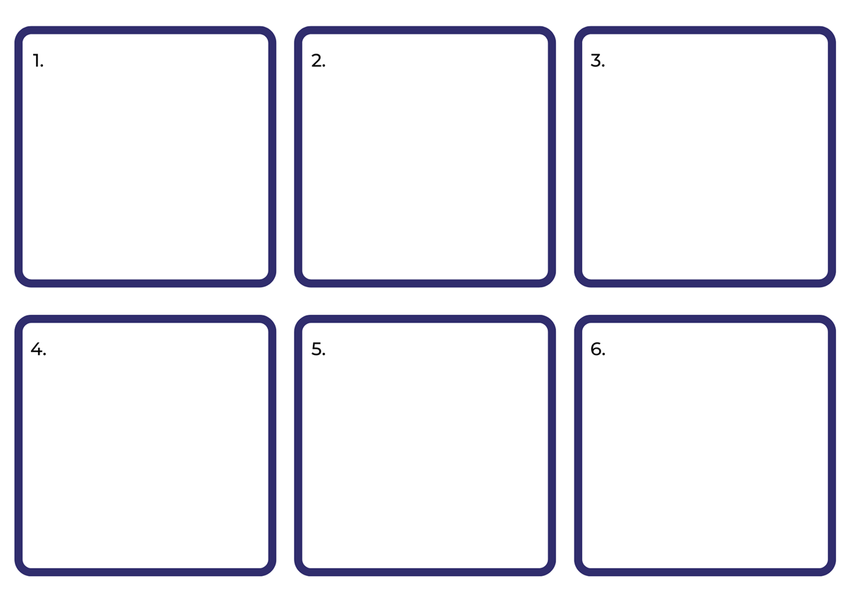

Resource 5: Class book

Resource 6: Speech and thought bubbles
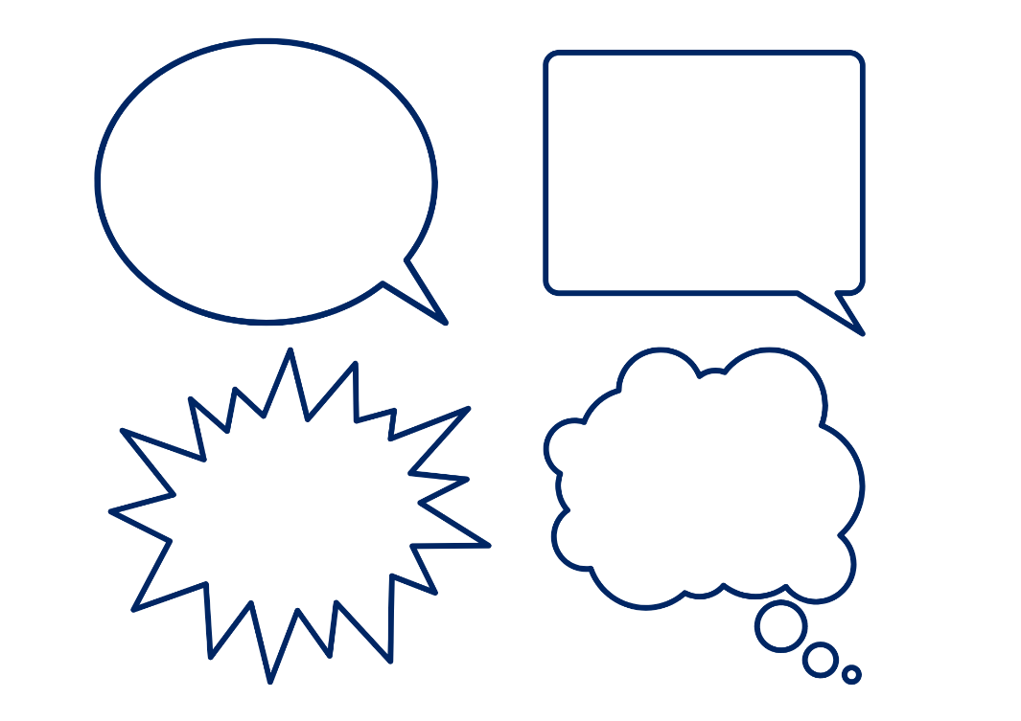

Resource 7: Sentences with punctuation teacher model
Statements | Questions | Exclamation
You turned the page.  Okay I warned you.  Now I’m calling your parents.  Just please don’t turn the page.  I’m not even angry.  I just told you not to turn it.  You’re now in danger. | Did you hear me okay?  What are you doing?  Are you mad?  Are you not thinking straight?  [Do] you want gold?  [Do] you want a flying car? | PLEASE DON’T TURN THE PAGE!  ARGHHHHH!!!  You turned AGAIN!!!  Your child keeps turning the page and must be punished!  NOOOOOO!!!

Resource 8: Sentences without punctuation
You turned the page | Now I’m calling your parents | PLEASE DON’T TURN THE PAGE
NOOOOOO | What are you doing | You must stop what you’re doing
Just please don’t turn the page | Are you mad | Did you hear me okay
You turned AGAIN | Are you not thinking straight | Your child keeps turning the page and must be punished
I’m not even angry | Do you want gold | ARGHHHHH
Do you want a flying car | Please don’t turn the page | I just told you not to turn it

Resource 9: FANBOYS
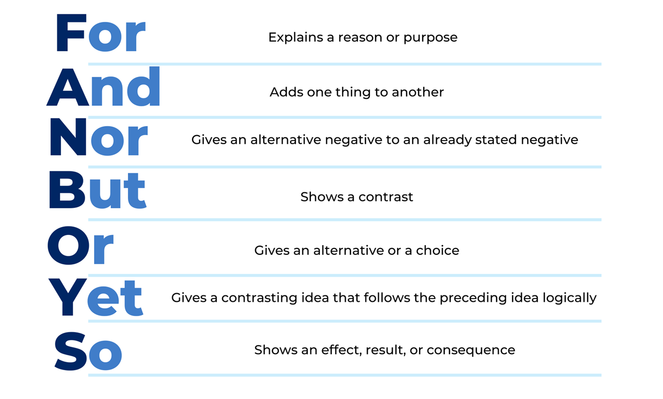

Resource 10: Comic strip plan
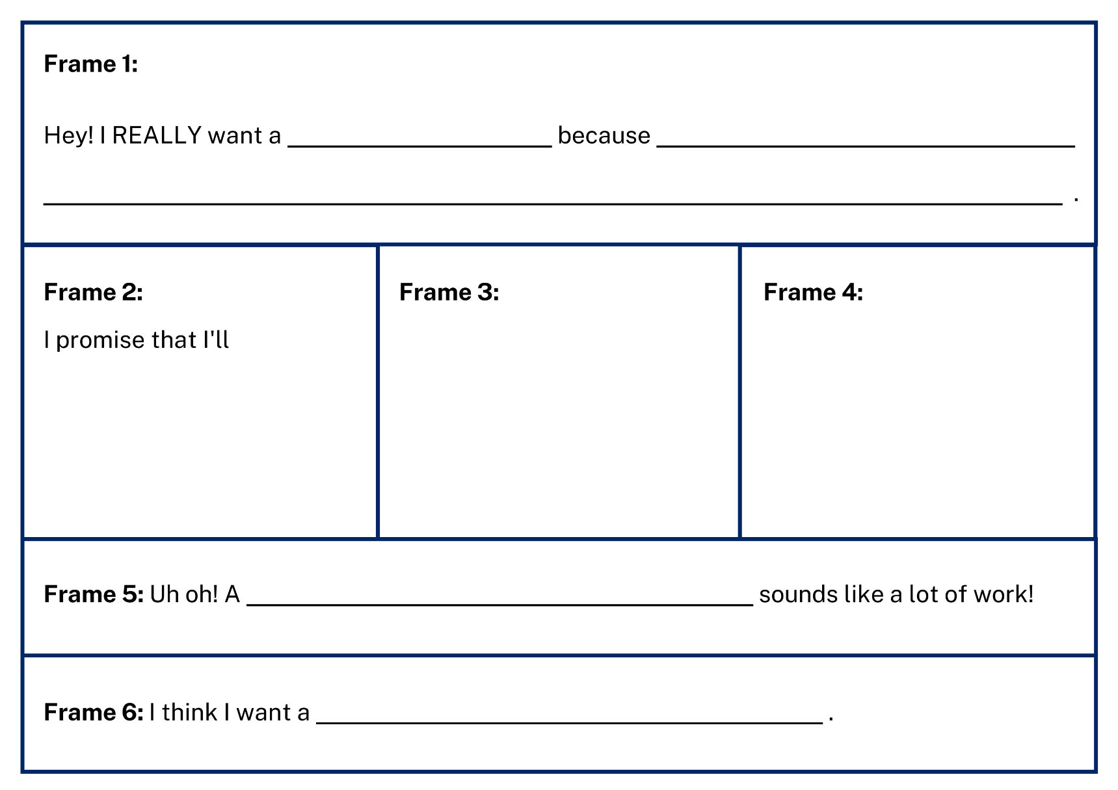

Resource 11: Comic strip
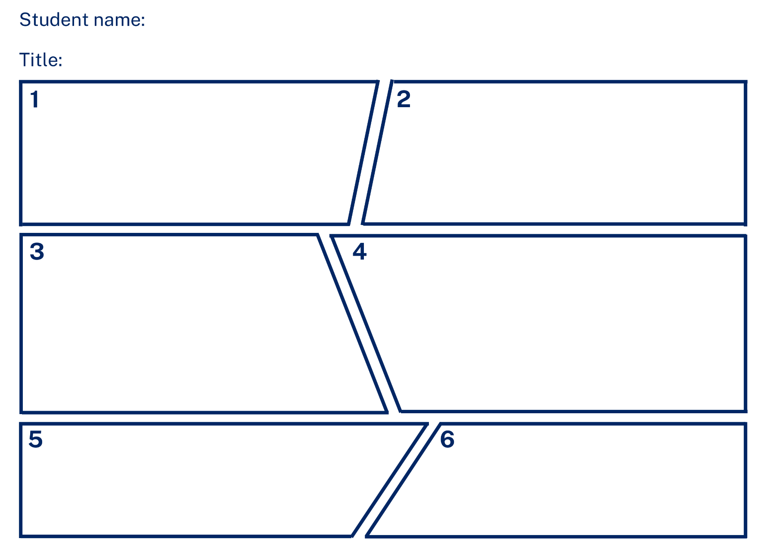

References
Links to third-party material and websites
Please note that the provided (reading/viewing material/list/links/texts) are a suggestion only and implies no endorsement, by the New South Wales Department of Education, of any author, publisher, or book title. School principals and teachers are best placed to assess the suitability of resources that would complement the curriculum and reflect the needs and interests of their students.
If you use the links provided in this document to access a third-party's website, you acknowledge that the terms of use, including licence terms set out on the third-party's website apply to the use which may be made of the materials on that third-party website or where permitted by the Copyright Act 1968 (Cth). The department accepts no responsibility for content on third-party websites.
Except as otherwise noted, all material is © State of New South Wales (Department of Education), 2021 and licensed under the Creative Commons Attribution 4.0 International License. All other material (third-party material) is used with permission or under licence. Where the copyright owner of third-party material has not licensed their material under a Creative Commons or similar licence, you should contact them directly for permission to reuse their material.
English K–10 Syllabus © 2022 NSW Education Standards Authority (NESA) for and on behalf of the Crown in right of the State of New South Wales.
© 2021 NSW Education Standards Authority. This document contains NSW Curriculum and syllabus content. The NSW Curriculum is developed by the NSW Education Standards Authority. This content is prepared by NESA for and on behalf of the Crown in right of the State of New South Wales. The material is protected by Crown copyright.
Please refer to the NESA Copyright Disclaimer for more information.
NESA holds the only official and up-to-date versions of the NSW Curriculum and syllabus documents. Please visit the NSW Education Standards Authority (NESA) website and the NSW Curriculum website.
National Literacy Learning Progression © Australian Curriculum, Assessment and Reporting Authority (ACARA) 2010 to present, unless otherwise indicated. This material was downloaded from the Australian Curriculum website (National Literacy Learning Progression) (accessed 27 September 2022) and was not modified. The material is licensed under CC BY 4.0. Version updates are tracked in the ‘Curriculum version history’ section on the 'About the Australian Curriculum' page of the Australian Curriculum website.
ACARA does not endorse any product that uses the Australian Curriculum or make any representations as to the quality of such products. Any product that uses material published on this website should not be taken to be affiliated with ACARA or have the sponsorship or approval of ACARA. It is up to each person to make their own assessment of the product, taking into account matters including, but not limited to, the version number and the degree to which the materials align with the content descriptions and achievement standards (where relevant). Where there is a claim of alignment, it is important to check that the materials align with the content descriptions and achievement standards (endorsed by all education Ministers), not the elaborations (examples provided by ACARA).
ETA (English Teachers Association) and NSW Department of Education (2016) The Textual Concepts and Processes resource, English Textual Concepts website, accessed 27 September 2022.
ETA (English Teachers Association) and NSW Department of Education (2016) Argument, English Textual Concepts website accessed 27 September 2022.
Lee A (2016) Do Not Open This Book, Lake Press, Australia.
Willems M (2005) Don’t Let the Pigeon Drive the Bus!, Walker Books, Australia.
Willems M (n.d.) ‘The Pigeon: How to Draw the Pigeon!’, Downloadable teacher’s guides and event kits, Disney Hyperion website, accessed 27 September 2022.

