English – Stage 1 – Unit 4
Contents
Unit overview and instructions for use 3
Teacher notes 4
Outcomes and content – Component A 5
Outcomes and content – Component B 7
Week 1 10
Component A teaching and learning 10
Component B teaching and learning 11
Lesson 1: Making inferences 12
Lesson 2: Wordplay 14
Lesson 3: Comparing characters 16
Lesson 4: Character dialogue 17
Lesson 5: Create a character 18
Week 2 20
Component A teaching and learning 20
Component B teaching and learning 21
Lesson 6: The Good Egg 22
Lesson 7: Character descriptions with noun groups 24
Lesson 8: Character planning 24
Lesson 9: Story planning 25
Lesson 10: Composing and editing 26
Resource 1: Kitchen utensils 28
Resource 2: Rhyme 29
Resource 3: Dialogue checklist 30
Resource 4: Dialogue example 31
Resource 5: Speech bubble example 32
Resource 6: Egg puns 33
Resource 7: Storyboard 34
References 35

Unit overview and instructions for use
This two-week unit is comprised of Component A and Component B. Connecting learning across both components is encouraged.
Teaching and learning | Component A | Component B
Suggested duration | 60 minutes | 45 minutes
Explicit teaching focus areas | - Phonic knowledge  - Reading fluency  - Reading comprehension  - Spelling  - Handwriting | - Oral language and communication  - Vocabulary  - Reading comprehension  - Creating written texts  - Understanding and responding to literature
To prepare for teaching and learning: | - Refer to Outcomes and content – Component A, K-2 – Instructional sequence – grapheme–phoneme correspondences [PDF 825 KB], and the teaching advice documents (hyperlinked in Component A teaching and learning table).  - Based on student needs identified through ongoing assessment data, plan and document how you will sequence teaching and learning in whole class and targeted teaching groups across the two-week cycle. | - Familiarise yourself with Outcomes and content – Component B, Textual concepts information and videos, English Textual Concepts and Learning Processes (2016), and the teaching and learning sequence.  - Based on student needs identified through ongoing assessment data, determine how you will support students in whole class and targeted teaching groups across the two-week cycle as required.
English K–10 Syllabus © 2022 NSW Education Standards Authority (NESA) for and on behalf of the Crown in right of the State of New South Wales.

Teacher notes
- ‘Character is traditionally viewed as a description of a fictional identity. It is made up of verbal and visual statements about what a character does, says and thinks and what other fictional characters and the author of the text say about them. Analysis of characters can contribute to our own personal judgements about self, morals, and values’. – English Textual Concepts and Learning Processes (2016).
- Understanding of character can be supported through watching the department’s video: Character (2:31).
- While ‘character’ is the mentor concept for the conceptual component of this unit, the supporting concepts of ‘imagery, symbol and connotation’ can be explored using the mentor text Spoon by Amy Krouse Rosenthal and Scott Magoon and the supporting text The Good Egg by Jory John.
- A noun group is a group of words relating to, or building on, a noun. Noun groups usually consist of a pointer (the, a, an, this, that, these, those, my, your, his, her, its, our, mum’s, Mr Smith’s) plus one or more adjectives or adverbs. They are an important language resource for building descriptions.
- Idioms are an expression peculiar to a language that cannot be taken literally. For example, ‘at the drop of a hat.’
- For information on quotation marks, dialogue, wordplay, and puns refer to the NESA Glossary.
- ‘Thinking aloud’ involves verbally modelling the thinking processes before, during and after reading or writing. It is important that you verbalise what is going on in your mind as you read or write. Having a focus for a think aloud makes sure that this strategy is used effectively and efficiently.
- Reflect on student learning and engagement in activities and record differentiation and adjustments within the unit to inform future teaching and learning. One way of doing this could be to add comments to the digital file.
- Content points are linked to the National Literacy Learning Progression version (3).
Levels and indicators sourced from National Literacy Learning Progression © Australian Curriculum, Assessment and Reporting Authority (ACARA), (accessed 21 September 2022) and was not modified. See references for more information.

Outcomes and content – Component A
The table below outlines the focus outcomes and content. Content is linked to the National Literacy Learning Progression version (3).
Focus area and outcome | Content points and National Literacy Learning Progression
Phonic knowledge  EN1-PHOKW-01 – uses initial and extended phonics, including vowel digraphs, trigraphs to decode and encode words when reading and creating texts | - segment and encode one-syllable high-frequency base words with split digraphs and apply this when creating texts (SpG6)  - blend and decode one-syllable words with taught extended vowel graphs and digraphs, including graphemes for r-controlled vowels and diphthongs, and apply this when reading texts (PKW6, PKW7)  - segment and encode one-syllable words with taught vowel graphs, digraphs and trigraphs and apply this when creating texts
Reading fluency  EN1-REFLU-01 – sustains reading unseen texts with automaticity and prosody and self-corrects errors | - apply grapheme–phoneme correspondence to read words with automaticity (FlY1)  - use sentence punctuation to enhance reading in a conversational manner (FlY3, FlY4)  - adjust phrasing, intonation, volume or rate to maintain fluency when reading aloud (FlY4)  - vary pace when reading according to the audience and purpose (FlY4)
Reading comprehension  EN1-RECOM-01 – comprehends independently read texts that require sustained reading by activating background and word knowledge, connecting and understanding sentences and whole text, and monitoring for meaning | - make text-to-self, text-to-text or text-to-world connections when reading (UnT6)  - recount relevant ideas from texts in the form of a written, visual or oral summary (UnT6)
Spelling  EN1-SPELL-01 – applies phonological, orthographic and morphological generalisations and strategies when spelling words in a range of writing contexts | - segment single-syllable words into phonemes as a strategy for spelling (SpG4)  - spell high-frequency base words with taught vowel graphs, digraphs, split digraphs, trigraphs and quadgraphs (SpG6)  - use spelling conventions when adding plural-marking suffixes (SpG9)
Handwriting  EN1-HANDW-01 – uses a legible, fluent and automatic handwriting style, and digital technology, including word-processing applications, when creating texts | - form all letters with consistent size and slope in NSW Foundation Style from memory (HwK5)  - position all letters correctly on the line with appropriate spacing between words (HwK5)

Outcomes and content – Component B
The table below outlines the focus outcomes and content. Content is linked to the National Literacy Learning Progression version (3).
Focus area and outcome | Content points and National Literacy Learning Progression
Oral language and communication  EN1-OLC-01 – communicates effectively by using interpersonal conventions and language to extend and elaborate ideas for social and learning interactions | - initiate, listen and/or respond in partner and group conversations (InT3, InT5)  - recite poems and rhymes
Vocabulary  EN1-VOCAB-01 – understands and effectively uses Tier 1, taught Tier 2 and Tier 3 vocabulary to extend and elaborate ideas | - understand and communicate jokes and riddles that play on words  - identify, understand and use wordplay and rhyme in a range of texts
Reading comprehension  EN1-RECOM-01 – comprehends independently read texts that require sustained reading by activating background and word knowledge, connecting and understanding sentences and whole text, and monitoring for meaning | - understand vocabulary that signals humorous wordplay in texts  - make an inference by connecting the meaning of words across sentences and/or paragraphs  - identify how creative visual features are used to expand meaning  - use visual and/or auditory features in multimodal texts to build meaning (UnT5)
Creating written texts  EN1-CWT-01 – plans, creates and revises texts written for different purposes, including paragraphs, using knowledge of vocabulary, text features and sentence structure | - use visual elements to expand meaning in own texts  - use a logical order to sequence ideas and events in sentences across a text (GrA4)  - use noun groups to build descriptions of people and things (CrT6)  - use quotation marks for simple dialogue (PuN5)  - use creative wordplay to affect the reader  - understand that their own texts can be improved by incorporating feedback and editing
Understanding and responding to literature  EN1-UARL-01 – understands and responds to literature by creating texts using similar structures, intentional language choices and features appropriate to audience and purpose | - compare and contrast characters in text  - create and re-create characters in texts that demonstrate understanding of character traits  - identify figurative language and wordplay in texts  - innovate from studied texts using wordplay and figurative language

Week 1

Component A teaching and learning
The table below can be used to plan and document lessons that address Component A outcomes and content. Both the detailed example [DOC 529KB] of a two-week teaching and learning cycle and brief example [DOC 66KB] may support you in your planning.
Focus Areas | Lesson 1 | Lesson 2 | Lesson 3 | Lesson 4 | Lesson 5
Phonic knowledge
15 minutes
Spelling and Handwriting
15 minutes
Reading comprehension and Reading fluency
30 minutes

Component B teaching and learning
The following teaching and learning sequence has been designed to address Component B outcomes and content. Adapt the sequence as required to best meet the needs of your students.

Learning intention and success criteria
Learning intentions and success criteria are best co-constructed with students.

Learning intention
Students are learning to understand how author’s create characters using a variety of language features and visual elements.

Success criteria
Students can:
- make inferences about a text
- identify figurative language and wordplay in texts
- recite poems and rhymes
- compare and contrast characters
- use quotation marks for simple dialogue.

Resources
- Krouse Rosenthal A and Magoon S (2009) Spoon, Little, Brown, New York. ISBN: 9781423106852
- Resource 1: Kitchen utensils
- Resource 2: Rhyme
- Resource 3: Dialogue checklist
- Resource 4: Dialogue example
- Resource 5: Speech bubble example
- Video: 'Hey diddle diddle' sung by Teddy Rock (1:38)
- Venn diagram
- Image of quotation marks
- Images of Spoon, Knife, Fork, and Chopsticks (from the text Spoon)
- Mystery bag of kitchen utensils
- Mini whiteboards
- Sticky notes

Lesson 1: Making inferences
- Prompt students to think about characters they know from a favourite book or movie.
- Ask students:
- Are all characters people?
- In what types of texts do we read about characters?
- Why do authors create characters?
- Why are characters important to a narrative?
- Record student responses. During the lesson, revisit student responses and build on original ideas.
- Explain that character is traditionally viewed as a description of a fictional identity. It is made up of verbal and visual statements about what a character does, says and thinks and what other fictional characters and the author of the text say about them.
- Display the book Spoon by Amy Krouse Rosenthal and Scott Magoon and identify who the main character is in the story. Students make predictions about what other characters may be in the book. Encourage students to use their background knowledge to make predictions.
- Explain that good viewers and readers build their understanding of a text by looking for hidden meanings in situations. They use clues from the situation and their own background knowledge to understand the situation. These clues can be found in sounds, objects, images, and written text. Explain that when viewers do this, it is called making an inference.
- Read Spoon and stop at the text ‘“Nothing,” mumbled Spoon.’ Focus on Spoon’s facial expression and provide students with an opportunity to infer how Spoon is feeling and why. Ask students if they believe Spoon when he says that nothing is bothering him. Share student responses. Continue reading and stop at the text ‘It’s just that ...I don’t know...All my friends have it so much better than me.’ Ask students if their inferences about how Spoon was feeling were correct. Introduce the term ‘jealous’ and discuss its meaning.
- Explain that students will be predicting why Spoon could be jealous of the other characters. Provide students with images of Fork, Knife and Chopsticks from the text. In small groups, students make inferences about why Spoon thinks Fork, Knife and Chopsticks are better than him. Students record their ideas on sticky notes or label their image using words and phrases. Encourage students to use their background knowledge to support making inferences. As a class, discuss student responses.
- Continue reading Spoon. Discuss the theme of the book and the importance of individuality and the feeling of jealousy.

Lesson 2: Wordplay
- Introduce the concept of imagery, symbol, and connotation. Explain that imagery, symbol, and connotation extend words and symbols beyond their literal meaning. They are used to provide deeper meaning, evoke emotion, and enhance enjoyment in texts.
- Introduce the term ‘wordplay’ and explain that authors experiment with language in a text to create humour and enhance enjoyment. Re-read the text Spoon and stop at the page with the text, ‘Lately though, Spoon had been feeling blue.’ Explain that the author has used an idiom to express how the character is feeling and that this statement cannot be taken literally. Ask students how they think Spoon is feeling. Explore the phrase, ‘You look a bit out of shape’ on the same page. Discuss the meaning of this phrase within the context of the story. Ask students to retell a time they have felt ‘a bit out of shape.’
- Re-read the phrase ‘Spoon likes to hear about his great grandmother who fell in love with a dish and ran off to a distant land.’ Explain that this phrase refers to a well-known nursery rhyme. Students Think-Pair-Share what nursery rhyme it is referring to. Watch 'Hey diddle diddle' sung by Teddy Rock (1:38). Explore the connection between the nursery rhyme and the text. For example, the dish ran away with the spoon. Explain that rhyme is the repetition of similar speech sounds in the final syllable of words. Discuss the use of rhyme in the nursery rhyme and create a list of rhyming words.
- Explain that students will re-create the nursery rhyme Hey diddle, diddle with 2 new kitchen utensils. Display Resource 1: Kitchen utensils and discuss the names and purpose of each item.
- Display Resource 2: Rhyme and read the text example by modelling how to substitute words. For example:
Hey diddle, diddle,
The cat and the fiddle,
The cow jumped over the fan
The little dog laughed
To see such fun,
And the tongs ran away with the pan.
- Students use Resource 2: Rhyme to re-create their own version of Hey diddle, diddle. Encourage students to use the list of rhyming words created in activity 3. In small groups, students share their re-created nursery rhyme.
Stage 1 Assessment task 1 – Observations and work samples from this lesson allow students to demonstrate achievement towards the following syllabus outcomes and content points:
EN1-OLC-01 – communicates effectively by using interpersonal conventions and language to extend and elaborate ideas for social and learning interactions
- recite poems and rhymes.
EN1-VOCAB-01 – understands and effectively uses Tier 1, taught Tier 2 and Tier 3 vocabulary to extend and elaborate ideas
- identify, understand and use wordplay and rhyme in a range of texts.
EN1-UARL-01 – understands and responds to literature by creating texts using similar structures, intentional language choices and features appropriate to audience and purpose
- identify figurative language and wordplay in texts.

Lesson 3: Comparing characters
- Revise the concept of character. Play a game of ‘guess my character.’ Provide students with clues about a character from the text Spoon. For example, this character is easy going and fun; he is independent because he goes places on his own.
- Display images of Fork, Knife, Spoon and Chopsticks from the text Spoon. Ask students to identify the human characteristics each character has, for example, arms and legs, a face, walks, talks, has feelings and a family. As a class, label the images with human characteristics.
- Display an enlarged copy of a Venn diagram with the headings ‘Fork’ and ‘Spoon’. Explain that students will compare and contrast the 2 characters. Ask students how Fork and Spoon are similar. Encourage students to provide reasoning using examples from the text. For example, both characters are similar because they both help you to eat food. Model writing information on a sticky note and placing it in the middle of the Venn diagram. Ask students how Fork and Spoon are different. For example, Spoon gets to measure things and is round, Fork practically gets to go everywhere and has sharp pointy ends. Model writing ‘used for measuring’ on a sticky note and placing it under the heading ‘Spoon.’ Model writing ‘gets to go everywhere’ and placing it under the heading ‘Fork.’
- Students complete their own Venn diagram by selecting 2 new characters from the text Spoon. Encourage students to include the character’s skills, feelings, and emotions.
- In pairs, students share their Venn diagram.
Too hard? Co–construct a Venn diagram for the characters Spoon and Fork using word and drawings.
Too easy? Students compare Spoon, Fork and Chopsticks using a Triple Venn diagram.
Stage 1 Assessment task 2 – Observations and work samples from this lesson allow students to demonstrate achievement towards the following syllabus outcome and content point:
EN1-UARL-01 – understands and responds to literature by creating texts using similar structures, intentional language choices and features appropriate to audience and purpose
- compare and contrast characters in text.

Lesson 4: Character dialogue
- Introduce the term dialogue and explain that it is a conversation between 2 or more characters in a text. Character dialogue helps readers to understand a character’s thoughts, feelings, and emotions. It helps readers to understand and relate to characters, even if they are an inanimate object like Spoon. Display an image of quotation marks and explain that they are punctuation markers used in a text to show when a character is talking.
- Re-read selected pages of the text Spoon that include examples of dialogue. For example, ‘“Nothing,” mumbled Spoon.’ Discuss who is speaking and how students know. Highlight or circle the words ‘mumbled Spoon’ and explain that identifying the saying verb is one way to find out who is speaking. This also gives the reader clues as to how the character is feeling. Discuss other ways the author uses dialogue to show who is speaking. For example, ‘Goodbye, darling! Ta, ta!’ Discuss how the reader needs to infer who is speaking using clues from the text such as images.
- Display Resource 3: Dialogue checklist. Discuss the dialogue conventions in the checklist.
- Display the passage, ‘“What’s wrong?” asked his mother. “You look a bit out of shape.” “Nothing,” mumbled Spoon.’ As a class, use the dialogue checklist to identify and circle the dialogue conventions.
- Model drawing 2 characters from the text. For example, Spoon and Fork. Model using the dialogue checklist to write a conversation between the 2 characters using quotation marks. Explicitly discuss how the dialogue provides the reader with more information about the character. Refer to Resource 4: Dialogue example.
- Students choose 2 characters from the text. Using Resource 3: Dialogue checklist, students write a conversation between 2 characters.
Too hard? Students role play a conversation between 2 characters, considering body movements and facial expressions. Co-construct a conversation between the 2 characters using quotation marks.

Lesson 5: Create a character
- Create a mystery bag of kitchen utensils. Provide students with clues about the item before pulling it out of the mystery bag. For example, this kitchen utensil has a handle and a pourer; it is helpful because it has units of measurement on the outside. Repeat with the rest of the items in the mystery bag.
- Ask students which kitchen utensil would make a good character in the text, Spoon. Encourage students to think of skills their new character could have and discuss what traits Spoon may feel jealous of. Share student responses.
- Explain that students will create a new character for the text, Spoon and write dialogue between the 2 characters. Students role play a conversation between Spoon and the new character. Encourage students to take turns in initiating and responding to conversations.
- On mini whiteboards, students draw a kitchen utensil from Resource 1: Kitchen utensils or the mystery bag. Students list positive traits or skills their character might have that may make Spoon jealous. Model expanding on students’ ideas and providing reasons why Spoon would be jealous. For example, Tongs always get invited to the best parties, Pan is so lucky because she always stays warm.
- Model drawing Spoon and a new character for the text, for example, Tongs or Frying Pan. Using Resource 3: Dialogue checklist, model writing a conversation between the 2 characters. Optional: create a cartoon using speech bubbles. Refer to Resource 5: Speech bubble example.
- Students draw and write a conversation between the 2 characters using the dialogue checklist. Optional: students create their character through images and recordings on a digital platform.
Stage 1 Assessment task 3 – Observations and collecting work samples from this lesson allows students to demonstrate achievement towards the following syllabus outcomes and content points:
EN1-OLC-01 – communicates effectively by using interpersonal conventions and language to extend and elaborate ideas for social and learning interactions
- initiate, listen and/or respond in partner and group conversations.
EN1-CWT-01 – plans, creates and revises texts written for different purposes, including paragraphs, using knowledge of vocabulary, text features and sentence structure
- use quotation marks for simple dialogue.
EN1-UARL-01 – understands and responds to literature by creating texts using similar structures, intentional language choices and features appropriate to audience and purpose
- create and re-create characters in texts that demonstrate understanding of character traits.

Week 2

Component A teaching and learning
The table below can be used to plan and document lessons that address Component A outcomes and content. Both the detailed example [DOC 529KB] of a two-week teaching and learning cycle and brief example [DOC 66KB] may support you in your planning.
Focus Areas | Lesson 6 | Lesson 7 | Lesson 8 | Lesson 9 | Lesson 10
Phonic knowledge
15 minutes
Spelling and Handwriting
15 minutes
Reading comprehension and Reading fluency
30 minutes

Component B teaching and learning
The following teaching and learning sequence has been designed to address Component B outcomes and content. Adapt the sequence as required to best meet the needs of your students.

Learning intention and success criteria
Learning intentions and success criteria are best co-constructed with students.

Learning intention
Students are learning to understand how authors create characters using a variety of language features and visual elements.

Success criteria
Students can:
- understand and communicate jokes and riddles that play on words
- use noun groups to build character descriptions
- create character traits for an inanimate object
- use feedback to improve writing.

Resources
- John J and Oswald P (2019) The Good Egg, HarperCollins Publishers, New York. ISBN: 9780062866004
- Resource 6: Egg puns
- Resource 7: Storyboard
- Concept map (enlarged copy and one copy per student)
- Soft ball or beanbag

Lesson 6: The Good Egg
- Introduce the text The Good Egg by Jory John. Guide students to make predictions about what type of text it is, using the front and back covers, title, and illustrations. Discuss narrative elements and who the main character of the story may be. Revise the concept of character and how authors use descriptive and figurative language to help the audience build a deeper understanding of a character’s actions and emotions. Explain that a character can be an inanimate object, but they must always have an identity.
- Revise the term ‘inference’ and explain that as students listen to the story, and they will use clues from the text and their background knowledge to identify the hidden meaning or idea. Begin reading the text and stop reading when Good Egg leaves the dozen. Using clues from the text and background knowledge, students make inferences about how Good Egg was feeling. Encourage students to use evidence from the text to support their reasoning. Share student responses. Discuss how colour and facial expression has been used to convey emotions and feelings.
- Revise the term ‘wordplay.’ Discuss the use of wordplay in the title of text. Explain that ‘being a good egg’ means being a likeable person. Discuss how the title of the book reflects Good Egg’s character traits. Display the sentence ‘My head felt scrambled’ and ask students how Good Egg was feeling. Explain that a pun is a play on words and the author used the word ‘scrambled’ to create humour for the reader. Using Resource 6: Egg puns, discuss other puns the author could use to create humour in the text.
- Explain that students will be creating a concept map of Good Egg’s character traits. Display an enlarged concept map and model drawing Good Egg in the centre. Using the Think-Pair-Share strategy, students discuss Good Egg’s character traits. For example: brave, helpful, independent, patient, well mannered. Share student responses. Model writing Good Egg’s character traits around the outside of the concept map. Use think-alouds explain that carrying groceries and watering plants are examples from the text and Good Egg’s character trait is being helpful.
- Students create their own concept map of Good Egg’s character traits.
Too hard? Students draw Good Egg’s character traits around the outside of their concept map. For example, showing Good Egg was brave by drawing an image of him rescuing a cat. Students orally share their ideas with a partner.
Too easy? Students list character traits and provide reasoning using examples from the text. For example, Good Egg was patient when the other eggs were misbehaving.
Stage 1 Assessment task 4 – Observations from this lesson allows students to demonstrate achievement towards the following syllabus outcomes and content points:
EN1-VOCAB-01 – understands and effectively uses Tier 1, taught Tier 2 and Tier 3 vocabulary to extend and elaborate ideas
- understand and communicate jokes and riddles that play on words.
EN1-RECOM-01 – comprehends independently read texts that require sustained reading by activating background and word knowledge, connecting and understanding sentences and whole text, and monitoring for meaning
- understand vocabulary that signals humorous wordplay in texts
- identify how creative visual features are used to expand meaning
- use visual and/or auditory features in multimodal texts to build meaning
- make an inference by connecting the meaning of words across sentences and/or paragraphs.

Lesson 7: Character descriptions with noun groups
- Re-read the text The Good Egg by Jory John.
- Revise noun groups and explain that they are a group of words that build on a noun. Authors use noun groups to create character descriptions. They include a pointer such as his, her, the, or our, plus one or more adjectives or adverbs and a noun. Identify the noun group used in the title of the text The Good Egg. Circle the pointer ‘The’ and underline the noun group ‘Good Egg.’
- In small groups, students stand up in a circle. Students share Good Egg’s character traits as they pass around a beanbag or soft ball. Encourage students to use their ideas from the previous lesson.
- Explain that students will create another title for the text The Good Egg. Using the concept map from Lesson 6, model choosing a character trait to create a new title. For example, The Brave Egg or The Patient Egg. Use think-alouds to explain why it is a good title for the text. For example, The Brave Egg is a good title for the text because Egg is not afraid to climb up the tall ladder and rescue the cat from the tree. Leaving your friends and family behind is difficult and Egg was brave enough to go out on an amazing adventure on his own. Highlight the use of noun groups to build descriptions of characters and things.
- Using the text, find other noun groups that describe a character. Write these on a retrieval chart for ongoing reference.
- Provide students with their concept map from the previous lesson. Students use their ideas to create a new title for the text and write sentences to explain why it is a good title.

Lesson 8: Character planning
- Discuss how Spoon and Egg are inanimate objects and are characters in a text because they have emotions, needs, and wants. Explain that students will create a text about an inanimate object and what makes it special.
- Display the concept map of Good Egg’s character traits from Lesson 6 and discuss the list of positive qualities. Explain that students will be creating a concept map for their own character about a kitchen utensil or type of food. Model drawing an inanimate object such as a pot or a pair of tongs in the middle of a concept map. Model writing character traits around the outside.
- Provide students with a copy of their own concept map. Students draw an inanimate object in the middle and list character traits around the outside.
- Explain that students will choose one character trait to include in the title of their text. For example, the polite pot, the responsible tongs, the helpful whisk, the brave broccoli. Students create a title for their text using a noun group and write it at the top of their concept map.
- Students will create a storyboard using visuals and text to replicate a day in the life of their inanimate object. Co-construct success criteria for the storyboard. For example:
- create a character from an inanimate object
- sequence events in a logical order
- use wordplay in writing
- use noun groups to build descriptions
- use quotation marks for simple dialogue
- use visuals, such as colour and size to expand meaning
- use feedback to improve writing.

Lesson 9: Story planning
- Revise the purpose for writing and review the success criteria from Lesson 8.
- Model using Resource 7: Storyboard to draw a series of events from a character’s day. Use colour and detailed drawings to reflect what makes the character special. Discuss the importance of visual elements to expand meaning in a text.
- Students draw their ideas on their own storyboard in a logical sequence. Encourage students to include images about what makes their character special.
Too hard? Co-construct a storyboard by drawing a series of events from a character’s day.

Lesson 10: Composing and editing
- Revise the purpose for writing and review the success criteria from Lesson 8. Model using Resource 7: Storyboard from Lesson 9 to create a written text. Students refer to the success criteria to highlight examples identified in the modelled text.
- In pairs, students use their storyboard to share the sequence of events. Students write sentences about the events that were included on their storyboard.
- Model how to give and receive peer feedback in a respectful, constructive way. Students use the success criteria to provide peer feedback in pairs or small groups.
- Provide time for students to apply feedback to edit and improve their writing.
Stage 1 Assessment task 5 – Observations and work samples from this lesson allow students to demonstrate achievement towards the following syllabus outcomes and content points:
EN1-CWT-01 – plans, creates and revises texts written for different purposes, including paragraphs, using knowledge of vocabulary, text features and sentence structure
- use visual elements to expand meaning in own texts
- use a logical order to sequence ideas and events in sentences across a text
- use noun groups to build descriptions of people and things
- use creative wordplay to affect the reader
- understand that their own texts can be improved by incorporating feedback and editing.
EN1-UARL-01 – understands and responds to literature by creating texts using similar structures, intentional language choices and features appropriate to audience and purpose
- innovate from studied texts using wordplay and figurative language.

Resource 1: Kitchen utensils
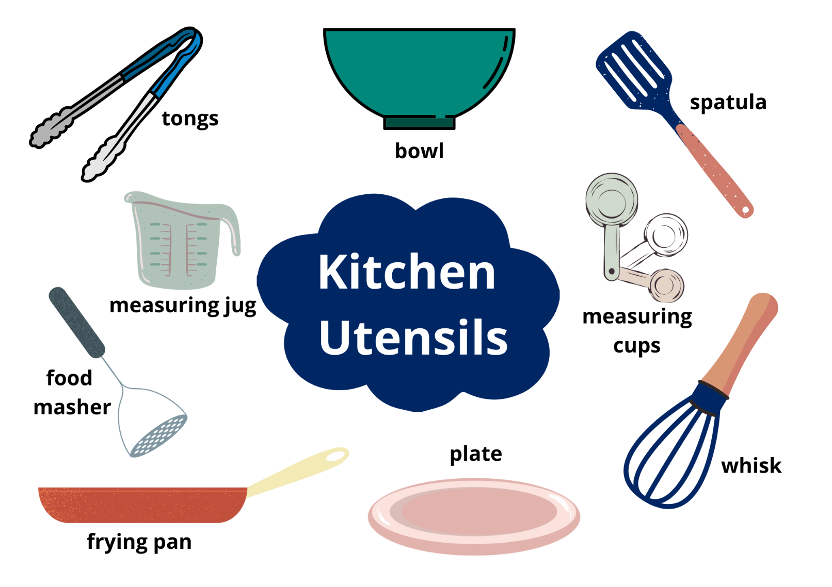
Images sourced from Canva and used in accordance with the Canva Content License Agreement.

Resource 2: Rhyme
Hey diddle, diddle,
The cat and the fiddle,
The cow jumped over the __;
The little dog laughed
To see such fun,
And the __ ran away with the __.

Resource 3: Dialogue checklist
Dialogue Checklist | Dialogue Checklist
- Speech marks go around exactly what is spoken.  - A capital letter is used at the start of what is spoken.  - There is a piece of punctuation before the close of quotation marks.  - ‘Saying verbs’ are used to describe how the speech is spoken.  - A new line is used when each new character speaks. | - Speech marks go around exactly what is spoken.  - A capital letter is used at the start of what is spoken.  - There is a piece of punctuation before the close of quotation marks.  - ‘Saying’ verbs are used to describe how the speech is spoken.  - A new line is used when each new character speaks.

Resource 4: Dialogue example
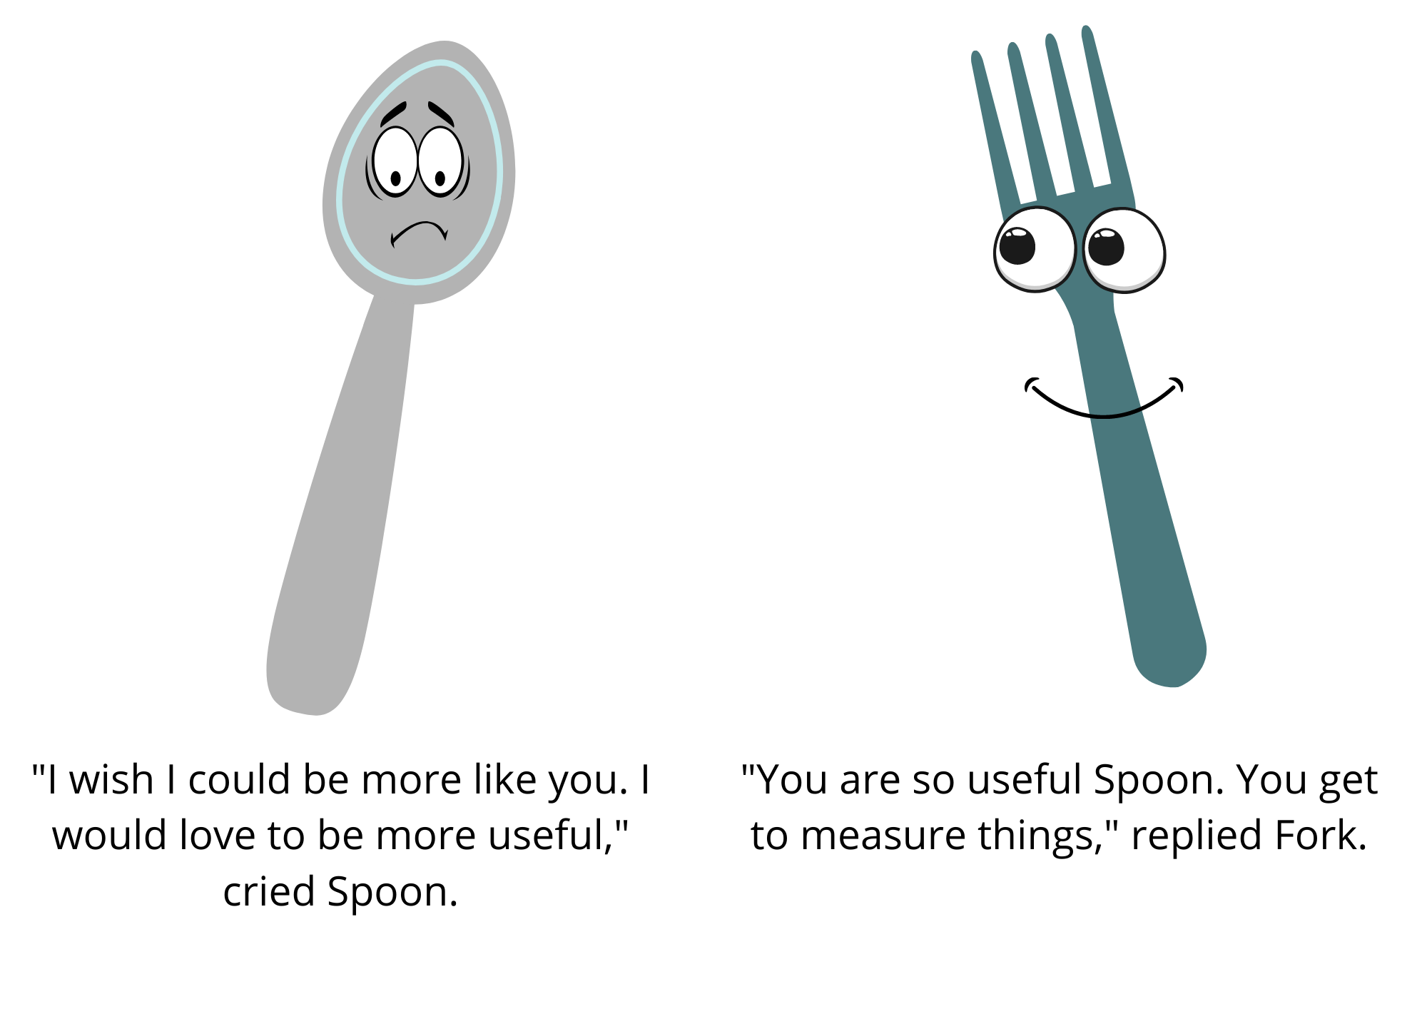
Images sourced from Canva and used in accordance with the Canva Content License Agreement.

Resource 5: Speech bubble example
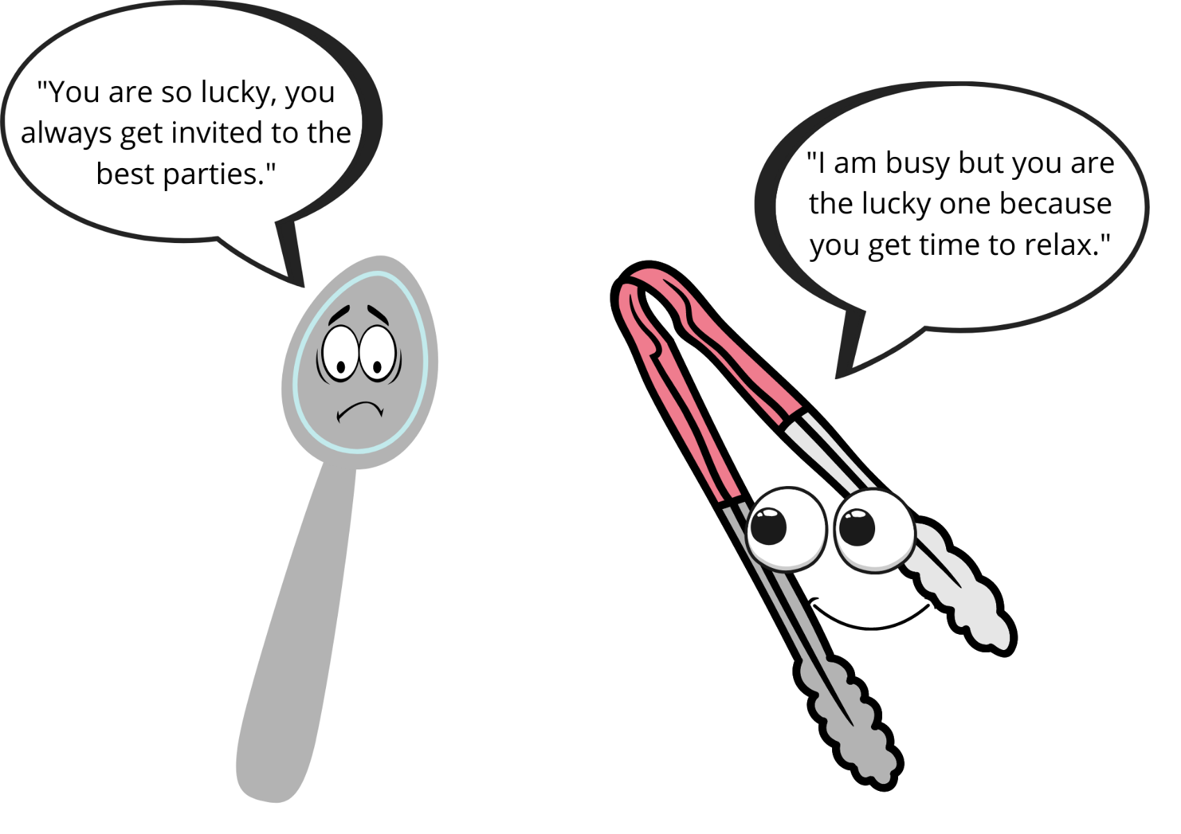
Images sourced from Canva and used in accordance with the Canva Content License Agreement.

Resource 6: Egg puns
- Egg went out on an adventure and felt terri-fried.
- Egg went out on an egg-citing adventure.
- Good Egg was upset when the other eggs were egg-noring him.
- Egg laughed so hard he started to crack up.
- Egg is well mannered and always says egg-scuse me.
- Egg rescued the cat on Fry-day.
- Egg stayed fit and healthy and loves to eggs-ercise.
- Egg felt eggs-hausted when the other Eggs were misbehaving.

Resource 7: Storyboard
TITLE:
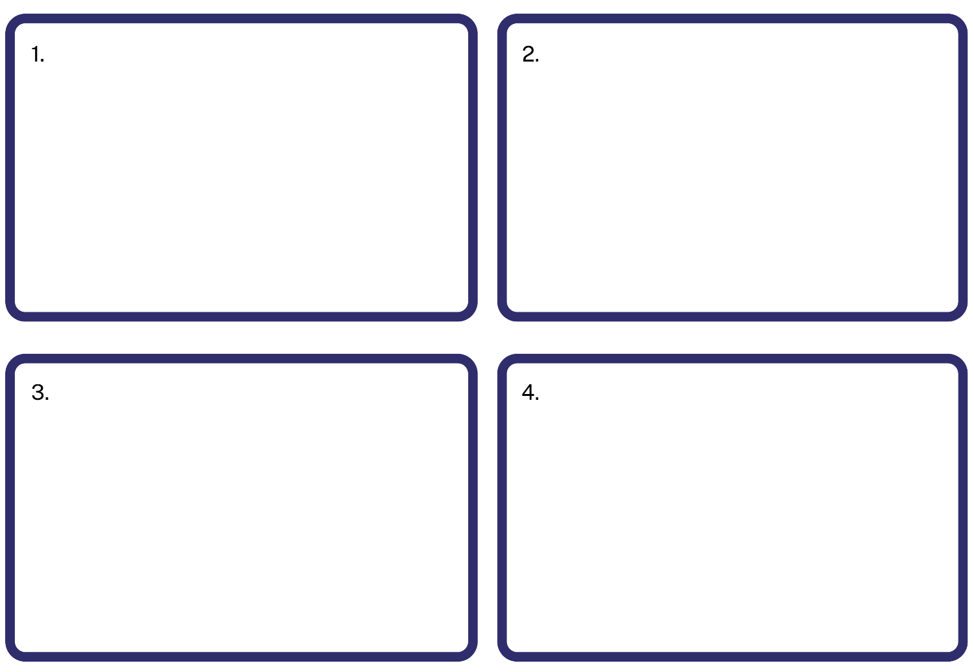

References
Links to third-party material and websites
Please note that the provided (reading/viewing material/list/links/texts) are a suggestion only and implies no endorsement, by the New South Wales Department of Education, of any author, publisher, or book title. School principals and teachers are best placed to assess the suitability of resources that would complement the curriculum and reflect the needs and interests of their students.
If you use the links provided in this document to access a third-party's website, you acknowledge that the terms of use, including licence terms set out on the third-party's website apply to the use which may be made of the materials on that third-party website or where permitted by the Copyright Act 1968 (Cth). The department accepts no responsibility for content on third-party websites.
Except as otherwise noted, all material is © State of New South Wales (Department of Education), 2021 and licensed under the Creative Commons Attribution 4.0 International License. All other material (third-party material) is used with permission or under licence. Where the copyright owner of third-party material has not licensed their material under a Creative Commons or similar licence, you should contact them directly for permission to reuse their material.
English K–10 Syllabus © 2022 NSW Education Standards Authority (NESA) for and on behalf of the Crown in right of the State of New South Wales.
© 2021 NSW Education Standards Authority. This document contains NSW Curriculum and syllabus content. The NSW Curriculum is developed by the NSW Education Standards Authority. This content is prepared by NESA for and on behalf of the Crown in right of the State of New South Wales. The material is protected by Crown copyright.
Please refer to the NESA Copyright Disclaimer for more information.
NESA holds the only official and up-to-date versions of the NSW Curriculum and syllabus documents. Please visit the NSW Education Standards Authority (NESA) website and the NSW Curriculum website.
National Literacy Learning Progression © Australian Curriculum, Assessment and Reporting Authority (ACARA) 2010 to present, unless otherwise indicated. This material was downloaded from the Australian Curriculum website (National Literacy Learning Progression) (accessed 21 September 2022) and was not modified. The material is licensed under CC BY 4.0. Version updates are tracked in the ‘Curriculum version history’ section on the 'About the Australian Curriculum' page of the Australian Curriculum website.
ACARA does not endorse any product that uses the Australian Curriculum or make any representations as to the quality of such products. Any product that uses material published on this website should not be taken to be affiliated with ACARA or have the sponsorship or approval of ACARA. It is up to each person to make their own assessment of the product, taking into account matters including, but not limited to, the version number and the degree to which the materials align with the content descriptions and achievement standards (where relevant). Where there is a claim of alignment, it is important to check that the materials align with the content descriptions and achievement standards (endorsed by all education Ministers), not the elaborations (examples provided by ACARA).
ETA (English Teachers Association) and NSW Department of Education (2017) The Textual Concepts and Processes resource, English Textual Concepts website, accessed 16 August 2022.
ETA (English Teachers Association) and NSW Department of Education (2016) Character, English Textual Concepts website accessed Day Month Year.
ETA (English Teachers Association) and NSW Department of Education (2016) Connotation, imagery and symbol, English Textual Concepts website accessed Day Month Year.
Krouse A and Magoon S (2009) Spoon, Little, Brown, New York.
John J and Oswald P (2019) The Good Egg, HarperCollins Publishers, New York.
ABC Education (2010) ‘Hey diddle diddle sung by Teddy Rock’, ABC Education, accessed 9 September 2022.

