English – Stage 1 – Unit 3
Contents
Unit overview and instructions for use 3
Teacher notes 4
Outcomes and content – Component A 5
Outcomes and content – Component B 7
Week 1 10
Component A teaching and learning 10
Component B teaching and learning 11
Lesson 1: Introduction 12
Lesson 2: Verbs 15
Lesson 3: Noun groups 16
Lesson 4: Compound sentences with cause and effect 17
Lesson 5: Narrowing the focus 19
Week 2 21
Component A teaching and learning 21
Component B teaching and learning 22
Lesson 6: Sequencing the parts of an informative text 23
Lesson 7: Researching and planning 25
Lesson 8: Information report writing 25
Lesson 9: Feedback and editing 26
Lesson 10: Presenting 27
Resource 1: Labelled diagram 29
Resource 2: Informative text exemplar 30
Resource 3: Tiered words 32
Resource 4: Sequencing parts of an informative text 33
Resource 5: Informative text template 35
References 36
Further reading 38

Unit overview and instructions for use
This two-week unit is comprised of Component A and Component B. Connecting learning across both components is encouraged.
Teaching and learning | Component A | Component B
Suggested duration | 60 minutes | 45 minutes
Explicit teaching focus areas | - Phonic knowledge  - Reading fluency  - Reading comprehension  - Spelling  - Handwriting | - Oral language and communication  - Vocabulary  - Reading comprehension  - Creating written texts  - Understanding and responding to literature
To prepare for teaching and learning: | - Refer to Outcomes and content – Component A, K-2 – Instructional sequence – grapheme–phoneme correspondences [PDF 825 KB], and the teaching advice documents (hyperlinked in Component A teaching and learning table).  - Based on student needs identified through ongoing assessment data, plan and document how you will sequence teaching and learning in whole class and targeted teaching groups across the two-week cycle. | - Familiarise yourself with Outcomes and content – Component B, Textual concepts information and videos, English Textual Concepts and Learning Processes (2016), and the teaching and learning sequence.  - Based on student needs identified through ongoing assessment data, determine how you will support students in whole class and targeted teaching groups across the two-week cycle as required.
English K–10 Syllabus © 2022 NSW Education Standards Authority (NESA) for and on behalf of the Crown in right of the State of New South Wales.

Teacher notes
- Context is defined as ‘a culturally or socially situated circumstance that may give rise to a particular register’ (NESA Glossary). To understand context, we look beyond the text to ‘consider the world in which it was produced and the worlds of its reception’ – English Textual Concepts and Learning Processes (2016).
- Representation is ‘the depiction of a thing, person, or idea in written, visual, digital, performed or spoken language and conventions’ (NESA Glossary).
- The text Eric Carle’s Book of Amazing Animals is intended to be used in sections throughout Week 1 rather than reading the entire text.
- For information on Tier 1, Tier 2, and Tier 3 words, refer to the NESA Glossary.
- For information on noun groups refer to Teaching strategies.
- In Lesson 10 students are required to make a diorama of their animal and its habitat. This activity could be completed across the 2 weeks or integrated into creative arts lessons.
- This unit could enhance student learning towards achievement of outcomes from the Science and Technology and the Creative Arts syllabuses.
- Reflect on student learning and engagement in activities and record differentiation and adjustments within the unit to inform future teaching and learning. One way of doing this could be to add comments to the digital file.
- Content points are linked to the National Literacy Learning Progression version (3).
Levels and indicators sourced from National Literacy Learning Progression © Australian Curriculum, Assessment and Reporting Authority (ACARA), (accessed 8 September 2022) and was not modified. See references for more information.

Outcomes and content – Component A
The table below outlines the focus outcomes and content. Content is linked to the National Literacy Learning Progression version (3).
Focus area and outcome | Content points and National Literacy Learning Progression
Phonic knowledge  EN1-PHOKW-01 – uses initial and extended phonics, including vowel digraphs, trigraphs to decode and encode words when reading and creating texts | - segment and encode one-syllable high-frequency base words with split digraphs and apply this when creating texts (SpG6)  - blend and decode one-syllable words with taught extended vowel graphs and digraphs, including graphemes for r-controlled vowels and diphthongs, and apply this when reading texts (PKW6, PKW7)  - segment and encode one-syllable words with taught vowel graphs, digraphs and trigraphs and apply this when creating texts
Reading fluency  EN1-REFLU-01 – sustains reading unseen texts with automaticity and prosody and self-corrects errors | - apply grapheme–phoneme correspondence to read words with automaticity (FIY1)  - adjust phrasing, intonation, volume or rate to maintain fluency when reading aloud (FIY4)
Reading comprehension  EN1-RECOM-01 – comprehends independently read texts that require sustained reading by activating background and word knowledge, connecting and understanding sentences and whole text, and monitoring for meaning | - recount relevant ideas from texts in the form of a written, visual or oral summary (UnT6)
Spelling  EN1-SPELL-01 – applies phonological, orthographic and morphological generalisations and strategies when spelling words in a range of writing contexts | - segment single-syllable words into phonemes as a strategy for spelling (SpG4)  - spell high-frequency base words with taught vowel graphs, digraphs, split digraphs, trigraphs and quadgraphs (SpG6)  - use spelling conventions when adding plural-marking suffixes (SpG9)
Handwriting  EN1-HANDW-01 – uses a legible, fluent and automatic handwriting style, and digital technology, including word-processing applications, when creating texts | - position all letters correctly on the line with appropriate spacing between words (HwK5)

Outcomes and content – Component B
The table below outlines the focus outcomes and content. Content is linked to the National Literacy Learning Progression version (3).
Focus area and outcome | Content points and National Literacy Learning Progression
Oral language and communication  EN1-OLC-01 – communicates effectively by using interpersonal conventions and language to extend and elaborate ideas for social and learning interactions | - follow extended instructions that contain connectives and conjunctions (LiS5)  - incorporate extended sentences (simple, compound, complex) during dialogue (SpK3)
Vocabulary  EN1-VOCAB-01 – understands and effectively uses Tier 1, taught Tier 2 and Tier 3 vocabulary to extend and elaborate ideas | - use vocabulary to express cause and effect (SpK3)
Reading comprehension  EN1-RECOM-01 – comprehends independently read texts that require sustained reading by activating background and word knowledge, connecting and understanding sentences and whole text, and monitoring for meaning | - use known vocabulary to build a mental model of the content of the text  - combine multiple sources of information within a text to make meaning  - identify how creative visual features are used to expand meaning  - use knowledge of text structure, type of text, author, and forms of writing to predict and confirm meaning (UnT6)  - make text-to-self, text-to-text or text-to-world connections when reading (UnT6)
Creating written texts  EN1-CWT-01 – plans, creates and revises texts written for different purposes, including paragraphs, using knowledge of vocabulary, text features and sentence structure | - write texts that describe, explain, give an opinion, recount an event, tell a story (CrT7)  - select and use a range of conjunctions to create cohesive texts (GrA5)  - use appropriate tense across a text (GrA4)  - write compound sentences using coordinating conjunctions (GrA4, CrT5)  - recognise compound sentences in own writing, knowing that each clause has meaning by itself (CrT5, CrT7)  - use noun groups to build descriptions of people and things (CrT6)  - use action, saying, relating and sensing verbs to add detail and precision to writing (GrA2, GrA5)  - use a variety of planning strategies and tools for creating texts
Understanding and responding to literature  EN1-UARL-01 – understands and responds to literature by creating texts using similar structures, intentional language choices and features appropriate to audience and purpose | - express personal responses to the real and imagined worlds that are represented in texts  - identify how the language and form of a text vary according to purpose, audience and mode (UnT5)

Week 1

Component A teaching and learning
The table below can be used to plan and document lessons that address Component A outcomes and content. Both the detailed example [DOC 529KB] of a two-week teaching and learning cycle and brief example [DOC 66KB] may support you in your planning.
Focus Areas | Lesson 1 | Lesson 2 | Lesson 3 | Lesson 4 | Lesson 5
Phonic knowledge
15 minutes
Spelling and Handwriting
15 minutes
Reading comprehension and Reading fluency
30 minutes

Component B teaching and learning
The following teaching and learning sequence has been designed to address Component B outcomes and content. Adapt the sequence as required to best meet the needs of your students.

Learning intention and success criteria
Learning intentions and success criteria are best co-constructed with students.

Learning intention
Students are learning to explore real and imagined worlds that are represented in texts and to identify the structure and features of informative texts.

Success criteria
Students can:
- follow extended instructions with connectives and conjunctions
- respond to real and imagined worlds in texts
- identify how the language and form of a text vary according to purpose, audience, and mode
- use action verbs to add detail to writing
- identify noun groups in an informative text
- write compound sentences.

Resources
- Carle E (2021) Eric Carle’s Book of Amazing Animals, Puffin, London. ISBN: 9780241381670
- Resource 1: Labelled diagram
- Video: Finding A Leopard In The Wild (3:01)
- Video: What is that Sound (11:26)
- Video: Guess Who at the Zoo – What is that Tail? (21:41)
- Variety of informative and imaginative texts about animals
- Materials and resources for drawing
- Three large dice and sticky notes for Lesson 3

Lesson 1: Introduction
- Explain that students will be drawing an animal from instructions given to them. It is intended that students draw an elephant; however, it is anticipated that students will interpret the information differently. This will become a teaching point about precise vocabulary in informative texts. Provide students with a mini whiteboard and a marker. Explain:
- Before you start drawing, close your eyes so that you can visualise the clues you hear and what you will draw.
- First, draw a head with 2 large, floppy ears.
- In the middle of the head, draw a long, curled nose and then add 2 small eyes.
Continue with similar instructions that use connectives and conjunctions until students have drawn a picture of an animal. Explain that the intended drawing was to be of an elephant.
- Compare drawings and discuss how students built a mental model of the animal. Ask how the description could have been improved to draw a more accurate picture of an elephant. Highlight the description ‘long, curled nose’. Prompt students to suggest more precise vocabulary.
- Introduce the text Eric Carle’s Book of Amazing Animals. Students Think-Pair-Share to discuss the text type and make predictions. Start an anchor chart and write ‘Informative Texts’. Record student knowledge using the following prompts:
- Who would read an informative text and why?
- Why do people write informative texts?
- What does non-fiction mean?
- What text features might you find in an informative text?
- Read sections of the text and discuss how this text is informative. Focus on the contents page and add key features to the anchor chart. For example: information, fact, contents page, page numbers, headings, and labels. Discuss who the intended audience might be.
- Explain that students will be exploring different types of informative texts that will be both similar and different to Eric Carle’s Book of Amazing Animals, which has elements of both real and imagined worlds.
- Without showing the text or naming the animal, read page 14 about elephants. Students guess what the animal is by using clues in the text. Compare and contrast the elephant text with the drawing instructions in activity 1. Discuss how more precise language should be used to give information. For example, ‘bendy trunks’ compared to ‘long, curled nose’.
- Discuss how animals are represented in imaginative texts and informative texts. Students draw and label an animal represented in both a realistic and imaginative way. For example, a realistic drawing of an elephant compared to the elephant character Elmer from Elmer.
- In pairs, students explain their representations and explain which image they prefer.
Too easy? Write sentences describing the animals in imaginative and realistic drawings.
Stage 1 Assessment task 1 – Observations from this lesson allow students to demonstrate achievement towards the following syllabus outcomes and content points:
EN1-OLC-01 – communicates effectively by using interpersonal conventions and language to extend and elaborate ideas for social and learning interactions
- follow extended instructions that contain connectives and conjunctions.
EN1-UARL-01 – understands and responds to literature by creating texts using similar structures, intentional language choices and features appropriate to audience and purpose
- identify how the language and form of a text vary according to purpose, audience and mode
- express personal responses to the real and imagined worlds that are represented in texts.
EN1-RECOM-01 – comprehends independently read texts that require sustained reading by activating background and word knowledge, connecting and understanding sentences and whole text, and monitoring for meaning
- use known vocabulary to build a mental model of the content of the text
- combine multiple sources of information within a text to make meaning
- use knowledge of text structure, type of text, author, and forms of writing to predict and confirm meaning.

Lesson 2: Verbs
- Play a game of ‘Who am I?’ about an animal from the text Eric Carle’s Book of Amazing Animals. Give clues that include action verbs for students to guess the animal.
- Refer to the anchor chart from Lesson 1 and revise the different ways information can be presented. Focus on how the use of illustrations, images and diagrams can expand meaning. For example, labelled models and diagrams.
- Display the koala illustration on page 57 of the text and compare with the labelled diagram in Resource 1. Discuss how Eric Carle’s illustrations represent animals compared to the diagram. Discuss the purpose of each and which representation gives more information. Students will revisit diagrams in Lesson 8.
- Use think-alouds to model drawing and labelling a diagram of a different animal from the text.
- Brainstorm and record verbs that describe the animal’s characteristics, habits, and behaviour. For example, hangs, sleeps, climbs.
- Model writing a fact about the animal using the diagram and some of the action verbs from activity 5. For example, the sloth uses its toes to hang on trees. Highlight the verbs in the sentence.
- Students draw and label a detailed diagram of a chosen animal and write facts about it, using verbs to add detail and precision.
- Share students’ work and discuss how information can be effectively presented through both visual features and the use of language, such as verbs to give accurate and detailed descriptions.
Too hard? Draw a diagram and label body parts. Use sentence stems to add a verb. For example: The tiger has claws to_______.
Too easy? Colour code the different verbs in sentences. For example, action, saying, relating, and sensing verbs.

Lesson 3: Noun groups
- View Finding A Leopard In The Wild (3:01). Discuss the information about leopards and how it was presented in the video.
- Create a word wall to record animal traits, appearance, and other interesting words. This word wall will be added to in following lessons when reading and viewing texts.
- Read a new section of the text Eric Carle’s Book of Amazing Animals, stopping to add words to the word wall.
- Play a noun group game. Explain that an article and a noun will be written on the board. For example, a lizard. Students write as many adjectives as they can to describe the given animal, within a set time. Remind students to refer to the word wall from activity 2 to help play the game. The game could be played with teams competing against each other.
- Using the adjectives from activity 4, model writing noun groups. Colour code the grammatical features, such as articles, adjectives, nouns. Explain that noun groups are chunks of information.
- Prepare 3 large dice labelled with sticky notes. The first labelled with articles, the second with adjectives and the third with nouns (animals). Articles could include words such as the, a, an, this, these. Roll the 3 dice together to create several noun groups. Teach the correct use of an article with a noun. For example, an echidna not a echidna.
- Model writing a sentence about an animal using a noun group that was constructed from the dice. Colour code the noun group.
- Students write sentences about a chosen animal. In pairs, students share their work and colour code the noun group.
Too hard? Support students to use the dice from activity 6 to construct a noun group. Verbalise the noun group, draw it and co-construct a sentence.
Stage 1 Assessment task 2 – Work samples from this lesson allow students to demonstrate achievement towards the following syllabus outcome and content point:
EN1-CWT-01– plans, creates and revises texts written for different purposes, including paragraphs, using knowledge of vocabulary, text features and sentence structure
- use noun groups to build descriptions of people and things.

Lesson 4: Compound sentences with cause and effect
- Visit What is that Sound (11.26). Sections of the episode will be viewed throughout the lesson as a stimulus to write compound sentences that express cause and effect.
- View the first section in the episode about elephants. Pause the video after the section on the elephant and discuss the reasons why an elephant trumpets and/or stomps.
- Use think-alouds to model drawing cause and effect, using the elephant sound as an example. Draw the cause (an elephant trumpeting) and the effect (a lost elephant finding its way back to the herd).
- Model writing a compound sentence with a conjunction to match the drawing from activity 3. For example, ‘The elephant trumpets loudly so that the herd can locate each other.’ Circle the conjunction and explain why conjunctions are used.
- View the next section about meerkats. Ask students to show their understanding of cause and effect by drawing pictures.
- Using the student drawings from activity 5, co-construct a compound sentence. Circle the conjunction. Colour code the cause and effect.
- Display some conjunctions for students to refer to.
- View another section in the episode. Students verbalise the cause and effect then write a compound sentence.
- Flick through the text Eric Carle’s Book of Amazing Animals to discuss animal behaviours that show cause and effect. For example, penguins huddling together to keep warm.
- In pairs, students choose an animal and discuss the cause and then the effect on its behaviour. Students independently write compound sentences to show cause and effect. Circle the conjunction. Colour code the cause and effect.
- Record new vocabulary from the episode on the word wall.
Too hard? Continue watching the video about animal sounds. Draw, talk about and co-construct sentences that express cause and effect.
Too easy? Students write sentences that show multiple effects. For example, the elephant trumpets so that it can find its herd and warn for predators.
Stage 1 Assessment task 3 – Observations and work samples from this lesson allow students to demonstrate achievement towards the following syllabus outcomes and content points:
EN1-VOCAB-01 – understands and effectively uses Tier 1, taught Tier 2 and Tier 3 vocabulary to extend and elaborate ideas
- use vocabulary to express cause and effect.
EN1-CWT-01- plans, creates and revises texts written for different purposes, including paragraphs, using knowledge of vocabulary, text features and sentence structure
- write compound sentences using coordinating conjunctions
- select and use a range of conjunctions to create cohesive texts
- recognise compound sentences in own writing, knowing that each clause has meaning by itself.

Lesson 5: Narrowing the focus
- Watch sections of Guess Who at the Zoo – What is that Tail? (21:41). As each animal is guessed, ask students what they noticed.
- Use factual books and/or website images to look closely at the details of an animal’s tail.
- Model drawing a detailed diagram of an animal’s tail. Provide students with sticky notes to write and add verbs and adjectives to the diagram.
- Jointly construct a sentence to describe the animal’s tail.
- Deconstruct the sentence to identify the noun groups, verbs, and adjectives. Colour coding may help.
- Provide students with an A4 piece of paper. On one half students draw an animal, on the other half students draw detailed, separate body parts of the animal.
- In pairs, students share their drawings and discuss what the animal uses each body part for.
- Students add verbs and adjectives to their drawing then write descriptive sentences. For example, ‘The elephant uses its tail to swish flies and insects away.’
- Ask students to review their work to ensure that they have included adjectives and verbs.
Stage 1 Assessment task 4 – Work samples from this lesson allow students to demonstrate achievement towards the following syllabus outcome and content point:
EN1-CWT-01 – plans, creates and revises texts written for different purposes, including paragraphs, using knowledge of vocabulary, text features and sentence structure
- use action, saying, relating and sensing verbs to add detail and precision to writing.

Week 2

Component A teaching and learning
The table below can be used to plan and document lessons that address Component A outcomes and content. Both the detailed example [DOC 529KB] of a two-week teaching and learning cycle and brief example [DOC 66KB] may support you in your planning.
Focus Areas | Lesson 6 | Lesson 7 | Lesson 8 | Lesson 9 | Lesson 10
Phonic knowledge
15 minutes
Spelling and Handwriting
15 minutes
Reading comprehension and Reading fluency
30 minutes

Component B teaching and learning
The following teaching and learning sequence has been designed to address Component B outcomes and content. Adapt the sequence as required to best meet the needs of your students.

Learning intention and success criteria
Learning intentions and success criteria are best co-constructed with students.

Learning intention
Students are learning to plan, write and edit an informative text.

Success criteria
Students can:
- identify and sequence the features of an informative text
- use Tier 2 and Tier 3 vocabulary
- research information using different digital and non-digital texts
- use a graphic organiser to plan writing
- edit writing using feedback and a success criteria
- use extended sentences when presenting information.

Resources
- Carle E (2021) Eric Carle’s Book of Amazing Animals, Puffin, London. ISBN: 9780241381670
- Resource 2: Informative text exemplar (enlarged)
- Resource 3: Tiered words (enlarged)
- Resource 4: Sequencing parts of an informative text
- Resource 5: Informative text template
- Video: Our Animals: Spider features (1:35)
- Video: Meet The Penguins: Trailer (0:30) (for the documentary Meet the Penguins)
- Video: The Penguin King with David Attenborough (56:00)
- Website: Native animals
- Website: National Geographic Kids: Animals
- Frayer diagram (one enlarged and multiple copies for students)
- Animal informative texts, both digital and non-digital
- Resources to create a diorama

Lesson 6: Sequencing the parts of an informative text
- Watch Our Animals: Spider features (1:35). Discuss the information presented in the video and how it is the same or different from other information texts students have read or viewed. Add ideas to the anchor chart from Lesson 1.
- Use an enlarged copy of Resource 2 to read and discuss the purpose of the exemplar text. Deconstruct and annotate the text features. Ask:
- How does the author introduce the topic?
- What information is important in the introduction?
- Are there subheadings? How do these help the reader?
- Why has the author sequenced the information in this way?
- How does the labelled image support your understanding of the topic?
- On an enlarged copy of Resource 3 discuss and record Tier 2 and Tier 3 vocabulary about spiders.
- Individually, in pairs or small groups, students use Resource 4 to practise applying their understanding of informative text features by sequencing the information about sea turtles in a logical order and labelling the text features.
Too hard? Focus on headings, subheadings, and diagrams. Students verbalise keywords that could be placed in each section.
Too easy? Think of additional subheadings that could be included and add labels to the diagram.
- Display the website about native animals. Model how to navigate the page for information. Discuss how the website presents information differently to Eric Carle’s Book of Amazing Animals. Select a native animal to read about and discuss the similarities and differences with the structure of the text in Resource 4.

Lesson 7: Researching and planning
- View the website National Geographic Kids: Animals. Model how to navigate the page for information. Select an animal to read about and add Tier 2 and Tier 3 words to Resource 3.
- Revise the structure of an informative text from Resource 2 in Lesson 6. Explain that the class will be using different texts to gather information about an animal to write an informative text. Discuss why it is important to use different sources of information.
- Display an enlarged Frayer diagram with the subheadings: appearance, habitat, diet, behaviour, and other facts. Choose an animal from the text Eric Carle’s Book of Amazing Animals and model adding information to the Frayer diagram using dot points or keywords. Ask students to reflect on the completed diagram and decide if enough information about the animal can be accessed from the text. Brainstorm other sources of information that could be used.
- Model how to use a range of other resources, including websites and books, to gather more information about the chosen animal. Continue adding to the Frayer diagram and keep for Lesson 8 to model writing.
- In pairs or independently, students research an animal of their choice using a Frayer diagram to record keywords and information. Provide students with informative texts, including online resources. Students will need their completed Frayer diagram for Lesson 8.
- Display labels with animal classifications. Explain what classifications are and why they are used. For example, mammals, amphibians, reptiles. Ask students to group themselves according to their animal’s classification. In classification groups, students share and exchange information they have researched.

Lesson 8: Information report writing
- View the Meet the Penguins: Trailer (0:30) for the documentary Meet the Penguins. Discuss the word ‘documentary’, and how it fits with the genre of informative texts. Add Tier 2 and Tier 3 words from the video to Resource 3.
- Model completing Resource 5 with information from the enlarged Frayer diagram completed in Lesson 7. The introduction and conclusion can be written last using the other facts gathered on the Frayer diagram.
- Use an interactive writing strategy to co-construct the text. Focus on the use of present tense.
- Co-construct a success criteria for students’ information report writing by deconstructing the text. Ensure that it includes compound sentences, present tense, verbs, noun groups and labelled diagrams.
- Students complete Resource 5 using their completed Frayer diagram.
Stage 1 Assessment task 5 – Observations and work samples from this lesson allow students to demonstrate achievement towards the following syllabus outcomes and content points:
EN1-RECOM-01 – comprehends independently read texts that require sustained reading by activating background and word knowledge, connecting and understanding sentences and whole text, and monitoring for meaning
- identify how creative visual features are used to expand meaning.
EN1-CWT-01 – plans, creates and revises texts written for different purposes, including paragraphs, using knowledge of vocabulary, text features and sentence structure
- write texts that describe, explain, give an opinion, recount an event, tell a story
- use a variety of planning strategies and tools for creating texts.

Lesson 9: Feedback and editing
- In pairs or small groups, students share their information reports. Students use the success criteria to provide feedback to their peers. Review peer feedback strategies as needed.
- Provide time for students to apply feedback, edit and publish the final copy of their information report.
Stage 1 Assessment task 6 – Observations and work samples from this lesson allow students to demonstrate achievement towards the following syllabus outcome and content points:
EN1-CWT-01 – plans, creates and revises texts written for different purposes, including paragraphs, using knowledge of vocabulary, text features and sentence structure
- use action, saying, relating and sensing verbs to add detail and precision to writing
- use appropriate tense across a text.

Lesson 10: Presenting
- View part of the video The Penguin King with David Attenborough (56:00). Discuss how the narrator engages the audience through use of interesting vocabulary and precise details to give information about penguins.
- Provide students with the time and resources to make an animal and habitat diorama.
- Model how to deliver an engaging presentation, using the information report and diorama. Model effective oral language and communication strategies, using conjunctions to extend sentences and explain thinking. For example, using a because statement.
- In small groups students practise their presentation and provide peers with feedback.
- Students present a narration of their information report and diorama to the class or in small groups. Presentations could be recorded. Dioramas and information reports can be displayed in the class, or within the school, to be shared with a wider audience.
Too hard? Provide students with visual prompts to support the sequencing of ideas.
- At the end of the presentations, ask students to reflect on their learning and write some new facts they learnt about an animal and something they learnt about information reports.
Stage 1 Assessment task 7 – Observations from this lesson allows students to demonstrate achievement towards the following syllabus outcome and content point:
EN1-OLC-01 – communicates effectively by using interpersonal conventions and language to extend and elaborate ideas for social and learning interactions
- incorporate extended sentences (simple, compound, complex) during dialogue.

Resource 1: Labelled diagram
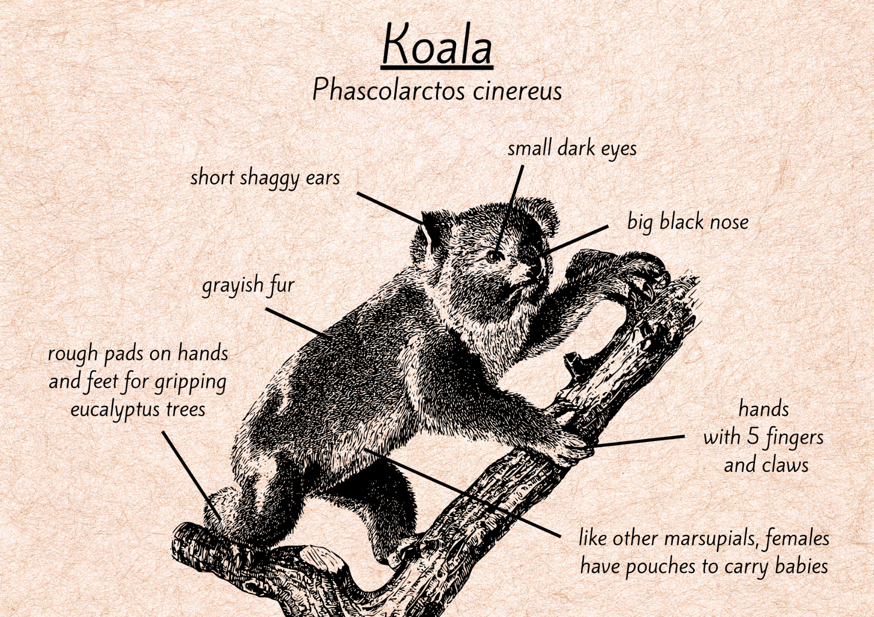
Images sourced from Canva and used in accordance with the Canva Content License Agreement.

Resource 2: Informative text exemplar
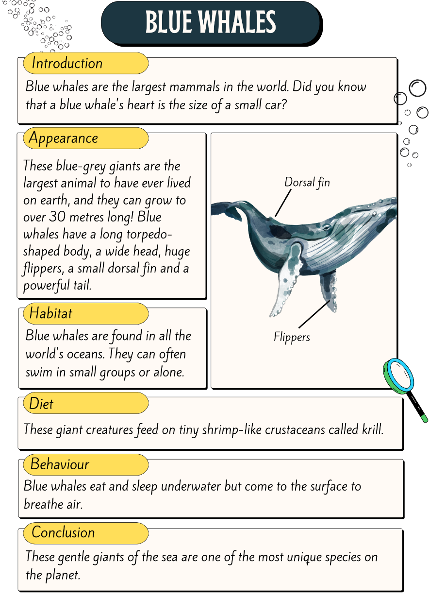
Images sourced from Canva and used in accordance with the Canva Content License Agreement.

Resource 3: Tiered words
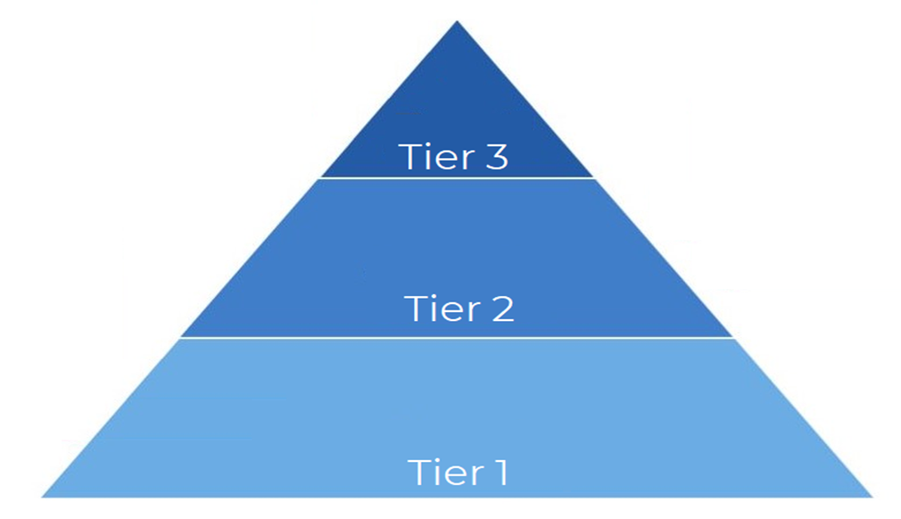

Resource 4: Sequencing parts of an informative text
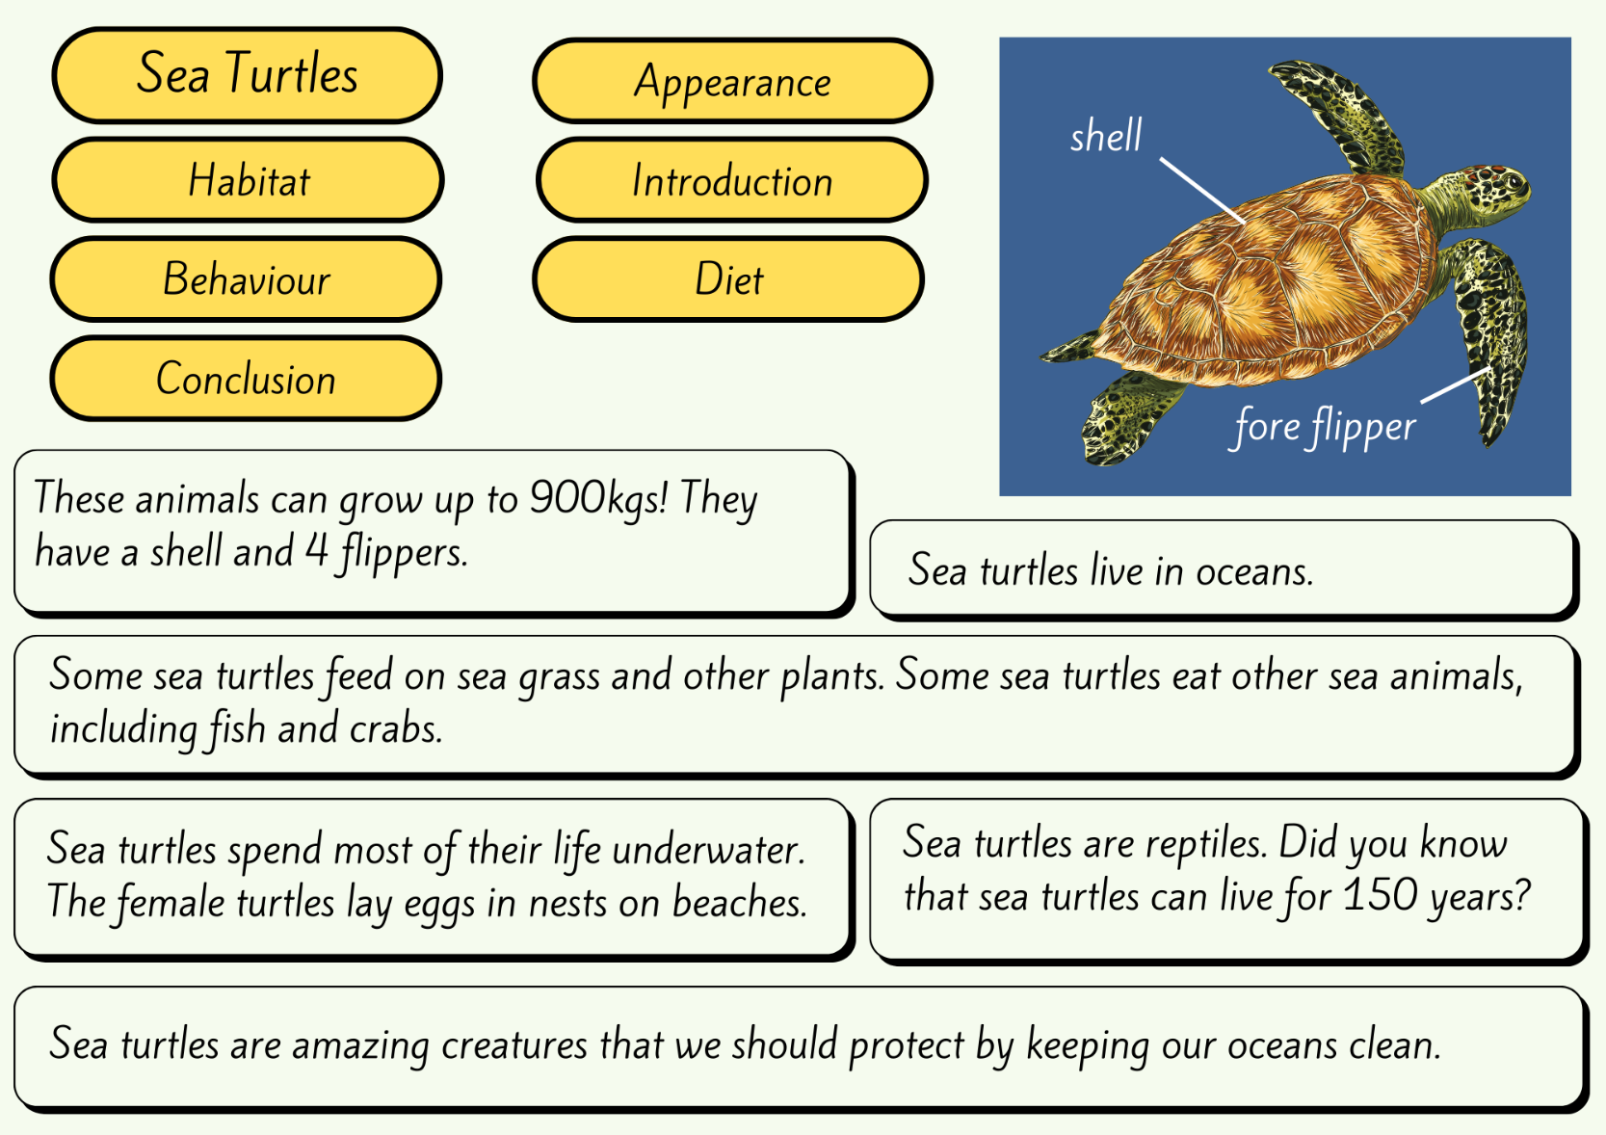
Images sourced from Canva and used in accordance with the Canva Content License Agreement.

Resource 5: Informative text template
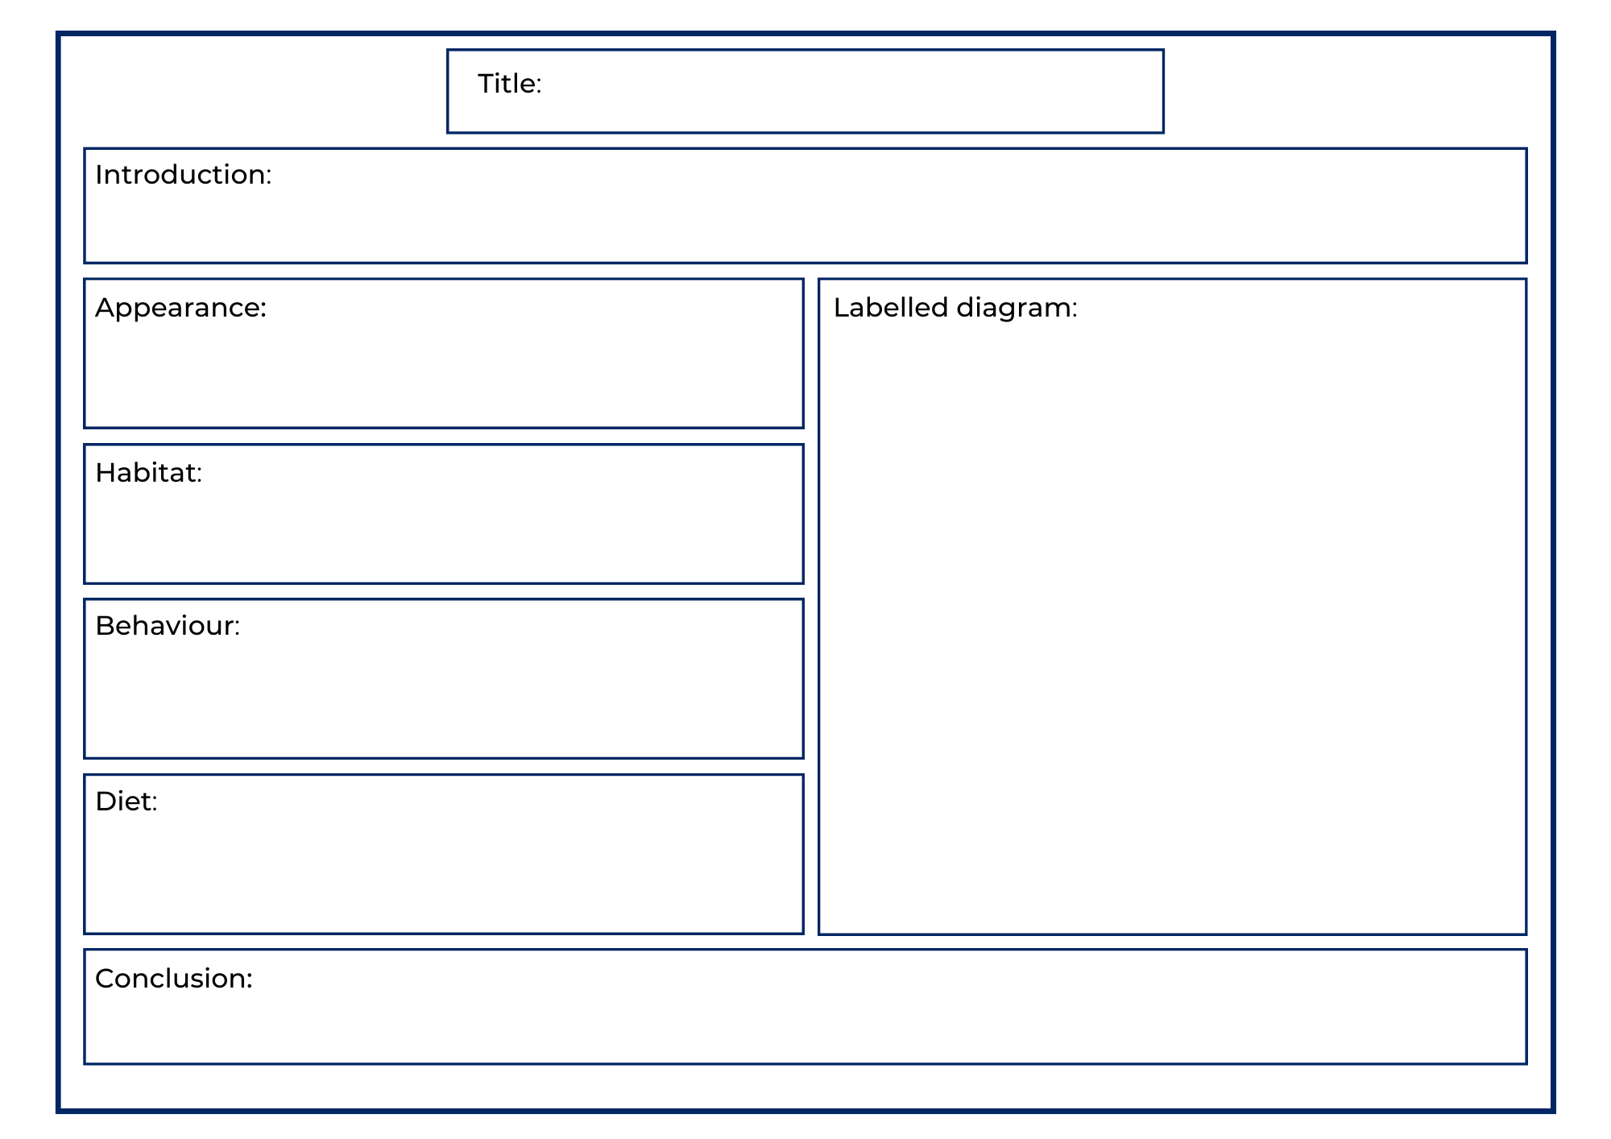

References
Links to third-party material and websites
Please note that the provided (reading/viewing material/list/links/texts) are a suggestion only and implies no endorsement, by the New South Wales Department of Education, of any author, publisher, or book title. School principals and teachers are best placed to assess the suitability of resources that would complement the curriculum and reflect the needs and interests of their students.
If you use the links provided in this document to access a third-party's website, you acknowledge that the terms of use, including licence terms set out on the third-party's website apply to the use which may be made of the materials on that third-party website or where permitted by the Copyright Act 1968 (Cth). The department accepts no responsibility for content on third-party websites.
Except as otherwise noted, all material is © State of New South Wales (Department of Education), 2021 and licensed under the Creative Commons Attribution 4.0 International License. All other material (third-party material) is used with permission or under licence. Where the copyright owner of third-party material has not licensed their material under a Creative Commons or similar licence, you should contact them directly for permission to reuse their material.
English K–10 Syllabus © 2022 NSW Education Standards Authority (NESA) for and on behalf of the Crown in right of the State of New South Wales.
Creative Arts K–6 Syllabus © 2006 NSW Education Standards Authority (NESA) for and on behalf of the Crown in right of the State of New South Wales.
Science and Technology K–6 Syllabus © 2017 NSW Education Standards Authority (NESA) for and on behalf of the Crown in right of the State of New South Wales.
© 2021 NSW Education Standards Authority. This document contains NSW Curriculum and syllabus content. The NSW Curriculum is developed by the NSW Education Standards Authority. This content is prepared by NESA for and on behalf of the Crown in right of the State of New South Wales. The material is protected by Crown copyright.
Please refer to the NESA Copyright Disclaimer for more information.
NESA holds the only official and up-to-date versions of the NSW Curriculum and syllabus documents. Please visit the NSW Education Standards Authority (NESA) website and the NSW Curriculum website.
National Literacy Learning Progression © Australian Curriculum, Assessment and Reporting Authority (ACARA) 2010 to present, unless otherwise indicated. This material was downloaded from the Australian Curriculum website (National Literacy Learning Progression) (accessed 18 August 2022) and was not modified. The material is licensed under CC BY 4.0. Version updates are tracked in the ‘Curriculum version history’ section on the 'About the Australian Curriculum' page of the Australian Curriculum website.
ACARA does not endorse any product that uses the Australian Curriculum or make any representations as to the quality of such products. Any product that uses material published on this website should not be taken to be affiliated with ACARA or have the sponsorship or approval of ACARA. It is up to each person to make their own assessment of the product, taking into account matters including, but not limited to, the version number and the degree to which the materials align with the content descriptions and achievement standards (where relevant). Where there is a claim of alignment, it is important to check that the materials align with the content descriptions and achievement standards (endorsed by all education Ministers), not the elaborations (examples provided by ACARA).
ETA (English Teachers Association) and NSW Department of Education (2016) The Textual Concepts and Processes resource, English Textual Concepts website, accessed 8 September 2022.
ABC (2022) ‘Meet the Penguins’ [video], ABC, ABC iView, accessed 8 September 2022.
ABC (31 May 2022) ‘Our Animals: Spider Features’ [video], ABC Education, ABC website, accessed 8 September 2022.
Attenborough D (2012) ‘The Penguin King’, Atlantic Productions, ABC iView, accessed 8 September 2022.
BBC Earth Kids (4 March 2020) ‘Deadly 60: Finding a Leopard in the Wild’ [video], BBC Earth Kids, YouTube, accessed 8 September 2022.
Carle E (2021) Eric Carle’s Book of Amazing Animals, Puffin, London.
National Geographic Partners, LLC (2022) Animals, National Geographic Kids, accessed 8 September 2022.
State of New South Wales (Department of Planning and Environment) (2022), Native Animals, NSW Department of Planning and Environment website, accessed 8 September 2022.
Taronga Zoo (14 September 2021) 'Guess Who at the Zoo - What is that Tail? - Taronga Education - Lockdown Lessons' [video], Taronga Education, Vimeo, accessed 8 September 2022.
Taronga Zoo (7 September 2021) 'What is that Sound - Taronga Education - Lockdown Lessons' [video], Taronga Education, Vimeo, accessed 8 September 2022.

Further reading
ABC (27 October 2021) ‘Our Animals: Ever seen a Sea dragon’ [video], ABC Education, ABC website, accessed 8 September 2022.

