English – Stage 1 – Unit 2
Contents
Unit overview and instructions for use 3
Teacher notes 4
Outcomes and content – Component A 6
Outcomes and content – Component B 8
Week 1 11
Component A teaching and learning 11
Component B teaching and learning 12
Lesson 1: Going on a narrative journey 13
Lesson 2: Sequencing narrative journeys 14
Lesson 3: Prepositional phrases 17
Lesson 4: Planning a narrative journey 19
Lesson 5: Creating a narrative journey 20
Week 2 23
Component A teaching and learning 23
Component B teaching and learning 24
Lesson 6: Building character descriptions 25
Lesson 7: Sequencing events with time connectives 27
Lesson 8: Connecting to characters and places along the journey 29
Lesson 9: Present tense and past tense verbs 30
Lesson 10: Using story maps to retell a journey 32
Resource 1: Talking strip 35
Resource 2: Writing strip 36
Resource 3: Story map 37
Resource 4: Gumboots escapes 38
Resource 5: Character conversations 39
Resource 6: Transformations 41
Resource 7: Duck on a Bike story map 42
References 43
Further reading 45

Unit overview and instructions for use
This two-week unit is comprised of Component A and Component B. Connecting learning across both components is encouraged.
Teaching and learning | Component A | Component B
Suggested duration | 60 minutes | 45 minutes
Explicit teaching focus areas | - Phonic knowledge  - Reading fluency  - Reading comprehension  - Spelling  - Handwriting | - Oral language and communication  - Vocabulary  - Reading comprehension  - Creating written texts  - Understanding and responding to literature
To prepare for teaching and learning: | - Refer to Outcomes and content – Component A, K-2 – Instructional sequence – grapheme–phoneme correspondences [PDF 825 KB], and the teaching advice documents (hyperlinked in Component A teaching and learning table).  - Based on student needs identified through ongoing assessment data, plan and document how you will sequence teaching and learning in whole class and targeted teaching groups across the two-week cycle. | - Familiarise yourself with Outcomes and content – Component B, Textual concepts information and videos, English Textual Concepts and Learning Processes (2016), and the teaching and learning sequence.  - Based on student needs identified through ongoing assessment data, determine how you will support students in whole class and targeted teaching groups across the two-week cycle as required.
English K–10 Syllabus © 2022 NSW Education Standards Authority (NESA) for and on behalf of the Crown in right of the State of New South Wales.

Teacher notes
- Narrative is the key concept of this unit, explored using the mentor texts A Bag and a Bird by Pamela Allen and The Great Rabbit Chase by Freya Blackwood. The supporting concept is character. Narrative is defined as an account of events or related experiences which may be fictional or non-fictional (NESA Glossary). A narrative is usually structured to invite responder involvement. Narrative helps us make sense of our lives. Understanding of narrative can be supported through watching the department’s video Narrative (3:51). Narratives that contain a journey are the central focus of this unit of learning.
- For information on mentor texts, Tier 1 and Tier 2 words and mental model refer to the NESA Glossary.
- This unit could enhance student learning towards achievement of outcomes from the Creative Arts and Geography syllabuses.
- In-depth support and resources, including links to professional learning on vocabulary are available on the department’s webpage. Effective reading in the early years of school.
- The Gradual Release of Responsibility framework (3:32) (I do, we do, you do) shifts teacher centred learning to joint responsibility to student agency. Understanding this framework will enhance implementation of this unit.
- Reflect on student learning and engagement in activities and record differentiation and adjustments within the unit to inform future teaching and learning. One way of doing this could be to add comments to the digital file.
- The following instructional strategies are included to enhance students’ understanding and responding to literature and creating written texts.
Strategies for understanding and responding to literature:
- Thinking aloud involves verbally modelling the thinking processes before, during, and after reading or writing. It is important that you verbalise what is going on in your mind as you read or write. Having a focus for a think aloud makes sure that this strategy is used effectively and efficiently.
- See, Think, Wonder encourages students to make careful observations and thoughtful interpretations. Teachers can model by using the sentence starters ‘I see...., I think..., I wonder...'
- Thinking partners are used to engage students in accountable conversations about texts and personal experiences. This strategy helps students share their experiences and thinking in a non-threatening way. Similar strategies include ‘talk partners’, ‘Think-Pair-Share’, and ‘turn and talk’.
Strategies for creating written texts:
- ‘Draw, Talk, Write, Share’ for emergent writers includes drawing as part of a meaning making process, while talking and sharing allows children to make sense of their ideas and to develop their vocabulary and oral language skills. Writing provides an opportunity to apply phonic and word knowledge into another context. For best practice see Mackenzie (2019), Draw, Talk, Write (and Share).
- Interactive writing – teacher and students compose and record a co-constructed text. The teacher models how successful writers generate and organise their ideas, and guides students to record the text. Interactive writing can also provide an opportunity to teach concepts about print, sentence structure and grammar, spelling strategies, punctuation, and handwriting.
- Guided writing is providing targeted scaffolds and support to groups of or individuals students with similar needs as they develop writing skills and understandings. Guided writing involves guiding and supporting students through the process of writing, providing explicit instruction and feedback through planned mini-lessons and conferences.
For further information, refer to the English K–10 Syllabus additional teaching advice: Stage 1 – Understanding and responding to literature and Stage 1 – Creating written texts.
- Content points are linked to the National Literacy Learning Progression version (3).
Levels and indicators sourced from National Literacy Learning Progression © Australian Curriculum, Assessment and Reporting Authority (ACARA), (accessed 7 September 2022) and was not modified. See references for more information.

Outcomes and content – Component A
The table below outlines the focus outcomes and content. Content is linked to the National Literacy Learning Progression version (3).
Focus area and outcome | Content points and National Literacy Learning Progression
Phonic knowledge  EN1-PHOKW-01 – uses initial and extended phonics, including vowel digraphs, trigraphs to decode and encode words when reading and creating texts | - segment and encode one-syllable high-frequency base words with split digraphs and apply this when creating texts (SpG6)  - blend and decode one-syllable words with taught extended vowel graphs and digraphs, including graphemes for r-controlled vowels and diphthongs, and apply this when reading texts (PKW6, PKW7)  - segment and encode one-syllable words with taught vowel graphs, digraphs and trigraphs and apply this when creating texts
Reading fluency  EN1-REFLU-01 – sustains reading unseen texts with automaticity and prosody and self-corrects errors | - apply grapheme–phoneme correspondence to read words with automaticity (FlY1)  - use sentence punctuation to enhance reading in a conversational manner (FlY3, FlY4)
Reading comprehension  EN1-RECOM-01 – comprehends independently read texts that require sustained reading by activating background and word knowledge, connecting and understanding sentences and whole text, and monitoring for meaning | - make text-to-self, text-to-text or text-to-world connections when reading (UnT6)  - recount relevant ideas from texts in the form of a written, visual or oral summary (UnT6)
Spelling  EN1-SPELL-01 – applies phonological, orthographic and morphological generalisations and strategies when spelling words in a range of writing contexts | - segment single-syllable words into phonemes as a strategy for spelling (SpG4)  - spell high-frequency base words with taught vowel graphs, digraphs, split digraphs, trigraphs and quadgraphs (SpG6)  - use spelling conventions when adding tense-marking suffixes (SpG9)
Handwriting  EN1-HANDW-01 – uses a legible, fluent and automatic handwriting style, and digital technology, including word-processing applications, when creating texts | - form all letters with consistent size and slope in NSW Foundation Style from memory (HwK5)

Outcomes and content – Component B
The table below outlines the focus outcomes and content. Content is linked to the National Literacy Learning Progression version (3).
Focus area and outcome | Content points and National Literacy Learning Progression
Oral language and communication  EN1-OLC-01 – communicates effectively by using interpersonal conventions and language to extend and elaborate ideas for social and learning interactions | - initiate, listen and/or respond in partner and group conversations (InT3, InT5)  - organise key ideas in logical sequence
Vocabulary  EN1-VOCAB-01 – understands and effectively uses Tier 1, taught Tier 2 and Tier 3 vocabulary to extend and elaborate ideas | - use taught morphemic knowledge to create word families
Reading comprehension  EN1-RECOM-01 – comprehends independently read texts that require sustained reading by activating background and word knowledge, connecting and understanding sentences and whole text, and monitoring for meaning | - use known vocabulary to build a mental model of the content of the text  - make text-to-self, text-to-text or text-to-world connections when reading (UnT6)  - recount relevant ideas from texts in the form of a written, visual or oral summary (UnT6)
Creating written texts  EN1-CWT-01 – plans, creates and revises texts written for different purposes, including paragraphs, using knowledge of vocabulary, text features and sentence structure | - write texts that describe, explain, give an opinion, recount an event, tell a story (CrT7)  - use a logical order to sequence ideas and events in sentences across a text (GrA4)  - use appropriate tense across a text (GrA4)  - use noun groups to build descriptions of people and things (CrT6)  - use contextually precise prepositional phrases when creating texts (GrA4)  - use time connectives to sequence information and events in texts (GrA4)  - use a variety of planning strategies and tools for creating texts
Understanding and responding to literature  EN1-UARL-01 – understands and responds to literature by creating texts using similar structures, intentional language choices and features appropriate to audience and purpose | - identify the sequence of events that make up a narrative in own and others’ texts (UnT6)

Week 1

Component A teaching and learning
The table below can be used to plan and document lessons that address Component A outcomes and content. Both the detailed example [DOC 529KB] of a two-week teaching and learning cycle and brief example [DOC 66KB] may support you in your planning.
Focus Areas | Lesson 1 | Lesson 2 | Lesson 3 | Lesson 4 | Lesson 5
Phonic knowledge
15 minutes
Spelling and Handwriting
15 minutes
Reading comprehension and Reading fluency
30 minutes

Component B teaching and learning
The following teaching and learning sequence has been designed to address Component B outcomes and content. Adapt the sequence as required to best meet the needs of your students.

Learning intention and success criteria
Learning intentions and success criteria are best co-constructed with students.

Learning intention
Students are learning to understand the elements of a narrative through texts that include a journey, and use planning tools and prepositional phrases to create a narrative.

Success criteria
Students can:
- identify the sequence of a narrative
- use planning tools to plan a narrative
- create mental models using known words in text
- create simple prepositional phrases.

Resources
- Allen P (2019) A Bag and a Bird, Puffin, Australia. ISBN: 9780143784289
- Resource 1: Talking strip (enlarged copy and copies for students)
- Resource 2: Writing strip (enlarged copy and copies for students)
- Resource 3: Story map (copies for students)
- Google Earth image of Sydney Opera House
- Mini whiteboards
- Paper for labels
- Poster paper
- Props such as a plastic bag, bucket for a bin, backpacks, hat
- Unlined scrap book, student workbook or blank paper

Lesson 1: Going on a narrative journey
- Introduce the text concept, narrative. A narrative is an account of events which may be real or imagined. A narrative has elements including characters, setting, and events.
- Introduce the text A Bag and a Bird by Pamela Allen as a narrative about a journey. Ask students to See, Think, Wonder about the visual elements on the cover. Using mini whiteboards, students write or draw their predictions about the events that may take place in the story. Students share their predictions and explain their reasoning.
- Read the text, stopping occasionally at key points to predict what may happen next. Review students’ predictions from their whiteboards. Invite students to self-assess their predictions. Students use thumbs up, down, or sideways to indicate how accurate their predictions were.
- Use the map from inside the text cover and Google Earth image of Sydney Opera House, to revisit the journey John and his mother take in the text. Discuss where they travelled (the setting) and what John and his mother saw. Explain that they were in Sydney Harbour, the traditional lands of the Gadigal people of the Eora Nation. Compare the 2 maps. Discuss any similarities to highlight text-to-world connections.
- Discuss the places in the text. Write place names on paper labels and display around the classroom, in order of the journey taken in the story.
- Discuss the characters in the text. Create a list of characters.
- Divide the class into small groups and assign each group of students to a character. Select students to role play characters including John, his mother, a group of birds, the elderly couple, and onlookers at the park. Students sit or stand at the place where their character appears in the text. For example, the group of birds stand or sit next to the Botanic Gardens label.
- Students act out events from the narrative as you retell the story. Use props to enhance the retell. For example, a plastic bag, a bucket for a bin and back packs.
- Discuss the sequence of events in the story, the complication that arose from the bird being caught in the plastic bag and the resolution of the man freeing the bird. Make text-to-self connections by discussing the need to care for our environment. Highlight that students will continue to understand narrative elements throughout the week.

Lesson 2: Sequencing narrative journeys
- Re-read the text A Bag and a Bird.
- Re-visit pages of the text with Tier 2 vocabulary. For example, esplanade, harbour, ferry, parachute, waded, elderly and exhausted. Draw students’ attention to how these words appear in the text and the illustrations. Highlight how the illustration helps to understand the meaning of the word and create a mental model.
- Discuss how narratives have a sequence of events.
- In groups of 3 to 4, students create an oral retelling of 4 to 6 main events in the text. Invite groups to share their retell as you monitor and check in with each group.
- As a whole class, record 4 to 6 main events of the text onto poster paper or the board. For example:
- John and his mother making sandwiches and storing them in a plastic bag.
- John and his mother walking to the gardens.
- The plastic bag flying away and the birds eating the bread.
- The bag getting caught on the bird and dragging it into the water.
- The elderly man rescuing the bird and untangling the bag from the bird.
- John putting the bag in the bin and walking home with his mother.
- Students are given paper to draw a story map of the journey in the text. Show the map from the inside cover as an example.
- Students write 3 to 4 events in sequence that took place in the text by adding a sentence to a place on their map.
Too hard? Use a text walk through to explicitly show the main events. Scaffold and co-construct an oral retell of the beginning, middle and end. Students draw 3 events on the map.
Too easy? Students write 4 to 6 sentences to retell the sequence of events.
- Students share their completed map in a gallery walk.
Stage 1 Assessment task 1 – Observations and work samples from this lesson allow students to demonstrate achievement towards the following syllabus outcomes and content points:
EN1-OLC-01 – communicates effectively by using interpersonal conventions and language to extend and elaborate ideas for social and learning interactions
- initiate, listen and/or respond in partner and group conversations
- organise key ideas in logical sequence.
EN1-RECOM-01 – comprehends independently read texts that require sustained reading by activating background and word knowledge, connecting and understanding sentences and whole text, and monitoring for meaning
- use known vocabulary to build a mental model of the content of the text
- make text-to-self, text-to-text or text-to-world connections when reading
- recount relevant ideas from texts in the form of a written, visual or oral summary.
EN1-CWT-01 – plans, creates and revises texts written for different purposes, including paragraphs, using knowledge of vocabulary, text features and sentence structure
- use a variety of planning strategies and tools for creating texts organise key ideas in logical sequence.
EN1-UARL-01 – understands and responds to literature by creating texts using similar structures, intentional language choices and features appropriate to audience and purpose
- identify the sequence of events that make up a narrative in own and others’ texts.

Lesson 3: Prepositional phrases
- Revise simple sentences as subject-noun group, verb-verb group, and object-noun group (subject-verb-object structure). Introduce prepositions. Explain that authors use prepositions to tell the reader where (place) or when (time) something is in relation to something else. Create a class definition of prepositions on poster paper.
- Give students examples of prepositions in relation to place such as on, in, up, down, under. Ask students to brainstorm other prepositions for place. Record and add student responses to the class definition.
- Explain that when a preposition and noun group are added, they form a prepositional phrase in a sentence.
- Write on poster paper ‘They climbed the steps onto the bridge’. Using colour coding, highlight the subject (they), verb (climbed), preposition (onto) and noun-object (the bridge). Repeat for the following sentences:
- They walked past the Opera House, along the esplanade beside the sea wall, until at last they came to the Botanic Gardens.
- He climbed over the wall.
- He waded into the water.
- Model how to use Resource 1: Talking strip, to create a sentence with a prepositional phrase. Using an enlarged copy of the resource, select and say a subject-noun group, for example ‘the dog’, then choose a verb-verb group ‘is running’, add a position and noun group ‘across the road’.
- Teach how to listen and respond to a partner by inviting 2 students to sit in the centre of a class circle and demonstrate how to use Resource 1: Talking strip. Explain one student is the listener and the other is the speaker, they sit knee to knee, looking at each other. The listener uses non-verbal cues to show that they are listening, such as small nods. The speaker uses voice, pitch, and pace to deliver a sentence in a clear voice. Students swap roles.
- Divide students into small groups. Give each group a copy of Resource 1: Talking strip. One student creates a sentence with a prepositional phrase while the other students listen. Students take turns being the speaker and the listener.
- Using an enlarged copy of the Resource 2: Writing strip, model how to write a sentence with a prepositional phrase.
- Using Resource 2: Writing strip, students write a sentence with a prepositional phrase. Encourage students to add an illustration to match the image. Create a class display of students’ published sentences.
Too hard? Jointly construct a sentence with students. Create a small, guided writing group, use interactive writing strategies to co-construct sentences with a prepositional phrase.
Too easy? Students write a sentence with a prepositional phrase without the resource scaffold.
Stage 1 Assessment task 2 – Observations and work samples from this lesson allow students to demonstrate achievement towards the following syllabus outcomes and content points:
EN1-OLC-01 – communicates effectively by using interpersonal conventions and language to extend and elaborate ideas for social and learning interactions
- initiate, listen and/or respond in partner and group conversations
- organise key ideas in logical sequence.
EN1-CWT-01 – plans, creates and revises texts written for different purposes, including paragraphs, using knowledge of vocabulary, text features and sentence structure
- use contextually precise prepositional phrases when creating texts
- use a variety of planning strategies and tools for creating texts organise key ideas in logical sequence.

Lesson 4: Planning a narrative journey
- Share an oral narrative of a journey, for example a journey to or around the school. Create a simple map as you retell the journey. Identify the main characters and the problem, which may be related to a simple environmental problem.
- Discuss 3 to 6 main events. These can be real or imagined. Link the main events to places on the journey.
- With a thinking partner, students take turns to create an oral narrative about their journey to or around the school and listen to each other’s oral narrative. Encourage students to include 3 to 6 main events, linking them to a place on the journey.
Too hard? Join a thinking pair and scaffold the structure of an oral retell using prompts about what happens and where.
- Explicitly model how to complete Resource 3: Story map to plan a narrative journey retell from activity 1. Model drawing the event linked to a place in sequence. Use arrows or number boxes to show the sequence of the narrative. Add a title to the story map.
- Students draw 3 events and the places on their journey to or around the school in sequence. Encourage students to use arrows or number boxes to show the structure of their narrative and write an appropriate title.
- Use interactive writing to model writing sentences for the orientation of the oral narrative. Use the think aloud strategy and colour coding to highlight the subject-noun group, verb-verb group, preposition, and noun-noun group.
- Students add sentences to 3 events on their copy of Resource 3: Story map.
Too hard? Students draw 3 events, scribe or jointly construct sentences to support their illustrations.
Too easy? Students draw more than 3 events and write sentences with prepositional phrases to support their illustrations.
- Invite students to share an event from their map with the class.

Lesson 5: Creating a narrative journey
- Revise the text concept narrative.
- Explain that students are going to create a narrative about a journey. Using a hat as a prop, explain that the hat is magical, and it has the power to make whoever is wearing it fly. Co-construct a title for the narrative journey.
- Ask students to create a mental model of where they could fly to while wearing the hat.
- Brainstorm and record the different places on a class mind map, for example to school, a park, bushlands, beach, a city. Students choose a place (setting) for their narrative journey.
- Give students time to think about their narrative journey and create a mental model of 3 to 4 events that might occur while flying to that place. Ask students to visualise what could happen on this journey. Revise prepositions about place, such as over, through, along, past. Encourage students to think about how prepositions can be used to add details to their narrative journey.
- In small groups, students discuss where they will go and what will happen (events).
- Students plan their narrative using Resource 3: Story map or plain paper to draw 3 to 4 events in sequence. Students draw a map of where they will travel to while wearing the hat, linking the events to a place on the map.
- Brainstorm words with students that they may need to write in their narrative. Create a class word bank.
- Students write a short narrative using their plans.
Too hard? Jointly construct or scribe for students. Create a guided writing group and engage students in interactive writing.
Too easy? Ask students to write sentences with prepositional phrases.
- In pairs, students take turns retelling their narrative journey. Remind students to talk about their writing, their drawings, and their ideas. Encourage students to ask each other questions and make comments.
Stage 1 Assessment task 3 – Observations and work samples from this lesson allow students to demonstrate achievement towards the following syllabus outcomes and content points:
EN1-OLC-01 – communicates effectively by using interpersonal conventions and language to extend and elaborate ideas for social and learning interactions
- initiate, listen and/or respond in partner and group conversations
- organise key ideas in logical sequence.
EN1-CWT-01 – plans, creates and revises texts written for different purposes, including paragraphs, using knowledge of vocabulary, text features and sentence structure
- write texts that describe, explain, give an opinion, recount an event, tell a story
- use a logical order to sequence ideas and events in sentences across a text
- use appropriate tense across a text
- use contextually precise prepositional phrases when creating texts
- use a variety of planning strategies and tools for creating texts organise key ideas in logical sequence.
EN1-UARL-01 – understands and responds to literature by creating texts using similar structures, intentional language choices and features appropriate to audience and purpose
- identify the sequence of events that make up a narrative in own and others’ texts.

Week 2

Component A teaching and learning
The table below can be used to plan and document lessons that address Component A outcomes and content. Both the detailed example [DOC 529KB] of a two-week teaching and learning cycle and brief example [DOC 66KB] may support you in your planning.
Focus Areas | Lesson 6 | Lesson 7 | Lesson 8 | Lesson 9 | Lesson 10
Phonic knowledge
15 minutes
Spelling and Handwriting
15 minutes
Reading comprehension and Reading fluency
30 minutes

Component B teaching and learning
The following teaching and learning sequence has been designed to address Component B outcomes and content. Adapt the sequence as required to best meet the needs of your students.

Learning intention and success criteria
Learning intentions and success criteria are best co-constructed with students.

Learning intention
Students are learning to understand narrative elements including character, setting and story structure through viewing, planning, and creating narratives that include a journey.

Success criteria
Students can:
- describe people and things using nouns, adjectives, verbs, and prepositions
- use time connectives to retell a sequence of events in order
- change present tense verbs into past tense verbs and use them in a sentence
- use story maps to retell and plan a narrative.

Resources
- Blackwood F (2017) The Great Rabbit Chase, Scholastic Australia. ISBN: 9781743811641
- Shannon D (2021) Duck on a Bike, Scholastic Inc, USA. ISBN: 9781338744903
- Resource 4: Gumboots escapes (enlarged copy, cut sentences and time connectives into individual pieces prior to the lesson)
- Resource 5: Character conversations (teacher copy)
- Resource 6: Transformations (enlarged copy or write onto sentence strips prior to lesson)
- Resource 7: Duck on a Bike story map (enlarged copy)
- Video: Let's Learn About Rabbits (2:58)
- T-chart
- Coloured pencils, markers
- Large sticky notes
- Mini whiteboards
- Poster paper for anchor charts and story maps
- Unlined scrap book, student workbook or blank paper

Lesson 6: Building character descriptions
- Activate students’ background knowledge of rabbits to support their understanding of the character Gumboots in The Great Rabbit Chase. Using mini whiteboards or paper, students draw or write known facts about rabbits. If needed, watch the video Let's Learn About Rabbits (2:58). Share and record student responses using a mind map.
- Using online photos of wild and domestic rabbits, as well as students’ background knowledge, model and co-construct descriptive sentences about rabbits. Use simple subject-verb-object structure and simple sentences with prepositional phrases. Ask students to identify capital letters, spaces, and full stops.
- Example sentences demonstrating subject-verb-object: Rabbits have soft fluffy fur; Some pet rabbits have long floppy ears.
- Example simple sentences with prepositional phrases: Wild rabbits live in burrows; Pet rabbits sleep in a hutch.
- Students complete a directed drawing of a rabbit. Read rabbit descriptions aloud one at a time:
- My body is the size and shape of a large football.
- I have 2 front legs with small paws and 2 back legs with long paws.
- I have an egg-shaped head with a small pink nose at the tip, 2 small round black eyes, a pink mouth and long whiskers.
- I have 2 long ears that stand up tall and are on the top of my head. They are rounded at the tips.
- I have short, soft fur. It is grey on my body and head and back. My paws and ears are black.
- I have a small grey and white fluffy tail.
- Explain that the rabbit described in activity 3 is a character in a book. Avoid sharing the character’s name. With a thinking partner, students make predictions about the character. Ask students to predict if it is a pet or wild rabbit, what its name might be, and what it could do. Share and record several responses.
Too easy? Students write predictions about their rabbit character.

Lesson 7: Sequencing events with time connectives
- Introduce the text The Great Rabbit Chase. Ask students to think about what type of text this book might be by looking at the illustrations on the front and back cover and reading the title. Explain that the rabbit character described in the previous lesson is the rabbit on the front cover. Revisit previous predictions about the rabbit.
- In small groups, students draw or write predictions about narrative elements including the characters, setting and events using the information on the cover. Ask one student from each group to share their predictions with the class. Record student predictions on large sticky notes. Ask students to classify predictions according to narrative elements, for example, placing all setting or complication predictions together.
- Display the inside cover of the text showing the gameboard to make connections with narrative as a journey. Highlight the start, finish, and other landmarks. Ask students to add to their predictions about the characters, setting and events, giving reasons for their answers. Record several responses to add to predictions from activity 2.
- Complete an uninterrupted read of The Great Rabbit Chase. Ask students to compare their predictions about the characters, setting and events to those in the narrative.
- On a sheet of poster paper, create a quickly drawn story map, like the gameboard at the beginning of the text. Add key landmarks and the location of characters connected to Gumboots’ escape journey.
- Shuffle and read aloud the events from Resource 4: Gumboots escapes. Ask students to sort the events into the sequence of the narrative and stick on the story map in the correct position.
- Explain that time connectives are used to sequence events in a narrative and can be used instead of phrases like ‘and then’ and ‘next’. Model retelling part of the story with the accentuated repetition of ‘and then’. Shuffle and read the time connectives from Resource 4: Gumboots escapes. Ask students to identify where in the story could they use the time connective, then match each time connective to an event on the story map.
- Students chorally retell the story using the story map, labels, and time connectives.
- Use the Draw, Talk, Write, Share process for students to recount relevant ideas about Gumboots’ journey in the form of a written or visual summary. Students label each event with a time connective to sequence their ideas.
Stage 1 Assessment task 4 – Observations and work samples from this lesson allow students to demonstrate achievement towards the following syllabus outcomes and content points:
EN1-RECOM-01 – comprehends independently read texts that require sustained reading by activating background and word knowledge, connecting and understanding sentences and whole text, and monitoring for meaning
- recount relevant ideas from texts in the form of a written, visual or oral summary.
EN1-CWT-01 – plans, creates and revises texts written for different purposes, including paragraphs, using knowledge of vocabulary, text features and sentence structure
- use a logical order to sequence ideas and events in sentences across a text
- use time connectives to sequence information and events in texts.
EN1-UARL-01 – understands and responds to literature by creating texts using similar structures, intentional language choices and features appropriate to audience and purpose
- identify the sequence of events that make up a narrative in own and others’ texts.

Lesson 8: Connecting to characters and places along the journey
- Explain that the characters are an important part of a narrative and that, in this story, along the journey or chase, the author has included interesting characters at each location. These characters want to help find Gumboots so much that they join the chase.
- Re-read The Great Rabbit Chase using the think aloud strategy to highlight the characters’ actions. Ask students to recall the characters in the text in the order they were introduced. Record a list of characters in their order of appearance in the text. Ask students how the author makes the reader think that the characters want to help find Gumboots.
- Allocate characters to students: the girl, Mum, Norman, Edith, Mr Kirkpatrick, John, Mrs Finkel and the important man. Read the text until Gumboots reaches the big park. As each character is introduced, students create a freeze frame of the character. Using Resource 5: Character conversations, ask questions to help build a mental model of each character’s personal traits. Students can adjust their freeze frame as the narrative progresses.
- Model using an enlarged copy of Resource 6: Transformations to explain use of sentence structures such as a subject (who the character is), verb group (what the character was doing), prepositional phrase (where the character was) and noun group to describe narrative events in the text involving characters.
- Deconstruct sentences one at a time, to separate and discuss the subject, verb, and prepositional phrase. Ask students to identify the who, what, and where parts of each sentence. Explore changing the word order and how prepositional phrases can be used at the beginning of end of the sentence. Briefly discuss the use of a comma after a prepositional phrase at the beginning of a sentence.
- As a class, imagine what it would be like if Gumboots ran through their school as part of his escape journey. Create an anchor chart with the headings such as who (subject), what (verb) and where (prepositional phrase). Brainstorm people and places in the school familiar to students. Add verbs or verb phrases to describe people’s actions.
- Select vocabulary from the anchor chart to co-construct events including characters involved in Gumboots journey through the school. Students can compose their own sentences to add to the narrative on mini whiteboards.
Stage 1 Assessment task 5 – Observations and work samples from this lesson allow students to demonstrate achievement towards the following syllabus outcomes and content points:
EN1-OLC-01 – communicates effectively by using interpersonal conventions and language to extend and elaborate ideas for social and learning interactions
- initiate, listen and/or respond in partner and group conversations.
EN1-RECOM-01 – comprehends independently read texts that require sustained reading by activating background and word knowledge, connecting and understanding sentences and whole text, and monitoring for meaning
- use known vocabulary to build a mental model of the content of the text.
EN1-CWT-01 – plans, creates and revises texts written for different purposes, including paragraphs, using knowledge of vocabulary, text features and sentence structure
- use contextually precise prepositional phrases when creating texts.

Lesson 9: Present tense and past tense verbs
- Ask students if they think the narrative The Great Rabbit Chase is a real or imagined story. Prompt students to give reasons for their answers. Explain that authors can write narratives about real life or imagined experiences that have happened in the past, or about something that is happening now (present). Explain that The Great Rabbit Chase is written in the present. Read the text on the page where Norman is at the front door waiting to play. Highlight the words ‘But today’, indicating the present.
- Introduce past, present, and future tense using a large, blank timeline. Label end points as past and future, and a middle point as present. Write last year, last week, yesterday, now, today, tomorrow, next week and next year on sticky notes. Students position sticky notes on the timeline and give an example of a real-life event that happened, or could happen, at each label on the timeline.
- Read selected pages from the text demonstrating the use of present tense verbs. On a T-chart, write the headings ‘present tense’ and ‘past tense’. Record present tense verbs from the text that describe the actions of the characters as they chase Gumboots. For example, race, tiptoe, follow and help.
- Explain that the beginning of the text gives hints that Gumboots has escaped before. Ask students to imagine that Gumboots escaped last week. Re-read 3 to 4 sentences from the text, substituting present tense verbs with a past tense verbs, beginning each sentence with ‘Last week...’. Ask students to identify the word that changed. Record past tense vocabulary on an anchor chart to match each present tense word. Discuss the use of the suffix -ed for past tense.
- Using mini whiteboards, explicitly teach and model spelling processes to create word families for past tense verbs for words from the text and CVCC and CCVC verbs. For example, jump + ed = jumped. Discuss any unusual spelling patterns such as double consonants, only adding ‘d’ when a word ends in ‘e’ and irregular past tense words that change, such as run and ran, as needed.
- Revisit the part of The Great Rabbit Chase when everyone reaches the park. Select sentences from the text that describe what the characters were doing and read sentences in past tense. For example: We explored the trees; Norman giggled at the cherubs; Edith and John watched tadpoles in the little creek and dropped leaf boats into the water.
- Ask students to recall a place they have journeyed to in the past. With a thinking partner, students share what they did using past tense. Encourage students to use time connectives taught in the previous lesson. Students give 3 to 4 examples of things they did. Select students to share their responses with the class.
- Using the Draw, Talk, Write, Share process, students record what they did in the form of a written or visual summary using past tense verbs to describe their journey or actions.
Stage 1 Assessment task 6 – Observations and work samples from this lesson allow students to demonstrate achievement towards the following syllabus outcomes and content points:
EN1-VOCAB-01 – understands and effectively uses Tier 1, taught Tier 2 and Tier 3 vocabulary to extend and elaborate ideas
- use taught morphemic knowledge to create word families.
EN1-CWT-01 – plans, creates and revises texts written for different purposes, including paragraphs, using knowledge of vocabulary, text features and sentence structure
- use appropriate tense across a text
- use time connectives to sequence information and events in texts.

Lesson 10: Using story maps to retell a journey
- Remind students that the text The Great Rabbit Chase is a narrative about a rabbit escaping and going on a journey and it included characters who were chasing him. Display the front cover of the text Duck on a Bike and read the title. Ask students why the text might be a narrative that also includes a journey. Ask students to predict if it is a real or imagined narrative, giving reasons for their answers.
- Complete an uninterrupted read of the text Duck on a Bike. Discuss the features of the narrative that are real or imagined including the characters and their actions, the setting, and events.
- Allocate students to characters from the text (duck, cow, sheep, dog, cat, horse, chicken, goat, 2 pigs, mouse, children on bikes). Select 2 students as narrators. Support students with each animal’s thoughts about Duck by giving the spoken text and asking students to repeat it. Encourage the use of expressions, actions, and body language to portray each character. Briefly discuss what the other characters thought about Duck’s journey.
- Display Resource 7: Duck on a Bike story map and explain that the story map can be used to recall details of the story and give an oral summary of the narrative. In pairs, students give an oral retell of the narrative using the story map. Encourage the use of time connectives and verbs in past tense.
- Explain that story maps can be used to plan a narrative as well as giving a summary of the sequence of events. Ask students to imagine another animal using some form of transport to go on a journey. Discuss what or who they will see on the way, where they could go, and what they could do. Co-construct and create a story map with narrative elements of characters, setting, and events. Model drawing to create the story map. Add labels to images if needed to support meaning. Give the narrative a title.
- In small groups, students develop their own narrative story map about an animal using some form of transport to go on a journey. Record plans on poster paper to display in classroom. Students share their story map with the class and give an oral retell of their story.
Too hard? Students use loose objects to represent characters or places and create a model of their story before recording their plan. Use sticky notes for initial drawings, which students then manipulate into the correct position before drawing on their story map.
Stage 1 Assessment task 7 – Observations and work samples from this lesson allow students to demonstrate achievement towards the following syllabus outcomes and content points:
EN1-OLC-01 – communicates effectively by using interpersonal conventions and language to extend and elaborate ideas for social and learning interactions
- organise key ideas in logical sequence.
EN1-RECOM-01 – comprehends independently read texts that require sustained reading by activating background and word knowledge, connecting and understanding sentences and whole text, and monitoring for meaning
- make text-to-self, text-to-text or text-to-world connections when reading
- recount relevant ideas from texts in the form of a written, visual or oral summary.
EN1-CWT-01 – plans, creates and revises texts written for different purposes, including paragraphs, using knowledge of vocabulary, text features and sentence structure
- use a logical order to sequence ideas and events in sentences across a text
- use a variety of planning strategies and tools for creating texts organise key ideas in logical sequence.
EN1-UARL-01 – understands and responds to literature by creating texts using similar structures, intentional language choices and features appropriate to audience and purpose
- identify the sequence of events that make up a narrative in own and others’ texts.

Resource 1: Talking strip
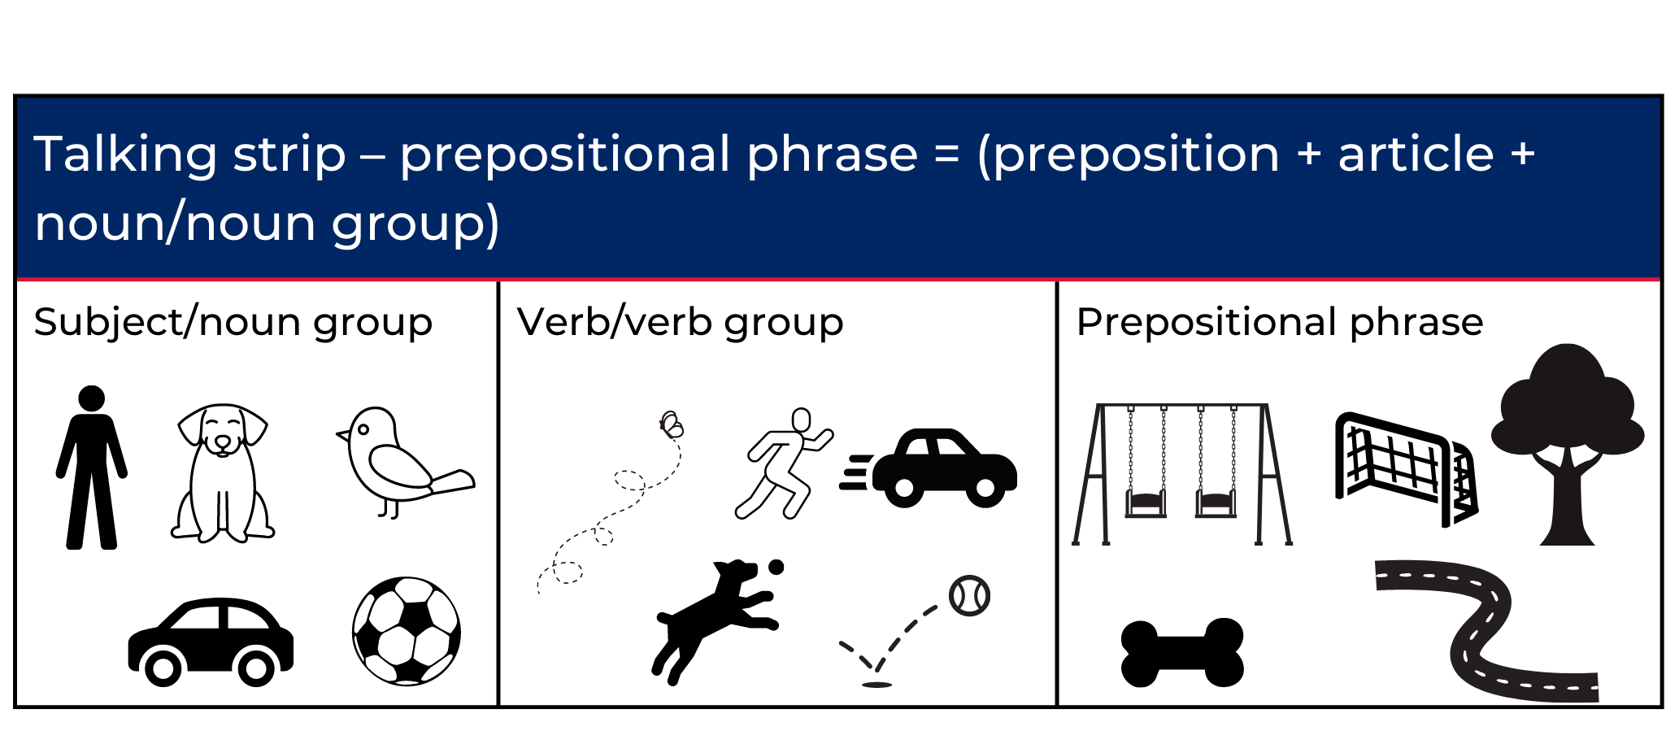
Images sourced from Canva and used in accordance with the Canva Content License Agreement.

Resource 2: Writing strip
Writing strip – prepositional phrase = (preposition + article + noun / noun group)
Subject-noun group | Verb-verb group | Prepositional phrase

Resource 3: Story map
Name:
Title:
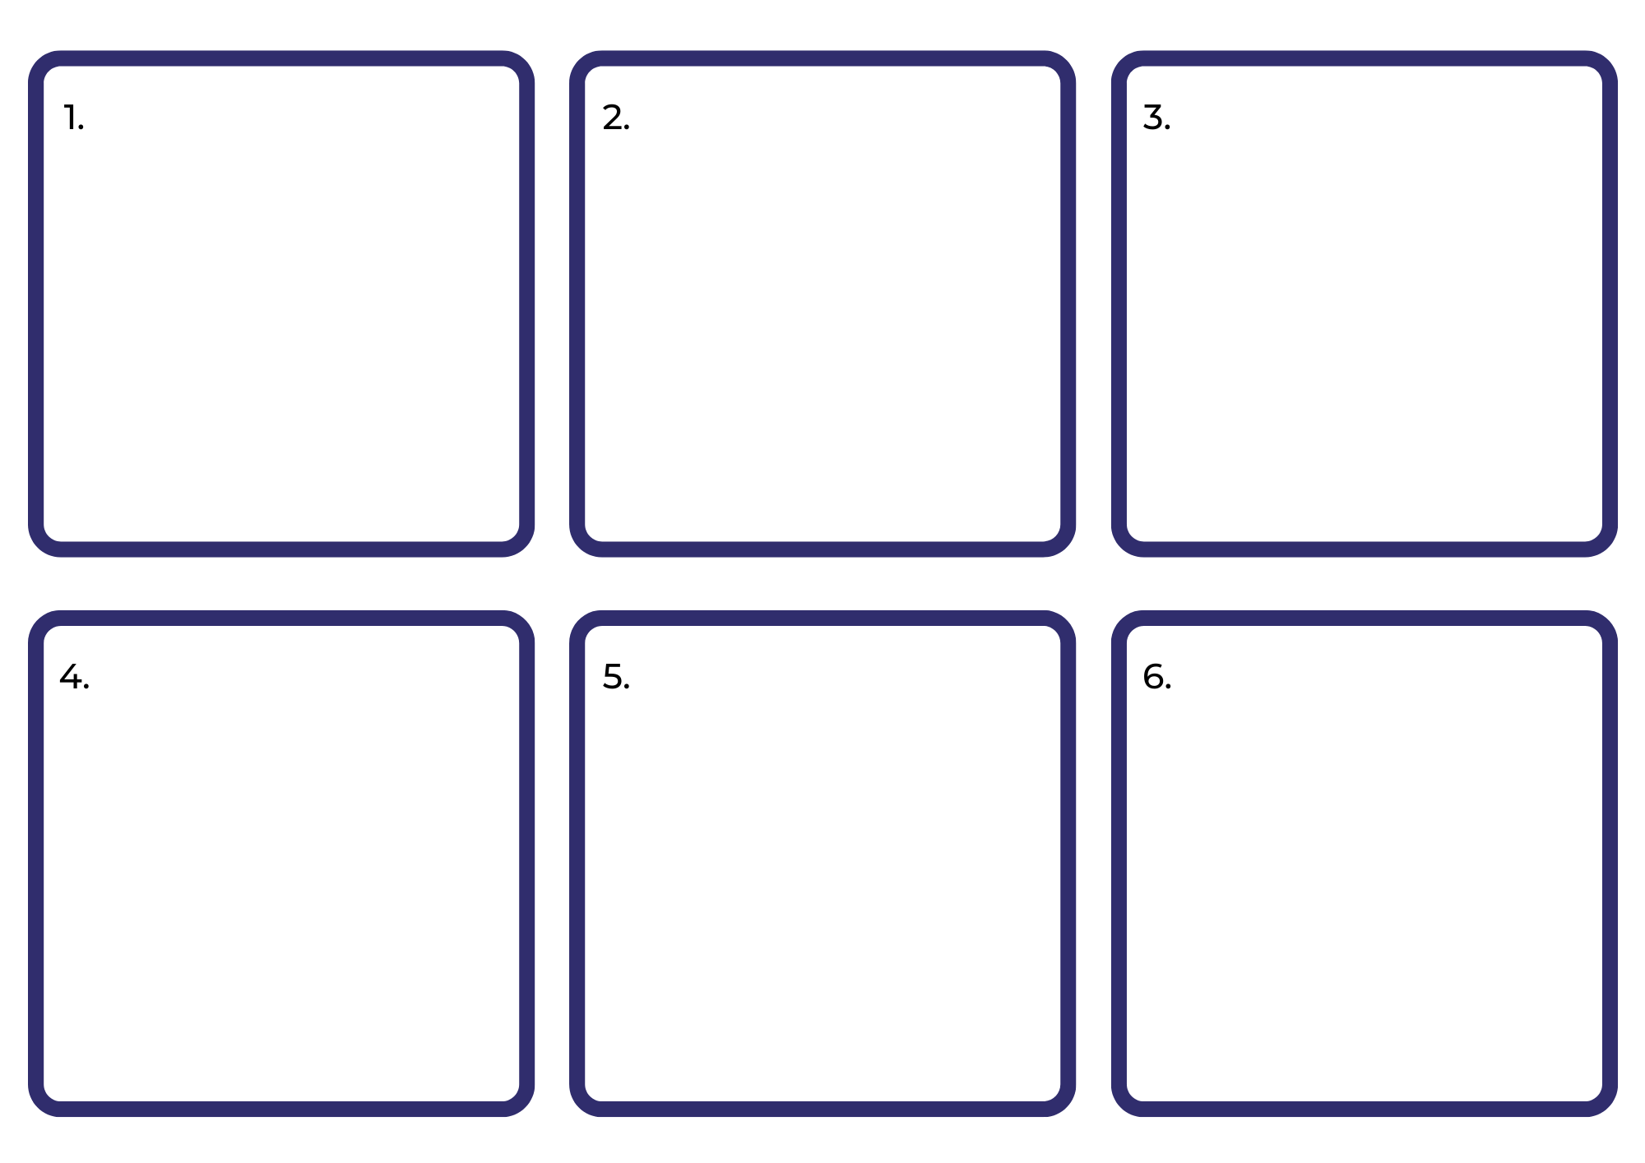

Resource 4: Gumboots escapes
Time connectives | Sequence of events
Today | Gumboots digs a burrow under the fence and escapes.
First | he races down the road past Edith waiting for the postman.
Next | Gumboots hops down a driveway, into a jungle of elm trees and through a broken paling fence.
After that | he goes across Mr Kirkpatrick's backyard without stopping.
Then | Gumboots hops over the zebra crossing past John with his red stop sign.
Following this | he travels along the path near the school, past Mrs Finkel and her baby Anna.
Next | Gumboots goes up the main street.
Eventually | Gumboots reaches the big park and disappears.
After a long time | Gumboots hops out, straight past the girl, along with 5 little grey and black rabbits.
In the end | all the rabbits hop back through the park, and we follow them home.

Resource 5: Character conversations
Characters | Questions/Conversation prompts
The girl | Hello girl. What’s your name? Where do you live? Do you have any pets? Tell me more about your pet rabbit. What does he look like? What does he like to do? How do you catch him when he escapes? How do you feel when he escapes?
Mum | Hello Mum. Tell me what happened when you went out to get new gumboots but came home with a rabbit. Why do you think it would be a good pet? What did you think when it first escaped? How many times has he escaped? How do you catch him? Do you have any help?
Norman | Hi Norman. Where do you live? Do play often with the girl? What do you like to do together? Do you play with any other children in the community? Do you like helping to catch Gumboots when he escapes? Why? Do you help anyone else in the community?
Edith | Hello Edith. What are you holding? Who are they for? Why do you give the postman cakes? Do you bake for anyone else in your community? It seems you like helping people. Why? Have you ever helped your neighbours? What do you think of their pet rabbit?
Mr Kirkpatrick | Hi Mr Kirkpatrick. Your backyard looks nice after mowing it. I understand you don’t like visitors, or dogs or cats and especially rabbits. Can you tell me why? Is there anything I can do to help you?
John | Hello John. How is the traffic today? Have you been doing this job for very long? Do you like it? Why? I notice some days you seem like you are daydreaming. What are you thinking about? You must see many people cross the road each day. How do you help people cross the road? Do you do any other jobs in the community helping people?
The important man | Hello important man. I like your shiny blue car. Have you had it very long? Tell me about where you work. You look nice in your suit. Do you work with people? How do you help them? I noticed you jumped out of your car to help chase a pet rabbit. Why did you do that?
Mrs Finkel | Good morning, Mrs Finkel. How is your walk going today? Where are you going? I can hear baby Anna crying. Does walking her in the pram help? Do you have any friends in the community that help you with Anna too?

Resource 6: Transformations
Sentences (I indicates parts to be separated by cutting)
Norman | is | at the front door | waiting to play.
We all | race | down the road.
We | tiptoe | across the Kirkpatrick’s backyard.
At the zebra crossing, | John | is daydreaming.
A man | in a shiny blue car | gets out | to help us.
We | follow him | down a driveway, | into a jungle of elm trees | and | through a broken paling fence.
Along the path | near the big school, | we | meet Mrs Finkel | and | her baby Anna | who is crying very loudly.

Resource 7: Duck on a Bike story map
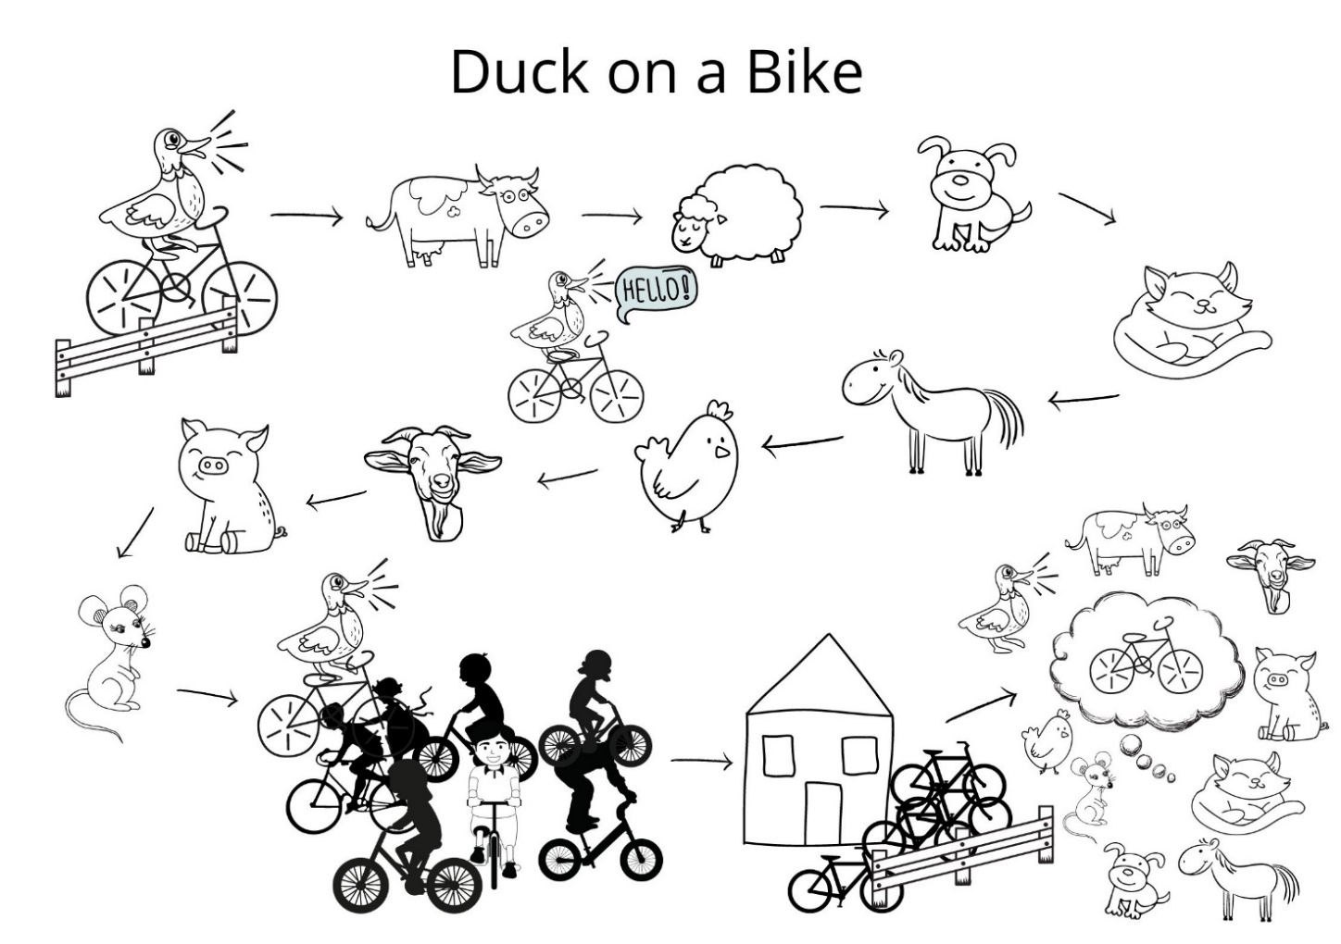
Images sourced from Canva and used in accordance with the Canva Content License Agreement.

References
Links to third-party material and websites
Please note that the provided (reading/viewing material/list/links/texts) are a suggestion only and implies no endorsement, by the New South Wales Department of Education, of any author, publisher, or book title. School principals and teachers are best placed to assess the suitability of resources that would complement the curriculum and reflect the needs and interests of their students.
If you use the links provided in this document to access a third-party's website, you acknowledge that the terms of use, including licence terms set out on the third-party's website apply to the use which may be made of the materials on that third-party website or where permitted by the Copyright Act 1968 (Cth). The department accepts no responsibility for content on third-party websites.
Except as otherwise noted, all material is © State of New South Wales (Department of Education), 2021 and licensed under the Creative Commons Attribution 4.0 International License. All other material (third-party material) is used with permission or under licence. Where the copyright owner of third-party material has not licensed their material under a Creative Commons or similar licence, you should contact them directly for permission to reuse their material.
English K–10 Syllabus © 2022 NSW Education Standards Authority (NESA) for and on behalf of the Crown in right of the State of New South Wales.
Creative Arts K–6 Syllabus © 2006 NSW Education Standards Authority (NESA) for and on behalf of the Crown in right of the State of New South Wales.
Geography K–10 Syllabus © 2015 NSW Education Standards Authority (NESA) for and on behalf of the Crown in right of the State of New South Wales.
© 2021 NSW Education Standards Authority. This document contains NSW Curriculum and syllabus content. The NSW Curriculum is developed by the NSW Education Standards Authority. This content is prepared by NESA for and on behalf of the Crown in right of the State of New South Wales. The material is protected by Crown copyright.
Please refer to the NESA Copyright Disclaimer for more information.
NESA holds the only official and up-to-date versions of the NSW Curriculum and syllabus documents. Please visit the NSW Education Standards Authority (NESA) website and the NSW Curriculum website.
National Literacy Learning Progression © Australian Curriculum, Assessment and Reporting Authority (ACARA) 2010 to present, unless otherwise indicated. This material was downloaded from the Australian Curriculum website (National Literacy Learning Progression) (accessed 7 September 2022) and was not modified. The material is licensed under CC BY 4.0. Version updates are tracked in the ‘Curriculum version history’ section on the 'About the Australian Curriculum' page of the Australian Curriculum website.
ACARA does not endorse any product that uses the Australian Curriculum or make any representations as to the quality of such products. Any product that uses material published on this website should not be taken to be affiliated with ACARA or have the sponsorship or approval of ACARA. It is up to each person to make their own assessment of the product, taking into account matters including, but not limited to, the version number and the degree to which the materials align with the content descriptions and achievement standards (where relevant). Where there is a claim of alignment, it is important to check that the materials align with the content descriptions and achievement standards (endorsed by all education Ministers), not the elaborations (examples provided by ACARA).
ETA (English Teachers Association) and NSW Department of Education (2016) The Textual Concepts and Processes resource, English Textual Concepts website, accessed 7 September 2022.
Allen P (2019), A Bag and a Bird, Puffin, Australia.
Blackwood F (2017) The Great Rabbit Chase, Scholastic Press, Australia.
Chrysaellect India (25 August 2021) 'Let’s learn about rabbits| preschool learning videos for kids| cute bunny rabbits' [video] Chrysaellect India, YouTube, accessed 7 September 2022.
Department of Education, Western Australia (2013). ‘Writing Resource Book’, First Steps Literacy, Department of Education, Western Australia, accessed 7 September 2022.
Google Earth (n.d.) Sydney Opera House, Sydney NSW, Google Earth, accessed 7 September 2022.
Harvard Graduate School of Education (2022) ‘See, Think, Wonder’, Core Thinking Routines, Project Zero website, accessed 7 September 2022.
Mackenzie N (22 October 2019) ‘Draw, Talk, Write (and Share)’, Noella Mackenzie, accessed 7 September 2022.
Shannon D (2021) Duck on a Bike. Scholastic Inc, USA.
State of Victoria (Department of Education and Training) (2019) ‘Guided writing/writing conferences’, Literacy Teaching Toolkit, State of Victoria Department of Education and Training website, accessed 7 September 2022.

Further reading
Listed in the K-2 English Research Tool Kit English professional reading library:
Mackenzie N and Scull J (2017) Understanding and Supporting Young Writers from Birth to 8, 1st edn, Routledge, London.
Derewianka B and Jones P (2016) Teaching Language in Context, 2nd edn, Oxford University Press, Melbourne.
McCarrier A, Pinnell GS and Fountas IC (2000) Interactive writing: How Language and Literacy come together, K-2, Heinemann Educational Books, US.
Mackenzie NM (2015) ‘Interactive Writing: a powerful teaching strategy’, Practical Literacy: The Early & Primary Years, 20(3), 36.

