English – Stage 1 – Unit 1
Contents
Unit overview and instructions for use 3
Teacher notes 4
Outcomes and content – Component A 5
Outcomes and content – Component B 7
Week 1 10
Component A teaching and learning 10
Component B teaching and learning 11
Lesson 1: Our Island 12
Lesson 2: Noun groups 14
Lesson 3: Prepositional phrases 15
Lesson 4: Context 16
Lesson 5: Our school context 17
Week 2 19
Component A teaching and learning 19
Component B teaching and learning 20
Lesson 6: Under the Southern Cross 21
Lesson 7: Comparing context 22
Lesson 8: Planning 22
Lesson 9: Composing 23
Lesson 10: Publishing 24
Resource 1: Animal cards 26
Resource 2: Sentence frame 28
Resource 3: Map of Australia 29
Resource 4: Our Island example 30
References 31

Unit overview and instructions for use
This two-week unit is comprised of Component A and Component B. Connecting learning across both components is encouraged.
Teaching and learning | Component A | Component B
Suggested duration | 60 minutes | 45 minutes
Explicit teaching focus areas | - Phonic knowledge  - Reading fluency  - Reading comprehension  - Spelling  - Handwriting | - Oral language and communication  - Vocabulary  - Reading comprehension  - Creating written texts  - Understanding and responding to literature
To prepare for teaching and learning: | - Refer to Outcomes and content – Component A, K-2 – Instructional sequence – grapheme–phoneme correspondences [PDF 825 KB], and the teaching advice documents (hyperlinked in Component A teaching and learning table).  - Based on student needs identified through ongoing assessment data, plan and document how you will sequence teaching and learning in whole class and targeted teaching groups across the two-week cycle. | - Familiarise yourself with Outcomes and content – Component B, Textual concepts information and videos, English Textual Concepts and Learning Processes (2016), and the teaching and learning sequence.  - Based on student needs identified through ongoing assessment data, determine how you will support students in whole class and targeted teaching groups across the two-week cycle as required.
English K–10 Syllabus © 2022 NSW Education Standards Authority (NESA) for and on behalf of the Crown in right of the State of New South Wales.

Teacher notes
- Context is defined as ‘a culturally or socially situated circumstance that may give rise to a particular register’ (NESA Glossary). To understand context, we look beyond the text to ‘consider the world in which it was produced and the worlds of its reception’ – English Textual Concepts and Learning Processes (2016).
- Understanding of context can be supported through watching the department’s video: Understanding context video (5:24).
- While context is the mentor concept for the conceptual component of this unit, the supporting concept of representation can be explored using the mentor text Our Island by Children of Gununa, Alison Lester, and Elizabeth Honey.
- For information on nouns, verbs, and prepositions refer to the NESA Glossary.
- A noun group is a group of words relating to, or building on, a noun. Noun groups usually consist of a pointer (the, a, an, this, that, these, those, my, your, his, her, its, our, mum’s, Mr Smith’s) plus one or more adjectives or adverbs. They are an important language resource for building descriptions.
- This unit could enhance student learning towards achievement of outcomes from the Creative Arts Syllabus regarding visual arts.
- Consider student prior knowledge of nouns, verbs, and prepositions.
- Reflect on student learning and engagement in activities, and record differentiation and adjustments within the unit to inform future teaching and learning. One way of doing this could be to add comments to the digital file.
- Content points are linked to the National Literacy Learning Progression version (3).
Levels and indicators sourced from National Literacy Learning Progression © Australian Curriculum, Assessment and Reporting Authority (ACARA), (accessed 15 August 2022) and was not modified. See references for more information.

Outcomes and content – Component A
The table below outlines the focus outcomes and content. Content is linked to the National Literacy Learning Progression version (3).
Focus area and outcome | Content points and National Literacy Learning Progression
Phonic knowledge  EN1-PHOKW-01 – uses initial and extended phonics, including vowel digraphs, trigraphs to decode and encode words when reading and creating texts | - blend and decode one-syllable words with taught extended vowel graphs and digraphs, including graphemes for r-controlled vowels and diphthongs, and apply this when reading texts (PKW6, PKW7)  - segment and encode one-syllable words with taught vowel graphs, digraphs and trigraphs and apply this when creating texts
Reading fluency  EN1-REFLU-01 – sustains reading unseen texts with automaticity and prosody and self-corrects errors | - apply grapheme–phoneme correspondence to read words with automaticity (FlY1)  - self-correct when fluency and/or meaning is interrupted  - use sentence punctuation to enhance reading in a conversational manner (FlY3, FlY4)
Reading comprehension  EN1-RECOM-01 – comprehends independently read texts that require sustained reading by activating background and word knowledge, connecting and understanding sentences and whole text, and monitoring for meaning | - use known vocabulary to build a mental model of the content of the text  - make text-to-self, text-to-text or text-to-world connections when reading (UnT6)
Spelling  EN1-SPELL-01 – applies phonological, orthographic and morphological generalisations and strategies when spelling words in a range of writing contexts | - segment single-syllable words into phonemes as a strategy for spelling (SpG4)  - spell high-frequency base words with taught vowel graphs, digraphs, split digraphs, trigraphs and quadgraphs (SpG6)  - use knowledge of morphemes to spell taught compound words and homophones with taught single-letter graphemes, digraphs, split digraphs, trigraphs and quadgraphs (SpG7)
Handwriting  EN1-HANDW-01 – uses a legible, fluent and automatic handwriting style, and digital technology, including word-processing applications, when creating texts | - form all letters with consistent size and slope in NSW Foundation Style from memory (HwK5)

Outcomes and content – Component B
The table below outlines the focus outcomes and content. Content is linked to the National Literacy Learning Progression version (3).
Focus area and outcome | Content points and National Literacy Learning Progression
Oral language and communication  EN1-OLC-01 – communicates effectively by using interpersonal conventions and language to extend and elaborate ideas for social and learning interactions. | - listen to or engage with texts for enjoyment and recognise that their own experience can shape their ideas and opinions of texts  - initiate, listen and/or respond in partner and group conversations (LiS4, LiS6)
Vocabulary  EN1-VOCAB-01 – understands and effectively uses Tier 1, taught Tier 2 and Tier 3 vocabulary to extend and elaborate ideas | N/A
Reading comprehension  EN1-RECOM-01 – comprehends independently read texts that require sustained reading by activating background and word knowledge, connecting and understanding sentences and whole text, and monitoring for meaning | - use known vocabulary to build a mental model of the content of the text  - make text-to-self, text-to-text or text-to-world connections when reading (UnT6)
Creating written texts  EN1-CWT-01 – plans, creates and revises texts written for different purposes, including paragraphs, using knowledge of vocabulary, text features and sentence structure | - write texts that describe, explain, give an opinion, recount an event, tell a story (CrT7)  - use visual elements to expand meaning in own texts  - use noun groups to build descriptions of people and things (CrT6)  - use contextually precise prepositional phrases when creating texts (GrA4)  - use a variety of planning strategies and tools for creating texts
Understanding and responding to literature  EN1-UARL-01 – understands and responds to literature by creating texts using similar structures, intentional language choices and features appropriate to audience and purpose | - identify representations of groups and cultures in a range of texts  - create and re-create texts in a range of modes and media using understanding of context (CrT5)

Week 1

Component A teaching and learning
The table below can be used to plan and document lessons that address Component A outcomes and content. Both the detailed example [DOC 529KB] of a two-week teaching and learning cycle and brief example [DOC 66KB] may support you in your planning.
Focus Areas | Lesson 1 | Lesson 2 | Lesson 3 | Lesson 4 | Lesson 5
Phonic knowledge
15 minutes
Spelling and Handwriting
15 minutes
Reading comprehension and Reading fluency
30 minutes

Component B teaching and learning
The following teaching and learning sequence has been designed to address Component B outcomes and content. Adapt the sequence as required to best meet the needs of your students.

Learning intention and success criteria
Learning intentions and success criteria are best co-constructed with students.

Learning intention
Students are learning to make connections with texts and understand how an author’s context and personal experiences help them create texts.

Success criteria
Students can:
- respond to texts by making connections to their own experience and context
- use noun groups to build descriptions of people and things
- identify and use prepositional phrases
- create texts demonstrating an understanding of context.

Resources
- Children of Gununa, Lester A and Honey E (2016) Our Island, Picture Puffin, Australia. ISBN: 9780143505938
- Resource 1: Animal cards
- Resource 2: Sentence frame
- Resource 3: Map of Australia (enlarged copy)
- Resource 4: Our Island example
- T−chart
- Art materials such as crayons and food dye
- Large piece of paper
- Mini whiteboards
- Photos of school locations
- Soft ball or beanbag

Lesson 1: Our Island
- Display the text, Our Island by Children of Gununa, Alison Lester, and Elizabeth Honey. Highlight the word ‘island’ and ask students what they know about the topic. Ask students to share any personal experiences or connections to the word. On mini whiteboards, students make connections to the topic by drawing images and writing associated words related to the topic of islands. Discuss students’ connections and personal experiences. Create a concept map of ideas.
- Before reading the text, Our Island, establish class expectations for modelled reading. Explain that, when reading a new text, it is important to pause and clarify meaning to support comprehension. Read Our Island. Ask students to put their hands on their head when they hear an unfamiliar word or phrase. Pause reading and create a list of new vocabulary from the text. Discuss the meaning of new or unknown words and encourage students to ask questions to clarify their understanding. Using the Think-Pair-Share strategy, students discuss if the text represents their own culture, setting, or experiences.
- Revise the terms noun and verb. Explain that the authors, Alison Lester and Elizabeth Honey, use interesting words to begin sentences in the text. Re-read the beginning of some sentences from the text and write them on a large piece of paper. Some in-text examples include ‘Turtles glide’, ‘An old man crane watches’ and ‘One dog howls’. Ask students to circle the nouns and underline the verbs. Encourage students to recognise that many of the nouns are the names of animals and that they are followed by a verb describing what the animal is doing. Create a list of nouns and verbs from the text.
- Explain that students will retell parts of the story focusing on one animal. In pairs, provide students with one animal from Resource 1: Animal cards. Students discuss what the animal is, where it lives, and what it was doing in the story. Students plan and rehearse the story in their own words and create actions that mirror what their animal was doing in the story.
- Create a class performance of the text. Introduce the text and read lines from the book not associated with an animal. For example, ‘Every tide, the ocean leaves a line of shells along the beach.’ In pairs, students retell their part of the story when you turn to the page about their chosen animal. Encourage students to retell the story in their own words and perform actions to support their understanding.
Stage 1 Assessment task 1 – Observations from this lesson allow students to demonstrate achievement towards the following syllabus outcomes and content points:
EN1-OLC-01 – communicates effectively by using interpersonal conventions and language to extend and elaborate ideas for social and learning interactions
- listen to or engage with texts for enjoyment and recognise that their own experience can shape their ideas and opinions of texts
- initiate, listen and/or respond in partner and group conversations.
EN1-RECOM-01 – comprehends independently read texts that require sustained reading by activating background and word knowledge, connecting and understanding sentences and whole text, and monitoring for meaning
- use known vocabulary to build a mental model of the content of the text
- make text-to-self, text-to-text or text-to-world connections when reading.

Lesson 2: Noun groups
- Re-read the text, Our Island. Explain that noun groups are a group of words that build on a noun and include a pointer such as his, her, the, our, and one or more adjectives or adverbs. Authors use them to build descriptions of people and things. Create a list of noun groups from the text. For example, ‘the turquoise sea’, ‘the clear salt water’, ‘the red and white cliffs’, and ‘the shimmering salt pans.’
- Students stand up and spread out around the room. Choose an animal from the text and explain that students will say an adjective to describe the chosen animal as they pass around a soft ball or beanbag. Continue until all ideas have been exhausted. Repeat the activity for different animals from the text. Encourage students to use a variety of adjectives for each animal.
- Draw an animal from the text or display an enlarged copy from Resource 1: Animal cards. Model labelling the image using noun groups. For example, sharp beak, strong wings, and long, skinny legs. Provide each student with an image of the animal they performed in Lesson 1. Students label their image using noun groups.
- Introduce Resource 2: Sentence frame. Using sentences from the text, model writing each part of the sentence into the correct box on the frame. Identify and discuss the subject-verb-object structures in sentences. For example, ‘Sea rats (subject) hide (verb) in the red and white cliffs (object)’. Revise sentence punctuation and explain that a sentence starts with a capital letter and ends with a punctuation marker such as a full stop.
- Using their labelled image from activity 3, students write sentences about their animal using Resource 2: Sentence frame. For example, ‘Brolgas eat insects with their sharp beaks.’ Encourage students to use correct punctuation in their sentences.
Too hard? Co-construct sentences about an animal using the sentence frame.

Lesson 3: Prepositional phrases
- Play a game such as a preposition scavenger hunt. Hide an object in the classroom, then give clues using prepositions. For example, the object is under the desk, the desk is next to the window. Encourage students to give descriptive clues.
Note: A preposition is a word that begins an adverbial phrase or an adjectival phrase to indicate a circumstance such as time, place, manner or causality. For example, in, on, after, before, by, under, over, of. A prepositional phrase consists of a preposition followed by a noun or pronoun, for example, in the phrase ‘the teddy has landed under the table’, ‘under the table’ is the prepositional phrase.
- Explain that prepositional phrases include a preposition followed by a noun group or phrase. Discuss that prepositional phrases provide details about where or when and may be called ‘time phrases’ or ‘place phrases’. Read the sentence, ‘Our island lies beneath a big blue sky, surrounded by the turquoise sea’. Deconstruct the ‘where’ prepositional phrase by circling the preposition ‘beneath’ and underlining the noun group ‘a big blue sky’.
- Read sentences from Our Island and identify ‘where’ and ‘when’ prepositional phrases. For example, along the beach, across the ocean, at midday, late at night. Create a T-chart with the headings ‘Where’ and ‘When’. Record prepositional phrases from the text.
- Display the sentence ‘Brolgas eat insects with their sharp beaks.’ from Lesson 2. Model adding a prepositional phrase to the sentence to indicate ‘where’ or ‘when’. For example, ‘Brolgas eat insects with their sharp beaks near the mudflats.’, or ‘Early in the morning, brolgas eat insects with their sharp beaks.’ Underline the prepositional phrase in the sentence.
- Students add ‘where’ and ‘when’ prepositional phrases to their sentences from the previous lesson.
Too hard? Co-construct sentences using ‘where’ and ‘when’ prepositional phrases from the T−chart.
Too easy? Create sentences about a new animal using ‘where’ and ‘when’ prepositional phrases.

Lesson 4: Context
- Introduce the concept of context (5:24). Explain that where someone lives, what they have done, and what they know affects what they can speak and write about.
- Re-read the text, Our Island. Ask students how their context compares to the context of Our Island, and what the similarities and differences are.
- Display an enlarged copy of Resource 3: Map of Australia. As a class, locate Mornington Island and the students’ local area on the map. Explain that the traditional language of Mornington Island is Lardil. Explore the Lardil language by using the identified words in the back of the text. Discuss how the students’ experiences, culture, and context have shaped the story.
- Model drawing 4 pictures associated with the context of Our Island. Refer to Resource 4: Our Island example. Ask students to close their eyes and think of 4 images related to their context. Students share responses. Model drawing 4 pictures related to the local context. Use think alouds to highlight similarities and differences between the 2 contexts.
- Students draw 4 pictures associated with the text and 4 pictures about their own local context. In pairs, students discuss the similarities and differences. Students write sentences comparing the 2 contexts.
Stage 1 Assessment task 2 – Observations from this lesson allow students to demonstrate achievement towards the following syllabus outcome and content point:
EN1-UARL-01 – understands and responds to literature by creating texts using similar structures, intentional language choices and features appropriate to audience and purpose
- identify representations of groups and cultures in a range of texts.

Lesson 5: Our school context
- Explain that students will co-construct a class text about their school context. Display photos of various school locations, for example, library, canteen, playground, classroom, and office. In small groups, students label the photos. For example, long blue slide, excited children, or playing safely.
- Students create sentences using noun groups and prepositional phrases to describe the locations. For example, ‘During lunch, students play safely in the playground. There are excited children having fun on the long blue slide.’ As a class, share sentences from each group.
- Display images from the text, Our Island. Discuss how the students at Mornington Island State School used crayons and food dye to illustrate the book. Provide students with art materials to create illustrations of the locations they wrote about and publish their sentences. Collate student work to create the class text.
Stage 1 Assessment task 3 – Observations and work samples from this lesson allow students to demonstrate achievement towards the following syllabus outcome and content points:
EN1-CWT-01 – plans, creates and revises texts written for different purposes, including paragraphs, using knowledge of vocabulary, text features and sentence structure
- use visual elements to expand meaning in own texts
- use contextually precise prepositional phrases when creating texts.

Week 2

Component A teaching and learning
The table below can be used to plan and document lessons that address Component A outcomes and content. Both the detailed example [DOC 529KB] of a two-week teaching and learning cycle and brief example [DOC 66KB] may support you in your planning.
Focus Areas | Lesson 6 | Lesson 7 | Lesson 8 | Lesson 9 | Lesson 10
Phonic knowledge
15 minutes
Spelling and Handwriting
15 minutes
Reading comprehension and Reading fluency
30 minutes

Component B teaching and learning
The following teaching and learning sequence has been designed to address Component B outcomes and content. Adapt the sequence as required to best meet the needs of your students.

Learning intention and success criteria
Learning intentions and success criteria are best co-constructed with students.

Learning intention
Students are learning to make connections with texts and understand how an author’s context and personal experiences help them create texts.

Success criteria
Students can:
- understand and recognise ways that context is represented in texts
- create texts using their understanding of context
- use planning strategies to create texts
- use noun groups to build descriptions of places
- use visual elements to expand meaning in own texts.

Resources
- Lessac F (2020) Under the Southern Cross, Walker Books Australia. ISBN: 9781760651718
- Venn diagram
- Art materials such as crayons and watercolour paints
- Enlarged images of 2 places from the text

Lesson 6: Under the Southern Cross
- Display the text, Under the Southern Cross by Frané Lessac. Look at the images on the front cover and ask students to make predictions about where the story takes place. Ask students to share what they know about the Southern Cross. Explain that the Southern Cross is a star constellation that can be seen from anywhere in Australia. Discuss if students’ predictions were correct about where the story takes place.
- Explain that Under the Southern Cross is an informative text that tours Australia at night. Read the text, focusing on the sentences at the top of each page. Discuss the use of prepositional phrases to introduce a new place. For example, ‘On Phillip Island’, ‘Near Boulia’, and ‘Around Broome’. Display the map of Australia from Lesson 4. As the text introduces a new place, locate it on the map and draw an image to represent the activity described in that place. For example, a penguin for Phillip Island and a football for Melbourne. Discuss the repetition of the phrase ‘under the Southern Cross’ and find the image on each page.
- Using the Think-Pair-Share strategy, students discuss their favourite place from the text. Encourage students to provide reasons using personal experiences or examples from the text. Create a class graph or tally the number of students who have visited places from the text.
- Students identify a place that they would like to visit from the text and create a poster. Include information and illustrations about what makes that place a unique and special part of Australia to visit.

Lesson 7: Comparing context
- Re-read the text, Under the Southern Cross, focusing on the sentences at the top of each page. Write the sentence ‘Near Boulia, a light follows people.’ Display the sentence from the text, ‘Near Boulia, a mysterious light bounces and bobs and chases scared travellers down the road.’ Discuss the differences between the sentences and how authors use adjectives, verbs, noun groups, and prepositional phrases to create interesting and engaging texts.
- Display enlarged images of 2 places from the text. For example, ‘In Brisbane’ and ‘On the Daintree River’. Read the information on the selected pages including the smaller informative paragraphs. Discuss the similarities and differences between the 2 places and record ideas on a Venn diagram.
- Students write sentences to compare the 2 places. For example, ‘There are tall high-rise buildings in Brisbane and dangerous crocodiles in the Daintree River.’
Too hard? Draw a picture of 2 places and label their features.
Too easy? Students circle the prepositions and underline the noun groups in their sentences, then work to strengthen these.

Lesson 8: Planning
- Explain that students will create a new page for the text, Under the Southern Cross. Students will use the structure of the text to write about a place that they think should be included in the text. This could include a special place in their local context or a favourite holiday destination.
- Explain that planning is an important part of creating texts. Model using a concept map to identify a location important to you that is under the Southern Cross. Extend the map to show why it is special, for example, the animals found there, activities you can do there, the landscape. Include noun groups and prepositional phrases as appropriate. Explain that Frané Lessac included distinctive features of each place that make them a unique and special part of Australia.
- Students plan their ideas using a concept map. Encourage students to identify a place that is important to them and what is special about that place.
- In pairs, students share their planning.
Stage 1 Assessment task 4 – Observations and work samples from this lesson allow students to demonstrate achievement towards the following syllabus outcome and content point:
EN1-CWT-01 – plans, creates and revises texts written for different purposes, including paragraphs, using knowledge of vocabulary, text features and sentence structure
- use a variety of planning strategies and tools for creating texts.

Lesson 9: Composing
- Re-read a page from the text, Under the Southern Cross and ask students to identify the structure of the text. For example, each page begins with a preposition to introduce a new place, describes why the place is special using interesting words, and ends with the phrase ‘under the Southern Cross’.
- Revise the purpose for writing to create a new page for the text, Under the Southern Cross. Using their planning page and the structure of the mentor text, students write about their chosen place. Encourage students to use noun groups to build descriptions of people, places, and things.
- Students provide peer feedback and edit their work.
Stage 1 Assessment task 5 – Observations and work samples from this lesson allow students to demonstrate achievement towards the following syllabus outcomes and content points:
EN1-CWT-01 – plans, creates and revises texts written for different purposes, including paragraphs, using knowledge of vocabulary, text features and sentence structure
- write texts that describe, explain, give an opinion, recount an event, tell a story
- use noun groups to build descriptions of people and things.
EN1-UARL-01 – understands and responds to literature by creating texts using similar structures, intentional language choices and features appropriate to audience and purpose
- create and re-create texts in a range of modes and media using understanding of context.

Lesson 10: Publishing
- Examine pictures from the text, Under the Southern Cross. Explain that Frané Lessac has used gouache, a water-based paint to illustrate the images. Discuss the different colours used in the night sky and identify the Southern Cross in each picture. Ask students what colours are emphasised on each page and why they think Frané Lessac chose to use those colours.
- Students replicate this style of artwork using crayons and watercolour paints to illustrate their writing from Lesson 9.
- Students share their work in small groups or participate in a gallery walk.

Resource 1: Animal cards
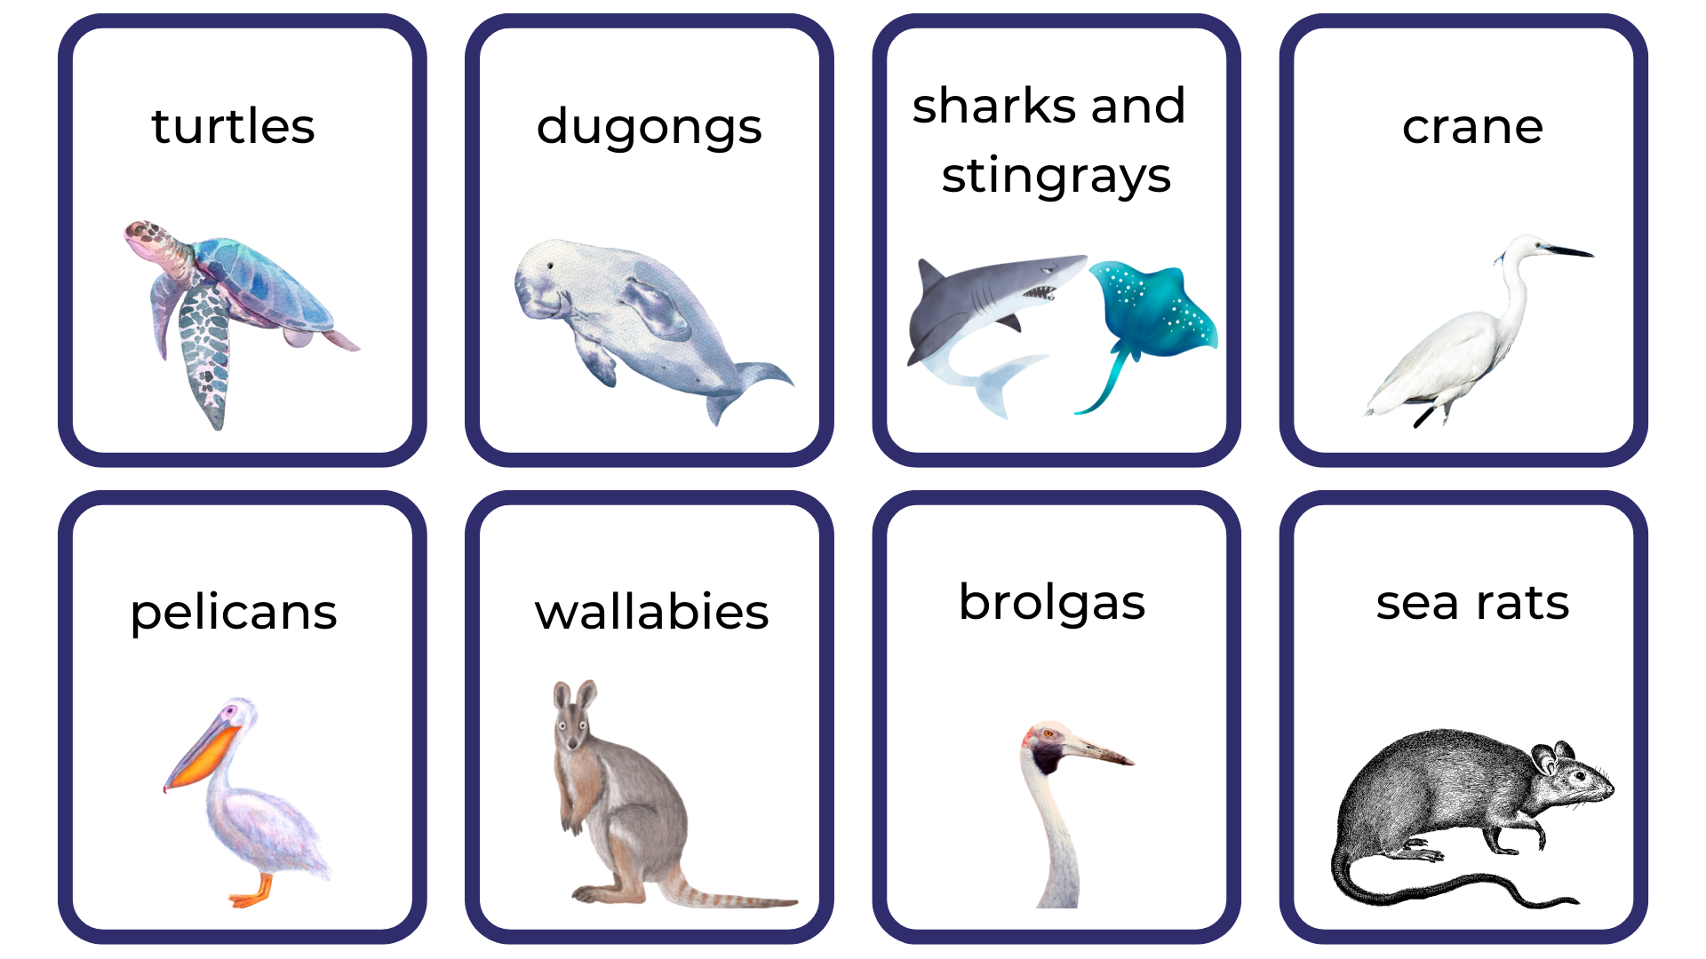
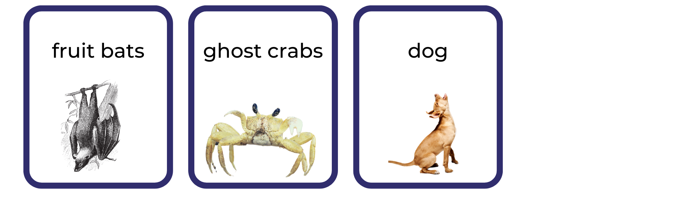
Images sourced from Canva and used in accordance with the Canva Content License Agreement.

Resource 2: Sentence frame
The naming part  (the ‘who’ or ‘what’)  subject/noun/noun group | The happening part  (what the naming part is doing)  verb/verb group (includes preposition) | The naming part  (the ‘what’)  object/noun/noun group
Turtles | glide through | the clear salt water.
An old man crane | watches for | fish in the shallows.
Use the sentence frame to create your own sentences.
The naming part  (the ‘who’ or ‘what’)  subject/noun/noun group | The happening part  (what the naming part is doing)  verb/verb group (includes preposition) | The naming part  (the ‘what’)  object/noun/noun group

Resource 3: Map of Australia
Images sourced from Canva and used in accordance with the Canva Content License Agreement.

Resource 4: Our Island example
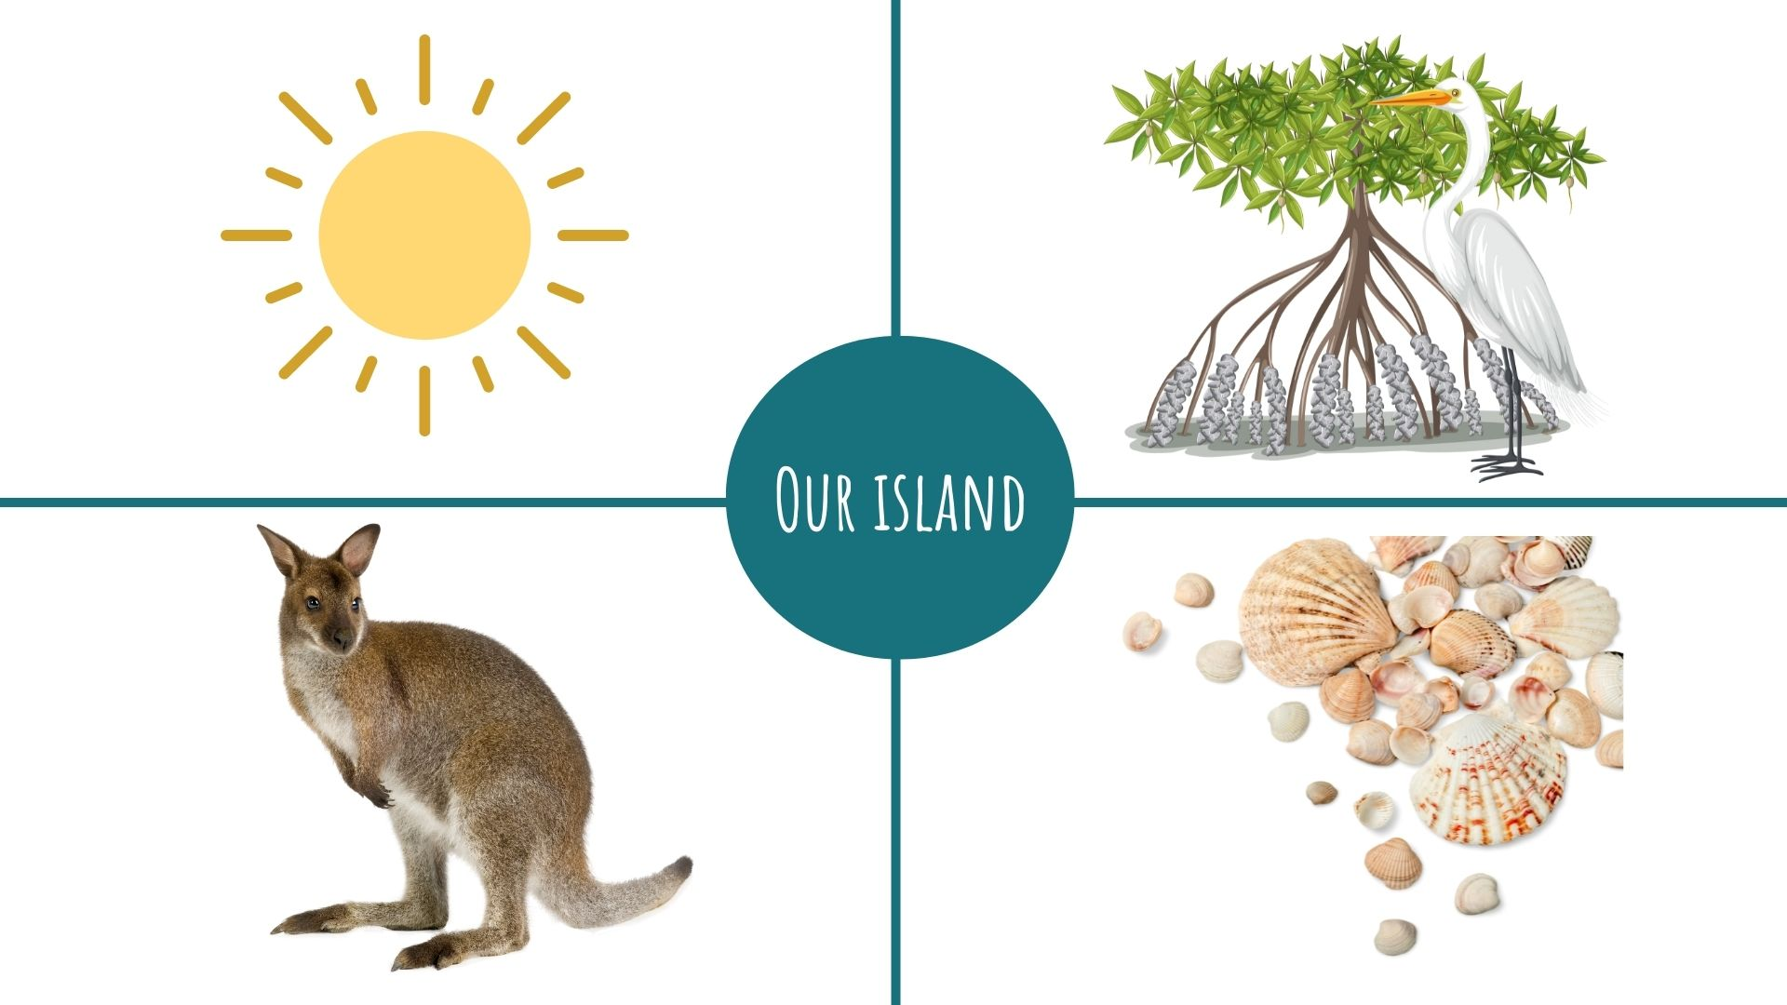
Images sourced from Canva and used in accordance with the Canva Content License Agreement.

References
Links to third-party material and websites
Please note that the provided (reading/viewing material/list/links/texts) are a suggestion only and implies no endorsement, by the New South Wales Department of Education, of any author, publisher, or book title. School principals and teachers are best placed to assess the suitability of resources that would complement the curriculum and reflect the needs and interests of their students.
If you use the links provided in this document to access a third-party's website, you acknowledge that the terms of use, including licence terms set out on the third-party's website apply to the use which may be made of the materials on that third-party website or where permitted by the Copyright Act 1968 (Cth). The department accepts no responsibility for content on third-party websites.
Except as otherwise noted, all material is © State of New South Wales (Department of Education), 2021 and licensed under the Creative Commons Attribution 4.0 International License. All other material (third-party material) is used with permission or under licence. Where the copyright owner of third-party material has not licensed their material under a Creative Commons or similar licence, you should contact them directly for permission to reuse their material.
English K–10 Syllabus © 2022 NSW Education Standards Authority (NESA) for and on behalf of the Crown in right of the State of New South Wales.
Creative Arts K–6 Syllabus © 2006 NSW Education Standards Authority (NESA) for and on behalf of the Crown in right of the State of New South Wales.
© 2021 NSW Education Standards Authority. This document contains NSW Curriculum and syllabus content. The NSW Curriculum is developed by the NSW Education Standards Authority. This content is prepared by NESA for and on behalf of the Crown in right of the State of New South Wales. The material is protected by Crown copyright.
Please refer to the NESA Copyright Disclaimer for more information.
NESA holds the only official and up-to-date versions of the NSW Curriculum and syllabus documents. Please visit the NSW Education Standards Authority (NESA) website and the NSW Curriculum website.
National Literacy Learning Progression © Australian Curriculum, Assessment and Reporting Authority (ACARA) 2010 to present, unless otherwise indicated. This material was downloaded from the Australian Curriculum website (National Literacy Learning Progression) accessed 15 August 2022 and was not modified. The material is licensed under CC BY 4.0. Version updates are tracked in the ‘Curriculum version history’ section on the 'About the Australian Curriculum' page of the Australian Curriculum website.
ACARA does not endorse any product that uses the Australian Curriculum or make any representations as to the quality of such products. Any product that uses material published on this website should not be taken to be affiliated with ACARA or have the sponsorship or approval of ACARA. It is up to each person to make their own assessment of the product, taking into account matters including, but not limited to, the version number and the degree to which the materials align with the content descriptions and achievement standards (where relevant). Where there is a claim of alignment, it is important to check that the materials align with the content descriptions and achievement standards (endorsed by all education Ministers), not the elaborations (examples provided by ACARA).
Children of Gununa, Lester A and Honey E (2016) Our Island, Picture Puffin, Australia.
ETA (English Teachers Association) and NSW Department of Education (2016) Context, English Textual Concepts website, accessed 25 July 2022.
ETA (English Teachers Association) and NSW Department of Education (2016) The Textual Concepts and Processes resource, English Textual Concepts website, accessed 12 August 2022.
Lessac F (2020) Under the Southern Cross, Walker Books Australia.

