English – K-2 multi-age – Year B – Unit 19
Contents
Unit overview and instructions for use 3
Teacher notes 4
Outcomes and content – Component A 5
Outcomes and content – Component B 9
Week 1 13
Component A teaching and learning 13
Component B teaching and learning 14
Lesson 1: Introduction to Silly Billy and understanding character 15
Lesson 2: Identifying and analysing imagery, symbol and connotation in Silly Billy 17
Lesson 3: Exploring a multimodal text to understand character 20
Lesson 4: Comparing characters and writing a character description 23
Lesson 5: Recreating a page from Silly Billy using visual cues 28
Week 2 32
Component A teaching and learning 32
Component B teaching and learning 33
Lesson 6: Comparing character experiences, feelings, and actions 34
Lesson 7: Planning a multimodal text 37
Lesson 8: Drafting a multimodal text 38
Lesson 9: Publishing and presenting a multimodal text 41
Lesson 10: Reflecting on character through imagery, symbol and connotation 41
Resource 1: Question wheel 43
Resource 2: Venn diagram 44
Resource 3: Billy’s new worries 45
Resource 4: Worries and strategies 46
References 47
Further reading 49

Unit overview and instructions for use
This two-week unit is comprised of Component A and Component B. Connecting learning across both components is encouraged.
Teaching and learning | Component A | Component B
Suggested duration | 60 minutes | 45 minutes
Explicit teaching focus areas | - Phonological awareness (Early Stage 1)  - Print conventions (Early Stage 1)  - Phonic knowledge  - Reading fluency  - Reading comprehension  - Spelling  - Handwriting | - Oral language and communication  - Vocabulary  - Reading comprehension  - Creating written texts  - Understanding and responding to literature
To prepare for teaching and learning: | - Refer to Outcomes and content – Component A, K-2 – Instructional sequence – grapheme–phoneme correspondences [PDF 825 KB], and the teaching advice documents (hyperlinked in Component A teaching and learning table).  - Based on student needs identified through ongoing assessment data, plan and document how you will sequence teaching and learning in whole class and targeted teaching groups across the two-week cycle. | - Familiarise yourself with Outcomes and content – Component B, Textual concepts information and videos, English Textual Concepts and Learning Processes (2016), and the teaching and learning sequence.  - Based on student needs identified through ongoing assessment data, determine how you will support students in whole class and targeted teaching groups across the two-week cycle as required.
English K–10 Syllabus © 2022 NSW Education Standards Authority (NESA) for and on behalf of the Crown in right of the State of New South Wales.

Teacher notes
- Character is traditionally viewed as a description of a fictional identity. It is made up of verbal and visual statements about what a character does, says and thinks and what other fictional characters and the author of the text say about them. Analysis of characters can contribute to our own personal judgements about self, morals and values. – English Textual Concepts and Learning Processes (2016).
- Understanding of character can be supported through watching the department’s video: Character (2:31).
- While ‘character’ is the mentor concept for the conceptual component of this unit, the supporting concept of ‘imagery, symbol and connotation’ can be explored using the mentor text Silly Billy by Anthony Browne.
- For information on multimodal texts, nouns, verbs, adjectives, coordinating conjunctions, and clauses refer to the NESA Glossary.
- This unit could enhance student learning towards the achievement of creative arts and PDHPE outcomes.
- Consider prior student knowledge on compound sentences and paragraphs.
- This unit explores concepts about worries and fears through the mentor text, Silly Billy by Anthony Browne and the supporting digital texts. Teachers are encouraged to be mindful of individual student needs when discussing their worries and fears.
- This unit explores ways students can manage stress and worries through relaxation and mindfulness practices. Refer to Teaching and Learning Mindfulness activities for more information.
- Reflect on student learning and engagement in activities and record differentiation and adjustments within the unit to inform future teaching and learning. One way of doing this could be to add comments to the digital file.
- Content points are linked to the National Literacy Learning Progression version (3).
Levels and indicators sourced from National Literacy Learning Progression © Australian Curriculum, Assessment and Reporting Authority (ACARA), (accessed 2 March 2023) and was not modified. See references for more information.

Outcomes and content – Component A
The table below outlines the focus outcomes and content. Content is linked to the National Literacy Learning Progression version (3).
Early Stage 1 Focus area and outcome | Stage 1 Focus area and outcome
Phonological awareness  ENE-PHOAW-01 – identifies, blends, segments and manipulates phonological units in spoken words as a strategy for reading and creating texts  - as needed | N/A
Print conventions  ENE-PRINT-01 – tracks written text from left to right and from top to bottom of the page and identifies visual and spatial features of print  - as needed | N/A
Phonic knowledge  ENE-PHOKW-01 – uses single-letter grapheme–phoneme correspondences and common digraphs to decode and encode words when reading and creating texts  - decode words containing split digraphs and vowel digraphs (PKW5)  - experiment with encoding high-frequency words containing split digraphs and vowel digraphs | Phonic knowledge  EN1-PHOKW-01 – uses initial and extended phonics, including vowel digraphs, trigraphs to decode and encode words when reading and creating texts  - blend and decode one-syllable words with taught extended vowel graphs and digraphs, including graphemes for r-controlled vowels and diphthongs, and apply this when reading texts (PKW6, PKW7)  - segment and encode one-syllable words with taught vowel graphs, digraphs and trigraphs and apply this when creating texts  - decode words with less common consonant digraphs and apply this when reading texts  - blend and decode 2-syllable words with taught vowel graphs, digraphs, trigraphs and quadgraphs, including graphemes for r-controlled vowels and diphthongs and apply this when reading texts (PKW6, PKW7)
Reading fluency  ENE-REFLU-01 – reads decodable texts aloud with automaticity  - know that fluent reading involves recognising and reading words accurately and automatically  - regulate their voice to respond to punctuation such as question marks and exclamation marks (FlY4) | Reading fluency  EN1-REFLU-01 – sustains reading unseen texts with automaticity and prosody and self-corrects errors  - self-correct when fluency and/or meaning is interrupted  - adjust phrasing, intonation, volume or rate to maintain fluency when reading aloud (FlY4)
Reading comprehension  ENE-RECOM-01 – comprehends independently read texts using background knowledge, word knowledge and understanding of how sentences connect  - recognise how the position of words in a sentence changes its meaning  - clarify own purpose for reading a text  - use information or events from different parts of the text to form an opinion | Reading comprehension  EN1-RECOM-01 – comprehends independently read texts that require sustained reading by activating background and word knowledge, connecting and understanding sentences and whole text, and monitoring for meaning  - re-read words, phrases or sentences to check and clarify precise meaning  - ask a clarifying question when more background knowledge is needed to make an inference  - interpret patterns in texts to enhance understanding
Spelling  ENE-SPELL-01 – applies phonological, orthographic and morphological generalisations and strategies to spell taught familiar and high-frequency words when creating texts  - segment multisyllabic words into syllables and phonemes as a strategy for spelling  - experiment with some vowel digraphs and split digraphs to spell taught high-frequency words and/or personally significant words | Spelling  EN1-SPELL-01 – applies phonological, orthographic and morphological generalisations and strategies when spelling words in a range of writing contexts  - segment multisyllabic words into syllables and phonemes as a strategy for spelling (SpG5)  - use extended phonic code for taught consonant phoneme
Handwriting  ENE-HANDW-01 – produces all lower-case and upper-case letters to create texts  - apply taught handwriting skills when creating texts. | Handwriting  EN1-HANDW-01 – uses a legible, fluent and automatic handwriting style, and digital technology, including word-processing applications, when creating texts  - form all letters with consistent size and slope in NSW Foundation Style from memory (HwK5).

Outcomes and content – Component B
The table below outlines the focus outcomes and content. Content is linked to the National Literacy Learning Progression version (3).
Early Stage 1 Focus area and outcome | Stage 1 Focus area and outcome
Oral language and communication  ENE-OLC-01 – communicates effectively by using interpersonal conventions and language with familiar peers and adults  - ask questions using who, what, when, where, why or how  - use connectives such as and, but and because when speaking (SpK2) | Oral language and communication  EN1-OLC-01 – communicates effectively by using interpersonal conventions and language to extend and elaborate ideas for social and learning interactions  - respond to information by asking relevant questions to extend their own and others' knowledge (LiS4, LiS6)  - interact to evaluate ideas and refine meaning (InT4, InT5)  - link or compare ideas when interacting
Vocabulary  ENE-VOCAB-01 – understands and effectively uses Tier 1 words and Tier 2 words in familiar contexts  - use vocabulary to select, match and provide categories for groups of images or words  - identify, name and describe a range of objects, characters, animals, people and places when given visual and/or auditory prompts (GrA1) | Vocabulary  EN1-VOCAB-01 – understands and effectively uses Tier 1, taught Tier 2 and Tier 3 vocabulary to extend and elaborate ideas  - understand and intentionally choose subject-specific vocabulary to enhance precision and for effect
Reading comprehension  ENE-RECOM-01 – comprehends independently read texts using background knowledge, word knowledge and understanding of how sentences connect  - identify conjunctions in a compound sentence, their meaning and purpose  - use background knowledge when identifying connections between a text, own life, other texts and/or the world (UnT4)  - use visual cues in multimodal texts to interpret meaning (UnT5)  - use information or events from different parts of the text to form an opinion | Reading comprehension  EN1-RECOM-01 – comprehends independently read texts that require sustained reading by activating background and word knowledge, connecting and understanding sentences and whole text, and monitoring for meaning  - ask a clarifying question when more background knowledge is needed to make an inference  - make text-to-self, text-to-text or text-to-world connections when reading (UnT6)  - use visual and/or auditory features in multimodal texts to build meaning (UnT5)
Creating written texts  ENE-CWT-01 – creates written texts that include at least 2 related ideas and correct simple sentences  - create a text including at least 2 related ideas (CrT5)  - experiment with writing compound sentences and recognise that each clause makes meaning by itself (GrA4)  - understand that punctuation is a feature of written language and how it impacts meaning  - use capital letters when writing proper nouns (PuN3, CrT5)  - intentionally select nouns, verbs, adjectives and articles in own writing  - edit their texts after receiving feedback | Creating written texts  EN1-CWT-01 – plans, creates and revises texts written for different purposes, including paragraphs, using knowledge of vocabulary, text features and sentence structure  - group sentences into paragraphs commencing with a topic sentence, followed by other sentences with related ideas (CrT7)  - select and use a range of conjunctions to create cohesive texts (GrA5)  - write compound sentences using coordinating conjunctions (GrA4, CrT5)  - use punctuation, including question marks and exclamation marks, accurately and for effect (PuN3)  - make intentional word choices to enhance precision of meaning and ideas in a text (CrT5)  - re-read and edit their own texts after receiving feedback
Understanding and responding to literature  ENE-UARL-01 – understands and responds to literature read to them  - reason using background knowledge as to why a character has acted in a certain way (UnT4)  - identify and discuss character features and actions (UnT3)  - identify and compare characters in a range of texts  - identify how visual cues contribute to the meaning of a text. | Understanding and responding to literature  EN1-UARL-01 – understands and responds to literature by creating texts using similar structures, intentional language choices and features appropriate to audience and purpose  - identify how characters are constructed through different modes and media and through a combination of modes  - compare and contrast characters in text  - identify the language, dialogue, actions, images or music that create a reader response to a character  - identify symbols and images in texts, and how they bring deeper meaning.

Week 1

Component A teaching and learning
The table below can be used to plan and document lessons that address Component A outcomes and content. Both the detailed example [DOC 529KB] of a two-week teaching and learning cycle and brief example [DOC 66KB] may support you in your planning.
Focus Areas | Lesson 1 | Lesson 2 | Lesson 3 | Lesson 4 | Lesson 5
Phonological awareness (Early Stage 1) and Phonic knowledge
15 minutes
Spelling and Handwriting
15 minutes
Print conventions (Early Stage 1), Reading comprehension and Reading fluency
30 minutes

Component B teaching and learning
The following teaching and learning sequence has been designed to address Component B outcomes and content. Adapt the sequence as required to best meet the needs of your students.

Learning intention and success criteria
Learning intentions and success criteria are best co-constructed with students. The table below contains suggested learning intentions and success criteria.
Element | Early Stage 1 | Stage 1
Learning intentions | Students are learning to identify and compare character features and actions. | Students are learning to identify how character traits and actions can create different responses in readers.
Success criteria | Students can:  - use questioning to understand character traits  - understand how visual cues contribute to the meaning of a text  - identify visual cues used in multimodal texts  - compare and contrast character traits and actions  - use compound sentences to write a character description  - use knowledge of character, visual and auditory cues, to recreate a text. | Students can:  - use questioning to understand character traits  - identify symbols and images in texts and understand how they bring deeper meaning to a character  - understand how visual cues impact upon meaning in a multimodal text  - compare and contrast character traits and actions  - write a paragraph to describe a character  - apply knowledge and understanding of character, visual and auditory cues to recreate a text.

Resources
- Browne A (2007) Silly Billy Walker Books Australia, Newtown. ISBN: 9781406305760
- Video: Pip | A Short Animated Film by Southeastern Guide Dogs (4:05)
- Resource 1: Question wheel (enlarged copy and copies for student groups)
- Resource 2: Venn diagram (enlarged copy and copies for student groups)
- Resource 3: Billy’s new worries (enlarged copy and individual copies for each student)
- Mini whiteboards and/or A4 paper
- Poster paper or cardboard.

Lesson 1: Introduction to Silly Billy and understanding character
The following teaching and learning activities support multi-age settings.

Whole
- Write the phrase, ‘silly billy’ on the board. Students turn and talk to discuss what it means. Create a class definition for ‘silly billy’, for example, to do or make silly mistakes.
- Display the front cover of Silly Billy by Anthony Browne. Students make predictions about the purpose of the text and who the characters in the story might be. Ask students what they might already know about the characters based on the title.
- Read Silly Billy. Discuss why Billy might have been described as silly. List student responses on the board. For example, Billy feared silly things, Billy was worried about things that could not happen.
- Display an enlarged copy of Resource 1: Question wheel. In small groups, students answer questions about Billy. Ask:
- Who is Billy?
- Where did Billy worry?
- When did Billy worry?
- What did Billy worry about?
- Why did Billy worry about these things?
- How did Billy overcome his worries and fears?
Students share their responses with the class.
- Explain that students will be exploring Billy’s character traits and what makes him unique.
- Model drawing an outline of the character Billy on a poster. Ask students to identify Billy’s physical characteristics and record these on the outside of the drawing. Ask students to identify his personal characteristics, such as his personality traits, wants, emotions, and feelings, and record these on the inside of the drawing. Keep the poster for Lesson 4 and Lesson 6.
- Using the completed poster, students write sentences describing their thoughts and feelings about Billy’s personality and character. For example, ‘I think Billy worries too much and needs to tell his worry dolls everything; Billy worries a lot just like everyone else in the world, but he should talk to someone about the things that are bothering him.’
Too hard? Students use the Draw, Talk, Write, Share strategy to explain one thing that Billy worried about in the text.
Too easy? Students support their writing with a reason as to why they think Billy acted in a certain way. For example, ‘I think Billy worried about so many things because he was lonely and needed friends to talk to.’
- Ask students if they think Billy was a ‘silly billy’ in the story. Label each side of the classroom as ‘Agree’ or ‘Disagree’ and ask students to stand on the side to represent their opinion. Encourage students to justify their opinion. For example, ‘I think Billy is silly because he fears things that cannot happen’; ‘I don’t think Billy was silly because everyone gets worried sometimes.’ Highlight that being worried about things is normal behaviour, however small or insignificant this is to others.
- Optional: Ask students to share other strategies they know of that could be useful if they are ever feeling worried.

Lesson 2: Identifying and analysing imagery, symbol and connotation in Silly Billy
The following teaching and learning activities support multi-age settings.

Whole
- Ask students to sit on the floor, close their eyes, breathe in slowly through their nose and out through their mouth. Students make a fist with their hand, squeezing tightly and holding for 10 seconds. Students slowly open their hand and relax it. Continue tensing and releasing various muscle groups in the body such as legs, shoulders and feet.
- Re-read Silly Billy. Explain that Anthony Browne uses specific colour and visual cues in his illustrations to emphasise the feelings a character is experiencing to communicate directly with the audience.
- Open Silly Billy to the page where Billy is worried about clouds. Ask students how Billy might be feeling at this point and why. Students write their response in a sentence on mini whiteboards. For example, ‘I think Billy feels scared because he is hiding under his blanket’; ‘I think Billy is worried because the cloud is really big’.
- Students interpret how body language is used in the illustrations to represent Billy’s character in the text. For example, when Billy is feeling worried, he is often hunched over and frowning, and when he is feeling assured, he is smiling and his shoulders appear to relax. Ask students to mime representing feeling worried and assured by using appropriate body language.
- Explore how colour is used in Silly Billy to represent characters to create an audience response. For example:
- the colours of the illustrations are dull and dark when Billy is lying in bed and worried about different things, including when he is worried staying at Grandma’s house
- Billy’s parents are drawn in bright colours to show that they can reassure and comfort him
- the colour in the text changes once Grandma suggests using worry dolls, this shows she has empathy and kindness.
Encourage students to ask questions about the colours used in the text to reflect Billy’s character and personality.
- Provide small groups of students with a list of colours and ask them to identify emotions or feelings the colours may represent. For example, green – relaxation; blue – sadness; red – anger; pink – joy; yellow – positivity. Discuss any similarities or differences between student ideas.
- Students identify visual cues and symbols included in the illustrations and describe how these represent Billy’s level of worry and fear. For example:
- the wallpaper depicts the things Billy is worried about, for example, hats, shoes, clouds, giant birds
- the large, dark rain cloud throwing a shadow over Billy’s bed makes him feel intimidated or scared
- the wind-swept water rising and threatening to submerge Billy and everything in the room makes him feel terrified.

Part
The table below details the differentiated teaching and learning activities for each stage.
Early Stage 1 (teacher guided/independent) | Stage 1 (pairs/independent)
- Display the page where the giant bird attempts to carry Billy out the window.  - Assist students to identify visual cues used in the illustration, such as the use of colour, size, and body language.  - Students write a compound sentence identifying one visual cue used in the illustration and describe how it helps the readers understand what Billy is feeling. For example, ‘The bird is very big and this makes Billy look small and afraid.’ | - Display the page where Billy is lying in bed at Grandma’s house.  - In pairs, students identify visual cues used in the illustration, such as the use of colour, size, and body language.  - Students write compound sentences identifying 2 visual cues used in the illustration and how they are used to express Billy’s feelings and emotions. For example, dull colours are used to show that Billy is feeling lonely and that he is scared of the dark. The contrast of sizes has also been used to show that Billy is feeling helpless and worried.
Early Stage 1 Assessment task 1 – Observations from this lesson allow students to demonstrate achievement towards the following syllabus outcome and content point:
ENE-UARL-01 – understands and responds to literature read to them
- identify how visual cues contribute to the meaning of a text.
Stage 1 Assessment task 1 – Observations from this lesson allow students to demonstrate achievement towards the following syllabus outcome and content point:
EN1-UARL-01 – understands and responds to literature by creating texts using similar structures, intentional language choices and features appropriate to audience and purpose
- identify symbols and images in texts, and how they bring deeper meaning.

Lesson 3: Exploring a multimodal text to understand character
The following teaching and learning activities support multi-age settings.

Whole
- Ask students to sit or lay down on the floor. Explain that focused breathing is a useful strategy if people are ever feeling worried. Students close their eyes and place their hands on their stomach. Direct students to breathe in and out slowly, counting from 1 to 10, feeling their stomach expand and deflate with each breath. Repeat if necessary.
- Revise the use of visual features in Silly Billy from Lesson 2 and how the use of colour and visual cues support the audience in understanding more about the text and Billy’s character.
- Explain that multimodal texts can use different cues such as audio and visuals, to portray a character and their actions.
- Watch Pip | A Short Animated Film by Southeastern Guide Dogs (4:05). Make a list of vocabulary sourced from the video or students’ background knowledge. For example, guide dog, canine, trainer, university, blind or vision impaired, courtyard, learning, mistakes, disappointment, bravery.
- Ask students how the video, Pip, is similar to the print text, Silly Billy. Explore how print and digital texts both use visual prompts to deepen the reader’s understanding of the characters.
- Discuss how audio or music in the video helps the audience to understand what Pip is thinking, feeling, and her actions. Students draw or write the feeling or emotion Pip might be experiencing at different parts of the video. Students could draw emojis or write key words. For example:
- upbeat music plays as Pip enters the university, showing that she is hopeful and excited to be there (0:17-0:28)
- steady music is depicting that Pip is naive and learning, but making mistakes along the way (0:59-1:29)
- the pace of the music quickens to indicate danger and that Pip is acting urgently to save the visually impaired woman (2:51-3:00).
- Explore how colour, facial expressions, and body language have been used to elicit certain feelings and the mood of the characters. For example:
- dark colours and positioning her tail between her legs to show that Pip is sad and disappointed (1:31-1:36)
- gloomy skies change to bright blue once Pip saves the visually impaired woman, she receives Ace’s cape for showing bravery and appears happy (3:05-3:36).
- Draw an outline of the character Pip on a poster. Ask students to identify Pip’s physical characteristics and record these on the outside of the drawing. Ask students to identify her personal characteristics, such as personality traits, wants, emotions, and feelings, and record these on the inside of the drawing. Keep the poster for Lesson 4 and Lesson 6.
- Students write to describe their thoughts and feelings about Pip and her character traits and actions using the vocabulary listed in activity 4. For example, ‘I think Pip is very clever and wants to prove that she can be a good guide dog; Pip is a brave dog because she used her instincts to save the visually impaired woman’. Note: The video description indicates that Pip is female.
- Students reflect on their learning and identify whether visual or auditory cues best support their understanding of Pip and why.
Too hard? Students use the Draw, Talk, Write, Share strategy to explain one thing that Pip worried about in the text.
Too easy? Students support their writing with a reason as to why they think Pip acted in a certain way. For example, ‘I think Pip is worried that she would not graduate because she was clumsy and nervous during her test’.
Early Stage 1 Assessment task 2 – Observations and work samples from this lesson allow students to demonstrate achievement towards the following syllabus outcomes and content points:
ENE-VOCAB-01 – understands and effectively uses Tier 1 words and Tier 2 words in familiar contexts
- identify, name and describe a range of objects, characters, animals, people and places when given visual and/or auditory prompts.
ENE-RECOM-01 – comprehends independently read texts using background knowledge, word knowledge and understanding of how sentences connect
- use visual cues in multimodal texts to interpret meaning.
ENE-UARL-01 – understands and responds to literature read to them
- identify and discuss character features and actions.
Stage 1 Assessment task 2 – Observations from this lesson allow students to demonstrate achievement towards the following syllabus outcomes and content points:
EN1-RECOM-01 – comprehends independently read texts that require sustained reading by activating background and word knowledge, connecting and understanding sentences and whole text, and monitoring for meaning
- use visual and/or auditory features in multimodal texts to build meaning.
EN1-UARL-01 – understands and responds to literature by creating texts using similar structures, intentional language choices and features appropriate to audience and purpose
- identify how characters are constructed through different modes and media and through a combination of modes
- identify the language, dialogue, actions, images or music that create a reader response to a character.

Lesson 4: Comparing characters and writing a character description
The following teaching and learning activities support multi-age settings.

Whole
- Ask students to sit on the floor with their legs crossed. Explain that mindfulness is a useful strategy to help calm down when feeling worried. Select a short sample of appropriate relaxation music. Ask students to close their eyes and focus on the sounds in the audio as they breathe slowly and deeply. Continue this practice for a few minutes.
- Review the character trait posters about Billy and Pip from Lesson 1 and Lesson 3. Explain that students will be comparing the 2 characters using a Venn diagram to list their similarities and differences regarding their personality, qualities, skills and actions.
- Display an enlarged copy of Resource 2: Venn diagram. Organise students into small groups and provide a copy of Resource 1: Question wheel. Model asking some who, what, when, where, why, and how questions to assist students in their small groups. Students ask each other questions using the question wheel to generate ideas for the Venn diagram.
- Record students’ ideas on the enlarged copy of the Venn diagram to compare the characters, Billy and Pip. Encourage students to ask questions to deepen their understanding of how the characters are similar and different. For example, why were Billy and Pip worried about things; what might have triggered the characters to feel worried; how did they overcome their problems; how did they both act after overcoming their worries?
- Explain that students will write a character description about Billy or Pip using the posters and a Venn diagram to support.
- Discuss and list the information required for a character description to support students in their writing. For example:
- physical features
- personality traits
- emotions and feelings
- characters’ actions.

Part
The table below details the differentiated teaching and learning activities for each stage.
Early Stage 1 (teacher guided/pairs) | Stage 1 (independent)
- Revise compound sentences and the conjunctions ‘and’, ‘but’, ‘because’.  - In pairs, ask students to share example compound sentences to describe Billy or Pip using ‘and’, ‘but’, or ‘because’.  - Revise the importance of using a capital letter for proper nouns, including Billy and Pip, and the use of punctuation markers for accuracy and effect. For example, capital letters, full stops, exclamation marks.  - Model writing a character description about Billy or Pip using the completed class posters and Venn diagram. For example, Pip is a small Labrador who wants to become a guide dog to help people. She is very hard working, but she can get distracted sometimes. Pip is very brave and saved a visually impaired woman when she was in danger. | - Students select at least 4 traits for their chosen character from the character trait posters and completed Venn diagram and draft ideas on mini whiteboards or A4 paper.  - Students independently write a character description paragraph using compound sentences.  Too hard? Students work in pairs to jointly write a character description about a chosen character.  Too easy? Students write a character description using complex sentences.

Part
The table below details the differentiated teaching and learning activities for each stage.
Early Stage 1 (independent) | Stage 1 (pairs/teacher guided)
- Students select at least 2 traits for their chosen character from the character trait posters and completed Venn diagram and draft ideas on mini whiteboards or A4 paper.  - Students independently write a character description using compound sentences, appropriate punctuation, coordinating conjunctions and capital letters for proper nouns.  Too hard? Students work in pairs to jointly write a character description about a chosen character. | - In pairs, students share their character descriptions and ask each other questions to strengthen their inferencing skills.  - Ask students to consider how the illustrations and/or audio supports their understanding of Billy or Pip and their actions. For example, the colour used in Silly Billy brightens when Billy begins to talk to the worry dolls; the music in Pip reflects her actions and when she is confident the music feels happy.  - Students reflect on both texts and write questions they would ask the author or video producer about Billy and Pip’s personality and character. For example, why was Billy worried about so many things? Why didn’t he have any friends to talk to? Why did Pip want to become a guide dog? What happens to Pip after she graduates?

Whole
- Ask students to select the character they relate to the most and state their choice with a reason why. For example, ‘I chose Billy or Pip because__; I relate to Billy or Pip the most because __.’ Students share their responses with the class.
Early Stage 1 Assessment task 3 – Observations and work samples from this lesson allow students to demonstrate achievement towards the following syllabus outcomes and content points:
ENE-OLC-01 – communicates effectively by using interpersonal conventions and language with familiar peers and adults
- ask questions using who, what, when, where, why or how
- use connectives such as and, but and because when speaking.
ENE-RECOM-01 – comprehends independently read texts using background knowledge, word knowledge and understanding of how sentences connect
- identify conjunctions in a compound sentence, their meaning and purpose
- use information or events from different parts of the text to form an opinion.
ENE-UARL-01 – understands and responds to literature read to them
- identify and compare characters in a range of texts.
Stage 1 Assessment task 3 – Observations from this lesson allow students to demonstrate achievement towards the following syllabus outcomes and content points:
EN1-OLC-01 – communicates effectively by using interpersonal conventions and language to extend and elaborate ideas for social and learning interactions
- respond to information by asking relevant questions to extend their own and others' knowledge
- interact to evaluate ideas and refine meaning.
EN1-RECOM-01 – comprehends independently read texts that require sustained reading by activating background and word knowledge, connecting and understanding sentences and whole text, and monitoring for meaning
- ask a clarifying question when more background knowledge is needed to make an inference
- make text-to-self, text-to-text or text-to-world connections when reading.
EN1-UARL-01 – understands and responds to literature by creating texts using similar structures, intentional language choices and features appropriate to audience and purpose
- compare and contrast characters in text.

Lesson 5: Recreating a page from Silly Billy using visual cues
The following teaching and learning activities support multi-age settings.

Whole
- Flick through Silly Billy, pausing to discuss and list the different things Billy worried about. Revisit the page where Billy stays at Grandma’s house with the text ‘But still Billy worried.’
- Explain that students will recreate this page of the text to write their own sentences about additional things Billy might be worried about. Students will also draw an illustration depicting these worries using appropriate visual cues such as colour and size.
- Ask students to use knowledge gained about Billy in previous lessons to imagine what other things he might be worried about. Brainstorm and list ideas and generate reasons why Billy might be worried. For example, flies – they are dirty, hankies – they are covered in snot, erasers – they might accidentally erase him.
- List colours students may need to use in their illustration to convey the emotions, feelings or thoughts Billy has about his new worries. For example, sadness – grey, blue; happiness – yellow, orange, peacefulness – purple, green; fear – black.
- Discuss the facial expressions or body language students may need to include when drawing Billy. For example, sadness – frowning, tears, slumped body; shock or surprise – open mouth, wide eyes, upright body.
- Display an enlarged copy of Resource 3: Billy’s new worries. Explain that Early Stage 1 students will write compound sentences and Stage 1 students will write a paragraph about Billy’s new worries.
- Model writing compound sentences about new worries for Billy using the ideas generated in activity 3. For example, ‘Billy is worried about flies because they are dirty’; ‘Billy worries a lot, but he mostly fears snotty hankies.’

Part
The table below details the differentiated teaching and learning activities for each stage.
Early Stage 1 (independent/pairs) | Stage 1 (teacher guided/independent)
- Students create a text with related ideas. Students select at least 2 new worries for Billy from the list in activity 3.  - Students independently draft their sentences. Remind students to use appropriate punctuation, including capital letters for proper nouns.  Too hard? Students work in pairs to draft their sentences.  - Students finalise their draft sentences before publishing on their own copy of Resource 3: Billy’s new worries.  - Students draw an illustration to accompany their writing on the resource using appropriate colour, size, and character facial expressions. | - Revise the use of question marks and exclamation marks in writing and discuss how these can be used to improve accuracy and effect. Model this by writing examples, such as ‘What was Billy so worried about?’  - Students select at least 3 new worries from the list created in activity 3 and draft their sentences.  - Select a student’s draft writing from activity 13 and model editing their work to include a question and the use of an exclamation mark. For example, ‘What was Billy so worried about? He was worried about flies because they land on dirty, stinky rubbish. Billy was also worried about his eraser accidentally rubbing him out at school, so he refused to use it. He only ever had showers because he was worried about sharks in the bath. Billy was really silly!’  - Students edit their draft writing to include a question mark and exclamation mark before publishing on their own copy of Resource 3: Billy’s new worries.  - Students draw an illustration to accompany their writing on the resource using appropriate colour, size and facial expressions.

Whole
- Students share their published page recreations in small groups.
Early Stage 1 Assessment task 4 – Collecting work samples from this lesson allows students to demonstrate achievement towards the following syllabus outcome and content points:
ENE-CWT-01 – creates written texts that include at least 2 related ideas and correct simple sentences
- understand that punctuation is a feature of written language and how it impacts meaning
- use capital letters when writing proper nouns.
Stage 1 Assessment task 4 – Observations and work samples from this lesson allow students to demonstrate achievement towards the following syllabus outcomes and content points:
EN1-OLC-01 – communicates effectively by using interpersonal conventions and language to extend and elaborate ideas for social and learning interactions
- link or compare ideas when interacting.
EN1-CWT-01 – plans, creates and revises texts written for different purposes, including paragraphs, using knowledge of vocabulary, text features and sentence structure
- use punctuation, including question marks and exclamation marks, accurately and for effect.

Week 2

Component A teaching and learning
The table below can be used to plan and document lessons that address Component A outcomes and content. Both the detailed example [DOC 529KB] of a two-week teaching and learning cycle and brief example [DOC 66KB] may support you in your planning.
Focus Areas | Lesson 6 | Lesson 7 | Lesson 8 | Lesson 9 | Lesson 10
Phonological awareness (Early Stage 1) and Phonic knowledge
15 minutes
Spelling and Handwriting
15 minutes
Print conventions (Early Stage 1), Reading comprehension and Reading fluency
30 minutes

Component B teaching and learning
The following teaching and learning sequence has been designed to address Component B outcomes and content. Adapt the sequence as required to best meet the needs of your students.

Learning intention and success criteria
Learning intentions and success criteria are best co-constructed with students. The table below contains suggested learning intentions and success criteria.
Element | Early Stage 1 | Stage 1
Learning intentions | Students are learning to use an understanding of character actions and feelings to create a multimodal text about personal experiences. | Students are learning to use an understanding of character actions and feelings to create a multimodal text about personal experiences.
Success criteria | Students can:  - identify vocabulary used to describe character experiences, feelings and actions  - make text-to-self connections to identify personal worries and coping strategies  - write compound sentences to describe personal experiences  - edit writing after receiving peer feedback and present published work  - reflect on character traits through visual cues used in a multimodal text. | Students can:  - generate vocabulary to describe character experiences, feelings and actions  - make text-to-self connections to identify personal worries and management strategies  - write a paragraph to describe personal experiences  - edit writing after receiving peer feedback and present published work  - reflect on character traits through imagery, symbol, and connotation used in a multimodal text.

Resources
- Browne A (2007) Silly Billy, Walker Books Australia, Newtown. ISBN: 9781406305760
- Video: Pip | A Short Animated Film by Southeastern Guide Dogs (4:05)
- Video: BBC One Christmas 2017 | The Supporting Act (2:00)
- Resource 4: Worries and strategies (Two enlarged copies and individual copies for each student)
- Mini whiteboards and/or A4 paper
- Craft materials such as fabric, felt, cardboard cylinders, coloured paper, wool, paddle pop sticks, glue, scissors, sticky tape.

Lesson 6: Comparing character experiences, feelings, and actions
The following teaching and learning activities support multi-age settings.

Whole
- Revisit Silly Billy and Pip | A Short Animated Film by Southeastern Guide Dogs (4:05). Discuss the characters and sequence of events in the stories.
- Using background knowledge of the texts, reflect upon Billy and Pip’s feelings and actions. Ask students to discuss and share why the 2 characters may have acted the way they did.
- Display an enlarged copy of Resource 4: Worries and strategies. Explain that Billy and Pip both experienced their own worries. Write the worries both characters experienced under the heading ‘Worries’ on the enlarged copy of the resource. For example:
- Billy: hats, shoes, clouds, rain, giant birds, worried about the worry dolls
- Pip: not tall enough to enter, could not see over the desk, did not assist trainer properly, could not stop food dispenser, worried about the result in her final test.
- Explain that, although Billy and Pip experienced worries, they both used different strategies to overcome them. Explicitly teach what ‘strategy’ means. For example, a strategy is a way to manage a problem or issue.
- Discuss and list the different strategies or ways the 2 characters overcame their worries, listing ideas on the enlarged copy of the resource under the heading ‘Strategies’. For example:
- Billy: he spoke with his parents, he talked to Grandma, he made worry dolls, he made worry dolls for his worry dolls
- Pip: raised her ear to reach the height requirement, she stood on books, she kept her eyes open and concentrated during practise, she jumped and used her nose to hit the button, she showed determination and bravery to save the visually impaired woman.
- In small groups, students use mini whiteboards to describe how Billy and Pip felt when they were worried and how they used different strategies to manage their worries. Categorise the words into feelings or emotions, bodily reactions and strategies. For example, Feelings – worried, scared, nervous; Bodily reactions – sweating, shaking, crying; Strategies – brave, strong, confident, resilient, clever.
- Explain that students will write sentences to describe Billy or Pip’s feelings or bodily reactions when they were worried and when they overcame their worries.
- Model writing sentences to describe Billy or Pip’s feelings and actions. For example, ‘Billy was worried about many things and he could not sleep at night’; ‘Billy was sweaty when he was scared about silly things that might happen to him’; ‘Billy was clever and talked to adults to get some help’; ‘Pip tried her best at the university but became sad when she made mistakes’; ‘Pip was strong and resilient and she never gave up’; ‘Pip trusted her instincts and showed bravery when she saved the visually impaired woman.’
- Students write sentences to explain Billy or Pip’s feelings and a strategy they used.
- Students share their sentences with the class or in small groups.
- Ask students to reflect on which character they related to the most in Lesson 4. Students list some worries that they might have in common with their chosen character and write their ideas on mini whiteboards before sharing with the class or in small groups.
Early Stage 1 Assessment task 5 – Observations and work samples from this lesson allow students to demonstrate achievement towards the following syllabus outcomes and content points:
ENE-VOCAB-01 – understands and effectively uses Tier 1 words and Tier 2 words in familiar contexts
- use vocabulary to select, match and provide categories for groups of images or words.
ENE-RECOM-01 – comprehends independently read texts using background knowledge, word knowledge and understanding of how sentences connect
- use background knowledge when identifying connections between a text, own life, other texts and/or the world.
ENE-UARL-01 – understands and responds to literature read to them
- reason using background knowledge as to why a character has acted in a certain way.
Stage 1 Assessment task 5 – Observations and work samples from this lesson allow students to demonstrate achievement towards the following syllabus outcomes and content points:
EN1-VOCAB-01 – understands and effectively uses Tier 1, taught Tier 2 and Tier 3 vocabulary to extend and elaborate ideas
- understand and intentionally choose subject-specific vocabulary to enhance precision and for effect.
EN1-CWT-01 – plans, creates and revises texts written for different purposes, including paragraphs, using knowledge of vocabulary, text features and sentence structure
- make intentional word choices to enhance precision of meaning and ideas in a text.

Lesson 7: Planning a multimodal text
The following teaching and learning activities support multi-age settings.

Whole
- Revise the list of worries experienced by Billy and Pip and the strategies they used to manage these from Lesson 6.
- Explain that students will create a worry doll. This will be used to create a multimodal text. The multimodal text will be about their own worries and effective strategies to manage them.
- Revisit the final page in Silly Billy to discuss the purpose of worry dolls. Display a page from the text with illustrations of worry dolls to explore their features. For example, male and female, colourful and facial expressions.
- Display a blank enlarged copy of Resource 4: Worries and strategies. Discuss and record some worries students may experience. For example, finishing last in a race, having a disagreement with friends, starting a new school year.
- Review the list of worries and brainstorm some strategies that would be effective in managing them. For example, telling a trusted adult, practising a skill, being honest and apologising, reviewing the mindfulness activities from Lesson 2, Lesson 3 and Lesson 4.
- Provide students with their own copy of Resource 4: Worries and strategies to start planning their multimodal text.
- Select students to share a worry and a strategy that they have identified on their planning sheet.
Too hard? Students work in pairs or small groups to select and write their worries and strategies.
- Students create a personal worry doll using a variety of craft materials.

Lesson 8: Drafting a multimodal text
The following teaching and learning activities support multi-age settings.

Whole
- In pairs, students discuss their worries and strategies from Lesson 7 and identify similarities or differences from the responses.
- Explain that students will use their completed copy of Resource 4: Worries and strategies to write compound sentences (Early Stage 1) or a paragraph (Stage 1) about their personal worries and strategies to manage them.
- Revise compound sentences, including coordinating conjunctions and explain that each clause makes meaning by itself.
- Revise how the placement of nouns, verbs, adjectives and articles is used to convey and enhance meaning.
- Select a student’s work sample from Lesson 7 to model writing a series of compound sentences about their worries and strategies to manage them.

Part
The table below details the differentiated teaching and learning activities for each stage.
Early Stage 1 (independent) | Stage 1 (teacher guided/independent)
- Students use their completed copy of Resource 4: Worries and strategies to draft writing compound sentences about their worries and the strategies that can be helpful in managing them.  Too hard? Students write simple and compound sentences. | - Revise the structure of a paragraph, explaining that it must contain a topic sentence followed by other sentences with related ideas. Use the modelled writing from activity 5 to identify the structure of a paragraph.  - Students use their completed copy of Resource 4: Worries and strategies to draft a paragraph about their worries and the strategies that can be help manage them.  Too easy? Students write compound and complex sentences.

Whole
- In pairs, students read their sentences or paragraph and provide peer feedback. Allow time for students to edit their work. Encourage students to use the words generated in previous lessons to describe feelings or bodily reactions when feeling worried or solving a problem to add precision to their writing.
Early Stage 1 Assessment task 6 – Collecting work samples from this lesson allow students to demonstrate achievement towards the following syllabus outcome and content points:
ENE-CWT-01 – creates written texts that include at least 2 related ideas and correct simple sentences
- create a text including at least 2 related ideas
- experiment with writing compound sentences and recognise that each clause makes meaning by itself
- intentionally select nouns, verbs, adjectives and articles in own writing
- edit their texts after receiving feedback.
Stage 1 Assessment task 6 – Collecting work samples from this lesson allow students to demonstrate achievement towards the following syllabus outcome and content points:
EN1-CWT-01 – plans, creates and revises texts written for different purposes, including paragraphs, using knowledge of vocabulary, text features and sentence structure
- group sentences into paragraphs commencing with a topic sentence, followed by other sentences with related ideas
- select and use a range of conjunctions to create cohesive texts
- write compound sentences using coordinating conjunction
- re-read and edit their own texts after receiving feedback.

Lesson 9: Publishing and presenting a multimodal text
The following teaching and learning activities support multi-age settings.

Whole
- Provide time for students to publish their writing from Lesson 8. To create a multimodal text, students combine 2 or more modes. For example, students can attach their worry doll from Lesson 7 or a photograph or illustration of their worry doll to their writing.
Note: Multimodal texts may be created digitally and include an audio recording or photograph to support their work. Texts may be created in Canva for Education, Book Creator, or another familiar software program.
- Students present their final text to the class or upload their work to digital family sharing platform.

Lesson 10: Reflecting on character through imagery, symbol and connotation
The following teaching and learning activities support multi-age settings.

Whole
- Revise the concepts of character, imagery, symbol and connotation.
- Watch BBC One Christmas 2017 | The Supporting Act (2:00). In small, mixed stage groups, students choose a character from the video. Students draw and write the character’s physical characteristics and personality traits (refer to Lesson 1, activity 6).
- Students share and discuss their ideas about the characters. For example:
- girl: she loves to dance, she spends a lot of time with her father, she wants to involve her father, she is brave when performing
- dad: he loves his daughter but he is focused on his job, he is always busy, he finally realises how important the dance is to her.
- Rewatch The Supporting Act, pausing to discuss how the visual and audio features show the character’s feelings or actions. For example:
- colour: when the music is upbeat and loud there is more colour compared to moments of sadness
- audio: the volume of the audio reflects the feelings, mood and actions of the characters in the video, such as soft strings, slow piano or no music when the girl is sad or nervous just before her performance; high-tempo loud music when the girl is confident and practising for the show and when her father performs with her at the end.
- In small groups, students discuss the similarities between The Supporting Act, Silly Billy and Pip. For example, the main characters all experience worries, the characters showed resilience in managing their worries, the illustrations or images and/or music emphasises the characters’ feelings and actions.
- Play a class game of ‘Who am I?’. Select students to pretend that they are characters from the 3 texts. For example, Billy, mum, dad, Grandma, Pip, the guide dog trainer, the visually impaired woman, the girl or her father (from The Supporting Act). Students can ask up to 10 questions to determine a character’s identity.

Resource 1: Question wheel
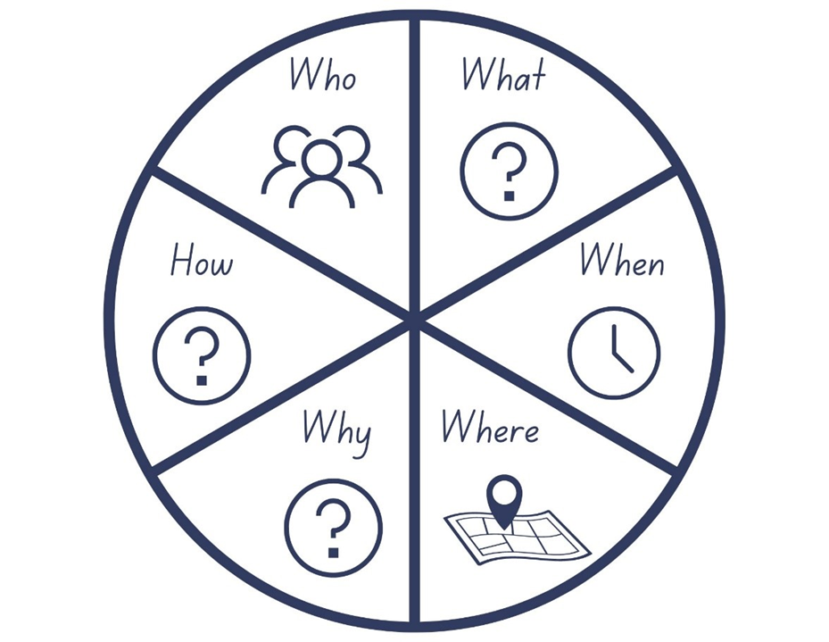
Images sourced from Canva and used in accordance with the Canva Content License Agreement.

Resource 2: Venn diagram
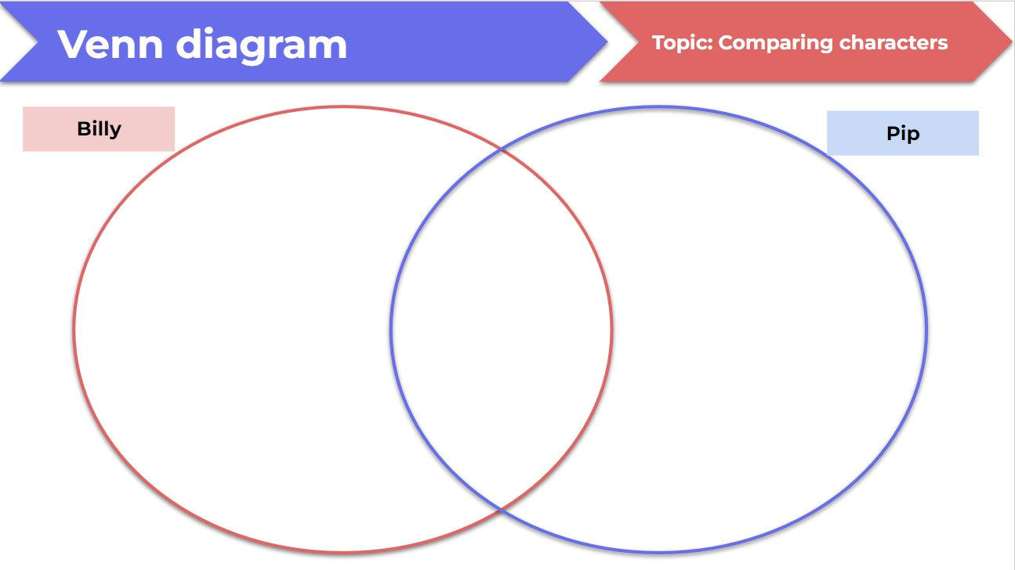

Resource 3: Billy’s new worries
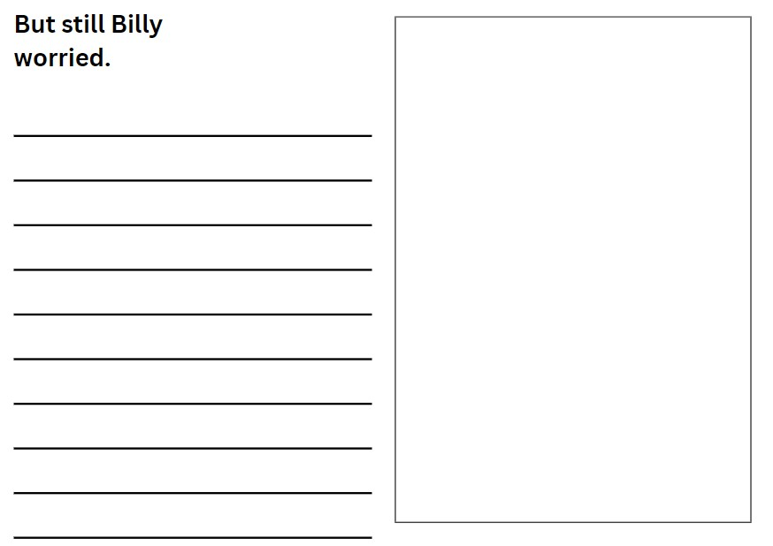

Resource 4: Worries and strategies
Worries | Strategies

References
Links to third-party material and websites
Please note that the provided (reading/viewing material/list/links/texts) are a suggestion only and implies no endorsement, by the New South Wales Department of Education, of any author, publisher, or book title. School principals and teachers are best placed to assess the suitability of resources that would complement the curriculum and reflect the needs and interests of their students.
If you use the links provided in this document to access a third-party's website, you acknowledge that the terms of use, including licence terms set out on the third-party's website apply to the use which may be made of the materials on that third-party website or where permitted by the Copyright Act 1968 (Cth). The department accepts no responsibility for content on third-party websites.
Except as otherwise noted, all material is © State of New South Wales (Department of Education), 2023 and licensed under the Creative Commons Attribution 4.0 International License. All other material (third-party material) is used with permission or under licence. Where the copyright owner of third-party material has not licensed their material under a Creative Commons or similar licence, you should contact them directly for permission to reuse their material.
English K–10 Syllabus © 2022 NSW Education Standards Authority (NESA) for and on behalf of the Crown in right of the State of New South Wales.
© 2022 NSW Education Standards Authority. This document contains NSW Curriculum and syllabus content. The NSW Curriculum is developed by the NSW Education Standards Authority. This content is prepared by NESA for and on behalf of the Crown in right of the State of New South Wales. The material is protected by Crown copyright.
Please refer to the NESA Copyright Disclaimer for more information.
NESA holds the only official and up-to-date versions of the NSW Curriculum and syllabus documents. Please visit the NSW Education Standards Authority (NESA) website and the NSW Curriculum website.
National Literacy Learning Progression © Australian Curriculum, Assessment and Reporting Authority (ACARA) 2010 to present, unless otherwise indicated. This material was downloaded from the Australian Curriculum website (National Literacy Learning Progression) (accessed 2 March 2023) and was not modified. The material is licensed under CC BY 4.0. Version updates are tracked in the ‘Curriculum version history’ section on the 'About the Australian Curriculum' page of the Australian Curriculum website.
ACARA does not endorse any product that uses the Australian Curriculum or make any representations as to the quality of such products. Any product that uses material published on this website should not be taken to be affiliated with ACARA or have the sponsorship or approval of ACARA. It is up to each person to make their own assessment of the product, taking into account matters including, but not limited to, the version number and the degree to which the materials align with the content descriptions and achievement standards (where relevant). Where there is a claim of alignment, it is important to check that the materials align with the content descriptions and achievement standards (endorsed by all education Ministers), not the elaborations (examples provided by ACARA).
British Broadcasting Corporation (2 December 2017) ‘BBC One Christmas 2017 – The Supporting Act’ [video], BBC, YouTube, accessed 2 March 2023.
Browne A (2007) Silly Billy, Walker Books Australia, Newtown.
ETA (English Teachers Association) and NSW Department of Education (2016) The Textual Concepts and Processes resource, English Textual Concepts website, accessed 2 March 2023
Southeastern Guide Dogs (25 October 2018) ‘Pip | A Short Animated Film by Southeastern Guide Dogs’ [video], Southeastern Guide Dogs, YouTube, accessed 3 March 2023.

Further reading
State of New South Wales (Department of Education) (2020) ‘Mindfulness activities’, Teaching and learning, NSW Department of Education website, accessed 8 March 2023.

