English – K-2 multi-age – Year B – Unit 17
Contents
Unit overview and instructions for use 3
Teacher notes 4
Outcomes and content – Component A 5
Outcomes and content – Component B 9
Week 1 13
Component A teaching and learning 13
Component B teaching and learning 14
Lesson 1: Reviewing the key ideas of familiar texts 16
Lesson 2: Analysing the text Chalk 17
Lesson 3: Analysing the text The Patchwork Bike 20
Lesson 4: Analysing the text What’s Inside a Flower? 24
Lesson 5: Identifying a favourite text and planning for writing 28
Week 2 32
Component A teaching and learning 32
Component B teaching and learning 33
Lesson 6: Using compound and complex sentences 34
Lesson 7: Intentional word choice 38
Lesson 8: Learning to self-assess 40
Lesson 9: Publishing writing 43
Lesson 10: Comparing opinions with peers 44
Resource 1: Images 46
Resource 2: Question wheel 47
Resource 3: Mentor text analysis (Early Stage 1) 48
Resource 4: Mentor text analysis (Stage 1) 49
Resource 5: Keyhole template 50
Resource 6: Planning (Early Stage 1) 51
Resource 7: Planning (Stage 1) 52
Resource 8: Exemplar texts 53
References 54

Unit overview and instructions for use
This two-week unit is comprised of Component A and Component B. Connecting learning across both components is encouraged.
Teaching and learning | Component A | Component B
Suggested duration | 60 minutes | 45 minutes
Explicit teaching focus areas | - Phonological awareness (Early Stage 1)  - Print conventions (Early Stage 1)  - Phonic knowledge  - Reading fluency  - Reading comprehension  - Spelling  - Handwriting | - Oral language and communication  - Vocabulary  - Reading comprehension  - Creating written texts  - Understanding and responding to literature
To prepare for teaching and learning: | - Refer to Outcomes and content – Component A, K-2 – Instructional sequence – grapheme–phoneme correspondences [PDF 825 KB], and the teaching advice documents (hyperlinked in Component A teaching and learning table).  - Based on student needs identified through ongoing assessment data, plan and document how you will sequence teaching and learning in whole class and targeted teaching groups across the two-week cycle. | - Familiarise yourself with Outcomes and content – Component B, Textual concepts information and videos, English Textual Concepts and Learning Processes (2016), and the teaching and learning sequence.  - Based on student needs identified through ongoing assessment data, determine how you will support students in whole class and targeted teaching groups across the two-week cycle as required.
English K–10 Syllabus © 2022 NSW Education Standards Authority (NESA) for and on behalf of the Crown in right of the State of New South Wales.

Teacher notes
- Perspective is a lens through which we learn to see the world. It can clarify, magnify, distort or blur what we see. By adopting different perspectives, a responder can bring to light the underlying values in the text and construct meanings that may challenge, confirm or modify the original reading of a text.– English Textual Concepts and Learning Processes (2016).
- Understanding of perspective can be supported through watching the department’s video: Perspective (3:37).
- While perspective is the mentor concept for the conceptual component of this unit, the supporting concepts of context and argument (Stage 1) can be explored using the texts Chalk by Bill Thomson, The Patchwork Bike by Maxine Beneba Clarke and What’s Inside a Flower? by Rachel Ignotofsky.
- The abovementioned texts have been explored in previous multi-age Year B units, Unit 9 (Chalk), Unit 12 (The Patchwork Bike) and Unit 16 (What’s Inside a Flower?).
- Refer to the NESA Glossary for information on grammatical terms within the unit.
- Modifying and qualifying words are words that add detail to a sentence. Some modifying and qualifying words show quantity. For example, very, every, some and a few.
- This unit could enhance student learning towards the achievement of PDHPE Syllabus outcomes.
- Consider prior student knowledge on compound sentences, complex sentences, coordinating conjunctions, subordinating conjunctions, adverbs, and modifying and qualifying words.
- Reflect on student learning and engagement in activities and record differentiation and adjustments within the unit to inform future teaching and learning. One way of doing this could be to add comments to the digital file.
- Content points are linked to the National Literacy Learning Progression version (3).
Levels and indicators sourced from National Literacy Learning Progression © Australian Curriculum, Assessment and Reporting Authority (ACARA), (accessed 25 January 2023) and was not modified. See references for more information.

Outcomes and content – Component A
The table below outlines the focus outcomes and content. Content is linked to the National Literacy Learning Progression version (3).
Early Stage 1 Focus area and outcome | Stage 1 Focus area and outcome
Phonological awareness  ENE-PHOAW-01 – identifies, blends, segments and manipulates phonological units in spoken words as a strategy for reading and creating texts  - As needed. | N/A
Print conventions  ENE-PRINT-01 – tracks written text from left to right and from top to bottom of the page and identifies visual and spatial features of print  - As needed. | N/A
Phonic knowledge  ENE-PHOKW-01 – uses single-letter grapheme–phoneme correspondences and common digraphs to decode and encode words when reading and creating texts  - decode words containing split digraphs and vowel digraphs (PKW5)  - experiment with encoding high-frequency words containing split digraphs and vowel digraphs. | Phonic knowledge  EN1-PHOKW-01 – uses initial and extended phonics, including vowel digraphs, trigraphs to decode and encode words when reading and creating texts  - decode words with less common consonant digraphs and apply this when reading texts  - decode words with trigraphs and quadgraphs and apply this when reading texts  - blend and decode 2-syllable words with taught vowel graphs, digraphs, trigraphs and quadgraphs, including graphemes for r-controlled vowels and diphthongs and apply this when reading texts (PKW6, PKW7).
Reading fluency  ENE-REFLU-01 – reads decodable texts aloud with automaticity  - read words automatically then apply to texts  - regulate their voice to respond to punctuation such as question marks and exclamation marks (FlY4). | Reading fluency  EN1-REFLU-01 – sustains reading unseen texts with automaticity and prosody and self-corrects errors  - self-correct when fluency and/or meaning is interrupted  - adjust phrasing, intonation, volume or rate to maintain fluency when reading aloud (FlY4).
Reading comprehension  ENE-RECOM-01 – comprehends independently read texts using background knowledge, word knowledge and understanding of how sentences connect  - use known vocabulary to work out or refine the meaning of unknown words  - clarify own purpose for reading a text  - use information or events from different parts of the text to form an opinion. | Reading comprehension  EN1-RECOM-01 – comprehends independently read texts that require sustained reading by activating background and word knowledge, connecting and understanding sentences and whole text, and monitoring for meaning  - identify when meaning is not complete and/or contradicts prior understanding  - re-read words, phrases or sentences to check and clarify precise meaning  - interpret patterns in texts to enhance understanding.
Spelling  ENE-SPELL-01 – applies phonological, orthographic and morphological generalisations and strategies to spell taught familiar and high-frequency words when creating texts  - segment multisyllabic words into syllables and phonemes as a strategy for spelling  - experiment with some vowel digraphs and split digraphs to spell taught high-frequency words and/or personally significant words. | Spelling  EN1-SPELL-01 – applies phonological, orthographic and morphological generalisations and strategies when spelling words in a range of writing contexts  - segment multisyllabic words into syllables and phonemes as a strategy for spelling (SpG5)  - spell high-frequency base words with taught vowel graphs, digraphs, split digraphs, trigraphs and quadgraphs (SpG6)  - use extended phonic code for taught consonant phoneme  - use the comparative and superlative suffixes –er and –est (SpG9).
Handwriting  ENE-HANDW-01 – produces all lower-case and upper-case letters to create texts  - apply taught handwriting skills when creating texts. | Handwriting  EN1-HANDW-01 – uses a legible, fluent and automatic handwriting style, and digital technology, including word-processing applications, when creating texts  - use word-processing program functions, including text-editing applications (HwK5)  - recognise and use keys to show more complex punctuation or symbols (HwK5).

Outcomes and content – Component B
The table below outlines the focus outcomes and content. Content is linked to the National Literacy Learning Progression version (3).
Early Stage 1 Focus area and outcome | Stage 1 Focus area and outcome
Oral language and communication  ENE-OLC-01 – communicates effectively by using interpersonal conventions and language with familiar peers and adults  - listen for a purpose by agreeing or disagreeing, adding to the comment of others, or sharing thoughts and feelings  - use oral language to reason when speaking  - use oral language to persuade, negotiate, give opinions or discuss ideas (InT4)  - use a combination of sentences to elaborate and connect ideas (SpK3). | Oral language and communication  EN1-OLC-01 – communicates effectively by using interpersonal conventions and language to extend and elaborate ideas for social and learning interactions  - understand when a message is not clear and ask questions and/or gesture to elicit support and/or seek clarification (LiS4)  - interact to evaluate ideas and refine meaning (InT4, InT5)  - link or compare ideas when interacting.
Vocabulary  ENE-VOCAB-01 – understands and effectively uses Tier 1 words and Tier 2 words in familiar contexts  - use vocabulary that is specific to key learning areas (SpK3, CrT3). | Vocabulary  EN1-VOCAB-01 – understands and effectively uses Tier 1, taught Tier 2 and Tier 3 vocabulary to extend and elaborate ideas  - understand and intentionally choose subject-specific vocabulary to enhance precision and for effect.
Reading comprehension  ENE-RECOM-01 – comprehends independently read texts using background knowledge, word knowledge and understanding of how sentences connect  - identify conjunctions in a compound sentence, their meaning and purpose  - understand that informative and imaginative texts have different structures, features and forms (UnT5)  - use information or events from different parts of the text to form an opinion. | Reading comprehension  EN1-RECOM-01 – comprehends independently read texts that require sustained reading by activating background and word knowledge, connecting and understanding sentences and whole text, and monitoring for meaning  - know the meaning and purpose of coordinating and subordinating conjunctions and identify them in a complex sentence  - coordinate information or events from different parts of the text to form an overall opinion  - interpret patterns in texts to enhance understanding.
Creating written texts  ENE-CWT-01 – creates written texts that include at least 2 related ideas and correct simple sentences  - create a text including at least 2 related ideas (CrT5)  - create written texts that describe, give an opinion, recount an event, convey a story  - experiment with writing compound sentences and recognise that each clause makes meaning by itself (GrA4)  - use capital letters when writing proper nouns (PuN3, CrT5)  - explain the purpose of a verb, a noun and an adjective in own writing (GrA2, GrA3)  - intentionally select nouns, verbs, adjectives and articles in own writing  - edit their texts after receiving feedback. | Creating written texts  EN1-CWT-01 – plans, creates and revises texts written for different purposes, including paragraphs, using knowledge of vocabulary, text features and sentence structure  - group sentences into paragraphs commencing with a topic sentence, followed by other sentences with related ideas (CrT7)  - write compound sentences using coordinating conjunctions (GrA4, CrT5)  - use adverbs to modify the meaning of verbs and adjectives (GrA3)  - experiment with writing complex sentences which include a clause for the main message and dependent clause to elaborate or modify the message (GrA5)  - use modifying and qualifying words and words to indicate quantity  - make intentional word choices to enhance precision of meaning and ideas in a text (CrT5)  - re-read and edit their own texts after receiving feedback.
Understanding and responding to literature  ENE-UARL-01 – understands and responds to literature read to them  - express likes and dislikes about a text (UnT5)  - identify favourite stories and/or characters in texts using verbal and/or nonverbal modes  - compare opinions of a text or characters with peers (InT2)  - identify and contrast features of texts that inform, persuade and/or entertain (UnT5). | Understanding and responding to literature  EN1-UARL-01 – understands and responds to literature by creating texts using similar structures, intentional language choices and features appropriate to audience and purpose  - identify and share how their own experience and interests influence opinions and/or interpretations of texts  - express preferences for specific texts and authors and recognise the opinions of others (UnT5)  - identify how the language and form of a text vary according to purpose, audience and mode (UnT5).

Week 1

Component A teaching and learning
The table below can be used to plan and document lessons that address Component A outcomes and content. Both the detailed example [DOC 529KB] of a two-week teaching and learning cycle and brief example [DOC 66KB] may support you in your planning.
Focus Areas | Lesson 1 | Lesson 2 | Lesson 3 | Lesson 4 | Lesson 5
Phonological awareness (Early Stage 1) and Phonic knowledge
15 minutes
Spelling and Handwriting
15 minutes
Print conventions (Early Stage 1), Reading comprehension and Reading fluency
30 minutes

Component B teaching and learning
The following teaching and learning sequence has been designed to address Component B outcomes and content. Adapt the sequence as required to best meet the needs of your students.

Learning intention and success criteria
Learning intentions and success criteria are best co-constructed with students. The table below contains suggested learning intentions and success criteria.
Element | Early Stage 1 | Stage 1
Learning intentions | Students are learning to express their opinions of texts that inform, persuade or entertain. | Students are learning to identify how the language and form of texts varies, and to express an opinion of a range of texts based on its features.
Success criteria | Students can:  - identify the features of texts that inform, persuade or entertain  - express likes and dislikes about a text  - listen and interact with others by agreeing or disagreeing  - compare opinions about a text with peers  - plan a text that gives an opinion. | Students can:  - ask questions to seek clarification  - express preferences for texts and recognise the opinions of others  - identify own experience and interests influence opinions of texts  - identify how the language and form of a text vary according to purpose, audience and mode  - identify modifying and qualifying words that indicate quantity  - plan to write a paragraph to express a text preference.

Resources
- Thomson B (2010) Chalk, Amazon Publishing, Seattle. ISBN: 9780761455264
- Ignotofsky R (2021) What’s Inside a Flower? Random House Children’s Books, United States. ISBN: 9780593176474
- Beneba Clarke M (2016) The Patchwork Bike (Rudd VT, illus) Lothian Children’s Books, Melbourne. ISBN: 9780734418609
- Resource 1: Images (enlarged colour copy cut up prior to lesson)
- Resource 2: Question wheel
- Resource 3: Mentor text analysis (Early Stage 1) (enlarged copy and 3 copies for each student)
- Resource 4: Mentor text analysis (Stage 1) (enlarged copy and 3 copies for each student)
- Resource 5: Keyhole template
- Resource 6: Planning (Early Stage 1)
- Resource 7: Planning (Stage 1)
- Large blank paper
- 2 blindfolds, 2 empty tissue boxes with a range of objects inside (see Lesson 5 for more details)
- Mini whiteboards

Lesson 1: Reviewing the key ideas of familiar texts
The following teaching and learning activities support multi-age settings.

Whole
- Print an enlarged colour copy of Resource 1: Images. Cut up and display in 3 locations around the room. Explain that students will select which image they like the best and stand in that area. Ask students to provide a reason why they chose their image and encourage them to use a ‘because’ statement to support their reasoning. For example, I chose the dinosaur because it is scary; I chose the flower because it smells nice.
- Display the mentor texts, Chalk, The Patchwork Bike, and What’s Inside a Flower?. Explain that over the next few lessons, students will complete a critical review of 3 familiar texts that they have explored in previous units. Ask students to recall what they remember about each text. Support students to think about the purpose of the text. For example, What's Inside a flower? is written to inform. As a class, walk through each text, discussing text features.
- Organise students into 3 mixed ability groups, providing each group with one of the mentor texts, a copy of Resource 2: Question wheel and blank paper. Select a group leader to use Resource 2: Question wheel for the group to discuss the purpose and main features of the text. Students write or draw their thoughts on the blank paper.
Too hard? Analyse each text as a class group.
- Create a three-column chart with the headings, ‘Chalk’, ‘The Patchwork Bike’, and ‘What’s Inside a Flower?’ to compare the purpose and main features of each text. Model writing student responses in each column as they share with the class.
- Model writing the name of each text and the authors on the board. Revise that proper nouns need a capital letter.
- Ask students to decide which of the 3 texts is their favourite. Students write simple sentences (Early Stage 1) or compound sentences (Stage 1) stating which text is their favourite and provide a reason to support this. Encourage students to use the author’s name in their sentences. For example, ‘My favourite book is Chalk by Bill Thompson. I like this book because of the colourful pictures.’

Lesson 2: Analysing the text Chalk
The following teaching and learning activities support multi-age settings.

Whole
- Revise the concept of perspective. Explain that perspective is our point of view. It is what people may think or believe to be true. Perspective is shaped by our personal experiences and can influence our opinions and choices. Model examples of perspective using the text.
- Display the completed chart from Lesson 1. Revisit the key ideas listed about each text and explain that the features of a text can influence a reader’s opinion.
- Explain that a reader’s perspective and opinion of a text can change over time. Ask students what things might impact and change their opinion. For example, listening to the opinions of peers, having an experience that has changed their thinking about different topics or learning about an author and why they have written a text.
- Display an enlarged copy of Resource 3: Mentor text analysis (Early Stage 1) and Resource 4: Mentor text analysis (Stage 1). Explain that students will use this resource for each of the texts over the next 3 lessons. The completed templates will be needed for later lessons.
- Complete a guided walk through of Chalk as a class, pausing to discuss what is occurring in each page of the story. Encourage students to ask questions to support their understanding of the main events in the text.
- Explain that students will analyse the structure, purpose, visual and language features in Chalk. Discuss each aspect and ask questions to support student understanding referring to the chart from Lesson 1. For example:
Purpose and structure:
- Discuss the purpose of this text. For example, to entertain.
- Explain that text structure is used to organise information to suit the style of the text and its purpose.
- Is there a recognisable structure? For example, a narrative has a beginning, middle and end (Early Stage 1), introduction, series of events and resolution (Stage 1) and characters.
Visual features:
- Look at the first double page of the text, notice how the illustration shows the dinosaur watching the children. Ask what the dinosaur might be thinking. Is this illustration used to show the perspective of the children or the dinosaur?
- Display the double page with the dinosaur’s shadow over the children. Ask how the illustration shows the emotion of the children.
- Discuss the colours used throughout the book and how the use of colour can influence readers’ opinions and interpretations.
Language features:
- This is a wordless text.
- Discuss how the wordless text allows readers to interpret their own version of the events and what characters might be thinking and feeling.
- Discuss whether wordless texts allow the reader the same enjoyment as a text with words.

Part
The table below details the differentiated teaching and learning activities for each stage.
Early Stage 1 (teacher guided/independent/pairs) | Stage 1 (independent/pairs)
- Provide each student with a copy of Resource 3: Mentor text analysis (Early Stage 1) to analyse the text Chalk. Model how to complete the resource.  - Students independently complete the first 3 parts of the resource.  - Students complete the last section of the resource to compare their opinion with a peer. This is an oral language activity.  - Optional: Students write to explain a peer’s opinion.  Too hard: Students draw what they like or dislike about the text.  Too easy? Students write a ‘because’ statement to explain their peer’s opinion. | - Students express their opinions about Chalk by completing the first 3 parts of Resource 4: Mentor text analysis (Stage 1).  - In pairs, students complete the last section of the resource to share and compare their opinion with a peer. This is an oral language activity.  - Optional: Students write to explain a peer’s opinion.  Too easy? Students write sentences to explain any similarities or differences of opinions. For example, ‘I like Chalk because __ but, Sam did not like Chalk because __.’

Whole
- Ask students to stand on one side of the room if they liked Chalk, and on the other side if they did not. Select students to share their opinions and why. Discuss the popularity of the text.

Lesson 3: Analysing the text The Patchwork Bike
The following teaching and learning activities support multi-age settings.

Whole
- As a class, decide on a special place, for example, a beach, rainforest or the desert. Ask students to close their eyes and imagine they are in this special place. Using Resource 5: Keyhole template, students draw what they saw looking through the keyhole. Compare and discuss student drawings. Explain that the drawings might be different because people may have a different perspective of the same place. Perspectives are influenced by personal experiences. Discuss how people’s experiences shape their perspectives.
- Read The Patchwork Bike as a class. Select pages and model asking clarifying questions about the characters or what is happening in the story. For example, ask why the children made a bike out of bits and pieces.
- Explain that students will analyse the purpose, structure, visual and language features in The Patchwork Bike. Discuss each aspect and ask prompting questions to support student understanding. Refer to the chart from Lesson 1. For example:
Purpose and structure:
- Discuss the purpose of this text. For example, to entertain. Ask students to justify their reasons.
- Remind students that text structure is used to organise information to suit the style of the text and its purpose.
- Discuss the structure. For example, a narrative has a beginning, middle and end (Early Stage 1), introduction, series of events and resolution (Stage 1).
Visual features:
- Display the pages where the illustrator has used streaks of paint across 2 pages. How does this technique help the reader gain a deeper understanding of the characters and what is happening in the text? For example, the children are zooming around and are a bit cheeky.
- Ask how the colours of the illustrations are used to help the reader understand the setting (desert, village), movement (zooming) and emotions (the page where the children are on the bike with the blue striped background).
- Discuss how the illustrator has used shadows to show time passing.
Language features:
- The author uses a variety of adjectives in the text. For example, crazy brothers, fed-up mum, no-go desert, stretching-out sky, best thing. Some of these are in a different colour font. Discuss the impact of these adjectives and how they help a reader respond to the text.
- What does ‘fed-up’ mean and why does the mother feel this way? For example, the mother is feeling annoyed because the children are taking her kitchen items.
- Draw attention to the use of onomatopoeia. For example, ‘winketty wonk’, ‘bumpetty bump’.
- How do these language features influence our opinion of the text?

Part
The table below details the differentiated teaching and learning activities for each stage.
Early Stage 1 (independent/pairs) | Stage 1 (teacher guided/independent/pairs)
- Provide each student with a copy of Resource 3: Mentor text analysis (Early Stage 1) to analyse the text The Patchwork Bike.  - Students independently complete the first 3 parts of the resource.  - Students complete the last section to compare their opinion with a peer. This is an oral language activity.  - Optional: Students write to explain a peer’s opinion.  Too easy? Students use the resource from Chalk and The Patchwork Bike to write sentences comparing their opinions about the 2 texts. For example, ‘I like Chalk better because __.’ | - Continue the discussion about language features in a text. Explain that texts can have a pattern. When readers can understand and identify a pattern it helps them to comprehend what they are reading. Some texts repeat words/phrases, some texts are organised in a distinctive way.  - Explain that the structure of the narrative follows a pattern – orientation, complication and resolution. Flick through the text to revisit the orientation, complication/series of events and resolution.  - Explain that the language patterns of a text contribute to the distinctive nature of its overall organisation and shape its meaning.  - Ask students if they notice other language patterns in the text. For example, the use of colour for some adjectives, the larger use of font for some words, several of the sentences starting with ‘it’.  - Students express their opinions about The Patchwork Bike by completing the first 3 parts of Resource 4: Mentor text analysis (Stage 1).  - In pairs, students complete the last section of the resource to share and compare their opinion with a peer. This is an oral language activity. Encourage students to ask questions that clarify each other’s opinions. For example, students could ask why their partner liked the characters.  - Optional: Students write to explain a peer’s opinion.

Whole
- Ask students to explain whose perspective the text was written from and what features within the text helped them to come to that conclusion.
Stage 1 Assessment task 1 – Observations from this lesson allow students to demonstrate achievement towards the following syllabus outcome and content point:
EN1-RECOM-01 – comprehends independently read texts that require sustained reading by activating background and word knowledge, connecting and understanding sentences and whole text, and monitoring for meaning
- interpret patterns in texts to enhance understanding.

Lesson 4: Analysing the text What’s Inside a Flower?
The following teaching and learning activities support multi-age settings.

Whole
- Introduce informative texts by playing a game of ‘What am I?’ Give several facts (clues) without telling students the name of the object they are guessing (such as a plant). For example, ‘I am a living thing, I need food and water to survive.’ After each fact is given, allow students to ask clarifying questions. For example, ‘Are you human or an animal? Do you eat meat?’
- Select and read some pages of What’s Inside a Flower? as a class, pausing to discuss its features. Encourage students to ask questions to support their understanding of the text.
- Explain that students will analyse the structure, purpose, visual and language features in What’s Inside a Flower? Discuss each aspect and ask questions to support student understanding referring to the chart from Lesson 1. For example:
Purpose and structure:
- Identify the purpose of the text and ask students to justify their thinking. For example, the text informs. It has information (facts) about flowers.
- Discuss the structure of the text. Each page has information about a topic. For example, where flowers are found, the variety of shapes, colours and sizes.
- Compare the main differences between this text Chalk and The Patchwork Bike.
Visual features:
- Examine the labelled diagrams on some of the pages. Ask how these differ from other illustrations in Chalk and The Patchwork Bike.
- The illustrations support the information being provided. For example, ‘Flowers are found growing on trees (statement), in orchards (illustration), on the vines of fruits (illustration), in grassy fields (illustration), and fancy gardens (illustration).’
- Describe and compare the illustrations used in the text. For example, two-dimensional and cartoon-like in What’s Inside a Flower? in contrast to the life-like, three-dimensional images in Chalk.
Language features:
- Highlight the use of subject-specific words in an informative text. For example, bud, petal, sepal, pollen and photosynthesis. Open What’s Inside a Flower? to the double page about earthworms.
- Support students to identify nouns, verbs, and adjectives on the pages. For example, nouns – bugs, bacteria, fungi; verbs – munch, crunch, wiggle; adjectives – first, new, dead. Discuss how these words help the author convey information.
- Highlight the changing complexity of the language used by the author throughout the text. It begins with one or two sentences per page and slowly becomes more complex as the information on plants is explained.

Part
The table below details the differentiated teaching and learning activities for each stage.
Early Stage 1 (independent/pairs) | Stage 1 (teacher guided/pairs/independent)
- Provide each student with a copy of Resource 3: Mentor text analysis (Early Stage 1) to express their opinions about What’s Inside a Flower?  - Students independently complete the first 3 parts of the resource.  - Students complete the last section to compare their opinion with a peer. This is an oral language activity.  - Optional: Students write to explain a peer’s opinion.  Too easy? Students use nouns, verbs and adjectives to write facts they learnt from the text. | - Continue the discussion about language features in the text.  - Modifying and qualifying words are words that add detail to a sentence. Some modifying and qualifying words show quantity. For example, very, every, some and a few.  - Discuss why the author has used modifying and qualifying words to indicate quantity. Discuss and identify where these can be found in the text, What’s Inside a Flower? For example:  - ‘Most flowers need pollen to come from another plant to make seeds’  - ‘Some flowers rely on the wind to spread their pollen.’  - Model using modifying and qualifying words that indicate quantity to give an opinion about a text. For example, ‘I think that the book What’s Inside a Flower? is very interesting because it has many facts about how flowers grow and reproduce.’ Identify the modifying and qualifying words (very, many).  - Students express their opinions about What’s Inside a Flower? by completing the first 3 parts of Resource 4: Mentor text analysis (Stage 1). Encourage students to use modifying and qualifying words in their descriptions, as modelled in the previous activity.  - In pairs, students complete the last section of the resource to share and compare their opinion with a peer. This is an oral language activity. Encourage students to ask questions that clarify each other’s opinions.  - Optional: Students write to explain a peer’s opinion.  Too easy? Students write their ideas in the form of sentences.

Whole
- Play another game of ‘What am I?’ using a subject-specific word from the text, such as, petal, pollen, or photosynthesis. Encourage students to use subject-specific words to ask clarifying questions. For example, if given the clue: ‘I am carried by bees (pollen)’, students could ask if the object is made in the stamen of a flower.
Early Stage 1 Assessment task 1 – Observations and work samples from this lesson allow students to demonstrate achievement towards the following syllabus outcomes and content points:
ENE-OLC-01 – communicates effectively by using interpersonal conventions and language with familiar peers and adults
- listen for a purpose by agreeing or disagreeing, adding to the comment of others, or sharing thoughts and feelings
- use oral language to reason when speaking
- use oral language to persuade, negotiate, give opinions or discuss ideas
- use a combination of sentences to elaborate and connect ideas.
ENE-RECOM-01 – comprehends independently read texts using background knowledge, word knowledge and understanding of how sentences connect
- understand that informative and imaginative texts have different structures, features and forms
ENE-CWT-01 – creates written texts that include at least 2 related ideas and correct simple sentences
- use capital letters when writing proper nouns.
Stage 1 Assessment task 2 – Observations and work samples from this lesson allow students to demonstrate achievement towards the following syllabus outcomes and content points:
EN1-OLC-01 – communicates effectively by using interpersonal conventions and language to extend and elaborate ideas for social and learning interactions
- interact to evaluate ideas and refine meaning
- link or compare ideas when interacting
- understand when a message is not clear and ask questions and/or gesture to elicit support and/or seek clarification.
EN1-CWT-01 – plans, creates and revises texts written for different purposes, including paragraphs, using knowledge of vocabulary, text features and sentence structure
- use modifying and qualifying words and words to indicate quantity.

Lesson 5: Identifying a favourite text and planning for writing
The following teaching and learning activities support multi-age settings.

Whole
- Set up a feely bag/box with objects of different sizes and textures, such as, bolts, fruit, dominoes, sandpaper, toy car. Choose a student, place a blindfold over their eyes and have them select an object from the bag/box and describe it to the class. Ensure that the objects remain hidden so that the rest of the class can listen to the description. On mini whiteboards, the rest of the students write the words used to describe the objects or draw what they think the object is based on the description given. When the student has finished describing the object, the class shares what they think the object is. Reveal the object. Discuss whether students’ descriptions and drawings were similar or different. Repeat with different students and objects.
- Revise the concept of perspective and explore how the descriptions varied among students in activity 1. Ask why students may have used different words/drawings to describe the objects and why students might have different ideas.
- Students review their 3 completed text analysis resources to determine which was their overall favourite text. Ask students to justify their decision based on the purpose, structure, visual and language features of their chosen text. Highlight how choices may be different from initial opinions in Lesson 1.

Part
The table below details the differentiated teaching and learning activities for each stage.
Early Stage 1 (teacher guided/ independent) | Stage 1 (small groups/independent)
- Model completing Resource 6: Planning (Early Stage 1) to demonstrate how students will plan for writing a short text that gives an opinion.  - Students complete Resource 6: Planning (Early Stage 1).  Too hard? Co-construct sentences in small groups based on favourite text selection. | - Students work in small groups based on their favourite text and share their opinions.  - Students plan for writing a text that gives an opinion using Resource 7: Planning (Stage 1).
- Create a class graph with the title, ‘Our Favourite Book’, to visually show the class opinions. Analyse the most and least favourite texts and discuss.
- Ask if students’ opinions have changed since Lesson 1. Discuss how personal experiences and interest influenced opinions and preferences.
Early Stage 1 Assessment task 2 – Collecting work samples from this lesson allow students to demonstrate achievement towards the following syllabus outcomes and content points:
ENE-RECOM-01 – comprehends independently read texts using background knowledge, word knowledge and understanding of how sentences connect
- use information or events from different parts of the text to form an opinion.
ENE-UARL-01 – understands and responds to literature read to them
- express likes and dislikes about a text
- identify favourite stories and/or characters in texts using verbal and/or nonverbal modes
- identify and contrast features of texts that inform, persuade and/or entertain.
Stage 1 Assessment task 3 – Observations from this lesson allow students to demonstrate achievement towards the following syllabus outcome and content points:
EN1-UARL-01 – understands and responds to literature by creating texts using similar structures, intentional language choices and features appropriate to audience and purpose
- identify and share how their own experience and interests influence opinions and/or interpretations of texts
- express preferences for specific texts and authors and recognise the opinions of others
- identify how the language and form of a text vary according to purpose, audience and mode.

Week 2

Component A teaching and learning
The table below can be used to plan and document lessons that address Component A outcomes and content. Both the detailed example [DOC 529KB] of a two-week teaching and learning cycle and brief example [DOC 66KB] may support you in your planning.
Focus Areas | Lesson 6 | Lesson 7 | Lesson 8 | Lesson 9 | Lesson 10
Phonological awareness (Early Stage 1) and Phonic knowledge
15 minutes
Spelling and Handwriting
15 minutes
Print conventions (Early Stage 1), Reading comprehension and Reading fluency
30 minutes

Component B teaching and learning
The following teaching and learning sequence has been designed to address Component B outcomes and content. Adapt the sequence as required to best meet the needs of your students.

Learning intention and success criteria
Learning intentions and success criteria are best co-constructed with students. The table below contains suggested learning intentions and success criteria.
Element | Early Stage 1 | Stage 1
Learning intentions | Students are learning to write their opinion about a text. | Students are learning to write a paragraph explaining their perspective and opinion about a text.
Success criteria | Students can:  - write compound sentences to express an opinion  - use nouns, verbs, adjectives to improve their own writing  - create a text to give an opinion  - edit and publish their own writing after receiving feedback  - compare opinions of texts with peers. | Students can:  - write compound and complex sentences to express a preference  - use adverbs to enhance their own writing  - organise writing into a paragraph  - provide feedback to peers and edit their own writing  - express preferences for texts and recognise the opinions of others.

Resources
- Thomson B (2010) Chalk, Amazon Publishing, Seattle. ISBN: 9780761455264
- Ignotofsky R (2021) What’s Inside a Flower? Random House Children’s Books, United States. ISBN: 9780593176474
- Beneba Clarke M (2016) The Patchwork Bike (Rudd VT, illus) Lothian Children’s Books, Melbourne. ISBN: 9780734418609
- Resource 3: Mentor text analysis (Early Stage 1)
- Resource 4: Mentor text analysis (Stage 1)
- Resource 6: Planning (Early Stage 1) (enlarged copy and individual copies for each student)
- Resource 7: Planning (Stage 1) (enlarged copy and individual copies for each student)
- Resource 8: Exemplar texts (enlarged copy).

Lesson 6: Using compound and complex sentences
The following teaching and learning activities support multi-age settings.

Whole
- Play a game of ‘true or false’. Provide students with statements to assess their understanding of the 3 texts. For example, ‘Is What’s Inside a Flower? an informative text?’ If students think the statement is true, they do a star jump; they sit if they think the statement is false.
- Explain to students that they will be working towards writing sentences (Early Stage 1) or a paragraph (Stage 1) stating their opinion about their favourite text.
- Revise compound sentences as a sentence with 2 or more independent clauses joined by a coordinating conjunction. Look at an example of a compound sentence from one of the texts. For example, in The Patchwork Bike, ‘These are my crazy brothers (independent clause) and (coordinating conjunction) this is my fed-up mum (independent clause).’
- Jointly construct a compound sentence that states the opinion of a chosen student. For example, ‘Shahida likes nature, so What’s Inside a Flower? is her favourite text.’

Part
The table below details the differentiated teaching and learning activities for each stage.
Early Stage 1 (pairs) | Stage 1 (teacher guided)
- In pairs, students discuss their favourite texts.  - Using the modelled example in activity 4, students write a compound sentence describing their partner’s favourite text and why. For example, ‘Jackson liked Chalk because he likes dinosaurs.’ | - Use Resource 8: Exemplar texts to demonstrate how to write a paragraph that states an opinion about a favourite text.  - Revise the structure of a paragraph drawing attention to the topic sentence.  - Ask students to identify compound and complex sentences. If needed, identify complex sentences in a text to support understanding. For example, ‘Some petals are shaped like a landing pad for bugs, (independent clause) while (subordinating conjunction) other flowers are perfect for long tongues and beaks (dependent clause).’  - Highlight the use of modifying and qualifying words used to indicate quantity in Resource 8: Exemplar texts (some, many, lots of).

Part
The table below details the differentiated teaching and learning activities for each stage.
Early Stage 1 (teacher guided) | Stage 1 (independent)
- Use Resource 8: Exemplar texts to demonstrate how to write sentences that share an opinion about a favourite text and how ideas are related across sentences.  - Ask students to identify and explain the use of capital letters. If needed, remind students that proper nouns need a capital letter.  - Highlight the use of simple and compound sentences.  - Model using Resource 6: Planning (Early Stage 1) to write a text to share an opinion.  - Students write to explain their opinion. | - Students use their planning sheets from Lesson 5 to independently draft a paragraph to express an opinion. Remind students to include at least 3 reasons to support their opinion.
Early Stage 1 Assessment task 3 – Observations and work samples from this lesson allow students to demonstrate achievement towards the following syllabus outcomes and content points:
ENE-RECOM-01 – comprehends independently read texts using background knowledge, word knowledge and understanding of how sentences connect
- identify conjunctions in a compound sentence, their meaning and purpose.
ENE-CWT-01 – creates written texts that include at least 2 related ideas and correct simple sentences
- experiment with writing compound sentences and recognise that each clause makes meaning by itself.
Stage 1 Assessment task 4 – Observations and work samples from this lesson allow students to demonstrate achievement towards the following syllabus outcomes and content points:
EN1-RECOM-01 – comprehends independently read texts that require sustained reading by activating background and word knowledge, connecting and understanding sentences and whole text, and monitoring for meaning
- know the meaning and purpose of coordinating and subordinating conjunctions and identify them in a complex sentence.
EN1-CWT-01 – plans, creates and revises texts written for different purposes, including paragraphs, using knowledge of vocabulary, text features and sentence structure
- write compound sentences using coordinating conjunctions
- experiment with writing complex sentences which include a clause for the main message and dependent clause to elaborate or modify the message.

Lesson 7: Intentional word choice
The following teaching and learning activities support multi-age settings.

Whole
- Create an anchor chart with the headings ‘nouns’, ‘verbs’, and ‘adjectives’. Ask students to recall any nouns, verbs, and adjectives from each text. For example:
Chalk:
- nouns – Tyrannosaurus-rex, carnivore, creature
- verbs – crouching, stalking, crawling
- adjectives – terrified, excited, anxious.
The Patchwork Bike:
- nouns – machine, vehicle, village
- verbs – building, exploding, accelerating
- adjectives – deserted, isolated, frustrated.
What’s Inside a Flower?:
- nouns – photosynthesis, pollination, decomposers
- verbs – bloom, slurp, buried
- adjectives – sturdy, colourful, attractive.
- Write the sentence ‘I like dinosaurs so Chalk is my favourite book’. Model how to use more specific words to enhance meaning. For example, ‘Tyrannosaurus-rex dinosaurs are terrifying, so Chalk is my favourite book.’ Draw attention to the use of the adverb ‘terrifying’ for Stage 1 students.
- In mixed stage groups students read their writing from Lesson 6 and identify the nouns, verbs and adjectives. Students identify words that could be added, changed or enhanced by highlighting or circling. Explain that Stage 1 students should include adverbs.
- Students re-write their sentences to add or change words to enhance the meaning. Stage 1 students may need a list of adverbs to support their writing.
Early Stage 1 Assessment task 4 – Observations and work samples from this lesson allow students to demonstrate achievement towards the following syllabus outcomes and content points:
ENE-VOCAB-01 – understands and effectively uses Tier 1 words and Tier 2 words in familiar contexts
- use vocabulary that is specific to key learning areas.
ENE-CWT-01 – creates written texts that include at least 2 related ideas and correct simple sentences
- explain the purpose of a verb, a noun and an adjective in own writing
- intentionally select nouns, verbs, adjectives and articles in own writing.
Stage 1 Assessment task 5 – Observations and work samples from this lesson allow students to demonstrate achievement towards the following syllabus outcomes and content points:
EN1-VOCAB-01 – understands and effectively uses Tier 1, taught Tier 2 and Tier 3 vocabulary to extend and elaborate ideas
- understand and intentionally choose subject-specific vocabulary to enhance precision and for effect.
EN1-CWT-01 – plans, creates and revises texts written for different purposes, including paragraphs, using knowledge of vocabulary, text features and sentence structure
- make intentional word choices to enhance precision of meaning and ideas in a text.

Lesson 8: Learning to self-assess
The following teaching and learning activities support multi-age settings.

Whole
- Remind students that they will create a text with 2 to 3 related ideas (Early Stage 1), and Stage 1 students will finalise their paragraph (Stage 1) to convey an opinion about their favourite text.
- Remind students that good writers continually self-assess and edit their work. An example of a co-constructed writing criteria is set out in the table below.
Early Stage 1 writing criteria | Stage 1 writing criteria
- write sentences with at least 2 ideas that match  - state an opinion about your favourite book  - give a reason for your opinion  - write compound sentences  - use capital letters at the start of a sentence and when writing proper nouns. | - state an opinion about your favourite book  - provide at least 2 reasons to support your perspective  - write compound and complex sentences  - organise your writing into a coherent paragraph  - select and use appropriate vocabulary to enhance your writing including adverbs.
- Display an enlarged copy of Resource 8: Exemplar texts and use the think aloud strategy to explain how these examples meet the writing criteria. Leave this on display for students to refer to throughout the lesson.

Part
The table below details the differentiated teaching and learning activities for each stage.
Early Stage 1 (pairs) | Stage 1 (teacher guided)
- In pairs, students Draw-Talk-Share to complete a detailed illustration to match their writing from Lesson 6.  - Optional: Supply students with a variety of art and craft materials to add detail to their illustrations. | - Revise the purpose and structure of a paragraph including:  - topic sentence  - related ideas  - closing sentence.  - Identify the features of a paragraph in the Stage 1 example on Resource 8: Exemplar texts. Explain that students will create a paragraph using the structure of their planning template.

Part
The table below details the differentiated teaching and learning activities for each stage.
Early Stage 1 (teacher guided) | Stage 1 (independent)
- Use the co-constructed success criteria and a writing sample to model how to self-assess.  - Explain that students will use their writing to self-assess. Ensure each student has their writing from Lesson 6 in front of them.  - Explicitly focus on one success criteria point at a time with students. Ask them to place a tick above their writing when they identify where each point has been met.  - Provide time for students to edit their writing to ensure all the points of the success criteria are met.  Too hard? Simplify the success criteria for students to focus on targeted areas. | - Students write their paragraph using their completed copy of Resource 7: Planning (Stage 1). Encourage students to use the exemplar text and the co-constructed writing criteria.  Too hard? Students write compound sentences using fewer reasons for liking the text.
- Sit students in a circle to share progress on their learning. This could include something they found hard or easy, a goal they have or something new they have learnt.
Early Stage 1 Assessment task 5 – Collecting work samples from this lesson allows students to demonstrate achievement towards the following syllabus outcome and content points:
ENE-CWT-01 – creates written texts that include at least 2 related ideas and correct simple sentences
- create a text including at least 2 related ideas
- create written texts that describe, give an opinion, recount an event, convey a story
- edit their texts after receiving feedback.
Stage 1 Assessment task 6 – Observations and work samples from this lesson allow students to demonstrate achievement towards the following syllabus outcomes and content points:
EN1-RECOM-01 – comprehends independently read texts that require sustained reading by activating background and word knowledge, connecting and understanding sentences and whole text, and monitoring for meaning
- coordinate information or events from different parts of the text to form an overall opinion.
EN1-CWT-01 – plans, creates and revises texts written for different purposes, including paragraphs, using knowledge of vocabulary, text features and sentence structure
- group sentences into paragraphs commencing with a topic sentence, followed by other sentences with related ideas
- use adverbs to modify the meaning of verbs and adjectives
- re-read and edit their own texts after receiving feedback.

Lesson 9: Publishing writing
The following teaching and learning activities support multi-age settings.

Whole
- Provide time for students to publish their writing from Lesson 9.
- Optional: Record or video students reading their published writing and upload to a school online communication platform to share with family members.
- Support students to reflect on their learning by providing some self-assessment questions. For example:
- What was the most important thing you learned?
- What would you improve in your writing next time?
- What did you enjoy the most and why?

Lesson 10: Comparing opinions with peers
- Visit the school library and ask students to select a text that has similar features to the favourite text they identified in this unit. For example, a wordless text or a text that informs/entertains.
- In small mixed ability groups, students explore and discuss the features in their favourite text from home or school.
- Explain that students will create a book wrap for their favourite text. On the book wrap, students will draw and write clues about the book to entice others to want to read it.
- Model writing sentences to describe an opinion of the text. For example, ‘I like this book because:
- it has rhyming words
- it has facts
- it is funny.’
- Provide students with white wrapping paper or A3 envelopes to create a book wrap for their chosen text. On the book wrap, students write an opinion about the text using the modelled writing from activity 4.
- Students draw other features of the text that they like, such as favourite characters and scenes or a fact or topic. Once students have written and drawn several clues on the book wraps (without writing the text title), wrap the books or place them inside the A3 envelopes.
- Place the wrapped/covered books around the classroom for students to access easily. Allow students time to select different books to unwrap or open based on the clues drawn and written on the wrap. When students have finished looking at a book, they express whether they agree with the opinion by placing a tick or smiley face on the back of the wrap. They then re-wrap it or put in back in the envelope for another student to explore.
- Select students to discuss how many of their peers agreed with their opinion about the text.
Early Stage 1 Assessment task 6 – Observations from this lesson allow students to demonstrate achievement towards the following syllabus outcome and content point:
ENE-UARL-01 – understands and responds to literature read to them
- compare opinions of a text or characters with peers.

Resource 1: Images
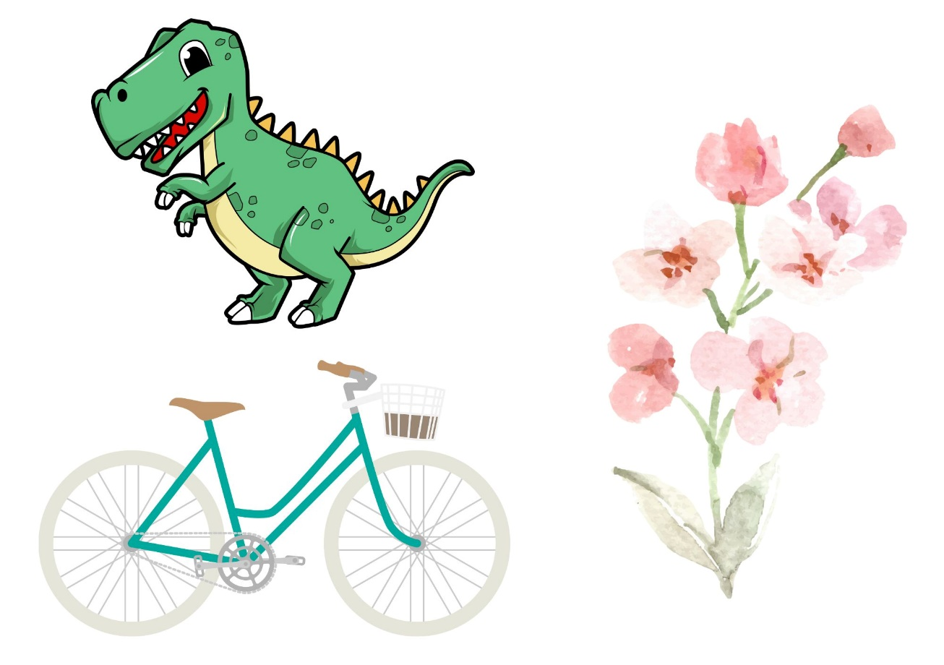
Images sourced from Canva and used in accordance with the Canva Content License Agreement.

Resource 2: Question wheel
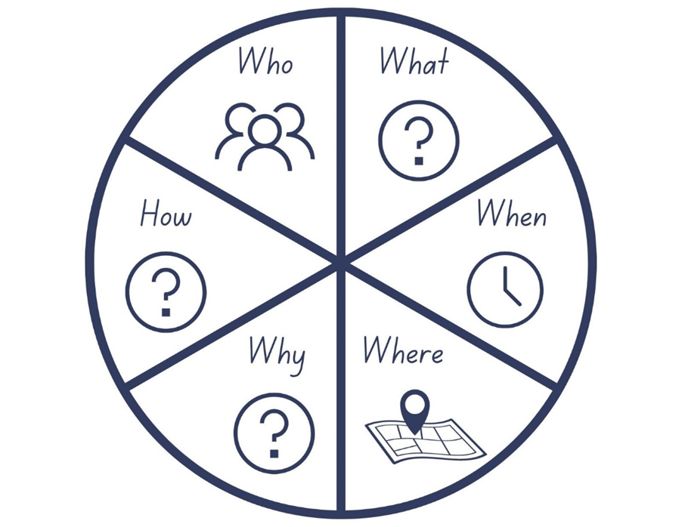
Images sourced from Canva and used in accordance with the Canva Content License Agreement.

Resource 3: Mentor text analysis (Early Stage 1)
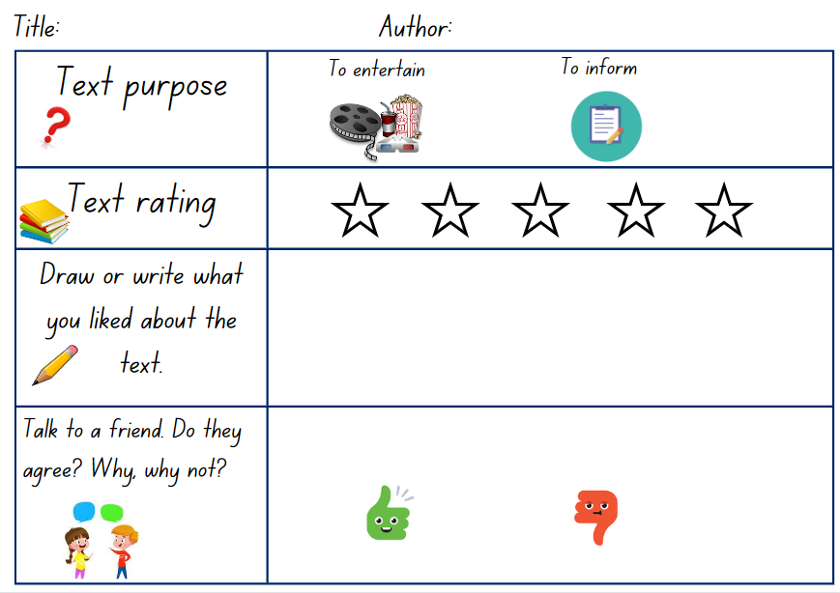
Images sourced from Canva and used in accordance with the Canva Content License Agreement.

Resource 4: Mentor text analysis (Stage 1)
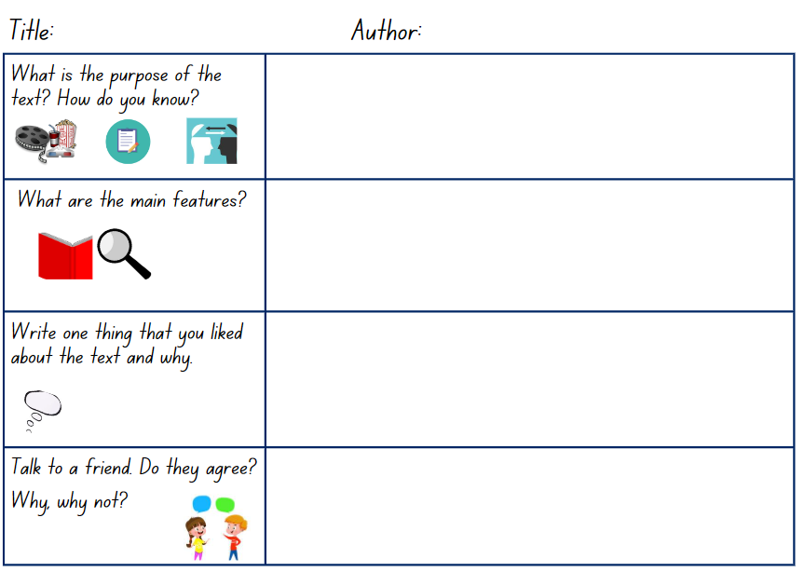
Images sourced from Canva and used in accordance with the Canva Content License Agreement.

Resource 5: Keyhole template
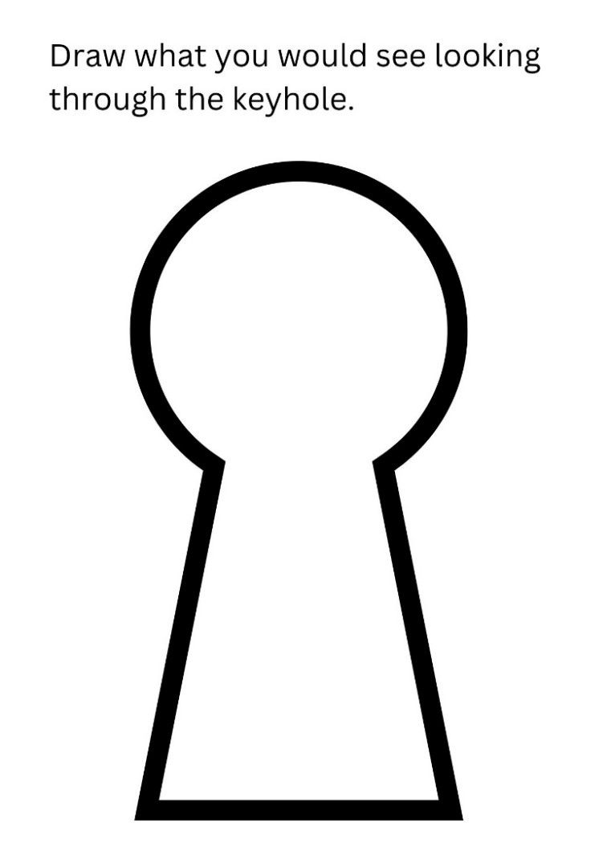
‘Keyhole icon’ by Graphixmania sourced from Canva and used in accordance with the Canva Content License Agreement.

Resource 6: Planning (Early Stage 1)
Early Stage 1 planning template
Who is the author of the book?
Write the reason you liked the book.
Write another reason why you liked the book.
Why would you recommend this book to a friend?

Resource 7: Planning (Stage 1)
Stage 1 planning template
Write the reason why you liked the text (use key words or sentences)
Write 2 more reasons why this text is your favourite.
State some features of the text.
Why would you recommend this text to a friend?

Resource 8: Exemplar texts
Early Stage 1 | Stage 1
I really like Tyrannosaurus-rex dinosaurs, so Chalk by Bill Thompson is my favourite book. I like that it has no words. I would tell my friend to read Chalk because they like scary dinosaurs. | My favourite book is What’s Inside a Flower? because the information about plants is fascinating. Although I found some of the words hard to read, the facts were very interesting. I also liked how the author used different sized text and scientific words. The book has many features including labelled diagrams, and lots of interesting words to describe plants. I would recommend this book to anyone who is interested in learning more about science and how plants grow.

References
Links to third-party material and websites
Please note that the provided (reading/viewing material/list/links/texts) are a suggestion only and implies no endorsement, by the New South Wales Department of Education, of any author, publisher, or book title. School principals and teachers are best placed to assess the suitability of resources that would complement the curriculum and reflect the needs and interests of their students.
If you use the links provided in this document to access a third-party's website, you acknowledge that the terms of use, including licence terms set out on the third-party's website apply to the use which may be made of the materials on that third-party website or where permitted by the Copyright Act 1968 (Cth). The department accepts no responsibility for content on third-party websites.
Except as otherwise noted, all material is © State of New South Wales (Department of Education), 2023 and licensed under the Creative Commons Attribution 4.0 International License. All other material (third-party material) is used with permission or under licence. Where the copyright owner of third-party material has not licensed their material under a Creative Commons or similar licence, you should contact them directly for permission to reuse their material.
English K–10 Syllabus © 2022 NSW Education Standards Authority (NESA) for and on behalf of the Crown in right of the State of New South Wales.
© 2022 NSW Education Standards Authority. This document contains NSW Curriculum and syllabus content. The NSW Curriculum is developed by the NSW Education Standards Authority. This content is prepared by NESA for and on behalf of the Crown in right of the State of New South Wales. The material is protected by Crown copyright.
Please refer to the NESA Copyright Disclaimer for more information.
NESA holds the only official and up-to-date versions of the NSW Curriculum and syllabus documents. Please visit the NSW Education Standards Authority (NESA) website and the NSW Curriculum website.
National Literacy Learning Progression © Australian Curriculum, Assessment and Reporting Authority (ACARA) 2010 to present, unless otherwise indicated. This material was downloaded from the Australian Curriculum website (National Literacy Learning Progression) (accessed 25 January 2023) and was not modified. The material is licensed under CC BY 4.0. Version updates are tracked in the ‘Curriculum version history’ section on the 'About the Australian Curriculum' page of the Australian Curriculum website.
ACARA does not endorse any product that uses the Australian Curriculum or make any representations as to the quality of such products. Any product that uses material published on this website should not be taken to be affiliated with ACARA or have the sponsorship or approval of ACARA. It is up to each person to make their own assessment of the product, taking into account matters including, but not limited to, the version number and the degree to which the materials align with the content descriptions and achievement standards (where relevant). Where there is a claim of alignment, it is important to check that the materials align with the content descriptions and achievement standards (endorsed by all education Ministers), not the elaborations (examples provided by ACARA).
Beneba Clarke M (2016) The Patchwork Bike (Rudd VT, illus) Lothian Children’s Books, Melbourne
ETA (English Teachers Association) and NSW Department of Education (2016) The Textual Concepts and Processes resource, English Textual Concepts website, accessed 25 January 2023
Ignotofsky R (2021) What’s Inside a Flower? Random House Children’s Books, United States.
Thomson B (2010) Chalk, Amazon Publishing, Seattle.

