English – K-2 multi-age – Year B – Unit 16
Contents
Unit overview and instructions for use 3
Teacher notes 4
Outcomes and content – Component A 6
Outcomes and content – Component B 9
Week 1 13
Component A teaching and learning 13
Component B teaching and learning 14
Lesson 1: Previewing the text 15
Lesson 2: Images, adjectives, nouns and paragraphs 18
Lesson 3: Vocabulary 22
Lesson 4: Verbs and possessive apostrophes 26
Lesson 5: Context and oral language 28
Week 2 31
Component A teaching and learning 31
Component B teaching and learning 32
Lesson 6: Text purpose and features 33
Lesson 7: Time connectives and words to indicate quantity 37
Lesson 8: Sequencing and paragraphs 40
Lesson 9: Reflection and poster creation 42
Lesson 10: Sharing and review 45
Resource 1: See-Think-Wonder 47
Resource 2: Parts of a flower 48
Resource 3: Word mat – Stage 1 49
Resource 4: Word mat – Early Stage 1 50
Resource 5: Save the Bees! 51
Resource 6: Text purpose and features 52
Resource 7: Plant life cycle 54
References 55

Unit overview and instructions for use
This two-week unit is comprised of Component A and Component B. Connecting learning across both components is encouraged.
Teaching and learning | Component A | Component B
Suggested duration | 60 minutes | 45 minutes
Explicit teaching focus areas | - Phonological awareness (Early Stage 1)  - Print conventions (Early Stage 1)  - Phonic knowledge  - Reading fluency  - Reading comprehension  - Spelling  - Handwriting | - Oral language and communication  - Vocabulary  - Reading comprehension  - Creating written texts  - Understanding and responding to literature
To prepare for teaching and learning: | - Refer to Outcomes and content – Component A, K-2 – Instructional sequence – grapheme–phoneme correspondences [PDF 825 KB], and the teaching advice documents (hyperlinked in Component A teaching and learning table).  - Based on student needs identified through ongoing assessment data, plan and document how you will sequence teaching and learning in whole class and targeted teaching groups across the two-week cycle. | - Familiarise yourself with Outcomes and content – Component B, Textual concepts information and videos, English Textual Concepts and Learning Processes (2016), and the teaching and learning sequence.  - Based on student needs identified through ongoing assessment data, determine how you will support students in whole class and targeted teaching groups across the two-week cycle as required.
English K–10 Syllabus © 2022 NSW Education Standards Authority (NESA) for and on behalf of the Crown in right of the State of New South Wales.

Teacher notes
- Context is defined as a culturally or socially situated circumstance that may give rise to a particular register (NESA Glossary). To understand context, we look beyond the text to consider the world in which it was produced and the worlds of its reception. – English Textual Concepts and Learning Processes (2016).
- Understanding of context can be supported through watching the department’s video: Context (5:24).
- While context is the mentor concept for the conceptual component of this unit, the supporting concept of imagery, symbol and connotation can be explored using the mentor text What’s Inside a Flower?: And Other Questions About Science and Nature by Rachel Ignotofsky.
- The text is intended to be read in parts over the course of the 2-week duration of the unit.
- Throughout the unit, each student will store all completed work samples in their own plastic sleeve or sheet protector. At the completion of the unit, students will use aspects of their completed work samples to create a poster.
- Teachers will be required to display a tomato or sunflower seed and plant. Optional activity – students will plant a seed and watch it sprout. Provide students with cotton wool, a resealable plastic bag and a seed, for example, sunflower or tomato.
- A digital platform will be used to showcase student informative texts. Students require access to recording devices with digital platforms such as Flip or Apple iMovie.
- For information on nouns, adjectives, verbs, possessive apostrophes and time connectives refer to the NESA Glossary.
- Refer to Rachel Ignotofsky’s website and The making of What's Inside a Flower? By Rachel Ignotofsky (0:53) to support further understanding of the author and their context.
- This unit could enhance student learning towards achievement of outcomes from the Science syllabus regarding changes and growth of living things and how their environments provide for their need.
- Consider prior student learning and knowledge of paragraphing.
- Reflect on student learning and engagement in activities and record differentiation and adjustments within the unit to inform future teaching and learning. One way of doing this could be to add comments to the digital file.
- Content points are linked to the National Literacy Learning Progression version (3).
Levels and indicators sourced from National Literacy Learning Progression © Australian Curriculum, Assessment and Reporting Authority (ACARA), (accessed 24 January 2023) and was not modified. See references for more information.

Outcomes and content – Component A
The table below outlines the focus outcomes and content. Content is linked to the National Literacy Learning Progression version (3).
Early Stage 1 Focus area and outcome | Stage 1 Focus area and outcome
Phonological awareness  ENE-PHOAW-01 – identifies, blends, segments and manipulates phonological units in spoken words as a strategy for reading and creating texts  - identify the first, middle and final phonemes in a one-syllable word (PhA4)  - blend aloud all phonemes when asked to delete, add or substitute an initial phoneme (PhA5) | N/A
Print conventions  ENE-PRINT-01 – tracks written text from left to right and from top to bottom of the page and identifies visual and spatial features of print  - as needed | N/A
Phonic knowledge  ENE-PHOKW-01 – uses single-letter grapheme–phoneme correspondences and common digraphs to decode and encode words when reading and creating texts  - decode words containing split digraphs and vowel digraphs (PKW5)  - experiment with encoding high-frequency words containing split digraphs and vowel digraphs | Phonic knowledge  EN1-PHOKW-01 – uses initial and extended phonics, including vowel digraphs, trigraphs to decode and encode words when reading and creating texts  - blend and decode one-syllable words with taught extended vowel graphs and digraphs, including graphemes for r-controlled vowels and diphthongs, and apply this when reading texts (PKW6, PKW7)  - segment and encode one-syllable words with taught vowel graphs, digraphs and trigraphs and apply this when creating texts  - blend and decode 2-syllable words with taught vowel graphs, digraphs, trigraphs and quadgraphs, including graphemes for r-controlled vowels and diphthongs and apply this when reading texts (PKW6, PKW7)
Reading fluency  ENE-REFLU-01 – reads decodable texts aloud with automaticity  - read words automatically then apply to texts  - regulate their voice to respond to punctuation such as question marks and exclamation marks (FlY4) | Reading fluency  EN1-REFLU-01 – sustains reading unseen texts with automaticity and prosody and self-corrects errors  - read aloud with an easy speech rhythm (FlY3)  - vary pace when reading according to the audience and purpose (FlY4)
Reading comprehension  ENE-RECOM-01 – comprehends independently read texts using background knowledge, word knowledge and understanding of how sentences connect  - use known vocabulary to work out or refine the meaning of unknown words  - clarify own purpose for reading a text  - recount the relevant ideas from the text (UnT5) | Reading comprehension  EN1-RECOM-01 – comprehends independently read texts that require sustained reading by activating background and word knowledge, connecting and understanding sentences and whole text, and monitoring for meaning  - draw on sources to seek clarification for unknown words  - identify when meaning is not complete and/or contradicts prior understanding  - recount relevant ideas from texts in the form of a written, visual or oral summary (UnT6)
Spelling  ENE-SPELL-01 – applies phonological, orthographic and morphological generalisations and strategies to spell taught familiar and high-frequency words when creating texts  - segment multisyllabic words into syllables and phonemes as a strategy for spelling  - experiment with some vowel digraphs and split digraphs to spell taught high-frequency words and/or personally significant words | Spelling  EN1-SPELL-01 – applies phonological, orthographic and morphological generalisations and strategies when spelling words in a range of writing contexts  - use extended phonic code for taught consonant phonemes  - use the suffixes –ful, –y and –ly to spell taught high-frequency words (SpG9)
Handwriting  ENE-HANDW-01 – produces all lower-case and upper-case letters to create texts  - use a stable posture when handwriting or drawing by sitting comfortably with feet flat on the floor, the writing arm resting on a table, with the opposite hand resting on the paper, and shoulders relaxed | Handwriting  EN1-HANDW-01 – uses a legible, fluent and automatic handwriting style, and digital technology, including word-processing applications, when creating texts  - position all letters correctly on the line with appropriate spacing between words (HwK5)

Outcomes and content – Component B
The table below outlines the focus outcomes and content. Content is linked to the National Literacy Learning Progression version (3).
Early Stage 1 Focus area and outcome | Stage 1 Focus area and outcome
Oral language and communication  ENE-OLC-01 – communicates effectively by using interpersonal conventions and language with familiar peers and adults  - listen for a purpose by agreeing or disagreeing, adding to the comment of others, or sharing thoughts and feelings  - tell a story or information to peers or adults using oral language (SpK3) | Oral language and communication  EN1-OLC-01 – communicates effectively by using interpersonal conventions and language to extend and elaborate ideas for social and learning interactions  - interact to evaluate ideas and refine meaning (InT4, InT5)
Vocabulary  ENE-VOCAB-01 – understands and effectively uses Tier 1 words and Tier 2 words in familiar contexts  - use vocabulary that is specific to key learning areas (SpK3, CrT3)  - use and understand Tier 3 words that are of personal interest | Vocabulary  EN1-VOCAB-01 – understands and effectively uses Tier 1, taught Tier 2 and Tier 3 vocabulary to extend and elaborate ideas  - understand and intentionally choose subject-specific vocabulary to enhance precision and for effect
Reading comprehension  ENE-RECOM-01 – comprehends independently read texts using background knowledge, word knowledge and understanding of how sentences connect  - use known vocabulary to work out or refine the meaning of unknown words  - understand that informative and imaginative texts have different structures, features and forms (UnT5)  - clarify own purpose for reading a text  - recount the relevant ideas from the text (UnT5) | Reading comprehension  EN1-RECOM-01 – comprehends independently read texts that require sustained reading by activating background and word knowledge, connecting and understanding sentences and whole text, and monitoring for meaning  - draw on sources to seek clarification for unknown words  - ask a clarifying question when more background knowledge is needed to make an inference  - use visual and/or auditory features in multimodal texts to build meaning (UnT5)  - use information read in texts to enhance learning across key learning areas  - recount relevant ideas from texts in the form of a written, visual or oral summary (UnT6)
Creating written texts  ENE-CWT-01 – creates written texts that include at least 2 related ideas and correct simple sentences  - include recognisable structural features for text purpose (CrT5)  - explain the purpose of a verb, a noun and an adjective in own writing (GrA2, GrA3)  - intentionally select nouns, verbs, adjectives and articles in own writing  - identify different purposes for writing (CrT4)  - identify and use time connectives to sequence information and events (GrA4) | Creating written texts  EN1-CWT-01 – plans, creates and revises texts written for different purposes, including paragraphs, using knowledge of vocabulary, text features and sentence structure  - group sentences into paragraphs commencing with a topic sentence, followed by other sentences with related ideas (CrT7)  - use visual elements to expand meaning in own texts  - use possessive apostrophes in own writing (PuN4)  - use modifying and qualifying words and words to indicate quantity  - make intentional word choices to enhance precision of meaning and ideas in a text (CrT5)  - use knowledge of similarities and differences between imaginative, informative and persuasive texts when planning for writing  - use different modes and media to enhance the presentation of texts they have created (CrT5, CrT6)  - use time connectives to sequence information and events in texts (GrA4)
Understanding and responding to literature  ENE-UARL-01 – understands and responds to literature read to them  - identify texts that are composed for specific audiences and purposes  - identify and contrast features of texts that inform, persuade and/or entertain (UnT5)  - create imaginative and/or informative texts relating to their own experience, the world and/or other texts (CrT3)  - identify how visual cues contribute to the meaning of a text | Understanding and responding to literature  EN1-UARL-01 – understands and responds to literature by creating texts using similar structures, intentional language choices and features appropriate to audience and purpose  - identify how the language and form of a text vary according to purpose, audience and mode (UnT5)  - create and re-create texts in a range of modes and media using understanding of context (CrT5)  - identify symbols and images in texts, and how they bring deeper meaning

Week 1

Component A teaching and learning
The table below can be used to plan and document lessons that address Component A outcomes and content. Both the detailed example [DOC 529KB] of a two-week teaching and learning cycle and brief example [DOC 66KB] may support you in your planning.
Focus Areas | Lesson 1 | Lesson 2 | Lesson 3 | Lesson 4 | Lesson 5
Phonological awareness (Early Stage 1) and Phonic knowledge
15 minutes
Spelling and Handwriting
15 minutes
Print conventions (Early Stage 1), Reading comprehension and Reading fluency
30 minutes

Component B teaching and learning
The following teaching and learning sequence has been designed to address Component B outcomes and content. Adapt the sequence as required to best meet the needs of your students.

Learning intention and success criteria
Learning intentions and success criteria are best co-constructed with students. The table below contains suggested learning intentions and success criteria.
Element | Early Stage 1 | Stage 1
Learning intentions | Students are learning to understand the context and features of informative texts. | Students are learning to understand the context, language, and structural and visual features of informative texts.
Success criteria | Students can:  - make predictions about a text  - make ‘wonderings’ about a text  - use nouns and adjectives in writing  - identify and unpack subject-specific vocabulary  - use verbs in writing  - orally share connections and information with peers. | Students can:  - make predictions about a text  - make ‘wonderings’ about a text  - write a paragraph  - identify and unpack subject-specific vocabulary  - understand and use possessive apostrophes in writing  - orally share connections and information with peers.

Resources
- Ignotofsky R (2021) What’s Inside A Flower?: And Other Questions About Science and Nature, Crown Books for Young Readers New York. ISBN: 9780593176474
- Resource 1: See-Think-Wonder (one for each student)
- Resource 2: Parts of a flower (one for each student)
- Resource 3: Word mat – Stage 1 (one for each Stage 1 student)
- Resource 4: Word mat – Early Stage 1 (one for each Early Stage 1 student)
- Blank paper and plastic sleeves for each student
- Mini whiteboards
- Recording devices with a digital platform such as Flip or Apple iMovie (one for each pair)
- Sunflower plant and seeds or tomato plant and seeds (for teacher use)
- Optional activity items: seeds, cotton wool, resealable plastic bags for each student

Lesson 1: Previewing the text
The following teaching and learning activities support multi-age settings.

Whole
- Display a sunflower plant and sunflower seeds. Ask:
- What are they?
- What do they have in common?
- How did the seed become a plant?
Optional activity: Students plant a seed and watch it sprout. Provide students with cotton wool, a resealable plastic bag and a seed, for example, sunflower or tomato.
- Introduce What’s Inside A Flower?: And Other Questions About Science and Nature. Display the front and back cover. Discuss the title and author. Allow time for students to make observations.
- In small groups, students make predictions using their observations.
- Students share their predictions with the class. Encourage students to consider how the images assisted in the prediction process.
Note: A book walk is a preview of the text before reading. It allows students to build a mental model of the content.
- Preview What’s Inside A Flower?: And Other Questions About Science and Nature with a book walk.
- Ask and discuss:
- What type of text is this?
- How do you know?
- How do the diagrams, symbols and images help us to understand the text?
- Where do we see images like these in our world?
- What is the author’s purpose for this text?
- Who is the audience?
- Why do you think the author wrote this text?
- Read the author’s biography on the end dust cover. Support students to consider the author’s context. Explain that the author hopes to inspire kids to ask questions about their world.
- Explain that informative texts differ to narrative texts as they have different structures, features and forms.
- In small groups, students revisit their predictions and explain the reasoning behind their predictions.
- Display See-Think-Wonder or Resource 1: See-Think-Wonder. Explain each section. Model writing and drawing ideas. For example, ‘I see lots of different types of plants that are a range of colours. I think that plants and flowers have special names for all the different parts. I wonder why there are lots of worms in the soil.’
- Students write and draw ideas in their own copy of Resource 1: See-Think-Wonder.
Too hard? Students draw pictures in each section.
Too easy? Students record and link ‘wonderings’ using a mind map structure.
- Students share their ideas documented in Resource 1: See-Think-Wonder.
- Explain that students will identify and answer their ‘wonderings’ throughout the unit.

Lesson 2: Images, adjectives, nouns and paragraphs
The following teaching and learning activities support multi-age settings.

Whole
- Remind students that the purpose of informative texts is to describe and explain. Discuss how the visual and language features support this purpose and add meaning to the text. For example:
- labels – identify the name of the flower or plant
- images next to text – provide examples of different places
- diagrams – to show specific information about the part of a flower
- use of colour – to show range and variety
- language – is subject specific.
- Begin reading What’s Inside A Flower?: And Other Questions About Science and Nature, stopping at the end of the page that states ‘Science will help us answer those questions!’
- Review and analyse the visual elements within this section of the text. For example, speech bubbles, labelled images and diagrams. Ask students how these visual features assist their understanding of the text.
- Remind students that the author hopes to inspire readers to ask questions about science. Ask students what the author wanted the audience to know in this section.
- Review nouns and adjectives. Explain that nouns and adjectives are used to describe facts in texts that inform.
- Re-read each double page in this section of text. Identify nouns and adjectives and record on an anchor chart. Display for remainder of the unit. For example:
- nouns: flowers, orchid, cities, trees
- adjectives: bustling, rocky, grassy, thin, colourful.
- Discuss how visual features in informative texts deepen meaning and enhance explanations. For example, the images on the double page with the text ‘They bloom in...’ provide additional information. Draw attention to the author’s use of labels and colour.
- Display Resource 2: Parts of a flower. Identify some of the parts of a flower, for example, roots, leaves, stem, petals or flower. Model labelling using adjectives and nouns, referring to the anchor chart. For example, soft, bright petals; long, thin stem.
- Explain that students will write a description of a flower and create a labelled drawing to deepen meaning and provide additional information.
- Model writing a sentence to describe a flower using adjectives and nouns from the anchor chart, for example, ‘Flowers have soft, bright petals. They grow on a long, thin stem.’
- Provide students with Resource 2: Parts of a flower.

Part
The table below details the differentiated teaching and learning activities for each stage.
Early Stage 1 (independent/pairs) | Stage 1 (teacher guided/independent)
- Students label Resource 2: Parts of a flower using nouns and adjectives, referring to the anchor chart.  - Students write sentences to describe the flower using the adjective and noun labels on Resource 2: Parts of a flower.  Too hard? Students verbally describe their flower to a partner. | - Explain that students will write a paragraph to describe a flower.  - Revise paragraphs as a group of sentences of related ideas, beginning with a topic sentence. Make connections to prior learning and other familiar texts.  - Display teacher modelled Resource 2: Parts of a flower. Co-construct a paragraph about one of the labels to add further description and enhance meaning. For example, ‘The petals are the soft, colourful pieces that make up a flower. Petals range in shape, size and colour. They are the part of the flower that we like to smell.’  - Underline the topic sentence. For example, ‘The petals are the soft, colourful pieces that make up a flower.’ Model reviewing the whole paragraph to check that each sentence relates to the topic sentence.  - Remind students that each label represents a new idea. This becomes a new paragraph and must be started on a new line.  - Students complete Resource 2: Parts of a flower using nouns and adjectives to label, referring to the anchor chart.  - Students write a paragraph to describe one part of a flower using a topic sentence and sentences with related ideas. Refer to adjective and noun labels on Resource 2: Parts of a flower.  Too easy? Students write paragraphs about each part of a flower.

Whole
- Ask students to describe the different parts of a flower. Students answer by sharing their sentences and paragraphs.
- Discuss how the visual representation of the flower and the use of verbs, nouns and adjectives supports meaning.
Early Stage 1 Assessment task 1 – Observations and work samples from this lesson allow students to demonstrate achievement towards the following syllabus outcomes and content points:
ENE-CWT-01 – creates written texts that include at least 2 related ideas and correct simple sentences
- explain the purpose of a verb, a noun and an adjective in own writing
- intentionally select nouns, verbs, adjectives and articles in own writing.
ENE-UARL-01 – understands and responds to literature read to them
- identify how visual cues contribute to the meaning of a text.
Stage 1 Assessment task 1 – Observations and work samples from this lesson allow students to demonstrate achievement towards the following syllabus outcome and content point:
EN1-UARL-01 – understands and responds to literature by creating texts using similar structures, intentional language choices and features appropriate to audience and purpose
- identify symbols and images in texts, and how they bring deeper meaning.

Lesson 3: Vocabulary
The following teaching and learning activities support multi-age settings.

Whole
Note: For further additional teaching strategies, refer to the Additional teaching advice – Early Stage 1: Vocabulary and Additional teaching advice – Stage 1: Vocabulary.
- Revisit the use of language and visual features within informative texts, explaining that they add purpose and meaning.
- Ask what a seed needs to become a flower to engage students in thinking while they read.
- Read What’s Inside A Flower?: And Other Questions About Science and Nature, starting on the page that states ‘The flower starts as a seed underground’ and finishing on the page that states ‘Look! An aphid is having a snack...’.
- Revisit the question of what a seed needs to become a flower. Students brainstorm ideas from the text.
- Identify the subject-specific vocabulary within this section of text. Record on an anchor chart. For example, decomposers, bacteria, fungi, nematode, minerals, calcium.
- Explain that students may not know some of the vocabulary written on the anchor chart. Discuss the strategies students can use to unpack unknown words. For example, ask clarifying questions, draw on other sources, use known vocabulary, find the meaning.
- Explain that students can use the images, symbols and diagrams to infer meaning. For example, the word ‘nematode’ is an unknown word. By drawing on picture sources, students can see that it looks like a worm and infer that it is a type of worm.
- Display the word ‘decomposer’ and explain that you will unpack the word as a class. Ask students what strategies they could use to unpack the word. For example, the prefix ‘de’ means ‘from’, ‘compose’ means ‘make’, ‘compost’ is where natural or organic matter breaks down. Ask if there is a picture source. Students ask clarifying questions and infer what the word ‘decomposer’ means from the strategies used.
- Display and model the use of Resource 3: Word mat – Stage 1, using the word ‘decomposer’. Provide students with strategies for finding the relevant information, for example, the use of a dictionary, clapping to find the number of syllables.
- Explain that students will unpack vocabulary from the text and complete their own word mat.

Part
The table below details the differentiated teaching and learning activities for each stage.
Early Stage 1 (teacher guided) | Stage 1 (independent/in pairs)
- Select and display another Tier 3 word from the anchor chart, for example, bacteria.  - Students brainstorm using the prompt, ‘I wonder what this word means?’  - Discuss the meaning of the word, for example, bacteria are tiny cells or organisms that are found in natural environments. Use think alouds to explain how the information can be found in the text.  - Model orally, sharing a sentence using the word, for example, ‘The soil has lots of good bacteria in it’.  - Model completing Resource 4: Word mat – Early Stage 1 using the Tier 3 word selected in activity 11.  - Students complete Resource 4: Word mat – Early Stage 1 using the word 'nematode.  Too easy? Students choose their own Tier 3 word from the text to complete Resource 4: Word mat – Early Stage 1.  - As a group, students share their sentences. | - Students select a word from the vocabulary anchor chart and complete Resource 3: Word mat – Stage 1.  - In pairs, students share completed Resource 3: Word mat – Stage 1 to expand student vocabulary. Students use some of these words in sentences.  - Students discuss the strategies used to complete Resource 3: Word mat – Stage 1.

Whole
- Play a modified hangman using the vocabulary from the anchor chart. For each incorrect guess, draw the flower’s stem, the flower’s head and 5 individual petals. Students say the word when they know what it is.
Early Stage 1 Assessment task 2 – Observations and work samples from this lesson allow students to demonstrate achievement towards the following syllabus outcomes and content points:
ENE-VOCAB-01 – understands and effectively uses Tier 1 words and Tier 2 words in familiar contexts
- use vocabulary that is specific to key learning areas
- use and understand Tier 3 words that are of personal interest.
ENE-RECOM-01 – comprehends independently read texts using background knowledge, word knowledge and understanding of how sentences connect
- use known vocabulary to work out or refine the meaning of unknown words.
Stage 1 Assessment task 2 – Observations and work samples from this lesson allow students to demonstrate achievement towards the following syllabus outcomes and content points:
EN1-VOCAB-01 – understands and effectively uses Tier 1, taught Tier 2 and Tier 3 vocabulary to extend and elaborate ideas
- understand and intentionally choose subject-specific vocabulary to enhance precision and for effect.
EN1-RECOM-01 – comprehends independently read texts that require sustained reading by activating background and word knowledge, connecting and understanding sentences and whole text, and monitoring for meaning
- draw on sources to seek clarification for unknown words
- ask a clarifying question when more background knowledge is needed to make an inference
- use visual and/or auditory features in multimodal texts to build meaning.
EN1-CWT-01 – plans, creates and revises texts written for different purposes, including paragraphs, using knowledge of vocabulary, text features and sentence structure
- make intentional word choices to enhance precision of meaning and ideas in a text.

Lesson 4: Verbs and possessive apostrophes
The following teaching and learning activities support multi-age settings.

Whole
- Revisit the use of use of vocabulary and visual features in informative texts to enhance meaning.
- Review verbs. Explain how verbs are used to describe what is happening within informative texts.
- Re-read What’s Inside A Flower?: And Other Questions About Science and Nature, starting on the page that states ‘The flower starts as a seed underground’ and finishing on the page that states ‘Look! An aphid is having a snack...’.
- Identify and record verbs within this section of text, for example, wiggle, grow, eat, spread, soaks. Display on an anchor chart for remainder of the unit.
- Ask what happens underground when a seed begins to grow into a flower. Students draw and write ideas on mini whiteboards.
- In small groups, students share their ideas.
- Explain that students will use these ideas to draw and label a diagram of what happens underground when a seed begins to grow into a flower. Revise how diagrams add information and enhance explanations in texts that inform.
- Model drawing a diagram to explain what happens underground when a seed begins to grow into a flower.

Part
The table below details the differentiated teaching and learning activities for each stage.
Early Stage 1 (independent) | Stage 1 (teacher guided)
- Students draw a diagram to explain what happens underground when a seed begins to grow into a flower. | - Discuss possessive apostrophes and how they are used to indicate possession, for example, Rachel’s book.  - Explain that informative texts use possessive apostrophes to show that objects can have ownership. Refer to examples in a section of text, for example, ‘The flower’s roots’, ‘A flower’s stem’, ‘the plant’s leaves’.  - Model writing sentences using possessive apostrophes and verbs to describe what happens underground, for example, ‘The seed’s roots need soil to grow.’

Whole
- Model adding word or phrase labels, referring to the verb, noun, adjective and vocabulary anchor charts. For example, sprouting seeds; spreading roots.

Part
The table below details the differentiated teaching and learning activities for each stage.
Early Stage 1 (teacher guided/independent) | Stage 1 (independent)
- Students add word or phrase labels to explain what happens in their diagram. Refer to verb, noun and adjective anchor charts and vocabulary from Lesson 3.  - Co-construct sentences that explain what happens to the seed using the word or phrase labels, referring to language anchor charts. For example, ‘The seed begins to sprout and push through the soil.’  - Identify and underline the verb within the sentence. Ask what information it provides.  - Referring to the anchor charts, students write a sentence to explain what happens underground when a seed begins to grow into a flower. They then underline the verbs. | - Students draw a diagram to explain what happens underground when a seed begins to grow into a flower.  - Students add word or phrase labels to explain what happens in their diagram.  - Students write a paragraph to explain what happens using possessive apostrophes and vocabulary identified in Lesson 3.

Whole
- Share student work samples. Discuss how the language and diagrams add information and enhance meaning.

Lesson 5: Context and oral language
The following teaching and learning activities support multi-age settings.

Whole
- Revise that the purpose of an informative text is to describe and explain.
- Ask how a seed becomes a flower to engage students in thinking while they read.
- Read What’s Inside A Flower?: And Other Questions About Science and Nature, starting on the page that states ‘Photosynthesis’ and finishing on the page that states ‘FLOWER!’
- Explain that students will go on a ‘plant or flower hunt’ and find one they have a connection with. They will then orally share their connection with their plant or flower in the form of an informative text.
- Display a plant or flower from the school playground that you have a connection with. Brainstorm examples of information that could be shared. For example, students have the same plant at home, they see it every day when they collect the soccer ball from the bush, they like the smell of it.
- Model orally sharing information by outlining a connection or experience had with the plant or flower. For example:
When I was a child, my family would go camping every Easter. At our favourite campsite, there was a hard, prickly bush. We would always have to dig our ball out of it because there would always be someone who hooked it the wrong way. One year, we changed our trip and went in spring. The hard, prickly bush looked and smelled amazing. It was covered with bright, fragrant flowers that I would pick and display at our campsite. When I see this plant in the playground, it reminds me of our family camping trips and the fun we would have.
- Students go on ‘plant or flower hunt’ and find one that they have a connection or experience with. Provide thinking time for students to consider information to share.
- In pairs, near the plant or flower, students record a video sharing information based on their connection or experience. Use a digital platform such as Flip or Apple iMovie.
- Students share their videos. Invite other students to add comments or share their thoughts and feelings about what they have listened to.
Early Stage 1 Assessment task 3 – Observations and work samples from this lesson allow students to demonstrate achievement towards the following syllabus outcome and content points:
ENE-OLC-01 – communicates effectively by using interpersonal conventions and language with familiar peers and adults
- listen for a purpose by agreeing or disagreeing, adding to the comment of others, or sharing thoughts and feelings
- tell a story or information to peers or adults using oral language.

Week 2

Component A teaching and learning
The table below can be used to plan and document lessons that address Component A outcomes and content. Both the detailed example [DOC 529KB] of a two-week teaching and learning cycle and brief example [DOC 66KB] may support you in your planning.
Focus Areas | Lesson 6 | Lesson 7 | Lesson 8 | Lesson 9 | Lesson 10
Phonological awareness (Early Stage 1) and Phonic knowledge
15 minutes
Spelling and Handwriting
15 minutes
Print conventions (Early Stage 1), Reading comprehension and Reading fluency
30 minutes

Component B teaching and learning
The following teaching and learning sequence has been designed to address Component B outcomes and content. Adapt the sequence as required to best meet the needs of your students.

Learning intention and success criteria
Learning intentions and success criteria are best co-constructed with students. The table below contains suggested learning intentions and success criteria.
Element | Early Stage 1 | Stage 1
Learning intentions | Students are learning to identify the language, structural and visual features of texts. They will apply their understanding to compose informative texts. | Students are learning to understand how language, structural and visual features vary according to context. They will apply their understanding to compose informative texts.
Success criteria | Students can:  - identify similarities and differences between the purpose, audience and features of texts  - use time connectives in writing  - write sequenced sentences to describe the life cycle of a flower  - reflect on and answer their ‘wonderings’  - create a ‘collection of work’ poster  - make positive statements about the work of others. | Students can:  - identify similarities and differences between the purpose, audience and features of texts  - use time connectives in writing  - understand and use words to show quantity  - write sequenced paragraphs to describe the life cycle of a flower  - reflect on and answer their ‘wonderings’  - create a ‘collection of work’ poster  - make positive statements about the work of others.

Resources
- Ignotofsky R (2021) What’s Inside A Flower?: And Other Questions About Science and Nature, Crown Books for Young Readers, New York. ISBN: 9780593176474
- Resource 5: Save the Bees! (one for each student)
- Resource 6: Text purpose and features (one per group)
- Resource 7: Plant life cycle (one for each student)
- Video: The Little Bees Learn How To Fly! – Maya the bee (2:58)
- A3 paper or poster cardboard for posters (one for each student)
- Student work samples in plastic sleeves.

Lesson 6: Text purpose and features
The following teaching and learning activities support multi-age settings.

Whole
- Revise context. Remind students identifying context means considering the world in which the text was produced and the world of the person reading.
- Remind students that What’s Inside A Flower?: And Other Questions About Science and Nature is a text that informs in an entertaining way. Discuss the intended audience, for example, a child reading with a parent or a child who is interested in science.
- Revise the features of texts that inform, including the visual, language and structural features.
- Ask where seeds come from. Students Think-Pair-Share what information the author might include in this section.
- Read What’s Inside A Flower?: And Other Questions About Science and Nature, starting on the page that states ‘Look inside a flower to see where seeds are made’ and finishing on the page that states ‘a brand-new seed begins to grow’.
- Draw attention to:
- visual features – scientific diagrams, arrows, labels
- language features – Tier 2 words such as ‘nectar’ and ‘animals’ and Tier 3 words such as ‘pollinators’ and ‘stamen’.
- structural features – layout to group written information with visual information.
- Discuss how the visual features enhance the audience’s enjoyment of the text and make it entertaining, for example, the cartoon style illustrations of the pollinators with smiley faces.
- Explain that students will identify and contrast the features of texts that inform, persuade and entertain.
- Display Resource 5: Save the Bees!
- Students Think-Pair-Share what they think the purpose is and who audience could be.
- Discuss how the visual, language and structural features provide information about the purpose and audience. Use the think aloud strategy to identify:
- purpose, for example, ‘I think the purpose of the text is to persuade us to save bees because it has advice about how to help bees.’
- audience, for example, ‘I think the audience could be children because of the bright colours and cartoon style pictures.’
- Display The Little Bees Learn How To Fly! – Maya the bee (2:58). Repeat activities 10 and 11.
- Display Resource 6: Text purpose and features. Explain that it will be used to identify the purpose, audience and features of What’s Inside A Flower?: And Other Questions About Science and Nature, Resource 5: Save the Bees! and The Little Bees Learn How To Fly! – Maya the bee (2:58).
- Model completing the What’s Inside A Flower?: And Other Questions About Science and Nature section of the resource. Use think aloud strategy to identify specific visual, language and structural features. Record and display.
- Students complete Resource 6: Text purpose and features in small, mixed ability groups.
Too hard? Students draw their responses.
Too easy? Students select their own texts and complete Resource 6: Text purpose and features.
- Discuss the similarities and differences between the purpose, audience and features of What’s Inside A Flower?: And Other Questions About Science and Nature, Resource 5: Save the Bees! and The Little Bees Learn How To Fly! – Maya the bee (2:58)
Early Stage 1 Assessment task 4 – Observations and work samples from this lesson allow students to demonstrate achievement towards the following syllabus outcomes and content points:
ENE-RECOM-01 – comprehends independently read texts using background knowledge, word knowledge and understanding of how sentences connect
- understand that informative and imaginative texts have different structures, features and forms
- clarify own purpose for reading a text.
ENE-CWT-01 – creates written texts that include at least 2 related ideas and correct simple sentences
- identify different purposes for writing.
ENE-UARL-01 – understands and responds to literature read to them
- identify texts that are composed for specific audiences and purposes
- identify and contrast features of texts that inform, persuade and/or entertain.
Stage 1 Assessment task 3 – Observations and work samples from this lesson allow students to demonstrate achievement towards the following syllabus outcomes and content points:
EN1-RECOM-01 – comprehends independently read texts that require sustained reading by activating background and word knowledge, connecting and understanding sentences and whole text, and monitoring for meaning
- use information read in texts to enhance learning across key learning areas.
EN1-UARL-01 – understands and responds to literature by creating texts using similar structures, intentional language choices and features appropriate to audience and purpose
- identify how the language and form of a text vary according to purpose, audience and mode.

Lesson 7: Time connectives and words to indicate quantity
The following teaching and learning activities support multi-age settings.

Whole
- Revise prior learning. Discuss how visual, language and structural features vary according to audience and purpose.
- Remind students that the author of What’s Inside A Flower?: And Other Questions About Science and Nature aims to create texts that inform in entertaining ways.
- Explain that students will draw on their understanding of the features of informative texts to describe and explain the life cycle of a plant.
Note: As a life cycle is cyclical, there is not a first or last stage.
- Establish student understanding of time connectives. Discuss how time connectives are used across informative, persuasive and imaginative texts. Explain that in texts that inform, time connectives are used to sequence information. Brainstorm time connectives and display.
- Ask how flowers attract pollinators to engage students in thinking while they read.
- Read What’s Inside A Flower?: And Other Questions About Science and Nature, starting on the page that states ‘As the seeds get bigger, the flower begins to change’ and finishing on the page that states ‘Plants also do countless other things’.
- Students Think-Pair-Share the main ideas from the pages read.
- Model recounting the main ideas using time connectives, for example, ‘...next animals eat the fruit, then the seeds are scattered when the animals poop’.
- Model beginning Resource 7: Plant life cycle, revising and re-reading the text as needed to ensure correct order.

Part
The table below details the differentiated teaching and learning activities for each stage.
Early Stage 1 (independent) | Stage 1 (teacher guided)
- Students begin Resource 7: Plant life cycle, cutting and pasting each stage in order.  - Students add time connectives from the anchor chart. | - Display the teacher modelled resource and time connectives.  - Explicitly teach that modifying and qualifying words indicate quantity and add detail to a sentence. For example, several, few, more.  - Display examples of words modifying and qualifying words that indicate quantity from the text, for example, many, few, some, all, most.  - Model writing a paragraph that explains one stage of Resource 7: Plant life cycle using time connectives and words to indicate quantity. For example, ‘The seed begins to grow roots underground. Most seeds need water and many nutrients from the soil to grow. Next, a small shoot begins to push up through the soil and poke out of the ground.’

Part
The table below details the differentiated teaching and learning activities for each stage.
Early Stage 1 (teacher guided) | Stage 1 (independent)
- Revise how time connectives sequence information.  - Display the teacher modelled resource with time connectives.  - Model writing sentences that explain one stage of Resource 7: Plant life cycle, for example, ‘The seed begins to grow roots underground. Next, a tiny shoot comes out of the seed.’  - Select another stage. Brainstorm and record relevant vocabulary with the students.  - Students write sentences to explain the stage, including a time connective.  Too hard? Students verbally explain one stage of the life cycle.  - Underline the time connectives. | - Students complete Resource 7: Plant life cycle, adding relevant vocabulary and time connectives.  - Students write one paragraph that explains one of the stages, including words to indicate quantity and a time connective. Students underline these words.

Whole
- Explain that in Lesson 8, students will sequence information and group ideas to explain the other stages in the plant life cycle.

Lesson 8: Sequencing and paragraphs
The following teaching and learning activities support multi-age settings.

Whole
- Display teacher modelled Resource 7: Plant life cycle and modelled writing from Lesson 7. Explain that students will describe the remaining stages in the cycle. Discuss how visual features deepen and enhance meaning.
- Re-read What’s Inside A Flower?: And Other Questions About Science and Nature, starting on the page that states ‘As the seeds get bigger, the flower begins to change’ and finishing on the page that states ‘Plants also do countless other things’.
- Discuss what happens during each stage of the life cycle. Refer and add to the previously created anchor charts.
- Revise time connectives (Early Stage 1 and Stage 1) and modifying and qualifying words that indicate quantity (Stage 1).
- Explicitly teach that in informative texts, ideas must be sequenced and ordered in meaningful ways. For example, to accurately describe a plant’s life cycle, each stage must be shown in a specific order.
- Explain that students will write sentences (Early Stage 1) and paragraphs (Stage 1) to describe and explain the remaining stages in the life cycle of a plant. Remind Stage 1 students that each stage of the cycle is a new idea and must be a new paragraph.

Part
The table below details the differentiated teaching and learning activities for each stage.
Early Stage 1 (teacher guided/independent) | Stage 1 (independent)
- Refer to teacher modelled Resource 7: Plant life cycle and modelled writing from Lesson 7.  - Model writing a sentence to explain the next stage of the plant life cycle using time connectives. For example, ‘Then the tiny shoot begins to push up through the soil and poke out of the ground.’  - Students refer to their completed Resource 7: Plant life cycle.  - Students write sentences that explain remaining stages of the plant life cycle in order, including time connectives.  Too hard? Students verbally explain each stage of the plant life cycle, using time connectives. | - Students refer to the anchor charts and their completed Resource 7: Plant life cycle to order and write paragraphs explaining the remaining stages of the plant life cycle. Remind them to use time connectives and words to indicate quantity.  Too easy? Students use Tier 3 vocabulary to enhance precision in their writing.

Whole
- Students share their writing.
Early Stage 1 Assessment task 5 – Observations and work samples from this lesson allow students to demonstrate achievement towards the following syllabus outcome and content point:
ENE-CWT-01 – creates written texts that include at least 2 related ideas and correct simple sentences
- identify and use time connectives to sequence information and events.
Stage 1 Assessment task 4 – Observations and work samples from this lesson allow students to demonstrate achievement towards the following syllabus outcome and content points:
EN1-CWT-01 – plans, creates and revises texts written for different purposes, including paragraphs, using knowledge of vocabulary, text features and sentence structure
- group sentences into paragraphs commencing with a topic sentence, followed by other sentences with related ideas
- use modifying and qualifying words and words to indicate quantity
- use time connectives to sequence information and events in texts.

Lesson 9: Reflection and poster creation
The following teaching and learning activities support multi-age settings.

Whole
- Finish reading What’s Inside A Flower?: And Other Questions About Science and Nature.
- Students revisit their completed Resource 1: See -Think-Wonder from Lesson 1.
- In small groups, students discuss their ‘wonderings’. Students answer their own and other’s ‘wonderings’ by evaluating ideas and refining meaning through discussion.
- Students write a response to their ‘wonderings’ using information from the text and their work samples. Clarify any ‘wonderings’ that have not been answered.
- Explain that students will apply their understanding of the visual, language and structural features of informative texts to create a poster using their work samples. Discuss how different modes and media can be used to enhance written texts. For example, diagrams provide additional detail and information to support a written explanation.
- Discuss the purpose of their poster (to inform) and who the audience will be. Display a student’s plastic sleeve or sheet protector with completed work samples. Explain that they will finalise and arrange these onto their poster:
- Lesson 2: Flower diagram and description
- Lesson 3: Word mat
- Lesson 4: Underground drawing
- Lesson 7 and Lesson 8: Flower life cycle.
- Model arranging work samples on a poster. Use the think aloud strategy to explain the placement of each work sample and select and add an appropriate title and subheadings as required.
- Provide students with A3 paper or poster cardboard.
- Students brainstorm an appropriate title and subheading (Stage 1) for their poster, then arrange and glue their work samples onto their poster sheet.
Early Stage 1 Assessment task 6 – Observations and work samples from this lesson allow students to demonstrate achievement towards the following syllabus outcomes and content points:
ENE-RECOM-01 – comprehends independently read texts using background knowledge, word knowledge and understanding of how sentences connect
- recount the relevant ideas from the text.
ENE-CWT-01 – creates written texts that include at least 2 related ideas and correct simple sentences
- include recognisable structural features for text purpose.
ENE-UARL-01 – understands and responds to literature read to them
- create imaginative and/or informative texts relating to their own experience, the world and/or other texts.
Stage 1 Assessment task 5 – Observations and work samples from this lesson allow students to demonstrate achievement towards the following syllabus outcomes and content points:
EN1-OLC-01 – communicates effectively by using interpersonal conventions and language to extend and elaborate ideas for social and learning interactions
- interact to evaluate ideas and refine meaning.
EN1-RECOM-01 – comprehends independently read texts that require sustained reading by activating background and word knowledge, connecting and understanding sentences and whole text, and monitoring for meaning
- recount relevant ideas from texts in the form of a written, visual or oral summary.
EN1-CWT-01 – plans, creates and revises texts written for different purposes, including paragraphs, using knowledge of vocabulary, text features and sentence structure
- use visual elements to expand meaning in own texts
- use possessive apostrophes in own writing
- use knowledge of similarities and differences between imaginative, informative and persuasive texts when planning for writing
- use different modes and media to enhance the presentation of texts they have created.
EN1-UARL-01 – understands and responds to literature by creating texts using similar structures, intentional language choices and features appropriate to audience and purpose
- create and re-create texts in a range of modes and media using understanding of context.

Lesson 10: Sharing and review
The following teaching and learning activities support multi-age settings.

Whole
- Revise the purpose and audience of What's Inside A Flower?: And Other Questions About Science and Nature. Remind students that the author, Rachel Ignotofsky, hopes ‘to inspire kids to ask questions about their world’.
- Revisit the purpose of their poster and who the audience will be.
- Provide time for students to finalise their poster.
- Explain that students will analyse their peers’ posters and consider the language, visual and structural features of informative texts.
- Pose the following statements for students to consider:
- I like [student’s] poster because... For example, ‘I liked Alex’s poster because the visual features were carefully organised and helped me to better understand the information.’
- I could understand the word [Tier 2 or 3 vocabulary] looking at [student’s] poster because… For example, ‘I could understand the word “bacteria” looking at Sophie's poster because she explained what bacteria is and where it can be found. Her diagram also helped me to better understand what she had written.’
- Something interesting from [student’s] poster was... For example, ‘Something interesting from David’s poster was his underground drawing of a seed. The way he labelled the diagram helped me to easily understand the information he was sharing.’
- Discuss other observations that could be made.
- Orally model how each statement could be addressed.
- In small groups, students share their posters.
- Students orally share 2 observational statements after reviewing their peer's work.

Resource 1: See-Think-Wonder
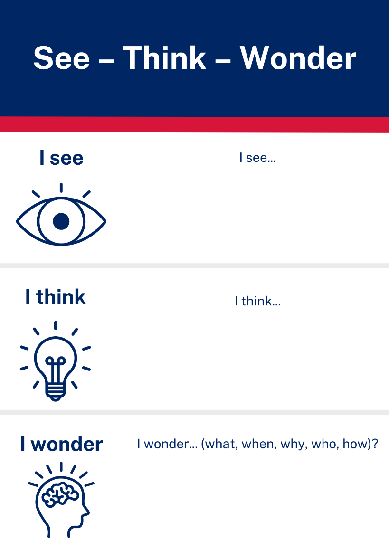
Images sourced from Canva and used in accordance with the Canva Content License Agreement.

Resource 2: Parts of a flower
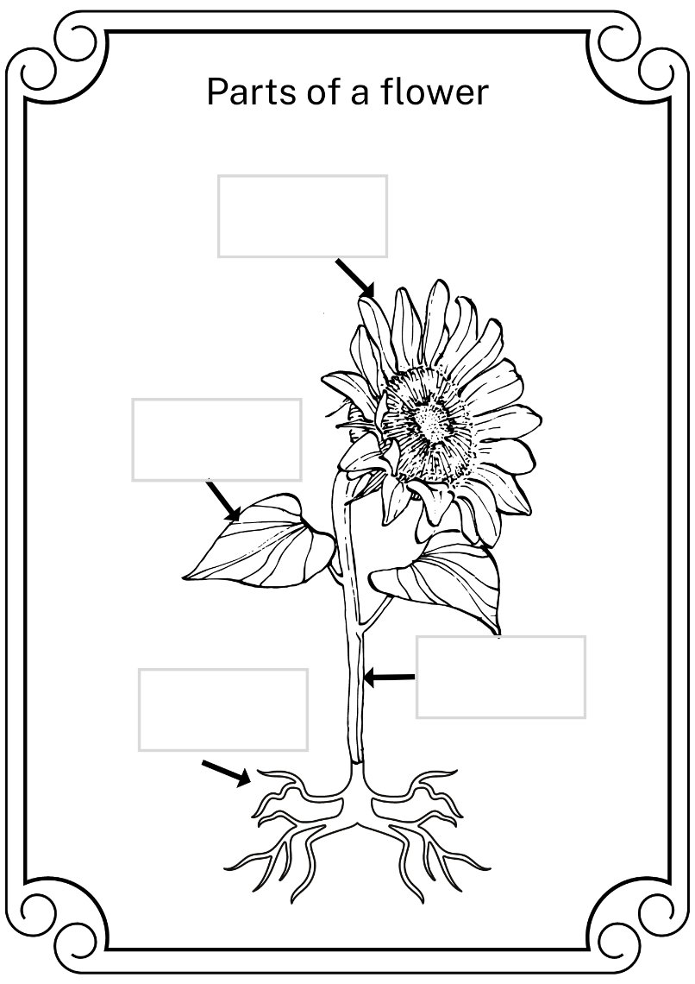
Images sourced from Canva and used in accordance with the Canva Content License Agreement.

Resource 3: Word mat – Stage 1
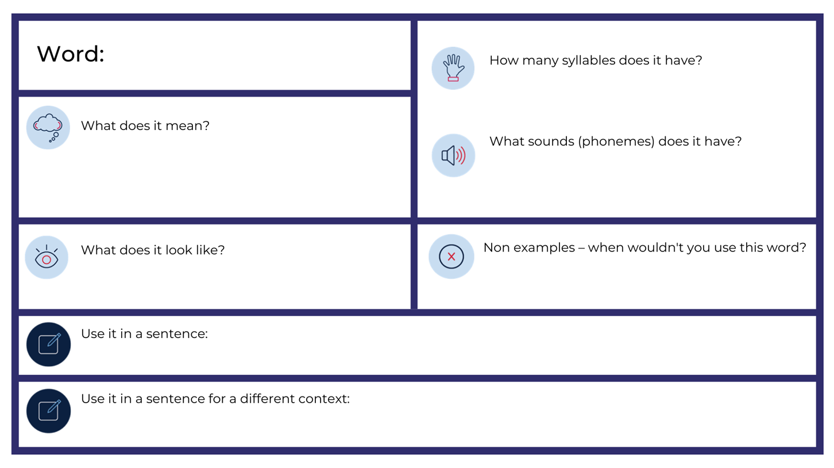

Resource 4: Word mat – Early Stage 1

Resource 5: Save the Bees!
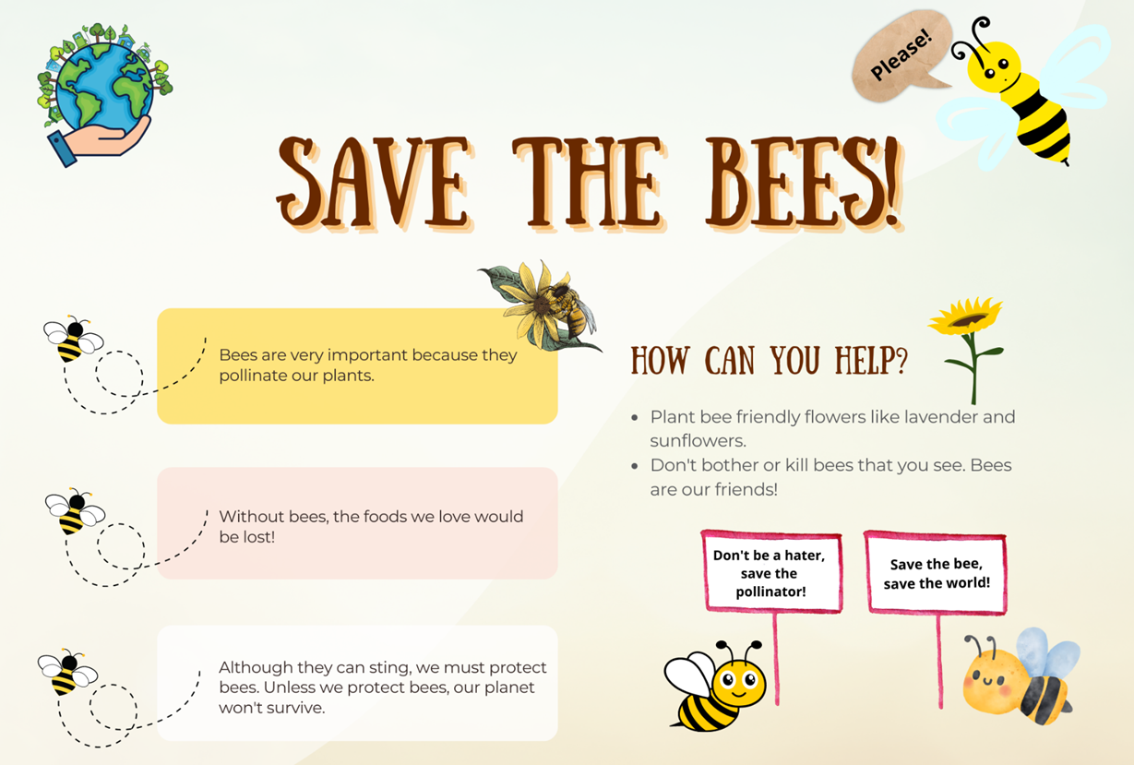
Images sourced from Canva and used in accordance with the Canva Content License Agreement.

Resource 6: Text purpose and features
Text | Purpose | Audience | Visual features | Language features | Structural features
What’s Inside A Flower?
Save the Bees
The Little Bees Learn To Fly

Resource 7: Plant life cycle
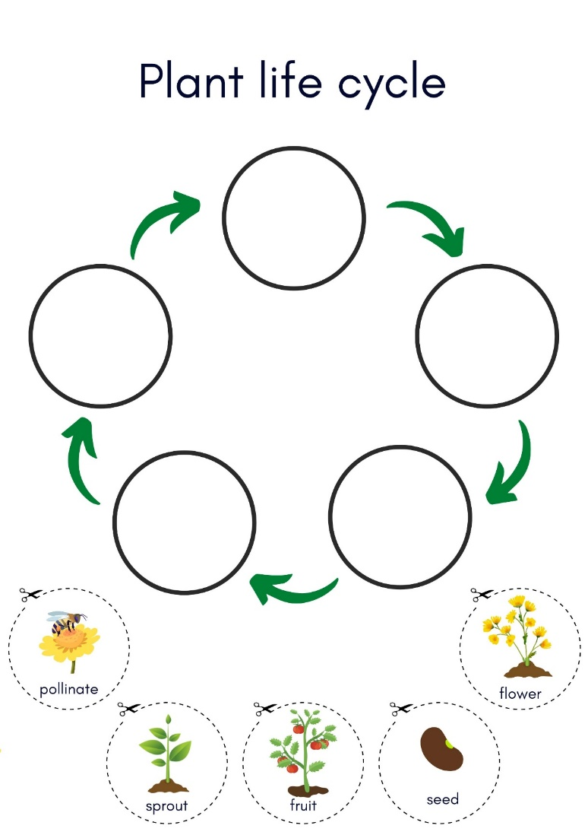
Images sourced from Canva and used in accordance with the Canva Content License Agreement.

References
Links to third-party material and websites
Please note that the provided (reading/viewing material/list/links/texts) are a suggestion only and implies no endorsement, by the New South Wales Department of Education, of any author, publisher, or book title. School principals and teachers are best placed to assess the suitability of resources that would complement the curriculum and reflect the needs and interests of their students.
If you use the links provided in this document to access a third-party's website, you acknowledge that the terms of use, including licence terms set out on the third-party's website apply to the use which may be made of the materials on that third-party website or where permitted by the Copyright Act 1968 (Cth). The department accepts no responsibility for content on third-party websites.
Except as otherwise noted, all material is © State of New South Wales (Department of Education), 2023 and licensed under the Creative Commons Attribution 4.0 International License. All other material (third-party material) is used with permission or under licence. Where the copyright owner of third-party material has not licensed their material under a Creative Commons or similar licence, you should contact them directly for permission to reuse their material.
English K–10 Syllabus © 2022 NSW Education Standards Authority (NESA) for and on behalf of the Crown in right of the State of New South Wales.
© 2022 NSW Education Standards Authority. This document contains NSW Curriculum and syllabus content. The NSW Curriculum is developed by the NSW Education Standards Authority. This content is prepared by NESA for and on behalf of the Crown in right of the State of New South Wales. The material is protected by Crown copyright.
Please refer to the NESA Copyright Disclaimer for more information.
NESA holds the only official and up-to-date versions of the NSW Curriculum and syllabus documents. Please visit the NSW Education Standards Authority (NESA) website and the NSW Curriculum website.
National Literacy Learning Progression © Australian Curriculum, Assessment and Reporting Authority (ACARA) 2010 to present, unless otherwise indicated. This material was downloaded from the Australian Curriculum website (National Literacy Learning Progression) (accessed 25 January 2023) and was not modified. The material is licensed under CC BY 4.0. Version updates are tracked in the ‘Curriculum version history’ section on the 'About the Australian Curriculum' page of the Australian Curriculum website.
ACARA does not endorse any product that uses the Australian Curriculum or make any representations as to the quality of such products. Any product that uses material published on this website should not be taken to be affiliated with ACARA or have the sponsorship or approval of ACARA. It is up to each person to make their own assessment of the product, taking into account matters including, but not limited to, the version number and the degree to which the materials align with the content descriptions and achievement standards (where relevant). Where there is a claim of alignment, it is important to check that the materials align with the content descriptions and achievement standards (endorsed by all education Ministers), not the elaborations (examples provided by ACARA).
ETA (English Teachers Association) and NSW Department of Education (2016) The Textual Concepts and Processes resource, English Textual Concepts website, accessed 25 January 2023.
Ignotofsky R (n.d.) Rachel Ignotofsky Design [website], accessed 25 January 2023.
Ignotofsky R (2021) What’s Inside A Flower?: And Other Questions About Science and Nature, Crown Books for Young Readers, New York.
Ignotofsky R (6 May 2022) 'The making of What's Inside a Flower? By Rachel Ignotofsky' [video], Rachel Ignotofsky, YouTube, accessed 25 January 2023.
Maya the Bee (4 November 2022) 'The Little Bees Learn How To Fly! - Maya the bee' [video], Maya the Bee, YouTube, accessed 25 January 2023.

