English – K-2 multi-age – Year B – Unit 15
Contents
Unit overview and instructions for use 3
Teacher notes 4
Outcomes and content – Component A 5
Outcomes and content – Component B 8
Week 1 12
Component A teaching and learning 12
Component B teaching and learning 13
Lesson 1: Introduction to Rose meets Mr Wintergarten 15
Lesson 2: Identifying how characters change 16
Lesson 3: Identifying and using verbs 20
Lesson 4: Introducing The Fantastic Flying Books of Mr Morris Lessmore 23
Lesson 5: Comparing characters 26
Week 2 30
Component A teaching and learning 30
Component B teaching and learning 31
Lesson 6: Identifying and using different sentence structures 32
Lesson 7: Planning to write 37
Lesson 8: Using personal experiences to write 38
Lesson 9: Using feedback to edit and improve writing 40
Lesson 10: Publishing writing 42
Resource 1: Beginning to end 43
Resource 2: Question bear 44
Resource 3: Verb action cards 45
Resource 4: Diary images 46
Resource 5: Conjunctions 47
Resource 6: Planning template 48
Resource 7: Sequencing template (Early Stage 1) 49
Resource 8: Sequencing template (Stage 1) 50
References 51

Unit overview and instructions for use
This two-week unit is comprised of Component A and Component B. Connecting learning across both components is encouraged.
Teaching and learning | Component A | Component B
Suggested duration | 60 minutes | 45 minutes
Explicit teaching focus areas | - Phonological awareness (Early Stage 1)  - Print conventions (Early Stage 1)  - Phonic knowledge  - Reading fluency  - Reading comprehension  - Spelling  - Handwriting | - Oral language and communication  - Vocabulary  - Reading comprehension  - Creating written texts  - Understanding and responding to literature
To prepare for teaching and learning: | - Refer to Outcomes and content – Component A, K-2 – Instructional sequence – grapheme–phoneme correspondences [PDF 825 KB], and the teaching advice documents (hyperlinked in Component A teaching and learning table).  - Based on student needs identified through ongoing assessment data, plan and document how you will sequence teaching and learning in whole class and targeted teaching groups across the two-week cycle. | - Familiarise yourself with Outcomes and content – Component B, Textual concepts information and videos, English Textual Concepts and Learning Processes (2016), and the teaching and learning sequence.  - Based on student needs identified through ongoing assessment data, determine how you will support students in whole class and targeted teaching groups across the two-week cycle as required.
English K–10 Syllabus © 2022 NSW Education Standards Authority (NESA) for and on behalf of the Crown in right of the State of New South Wales.

Teacher notes
- ‘Character is traditionally viewed as a description of a fictional identity. It is made up of verbal and visual statements about what a character does, says and thinks and what other fictional characters and the author of the text say about them. Analysis of characters can contribute to our own personal judgements about self, morals and values.’ – English Textual Concepts and Learning Processes (2016).
- Understanding of character can be supported through watching the department’s video: Understanding character video (2:31).
- For information on coordinating and subordinating conjunctions, compound and complex sentences refer to the NESA Glossary.
- Reflect on student learning and engagement in activities and record differentiation and adjustments within the unit to inform future teaching and learning. One way of doing this could be to add comments to the digital file.
- Content points are linked to the National Literacy Learning Progression version (3).
Levels and indicators sourced from National Literacy Learning Progression © Australian Curriculum, Assessment and Reporting Authority (ACARA), (accessed 28 November 2022) and was not modified. See references for more information.

Outcomes and content – Component A
The table below outlines the focus outcomes and content. Content is linked to the National Literacy Learning Progression version (3).
Early Stage 1 Focus area and outcome | Stage 1 Focus area and outcome
Phonological awareness  ENE-PHOAW-01 – identifies, blends, segments and manipulates phonological units in spoken words as a strategy for reading and creating texts  - blend aloud all phonemes when asked to delete, add or substitute a final phoneme | N/A
Print conventions  ENE-PRINT-01 – tracks written text from left to right and from top to bottom of the page and identifies visual and spatial features of print  - N/A | N/A
Phonic knowledge  ENE-PHOKW-01 – uses single-letter grapheme–phoneme correspondences and common digraphs to decode and encode words when reading and creating texts  - decode words containing split digraphs and vowel digraphs (PKW5)  - experiment with encoding high-frequency words containing split digraphs and vowel digraphs | Phonic knowledge  EN1-PHOKW-01 – uses initial and extended phonics, including vowel digraphs, trigraphs to decode and encode words when reading and creating texts  - decode words with trigraphs and quadgraphs and apply this when reading texts  - segment and encode one-syllable words with taught vowel graphs, digraphs and trigraphs and apply this when creating texts  - decode words with less common consonant digraphs and apply this when reading texts
Reading fluency  ENE-REFLU-01 – reads decodable texts aloud with automaticity  - know that fluent reading involves recognising and reading words accurately and automatically  - know that pace and expression vary when reading, according to the audience and purpose | Reading fluency  EN1-REFLU-01 – sustains reading unseen texts with automaticity and prosody and self-corrects errors  - self-correct when fluency and/or meaning is interrupted  - vary pace when reading according to the audience and purpose (FlY4)
Reading comprehension  ENE-RECOM-01 – comprehends independently read texts using background knowledge, word knowledge and understanding of how sentences connect  - stop reading when a break in comprehension is registered (UnT4)  - self-correct error using phonic knowledge (UnT5) | Reading comprehension  EN1-RECOM-01 – comprehends independently read texts that require sustained reading by activating background and word knowledge, connecting and understanding sentences and whole text, and monitoring for meaning  - monitor understanding to ensure meaning is sustained and expanded through the whole text (UnT6)
Spelling  ENE-SPELL-01 – applies phonological, orthographic and morphological generalisations and strategies to spell taught familiar and high-frequency words when creating texts  - combine phonological, phonic, orthographic and morphemic knowledge to spell taught high-frequency irregular words comprising up to 3 phonemes (SpG5)  - experiment with some vowel digraphs and split digraphs to spell taught high-frequency words and/or personally significant words | Spelling  EN1-SPELL-01 – applies phonological, orthographic and morphological generalisations and strategies when spelling words in a range of writing contexts  - explain that the consonant trigraphs, –tch and –dge, can end a base word immediately following a short vowel and apply this when spelling (SpG6)  - use extended phonic code for taught consonant phoneme  - use spelling conventions when adding tense-marking suffixes (SpG9)
Handwriting  ENE-HANDW-01 – produces all lower-case and upper-case letters to create texts  - use a stable posture when handwriting or drawing by sitting comfortably with feet flat on the floor, the writing arm resting on a table, with the opposite hand resting on the paper, and shoulders relaxed | Handwriting  EN1-HANDW-01 – uses a legible, fluent and automatic handwriting style, and digital technology, including word-processing applications, when creating texts  - form all letters with consistent size and slope in NSW Foundation Style from memory (HwK5)

Outcomes and content – Component B
The table below outlines the focus outcomes and content. Content is linked to the National Literacy Learning Progression version (3).
Early Stage 1 Focus area and outcome | Stage 1 Focus area and outcome
Oral language and communication  ENE-OLC-01 – communicates effectively by using interpersonal conventions and language with familiar peers and adults  - use connectives such as and, but and because when speaking (SpK2)  - use a combination of sentences to elaborate and connect ideas (SpK3)  - recall details of events or stories using who, what, when, where, why and how (SpK2) | Oral language and communication  EN1-OLC-01 – communicates effectively by using interpersonal conventions and language to extend and elaborate ideas for social and learning interactions  - use adjectives and adverbs to elaborate and/or provide some supporting details or justifications and express causal relationships (SpK3)  - link or compare ideas when interacting
Vocabulary  ENE-VOCAB-01 – understands and effectively uses Tier 1 words and Tier 2 words in familiar contexts  - identify, name and describe a range of objects, characters, animals, people and places when given visual and/or auditory prompts (GrA1) | Vocabulary  EN1-VOCAB-01 – understands and effectively uses Tier 1, taught Tier 2 and Tier 3 vocabulary to extend and elaborate ideas  - understand and intentionally choose subject-specific vocabulary to enhance precision and for effect
Reading comprehension  ENE-RECOM-01 – comprehends independently read texts using background knowledge, word knowledge and understanding of how sentences connect  - identify conjunctions in a compound sentence, their meaning and purpose  - understand how adjectives describe a noun and verbs identify actions in a sentence  - use background knowledge when identifying connections between a text, own life, other texts and/or the world (UnT4)  - use visual cues in multimodal texts to interpret meaning (UnT5) | Reading comprehension  EN1-RECOM-01 – comprehends independently read texts that require sustained reading by activating background and word knowledge, connecting and understanding sentences and whole text, and monitoring for meaning  - know that a complex sentence includes a clause for expressing a main message and one or more clauses that elaborate on that message  - know the meaning and purpose of coordinating and subordinating conjunctions and identify them in a complex sentence  - use a mental model to confirm predictions
Creating written texts  ENE-CWT-01 – creates written texts that include at least 2 related ideas and correct simple sentences  - create written texts that describe, give an opinion, recount an event, convey a story  - create a text including at least 2 related ideas (CrT5)  - write a simple sentence with correct subject–verb–object structure to convey an idea (GrA2, GrA3, CrT4)  - identify and use verbs in simple sentences, including in own writing (GrA2)  - experiment with writing compound sentences and recognise that each clause makes meaning by itself (GrA4)  - use capital letters when writing proper nouns (PuN3, CrT5)  - edit their texts after receiving feedback | Creating written texts  EN1-CWT-01 – plans, creates and revises texts written for different purposes, including paragraphs, using knowledge of vocabulary, text features and sentence structure  - use subject–verb agreement across a text (GrA5)  - use a combination of simple and compound sentences to engage the reader when creating written texts (CrT6,GrA4)  - use noun groups to build descriptions of people and things (CrT6)  - use action, saying, relating and sensing verbs to add detail and precision to writing (GrA2)  - experiment with writing complex sentences which include a clause for the main message and dependent clause to elaborate or modify the message (GrA5)  - make intentional word choices to enhance precision of meaning and ideas in a text (CrT5)  - use possessive apostrophes in own writing (PuN4)  - re-read and edit their own texts after receiving feedback
Understanding and responding to literature  ENE-UARL-01 – understands and responds to literature read to them  - reason using background knowledge as to why a character has acted in a certain way (UnT4)  - understand that characters in texts are represented by how they look, what they say and do, and their thoughts  - use background knowledge to support understanding of characters’ actions in a text | Understanding and responding to literature  EN1-UARL-01 – understands and responds to literature by creating texts using similar structures, intentional language choices and features appropriate to audience and purpose  - identify how characters are constructed through different modes and media and through a combination of modes  - identify how a character reflects their own or other lived experiences  - identify the language, dialogue, actions, images or music that create a reader response to a character

Week 1

Component A teaching and learning
The table below can be used to plan and document lessons that address Component A outcomes and content. Both the detailed example [DOC 529KB] of a two-week teaching and learning cycle and brief example [DOC 66KB] may support you in your planning.
Focus Areas | Lesson 1 | Lesson 2 | Lesson 3 | Lesson 4 | Lesson 5
Phonological awareness (Early Stage 1) and Phonic knowledge
15 minutes
Spelling and Handwriting
15 minutes
Print conventions (Early Stage 1), Reading comprehension and Reading fluency
30 minutes

Component B teaching and learning
The following teaching and learning sequence has been designed to address Component B outcomes and content. Adapt the sequence as required to best meet the needs of your students.

Learning intention and success criteria
Learning intentions and success criteria are best co-constructed with students. The table below contains suggested learning intentions and success criteria.
Element | Early Stage 1 | Stage 1
Learning intentions | Students are learning to use their background knowledge to understand characters and their actions. | Students are learning to understand how authors construct characters and how they reflect lived experiences.
Success criteria | Students can:  - make connections between a text, their own life and other texts  - identify how a character’s actions and feelings change throughout a text  - use capital letters when writing proper nouns  - use visual cues, such as colour to understand a text  - use conjunctions to compare characters. | Students can:  - make predictions about a text and use a mental model to confirm predictions  - identify how a character reflects their own experiences  - use possessive apostrophes in their own writing  - use noun groups to build descriptions  - compare and contrast characters in texts.

Resources
- Graham B (2004) Rose Meets Mr Wintergarten, Walker Books Australia. ISBN: 9780744598292
- Joyce W (2012) The Fantastic Flying Books of Mr Morris Lessmore (Joyce W and Bluhm J, illus.), Atheneum Books for Young Readers, Great Britain. ISBN: 9781442457027
- Resource 1: Beginning to end
- Resource 2: Question bear
- Resource 3: Verb action cards
- Resource 4: Diary images or teacher’s personal diary
- Enlarged concept map
- Venn diagram – one per student (Stage 1)
- Enlarged image of Rose
- Image of Mr Wintergarten at the beginning and end of the story
- Mini whiteboards
- One counter per student
- Soft ball or bean bag

Lesson 1: Introduction to Rose meets Mr Wintergarten
The following teaching and learning activities support multi-age settings.

Whole
- Introduce the text Rose meets Mr Wintergarten by Bob Graham. Encourage students to make predictions about the text using the front and back covers. Silently walkthrough the text and explore the images. Guide students to make careful observations and interpretations about the images using the See-Think-Wonder routine. For example, I can see a grey house with spiky bushes; I think the children are scared of the house; I wonder who lives in the house?
- Read Rose meets Mr Wintergarten. Ask students to put their hands on their heads when they hear an unfamiliar word or phrase. For example, bristled, handkerchief, as big as a wolf. As a class, identify the best way to clarify meaning, such as re-reading parts of the text, reading ahead or using visual cues. Provide a student-friendly definition for unknown words.
- Explain that a reader can draw meaning from a text’s words and illustrations, as well as their own experiences. Reflect on student predictions and observations. Students Think-Pair-Share what the story was about.
- Revise the concept of character and how authors use images and language to help the audience build a deeper understanding of a character’s actions, feelings and traits.
- Draw attention to the characters’ names and their connection to the seasons. Highlight how colour has been used in the images to bring deeper meaning to the characters and their feelings. Ask students to close their eyes and visualise a warm, summer’s day and then a cold, winter’s day. Label one side of the classroom ‘Summer’ and the other ‘Winter’. Call out different colours and have students move to the season that they feel represents that colour. Encourage students to explain their reasoning.
- Display an enlarged image of Rose. Discuss Rose’s character and ask students what actions, words and images help describe her. As a class, label Rose’s character traits around the outside of the image. For example, cheerful, caring, kind. Make connections between the colours used in the images and Rose’s character traits.
- Model writing sentences about Rose. For example, Rose is kind; She helped Mr Wintergarten. Explain that capital letters are used for proper nouns, the names of the characters. Highlight the use of proper nouns in the sentence.
- Students turn and talk about a time they were kind. Share student responses and create an anchor chart of modelled vocabulary. Encourage students to identify similarities between Rose’s experiences and their own.
- Students write a reflection about a time they were kind.
Too hard? Students draw a picture of a time when they were kind.
Too easy? Within their reflection, students include details about how they felt.
- In pairs or small groups, students share their reflections.

Lesson 2: Identifying how characters change
The following teaching and learning activities support multi-age settings.

Whole
- Display the image from the first and last page of Rose meets Mr Wintergarten, showing the transformation of Mr Wintergarten’s home. Ask students what they notice and identify the differences between the 2 images.
- Display an image of Mr Wintergarten at the beginning and end of the story. In pairs, students use examples from the text to describe his feelings and actions and how they changed. Discuss the events that helped Mr Wintergarten change. For example, Rose taking cakes to Mr Wintergarten and Rose throwing the slipper back to Mr Wintergarten.
- Discuss how authors uses intentional word choices and images to convey meaning in a text. Re-read the text. Create a class concept map of features from the text that show how Mr Wintergarten changed. For example, the use of saying verbs, such as shouted and glared, the actions of the character, the change in colour.
- Display the page of Mr Wintergarten opening his window. Students Think-Pair-Share reasons why Mr Wintergarten opened his curtains. Using student responses, model verbalising a compound sentence to explain why Mr Wintergarten opened his curtains. For example, Mr Wintergarten opened his curtains so the sunlight could shine inside. In pairs, students verbalise a compound or complex sentence to explain why Mr Wintergarten opened his curtains.

Part
The table below details the differentiated teaching and learning activities for each stage.
Early Stage 1 (independent) | Stage 1 (teacher guided/small groups)
- Students draw Mr Wintergarten at the beginning and end of the story, on Resource 1: Beginning to end. Using colours, students represent how Mr Wintergarten changed. Students label their drawing with words to describe his feelings and actions. | - Revise adjectives and adverbs and their purpose; to provide more detail about the noun or verb. Model retelling part of the story, without any adjectives and adverbs. Complete the same retell, including adjective and adverbs. Ask how the retell improved.  - In small groups, students retell the part of the story when Rose enters Mr Wintergarten’s house, using adjectives and adverbs to enhance details.

Part
The table below details the differentiated teaching and learning activities for each stage.
Early Stage 1 (teacher guided/pairs) | Stage 1 (independent)
- Explain that good authors provide information to their audience when telling stories, by including who, what, when, where, why, and how.  - Model using Resource 2: Question bear to retell the part of the text when Rose enters Mr Wintergarten’s house and meets him. Place a counter on the corresponding part of the bear once the information has been given.  - In pairs, students use Resource 2: Question bear to retell the part of the text when Rose meets Mr Wintergarten.  - Students use their oral retell to write a sentence about Rose meeting Mr Wintergarten.  Too hard? Co-construct sentences about the text.  Too easy? Students include details about who, what, when, where, why and how. | - Using Resource 1: Beginning to end, students draw a representation of Mr Wintergarten at the beginning and end of the story. Students write sentences explaining how Mr Wintergarten’s feelings and actions changed and why.  Too easy? Students write a short paragraph, describing Mr. Wintergarten’s change from the beginning to the end of the story.
Early Stage 1 Assessment task 1 – Observations from this lesson allow students to demonstrate achievement towards the following syllabus outcomes and content points:
ENE-OLC-01 – communicates effectively by using interpersonal conventions and language with familiar peers and adults
- use a combination of sentences to elaborate and connect ideas
- recall details of events or stories using who, what, when, where, why and how.
ENE-RECOM-01 – comprehends independently read texts using background knowledge, word knowledge and understanding of how sentences connect
- use visual cues in multimodal texts to interpret meaning.
ENE-UARL-01 – understands and responds to literature read to them
- reason using background knowledge as to why a character has acted in a certain way
- understand that characters in texts are represented by how they look, what they say and do, and their thoughts
- use background knowledge to support understanding of characters’ actions in a text.
Stage 1 Assessment task 1 – Observations and work samples from this lesson allow students to demonstrate achievement towards the following syllabus outcomes and content points:
EN1-OLC-01 – communicates effectively by using interpersonal conventions and language to extend and elaborate ideas for social and learning interactions
- use adjectives and adverbs to elaborate and/or provide some supporting details or justifications and express causal relationships.
EN1-UARL-01 – understands and responds to literature by creating texts using similar structures, intentional language choices and features appropriate to audience and purpose
- identify how characters are constructed through different modes and media and through a combination of modes.

Lesson 3: Identifying and using verbs
The following teaching and learning activities support multi-age settings.

Whole
- Revise the definition of a verb and identify the different types (action, saying, relating and sensing). Explain that verbs can be used to add detail and precision to writing. Display the sentence ‘Baby Blossom watched.’ As a class, read the sentence and circle the verb (watched). Explain that some sentences may include more than one verb. Display the sentence ‘Rose knocked at Mr Wintergarten’s door, “It’s me,” said Rose, and she tiptoed in.’ As a class, read the sentence and circle the verbs (knocked, said, tiptoed).
- Discuss how verbs can show character’s feelings and personalities. Display the sentence ‘She twisted her fingers in her handkerchief.’ Ask students how Rose felt in the sentence. For example, Rose felt nervous to meet Mr Wintergarten because the children thought he was mean and horrible. Encourage students to use evidence from the text to support their thinking.
- Use Resource 3: Verb action cards to read out sentences from the text and encourage students to show how the character is feeling through their actions.

Part
The table below details the differentiated teaching and learning activities for each stage.
Early Stage 1 (independent) | Stage 1 (teacher guided)
- Students draw a picture about an event from the text. For example, Rose playing with the soccer ball in the yard.  - In pairs, students orally share a sentence about their drawing using subject–verb–object structure. For example, Rose played outside.  Too easy? Students include prepositional phrases in their sentence. For example, Rose played outside in the garden. | - Explain that possessive apostrophes are used to show ownership. Display the sentence, ‘And just then, Rose’s ball went straight over Mr Wintergarten’s fence.’ Locate the possessive apostrophes, the owner and the item of ownership.  - Display the page where Mr Wintergarten’s slipper goes over the fence. Write a short text about this page, purposely omitting possessive apostrophes. For example, ‘Mr Wintergartens slipper flew over the fence as he kicked Roses ball.’ Students jointly insert the possessive apostrophes.

Part
The table below details the differentiated teaching and learning activities for each stage.
Early Stage 1 (teacher guided/independent) | Stage 1 (pairs/independent)
- Revise proper nouns and that they must use a capital letter.  - Write and display a paragraph from the text without the proper nouns capitalised. For example, ‘the children in the family were rose, faith and blossom. The kids said that mr wintergarten was not very nice. Baby blossom liked to go on the swing.’  - Jointly edit the paragraph, to ensure all proper nouns are capitalised.  - Students write a sentence about their drawing from activity 4 using a proper noun. For example, ‘Rose played outside. Mr Wintergarten sat inside.’  Too hard? Co-construct a sentence using proper nouns. | - Provide students with different pages from the text. In pairs, students label the objects in the image with possessive apostrophes. For example, Rose’s ball, Mr Wintergarten’s fence, Rose’s flowers, Mr Wintergarten’s curtains.  - Students write a sentence about the image using possessive apostrophes.  Too hard? Co-construct sentences using possessive apostrophes.

Whole
- Students stand up and spread out around the room. Call out a verb from the text, for example, darting, floating, glared, twisted. As the soft ball or beanbag is passed around, students will orally share a sentence using the verb. Encourage students to use correct tense.
Too easy? Students change the tense of the verb before orally sharing a sentence containing the verb.
Early Stage 1 Assessment task 2 – Observations and work samples from this lesson allow students to demonstrate achievement towards the following syllabus outcomes and content points:
ENE-RECOM-01 – comprehends independently read texts using background knowledge, word knowledge and understanding of how sentences connect
- understand how adjectives describe a noun and verbs identify actions in a sentence.
ENE-CWT-01 – creates written texts that include at least 2 related ideas and correct simple sentences
- write a simple sentence with correct subject–verb–object structure to convey an idea
- identify and use verbs in simple sentences, including in own writing
- use capital letters when writing proper nouns.

Lesson 4: Introducing The Fantastic Flying Books of Mr Morris Lessmore
The following teaching and learning activities support multi-age settings.

Whole
- Display the front cover of the text The Fantastic Flying Books of Mr Morris Lessmore by William Joyce. Discuss what type of text it is and identify its purpose. Guide students to make careful predictions about what the text might be about. Students draw or write their predictions on individual whiteboards. Share student responses and record predictions on an enlarged concept map. Display in the classroom.
- Display Resource 4: Diary images or show students a diary or journal. Ask students if they have seen or used a diary or journal before and discuss its purpose. Explain that diaries are used to record our own memories or stories and that they can include both happy and sad times. Discuss moments within our lives that may be happy or sad. For example, a birthday, a loved one or pet passing away, floods and bushfires, starting a new school, making a new friend.
- Read The Fantastic Flying Books of Mr Morris Lessmore.
- Explain that good authors carefully consider their language choices. Identify and create a list of new vocabulary from the text, for example, orderly, joy, sorrow, festive squadron, amiable, stooped. Discuss the meaning of new words and make connections to students’ prior knowledge using synonyms to support understanding.
- Review student predictions from activity 1. Students turn and talk to compare their predictions with what the text was about.
Too hard? Provide the conversation scaffold, I thought the text was going to be about __ but it was about __.
- Explore the use of colour within the text to portray emotion. For example, during a time of hardship, Morris Lessmore changes from colour to grey. He changes back to colour when he finds the library and shares his love of books with others to help them change.
- Display 3 contrasting pages from the text. For example, the page where Morris Lessmore is writing in his journal, the page where the house is turned upside down and the page where Morris is sharing the books with others. Ask how Morris Lessmore is feeling in each of these illustrations and how readers know. Ask how the other characters are feeling. Encourage students to use visual cues, such as colour to support their thinking.

Part
The table below details the differentiated teaching and learning activities for each stage.
Early Stage 1 (pairs/independent) | Stage 1 (teacher guided/small groups/independent)
- In pairs, students orally share what makes Morris Lessmore sad and happy.  - Students draw and write about a something that makes Morris Lessmore sad or happy.  Too hard? Students write what makes them happy or sad.  Too easy? Students write a compound sentence about what makes Morris Lessmore sad and happy. | - Display the last 2 pages of the text, when the girl arrives at the library and sits on the steps reading. Model giving an oral prediction of the girl’s backstory and what might happen next.  - In small groups, students orally share a prediction of the girl’s backstory and what might happen next.  - Students write about the girl’s backstory what they think will happen next.  Too hard? Co-construct sentences about the girl’s backstory.
Stage 1 Assessment task 2 – Observations and work samples from this lesson allow students to demonstrate achievement towards the following syllabus outcomes and content points:
EN1-RECOM-01 – comprehends independently read texts that require sustained reading by activating background and word knowledge, connecting and understanding sentences and whole text, and monitoring for meaning
- use a mental model to confirm predictions.
EN1-UARL-01 – understands and responds to literature by creating texts using similar structures, intentional language choices and features appropriate to audience and purpose
- identify how a character reflects their own or other lived experiences
- identify the language, dialogue, actions, images or music that create a reader response to a character.

Lesson 5: Comparing characters
The following teaching and learning activities support multi-age settings.

Whole
- Re-read Rose meets Mr Wintergarten. Discuss Mr Wintergarten’s ‘inside’ and ‘outside’ character traits. Brainstorm and record words on an anchor chart.
- Display the front cover of The Fantastic Flying Books of Mr Morris Lessmore. Discuss Morris Lessmore’s ‘inside’ and ‘outside’ character traits. Brainstorm and record words on an anchor chart.

Part
The table below details the differentiated teaching and learning activities for each stage.
Early Stage 1 (teacher guided) | Stage 1 (pairs/independent)
- Model comparing the 2 characters using a conjunction. For example, ‘Mr Wintergarten is __ but Mr Lessmore is __.’  - In pairs, students orally share a compound sentence comparing the 2 characters, using the anchor chart to assist them. | - In pairs, students discuss the similarities and differences between the 2 characters.  - Students complete a Venn diagram comparing Mr Wintergarten and Mr Lessmore.

Part
The table below details the differentiated teaching and learning activities for each stage.
Early Stage 1 (independent) | Stage 1 (teacher guided)
- Students draw an outline of Mr Wintergarten or Mr Lessmore. Students list the internal characteristics inside the outline and the external characteristics around the outside.  - Students write a sentence about one of the characters.  Too hard? Co-construct a sentence about a character from either texts.  Too easy? Students write sentences comparing the 2 characters. | - Discuss how adjectives can be used to create noun groups, adding detail and clarity to writing.  - Ask students to close their eyes. Say the sentence ‘Mr Wintergarten is a man.’ Discuss whether the sentence gives enough detail about the character. Say the sentence ‘Mr Wintergarten is a tall, thin, grumpy man.’ Discuss how noun groups are used to build descriptions.  - Students use their completed Venn diagram to write a paragraph, comparing Mr Wintergarten and Mr Morris Lessmore. Students use noun groups within their text, to add detail to their description.  Too hard? Students write a sentence describing Mr Wintergarten and another describing Morris Lessmore.

Whole
- In pairs, students list 3 words to describe Morris Lessmore or Mr Wintergarten. Share with the class and discuss similarities between student responses.
Early Stage 1 Assessment task 3 – Observations from this lesson allow students to demonstrate achievement towards the following syllabus outcomes and content points:
ENE-OLC-01 – communicates effectively by using interpersonal conventions and language with familiar peers and adults
- use connectives such as and, but and because when speaking.
ENE-RECOM-01 – comprehends independently read texts using background knowledge, word knowledge and understanding of how sentences connect
- use background knowledge when identifying connections between a text, own life, other texts and/or the world.
Stage 1 Assessment task 3 – Observations and work samples from this lesson allow students to demonstrate achievement towards the following syllabus outcomes and content points:
EN1-OLC-01 – communicates effectively by using interpersonal conventions and language to extend and elaborate ideas for social and learning interactions
- link or compare ideas when interacting.
EN1-CWT-01 – plans, creates and revises texts written for different purposes, including paragraphs, using knowledge of vocabulary, text features and sentence structure
- use noun groups to build descriptions of people and things.
EN1-UARL-01 – understands and responds to literature by creating texts using similar structures, intentional language choices and features appropriate to audience and purpose
- identify the language, dialogue, actions, images or music that create a reader response to a character.

Week 2

Component A teaching and learning
The table below can be used to plan and document lessons that address Component A outcomes and content. Both the detailed example [DOC 529KB] of a two-week teaching and learning cycle and brief example [DOC 66KB] may support you in your planning.
Focus Areas | Lesson 6 | Lesson 7 | Lesson 8 | Lesson 9 | Lesson 10
Phonological awareness (Early Stage 1) and Phonic knowledge
15 minutes
Spelling and Handwriting
15 minutes
Print conventions (Early Stage 1), Reading comprehension and Reading fluency
30 minutes

Component B teaching and learning
The following teaching and learning sequence has been designed to address Component B outcomes and content. Adapt the sequence as required to best meet the needs of your students.

Learning intention and success criteria
Learning intentions and success criteria are best co-constructed with students. The table below contains suggested learning intentions and success criteria.
Element | Early Stage 1 | Stage 1
Learning intentions | Students are learning to use background knowledge and knowledge of text structure to write a short text that describes an event. | Students are learning to use character, text structure, language and visual features to write a text that reflects their own lived experiences.
Success criteria | Students can:  - experiment with compound sentences and identify conjunctions  - create a plan for writing, including important details  - write a text to describe an event, using verbs and correct capitalisation of proper nouns  - apply feedback to edit their own text  - use colour to represent character feelings. | Students can:  - identify dependent and independent clauses and compose a complex sentence  - create a plan for writing using correct sequencing structure  - compose a text using a variety of sentence structures, noun groups and intentional verb choices  - use feedback to edit and improve writing  - use colour to represent character feelings.

Resources
- Joyce W (2012) The Fantastic Flying Books of Mr Morris Lessmore (Joyce W and Bluhm J, illus.), Atheneum Books for Young Readers, Great Britain. ISBN: 9781442457027
- Graham B (2004) Rose Meets Mr Wintergarten, Walker Books Australia. ISBN: 9780744598292
- Resource 5: Conjunctions
- Resource 6: Planning template
- Resource 7: Sequencing template (Early Stage 1)
- Resource 8: Sequencing template (Stage 1)
- Art materials, such as crayons, watercolours or coloured markers
- Dice
- Individual whiteboards

Lesson 6: Identifying and using different sentence structures
The following teaching and learning activities support multi-age settings.

Whole
- Re-read The Fantastic Flying Books of Mr Morris Lessmore.
- Explain that good authors use a variety of sentence types to make writing interesting and aid the flow of the text. Students Think-Pair-Share what they know about sentences. Revise simple, compound, and complex sentences and identify sentences within the text.
- Display the following sentence from The Fantastic Flying Books, ‘Morris tried to keep the books in some sort of order, but they always mixed themselves up.’ Highlight the conjunction ‘but’ and explain it is used to connect ideas that contrast.
- Model using Resource 5: Conjunctions to identify the conjunctions ‘and’ and ‘but’.

Part
The table below details the differentiated teaching and learning activities for each stage.
Early Stage 1 (pairs/independent) | Stage 1 (teacher guided)
- In pairs, students use Resource 5: Conjunctions to identify conjunctions in a compound sentence.  - Students choose one of the sentences to write and illustrate.  Too hard? Students draw a verbalised sentence from activity 1.  Too easy? Students write their own compound sentence using ‘and’ or ‘but’. | - Review previous learning on sentences. Explain that a complex sentence is formed by adding one or more dependent (subordinate) clause to a main (independent) clause using a conjunction.  - Display the sentence ‘The book led him to an extraordinary building where many books apparently “nested”.’ Highlight the subordinating conjunction ‘where’. Identify the dependent and independent clause in the sentence. Explain that the subordinating conjunction ‘where’ is used to show a place or situation.  - Model writing a complex sentence, using the conjunction ‘where’. For example, ‘Mr Lessmore entered the house where his thoughts were scattered.’  - Jointly identify the independent (main) clause, dependant (subordinate) clause and subordinating conjunction.  - Provide students with a range of sentence starters. For example:  - Mr Lessmore entered the house where …  - Mr Lessmore entered the mysterious room where …  - Mr Lessmore entered the library where …  - The girl entered the room full of books where …  - Students orally share a complex sentence using the subordinating conjunction ‘where’ to link the independent and dependent clauses.

Part
The table below details the differentiated teaching and learning activities for each stage.
Early Stage 1 (teacher guided) | Stage 1 (independent)
- Display the picture of the flying lady from the text. Discuss the use of the adjective ‘lovely’ to describe the lady. Explain that adjectives provide more information about a person, place or thing. Brainstorm and record other words to describe the lady.  - Display other characters from the texts, Rose meets Mr Wintergarten and The Fantastic Flying Books of Mr Morris Lessmore. On individual whiteboards, students record adjectives to describe the characters.  Too hard? Students orally share adjectives and teacher records responses. | - Students write a complex sentence using one of the sentence starters. Students use the subordinating conjunction ‘where’.  - Students illustrate their sentence.  Too hard? Provide students with complex sentences. Students label the independent and dependent clauses and the subordinating conjunction.  Too easy? Students write a paragraph about Mr Lessmore, containing simple, compound, and complex sentences.

Whole
- Students share their sentences with the class.
Early Stage 1 Assessment task 4 – Observations and work samples from this lesson allow students to demonstrate achievement towards the following syllabus outcomes and content points:
ENE-VOCAB-01 – understands and effectively uses Tier 1 words and Tier 2 words in familiar contexts
- identify, name and describe a range of objects, characters, animals, people and places when given visual and/or auditory prompts.
ENE-RECOM-01 – comprehends independently read texts using background knowledge, word knowledge and understanding of how sentences connect
- identify conjunctions in a compound sentence, their meaning and purpose
- understand how adjectives describe a noun and verbs identify actions in a sentence.
ENE-CWT-01 – creates written texts that include at least 2 related ideas and correct simple sentences
- experiment with writing compound sentences and recognise that each clause makes meaning by itself.
Stage 1 Assessment task 4 – Observations and work samples from this lesson allow students to demonstrate achievement towards the following syllabus outcomes and content points:
EN1-VOCAB-01 – understands and effectively uses Tier 1, taught Tier 2 and Tier 3 vocabulary to extend and elaborate ideas
- understand and intentionally choose subject-specific vocabulary to enhance precision and for effect.
EN1-RECOM-01 – comprehends independently read texts that require sustained reading by activating background and word knowledge, connecting and understanding sentences and whole text, and monitoring for meaning
- know that a complex sentence includes a clause for expressing a main message and one or more clauses that elaborate on that message
- know the meaning and purpose of coordinating and subordinating conjunctions and identify them in a complex sentence.
EN1-CWT-01 – plans, creates and revises texts written for different purposes, including paragraphs, using knowledge of vocabulary, text features and sentence structure
- experiment with writing complex sentences which include a clause for the main message and dependent clause to elaborate or modify the message.

Lesson 7: Planning to write
The following teaching and learning activities support multi-age settings.

Whole
- Display the text, The Fantastic Flying Books of Mr. Lessmore. Explain that this text was inspired by a real person named Bill Morris, who loved books. Read the tribute at the back of the text. Discuss how authors used real experiences to create texts.
- Identify emotions felt throughout the text. For example, joy and sorrow. Display a T-chart with the heading ‘joy’ and ‘sorrow’. Create a list of synonyms for each word. For example, happiness, bliss, delight, glee, sadness, worry, anguish, misery.
- Revise what is known about the main characters, Mr Wintergarten and Mr Lessmore, from the 2 texts. Explain that students will develop a main character and use their own memories or personal experiences to write about an emotional journey that takes them from a time of sadness to happiness.
- Explain that planning is an important part of creating a text. Display Resource 6: Planning template and write the emotion ‘sadness’ in the middle of the template. Use think-alouds to share a personal experience about a sad time. Model writing details about the situation (who, what, where, when, why and how) into the planning template.
- Using Resource 6: Planning template, students plan their ideas about a time they felt sadness. Teachers to adapt this lesson as necessary to support student wellbeing.
Too hard? Students draw their ideas on the planning template.
- In pairs, students share their planning template. Prompt students to use a combination of sentences to connect their ideas.

Lesson 8: Using personal experiences to write
The following teaching and learning activities support multi-age settings.

Whole
- Revise the purpose for writing, for students to develop a main character and use their own memories or personal experiences to write about an emotional journey that takes them from a time of sadness to happiness.
- Display the planning template from Lesson 7. Explain that sadness is a feeling and feelings can change. Explore examples from the text where the characters feelings change. For example, Mr Wintergarten changes from feeling grumpy to happy after meeting Rose, Mr Lessmore changes from feeling sorrow to joy after meeting the flying lady and going to the library.
- Display Resource 7: Sequencing template (Early Stage 1). Model writing a sequence of events that takes a character from sadness to happiness (based on a real experience). Encourage students to include information about who or what helped them change through their emotions.

Part
The table below details the differentiated teaching and learning activities for each stage.
Early Stage 1 (independent) | Stage 1 (teacher guided/independent)
- Provide students with a copy of Resource 7: Sequencing template (Early Stage 1). Students draw or write their ideas in sequence, about a time they felt sadness and how their feelings changed from sadness to happiness.  Too hard? Students draw or write the sequence of a time when they either felt sadness or happiness. | - Explain that students will write about a time they felt sadness and how their feelings changed from sadness to happiness, identifying the connection between the 2 emotions.  - Ask students to think about a time they felt sadness and then happiness. Prompt students to think about who or what helped them change their emotions. Share student responses.

Part
The table below details the differentiated teaching and learning activities for each stage.
Early Stage 1 (teacher guided/pairs) | Stage 1 (independent/teacher guided)
- In pairs, students orally share their sequence. Prompt students to use sequencing words to connect their ideas.  - Co-construct a success criteria for writing. For example:  - use simple and compound sentences  - use verbs  - use capital letters for proper nouns  - use feedback to edit and improve writing. | - Provide students with a copy of Resource 8: Sequencing template (Stage 1). Students plan their ideas and sequence them, showing the change from sadness to happiness.  Too hard? Students plan a sequence of a time when they either felt sadness or happiness.  - Co-construct a success criteria for writing. For example:  - includes simple, compound and complex sentences  - use noun groups  - use action, saying, relating and sensing verbs  - use possessive apostrophes  - use feedback to edit and improve writing.

Lesson 9: Using feedback to edit and improve writing
The following teaching and learning activities support multi-age settings.

Whole
- Revisit the co-constructed success criteria, planning and sequencing templates.
- Explain that students will use their planned ideas to write a text about a character journey based on lived experiences.
- Students compose their texts.
- Revise the purpose of feedback and how it is used to improve writing.
- In pairs, students provide peer feedback. Provide time for students to apply feedback and improve their writing.
Early Stage 1 Assessment task 5 – Collecting work samples from this lesson allows students to demonstrate achievement towards the following syllabus outcome and content points:
ENE-CWT-01 – creates written texts that include at least 2 related ideas and correct simple sentences
- create written texts that describe, give an opinion, recount an event, convey a story
- create a text including at least 2 related ideas
- edit their texts after receiving feedback.
Stage 1 Assessment task 5 – Collecting work samples from this lesson allows students to demonstrate achievement towards the following syllabus outcome and content points:
EN1-CWT-01 – plans, creates and revises texts written for different purposes, including paragraphs, using knowledge of vocabulary, text features and sentence structure
- use subject–verb agreement across a text
- use a combination of simple and compound sentences to engage the reader when creating written texts
- use action, saying, relating and sensing verbs to add detail and precision to writing
- make intentional word choices to enhance precision of meaning and ideas in a text
- use possessive apostrophes in own writing
- re-read and edit their own texts after receiving feedback.

Lesson 10: Publishing writing
The following teaching and learning activities support multi-age settings.

Whole
- Examine pictures from the texts, Rose Meets Mr Wintergarten and The Fantastic Flying Books of Mr Lessmore. Discuss the use of colour to convey emotion.
- Explain that students will use illustrations and colour to represent the emotions in their text. Provide students with art materials, such as crayons, watercolours, or coloured markers. Students publish and illustrate their text, using colour to convey different emotions. Optional: create a class text or using digital tools such as Book Creator to create a digital text.

Resource 1: Beginning to end
Beginning | End

Resource 2: Question bear
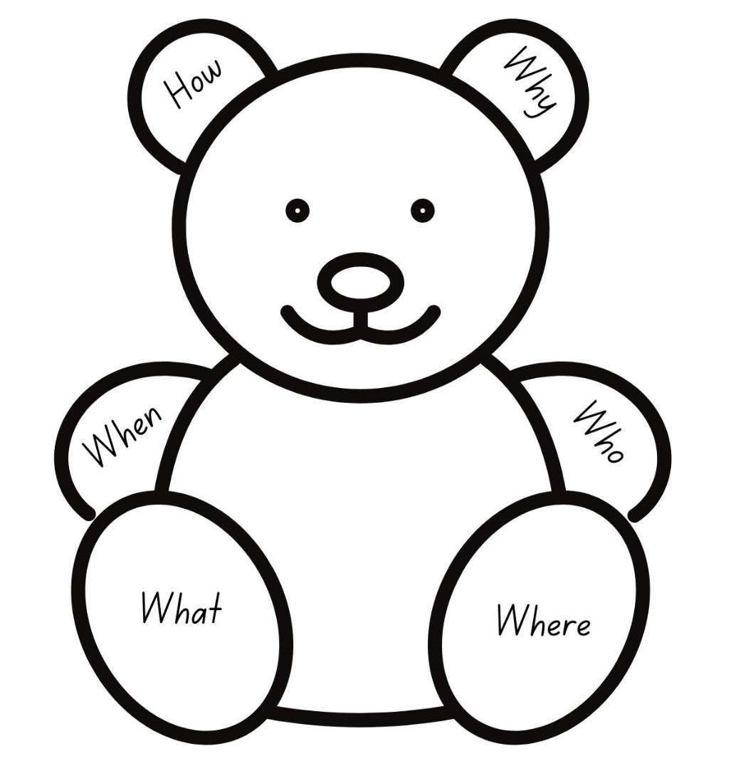
Images sourced from Canva and used in accordance with the Canva Content License Agreement.

Resource 3: Verb action cards
Mum threw the dog a cake. | Mr Wintergarten did some darting movements that made his coat-tails fly in the sun. | She twisted her fingers in her handkerchief.
Rose threw his slipper high into the air. | Rose heaved and pushed the gate. | He sat on the front step in the sun.
Mr Wintergarten glared at her. | “It’s me,” said Rose, and tiptoed in. | “No,” growled Mr Wintergarten.
“Who the devil is that?” shouted a voice from inside. | Mr Wintergarten slowly pushed back his chair. | Mr Wintergarten thoughtfully pushed Rose’s ball with his toe.

Resource 4: Diary images
Images sourced from Canva and used in accordance with the Canva Content License Agreement.

Resource 5: Conjunctions
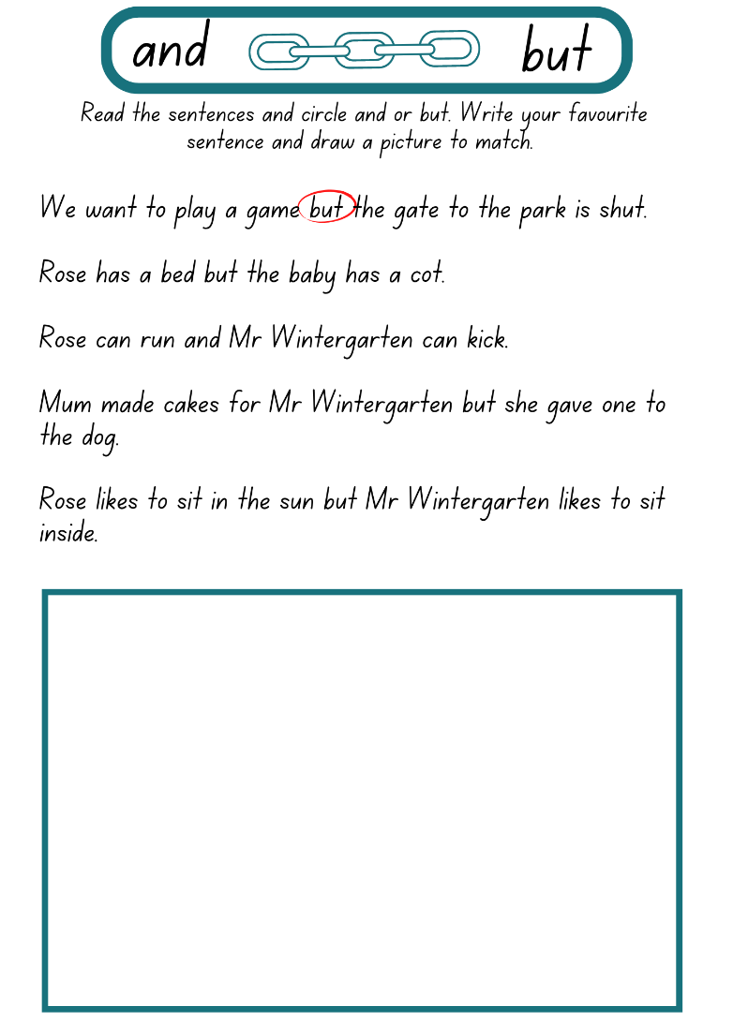
Images sourced from Canva and used in accordance with the Canva Content License Agreement.

Resource 6: Planning template
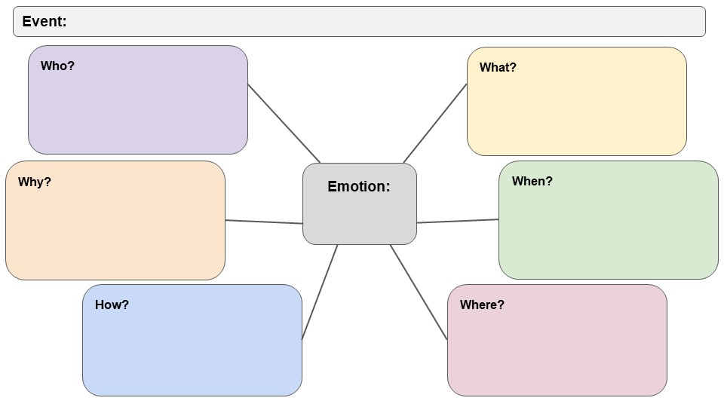

Resource 7: Sequencing template (Early Stage 1)
Sequence | What happened?
Beginning
Middle
End

Resource 8: Sequencing template (Stage 1)
Element | What happened?
Orientation
Character, setting, time
Problem
What causes the sadness?
Change
What helps the feelings to change?
Conclusion
(Solution/Resolution)
What is happening at the end?

References
Links to third-party material and websites
Please note that the provided (reading/viewing material/list/links/texts) are a suggestion only and implies no endorsement, by the New South Wales Department of Education, of any author, publisher, or book title. School principals and teachers are best placed to assess the suitability of resources that would complement the curriculum and reflect the needs and interests of their students.
If you use the links provided in this document to access a third-party's website, you acknowledge that the terms of use, including licence terms set out on the third-party's website apply to the use which may be made of the materials on that third-party website or where permitted by the Copyright Act 1968 (Cth). The department accepts no responsibility for content on third-party websites.
Except as otherwise noted, all material is © State of New South Wales (Department of Education), 2023 and licensed under the Creative Commons Attribution 4.0 International License. All other material (third-party material) is used with permission or under licence. Where the copyright owner of third-party material has not licensed their material under a Creative Commons or similar licence, you should contact them directly for permission to reuse their material.
English K–10 Syllabus © 2022 NSW Education Standards Authority (NESA) for and on behalf of the Crown in right of the State of New South Wales.
© 2022 NSW Education Standards Authority. This document contains NSW Curriculum and syllabus content. The NSW Curriculum is developed by the NSW Education Standards Authority. This content is prepared by NESA for and on behalf of the Crown in right of the State of New South Wales. The material is protected by Crown copyright.
Please refer to the NESA Copyright Disclaimer for more information.
NESA holds the only official and up-to-date versions of the NSW Curriculum and syllabus documents. Please visit the NSW Education Standards Authority (NESA) website and the NSW Curriculum website.
National Literacy Learning Progression © Australian Curriculum, Assessment and Reporting Authority (ACARA) 2010 to present, unless otherwise indicated. This material was downloaded from the Australian Curriculum website (National Literacy Learning Progression) (accessed 28 November 2022 and was not modified. The material is licensed under CC BY 4.0. Version updates are tracked in the ‘Curriculum version history’ section on the 'About the Australian Curriculum' page of the Australian Curriculum website.
ACARA does not endorse any product that uses the Australian Curriculum or make any representations as to the quality of such products. Any product that uses material published on this website should not be taken to be affiliated with ACARA or have the sponsorship or approval of ACARA. It is up to each person to make their own assessment of the product, taking into account matters including, but not limited to, the version number and the degree to which the materials align with the content descriptions and achievement standards (where relevant). Where there is a claim of alignment, it is important to check that the materials align with the content descriptions and achievement standards (endorsed by all education Ministers), not the elaborations (examples provided by ACARA).
ETA (English Teachers Association) and NSW Department of Education (2016) The Textual Concepts and Processes resource, English Textual Concepts website, accessed 28 November 2022.
Graham B (2004) Rose Meets Mr Wintergarten, Walker Books Australia.
Joyce W (2012) The Fantastic Flying Books of Mr Morris Lessmore (Joyce W and Bluhm J, illus.), Atheneum Books for Young Readers, Great Britain.

