English – K-2 multi-age – Year B – Unit 13
Contents
Unit overview and instructions for use 3
Teacher notes 4
Outcomes and content – Component A 5
Outcomes and content – Component B 9
Week 1 13
Component A teaching and learning 13
Component B teaching and learning 14
Lesson 1: Text orientation I Wanna Iguana 15
Lesson 2: Using punctuation 18
Lesson 3: Extending simple sentences to compound sentences 21
Lesson 4: Expressing opinions and using adverbs 24
Lesson 5: Text orientation CLICK, CLACK, MOO: Cows That Type 28
Week 2 30
Component A teaching and learning 30
Component B teaching and learning 31
Lesson 6: Relating and sequencing ideas 32
Lesson 7: Planning a letter 37
Lesson 8: Writing a letter 39
Lesson 9: Feedback and publish 42
Lesson 10: Share and distribute the letter 44
Resource 1: About the text (Early Stage 1) 46
Resource 2: About the text (Stage 1) 47
Resource 3: Class letter 49
Resource 4: FANBOYS mnemonic 50
Resource 5: Oral language and communication grid 51
Resource 6: I Wanna Iguana 52
Resource 7: Adverbs word bank 53
Resource 8: Related ideas 54
Resource 9: Let’s plan a letter (Early Stage 1) 55
Resource 10: Let’s plan a letter (Stage 1) 56
Resource 11: Deconstructed letter 57
Resource 12: Reconstructed letter 59
References 61

Unit overview and instructions for use
This two-week unit is comprised of Component A and Component B. Connecting learning across both components is encouraged.
Teaching and learning | Component A | Component B
Suggested duration | 60 minutes | 45 minutes
Explicit teaching focus areas | - Phonological awareness (Early Stage 1)  - Print conventions (Early Stage 1)  - Phonic knowledge  - Reading fluency  - Reading comprehension  - Spelling  - Handwriting | - Oral language and communication  - Vocabulary  - Reading comprehension  - Creating written texts  - Understanding and responding to literature
To prepare for teaching and learning: | - Refer to Outcomes and content – Component A, K-2 – Instructional sequence – grapheme–phoneme correspondences [PDF 825 KB], and the teaching advice documents (hyperlinked in Component A teaching and learning table).  - Based on student needs identified through ongoing assessment data, plan and document how you will sequence teaching and learning in whole class and targeted teaching groups across the two-week cycle. | - Familiarise yourself with Outcomes and content – Component B, Textual concepts information and videos, English Textual Concepts and Learning Processes (2016), and the teaching and learning sequence.  - Based on student needs identified through ongoing assessment data, determine how you will support students in whole class and targeted teaching groups across the two-week cycle as required.
English K–10 Syllabus © 2022 NSW Education Standards Authority (NESA) for and on behalf of the Crown in right of the State of New South Wales.

Teacher notes
- Argument is persuasion using the conventions of various forms, modes (visual, spoken, written and performative) and media. Perspective is a lens through which people learn to see the world; it shapes what they see and the way they see it. Students understand that opinions can be articulated in and through texts. – English Textual Concepts and Learning Processes (2016).
- Understanding of argument can be supported through watching the department’s video: Argument (3:17).
- Understanding of perspective can be supported through watching the department’s video: Perspective (3:37).
- While ‘perspective’ and ‘argument’ are the mentor concepts for the conceptual component of this unit, the supporting concept of ‘context’ can be explored using the mentor text I Wanna Iguana by Karen Kaufman Orloff.
- Learning tools such as Pear Deck from the Digital Learning Selector are recommended for collaborative activities that require verbal student input.
- Significant verbal/class discussion in this unit may require students to develop skills in using augmentative and alternative forms of communication (AAC) to supplement or replace oral language.
- Take copies or photos of letters from Lesson 10 before sending home, if required for future teacher reference.
- For information on commas, adverbs, coordinating conjunctions, compound sentences and paragraphs, refer to the NESA Glossary.
- Reflect on student learning and engagement in activities and record differentiation and adjustments within the unit to inform future teaching and learning. One way of doing this could be to add comments to the digital file.
- Content points are linked to the National Literacy Learning Progression version (3).
Levels and indicators sourced from National Literacy Learning Progression © Australian Curriculum, Assessment and Reporting Authority (ACARA), (accessed 6 December 2022) and was not modified. See references for more information.

Outcomes and content – Component A
The table below outlines the focus outcomes and content. Content is linked to the National Literacy Learning Progression version (3).
Early Stage 1 Focus area and outcome | Stage 1 Focus area and outcome
Phonological awareness  ENE-PHOAW-01 – identifies, blends, segments and manipulates phonological units in spoken words as a strategy for reading and creating texts  - blend aloud all phonemes when asked to substitute a medial vowel phoneme | N/A
Print conventions  ENE-PRINT-01 – tracks written text from left to right and from top to bottom of the page and identifies visual and spatial features of print  - As needed | N/A
Phonic knowledge  ENE-PHOKW-01 – uses single-letter grapheme–phoneme correspondences and common digraphs to decode and encode words when reading and creating texts  - decode words containing split digraphs and vowel digraphs (PKW5)  - experiment with encoding high-frequency words containing split digraphs and vowel digraphs | Phonic knowledge  EN1-PHOKW-01 – uses initial and extended phonics, including vowel digraphs, trigraphs to decode and encode words when reading and creating texts  - blend and decode one-syllable words with taught extended vowel graphs and digraphs, including graphemes for r-controlled vowels and diphthongs, and apply this when reading texts (PKW6, PKW7)  - decode words with trigraphs and quadgraphs and apply this when reading texts  - blend and decode 2-syllable words with taught vowel graphs, digraphs, trigraphs and quadgraphs, including graphemes for r-controlled vowels and diphthongs and apply this when reading texts (PKW6, PKW7)
Reading fluency  ENE-REFLU-01 – reads decodable texts aloud with automaticity  - read words automatically then apply to texts  - regulate their voice to respond to punctuation such as question marks and exclamation marks (FlY4) | Reading fluency  EN1-REFLU-01 – sustains reading unseen texts with automaticity and prosody and self-corrects errors  - self-correct when fluency and/or meaning is interrupted  - vary pace when reading according to the audience and purpose (FlY4)
Reading comprehension  ENE-RECOM-01 – comprehends independently read texts using background knowledge, word knowledge and understanding of how sentences connect  - stop reading when a break in comprehension is registered (UnT4)  - re-read to check if an error was made  - recount the relevant ideas from the text (UnT5) | Reading comprehension  EN1-RECOM-01 – comprehends independently read texts that require sustained reading by activating background and word knowledge, connecting and understanding sentences and whole text, and monitoring for meaning  - register a break in comprehension when reading (UnT5)  - monitor understanding to ensure meaning is sustained and expanded through the whole text (UnT6)
Spelling  ENE-SPELL-01 – applies phonological, orthographic and morphological generalisations and strategies to spell taught familiar and high-frequency words when creating texts  - experiment with some vowel digraphs and split digraphs to spell taught high-frequency words and/or personally significant words  - spell high-frequency compound words and homophones comprising taught graphemes | Spelling  EN1-SPELL-01 – applies phonological, orthographic and morphological generalisations and strategies when spelling words in a range of writing contexts  - spell nouns ending in the suffix –er to indicate a person (SpG9)
Handwriting  ENE-HANDW-01 – produces all lower-case and upper-case letters to create texts  - apply appropriate pressure when handwriting to produce legible writing (HwK2) | Handwriting  EN1-HANDW-01 – uses a legible, fluent and automatic handwriting style, and digital technology, including word-processing applications, when creating texts  - use taught software functions to create texts in a range of modes for different contexts, audiences and purposes

Outcomes and content – Component B
The table below outlines the focus outcomes and content. Content is linked to the National Literacy Learning Progression version (3).
Early Stage 1 Focus area and outcome | Stage 1 Focus area and outcome
Oral language and communication  ENE-OLC-01 – communicates effectively by using interpersonal conventions and language with familiar peers and adults  - use oral language to reason when speaking  - use oral language to persuade, negotiate, give opinions or discuss ideas (InT4)  - use connectives such as and, but and because when speaking (SpK2)  - use a combination of sentences to elaborate and connect ideas (SpK3) | Oral language and communication  EN1-OLC-01 – communicates effectively by using interpersonal conventions and language to extend and elaborate ideas for social and learning interactions  - respond to information by asking relevant questions to extend their own and others' knowledge (LiS4, LiS6)  - incorporate extended sentences (simple, compound, complex) during dialogue (SpK3)  - link or compare ideas when interacting
Vocabulary  ENE-VOCAB-01 – understands and effectively uses Tier 1 words and Tier 2 words in familiar contexts  - N/A | Vocabulary  EN1-VOCAB-01 – understands and effectively uses Tier 1, taught Tier 2 and Tier 3 vocabulary to extend and elaborate ideas  - N/A
Reading comprehension  ENE-RECOM-01 – comprehends independently read texts using background knowledge, word knowledge and understanding of how sentences connect  - identify conjunctions in a compound sentence, their meaning and purpose  - predict purpose, type of text or topic from title, illustration, image and/or form (UnT4)  - recount the relevant ideas from the text (UnT5) | Reading comprehension  EN1-RECOM-01 – comprehends independently read texts that require sustained reading by activating background and word knowledge, connecting and understanding sentences and whole text, and monitoring for meaning  - coordinate information or events from different parts of the text to form an overall opinion  - make text-to-self, text-to-text or text-to-world connections when reading (UnT6)
Creating written texts  ENE-CWT-01 – creates written texts that include at least 2 related ideas and correct simple sentences  - create a text including at least 2 related ideas (CrT5)  - sequence ideas in a text (GrA4)  - include recognisable structural features for text purpose (CrT5)  - recognise a simple sentence in own writing (GrA3)  - experiment with writing compound sentences and recognise that each clause makes meaning by itself (GrA4)  - identify different purposes for writing (CrT4)  - edit their texts after receiving feedback  - understand that punctuation is a feature of written language and how it impacts meaning | Creating written texts  EN1-CWT-01 – plans, creates and revises texts written for different purposes, including paragraphs, using knowledge of vocabulary, text features and sentence structure  - use a logical order to sequence ideas and events in sentences across a text (GrA4)  - group sentences into paragraphs commencing with a topic sentence, followed by other sentences with related ideas (CrT7)  - select and use a range of conjunctions to create cohesive texts (GrA5)  - write compound sentences using coordinating conjunctions (GrA4, CrT5)  - use a combination of simple and compound sentences to engage the reader when creating written texts (CrT6, GrA4)  - use adverbs to modify the meaning of verbs and adjectives (GrA3)  - make intentional word choices to enhance precision of meaning and ideas in a text (CrT5)  - identify the context, audience and purpose for own texts (CrT5, CrT6)  - re-read and edit their own texts after receiving feedback  - use commas to separate ideas, lists and/or dependent clauses in a sentence (PuN4, PuN6)
Understanding and responding to literature  ENE-UARL-01 – understands and responds to literature read to them  - compare opinions of a text or characters with peers (InT2)  - express likes and dislikes about a text (UnT5)  - identify and contrast features of texts that inform, persuade and/or entertain (UnT5) | Understanding and responding to literature  EN1-UARL-01 – understands and responds to literature by creating texts using similar structures, intentional language choices and features appropriate to audience and purpose  - identify arguments and the intended audience  - create paragraphs that contain a single idea, beginning with a topic sentence and including supporting evidence with elaborations (CrT7)  - create and re-create texts that include persuasive arguments, using knowledge of text and language features  - identify how the language and form of a text vary according to purpose, audience and mode (UnT5)

Week 1

Component A teaching and learning
The table below can be used to plan and document lessons that address Component A outcomes and content. Both the detailed example [DOC 529KB] of a two-week teaching and learning cycle and brief example [DOC 66KB] may support you in your planning.
Focus Areas | Lesson 1 | Lesson 2 | Lesson 3 | Lesson 4 | Lesson 5
Phonological awareness (Early Stage 1) and Phonic knowledge
15 minutes
Spelling and Handwriting
15 minutes
Print conventions (Early Stage 1), Reading comprehension and Reading fluency
30 minutes

Component B teaching and learning
The following teaching and learning sequence has been designed to address Component B outcomes and content. Adapt the sequence as required to best meet the needs of your students.

Learning intention and success criteria
Learning intentions and success criteria are best co-constructed with students. The table below contains suggested learning intentions and success criteria.
Element | Early Stage 1 | Stage 1
Learning intentions | Students are learning to explore how opinions and persuasive arguments can be presented in narrative texts. | Students are learning to explore how opinions and persuasive arguments can be supported by reasons and how they are presented in narrative texts.
Success criteria | Students can:  - make predictions  - understand the author’s purpose  - use capital letters, full stops, and question marks when writing  - identify and use simple coordinating conjunctions and compound sentences  - express likes and dislikes about a text  - discuss similarities and differences between texts  - plan an alternate ending to a story. | Students can:  - make predictions  - understand the author’s purpose  - use commas to separate ideas  - identify and use coordinating conjunctions and compound sentences  - form an opinion on a text  - use adverbs in their writing  - discuss similarities and differences between texts  - plan an alternate ending to a story.

Resources
- Kaufman Orloff K (2011) I Wanna Iguana (Catrow D, illus.), Putnam, New York. ISBN: 9780399237171
- Cronin D (2003) CLICK, CLACK, MOO: Cows That Type (Lewin B, illus.), Simon & Schuster UK. ISBN: 9780743461511
- Resource 1: About the text (Early Stage 1) – one for each Early Stage 1 student
- Resource 2: About the text (Stage 1) – one for each Stage 1 student
- Resource 3: Class letter
- Resource 4: FANBOYS mnenmonic
- Resource 5: Oral language and communication grid – one for each student
- Resource 6: I Wanna Iguana – one for each student
- Resource 7: Adverbs word bank

Lesson 1: Text orientation I Wanna Iguana
The following teaching and learning activities support multi-age settings.
Whole
- Display the front cover of I Wanna Iguana and allow time for the students to observe and analyse details. Ask students to share their observations about what they can see and who the characters are. Ask students to share any knowledge they may have about iguanas.
- Show students the pages of I Wanna Iguana that do not have text. For example, the page of the little boy looking out the window of the house.
- In pairs, students make predictions about I Wanna Iguana. Ask students to explain why they made their predictions.
- Display Resource 1: About the text (Early Stage 1) and Resource 2: About the text (Stage 1) and read the top 2 boxes. Model completing the top 2 boxes of the resource, using a student prediction. Explain that Stage 1 students will complete this remainder of the resource later in the lesson, including the second ‘why’ section.
- Students complete the top 2 boxes of Resource 1: About the text (Early Stage 1) and Resource 2: About the text (Stage 1).
Too hard? Students complete the top 2 boxes by drawing and labelling.
- To Stage 1 students, point out the second ‘Why?’ in the ‘Why I think this?’ box. Using a 2 Whys? strategy (similar to 5 Whys?) ask a student a question based on their predictions and prompt them to explain why they think that.
- Model completing the second ‘Why?’ section in Resource 2: About the text (Stage 1). Students write their predictions on Resource 2: About the text (Stage 1).
- Present an envelope addressed to the class, with Resource 3: Class letter inside. Discuss what could be inside the envelope. Ask if anyone has received a letter before.
- Open and read Resource 3: Class letter. Discuss the letter.
- Read I Wanna Iguana.
- Discuss:
- What type of text is I Wanna Iguana? How do we know?
- What is the purpose of this text? Who is the audience?
- How is the text structured? Why do you think the author and illustrator did this?
- What were some of the reasons/arguments the author gave Alex and Mum? Why?
- Model completing the bottom section of Resource 1: About the text (Early Stage 1) and Resource 2: About the text (Stage 1) using a student’s response.
- Students complete the bottom section of Resource 1: About the text (Early Stage 1) and Resource 2: About the text (Stage 1).
Too hard? Students complete by drawing and labelling.
Too easy? Students complete ‘Why?’ using the 5 Whys? strategy instead of 2 Whys?
- In pairs, students ask each question on the resource, while their partner responds using their completed Resource 1: About the text (Early Stage 1) and Resource 2: About the text (Stage 1).
Early Stage 1 Assessment task 1 – Observations and work samples from this lesson allow students to demonstrate achievement towards the following syllabus outcome and content points:
ENE-RECOM-01 – comprehends independently read texts using background knowledge, word knowledge and understanding of how sentences connect
- predict purpose, type of text or topic from title, illustration, image and/or form
- recount the relevant ideas from the text.
Stage 1 Assessment task 1 – Observations and work samples from this lesson allow students to demonstrate achievement towards the following syllabus outcomes and content points:
EN1-RECOM-01 – comprehends independently read texts that require sustained reading by activating background and word knowledge, connecting and understanding sentences and whole text, and monitoring for meaning
- make text-to-self, text-to-text or text-to-world connections when reading.
EN1-UARL-01 – understands and responds to literature by creating texts using similar structures, intentional language choices and features appropriate to audience and purpose
- identify arguments and the intended audience
- identify how the language and form of a text vary according to purpose, audience and mode.

Lesson 2: Using punctuation
The following teaching and learning activities support multi-age settings.

Whole
- Re-read I Wanna Iguana.
- Revise the author’s purpose. Explain that the author presents an entertaining narrative where each character shares letters that attempt to persuade the other. Alex is trying to persuade his mum to let him have a pet by presenting his opinion and arguments in the form of letters. Each letter has a different reason/persuasive argument for why Alex should or should not have the iguana.
- Display the letter starting with the sentence ‘I know I have a brother but ...’. Identify the punctuation in the sentence and explain why it was used. Discuss how authors use punctuation to enhance meaning.
- Model writing a sentence about the text using a capital letter and full stop. For example, ‘The iguana is riding a bike.’
- Model writing a question about the text using a capital letter and a question mark. For example, ‘Can you see the iguana playing the guitar?’ Demonstrate how to correctly form a question mark.

Part
The table below details the differentiated teaching and learning activities for each stage.
Early Stage 1 (independent) | Stage 1 (teacher guided)
- Explain that Early Stage 1 students will write sentences and questions about the text using a capital letter, full stop or question mark and use modelling clay to make punctuation.  - Students make a question mark and full stop from modelling clay.  - Provide students with long strips of paper to write sentences and questions about the text. Students place their modelling clay question mark or full stop over their written punctuation.  Too hard? Provide students with sentence or question stems to complete and use the correct punctuation.  - Students use modelling clay to construct a representation that matches a sentence they have written. | - Display the sentence ‘If I don’t take it, he goes to Stinky and Sticky’s dog, Lurch, will eat it.’ Identify the punctuation in the sentence and explain why it was used. For example, apostrophes are used for contractions and to show ownership, commas are used to separate ideas.  - Display and read the same sentence without the commas. Ask if the sentence makes sense.  - Explain that the commas are used to separate ideas within the sentence. Note that each part of the sentence that is separated by a comma is a different idea. For example:  - ‘If I don’t take it,’ – ‘it’ being the iguana  - ‘he goes to Stinky and Sticky’s dog,’ – where the iguana will go  - ‘Lurch,’ – the name of the dog  - ‘will eat it.’ – what will happen to the iguana.  - Display the first sentence on the same page of the text, ‘I know you don’t think...’ Students identify the comma and what ideas are in the sentence.  - Note that commas have been used after ‘Dear Mum’ and ‘Signed’, as they are greetings in a letter.  - Read the letter to mum on the following page. Students identify the commas and separated ideas.  - Model writing a letter from mum responding to one of Alex’s requests, using commas to separate ideas. For example, ‘Dear Alex, Thank you for being very concerned, but I really do not think that Lurch would like to eat iguanas. Love, your unconcerned mother.’  - Students write a letter from mum responding to one of Alex’s letter requests, using commas to separate ideas.

Whole
- In mixed stage groups students share their work and explain something they learnt.

Lesson 3: Extending simple sentences to compound sentences
The following teaching and learning activities support multi-age settings.

Whole
- Discuss how authors create engaging texts. Explain that authors use varied sentence structure to make their writing engaging.
- Establish prior learning – students Think-Pair-Share what they know about sentence structure.
- Remind students that a simple sentence is an independent clause. It has a subject and a verb and represents a complete thought.
- Co-construct simple sentences, for example, Alex wanted an iguana. He wrote his mum a letter. Use different coloured markers to underline the subject, verb and object in each simple sentence.
- Ask students to write their own simple sentence about Alex. Keep this for activity 13.
- Explicitly teach that simple sentences can be joined with coordinating conjunctions to make a compound sentence. Display Resource 4: FANBOYS mnemonic.
- Model extending a simple sentence to a compound sentence by using a conjunction. For example, Alex wanted an iguana, so he wrote his mum a letter.
- Display compound sentences from I Wanna Iguana, such as:
- ‘I’m glad you’re so compassionate, but I doubt that Stinky’s mother will let Lurch get into the iguana’s cage.’
- ‘Tarantulas are quiet too, but I wouldn’t want one as a pet.’
- Circle the coordinating conjunction and underline each independent clause/simple sentence.
- Explain that compound sentences can be used to add detail to writing. When composing persuasive texts, compound sentences expand and support ideas and arguments.
- Flick through I Wanna Iguana. Use the think-aloud strategy to identify where the author has used compound sentences. Discuss how the use of compound sentences adds detail to Alex’s letters and supports his opinion.
- Display 2 related simple sentences, for example, ‘Alex tried to convince his mum to let him have an iguana. He said he would feed it every day.’ Verbally model how to use coordinating conjunctions to create a compound sentence, for example, ‘Alex tried to convince his mum to let him have an iguana, and he said he would feed it every day.’
- Provide students with Resource 4: FANBOYS mnemonic and a range of paired simple sentences, such as:
- Alex wanted an iguana. He tried to convince his mum.
- Iguanas grow to 6 feet. They do not make good pets.
- Alex said he wanted a brother. He already has a brother.
- Students verbally create compound sentences using simple sentences and coordinating conjunctions.
- Students use their simple sentence from activity 5 to extend to a compound sentence.
- Explain that students will use compound sentences to persuade an adult to agree with an opinion of their own. Brainstorm ideas, such as having a play date, getting an ice cream, or going to the park.
- Model writing compound sentences using brainstormed ideas. For example, I want to go to the park so I can play on the swings.
- Circle the coordinating conjunction and underline each independent clause.
- Students write compound sentences about their chosen topic.
Too hard? Provide students with the first clause and conjunction to complete a compound sentence.
Too easy? Students use different coordinating conjunctions to write compound sentences. Consider how different coordinating conjunctions affect meaning.
- In pairs, students share their sentences and identify the clauses and conjunction.
Early Stage 1 Assessment task 2 – Observations and work samples from this lesson allow students to demonstrate achievement towards the following syllabus outcomes and content points:
ENE-OLC-01 – communicates effectively by using interpersonal conventions and language with familiar peers and adults
- use connectives such as and, but and because when speaking
- use a combination of sentences to elaborate and connect ideas.
ENE-RECOM-01 – comprehends independently read texts using background knowledge, word knowledge and understanding of how sentences connect
- identify conjunctions in a compound sentence, their meaning and purpose.
ENE-CWT-01 – creates written texts that include at least 2 related ideas and correct simple sentences
- recognise a simple sentence in own writing
- experiment with writing compound sentences and recognise that each clause makes meaning by itself.
Stage 1 Assessment task 2 – Observations and work samples from this lesson allow students to demonstrate achievement towards the following syllabus outcomes and content points:
EN1-OLC-01 – communicates effectively by using interpersonal conventions and language to extend and elaborate ideas for social and learning interactions
- incorporate extended sentences (simple, compound, complex) during dialogue.
EN1-CWT-01 – plans, creates and revises texts written for different purposes, including paragraphs, using knowledge of vocabulary, text features and sentence structure
- select and use a range of conjunctions to create cohesive texts
- write compound sentences using coordinating conjunctions.

Lesson 4: Expressing opinions and using adverbs
The following teaching and learning activities support multi-age settings.

Whole
- Revisit I Wanna Iguana.
- Discuss how a story can be liked or disliked, based on individual opinions and thoughts about texts and characters.
- Explain that students will participate in an oral language activity to communicate and compare what they like and dislike about the text.
- Model completing Resource 5: Oral language and communication grid. Ask students if they liked or disliked each element identified in the grid. Record some students’ names in relevant boxes.
- Use Resource 5: Oral language and communication grid to record your favourite part of the text. Carefully select a student to share their favourite part of the text and record. Model use of oral language to try and persuade the student to agree with your favourite part. Use reasons to justify your opinion, for example, ‘My favourite part was when the iguana was at the wedding. I thought it was funny because iguanas don’t go to weddings.’ Allow the student an opportunity to respond and persuade you, in turn.
- Students complete Resource 5: Oral language and communication grid.
Too hard? Students work in pairs or small groups.
- Select students with opposing opinions about the text. Students take turns to try and persuade the other to like or dislike the text.
- Model using Resource 6: I Wanna Iguana. Explicitly teach use of reasons to justify and support opinions. For example, ‘I liked the illustrations because they were funny. My favourite illustration was when Alex was on the bike with the iguana. It made me laugh.’

Part
The table below details the differentiated teaching and learning activities for each stage.
Early Stage 1 (independent) | Stage 1 (teacher guided/independent)
- Students use Resource 6: I Wanna Iguana to write their opinion of the text then draw an illustration to match.  Too easy? Students give more than one reason to justify their opinions.  - Students share their opinion with a partner who has similar likes or dislikes. | - Explain that students will use adverbs to support their opinions and add detail to their writing.  - Explicitly teach that an adverb is a word that tells something more about a verb or adjective.  - Use the text I Wanna Iguana to identify adverbs and discuss how they add detail. For example, really quiet, much cuter, adorable son.  - Display Resource 7: Adverbs word bank. Brainstorm additional adverbs and add to resource.  - Students complete Resource 6: I Wanna Iguana and include adverbs to add detail. For example, I think the story is very funny. I really loved the way Alex persisted and tried so hard to convince his mum.  Too easy? Students give multiple reasons to support their opinions.

Whole
- Students share their writing with a peer or the class.
Too easy? Students use oral language to persuade the class to agree with their opinions, recorded in Resource 6: I Wanna Iguana.
Early Stage 1 Assessment task 3 – Observations and work samples from this lesson allow students to demonstrate achievement towards the following syllabus outcomes and content points:
ENE-OLC-01 – communicates effectively by using interpersonal conventions and language with familiar peers and adults
- use oral language to reason when speaking
- use oral language to persuade, negotiate, give opinions or discuss ideas.
ENE-UARL-01 – understands and responds to literature read to them
- express likes and dislikes about a text
- compare opinions of a text or characters with peers.
Stage 1 Assessment task 3 – Observations and work samples from this lesson allow students to demonstrate achievement towards the following syllabus outcomes and content points:
EN1-OLC-01 – communicates effectively by using interpersonal conventions and language to extend and elaborate ideas for social and learning interactions
- respond to information by asking relevant questions to extend their own and others' knowledge
- link or compare ideas when interacting.
EN1-RECOM-01 – comprehends independently read texts that require sustained reading by activating background and word knowledge, connecting and understanding sentences and whole text, and monitoring for meaning
- coordinate information or events from different parts of the text to form an overall opinion.
EN1-CWT-01 – plans, creates and revises texts written for different purposes, including paragraphs, using knowledge of vocabulary, text features and sentence structure
- use adverbs to modify the meaning of verbs and adjectives.

Lesson 5: Text orientation CLICK, CLACK, MOO: Cows That Type
The following teaching and learning activities support multi-age settings.

Whole
- Display the front cover of CLICK, CLACK, MOO: Cows That Type. Ask students:
- What do you notice? Who do you think might be in the story?
- What are the animals looking at? What is a typewriter? Do you know anything about typewriters?
- What do you think the animals are doing? Why?
- Read the text.
- Use effective questioning to guide discussion. Ask students:
- What is the purpose of CLICK, CLACK, MOO: Cows That Type? How do we know?
- Who is the intended audience?
- How did the author structure the text? Why do you think they did this?
- Explain that this text presents an entertaining narrative and includes persuasive features.
- Revisit I Wanna Iguana.
- Discuss the similarities and differences between CLICK, CLACK, MOO: Cows That Type and I Wanna Iguana. Consider characters, text structure, language features and persuasive elements. Support students to make connections.
- Display the last 2 pages of CLICK, CLACK, MOO: Cows That Type. Explain that, in Lesson 6, students will write what happens next in the story.
- Brainstorm what might happen after the ducks get their diving board. Record and display ideas. For example, the ducks:
- ask the farmer for towels to dry off
- give the typewriter to the horses so they can ask for something.
- Students Think-Pair-Share 2 ideas or events that happen next. Refer to ideas from activity 7.
- Model drawing 2 events that might happen next in the story. Label each drawing with descriptive key words. Keep this for Lesson 6.
- Students fold a blank piece of A4 paper in half. Students draw and label 2 events that could happen next, one on each side of the paper.
Too easy? Students plan how the ducks will persuade Farmer Brown for each event.

Week 2

Component A teaching and learning
The table below can be used to plan and document lessons that address Component A outcomes and content. Both the detailed example [DOC 529KB] of a two-week teaching and learning cycle and brief example [DOC 66KB] may support you in your planning.
Focus Areas | Lesson 6 | Lesson 7 | Lesson 8 | Lesson 9 | Lesson 10
Phonological awareness (Early Stage 1) and Phonic knowledge
15 minutes
Spelling and Handwriting
15 minutes
Print conventions (Early Stage 1), Reading comprehension and Reading fluency
30 minutes

Component B teaching and learning
The following teaching and learning sequence has been designed to address Component B outcomes and content. Adapt the sequence as required to best meet the needs of your students.

Learning intention and success criteria
Learning intentions and success criteria are best co-constructed with students. The table below contains suggested learning intentions and success criteria.
Element | Early Stage 1 | Stage 1
Learning intentions | Students are learning to write opinions and arguments in letter form to persuade an audience. | Students are learning to write opinions and arguments as paragraphs in letter form to persuade an audience.
Success criteria | Students can:  - create a text including at least 2 related ideas  - develop a plan for letter writing  - write a persuasive letter to a family member  - provide and apply relevant feedback to their own and others’ letters  - share their letters and identify persuasive strategies. | Students can:  - group sentences and ideas using paragraphs  - develop a plan for letter writing  - write a persuasive letter to a family member  - provide and apply relevant feedback to own and others’ letters  - share their letters and identify persuasive strategies.

Resources
- Kaufman Orloff K (2011) I Wanna Iguana (Catrow D, illus.), Putnam, New York. ISBN: 9780399237171
- Cronin D (2003) CLICK, CLACK, MOO: Cows That Type (Lewin B, illus.), Simon & Schuster UK. ISBN: 9780743461511
- Resource 8: Related ideas – one for each Early Stage 1 student
- Resource 9: Let’s plan a letter (Early Stage 1) – one for each Early Stage 1 student
- Resource 10: Let’s plan a letter (Stage 1) – one for each Stage 1 student
- Resource 11: Deconstructed letter
- Resource 12: Reconstructed letter

Lesson 6: Relating and sequencing ideas
The following teaching and learning activities support multi-age settings.

Whole
- Display and read the page in CLICK, CLACK, MOO: Cows That Type that starts with ‘The cows held an emergency meeting.’
- Read the first 2 sentences. Explicitly teach how the ideas presented in each sentence are related and sequenced. Use think-alouds to identify the subject of each sentence and how they are related, for example, ‘I can see that the first sentence is about the cows having a meeting. The second sentence is about how the animals were trying to listen. The sentences would not make sense if they were not related and in a different order.’
- Read the third sentence. Use think-alouds to highlight that the sentence is about a different idea (Farmer Brown) to the first 2 sentences (cows and animals). Note the use of a new line or paragraph for a different idea.
- Display the following sentences:
- ‘The barn is very cold at night.’
- ‘His cows like to type.’
- ‘We’d like some electric blankets.’
- ‘Farmer Brown has a problem.’
- Discuss which sentences have ideas that are related.
- Use think-alouds to relate ideas from each sentence. For example, ‘If I was in a cold barn, I would like an electric blanket.’
- Rearrange the sentences and group related ideas. For example, ‘The barn is very cold at night. We’d like some electric blankets.’

Part
The table below details the differentiated teaching and learning activities for each stage.
Early Stage 1 (small groups/independent) | Stage 1 (teacher guided)
- Provide students with Resource 8: Related ideas.  - Explain that students will group sentences that have related ideas.  - Students cut out each sentence and group them into ideas that are related.  Too hard? Students work with a partner.  Too easy? Students add their own sentences to each related idea. | - Display and read the second page of CLICK, CLACK, MOO: Cows That Type. Discuss how the text is structured and why.  - Explain that the text is structured into 2 paragraphs, separated by a space. Explicitly teach that a paragraph is a group of sentences with related ideas, beginning with a topic sentence.  - Display the page in CLICK, CLACK, MOO: Cows That Type that starts with ‘The cows held an emergency meeting.’ Draw attention to the paragraphs.  - Identify and highlight the topic sentence, ‘The cows held an emergency meeting.’ Explain that the other sentence in the paragraph relates to the topic sentence.  - Display teacher modelled drawn events from Lesson 5. Co-construct a paragraph using the first teacher drawn event. For example, ‘The ducks were so excited to play on the diving board. They decided they also needed pool toys so they wrote another letter to Farmer Brown. Farmer Brown was not impressed.’  - Underline the topic sentence. For example, ‘The ducks were so excited to play with the diving board.’ Model reviewing the whole paragraph to check that each sentence relates to the topic sentence.  - Explicitly teach that a new event represents a new idea. This becomes a new paragraph and must be started on a new line. Display teacher modelled drawn events. Explain that the second event will be a new paragraph.

Part
The table below details the differentiated teaching and learning activities for each stage.
Early Stage 1 (teacher guided/independent) | Stage 1 (independent)
- Revise how authors sequence and relate ideas to support meaning. Discuss completed Resource 8: Related ideas and how ideas can be grouped together and put in order.  - Revise what students know about simple and compound sentences. Discuss how authors use different kinds of sentences to make their writing engaging.  - Display teacher modelled drawn events from Lesson 5. Co-construct text with 2 related ideas using the first teacher drawn event. For example, ‘The ducks liked playing on the diving board. They also wanted pool toys so they wrote a letter to Farmer Brown.’  - Identify the main idea as ‘the ducks’. Explain that each sentence relates to the ducks and what they want from Farmer Brown. For example, the ducks like to play on the diving board, the ducks want more toys, the ducks write to Farmer Brown.  - Students use their drawn events from Lesson 5 to write what happens next in the story.  Too hard? Students verbally explain their drawings using related ideas.  Too easy? Students colour code their writing and identify simple and compound sentences and coordinating conjunctions. | - Students use their drawn ideas from Lesson 5 to write 2 paragraphs about what happens next in the story.  Too hard? Students write simple sentences about their drawings.  Too easy? Students write a letter from Farmer Brown in response to their ideas for what happens next.

Whole
- Select students to read their writing with the class then explain what learning they applied. For example, the use of compound sentences and/or paragraphs.

Lesson 7: Planning a letter
The following teaching and learning activities support multi-age settings.

Whole
- Explain that students will write a letter convincing their parents or family member of something.
- Explain that writers can be more persuasive by including reasons and making intentional word choices to support their arguments.
- View letters from I Wanna Iguana and CLICK, CLACK, MOO: Cows That Type. Discuss the reasons and intentional word choices used to support characters’ opinions or arguments.
- Revisit I Wanna Iguana and identify the reasons Alex used to support his opinion/argument. For example:
- iguanas are quiet and cute
- iguanas take a long time to grow
- he would feed the iguana every day and keep his cage clean.
- Discuss how these reasons are expanded within the text in more detail. This is to persuade the audience to agree with Alex's opinion/argument.
- Brainstorm topics that students could write about. For example, to own a pet, not do homework, have a later bedtime.
- As a class, select one topic to write a letter about.
- Identify the purpose and audience for the letter. Discuss the importance of understanding the purpose and audience for effective writing.
- In pairs, students discuss reasons that support their opinion/argument of the class topic. Students write ideas onto sticky notes.
- Record and display reasons on an anchor chart.
- Display letters from I Wanna Iguana and CLICK, CLACK, MOO: Cows That Type. Discuss the features of letter writing and identify them within the letters in the texts. For example:
- greeting or salutation (Dear Alex,)
- body (ideas and reasons in paragraphs)
- closing and signature (Love, Mum).
- Note that Alex gave reasons for why he wanted an iguana over several letters. Explain that students will write all their reasons in one letter.
- Model completing Resource 9: Let’s plan a letter (Early Stage 1) or Resource 10: Let’s plan a letter (Stage 1) using dot points and referring to brainstormed reasons.
- Students complete Resource 9: Let’s plan a letter (Early Stage 1) or Resource 10: Let’s plan a letter (Stage 1) using dot points and referring to both their sticky note ideas and brainstormed reasons.
Too hard? Students plan by drawing and labelling pictures.
Too easy? Students select their own topic and expand on their reasons by providing additional justifications.
- Students share their plan with a peer and compare reasons to support their opinion or argument.
- Students add additional reasons to their plan based on peer discussion.

Lesson 8: Writing a letter
The following teaching and learning activities support multi-age settings.

Whole
- Revise the purpose and audience for the class letter. Remind students that authors can successfully persuade an audience by using reasons to support their opinions or arguments.
- Revisit the letter structure in I Wanna Iguana and CLICK, CLACK, MOO: Cows That Type. Remind students of the features of letter writing.
- Display Resource 11: Deconstructed letter. Jointly reconstruct the letter in sequence. Students explain their reasoning for the order throughout the process, correcting where necessary (note that the reasons have been placed in paragraphs of related ideas). Use Resource 12: Reconstructed letter to compare the correct order.
- Revisit the teacher modelled Resource 9: Let’s plan a letter (Early Stage 1) or Resource 10: Let’s plan a letter (Stage 1) from Lesson 7.
- Co-construct a letter writing success criteria. For example, an effective persuasive letter includes:
- simple and compound sentences
- related ideas (Early Stage 1) and paragraphs (Stage 1)
- adverbs (Stage 1)
- correct punctuation
- commas (Stage 1)
- reasons to persuade the audience.
- Model writing the greeting/salutation and the first paragraph using the teacher modelled Resource 9: Let’s plan a letter (Early Stage 1) or Resource 10: Let’s plan a letter (Stage 1) from Lesson 7.

Part
The table below details the differentiated teaching and learning activities for each stage.
Early Stage 1 (teacher guided/independent) | Stage 1 (independent)
- Students refer to their planned Resource 9: Let’s plan a letter (Early Stage 1).  - Refer to the teacher modelled letter. Guide students to start their letter with a greeting or salutation.  - Students write their greeting or salutation that addresses their audience.  - Support students to write the body of the letter. Remind them that they must have at least 2 sentences that relate to each other before they move on to the next reason.  Too hard? Provide students with sentence starters.  - Remind students that they must finish their letter with a closing or signature. For example, ‘Love, your excited son/daughter.’ | - Explain that students are to use paragraphs to structure their letter. Each paragraph must have a topic sentence and related ideas that support each reason.  - Students write their letter using Resource 10: Let’s plan a letter (Stage 1) from Lesson 7. Referring to the persuasive language anchor chart from Lesson 2 and the success criteria.

Whole
- Students read their letters and compare their supporting reasons.
Early Stage 1 Assessment task 4 – Observations and work samples from this lesson allow students to demonstrate achievement towards the following syllabus outcomes and content points:
ENE-CWT-01 – creates written texts that include at least 2 related ideas and correct simple sentences
- create a text including at least 2 related ideas
- sequence ideas in a text
- include recognisable structural features for text purpose
- understand that punctuation is a feature of written language and how it impacts meaning
- identify different purposes for writing.
ENE-UARL-01 – understands and responds to literature read to them
- identify and contrast features of texts that inform, persuade and/or entertain.
Stage 1 Assessment task 4 – Observations and work samples from this lesson allow students to demonstrate achievement towards the following syllabus outcomes and content points:
EN1-CWT-01 – plans, creates and revises texts written for different purposes, including paragraphs, using knowledge of vocabulary, text features and sentence structure
- group sentences into paragraphs commencing with a topic sentence, followed by other sentences with related ideas
- use a logical order to sequence ideas and events in sentences across a text
- make intentional word choices to enhance precision of meaning and ideas in a text
- use commas to separate ideas, lists and/or dependent clauses in a sentence
- use adverbs to modify the meaning of verbs and adjectives
- use a combination of simple and compound sentences to engage the reader when creating written texts.
EN1-UARL-01 – understands and responds to literature by creating texts using similar structures, intentional language choices and features appropriate to audience and purpose
- create paragraphs that contain a single idea, beginning with a topic sentence and including supporting evidence with elaborations
- create and re-create texts that include persuasive arguments, using knowledge of text and language features.

Lesson 9: Feedback and publish
The following teaching and learning activities support multi-age settings.

Whole
- Explain that good writers improve their writing by re-reading and editing.
- Display the co-constructed success criteria. Explain that students will use the success criteria to edit and improve their writing.
- Display and re-read the teacher modelled letter from Lesson 8.
- Students re-read their letter from Lesson 8.
- Model editing the teacher letter.
- Review the teacher letter against the first success criteria. Make edits and adjustments to improve the letter.
- Students re-read and check their writing against the first success criteria. Provide time for students to edit their work.
- Repeat activities 6 and 7 for all success criteria.
- Students swap their letter with a partner to read.
- Guide students to review their partner’s writing, working through the success criteria one at a time. Allow time for students to provide partner feedback on each criterion.
- Ask students to think about the audience and purpose for their letter. Students discuss with a partner.

Part
The table below details the differentiated teaching and learning activities for each stage.
Early Stage 1 (teacher guided/ independent) | Stage 1 (independent)
- Students share their letters with you. Provide feedback to each student.  - Students apply relevant feedback to their letters.  - Students begin publishing their letters. | - Students re-read their letter and apply relevant partner feedback.  - Students begin publishing their letters.
Early Stage 1 Assessment task 5 – Observations and work samples from this lesson allow students to demonstrate achievement towards the following syllabus outcome and content point:
ENE-CWT-01 – creates written texts that include at least 2 related ideas and correct simple sentences
- edit their texts after receiving feedback.
Stage 1 Assessment task 5 – Observations and work samples from this lesson [x] allow students to demonstrate achievement towards the following syllabus outcome and content points:
EN1-CWT-01 – plans, creates and revises texts written for different purposes, including paragraphs, using knowledge of vocabulary, text features and sentence structure
- re-read and edit their own texts after receiving feedback
- identify the context, audience and purpose for own texts.

Lesson 10: Share and distribute the letter
The following teaching and learning activities support multi-age settings.

Whole
- Students finish publishing their letter from Lesson 9.
- Explain that students will share their letters with peers and decide which letter is the most persuasive and why.
- Read the teacher letter and discuss reasons why it is persuasive. Record reason on a sticky note.
- In small groups, students share their letters.
- Students select the letter that was the most persuasive and state why.
- Place letters into an envelope addressed to parents or carers. Send letters home with students to give to parents or carers.

Resource 1: About the text (Early Stage 1)
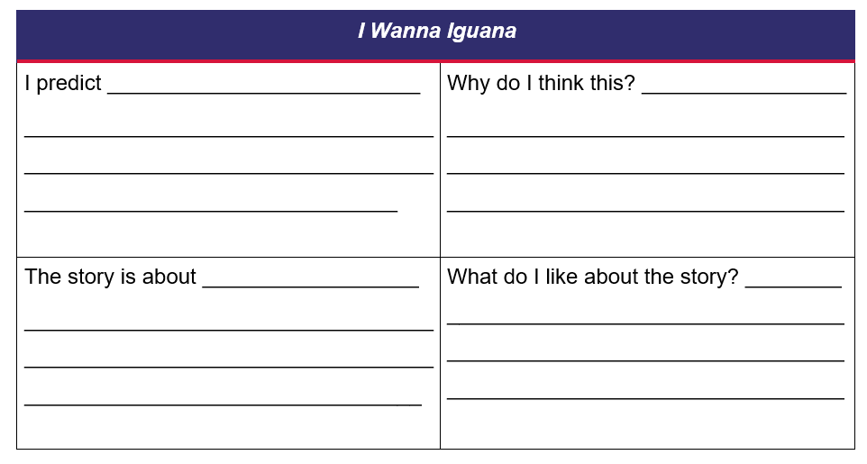

Resource 2: About the text (Stage 1)
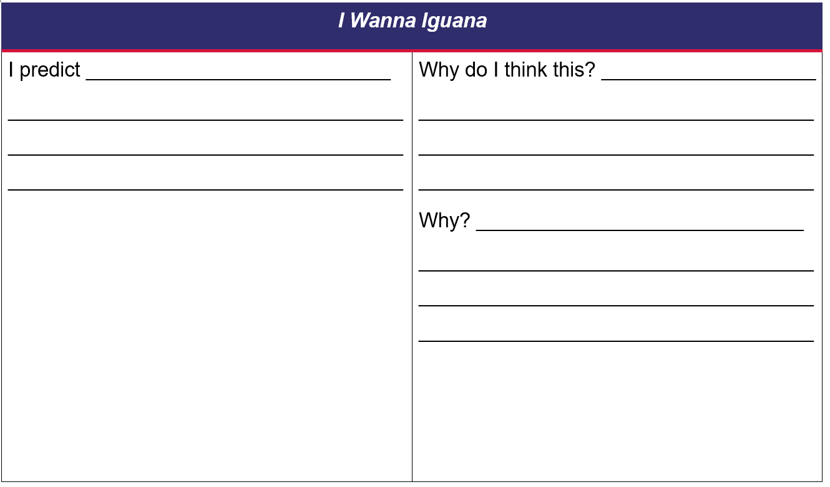
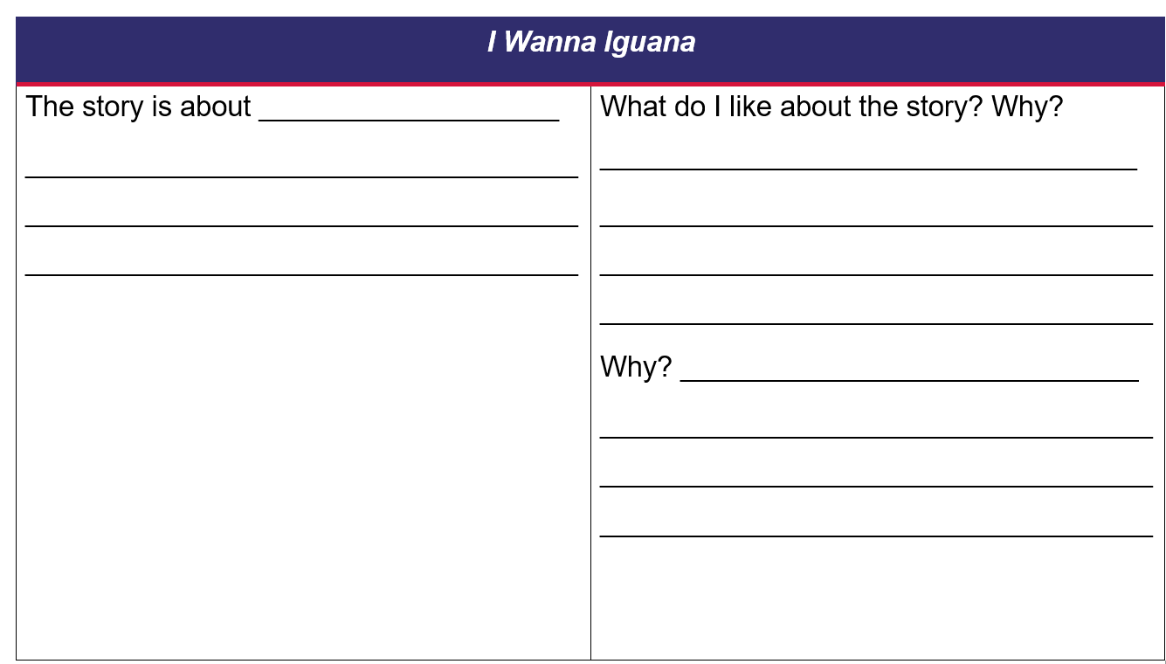

Resource 3: Class letter
Dear Class,
Do you have a pet? What pets would be easy to look after? We are going to read about a little boy who wants a pet. He thinks the pet is quiet and cute.
From your curious teacher,
_____

Resource 4: FANBOYS mnemonic
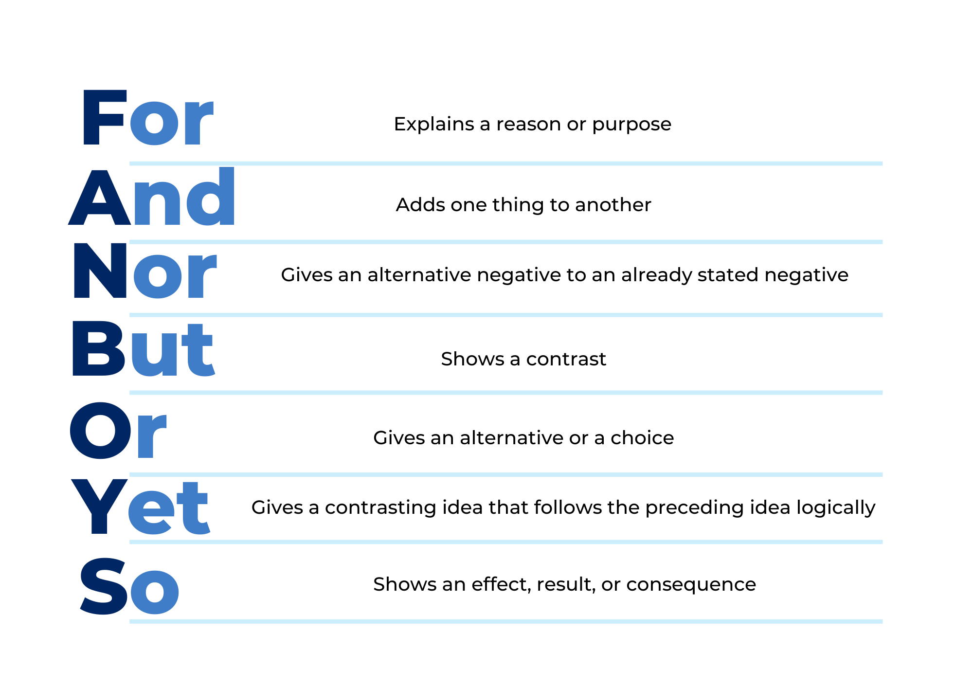

Resource 5: Oral language and communication grid
Find someone who...
Liked the illustrations | Didn’t like the illustrations
Liked the characters | Didn’t like the characters
Liked the structure | Didn’t like the structure
Ask yourself... | Ask a friend...
What was my favourite part of I Wanna Iguana? | What was your favourite part of I Wanna Iguana?
Try to persuade your friend that your favourite part is the best.

Resource 6: I Wanna Iguana
My opinion | Supporting image
What did you like or dislike about the text? Why?
Do iguanas make good pets? Why?
Would you recommend this text to a friend? Why?

Resource 7: Adverbs word bank
Examples of adverbs
sincerely | probably | really
probably | exactly | never
loosely | lazily | quietly
softly

Resource 8: Related ideas
We’d like a diving board. | I demand milk and eggs.
You are cows and hens. | Click, clack, quack.
The pond is quite boring. | Dear Cows and Hens:

Resource 9: Let’s plan a letter (Early Stage 1)
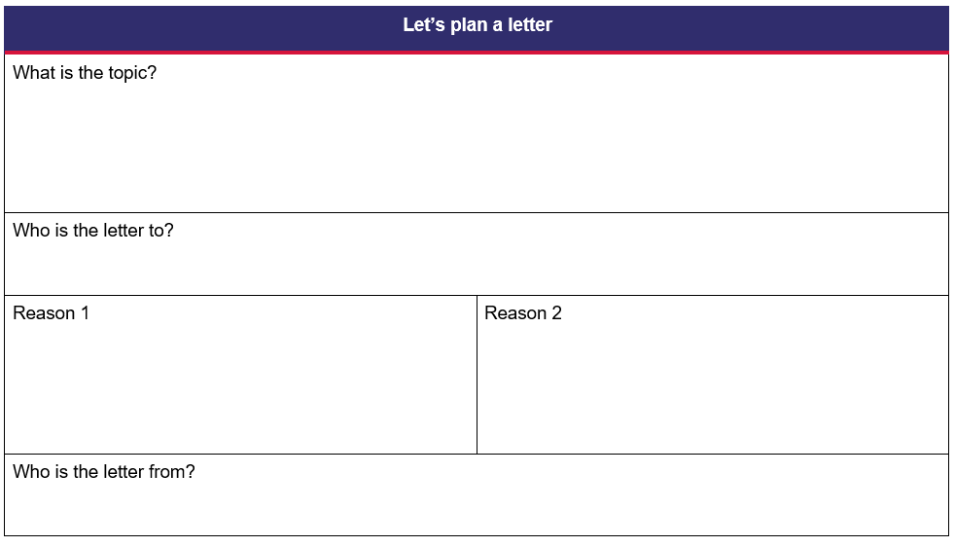

Resource 10: Let’s plan a letter (Stage 1)
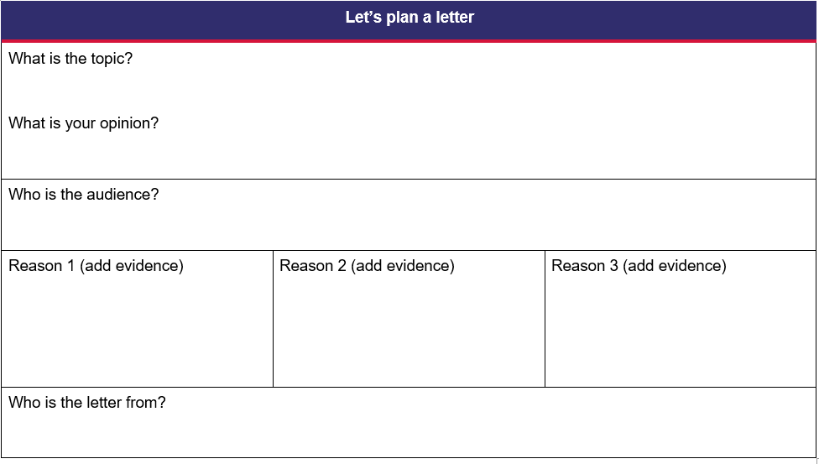

Resource 11: Deconstructed letter
I will give him enough water.
If I don’t keep it Stinky’s dog will eat it. You wouldn’t want that to happen.
Love, your responsible son Alex
I will keep the iguana in his cage.
Dear Mum,
You will never see him, and you won’t know he is there.
I will feed him every day.
I know you think I shouldn’t have an iguana, but here is why I should.
I will clean his cage.

Resource 12: Reconstructed letter
Dear Mum,
I know you think I shouldn’t have an iguana, but here is why I should.
If I don’t keep it Stinky’s dog will eat it. You wouldn’t want that to happen.
I will keep the iguana in his cage.
You will never see him, and you won’t know he is there.
I will feed him every day.
I will give him enough water.
I will clean his cage.
Love, your responsible son Alex.

References
Links to third-party material and websites
Please note that the provided (reading/viewing material/list/links/texts) are a suggestion only and implies no endorsement, by the New South Wales Department of Education, of any author, publisher, or book title. School principals and teachers are best placed to assess the suitability of resources that would complement the curriculum and reflect the needs and interests of their students.
If you use the links provided in this document to access a third-party's website, you acknowledge that the terms of use, including licence terms set out on the third-party's website apply to the use which may be made of the materials on that third-party website or where permitted by the Copyright Act 1968 (Cth). The department accepts no responsibility for content on third-party websites.
Except as otherwise noted, all material is © State of New South Wales (Department of Education), 2023 and licensed under the Creative Commons Attribution 4.0 International License. All other material (third-party material) is used with permission or under licence. Where the copyright owner of third-party material has not licensed their material under a Creative Commons or similar licence, you should contact them directly for permission to reuse their material.
English K–10 Syllabus © 2022 NSW Education Standards Authority (NESA) for and on behalf of the Crown in right of the State of New South Wales.
© 2022 NSW Education Standards Authority. This document contains NSW Curriculum and syllabus content. The NSW Curriculum is developed by the NSW Education Standards Authority. This content is prepared by NESA for and on behalf of the Crown in right of the State of New South Wales. The material is protected by Crown copyright.
Please refer to the NESA Copyright Disclaimer for more information.
NESA holds the only official and up-to-date versions of the NSW Curriculum and syllabus documents. Please visit the NSW Education Standards Authority (NESA) website and the NSW Curriculum website.
National Literacy Learning Progression © Australian Curriculum, Assessment and Reporting Authority (ACARA) 2010 to present, unless otherwise indicated. This material was downloaded from the Australian Curriculum website (National Literacy Learning Progression) (accessed 6 December 2022) and was not modified. The material is licensed under CC BY 4.0. Version updates are tracked in the ‘Curriculum version history’ section on the 'About the Australian Curriculum' page of the Australian Curriculum website.
ACARA does not endorse any product that uses the Australian Curriculum or make any representations as to the quality of such products. Any product that uses material published on this website should not be taken to be affiliated with ACARA or have the sponsorship or approval of ACARA. It is up to each person to make their own assessment of the product, taking into account matters including, but not limited to, the version number and the degree to which the materials align with the content descriptions and achievement standards (where relevant). Where there is a claim of alignment, it is important to check that the materials align with the content descriptions and achievement standards (endorsed by all education Ministers), not the elaborations (examples provided by ACARA).
Cronin D (2003) CLICK, CLACK, MOO: Cows That Type (Lewin B, illus.), Simon & Schuster UK.
ETA (English Teachers Association) and NSW Department of Education (2016) The Textual Concepts and Processes resource, English Textual Concepts website, accessed 6 December 2022.
Kaufman Orloff K (2011) I Wanna Iguana (Catrow D, illus.), Putnam, New York.

