English – K-2 multi-age – Year B – Unit 12
Contents
Unit overview and instructions for use 3
Teacher notes 4
Outcomes and content – Component A 5
Outcomes and content – Component B 10
Week 1 13
Component A teaching and learning 13
Component B teaching and learning 14
Lesson 1: Context of The Patchwork Bike 16
Lesson 2: Verbs and subject–verb agreement 19
Lesson 3: Compound and complex sentences 23
Lesson 4: Sequencing events and possessive apostrophes 28
Lesson 5: Context and imaginative play 32
Week 2 34
Component A teaching and learning 34
Component B teaching and learning 35
Lesson 6: Digression and planning an adventure 37
Lesson 7: Visual representation of the adventure 39
Lesson 8: Writing the adventure 40
Lesson 9: Edit and publish 42
Lesson 10: Context and sharing 44
Resource 1: Stimulus images 47
Resource 2: Types of verbs 50
Resource 3: Complex sentences 51
Resource 4: Model 1 – Illustrated adventure 53
Resource 5: Illustrated adventure 54
Resource 6: Model 2 – Illustrated adventure 55
Resource 7: My unique context 56
References 57

Unit overview and instructions for use
This two-week unit is comprised of Component A and Component B. Connecting learning across both components is encouraged.
Teaching and learning | Component A | Component B
Suggested duration | 60 minutes | 45 minutes
Explicit teaching focus areas | - Phonological awareness (Early Stage 1)  - Print conventions (Early Stage 1)  - Phonic knowledge  - Reading fluency  - Reading comprehension  - Spelling  - Handwriting | - Oral language and communication  - Vocabulary  - Reading comprehension  - Creating written texts  - Understanding and responding to literature
To prepare for teaching and learning: | - Refer to Outcomes and content – Component A, K-2 – Instructional sequence – grapheme–phoneme correspondences [PDF 825 KB], and the teaching advice documents (hyperlinked in Component A teaching and learning table).  - Based on student needs identified through ongoing assessment data, plan and document how you will sequence teaching and learning in whole class and targeted teaching groups across the two-week cycle. | - Familiarise yourself with Outcomes and content – Component B, Textual concepts information and videos, English Textual Concepts and Learning Processes (2016), and the teaching and learning sequence.  - Based on student needs identified through ongoing assessment data, determine how you will support students in whole class and targeted teaching groups across the two-week cycle as required.
English K–10 Syllabus © 2022 NSW Education Standards Authority (NESA) for and on behalf of the Crown in right of the State of New South Wales.

Teacher notes
- Context refers to factors acting upon composers and responders that affect meaning. To understand context, we look beyond the text to consider the world in which it was produced and the worlds of its reception. Different contexts can affect the meanings and values of similar content. – English Textual Concepts and Learning Processes (2016).
- Understanding of context can be supported through watching the department’s video: Understanding context video (5:24).
- Representation is the depiction of a thing, person, or idea in written, visual, performed or spoken language. It can reflect the natural world realistically or convey people, objects, experiences and ideas in a more abstract way. – English Textual Concepts and Learning Processes (2016).
- Understanding of representation can be supported through watching the department’s video: Understanding representation video (2:46).
- For information on subject-verb agreement, compound and complex sentences, conjunctions, dependent and main (independent) clauses refer to the NESA Glossary.
- It is suggested that school-level IT requirements are checked and in place at the beginning of the unit, in respect to digital platforms such as Canva. A digital platform is optional for publishing student work.
- Optional: Provide everyday items from the text as stimulus, for example, skateboard, laundry basket, kitchen utensils.
- Consider prior learning of simple sentences.
- Reflect on student learning and engagement in activities and record differentiation and adjustments within the unit to inform future teaching and learning. One way of doing this could be to add comments to the digital file.
- Content points are linked to the National Literacy Learning Progression version (3).
Levels and indicators sourced from National Literacy Learning Progression © Australian Curriculum, Assessment and Reporting Authority (ACARA), (accessed 9 February 2023) and was not modified. See references for more information.

Outcomes and content – Component A
The table below outlines the focus outcomes and content. Content is linked to the National Literacy Learning Progression version (3).
Early Stage 1 Focus area and outcome | Stage 1 Focus area and outcome
Phonological awareness  ENE-PHOAW-01 – identifies, blends, segments and manipulates phonological units in spoken words as a strategy for reading and creating texts  - identify the first, middle and final phonemes in a one-syllable word (PhA4)  - blend aloud all phonemes when asked to delete, add or substitute an initial phoneme (PhA5)  - blend aloud all phonemes when asked to delete, add or substitute a final phoneme  - blend aloud all phonemes when asked to substitute a medial vowel phoneme | N/A
Print conventions  ENE-PRINT-01 – tracks written text from left to right and from top to bottom of the page and identifies visual and spatial features of print  - as needed | N/A
Phonic knowledge  ENE-PHOKW-01 – uses single-letter grapheme–phoneme correspondences and common digraphs to decode and encode words when reading and creating texts  - decode and blend words containing consonant digraphs and apply this when reading texts, including decodable texts (PKW5)  - segment and encode CVC words containing consonant digraphs (PKW4, PKW5) | Phonic knowledge  EN1-PHOKW-01 – uses initial and extended phonics, including vowel digraphs, trigraphs to decode and encode words when reading and creating texts  - blend and decode one-syllable words with taught extended vowel graphs and digraphs, including graphemes for r-controlled vowels and diphthongs, and apply this when reading texts (PKW6, PKW7)  - decode words with trigraphs and quadgraphs and apply this when reading texts  - blend and decode 2-syllable words with taught vowel graphs, digraphs, trigraphs and quadgraphs, including graphemes for r-controlled vowels and diphthongs and apply this when reading texts (PKW6, PKW7)
Reading fluency  ENE-REFLU-01 – reads decodable texts aloud with automaticity  - read words automatically then apply to texts  - know that pace and expression vary when reading, according to the audience and purpose  - regulate their voice to respond to punctuation such as question marks and exclamation marks (FlY4) | Reading fluency  EN1-REFLU-01 – sustains reading unseen texts with automaticity and prosody and self-corrects errors  - self-correct when fluency and/or meaning is interrupted  - adjust phrasing, intonation, volume or rate to maintain fluency when reading aloud (FlY4)
Reading comprehension  ENE-RECOM-01 – comprehends independently read texts using background knowledge, word knowledge and understanding of how sentences connect  - ask or pause to clarify meaning of unknown words (UnT3)  - stop reading when a break in comprehension is registered (UnT4)  - re-read to check if an error was made  - self-correct error using phonic knowledge (UnT5)  - recall the sequence of events/information in texts (UnT5) | Reading comprehension  EN1-RECOM-01 – comprehends independently read texts that require sustained reading by activating background and word knowledge, connecting and understanding sentences and whole text, and monitoring for meaning  - draw on sources to seek clarification for unknown words  - know that a complex sentence includes a clause for expressing a main message and one or more clauses that elaborate on that message  - coordinate information or events from different parts of the text to form an overall opinion  - monitor understanding to ensure meaning is sustained and expanded through the whole text (UnT6)  - confirm meaning by sequencing and explaining events and information
Spelling  ENE-SPELL-01 – applies phonological, orthographic and morphological generalisations and strategies to spell taught familiar and high-frequency words when creating texts  - segment single-syllable words into phonemes as a strategy for spelling (SpG4)  - experiment with the tense-marking suffixes to spell familiar base verbs (SpG5) | Spelling  EN1-SPELL-01 – applies phonological, orthographic and morphological generalisations and strategies when spelling words in a range of writing contexts  - segment multisyllabic words into syllables and phonemes as a strategy for spelling (SpG5)  - spell high-frequency base words with taught vowel graphs, digraphs, split digraphs, trigraphs and quadgraphs (SpG6)  - use common prefixes such as un–, re– and dis– (SpG9)
Handwriting  ENE-HANDW-01 – produces all lower-case and upper-case letters to create texts  - form all handwritten letters in NSW Foundation Style when given a verbal prompt from the correct starting point and continue in the correct direction (HwK4) | Handwriting  EN1-HANDW-01 – uses a legible, fluent and automatic handwriting style, and digital technology, including word-processing applications, when creating texts  - recognise and use keys to show more complex punctuation or symbols (HwK5)  - type up to 5 familiar words per minute  - use taught software functions to create texts in a range of modes for different contexts, audiences and purposes

Outcomes and content – Component B
The table below outlines the focus outcomes and content. Content is linked to the National Literacy Learning Progression version (3).
Early Stage 1 Focus area and outcome | Stage 1 Focus area and outcome
Oral language and communication  ENE-OLC-01 – communicates effectively by using interpersonal conventions and language with familiar peers and adults  - start a conversation with a peer and/or adult, staying on topic (InT3)  - use oral language to reason when speaking  - use oral language to persuade, negotiate, give opinions or discuss ideas (InT4) | Oral language and communication  EN1-OLC-01 – communicates effectively by using interpersonal conventions and language to extend and elaborate ideas for social and learning interactions  - link or compare ideas when interacting  - use a range of strategies for effective dialogue and manage digression from a topic (InT3, InT5)
Vocabulary  ENE-VOCAB-01 – understands and effectively uses Tier 1 words and Tier 2 words in familiar contexts  - use specific word choice to clarify meaning | Vocabulary  EN1-VOCAB-01 – understands and effectively uses Tier 1, taught Tier 2 and Tier 3 vocabulary to extend and elaborate ideas  - understand and intentionally choose subject-specific vocabulary to enhance precision and for effect
Reading comprehension  ENE-RECOM-01 – comprehends independently read texts using background knowledge, word knowledge and understanding of how sentences connect  - ask or pause to clarify meaning of unknown words (UnT3)  - identify conjunctions in a compound sentence, their meaning and purpose  - recall the sequence of events/information in texts (UnT5) | Reading comprehension  EN1-RECOM-01 – comprehends independently read texts that require sustained reading by activating background and word knowledge, connecting and understanding sentences and whole text, and monitoring for meaning  - draw on sources to seek clarification for unknown words  - use a mental model to confirm predictions  - coordinate information or events from different parts of the text to form an overall opinion  - confirm meaning by sequencing and explaining events and information
Creating written texts  ENE-CWT-01 – creates written texts that include at least 2 related ideas and correct simple sentences  - sequence ideas in a text (GrA4)  - identify and use verbs in simple sentences, including in own writing (GrA2)  - experiment with writing compound sentences and recognise that each clause makes meaning by itself (GrA4)  - understand that punctuation is a feature of written language and how it impacts meaning  - edit their texts after receiving feedback | Creating written texts  EN1-CWT-01 – plans, creates and revises texts written for different purposes, including paragraphs, using knowledge of vocabulary, text features and sentence structure  - use subject–verb agreement across a text (GrA5)  - use action, saying, relating and sensing verbs to add detail and precision to writing (GrA2, GrA5)  - experiment with writing complex sentences which include a clause for the main message and dependent clause to elaborate or modify the message (GrA5)  - use commas to separate ideas, lists and/or dependent clauses in a sentence (PuN4, PuN6)  - use possessive apostrophes in own writing (PuN4)  - make intentional word choices to enhance precision of meaning and ideas in a text (CrT5)  - use different modes and media to enhance the presentation of texts they have created (CrT5, CrT6)
Understanding and responding to literature  ENE-UARL-01 – understands and responds to literature read to them  - identify aspects of their own world represented in texts (UnT4)  - create imaginative and/or informative texts relating to their own experience, the world and/or other text (CrT3) | Understanding and responding to literature  EN1-UARL-01 – understands and responds to literature by creating texts using similar structures, intentional language choices and features appropriate to audience and purpose  - recognise ways that settings and situations are represented within texts  - express personal responses to the real and imagined worlds that are represented in texts

Week 1

Component A teaching and learning
The table below can be used to plan and document lessons that address Component A outcomes and content. Both the detailed example [DOC 529KB] of a two-week teaching and learning cycle and brief example [DOC 66KB] may support you in your planning.
Focus Areas | Lesson 1 | Lesson 2 | Lesson 3 | Lesson 4 | Lesson 5
Phonological awareness (Early Stage 1) and Phonic knowledge
15 minutes
Spelling and Handwriting
15 minutes
Print conventions (Early Stage 1), Reading comprehension and Reading fluency
30 minutes

Component B teaching and learning
The following teaching and learning sequence has been designed to address Component B outcomes and content. Adapt the sequence as required to best meet the needs of your students.

Learning intention and success criteria
Learning intentions and success criteria are best co-constructed with students. The table below contains suggested learning intentions and success criteria.
Element | Early Stage 1 | Stage 1
Learning intentions | Students are learning to understand how imaginative play is represented in different contexts and consider the real and imagined worlds through play. | Students are learning to consider how settings and situations are represented in texts and explore how the experiences, memories and knowledge of authors influence their writing. They will explore the real and imagined worlds through play.
Success criteria | Students can:  - identify aspects of their own world represented in texts  - use oral language to share ideas  - use verbs in writing  - use compound sentences and coordinating conjunctions in writing  - sequence events in a text  - innovate from mentor texts. | Students can:  - recognise and respond to context of a text  - use oral language to link and compare ideas during discussions  - use verbs and subject–verb agreement  - use complex sentences and commas to separate clauses in writing  - use possessive apostrophes in writing  - innovate from mentor texts.

Resources
- Beneba Clarke M (2016) The Patchwork Bike (Rudd VT, illus) Lothian Children’s Books, Australia. ISBN: 9780734418609
- Teece L (2017) Molly the Pirate (Seden P, illus) Magabala Books, Australia. ISBN: 9781925360660
- Resource 1: Stimulus images
- Resource 2: Types of verbs
- Resource 3: Complex sentences
- A4 paper
- Mini whiteboards
- Whiteboard markers

Lesson 1: Context of The Patchwork Bike
The following teaching and learning activities support multi-age settings.

Whole
- Display Resource 1: Stimulus images. Students brainstorm what they see, think and wonder about the images.
- Ask:
- What is imaginative play?
- How have you been involved in imaginative play?
If required, teacher models a memory of imaginative play to initiate student conversation.
- Introduce the concept of context. Explain that a person’s context is unique to them. It is shaped by where someone lives, their experiences, memories and knowledge. Context affects the way people think, feel, speak, and write.
- Introduce The Patchwork Bike by displaying the front and back cover. Read the blurb on the back cover ‘What’s the best fun in the whole village? Riding the patchwork bike we made!’
- In pairs, students make predictions about The Patchwork Bike. After predictions have been made, ask why students think this.
- Read The Patchwork Bike.
- In pairs, students discuss what the text was about and compare their predictions with events in the text. Support students to use reasoning to identify similarities and/or differences.
- Ask what the word ‘patchwork’ means and explain that ‘patchwork’ is something that has been pieced together or put together using different parts. For example, a patchwork quilt or the patchwork bike that is made up of ‘a bent bucket seat’, ‘handlebar branches’, ‘a flag that’s made from a flour sack’ and ‘a bark number plate’.
- Discuss the context of The Patchwork Bike and make text-to-world and text-to-self connections. Ask:
- Where do the kids live? How do you know?
- What did they use to make the bike? Why?
- Why did they make the patchwork bike?
- Do you think it was a good idea to make the bike? Why or why not? Explain your opinion.
- What else could they have made?
- Have you ever made something like a patchwork bike to play with? Describe it.
- Revisit Resource 1: Stimulus images. Students recall a time they have made something which they have used in imaginative play. Prompt students to think about what they made, what they used to make it and where they imagined they were (setting).
- Students draw their imaginative play memory.
Too hard? Students select one of the Resource 1: Stimulus images to draw.
- In pairs, students orally share what has been drawn. Students discuss and compare ideas, and explain what they made, what they used to make it and where they imagined they were.
- Students write sentences to match their drawing.
Early Stage 1 Assessment task 1 – Observations from this lesson allow students to demonstrate achievement towards the following syllabus outcomes and content points:
ENE-OLC-01 – communicates effectively by using interpersonal conventions and language with familiar peers and adults
- use oral language to reason when speaking
- use oral language to persuade, negotiate, give opinions or discuss ideas.
ENE-UARL-01 – understands and responds to literature read to them
- identify aspects of their own world represented in texts.
Stage 1 Assessment task 1 – Observations from this lesson allow students to demonstrate achievement towards the following syllabus outcomes and content points:
EN1-OLC-01 – communicates effectively by using interpersonal conventions and language to extend and elaborate ideas for social and learning interactions
- link or compare ideas when interacting.
EN1-RECOM-01 – comprehends independently read texts that require sustained reading by activating background and word knowledge, connecting and understanding sentences and whole text, and monitoring for meaning
- coordinate information or events from different parts of the text to form an overall opinion.
EN1-UARL-01 – understands and responds to literature by creating texts using similar structures, intentional language choices and features appropriate to audience and purpose
- recognise ways that settings and situations are represented within texts
- express personal responses to the real and imagined worlds that are represented in texts.

Lesson 2: Verbs and subject–verb agreement
The following teaching and learning activities support multi-age settings.

Whole
- Display The Patchwork Bike double page ‘It can bumpetty bump through the village, glide right through our mud-for-walls home’. Allow students time to focus on the illustrations. Discuss what the students notice about the illustrations and what they represent. Draw attention to how the author created the illustrations. For example, the use of colour, the use of a cardboard box as pages in the text, the streak of paint to create a sense of fast movement.
- Discuss prior knowledge of verbs. Read the text on the double page. Note the verbs and how they add meaning to the illustration. For example, ‘bumpetty bump’ along the ripples in the cardboard, ‘glide’ represented by the swipes of paint. Ask how the illustrations help how readers understand the text.
- Build on verb knowledge and write a class definition. Discuss the different types of verbs. For example, action, saying, sensing and relating.
- Skim the text. Identify and write verbs from the text on an anchor chart. Discuss how the author was intentional in her choice of verbs to give detail to the reader.
- Revisit the different types of verbs. Identify an example of each type of verb on the anchor chart.
- Explain that Stage 1 students will sort the types of verbs from the anchor chart using Resource 2: Types of verbs.

Part
The table below details the differentiated teaching and learning activities for each stage.
Early Stage 1 (teacher guided) | Stage 1 (pairs/ independent)
- Revisit knowledge of verbs and the class definition.  - Display the double page in the text that says ‘Here is the sandhill we built to slide down’. Point out the verb, ‘slide’. Ask students if they can think of additional examples of verbs that could be used instead of slide. For example, roll, tumble, leap.  - Jointly construct simple sentences using the additional verbs. For example, ‘Here is the sandhill that we roll down. Here is the sandhill that we leap down.’  - Repeat activity 8 and 9 for the double page in the text that says, ‘This is the big Fiori tree where we go jumping and climbing’.  - Explain that students will write simple sentences using additional verbs for the 2 sentences from the text in activity 8. | - Students sort verbs from anchor chart using Resource 2: Types of verbs. For example:  - saying – shrieking, whooping  - relating – are, is  - action – built, climbing, shake, remake, speed.  - Add additional verbs to Resource 2: Types of verbs.  Too easy? Students change and record different tense for verbs. For example, shrieking, shrieked.

Part
The table below details the differentiated teaching and learning activities for each stage.
Early Stage 1 (independent) | Stage 1 (teacher guided)
- Students write simple sentences using additional verbs for the 2 sentences from the text in activity 8. Underline the verb.  - Students create illustrations that demonstrate the verbs they have included in their sentences. | - Revise that clauses have a subject and a verb.  - Identify the subject and verb in the sentence, ‘The bike (subject) was (verb) here’.  - Explicitly teach that subject-verb agreement occurs when the writer or speaker selects the correct verb for the noun. For example, ‘The bike was here’ (not: ‘The bike were here’).  - Explain that verbs lose an ‘s’ to agree with plurals. For example, he jumps over the log, they jump over the log.  - Draw attention to single subject and single verbs used in the text, for example, ‘it has’.  - Identify plural subject and plural verbs used in the text, for example, ‘these are’.  - Identify subject-verb agreement throughout the text. For example, ‘These are (verb) my crazy brothers (subject) and this is (verb) our fed-up mum (subject).’ Point out subject-verb agreement in each clause of compound sentences.  - Students write sentences about the text, using subject–verb agreement and verbs from Resource 2: Types of verbs. Underline the verb and circle the subject in each sentence.

Whole
- Students give instructions for peers to perform, using different types of verbs and sentences with correct subject–verb agreement. For example, build something, jump over the log.
Early Stage 1 Assessment task 2 – Observations and work samples from this lesson allow students to demonstrate achievement towards the following syllabus outcome and content point:
ENE-CWT-01 – creates written texts that include at least 2 related ideas and correct simple sentences
- identify and use verbs in simple sentences, including in own writing.
Stage 1 Assessment task 2 – Observations and work samples from this lesson allow students to demonstrate achievement towards the following syllabus outcome and content points:
EN1-CWT-01 – plans, creates and revises texts written for different purposes, including paragraphs, using knowledge of vocabulary, text features and sentence structure
- use subject–verb agreement across a text
- use action, saying, relating and sensing verbs to add detail and precision to writing.

Lesson 3: Compound and complex sentences
The following teaching and learning activities support multi-age settings.

Whole
- Display The Patchwork Bike. Ask students to share what they have previously learnt about sentences.
- Look at the front cover of the text. Describe and record what students see, using simple sentences. For example, ‘The bike has wooden wheels.’ ‘The bike has a blue bucket seat.’
Note: A main clause (also known as principal or independent clause) is a clause that can stand alone as a complete sentence. A compound sentence is a sentence comprising 2 or more independent clauses joined by a coordinating conjunction.
- Revise coordinating conjunctions. For example, for, and, not, but, or, yet, so. Revise that the purpose of a coordinating conjunction is to link 2 independent clauses.
- Display the sentence, ‘The bike has wooden wheels and it has a blue bucket seat.’ Explain that this sentence is a compound sentence with 2 main (independent) clauses and a coordinating conjunction. Underline the 2 independent clauses and circle the coordinating conjunction.
- Select and display 2 sentences from activity 2. Use the displayed sentences to jointly construct a compound sentence. Underline the independent clauses and circle the coordinating conjunction. Repeat as required.
- Skim the first 2 double pages of The Patchwork Bike. Draw attention to the independent clauses on these pages. For example, ‘These are my crazy brothers’, ‘this is our fed-up mum’. To prepare for learning about complex sentences, explain that Stage 1 students will complete a text analysis and identify independent clauses in the text.

Part
The table below details the differentiated teaching and learning activities for each stage.
Early Stage 1 (teacher guided) | Stage 1 (small groups/pairs/ independent)
- Revise compound sentences.  - Display the following compound sentences from the text:  - ‘These are my crazy brothers and this is my fed-up mum.’  - ‘It has painted-on lights and a bark numberplate that keeps falling off and we have to remake it.’  - Explain that the coordinating conjunction ‘and’ can be used to link ideas within an independent clause, for example, ‘It has painted on lights and a bark numberplate that keeps falling off’.  - Students take turns to underline the independent clauses and circle the coordinating conjunctions.  - Display the title page of The Patchwork Bike. Describe and record what students see using simple sentences.  - Select 2 simple sentences from activity 12 to use to construct a compound sentence. Underline the independent clauses and circle the coordinating conjunction.  - On mini whiteboards, students select 2 sentences from activity 12 and write a compound sentence. Underline the independent clauses and circle the coordinating conjunction. | - Provide students with an excerpt of the text.  - Students complete a text analysis of The Patchwork Bike by identifying independent clauses in the excerpts.  Too easy? Students identify dependent clauses, in the text analysis.

Part
The table below details the differentiated teaching and learning activities for each stage.
Early Stage 1 (in pairs/ independent) | Stage 1 (teacher guided)
- In pairs, each student writes a simple sentence about the text on mini whiteboards.  - Students link their sentences together to make a compound sentence using a coordinating conjunction.  - Independently, students write compound sentences about the text. Underline the independent clauses and circle the coordinating conjunctions.  Too hard? Provide students with a sentence scaffold to complete. For example, ‘The bike has _ and it _.’  Too easy? Students experiment with writing compound sentences using a variety of coordinating conjunctions. | Note: A complex sentence is formed by adding one or more dependent (subordinate) clauses to a main (independent) clause using conjunctions and/or relative pronouns. A dependent clause (also known as subordinate clause) is a group of words that cannot stand alone as a sentence.  - Revise complex sentences and subordinating conjunctions. Explicitly teach that a complex sentence is formed by adding one or more dependent clauses to a main (independent) clause using a subordinating conjunction. Explain that commas can be used to separate dependent and independent clauses in complex sentences.  - Model writing a complex sentence using ideas from the text. For example, ‘The handlebars shicketty shake when riding over sandhills’. Underline the independent clause, circle the subordinating conjunction and highlight the dependent clause.  - Explain that a dependent clause is a group of words that cannot stand alone as a sentence. They do not make sense on their own. For example, ‘that shicketty shake when we ride over sandhills.’  - Refer to the displayed complex sentence, noting that the subordinating conjunction links the independent and dependent clauses.  - Explain that the dependent clause can be at the beginning of the sentence with a comma separating the clauses. For example, ‘Because (subordinating conjunction) it has handlebar branches, (dependent clause) the bike would shicketty shake over sandhills (independent clause)’. Circle the subordinating conjunction, underline the independent clause and highlight the dependent clause. Note the use of a comma to separate clauses.  - Display Resource 3: Complex sentences (bike). Model writing a complex sentence with a subordinating conjunction linking the 2 clauses. Jointly construct a complex sentence with the subordinating conjunction at the beginning with a comma separating the clauses.  - Display Resource 3: Complex sentences (dog). Students write 2 complex sentences:  - one with a subordinating conjunction linking the 2 clauses  - one with the subordinating conjunction at the beginning with a comma separating the clauses.

Whole
- Students share their sentences.

Lesson 4: Sequencing events and possessive apostrophes
The following teaching and learning activities support multi-age settings.

Whole
- Revise context. Explain that a person’s context is unique to them. It is shaped by where someone lives, their experiences, memories and knowledge. Context affects the way people think, feel, speak, and write.
Note: A mental model is a mental representation of the information in a real or an imaginary world. A student develops a mental model as the text progresses. It may include information derived from inferences and from background knowledge as well as what is explicitly stated in the text itself.
- Introduce Molly the Pirate. Display the front and back covers. Explain that students will make a prediction using a mental model. Using mini whiteboards, students draw what they think the text is about.
- Read Molly the Pirate.
- Students compare their drawn predictions to the events in the text using the Think-Pair-Share strategy. Provide time for students to add to or adjust their mental model.
- Explore the context of Molly the Pirate. Ask:
- Why might Molly have imagined she was a pirate?
- What experiences or knowledge inspired her?
- How might Molly’s surroundings influence how she imagined? For example, the clothesline, the use of kitchen utensils.
- Explain that good authors use rich vocabulary to help the audience to deepen their understanding of texts. At times, the audience may come across words they are not familiar with. Discuss strategies that can be used to clarify the meaning of unknown words. For example, re-read, read forward or use visual cues.
- Re-read Molly the Pirate. Pause at less familiar vocabulary and discuss. Use think aloud strategy to model how to clarify meaning. For example, ‘I think rigging means the ropes that hold up the mast and sails on a ship because Molly is standing on top of the clothesline. The clothesline is the mast and the sheets are the sails of her imagined pirate ship’.
- Explain that students will recall the sequence of events in the text whilst trying to include the vocabulary explored in activity 7.
- In pairs or small groups, students orally recall the sequence of events in the text.
- As a class, discuss the sequence of events. Model recording events with a drawing.

Part
The table below details the differentiated teaching and learning activities for each stage.
Early Stage 1 (independent) | Stage 1 (teacher guided)
- On mini whiteboards or blank paper, students draw the sequence of events from the text. | - Display the page the starts with ‘Wake up sleepyhead’. Identify the possessive apostrophe.  - Explain possessive apostrophes are used to show ownership. Discuss where the apostrophe is placed.  - Model writing using a possessive apostrophe to recall the first event in the text. For example, ‘Molly’s wish was to be a pirate’.

Part
The table below details the differentiated teaching and learning activities for each stage.
Early Stage 1 (teacher guided/ independent) | Stage 1 (independent)
- Students share their drawn sequence of events.  - Discuss how punctuation affects meaning in text, for example, a sentence has a capital letter and a full stop to show where it begins and ends.  - Model writing sentences recalling the sequence of events from the text. Refer to a student’s drawn sequence or the teacher modelled drawings from activity 10. Use think aloud strategy to include vocabulary from the text.  - Students write sentences recalling the sequence of events, referring to their drawings.  Too hard? Students orally recall the sequence of events.  Too easy? Students use compound sentences to recall the sequence of events. Circle the coordinating conjunctions. | - Students write sentences to recall the sequence of events from the text using possessive apostrophes to show ownership.  - Students circle the possessive apostrophes in their writing.  Too easy? Students use complex sentences to recall the sequence of events. Circle the subordinating conjunctions.

Whole
- Students share their work.
Early Stage 1 Assessment task 3 – Observations and work samples from this lesson allow students to demonstrate achievement towards the following syllabus outcomes and content points:
ENE-RECOM-01 – comprehends independently read texts using background knowledge, word knowledge and understanding of how sentences connect
- ask or pause to clarify meaning of unknown words
- recall the sequence of events/information in texts.
ENE-CWT-01 – creates written texts that include at least 2 related ideas and correct simple sentences
- sequence ideas in a text.
Stage 1 Assessment task 3 – Observations and work samples from this lesson allow students to demonstrate achievement towards the following syllabus outcomes and content points:
EN1-RECOM-01 – comprehends independently read texts that require sustained reading by activating background and word knowledge, connecting and understanding sentences and whole text, and monitoring for meaning
- draw on sources to seek clarification for unknown words
- use a mental model to confirm predictions
- confirm meaning by sequencing and explaining events and information.
EN1-CWT-01 – plans, creates and revises texts written for different purposes, including paragraphs, using knowledge of vocabulary, text features and sentence structure
- use possessive apostrophes in own writing.

Lesson 5: Context and imaginative play
The following teaching and learning activities support multi-age settings.

Whole
- Revise context. Discuss how where someone lives, their experiences, knowledge and memories affect what they can speak and write about.
- Display and discuss the pages in Molly the Pirate that have information about Lorraine Teece, author, and Paul Seeden, illustrator. Discuss the author's context. Ask:
- What experiences may have inspired them to write Molly the Pirate?
- What memories of imaginative play might they have drawn from?
- Is there any knowledge they might have needed? For example, an understanding of the outback landscape and way of life.
- Display the covers of Molly the Pirate and The Patchwork Bike. Discuss how the character’s context in each text informs how they engage in imaginative play. For example, Molly appears as an only child, her imaginative play is framed as a daydream. The main character in The Patchwork Bike has brothers to play with. Their imaginative play is framed as adventures on their patchwork bike.
- Display the page in Molly the Pirate that starts with ‘She pushed her boat’ alongside the page in The Patchwork Bike that starts with ‘It has a bent bucket seat’.
- Discuss how the illustrations support the audience to deepen their understanding of context, including the setting and the characters’ experiences. Support students to identify similarities between the texts and make text-to-text connections.
- Draw attention to the use of colour, media and texture. Use think aloud strategy to explore context. For example, in Molly the Pirate, Molly imagines the red dirt as the choppy sea. I think she does this because the desert is vast like the ocean.
- Introduce the concept of representation. Explain that representation is the depiction of a thing, person or idea.
- Re-read Molly the Pirate. While reading, identify and record the everyday objects that Molly played with and imagined they were something else. For example, a skateboard becomes a boat, a laundry basket becomes a pirate ship.
- Optional: Provide everyday items from text as stimulus, for example, skateboard, laundry basket, kitchen utensils. Students can interact with and manipulate items to innovate from.
- Explain that students will use one or more of the same everyday items from the text to imagine a different adventure. Students Think-Pair-Share an idea for a different adventure.
- Model drawing a different adventure using one of the items from Molly the Pirate. For example, 3 washing baskets in a row could be a train, a skateboard could be a toboggan.
- Students draw themselves having a different adventure, using an everyday item in imaginative play.
- Revise prior learning about compound and complex sentences. Model writing compound (Early Stage 1) and complex (Stage 1) sentences to describe the modelled drawing.
- Students write compound (Early Stage 1) and complex (Stage 1) sentences to describe their drawing.
- Provide time for sharing.
- Discuss how each student’s unique context, including their experiences and interests, informs what they imagined.

Week 2

Component A teaching and learning
The table below can be used to plan and document lessons that address Component A outcomes and content. Both the detailed example [DOC 529KB] of a two-week teaching and learning cycle and brief example [DOC 66KB] may support you in your planning.
Focus Areas | Lesson 6 | Lesson 7 | Lesson 8 | Lesson 9 | Lesson 10
Phonological awareness (Early Stage 1) and Phonic knowledge
15 minutes
Spelling and Handwriting
15 minutes
Print conventions (Early Stage 1), Reading comprehension and Reading fluency
30 minutes

Component B teaching and learning
The following teaching and learning sequence has been designed to address Component B outcomes and content. Adapt the sequence as required to best meet the needs of your students.

Learning intention and success criteria
Learning intentions and success criteria are best co-constructed with students. The table below contains suggested learning intentions and success criteria.
Element | Early Stage 1 | Stage 1
Learning intentions | Students are learning to innovate from texts to create their own imagined adventure. | Students are learning to innovate from texts to represent their own unique context through an imagined adventure.
Success criteria | Students can:  - use strategies to stay on topic during conversations  - engage in imaginative play to prepare and plan for writing  - explore how their unique context informs what they write about  - use a co-constructed success criteria for writing  - use a co-constructed success criteria to edit, make changes to, and publish writing  - share their unique context and engage in imaginative play. | Students can:  - use strategies to manage digression during discussions  - engage in imaginative play to prepare and plan for writing  - explore how their context informs what they write about and how they represent their ideas  - use a co-constructed success criteria for writing  - use a co-constructed success criteria to edit, make changes to and publish writing  - share their unique context to deepen understanding of their writing.

Resources
- Beneba Clarke M (2016) The Patchwork Bike (Rudd VT, illus) Lothian Children’s Books, Australia. ISBN: 9780734418609
- Teece L (2017) Molly the Pirate (Seden P, illus) Magabala Books, Australia. ISBN: 9781925360660
- Resource 4: Model 1 – Illustrated adventure
- Resource 5: Illustrated adventure
- Resource 6: Model 2 – Illustrated adventure
- Resource 7: My unique context
- A4 paper
- Mini whiteboards
- Whiteboard markers

Lesson 6: Digression and planning an adventure
The following teaching and learning activities support multi-age settings.

Whole
- Explain that students will discuss and compare the representations of imaginative play in Molly the Pirate and their alternative adventures from Lesson 5, in small groups.
- Students share their alternative adventures with their group. Each group will:
- compare the use of everyday items in their alternative adventures with Molly the Pirate
- discuss which alternative adventures they would most like to go on and why
- consider how their context informs their opinion.
- Display these discussion points.
- Explain that students will use strategies to help manage digression. Students brainstorm strategies to help stay on topic. For example, referring to their illustrations to discuss only what they see and using statements to help bring others back on topic respectfully, such as ‘that’s interesting’, ‘I’d like to hear more about that later’; ‘let’s get back to...’; ‘remember, we’re talking about...’
- In small groups, students discuss and compare their alternative adventures with Molly the Pirate. Students refer to the discussion points and use strategies to stay on topic.
- Introduce students to the final task, creating an illustrated adventure. Explain that this will be a visual and written text about an imaginative adventure. Remind students that their unique context, including their experiences and memories, will inform and shape their adventure. Students will create an adventure and innovate from everyday items, imagining that they are something else.
Note: Structured opportunities such as experiential play create situations that encourage and increase the student’s desire to communicate. This can include using high-value activities or topics of high interest to increase the intrinsic motivation and the desire to communicate.
- Explain that students will develop ideas for their adventure by engaging in experiential play. Provide items from the classroom as stimulus, for example, cushions, blocks, material pieces, small furniture.
- Optional: Provide additional everyday items. For example, laundry basket, colander, broom, wooden spoon.
- Allow time for students to engage in imaginary play, supporting the development of rich ideas to create an adventure. Encourage peer collaboration.
Too hard? Students may use their different adventure drawing from Lesson 5 as a starting point.
- Students draw or write about their adventure ideas discovered through imaginative play, on A4 paper folded into 4 squares.
- Provide time for students to consider and discuss how their context will shape their adventure.
Early Stage 1 Assessment task 4 – Observations from this lesson allow students to demonstrate achievement towards the following syllabus outcome and content point:
ENE-OLC-01 – communicates effectively by using interpersonal conventions and language with familiar peers and adults
- start a conversation with a peer and/or adult, staying on topic.
Stage 1 Assessment task 4 – Observations from this lesson allow students to demonstrate achievement towards the following syllabus outcome and content point:
EN1-OLC-01 – communicates effectively by using interpersonal conventions and language to extend and elaborate ideas for social and learning interactions
- use a range of strategies for effective dialogue and manage digression from a topic.

Lesson 7: Visual representation of the adventure
The following teaching and learning activities support multi-age settings.

Whole
- Reintroduce the task – illustrated adventure. Explain that the task will be developed over 2 days before a final edit using the co-constructed success criteria. The final published text can be a print or digital text.
- Revise prior learning about imaginative play and context. Make connections to:
- Lesson 1: the kids in The Patchwork Bike using everyday items to imagine and create a bike
- Lesson 4: Molly using everyday items to imagine a pirate adventure
- Lesson 5: students’ alternative adventures using Molly’s everyday items
- Lesson 6: experiential play to plan imaginative adventures.
- Explain that students will use adventure ideas recorded in the previous lesson as a plan for their illustrated adventure.
- Display Resource 4: Model 1 – Illustrated adventure.
- Revise the concept of representation as the depiction of a thing, person or idea.
- Use think aloud strategy to identify the everyday items used in the adventure. Discuss how the items have been represented in the drawings. For example, the broom represents a horse.
- Discuss how the audience understands the sequence of events represented in Resource 4: Model 1 – Illustrated adventure. Revise print conventions and remind students that a page is read left to right, top to bottom.
- Explain that students will refer to their adventure ideas from Lesson 6 to create their illustrated adventure.
- Students Think-Pair-Share 4 events that might take place in their illustrated adventure.
- Provide students with Resource 5: Illustrated adventure.
- Students draw pictures to represent 4 events in an imagined adventure, referring to their adventure ideas from Lesson 6.
Too easy? Students draw pictures for additional events in their adventure. Provide additional copies of Resource 5: Illustrated adventure as needed.

Lesson 8: Writing the adventure
The following teaching and learning activities support multi-age settings.

Whole
- Explain that students will write sentences for each illustration of Resource 5: Illustrated adventure.
- Display Resource 4: Model 1 – Illustrated adventure. Discuss what language features could be used to write about the sequence of events.
- Co-construct success criteria for illustrated adventure. For example:
- punctuation (Early Stage 1)
- conjunctions (Early Stage 1)
- compound sentences (Early Stage 1/Stage 1) and complex sentences (Stage 1)
- commas to separate clauses (Stage 1)
- specific word choice (Early Stage 1) subject specific vocabulary (Stage 1)
- edit text after feedback (Early Stage 1).
- Discuss expectations when writing and editing.
- Display Resource 6: Model 2 – Illustrated adventure. Read the written component and review against the co-constructed success criteria. For example, has the author used:
- compound sentences? For example, ‘Kye had a quiet life but every day he longed for adventure’.
- complex sentences? For example, ‘Although he was trying to be brave, Kye felt fear creeping into his heart’.
- commas to separate clauses? For example, ‘It lunged at Kye, snapping it’s teeth’.
- conjunctions? For example, ‘but’, ‘although’
- specific word choice/subject specific vocabulary? For example, ‘steed’, ‘quest’
- punctuation? For example, the use of capital letters, full stops and commas.
Optional: Model writing using Resource 4: Model 1 – Illustrated adventure. Use think alouds to draw attention to the use of each success criteria.
- Remind students that they will write sentences for each illustration in Resource 5: Illustrated adventure, referring to the co-constructed success criteria.
- In pairs, students review their Resource 5: Illustrated adventure. Students discuss their illustrations and brainstorm specific word choices and subject specific vocabulary.
- Students record words and vocabulary for each illustration on mini whiteboards or blank paper.
- Revisit prior learning related to the success criteria.
- Students write sentences for each illustration in Resource 5: Illustrated adventure, referring to the co-constructed success criteria.
- Provide time for students to review and check their writing, against the co-constructed success criteria.
- Explain that students will publish their work in written or digital form. Provide time for students to forward think and plan.

Lesson 9: Edit and publish
The following teaching and learning activities support multi-age settings.

Whole
- Explain that students will edit, publish and finalise their illustrated adventure.
- In pairs, students will swap their illustrated adventures.
- Display the co-constructed success criteria from Lesson 8. Explain that students will use the success criteria to edit their partners writing.
- Display and review the teacher Resource 6: Model 2 – Illustrated adventure or optional modelled writing from Lesson 8.
- Students review the Resource 5: Illustrated adventure.
- Model editing the teacher illustrated adventure. Review the teacher illustrated adventure against the first co-constructed success criterion. Use think aloud strategy to identify areas to refine. Make edits and adjustments to improve.
- Students review their partner’s writing against the first co-constructed success criterion. Provide time for students to edit the work. For example, use of correct punctuation such as capital letters to begin a sentence and full stops to end a sentence.
- Repeat activities 6 and 7 for all co-constructed success criterion.
- Allow time for students to provide partner feedback on each criterion.
- Students review their edits and apply relevant partner feedback.
- Students publish their illustrated adventure. Provide additional copies of Resource 5: Illustrated adventure for written form or technology to access digital platforms such as Canva for Education.
Early Stage 1 Assessment task 5 – Observations and work samples from this lesson allow students to demonstrate achievement towards the following syllabus outcomes and content points:
ENE-VOCAB-01 – understands and effectively uses Tier 1 words and Tier 2 words in familiar contexts
- use specific word choice to clarify meaning.
ENE-RECOM-01 – comprehends independently read texts using background knowledge, word knowledge and understanding of how sentences connect
- identify conjunctions in a compound sentence, their meaning and purpose.
ENE-CWT-01 – creates written texts that include at least 2 related ideas and correct simple sentences
- experiment with writing compound sentences and recognise that each clause makes meaning by itself
- understand that punctuation is a feature of written language and how it impacts meaning
- edit their texts after receiving feedback.
ENE-UARL-01 – understands and responds to literature read to them
- create imaginative and/or informative texts relating to their own experience, the world and/or other text.
Stage 1 Assessment task 5 – Observations and work samples from this lesson allow students to demonstrate achievement towards the following syllabus outcomes and content points:
EN1-VOCAB-01 – understands and effectively uses Tier 1, taught Tier 2 and Tier 3 vocabulary to extend and elaborate ideas
- understand and intentionally choose subject-specific vocabulary to enhance precision and for effect.
EN1-CWT-01 – plans, creates and revises texts written for different purposes, including paragraphs, using knowledge of vocabulary, text features and sentence structure
- experiment with writing complex sentences which include a clause for the main message and dependent clause to elaborate or modify the message
- use commas to separate ideas, lists and/or dependent clauses in a sentence
- make intentional word choices to enhance precision of meaning and ideas in a text
- use different modes and media to enhance the presentation of texts they have created.

Lesson 10: Context and sharing
The following teaching and learning activities support multi-age settings.

Whole
- Revisit context and representation.
- Discuss how the context of the authors and characters is represented in The Patchwork Bike and Molly the Pirate.
- Display teacher Resource 6: Model 2 – Illustrated adventure from Lesson 8 and Resource 7: My unique context.
- Explain that students will consider the context of their adventure through the following:
- character/s
- setting
- events/ experiences
- why they wrote about this adventure the way they did.
- Model completing Resource 7: My unique context using information from the teacher Resource 6: Model 2 – Illustrated adventure. For example, from my unique context, what inspired:
- character/s: My main character was knight because I love the story of King Arthur and the sword in the stone.
- setting: My house backs onto a national park. The dense bushland looks like a great place for a knight to have an adventure.
- events: I have a Venus flytrap on my windowsill that I got for my birthday. I always use dad’s broom as a horse.
- optional: what other experiences, memories or knowledge inspired me? I know lots of vocabulary, like steed and quest, from reading books about knights.
- Students complete Resource 7: My unique context referring to their published illustrated adventure.
- Explain that students will share their illustrated adventures and completed Resource 7: My unique context with their partner. Each pair will engage in play, drawing on their understanding of the partner’s context to enhance how they imagine and understand the adventure.
- Students share their adventures, explain the context that informed it and engage in play inspired by the adventure.

Resource 1: Stimulus images
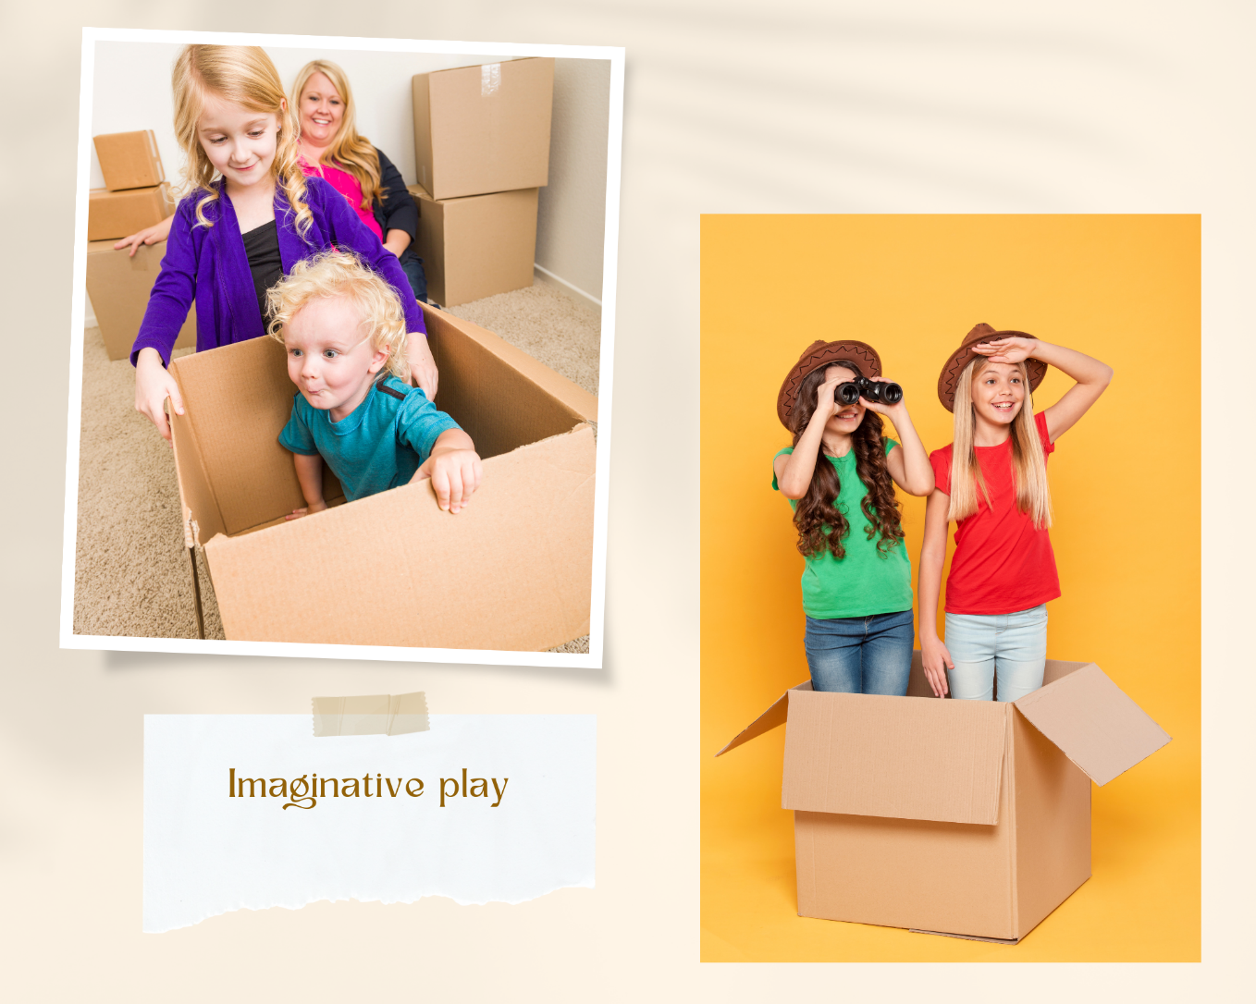
Images sourced from Canva and used in accordance with the Canva Content License Agreement.
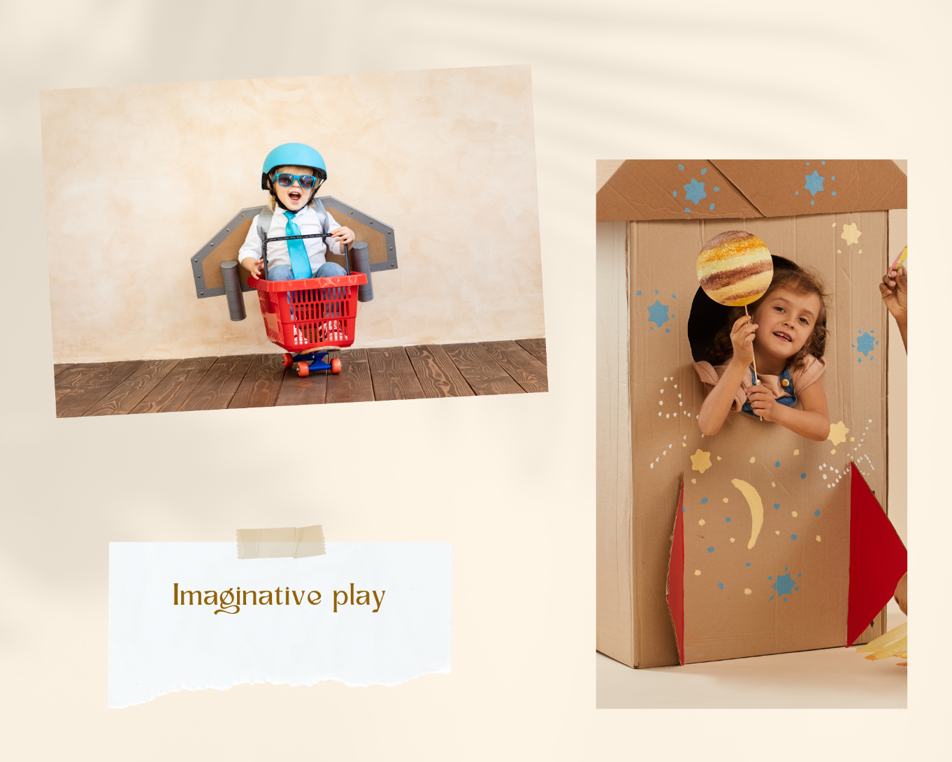
Images sourced from Canva and used in accordance with the Canva Content License Agreement.
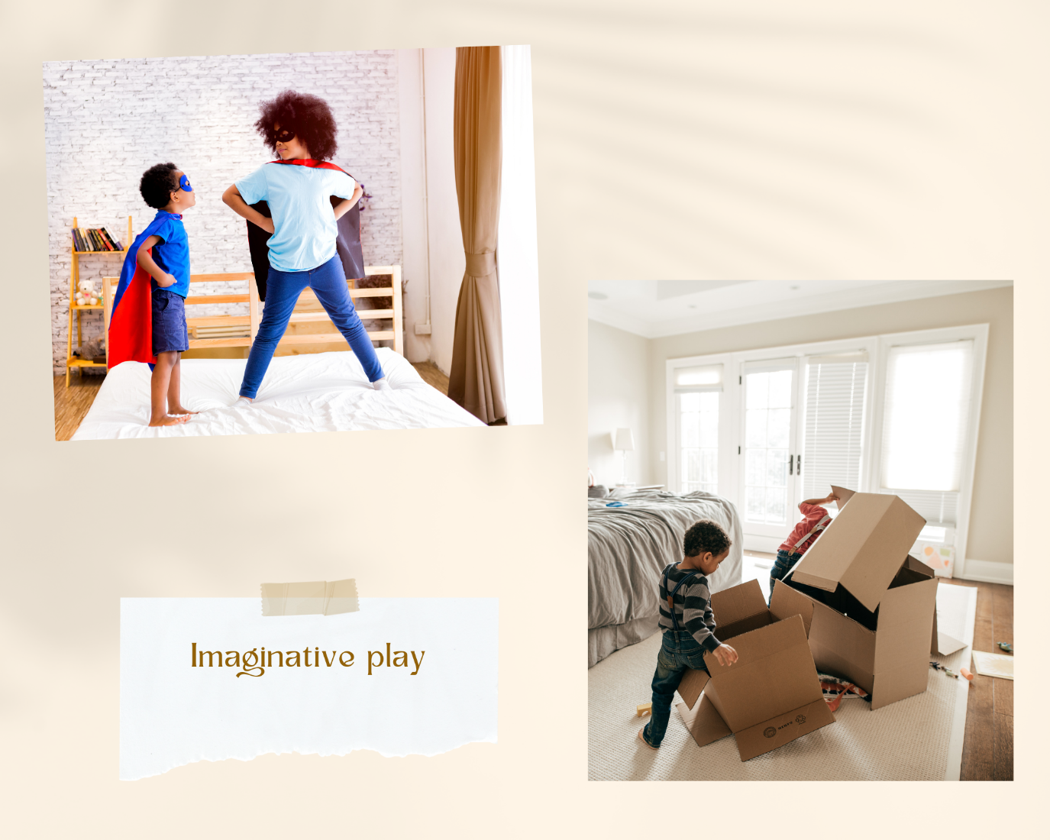
Images sourced from Canva and used in accordance with the Canva Content License Agreement.

Resource 2: Types of verbs
Type | Verbs from ‘The Patchwork Bike’ | Other verbs
action | built
saying | shrieking
relating | are

Resource 3: Complex sentences
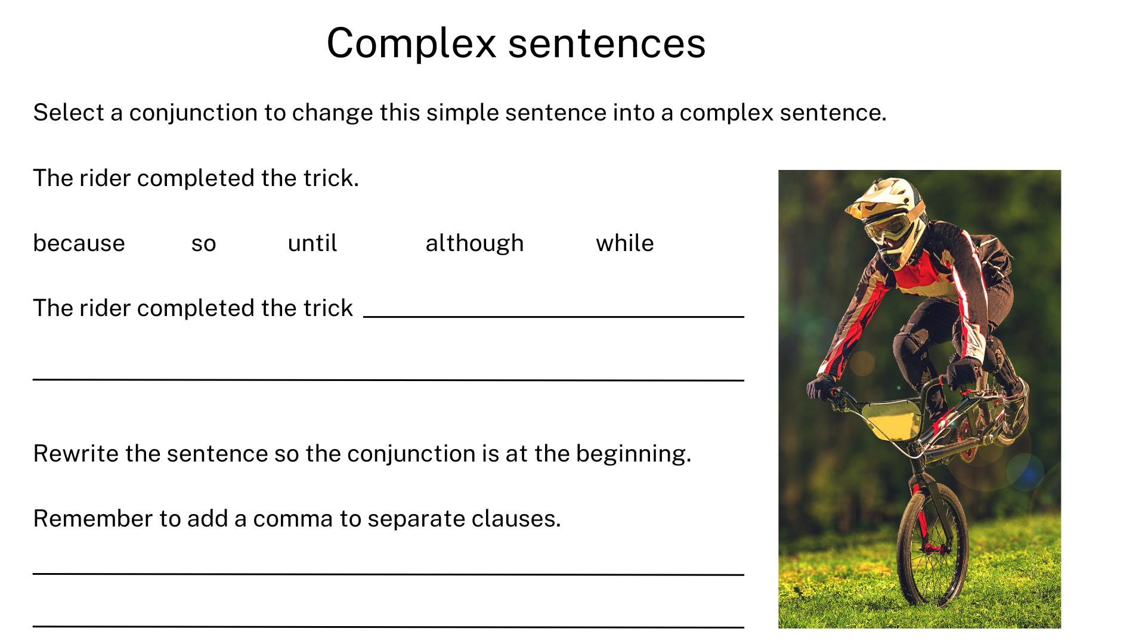
“Man riding BMX bike” by Masisyan sourced from Canva and used in accordance with the Canva Content License Agreement.
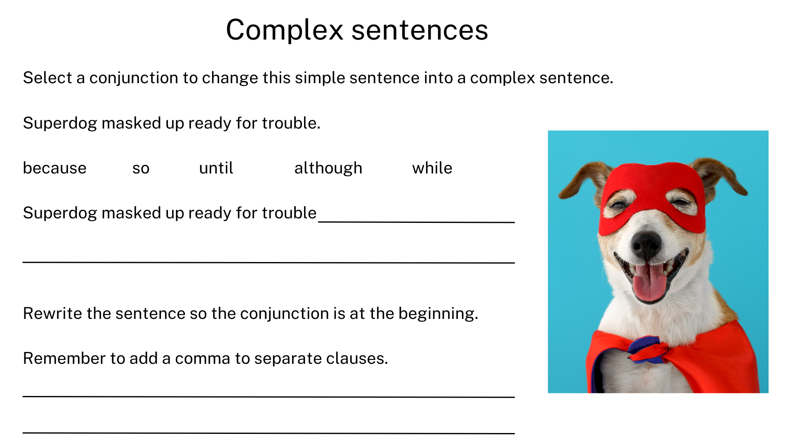
“Dog Super Hero Costume” by Ekaterina Demidova sourced from Canva and used in accordance with the Canva Content License Agreement.

Resource 4: Model 1 – Illustrated adventure
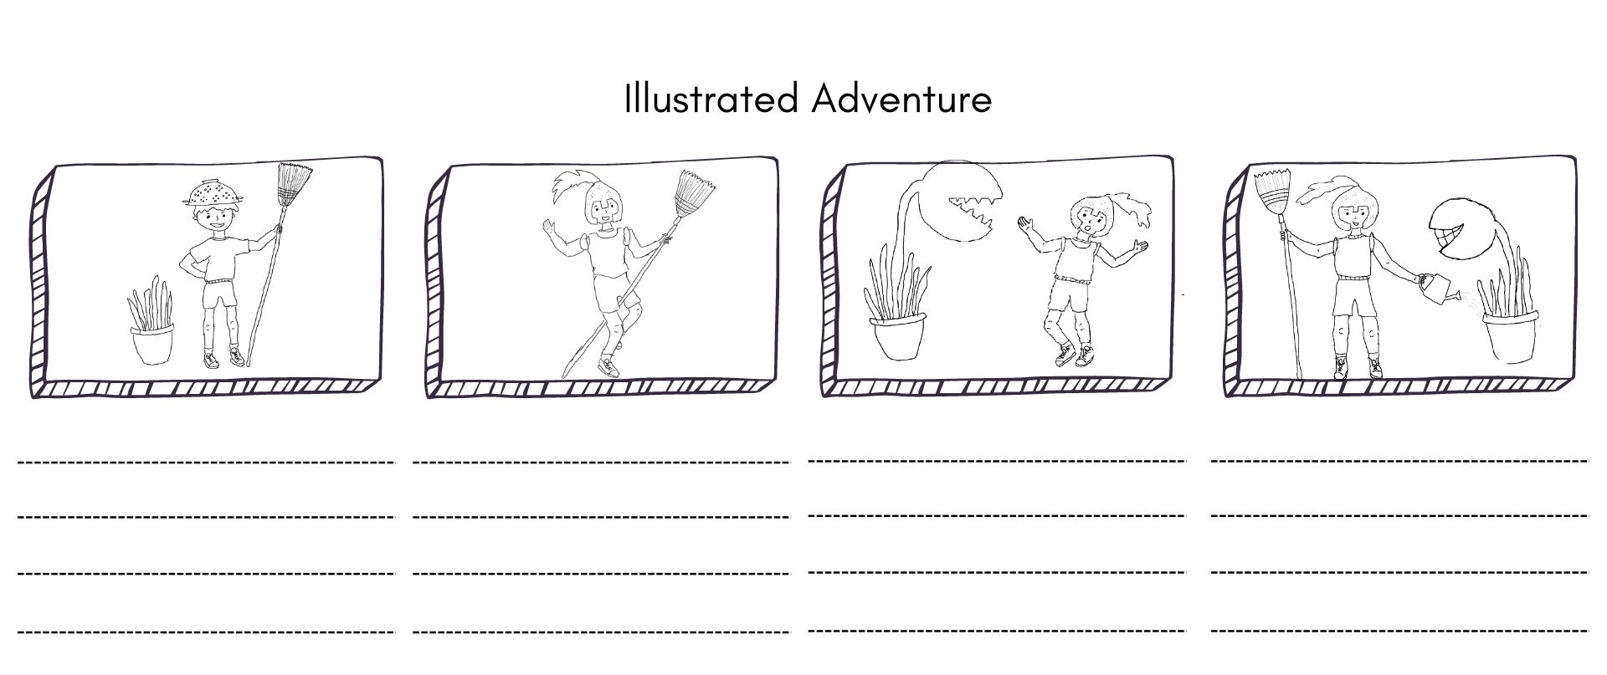
Images sourced from Canva and used in accordance with the Canva Content License Agreement.

Resource 5: Illustrated adventure
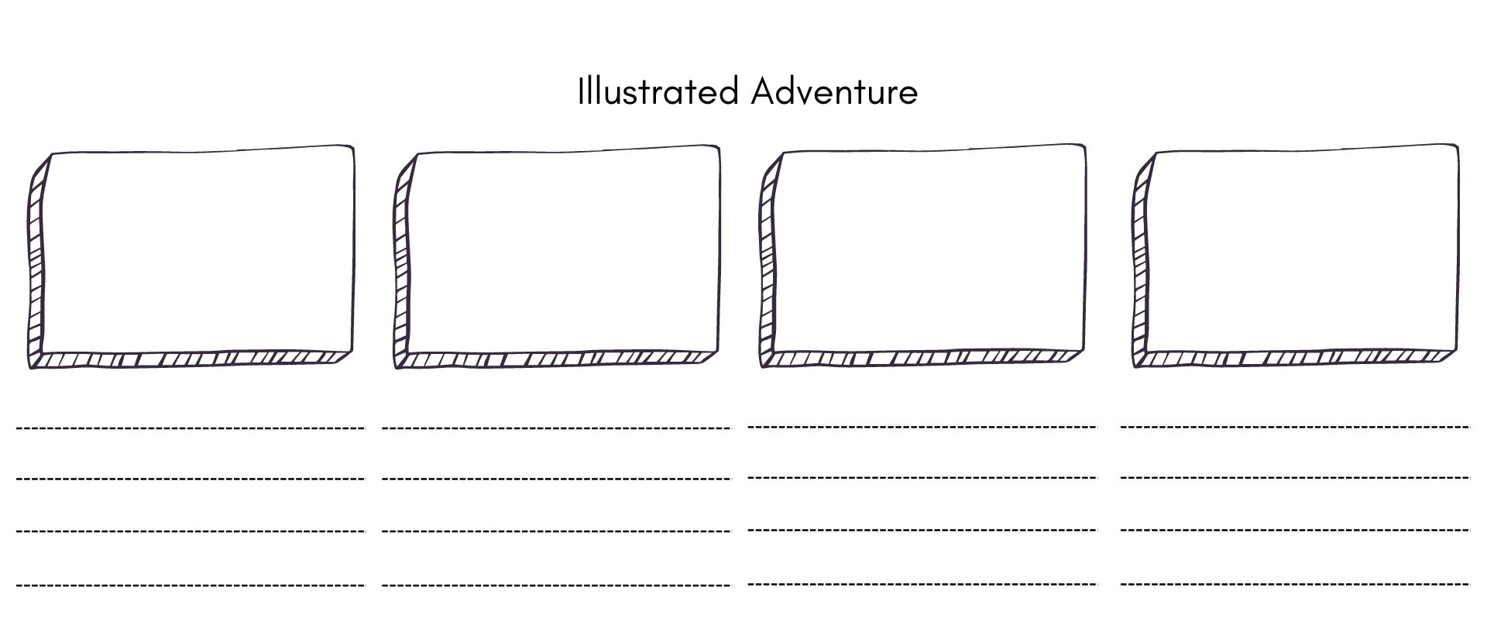

Resource 6: Model 2 – Illustrated adventure
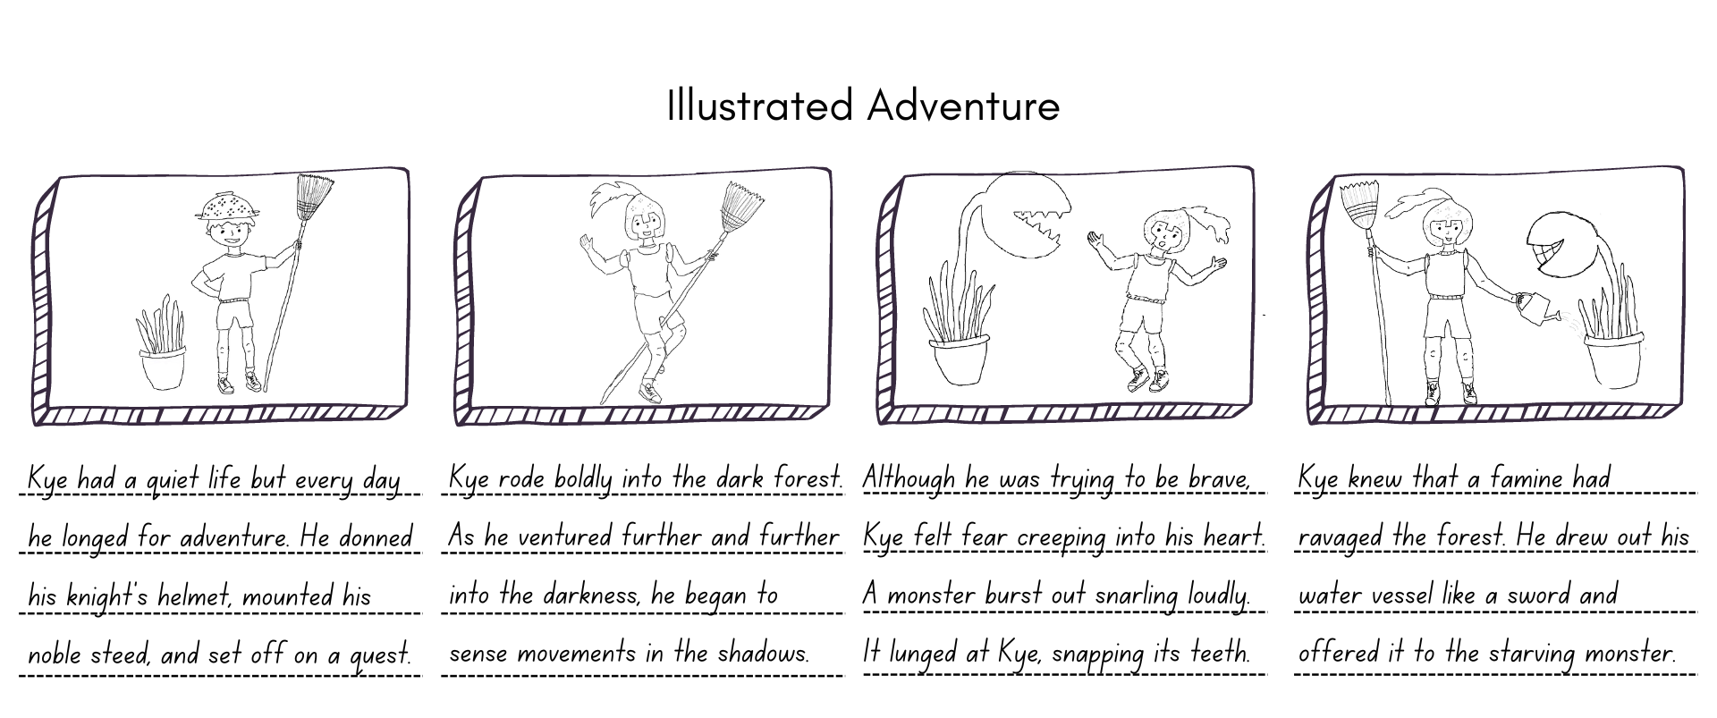
Images sourced from Canva and used in accordance with the Canva Content License Agreement.

Resource 7: My unique context
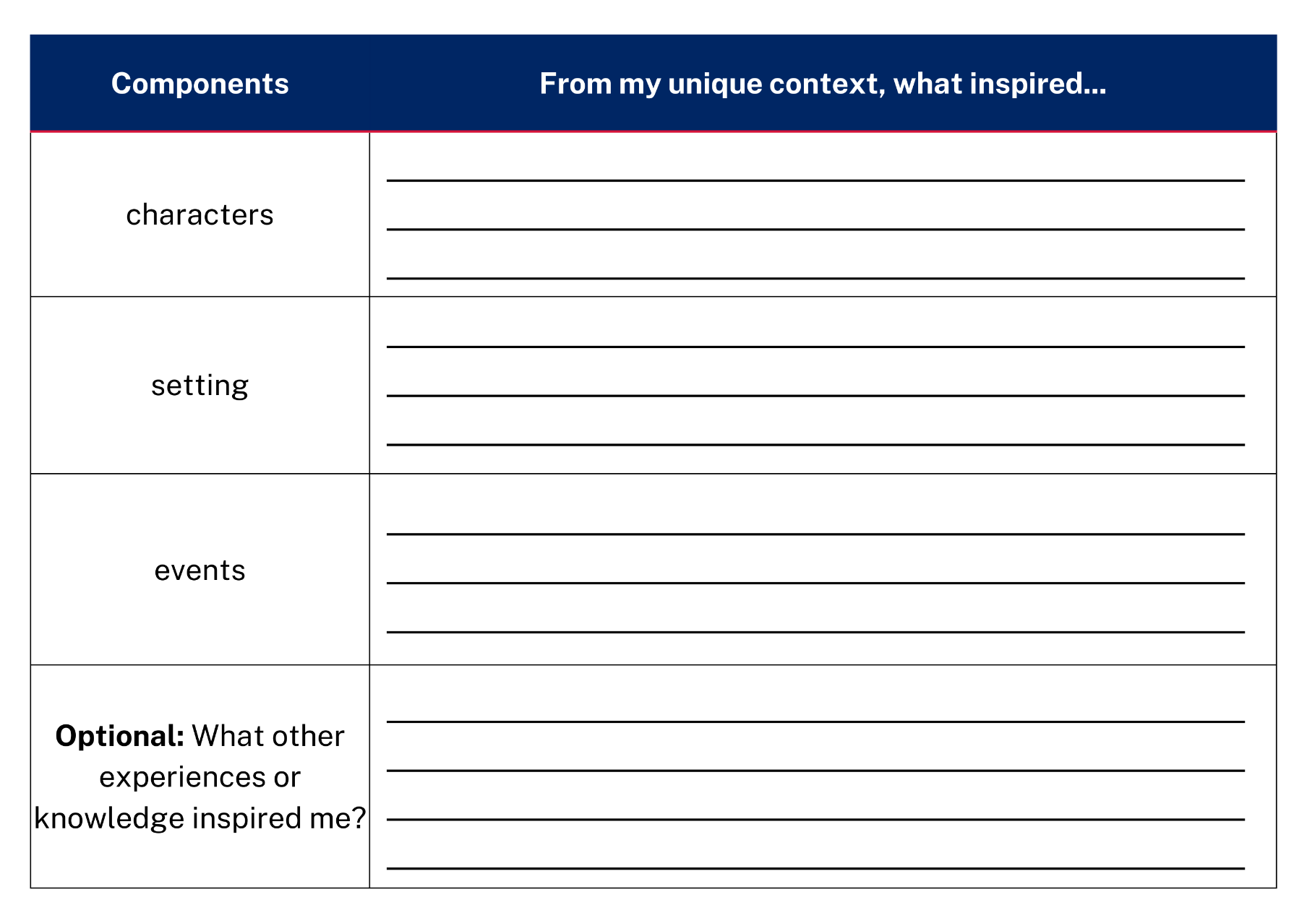

References
Links to third-party material and websites
Please note that the provided (reading/viewing material/list/links/texts) are a suggestion only and implies no endorsement, by the New South Wales Department of Education, of any author, publisher, or book title. School principals and teachers are best placed to assess the suitability of resources that would complement the curriculum and reflect the needs and interests of their students.
If you use the links provided in this document to access a third-party's website, you acknowledge that the terms of use, including licence terms set out on the third-party's website apply to the use which may be made of the materials on that third-party website or where permitted by the Copyright Act 1968 (Cth). The department accepts no responsibility for content on third-party websites.
Except as otherwise noted, all material is © State of New South Wales (Department of Education), 2023 and licensed under the Creative Commons Attribution 4.0 International License. All other material (third-party material) is used with permission or under licence. Where the copyright owner of third-party material has not licensed their material under a Creative Commons or similar licence, you should contact them directly for permission to reuse their material.
English K–10 Syllabus © 2022 NSW Education Standards Authority (NESA) for and on behalf of the Crown in right of the State of New South Wales.
© 2022 NSW Education Standards Authority. This document contains NSW Curriculum and syllabus content. The NSW Curriculum is developed by the NSW Education Standards Authority. This content is prepared by NESA for and on behalf of the Crown in right of the State of New South Wales. The material is protected by Crown copyright.
Please refer to the NESA Copyright Disclaimer for more information.
NESA holds the only official and up-to-date versions of the NSW Curriculum and syllabus documents. Please visit the NSW Education Standards Authority (NESA) website and the NSW Curriculum website.
National Literacy Learning Progression © Australian Curriculum, Assessment and Reporting Authority (ACARA) 2010 to present, unless otherwise indicated. This material was downloaded from the Australian Curriculum website (National Literacy Learning Progression) (accessed 9 February 2023) and was not modified. The material is licensed under CC BY 4.0. Version updates are tracked in the ‘Curriculum version history’ section on the 'About the Australian Curriculum' page of the Australian Curriculum website.
ACARA does not endorse any product that uses the Australian Curriculum or make any representations as to the quality of such products. Any product that uses material published on this website should not be taken to be affiliated with ACARA or have the sponsorship or approval of ACARA. It is up to each person to make their own assessment of the product, taking into account matters including, but not limited to, the version number and the degree to which the materials align with the content descriptions and achievement standards (where relevant). Where there is a claim of alignment, it is important to check that the materials align with the content descriptions and achievement standards (endorsed by all education Ministers), not the elaborations (examples provided by ACARA).
Beneba Clarke M (2016) The Patchwork Bike (Rudd VT, illus) Lothian Children’s Books, Australia.
ETA (English Teachers Association) and NSW Department of Education (2016) The Textual Concepts and Processes resource, English Textual Concepts website, accessed 9 February 2023.
Teece L (2017) Molly the Pirate (Seden P, illus) Magabala Books, Australia.

