English – K-2 multi-age – Year B – Unit 11
Contents
Unit overview and instructions for use 3
Teacher notes 4
Outcomes and content – Component A 5
Outcomes and content – Component B 9
Week 1 13
Component A teaching and learning 13
Component B teaching and learning 14
Lesson 1: Introduction to The Gruffalo Play 15
Lesson 2: Sequencing events using time connectives 18
Lesson 3: Exploring the features and structure of a play 21
Lesson 4: Using coordinating conjunctions to form compound sentences 24
Lesson 5: Introduction to Room on the Broom 27
Week 2 29
Component A teaching and learning 29
Component B teaching and learning 30
Lesson 6: Creating a class play 31
Lesson 7: Drafting and editing play scripts 33
Lesson 8: Writing to inform or persuade 35
Lesson 9: Enhancing the presentation of a play 37
Lesson 10: Performing a play 38
Resource 1: Story timeline 39
Resource 2: Script exemplar 40
Transcript of class exemplar 43
Resource 3: Script templates 46
Resource 4: Mask template 47
References 48

Unit overview and instructions for use
This two-week unit is comprised of Component A and Component B. Connecting learning across both components is encouraged.
Teaching and learning | Component A | Component B
Suggested duration | 60 minutes | 45 minutes
Explicit teaching focus areas | - Phonological awareness (Early Stage 1)  - Print conventions (Early Stage 1)  - Phonic knowledge  - Reading fluency  - Reading comprehension  - Spelling  - Handwriting | - Oral language and communication  - Vocabulary  - Reading comprehension  - Creating written texts  - Understanding and responding to literature
To prepare for teaching and learning: | - Refer to Outcomes and content – Component A, K-2 – Instructional sequence – grapheme–phoneme correspondences [PDF 825 KB], and the teaching advice documents (hyperlinked in Component A teaching and learning table).  - Based on student needs identified through ongoing assessment data, plan and document how you will sequence teaching and learning in whole class and targeted teaching groups across the two-week cycle. | - Familiarise yourself with Outcomes and content – Component B, Textual concepts information and videos, English Textual Concepts and Learning Processes (2016), and the teaching and learning sequence.  - Based on student needs identified through ongoing assessment data, determine how you will support students in whole class and targeted teaching groups across the two-week cycle as required.
English K–10 Syllabus © 2022 NSW Education Standards Authority (NESA) for and on behalf of the Crown in right of the State of New South Wales.

Teacher notes
- In this unit the students are provided with an opportunity to adapt the text Room on the Broom by creating their own class play to perform in front of an audience. Parents, students or community members could be invited to watch the class play.
- Context is the communication of information and ideas. It reflects aspects of the world. Context varies according to purpose and audience and the mode and medium through which it is delivered. – English Textual Concepts and Learning Processes (2016).
- Understanding of context can be supported through watching the department’s video: Context (5:24).
- While context is the mentor concept for the conceptual component of this unit, the supporting concept of narrative can be explored using the mentor text The Gruffalo Play by Julia Donaldson.
- For information on adjectives and compound sentences refer to the NESA Glossary.
- This unit could enhance student learning towards achievement of outcomes from the Creative Arts syllabus regarding drama.
- Consider prior student knowledge on compound sentences and coordinating conjunctions.
- Reflect on student learning and engagement in activities and record differentiation and adjustments within the unit to inform future teaching and learning. One way of doing this could be to add comments to the digital file.
- Content points are linked to the National Literacy Learning Progression version (3).
Levels and indicators sourced from National Literacy Learning Progression © Australian Curriculum, Assessment and Reporting Authority (ACARA), (accessed 23 January 2023) and was not modified. See references for more information.

Outcomes and content – Component A
The table below outlines the focus outcomes and content. Content is linked to the National Literacy Learning Progression version (3).
Early Stage 1 Focus area and outcome | Stage 1 Focus area and outcome
Phonological awareness  ENE-PHOAW-01 – identifies, blends, segments and manipulates phonological units in spoken words as a strategy for reading and creating texts  - identify the difference between a voiced phoneme and an unvoiced phoneme  - blend aloud all phonemes when asked to delete, add or substitute an initial phoneme (PhA5) | N/A
Print conventions  ENE-PRINT-01 – tracks written text from left to right and from top to bottom of the page and identifies visual and spatial features of print  - as needed | N/A
Phonic knowledge  ENE-PHOKW-01 – uses single-letter grapheme–phoneme correspondences and common digraphs to decode and encode words when reading and creating texts  - blend common single-letter grapheme–phoneme correspondences to read CCVC and CVCC words, and apply this when reading texts, including decodable texts (PKW5)  - segment common, single-letter grapheme–phoneme correspondences to encode CCVC and CVCC words (PKW5)  - decode and blend words containing consonant digraphs and apply this when reading texts, including decodable texts (PKW5)  - segment and encode CVC words containing consonant digraphs (PKW4, PKW5) | Phonic knowledge  EN1-PHOKW-01 – uses initial and extended phonics, including vowel digraphs, trigraphs to decode and encode words when reading and creating texts  - blend grapheme–phoneme correspondences to read CCVCC words, CCCVC words and CCCVCC words and apply this when reading texts (PKW7)  - segment and encode CCVCC words, CCCVC words and CCCVCC words and apply this when creating texts (SpG8)  - blend and decode one-syllable words with taught extended vowel graphs and digraphs, including graphemes for r-controlled vowels and diphthongs, and apply this when reading texts (PKW6, PKW7)  - decode words with less common consonant digraphs and apply this when reading texts  - decode words with trigraphs and quadgraphs and apply this when reading texts
Reading fluency  ENE-REFLU-01 – reads decodable texts aloud with automaticity  - read texts with taught grapheme–phoneme correspondences and taught high-frequency words with automaticity  - know that pace and expression vary when reading, according to the audience and purpose | Reading fluency  EN1-REFLU-01 – sustains reading unseen texts with automaticity and prosody and self-corrects errors  - read aloud with an easy speech rhythm (FlY3)  - vary pace when reading according to the audience and purpose (FlY4)
Reading comprehension  ENE-RECOM-01 – comprehends independently read texts using background knowledge, word knowledge and understanding of how sentences connect  - ask or pause to clarify meaning of unknown words (UnT3)  - re-read to check if an error was made  - ask a question or make a statement to clarify meaning (UnT3, UnT4)  - recount the relevant ideas from the text (UnT5) | Reading comprehension  EN1-RECOM-01 – comprehends independently read texts that require sustained reading by activating background and word knowledge, connecting and understanding sentences and whole text, and monitoring for meaning  - register a break in comprehension when reading (UnT5)  - make text-to-self, text-to-text or text-to-world connections when reading (UnT6)  - use visual and/or auditory features in multimodal texts to build meaning (UnT5)
Spelling  ENE-SPELL-01 – applies phonological, orthographic and morphological generalisations and strategies to spell taught familiar and high-frequency words when creating texts  - know that words do not usually end with the letter v, and that ve is commonly used  - spell high-frequency compound words and homophones comprising taught graphemes | Spelling  EN1-SPELL-01 – applies phonological, orthographic and morphological generalisations and strategies when spelling words in a range of writing contexts  - segment single-syllable words into phonemes as a strategy for spelling (SpG4)  - segment multisyllabic words into syllables and phonemes as a strategy for spelling (SpG5)  - spell high-frequency base words with taught vowel graphs, digraphs, split digraphs, trigraphs and quadgraphs (SpG6)  - use extended phonic code for taught consonant phonemes  - use common prefixes such as un–, re– and dis– (SpG9)
Handwriting  ENE-HANDW-01 – produces all lower-case and upper-case letters to create texts  - use a stable posture when handwriting or drawing by sitting comfortably with feet flat on the floor, the writing arm resting on a table, with the opposite hand resting on the paper, and shoulders relaxed | Handwriting  EN1-HANDW-01 – uses a legible, fluent and automatic handwriting style, and digital technology, including word-processing applications, when creating texts  - use taught software functions to create texts in a range of modes for different contexts, audiences and purposes

Outcomes and content – Component B
The table below outlines the focus outcomes and content. Content is linked to the National Literacy Learning Progression version (3).
Early Stage 1 Focus area and outcome | Stage 1 Focus area and outcome
Oral language and communication  ENE-OLC-01 – communicates effectively by using interpersonal conventions and language with familiar peers and adults  - recognise how nonverbal language can contribute to meaning in spoken communication (LiS3)  - use connectives such as and, but and because when speaking (SpK2)  - tell a story or information to peers or adults using oral language (SpK3) | Oral language and communication  EN1-OLC-01 – communicates effectively by using interpersonal conventions and language to extend and elaborate ideas for social and learning interactions  - understand that oral language can be used in combination with nonverbal communication  - adapt a narrative for a particular audience
Vocabulary  ENE-VOCAB-01 – understands and effectively uses Tier 1 words and Tier 2 words in familiar contexts  - use vocabulary to select, match and provide categories for groups of images or words | Vocabulary  EN1-VOCAB-01 – understands and effectively uses Tier 1, taught Tier 2 and Tier 3 vocabulary to extend and elaborate ideas  - understand and intentionally choose subject-specific vocabulary to enhance precision and for effect
Reading comprehension  ENE-RECOM-01 – comprehends independently read texts using background knowledge, word knowledge and understanding of how sentences connect  - identify conjunctions in a compound sentence, their meaning and purpose  - recount the relevant ideas from the text (UnT5) | Reading comprehension  EN1-RECOM-01 – comprehends independently read texts that require sustained reading by activating background and word knowledge, connecting and understanding sentences and whole text, and monitoring for meaning  - identify how creative visual features are used to expand meaning  - make text-to-self, text-to-text or text-to-world connections when reading (UnT6)  - use visual and/or auditory features in multimodal texts to build meaning (UnT5)
Creating written texts  ENE-CWT-01 – creates written texts that include at least 2 related ideas and correct simple sentences  - identify and use time connectives to sequence information and events (GrA4)  - sequence ideas in a text (GrA4)  - include recognisable structural features for text purpose (CrT5)  - experiment with writing compound sentences and recognise that each clause makes meaning by itself (GrA4)  - identify different purposes for writing (CrT4)  - understand they can improve their writing based on feedback from teachers | Creating written texts  EN1-CWT-01 – plans, creates and revises texts written for different purposes, including paragraphs, using knowledge of vocabulary, text features and sentence structure  - use a logical order to sequence ideas and events in sentences across a text (GrA4)  - use visual elements to expand meaning in own texts  - write compound sentences using coordinating conjunctions (GrA4, CrT5)  - use knowledge of similarities and differences between imaginative, informative and persuasive texts when planning for writing  - use different modes and media to enhance the presentation of texts they have created (CrT5, CrT6)
Understanding and responding to literature  ENE-UARL-01 – understands and responds to literature read to them  - identify texts that are composed for specific audiences and purposes  - identify and contrast features of texts that inform, persuade and/or entertain (UnT5)  - create imaginative and/or informative texts relating to their own experience, the world and/or other text (CrT3) | Understanding and responding to literature  EN1-UARL-01 – understands and responds to literature by creating texts using similar structures, intentional language choices and features appropriate to audience and purpose  - recognise ways that settings and situations are represented within texts  - create and re-create texts in a range of modes and media using understanding of context (CrT5)  - identify how the language and form of a text vary according to purpose, audience and mode (UnT5)  - adapt a well-known text for a different audience and/or purpose

Week 1

Component A teaching and learning
The table below can be used to plan and document lessons that address Component A outcomes and content. Both the detailed example [DOC 529KB] of a two-week teaching and learning cycle and brief example [DOC 66KB] may support you in your planning.
Focus Areas | Lesson 1 | Lesson 2 | Lesson 3 | Lesson 4 | Lesson 5
Phonological awareness (Early Stage 1) and Phonic knowledge
15 minutes
Spelling and Handwriting
15 minutes
Print conventions (Early Stage 1), Reading comprehension and Reading fluency
30 minutes

Component B teaching and learning
The following teaching and learning sequence has been designed to address Component B outcomes and content. Adapt the sequence as required to best meet the needs of your students.

Learning intention and success criteria
Learning intentions and success criteria are best co-constructed with students. The table below contains suggested learning intentions and success criteria.
Element | Early Stage 1 | Stage 1
Learning intentions | Students are learning to respond to literature read to them and identify that texts that are composed for specific audiences and purposes. | Students are learning to identify how the language and form of a text vary according to purpose, audience and mode.
Success criteria | Students can:  - identify vocabulary to match images  - identify the purpose of a text and who the audience might be  - use time connectives to sequence information and events  - experiment with saying and writing compound sentences. | Students can:  - understand and intentionally choose subject-specific vocabulary to enhance precision and for effect  - recognise ways that settings and situations are represented within texts  - identify how creative visual features are used to expand meaning  - use a logical order to sequence ideas and events  - write compound sentences using coordinating conjunctions.

Resources
- Donaldson J (2014) The Gruffalo Play (Scheffler A, illus), Macmillan Children’s Books, Australia. ISBN: 9781447243090
- Donaldson J (2016) Room on the Broom (Scheffler A, illus), Macmillan Children’s Books, Australia. ISBN: 9781509804771
- Donaldson J (2016) The Gruffalo (Scheffler A, illus), Macmillan Children’s Books, Australia. ISBN: 9781509804757
- Resource 1: Story timeline
- Storyboard
- Venn diagram
- Enlarged illustrated pages with the script covered from The Gruffalo Play
- Modelling clay

Lesson 1: Introduction to The Gruffalo Play
The following teaching and learning activities support multi-age settings.

Whole
- Introduce The Gruffalo Play. Draw attention to the word ‘play’ on the front cover. Ask students what they think ‘play’ means in this context. Support the idea that a play is an imaginative text, intended to entertain through dramatisation. Ask students to consider how they think the play will be different or the same to the original text.
- Ask students if they are familiar with The Gruffalo story and to share what they know about the text, such as recalling events and characters.
- Introduce the term ‘setting’ and ask students to describe what they know about this word. Explain that the setting is an important feature of an imaginative text. It influences the storyline, illustrations, characters and vocabulary selected by the author. If students are familiar with the text, ask them to describe where the story takes place, otherwise explain that it is set in the deep dark wood.
- Play a vocabulary word association game for the setting of the text (the deep dark wood). In small groups, students form a circle and take turns saying words associated with the woods. For example, large rocks, thick trees, running water, animals.
- Create an anchor chart with the heading ‘The Wood’. Ask students to share words they contributed during the game in activity 4. Record students’ responses as labelled illustrations, which can be used to support independent writing.
- Read The Gruffalo Play. Briefly discuss the text, focussing on the illustrations and language used to represent the setting.
- Revisit the anchor chart and confirm subject-specific words on the chart that are also in the text. Add other setting associated words to the chart, using the text and illustrations. Highlight that settings can be represented through words and images and reflect on the range of vocabulary.
- Model using up to 3 words from the chart to write a short text that clearly describes the setting in The Gruffalo Play. For example, The Gruffalo Play is set in the deep dark wood with tall trees and a long, windy path. There are scary animals and a large lake.
- Students draw an illustration of the ‘deep dark wood’ depicted in the text. Students then independently write a description of the setting using the chart and other words on display for precision and effect.
Too hard? Students draw an illustration of the ‘deep dark wood’ and label it with subject-specific words from the chart.
Too easy? Students write a descriptive paragraph about their illustration.
Early Stage 1 Assessment task 1 – Observations and work samples from this lesson allow students to demonstrate achievement towards the following syllabus outcome and content point:
ENE-VOCAB-01 – understands and effectively uses Tier 1 words and Tier 2 words in familiar contexts
- use vocabulary to select, match and provide categories for groups of images or words.
Stage 1 Assessment task 1 – Observations and work samples from this lesson allow students to demonstrate achievement towards the following syllabus outcomes and content points:
EN1-VOCAB-01 – understands and effectively uses Tier 1, taught Tier 2 and Tier 3 vocabulary to extend and elaborate ideas
- understand and intentionally choose subject-specific vocabulary to enhance precision and for effect.
EN1-UARL-01 – understands and responds to literature by creating texts using similar structures, intentional language choices and features appropriate to audience and purpose
- recognise ways that settings and situations are represented within texts.

Lesson 2: Sequencing events using time connectives
The following teaching and learning activities support multi-age settings.

Whole
- Remind students that The Gruffalo Play is a rendition of the original text The Gruffalo.
- Introduce and read the original text The Gruffalo. After reading, ask students to identify the sequence of events in the story. Display a storyboard template and jointly sequence the events.
- Using the storyboard as a reference, prompt students to make text-to-text connections by comparing the sequence of events in both texts.
- Guide students to understand how both texts tell the same story, are set in the wood and have the same characters and sequence of events. Highlight the different features and structures across both texts. Compare 2 pages from each text and ask students to identify the differences. For example, The Gruffalo Play has stage instructions, speaking prompts, character icons and narrator, with punctuation for effect; the original text uses speech marks to indicate dialogue between the characters and other punctuation for effect.
- Explain that time connectives are words or phrases which are used to tell a reader when something has happened. Record a list of time connectives on the board, for example, ‘first’, ‘then’, ‘after that’. Revisit the storyboard. Ask students to identify where the time connectives could be placed on the storyboard to show order or sequence. Record student responses and model retelling the sequence of events using the suggested time connectives.
- Model writing a sequence of events from the story using time connectives. For example, ‘First, the little brown mouse met a cunning fox who tried to lure him into his underground house. Then, the clever mouse outsmarted the fox by saying he was meeting a Gruffalo who loved to eat “roasted fox”.’ Add any newly identified time connectives to the list from activity 5.

Part
The table below details the differentiated teaching and learning activities for each stage.
Early Stage 1 (teacher guided/pairs/independent) | Stage 1 (independent/pairs)
- Students draw 3 events from the story.  - Identify 3 time connectives, for example, ‘first’, ‘then’, ‘after’. Ensure these words are on display for students to access.  - In pairs, students orally retell the sequence of the chosen events using the suggested time connectives.  - Students write sentences to describe the 3 events, using the time connectives ‘first’, ‘then’ and ‘after’ to sequence them.  Too hard? Students draw 3 events from the story and label them with the time connectives ‘first’, ‘then’ and ‘after’. | - Students use the storyboard from activity 2 and time connectives list to write a short summary of The Gruffalo story, sequencing events in a logical order.  - In pairs, students compare their summaries and the time connectives they used to order events from the text.  Too hard? Limit the number of events to sequence and provide students with appropriate time connectives.

Whole
- In small groups, students perform an event from the story as a mime. Explain and model mime as a technique to convey a story and emotion using body movements and facial expressions.
- Groups take turns performing and guessing the scene of each other’s mimes.
Early Stage 1 Assessment task 2 – Observations and work samples from this lesson allow students to demonstrate achievement towards the following syllabus outcomes and content points:
ENE-OLC-01 – communicates effectively by using interpersonal conventions and language with familiar peers and adults
- recognise how nonverbal language can contribute to meaning in spoken communication
- tell a story or information to peers or adults using oral language.
ENE-RECOM-01 – comprehends independently read texts using background knowledge, word knowledge and understanding of how sentences connect
- recount the relevant ideas from the text.
ENE-CWT-01 – creates written texts that include at least 2 related ideas and correct simple sentences
- identify and use time connectives to sequence information and events
- sequence ideas in a text.
Stage 1 Assessment task 2 – Observations and work samples from this lesson allow students to demonstrate achievement towards the following syllabus outcomes and content points:
EN1-OLC-01 – communicates effectively by using interpersonal conventions and language to extend and elaborate ideas for social and learning interactions
- understand that oral language can be used in combination with nonverbal communication.
EN1-RECOM-01 – comprehends independently read texts that require sustained reading by activating background and word knowledge, connecting and understanding sentences and whole text, and monitoring for meaning
- make text-to-self, text-to-text or text-to-world connections when reading.
EN1-CWT-01 – plans, creates and revises texts written for different purposes, including paragraphs, using knowledge of vocabulary, text features and sentence structure
- use a logical order to sequence ideas and events in sentences across a text.

Lesson 3: Exploring the features and structure of a play
The following teaching and learning activities support multi-age settings.

Whole
- Remind students that texts are written for different audiences and purposes. Ask students who they think the intended audience of The Gruffalo Play is and to identify clues from the text that support their answers. In pairs, students turn and talk to share their responses.
- Support the idea that the play was written for young readers and to entertain an audience. Examples from the play that support this include:
- the cumulative nature of the story
- use of rhyme and repetition
- humour (words and pictures)
- the imaginative characters (talking animals and Gruffalo).
- Ask students (Stage 1) how the text might change if it was written for a different audience or purpose. Prompt them to consider the language used and form the text would take.
- Display an enlarged copy of a double page spread from The Gruffalo Play. Explore the text by annotating key structural features of the play and discuss how these features have a different purpose. For example:
- stage instructions – give information about when and how to enter/exit the stage
- speaking prompts – give information about how something is said
- character icons – indicate who is talking and in what order
- narrator – helps to tell the story
- dialogue – what the characters are saying. Note: Speech marks are not used in this format.
- descriptive language – adds detail and makes the play interesting, helps creates a picture in the audience’s mind.
- Display an illustrated page from The Gruffalo Play with the written text covered. Using the key features unpacked in activity 4, model writing a script to match the illustrations.
Early Stage 1 (teacher guided/small groups/independent) | Stage 1 (small groups/teacher guided)
- Provide students with different scenes or pages from The Gruffalo Play. Support students to re-create scenes using modelling clay or other materials. Students may use the layout and features of the play (character icons, illustrations, instructions and narration) to support them.  - Students write a short text describing the scene. For example, ‘The mouse met fox.’  Too hard? Students label the characters and objects in their models. | - Provide students with different scenes or pages (illustrations only) from The Gruffalo Play. Students create a script to expand on the meaning of the illustrations.  Too hard? Co-construct a script with students or complete as a whole class activity using one illustration.  Too easy? Students create an additional scene to The Gruffalo Play, for example, introducing a new animal character.
- In small groups, students take turns sharing their models and acting out their given scenes from the play.
Early Stage 1 Assessment task 3 – Observations and work samples from this lesson allow students to demonstrate achievement towards the following syllabus outcomes and content points:
ENE-CWT-01 – creates written texts that include at least 2 related ideas and correct simple sentences
- identify different purposes for writing.
ENE-UARL-01 – understands and responds to literature read to them
- identify texts that are composed for specific audiences and purposes.
Stage 1 Assessment task 3 – Observations and work samples from this lesson allow students to demonstrate achievement towards the following syllabus outcomes and content points:
EN1-RECOM-01 – comprehends independently read texts that require sustained reading by activating background and word knowledge, connecting and understanding sentences and whole text, and monitoring for meaning
- identify how creative visual features are used to expand meaning
- use visual and/or auditory features in multimodal texts to build meaning.
EN1-UARL-01 – understands and responds to literature by creating texts using similar structures, intentional language choices and features appropriate to audience and purpose
- identify how the language and form of a text vary according to purpose, audience and mode.

Lesson 4: Using coordinating conjunctions to form compound sentences
The following teaching and learning activities support multi-age settings.

Whole
- Co-construct a wall chart of coordinating conjunctions. Add a class definition, example sentences and drawings to support student understanding. Some examples of coordinating conjunctions could include ‘and’, ‘or’, ‘but’, ‘so’.
- To reinforce the idea of coordinating conjunctions, students will engage in an oral language game. Using the story of The Gruffalo, students relay parts of the text in order, using coordinating conjunctions to join ideas into compound sentences. This could be played in small groups or as a whole class. A student starts the game with a simple sentence, such as, ‘The little brown mouse walked through the deep, dark wood.’ The next student selects a coordinating conjunction for example, ‘and’. The subsequent player adds a second clause to the original sentence, for example, ‘he saw a cunning fox’. The group continues to build the story through the game using the same structure (clause 1 + coordinating conjunction + clause 2). Pause occasionally to reflect on the meaning and purpose of the conjunctions used.
- Revisit the text to show how ideas can be joined with a coordinating conjunction to form a compound sentence. For example, ‘The Gruffalo has wobbly knees. He has a wart on his nose.’ can become, ‘The Gruffalo has wobbly knees and he has a wart on his nose.’ Highlight the 2 independent clauses and coordinating conjunction, and that the independent clauses make sense by themselves.

Part
The table below details the differentiated teaching and learning activities for each stage.
Early Stage 1 (teacher guided/independent) | Stage 1 (independent/in pairs)
- Students draw and label the parts of a Gruffalo.  - Using their labelled drawings, students use simple sentences to orally describe the Gruffalo. Record some of these on the board. For example, ‘The Gruffalo has purple prickles. The Gruffalo has a black tongue.’  - Select 2 simple sentences written in activity 5 and model using ‘and’ to form a compound sentence. For example, ‘The Gruffalo has purple prickles and he has a black tongue.’ Ask students to identify the purpose of the conjunction ‘and’.  - Students use simple sentences from activity 5 to say and write a compound sentence using the coordinating conjunction ‘and’.  Too hard? Provide students with a sentence scaffold to complete. For example, ‘The Gruffalo has _ and he _.’  Too easy? Students experiment with writing compound sentences using a variety of coordinating conjunctions. | - Students write and illustrate compound sentences about the text using a range of coordinating conjunctions.  Too hard? Students write 2 simple sentences describing the Gruffalo then use a coordinating conjunction to form a compound sentence.
Early Stage 1 Assessment task 4 – Observations and work samples from this lesson allow students to demonstrate achievement towards the following syllabus outcomes and content points:
ENE-OLC-01 – communicates effectively by using interpersonal conventions and language with familiar peers and adults
- use connectives such as and, but and because when speaking.
ENE-RECOM-01 – comprehends independently read texts using background knowledge, word knowledge and understanding of how sentences connect
- identify conjunctions in a compound sentence, their meaning and purpose.
ENE-CWT-01 – creates written texts that include at least 2 related ideas and correct simple sentences
- experiment with writing compound sentences and recognise that each clause makes meaning by itself.
Stage 1 Assessment task 4 – Observations and work samples from this lesson allow students to demonstrate achievement towards the following syllabus outcome and content point:
EN1-CWT-01 – plans, creates and revises texts written for different purposes, including paragraphs, using knowledge of vocabulary, text features and sentence structure
- write compound sentences using coordinating conjunctions.

Lesson 5: Introduction to Room on the Broom
The following teaching and learning activities support multi-age settings.

Whole
- Introduce and read Room on the Broom. In Week 2, students will co-create a class play with cumulative structure similar to this text.
- Ask students to identify similarities and differences between The Gruffalo Play and Room on the Broom. Focus the discussion on identifying the audience, purpose and features and structure of the texts. Record student responses on an enlarged Venn diagram. Draw attention to the cumulative nature of both texts and what the purpose and impact this has.
- Review learning about coordinating conjunctions by identifying some coordinating conjunctions in Room on the Broom.
- Model illustrating and writing compound sentences to describe a scene from Room on the Broom. For example, draw the dragon scene from Room on the Broom. ‘The ferocious dragon blew fire from his mouth and the witch shivered with fear.’

Part
The table below details the differentiated teaching and learning activities for each stage.
Early Stage 1 (teacher guided/independent) | Stage 1 (pairs)
- Display a page or scene from Room on a Broom.  - Ask students to describe the scene. Record initial ideas as simple sentences, explicitly modelling that each simple sentence is a complete thought. Invite students to provide further simple sentences.  - Model joining 2 recorded sentences with a coordinating conjunction to form a compound sentence.  - Students experiment with writing compound sentences using the recorded sentences from activity 7 and simple conjunctions from the chart created in Lesson 4. | - Pair students and allocate each pair a scene from Room on the Broom (all scenes need to be allocated including the ending). Pairs discuss and describe the scene.  - Students draw an illustration of their allocated scene and label it with key words that describe it.  - Students use the words to orally form short simple sentences about the scene they have selected and illustrated. They then practice joining 2 sentences at a time, using conjunctions from the chart created in Lesson 4.  - Students write compound sentences to describe their allocated scene.  - All students work together to sequence their scene in the correct order on a timeline. For an example on how to construct a timeline, refer to Resource 1: Story timeline.

Whole
- Stage 1 students retell the story, reading aloud their sequenced scenes to the class.

Week 2

Component A teaching and learning
The table below can be used to plan and document lessons that address Component A outcomes and content. Both the detailed example [DOC 529KB] of a two-week teaching and learning cycle and brief example [DOC 66KB] may support you in your planning.
Focus Areas | Lesson 6 | Lesson 7 | Lesson 8 | Lesson 9 | Lesson 10
Phonological awareness (Early Stage 1) and Phonic knowledge
15 minutes
Spelling and Handwriting
15 minutes
Print conventions (Early Stage 1), Reading comprehension and Reading fluency
30 minutes

Component B teaching and learning
The following teaching and learning sequence has been designed to address Component B outcomes and content. Adapt the sequence as required to best meet the needs of your students.

Learning intention and success criteria
Learning intentions and success criteria are best co-constructed with students. The table below contains suggested learning intentions and success criteria.
Element | Early Stage 1 | Stage 1
Learning intentions | Students are learning to create imaginative and/or informative texts relating to their own experience, the world and/or other texts and communicate it to an audience. | Students are learning to understand and respond to literature by creating texts using similar structures, intentional language choices and features appropriate to audience and purpose.
Success criteria | Students can:  - experiment with writing using specific text structures  - communicate using nonverbal language  - tell a story or information to peers or adults using oral language. | Students can:  - adapt a narrative for a particular audience  - use visual elements to expand meaning in own texts  - identify how the language and form of a text vary according to purpose, audience and mode  - understand that oral language can be used in combination with nonverbal communication.

Resources
- Donaldson J (2014) The Gruffalo Play (Scheffler A, illus), Macmillan Children’s Books, Australia. ISBN: 9781447243090
- Donaldson J (2016) Room on the Broom (Scheffler A, illus), Macmillan Children’s Books, Australia. ISBN: 9781509804771
- Resource 2: Script exemplar
- Resource 3: Script Template
- Resource 4: Mask template
- Video: Room on the Broom – Live on Stage Australia (1:54)
- Video: House Play You’re a Producer! Episode 6 (4:01)
- Materials and resources for props and costume
- Poster paper

Lesson 6: Creating a class play
The following teaching and learning activities support multi-age settings.

Whole
- Explain that students will create a play using the same cumulative structure as Room on the Broom. They will develop new characters who will drop and pick up items, just like in the text.
- Revisit Room on the Broom and remind students how the witch drops an item, flies down to retrieve it and encounters a new animal who helps her. Refer to Resource 2: Script exemplar for an idea of the characters, setting and sequence of events that students could come up with for the class play.
- As a class, agree on a main character and the mode of transport the character will fly on. For example, ‘Grandma and her cat on their way to a birthday party are travelling on a flying bike.’
- As a class, brainstorm and record a list of items that the main character might be carrying. For example, presents, party hats, balloons, candles, glasses, a handbag and a box of cupcakes.
- Ask students to imagine their main character is flying in their local area, record a list of possible local landmarks that could be used in the class play.
- Create a class list using student ideas and decide on other characters to include in the class play. The number of characters needed will depend on the class size. Ensure that all students have a role to play.
- Divide the class into small, mixed-ability groups. Each group will write the script for and act out a scene of the class play.
- Provide each group with planning paper to allocate the character roles and record the events for their scene. On the planning sheet, students draw and label the scene and characters using key words and descriptive language.
Too hard? Students work with the teacher to draw and label the scene in the class play.
Too easy? Students write sentences describing the scene in the class play.
- As a class, co-construct a class play timeline using student ideas, similar to the story timeline created in Lesson 5. Discuss and decide on the order of the scenes. Place the scenes on the class play timeline. The timeline will be used as a plan to support students as they write the play.

Lesson 7: Drafting and editing play scripts
The following teaching and learning activities support multi-age settings.

Whole
- Revisit The Gruffalo Play.
- Display a section of Resource 2: Script exemplar to identify the features a script.
- Explain that each group will use their planning from Lesson 6 to write a script for their scene of the class play.
- Co-construct a success criteria to guide student writing for their scene of the class play. For example, students can:
- use a character or narrator image to illustrate who is talking and in what order
- include what the narrator will say to help tell the story
- use dialogue to tell us what the characters are saying
- add stage directions for the performers
- use descriptive language to add detail and make the play interesting.
- Use the blank section of Resource 3: Script templates to model how to write a script using the same structure as The Gruffalo Play.
- Provide each group with a copy of Resource 3: Script templates. Using their plans from Lesson 6 students write a script for their scene of the class play.
- Allow students to practise rehearsing their script. While groups are engaging in this, work with each group to individually provide feedback on their script, which students use to improve their writing.
- As a class, compile the scripts to write a complete class play, adding an introduction and/or conclusion as needed.
Early Stage 1 Assessment task 5 – Observations and work samples from this lesson allow students to demonstrate achievement towards the following syllabus outcomes and content points:
ENE-CWT-01 – creates written texts that include at least 2 related ideas and correct simple sentences
- include recognisable structural features for text purpose
- understand they can improve their writing based on feedback from teachers.
ENE-UARL-01 – understands and responds to literature read to them
- create imaginative and/or informative texts relating to their own experience, the world and/or other text.
Stage 1 Assessment task 5 – Observations and work samples from this lesson allow students to demonstrate achievement towards the following syllabus outcomes and content points:
EN1-OLC-01 – communicates effectively by using interpersonal conventions and language to extend and elaborate ideas for social and learning interactions
- adapt a narrative for a particular audience.
EN1-CWT-01 – plans, creates and revises texts written for different purposes, including paragraphs, using knowledge of vocabulary, text features and sentence structure
- use visual elements to expand meaning in own texts
- use different modes and media to enhance the presentation of texts they have created.
EN1-UARL-01 – understands and responds to literature by creating texts using similar structures, intentional language choices and features appropriate to audience and purpose
- create and re-create texts in a range of modes and media using understanding of context
- identify how the language and form of a text vary according to purpose, audience and mode
- adapt a well-known text for a different audience and/or purpose.

Lesson 8: Writing to inform or persuade
The following teaching and learning activities support multi-age settings.

Whole
- Rehearse the class play.
- Remind students that the class play will be performed for an audience, such as another class, parents or other members of the school community.
- Ask students about events they have attended, such as the movies, plays or parties how the event organisers informed them of this. Some ideas could include invitations, posters, email or other social media platforms.
- Ask students how they could advertise and inform the school community about their class play. View House Play You’re a Producer! Episode 6 (4:01) to elicit student ideas for creating a poster to advertise the class play.
- Explain that the purpose of their poster will be to persuade and inform people to come to the class play. It will provide information about the play such as when it is on, where it will be shown, what it is about and who is performing.
- Brainstorm what the class play poster should include. For example:
- an engaging title – to persuade people to attend
- use of bright colours – to catch people’s attention
- performance details – time, place, performers, title and a synopsis of the play
- price – FREE.
- Students work in pairs or small mixed-ability groups to design a persuasive and informative poster for the class play.
- Share posters with the class and place them around the school.
Early Stage 1 Assessment task 6 – Observations and work samples from this lesson allow students to demonstrate achievement towards the following syllabus outcome and content points:
ENE-UARL-01 – understands and responds to literature read to them
- identify texts that are composed for specific audiences and purposes
- identify and contrast features of texts that inform, persuade and/or entertain
- create imaginative and/or informative texts relating to their own experience, the world and/or other text.
Stage 1 Assessment task 6 – Observations and work samples from this lesson allow students to demonstrate achievement towards the following syllabus outcomes and content points:
EN1-CWT-01 – plans, creates and revises texts written for different purposes, including paragraphs, using knowledge of vocabulary, text features and sentence structure
- use knowledge of similarities and differences between imaginative, informative and persuasive texts when planning for writing.
EN1-UARL-01 – understands and responds to literature by creating texts using similar structures, intentional language choices and features appropriate to audience and purpose
- create and re-create texts in a range of modes and media using understanding of context.

Lesson 9: Enhancing the presentation of a play
The following teaching and learning activities support multi-age settings.

Whole
- View the Room on the Broom – Live on Stage Australia (1:54). Discuss the performance and the visual and auditory elements that make the performance effective. For example, costumes, props, music, sound and voice.
- In groups, students discuss simple props and costumes they could create to enhance the presentation of their scene in the class play. Students design, draw and label these.
- Provide students with a range of resources, such as dress ups and craft material make their props and costumes. Resource 4: Mask template could be used for students to make character masks.
- Revisit Room on the Broom – Live on Stage Australia (1:54) and pause the video at different points where the performers are conveying emotion through body language or voice. For example, at 0:43 when the cat folds her arms and frowns while saying ‘there’s no room’.
- Ask students to choose an emotion, such as happy, angry sad, excited, angry or surprised. Model how to portray this emotion using body language, facial expression and voice intonation. For example, show being angry by placing arms on hips and stomping nosily with an angry facial expression.
- In small groups, students practise conveying different emotions using body language, facial expression and voice intonation. Students take turns acting and guessing the emotion being portrayed.
- Allow students to practise acting out their scenes from the class play they created using the props and costumes they created, and the skills practised in activity 5. Provide students the opportunity to give and receive feedback on each other’s performances.
- Rehearse the class play.

Lesson 10: Performing a play
The following teaching and learning activities support multi-age settings.

Whole
- Rehearse the class play.
- Students perform the class play in front of an audience.
- Use exit tickets to reflect on what students have learnt about texts (that entertain, inform and persuade) and how they can adapt texts using different modes and media using their understanding of context.

Resource 1: Story timeline
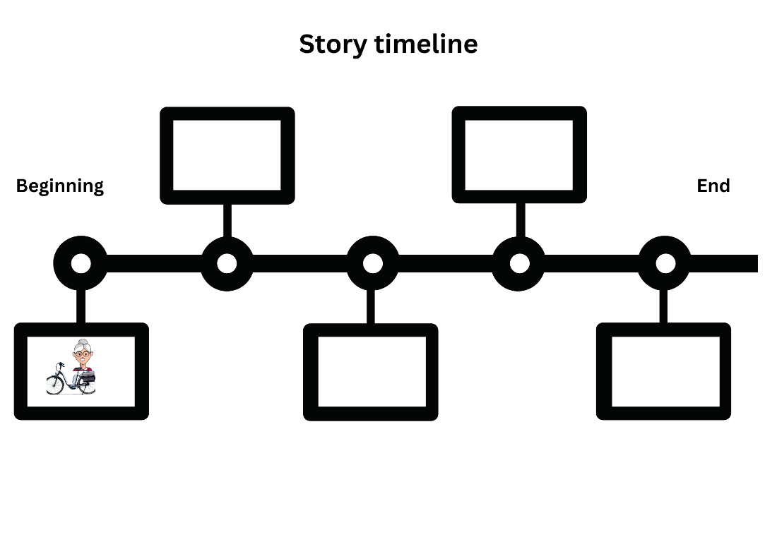
Images sourced from Canva and used in accordance with the Canva Content License Agreement.

Resource 2: Script exemplar
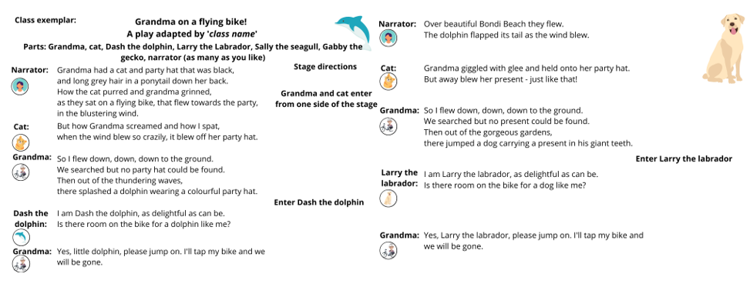
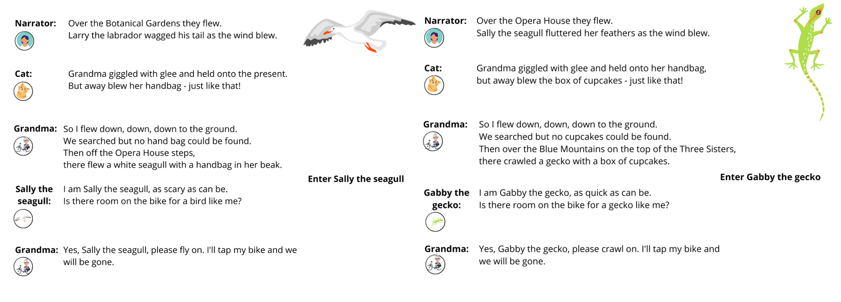
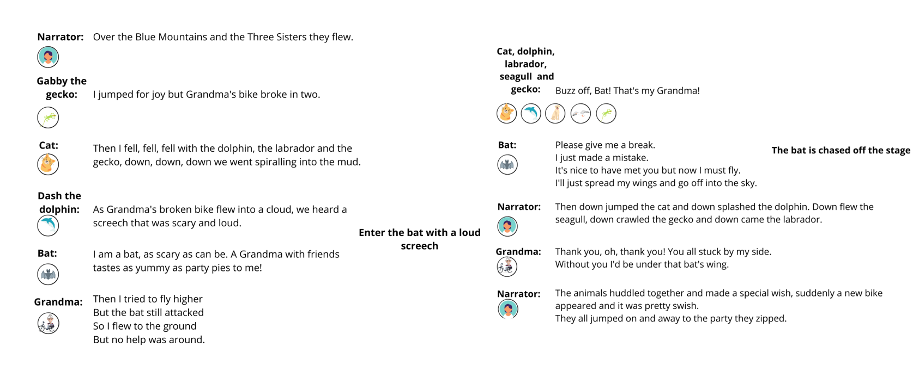
Images sourced from Canva and used in accordance with the Canva Content License Agreement.

Transcript of class exemplar

Grandma on a flying bike! A play adapted by ‘class name’.
Parts: Grandma, cat, Dash the dolphin, Larry the Labrador, Sally the seagull, Gabby the gecko, narrator (as many as you like)
Stage directions: Grandma and cat enter from one side of the stage.
Narrator: Grandma had a cat and party hat that was black, and long grey hair in a ponytail down her back. How the cat purred and grandma grinned, as they sat on a flying bike, that flew towards the party, in the blustering wind.
Cat: But how Grandma screamed and how I spat, when the wind blew so crazily, it blew off her party hat.
Grandma: So I flew down, down, down to the ground. We searched but no party hat could be found. Then out of the thundering waves, there splashed a dolphin wearing a colourful party hat.
Stage directions: Enter Dash the dolphin.
Dash the dolphin: I am Dash the dolphin, as delightful as can be. Is there room on the bike for a dolphin like me?
Grandma: Yes, little dolphin, please jump on. I’ll tap my bike and we will be gone.
Narrator: Over beautiful Bondi Beach they flew. The dolphin flapped its tail as the wind blew.
Cat: Grandma giggled with glee and held onto her party hat. But away blew her present – just like that!
Grandma: So I flew down, down, down to the ground. We searched but no present could be found. Then out of the gorgeous gardens, there jumped a dog carrying a present in his giant teeth.
Stage directions: Enter Larry the labrador.
Larry the labrador: I am Larry the labrador, as delightful as can be. Is there room on the bike for a dog like me?
Grandma: Yes, Larry the labrador, please jump on. I’ll tap my bike and we will be gone.
Narrator: Over the Botanical Gardens they flew. Larry the labrador wagged his tail as the wind blew.
Cat: Grandma giggled with glee and held onto the present. But away blew her handbag – just like that!
Grandma: So I flew down, down, down to the ground. We searched but no handbag could be found. Then off the Opera House steps there flew a white seagull with a handbag in her beak.
Stage directions: Enter Sally the seagull.
Sally the seagull: I am Sally the seagull, as scary as can be. Is there room on the bike for a bird like me?
Grandma: Yes, Sally the seagull, please fly on. I’ll tap my bike and we will be gone.
Narrator: Over the Opera House they flew. Sally the seagull fluttered her feathers as the wind blew.
Cat: Grandma giggled with glee and held onto her handbag, but away flew the box of cupcakes – just like that!
Grandma: So I flew down, down, down to the ground. We searched but no cupcakes could be found. Then, over the Blue Mountains, on top of the Three Sisters, there crawled a gecko with a box of cupcakes.
Stage directions: Enter Gabby the gecko.
Gabby the gecko: I am Gabby the gecko, as quick as can be. Is there room on the bike for a gecko like me?
Grandma: Yes, Gabby the gecko, please crawl on. I’ll tap my bike and we will be gone.
Narrator: Over the Blue Mountains and the Three Sisters they flew.
Gabby the gecko: I jumped for joy but Grandma’s bike broke in two.
Cat: Then I fell, fell, fell with the dolphin, the labrador and the gecko, down, down, down we went spiralling into the mud.
Dash the dolphin: As Grandma’s broken bike flew into a cloud, we heard a screech that was scary and loud.
Stage directions: Enter the bat with a loud screech.
Bat: I am a bat, as scary as can be. A Grandma with friends tastes as yummy as party pies to me!
Grandma: Then I tried to fly higher, but the bat still attacked, so I flew to the ground, but no help was around.
Cat, dog, Labrador, seagull and gecko: Buzz off, Bat! That’s my Grandma!
Bat: Please give me a break, I just made a mistake. It’s nice to have met you, but now I must fly. I’ll just spread my wings and go off into the sky.
Stage directions: The bat is chased off the stage.
Narrator: Then, down jumped the cat and down splashed the dolphin. Down flew the seagull, down crawled the gecko and down came the labrador.
Grandma: Thank you, oh, thank you! You all stuck by my side. Without you I’d be under that bat’s wing.
Narrator: The animals huddled together and made a special wish. Suddenly a new bike appeared, and it was pretty swish. They all jumped on and away to the party they zipped.

Resource 3: Script templates
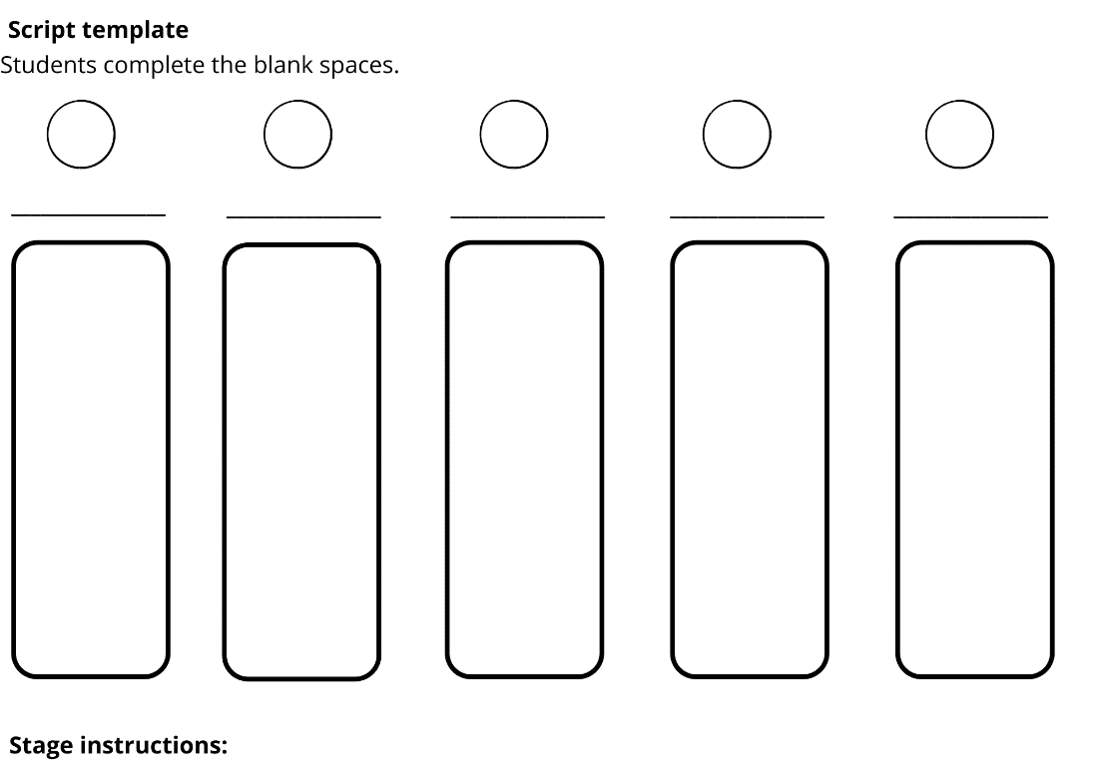

Resource 4: Mask template
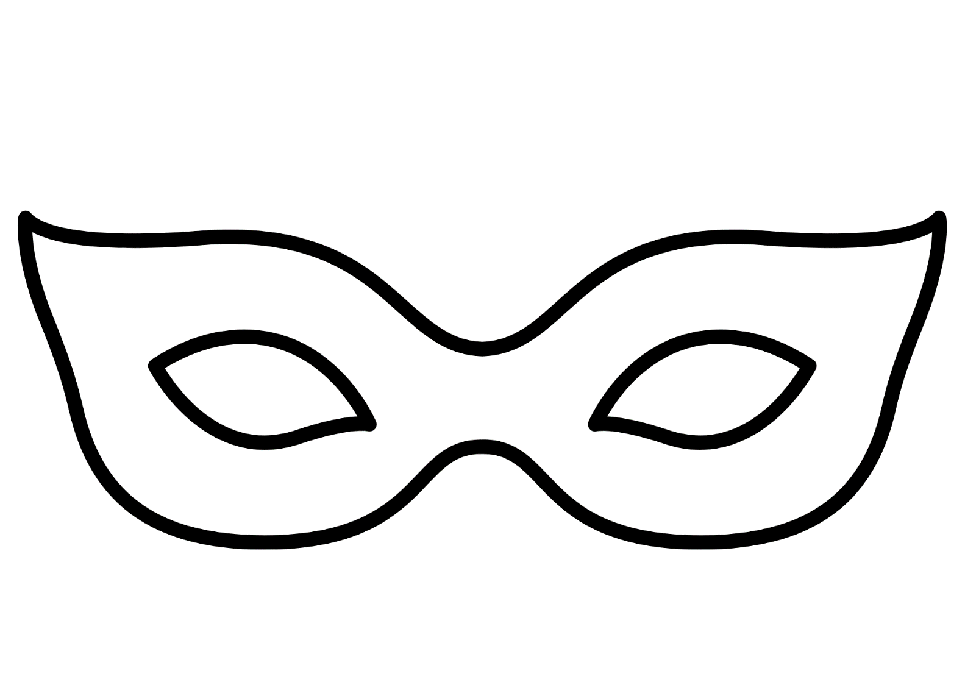
“Mask of Carnival Design” by grmarc is used accordance with the Canva Content Licence Agreement.

References
Links to third-party material and websites
Please note that the provided (reading/viewing material/list/links/texts) are a suggestion only and implies no endorsement, by the New South Wales Department of Education, of any author, publisher, or book title. School principals and teachers are best placed to assess the suitability of resources that would complement the curriculum and reflect the needs and interests of their students.
If you use the links provided in this document to access a third-party's website, you acknowledge that the terms of use, including licence terms set out on the third-party's website apply to the use which may be made of the materials on that third-party website or where permitted by the Copyright Act 1968 (Cth). The department accepts no responsibility for content on third-party websites.
Except as otherwise noted, all material is © State of New South Wales (Department of Education), 2023 and licensed under the Creative Commons Attribution 4.0 International License. All other material (third-party material) is used with permission or under licence. Where the copyright owner of third-party material has not licensed their material under a Creative Commons or similar licence, you should contact them directly for permission to reuse their material.
English K–10 Syllabus © 2022 NSW Education Standards Authority (NESA) for and on behalf of the Crown in right of the State of New South Wales.
Creative Arts K–6 Syllabus © 2006 NSW Education Standards Authority (NESA) for and on behalf of the Crown in right of the State of New South Wales.
© 2022 NSW Education Standards Authority. This document contains NSW Curriculum and syllabus content. The NSW Curriculum is developed by the NSW Education Standards Authority. This content is prepared by NESA for and on behalf of the Crown in right of the State of New South Wales. The material is protected by Crown copyright.
Please refer to the NESA Copyright Disclaimer for more information.
NESA holds the only official and up-to-date versions of the NSW Curriculum and syllabus documents. Please visit the NSW Education Standards Authority (NESA) website and the NSW Curriculum website.
National Literacy Learning Progression © Australian Curriculum, Assessment and Reporting Authority (ACARA) 2010 to present, unless otherwise indicated. This material was downloaded from the Australian Curriculum website (National Literacy Learning Progression) (accessed 23 January 2023) and was not modified. The material is licensed under CC BY 4.0. Version updates are tracked in the ‘Curriculum version history’ section on the 'About the Australian Curriculum' page of the Australian Curriculum website.
ACARA does not endorse any product that uses the Australian Curriculum or make any representations as to the quality of such products. Any product that uses material published on this website should not be taken to be affiliated with ACARA or have the sponsorship or approval of ACARA. It is up to each person to make their own assessment of the product, taking into account matters including, but not limited to, the version number and the degree to which the materials align with the content descriptions and achievement standards (where relevant). Where there is a claim of alignment, it is important to check that the materials align with the content descriptions and achievement standards (endorsed by all education Ministers), not the elaborations (examples provided by ACARA).
CDP Theatre Producers (n.d) 'Room on the Broom – Live on Stage Australia' [video], CDP Theatre Producers, CDP Kids website, accessed 23 January 2023.
Donaldson J (2014) The Gruffalo Play (Scheffler A, illus), Macmillan Children’s Books, Australia.
Donaldson J (2016) Room on the Broom (Scheffler A, illus), Macmillan Children’s Books, Australia.
Donaldson J (2016) The Gruffalo (Scheffler A, illus), Macmillan Children’s Books, Australia.
ETA (English Teachers Association) and NSW Department of Education (2016) The Textual Concepts and Processes resource, English Textual Concepts website, accessed 23 January 2023.
Sydney Opera House (28 June 2021) ‘House Play: You’re a Producer! | Episode 6’ [video], Sydney Opera House, YouTube, accessed 23 January 2023.

