English – K-2 multi-age – Year B – Unit 10
Contents
Unit overview and instructions for use 3
Teacher notes 4
Outcomes and content – Component A 5
Outcomes and content – Component B 9
Week 1 13
Component A teaching and learning 13
Component B teaching and learning 14
Lesson 1: Introduction to Iggy Peck Architect 15
Lesson 2: Identifying the features of an imaginative text and writing with nouns and verbs 17
Lesson 3: Using descriptive language in an imaginative text 19
Lesson 4: Identifying the structure and language features in an informative text 20
Lesson 5: Following and writing a set of instructions 24
Week 2 27
Component A teaching and learning 27
Component B teaching and learning 28
Lesson 6: Navigating texts to build background knowledge 29
Lesson 7: Designing and making a bridge 32
Lesson 8: Writing a set of instructions 34
Lesson 9: Following a set of instructions 38
Lesson 10: Editing and publishing informative texts 38
Resource 1: Build-a-bird template 40
Resource 2: Build-a-bird instructions – Early Stage 1 41
Resource 3: Build-a-bird instructions – Stage 1 42
Resource 4: Informative text – Bridges 43
Resource 5: What do you know about bridges? 44
Resource 6: Bridge design template 45
Resource 7: Informative text writing template 46
References 47

Unit overview and instructions for use
This two-week unit is comprised of Component A and Component B. Connecting learning across both components is encouraged.
Teaching and learning | Component A | Component B
Suggested duration | 60 minutes | 45 minutes
Explicit teaching focus areas | - Phonological awareness (Early Stage 1)  - Print conventions (Early Stage 1)  - Phonic knowledge  - Reading fluency  - Reading comprehension  - Spelling  - Handwriting | - Oral language and communication  - Vocabulary  - Reading comprehension  - Creating written texts  - Understanding and responding to literature
To prepare for teaching and learning: | - Refer to Outcomes and content – Component A, K-2 – Instructional sequence – grapheme–phoneme correspondences [PDF 825 KB], and the teaching advice documents (hyperlinked in Component A teaching and learning table).  - Based on student needs identified through ongoing assessment data, plan and document how you will sequence teaching and learning in whole class and targeted teaching groups across the two-week cycle. | - Familiarise yourself with Outcomes and content – Component B, Textual concepts information and videos, English Textual Concepts and Learning Processes (2016), and the teaching and learning sequence.  - Based on student needs identified through ongoing assessment data, determine how you will support students in whole class and targeted teaching groups across the two-week cycle as required.
English K–10 Syllabus © 2022 NSW Education Standards Authority (NESA) for and on behalf of the Crown in right of the State of New South Wales.

Teacher notes
- ‘Representation is the depiction of a thing, person, or idea in written, visual, performed or spoken language. It can reflect the natural world realistically or convey people, objects, experiences and ideas in a more abstract way’. – English Textual Concepts and Learning Processes (2016).
- Understanding of representation can be supported through watching the department’s video: Representation (2:46).
- ‘Context refers to factors acting upon composers and responders that affect meaning. To understand context, we look beyond the text to consider the world in which it was produced and the worlds of its reception. Different contexts can affect the meanings and values of similar content.’ – English Textual Concepts and Learning Processes (2016).
- Understanding of context can be supported through watching the department’s video: Context (5:24).
- This unit could enhance student learning towards achievement of outcomes from the Science and Technology syllabus regarding material world.
- Reflect on student learning and engagement in activities and record differentiation and adjustments within the unit to inform future teaching and learning. One way of doing this could be to add comments to the digital file.
- Content points are linked to the National Literacy Learning Progression version (3).
Levels and indicators sourced from National Literacy Learning Progression © Australian Curriculum, Assessment and Reporting Authority (ACARA), (accessed 5 December 2022) and was not modified. See references for more information.

Outcomes and content – Component A
The table below outlines the focus outcomes and content. Content is linked to the National Literacy Learning Progression version (3).
Early Stage 1 Focus area and outcome | Stage 1 Focus area and outcome
Phonological awareness  ENE-PHOAW-01 – identifies, blends, segments and manipulates phonological units in spoken words as a strategy for reading and creating texts  - listen to up to 4 words, indicate those that start with the same phoneme and say other words that start with that phoneme (PhA2)  - identify the difference between a voiced phoneme and an unvoiced phoneme (PhA5) | N/A
Print conventions  N/A | Print conventions  N/A
Phonic knowledge  ENE-PHOKW-01 – uses single-letter grapheme–phoneme correspondences and common digraphs to decode and encode words when reading and creating texts  - decode and blend words containing consonant digraphs and apply this when reading texts, including decodable texts (PKW5)  - segment and encode CVC words containing consonant digraphs (PKW4, PKW5). | Phonic knowledge  EN1-PHOKW-01 – uses initial and extended phonics, including vowel digraphs, trigraphs to decode and encode words when reading and creating texts  - blend and decode one-syllable words with taught extended vowel graphs and digraphs, including graphemes for r-controlled vowels and diphthongs, and apply this when reading texts (PKW6, PKW7)  - segment and encode one-syllable words with taught vowel graphs, digraphs and trigraphs and apply this when creating texts  - decode words with trigraphs and quadgraphs and apply this when reading texts  - blend and decode 2-syllable words with taught vowel graphs, digraphs, trigraphs and quadgraphs, including graphemes for r-controlled vowels and diphthongs and apply this when reading texts (PKW6, PKW7).
Reading fluency  ENE-REFLU-01 – reads decodable texts aloud with automaticity  - know that fluent reading involves recognising and reading words accurately and automatically  - stop at the end of a sentence in response to a full stop (FIY3). | Reading fluency  EN1-REFLU-01 – sustains reading unseen texts with automaticity and prosody and self-corrects errors  - read aloud with an easy speech rhythm (FlY3)  - vary pace when reading according to the audience and purpose (FlY4).
Reading comprehension  ENE-RECOM-01 – comprehends independently read texts using background knowledge, word knowledge and understanding of how sentences connect  - use known vocabulary to build a mental model of the content of a text  - recall the sequence of events/information in texts (UnT5). | Reading comprehension  EN1-RECOM-01 – comprehends independently read texts that require sustained reading by activating background and word knowledge, connecting and understanding sentences and whole text, and monitoring for meaning  - use known morphemes and known vocabulary in the text to work out or refine the meaning of unknown words (UnT4)  - register a break in comprehension when reading (UnT5)  - use information read in texts to enhance learning across key learning areas.
Spelling  ENE-SPELL-01 – applies phonological, orthographic and morphological generalisations and strategies to spell taught familiar and high-frequency words when creating texts  - combine phonological, phonic, orthographic and morphemic knowledge to spell taught high-frequency irregular words comprising up to 3 phonemes (SpG5)  - experiment with the tense-marking suffixes to spell familiar base verbs (SpG5). | Spelling  EN1-SPELL-01 – applies phonological, orthographic and morphological generalisations and strategies when spelling words in a range of writing contexts  - spell high-frequency base words with taught vowel graphs, digraphs, split digraphs, trigraphs and quadgraphs (SpG6)  - explain that the consonant trigraphs, –tch and –dge, can end a base word immediately following a short vowel and apply this when spelling.
Handwriting  ENE-HANDW-01 – produces all lower-case and upper-case letters to create texts  - use writing implements with a stable and relaxed pencil grasp (HwK2). | Handwriting  EN1-HANDW-01 – uses a legible, fluent and automatic handwriting style, and digital technology, including word-processing applications, when creating texts  - use word-processing program functions, including text-editing applications (HwK5).

Outcomes and content – Component B
The table below outlines the focus outcomes and content. Content is linked to the National Literacy Learning Progression version (3).
Early Stage 1 Focus area and outcome | Stage 1 Focus area and outcome
Oral language and communication  ENE-OLC-01 – communicates effectively by using interpersonal conventions and language with familiar peers and adults  - follow up to 3-part spoken instructions (LiS3)  - start a conversation with a peer and/or adult, staying on topic (InT3) | Oral language and communication  EN1-OLC-01 – communicates effectively by using interpersonal conventions and language to extend and elaborate ideas for social and learning interactions  - follow extended instructions that contain connectives and conjunctions (LiS5)  - use tense correctly to discuss past, present and future events
Vocabulary  ENE-VOCAB-01 – understands and effectively uses Tier 1 words and Tier 2 words in familiar contexts  - understand and use words to describe shape, size, texture, position, numerical order, time and seasons (SpK2, CrT5). | Vocabulary  N/A
Reading comprehension  ENE-RECOM-01 – comprehends independently read texts using background knowledge, word knowledge and understanding of how sentences connect  - understand that informative and imaginative texts have different structures, features and forms (UnT5)  - predict purpose, type of text or topic from title, illustration, image and/or form (UnT4)  - use visual cues in multimodal texts to interpret meaning (UnT5). | Reading comprehension  EN1-RECOM-01 – comprehends independently read texts that require sustained reading by activating background and word knowledge, connecting and understanding sentences and whole text, and monitoring for meaning  - combine multiple sources of information within a text to make meaning  - use navigation pathways, including hyperlinks, to extract essential information to support reading fluency and enhance meaning when reading digital texts  - use visual and/or auditory features in multimodal texts to build meaning (UnT5)  - confirm meaning by sequencing and explaining events and information.
Creating written texts  ENE-CWT-01 – creates written texts that include at least 2 related ideas and correct simple sentences  - include recognisable structural features for text purpose (CrT5)  - identify and use verbs in simple sentences, including in own writing (GrA2)  - identify and use nouns in simple sentences, including in own writing (GrA1)  - write a simple sentence with correct subject–verb–object structure to convey an idea (GrA2, GrA3, CrT4)  - use prepositional phrases to indicate time or place (GrA2)  - use a capital letter to start a sentence and a full stop to end a sentence (PuN2, CrT5)  - identify different purposes for writing (CrT4)  - use drawing, images or mind maps to support planning and writing (CrT4). | Creating written texts  EN1-CWT-01 – plans, creates and revises texts written for different purposes, including paragraphs, using knowledge of vocabulary, text features and sentence structure  - use visual elements to expand meaning in own texts  - use a logical order to sequence ideas and events in sentences across a text (GrA4)  - use a combination of simple and compound sentences to engage the reader when creating written texts (CrT6, GrA4)  - use action, saying, relating and sensing verbs to add detail and precision to writing (GrA2, GrA5)  - use contextually precise prepositional phrases when creating texts (GrA4)  - identify the context, audience and purpose for own texts (CrT5, CrT6)  - use knowledge of similarities and differences between imaginative, informative and persuasive texts when planning for writing.
Understanding and responding to literature  ENE-UARL-01 – understands and responds to literature read to them  - identify texts that are composed for specific audiences and purposes  - create imaginative and/or informative texts relating to their own experience, the world and/or other texts (CrT3). | Understanding and responding to literature  EN1-UARL-01 – understands and responds to literature by creating texts using similar structures, intentional language choices and features appropriate to audience and purpose  - adapt a well-known text for a different audience and/or purpose  - express personal responses to the real and imagined worlds that are represented in texts  - identify how the language and form of a text vary according to purpose, audience and mode (UnT5).

Week 1

Component A teaching and learning
The table below can be used to plan and document lessons that address Component A outcomes and content. Both the detailed example [DOC 529KB] of a two-week teaching and learning cycle and brief example [DOC 66KB] may support you in your planning.
Focus Areas | Lesson 1 | Lesson 2 | Lesson 3 | Lesson 4 | Lesson 5
Phonological awareness (Early Stage 1) and Phonic knowledge
15 minutes
Spelling and Handwriting
15 minutes
Print conventions (Early Stage 1), Reading comprehension and Reading fluency
30 minutes

Component B teaching and learning
The following teaching and learning sequence has been designed to address Component B outcomes and content. Adapt the sequence as required to best meet the needs of your students.

Learning intention and success criteria
Learning intentions and success criteria are best co-constructed with students. The table below contains suggested learning intentions and success criteria.
Element | Early Stage 1 | Stage 1
Learning intentions | Students are learning to identify that texts are composed for specific purposes and audiences. | Students are learning to understand, compare and respond to information represented in informative and imaginative texts.
Success criteria | Students can:  - understand that informative and imaginative texts have different structures, features and forms  - predict purpose and type of text using title, illustration, image and/or form  - use visual cues in multimodal texts to interpret meaning  - follow up to three-part spoken instructions. | Students can:  - express personal responses to the real and imagined worlds that are represented in texts  - identify how the language and form of a text vary according to purpose, audience and mode  - use features and multiple sources of information within a text to make meaning  - follow extended instructions that contain connectives and conjunctions.

Resources
- Beaty A (2007) Iggy Peck, Architect (Roberts, D illus.), Abrams Books for Young Readers, New York. ISBN: 9780810911062
- Resource 1: Build-a-bird template
- Resource 2: Build-a-bird instructions – Early Stage 1
- Resource 3: Build-a-bird instruction – Stage 1
- T-chart
- Coloured markers, pens pencils, scissors, glue stick
- Sticky notes

Lesson 1: Introduction to Iggy Peck Architect
The following teaching and learning activities support multi-age settings.

Whole
- Write the word ‘architect’ on the board. Say the word and have students repeat.
- As a class, clap and count the syllables in architect.
- Provide a student-friendly definition of the word architect. For example, an architect is a person who plans and guides the building of things such as houses and bridges.
- Introduce the text Iggy Peck Architect. Students Think-Pair-Share what they predict the story will be about by viewing the front and back covers. Ask students what type of text it is and the author’s intention for writing it.
- Discuss why the main character in the text is referred to as an architect. Ask if this helps with predicting what the text is about.
- Read Iggy Peck Architect.
- Discuss and compare student predictions made prior to reading and how accurate they were. Check that students understand the text is imaginative and its purpose is to entertain.
- As a class, co-construct an illustrated summary of what happened in the text (beginning/orientation, middle/series of events and end/conclusion). Use who, when, where, what and why question prompts to scaffold student responses.
- Explore the text’s structure (visual and language features that are informed by its purpose (to entertain) such as the use of illustrations and rhyme. View the 2 double spread pages in the text where the children are gathering materials to make the bridge and where the bridge has been constructed. Unpack how the language (verbs that describe character’s actions, rhyme and descriptive language) and illustrations (that show what the characters are doing, colour and facial expressions) on these pages entertain and describe events in the text.
- Display an enlarged copy of the pages in activity 6. As a class, identify, discuss and label features of the text using sticky notes. For example, illustrations, nouns, rhyme, verbs, describing words.
- Ask students to imagine they are architects, like Iggy Peck, and that they will design (draw) a bridge. Students draw a bridge that is made from everyday materials found at home or in the classroom, for example, pencils, chairs, mini whiteboards, food items. They then write a short text to describe it. Students will use their bridge designs again in Lesson 3.
- Revisit the page in Iggy Peck Architect where the children have constructed the bridge. Read the sentence ‘She looked in the air and saw hanging there a structure with cables and braces.’ Discuss and define the word ‘structure’ and ask students to give other examples of structures that they know (houses, buildings, vehicles).
Too hard? Students label their illustration with nouns.
Too easy? Students use descriptive language and or rhyme to mimic the language features in the text.

Lesson 2: Identifying the features of an imaginative text and writing with nouns and verbs
The following teaching and learning activities support multi-age settings.

Whole
- Re-read Iggy Peck Architect.
- Create a T-chart and write imaginative texts as one of the headings. Leave the other side blank to be re-visited in Lesson 4. Ask students to describe some of the features of an imaginative text, like Iggy Peck Architect. Record these on the chart. Student responses may include:
- a fictional story with beginning/orientation, middle/series of events, end/conclusion
- the purpose is to entertain
- colourful illustrations used to convey meaning
- use of characters
- story told in longer sentence and paragraphs across several pages
- no page numbers
- uses rhyme and other descriptive language
- uses past tense verbs.
- Explore the visual and language features of Iggy Peck Architect by displaying an enlarged copy of the page where the children are collecting items to construct the bridge. Read the text and discuss how the nouns/noun groups and verbs effectively entertain the reader while describing what is happening. For example, ‘But one bright man was off hatching a plan, which started with Miss Lila’s shoe’. Analyse the illustrations (which show what the characters are doing) and label the page with nouns and verbs. For example, log/carried, string/tied, sticks/bundled.
- Model writing a sentence with a noun and verb to describe the illustration on the page. For example, ‘The children carried the log.’

Part
The table below details the differentiated teaching and learning activities for each stage.
Early Stage 1 (independent) | Stage 1 (teacher guided/independent)
- Using the labelled illustration from activity 3 and the modelled writing from activity 4, students write a sentence using a verb and noun.  - Students draw a picture to match their writing.  Too hard? Students label their illustration with nouns and verbs. Too easy? Students write a compound sentence using nouns and verbs. | - Remind students how simple and compound sentences are used in texts. Re-visit the simple sentence modelled in activity 4 and co-construct it into a compound sentence using a conjunction. For example, ‘The children carried the log so they could build the bridge.’  - Students use the labelled illustration from activity 3 and the co-constructed sentence from activity 7 to write a short text containing compound sentences.  Too hard? Students write a simple sentence with nouns and verbs.  Too easy? Students write a short text using a range of both simple and compound sentences.

Whole
- Ask students how the illustrations and language in Iggy Peck Architect both entertain and help the reader understand what is happening in the text.

Lesson 3: Using descriptive language in an imaginative text
The following teaching and learning activities support multi-age settings.

Whole
- Re-visit Iggy Peck Architect. Remind students that language and illustrations are used in imaginative texts to entertain and help readers understand what is happening.
- Revise the chart about the features of imaginative texts from Lesson 2. Ask students to add more information to the chart after exploring Iggy Peck Architect in the last few lessons.
- Display an enlarged copy of the page that shows when the bridge was constructed. Read the text and identify the descriptive language. For example, ‘beaming with pride,’ ‘dangling from shoestring suspension.’
- Display an enlarged copy of the page that shows Miss Lila Greer walking across the bridge. As a class, brainstorm descriptive language that describes how she walks across the bridge. Use the visual features of the text, such as facial expressions, to help come up with descriptive language. Language may include verbs (walked, strutted) and adjectives (joy, sturdy).
- Using the brainstorm from activity 4, co-construct a sentence describing Miss Lila Greer walking across the bridge. For example, ‘Miss Lila Greer beamed with joy as she strutted across the sturdy bridge.’ Identify the verbs and adjectives used in the sentence.
- Students use their bridge designs from Lesson 1 to write a short text describing how a peer might move across their bridge. Encourage students to think about the materials they used in their designs and how this will influence the type of verbs and adjectives they use. For example, if students used weak or soft materials in their design, a peer might tiptoe across the wobbling bridge.

Lesson 4: Identifying the structure and language features in an informative text
The following teaching and learning activities support multi-age settings.

Whole
- Introduce the informative text, Resource 2: Build-a-bird instruction – Early Stage 1. Read the text title and draw attention to the diagrams and instructions. Ask students what the text’s purpose is and who the audience might be.
- Read the text with the class. Highlight the text structure by pointing at and reading the numbers for each instruction. Discuss the accuracy of student predictions made prior to reading the text. Remind students that it is an informative text, and its purpose is to give instructions on how to make something.
- Display an enlarged copy of Resource 2: Build-a-bird instructions – Early Stage 1. As a class identify, discuss and label features of the text using sticky notes. For example, numbered instructions, diagrams, verbs, positional words.
- Use think-alouds to model reading and follow the instructions to construct a paper bird using Resource 1: Build-a-bird template. Emphasise how the diagrams help make sense of the instructions. Highlight the use the of verbs (colour, cut, fold) and positional words (in, on, down) in the written instructions. Draw attention to the use of present tense verbs and that they are a feature of informative texts.
- Brainstorm a list of action verbs and positional words used in the text. Add other words that could be used instead of or in addition to those listed, to support students to write independently.
- Using the list from activity 5, model writing an instruction using verbs and prepositions. For example, ‘I cut the paper.’

Part
The table below details the differentiated teaching and learning activities for each stage.
Early Stage 1 (independent) | Stage 1 (teacher guided/independent)
- Students construct a paper bird using Resource 2: Build-a-bird instructions – Early Stage 1 and Resource 1: Build-a-bird template.  - Students use the list and modelled writing from activities 5 and 6 to write a sentence describing one of the instructions they followed. For example, ‘I folded the paper.’  Too hard? Students work in pairs or small groups with the teacher, focusing on the diagrams to support the instructions. | - Students use the diagrams on Resource 3: Build-a-bird instructions – Stage 1 to write instructions using verbs and prepositional phrases.  Too hard? Students use Resource 2: Build-a-bird instructions – Early Stage 1 and write a sentence for one of the instructions they followed, using a verb and preposition.  - Model writing the first instruction, for example, ‘Colour the bird’. Add details to the instruction with prepositional phrases, for example, ‘Colour in between the lines of the bird.’  - Students use the list from activity 5 and the modelled writing from activity 10 to write detailed instructions to construct the paper bird.  - Students use their written instructions and the diagrams to construct the bird.

Whole
- Ask students which features of the informative text (the diagrams or written instructions) helped them the most when constructing the bird.
- Remind students of the purpose of Iggy Peck Architect. Revisit the T-chart from Lesson 2 and revise the features of imaginative texts like Iggy Peck Architect. Discuss how the purpose of a text influences the structure and language used in a text.
- Discuss and compare the similarities and differences between the 2 texts. Write ‘informative texts’ on the other side of the chart. Ask students to describe some of the features of an informative text, like the build-a-bird instructions. Record student responses on the chart. Students’ responses could include numbers to sequence instructions, instructions start with a verb, use of diagrams to support instructions, written in present tense.
Early Stage 1 Assessment task 1– Observations from this lesson allow students to demonstrate achievement towards the following syllabus outcomes and content points:
ENE-RECOM-01 – comprehends independently read texts using background knowledge, word knowledge and understanding of how sentences connect
- understand that informative and imaginative texts have different structures, features and forms
- predict purpose, type of text or topic from title, illustration, image and/or form
- use visual cues in multimodal texts to interpret meaning.
ENE-UARL-01 – understands and responds to literature read to them
- identify texts that are composed for specific audiences and purposes.
Stage 1 Assessment task 1 – Observations from this lesson allow students to demonstrate achievement towards the following syllabus outcome and content points:
EN1-UARL-01 – understands and responds to literature by creating texts using similar structures, intentional language choices and features appropriate to audience and purpose
- express personal responses to the real and imagined worlds that are represented in texts
- identify how the language and form of a text vary according to purpose, audience and mode.

Lesson 5: Following and writing a set of instructions
The following teaching and learning activities support multi-age settings.

Whole
- Remind students about the informative text explored in Lesson 4 and how the effective use of verbs and prepositions made the instructions for constructing the paper bird easy to follow.
- To further explore how instructions can be given clearly and precisely using verbs and prepositions, play a quick drawing game. Draw a simple object (such as a house) and hide it from view. Give students step by step instructions on how to complete the drawing. Each step starts with a verb, use prepositional phrases within the instructions. For example:
- Pick up a piece of paper and draw a large rectangle in the middle of the page.
- Draw a triangle on top of the rectangle so that it is the same length as the rectangle.
- Point to the right side of the triangle. Find the middle of the line and draw a small rectangle there.
- Look at the large rectangle. Draw a smaller rectangle in the middle of it.
- Put 2 small squares above the smaller rectangle, on either side of it.
- Display the hidden picture (of a house). Students compare their drawings and discuss why there may be similarities and differences. Ask students to explain whether verbal instructions or written instructions with diagrams are easier to follow and why.
- Play a quick game of charades to explore action verbs, for example, acting out how to brush teeth. In pairs, students discuss and write a verb that describes the action. As a class, agree on a list of verbs that could be used to describe the actions to brush teeth in sequence. List and number the verbs on a class display. For example, hold, squeeze, brush, rinse.
- Explain that students are going to write a set of instructions to brush teeth. The instructions are to be written for an alien from another planet, who has never seen or done it before. Remind students that, when writing a set of instructions, the choice of words should be precise and provide enough information for the reader to complete the task.
- Using the list from activity 4, allocate students a verb. Students work in small, mixed ability groups to write an instruction using their allocated verb. Remind students to start with a verb listed on the class display.
Too hard? Students verbally construct and draw sentences that give an instruction.
- Co-construct the instructions on a class display with students sentences. For example:
- 1: Hold the toothbrush in your hand.
- 2: Squeeze some toothpaste onto the toothbrush.
- 3: Brush your teeth gently, starting with your top teeth and then the bottom teeth.
- 4: Rinse your mouth with clean water and spit it out.
- Using sticky notes, students work in pairs to identify and label a verb, object or prepositional phrase. For example, Hold (verb) the toothbrush carefully in your hand (prepositional phrase).
Early Stage 1 Assessment task 2 – Observations from this lesson allow students to demonstrate achievement towards the following syllabus outcome and content points:
ENE-OLC-01 – communicates effectively by using interpersonal conventions and language with familiar peers and adults
- follow up to 3-part spoken instructions
- start a conversation with a peer and/or adult, staying on topic.
Stage 1 Assessment task 2 – Observations from this lesson allow students to demonstrate achievement towards the following syllabus outcome and content points:
EN1-OLC-01 – communicates effectively by using interpersonal conventions and language to extend and elaborate ideas for social and learning interactions
- follow extended instructions that contain connectives and conjunctions
- use tense correctly to discuss past, present and future events.

Week 2

Component A teaching and learning
The table below can be used to plan and document lessons that address Component A outcomes and content. Both the detailed example [DOC 529KB] of a two-week teaching and learning cycle and brief example [DOC 66KB] may support you in your planning.
Focus Areas | Lesson 6 | Lesson 7 | Lesson 8 | Lesson 9 | Lesson 10
Phonological awareness (Early Stage 1) and Phonic knowledge
15 minutes
Spelling and Handwriting
15 minutes
Print conventions (Early Stage 1), Reading comprehension and Reading fluency
30 minutes

Component B teaching and learning
The following teaching and learning sequence has been designed to address Component B outcomes and content. Adapt the sequence as required to best meet the needs of your students.

Learning intention and success criteria
Learning intentions and success criteria are best co-constructed with students. The table below contains suggested learning intentions and success criteria.
Element | Early Stage 1 | Stage 1
Learning intentions | Students are learning to plan and create a procedural text for a specific purpose and audience. | Students are learning to plan, create and revise a procedural text using knowledge of text features and sentence structure for a specific purpose and audience.
Success criteria | Students can:  - use drawings, images or mind maps to support planning and writing  - use structural features to create a procedural text  - write an instruction using a simple sentence comprising of a capital letter, verb, prepositional phrase and a full stop. | Students can:  - use visual elements, such as illustrations, to expand meaning in a procedural text  - use a logical order to sequence ideas and events in a procedural text  - use a combination of simple and compound sentences to engage the reader  - use contextually precise prepositional phrases and verbs to add detail and precision.

Resources
- Beaty A (2007) Iggy Peck, Architect (Roberts, D illus.), Abrams Books for Young Readers, New York. ISBN: 9780810911062
- Resource 4: Informative text – Bridges
- Resource 5: What do you know about bridges?
- Resource 6: Bridge design template
- Resource 7: Informative text writing template.
- Appropriate materials for construction of bridges such as cardboard, paper cups and glue

Lesson 6: Navigating texts to build background knowledge
The following teaching and learning activities support multi-age settings.

Whole
- Introduce Resource 4: Informative text – Bridges, guiding students to make predictions about what type of text it is, including its purpose and audience. For example, the purpose of the text is to provide the reader with information about bridges, the audience would be someone who wants to learn about bridges. Read the text and identify new language. Create an anchor chart using Tier 2 and Tier 3 vocabulary about bridges from the text. For example, ‘beam’, ‘truss’ and ‘suspension’. Discuss how some of these words were used in Iggy Peck Architect.
- Revise the different purposes of informative texts using the chart from Lesson 4.
- Explain that over the next few lessons, students will be designing and making a bridge and then writing a set of instructions for someone else to make their bridge. Remind students of the build-a-bird instructions from Lesson 4 and explain that their instructions will use the same features.
- Highlight that students need background knowledge about bridges to design and make a bridge themselves. Revise the bridge vocabulary from activity 1 and explain that students will be learning more about bridges to help them with their designs.
- View the website, Britannica kids – bridge and prompt students to consider the audience of the text. Use think-alouds to model navigating and reading the digital text. Ask students to identify similarities and differences between digital texts and printed texts. Explain that Britannica kids is a trusted source and that the website’s ‘Site last updated’ information, located at the bottom of the page, indicates that the information is recent.
- Read through the information and watch the video on the website, pausing to discuss key facts about bridges.
- Display an enlarged copy of Resource 5: What do you know about bridges?. Read through the headings and discuss new vocabulary. Model writing one fact about bridges on Resource 5: What do you know about bridges?. Explain that students will write words or phrases rather than full sentences.

Part
The table below details the differentiated teaching and learning activities for each stage.
Early Stage 1 (teacher guided) | Stage 1 (pairs/ independent)
- Students verbalise information about bridges that they have learnt from either Resource 4: Informative text – Bridges or the Britannica kids – bridges website. Co-construct phrases and continue to record them on the enlarged copy of Resource 5: What do you know about bridges? from activity 7.  - Provide students with their own copy of Resource 5: What do you know about bridges? Students write or draw facts about bridges.  Too hard? Students work in pairs or small groups. | - Provide students with their own copy of Resource 5: What do you know about bridges? Students write information about bridges under the headings using information sourced from the Britannica kids – bridges website and Resource 4: Informative text – Bridges.  Too easy? Students write detailed sentences using the facts from the website, rewriting information in their own words.

Whole
- Students participate in a gallery walk to view what information was recorded about bridges. Encourage students to identify one new piece of information that they could include on Resource 5: What do you know about bridges?
Early Stage 1 Assessment task 3 – Observations and work samples from this lesson allow students to demonstrate achievement towards the following syllabus outcomes and content points:
ENE-CWT-01 – creates written texts that include at least 2 related ideas and correct simple sentences
- identify different purposes for writing
- use drawing, images or mind maps to support planning and writing.
ENE-UARL-01 – understands and responds to literature read to them
- identify texts that are composed for specific audiences and purposes.
Stage 1 Assessment task 3 – Observations and work samples from this lesson allow students to demonstrate achievement towards the following syllabus outcomes and content points:
EN1-RECOM-01 – comprehends independently read texts that require sustained reading by activating background and word knowledge, connecting and understanding sentences and whole text, and monitoring for meaning
- use navigation pathways, including hyperlinks, to extract essential information to support reading fluency and enhance meaning when reading digital texts.
EN1-CWT-01 – plans, creates and revises texts written for different purposes, including paragraphs, using knowledge of vocabulary, text features and sentence structure
- identify the context, audience and purpose for own texts
- use knowledge of similarities and differences between imaginative, informative and persuasive texts when planning for writing.

Lesson 7: Designing and making a bridge
The following teaching and learning activities support multi-age settings.

Whole
- Re-visit the text Iggy Peck Architect. Students retell the story using the co-constructed story summary from Lesson 1 as a prompt.
- Focus on the part in the text where the class built a bridge.
- Explain that students will design a new bridge to replace the bridge Iggy Peck designed and built.
- As a class, co-construct a differentiated success criteria for making bridges. For example:
- The bridge must stand up without being held up by a person/people.
- The bridge must be strong enough to hold the weight of one book.
- The bridge must be at least as long as a ruler.
- The bridge must be constructed in 15 minutes.
- Using Resource 6: Bridge design template, model designing a class bridge and listing the required materials. Ask:
- What design components have been incorporated? Remind students of components learnt from Lesson 6 and revisit if necessary to guide students’ thinking.
- Why is the bridge designed the way it is?
- How will the bridge be constructed? What materials will be needed?
- Will the bridge meet the success criteria? How?
- In mixed ability groups, students use the information learnt in Lesson 6 and Resource 6: Bridge design template to begin designing their bridge. Students will need to consider what they have learnt about bridges and agree on an effective design, available materials and how the bridge will be constructed. Pose a time limit on the design process, for example, students have 10 minutes to complete their design.
- Encourage students to consider the evaluative questions from activity 5 when designing.
Too hard? Provide students with example designs they can use for their own bridge.
Too easy? Each student completes Resource 6: Bridge design template including different structural components and then decide in their pair which design they will use to build and write their informative text.
- Students share their designs with the class, identifying the design components and materials they have chosen for their bridge.
- Remind students of their task and the agreed success criteria for their bridges. Ensure students have access to appropriate materials to build their bridges.
- In mixed ability groups, students use Resource 6: Bridge design template to construct their bridge. Support students by displaying the success criteria in a visible place in the classroom and frequently reminding them to refer to it throughout construction. Remind students of the time limit by providing updates on the time left to complete their bridge.
- Upon completion of their bridges, ask students to consider the process they undertook to reach their finished product and make any adjustments to their design template.

Lesson 8: Writing a set of instructions
The following teaching and learning activities support multi-age settings.

Whole
- Display the teachers preconstructed bridge from Lesson 7 and Resource 6: Bridge design template. Explain that students will be writing an informative text with a set of instructions for the bridges they designed and constructed in Lesson 7. Although each bridge was constructed in mixed ability groups, each student will write their own set of instructions.
- Co-construct a differentiated success criteria for writing an informative text about how to build a bridge. Use the chart from Lesson 4 to remind students about the features of the build-a-bird instructions.
- Display enlarged copy of Resource 7: Informative text writing template. Model how to complete the template, including materials used. Then, using the constructed bridge from Lesson 7, describe the steps taken to construct it. Use think-alouds to model using capital letters and full stops for each step. Highlight the use of verbs, nouns and prepositions to write clear precise instructions. For example:
- 1: Cut the cardboard into one long even strip 10 cm wide.
- 2: Place 3 paper cups underneath the cupboard strip at the beginning, middle and end.
- 3: Glue the cardboard strips to the closed end of the cups.
- 4: Reinforce the sides of the bridge by placing a long strip of cardboard or paper straws across each side.

Part
The table below details the differentiated teaching and learning activities for each stage.
Early Stage 1 (teacher guided) | Stage 1 (independent)
- Model writing steps 1 and 2 of the procedure using simple sentences with verb-object sentence structure.  - Using Resource 7: Informative text writing template (or in their workbook) students first draw the steps, then write a simple sentence with verb-object structure to accompany the illustration.  Too hard? Students label illustrations using verbs for each step. | - Using Resource 7: Informative text writing template (or in their workbook) students write and illustrate each step for how to build their bridge.
Early Stage 1 Assessment task 4 – Observations and work samples from this lesson allow students to demonstrate achievement towards the following syllabus outcomes and contents points:
ENE-VOCAB-01 – understands and effectively uses Tier 1 words and Tier 2 words in familiar contexts
- understand and use words to describe shape, size, texture, position, numerical order, time and seasons.
ENE-CWT-01 – creates written texts that include at least 2 related ideas and correct simple sentences
- include recognisable structural features for text purpose
- identify and use verbs in simple sentences, including in own writing
- write a simple sentence with correct subject–verb–object structure to convey an idea
- use prepositional phrases to indicate time or place
- use a capital letter to start a sentence and a full stop to end a sentence
- use drawing, images or mind maps to support planning and writing
- identify and use nouns in simple sentences, including in own writing.
ENE-UARL-01 – understands and responds to literature read to them
- create imaginative and/or informative texts relating to their own experience, the world and/or other texts.
Stage 1 Assessment task 4 – Observations and work samples from this lesson allow students to demonstrate achievement towards the following syllabus outcomes and content points:
EN1-CWT-01 – plans, creates and revises texts written for different purposes, including paragraphs, using knowledge of vocabulary, text features and sentence structure
- use visual elements to expand meaning in own texts
- use a logical order to sequence ideas and events in sentences across a text
- use a combination of simple and compound sentences to engage the reader when creating written texts
- use action, saying, relating and sensing verbs to add detail and precision to writing
- use contextually precise prepositional phrases when creating texts.
EN1-UARL-01 – understands and responds to literature by creating texts using similar structures, intentional language choices and features appropriate to audience and purpose
- adapt a well-known text for a different audience and/or purpose.

Lesson 9: Following a set of instructions
The following teaching and learning activities support multi-age settings.

Whole
- Students swap their instructions with a peer. Explain that they will follow the diagrams and written instructions to complete their peer’s bridge design.
- After the bridge has been built, students provide each other feedback on the accuracy of the diagrams and written instructions. Prompt students to use questions when providing feedback, such as:
- Was the bridge built successfully? Why/why not?
- Were the steps easy to follow? Why/why not?
- What was the most helpful feature of the instructions? Why?
- What other information could have been added to make it easier to build the bridge? Why?

Lesson 10: Editing and publishing informative texts
The following teaching and learning activities support multi-age settings.

Whole
- Provide opportunities for students to apply feedback, edit and publish their instructions. These could be published as a class book called ‘The book of bridges’ using paper and art materials or digitalised using applications, such as Microsoft Word or PowerPoint.
- Students share their informative text as a short presentation to the class or a wider audience.
- Constructed bridges and instructions can be displayed in the classroom or elsewhere in the school, such as the library.

Resource 1: Build-a-bird template
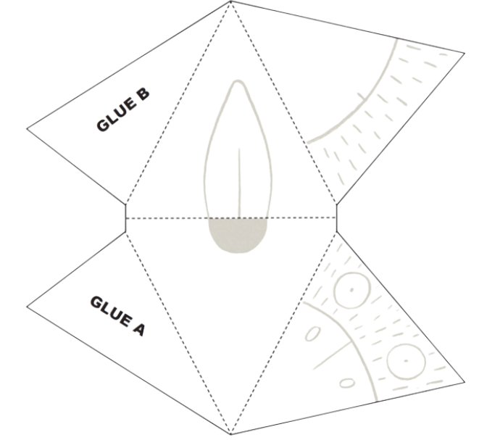
"Build-a-bird (Streich M, illus.)" by Stephanie Ryan, The School Magazine: Launchpad (Pilot Magazine) and used in accordance with The School Magazine Terms and Conditions.

Resource 2: Build-a-bird instructions – Early Stage 1
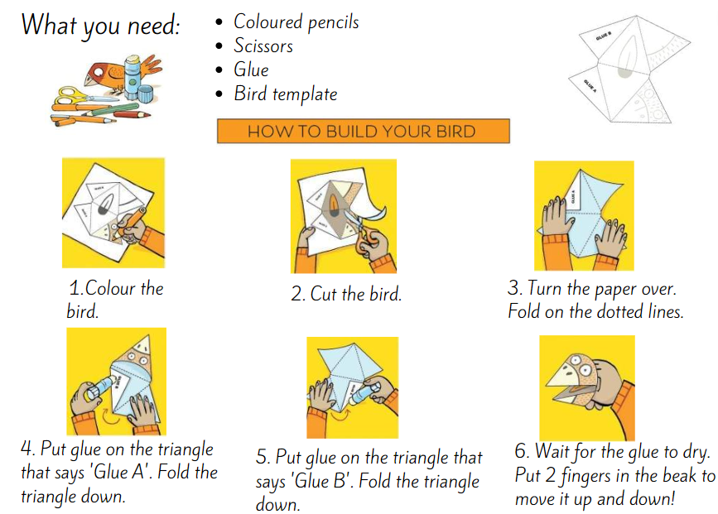
"Build-a-bird (Streich M, illus.)" by Stephanie Ryan, The School Magazine: Launchpad (Pilot Magazine) and used in accordance with The School Magazine Terms and Conditions.

Resource 3: Build-a-bird instructions – Stage 1
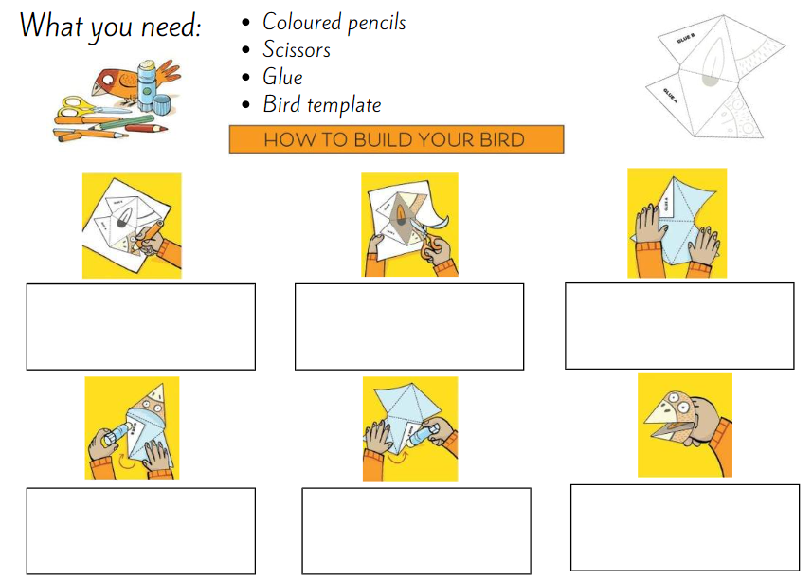
"Build-a-bird (Streich M, illus.)" by Stephanie Ryan, The School Magazine: Launchpad (Pilot Magazine) and used in accordance with The School Magazine Terms and Conditions.

Resource 4: Informative text – Bridges
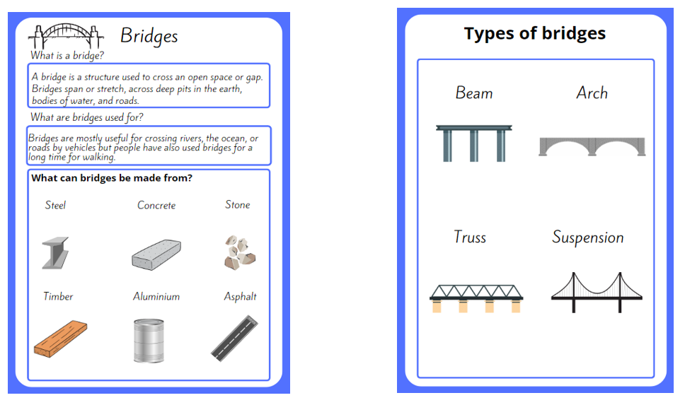
Images sourced from Canva and used in accordance with the Canva Content License Agreement.

Resource 5: What do you know about bridges?
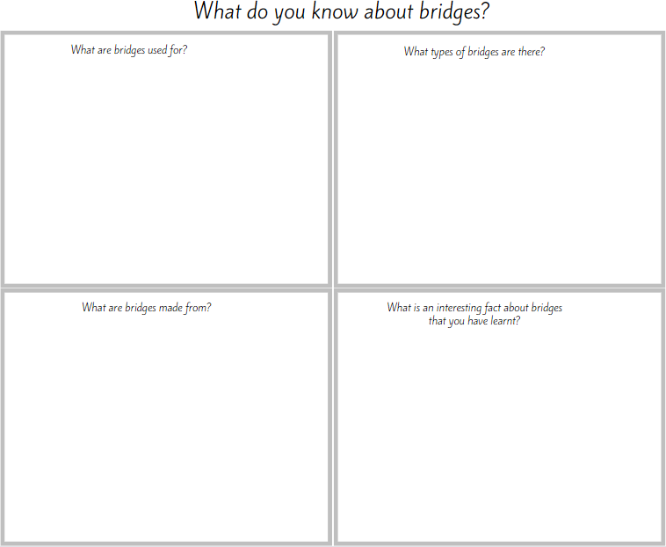

Resource 6: Bridge design template
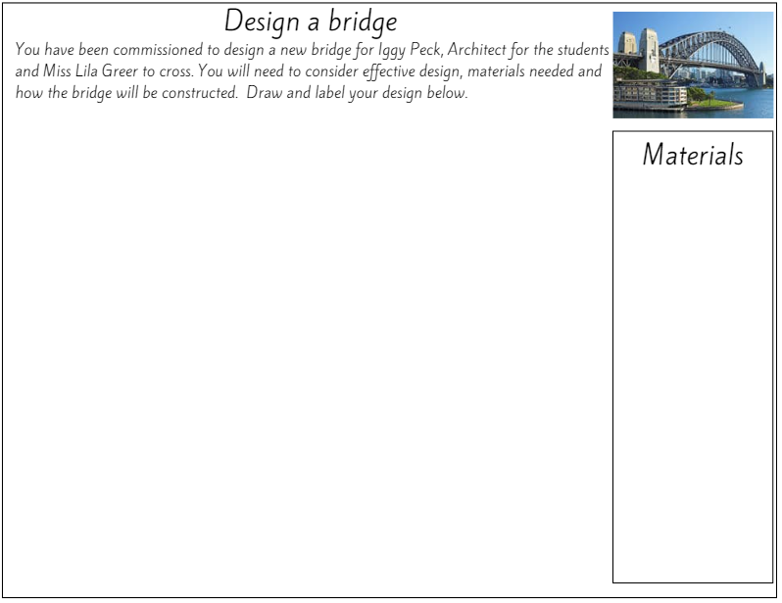
Images sourced from Canva and used in accordance with the Canva Content License Agreement.

Resource 7: Informative text writing template
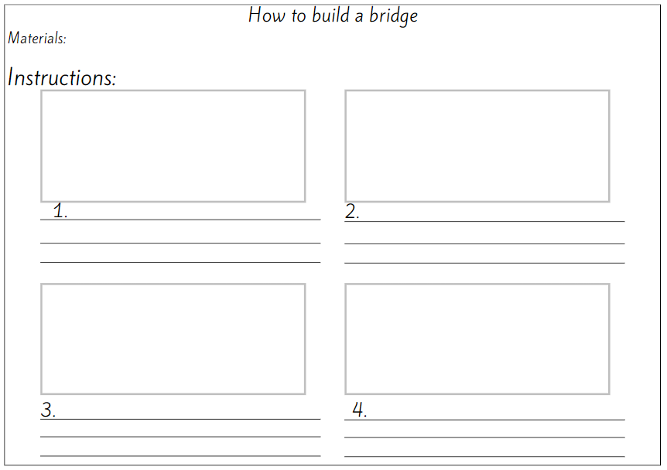

References
Links to third-party material and websites
Please note that the provided (reading/viewing material/list/links/texts) are a suggestion only and implies no endorsement, by the New South Wales Department of Education, of any author, publisher, or book title. School principals and teachers are best placed to assess the suitability of resources that would complement the curriculum and reflect the needs and interests of their students.
If you use the links provided in this document to access a third-party's website, you acknowledge that the terms of use, including licence terms set out on the third-party's website apply to the use which may be made of the materials on that third-party website or where permitted by the Copyright Act 1968 (Cth). The department accepts no responsibility for content on third-party websites.
Except as otherwise noted, all material is © State of New South Wales (Department of Education), 2021 and licensed under the Creative Commons Attribution 4.0 International License. All other material (third-party material) is used with permission or under licence. Where the copyright owner of third-party material has not licensed their material under a Creative Commons or similar licence, you should contact them directly for permission to reuse their material.
English K–10 Syllabus © 2022 NSW Education Standards Authority (NESA) for and on behalf of the Crown in right of the State of New South Wales.
Science and Technology K–6 Syllabus © 2017 NSW Education Standards Authority (NESA) for and on behalf of the Crown in right of the State of New South Wales.
© 2021 NSW Education Standards Authority. This document contains NSW Curriculum and syllabus content. The NSW Curriculum is developed by the NSW Education Standards Authority. This content is prepared by NESA for and on behalf of the Crown in right of the State of New South Wales. The material is protected by Crown copyright.
Please refer to the NESA Copyright Disclaimer for more information.
NESA holds the only official and up-to-date versions of the NSW Curriculum and syllabus documents. Please visit the NSW Education Standards Authority (NESA) website and the NSW Curriculum website.
National Literacy Learning Progression © Australian Curriculum, Assessment and Reporting Authority (ACARA) 2010 to present, unless otherwise indicated. This material was downloaded from the Australian Curriculum website (National Literacy Learning Progression) (accessed 5 December 2022) and was not modified. The material is licensed under CC BY 4.0. Version updates are tracked in the ‘Curriculum version history’ section on the 'About the Australian Curriculum' page of the Australian Curriculum website.
ACARA does not endorse any product that uses the Australian Curriculum or make any representations as to the quality of such products. Any product that uses material published on this website should not be taken to be affiliated with ACARA or have the sponsorship or approval of ACARA. It is up to each person to make their own assessment of the product, taking into account matters including, but not limited to, the version number and the degree to which the materials align with the content descriptions and achievement standards (where relevant). Where there is a claim of alignment, it is important to check that the materials align with the content descriptions and achievement standards (endorsed by all education Ministers), not the elaborations (examples provided by ACARA).
Beaty A (2007) Iggy Peck, Architect (Roberts, D illus.), Abrams Books for Young Readers, New York.
Encyclopædia Britannica, Inc (2022) Bridge, Britannica Kids website, accessed 5 December 2022.
ETA (English Teachers Association) and NSW Department of Education (2016) The Textual Concepts and Processes resource, English Textual Concepts website, accessed 14 November 2022.

