English – K-2 multi-age – Year B – Unit 9
Contents
Unit overview and instructions for use 3
Teacher notes 4
Outcomes and content – Component A 5
Outcomes and content – Component B 9
Week 1 13
Component A teaching and learning 13
Component B teaching and learning 14
Lesson 1: Imagery, symbol & connotation in wordless texts 15
Lesson 2: Using visual cues to make meaning 16
Lesson 3: Prepositional phrases to explore positioning 20
Lesson 4: Using verbs to recount an event in a wordless text 22
Lesson 5: Innovating on a text 26
Week 2 29
Component A teaching and learning 29
Component B teaching and learning 30
Lesson 6: Bee & Me 32
Lesson 7: Creating the beginning of a text using colour 34
Lesson 8: Creating the middle of a text using size 37
Lesson 9: Creating the end of a text using position 40
Lesson 10: Publishing and storytelling 42
Resource 1: Story element cards 44
Resource 2: Sentence frame 45
Resource 3: Storyboard (Early Stage 1) 46
Resource 4: Storyboard (Stage 1) 47
References 48

Unit overview and instructions for use
This two-week unit is comprised of Component A and Component B. Connecting learning across both components is encouraged.
Teaching and learning | Component A | Component B
Suggested duration | 60 minutes | 45 minutes
Explicit teaching focus areas | - Phonological awareness (Early Stage 1)  - Print conventions (Early Stage 1)  - Phonic knowledge  - Reading fluency  - Reading comprehension  - Spelling  - Handwriting | - Oral language and communication  - Vocabulary  - Reading comprehension  - Creating written texts  - Understanding and responding to literature
To prepare for teaching and learning: | - Refer to Outcomes and content – Component A, K-2 – Instructional sequence – grapheme–phoneme correspondences [PDF 825 KB], and the teaching advice documents (hyperlinked in Component A teaching and learning table).  - Based on student needs identified through ongoing assessment data, plan and document how you will sequence teaching and learning in whole class and targeted teaching groups across the two-week cycle. | - Familiarise yourself with Outcomes and content – Component B, Textual concepts information and videos, English Textual Concepts and Learning Processes (2016), and the teaching and learning sequence.  - Based on student needs identified through ongoing assessment data, determine how you will support students in whole class and targeted teaching groups across the two-week cycle as required.
English K–10 Syllabus © 2022 NSW Education Standards Authority (NESA) for and on behalf of the Crown in right of the State of New South Wales.

Teacher notes
- Imagery, symbol, and connotation extend words and symbols beyond their literal meaning. They are used to provide deeper meaning, evoke emotion and enhance enjoyment in texts. – English Textual Concepts and Learning Processes (2016).
- Understanding of imagery, symbol and connotation can be supported through watching the department’s video: Understanding connotation, imagery and symbol video (6:06).
- While ‘imagery, symbol and connotation’ is the mentor concept for the conceptual component of this unit, the supporting concept of ‘narrative’ can be explored using the mentor text Chalk by Bill Thomson and supporting text Bee & Me by Alison Jay.
- For information on verbs, tense and symbol refer to the NESA Glossary.
- A preposition is a word that begins an adverbial phrase or an adjectival phrase to indicate a circumstance such as time, place, manner, or causality, for example, in, on, after, before, by, under, over, of. A prepositional phrase consists of a preposition followed by a noun or pronoun, for example, in ‘The teddy has landed under the table’ – ‘under the table’ is the prepositional phrase.
- Reflect on student learning and engagement in activities and record differentiation and adjustments within the unit to inform future teaching and learning. One way of doing this could be to add comments to the digital file.
- Content points are linked to the National Literacy Learning Progression version (3).
Levels and indicators sourced from National Literacy Learning Progression © Australian Curriculum, Assessment and Reporting Authority (ACARA), (accessed 18 November 2022) and was not modified. See references for more information.

Outcomes and content – Component A
The table below outlines the focus outcomes and content. Content is linked to the National Literacy Learning Progression version (3).
Early Stage 1 Focus area and outcome | Stage 1 Focus area and outcome
Phonological awareness  ENE-PHOAW-01 – identifies, blends, segments and manipulates phonological units in spoken words as a strategy for reading and creating texts  - provide a word when given a starting phoneme (PhA2)  - identify the number of phonemes that make up a spoken one-syllable word comprising fewer than 4 phonemes (PhA4) | N/A
Print conventions  ENE-PRINT-01 – tracks written text from left to right and from top to bottom of the page and identifies visual and spatial features of print | N/A
Phonic knowledge  ENE-PHOKW-01 – uses single-letter grapheme–phoneme correspondences and common digraphs to decode and encode words when reading and creating texts  - blend common single-letter grapheme–phoneme correspondences to read CCVC and CVCC words, and apply this when reading texts, including decodable texts (PKW5)  - segment common, single-letter grapheme–phoneme correspondences to encode CCVC and CVCC words (PKW5)  - decode and blend words containing consonant digraphs and apply this when reading texts, including decodable texts (PKW5)  - segment and encode CVC words containing consonant digraphs (PKW4, PKW5) | Phonic knowledge  EN1-PHOKW-01 – uses initial and extended phonics, including vowel digraphs, trigraphs to decode and encode words when reading and creating texts  - blend and decode one-syllable words with taught extended vowel graphs and digraphs, including graphemes for r-controlled vowels and diphthongs, and apply this when reading texts (PKW6, PKW7)  - segment and encode one-syllable words with taught vowel graphs, digraphs and trigraphs and apply this when creating texts  - decode words with trigraphs and quadgraphs and apply this when reading texts  - blend and decode 2-syllable words with taught vowel graphs, digraphs, trigraphs and quadgraphs, including graphemes for r-controlled vowels and diphthongs and apply this when reading texts (PKW6, PKW7)  - decode 2-syllable base words with common double consonants when reading texts (PKW7)
Reading fluency  ENE-REFLU-01 – reads decodable texts aloud with automaticity  - know that fluent reading involves recognising and reading words accurately and automatically | Reading fluency  EN1-REFLU-01 – sustains reading unseen texts with automaticity and prosody and self-corrects errors  - read aloud with an easy speech rhythm (FLY3)  - self-correct when fluency and/or meaning is interrupted
Reading comprehension  ENE-RECOM-01 – comprehends independently read texts using background knowledge, word knowledge and understanding of how sentences connect  - use visual cues in multimodal texts to interpret meaning (UnT5)  - recall the sequence of events/information in texts (UnT5) | Reading comprehension  EN1-RECOM-01 – comprehends independently read texts that require sustained reading by activating background and word knowledge, connecting and understanding sentences and whole text, and monitoring for meaning  - register a break in comprehension when reading (UnT5).
Spelling  ENE-SPELL-01 – applies phonological, orthographic and morphological generalisations and strategies to spell taught familiar and high-frequency words when creating texts  - combine phonological, phonic, orthographic and morphemic knowledge to spell taught high-frequency irregular words comprising up to 3 phonemes (SpG5)  - know that the digraphs zz, ss, ll, ff and ck do not usually start a word in Standard Australian English  - experiment with the tense-marking suffixes to spell familiar base verbs (SpG5) | Spelling  EN1-SPELL-01 – applies phonological, orthographic and morphological generalisations and strategies when spelling words in a range of writing contexts  - explain when to use double consonants to spell 2-syllable base words and apply this when spelling (SpG6)  - spell high-frequency base words with taught vowel graphs, digraphs, split digraphs, trigraphs and quadgraphs (SpG6)  - use spelling conventions when adding plural-marking suffixes (SpG9)  - use spelling conventions when adding tense-marking suffixes (SpG9)
Handwriting  ENE-HANDW-01 – produces all lower-case and upper-case letters to create texts  - apply taught handwriting skills when creating texts. | Handwriting  EN1-HANDW-01 – uses a legible, fluent and automatic handwriting style, and digital technology, including word-processing applications, when creating texts  - type up to 5 familiar words per minute.

Outcomes and content – Component B
The table below outlines the focus outcomes and content. Content is linked to the National Literacy Learning Progression version (3).
Early Stage 1 Focus area and outcome | Stage 1 Focus area and outcome
Oral language and communication  ENE-OLC-01 – communicates effectively by using interpersonal conventions and language with familiar peers and adults  - understand how the most common inflected word forms affect the meanings of words  - ask questions using who, what, when, where, why or how  - use regular past tense verbs when speaking  - use irregular past tense verbs when speaking  - tell a story or information to peers or adults using oral language (SpK3) | Oral language and communication  EN1-OLC-01 – communicates effectively by using interpersonal conventions and language to extend and elaborate ideas for social and learning interactions  - understand that oral language can be used in combination with nonverbal communication  - use tense correctly to discuss past, present and future events  - recount narratives with key components (SpK3)
Vocabulary  ENE-VOCAB-01 – understands and effectively uses Tier 1 words and Tier 2 words in familiar contexts  - understand and use words to describe shape, size, texture, position, numerical order, time and seasons (SpK3, CrT3)  - identify, name and describe a range of objects, characters, animals, people and places when given visual and/or auditory prompts (GrA1) | Vocabulary  EN1-VOCAB-01 – understands and effectively uses Tier 1, taught Tier 2 and Tier 3 vocabulary to extend and elaborate ideas  - use taught morphemic knowledge to create word families
Reading comprehension  ENE-RECOM-01 – comprehends independently read texts using background knowledge, word knowledge and understanding of how sentences connect  - use visual cues in multimodal texts to interpret meaning  - recall the sequence of events/information in texts | Reading comprehension  EN1-RECOM-01 – comprehends independently read texts that require sustained reading by activating background and word knowledge, connecting and understanding sentences and whole text, and monitoring for meaning  - combine multiple sources of information within a text to make meaning  - identify how creative visual features are used to expand meaning  - confirm meaning by sequencing and explaining events and information  - recount relevant ideas from texts in the form of a written, visual or oral summary (UnT6)
Creating written texts  ENE-CWT-01 – creates written texts that include at least 2 related ideas and correct simple sentences  - include recognisable structural features for text purpose (CrT5)  - recount an event, convey a story  - write a simple sentence with correct subject–verb–object structure to convey an idea (GrA2, GrA3, CrT4)  - use prepositional phrases to indicate time or place (GrA4)  - use personal vocabulary, words on display and in mentor texts when constructing sentences  - use drawing, images or mind maps to support planning and writing (CrT4) | Creating written texts  EN1-CWT-01 – plans, creates and revises texts written for different purposes, including paragraphs, using knowledge of vocabulary, text features and sentence structure  - write texts that describe, explain, give an opinion, recount an event, tell a story (CrT7)  - use a combination of simple and compound sentences to engage the reader when creating written texts (CrT5, GrA4)  - use noun groups to build descriptions of people and things (CrT6)  - use contextually precise prepositional phrases when creating texts (GrA4)  - identify the context, audience and purpose for own texts (CrT5, CrT6)
Understanding and responding to literature  ENE-UARL-01 – understands and responds to literature read to them  - identify how visual cues contribute to the meaning of a text  - identify and discuss how creative language and/or symbols enhance enjoyment in texts  - experiment with using parts and/or features of a narrative, innovating from a mentor text | Understanding and responding to literature  EN1-UARL-01 – understands and responds to literature by creating texts using similar structures, intentional language choices and features appropriate to audience and purpose  - identify symbols and images in texts, and how they bring deeper meaning  - create texts that include symbols, wordplay and figurative language  - create and re-create narratives using understanding of narrative features (CrT5)

Week 1

Component A teaching and learning
The table below can be used to plan and document lessons that address Component A outcomes and content. Both the detailed example [DOC 529KB] of a two-week teaching and learning cycle and brief example [DOC 66KB] may support you in your planning.
Focus Areas | Lesson 1 | Lesson 2 | Lesson 3 | Lesson 4 | Lesson 5
Phonological awareness (Early Stage 1) and Phonic knowledge
15 minutes
Spelling and Handwriting
15 minutes
Print conventions (Early Stage 1), Reading comprehension and Reading fluency
30 minutes

Component B teaching and learning
The following teaching and learning sequence has been designed to address Component B outcomes and content. Adapt the sequence as required to best meet the needs of your students.

Learning intention and success criteria
Learning intentions and success criteria are best co-constructed with students. The table below contains suggested learning intentions and success criteria.
Element | Early Stage 1 | Stage 1
Learning intentions | Students are learning to understand that authors use illustrations to enhance meaning in texts. | Students are learning to identify and understand how authors use illustrations to convey meaning.
Success criteria | Students can:  - use visual cues to interpret meaning in a text  - use regular and irregular past tense verbs when speaking  - describe and recall information from a text  - use prepositional phrases  - create part of a narrative by innovating from a mentor text. | Students can:  - use visual features to interpret meaning in a text  - use tense correctly to discuss past, present and future events  - use precise prepositional phrases  - recount relevant ideas from texts in the form of a written, visual, or oral summary.

Resources
- Thomson B (2010) Chalk, Amazon Publishing, US. ISBN: 9780761455264
- Resource 1: Story element cards
- Resource 2: Sentence frame
- Art materials
- Copies of illustrations or pages from Chalk
- Enlarged images of a dinosaur, the sun, rain, and a playground

Lesson 1: Imagery, symbol & connotation in wordless texts
The following teaching and learning activities support multi-age settings.

Whole
- Display an enlarged image of a dinosaur. Give students time to think about how the image makes them feel (connotations). As a class, brainstorm and record the emotions associated with the image. For example, nervous, afraid, petrified.
- Repeat with images of the sun (happy, positive), rain (gloomy, boring) and a playground (playful, exciting).
- Discuss how the images alone, even without any words, still have meaning and prompt emotions (made students feel something). Explain how authors and illustrators use different techniques, including images or illustrations, to give a message or tell a story and make their audience feel different emotions (imagery, symbol and connotation).
- Introduce the wordless text Chalk by Bill Thomson. Note: Chalk will be viewed in its entirety in Lesson 2. Look at some of the pages to support students to identify that it is a wordless text. Ask students how they think they can make meaning of a text without any words.
- In mixed ability groups, provide students with different illustrations from the text. Students analyse the illustrations to work out what they think is happening and discuss how the illustrations made them feel and why. Use a jigsaw approach to share and discuss responses. Highlight the differences and similarities between student responses and how our own experiences and background knowledge influence this.
- Choose an illustration from the text and model writing a sentence describing how it makes you feel. For example, ‘The huge, green dinosaur made me feel scared because dinosaurs are ferocious predators.’
- Students independently write about their illustration from the text, describing how it made them feel and why.
Too hard? Students share their responses to the illustrations using the sentence stem ‘This made me feel __’
Too easy? Students compose a written response explaining how their image/illustration could connote different responses from different people.
- Revise that images/illustrations and symbols in texts can tell a story and make readers feel different emotions.

Lesson 2: Using visual cues to make meaning
The following teaching and learning activities support multi-age settings.

Whole
- Flick through the wordless text Chalk by Bill Thomson and compare it with a familiar picture book with text such as Pig the Pug by Aaron Blabey. Ask students to identify differences and similarities between the 2 texts. For example, the text Chalk includes illustrations and no text, Pig the Pug has both illustrations and text, but both texts are narratives – they tell a story. Remind students that the illustrations in Pig the Pug were very important in describing what kind of character Pig was and they prompted an emotional response (humour).
- Revisit that in the previous lesson students discussed the emotions that some of the illustrations in Chalk made them feel. Explain that the focus in this lesson will be how the author/illustrator, Bill Thomson, has used visual features, including colour, size, and facial expressions in his illustrations to tell a story (narrative).
- Silently walk-through Chalk. Ask students how the illustrations in the story made them feel.
- Revise the concept of narrative and that narratives give information including who it is about, what is happening and what the circumstances are (when, where, how and/or why). Explain that the author has provided this information using illustrations and symbols.
- Go to the page of the chalk drawn sun coming to life. Unpack the visual features in the illustrations, such as the contrasting colours between the setting and the characters, the positioning of the characters in relation to the sun and the facial expressions. Highlight how these features are effective in providing clues about what is happening in the story.
- Display Resource 1: Story element cards. Explain how question words and sentences can help readers understand details about the characters, events, and information in a story. Prompt students with guiding questions. For example:
- Who is in the picture?
- What did the girl kneeling on the ground do? What is happening to the sun?
- Where are the children?
- How do the children feel?
- Why is it happening?

Part
The table below details the differentiated teaching and learning activities for each stage.
Early Stage 1 (teacher guided/pairs/independent) | Stage 1 (pairs/independent)
- Display another double page from the text. Discuss the visual features that make the illustrations effective and provide information.  - In pairs, students construct and take turns answering who, what, or where questions about the pages.  Too easy? Students construct questions using the words ‘why’ or ‘how’.  - Model writing a short description of a character or object from the text. For example, ‘There is a huge, green dinosaur.’  - Students independently write a sentence describing a character or object from the text. | - Provide pairs of students with other illustrated double pages from the text for them to discuss the visual features that make the illustrations effective and provide information.  - In pairs, students construct and take turns answering who, what, when, where, why and how questions about the illustrated page.  Too hard? Students construct questions using the words who, what and where only.  Too easy? Discuss the connotations of the illustrations.
Early Stage 1 Assessment task 1 – Observations from this lesson allow students to demonstrate achievement towards the following syllabus outcomes and content points:
ENE-OLC-01 – communicates effectively by using interpersonal conventions and language with familiar peers and adults
- tell a story or information to peers or adults using oral language.
ENE-VOCAB-01 – understands and effectively uses Tier 1 words and Tier 2 words in familiar contexts
- identify, name and describe a range of objects, characters, animals, people and places when given visual and/or auditory prompts.
ENE-RECOM-01 – comprehends independently read texts using background knowledge, word knowledge and understanding of how sentences connect
- recall the sequence of events/information in texts.
Stage 1 Assessment task 1 – Observations from this lesson allow students to demonstrate achievement towards the following syllabus outcome and content point:
EN1-OLC-01 – communicates effectively by using interpersonal conventions and language to extend and elaborate ideas for social and learning interactions
- understand that oral language can be used in combination with nonverbal communication.

Lesson 3: Prepositional phrases to explore positioning
The following teaching and learning activities support multi-age settings.

Whole
- Revise prepositional phrases. A prepositional phrase consists of a preposition followed by a noun or pronoun. For example, in the phrase ‘the ball landed under the table’, ‘under the table’ is the prepositional phrase.
- Play a game such as a preposition scavenger hunt. Have students take turns hiding an object in the classroom and give clues using prepositions. For example, the brown desk is next to the window, the colourful pen is under the desk. Encourage students to use descriptive language in their clues.
- Explain that in texts, authors can use prepositions to tell the reader where (place) or when (time) something is in relation to something else. Create a class definition of prepositions and display in the classroom. Give students examples of prepositions that describe place, such as on, in, up, down, under. Ask students to brainstorm other prepositions. Record and add student responses to the display.
- Go to the page in Chalk where the dinosaur shadow is looming over the children. Highlight that, although there are no words on the page that describe the position of the characters or objects in the scene, the size and position of the characters and objects in the illustrations describe what is happening and prompt an emotional response.
- Ask students to imagine they were authors creating the ‘words’ to this page. Prompt them by asking what words could be used to make it descriptive and what prepositional phrases might be used to describe what is happening. Co-construct a sentence about the illustration using a prepositional phrase. For example, ‘The menacing shadow loomed over the frightened children.’

- Ask students:
- Why was the dinosaur shadow positioned over the children and what impression did this give?
- Would the illustration be as powerful if the dinosaur shadow was smaller?
- Would the illustration have the same effect if the shadow was positioned differently? For example, if it was positioned away from the children or facing the opposite direction.
- What feelings might the illustration evoke and how might this be different for different people?
- Look at different pages in the text and model using prepositional phrases to describe the illustrations. Write and display these to support student writing and have students identify the prepositional phrase. For example:
- The bright sun rose into the sky.
- The butterflies fluttered above the giggling children’s heads.
- The mischievous boy drew a large dinosaur on the ground.
- The frightened children hid inside the playground equipment.
- Students draw a scene from Chalk and describe the position of characters and objects in the illustration using a prepositional phrase. Encourage students to use personal vocabulary and words on display to support sentence construction.
Too hard? Students draw pictures of scenes from Chalk while orally describing the position of characters or objects using prepositional phrases. Co-construct these in sentences.
Too easy? Students include descriptive language in their sentence. For example, ‘The ferocious dinosaur towered over the children and stared at them with menacing eyes.’
- Share students’ responses and reflect on how the physical position of objects and characters in illustrations provide readers with more information and can prompt an emotional response.
Early Stage 1 Assessment task 2 – Observations and work samples from this lesson allows students to demonstrate achievement towards the following syllabus outcome and content point:
ENE-CWT-01 – creates written texts that include at least 2 related ideas and correct simple sentences
- use prepositional phrases to indicate time or place.
Stage 1 Assessment task 2 – Observations and work samples from this lesson allows students to demonstrate achievement towards the following syllabus outcome and content point:
EN1-CWT-01 – plans, creates and revises texts written for different purposes, including paragraphs, using knowledge of vocabulary, text features and sentence structure
- use contextually precise prepositional phrases when creating texts.

Lesson 4: Using verbs to recount an event in a wordless text
The following teaching and learning activities support multi-age settings.

Whole
- Display an enlarged copy of Resource 1: Story element cards. Re-view the illustrated pages in Chalk and ask students to become ‘story detectives’ by placing their hands on their heads when they identify an important part of the story (who, what, when, where, why). For example, on the first page there is an illustration of 3 children and a dinosaur, this shows who will be in the story. After viewing the text, use the story elements cards to record student responses and map out the key elements of the story in the appropriate columns.
- Revise verbs, explaining that they can describe both actions and feelings. Discuss how the author/illustrator, Bill Thomson, has used visual features (colour, size, position and facial expressions) in his illustrations to show what the children were doing and how they felt. Using events from the beginning of the story, create an anchor chart of verbs that provide information about the characters’ actions and feelings. For example:
- actions: ran, walked, played, drew
- feelings: happy, scared, worried.
- Discuss the use of regular and irregular past tense verbs. For example, walk/walked and draw/drew.
- In small groups, students use the listed action and feeling verbs to share sentences about how the children felt and what they did when the dinosaur drawing came to life. For example, the children were worried about the dinosaur, the frightened children ran away from the dinosaur. Model rephrasing/recasting statements to ensure correct inflections when speaking in past tense.

Part
The table below details the differentiated teaching and learning activities for each stage.
Early Stage 1 (pairs/independent) | Stage 1 (teacher guided)
- In pairs, students act out different scenes from the text.  - Students draw one scene from the text. | - Model writing a detailed description of a scene from the text in past tense. Include noun groups, verbs and prepositional phrases to add precision and detail to the text. For example, ‘Joey pulled a stick of green chalk from the bag. Kneeling on the pavement, he carefully drew an outline of the dinosaur. His mischievous grin showed he knew exactly what was going to happen next.’

Part
The table below details the differentiated teaching and learning activities for each stage.
Early Stage 1 (teacher guided) | Stage 1 (independent)
- Ask students guiding questions about their drawings. For example:  - Who is in the drawing?  - What is happening?  - Model using the questions to construct and write a sentence about the drawing using the subject-verb-object structure. For example, ‘The girl (subject) drew (verb) a butterfly (object).’  - Students share their drawing with a partner. Students take turns asking and responding to who and what questions.  - Using Resource 2: Sentence frame, students write a sentence about their drawing.  Too hard? Co-construct a short sentence with a subject and verb. For example, ‘The girl drew.’  Too easy? Students include a descriptive word before the subject and noun. For example, ‘The happy girl drew on the wet pavement.’ | - Using the modelled example, students write a description of a scene from the text.  Too hard? Using Resource 2: Sentence frame, students write a sentence about their drawing.  Too easy? Students experiment with changing the tense in their text. For example, re-writing the text in present tense.
Early Stage 1 Assessment task 3 – Observations and work samples from this lesson allows students to demonstrate achievement towards the following syllabus outcome and content points:
ENE-OLC-01 – communicates effectively by using interpersonal conventions and language with familiar peers and adults
- understand how the most common inflected word forms affect the meanings of words
- ask questions using who, what, when, where, why or how
- use regular past tense verbs when speaking
- use irregular past tense verbs when speaking.
Stage 1 Assessment task 3 – Observations and work samples from this lesson allows students to demonstrate achievement towards the following syllabus outcomes and content points:
EN1-OLC-01 – communicates effectively by using interpersonal conventions and language to extend and elaborate ideas for social and learning interactions
- use tense correctly to discuss past, present and future events
- recount narratives with key components.
EN1-VOCAB-01 – understands and effectively uses Tier 1, taught Tier 2 and Tier 3 vocabulary to extend and elaborate ideas
- use taught morphemic knowledge to create word families.
EN1-RECOM-01 – comprehends independently read texts that require sustained reading by activating background and word knowledge, connecting and understanding sentences and whole text, and monitoring for meaning
- confirm meaning by sequencing and explaining events and information
- recount relevant ideas from texts in the form of a written, visual or oral summary.

Lesson 5: Innovating on a text
The following teaching and learning activities support multi-age settings.

Whole
- Re-visit the text Chalk by flicking through the pages and providing students with an opportunity to orally retell the story, identifying important parts (who, what, where, when, why, how).
- Students imagine that they are the author/illustrator of Chalk and that they will create an additional scene in the text. Explain that they should apply the techniques that illustrators use to tell a story and prompt an emotion using the visual features explored (colour, size, position and facial expressions). Brainstorm ideas of what characters or objects students might introduce in their additional Chalk scene, such as a spider, a flower, the ocean, or a spaceship. Ask how the students would react if these pictures came to life.
- Model illustrating an additional scene, using think-alouds to describe how the use of colour, size, position and facial expressions mimic the techniques used by Bill Thomson in Chalk. Discuss what you are trying to convey in the illustration and the emotions you want the viewers to have.
- Students turn and talk to a partner to discuss their ideas and how they will illustrate their new part of the text.
- Provide students with art materials to create their illustration of an additional Chalk scene.

Part
The table below details the differentiated teaching and learning activities for each stage.
Early Stage 1 (teacher guided) | Stage 1 (independent)
- Ask students guiding questions about their drawings. For example:  - Who is in the drawing?  - What is happening?  - Referring to the modelled illustration from activity 3, model using the questions to construct and write a short text including verbs and prepositional phrases. For example, ‘The happy children danced and clapped in the park. The flower they drew on the ground was growing taller and taller.’  - Students write a short text about their illustration.  Too hard? Co-construct a short sentence about the illustration using Resource 2: Sentence frame. | - Students write a paragraph to describe their additional scene. Encourage students to write in past tense and to include noun groups, verbs and prepositional phrases. For example, ‘Billy slowly pulled a black stick of chalk out of the bag. Sitting on the path, he carefully drew the outline of a spider. Billy loved spiders. His nervousness showed as he knew exactly what was going to happen next.’
Early Stage 1 Assessment task 4 – Observations and work samples from this lesson allows students to demonstrate achievement towards the following syllabus outcomes and content points:
ENE-VOCAB-01 – understands and effectively uses Tier 1 words and Tier 2 words in familiar contexts
- understand and use words to describe shape, size, texture, position, numerical order, time and seasons.
ENE-CWT-01 – creates written texts that include at least 2 related ideas and correct simple sentences
- create written texts that describe, give an opinion, recount an event, convey a story.
ENE-UARL-01 – understands and responds to literature read to them
- experiment with using parts and/or features of a narrative, innovating from a mentor text.

Week 2

Component A teaching and learning
The table below can be used to plan and document lessons that address Component A outcomes and content. Both the detailed example [DOC 529KB] of a two-week teaching and learning cycle and brief example [DOC 66KB] may support you in your planning.
Focus Areas | Lesson 6 | Lesson 7 | Lesson 8 | Lesson 9 | Lesson 10
Phonological awareness (Early Stage 1) and Phonic knowledge
15 minutes
Spelling and Handwriting
15 minutes
Print conventions (Early Stage 1), Reading comprehension and Reading fluency
30 minutes

Component B teaching and learning
The following teaching and learning sequence has been designed to address Component B outcomes and content. Adapt the sequence as required to best meet the needs of your students.

Learning intention and success criteria
Learning intentions and success criteria are best co-constructed with students. The table below contains suggested learning intentions and success criteria.
Element | Early Stage 1 | Stage 1
Learning intentions | Students are learning to understand and respond to literature read to them through discussion and by creating texts. | Students are learning to understand and respond to literature by creating texts using similar structures, intentional language choices and features appropriate to audience and purpose.
Success criteria | Students can:  - identify how visual features contribute to the meaning of a text  - write a simple sentence using subject-verb-object structure  - tell a story using oral language  - create written texts to tell a story  - use drawings and images to support planning and writing. | Students can:  - identify how creative visual features are used to expand meaning  - write simple and compound sentences  - use noun groups to build descriptions of people and things  - create a story using narrative features and symbols.

Resources
- Jay A (2017) Bee & Me, Walker Books Australia, Sydney. ISBN: 9781910646199
- Thomson B (2010) Chalk, Amazon Publishing, US. ISBN: 9780761455264
- Resource 1: Story elements cards
- Resource 3: Storyboard (Early Stage 1)
- Resource 4: Storyboard (Stage 1)
- Art materials for illustrations
- Copies of pages from Bee & Me
- Sticky notes

Lesson 6: Bee & Me
The following teaching and learning activities support multi-age settings.

Whole
- Display the text Bee & Me. View the title and images on the front and back cover. Using the Think-Pair-Share strategy, students predict what the story will be about. Explain that there may be different interpretations of a wordless text depending on the audience’s personal experiences and knowledge of the subject or topic.
- Complete a silent walk-through of the text. Pause and draw attention to key parts of the story that students may not notice.
- In mixed groups, provide students with illustrated pages from various parts of Bee & Me. Using sticky notes, students draw pictures, symbols, or words describing what is happening and any emotions that the illustration has prompted. For example, on the first page of the text the clear blue sky makes me feel happy/calm/safe (draw a smiley face on the sticky note and place on the sky), on the page where the bee is first introduced and the girl looks surprised (write ‘surprised’ on a sticky note and place near the girl’s face).
- Share student responses and discuss how and why these might be different.
- Use the ‘story detectives’ activity from Lesson 2 to walk through the narrative aspects (who, what, where, when, why and how) of Bee & Me. Unpack the main message in this text - friendships.
- Flick through the text, stopping on each page to discuss story elements and visual features. Students share how the characters are feeling and how they know. Encourage students to consider the use of colour, size, and lines within the illustrations to gain a deeper meaning of the text. For example:
- colour: dark colours are used to indicate night-time, something bad happening, danger, and fear
- size: as the girl and Bee become better friends, Bee is getting bigger and more life-sized, draws the reader’s attention to the most important part of the page
- lines: lines on the face provide facial expression and information on how the character is feeling or thinking, at the beginning of the story the lines on the girls face such as her eyes and mouth show her surprise and fear, lines separating the pages show that time has passed.
- Choose an illustration from the text and model writing a sentence describing how it makes you feel. For example, ‘The dark, stormy night made me feel worried because I am afraid of thunder and lightning.’
- Students independently write about an illustration from the text, describing how it made them feel and why.
Early Stage 1 Assessment task 5 – Observations from this lesson allows students to demonstrate achievement towards the following syllabus outcomes and content points:
ENE-RECOM-01 – comprehends independently read texts using background knowledge, word knowledge and understanding of how sentences connect
- use visual cues in multimodal texts to interpret meaning.
ENE-OLC-01 – communicates effectively by using interpersonal conventions and language with familiar peers and adults
- tell a story or information to peers or adults using oral language.
ENE-UARL-01 – understands and responds to literature read to them
- identify how visual cues contribute to the meaning of a text
- identify and discuss how creative language and/or symbols enhance enjoyment in texts.
Stage 1 Assessment task 4 – Observations from this lesson allows students to demonstrate achievement towards the following syllabus outcomes and content points:
EN1-RECOM-01 – comprehends independently read texts that require sustained reading by activating background and word knowledge, connecting and understanding sentences and whole text, and monitoring for meaning
- combine multiple sources of information within a text to make meaning
- identify how creative visual features are used to expand meaning
- recount relevant ideas from texts in the form of a written, visual or oral summary.
EN1-UARL-01 – understands and responds to literature by creating texts using similar structures, intentional language choices and features appropriate to audience and purpose
- identify symbols and images in texts, and how they bring deeper meaning.

Lesson 7: Creating the beginning of a text using colour
The following teaching and learning activities support multi-age settings.

Whole
- Re-visit Bee & Me by slowly flicking through the pages. Discuss the relationship between the characters and how it changes as the story progresses. Model how this could be summarised in 3 main parts (beginning, middle and end). For example, it starts with the girl being scared of Bee so she traps it in a jar (beginning), then girl and Bee become friends and she helps Bee grow flowers and Bee leaves (middle), finally Bee returns and the girl is happy (end).
- Explain that texts have a context (the setting), audience (who is reading the text) and purpose (the author’s intended message). As a class, unpack these 3 ideas using Chalk and Bee & Me.
- Revise how colour is used in texts and images to create a mood or prompt an emotion (connotation). Display and compare illustrations from Chalk and Bee & Me. Discuss and highlight how colour helps readers to interpret and make meaning within a text, for example:
- Chalk uses bright colours to show happiness and excitement (in the sun and butterfly scenes) and dark colours to show fear and terror (in the dinosaur scenes).
- Bee & Me uses bright colours to indicate happiness, friendship, and positivity (when the girl rides on the back of Bee towards the end flying scene), and dark colours to indicate something bad happening, danger, and fear (in the beginning scenes).
- Explain that students will re-create their own story about a different animal using Bee & Me as a stimulus, for example, Tiger and Me.
- Display Resource 3: Storyboard (Early Stage 1) and model drawing an illustration in the first box (beginning) of the story. Use think-alouds to explain colour choices and their intention. For example, I am using dark colours to show how scared the main character is when the tiger suddenly leaps through the front door.
- Provide students with Resource 3: Storyboard (Early Stage 1) or Resource 4: Storyboard (Stage 1) to plan the beginning of their story. Remind them to focus on the use of colour in their illustrations. Students will need to keep their storyboards for the next lessons.

Part
The table below details the differentiated teaching and learning activities for each stage.
Early Stage 1 (pairs/teacher guided) | Stage 1 (pairs/independent)
- In pairs, students orally describe what is happening in their beginning illustration.  - Revise past tense and subject-verb-object structure. Model writing a sentence for the beginning of a story. For example, ‘The tiger (subject) ran (verb) through (preposition) the front door (object).’ | - In pairs, students share their illustrations and discuss:  - what is happening in the picture  - how and why colour is used in their images.

Part
The table below details the differentiated teaching and learning activities for each stage.
Early Stage 1 (independent/pairs) | Stage 1 (teacher guided/independent)
- Students write the beginning of their story on the storyboard using the modelled sentence as an exemplar.  Too hard? Students label their illustrations.  - Students share their storyboard with a partner and discuss:  - what is happening in their story  - how and why colour is used in their images. | - Students orally describe what is happening in their illustration.  - Model writing the beginning of a story in past tense, using descriptive language, verbs, and prepositional phrases. For example, ‘Lucy shivered with fright as the tiger broke through the front door. She frantically ran around the house trying to find a safe place to hide. Suddenly, she thought of a clever idea. She would trap the ferocious tiger in her wardrobe!’  - Students write the beginning of their story in past tense, using descriptive language, verbs, and prepositional phrases.  Too hard? Students use the subject-verb-object structure to write a sentence about the beginning of their story.

Lesson 8: Creating the middle of a text using size
The following teaching and learning activities support multi-age settings.

Whole
- Revise and discuss how the size of illustrated characters and objects in texts create connotations such as feelings and mood.
- Display images from Chalk and Bee & Me where size is used as a visual feature in the images. Discuss and highlight how size is used to bring deeper meaning to the text, for example:
- Chalk: size is used to show that the dinosaur is more powerful and dominating in the scene where the large dinosaur is looming over the smaller sized children, who are hiding in the playground equipment.
- Bee & Me: size is used throughout the text to show the change in the characters’ relationship. As the girl and Bee become better friends, Bee is getting bigger and more life-sized.
- Size is used across both texts to draw the reader’s attention to the most important section and ideas on each page.
- Re-visit the modelled storyboard from Lesson 7. Brainstorm what might happen next in this story. Model drawing an illustration for the middle part of the story on storyboard. Use think-alouds to explain how size can be used to add meaning to the text. Explicitly state which visual feature to focus on. For example, I will be using size to show how frightened the tiger is when it is trapped in the wardrobe.
- Students use their storyboards to draw illustrations representing what is happening at the middle of their story. They will focus on incorporating size effectively in their illustrations.

Part
The table below details the differentiated teaching and learning activities for each stage.
Early Stage 1 (teacher guided/independent) | Stage 1 (pairs/independent)
- Students orally describe what is happening in their illustration.  - Revise past tense, subject-verb-object structure and prepositional phrases. Model writing a sentence for the middle of the story. For example, ‘The tiger (subject) was trapped (verb) inside (preposition) the dark wardrobe (object).’ | - Students share their illustrations with a partner and discuss:  - what is happening in the picture  - how and why size is used in their images.

Part
The table below details the differentiated teaching and learning activities for each stage.
Early Stage 1 (pairs/independent) | Stage 1 (teacher guided/independent)
- Students write the middle of their story on their storyboard proforma.  Too hard? Students label their illustrations.  - Students share their storyboard with a partner and discuss:  - what is happening in the picture  - how and why size is used in their images. | - Model writing the middle of a story in past tense, using descriptive language, verbs, and prepositional phrases. For example, ‘The frightened and vulnerable tiger lay still in the dark corner of the wardrobe. It felt trapped and helpless. Lucy was surprised to see how timid the tiger looked, so she cautiously opened the door to let it free. The tiger’s face lit up brightly and he jumped about freely.’  - Students write the beginning of their story in past tense, using descriptive language, verbs, and prepositional phrases.  Too hard? Students write a sentence about the middle of their story.

Lesson 9: Creating the end of a text using position
The following teaching and learning activities support multi-age settings.

Whole
- Revise and discuss how position can be used effectively in illustrated texts to convey meaning and create a mood or emotion.
- Display images from Chalk and Bee & Me and ask students to identify how the position of the characters and objects in the illustrations describe what is happening and prompt an emotional response. For example:
- Chalk: discuss how one of the characters is positioned under the play equipment to show that she is hiding and is afraid of the dinosaur.
- Bee & Me: consider the page towards the end of the book that shows Bee and the girl in the field. How they are positioned on this page gives the impression that they are side-by-side and working together.
- Re-visit the modelled storyboard. Brainstorm what might happen at the end of this story. Model drawing an illustration for the ending. Use think-alouds to explain how position can be used to effectively in the illustration. For example, I will draw the child and the tiger running towards each other to show that they are now friends.
- Students use their storyboards to draw illustrations representing the ending of their story. They will focus on using position effectively in their illustrations.

Part
The table below details the differentiated teaching and learning activities for each stage.
Early Stage 1 (teacher guided) | Stage 1 (pairs/independent)
- In pairs, students orally describe what is happening in their illustration.  - Model writing a sentence for the end of the story. For example, ‘The tiger (subject) played (verb) outside (preposition) with the girl (object).’ | - Students share their illustrations with a partner and discuss:  - what is happening in the picture  - how and why position is used in their illustrations.

Part
The table below details the differentiated teaching and learning activities for each stage.
Early Stage 1 (pairs/independent) | Stage 1 (teacher guided/independent)
- Students write the ending for the story on their storyboard using the modelled example as a scaffold.  Too hard? Students label their illustrations.  - Students share their storyboards with a partner and discuss:  - what is happening in the picture  - how and why position is used in their illustrations. | - Model writing compound sentences using a conjunction. For example, ‘The friendly tiger ran towards his family and he was happy to be home.’  - Students write the ending of their story. Encourage students to use compound sentences and write in past tense and include noun groups, verbs and prepositional phrases.

Lesson 10: Publishing and storytelling
The following teaching and learning activities support multi-age settings.

Whole
- Provide opportunities for students to re-draft, edit, and publish their stories. These could be published as ‘books’ using paper and art materials or digitalised using applications such as Book Creator.
- Students share their stories as a gallery walk or as short presentations to the class or a wider audience.
- Students reflect on their learning throughout the unit and complete an exit ticket. For example:
- How did you use visual features in illustrations to add deeper meaning to your text?
- What feelings or emotions do you think your text will make people feel?
- I used to think…now I know.
Early Stage 1 Assessment task 6 – Observations and work samples from this lesson allows students to demonstrate achievement towards the following syllabus outcome and content points:
ENE-CWT-01 – creates written texts that include at least 2 related ideas and correct simple sentences
- include recognisable structural features for text purpose
- create written texts that describe, give an opinion, recount an event, convey a story
- write a simple sentence with correct subject–verb–object structure to convey an idea
- use prepositional phrases to indicate time or place
- use personal vocabulary, words on display and in mentor texts when constructing sentences
- use drawing, images or mind maps to support planning and writing.
Stage 1 Assessment task 5 – Observations and work samples from this lesson allows students to demonstrate achievement towards the following syllabus outcomes and content points:
EN1-CWT-01 – plans, creates and revises texts written for different purposes, including paragraphs, using knowledge of vocabulary, text features and sentence structure
- write texts that describe, explain, give an opinion, recount an event, tell a story
- use a combination of simple and compound sentences to engage the reader when creating written texts
- use noun groups to build descriptions of people and things
- use contextually precise prepositional phrases when creating texts
- identify the context, audience and purpose for own texts.
EN1-UARL-01 – understands and responds to literature by creating texts using similar structures, intentional language choices and features appropriate to audience and purpose
- create texts that include symbols, wordplay and figurative language
- create and re-create narratives using understanding of narrative features.

Resource 1: Story element cards
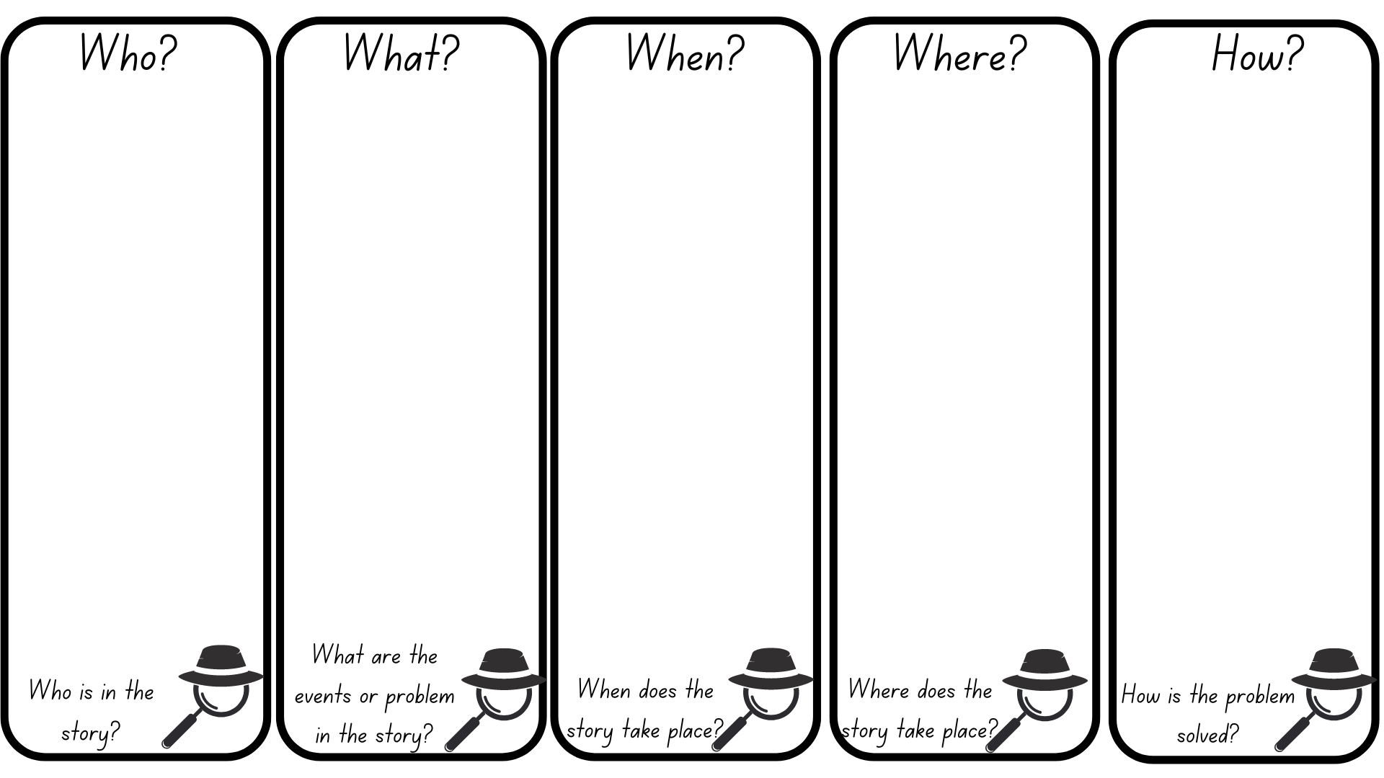
Images sourced from Canva and used in accordance with the Canva Content License Agreement.

Resource 2: Sentence frame
Use the sentence frame to create your own sentences.
Subject | Verb | Object

Resource 3: Storyboard (Early Stage 1)
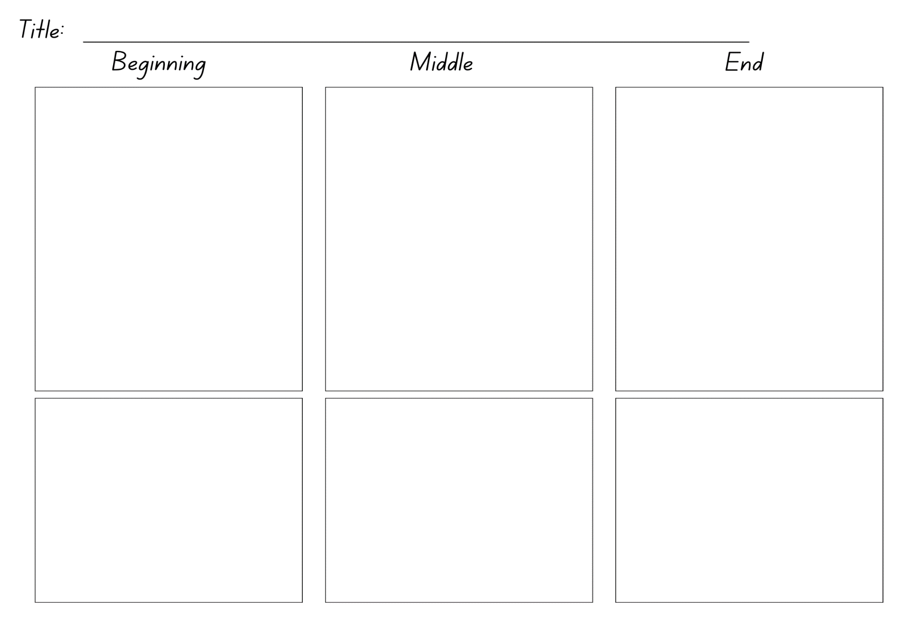

Resource 4: Storyboard (Stage 1)
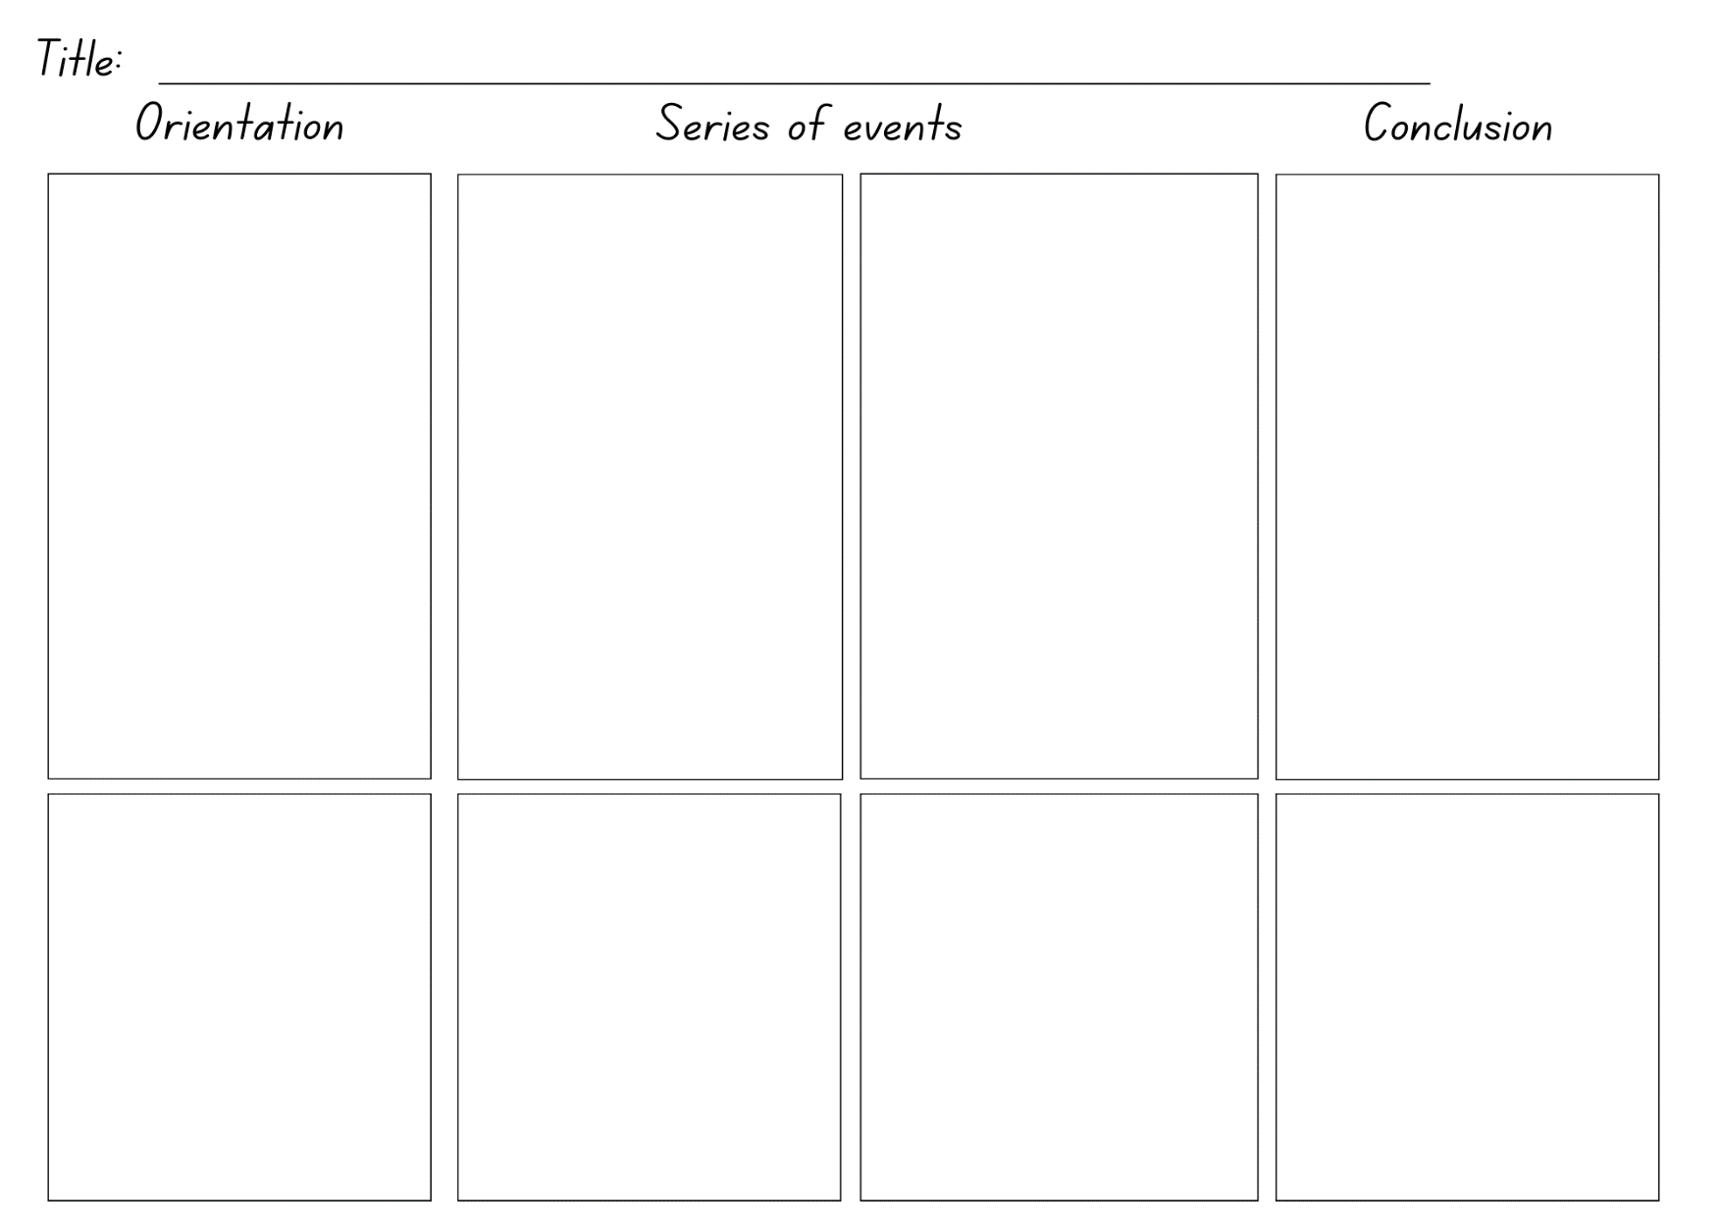

References
Links to third-party material and websites
Please note that the provided (reading/viewing material/list/links/texts) are a suggestion only and implies no endorsement, by the New South Wales Department of Education, of any author, publisher, or book title. School principals and teachers are best placed to assess the suitability of resources that would complement the curriculum and reflect the needs and interests of their students.
If you use the links provided in this document to access a third-party's website, you acknowledge that the terms of use, including licence terms set out on the third-party's website apply to the use which may be made of the materials on that third-party website or where permitted by the Copyright Act 1968 (Cth). The department accepts no responsibility for content on third-party websites.
Except as otherwise noted, all material is © State of New South Wales (Department of Education), 2021 and licensed under the Creative Commons Attribution 4.0 International License. All other material (third-party material) is used with permission or under licence. Where the copyright owner of third-party material has not licensed their material under a Creative Commons or similar licence, you should contact them directly for permission to reuse their material.
English K–10 Syllabus © 2022 NSW Education Standards Authority (NESA) for and on behalf of the Crown in right of the State of New South Wales.
© 2021 NSW Education Standards Authority. This document contains NSW Curriculum and syllabus content. The NSW Curriculum is developed by the NSW Education Standards Authority. This content is prepared by NESA for and on behalf of the Crown in right of the State of New South Wales. The material is protected by Crown copyright.
Please refer to the NESA Copyright Disclaimer for more information.
NESA holds the only official and up-to-date versions of the NSW Curriculum and syllabus documents. Please visit the NSW Education Standards Authority (NESA) website and the NSW Curriculum website.
National Literacy Learning Progression © Australian Curriculum, Assessment and Reporting Authority (ACARA) 2010 to present, unless otherwise indicated. This material was downloaded from the Australian Curriculum website (National Literacy Learning Progression) (accessed 18 November 2022) and was not modified. The material is licensed under CC BY 4.0. Version updates are tracked in the ‘Curriculum version history’ section on the 'About the Australian Curriculum' page of the Australian Curriculum website.
ACARA does not endorse any product that uses the Australian Curriculum or make any representations as to the quality of such products. Any product that uses material published on this website should not be taken to be affiliated with ACARA or have the sponsorship or approval of ACARA. It is up to each person to make their own assessment of the product, taking into account matters including, but not limited to, the version number and the degree to which the materials align with the content descriptions and achievement standards (where relevant). Where there is a claim of alignment, it is important to check that the materials align with the content descriptions and achievement standards (endorsed by all education Ministers), not the elaborations (examples provided by ACARA).
Blabey A (2014) Pig the Pug, Scholastic Australia Pty Ltd.
ETA (English Teachers Association) and NSW Department of Education (2016) The Textual Concepts and Processes resource, English Textual Concepts website, accessed 18 November 2022.
Jay A (2017) Bee & Me, Walker Books Australia, Sydney.
Thomson B (2010) Chalk, Amazon Publishing, US.

