English – K-2 multi-age – Year B – Unit 4
Contents
Unit overview and instructions for use 3
Teacher notes 4
Outcomes and content – Component A 6
Outcomes and content – Component B 10
Week 1 14
Component A teaching and learning 14
Component B teaching and learning 15
Lesson 1: Introducing the text 17
Lesson 2: Character dialogue 19
Lesson 3: Making connections and explaining 23
Lesson 4: Writing about our own context 25
Lesson 5: Creating a persuasive poster 29
Week 2 32
Component A teaching and learning 32
Component B teaching and learning 33
Lesson 6: Understanding text purpose and features 35
Lesson 7: Writing sentences to describe and persuade 37
Lesson 8: Organising factual texts and providing details with prepositional phrases 41
Lesson 9: Informative and persuasive class display 44
Lesson 10: Feedback, editing and presenting 45
Resource 1: Puppets 47
Resource 2: Writing dialogue checklist 48
Resource 3: Modelled example – Stage 1 49
Resource 4: Visual prompt cards 50
Resource 5: Meet the corroboree frog 51
Resource 6: Categorising 52
Resource 7: TAG feedback 53
References 54
Further reading 56

Unit overview and instructions for use
This two-week unit is comprised of Component A and Component B. Connecting learning across both components is encouraged.
Teaching and learning | Component A | Component B
Suggested duration | 60 minutes | 45 minutes
Explicit teaching focus areas | - Phonological awareness (Early Stage 1)  - Print conventions (Early Stage 1)  - Phonic knowledge  - Reading fluency  - Reading comprehension  - Spelling  - Handwriting | - Oral language and communication  - Vocabulary  - Reading comprehension  - Creating written texts  - Understanding and responding to literature
To prepare for teaching and learning: | - Refer to Outcomes and content – Component A, K-2 – Instructional sequence – grapheme–phoneme correspondences [PDF 825 KB], and the teaching advice documents (hyperlinked in Component A teaching and learning table).  - Based on student needs identified through ongoing assessment data, plan and document how you will sequence teaching and learning in whole class and targeted teaching groups across the two-week cycle. | - Familiarise yourself with Outcomes and content – Component B, Textual concepts information and videos, English Textual Concepts and Learning Processes (2016), and the teaching and learning sequence.  - Based on student needs identified through ongoing assessment data, determine how you will support students in whole class and targeted teaching groups across the two-week cycle as required.
English K–10 Syllabus © 2022 NSW Education Standards Authority (NESA) for and on behalf of the Crown in right of the State of New South Wales.

Teacher notes
- Perspective and argument are the mentor concepts for the conceptual component for Stage 1 and the supporting concept is context. For Early Stage 1, the mentor concept is perspective only and the supporting concept is context. These concepts are explored through the narrative structures of the texts Benny Bungarras’ Big Bush Clean-up by Sally Morgan and The Little Corroboree Frog by Tracey Holton-Ramirez.
- ‘Perspective is defined as a lens through which we learn to see the world. It shapes what we see and the way we see it’. – English Textual Concepts and Learning Processes (2016).
- Understanding of perspective can be supported through watching the department’s video: Perspective (3:37).
- ‘Argument is persuasion using the conventions of various forms, modes, and media’ – English Textual Concepts and Learning Processes (2016). Understanding of argument can be supported through watching the department’s video: Argument (3:17).
- Context is defined as a culturally or socially situated circumstance that may give rise to a particular register (NESA Glossary). To understand context, we look beyond the text to consider the world in which it was produced and the worlds of its reception. Different contexts can affect the meanings and values of similar content.
- For information on tiered words, conjunctions, compound sentences, verbs and prepositions refer to the NESA Glossary.
- This unit could enhance student learning towards achievement of outcomes from the Science and Technology syllabus regarding knowledge and understanding of the living world and sustainability.
- The video for Lesson 7, NAIDOC Week at Taronga - Leslie McLeod talks Corroboree Frogs! (9:58), includes a smoking ceremony at the beginning and explanation about NAIDOC Week at the end. Information most relevant to the lesson is within the viewing time 2:20 to 7:50 minutes.
- Before beginning a yarning circle, revisit the structure and process. A ‘talking stick’ is a tool that can be used to reinforce verbal turn-talking skills. A stick, wand, ball, or similar object is used by the person talking and passed to the next speaker to visually cue students whose turn it is to speak. Students can practise talking in a large class circle when holding the stick, and waiting for a turn to talk when not holding it.
- Reflect on student learning and engagement in activities and record differentiation and adjustments within the unit to inform future teaching and learning. One way of doing this could be to add comments to the digital file.
- Content points are linked to the National Literacy Learning Progression version (3).
Levels and indicators sourced from National Literacy Learning Progression © Australian Curriculum, Assessment and Reporting Authority (ACARA), (accessed 19 October 2022) and was not modified. See references for more information.

Outcomes and content – Component A
The table below outlines the focus outcomes and content. Content is linked to the National Literacy Learning Progression version (3).
Early Stage 1 Focus area and outcome | Stage 1 Focus area and outcome
Phonological awareness  ENE-PHOAW-01 – identifies, blends, segments and manipulates phonological units in spoken words as a strategy for reading and creating texts  - consistently say the first phoneme of a spoken one-syllable word (PhA2) | N/A
Print conventions  ENE-PRINT-01 – tracks written text from left to right and from top to bottom of the page and identifies visual and spatial features of print  - identify spaces between words (PKW2)  - identify numerals in texts (PKW2)  - track text left to right and use return sweep (UnT4) | N/A
Phonic knowledge  ENE-PHOKW-01 – uses single-letter grapheme–phoneme correspondences and common digraphs to decode and encode words when reading and creating texts  - blend single-letter grapheme–phoneme correspondences to decode VC and CVC words, and apply this knowledge when reading, including decodable texts (PKW3) (PKW4)  - segment and encode single-letter VC and CVC words, and apply this knowledge when writing words and creating texts. (PKW4) | Phonic knowledge  EN1-PHOKW-01 – uses initial and extended phonics, including vowel digraphs, trigraphs to decode and encode words when reading and creating texts  - blend grapheme–phoneme correspondences to read CCVCC words, CCCVC words and CCCVCC words and apply this when reading texts (PKW7)  - segment and encode one-syllable high-frequency base words with split digraphs and apply this when creating texts (PKW7)  - segment and encode CCVCC words, CCCVC words and CCCVCC words and apply this when creating texts (SpG8)  - blend and decode 2-syllable words with taught vowel graphs, digraphs, trigraphs and quadgraphs, including graphemes for r-controlled vowels and diphthongs and apply this when reading texts (PKW6) (PKW7)  - decode 2-syllable base words with common double consonants when reading texts (PKW7)
Reading fluency  ENE-REFLU-01 – reads decodable texts aloud with automaticity  - read words automatically then apply to texts  - stop at the end of a sentence in response to a full stop (FlY3) | Reading fluency  EN1-REFLU-01 – sustains reading unseen texts with automaticity and prosody and self-corrects errors  - adjust phrasing, intonation, volume or rate to maintain fluency when reading aloud (FlY4)
Reading comprehension  ENE-RECOM-01 – comprehends independently read texts using background knowledge, word knowledge and understanding of how sentences connect  - recognise familiar vocabulary in a text (UnT4)  - understand how adjectives describe a noun and verbs identify actions in a sentence  - identify words that represent who, what, when, where and why in texts | Reading comprehension  EN1-RECOM-01 – comprehends independently read texts that require sustained reading by activating background and word knowledge, connecting and understanding sentences and whole text, and monitoring for meaning  - make an inference by connecting the meaning of words across sentences and/or paragraphs  - make text-to-self, text-to-text or text-to-world connections when reading (UnT6)  - recount relevant ideas from texts in the form of a written, visual or oral summary (UnT6)
Spelling  ENE-SPELL-01 – applies phonological, orthographic and morphological generalisations and strategies to spell taught familiar and high-frequency words when creating texts  - combine phonological, phonic, orthographic and morphemic knowledge to spell taught high-frequency irregular words comprising up to 3 phonemes (SpG5)  - segment single-syllable words into phonemes as a strategy for spelling (SpG4)  - add the plural-marking suffix (s) to base nouns that require no change when suffixed (SpG5)  - experiment with the tense-marking suffixes to spell familiar base verbs (SpG5) | Spelling  EN1-SPELL-01 – applies phonological, orthographic and morphological generalisations and strategies when spelling words in a range of writing contexts  - segment single-syllable words into phonemes as a strategy for spelling (SpG4)  - segment multisyllabic words into syllables and phonemes as a strategy for spelling (SpG5)  - explain when to use double consonants to spell 2-syllable base words and apply this when spelling (SpG6)  - spell taught high-frequency contractions (SpG6)  - use spelling conventions when adding plural-marking suffixes (SpG9)  - use the comparative and superlative suffixes –er and –est (SpG9)  - use knowledge of morphemes to spell taught compound words and homophones with taught single-letter graphemes, digraphs, split digraphs, trigraphs and quadgraphs (SpG7)
Handwriting  ENE-HANDW-01 – produces all lower-case and upper-case letters to create texts  - apply appropriate pressure when handwriting to produce legible writing (HwK2)  - apply taught handwriting skills when creating texts | Handwriting  EN1-HANDW-01 – uses a legible, fluent and automatic handwriting style, and digital technology, including word-processing applications, when creating texts  - position all letters correctly on the line with appropriate spacing between words (HwK5)

Outcomes and content – Component B
The table below outlines the focus outcomes and content. Content is linked to the National Literacy Learning Progression version (3).
Early Stage 1 Focus area and outcome | Stage 1 Focus area and outcome
Oral language and communication  ENE-OLC-01 – communicates effectively by using interpersonal conventions and language with familiar peers and adults  - follow up to 3-part spoken instructions (LiS3)  - take turns when speaking during structured and unstructured play (InT3)  - use short phrases and simple sentences when speaking. (SpK1) | Oral language and communication  EN1-OLC-01 – communicates effectively by using interpersonal conventions and language to extend and elaborate ideas for social and learning interactions  - listen to or engage with texts for enjoyment and recognise that their own experience can shape their ideas and opinions of texts  - incorporate extended sentences (simple, compound, complex) during dialogue (SpK3)  - organise key ideas in logical sequence
Vocabulary  ENE-VOCAB-01 – understands and effectively uses Tier 1 words and Tier 2 words in familiar contexts  - identify, name and describe a range of objects, characters, animals, people and places when given visual and/or auditory prompts (GrA1)  - recognise and understand taught Tier 1 and Tier 2 words (PKW3) (SpK3) | Vocabulary  EN1-VOCAB-01 – understands and effectively uses Tier 1, taught Tier 2 and Tier 3 vocabulary to extend and elaborate ideas  - use vocabulary to express cause and effect (SpK3)
Reading comprehension  ENE-RECOM-01 – comprehends independently read texts using background knowledge, word knowledge and understanding of how sentences connect  - recognise familiar vocabulary in a text (UnT4)  - understand how adjectives describe a noun and verbs identify actions in a sentence  - identify words that represent who, what, when, where and why in texts  - use background knowledge when identifying connections between a text, own life, other texts and/or the world (UnT4) | Reading comprehension  EN1-RECOM-01 – comprehends independently read texts that require sustained reading by activating background and word knowledge, connecting and understanding sentences and whole text, and monitoring for meaning  - make an inference by connecting the meaning of words across sentences and/or paragraphs  - make text-to-self, text-to-text or text-to-world connections when reading (UnT6)  - recount relevant ideas from texts in the form of a written, visual or oral summary (UnT6)
Creating written texts  ENE-CWT-01 – creates written texts that include at least 2 related ideas and correct simple sentences  - create written texts that describe, give an opinion, recount an event, convey a story  - identify and use verbs in simple sentences, including in own writing (GrA2)  - identify and use nouns in simple sentences, including in own writing (GrA1)  - understand that punctuation is a feature of written language and how it impacts meaning  - use a capital letter to start a sentence and a full stop to end a sentence (PuN2) (CrT5)  - use personal vocabulary, words on display and in mentor texts when constructing sentences  - identify differences between spoken and written language  - use drawing, images or mind maps to support planning and writing (CrT4) | Creating written texts  EN1-CWT-01 – plans, creates and revises texts written for different purposes, including paragraphs, using knowledge of vocabulary, text features and sentence structure  - write texts that describe, explain, give an opinion, recount an event, tell a story (CrT7)  - use a logical order to sequence ideas and events in sentences across a text (GrA4)  - select and use a range of conjunctions to create cohesive texts (GrA5)  - write compound sentences using coordinating conjunctions (GrA4) (CrT5)  - use action, saying, relating and sensing verbs to add detail and precision to writing (GrA2) (GrA5)  - use contextually precise prepositional phrases when creating texts (GrA4)  - use quotation marks for simple dialogue (PuN5)  - understand that their own texts can be improved by incorporating feedback and editing
Understanding and responding to literature  ENE-UARL-01 – understands and responds to literature read to them  - express likes and dislikes about a text (CrT4)  - identify favourite stories and/or characters in texts using verbal and/or nonverbal modes  - identify texts that are composed for specific audiences and purposes | Understanding and responding to literature  EN1-UARL-01 – understands and responds to literature by creating texts using similar structures, intentional language choices and features appropriate to audience and purpose  - identify phrases in texts that project opinions  - identify how structure and images reinforce ideas  - create and re-create texts that include persuasive arguments, using knowledge of text and language features  - identify how the language and form of a text vary according to purpose, audience and mode (UnT5)

Week 1

Component A teaching and learning
The table below can be used to plan and document lessons that address Component A outcomes and content. Both the detailed example [DOC 529KB] of a two-week teaching and learning cycle and brief example [DOC 66KB] may support you in your planning.
Focus Areas | Lesson 1 | Lesson 2 | Lesson 3 | Lesson 4 | Lesson 5
Phonological awareness (Early Stage 1) and Phonic knowledge
15 minutes
Spelling and Handwriting
15 minutes
Print conventions (Early Stage 1), Reading comprehension and Reading fluency
30 minutes

Component B teaching and learning
The following teaching and learning sequence has been designed to address Component B outcomes and content. Adapt the sequence as required to best meet the needs of your students.

Learning intention and success criteria
Learning intentions and success criteria are best co-constructed with students. The table below contains suggested learning intentions and success criteria.
Element | Early Stage 1 | Stage 1
Learning intentions | Students are learning to express their likes and dislikes and are learning that texts are composed for specific audiences and purposes. | Students are learning to understand how language, structure and images can be used to present opinions and persuade an audience, and compose a text that presents their opinion about taking care of the environment.
Success criteria | Students can:  - take turns when speaking  - use short phrases and simple sentences in speech  - express likes and dislikes about a text  - identify favourite characters in a text  - follow spoken instructions  - name objects and understand that these are nouns  - use personal vocabulary when constructing sentences  - describe the intended audience and purpose of a text  - identify capital letters and full stops  - use drawings to support writing. | Students can:  - make inferences by connecting the meaning of words in a text  - identify phrases in text that give an opinion  - use quotation marks for simple dialogue  - describe the intended audiences and purpose of a text  - use verbs to add detail to writing  - write sentences that explain  - make connections to texts  - identify how structure and images reinforce ideas  - plan and create a persuasive text  - identify how the language and form of a text vary according to purpose.

Resources
- Morgan S (2018) Benny Bungarra’s Big Bush Clean-up (Kwaymullina A, illus.), Magabala Books, Broome. ISBN: 9781925360882
- Resource 1: Puppets
- Resource 2: Writing dialogue checklist
- Resource 3: Modelled example
- Resource 4: Visual prompt cards
- Website: WWF’s Reduce, Reuse, Recycle
- Labelled items such as plastic bottles, plastic bags, straws, bottle caps, string, reusable containers
- Craft sticks, sticky tape, construction paper or card (for Early Stage 1 students)
- Poster paper or cardboard to make posters

Lesson 1: Introducing the text
The following teaching and learning activities support multi-age settings.

Whole
- Introduce the text Benny Bungarra’s Big Bush Clean-up by looking at the front cover. Activate students’ background knowledge by asking questions linked to the title. For example, what clues do the front cover give the reader about the characters (who) and setting (where); what is a clean-up?
- Read the text and ask questions to scaffold and check student comprehension. Ask students if they can identify what type of text it is. If needed, explain that the text is predominately a narrative, although it is also persuasive because it highlights a problem and a call to action from the reader. Outline that when texts have stylistic elements from a range of different types of texts, they are called hybrid texts.
- In the first section of the narrative, use the illustrations and text to support the inferred message about the problem that human rubbish has on native animals. For example, Olive python gets stuck in a bottle because a human has thrown the bottle away.
- Compare this inferred message with the section of text where Benny Bungarra states that rubbish causes ‘a lot of trouble in the bush’. Outline that the author is using the animal’s perspective to highlight the problem.
- In mixed stage groups, students make text-to-self connections by discussing if they have been involved in a clean-up day and what they did to help clean up. Students can record ideas by writing and/or drawing.
- Explain that the author and illustrator, Sally Morgan and Ambelin Kwaymullina, are Aboriginal artists who both belong to the Palyku people of the Eastern Pilbara region of Western Australia. ‘Bungarra’ means ‘sand goanna’ and is an Aboriginal word used by some Aboriginal language groups in Western Australia. Consider the text creators’ connection to country and their focus on ensuring that our natural environment is protected.
Stage 1 Assessment task 1– Observations and work samples from this lesson allow students to demonstrate achievement towards the following syllabus outcomes and content points:
EN1-OLC-01 – communicates effectively by using interpersonal conventions and language to extend and elaborate ideas for social and learning interactions
- listen to or engage with texts for enjoyment and recognise that their own experience can shape their ideas and opinions of texts.
EN1-RECOM-01 – comprehends independently read texts that require sustained reading by activating background and word knowledge, connecting and understanding sentences and whole text, and monitoring for meaning
- make an inference by connecting the meaning of words across sentences and/or paragraphs.
EN1-UARL-01 – understands and responds to literature by creating texts using similar structures, intentional language choices and features appropriate to audience and purpose
- identify phrases in texts that project opinions.

Lesson 2: Character dialogue
The following teaching and learning activities support multi-age settings.

Whole
- Reread the text Benny Bungarra’s Big Bush Clean-up. Discuss the concept of audience being the intended readers of a text.
- Students discuss who the intended audience might be and why.
- Identify the dialogue that has been used between characters in the text and its purpose in building the persuasive argument that rubbish in the bush is dangerous to native animals.
- Highlight how dialogue is a turn taking interaction between people or characters. Reinforce this idea using examples from the text. Model using turn taking in dialogue with another student. For example:
- Person 1: Hello
- Person 2: Hi. How are you?
- Person 1: Great. What did you do on the weekend?
- Person 2: I went to my Nan’s house for a play. What did you do?
- In mixed stage pairs, have students practise using turn taking in dialogue.

Part
The table below details the differentiated teaching and learning activities for each stage.
Early Stage 1 (pairs/small group) | Stage 1 (teacher guided)
- Using Resource 1: Puppets students make puppets of the animals from the text by cutting out the images and attaching them to craft sticks. Plastic toy animals or ready-made puppets could be used if available.  - In pairs or small groups, students take turns using the character puppets to retell the story using dialogue. | - As a group, identify:  - what is spoken by the character (What’s that noise?)  - who spoke – the subject (Benny)  - how the text was spoken – saying verb (asked)  - Write these 3 parts of speech on different pieces of coloured card. Place the cards in a row to form a sentence and read aloud. Discuss the need to place quotation marks around the text that is being spoken. Write quotation marks on another coloured card and place in the correct locations.  - Look at the sample text and identify other pieces of punctuation in the sentence, including a capital letter at the beginning of the dialogue and a piece of punctuation before the close. Use the coloured card technique to add these to the sentence.  - As a group, create a checklist that can help writers to know how and when to use the correct conventions for writing character dialogue. An example checklist is provided in Resource 2: Writing dialogue checklist.  - Highlight that Sally Morgan, the author of the text, has used a repetitive text structure when introducing each new character. Model innovating on the text to include a new native animal that is affected by human waste. A modelled example is given in Resource 3: Modelled example – Stage 1.

Part
Early Stage 1 (teacher guided) | Stage 1 (independent)
- Ask students to use thumbs up or thumbs down to express if they liked or disliked the text and to share opinions on their favourite character.  - Select students to describe some of the things that their characters said or did in their puppet retell.  - Model writing a sentence to describe what the characters did or said. For example, ‘The python was stuck in the bottle.’  - Identify the character (the python) as the subject of the sentence.  - Support students to construct a simple sentence containing an identified subject. | - Provide students with coloured strips of paper matching those in the modelled example to construct their own dialogue innovated from the text.
Early Stage 1 Assessment task 1 – Observations and work samples from this lesson allow students to demonstrate achievement towards the following syllabus outcomes and content points:
ENE-OLC-01 – communicates effectively by using interpersonal conventions and language with familiar peers and adults
- take turns when speaking during structured and unstructured play.
EN1-UARL-01 – understands and responds to literature by creating texts using similar structures, intentional language choices and features appropriate to audience and purpose
- express likes and dislikes about a text
- identify favourite stories and/or characters in texts using verbal and/or nonverbal modes.
Stage 1 Assessment task 2 – Observations and work samples from this lesson allow students to demonstrate achievement towards the following syllabus outcome and content points:
EN1-CWT-01 – plans, creates and revises texts written for different purposes, including paragraphs, using knowledge of vocabulary, text features and sentence structure
- use quotation marks for simple dialogue
- use action, saying, relating, and sensing verbs to add detail and precision to writing.

Lesson 3: Making connections and explaining
The following teaching and learning activities support multi-age settings.

Whole
- Re-read Benny Bungarra’s Big Bush Clean-up. After reading, recall and discuss the main events in the persuasive-style narrative. Highlight the author’s purpose, issues presented in the text, and how the rubbish affects the animals.
- Ask students to recall the 3 strategies that were used to manage rubbish in the text. Discuss the concepts of reduce (remove), reuse and recycle.
- Go to WWF Australia. Display the Reduce, Reuse, Recycle poster. Identify the text purpose and audience. Highlight the connection between the mentor text and the website. Explain the use of symbols for reduce, reuse, recycle (visual prompts and images) and discuss how these can help give information to readers.
- To build students’ understanding of the author’s purpose, to care for the environment, use 3 large hoops to sort labelled items into categories. Use the visual prompts in Resource 4: Visual prompt cards to explain the categories for sorting. Instruct students to select an item, name and/or read the label and then explain why they sorted it into a category. Items such as clean plastic bottles, bits of plastic, straws, bottle caps, paper and reusable containers could be used.
- Within each category, create written labels for each item. Identify that each label is a noun, that is, a word that names things. Encourage students to use these nouns in their own writing.

Part
The table below details the differentiated teaching and learning activities for each stage.
Early Stage 1 (teacher guided) | Stage 1 (independent)
- Use labelled items from the previous activity to model writing a simple sentence. For example, ‘I can recycle a plastic bottle.’  - Using the modelled sentence highlight that a simple sentence is a group of words that is a complete idea. Reinforce spaces between words and sentence punctuation conventions.  - Ask students to select a different labelled material to draw and label or write a simple sentence using the sentence starter ‘I can recycle a __’.  Too easy? Students write a sentence without a sentence starter. | - Using the labelled items and the words and images from WWF Australia students write their own sentences to explain how different materials can be reduced, reused or recycled.  Too hard? Use labelled materials from activity 5 and the sentence starter ‘I can recycle a __’ to write a simple sentence.

Whole
- In a yarning circle, discuss the ideas and solutions that students represented in their writing.
Early Stage 1 Assessment task 2 – Observations and work samples from this lesson allow students to demonstrate achievement towards the following syllabus outcomes and content points:
ENE-OLC-01 – communicates effectively by using interpersonal conventions and language with familiar peers and adults
- follow up to 3-part spoken instructions.
ENE-VOCAB-01 – understands and effectively uses Tier 1 words and Tier 2 words in familiar contexts
- identify, name and describe a range of objects, characters, animals, people and places.
ENE-CWT-01 – creates written texts that include at least 2 related ideas and correct simple sentences
- identify and use nouns in simple sentences, including in own writing
- use personal vocabulary, words on display and in mentor texts when constructing sentences.

Lesson 4: Writing about our own context
The following teaching and learning activities support multi-age settings.

Whole
- Ask students to retell the text Benny Bungarra’s Big Bush Clean-up, recalling key ideas.
- Walk through the school grounds to determine if the playground is clean and to look for any animals that are present.
- Students decide if a ‘Big School Clean-Up’ is needed to care for the school environment. To show their opinion, students can move to one side of the room for ‘yes’ and the other side for ‘no’. Select students to share support for their argument.
- Display an illustration from the text that has a red cross through some rubbish. Model drawing the playground with items that are both good and bad for the environment and draw a red cross through the rubbish items. Revisit that the names of objects are referred to as nouns, for example, plastic bag, bin, paper, bottle.

Part
The table below details the differentiated teaching and learning activities for each stage.
Early Stage 1 (independent) | Stage 1 (teacher guided)
- In the same style as the illustrator of the text, Ambelin Kwaymullina, students draw what they see in the playground, including items that are both good and bad for the environment.  - Students draw a red cross through the rubbish items.  - Students can use nouns to label items in their illustration. | - Co-construct a letter with students to persuade the principal that a school clean-up day is needed.  - Structure the letter into sections, including:  - What is the problem? (there is rubbish around the school)  - Why is it a problem? (rubbish can impact on animals in our environment)  - Call to action (we need a ‘Big School Clean-Up')  - Steps to support (posters around the school, rubbish monitors at lunchtime, whole-school rubbish clean-up and new recycling bins).  - Explicitly use cause and effect vocabulary (including subordinating conjunctions) and modal verbs (such as must, should, can) to strengthen reasoning and arguments. For example, ‘The rubbish in our playground is harmful to local bird life, so we must take action and improve our use of recycling bins immediately.’  Too easy? Provide the letter structure for independent or partner text construction. Encourage students to experiment with writing complex sentences with subordinating conjunctions.

Part
The table below details the differentiated teaching and learning activities for each stage.
Early Stage 1 (teacher guided) | Stage 1 (pairs)
- Select students to share and explain their drawings.  - Use a student’s drawing to co-construct a sentence about what they saw in the playground. Continue to reinforce that a sentence is a complete idea with a subject and a verb, and that a capital letter is used at the start and a full stop at the end.  - Reread the sentences and explain how the drawings match the written sentences. | - Draft a persuasive poster to promote a ‘Big School Clean-up Day’. Students will use this draft to complete a published version in Lesson 5.  Too easy? Students plan their poster using digital software.  Too hard? Students work in mixed-ability groups to plan posters.

Whole
Early Stage 1 Assessment task 3 – Observations and work samples from this lesson allow students to demonstrate achievement towards the following syllabus outcomes and content points:
ENE-OLC-01 – communicates effectively by using interpersonal conventions and language with familiar peers and adults
- use short phrases and simple sentences when speaking.
ENE-CWT-01 – creates written texts that include at least 2 related ideas and correct simple sentences
- understand that punctuation is a feature of written language and how it impacts meaning
- use a capital letter to start a sentence and a full stop to end a sentence
- use drawing, images or mind maps to support planning and writing.
Stage 1 Assessment task 3 – Observations and work samples from this lesson allow students to demonstrate achievement towards the following syllabus outcome and content point:
EN1-OLC-01 – communicates effectively by using interpersonal conventions and language to extend and elaborate ideas for social and learning interactions
- incorporate extended sentences (simple, compound, complex) during dialogue.

Lesson 5: Creating a persuasive poster
The following teaching and learning activities support multi-age settings.

Whole
- Explain that students will create a poster to display in the school to promote the ‘Big School Clean-Up Day’. Remind students that the purpose of the poster is persuade an audience (school children) to reduce, reuse, or recycle their rubbish so that the school is a clean and safe place for people and visiting animals.
- Explain that the poster will use words and images to reinforce. To frame the text’s purpose, ask:
- What is the problem? (There is rubbish around the school.)
- Why is it a problem? (Rubbish can impact on animals in our environment.)
- What do we want people to do? What is our call to action? (We need a ‘Big School Clean-Up'.)
- Use think alouds to model drawing a poster to promote the ‘Big School Clean-Up’. Highlight key features of the poster including use of colour, simple images, persuasive language, labels and symbols. Discuss how the features of the poster support its purpose and audience.

Part
The table below details the differentiated teaching and learning activities for each stage.
Early Stage 1 (independent) | Stage 1 (teacher guided/independent)
- In pairs, students revisit their drawings from Lesson 4 to discuss what they drew.  - Provide students with craft materials to create a poster promoting the ‘Big School-Clean up’ day.  - Display the labelled items from Lesson 3 as a support for students to use in their own writing. | - Ask students to think about their draft from Lesson 4 and how it can be refined to ensure it fits the criteria for being persuasive and it is suitable for the intended audience.  - Provide students with craft materials to create a poster.  Too easy? Students create their poster using digital software.  Too hard? Students work in mixed ability groups to create posters.

Whole
- Conduct a gallery walk. Early Stage 1 students share their opinion of what they like about the posters. Stage 1 students can focus on discussing posters that would be most likely to persuade students to keep the school clean. Posters can be copied and displayed throughout the school.
Stage 1 Assessment task 4 – Observations and work samples from this lesson allow students to demonstrate achievement towards the following syllabus outcome and content points:
EN1-UARL-01 – understands and responds to literature by creating texts using similar structures, intentional language choices and features appropriate to audience and purpose
- identify how structure and images reinforce ideas
- create and re-create texts that include persuasive arguments, using knowledge of text and language features
- identify how the language and form of a text vary according to purpose, audience and mode.

Week 2

Component A teaching and learning
The table below can be used to plan and document lessons that address Component A outcomes and content. Both the detailed example [DOC 529KB] of a two-week teaching and learning cycle and brief example [DOC 66KB] may support you in your planning.
Focus Areas | Lesson 6 | Lesson 7 | Lesson 8 | Lesson 9 | Lesson 10
Phonological awareness (Early Stage 1) and Phonic knowledge
15 minutes
Spelling and Handwriting
15 minutes
Print conventions (Early Stage 1), Reading comprehension and Reading fluency
30 minutes

Component B teaching and learning
The following teaching and learning sequence has been designed to address Component B outcomes and content. Adapt the sequence as required to best meet the needs of your students.

Learning intention and success criteria
Learning intentions and success criteria are best co-constructed with students. The table below contains suggested learning intentions and success criteria.
Element | Early Stage 1 | Stage 1
Learning intentions | Students are learning to use their background knowledge to co-construct texts that describe. | Students are learning to use factual sentences within a persuasive text.
Success criteria | Students can:  - use background knowledge to make connections to a text  - identify who, what and where in a text  - express an opinion based on ideas presented in texts  - understand that adjectives describe a noun  - co-construct and create a written text to describe  - understand how language can be spoken or written. | Students can:  - describe the intended audience and purpose of a text  - make connections to texts when reading  - write compound sentences using a variety of conjunctions  - use vocabulary to express cause and effect  - understand the persuasive elements within a text  - use contextually precise prepositional phrases  - sequence ideas in sentences across a text  - use feedback to edit and improve own writing.

Resources
- Holton-Ramirez T (2013) The Little Corroboree Frog (Ramirez A, illus.), Magabala Books, Broome. ISBN: 9781921248818
- Resource 5: Meet the corroboree frog (enlarged copy for display and one copy for each group)
- Resource 6: Categorising (copies for Stage 1 students)
- Resource 7: TAG feedback (enlarged copy for teacher and one copy for each group)
- Video: NAIDOC Week at Taronga – Leslie McLeod talks Corroboree Frogs! (9:58) (recommended viewing time 2:20 to 7:50)
- 10 Fast Facts about Corroboree Frogs
- Blank paper
- Modelling clay
- Craft and natural materials, such as leaves, sticks, and pebbles
- Resources for creating a class display, including paper and art materials

Lesson 6: Understanding text purpose and features
The following teaching and learning activities support multi-age settings.

Whole
- Display the first page of Resource 5: Meet the corroboree frog. Ask students to share their background knowledge about frogs. If needed, explain that the images show the Australian corroboree frog.
- Introduce the text The Little Corroboree Frog. Ask students to make predictions about the purpose of the text and its intended audience.
- Read The Little Corroboree Frog. Discuss predictions made by students and ask them to share their opinions.
Suggested teaching and learning activities for Early Stage 1 and Stage 1.
Early Stage 1 (independent/pairs) | Stage 1 (teacher guided/independent)
- Identify and explain words that represent who is in the text, what happens in a text and where the text is set. Start a word wall with the columns: who, what and where. Revisit the text and write corresponding words.  - Students draw a corroboree frog (who), something the frog does (what), where it lives (where).  - In pairs, students talk about and share their drawings, using the words to describe the who, what and where of the text.  Too easy? Students use words listed in activity 4 to write labels and/or descriptive sentences. | - Look at and read the information on the ‘Did you know?’ pages. Consider the text layout and the information provided. Explain that the author is aiming to persuade a reader to protect the frogs by providing detailed information about an endangered species.  - Revisit how the author has included imaginative, informative, and persuasive elements in The Little Corroboree Frog. Outline that when texts have stylistic elements from a range of different types of texts, they are called hybrid texts.  - Create a table with 3 columns. Write a range of sentences and features from the text for students to categorise. For example:  - Imaginative: Jet hopped down the riverbank to join the other frogs and see his friend, Bindi.  - Persuasive: ‘Jet, every year the summers are getting hotter’, said Grandmother sadly.  - Informative: It takes us nearly four years to grow into adults.  - Using Resource 6: Categorising, students draw or write parts of the story that fit into the categories of imaginative, persuasive and informative.
- Make text-to-text comparisons with Benny Bungarra’s Big Bush Clean-up. Highlight how the texts include both narrative and persuasive elements. Ask students to describe the call to action that is implied in the text: people need to pick up their rubbish and care for the environment.
Early Stage 1 Assessment task 4 – Observations and work samples from this lesson allow students to demonstrate achievement towards the following syllabus outcomes and content points:
ENE-RECOM-01 – comprehends independently read texts using background knowledge, word knowledge and understanding of how sentences connect
- use background knowledge when identifying connections between a text, own life, other texts and/or the world
- identify words that represent who, what, when, where and why in texts.
ENE-UARL-01 – understands and responds to literature read to them
- identify texts that are composed for specific audiences and purposes.
Stage 1 Assessment task 5 – Observations and work samples from this lesson allow students to demonstrate achievement towards the following syllabus outcome and content point:
EN1-RECOM-01 – comprehends independently read texts that require sustained reading by activating background and word knowledge, connecting and understanding sentences and whole text, and monitoring for meaning
- make text-to-self, text-to-text or text-to-world connections when reading.

Lesson 7: Writing sentences to describe and persuade
The following teaching and learning activities support multi-age settings.

Whole
- Walk through the text The Little Corroboree Frog so that students orally recount relevant ideas and the purpose of the text.
- Model drawing (for Early Stage 1) and writing (for Stage 1) a fact about corroboree frogs. For example, a frog laying eggs. Provide students with an A4 piece of paper folded in half. Ask students to draw/write facts they recall from the text on one half of the page. Students will use the other half to draw/write new facts learnt after watching the video in activity 3.
- Watch the video NAIDOC Week at Taronga – Leslie McLeod talks Corroboree Frogs! (2:20 to 7:50) and students use the other side of their piece of paper to draw/write new facts learnt.
- Discuss the purpose of the video and its intended audience.

Part
The table below details the differentiated teaching and learning activities for each stage.
Early Stage 1 (independent/pairs) | Stage 1 (teacher guided)
- Students use modelling clay to create a model of a corroboree frog.  - When completed, students orally describe their model by naming parts of the frog (nouns: eyes, mouth) and words that describe them (adjectives: yellow, black, tiny). | - Revisit some of the facts from the book and/or video that support the opinion that corroboree frogs should be protected.  - Co-construct persuasive compound sentences that show cause and effect. For example:  - Rubbish is bad for the environment, and this has an impact on native Australian corroboree frogs.  - The corroboree frog needs to be protected, so they do not become extinct.  - Corroboree frogs are important to Aboriginal culture, and they need to be protected.

Part
Suggested teaching and learning activities for Early Stage 1 and Stage 1.
Early Stage 1 (teacher guided) | Stage 1 (pairs/independent)
- Brainstorm vocabulary from the text, and the previous activity, that could be used in a simple sentence. List some words for ongoing student reference.  - Use an interactive writing strategy to compose and write simple sentences. Identify the subject in each sentence and reinforce that a simple sentence is a complete idea that makes sense on its own. Consider how adjectives can be used to describe. For example:  - The corroboree frog (subject) has a yellow and black pattern.  - Corroboree frogs (subject) lay tiny eggs.  Too easy? Identify the main verb in each simple sentence. | - In pairs, students orally compose and then write sentences using coordinating conjunctions to show cause and effect.  Too hard? Students write simple sentences using facts learnt from the text and video.

Whole
- Students share their opinions about protecting an endangered species. Ask if either text makes students want to help protect corroboree frogs. Prompt students to explain their thinking. Early Stage 1 students can share which text they prefer, providing reasoning where possible.
Early Stage 1 Assessment task 5 – Observations and work samples from this lesson allow students to demonstrate achievement towards the following syllabus outcomes and content points:
ENE-VOCAB-01 – understands and effectively uses Tier 1 words and Tier 2 words in familiar contexts
- identify, name and describe a range of objects, characters, animals, people and places when given visual and/or auditory prompts
- recognise and understand taught Tier 1 and Tier 2 words.
ENE-RECOM-01 – comprehends independently read texts using background knowledge, word knowledge and understanding of how sentences connect
- recognise familiar vocabulary in a text
- understand how adjectives describe a noun and verbs identify actions in a sentence.
ENE-CWT-01 – creates written texts that include at least 2 related ideas and correct simple sentences
- create written texts that describe, give an opinion, recount an event, convey a story
- use personal vocabulary, words on display and in mentor texts when constructing sentences.
Stage 1 Assessment task 6 – Observations and work samples from this lesson allow students to demonstrate achievement towards the following syllabus outcomes and content points:
EN1-VOCAB-01 – understands and effectively uses Tier 1, taught Tier 2 and Tier 3 vocabulary to extend and elaborate ideas
- use vocabulary to express cause and effect.
EN1-RECOM-01 – comprehends independently read texts that require sustained reading by activating background and word knowledge, connecting and understanding sentences and whole text, and monitoring for meaning
- recount relevant ideas from texts in the form of a written, visual or oral summary.
EN1-CWT-01 – plans, creates and revises texts written for different purposes, including paragraphs, using knowledge of vocabulary, text features and sentence structure
- write compound sentences using coordinating conjunctions
- select and use a range of conjunctions to create cohesive texts.

Lesson 8: Organising factual texts and providing details with prepositional phrases
The following teaching and learning activities support multi-age settings.

Whole
- Display the ‘Did You Know?’ section of The Little Corroboree Frog. Consider the layout of the information and how easy it is to access specific facts about corroboree frogs.
- Complete the same process with 10 Fast Facts about Corroboree Frogs.
- Determine with students if there is common information provided in each text and, if so, what headings could be used to group this information together.
- Based on responses, write sample headings, such as habitat, appearance, diet, and other. Draw symbols to match each heading. These headings could be written on sticky notes and placed inside a corresponding number of hoops on the floor.
- In mixed stage groups, provide students with facts from the 2 texts. Students read each fact and determine which heading they could be placed with. Keep this information on a chart for students to refer to in Lesson 9.

Part
The table below details the differentiated teaching and learning activities for each stage.
Early Stage 1 (small groups) | Stage 1 (teacher guided)
- In small groups, provide students with craft and natural materials to create a suitable environment for a corroboree frog, based on the learnt facts from the text and website. For example, they create a pond with frog food (ants) and make a nest filled with eggs.  - Students use their frog models from Lesson 7 and the new habitats created in Lesson 8 activity 6 to ‘act out’ facts or information. For example, the corroboree frog lays eggs in a pond. | - Highlight how the authors provide specific details to support the reader, including through use of prepositional phrases to describe details related to where and when.  - Model writing a factual sentence with a prepositional phrase. For example, ‘Corroboree frogs live in the Mt Kosciuszko region (where). The frog eggs need to wait for the rain to flood the pond before they hatch (when).’  - Underline the prepositional phrase in each of the modelled sentences.  - Explain that authors use prepositions to provide the reader with details about where (place) or when (time) something is in relation to something else. Write a list of prepositions.

Part
The table below details the differentiated teaching and learning activities for each stage.
Early Stage 1 (teacher guided) | Stage 1 (pairs/independent)
- Demonstrate how language can be spoken or written. Have students share some of the factual sentences they verbalised in activity 4 and model writing these. | - With a thinking partner, students orally compose sentences using the headings from activity 4.  - Students write sentences using the headings from activity 4, then underline the prepositional phrases.

Whole
- In mixed stage and ability groups, students practise sharing information by saying and/or reading facts.
Early Stage 1 Assessment task 6 – Observations and work samples from this lesson allow students to demonstrate achievement towards the following syllabus outcome and content point:
ENE-CWT-01 – creates written texts that include at least 2 related ideas and correct simple sentences
- identify differences between spoken and written language.
Stage 1 Assessment task 7 – Observations and work samples from this lesson allow students to demonstrate achievement towards the following syllabus outcome and content point:
ENE-CWT-01 – creates written texts that include at least 2 related ideas and correct simple sentences
- use contextually precise prepositional phrases when creating texts.

Lesson 9: Informative and persuasive class display
The following teaching and learning activities support multi-age settings.

Whole
- Revisit the information chart from Lesson 8. Explain that students will collaborate to create a class display that informs others about the corroboree frog and persuades people to care for the environment to save the frogs. Create a space in the classroom with enlarged headings from the chart and enough space for the information that students will create to make the final class display.
- In mixed ability and stage groups, allocate students to a category from the chart. For example, appearance or habitat. Encourage Stage 1 students to write factual sentences about the corroboree frog and persuasive sentences to persuade others to save the frog, while Early Stage 1 students create images to match the sentences.
- Students use the jigsaw strategy to work in their groups to draw and write information about the corroboree frog specific to their allocated category.
- Provide students with writing and drawing materials to create a draft text. Students will edit and publish their drafts in Lesson 10.

Lesson 10: Feedback, editing and presenting
The following teaching and learning activities support multi-age settings.

Whole
- Explain to students that they will be editing and finalising the class display about corroboree frogs using peer feedback.
- Model what effective good feedback looks like. Use Resource 7: TAG feedback to model this using a group’s draft from Lesson 9. Highlight that students do not need to give feedback on everything all at once. Discuss how this can be overwhelming and therefore ineffective.
- Have students move into the groups they worked in during Lesson 9. Provide each group with a copy of Resource 7: TAG feedback. Groups work with another group to give and receive feedback using this resource.
- Provide time for students to enact the feedback to complete a published version of their work. Early Stage 1 students can focus on improving drawings by adding detail, such as colour. Stage 1 students focus on improving the written elements of the display.
- Students could invite another class as audience and present their findings about the corroboree frog and the call to action to care for the environment.
Stage 1 Assessment task 8 – Observations and work samples from this lesson allow students to demonstrate achievement towards the following syllabus outcomes and content points:
EN1-OLC-01 – communicates effectively by using interpersonal conventions and language to extend and elaborate ideas for social and learning interactions
- organise key ideas in logical sequence.
EN1-CWT-01 – plans, creates and revises texts written for different purposes, including paragraphs, using knowledge of vocabulary, text features and sentence structure
- use a logical order to sequence ideas and events in sentences across a text
- understand that their own texts can be improved by incorporating feedback and editing.

Resource 1: Puppets
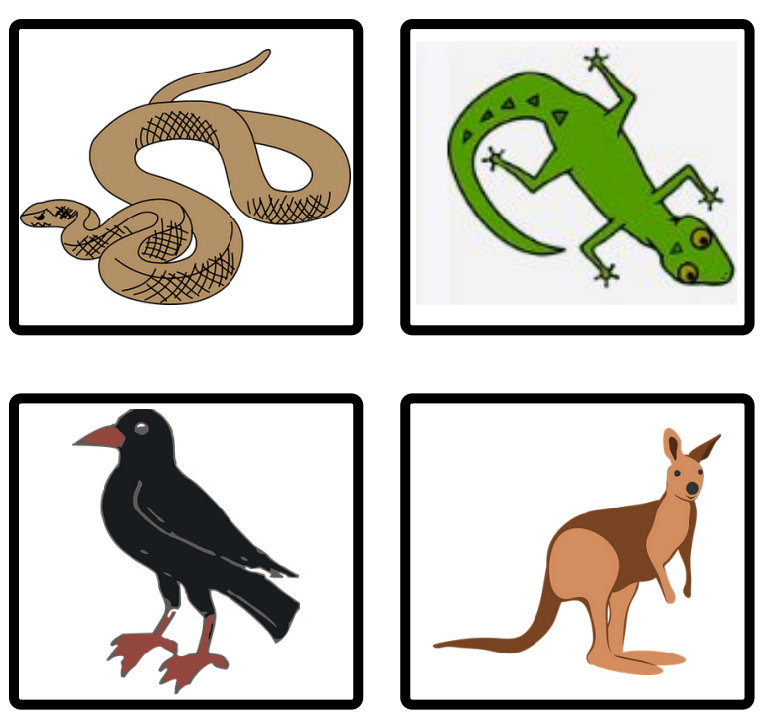
Images sourced from Canva and used in accordance with the Canva Content License Agreement.

Resource 2: Writing dialogue checklist
Writing Dialogue Checklist
- Quotation marks go around exactly what is spoken.
- A capital letter is used at the start of what is spoken.
- There is a piece of punctuation before the close of quotation marks.
- ‘Saying verbs’ are used to describe how the speech is spoken.
- A new line is used when each new character speaks.

Resource 3: Modelled example – Stage 1
BANG OW BANG OW [Repeated onomatopoeia]
“What’s that noise?” Benny asked. “Is there a new animal in the bush?” [Direct model from the mentor text]
Benny Bungarra, Olive Python and Colin Crow raced through the scrub to see. [Action verb followed by location]
“Wally Wombat,” cried Benny, “how did you get that can on your foot?” [New character with alliteration in the name and introduction of another type of waste that was caught on a body part]
“I was waddling to my burrow and my foot got stuck. Can you help me?” he asked. [Animal explains the problem and asks for help]
“Don’t worry Wally Wombat. I will get a stick to help pry it off,” said Benny. [Benny finds a solution to the problem]
Morgan S (2018) Benny Bungarra’s Big Bush Clean-up.

Resource 4: Visual prompt cards
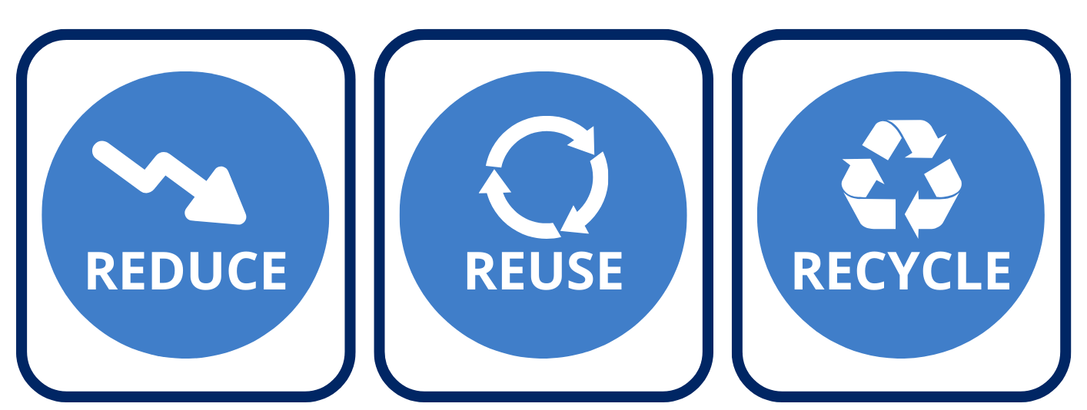
Images sourced from Canva and used in accordance with the Canva Content License Agreement.

Resource 5: Meet the corroboree frog
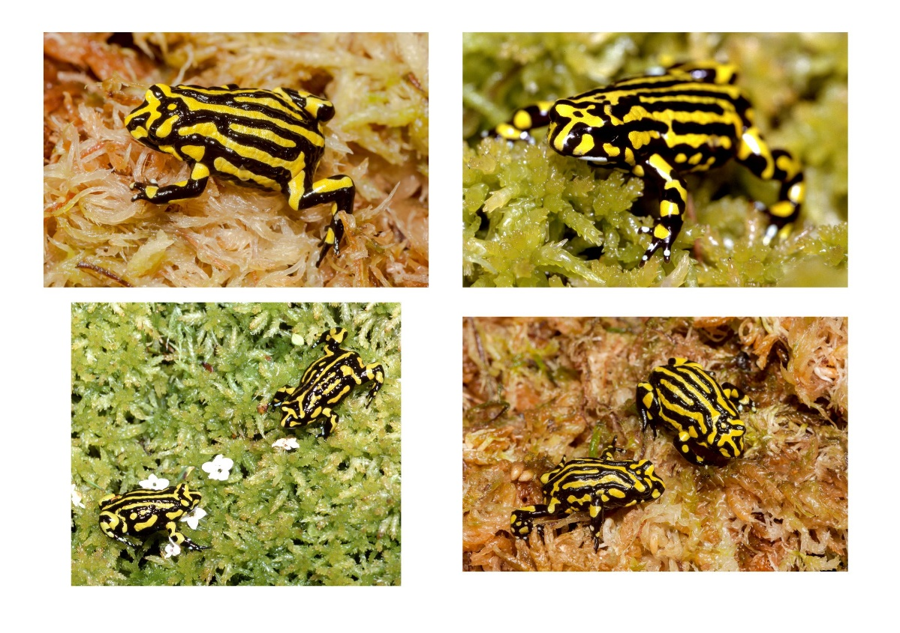
Images sourced from Canva and used in accordance with the Canva Content License Agreement.

Resource 6: Categorising
Imaginative | Persuasive | Informative

Resource 7: TAG feedback
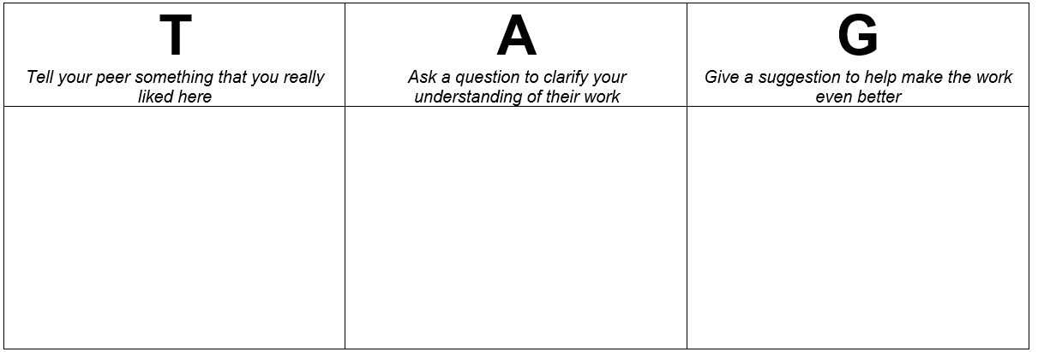

References
Links to third-party material and websites
Please note that the provided (reading/viewing material/list/links/texts) are a suggestion only and implies no endorsement, by the New South Wales Department of Education, of any author, publisher, or book title. School principals and teachers are best placed to assess the suitability of resources that would complement the curriculum and reflect the needs and interests of their students.
If you use the links provided in this document to access a third-party's website, you acknowledge that the terms of use, including licence terms set out on the third-party's website apply to the use which may be made of the materials on that third-party website or where permitted by the Copyright Act 1968 (Cth). The department accepts no responsibility for content on third-party websites.
Except as otherwise noted, all material is © State of New South Wales (Department of Education), 2021 and licensed under the Creative Commons Attribution 4.0 International License. All other material (third-party material) is used with permission or under licence. Where the copyright owner of third-party material has not licensed their material under a Creative Commons or similar licence, you should contact them directly for permission to reuse their material.
English K–10 Syllabus © 2022 NSW Education Standards Authority (NESA) for and on behalf of the Crown in right of the State of New South Wales.
Science and Technology K–6 Syllabus © 2017 NSW Education Standards Authority (NESA) for and on behalf of the Crown in right of the State of New South Wales.
© 2021 NSW Education Standards Authority. This document contains NSW Curriculum and syllabus content. The NSW Curriculum is developed by the NSW Education Standards Authority. This content is prepared by NESA for and on behalf of the Crown in right of the State of New South Wales. The material is protected by Crown copyright.
Please refer to the NESA Copyright Disclaimer for more information.
NESA holds the only official and up-to-date versions of the NSW Curriculum and syllabus documents. Please visit the NSW Education Standards Authority (NESA) website and the NSW Curriculum website.
National Literacy Learning Progression © Australian Curriculum, Assessment and Reporting Authority (ACARA) 2010 to present, unless otherwise indicated. This material was downloaded from the Australian Curriculum website (National Literacy Learning Progression) (accessed 19 October 2022) and was not modified. The material is licensed under CC BY 4.0. Version updates are tracked in the ‘Curriculum version history’ section on the 'About the Australian Curriculum' page of the Australian Curriculum website.
ACARA does not endorse any product that uses the Australian Curriculum or make any representations as to the quality of such products. Any product that uses material published on this website should not be taken to be affiliated with ACARA or have the sponsorship or approval of ACARA. It is up to each person to make their own assessment of the product, taking into account matters including, but not limited to, the version number and the degree to which the materials align with the content descriptions and achievement standards (where relevant). Where there is a claim of alignment, it is important to check that the materials align with the content descriptions and achievement standards (endorsed by all education Ministers), not the elaborations (examples provided by ACARA).
Corroboree Frog (2016) 10 Fast Facts about Corroboree Frogs, Corroboree Frog website, accessed 19 October 2022.
Corroboree Frog (2016) Corroboree Frog [website], accessed 19 October 2022.
ETA (English Teachers Association) and NSW Department of Education (2016) The Textual Concepts and Processes resource, English Textual Concepts website, accessed 19 October 2022.
Holton-Ramirez T (2013), The Little Corroboree Frog (Ramirez A, illus.), Magabala Books, Broome.
Morgan S (2018) Benny Bungarra’s big bush clean-up (Kwaymullina A, illus.), Magabala Books, Broome.
Taronga Zoo Sydney (10 November 2020), 'NAIDOC Week at Taronga – Leslie McLeod talks Corroboree Frogs!' [video], Taronga Education TV, YouTube, accessed 19 October 2022.
WWF-Australia (2018) ‘Reduce, Reuse, Recycle’, Get Involved, WWF-Australia website, accessed 19 October 2022.

Further reading
Kidcyber (2022) Corroboree Frog, Kidcyber website, accessed 19 October 2022.

