English – K-2 multi-age – Year B – Unit 2
Contents
Unit overview and instructions for use 3
Teacher notes 4
Outcomes and content – Component A 5
Outcomes and content – Component B 9
Week 1 13
Component A teaching and learning 13
Component B teaching and learning 14
Lesson 1: Introducing the text 16
Lesson 2: Retelling a narrative journey 18
Lesson 3: The cat and the narrative journey 21
Lesson 4: Adjectives and noun groups make a pattern 24
Lesson 5: Going on a narrative journey 27
Week 2 32
Component A teaching and learning 32
Component B teaching and learning 33
Lesson 6: Getting to know the text and making predictions 35
Lesson 7: Narrative journeys and characters 36
Lesson 8: Unexpected endings 40
Lesson 9: Sentences and noun groups 41
Lesson 10: Planning for sequel writing 43
Resource 1: Locations on the journey 47
Resource 2: Story map 48
Resource 3: Prepositions 49
Resource 4: Beginning, middle, end story map 52
Resource 5: Adjectives 53
Resource 6: Talking characters 54
Resource 7: Predictable speech 55
Resource 8: Narrative mountain 56
Resource 9: Narrative characters 57
References 58

Unit overview and instructions for use
This two-week unit is comprised of Component A and Component B. Connecting learning across both components is encouraged.
Teaching and learning | Component A | Component B
Suggested duration | 60 minutes | 45 minutes
Explicit teaching focus areas | - Phonological awareness (Early Stage 1)  - Print conventions (Early Stage 1)  - Phonic knowledge  - Reading fluency  - Reading comprehension  - Spelling  - Handwriting | - Oral language and communication  - Vocabulary  - Reading comprehension  - Creating written texts  - Understanding and responding to literature
To prepare for teaching and learning: | - Refer to Outcomes and content – Component A, K-2 – Instructional sequence – grapheme–phoneme correspondences [PDF 825 KB], and the teaching advice documents (hyperlinked in Component A teaching and learning table).  - Based on student needs identified through ongoing assessment data, plan and document how you will sequence teaching and learning in whole class and targeted teaching groups across the two-week cycle. | - Familiarise yourself with Outcomes and content – Component B, Textual concepts information and videos, English Textual Concepts and Learning Processes (2016), and the teaching and learning sequence.  - Based on student needs identified through ongoing assessment data, determine how you will support students in whole class and targeted teaching groups across the two-week cycle as required.
English K–10 Syllabus © 2022 NSW Education Standards Authority (NESA) for and on behalf of the Crown in right of the State of New South Wales.

Teacher notes
- Understanding of narrative can be supported through watching the department’s video: Narrative (3:51).
- Effective reading resources will support implementation of choral and echo reading strategies and reader’s theatre.
- This unit could enhance student learning towards achievement of outcomes from the Creative Arts syllabus regarding drama.
- The mentor text A Dark, Dark Tale is a cumulative narrative. It builds on a pattern. Each time a new location is shown, the previous one is repeated.
- In Lesson 7 two copies of the text support the whole class activity.
- Reflect on student learning and engagement in activities and record differentiation and adjustments within the unit to inform future teaching and learning. One way of doing this could be to add comments to the digital file.
- Guided writing is providing targeted scaffolds and support to groups of or individual students with similar needs as they develop writing skills and understandings. Guided writing involves guiding and supporting students through the process of writing, and providing explicit instruction and feedback through planned mini-lessons and conferences.
- ‘Draw, talk, write, share’ for emergent writers includes drawing as part of a meaning making process, while talking and sharing allows children to make sense of their ideas and to develop their vocabulary and oral language skills. Writing provides an opportunity to apply phonic and word knowledge to another context. For best practice see Draw, Talk, Write (and Share) (Mackenzie 2019).
- Thinking partners are used to engage students in accountable conversations about texts and personal experiences. This strategy helps students share their experiences and thinking in a non-threatening way. Similar strategies include ‘talk partners’, ‘Think-Pair-Share’, and ‘turn and talk’.
- Content points are linked to the National Literacy Learning Progression version (3).
Levels and indicators sourced from National Literacy Learning Progression © Australian Curriculum, Assessment and Reporting Authority (ACARA), (accessed 13 September 2022) and was not modified. See references for more information.

Outcomes and content – Component A
The table below outlines the focus outcomes and content. Content is linked to the National Literacy Learning Progression version (3).
Early Stage 1 Focus area and outcome | Stage 1 Focus area and outcome
Phonological awareness  ENE-PHOAW-01 – identifies, blends, segments and manipulates phonological units in spoken words as a strategy for reading and creating texts  - complete familiar spoken phrases in texts, including chants, rhymes, songs and poems (PhA1)  - segment a spoken sentence of 3 to 5 words into separate spoken words (PhA2)  - orally blend up to 4 phonemes together to make a one-syllable spoken word (PhA4)  - orally blend and segment syllables in words comprising up to 3 syllables (PhA2) | N/A
Print conventions  ENE-PRINT-01 – tracks written text from left to right and from top to bottom of the page and identifies visual and spatial features of print  - understand that written Standard Australian English uses letters to represent sounds  - know the difference between a letter and a word (PKW1)  - turn pages one at a time (UnT3)  - begin reading at the top of the page and conclude reading at the bottom of the page (UnT3) | N/A
Phonic knowledge  ENE-PHOKW-01 – uses single-letter grapheme–phoneme correspondences and common digraphs to decode and encode words when reading and creating texts  - match a single-letter grapheme with a phoneme  - say the most common phoneme for single-letter graphemes (graphs) (PKW3)  - blend single-letter grapheme–phoneme correspondences to decode VC and CVC words, and apply this knowledge when reading, including decodable texts (PKW3, PKW4) | Phonic knowledge  EN1-PHOKW-01 – uses initial and extended phonics, including vowel digraphs, trigraphs to decode and encode words when reading and creating texts  - segment and encode one-syllable high-frequency base words with split digraphs and apply this when creating texts (SpG6)  - blend and decode one-syllable words with taught extended vowel graphs and digraphs, including graphemes for r-controlled vowels and diphthongs, and apply this when reading texts (PKW6, PKW7)  - segment and encode one-syllable words with taught vowel graphs, digraphs and trigraphs and apply this when creating texts
Reading fluency  ENE-REFLU-01 – reads decodable texts aloud with automaticity (N/A) | Reading fluency  EN1-REFLU-01 – sustains reading unseen texts with automaticity and prosody and self-corrects errors  - apply grapheme–phoneme correspondence to read words with automaticity (FlY1)  - use sentence punctuation to enhance reading in a conversational manner (FlY3, FlY4)
Reading comprehension  ENE-RECOM-01 – comprehends independently read texts using background knowledge, word knowledge and understanding of how sentences connect  - use background knowledge when identifying connections between a text, own life, other texts and/or the world (UnT4)  - recall key characters, events and/or information in text (UnT5) | Reading comprehension  EN1-RECOM-01 – comprehends independently read texts that require sustained reading by activating background and word knowledge, connecting and understanding sentences and whole text, and monitoring for meaning  - use known vocabulary to build a mental model of the content of the text  - make text-to-self, text-to-text or text-to-world connections when reading (UnT6)
Spelling  ENE-SPELL-01 – applies phonological, orthographic and morphological generalisations and strategies to spell taught familiar and high-frequency words when creating texts  - spell their own name (SpG1) | Spelling  EN1-SPELL-01 – applies phonological, orthographic and morphological generalisations and strategies when spelling words in a range of writing contexts  - segment single-syllable words into phonemes as a strategy for spelling (SpG4)  - spell high-frequency base words with taught vowel graphs, digraphs, split digraphs, trigraphs and quadgraphs (SpG6)
Handwriting  ENE-HANDW-01 – produces all lower-case and upper-case letters to create texts  - use writing implements with a stable and relaxed pencil grasp (HwK2)  - use a stable posture when handwriting or drawing by sitting comfortably with feet flat on the floor, the writing arm resting on a table, with the opposite hand resting on the paper, and shoulders relaxed | Handwriting  EN1-HANDW-01 – uses a legible, fluent and automatic handwriting style, and digital technology, including word-processing applications, when creating texts  - form all letters with consistent size and slope in NSW Foundation Style from memory (HwK5)

Outcomes and content – Component B
The table below outlines the focus outcomes and content. Content is linked to the National Literacy Learning Progression version (3).
Early Stage 1 Focus area and outcome | Stage 1 Focus area and outcome
Oral language and communication  ENE-OLC-01 – communicates effectively by using interpersonal conventions and language with familiar peers and adults  - orientate self to the speaker (LiS1)  - contribute to group conversations (InT3)  - use oral language to make requests and express needs  - retell favourite stories, poems, songs and rhymes with some parts as exact repetition and some in their own words (SpK2) | Oral language and communication  EN1-OLC-01 – communicates effectively by using interpersonal conventions and language to extend and elaborate ideas for social and learning interactions  - initiate, listen and/or respond in partner and group conversations (InT3, InT5)  - organise key ideas in logical sequence
Vocabulary  ENE-VOCAB-01 – understands and effectively uses Tier 1 and Tier 2 words in familiar contexts  - recognise and understand taught Tier 1 and Tier 2 words (PKW3, SpK3) | Vocabulary  EN1-VOCAB-01 – understands and effectively uses Tier 1, taught Tier 2 and Tier 3 vocabulary to extend and elaborate ideas  - use taught morphemic knowledge to create word families
Reading comprehension  ENE-RECOM-01 – comprehends independently read texts using background knowledge, word knowledge and understanding of how sentences connect  - use background knowledge when identifying connections between a text, own life, other texts and/or the world (UnT4)  - use visual cues in multimodal texts to interpret meaning (UnT5)  - recall key characters, events and/or information in text (UnT5) | Reading comprehension  EN1-RECOM-01 – comprehends independently read texts that require sustained reading by activating background and word knowledge, connecting and understanding sentences and whole text, and monitoring for meaning  - use known vocabulary to build a mental model of the content of the text  - make text-to-self, text-to-text or text-to-world connections when reading (UnT6)
Creating written texts  ENE-CWT-01 – creates written texts that include at least 2 related ideas and correct simple sentences  - use personal vocabulary, words on display and in mentor texts when constructing sentences  - use drawing, images or mind maps to support planning and writing (CrT4) | Creating written texts  EN1-CWT-01 – plans, creates and revises texts written for different purposes, including paragraphs, using knowledge of vocabulary, text features and sentence structure  - write texts that describe, explain, give an opinion, recount an event, tell a story (CrT7)  - use visual elements to expand meaning in own texts  - use noun groups to build descriptions of people and things (CrT6)  - use action, saying, relating and sensing verbs to add detail and precision to writing (GrA2, GrA5)  - use contextually precise prepositional phrases when creating texts (GrA4)
Understanding and responding to literature  ENE-UARL-01 – understands and responds to literature read to them  - identify, discuss and compare the beginning, middle and end in a range of narratives  - experiment with using parts and/or features of a narrative, innovating from a mentor text | Understanding and responding to literature  EN1-UARL-01 – understands and responds to literature by creating texts using similar structures, intentional language choices and features appropriate to audience and purpose  - identify the sequence of events that make up a narrative in own and others’ texts (UnT6)  - identify patterns in narratives that set up expectations and aid prediction of actions and attitudes  - create and re-create narratives using understanding of narrative features (CrT5)

Week 1

Component A teaching and learning
The table below can be used to plan and document lessons that address Component A outcomes and content. Both the detailed example [DOC 529KB] of a two-week teaching and learning cycle and brief example [DOC 66KB] may support you in your planning.
Focus Areas | Lesson 1 | Lesson 2 | Lesson 3 | Lesson 4 | Lesson 5
Phonological awareness (Early Stage 1) and Phonic knowledge
15 minutes
Spelling and Handwriting
15 minutes
Print conventions (Early Stage 1), Reading comprehension and Reading fluency
30 minutes

Component B teaching and learning
The following teaching and learning sequence has been designed to address Component B outcomes and content. Adapt the sequence as required to best meet the needs of your students.

Learning intention and success criteria
Learning intentions and success criteria are best co-constructed with students. The table below contains suggested learning intentions and success criteria.
Element | Early Stage 1 | Stage 1
Learning intentions | Students are learning to identify the beginning, middle and end events in narratives. | Students are learning to explore narratives and understand features such as prediction, sequencing and patterns.
Success criteria | Students can:  - recognise the beginning, middle and end of a narrative  - explore different endings to a story  - recall characters, events and information  - retell their favourite parts of a story  - understand that illustrations support storytelling. | Students can:  - identify the characters, setting and structure of a story and give an opinion  - use story maps as a planning tool for writing  - create and recreate a text to explore alternative endings  - understand that events build on or repeat themselves to promote prediction  - explore the relationship between illustrations and the text.

Resources
- Brown R (1992) A Dark, Dark Tale, Dial Books, New York. ISBN13: 9780140546217
- Resource 1: Locations on the journey
- Resource 2: Story map
- Resource 3: Prepositions
- Resource 4: Beginning, middle, end story map
- Resource 5: Adjectives
- 3 sheets of different coloured paper
- Coloured crayons or pens
- Masking tape
- Poster paper
- Mini whiteboards
- Strips of paper for sentence construction and highlighters

Lesson 1: Introducing the text
The following teaching and learning activities support multi-age settings.

Whole
- Introduce the text concept, narrative. Explain a narrative is an account of events which may be real or imagined. A narrative has elements including characters, setting and events.
- Introduce the text A Dark, Dark Tale by Ruth Brown, as a narrative about a journey. Ask students to see, think and wonder about the visual elements on the cover. Using mini whiteboards, students write or draw their predictions about characters, setting and events in the story. Students share their predictions and explain their reasoning. Read the text, pausing to allow for students to check their predictions. Students use thumbs up, down, or sideways to indicate how accurate their predictions were.
- Clarify unfamiliar Tier 2 or Tier 3 words. For example, a moor is an overgrown area of land, a hall is a walkway that leads you to another room and a passage is a space or area between rooms. Add the words to a word wall.
- Discuss the text using guiding questions. For example:
- Who are the characters?
- Where is the setting and how do you know?
- Discuss the narrative elements and the events that occur, including the beginning (orientation to the setting and the main character), middle (locations throughout the cat’s journey) and end (where the cat encounters the mouse). Clarify the cat and the mouse are the main characters. The setting is the house.
- Explain that the story uses repeated patterns to build upon itself. Discuss how the author has chosen to use the repeated patterns in the text to support prediction. Explain that this takes readers on a journey.
- Students Think-Pair-Share a retell of where the cat travelled on the narrative journey.
- Model drawing a timeline including writing a title, and labels for the beginning, middle and end. Provide pairs of students with a large piece of paper. Students copy the timeline for the story as modelled.
- Students cut images from Resource 1: Locations on the journey and stick each object on the timeline in the order it was introduced in the narrative.

Part
The table below details the differentiated teaching and learning activities for each stage.
Early Stage 1 (teacher guided) | Stage 1 (pairs/independent)
- Students select a location from the beginning, middle or end of the timeline and draw an image of the setting, including the cat.  - Students share their drawings and describe the part of the story they have drawn.  Too easy? Students label their drawings. | - Students label the locations along the story’s timeline and write a sentence using the repeated language structure from the text, ‘A dark, dark _____.’ For example, A dark, dark hall.  - In pairs, students create a floor plan of the dark, dark house. Label each location that was in the text on the floor plan. Draw the path that the cat travelled through the house to get to the mouse.  Too hard? Students label the locations.  Too easy? Write sentences describing the cat’s journey. For example, The cat walked along the hall and turned to climb  the dark, dark stairs.

Whole
- In pairs, students share their work.

Lesson 2: Retelling a narrative journey
The following teaching and learning activities support multi-age settings.

Whole
- Revise the structure of a narrative as a sequence of events. Revisit the locations in the narrative of the cat’s journey.
- Revise sentences, as subject-noun group, verb-verb group and object-noun group (subject-verb-object structure). Introduce prepositions. Explain that authors use prepositions to tell the reader where (place) or when (time) something is in relation to something else. Create a class definition of prepositions on poster paper.
- Give students examples of prepositions in relation to place such as on, in, up, down, under. Ask students to brainstorm other prepositions for place. Record and add student responses to the class definition.
- Explain that when a preposition and noun group are joined, they form a prepositional phrase in a sentence.
- Re-read A Dark, Dark Tale. Highlight the prepositions, for example, behind, in front, on, in, across, up. Add these words to the class word wall.
- On poster paper, write the phrase ‘in the wood there was a dark, dark house’. Using colour coding, highlight the preposition ‘in’, subject-noun group ‘the wood’, verb ‘was’, and noun-object ‘a house’. Repeat for the following sentences:
- Behind the door was a dark, dark hall.
- Up the stairs there was a dark, dark passage.
- Across the passage was a dark, dark curtain.
- Model drawing the cat at a location from the text using Resource 2: Story map. For example, draw a cat on the stairs.
- Display Resource 3: Prepositions. Model writing a sentence with a prepositional phrase using a preposition from Resource 3 at the beginning of a sentence. For example, on the stairs is a cat. Use colour coding to highlight the preposition ‘on’, subject-noun group ‘the stairs’, verb ‘is’, and noun-object ‘a cat’.

Part
The table below details the differentiated teaching and learning activities for each stage.
Early Stage 1 (teacher guided) | Stage 1 (pairs/independent)
- Use magnetic letters or virtual manipulatives (magnetic letters) to model the grapheme–phoneme correspondence of prepositions.  - Select 2 to 3 prepositions for students to learn and practise writing on mini whiteboards.  - Co-construct 3 to 4 simple sentences using the prepositions ‘on’ and ‘in’. For example, ‘The cat is on the table.’ ‘The cat is in the box.’ Colour code the prepositions and nouns.  - Using the Draw, Talk, Write (and Share) strategy, students draw 2 images of a cat or mouse to model the prepositions on and in. Students add labels ‘in’ and ‘on’ to describe the position of their noun.  Too easy? Students write a sentence to describe their drawing. | - Students Think-Pair-Share about how the prepositions from Resource 3 tell the reader about the cat’s journey.  - Using Resource 2: Story map, students sequence relevant events about the cat’s journey, in the form of a visual summary.  - Students add sentences to their story map, writing prepositional phrases which retell where the cat was at each stage of its journey. Prompt students to use the prepositions from Resource 3: Prepositions.  Too hard? Create a small, guided writing group to co-construct sentences with a prepositional phrase.
Stage 1 Assessment task 1 – Observations and work sample from this lesson allow students to demonstrate achievement towards the following syllabus outcomes and content points:
EN1-CWT-01 – plans, creates and revises texts written for different purposes, including paragraphs, using knowledge of vocabulary, text features and sentence structure
- use noun groups to build descriptions of people and things
- use action, saying, relating and sensing verbs to add detail and precision to writing
- write texts that describe, explain, give an opinion, recount an event, tell a story
- use contextually precise prepositional phrases when creating texts
- use visual elements to expand meaning in own texts.
EN1-UARL-01 – understands and responds to literature by creating texts using similar structures, intentional language choices and features appropriate to audience and purpose
- identify patterns in narratives that set up expectations and aid prediction of actions and attitudes.

Lesson 3: The cat and the narrative journey
The following teaching and learning activities support multi-age settings.

Whole
- Read the text. Model using volume and prosody during the read to create or enhance the mood of the reading.
- Discuss that the cat’s journey through the house is telling the reader where the cat character goes, but not how it moves.
- Explain that action verbs can provide more information to tell us how the cat moves.
- Explain and define that an action verb is something that we, or a character, or things do (an action). Create a class definition of action verbs. Brainstorm action verbs that students can do. For example, jump, sit.
- Create a mind map of action verbs describing the cat's journey.
- Create space for students to dramatise the verbs describing the cat’s movements.
- Revise simple sentences, as subject/noun group, verb/verb group and object/noun group (subject-verb-object structure).
- Model writing a simple sentence using a subject-verb-object structure. For example, ‘The cat can walk in the house.’ Highlight the action verb (walk). Discuss how the action verb can change.

Part
The table below details the differentiated teaching and learning activities for each stage.
Early Stage 1 (pairs) | Stage 1 (teacher guided)
- Using Resource 4: Beginning, middle, end story map, students draw 3 images of the cat moving in different ways through the house. Label images with a matching verb from the mind map.  Too easy? Students write a sentence for each part of their narrative using the sentence frame ‘The cat can …. in the house.’ | - Model sentences instructing the cat to move through the narrative journey. For example:  - Walk (action verb) through the moor to the dark, dark wood (noun group) and tiptoe (action verb) quietly towards the house (noun group).  - Now that you are at the house, creep (action verb) to the dark, dark door (noun group).  - From the door, crawl (action verb) down the dark, dark hall (noun group).  - Students write instructions to help the cat find the mouse.  - Students use action verbs and noun groups to add precision to their writing. For example: ‘Tiptoe through the wood.’  - Students read their instructions to their group. Peers will review and may suggest alternative vocabulary choices. Provide time for students to edit their work.  Too hard? Jointly construct writing with small groups as required.  Too easy? Students include direct speech inferring a conversation with the cat. For example, ‘Come over here to the door. You will then enter the dark, dark hall.’
Early Stage 1 Assessment task 1 – Work samples from this lesson allow students to demonstrate achievement towards the following syllabus outcomes and content points:
ENE-OLC-01 – communicates effectively by using interpersonal conventions and language with familiar peers and adults
- contribute to group conversations.
ENE-VOCAB-01 – understands and effectively uses Tier 1 and Tier 2 words in familiar contexts
- recognise and understand taught Tier 1 and Tier 2 words.
ENE-UARL-01 – understands and responds to literature read to them
- identify, discuss and compare the beginning, middle and end in a range of narratives
- experiment with using parts and/or features of a narrative.
ENE-CWT-01 – creates written texts that include at least 2 related ideas and correct simple sentences
- use drawing, images or mind maps to support planning and writing.
ENE-RECOM-01 – comprehends independently read texts using background knowledge, word knowledge and understanding of how sentences connect
- recall key characters, events and/or information in text.

Lesson 4: Adjectives and noun groups make a pattern
The following teaching and learning activities support multi-age settings.

Whole
- Revise the structure of the narrative A Dark, Dark Tale. Explain how the author uses the repeated vocabulary pattern of ‘dark, dark’ and a place and this helps readers make predictions about the narrative journey. This sentence structure uses an adjective-noun group. For example, a dark, dark wood. Discuss how the repetition of the word ‘dark’ emphasises the darkness of the setting.
- Model the beginning of an oral narrative that has a predictable pattern with a repeated adjective-noun group. Ask students to predict what the final object could be. For example:
- On the desk is a sharp, sharp pencil. In the tin are sharp, sharp (scissors).
- In the box is a soft, soft ball. On the floor is a soft, soft bear. In the reading area is a soft, soft (cushion).
- On the shelf is a red, red book. In the tub is a red, red block. In my lunchbox is a red, red (apple).
- With a thinking partner, students brainstorm adjectives to describe objects in the classroom. Display Resource 5: Adjectives to assist student’s thinking. Share responses with the class to create a list of adjectives.

Part
The table below details the differentiated teaching and learning activities for each stage.
Early Stage 1 (teacher guided/pairs) | Stage 1 (pairs)
- Students select one adjective and collect 3 objects in their classroom that can be described using the adjective.  - Draw the 3 objects and label images using adjective and nouns.  Too easy? Provide students with the sentence starter, ‘I saw a…'. Model a think aloud and write the complete sentence for example, ‘I saw a small book on the shelf’ or ‘I saw a small ball in the box’. | - Students plan a classroom treasure map showing the location of objects within the classroom that can be described using the same adjective.  - Label the objects with the same adjective on the treasure map. For example, a red, red book; red, red pencils; a red, red pen.  - Create a narrative text of a sequence of events that match the treasure map and will lead to finding the objects in the classroom. Sentences should include a prepositional phrase and noun group. For example, on the table is a red, red book; under the shelf is a red, red pencil; behind the teacher’s desk is a red, red pen.  Too hard? Students give an oral narrative to describe and locate objects.
Early Stage 1 Assessment task 2 – Work samples from this lesson allow students to demonstrate achievement towards the following syllabus outcomes and content points:
ENE-CWT-01 – creates written texts that include at least 2 related ideas and correct simple sentences
- use drawing, images or mind maps to support planning and writing
- use personal vocabulary, words on display and in mentor texts when constructing sentences.
ENE-OLC-01 – communicates effectively by using interpersonal conventions and language with familiar peers and adults
- use oral language to make requests and express needs.
ENE-RECOM-01 – comprehends independently read texts using background knowledge, word knowledge and understanding of how sentences connect
- use visual cues in multimodal texts to interpret meaning.
ENE-UARL-01 – understands and responds to literature read to them
- identify, discuss and compare the beginning, middle and end in a range of narratives.
Stage 1 Assessment task 2 – Work samples from this lesson allow students to demonstrate achievement towards the following syllabus outcomes and content points:
EN1-RECOM-01 – comprehends independently read texts that require sustained reading by activating background and word knowledge, connecting and understanding sentences and whole text, and monitoring for meaning
- make text-to-self, text-to-text or text-to-world connections when reading.
EN1-CWT-01 – plans, creates and revises texts written for different purposes, including paragraphs, using knowledge of vocabulary, text features and sentence structure
- write texts that describe, explain, give an opinion, recount an event, tell a story
- use visual elements to expand meaning in own texts
- use noun groups to build descriptions of people and things
- use contextually precise prepositional phrases when creating texts.
EN1-OLC-01 – communicates effectively by using interpersonal conventions and language to extend and elaborate ideas for social and learning interactions
- initiate, listen and/or respond in partner and group conversations
- organise key ideas in logical sequence.
EN1-UARL-01 – understands and responds to literature by creating texts using similar structures, intentional language choices and features appropriate to audience and purpose
- identify patterns in narratives that set up expectations and aid prediction of actions and attitudes.

Lesson 5: Going on a narrative journey
The following teaching and learning activities support multi-age settings.

Whole
- Revise the text concept ‘narrative’.
- Create a simple map of the school. Explain that students are going to create a narrative about a journey around the school, with a repeated adjective pattern.
- Brainstorm adjectives describing the school, for example, noisy, busy, quiet. Record on poster paper.
- Brainstorm locations around the school that students could visit. Add responses to the poster.
- Revisit the ending of the text A Dark, Dark Tale, the cat finding a mouse. Discuss an item that students might find in the school that would be entertaining or unexpected.
- In small groups, students share their ideas for a narrative journey around the school including an ending.
- Model planning a sequence of events using Resource 2: Story map. Model writing a sentence, with a repeated adjective describing different locations within the classroom or school.

Part
The table below details the differentiated teaching and learning activities for each stage.
Early Stage 1 (independent) | Stage 1 (teacher guided/independent)
- Ask students to think of 3 events. In pairs, students discuss the beginning, middle and end of their narrative.  - Students draw 3 pictures, one for each of the beginning, middle and end using Resource 4: Beginning, middle, end story map. Encourage students to attempt writing simple sentences with repeated adjective patterns to match their drawings.  Too hard? Jointly construct a sentence or scribe for students.  Too easy? Create a guided writing group and engage students in interactive writing.  - When students have completed their drawing ask them to choose a partner. Each student takes turns retelling their narrative journey with a partner. Remind students to talk about the beginning, middle and end of their narrative. Encourage students to ask each other questions and make comments. | - Students plan their narrative using a student copy of Resource 2 or plain paper to draw 3 to 4 events in sequence. Students draw a map of where they will travel to around the school, labelling locations.  - Brainstorm words that students may need to write their narrative, including the repeated adjective pattern. Create a class word bank.  - Students write a short narrative using their plans. Monitor students' independent writing.  Too hard? Jointly construct or scribe for students. Create a guided writing group and engage students in interactive writing.  Too easy? Ask students to write sentences with prepositional phrases.  - When students have completed their writing ask them to choose a partner. Each student takes turns retelling their narrative journey with a partner. Remind students to talk about their writing, their drawings and their ideas. Encourage students to ask each other questions and make comments.
Early Stage 1 Assessment task 3 – Observations from this lesson allow students to demonstrate achievement towards the following syllabus outcomes and content points:
ENE-OLC-01 – communicates effectively by using interpersonal conventions and language with familiar peers and adults
- retell favourite stories, poems, songs and rhymes with some parts as exact repetition and some in their own words
- contribute to group conversations
- orientate self to the speaker
- use oral language to make requests and express needs.
ENE-RECOM-01 – comprehends independently read texts using background knowledge, word knowledge and understanding of how sentences connect
- recall key characters, events and/or information in text.
ENE-VOCAB-01 – understands and effectively uses Tier 1 and Tier 2 words in familiar contexts
- recognise and understand taught Tier 1 and Tier 2 words.
Stage 1 Assessment task 3 – Observations and work samples from this lesson allow students to demonstrate achievement towards the following syllabus outcomes and content points:
EN1-CWT-01 – plans, creates and revises texts written for different purposes, including paragraphs, using knowledge of vocabulary, text features and sentence structure
- use contextually precise prepositional phrases when creating texts
- use action, saying, relating and sensing verbs to add detail and precision to writing
- use visual elements to expand meaning in own texts.
EN1-RECOM-01 – comprehends independently read texts that require sustained reading by activating background and word knowledge, connecting and understanding sentences and whole text, and monitoring for meaning
- use known vocabulary to build a mental model of the content of the text.
EN1-OLC-01 – communicates effectively by using interpersonal conventions and language to extend and elaborate ideas for social and learning interactions
- organise key ideas in logical sequence.
EN1-UARL-01 – understands and responds to literature by creating texts using similar structures, intentional language choices and features appropriate to audience and purpose
- create and re-create narratives using understanding of narrative features.

Week 2

Component A teaching and learning
The table below can be used to plan and document lessons that address Component A outcomes and content. Both the detailed example [DOC 529KB] of a two-week teaching and learning cycle and brief example [DOC 66KB] may support you in your planning.
Focus Areas | Lesson 6 | Lesson 7 | Lesson 8 | Lesson 9 | Lesson 10
Phonological awareness (Early Stage 1) and Phonic knowledge
15 minutes
Spelling and Handwriting
15 minutes
Print conventions (Early Stage 1), Reading comprehension and Reading fluency
30 minutes

Component B teaching and learning
The following teaching and learning sequence has been designed to address Component B outcomes and content. Adapt the sequence as required to best meet the needs of your students.

Learning intention and success criteria
Learning intentions and success criteria are best co-constructed with students. The table below contains suggested learning intentions and success criteria.
Element | Early Stage 1 | Stage 1
Learning intentions | Students are learning to identify the events and patterns in a narrative. | Students are learning to innovate on a text using their knowledge of the sequence and patterns in narrative writing.
Success criteria | Students can:  - identify features of a narrative including setting, characters, beginning, middle and end  - retell and innovate on texts  - correctly order events  - identify clues in the text and illustrations that help to make meaning  - predict what might happen next. | Students can:  - identify and explain the sequence of events in a text  - understand that illustrations can extend, contradict or express a different story to the text  - hypothesise and make predictions based on the clues from the text and illustrations  - express and organise their thoughts before writing  - write a story or part of the story based on imaginary events.

Resources
- Fox, M (1996) Hattie and the Fox (Mullins P, illus), Scholastic Australia, Lindfield. ISBN 9781741698206
- Resource 6: Talking characters
- Resource 7: Predictable speech
- Resource 8: Narrative mountain
- Resource 9: Narrative characters
- Coloured crayons or pens
- Coloured pencils
- Craft sticks
- Mini whiteboards
- Playdough
- Poster paper
- Sticky notes (3 colours)
- Sticky tape

Lesson 6: Getting to know the text and making predictions
The following teaching and learning activities support multi-age settings.

Whole
- Introduce Hattie and the Fox. Explain the structure of repeated patterns is similar to A Dark, Dark Tale. Revise the text concept ‘narrative’. A cumulative story is a story that builds on a pattern.
- Remind students that repetition helps readers to make predictions.
- Explain that illustrations are a key feature of a narrative. There are clues in the images that will help to make predictions about the characters in Hattie and the Fox. Read the text and think aloud to prompt students’ predictions about who or what is hiding in the bushes. Provide opportunities for students to share their predictions.
- Discuss the unique print conventions and the use of quotation marks to denote the character’s dialogue and speech. Highlight the quotation marks and explain that authors use them to show the reader that someone is talking.
- Display Resource 6: Talking characters. Note the speech bubbles in Resource 6 represent the characters’ thoughts and speech. For example, the pig could say, ‘Well, well’.

Part
The table below details the differentiated teaching and learning activities for each stage.
Early Stage 1 (teacher guided/small groups) | Stage 1 (small groups)
- Walk through the texts, supporting students to identify the repeated dialogue of each character.  - Guide students to draw a simple image of horse, sheep and goose.  - Re-read a section of the text pausing at the repeated dialogue of the horse, goose and sheep for students to retell the repeated dialogue. | - With a displayed copy of the text and Resource 7: Predictable speech, students discuss and locate the dialogue of the sheep, horse and goose.  - Students write dialogue in the speech bubbles on their copy of Resource 7: Predictable speech.
- Students dramatise a retell of the repeated dialogue in the narrative journey. Divide the class into small groups and assign each group of students to a character. Select students to role-play characters including Hattie, the horse, sheep, pig, cow, goose. Students retell the dialogue of each animal they are role-playing.

Lesson 7: Narrative journeys and characters
The following teaching and learning activities support multi-age settings.

Whole
- Read Hattie and the Fox.
- Discuss Hattie’s feelings when she was not listened to and ask students to share similar experiences they have had. Provide a value statement for students to make text-to-self connections. For example, it is a good idea to listen to your friends.
- Clarify the meaning of vocabulary choices made by the author. For example, ‘good grief’ and ‘gracious me’. Discuss the names of the animals who use these words and add new vocabulary to the word wall.
- Students will be morpheme magicians and change base words using their understanding of morphology. Using mini whiteboards, explicitly teach and model spelling processes to create word families for past tense verbs about the character's actions in the text. For example, look + ed = looked. Write a list of present tense verbs, for example, look, flap, jump, surprise and scare and ask students to change them into past tense. Add present tense and past tense words to the word wall.
Too hard? Select 2 to 3 base word verbs for students to learn and practise writing on mini whiteboards.
Too easy? Write sentences about animal characters in the text with past tense verbs.
- Remind students of the sequence of events in a narrative structure. Walk through several pages pointing out the sequence of events. Students group into stages and role-play the text.
- Model a retell of the events in Hattie and the Fox using Resource 8: Narrative mountain by drawing the features of the fox that are revealed at each sequence of events in the narrative journey. For example, a nose in the first box, and a whole fox in the last box.

Part
The table below details the differentiated teaching and learning activities for each stage.
Early Stage 1 (pairs) | Stage 1 (teacher guided/independent)
- Students create puppets by colouring, then taping Resource 9: Narrative characters onto craft sticks. (Keep Resource 9 for Lesson 10).  - Students create a story timeline using playdough. Students identify the beginning, middle and end by positioning the characters puppets along the playdough story timeline.  - Students retell the story moving their puppets along the story timeline.  Too hard? Provide predetermined markers for the beginning and end.  Too easy? Students experiment with the order and sequence of events. | - Model a retell of the events in Hattie and the Fox using Resource 8: Narrative mountain. While doing this, ask students to identify words that indicate tense and their base word.  - Co-construct and model writing a short retell on the first. event on the class copy Resource 8: Narrative mountain. For example, ‘Hattie looked into the bushes and saw a nose.’  - Students add sentences to retell the narrative journey on a copy of Resource 8: Narrative mountain.  Too hard? Create a small, guided writing group. Co-construct sentences to complete a retell using a narrative mountain.

Whole
- Students share their work.
Early Stage 1 Assessment task 4 – Observations from this lesson allow students to demonstrate achievement towards the following syllabus outcomes and content points:
ENE-UARL-01 – understands and responds to literature read to them
- identify, discuss and compare the beginning, middle and end in a range of narratives
- experiment with using parts and/or features of a narrative.
ENE-RECOM-01 – comprehends independently read texts using background knowledge, word knowledge and understanding of how sentences connect
- use background knowledge when identifying connections between a text, own life, other texts and/or the world.
Stage 1 Assessment task 4 – Work samples from this lesson allow students to demonstrate achievement towards the following syllabus outcomes and content points:
EN1-OLC-01 – communicates effectively by using interpersonal conventions and language to extend and elaborate ideas for social and learning interactions
- initiate, listen and/or respond in partner and group conversations
- organise key ideas in logical sequence.
EN1-UARL-01 – understands and responds to literature by creating texts using similar structures, intentional language choices and features appropriate to audience and purpose
- create and re-create narratives using understanding of narrative features.
EN1-VOCAB-01 – understands and effectively uses Tier 1, taught Tier 2 and Tier 3 vocabulary to extend and elaborate ideas
- use taught morphemic knowledge to create word families.
EN1-RECOM-01 – comprehends independently read texts that require sustained reading by activating background and word knowledge, connecting and understanding sentences and whole text, and monitoring for meaning
- use known vocabulary to build a mental model of the content of the text
- make text-to-self, text-to-text or text-to-world connections when reading.

Lesson 8: Unexpected endings
The following teaching and learning activities support multi-age settings.

Whole
- Students discuss similarities between the 2 texts, A Dark, Dark Tale and Hattie and the Fox, using the Think-Pair-Share strategy. Similarities include:
- narrative structure
- imaginary themes
- a repeated sequence in the middle
- images of the characters appearing in the illustrations multiple times, but not mentioned in the text until the end.
- Students identify other similarities between the 2 texts by passing a ball. The catcher identifies a similarity between the texts before passing the ball. For example, both texts have animals as characters.
- Revise the sequence of events from Hattie and the Fox. For example, in the beginning (fox starts to emerge), middle (animals ignore Hattie’s warnings), and end (cow scares the fox away).
- Read the last few pages of the text. Model ‘I wonder’ statements. For example, ‘I wonder what would happen if the cow didn’t scare the fox’, or ‘I wonder what would happen if the fox returned’.
- Model developing an alternative ending and support pairs to develop their own.
- In pairs students brainstorm their own alternate endings. For example:
- the fox comes back with friends
- Hattie decides to look for the fox
- the cow says sorry for scaring the fox.
- Students use the Draw, Talk, Write (and Share) strategy to write and illustrate a script for their alternative ending.
- Explain the concept of a reader’s theatre, where students are given opportunities to familiarise themselves with a text through role-play.
- Students read alternatives endings to each other in small groups. Students rehearse and perform alternative endings in reader’s theatre.
- Groups perform for each other.
- After watching the performances, students draw and label an image of their favourite ending and share with students in their stage.

Lesson 9: Sentences and noun groups
The following teaching and learning activities support multi-age settings.

Whole
- Explain that authors and illustrators use a range of techniques to help prediction and create meaning in a text. Authors use different sentence structures in narratives to build descriptions of characters.
- Explain that a sentence is a group of words that have a complete thought or message. Create a class definition of a sentence. Discuss that sentences start with a capital letter and can have a full stop.
- Explain that authors use noun groups in sentences to build descriptions of characters or things in texts. Define a noun group as a group of words relating to, or building on, a noun.
- Model writing ‘The fox’ onto poster paper. Students assess whether this is a sentence by showing a thumbs up or thumbs down. Add ‘is brown’ to ‘The fox’ to complete the sentence on the poster. Use colour coding to highlight the subject (noun) ‘the fox’ and noun group ‘is brown’. Explain that this sentence has a subject/noun-noun group added to describe the fox.
- Students Think-Pair-Share the features of the fox in the text. Create a word bank of the features, for example, nose, eyes, ears, tail, body.
- Model drawing a fox on paper. Model adding the noun from the word bank to the drawing to add a label to the drawing. Model writing noun groups that describe the fox’s features. For example, black nose, small eyes, fluffy.

Part
The table below details the differentiated teaching and learning activities for each stage.
Early Stage 1 (independent) | Stage 1 (teacher guided/independent)
- Students draw one of the animals from the text.  - Students use the word bank and modelled writing to label their drawing using noun groups. For example, brown body, bushy tail, big eyes.  - Students turn to the student next to them and describe the animal in their drawing using noun groups to provide precision and detail.  Too easy? Students write a sentence including their noun groups to provide a description of their animal. For example, The cow has a brown body. | - Model writing the sentence, ‘I can see a nose in the bushes’ onto poster paper.  - Use colour coding to highlight parts of a sentence. Choose separate colours for each of the following:  - subject (noun) ‘I’  - verb-object group ‘can see’  - noun-noun group ‘a nose’.  - Explain that ‘in the bush’ is a prepositional phrase in the sentence, as it is giving more information about where Hattie saw the fox’s nose.  - Students write ‘I can see a nose in the bush’ on paper.  - Students write a sentence underneath that has a noun-group to add to the description of the fox. For example, ‘I can see a nose and two eyes in the bush’.  - Students continue to repeat adding sentences that build a description of the fox's features.  Too hard? Jointly construct sentences, to continue adding noun groups to describe the fox.  Too easy? Students innovate on the text by creating sentences that have noun groups that describe a character.

Lesson 10: Planning for sequel writing
The following teaching and learning activities support multi-age settings.

Whole
- Students recall the ending in Hattie and the Fox and revise examples of alternative endings from Lesson 8.
- Explain that a sequel is a story that follows on from a previous one and that students will be creating a sequel to Hattie and the Fox.
- Show students the last page of the text. Ask guiding questions to plan for writing a sequel. For example:
- How could the animals warn others about the fox?
- What could the animals say or do to convince the fox to return?
- Explain that students will plan and write dialogue with past tense vocabulary. For example, run (present tense) ran (past tense). Refer to the base words on the word wall for example, surprise (present tense) and surprised (past tense).
- Using effective questioning techniques, support students’ creative ideas. Students discuss and share ideas for a sequel.

Part
The table below details the differentiated teaching and learning activities for each stage.
Early Stage 1 (pairs/small groups) | Stage 1 (teacher guided/pairs)
- Students expand on the ideas for a sequel by creating 2 new characters to add to the puppets (Resource 9) from Lesson 7.  - Students create puppets by drawing a picture of themselves and a friend.  - Students create dialogue for the puppets and role-play using the playdough story line from Lesson 7.  - The improvised dialogue created during the role-play will inform the sequel. For example:  - I’m going to help Hattie find the fox.  - Let's make friends with the fox.  - Students Draw, Talk, Write (and Share) their ideas for a sequel, using the puppet characters as literacy supports.  Too easy? Students create 2 or 3 parts to their idea, for example, Let’s make friends with the fox and ask her to play. | - Support students to organise their ideas and the writing process by providing sticky notes as a planning tool.  - Explain story beginnings introduce key features such as setting, characters and some events. Students discuss ideas about the beginning of the sequel.  - Students select sticky notes of one colour to write about the setting, another colour to write about characters and a different colour for events.  - Students write or draw one idea per sticky note and organise notes into a logical sequence.  - During individual or small group teacher conferences, students explain their story plans.  - Students write and illustrate their sequel using their plan to sequence events. Remind students to focus on the use of consistent tense, noun groups and action verbs.
Stage 1 Assessment task 5 – Observations and work samples from this lesson allow students to demonstrate achievement towards the following syllabus outcomes and content points:
EN1-UARL-01 – understands and responds to literature by creating texts using similar structures, intentional language choices and features appropriate to audience and purpose
- create and re-create narratives using understanding of narrative features
- identify patterns in narratives that set up expectations and aid prediction of actions and attitudes.
EN1-OLC-01 – communicates effectively by using interpersonal conventions and language to extend and elaborate ideas for social and learning interactions
- organise key ideas in a logical sequence.
EN1-VOCAB-01 – understands and effectively uses Tier 1, taught Tier 2 and Tier 3 vocabulary to extend and elaborate ideas
- use taught morphemic knowledge to create word families.
EN1-CWT-01 – plans, creates and revises texts written for different purposes, including paragraphs, using knowledge of vocabulary, text features and sentence structure
- write texts that describe, explain, give an opinion, recount an event, tell a story
- use visual elements to expand meaning in own texts.

Resource 1: Locations on the journey
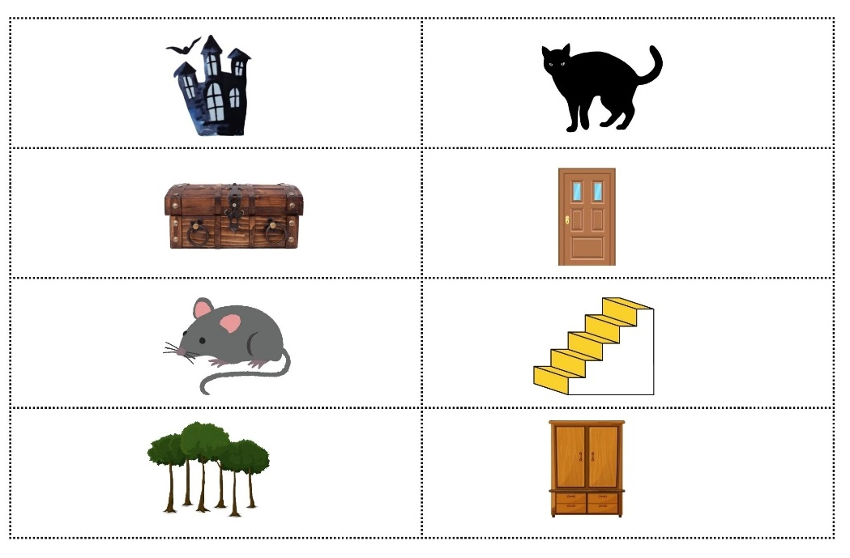
Images sourced from Canva and used in accordance with the Canva Content License Agreement.

Resource 2: Story map
Name:
Title:
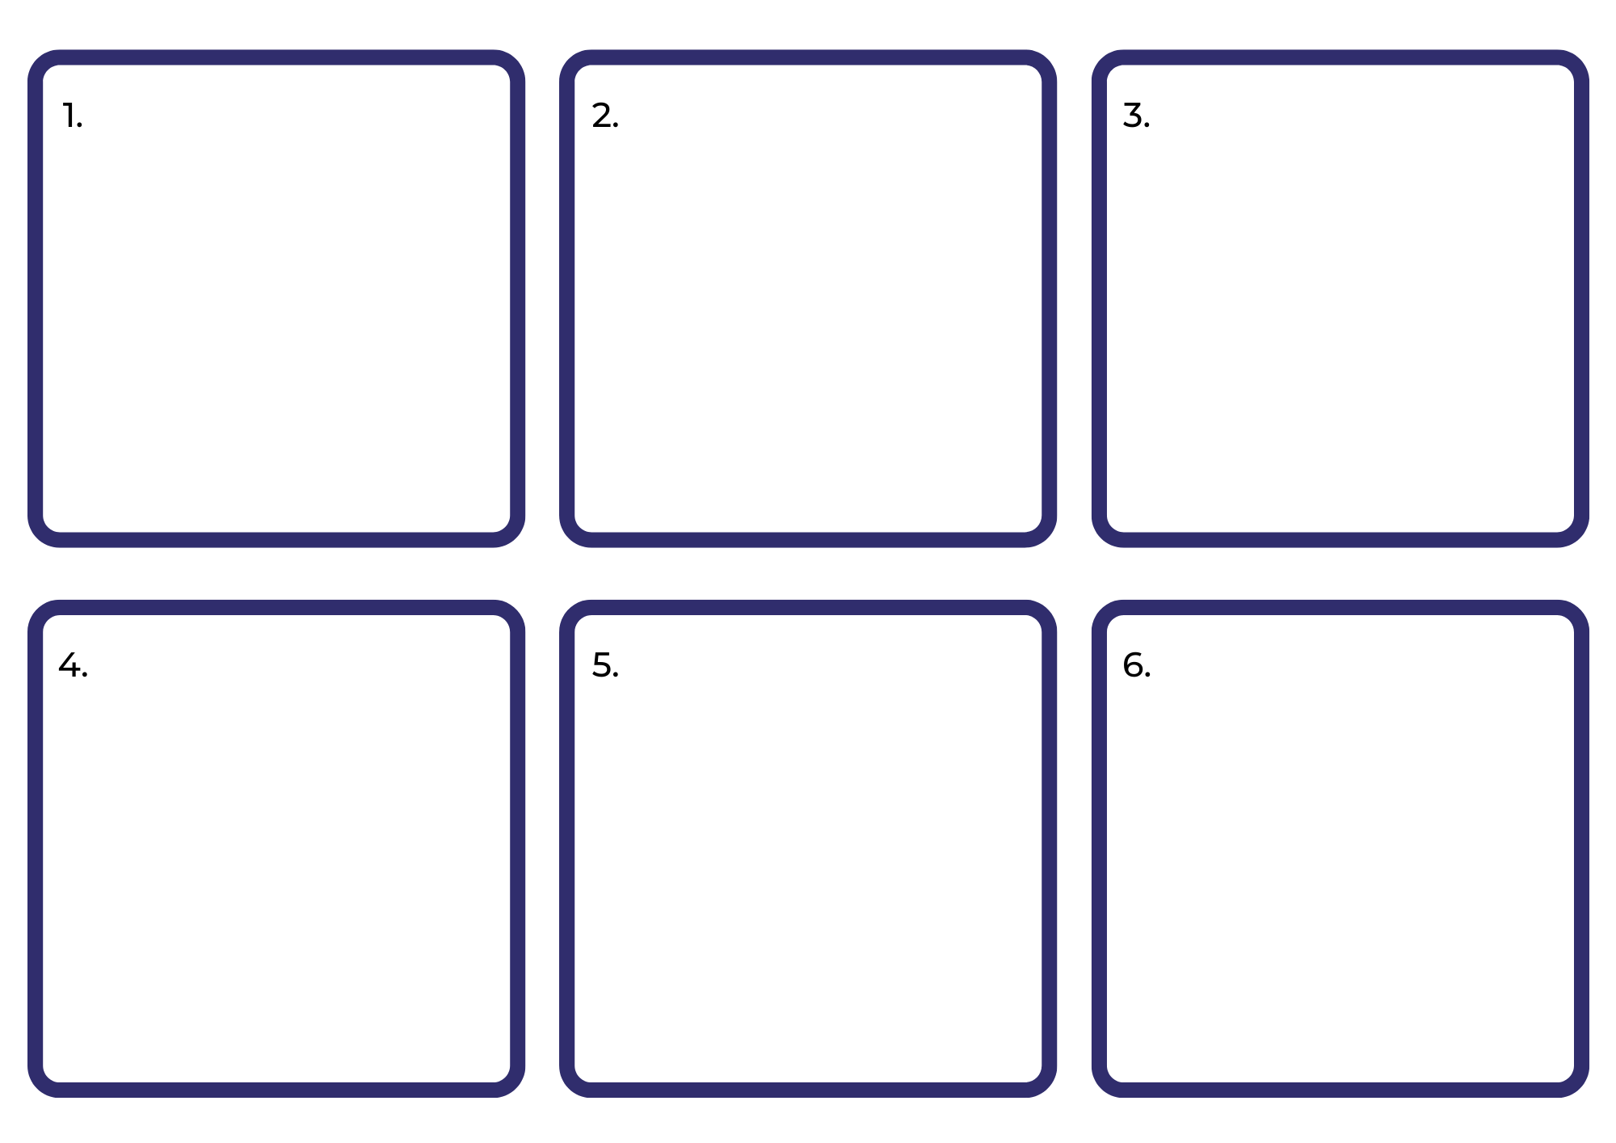

Resource 3: Prepositions
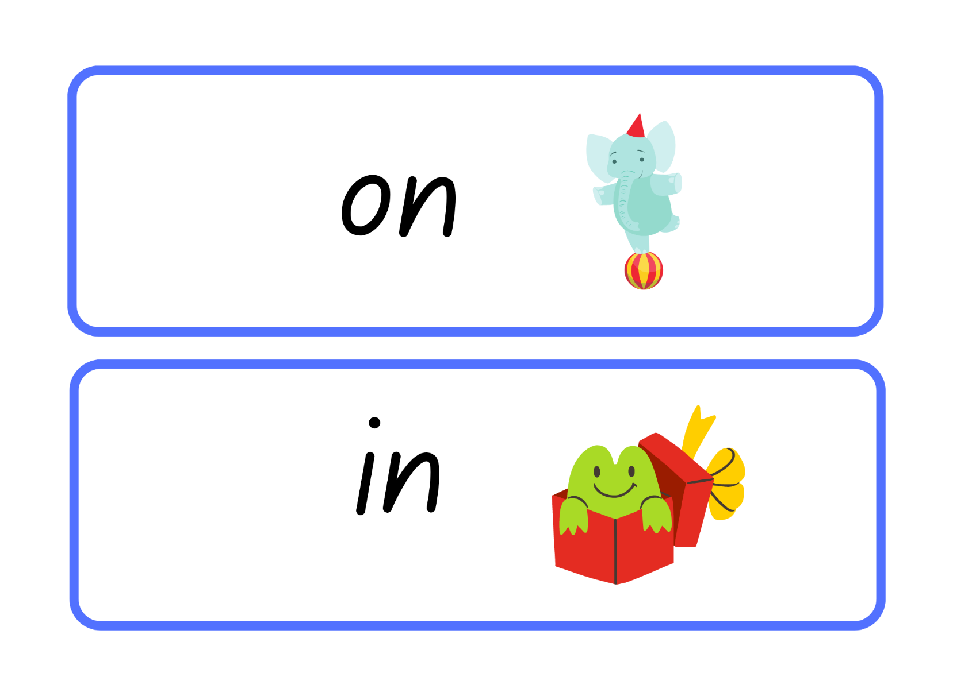
Images sourced from Canva and used in accordance with the Canva Content License Agreement.
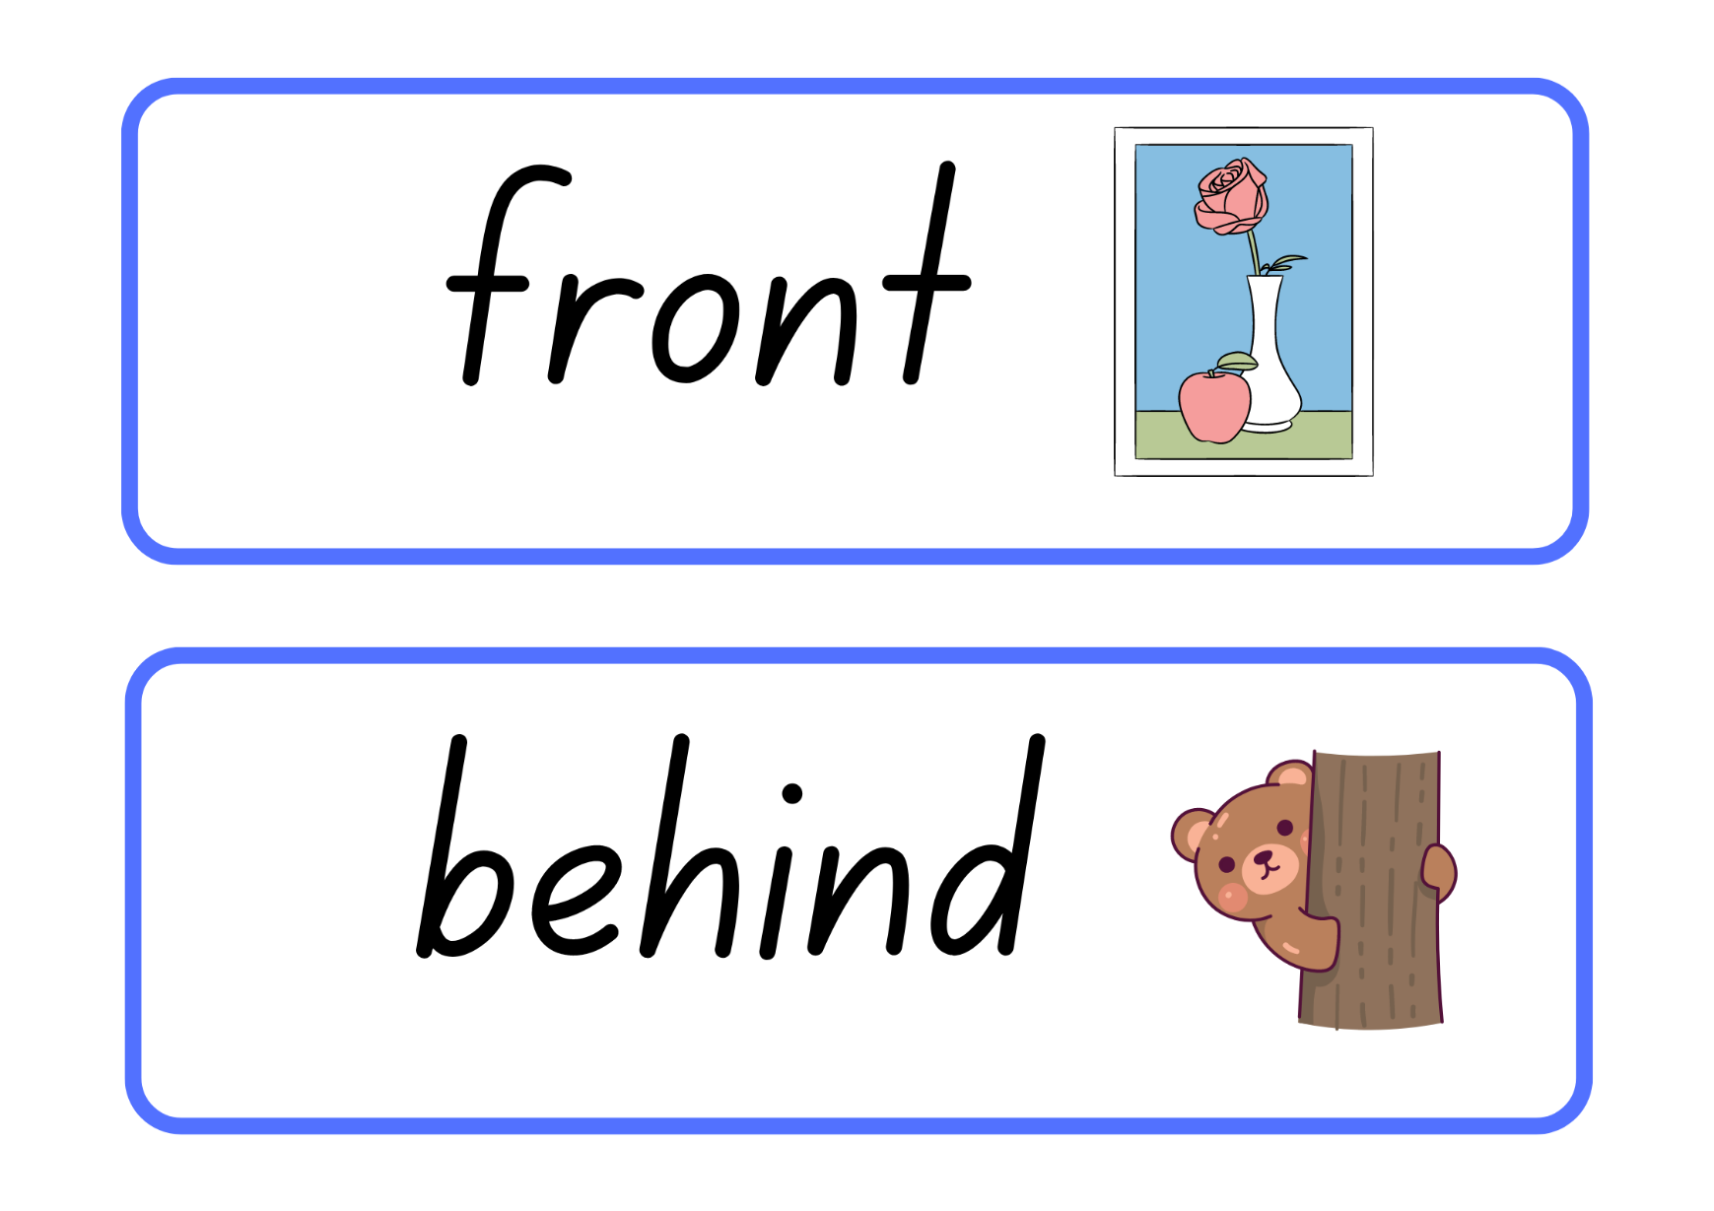
Images sourced from Canva and used in accordance with the Canva Content License Agreement.
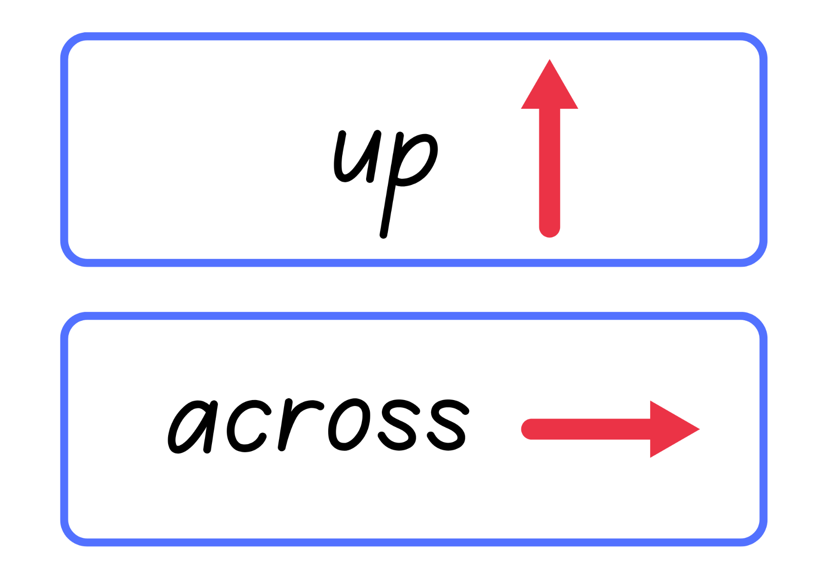
Images sourced from Canva and used in accordance with the Canva Content License Agreement.

Resource 4: Beginning, middle, end story map
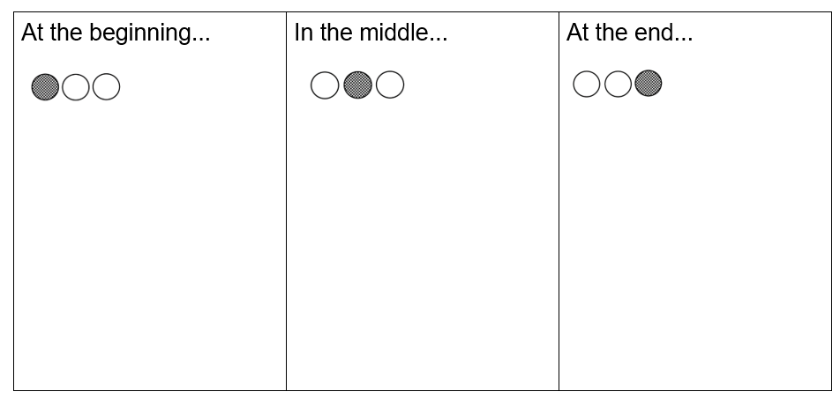

Resource 5: Adjectives
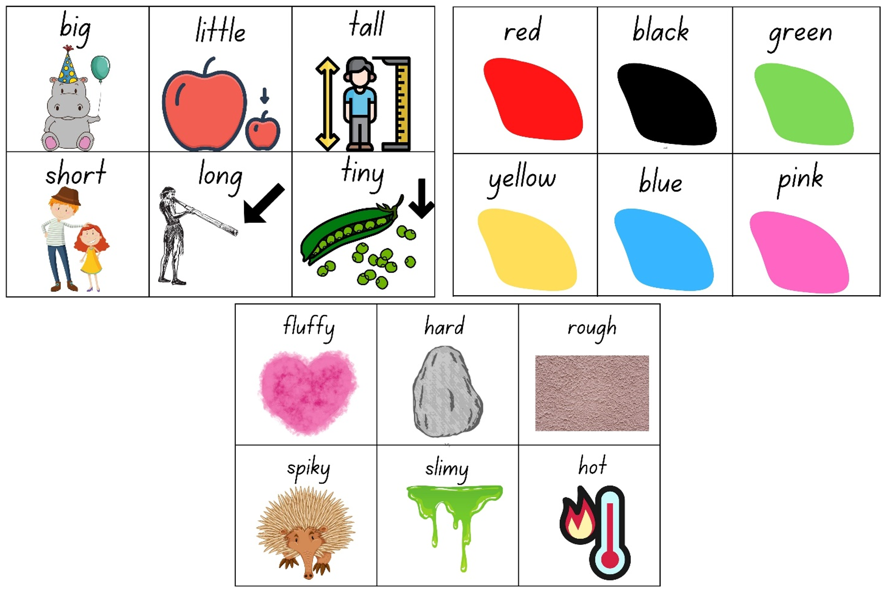
Images sourced from Canva and used in accordance with the Canva Content License Agreement.

Resource 6: Talking characters
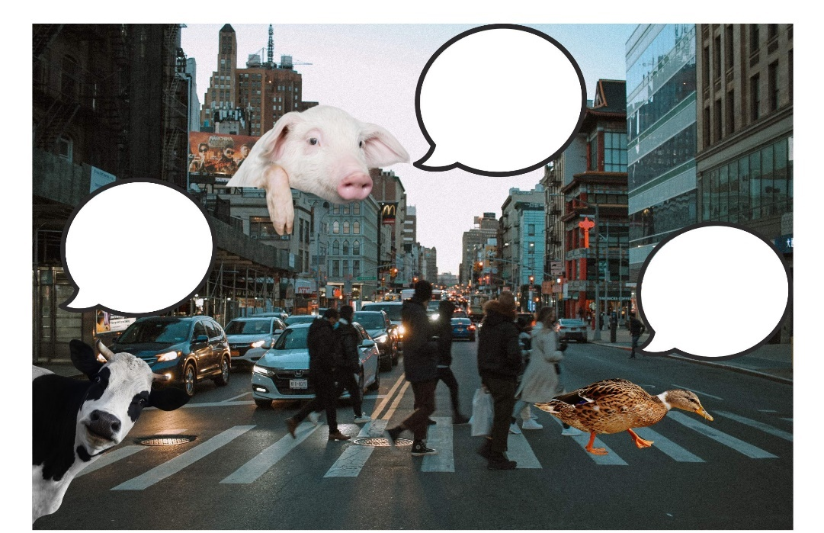
Images sourced from Canva and used in accordance with the Canva Content License Agreement.

Resource 7: Predictable speech
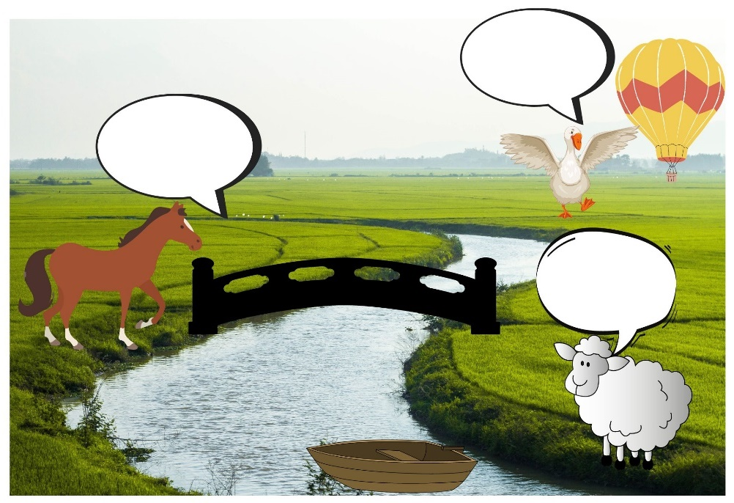
Images sourced from Canva and used in accordance with the Canva Content License Agreement.

Resource 8: Narrative mountain
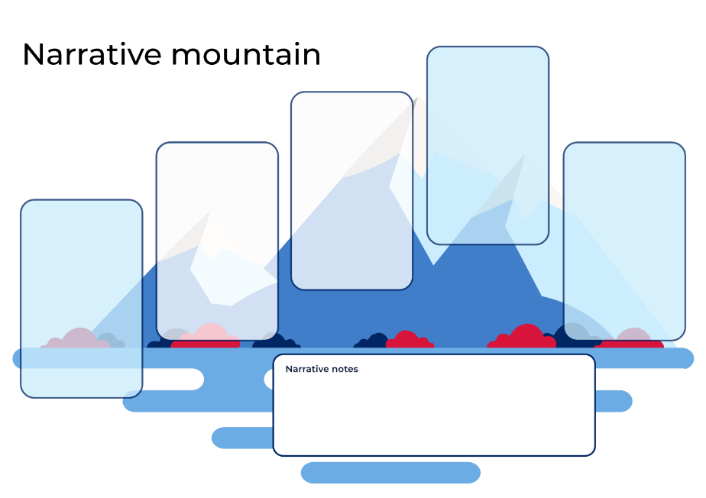

Resource 9: Narrative characters
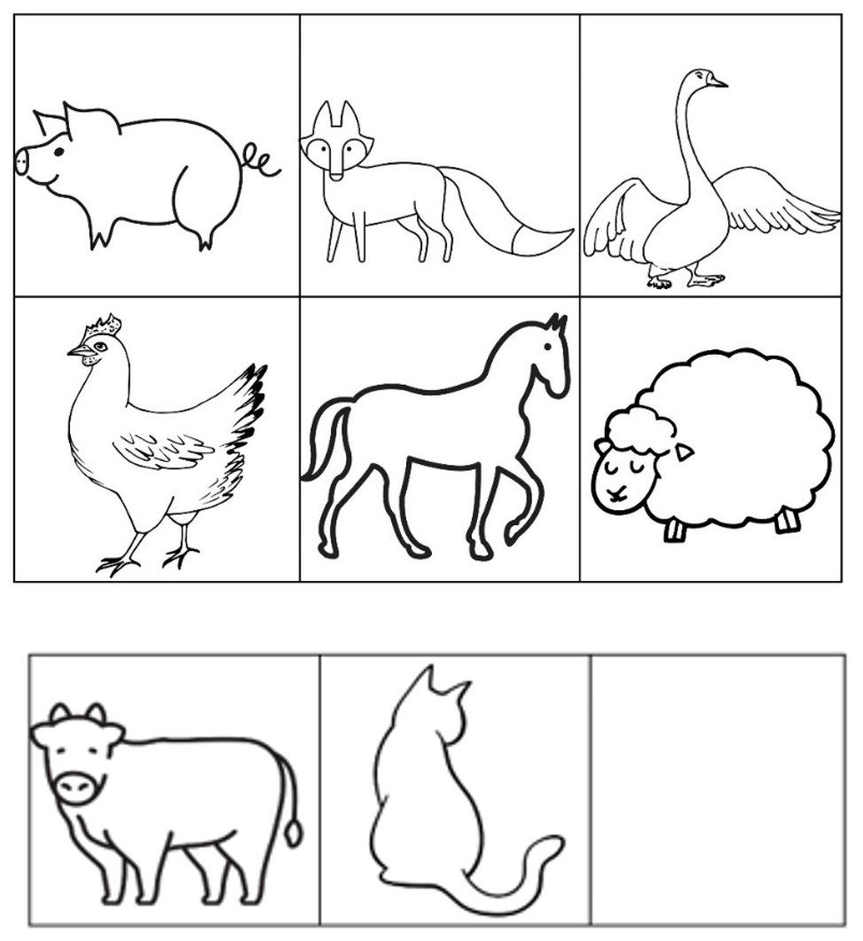
Images sourced from Canva and used in accordance with the Canva Content License Agreement.

References
Links to third-party material and websites
Please note that the provided (reading/viewing material/list/links/texts) are a suggestion only and implies no endorsement, by the New South Wales Department of Education, of any author, publisher or book title. School principals and teachers are best placed to assess the suitability of resources that would complement the curriculum and reflect the needs and interests of their students.
If you use the links provided in this document to access a third party's website, you acknowledge that the terms of use, including licence terms set out on the third party's website apply to the use which may be made of the materials on that third-party website or where permitted by the Copyright Act 1968 (Cth). The department accepts no responsibility for content on third-party websites.
Except as otherwise noted, all material is © State of New South Wales (Department of Education), 2021 and licensed under the Creative Commons Attribution 4.0 International License. All other material (third-party material) is used with permission or under licence. Where the copyright owner of third-party material has not licensed their material under a Creative Commons or similar licence, you should contact them directly for permission to reuse their material.
English K–10 Syllabus © 2022 NSW Education Standards Authority (NESA) for and on behalf of the Crown in right of the State of New South Wales.
Creative Arts K–6 Syllabus © 2006 NSW Education Standards Authority (NESA) for and on behalf of the Crown in right of the State of New South Wales.
© 2022 NSW Education Standards Authority. This document contains NSW Curriculum and syllabus content. The NSW Curriculum is developed by the NSW Education Standards Authority. This content is prepared by NESA for and on behalf of the Crown in right of the State of New South Wales. The material is protected by Crown copyright.
Please refer to the NESA Copyright Disclaimer for more information.
NESA holds the only official and up-to-date versions of the NSW Curriculum and syllabus documents. Please visit the NSW Education Standards Authority (NESA) website and the NSW Curriculum website.
National Literacy Learning Progression © Australian Curriculum, Assessment and Reporting Authority (ACARA) 2010 to present, unless otherwise indicated. This material was downloaded from the Australian Curriculum website (National Literacy Learning Progression) (accessed 13 September 2022) and was not modified. The material is licensed under CC BY 4.0. Version updates are tracked in the ‘Curriculum version history’ section on the 'About the Australian Curriculum' page of the Australian Curriculum website.
ACARA does not endorse any product that uses the Australian Curriculum or make any representations as to the quality of such products. Any product that uses material published on this website should not be taken to be affiliated with ACARA or have the sponsorship or approval of ACARA. It is up to each person to make their own assessment of the product, taking into account matters including, but not limited to, the version number and the degree to which the materials align with the content descriptions and achievement standards (where relevant). Where there is a claim of alignment, it is important to check that the materials align with the content descriptions and achievement standards (endorsed by all education Ministers), not the elaborations (examples provided by ACARA).
Brown R (1992) A Dark, Dark Tale, Dial Books, New York.
ETA (English Teachers Association) and NSW Department of Education (2016) The Textual Concepts and Processes resource, English Textual Concepts website, accessed 14 September 2022.
Fox M (1996) Hattie and the Fox (Mullins P, illus), Scholastic Australia, Lindfield.
Mackenzie N (22 October 2019) ‘Draw, Talk, Write (and Share)’, Noella’s Blog, accessed 14 September 2022.
State of Victoria (Department of Education and Training) (2019) ‘Guided writing/writing conferences’ Literacy Teaching Toolkit, Department of Education and Training website, accessed 14 September 2022.

