English – K-2 multi-age – Year B – Unit 1
Contents
Unit overview and instructions for use 3
Teacher notes 4
Outcomes and content – Component A 6
Outcomes and content – Component B 10
Week 1 13
Component A teaching and learning 13
Component B teaching and learning 14
Lesson 1: Getting ready for school 15
Lesson 2: Classroom context 18
Lesson 3: School expectations 20
Lesson 4: Getting to know each other 23
Lesson 5: Our school’s wild guide to starting school 25
Week 2 29
Component A teaching and learning 29
Component B teaching and learning 30
Lesson 6: Compare and contrast 31
Lesson 7: Similarities and differences 33
Lesson 8: Classroom environments 35
Lesson 9: This is our school 37
Lesson 10: School booklet 39
Resource 1: Emotion cards 40
Resource 2: School expectations 41
Resource 3: All about me – Early Stage 1 42
Resource 4: All about me – Stage 1 43
Resource 5: Interview questions 44
Resource 6: School guide 45
Resource 7: Classroom environments 46
References 47

Unit overview and instructions for use
This two-week unit is comprised of Component A and Component B. Connecting learning across both components is encouraged.
Teaching and learning | Component A | Component B
Suggested duration | 60 minutes | 45 minutes
Explicit teaching focus areas | - Phonological awareness (Early Stage 1)  - Print conventions (Early Stage 1)  - Phonic knowledge  - Reading fluency  - Reading comprehension  - Spelling  - Handwriting | - Oral language and communication  - Vocabulary  - Reading comprehension  - Creating written texts  - Understanding and responding to literature
To prepare for teaching and learning: | - Refer to Outcomes and content – Component A, K-2 – Instructional sequence – grapheme–phoneme correspondences [PDF 825 KB], and the teaching advice documents (hyperlinked in Component A teaching and learning table).  - Based on student needs identified through ongoing assessment data, plan and document how you will sequence teaching and learning in whole class and targeted teaching groups across the two-week cycle. | - Familiarise yourself with Outcomes and content – Component B, Textual concepts information and videos, English Textual Concepts and Learning Processes (2016), and the teaching and learning sequence.  - Based on student needs identified through ongoing assessment data, determine how you will support students in whole class and targeted teaching groups across the two-week cycle as required.
English K–10 Syllabus © 2022 NSW Education Standards Authority (NESA) for and on behalf of the Crown in right of the State of New South Wales.

Teacher notes
- ‘To understand context, we look beyond the text to consider the world in which it was produced and the worlds of its reception. Different contexts can have an effect on the meanings and values of similar content’ – English Textual Concepts and Learning Processes (2016).
- Understanding of context can be supported through watching the department’s video: Context video (5:24).
- Component B of this unit explores how familiar and current events can be used to develop deeper connections between students’ background knowledge and information in a text. The text will be read in sections.
- Provision for early literacy development with EAL/D students can be supported through watching the department’s video: EAL/D enhanced teaching and learning cycle (3:43). The use of tangible and concrete objects will further support skill acquisition. For example, a lunchbox when referring to items to place in your school bag.
- Use literacy supports such as emotion cards to reinforce inclusivity and clarify meaning for all students.
- Use of higher order thinking strategies such as justifying responses will support multi-age planning. For further information refer to the differentiation adjustment tool.
- For information on nouns, verbs and complex sentences refer to the NESA glossary.
- This unit could enhance student learning towards achievement of outcomes from the Creative Arts syllabus regarding visual arts activities that are developmentally appropriate for this age group.
- Consider student prior knowledge and learning to inform the planning cycle. The use of information from Best Start Kindergarten Assessment (BSKA), Phonics Screening Check for Year 1 students and the Transition to School Statements (TtSS) will provide baselines from which to individualise learning.
- Group discussion can be enriched by using a talking stick.
- Reflect on student learning and engagement in activities and record differentiation and adjustments within the unit to inform future teaching and learning. One way of doing this could be to add comments to the digital file.
- Content points are linked to the National Literacy Learning Progression version (3).
Levels and indicators sourced from National Literacy Learning Progression © Australian Curriculum, Assessment and Reporting Authority (ACARA), (accessed 4 August 2022) and was not modified. See references for more information.

Outcomes and content – Component A
The table below outlines the focus outcomes and content. Content is linked to the National Literacy Learning Progression version (3).
Early Stage 1 Focus area and outcome | Stage 1 Focus area and outcome
Phonological awareness  ENE-PHOAW-01 – identifies, blends, segments and manipulates phonological units in spoken words as a strategy for reading and creating texts  - repeat words and phrases  - complete familiar spoken phrases in texts, including chants, rhymes, songs and poems (PhA1)  - segment a spoken sentence of 3 to 5 words into separate spoken words (PhA2) | N/A
Print conventions  ENE-PRINT-01 – tracks written text from left to right and from top to bottom of the page and identifies visual and spatial features of print  - understand that print contains a message  - identify pictures in texts (PKW2)  - identify words in a variety of situations in school, the classroom and the environment (PKW1, UnT1)  - recognise symbols, icons and personally significant words in everyday situations and in texts (UnT2) | N/A
N/A | Phonic knowledge  EN1-PHOKW-01 – uses initial and extended phonics, including vowel digraphs, trigraphs to decode and encode words when reading and creating texts  - segment and encode one-syllable high-frequency base words with split digraphs and apply this when creating texts (SpG6)  - blend and decode one-syllable words with taught extended vowel graphs and digraphs, including graphemes for r-controlled vowels and diphthongs, and apply this when reading texts (PKW6, PKW7)  - segment and encode one-syllable words with taught vowel graphs, digraphs and trigraphs and apply this when creating texts
N/A | Reading fluency  EN1-REFLU-01 – sustains reading unseen texts with automaticity and prosody and self-corrects errors  - apply grapheme–phoneme correspondence to read words with automaticity (FlY1)  - use sentence punctuation to enhance reading in a conversational manner (FlY3, FlY4)
Reading comprehension  ENE-RECOM-01 – comprehends independently read texts using background knowledge, word knowledge and understanding of how sentences connect  - use background knowledge when identifying connections between a text, own life, other texts and/or the world (UnT4)  - recall key characters, events and/or information in text (UnT5) | Reading comprehension  EN1-RECOM-01 – comprehends independently read texts that require sustained reading by activating background and word knowledge, connecting and understanding sentences and whole text, and monitoring for meaning  - use known vocabulary to build a mental model of the content of the text  - make text-to-self, text-to-text or text-to-world connections when reading (UnT6)
Spelling  ENE-SPELL-01 – applies phonological, orthographic and morphological generalisations and strategies to spell taught familiar and high-frequency words when creating texts  - spell their own name (SpG1) | Spelling  EN1-SPELL-01 – applies phonological, orthographic and morphological generalisations and strategies when spelling words in a range of writing contexts  - segment single-syllable words into phonemes as a strategy for spelling (SpG4)  - spell high-frequency base words with taught vowel graphs, digraphs, split digraphs, trigraphs and quadgraphs (SpG6)
Handwriting  ENE-HANDW-01 – produces all lower-case and upper-case letters to create texts  - use writing implements with a stable and relaxed pencil grip (HwK2) | Handwriting  EN1-HANDW-01 – uses a legible, fluent and automatic handwriting style, and digital technology, including word-processing applications, when creating texts  - form all letters with consistent size and slope in NSW Foundation Style from memory (HwK5)

Outcomes and content – Component B
The table below outlines the focus outcomes and content. Content is linked to the National Literacy Learning Progression version (3).
Early Stage 1 Focus area and outcome | Stage 1 Focus area and outcome
Oral language and communication  ENE-OLC-01 – communicates effectively by using interpersonal conventions and language with familiar peers and adults  - orientate self to the speaker (LiS1)  - contribute to group conversations (InT3)  - use oral language to make requests and express needs  - understand there are many languages that are used by family, peers and community | Oral language and communication  EN1-OLC-01 – communicates effectively by using interpersonal conventions and language to extend and elaborate ideas for social and learning interactions  - listen to engage with texts for enjoyment and recognise that their own experience can shape their ideas and opinions of texts  - initiate, listen and/or respond in partner and group conversations (InT3, InT5)
Vocabulary  ENE-VOCAB-01 – understands and effectively uses Tier 1 and Tier 2 words in familiar contexts  - use vocabulary that is personal (SpK3) | Vocabulary  EN1-VOCAB-01 – understands and effectively uses Tier 1, taught Tier 2 and Tier 3 vocabulary to extend and elaborate ideas  - understand and communicate jokes and riddles that play on words
Reading comprehension  ENE-RECOM-01 – comprehends independently read texts using background knowledge, word knowledge and understanding of how sentences connect  - use background knowledge when identifying connections between a text, own life, other texts and/or the world (UnT4)  - recall key characters, events and/or information (UnT5) | Reading comprehension  EN1-RECOM-01 – comprehends independently read texts that require sustained reading by activating background and word knowledge, connecting and understanding sentences and whole text, and monitoring for meaning  - use known vocabulary to build a mental model of the content of the text (UnT4)  - make text-to-self, text-to-text or text-to world connections when reading (UnT6)
Creating written texts  ENE-CWT-01 – creates written texts that include at least 2 related ideas and correct simple sentences  - use personal vocabulary, words on display and in mentor texts when constructing sentences  - use drawing, images or mind maps to support planning and writing (CrT4) | Creating written texts  EN1-CWT-01 – plans, creates and revises texts written for different purposes, including paragraphs, using knowledge of vocabulary, text features and sentence structure  - write texts that describe, explain, give an opinion, recount an event, tell a story (CrT7)  - use visual elements to expand meaning in own texts  - use noun groups to build descriptions of people and things  - use action, saying, relating and sensing verbs to add detail and precision to writing  - experiment with writing complex sentences which include a clause for the main message and dependent clause to elaborate or modify the message (GrA5)  - use a variety of planning strategies and tools for creating texts
Understanding and responding to literature  ENE-UARL-01 – understands and responds to literature read to them  - identify aspects of their own world represented in texts (UnT4)  - create imaginative and/or informative texts relating to their own experience, the world and/or other texts (CrT3) | Understanding and responding to literature  EN1-UARL-01 – understands and responds to literature by creating texts using similar structures, intentional language choices and features appropriate to audience and purpose  - identify representations of groups and cultures in a range of texts  - create and re-create texts in a range of modes and media using understanding of context (CrT5)

Week 1

Component A teaching and learning
The table below can be used to plan and document lessons that address Component A outcomes and content. Both the detailed example [DOC 529KB] of a two-week teaching and learning cycle and brief example [DOC 66KB] may support you in your planning.
Focus Areas | Lesson 1 | Lesson 2 | Lesson 3 | Lesson 4 | Lesson 5
Phonological awareness (Early Stage 1) and Phonic knowledge
15 minutes
Spelling and Handwriting
15 minutes
Print conventions (Early Stage 1), Reading comprehension and Reading fluency
30 minutes

Component B teaching and learning
The following teaching and learning sequence has been designed to address Component B outcomes and content. Adapt the sequence as required to best meet the needs of your students.

Learning intention and success criteria
Learning intentions and success criteria are best co-constructed with students. The table below contains suggested learning intentions and success criteria.
Element | Early Stage 1 | Stage 1
Learning intentions | Students are learning to identify how aspects of their own world are represented in texts and make connections to their own experiences. | Students are learning to use their background knowledge to make connections with texts and understand how an author’s context and experiences can help them to create texts.
Success criteria | Students can:  - use words to describe themselves  - use drawings to show an understanding of their environment  - identify expectations in their school context  - use their own experiences to create informative texts. | Students can:  - reflect on their past experiences and express feelings and emotions  - use vocabulary from the text and connect meaning to their own context  - share feelings and thoughts about the events and characters in texts and identify connections  - use planning strategies to create texts  - use noun groups to build descriptions of places.

Resources
- Bunting L (2022) The Wild Guide to Starting School (Bunting P, illus.), Omnibus Books, Australia. ISBN: 9781761126284.
- Resource 1: Emotion cards
- Resource 2: School expectations
- Resource 3: All about me – Early Stage 1
- Resource 4: All about me – Stage 1
- Resource 5: Interview questions
- Resource 6: School guide

Lesson 1: Getting ready for school
The following teaching and learning activities support multi-age settings.

Whole
- Introduce the text, The Wild Guide to Starting School by Laura Bunting. Show the front cover and ask students why they think it is called the wild guide. Students predict what they think the story will be about.
- Explain that it is a wild and busy book, so students will need to be very good listeners. Open each page of the text and discuss the illustrations. Explain that each lesson will focus on ideas from the text and this lesson will focus on ‘getting ready for school’.
- Read points 1 to 6 in the text, focusing on getting ready for school. Ask students how they got ready for school today. Provide an opportunity for students to make text-to-self connections and share with the class. Discuss ways students get ready for school, for example, getting dressed, eating breakfast or organising belongings. Create a list using new vocabulary from the text.
- Display Resource 1: Emotion cards. Ask students how they felt on their first day of school. Encourage students to explain how they felt and why.
- Explain that students will draw a picture of themselves on their first day of school. Encourage students to include events such as their family taking photos of them or saying goodbye to their family. On a large piece of paper, model drawing a student on the first day of school. Using a ‘think aloud’, describe and label the image. Model spoken sentences about different ways families get ready for school, for example, ‘before school I packed my bag’, or ‘before school we rushed around but when we got in the car, we felt more relaxed’.

Part
The table below details the differentiated teaching and learning activities for each stage.
Early Stage 1 (independent/pairs) | Stage 1 (teacher guided/independent)
- Students draw a picture of themselves getting ready for their first day of school. Students write their name.  - Students share their picture with a partner using modelled vocabulary.  Too hard? Students use visual support to write their name.  Too easy? Students write about how they felt using the sentence starter ‘Today I feel _____.’ | - Provide students with a piece of paper folded in half. On the left-hand side of the page, students draw a picture of themselves on their first day of Kindergarten. Students use modelled vocabulary to write a sentence using a sentence starter. For example, ‘On my very first day in Kindergarten I ____.’  - On the right-hand side of the page, students draw how they got ready for school this year. Students write about how they felt starting in a new class. For example, ‘I am in year____ and I feel _________ at school.’  Too hard? Students use words or phrases to label their drawings.  Too easy? Write a more detailed text including a range of sentence types. For example, ‘I am in Year 2 and I’m happy when I am with people that make me feel safe, secure and calm.

Whole
- Display Resource 1: Emotion cards and discuss how students feel at school. Discuss strategies to help turn negative emotions into positive ones. Ask students questions about their school day. For example, ‘What do you play at school? or ‘What is your favourite time?’ Model writing a sentence using modelled vocabulary about how students feel at school. For example, ‘At school I play with my friends, and it makes me happy. If we see someone sitting on their own, we ask them to join us. Being a kind friend is valued at our school.’

Lesson 2: Classroom context
The following teaching and learning activities support multi-age settings.

Whole
- Explain that authors often write about concepts or topics to draw on their experiences and background. This is called their ‘context’. Explain that students will compare their own experiences and context about their classroom and school to the author.
- Read points 7 to 9 of the text, The Wild Guide to Starting School that focuses on being in the classroom and meeting the teacher. Draw students’ attention to the way the animals say goodbye before school and discuss new vocabulary. Explain the humour and word play in the farewells. For example, ‘The Galah – Ta ta’, ‘Smell you later’, ‘The Bil-Bye’, ‘Butt bump’.
- Discuss other ways of saying goodbye. For example, ‘See you later alligator’ and ‘See you round like a rissole’. Some people might use their home languages such as ‘ciao’ and ‘adios’. Explore languages used by students, and how greetings and goodbyes are said. Promote self-to-text connections and whole-class discussion by asking guiding questions such as: How do you say goodbye to the people that you live with? Are there funny ways that your family says goodbye? Students turn to a partner and show how they say farewell to their families for example, wave, thumbs up, high five, and create a humorous way to say goodbye to their family. Model and encourage jokes, rhyme or riddle type responses such as ‘out the door dinosaur’, ‘give me a hug ladybug’ and ‘got to go buffalo’.
- In mixed age pairs, students walk, talk and notice classroom objects and where they are located. For example, pencils at the back of the room, coloured pencils in tins.
- Display an enlarged picture of the classroom setting from the text and compare objects found in both settings. Discuss how the author, Laura Bunting, and the illustrator, Philip Bunting, used their own experiences and context to create the text. Select students to circle and label objects that are the same in both settings to stimulate group discussion.
- Model drawing the classroom environment. Explain that nouns are objects in our classroom and label the drawing, for example, pencils, library corner with pillows for reading. Explain that noun groups build descriptions of objects and places. Model adding adjectives to the labelled drawing, for example, ‘coloured pencils’. Explain that students will draw their classroom environment and create a ‘map’. Explain that students will be using their own experiences and context to re-create this part of The Wild Guide to Starting School.

Part
The table below details the differentiated teaching and learning activities for each stage.
Early Stage 1 (teacher guided/pairs) | Stage 1 (pairs)
- On a large piece of paper, draw and label students’ ideas.  - Students write their name and draw their classroom environment. Using the Think-Pair-Share strategy, students explain their drawings and discuss what they included in their drawing and how it reflects their own context.  Too hard? Co-construct a picture of the classroom. Display photos to support students to add detail to their drawings.  Too easy? Students label and write a sentence about their drawing. Provide sentence starter, ‘I saw a _____.’ | - In pairs, students draw features of their classroom environment to create a simple classroom map, then label their picture with noun groups.  - Students discuss what they would change to make their classroom more exciting and adjust the map to suit.  Too hard? Students orally describe details in their map such as books, pencils, or rulers.  Too easy? Students create a detailed map of a fantasy classroom.
Stage 1 Assessment task 1 – Observations and work samples from this lesson allow students to demonstrate achievement towards the following syllabus outcomes and content points:
EN1-OLC-01 – communicates effectively by using interpersonal conventions and language to extend and elaborate ideas for social and learning interactions
- listen to engage with texts for enjoyment and recognise that their own experience can shape their ideas and opinions of texts
- initiate, listen and/or respond in partner and group conversations.
EN1-VOCAB-01 – understands and effectively uses Tier 1, taught Tier 2 and Tier 3 vocabulary to extend and elaborate ideas
- understand and communicate jokes and riddles that play on words.
EN1-RECOM-01 – comprehends independently read texts that require sustained reading by activating background and word knowledge, connecting and understanding sentences and whole text, and monitoring meaning
- use known vocabulary to build a mental model of the content of the text.

Lesson 3: School expectations
The following teaching and learning activities support multi-age settings.

Whole
- Play a game of true or false about the text, The Wild Guide to Starting School. Explain to students the meaning of the words ‘true’ and ‘false’. Ask questions about characters or events in the story so far. Students respond to questions with true or false as a way of recalling the text. For example, ‘Were the animals in the story all farm animals? Were the animals in the story all Australian native animals?’
- Read the list of classroom expectations in the text and discuss similarities and differences to their current school context.
- Play a game of ‘yay or no way’. Read a school expectation from the text, students respond with ‘yay’ or ‘no way.’ For example, ‘It is okay to share your ideas?’ (students: ‘Yay’), ‘It is okay to be rude?’ (students: ‘No way’). Complete with example questions relevant to your context.
- Discuss and create a list of school expectations. Using the Think-Pair-Share strategy, students discuss how their school expectations are similar or different from the text. Explain that students will draw examples of school expectations. Using Resource 2: School expectations, model drawing examples in the box. Explain that verbs are words that tell us what is happening. Model writing the sentence ‘Walk in the playground.’ Explain that an action verb has been used and underline ‘walk’ in the sentence. Ask students to share other school expectations. Model writing these in a sentence using a verb at the beginning. Ask students to underline the verb in each sentence and add these to a verb anchor chart.

Part
The table below details the differentiated teaching and learning activities for each stage.
Early Stage 1 (independent/pairs) | Stage 1 (teacher guided/small groups)
- Using Resource 2: School expectations, students draw pictures to match school expectations.  - Students use modelled vocabulary to explain their drawings to a partner.  Too hard? Students complete the activity with a partner.  Too easy? Students write sentences about school expectations. | - Explain that a complex sentence is formed by adding a dependent clause to a main clause using a conjunction and/or relative pronoun. Model writing a complex sentence. For example, ‘Always use the school toilets. Ask a teacher (dependent clause) if (conjunction) anyone is unsure of where the toilets are’.  - Co-construct true or false statements through interactive writing with students. For example:  - If you don’t share the toys, then you might have to be reminded of the rules.  - If you don’t finish your work, then you may run out of time to play.  - Students experiment using complex sentences about school expectations.  Too hard? Co-construct complex sentences about school expectations.  Too easy? Connect complex sentences to create a paragraph about school expectations.

Whole
- Play a game of ‘Thumbs up, thumbs down’. Explain that students will put their thumb up when they hear an appropriate school expectation. For example, ‘asking for help’, ‘walking in the classroom’, or ‘listening to teacher instructions’. Students will put their thumbs down when they hear an inappropriate expectation. For example, ‘throwing rubbish on the ground’, or ‘running on the concrete’.

Lesson 4: Getting to know each other
The following teaching and learning activities support multi-age settings.

Whole
- Read points 13 to 16 from The Wild Guide to Starting School, discussing areas of the playground and making friends. Encourage students to make text-to-self-connections by discussing similarities and differences with their playground environment and the school environment in the text.
- Refer to point 16, ‘making new friends can be easy’. Read the suggested questions in the text to assist in making new friends. Using the Think-Pair-Share strategy, students discuss ways they have made friends at school.
- Explain that students will write a profile about themselves to help students get to know one another. Discuss how knowing your peers is an important step to making friends at school. Display Resource 3: All about me – Early Stage 1 and Resource 4: All about me – Stage 1. Read the information presented in the ‘All about me profile’. Students share information about themselves with a partner. Student’s personal profiles will be used in Lesson 6.

Part
The table below details the differentiated teaching and learning activities for each stage.
Early Stage 1 (independent) | Stage 1 (teacher guided)
- Provide students with a copy of Resource 3: All about me – Early Stage 1. Students draw pictures that represent themselves.  Too hard? Students write their name and draw a picture of themselves outdoors.  Too easy? Students can draw several examples of likes or dislikes to create a more detailed profile. | - Provide students with a copy of Resource 4: All about me – Stage 1. Students draw and write information about themselves using noun groups.  Too hard? Students draw and label pictures about themselves.  Too easy? Students create a text about themselves using noun groups and complex sentences.

Whole
- In small groups, students share their personal profiles. Encourage students to orally contribute further information, adding to their profile. Using Resource 5: Interview questions, ask the class questions to see what they have learned about their peers. For example, do you know someone who plays soccer? Do you know someone who likes ice cream? Provide time for students to ask additional questions to find out more information about their peers.
Early Stage 1 Assessment task 1 – Observations and work samples from this lesson allow students to demonstrate achievement towards the following syllabus outcome and content points:
ENE-OLC-01 – communicates effectively by using interpersonal conventions and language with familiar peers and adults
- orientate self to the speaker
- contribute to group conversations
- use oral language to make requests and express needs.

Lesson 5: Our school’s wild guide to starting school
The following teaching and learning activities support multi-age settings.

Whole
- Ask students to recall information from the text, The Wild Guide to Starting School. Students Think-Pair-Share what they think the main message of the text is. Discuss how the text is based on the author’s own personal experiences and context.
- Explain to the class they will create a guide and provide advice to students starting at their school. Walk around the classroom or playground to strengthen students’ understanding of the school context.
- Using ideas from the text, discuss what could be included in the guide that could best support new students starting at their school. Display Resource 6: School guide. Explain that students will be focusing on 3 key aspects, ‘getting ready for school’, ‘in the classroom’ and ‘in the playground’. Model drawing and writing advice about one of the key aspects.

Part
The table below details the differentiated teaching and learning activities for each stage.
Early Stage 1 (independent/pairs) | Stage 1 (teacher guided/independent)
- Provide students with their own copy of Resource 6: School guide. Students draw pictures in each box to support new students starting at their school.  - In pairs, students discuss the advice they would give to a new student. | - Explain that advice in a guide is brief and written in a personal tone. The guide will be unique to the context of the school and will include advice about where things are located and what to do at school. Model sentences that include verbs. Using verbs during writing will be important as the guide offers advice about what students can do at school. For example, ‘Walk through the school gate but be careful not to step on the delicate plants.’ ‘We read our books quietly in the library.’ ‘We play safely on the equipment.’  - Revise noun groups and explain that they build descriptions of people and things. Ask students to identify the noun group used in the sentence, ‘Be careful when you walk along the old, cracked and slippery path.’  - Provide students with their own copy of Resource 6: School guide. Students plan their ideas by drawing images in the boxes. Students write sentences using noun groups and verbs.  Too hard? Students co-construct sentences with teacher guidance or label drawings.  Too easy? Students add an opinion to their guide, for example, ‘Make sure you buy a delicious meat pie at the canteen, they are the best’.
Early Stage 1 Assessment task 2 – Observations and work samples from this lesson allow students to demonstrate achievement towards the following syllabus outcomes and content points:
ENE-RECOM-01 – comprehends independently read texts using background knowledge, word knowledge and understanding of how sentences connect
- recall key characters, events and/or information.
ENE-CWT-01 – creates written texts that include at least 2 related ideas and correct simple sentences
- use drawing, images or mind maps to support planning and writing.
ENE-UARL-01 – understands and responds to literature read to them
- identify aspects of their own world represented in texts
- create imaginative and/or informative texts relating to their own experience, the world and/or other texts.
Stage 1 Assessment task 2 – Observations and work samples from this lesson allow students to demonstrate achievement towards the following syllabus outcomes and content points:
EN1-CWT-01 – plans, creates and revises texts written for different purposes, including paragraphs, using knowledge of vocabulary, text features and sentence structure
- write texts that describe, explain, give an opinion, recount an event, tell a story
- use visual elements to expand meaning in own texts
- use noun groups to build descriptions of people and things
- use action, saying, relating and sensing verbs to add detail and precision to writing
- use a variety of planning strategies and tools for creating texts.
EN1-UARL-01 – understands and responds to literature by creating texts using similar structures, intentional language choices and features appropriate to audience and purpose
- create and re-create texts in a range of modes and media using understanding of context.

Week 2

Component A teaching and learning
The table below can be used to plan and document lessons that address Component A outcomes and content. Both the detailed example [DOC 529KB] of a two-week teaching and learning cycle and brief example [DOC 66KB] may support you in your planning.
Focus Areas | Lesson 6 | Lesson 7 | Lesson 8 | Lesson 9 | Lesson 10
Phonological awareness (Early Stage 1) and Phonic knowledge
15 minutes
Spelling and Handwriting
15 minutes
Print conventions (Early Stage 1), Reading comprehension and Reading fluency
30 minutes

Component B teaching and learning
The following teaching and learning sequence has been designed to address Component B outcomes and content. Adapt the sequence as required to best meet the needs of your students.

Learning intention and success criteria
Learning intentions and success criteria are best co-constructed with students. The table below contains suggested learning intentions and success criteria.
Element | Early Stage 1 | Stage 1
Learning intentions | Students are learning to identify how aspects of their own world are represented in texts and make connections to their own experiences. | Students are learning to use their background knowledge to make connections with texts and understand how authors use personal experiences and context to create texts.
Success criteria | Students can:  - make connections between a text and their own life  - use words to describe themselves  - use personal vocabulary to construct sentences  - use drawings to plan for writing  - label drawings using modelled vocabulary. | Students can:  - share feelings and thoughts about the events and characters in texts and make connections to themselves  - use noun groups to build descriptions of people  - compare and contrast classroom environments  - use complex sentences to communicate a message  - compare their own experiences and context to the author’s.

Resources
- Fox M (1997) Whoever you are (Staub L, illus.) Scholastic Australia Pty Ltd. ISBN: 9781760152871.
- Resource 7: Classroom environments

Lesson 6: Compare and contrast
The following teaching and learning activities support multi-age settings.

Whole
- Read the text, Whoever You Are written by Mem Fox and illustrated by Leslie Staub. Revise the concept of context. Ask students to use their background knowledge and personal experiences to make connections with the text. Explain that students will be thinking about what makes the children in the text similar or different to themselves. Discuss how students’ personalities, physical appearance, background experiences, culture or spoken languages may be similar or different.
- Students begin with their personal profile from Lesson 4. Students walk around the room and share information about themselves to find students who are like them, for example, ‘find someone who likes the same food’, or ‘stand beside someone who speaks the same home language as you’. Provide students with opportunities to find someone who is different to them. For example, ‘Find someone who worries about a different thing to you.’ One student might worry about being late for school, but another student might worry about not having a friend to play with.
- Students will use their personal profiles to assist them to answer teacher questions about their likes and dislikes. Explain that students will be working with a partner to identify similarities and differences between their likes and dislikes. Model drawing and writing words or phrases to complete a Venn diagram.

Part
The table below details the differentiated teaching and learning activities for each stage.
Early Stage 1 (teacher guided/pairs) | Stage 1 (pairs)
- In pairs, students complete their own Venn diagram drawing likes/dislikes. | - In pairs, students complete their own Venn diagram. Students write words or phrases to compare and contrast their likes and dislikes.  Too hard? Draw likes and dislikes in the Venn diagram.  Too easy? Write sentences that compare themselves to their peer for example, ‘I like honey, but Sarah likes jam.’
Early Stage 1 Assessment task 3 – Observations and work samples from this lesson allow students to demonstrate achievement towards the following syllabus outcomes and content points:
ENE-OLC-01 – communicates effectively by using interpersonal conventions and language with familiar peers and adults
- understand there are many languages that are used by family, peers and community.
ENE-VOCAB-01 – understands and effectively uses Tier 1 and Tier 2 words in familiar contexts
- use vocabulary that is personal.
ENE-RECOM-01 – comprehends independently read texts using background knowledge, word knowledge and understanding of how sentences connect
- use background knowledge when identifying connections between a text, own life, other texts and/or the world.
Stage 1 Assessment task 3 – Observations from this lesson allow students to demonstrate achievement towards the following syllabus outcome and content point:
EN1-RECOM-01 – comprehends independently read texts that require sustained reading by activating background and word knowledge, connecting and understanding sentences and whole text, and monitoring for meaning
- identify representations of groups and cultures in a range of texts.

Lesson 7: Similarities and differences
The following teaching and learning activities support multi-age settings.

Whole
- Students recall the concept of ‘different from yours’ from the text, Whoever You Are through a game of ‘Heads or Tails’. If a statement about the text is true, students put hands on their head; if the statement is false, students put their hands on their tail. For example, ‘We all look different’ or ‘We all speak the same language’.
- Explain that repeated phrases in a text reinforce the meaning for the reader and make it more entertaining to listen to. Read aloud the first couple of pages, drawing students' attention to the repeated phrase ‘different from yours’. Explain to students when you pause reading, it is their turn to complete the read by chanting ’different from yours’.
- Explain that students will work with a partner to identify ways in which they are similar and different. This may include their appearance, likes and dislikes, pets, and hobbies. Highlight that no two people are the same and our differences are what makes each of us special and unique. Model completing a Venn diagram, identifying how you and another teacher are both similar and different.

Part
The table below details the differentiated teaching and learning activities for each stage.
Early Stage 1 (teacher guided/pairs) | Stage 1 (small group/pairs)
- In pairs, students draw their similarities and differences using a Venn diagram.  Too hard? Co-construct with pairs as required.  Too easy? Students write sentences comparing their physical characteristics to a peer. | - In pairs, students write about their similarities and differences using a Venn diagram.  - Students write sentences using noun groups. For example, ‘Sophie’s big, brown dog is quite different to my small, fluffy dog.’

Lesson 8: Classroom environments
The following teaching and learning activities support multi-age settings.

Whole
- Show students the image of the classroom from the text, Whoever You Are. Identify similarities and differences between the classroom in the text to the students’ classroom. For example, the physical spaces look different but in both classrooms all children are learning. Revise the concept of context. Explain that the author has used their own experiences and context to create the text. Discuss similarities and differences between the text and students’ own context.
- Display Resource 7: Classroom environments and discuss the similarities and differences between the images. Students Think-Pair-Share ways their classroom environment is similar or different to the images. Prompt rich discussion through guided questioning, such as:
- What are the features of our school?
- Is our school a big school or a small school? How do you know?
- Where are we located?
- Draw a large Venn diagram with the headings ‘Our classroom’ and the various classrooms pictured in Resource 7. Ask students to identify similarities between the classroom environments and record in the middle of the Venn diagram. Repeat for differences.
- Ask students to choose one classroom environment from Resource 7. Explain that students will identify similarities and differences between the image and their classroom environment. Provide students with their own copy of a Venn diagram.

Part
The table below details the differentiated teaching and learning activities for each stage.
Early Stage 1 (teacher guided/independent) | Stage 1 (independent)
- Students draw similarities and differences between the image and their classroom environment.  - Co-construct sentences to support some drawings, for example, ‘We have a big mat.’  Too hard? Students add detail to drawings and write or copy their names.  Too easy? Students write words or phrases to compare the classroom environments. | - Students write words or phrases to complete their Venn diagram.  - Students write sentences detailing the similarities and differences between the image and their classroom environment. For example, compare the size, the furniture, and materials.  Too hard? Students draw images to compare the image with their classroom environment.  Too easy? Students write a paragraph detailing why they prefer one classroom.

Whole
- Discuss students’ Venn diagrams. Students Think-Pair-Share what could be added to their classroom environment, or what they like or dislike about other classroom environments.
Early Stage 1 Assessment task 4 – Observations and work samples from this lesson allow students to demonstrate achievement towards the following syllabus outcome and content point:
ENE-CWT-01 – creates written texts that include at least 2 related ideas and correct simple sentences
- use personal vocabulary, words on display and in mentor texts when constructing sentences.

Lesson 9: This is our school
- Re-read the text, Whoever You Are. Model a ‘think aloud’ such as, ‘Their seating area looks much bigger than ours.’
- Explain that students will walk around the school to notice the features that make their school a great place to learn. Students talk and walk with a partner outside, noticing school features and where they are located, for example, playground equipment, sandpit, handball courts.
- When students return to the classroom, explain that they will draw their school, or parts of their school. Discuss what students saw in the outdoor environment and what makes their school such a great place. Record ideas on a large piece of paper, for example, the names of outdoor features, ‘playground’, ‘frog pond’, ‘handball courts’.

Part
The table below details the differentiated teaching and learning activities for each stage.
Early Stage 1 (independent) | Stage 1 (teacher guided)
- Students draw their favourite outdoor area at school. Students write their name and label their drawing using the modelled writing.  Too hard? Rather than label, students verbalise a sentence about their drawing.  Too easy? Students write sentences about the outdoor area they have drawn. | - Ask students what makes our school great. For example, ‘Our school is great because we have colourful play equipment.’ Create a list of reasons why school is a great place.  - Using the list of reasons why school is a great place, model writing a complex sentence, identifying the main clause, dependent clause, and conjunction. For example, ‘When you hear the lunch bell, go outside and have fun with your friends’, ‘After lunch, it is Stage 1’s turn to go to the library.’  - Students draw and write complex sentences about their school.  Too hard? Co-construct complex sentences.  Too easy? Students write paragraphs about their school and what they would improve if given a choice.
Stage 1 Assessment task 4 – Collecting work samples from this lesson allows students to demonstrate achievement towards the following syllabus outcome and content point:
EN1-CWT-01 – plans, creates and revises texts written for different purposes, including paragraphs, using knowledge of vocabulary, text features and sentence structure
- experiment with writing complex sentences which include a clause for the main message and dependent clause to elaborate or modify the message.

Lesson 10: School booklet
The following teaching and learning activities support multi-age settings.

Whole
- Revise the features of your school that were identified and discussed during the previous lesson. Explain that students will be working together to create a book about their school.
- Co-construct differentiated success criteria to guide students in drafting their page of the class text. Model 2 examples of what an Early Stage 1 page and Stage 1 page might look like.
- Assign pairs one school feature or location to draw and write about, ensuring there are no double-ups. Support students as required to draft, edit, and publish their contribution to the class text.
- Collate all the pages in a book, adding a title page and introduction. Share with the principal or another class.
Too hard? Offer suggestions of key features of the school to support students.
Too easy? Students create their own class book and write 4 to 5 connected sentences about the places at school.

Resource 1: Emotion cards
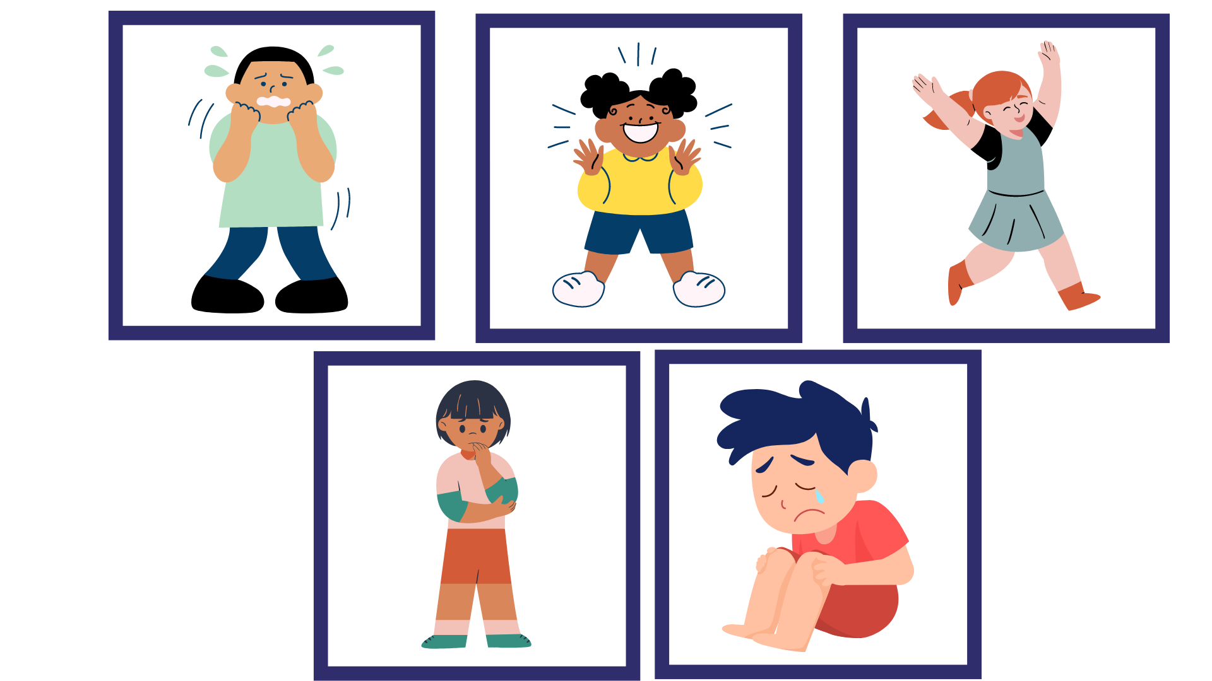
Images sourced from Canva and used in accordance with the Canva Content License Agreement.

Resource 2: School expectations
Draw pictures of 4 different school expectations below.
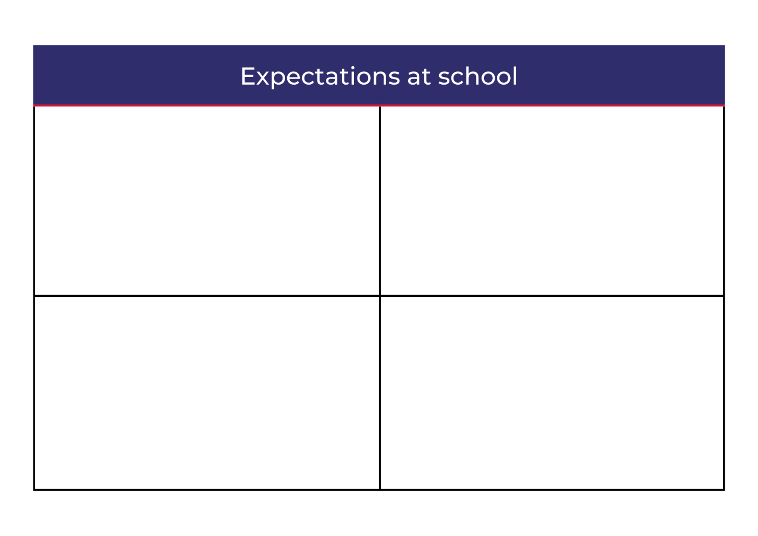

Resource 3: All about me – Early Stage 1
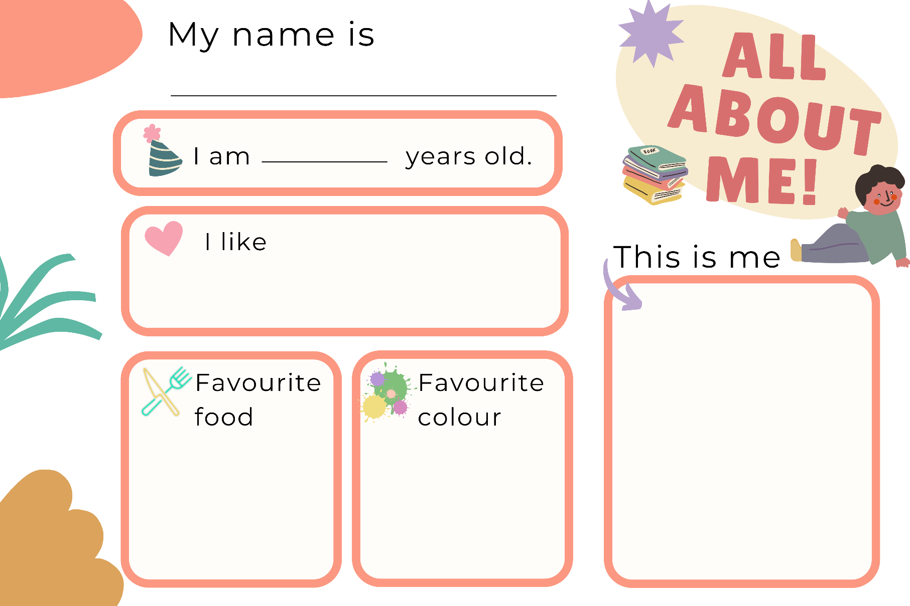
Images sourced from Canva and used in accordance with the Canva Content License Agreement.

Resource 4: All about me – Stage 1
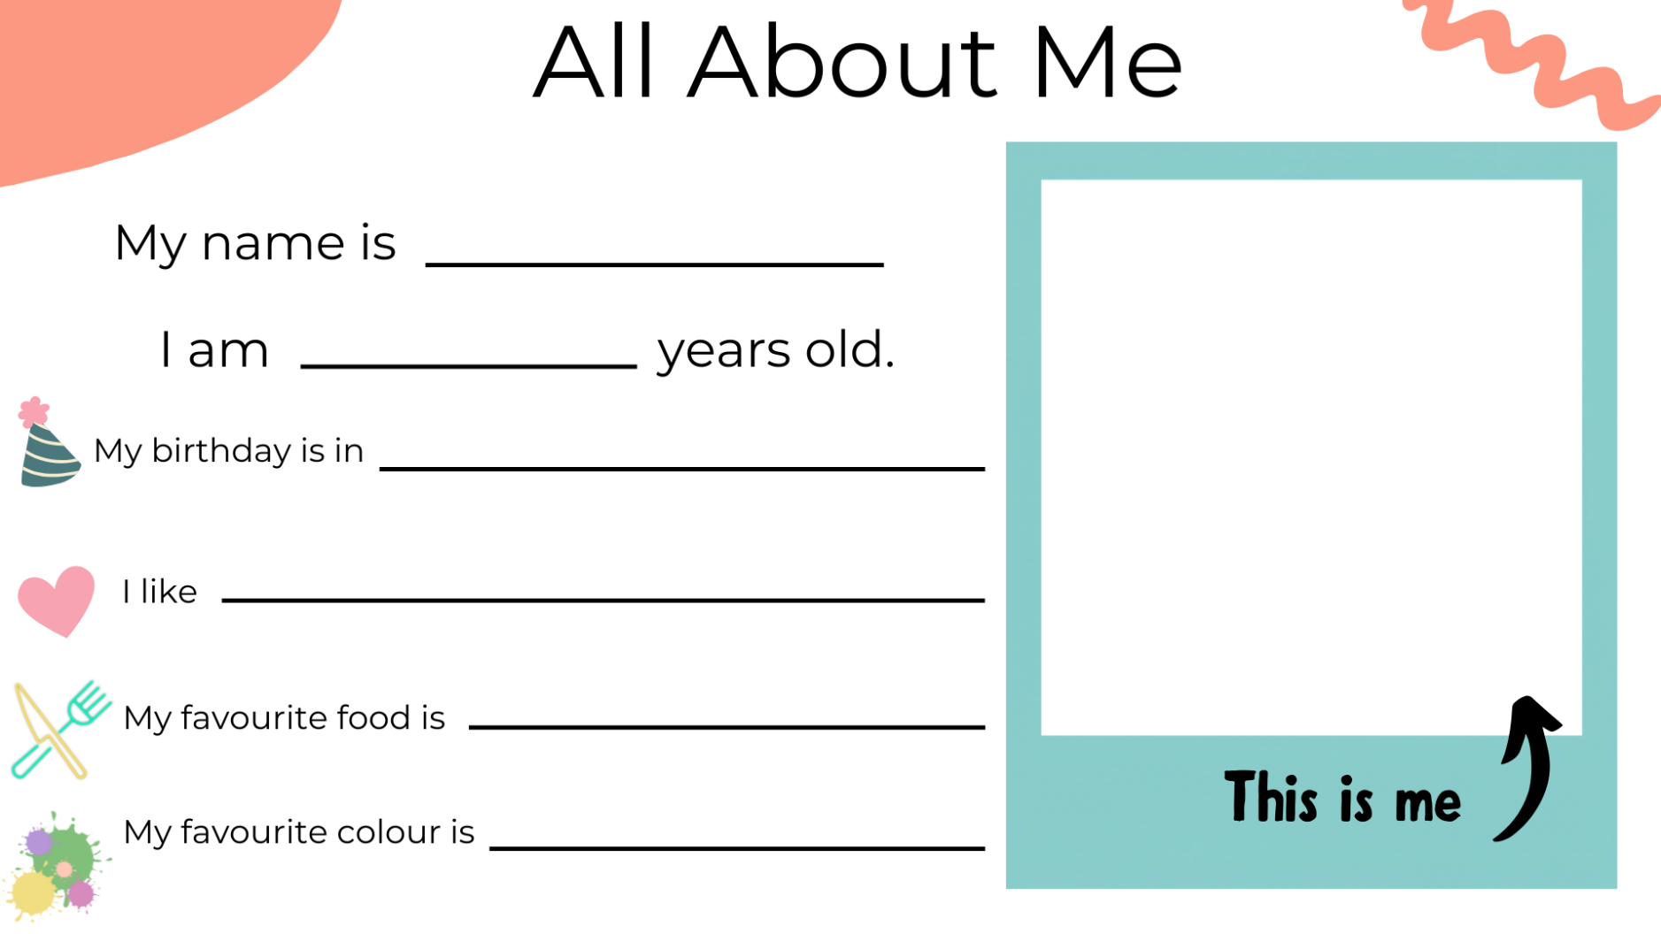
Images sourced from Canva and used in accordance with the Canva Content License Agreement.

Resource 5: Interview questions
Questions | Student answers
What is your name?
How old are you?
When is your birthday?
What do you like to play?
What is your favourite food?
What is your favourite colour?
What makes you feel scared?
What makes you feel happy?
What is your favourite movie?
Who are your friends?

Resource 6: School guide
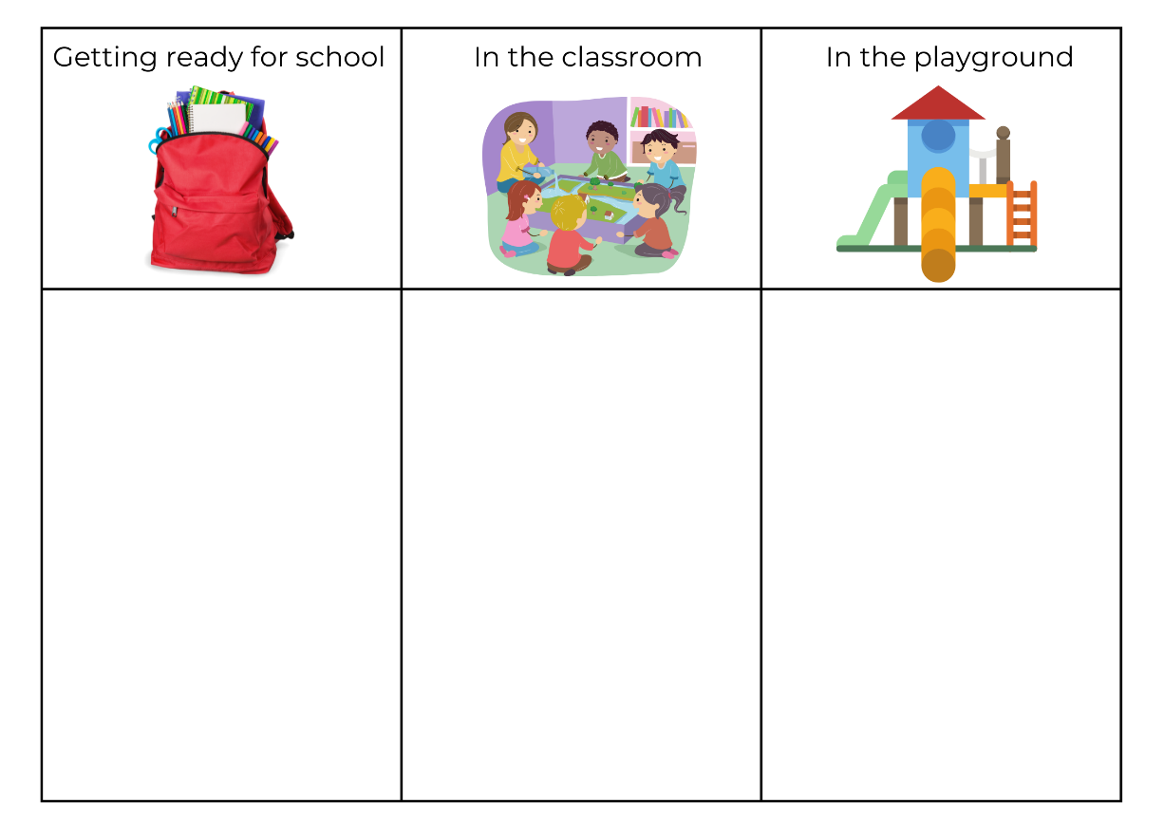
Images sourced from Canva and used in accordance with the Canva Content License Agreement.

Resource 7: Classroom environments
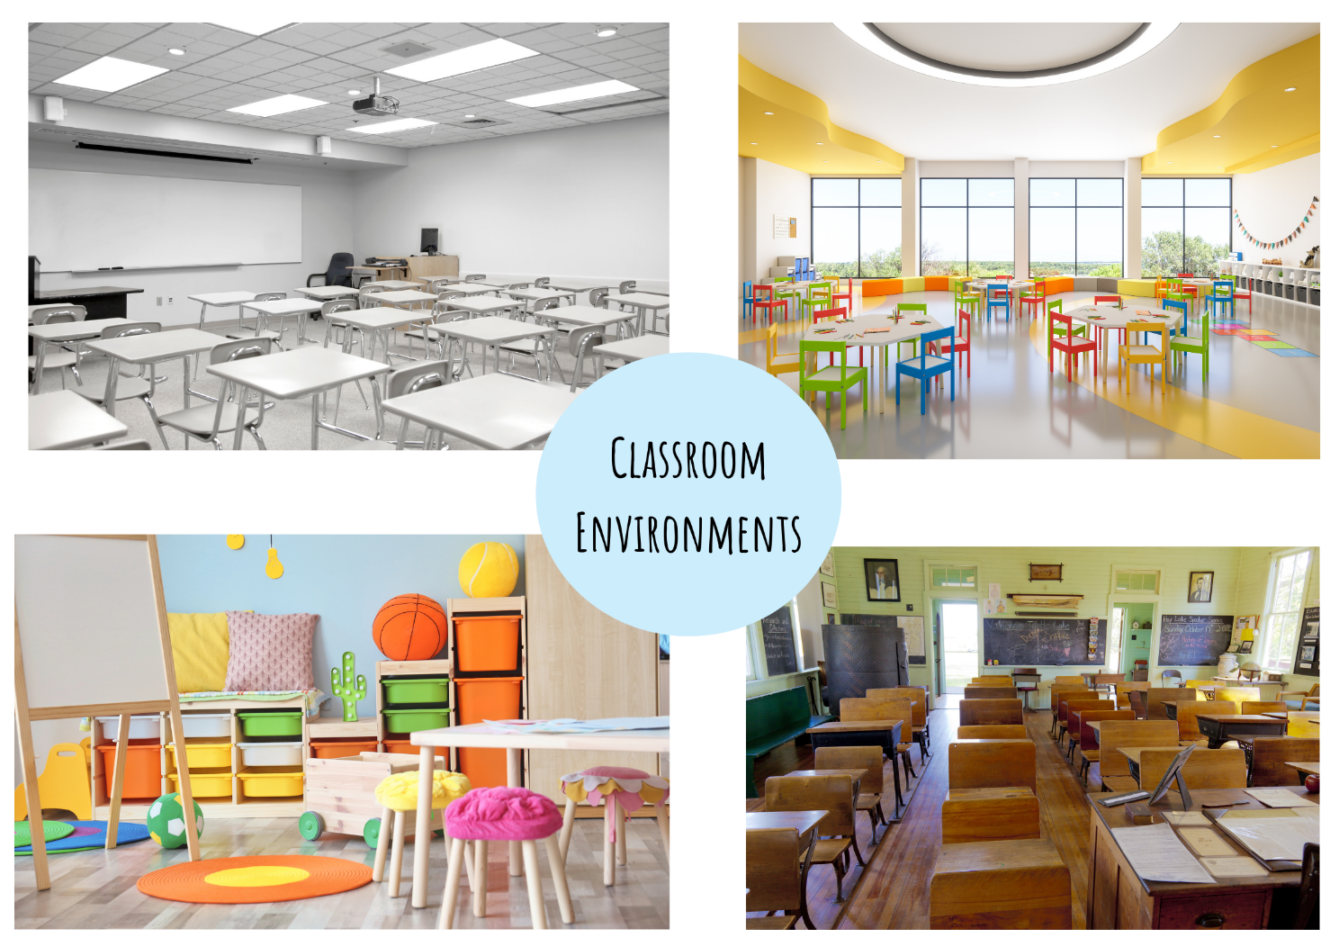
Images sourced from Canva and used in accordance with the Canva Content License Agreement.

References
Links to third-party material and websites
Please note that the provided (reading/viewing material/list/links/texts) are a suggestion only and implies no endorsement, by the New South Wales Department of Education, of any author, publisher, or book title. School principals and teachers are best placed to assess the suitability of resources that would complement the curriculum and reflect the needs and interests of their students.
If you use the links provided in this document to access a third-party's website, you acknowledge that the terms of use, including licence terms set out on the third-party's website apply to the use which may be made of the materials on that third-party website or where permitted by the Copyright Act 1968 (Cth). The department accepts no responsibility for content on third-party websites.
Except as otherwise noted, all material is © State of New South Wales (Department of Education), 2021 and licensed under the Creative Commons Attribution 4.0 International License. All other material (third-party material) is used with permission or under licence. Where the copyright owner of third-party material has not licensed their material under a Creative Commons or similar licence, you should contact them directly for permission to reuse their material.
English K–10 Syllabus © 2022 NSW Education Standards Authority (NESA) for and on behalf of the Crown in right of the State of New South Wales.
Creative Arts K–6 Syllabus © 2006 NSW Education Standards Authority (NESA) for and on behalf of the Crown in right of the State of New South Wales.
© 2021 NSW Education Standards Authority. This document contains NSW Curriculum and syllabus content. The NSW Curriculum is developed by the NSW Education Standards Authority. This content is prepared by NESA for and on behalf of the Crown in right of the State of New South Wales. The material is protected by Crown copyright.
Please refer to the NESA Copyright Disclaimer for more information.
NESA holds the only official and up-to-date versions of the NSW Curriculum and syllabus documents. Please visit the NSW Education Standards Authority (NESA) website and the NSW Curriculum website.
National Literacy Learning Progression © Australian Curriculum, Assessment and Reporting Authority (ACARA) 2010 to present, unless otherwise indicated. This material was downloaded from the Australian Curriculum website (National Literacy Learning Progression) (accessed 4 August 2022) and was not modified. The material is licensed under CC BY 4.0. Version updates are tracked in the ‘Curriculum version history’ section on the 'About the Australian Curriculum' page of the Australian Curriculum website.
ACARA does not endorse any product that uses the Australian Curriculum or make any representations as to the quality of such products. Any product that uses material published on this website should not be taken to be affiliated with ACARA or have the sponsorship or approval of ACARA. It is up to each person to make their own assessment of the product, taking into account matters including, but not limited to, the version number and the degree to which the materials align with the content descriptions and achievement standards (where relevant). Where there is a claim of alignment, it is important to check that the materials align with the content descriptions and achievement standards (endorsed by all education Ministers), not the elaborations (examples provided by ACARA).
Bunting L (2022) The Wild Guide to Starting School (Bunting P, illus.), Omnibus Books, Australia.
ETA (English Teachers Association) and NSW Department of Education (2016) The Textual Concepts and Processes resource, English Textual Concepts website, accessed 2 August 2022.
Fox M (1997) Whoever You Are (Staub L, illus.), Scholastic Australia Pty Ltd, Australia.

