English – K-2 multi-age – Year A – Unit 20
Contents
Unit overview and instructions for use 3
Teacher notes 4
Outcomes and content – Component A 5
Outcomes and content – Component B 9
Week 1 13
Component A teaching and learning 13
Component B teaching and learning 14
Lesson 1: Images and feelings 16
Lesson 2: Vocabulary, tense, and morphemic knowledge 18
Lesson 3: Adjectives and similes 21
Lesson 4: Representing and comparing characters 24
Lesson 5: Word order and similes to represent characters 28
Week 2 31
Component A teaching and learning 31
Component B teaching and learning 32
Lesson 6: Creative retell of Nop 33
Lesson 7: Prepositional phrases in sentences 35
Lesson 8: Using personal experience to write 38
Lesson 9: Publishing writing and creating multimodal texts 40
Lesson 10: Multimodal presentation and unit reflection 41
Resource 1: Stimulus image – Hot air balloon 43
Resource 2: Stimulus image – Rollercoaster 44
Resource 3: Images 45
Resource 4: Vocabulary self-assessment tool 46
Resource 5: Morphology teacher model chart 47
Resource 6: Changing the position of words in a sentence 48
Resource 7: Story map 49
References 50
Further reading 52

Unit overview and instructions for use
This two-week unit is comprised of Component A and Component B. Connecting learning across both components is encouraged.
Teaching and learning | Component A | Component B
Suggested duration | 60 minutes | 45 minutes
Explicit teaching focus areas | - Phonological awareness (Early Stage 1)  - Print conventions (Early Stage 1)  - Phonic knowledge  - Reading fluency  - Reading comprehension  - Spelling  - Handwriting | - Oral language and communication  - Vocabulary  - Reading comprehension  - Creating written texts  - Understanding and responding to literature
To prepare for teaching and learning: | - Refer to Outcomes and content – Component A, K-2 – Instructional sequence – grapheme–phoneme correspondences [PDF 825 KB], and the teaching advice documents (hyperlinked in Component A teaching and learning table).  - Based on student needs identified through ongoing assessment data, plan and document how you will sequence teaching and learning in whole class and targeted teaching groups across the two-week cycle. | - Familiarise yourself with Outcomes and content – Component B, Textual concepts information and videos, English Textual Concepts and Learning Processes (2016), and the teaching and learning sequence.  - Based on student needs identified through ongoing assessment data, determine how you will support students in whole class and targeted teaching groups across the two-week cycle as required.
English K–10 Syllabus © 2022 NSW Education Standards Authority (NESA) for and on behalf of the Crown in right of the State of New South Wales.

Teacher notes
- This unit explores how imagery, symbol and connotation can be used to enhance meaning and enjoyment of texts. It explores how words and images can extend beyond their literal meaning and focuses on a broadening understanding of texts and purposes, including multimodal texts – English Textual Concepts and Learning Processes (2016).
- Understanding of imagery, symbol and connotation can be strengthened by watching the department’s video: Connotation, imagery and symbol (6:06).
- While imagery, symbol and connotation is the mentor concept for the conceptual component of this unit, the supporting concept of character can be explored using the text Nop by Caroline Magerl.
- For more examples of similes used in texts, Crazy Like a Fox: A Simile Story by Loreen Leedy could be used.
- Refer to the NESA Glossary for information on similes, prepositional phrases, time connectives, and multimodal texts.
- This unit could enhance student learning towards achievement of outcomes from the Creative Arts and PDHPE syllabuses.
- Reflect on student learning and engagement in activities and record differentiation and adjustments within the unit to inform future teaching and learning. One way of doing this could be to add comments to the digital file.
- Content points are linked to the National Literacy Learning Progression version (3).
Levels and indicators sourced from National Literacy Learning Progression © Australian Curriculum, Assessment and Reporting Authority (ACARA), (accessed 19 January 2023) and was not modified. See references for more information.

Outcomes and content – Component A
The table below outlines the focus outcomes and content. Content is linked to the National Literacy Learning Progression version (3).
Early Stage 1 Focus area and outcome | Stage 1 Focus area and outcome
Phonological awareness  ENE-PHOAW-01 – identifies, blends, segments and manipulates phonological units in spoken words as a strategy for reading and creating texts  - blend aloud all phonemes when asked to substitute a medial vowel phoneme  - blend aloud all phonemes when asked to substitute a final vowel phoneme | N/A
Print conventions  ENE-PRINT-01 – tracks written text from left to right and from top to bottom of the page and identifies visual and spatial features of print  - identify pictures in texts (PKW2) | N/A
Phonic knowledge  ENE-PHOKW-01 – uses single-letter grapheme–phoneme correspondences and common digraphs to decode and encode words when reading and creating texts  - decode words containing split digraphs and vowel digraphs (PKW5)  - experiment with encoding high-frequency words | Phonic knowledge  EN1-PHOKW-01 – uses initial and extended phonics, including vowel digraphs, trigraphs to decode and encode words when reading and creating texts  - blend and decode one-syllable words with taught extended vowel graphs and digraphs, including graphemes for r-controlled vowels and diphthongs, and apply this when reading texts (PKW6, PKW7)  - decode words with less common consonant digraphs and apply this when reading texts  - decode words with trigraphs and quadgraphs and apply this when reading texts
Reading fluency  ENE-REFLU-01 – reads decodable texts aloud with automaticity  - know that fluent reading involves recognising and reading words accurately and automatically | Reading fluency  EN1-REFLU-01 – sustains reading unseen texts with automaticity and prosody and self-corrects errors  - self-correct when fluency and/or meaning is interrupted  - vary pace when reading according to the audience and purpose (FIY4)
Reading comprehension  ENE-RECOM-01 – comprehends independently read texts using background knowledge, word knowledge and understanding of how sentences connect  - ask or pause to clarify meaning of unknown words (UnT3)  - stop reading when a break in comprehension is registered (UnT4)  - re-read to check if an error was made | Reading comprehension  EN1-RECOM-01 – comprehends independently read texts that require sustained reading by activating background and word knowledge, connecting and understanding sentences and whole text, and monitoring for meaning  - draw on sources to seek clarification for unknown words  - monitor understanding to ensure meaning is sustained and expanded through the whole text (UnT6)
Spelling  ENE-SPELL-01 – applies phonological, orthographic and morphological generalisations and strategies to spell taught familiar and high-frequency words when creating texts  - combine phonological, phonic, orthographic and morphemic knowledge to spell taught high-frequency irregular words comprising up to 3 phonemes (SpG5)  - segment multisyllabic words into syllables and phonemes as a strategy for spelling (SpG4)  - experiment with some vowel digraphs and split digraphs to spell taught high-frequency words and/or personally significant words  - add the plural-marking suffix (s) to base nouns that require no change when suffixed (SpG5)  - experiment with the tense-marking suffixes to spell familiar base verbs (SpG5). | Spelling  EN1-SPELL-01 – applies phonological, orthographic and morphological generalisations and strategies when spelling words in a range of writing contexts  - segment single-syllable words into phonemes as a spelling strategy (SpG6)  - use extended phonic code for taught consonant phonemes
Handwriting  ENE-HANDW-01 – produces all lower-case and upper-case letters to create texts  - apply taught handwriting skills when creating texts (HwK4) | Handwriting  EN1-HANDW-01 – uses a legible, fluent and automatic handwriting style, and digital technology, including word-processing applications, when creating texts  - use taught software functions to create texts in a range of modes for different contexts, audiences and purposes

Outcomes and content – Component B
The table below outlines the focus outcomes and content. Content is linked to the National Literacy Learning Progression version (3).
Early Stage 1 Focus area and outcome | Stage 1 Focus area and outcome
Oral language and communication  ENE-OLC-01 – communicates effectively by using interpersonal conventions and language with familiar peers and adults  - use regular past tense verbs when speaking  - use irregular past tense verbs when speaking  - recall details of events or stories using who, what, when, where, why and how (SpK2) | Oral language and communication  EN1-OLC-01 – communicates effectively by using interpersonal conventions and language to extend and elaborate ideas for social and learning interactions  - organise key ideas in logical sequence  - recount narratives with key components (SpK3)
Vocabulary  ENE-VOCAB-01 – understands and effectively uses Tier 1 and Tier 2 words in familiar contexts  - understand and use words to describe shape, size, texture, position, numerical order, time and seasons (SpK2, CrT5) | Vocabulary  EN1-VOCAB-01 – understands and effectively uses Tier 1, taught Tier 2 and Tier 3 vocabulary to extend and elaborate ideas  - use taught morphemic knowledge to create word families
Reading comprehension  ENE-RECOM-01 – comprehends independently read texts using background knowledge, word knowledge and understanding of how sentences connect  - use known vocabulary to work out or refine the meaning of unknown words  - ask or pause to clarify meaning of unknown words (UnT3)  - recognise how the position of words in a sentence changes its meaning  - use visual cues in multimodal texts to interpret meaning (UnT5)  - recall key characters, events and/or information in text (UnT5) | Reading comprehension  EN1-RECOM-01 – comprehends independently read texts that require sustained reading by activating background and word knowledge, connecting and understanding sentences and whole text, and monitoring for meaning  - use known vocabulary to build a mental model of the content of the text  - ask a clarifying question when more background knowledge is needed to make an inference  - make text-to-self, text-to-text or text-to-world connections when reading (UnT6)  - identify when meaning is not complete and/or contradicts prior understanding  - recount relevant ideas from texts in the form of a written, visual or oral summary (UnT6)
Creating written texts  ENE-CWT-01 – creates written texts that include at least 2 related ideas and correct simple sentences  - sequence ideas in a text (GrA4)  - use prepositional phrases to indicate time or place (GrA2)  - identify and use time connectives to sequence information and events in texts (GrA4)  - use drawing, images or mind maps to support planning and writing (CrT4) | Creating written texts  EN1-CWT-01 – plans, creates and revises texts written for different purposes, including paragraphs, using knowledge of vocabulary, text features and sentence structure  - use a logical order to sequence ideas and events in sentences across a text (GrA4)  - use contextually precise prepositional phrases when creating texts (GrA4)  - use time connectives to sequence information and events in texts (GrA4)  - experiment with writing complex sentences which include a clause for the main message and dependent clause to elaborate or modify the message (GrA5)  - use different modes and media to enhance the presentation of texts they have created (CrT5, CrT6)
Understanding and responding to literature  ENE-UARL-01 – understands and responds to literature read to them  - identify and discuss how creative language and/or symbols enhance enjoyment in texts  - identify how words and word order influence meaning in texts  - identify and discuss character features and actions (UnT3)  - identify and discuss language used to describe characters in narratives | Understanding and responding to literature  EN1-UARL-01 – understands and responds to literature by creating texts using similar structures, intentional language choices and features appropriate to audience and purpose  - identify symbols and images in texts, and how they bring deeper meaning  - innovate from studied texts using wordplay and figurative language  - identify the language, dialogue, actions, images or music that create a reader response to a character  - identify how characters can invite positive and negative responses

Week 1

Component A teaching and learning
The table below can be used to plan and document lessons that address Component A outcomes and content. Both the detailed example [DOC 529KB] of a two-week teaching and learning cycle and brief example [DOC 66KB] may support you in your planning.
Focus Areas | Lesson 1 | Lesson 2 | Lesson 3 | Lesson 4 | Lesson 5
Phonological awareness (Early Stage 1) and Phonic knowledge
15 minutes
Spelling and Handwriting
15 minutes
Print conventions (Early Stage 1), Reading comprehension and Reading fluency
30 minutes

Component B teaching and learning
The following teaching and learning sequence has been designed to address Component B outcomes and content. Adapt the sequence as required to best meet the needs of your students.

Learning intention and success criteria
Learning intentions and success criteria are best co-constructed with students. The table below contains suggested learning intentions and success criteria.
Element | Early Stage 1 | Stage 1
Learning intentions | Students are learning to respond to narrative picture books that represent characters through vocabulary and imagery, symbol and connotation. | Students are learning to respond to narrative picture books that represent characters through vocabulary, figurative language and imagery, symbol and connotation.
Success criteria | Students can:  - identify and discuss character features and actions  - identify and discuss language used to describe characters  - identify and discuss how creative language and symbols enhance enjoyment in texts  - recognise how the position of words in a sentence can change the meaning. | Students can:  - identify symbols and images in texts and recognise how they bring deeper meaning  - use morphemic knowledge to create word families  - experiment with figurative language (similes)  - explore the use of language, dialogue, actions and images that describe characters in a text  - share positive and negative responses to characters in a text.

Resources
- Magerl C (2019) Nop, Walker Books Australia. ISBN: 9781760651251
- Waddell M (1995) Farmer Duck (Oxenbury H, illus.), Walker Books Australia. ISBN: 9780744536607
- Resource 1: Image of hot air balloon (enlarged)
- Resource 2: Image of rollercoaster (enlarged)
- Resource 3: Images (student copies)
- Resource 4: Vocabulary self-assessment tool (enlarged)
- Resource 5: Morphology teacher model chart
- Resource 6: Changing the position of words in a sentence
- Video: Connotation, imagery and symbol (6:06)
- T-chart
- Venn diagram (enlarged and student copies for Stage 1)
- Powerhouse Collection: Tin toys or an old toy
- Texts with corresponding play boxes including a variety of tactile resources for acting out stories, for example, puppets, dress ups, small toys, building blocks for Lesson 2 (Early Stage 1)
- Large dice labelled with verbs for Lesson 2 (Early Stage 1)
- Craft materials for designing their own soft toy for Lesson 3 (Early Stage 1)
- Watercolour paints and art paper for creating illustrations of a scene from Farmer Duck for Lesson 4 (Early Stage 1)
- Sticky notes for the Venn diagram activity in Lesson 4 (Stage 1)
- Prepare similes for Duck and butcher paper for students to record their feelings about Farmer for Lesson 5 (Stage 1)

Lesson 1: Images and feelings
The following teaching and learning activities support multi-age settings.

Whole
- Display an enlarged copy of Resource 1: Image of hot air balloon. Give students time to think about how the image makes them feel. As a class, brainstorm and record the emotions associated with the image. For example, excited, euphoric, ecstatic, giddy, nervous, afraid, petrified.
- Display an enlarged copy of Resource 2: Image of rollercoaster. Draw 2 columns on the whiteboard with the headings: positive feelings and negative feelings. Invite students to Think-Pair-Share different words that the image makes them feel. Record responses in the appropriate columns. Discuss how the same image can make people feel different emotions.

Part
The table below details the differentiated teaching and learning activities for each stage.
Early Stage 1 (independent/small groups) | Stage 1 (teacher guided/independent)
- Using Resource 3: Images, students cut out and sort images into 2 piles: positive feelings and negative feelings.  Too hard? Lessen the number of images given to sort.  - In small groups, students share their responses to some of the images using the sentence stem ‘This made me feel __ because __’ to explain their thinking. | - Explain that connotations are emotions, feelings, or moods that a word or image makes people feel. Connotations may be positive, neutral, or negative. Watch Connotation, imagery and symbol (6:06) to learn more.  - Explain that a neutral connotation occurs when there is neither a positive or negative feeling associated to the word or image.  - Add an additional column on the whiteboard titled, ‘neutral’. As a group, brainstorm different words that may fall into this category for the rollercoaster, or another appropriate image.  - Using Resource 3: Images, students cut out and sort images into 3 piles: positive feelings, neutral feelings, and negative feelings.  - Students compare and discuss their responses.  Too hard? In small groups, students share their responses to some of the images. Use the sentence stem ‘This made me feel __ because __’ so that students can explain their thinking.  Too easy? Students compose a written response explaining how an image can connote different responses from different people.

Whole
- Discuss the differences and similarities between student responses to the images. Ask how images and words evoke different feelings in people. Explain that the language as well as images and symbols in texts can make readers feel different emotions and that the class will be exploring this using different texts.

Lesson 2: Vocabulary, tense, and morphemic knowledge
The following teaching and learning activities support multi-age settings.

Whole
- Share an old toy with the class or one from a website, such as the Powerhouse Collection: Tin toys. Invite students to share how the chosen toy makes them feel (connotation).
- Using think alouds, describe the toy in detail using some of the vocabulary from the text Nop. For example, plush, rumpled, woolly, tassels, tufted. Record these on a word wall.
- Prior to reading Nop, examine the front cover and illustrations of the book. Ask students to share how the image of the character Nop makes them feel.
- Read the text, pausing at different points to make more predictions and inferences.
- Identify a range of Tier 2 words in the text. Record these on the word wall. Make note of the words already on the word wall from activity 2. Ask students to scale their understanding of these words using Resource 4: Vocabulary self-assessment tool. Discuss the meaning of these words. In pairs or in small groups, students practise using them in spoken sentences.
- Select a sentence that has one of the Tier 2 words and the suffix, -ed. For example, ‘The bell over the shop door trilled all day long.’ Revise how suffixes change tense. For example, base word + ed indicates past tense (trill + ed). Explain the meaning of the word ‘trilled’.
- Ask students to change the sentence from activity 6 into present tense and to explain their responses. For example, the bell over the shop door trills all day.
- Select other words from the word wall and have students add the suffix -ed and -s to experiment with tense. Record these on a T-chart under the headings: past and present. Discuss irregular past tense verbs. For example, bit, ate, drank. Invite students to practise the correct use of tense in spoken sentences using the examples on the T-chart.

Part
The table below details the differentiated teaching and learning activities for each stage.
Early Stage 1 (small groups/teacher guided/small groups) | Stage 1 (teacher guided/independent)
- Provide students with themed texts and play boxes. In small groups, students create their own stories using role play.  - Ask students a range of questions to encourage the correct use of regular and irregular past tense verbs. For example, you could ask what their character did or how their character moved. Rephrase student answers if incorrect tense is used.  - In small groups, provide large dice with present tense verbs that relate to the theme of the text and play box. For example, hop, jump, nibble, bite. Students take turns to roll the dice, say the verb, change it to past tense and write it in a sentence.  Too hard? Provide students with sentence starters. For example, The rabbit __. | - Explain that students will be using morphemic knowledge to create word families.  - Revise that morphemes are the smallest meaningful unit in a word. This could be a base word, prefix, or suffix. When a prefix or suffix is added to a base word it can make a new word. For example, the base word happy can be made into unhappy, happier, or happiest. Refer to Resource 5: Morphology teacher model chart.  - Co-create an anchor chart with the terms: morphemes, base word, prefix, and suffix.  - Model how to add prefixes and suffixes to base words using words from the text on the word wall. For example, billow, billows, billowed, billowing, billowy. Discuss the creation of word families with the use of different suffixes.  - Students create their own word families by selecting a base word/s or from the word wall and experiment with adding different prefixes and suffixes to change the meaning and tense of the word.

Whole
- Revisit the text. Discuss how the author has written in past tense consistently throughout the book.
Early Stage 1 Assessment task 1 – Observations and work samples from this lesson allow students to demonstrate achievement towards the following syllabus outcomes and content points:
ENE-OLC-01 – communicates effectively by using interpersonal conventions and language with familiar peers and adults
- use regular past tense verbs when speaking
- use irregular past tense verbs when speaking.
ENE-RECOM-01 – comprehends independently read texts using background knowledge, word knowledge and understanding of how sentences connect
- use known vocabulary to work out or refine the meaning of unknown words
- ask or pause to clarify meaning of unknown words.
Stage 1 Assessment task 1 – Observations and work samples from this lesson allow students to demonstrate achievement towards the following syllabus outcome and content point:
EN1-VOCAB-01 – understands and effectively uses Tier 1, taught Tier 2 and Tier 3 vocabulary to extend and elaborate ideas
- use taught morphemic knowledge to create word families.

Lesson 3: Adjectives and similes
The following teaching and learning activities support multi-age settings.

Whole
- Re-read the text Nop.
- Display an enlarged image of the character Nop. Brainstorm and record adjectives to describe Nop. Early Stage 1 students will use this list to support their independent writing in activity 5.
- Use a strategy such as share the pen to co-construct a written description of Nop using adjectives from activity 2.

Part
The table below details the differentiated teaching and learning activities for each stage.
Early Stage 1 (independent / small groups/independent) | Stage 1 (teacher guided/independent)
- Students design their own version of a soft toy like Nop using craft materials.  - In small groups, students select adjective/s from activity 2 to describe their soft toy designs. Students take turns practising using the adjectives to describe their soft toy in spoken sentences.  - Students write sentences using their ideas from activity 5 and the words displayed from activity 2. | - Display the simile in the text ‘landed like a feather’. Discuss this phrase and unpack what it means. Ask students to think about how it builds an image in the reader’s mind. Explain that it is a simile.  - Explain that similes are a type of figurative language. Similes describe something by comparing it to something else using ‘like’ or ‘as’, usually in an interesting or imaginative way. Give another example of a simile using ‘like’. For example, moves like a snail. Discuss this phrase and what it means.  - Display the simile in the text, ‘as light as dandelion fluff’. Ask what the author means by this. Give another example of a simile using ‘as’ and discuss its interpretation. For example, as brave as a lion.  - Ask students to think about when they have heard similes used. For example, in conversation, books or movies. Brainstorm other similes they know or can think of. For example, sings like an angel and as fast as a cheetah. Students may need visuals to support their thinking.  - Develop a definition for the word, ‘simile’. Write the definition on an anchor chart. Record and display the student similes from activity 10.  - Students write a description of Nop using as many similes as they can. They can refer to the adjectives in activity 2 for support.  Too hard? Provide sentence stems for students to create their simile. For example, ‘Nop is like __’ or ‘Nop is as __ as __’.

Whole
- Students participate in a gallery walk to share their work.
Early Stage 1 Assessment task 2 – Observations and work samples from this lesson allow students to demonstrate achievement towards the following syllabus outcome and content point:
ENE-VOCAB-01 – understands and effectively uses Tier 1 words and Tier 2 words in familiar contexts
- understand and use words to describe shape, size, texture, position, numerical order, time and seasons.

Lesson 4: Representing and comparing characters
The following teaching and learning activities support multi-age settings.

Whole
- Ask students to think about and name characters from books and movies they know. Ask why characters are important in a narrative and whether all characters are human.
- Display the front cover of the text Farmer Duck. Make predictions about the text. Ask students what they notice about the setting and discuss connections to other texts explored in previous units. For example, A Year on our Farm and Rosie’s Walk.
- Read the text.
- Discuss the main characters, Duck and Farmer. Brainstorm and record Duck and Farmer’s characteristics on an anchor chart. Encourage students to ask each other clarifying questions about the characters if responses are limited. Discuss how Duck had human characteristics (acted like a person).
- Display the second double-page spread of the text with the watercolour illustration of Duck leading the cow. Ask what students notice about the colour of the illustrations. Discuss how the image might make readers feel (connotations). Highlight how the beige and brown colours evoke gloomy or sad emotions.
- Using the same double-page spread, ask students if they can see any lines and what effect these lines have. Discuss how the raindrops lead readers’ eyes to Duck at the bottom of the page. Discuss how the position of the characters symbolise power and oppression.

Part
The table below details the differentiated teaching and learning activities for each stage.
Early Stage 1 (independent/teacher guided/independent) | Stage 1 (teacher guided/pairs/independent)
- Invite students to use watercolours to paint a scene from Farmer Duck. This may be one directly from the text or an imagined one. Ask students to use colour, shape, and size to represent characters.  - Re-visit the text. Draw attention to the use of onomatopoeia (animal sounds) and repetition (‘How goes the work?’) in the text.  - Using a student illustration from activity 7, model writing a description of the scene using onomatopoeia and repetition.  - Students write a description of their illustration using onomatopoeia and repetition.  Too hard? Students label their illustrations and use animal sounds (onomatopoeia) in speech bubbles. | - Re-introduce the text Nop. Have students turn and talk to a partner to discuss Nop’s personality traits.  - Display the third page of Nop which shows him sitting on the arm of a chair. Compare this illustration with the one in activities 5 and 6 from Farmer Duck. Discuss the use of angles and the size of both Duck and Nop in these illustrations. Highlight how the images give clues about the characters and bring deeper meaning to the texts.  - Using an enlarged Venn diagram, discuss and record the similarities and differences between the characters Nop and Duck. Students write similar and different character traits on sticky notes and place these on the Venn diagram.  - Co-construct a sentence using comparative language to describe how Nop and Duck are the same or different.  - Students choose a character from either Nop or Farmer Duck and another character from a text used in a previous unit. They compare and contrast the 2 characters and record their responses in a Venn diagram.  - Students write sentences using comparative language to describe how the characters are the same or different.  Too hard? Students record their responses in the Venn diagram using labelled drawings.

Whole
- Invite students to share their illustrations, diagrams, and writing. Discuss the ways that language and visual elements can help bring a character to life and make texts enjoyable.
Early Stage 1 Assessment task 3 – Observations and work samples from this lesson allow students to demonstrate achievement towards the following syllabus outcomes and content points:
ENE-RECOM-01 – comprehends independently read texts using background knowledge, word knowledge and understanding of how sentences connect
- use visual cues in multimodal texts to interpret meaning.
ENE-UARL-01 – understands and responds to literature read to them
- identify and discuss character features and actions
- identify and discuss language used to describe characters in narratives
- identify and discuss how creative language and/or symbols enhance enjoyment in texts.
Stage 1 Assessment task 2 – Observations and work samples from this lesson allow students to demonstrate achievement towards the following syllabus outcomes and content points:
EN1-RECOM-01 – comprehends independently read texts that require sustained reading by activating background and word knowledge, connecting and understanding sentences and whole text, and monitoring for meaning
- ask a clarifying question when more background knowledge is needed to make an inference
- make text-to-self, text-to-text or text-to-world connections when reading.
EN1-UARL-01 – understands and responds to literature by creating texts using similar structures, intentional language choices and features appropriate to audience and purpose
- identify symbols and images in texts, and how they bring deeper meaning
- identify the language, dialogue, actions, images or music that create a reader response to a character.

Lesson 5: Word order and similes to represent characters
The following teaching and learning activities support multi-age settings.

Whole
- Revise how images can make us feel different emotions. Display the front cover of Farmer Duck. Ask students to share how the image of Duck makes them feel. Examples might include:
- This image makes me feel sad because the duck does not look like he is having a fun time.
- This image makes me feel hopeful because it looks like Duck’s hard work will mean that something will grow in the field.

Part
The table below details the differentiated teaching and learning activities for each stage.
Early Stage 1 (teacher guided/independent/pairs) | Stage 1 (pairs/independent/teacher guided)
- Explain how the position of words in sentences can change the meaning. Write ‘The farmer’s duck only likes working’. Discuss the meaning of the sentence.  - Write ‘The farmer’s only duck likes working’. Discuss the meaning of the sentence and compare to the previous sentence.  - Students read the sentences in Resource 6: Changing the position of words in a sentence and draw a picture to match it.  - In pairs, students compare their drawings and discuss how the position of words in a sentence can change the meaning of a sentence. | - In pairs, students read pre-prepared similes describing Duck. For example, Duck works like a dog, Duck is as strong as an ox.  - With the same partner, students analyse the double-page spread of the Farmer in bed eating chocolate. They share how the image makes them feel, identifying and recording both positive and negative connotations.  - Encourage pairs to add a simile to their responses. For example:  - This makes me feel as hungry as a hippo because I love eating chocolate.  - This makes me feel as lazy as a sloth because it looks like Farmer hasn’t left the bed in a long time.  - Students compose a written response using the sentence stem, ‘This image makes me feel as __ as a __ because ….’ Students then continue to write a paragraph justifying their opinions.  Too hard? Students write simple similes to describe the farmer. For example, Farmer is as lazy as a sloth.
Early Stage 1 Assessment task 4 – Observations and work samples from this lesson allow students to demonstrate achievement towards the following syllabus outcomes and content points:
ENE-RECOM-01 – comprehends independently read texts using background knowledge, word knowledge and understanding of how sentences connect
- recognise how the position of words in a sentence changes its meaning.
ENE-UARL-01 – understands and responds to literature read to them
- identify how words and word order influence meaning in texts.
Stage 1 Assessment task 3 – Observations and work samples from this lesson allow students to demonstrate achievement towards the following syllabus outcome and content points:
EN1-UARL-01 – understands and responds to literature by creating texts using similar structures, intentional language choices and features appropriate to audience and purpose
- innovate from studied texts using wordplay and figurative language
- identify how characters can invite positive and negative responses.

Week 2

Component A teaching and learning
The table below can be used to plan and document lessons that address Component A outcomes and content. Both the detailed example [DOC 529KB] of a two-week teaching and learning cycle and brief example [DOC 66KB] may support you in your planning.
Focus Areas | Lesson 6 | Lesson 7 | Lesson 8 | Lesson 9 | Lesson 10
Phonological awareness (Early Stage 1) and Phonic knowledge
15 minutes
Spelling and Handwriting
15 minutes
Print conventions (Early Stage 1), Reading comprehension and Reading fluency
30 minutes

Component B teaching and learning
The following teaching and learning sequence has been designed to address Component B outcomes and content. Adapt the sequence as required to best meet the needs of your students.

Learning intention and success criteria
Learning intentions and success criteria are best co-constructed with students. The table below contains suggested learning intentions and success criteria.
Element | Early Stage 1 | Stage 1
Learning intentions | Students are learning to create multimodal texts that tell a story about themselves, using imagery, symbol, and connotation to enhance meaning. | Students are learning to create multimodal texts about a personal experience using vocabulary and imagery, symbol, and connotation.
Success criteria | Students can:  - recall main events of a story  - use time connectives to sequence events in a text  - create a short text using prepositional phrases  - create a multimodal text | Students can:  - recall main events of a story  - experiment with complex sentences  - use time connectives to sequence events  - use precise prepositional phrases  - use figurative language (similes) to express connotation and evoke imagery  - create a multimodal text.

Resources
- Magerl C (2019) Nop, Walker Books Australia. ISBN: 9781760651251
- Waddell M (1995) Farmer Duck (Oxenbury H, illus.), Walker Books Australia. ISBN: 9780744536607
- Resource 7: Story map (enlarged copy for Lesson 6 and student copies for Lesson 8)
- Exit ticket
- T-chart
- Craft materials for creating characters and setting in Lesson 6
- Art materials for creating illustrations in Lesson 8
- Craft materials for creating puppets or 3D models in Lesson 9
- Mini whiteboards

Lesson 6: Creative retell of Nop
The following teaching and learning activities support multi-age settings.

Whole
- Re-read the text Nop with a focus on identifying the sequence of events in the narrative. Explain that students will describe the most relevant details from the text in order, using time connectives to sequence.
- Review and discuss time connectives, recording some on an anchor chart. This will be used again in Lesson 8.
- Using an enlarged copy of Resource 7: Story map, jointly record the sequence of events from the text using time connectives. Remind students only key information needs to be recorded (who, what, when, where).
Too hard? Co-construct the story map using visuals from the text.
- In pairs, students present an oral retell of Nop. To enhance this activity and support oral language skill development, students create models of characters and the setting using craft materials. For example, craft sticks, felt, paper plates, and pipe cleaners. Early Stage 1 students will re-use these props in Lesson 7.
- Students present their retell to the class using the characters and settings they have made. Discuss the similarities and differences between presentations.
Too easy? Students also summarise the narrative using the vocabulary identified in Lesson 2 and Lesson 3 in written sentences.
Early Stage 1 Assessment task 5 – Observations and work samples from this lesson allow students to demonstrate achievement towards the following syllabus outcomes and content points:
ENE-OLC-01 – communicates effectively by using interpersonal conventions and language with familiar peers and adults
- recall details of events or stories using who, what, when, where, why and how.
ENE-RECOM-01 – comprehends independently read texts using background knowledge, word knowledge and understanding of how sentences connect
- recall key characters, events and/or information in text.
Stage 1 Assessment task 4 – Observations and work samples from this lesson allow students to demonstrate achievement towards the following syllabus outcomes and content points:
EN1-OLC-01 – communicates effectively by using interpersonal conventions and language to extend and elaborate ideas for social and learning interactions
- organise key ideas in logical sequence
- recount narratives with key components.
EN1-RECOM-01 – comprehends independently read texts that require sustained reading by activating background and word knowledge, connecting and understanding sentences and whole text, and monitoring for meaning
- recount relevant ideas from texts in the form of a written, visual or oral summary.

Lesson 7: Prepositional phrases in sentences
The following teaching and learning activities support multi-age settings.

Whole
- Students Think-Pair-Share to tell their partner what they know about sentences.
- Read 2 simple sentences to students. For example, Nop is a toy rabbit. In pairs, students write the sentences on mini whiteboards and identify grammatical features. For example, a full stop, noun, adjective, capital letters.
- Brainstorm a list of prepositions and record on an anchor chart. For example, in, on, down, over. Explain that students will be writing prepositional phrases in sentences.
- Revise prepositional phrases. Explain prepositional phrases are part of a sentence that show when or where. For example, the girl hid under the table. Ask students to identify and use prepositional phrases in spoken sentences.
- Display an illustration from the text Nop that shows Nop sitting on the arm of a chair. Ask students to think of sentences with prepositional phrases that match the illustration. Students may say or write these. For example, Nop is sitting on the chair, Nop is on a chair in front of the big window. Model writing some of these examples, highlighting the grammatical features of a sentence.

Part
The table below details the differentiated teaching and learning activities for each stage.
Early Stage 1 (pairs / independent) | Stage 1 (teacher guided / pairs / independent)
- In pairs, students play with and manipulate their props from Lesson 6 to create prepositional phrases. For example, Nop is standing on the box, Nop is falling down onto the ground.  - Using their ideas from activity 6, students write complete sentences with a prepositional phrase and underline the prepositions. | - Identify prepositional phrases used in the text. For example, ‘over the jumbled roof tops…’  - Display the simple sentence with a prepositional phrase: ‘Nop was soon a speck in the great march of clouds.’ Model how to write a complex sentence with a prepositional phrase. For example, ‘Nop swirled and twisted over the wispy treetops, although he did not know where his adventure would take him.’  - Jointly construct a complex sentence with a prepositional phrase. Deconstruct the modelled sentence, identifying the main (independent clause), the subordinating conjunction and the dependent (subordinate) clauses, and highlight the prepositional phrase.  - In pairs, students use illustrations from the text to verbalise a complex sentence with a prepositional phrase.  - Co-construct a writing success criteria using the model in activity 10.  - Students write complex sentences that include a prepositional phrase. Encourage students to refer to the anchor chart and success criteria.  Too hard? Write simple or compound sentences including a prepositional phrase.  Too easy? Students experiment with writing a paragraph that features a number of prepositional phrases and a variety of sentence structures, including simple, compound, and complex.
Stage 1 Assessment task 5 – Observations and work samples from this lesson allow students to demonstrate achievement towards the following syllabus outcome and content point:
EN1-CWT-01 – plans, creates and revises texts written for different purposes, including paragraphs, using knowledge of vocabulary, text features and sentence structure
- experiment with writing complex sentences which include a clause for the main message and dependent clause to elaborate or modify the message.

Lesson 8: Using personal experience to write
The following teaching and learning activities support multi-age settings.

Whole
- Prompt students to think about the texts Nop and Farmer Duck. Ask students if they think any of the characters in the stories were treated unfairly and how they know. Students share their responses using a ‘because’ statement.
- In pairs, ask students to think about a time when they have felt they were treated unfairly. Ask how it made them feel, what they did, if it was resolved and how so. Record student responses in a T-chart under the headings ‘Positive feelings’ and ‘Negative feelings’. Discuss how words connotate different emotions in people.
- Co-construct differentiated success criteria for writing a personal response about being treated unfairly. Include time connectives, prepositional phrases, and similes (Stage 1).
- Referring to a time when you have been treated unfairly, model planning for writing using Resource 7: Story map.

Part
The table below details the differentiated teaching and learning activities for each stage.
Early Stage 1 (independent/teacher guided/independent) | Stage 1 (teacher guided/independent)
- Students use Resource 7: Story map to plan their writing by drawing.  - Model using your story map and think alouds to write a personal response about being treated unfairly. Ask students to identify elements of the Early Stage 1 success criteria in the modelled writing (time connectives and prepositional phrases).  - Using their plan, students independently write their own text recounting their personal experience about an unfair situation. | - Model using your story map and think alouds to write a personal response about being treated unfairly, including how information can be organised into paragraphs. Ask students to identify elements of the success criteria in the modelled writing (time connectives, prepositional phrases and similes).  - Students use Resource 7: Story map to plan their writing, recounting their personal experience about an unfair situation.  - Students independently write.

Whole
- Revise the imagery, symbol, and connotation in the texts Nop and Farmer Duck. Invite students to create a watercolour image of a scene from their writing using colour, line, angle, and size to bring deeper meaning to their text.
Early Stage 1 Assessment task 6 – Observations and work samples from this lesson allow students to demonstrate achievement towards the following syllabus outcome and content points:
ENE-CRWT-01 – creates written texts that include at least 2 related ideas and correct simple sentences
- sequence ideas in a text
- use prepositional phrases to indicate time or place
- identify and use time connectives to sequence information and events
- use drawing, images or mind maps to support planning and writing.
Stage 1 Assessment task 6 – Observations and work samples from this lesson allow students to demonstrate achievement towards the following syllabus outcome and content points:
EN1-CWT-01 – plans, creates and revises texts written for different purposes, including paragraphs, using knowledge of vocabulary, text features and sentence structure
- use a logical order to sequence ideas and events in sentences across a text
- use contextually precise prepositional phrases when creating text
- use time connectives to sequence information and events in texts.

Lesson 9: Publishing writing and creating multimodal texts
The following teaching and learning activities support multi-age settings.

Whole
- Using the success criteria developed in Lesson 8, students share their writing from the previous lesson and provide peer feedback to a peer from their stage. Using this feedback, students edit their writing.
- Edited work can be re-written or typed to publish.
- Students create a finger puppet or 3D model of themselves as the main character of their text, considering how they can use imagery to evoke feelings. This will be used to engage the audience and enhance meaning as part of the multimodal text creation.
- In pairs, students work together to publish their multimodal texts. Suggested examples include:
- Recording a slideshow with narration using PowerPoint
- Creating a short video using stop motion animation, Seesaw or Flipgrid
- Performing a live show (this may be more suited to Early Stage 1).

Lesson 10: Multimodal presentation and unit reflection
The following teaching and learning activities support multi-age settings.

Whole
- Provide opportunities for students to complete and share their multimodal texts.
- Students reflect on their learning throughout the unit and complete an exit ticket. For example:
- How did you add deeper meaning to your text through the use of imagery or symbol?
- What connotations do you think your text might evoke?
- I used to think… Now I know…
Stage 1 Assessment task 7 – Observations and work samples from this lesson allow students to demonstrate achievement towards the following syllabus outcome and content point:
EN1-CWT-01 – plans, creates and revises texts written for different purposes, including paragraphs, using knowledge of vocabulary, text features and sentence structure
- use different modes and media to enhance the presentation of texts they have created.

Resource 1: Stimulus image – Hot air balloon
"Hot Air Balloon" by hazelw90 is used in accordance with the Pixabay License.

Resource 2: Stimulus image – Rollercoaster
"Roller Coaster" by Paul Brennan is used in accordance with the Pixabay License.

Resource 3: Images
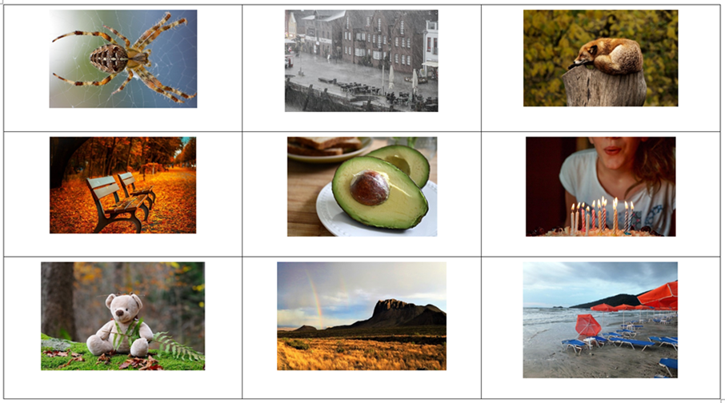
Images sourced from Pixabay and used in accordance with the Pixabay Licence.

Resource 4: Vocabulary self-assessment tool
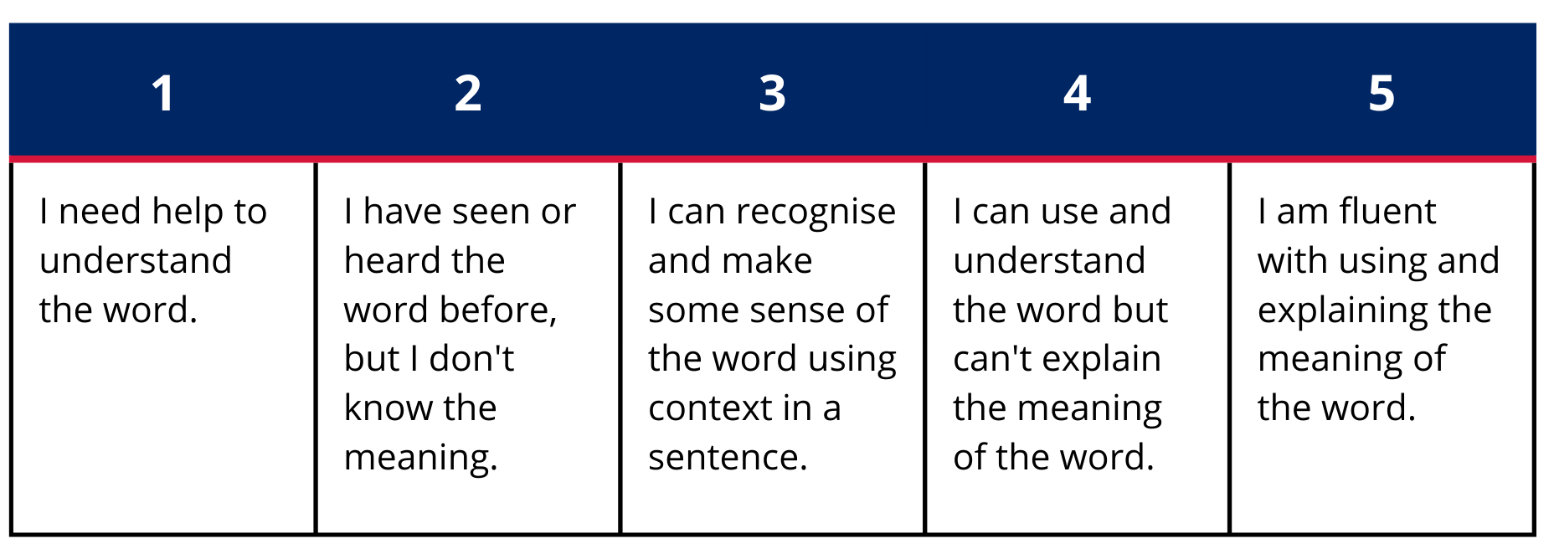

Resource 5: Morphology teacher model chart
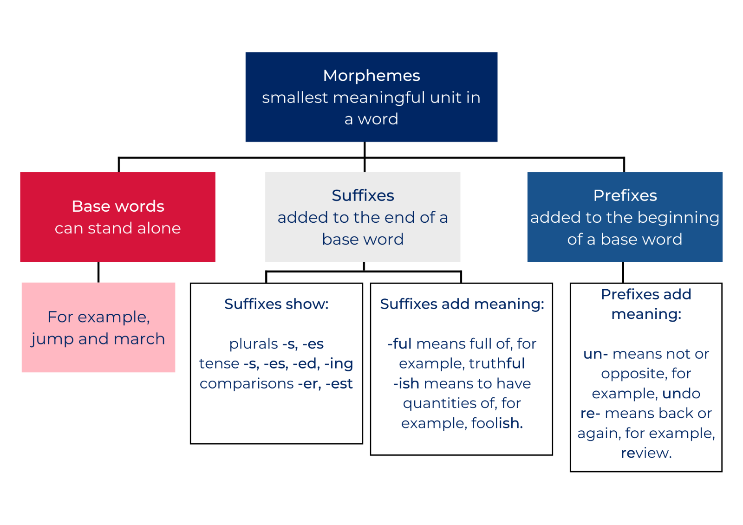

Resource 6: Changing the position of words in a sentence
The duck put the hens in the coop. | The hens put the duck in the coop.
Duck is on the farm. | The farm is on Duck.
Duck fetched the cow from the field. | The cow fetched duck from the field.

Resource 7: Story map
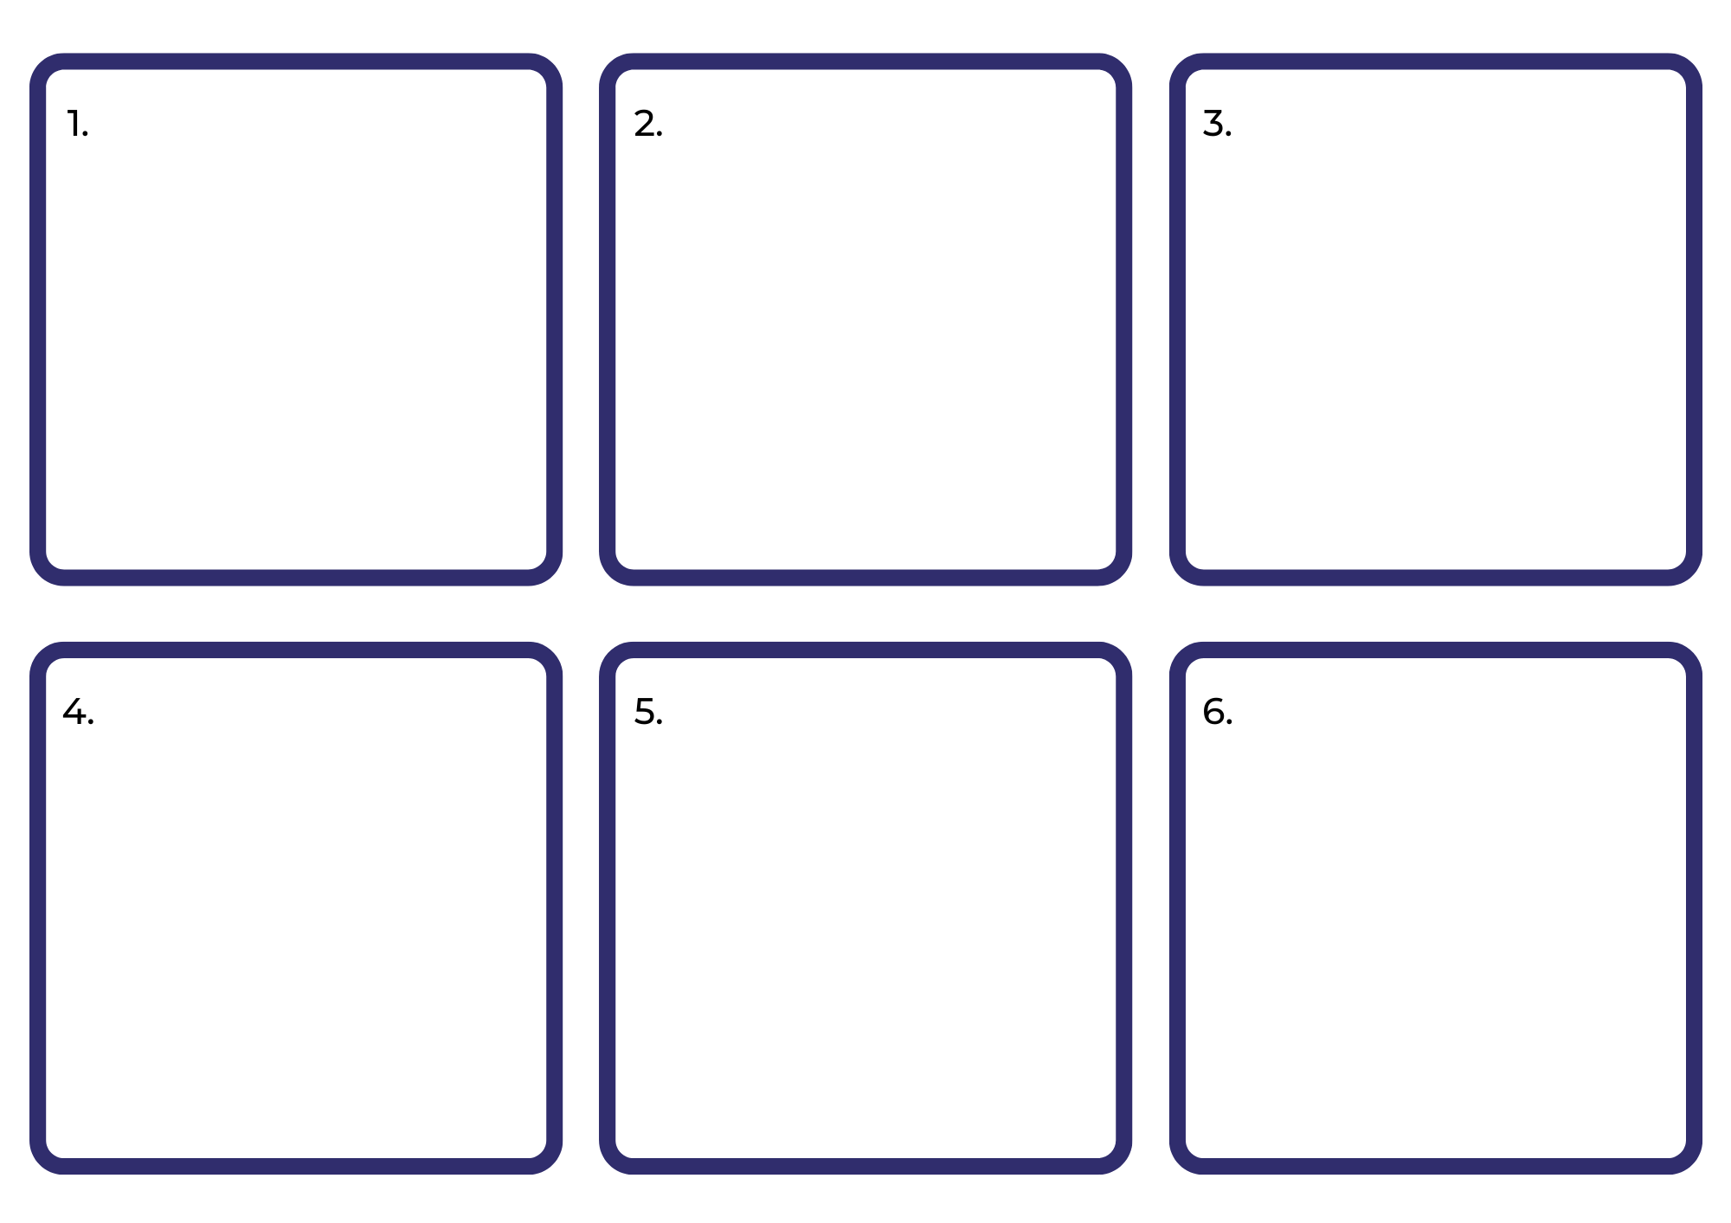

References
Links to third-party material and websites
Please note that the provided (reading/viewing material/list/links/texts) are a suggestion only and implies no endorsement, by the New South Wales Department of Education, of any author, publisher, or book title. School principals and teachers are best placed to assess the suitability of resources that would complement the curriculum and reflect the needs and interests of their students.
If you use the links provided in this document to access a third-party's website, you acknowledge that the terms of use, including licence terms set out on the third-party's website apply to the use which may be made of the materials on that third-party website or where permitted by the Copyright Act 1968 (Cth). The department accepts no responsibility for content on third-party websites.
Except as otherwise noted, all material is © State of New South Wales (Department of Education), 2023 and licensed under the Creative Commons Attribution 4.0 International License. All other material (third-party material) is used with permission or under licence. Where the copyright owner of third-party material has not licensed their material under a Creative Commons or similar licence, you should contact them directly for permission to reuse their material.
English K–10 Syllabus © 2022 NSW Education Standards Authority (NESA) for and on behalf of the Crown in right of the State of New South Wales.
Creative Arts Syllabus © 2006 NSW Education Standards Authority (NESA) for and on behalf of the Crown in right of the State of New South Wales.
PDHPE Syllabus © 2018 NSW Education Standards Authority (NESA) for and on behalf of the Crown in right of the State of New South Wales.
© 2022 NSW Education Standards Authority. This document contains NSW Curriculum and syllabus content. The NSW Curriculum is developed by the NSW Education Standards Authority. This content is prepared by NESA for and on behalf of the Crown in right of the State of New South Wales. The material is protected by Crown copyright.
Please refer to the NESA Copyright Disclaimer for more information.
NESA holds the only official and up-to-date versions of the NSW Curriculum and syllabus documents. Please visit the NSW Education Standards Authority (NESA) website and the NSW Curriculum website.
National Literacy Learning Progression © Australian Curriculum, Assessment and Reporting Authority (ACARA) 2010 to present, unless otherwise indicated. This material was downloaded from the Australian Curriculum website (National Literacy Learning Progression) (accessed 19 September 2022) and was not modified. The material is licensed under CC BY 4.0. Version updates are tracked in the ‘Curriculum version history’ section on the 'About the Australian Curriculum' page of the Australian Curriculum website.
ACARA does not endorse any product that uses the Australian Curriculum or make any representations as to the quality of such products. Any product that uses material published on this website should not be taken to be affiliated with ACARA or have the sponsorship or approval of ACARA. It is up to each person to make their own assessment of the product, taking into account matters including, but not limited to, the version number and the degree to which the materials align with the content descriptions and achievement standards (where relevant). Where there is a claim of alignment, it is important to check that the materials align with the content descriptions and achievement standards (endorsed by all education Ministers), not the elaborations (examples provided by ACARA).
ETA (English Teachers Association) and NSW Department of Education (2016) The Textual Concepts and Processes resource, English Textual Concepts website, accessed 19 September 2022.
Magerl C (2019) Nop, Walker Books Australia.
MAAS (Museum of Applied Arts and Sciences) (n.d) Collection of tin toys, MAAS Powerhouse Collection website, accessed 19 September 2022.
Seesaw Learning, Inc (2022) Seesaw [website], accessed 19 September 2022.
Waddell M (1995) Farmer Duck (Oxenbury H, illus.), Walker Books Australia.

Further reading
Hutchins P (2009) Rosie’s Walk, Red Fox Picture Books, London (original work published 1967).
Leedy L (2009) Crazy Like a Fox: A Simile Story, Holiday House Publishing Inc, New York.
Matthews P (2003) A Year on Our Farm, Scholastic Australia.

