English – K-2 multi-age – Year A – Unit 18
Contents
Unit overview and instructions for use 3
Teacher notes 4
Outcomes and content – Component A 5
Outcomes and content – Component B 9
Week 1 13
Component A teaching and learning 13
Component B teaching and learning 14
Lesson 1: Introducing the text 16
Lesson 2: The Imagineer 19
Lesson 3: Vocabulary 23
Lesson 4: The Most Magnificent Thing 27
Lesson 5: I am an imagineer 29
Week 2 32
Component A teaching and learning 32
Component B teaching and learning 33
Lesson 6: Planning a narrative 34
Lesson 7: Orientation 38
Lesson 8: Series of events and conclusion 41
Lesson 9: Editing 43
Lesson 10: Presenting 45
Resource 1: Matching invention names 46
Resource 2: Tiered vocabulary 48
Resource 3: What am I? – Early Stage 1 49
Resource 4: Narrative planning – Stage 1 50
Resource 5: Narrative planning modified 51
Resource 6: Narrative planning – Early Stage 1 52
References 53
Further reading 55

Unit overview and instructions for use
This two-week unit is comprised of Component A and Component B. Connecting learning across both components is encouraged.
Teaching and learning | Component A | Component B
Suggested duration | 60 minutes | 45 minutes
Explicit teaching focus areas | - Phonological awareness (Early Stage 1)  - Print conventions (Early Stage 1)  - Phonic knowledge  - Reading fluency  - Reading comprehension  - Spelling  - Handwriting | - Oral language and communication  - Vocabulary  - Reading comprehension  - Creating written texts  - Understanding and responding to literature
To prepare for teaching and learning: | - Refer to Outcomes and content – Component A, K-2 – Instructional sequence – grapheme–phoneme correspondences [PDF 825 KB], and the teaching advice documents (hyperlinked in Component A teaching and learning table).  - Based on student needs identified through ongoing assessment data, plan and document how you will sequence teaching and learning in whole class and targeted teaching groups across the two-week cycle. | - Familiarise yourself with Outcomes and content – Component B, Textual concepts information and videos, English Textual Concepts and Learning Processes (2016), and the teaching and learning sequence.  - Based on student needs identified through ongoing assessment data, determine how you will support students in whole class and targeted teaching groups across the two-week cycle as required.
English K–10 Syllabus © 2022 NSW Education Standards Authority (NESA) for and on behalf of the Crown in right of the State of New South Wales.

Teacher notes
- Context refers to factors that impinge on meaning. To understand context, we need to look beyond the text and consider the world in which it was produced and the worlds of its reception. – English Textual Concepts and Learning Processes (2016).
- Understanding of context can be supported through watching the department’s video: Context (5:23).
- For information on context, adjectives, action verbs, nouns, tiered words, and narrative refer to the NESA glossary.
- This unit could enhance student learning towards achievement of outcomes from the Science and Technology syllabus regarding STEM.
- Reflect on student learning and engagement in activities and record differentiation and adjustments within the unit to inform future teaching and learning. One way of doing this could be to add comments to the digital file.
- Content points are linked to the National Literacy Learning Progression version (3).
Levels and indicators sourced from National Literacy Learning Progression © Australian Curriculum, Assessment and Reporting Authority (ACARA), (accessed 26 September 2022) and was not modified. See references for more information.

Outcomes and content – Component A
The table below outlines the focus outcomes and content. Content is linked to the National Literacy Learning Progression version (3).
Early Stage 1 Focus area and outcome | Stage 1 Focus area and outcome
Phonological awareness  ENE-PHOAW-01 – identifies, blends, segments and manipulates phonological units in spoken words as a strategy for reading and creating texts  - As needed | N/A
Print conventions  ENE-PRINT-01 – tracks written text from left to right and from top to bottom of the page and identifies visual and spatial features of print  - As needed | N/A
Phonic knowledge  ENE-PHOKW-01 – uses single-letter grapheme–phoneme correspondences and common digraphs to decode and encode words when reading and creating texts  - decode words containing split digraphs and vowel digraphs (PKW5)  - experiment with encoding high-frequency words containing split digraphs and vowel digraphs | Phonic knowledge  EN1-PHOKW-01 – uses initial and extended phonics, including vowel digraphs, trigraphs to decode and encode words when reading and creating texts  - blend and decode one-syllable words with taught extended vowel graphs and digraphs, including graphemes for r-controlled vowels and diphthongs, and apply this when reading texts (PKW6, PKW7)  - blend and decode 2-syllable words with taught vowel graphs, digraphs, trigraphs and quadgraphs, including graphemes for r-controlled vowels and diphthongs and apply this when reading texts (PKW6, PKW7)  - decode words with less common consonant digraphs and apply this when reading texts  - decode words with trigraphs and quadgraphs and apply this when reading texts
Reading fluency  ENE-REFLU-01 – reads decodable texts aloud with automaticity  - know that fluent reading involves recognising and reading words accurately and automatically  - know that pace and expression vary when reading, according to the audience and purpose | Reading fluency  EN1-REFLU-01 – sustains reading unseen texts with automaticity and prosody and self-corrects errors  - self-correct when fluency and/or meaning is interrupted  - vary pace when reading according to the audience and purpose
Reading comprehension  ENE-RECOM-01 – comprehends independently read texts using background knowledge, word knowledge and understanding of how sentences connect  - use known vocabulary to build a mental model of the content of a text  - use known vocabulary to work out or refine the meaning of unknown words  - understand that informative and imaginative texts have different structures, features and forms (UnT5)  - ask a question or make a statement to clarify meaning (UnT3, UnT4)  - use visual cues in multimodal texts to interpret meaning (UnT5)  - recall the sequence of events/information in texts (UnT5) | Reading comprehension  EN1-RECOM-01 – comprehends independently read texts that require sustained reading by activating background and word knowledge, connecting and understanding sentences and whole text, and monitoring for meaning  - use known vocabulary to build a mental model of the content of a text  - use navigation pathways, including hyperlinks, to extract essential information to support reading fluency and enhance meaning when reading digital texts  - re-read words, phrases or sentences to check and clarify precise meaning  - use visual and/or auditory features in multimodal texts to build meaning (UnT5)  - monitor understanding to ensure meaning is sustained and expanded through the whole text (UnT6)  - draw on sources to seek clarification for unknown words  - use information read in texts to enhance learning across key learning areas  - confirm meaning by sequencing and explaining events and information
Spelling  ENE-SPELL-01 – applies phonological, orthographic and morphological generalisations and strategies to spell taught familiar and high-frequency words when creating texts  - segment multisyllabic words into syllables and phonemes as a strategy for spelling  - experiment with some vowel digraphs and split digraphs to spell taught high-frequency words and/or personally significant words | Spelling  EN1-SPELL-01 – applies phonological, orthographic and morphological generalisations and strategies when spelling words in a range of writing contexts  - use extended phonic code for taught consonant phonemes  - segment single-syllable words into phonemes as a strategy for spelling  - segment multisyllabic words into syllables and phonemes as a strategy for spelling (SpG5)  - use the comparative and superlative suffixes –er and –est (SpG9)  - spell nouns ending in the suffix –er to indicate a person (SpG9)
Handwriting  ENE-HANDW-01 – produces all lower-case and upper-case letters to create texts  - use a stable posture when handwriting or drawing by sitting comfortably with feet flat on the floor, the writing arm resting on a table, with the opposite hand resting on the paper, and shoulders relaxed | Handwriting  EN1-HANDW-01 – uses a legible, fluent and automatic handwriting style, and digital technology, including word-processing applications, when creating texts  - form all letters with consistent size and slope in NSW Foundation Style from memory (HwK5)  - use taught software functions to create texts in a range of modes for different contexts, audiences and purposes

Outcomes and content – Component B
The table below outlines the focus outcomes and content. Content is linked to the National Literacy Learning Progression version (3).
Early Stage 1 Focus area and outcome | Stage 1 Focus area and outcome
Oral language and communication  ENE-OLC-01 – communicates effectively by using interpersonal conventions and language with familiar peers and adults  - respond to spoken questions  - ask questions using who, what, when, where, why or how  - use short phrases and simple sentences when speaking (SpK1) | Oral language and communication  EN1-OLC-01 – communicates effectively by using interpersonal conventions and language to extend and elaborate ideas for social and learning interactions  - respond to information by asking relevant questions to extend their own and others' knowledge (LiS4, LiS6)  - interact to evaluate ideas and refine meaning (InT4, InT5)
Vocabulary  ENE-VOCAB-01 – understands and effectively uses Tier 1 and Tier 2 words in familiar contexts  - use vocabulary that is specific to key learning areas (SpK3, CrT3)  - use and understand Tier 3 words that are of personal interest | Vocabulary  EN1-VOCAB-01 – understands and effectively uses Tier 1, taught Tier 2 and Tier 3 vocabulary to extend and elaborate ideas  - understand and intentionally choose subject-specific vocabulary to enhance precision and for effect  - understand and use words that have different meanings in different contexts
Reading comprehension  ENE-RECOM-01 – comprehends independently read texts using background knowledge, word knowledge and understanding of how sentences connect  - use known vocabulary to build a mental model of the content of a text  - use known vocabulary to work out or refine the meaning of unknown words  - understand that informative and imaginative texts have different structures, features and forms (UnT5)  - ask a question or make a statement to clarify meaning (UnT3, UnT4)  - use visual cues in multimodal texts to interpret meaning (UnT5)  - recall the sequence of events/information in texts (UnT5) | Reading comprehension  EN1-RECOM-01 – comprehends independently read texts that require sustained reading by activating background and word knowledge, connecting and understanding sentences and whole text, and monitoring for meaning  - use navigation pathways, including hyperlinks, to extract essential information to support reading fluency and enhance meaning when reading digital texts  - use known vocabulary to build a mental model of the content of the text  - draw on sources to seek clarification for unknown words  - re-read words, phrases or sentences to check and clarify precise meaning  - use visual and/or auditory features in multimodal texts to build meaning (UnT5)  - use information read in texts to enhance learning across key learning areas  - confirm meaning by sequencing and explaining events and information
Creating written texts  ENE-CWT-01 – creates written texts that include at least 2 related ideas and correct simple sentences  - create written texts that describe, give an opinion, recount an event, convey a story  - create a text including at least 2 related ideas (CrT5)  - identify and use verbs in simple sentences, including in own writing (GrA2)  - use personal vocabulary, words on display and in mentor texts when constructing sentences  - identify different purposes for writing (CrT4)  - use drawing, images or mind maps to support planning and writing (CrT4) | Creating written texts  EN1-CWT-01 – plans, creates and revises texts written for different purposes, including paragraphs, using knowledge of vocabulary, text features and sentence structure  - write texts that describe, explain, give an opinion, recount an event, tell a story (CrT7)  - use visual elements to expand meaning in own texts  - use action, saying, relating and sensing verbs to add detail and precision to writing (GrA2, GrA5)  - use knowledge of similarities and differences between imaginative, informative and persuasive texts when planning for writing  - use modifying and qualifying words and words to indicate quantity
Understanding and responding to literature  ENE-UARL-01 – understands and responds to literature read to them  - identify texts that are composed for specific audiences and purposes  - create imaginative and/or informative texts relating to their own experience, the world and/or other texts (CrT3) | Understanding and responding to literature  EN1-UARL-01 – understands and responds to literature by creating texts using similar structures, intentional language choices and features appropriate to audience and purpose  - identify how the language and form of a text vary according to purpose, audience and mode (UnT5)  - create and re-create texts in a range of modes and media using understanding of context (CrT5)

Week 1

Component A teaching and learning
The table below can be used to plan and document lessons that address Component A outcomes and content. Both the detailed example [DOC 529KB] of a two-week teaching and learning cycle and brief example [DOC 66KB] may support you in your planning.
Focus Areas | Lesson 1 | Lesson 2 | Lesson 3 | Lesson 4 | Lesson 5
Phonological awareness (Early Stage 1) and Phonic knowledge
15 minutes
Spelling and Handwriting
15 minutes
Print conventions (Early Stage 1), Reading comprehension and Reading fluency
30 minutes

Component B teaching and learning
The following teaching and learning sequence has been designed to address Component B outcomes and content. Adapt the sequence as required to best meet the needs of your students.

Learning intention and success criteria
Learning intentions and success criteria are best co-constructed with students. The table below contains suggested learning intentions and success criteria.
Element | Early Stage 1 | Stage 1
Learning intentions | Students are learning to use background knowledge to recognise and compare aspects of their own world that appear in texts. | Students are learning to identify connections between texts and themselves to understand context.
Success criteria | Students can:  - identify and use verbs  - ask and respond to questions using who, what, where, when, why or how  - understand the purpose of subject-specific vocabulary  - describe similarities and differences between characters  - use drawing and images to support planning for writing. | Students can:  - understand the context of a character  - use various texts to access information  - understand the purpose of subject-specific vocabulary  - compare and contrast characters  - ask relevant questions to deepen understanding  - plan and create an invention to solve a problem.

Resources
- Cheng C (2022) The Imagineer (Masciullo L, illus.), National Library of Australia. ISBN: 9781922507341
- Spires A (2013) The Most Magnificent Thing, Kids Can Press. ISBN: 9781554537044
- Resource 1: Matching invention names
- Resource 2: Tiered vocabulary
- Resource 3: What am I? – Early Stage 1 – for pairs of students
- Inventions by Kids
- Venn diagram
- A3 colour copy of Penny’s final invention bifold page – one for each group
- Sticky notes
- Online and/or hardcopies of dictionaries
- Cardboard boxes – for each student
- Craft and recyclable items for creating an invention. For example: straws, lids, bottle tops, empty cylinder rolls, craft sticks, buttons, newspapers, masking tape, scissors, glue.

Lesson 1: Introducing the text
The following teaching and learning activities support multi-age settings.

Whole
- Introduce the text The Imagineer. Guide students to make predictions about the book using the front cover, the title, and the blurb. Read the text. Ask students questions to make text-to-self connections and to understand context. For example:
- What was something interesting you noticed?
- Who do you think the book was written for? (audience)
- What steps does Penny take to create her invention?
- In what ways are Penny and Grandpa similar?
- Where have you seen old objects like Grandpa’s before?
- Which one of Penny’s inventions did you like best? Why?
- Sometimes Penny’s inventions did not work the first time. What is something that did not work the first time for you? How did you feel?
- Have you tried to invent anything before?
- Revise adjectives, action verbs and nouns.
- Create an anchor chart titled ‘Wonderful Words’ using the headings: adjectives, action verbs, and nouns. Use the text to record vocabulary. Ask students if they can work out the meaning of an unknown word by using context, images, and prior knowledge. Clarify the meaning of unfamiliar words as required.
- Model writing a sentence about one of Penny’s inventions using words from the ‘Wonderful Words’ chart.

Part
The table below details the differentiated teaching and learning activities for each stage.
Early Stage 1 (pairs/independent) | Stage 1 (teacher guided)
- In pairs, students draw-talk-share about one of Penny’s inventions, discussing all the actions Penny needed to do to complete her invention. For example, cut, glue, draw, imagine.  - Display the ‘Wonderful Words’ chart for the students to access.  - Students write sentences using verbs to explain how Penny built her inventions and draw a picture to match. For example, Penny twisted, turned, cut, glued, and measured.  - Students share their writing and identify the verbs.  Too hard? Provide students with sentence stems.  Too easy? Students label their drawing to add meaning to their sentences. | - Explain that modifying and qualifying words add detail to a sentence. Some modifying and qualifying words show quantity. For example, several, few, more, a lot.  - Support students to search the text, identifying sentences or phrases that include modifying and qualifying words that indicate quantity. For example, ‘work out the first time’, ‘visit for the very first time’, ‘what many of the bits and pieces were used for’.  - Display ‘work out the first time’ and ‘visit for the very first time’. Discuss how the author intentionally chose the word ‘very’ to add detail and emphasise time.  - Record words from the text that indicate quantity. Brainstorm and record additional words, for example, many, some, a lot, most, few.  - Co-construct sentences about Penny’s inventions using words from the previous activity. For example, Penny made many inventions for Grandpa, but they did not always work the first time.  - Students write sentences about Penny’s inventions, which include words that indicate quantity.  Too hard? Co-construct sentences about Penny’s inventions.
Early Stage 1 Assessment task 1 – Work samples and observations from this lesson allow students to demonstrate achievement towards the following syllabus outcomes and content points:
ENE-RECOM-01 – comprehends independently read texts using background knowledge, word knowledge and understanding of how sentences connect
- use known vocabulary to work out or refine the meaning of unknown words
- use visual cues in multimodal texts to interpret meaning.
ENE-CWT-01 – creates written texts that include at least 2 related ideas and correct simple sentences
- identify and use verbs in simple sentences, including in own writing
- use personal vocabulary, words on display and in mentor texts when constructing sentences
- use drawing, images or mind maps to support planning and writing.
Stage 1 Assessment task 1 – Work samples and observations from this lesson allow students to demonstrate achievement towards the following syllabus outcomes and content points:
EN1-CWT-01 – plans, creates and revises texts written for different purposes, including paragraphs, using knowledge of vocabulary, text features and sentence structure
- use modifying and qualifying words and words to indicate quantity.

Lesson 2: The Imagineer
The following teaching and learning activities support multi-age settings.

Whole
- Re-read The Imagineer. Ask:
- What makes Penny an inventor?
- What were some things she found easy or hard?
- Discuss her growth mindset characteristics and how she started again if her creations did not work out.
Note: In a growth mindset, people believe that their most basic abilities can be developed through dedication and hard work – brains and talent are just the starting point. This view creates a love of learning and a resilience that is essential for great accomplishment (Dweck, 2008).
- In groups, students view an A3 copy of Penny’s final invention. Display and discuss questions to consider when working in groups. For example:
- What do you see?
- What do you think?
- What do you wonder?
- What real-life inventions can you see that we just learnt about?
- Can you see any other inventions that you know of?
- Hand out sticky notes to each group. Students write responses to the questions on the sticky notes and place them on the A3 picture.
- Invite groups to share responses. Ask:
- Why did Penny create this?
- What purpose does the invention have?
- How does it help Grandpa?

Part
The table below details the differentiated teaching and learning activities for each stage.
Early Stage 1 (teacher guided) | Stage 1 (independent)
- Model drawing one of Penny’s inventions and writing a sentence to explain what Grandpa could do with Penny’s invention. For example, Grandpa can use the umbrella to protect himself from the sun and the rain. | - In groups, students match the invention to its name by completing Resource 1: Matching invention names.

Part
The table below details the differentiated teaching and learning activities for each stage.
Early Stage 1 (independent) | Stage 1 (teacher guided/pairs)
- Students draw one of Penny’s inventions and then write sentences to explain what Grandpa can do with Penny’s invention.  - In pairs students share their work and use feedback from their partner to edit their writing and/or drawing.  Too easy? Students draw and label new additions to the invention that will help Grandpa. | - Access the website Inventions by Kids and discuss where information on inventors may be located. Use a think aloud when using navigation pathways and tools on the page, including hyperlinked images. Use vocabulary such as website title, heading, search bar, scroll bar, links, image, caption, text, navigation menu and background.  - Discuss the audience and purpose of the website. Ask:  - Who was the website created for?  - How do you know?  - What is the purpose of the website?  - Select an invention on the webpage to read about and discuss how the young inventors came up with the idea. Ask students what they think would have been hard or easy for the inventors.  - In pairs, students brainstorm and draw an invention they would like to make to help someone. They then write sentences to explain what their invention is, who it would help and how.  Too hard? Students access the Inventions by Kids website to search for ideas. Co-construct sentences that explain an invention.
Stage 1 Assessment task 2 – Observations from this lesson allow students to demonstrate achievement towards the following syllabus outcomes and content points:
EN1-RECOM-01 – comprehends independently read texts that require sustained reading by activating background and word knowledge, connecting and understanding sentences and whole text, and monitoring for meaning
- use navigation pathways, including hyperlinks to extract essential information to support reading fluency and enhance meaning when reading digital texts
- use visual and/or auditory features in multimodal texts to build meaning.
ENE1-VOCAB-01 – understands and effectively uses Tier 1, taught Tier 2 and Tier 3 vocabulary to extend and elaborate ideas
- understand and intentionally choose subject-specific vocabulary to enhance precision and for effect
- understand and use words that have different meanings in different contexts.
ENE1-RECOM-01 – comprehends independently reads texts that require sustained reading by activating background and word knowledge, connecting and understanding sentences and whole text, and monitoring for meaning
- use known vocabulary to build a mental model of the content of the text
- draw on sources to seek clarification for unknown words
- re-read words, phrases or sentences to check and clarify precise meaning.

Lesson 3: Vocabulary
The following teaching and learning activities support multi-age settings.

Whole
- Display the enlarged copy of Resource 2: Tiered vocabulary. Explain the difference between Tier 2 and Tier 3 words. Tier 3 words are rarely used and only in highly specific situations, while Tier 2 words are commonly used when writing to add power and precision.
- Re-read The Imagineer, stopping to add new or unfamiliar vocabulary to Resource 2.
- Without showing the students, refer to the page with Penny’s submarine. Ask students to create a mental model of the submarine as it is described and then draw it. Provide descriptions without using subject-specific (Tier 3) vocabulary. For example, draw a box with a tail and 2 holes.
- Show the students the picture of Penny’s submarine. Ask students to list subject-specific vocabulary that would allow them to create a stronger mental image and add further details to their drawing. For example, periscope, porthole, propeller. List the vocabulary on the board for students to refer to.
- Students re-draw and label a submarine using the subject-specific vocabulary. In pairs, students take turns to describe their submarine without showing their partner their drawing. Each student now draws the submarine described by their partner.

Part
The table below details the differentiated teaching and learning activities for each stage.
Early Stage 1 (independent) | Stage 1 (teacher guided)
- In pairs, students use Resource 3: What am I? – Early Stage 1 cut into strips to play a game. One partner describes the word and the other partner guesses it and then uses it in a sentence. Other variations of the game could be used such as matching the word and image by cutting out the images and words. Using multiple copies of the resource, cut into strips or boxes, students could play a matching game. | - Choose a Tier 3 word and ask students what strategies could be used to clarify the meaning. Access an online or hardcopy dictionary to look up the meaning and discuss what contexts the word could be used in.  - Discuss any words that could be used in different contexts. For example, communicator, visualiser, bellows.  - Provide students with a hard copy and/or online dictionary to search for a Tier 3 word.  - Explain that students will use their drawing of their submarine from activity 5 to write about what some of the inventions/parts of it can do. Model using Tier 2 and subject-specific Tier 3 words to add precision to writing. For example, ‘The periscope on Penny’s submarine was used when she explored the deepest oceans.’

Part
The table below details the differentiated teaching and learning activities for each stage.
Early Stage 1 (teacher guided) | Stage 1 (independent)
- Co-construct sentences with Tier 3 words from the text. Ask students to verbalise the sentence before sharing the pen to write.  - Ask students to think of some other Tier 3 words they are familiar with and verbalise a sentence. These words can be words students have a personal interest in. For example, galactic. As students verbalise sentences, support others to identify the Tier 3 word and explain how they help to make writing more precise. | - Students use their drawing of the submarine from activity 5 to explain what some of the inventions/parts of it can do. Remind students to use Tier 2 and subject-specific Tier 3 words to add precision to their writing. For example, ‘The periscope on Penny’s submarine was used when she explored the deepest oceans.’
Early Stage 1 Assessment task 2 – Observations and work samples from this lesson allow students to demonstrate achievement towards the following syllabus outcomes and content points:
ENE-VOCAB-01 – understands and effectively uses Tier 1 and Tier 2 words in familiar contexts
- use vocabulary that is specific to key learning areas
- use and understand Tier 3 words that are of personal interest.
ENE-RECOM-01 – comprehends independently reads texts using background knowledge, word knowledge and understanding of how sentences connect
- use known vocabulary to build a mental model of the content of a text
- use known vocabulary to work out or refine the meaning of unknown words.
Stage 1 Assessment task 3 – Observations and work samples from this lesson allow students to demonstrate achievement towards the following syllabus outcomes and content points:
EN1-RECOM-01 – comprehends independently read texts that require sustained reading by activating background and word knowledge, connecting and understanding sentences and whole text, and monitoring for meaning
- use known vocabulary to build a mental model of the content of the text
- draw on sources to seek clarification for unknown words.
EN1-VOCAB-01 – understands and effectively uses Tier 1, taught Tier 2 and Tier 3 vocabulary to extend and elaborate ideas
- understand and intentionally choose subject-specific vocabulary to enhance precision and for effect
- understand and use words that have different meanings in different contexts.

Lesson 4: The Most Magnificent Thing
The following teaching and learning activities support multi-age settings.

Whole
- Introduce the text The Most Magnificent Thing. As a class, make predictions about the book using the front cover, title, and blurb. Ask:
- Where could the girl be going?
- Why does she have so many objects in her wagon?
- What could be magnificent?
- Read the text The Most Magnificent Thing.

Part
The table below details the differentiated teaching and learning activities for each stage.
Early Stage 1 (teacher guided) | Stage 1 (small groups/independent)
- Flick through the text, drawing attention to the beginning, middle and end.  - Divide students into 3 groups and explain that each group will draw and write about a section from the text, the beginning, middle or end, to sequence events.  - Each group discusses what happened in their allocated section of the text and decides what to draw and/or write to show the most important events. | - Students use a large Venn diagram to compare and contrast The Imagineer and The Most Magnificent Thing. In small groups, students discuss similarities and differences between the 2 texts.  - Students divide a page in half. On one side of the page, students list personal challenges they have faced and on the other side they write things that helped them to learn and grow. For example, riding a bike – using positive self-talk.  - In small groups, students share their work and discuss how they overcame their personal challenges.

Part
The table below details the differentiated teaching and learning activities for each stage.
Early Stage 1 (small groups) | Stage 1 (teacher guided)
- Students collaborate to draw and write about their section of the text. This could be completed as a joint artwork and summary.  Too hard? Provide students with sentence stems to support writing.  - As a whole group, students use their drawings and writing to retell the narrative. | - Model writing sentences about a challenge using a student work sample. For example, When I learnt to ride my bike, I fell off a lot. It made me upset. I tried hard every day and never gave up because I was determined. Now I can go on bike rides with my family when we are on holidays.  - Students write sentences about one of their personal challenges, how it made them feel, and how they overcame it.  Too easy? Students also write about what would have happened if they hadn’t displayed a growth mindset.

Lesson 5: I am an imagineer
The following teaching and learning activities support multi-age settings.

Whole
- Look at the double-page spread from The Imagineer where Penny made her spaceship and submarine. Discuss the purpose for her 2 inventions, focusing on vocabulary. Add new vocabulary to Resource 2: Tiered vocabulary. For example, ‘interstellar communicator’ and ‘aquasonic visualiser’. Ask:
- What problem was Penny trying to solve?
- Why would she want to solve that problem?
- What materials do you think Penny used to create her inventions?
- What problems might Penny have with her spaceship?
- Explain that students will become an ‘imagineer’ and will write about an adventure like the one Penny went on. They will need to consider the setting and series of events during the adventure.
- Brainstorm settings for adventures. For example, flying, living in an underwater world, trekking through the jungle, travelling through time. As a class, choose one setting and discuss a problem that could be faced during the adventure.
- Ask students to think about what inventions they can think of to solve the problem. For example, travelling to the moon and an asteroid hit the spaceship. The invention is a safety capsule with propellers that ejects from the spaceship.
- Students Think-Pair-Share about a setting, problem, and an invention that would help them overcome the problem.
- Students write about their chosen setting and a problem that could be faced.
- Students ‘sketch, plan and scribble’ an invention to solve the problem. This will be used in Lesson 6.
- In pairs, students share their writing, sketches, and ideas. Ask students relevant questions, for example:
- Where will your story take place?
- What will you be doing?
- What is your problem?
- How will you solve it?
- Students name their invention.
- Provide students with a range of materials to build their inventions and remind them to use a growth mindset as they create.
Early Stage 1 Assessment task 3 – Work samples and observations from this lesson allow students to demonstrate achievement towards the following syllabus outcomes and content points:
ENE-OLC-01 – communicates effectively by using interpersonal conventions and language with familiar peers and adults
- respond to spoken questions
- ask questions using who, what, when, where, why or how
- use short phrases and simple sentences when speaking.
ENE-RECOM-01 – comprehends independently read texts using background knowledge, word knowledge and understanding of how sentences connect
- understand that informative and imaginative texts have different structures, features and forms
- use visual cues in multimodal texts to interpret meaning
- ask a question to make a statement to clarify meaning.

Week 2

Component A teaching and learning
The table below can be used to plan and document lessons that address Component A outcomes and content. Both the detailed example [DOC 529KB] of a two-week teaching and learning cycle and brief example [DOC 66KB] may support you in your planning.
Focus Areas | Lesson 6 | Lesson 7 | Lesson 8 | Lesson 9 | Lesson 10
Phonological awareness (Early Stage 1) and Phonic knowledge
15 minutes
Spelling and Handwriting
15 minutes
Print conventions (Early Stage 1), Reading comprehension and Reading fluency
30 minutes

Component B teaching and learning
The following teaching and learning sequence has been designed to address Component B outcomes and content. Adapt the sequence as required to best meet the needs of your students.

Learning intention and success criteria
Learning intentions and success criteria are best co-constructed with students. The table below contains suggested learning intentions and success criteria.
Element | Early Stage 1 | Stage 1
Learning intentions | Students are learning to respond to texts by planning and composing a narrative about an invention. | Students are learning to respond to literature by creating their own imaginary text using intentional language choices.
Success criteria | Students can:  - identify the differences between informative and imaginative texts  - plan a narrative that follows a beginning, middle, end structure  - write a narrative adventure that presents and solves a problem  - edit writing using feedback. | Students can:  - plan for an imaginative text  - add visual elements to expand meaning  - use action verbs to add precision to writing  - sequence events to write an imaginative text  - give and apply feedback to edit writing  - create a presentation to demonstrate understanding of context.

Resources
- Cheng C (2022) The Imagineer (Masciullo L, illus.), National Library of Australia. ISBN: 9781922507341
- Spires A (2013) The Most Magnificent Thing, Kids Can Press. ISBN: 9781554537044
- Resource 4: Narrative planning – Stage 1 (enlarged copy and one for each student)
- Resource 5: Narrative planning modified
- Resource 6: Narrative planning – Early Stage 1 (enlarged copy and one for each student)
- Two stars and a wish

Lesson 6: Planning a narrative
The following teaching and learning activities support multi-age settings.

Whole
- Review The Most Magnificent Thing. Highlight how the girl’s inventions went wrong and what she did about it. Ask:
- What inventions have you created?
- Did anything go wrong?
- How did you feel about it?
- What did you do?
- Explain that students are going to be using their invention and sketches from Lesson 5 as inspiration for their own narrative.
- Explain that, in the narrative, one of the events needs to include their invention failing. For example, a spaceship fails to launch. Discuss how the problem could be resolved. For example, the spaceship has an extra engine added.

Part
The table below details the differentiated teaching and learning activities for each stage.
Early Stage 1 (teacher guided) | Stage 1 (pairs)
- Revise the difference between an informative and imaginative text and the purpose of each. Inform students who the intended audience for their narrative is.  - Students review their inventions made in Lesson 5 and the purpose of the invention.  - Ask students to determine who the main character in their narrative will be, what could go wrong with their invention, and the problem their invention will solve.  - In pairs, students share their thinking as an oral narrative.  - Use a student’s oral narrative to model planning using Resource 6: Narrative planning – Early Stage 1. | - In pairs, students discuss their invention and a problem that might occur with it. Each student asks relevant questions to clarify their understanding of the invention. Students work together to find solutions to the problem.

Part
The table below details the differentiated teaching and learning activities for each stage.
Early Stage 1 (independent) | Stage 1 (teacher guided)
- Students draw and write to complete Resource 6: Narrative planning – Early Stage 1. | - Review the growth mindset characteristics of Penny from The Imagineer and the girl from The Most Magnificent Thing. Discuss where in the narrative a growth mindset could be included.  - Model writing a narrative plan using an enlarged copy of Resource 4: Narrative planning – Stage 1. Ensure that the main character is identified and that an invention failing is part of the series of events.  - Students use Resource 4: Narrative planning – Stage 1 to plan for writing.  Too hard? Students use Resource 5: Narrative planning modified to draw-talk-share their ideas. Co-construct sentences to add detail to planning.

Whole
- Students share their plans with a partner, providing feedback using Two stars and a wish.
Early Stage 1 Assessment task 4 – Observations and work samples from this lesson allow students to demonstrate achievement towards the following syllabus outcome and content point:
ENE-CWT-01 – creates written texts that include at least 2 related ideas and correct simple sentences
- identify different purposes for writing
- use drawing, images or mind maps to support planning and writing.
Stage 1 Assessment task 4 – Work samples and observations from this lesson allow students to demonstrate achievement towards the following syllabus outcomes and content points:
EN1-OLC-01 – communicates effectively by using interpersonal conventions and language to extend and elaborate ideas for social and learning interactions
- respond to information by asking relevant questions to extend their own and others’ knowledge
- interact to evaluate ideas and refine meaning.
EN1-CWT-01 – plans, creates and revises texts written for different purposes, including paragraphs, using knowledge of vocabulary, text features and sentence structure
- use knowledge of similarities and differences between imaginative, informative and persuasive texts when planning for writing.

Lesson 7: Orientation
The following teaching and learning activities support multi-age settings.

Whole
- Review previous learning on a narrative structure. Explain that students are to identify the series of events in the text The Most Magnificent Thing as you read.
Note: Early Stage 1 use beginning, middle, end and Stage 1 use orientation, series of events, and conclusion. Refer to NESA teaching guides for further information.
- Re-read The Most Magnificent Thing pausing to discuss the different parts of the text. This could be discussed as a class or by completing Resource 4: Narrative planning – Stage 1 and Resource 6: Narrative planning – Early Stage 1.
- Model writing the start of an orientation/beginning of a narrative by introducing the main character. Use one of the author’s story starters from the mentor texts. For example, ‘Billy was an imagineer. He created things to help him explore space.’

Part
The table below details the differentiated teaching and learning activities for each stage.
Early Stage 1 (teacher guided) | Stage 1 (independent)
- Students review their plans from Lesson 6 and add further detail. Ask students to write their character’s name on their plan.  - Provide students with sentence starters to introduce their character. Remind students to refer to the ‘Wonderful Words’ chart.  Too easy? Students write without using sentence starters. | - Students reflect on their plan from Lesson 6 and add further details.  - Students use their plan to begin writing their own orientation, including introducing the main character.

Part
The table below details the differentiated teaching and learning activities for each stage.
Early Stage 1 (independent) | Stage 1 (teacher guided)
- Using their plan, students continue writing the beginning of their narrative. Remind students to re-read and edit their work. | - Model writing the remainder of an orientation, following on from activity 3. Refer to the ‘Wonderful Words’ chart to ensure interesting action verbs are used. For example, ‘Late one evening Billy finally finished his supersonic alien tracker and was ready to depart. As he blasted off into space, he watched in wonder as his house got smaller and smaller. His heart was racing as he dodged asteroids across the vast galaxy.’  - Students continue to write their orientation using their plan and the ‘Wonderful Words’ chart.  Too hard? Provide sentence starters for students to complete an orientation.  - Remind students to re-read and edit their work.

Whole
- Model drawing illustrations that enhance and build the meaning of the orientation/beginning.
- Students build upon the meaning of their writing by drawing detailed illustrations showing the character and the setting.
Stage 1 Assessment task 5 – Observations and work samples from this lesson allow students to demonstrate achievement towards the following syllabus outcome and content point:
EN1-RECOM-01 – comprehends independently read texts that require sustained reading by activating background and word knowledge, connecting and understanding sentences and whole text, and monitoring for meaning
- confirm meaning by sequencing and explaining events and information.

Lesson 8: Series of events and conclusion
The following teaching and learning activities support multi-age settings.

Whole
- Open The Most Magnificent Thing and read the page beginning with ‘When she is finished’ where the girl realises her invention ‘isn’t magnificent or good at all’. Ask students what is wrong with the girl’s invention. Prompt students to explain if they think the fault is with its purpose, design or looks.
- Read the next 2 pages. Ask:
- How has the illustrator shown that the girl is experiencing a problem? (facial expression, actions, body language)
- How has the illustrator shown that the girl is trying to fix the problem?
- How does the text show us that the girl is trying to fix the problem?
- What are the action verbs used by the author?
- Can you see a pattern in the text? (3 action verbs in a sentence)
- As a class, brainstorm some action verbs to describe what is happening as the invention is failing. For example: wobble, rattle, beep, clink, leak, flash, clunk, beep, stall, rattle, bang, smash, froze, stop, blare, broke, split. Add new words to the ‘Wonderful Words’ chart.
- Explain that students will write the next part of their narrative and there will be a problem with the invention.

Part
The table below details the differentiated teaching and learning activities for each stage.
Early Stage 1 (pairs) | Stage 1 (teacher guided/independent)
- In pairs, students revisit their plan and explain what is happening in the middle of their narrative.  - Students draw their invention to show how the problem is occurring. For example, part of the spaceship fell off. | - Adding to the modelled orientation from Lesson 7, model writing a series of events, including a problem. For example, As the spaceship failed to launch it wobbled and rattled and beeped. There was no blast-off.  - Model or co-construct writing a conclusion for the narrative.

Part
The table below details the differentiated teaching and learning activities for each stage.
Early Stage 1 (teacher guided) | Stage 1 (independent)
- Revisit the beginning of the narrative modelled in Lesson 7. Model writing the middle and end of a narrative. Highlight how the text has related ideas.  - Students use their plans to plans to write the middle and end of their narrative.  - Students add illustrations to build meaning. | - Students use their narrative plan to write and illustrate their series of events and conclusion. Remind students to re-read and edit their work.
Stage 1 Assessment task 6 – Observations from this lesson allow students to demonstrate achievement towards the following syllabus outcomes and content points:
EN1-RECOM-01 – comprehends independently read texts that require sustained reading by activating background and word knowledge, connecting and understanding sentences and whole text, and monitoring for meaning
- use information read in texts to enhance learning across key learning areas.
EN1-CWT-01 – plans, creates and revises texts written for different purposes, including paragraphs, using knowledge of vocabulary, text features and sentence structure
- write texts that describe, explain, give an opinion, recount an event, tell a story
- use visual elements to expand meaning in own texts
- use action, saying, relating and sensing verbs to add detail and precision to writing.
EN1-UARL-01 – understands and responds to literature by creating texts using similar structures, intentional language choices and features appropriate to audience and purpose
- create and re-create texts in a range of modes and media using understanding of context.

Lesson 9: Editing
The following teaching and learning activities support multi-age settings.

Whole
- Develop success criteria for the narrative for each stage. Use the co-constructed texts from Lesson 7 and Lesson 8 to guide the development of the success criteria. Ensure verbs, narrative structure, illustrations, and audience and purpose are included. Explain that narratives need a title and add this to the success criteria.
- Students add a title to their narrative.
- Students share their narrative with a partner and use the success criteria to provide feedback using Two stars and a wish.
- Allow time for students to make any necessary edits, referring to the peer feedback and success criteria.
- Explain to students that they will publish their work, either as a multimodal text (text and illustrations) or a multimodal presentation. This could include a drama using spoken words and sound effects, or a recording with images/video.
Early Stage 1 Assessment task 5 – Observations from this lesson allow students to demonstrate achievement towards the following syllabus outcomes and content points:
ENE-CWT-01 – creates written texts that include at least 2 related ideas and correct simple sentences
- create written texts that describe, give an opinion, recount an event, convey a story
- create a text including at least 2 related ideas.
ENE-UARL-01 – understands and responds to literature read to them
- identify texts that are composed for specific audiences and purposes
- create imaginative and/or informative texts relating to their own experience, the world and/or other texts.

Lesson 10: Presenting
The following teaching and learning activities support multi-age settings.

Whole
- Students create/rehearse their multimodal text/presentation.
- Students share their multimodal text/presentation with a partner, the class, or a wider audience.

Resource 1: Matching invention names
Match the invention to its name.
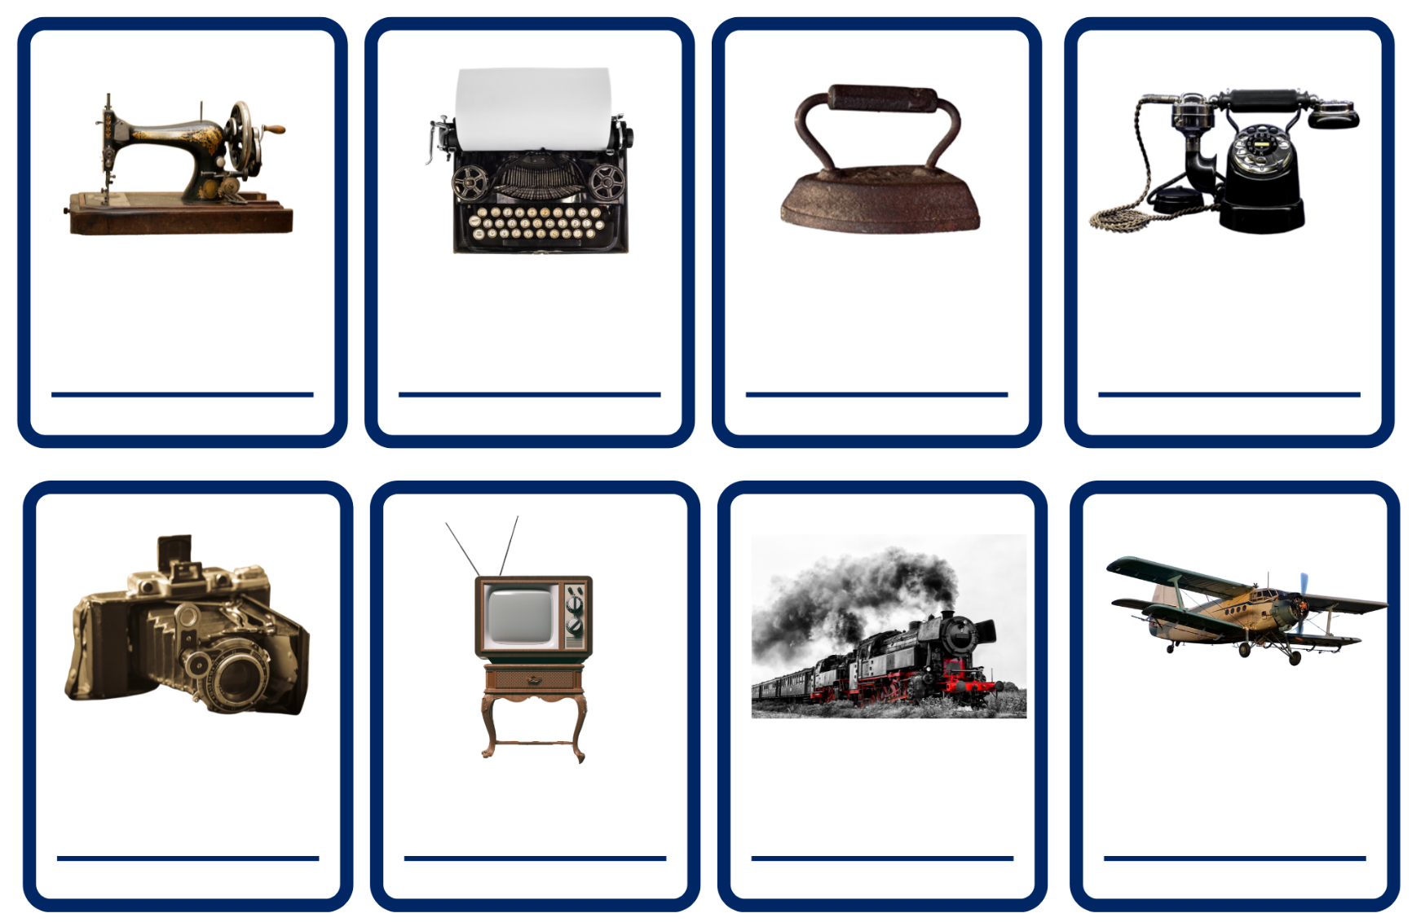
Images sourced from Canva and used in accordance with the Canva Content Licence Agreement.
telephone | iron | sewing machine | typewriter
television | steam train | aeroplane | camera

Resource 2: Tiered vocabulary
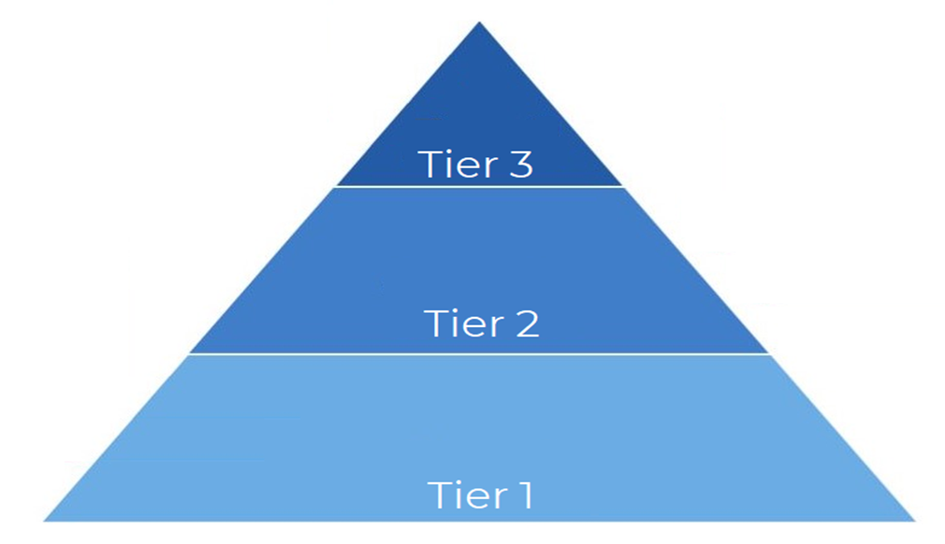

Resource 3: What am I? – Early Stage 1
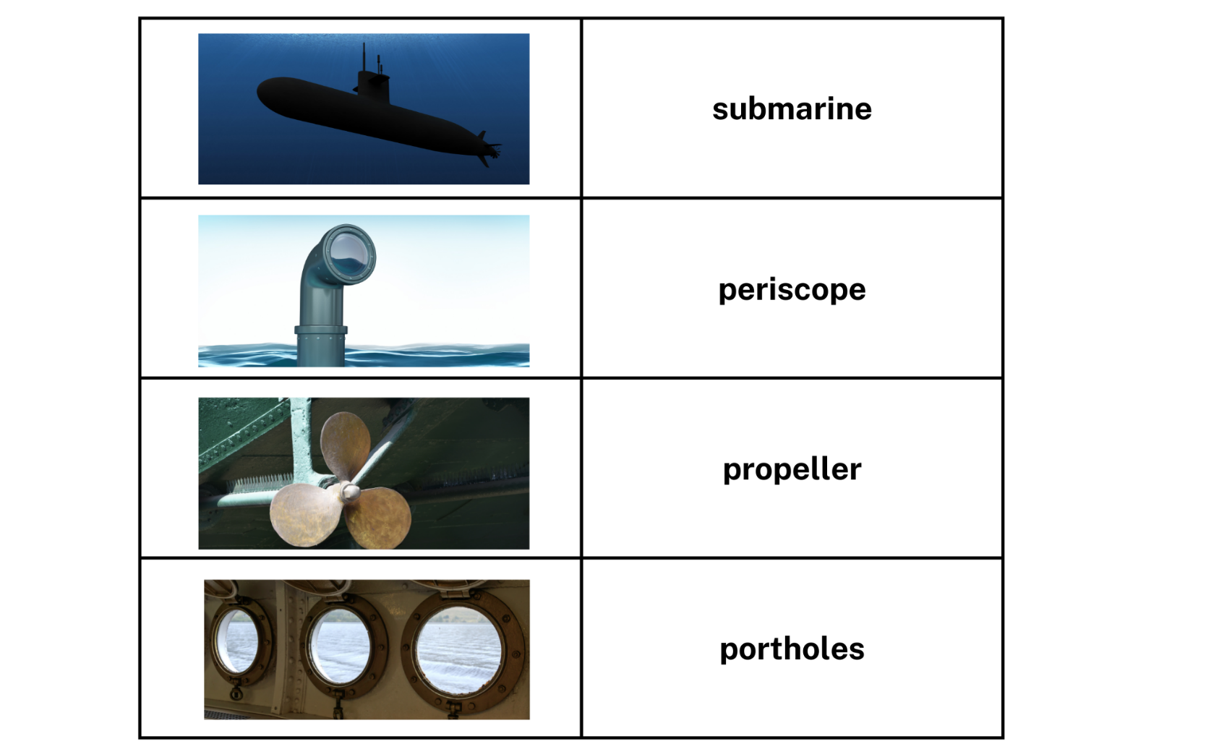
Images sourced from Canva and used in accordance with the Canva Content Licence Agreement.

Resource 4: Narrative planning – Stage 1
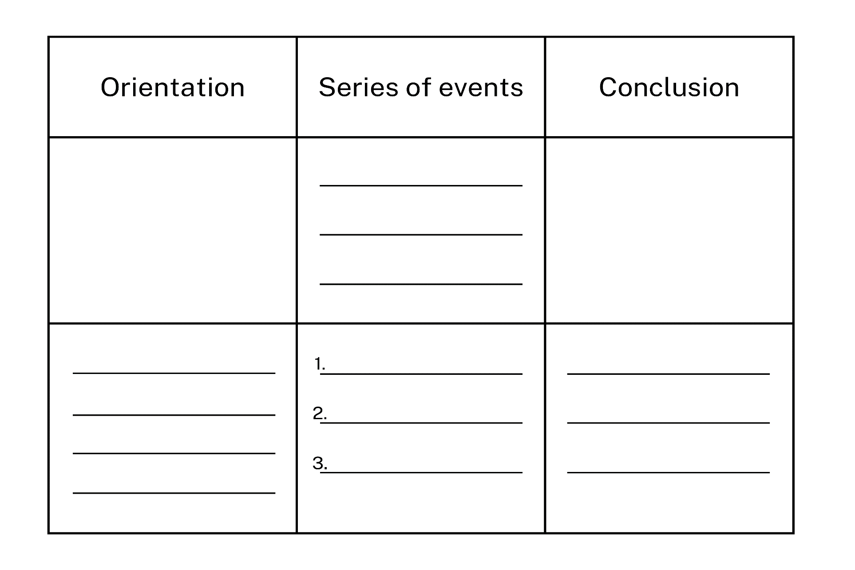

Resource 5: Narrative planning modified
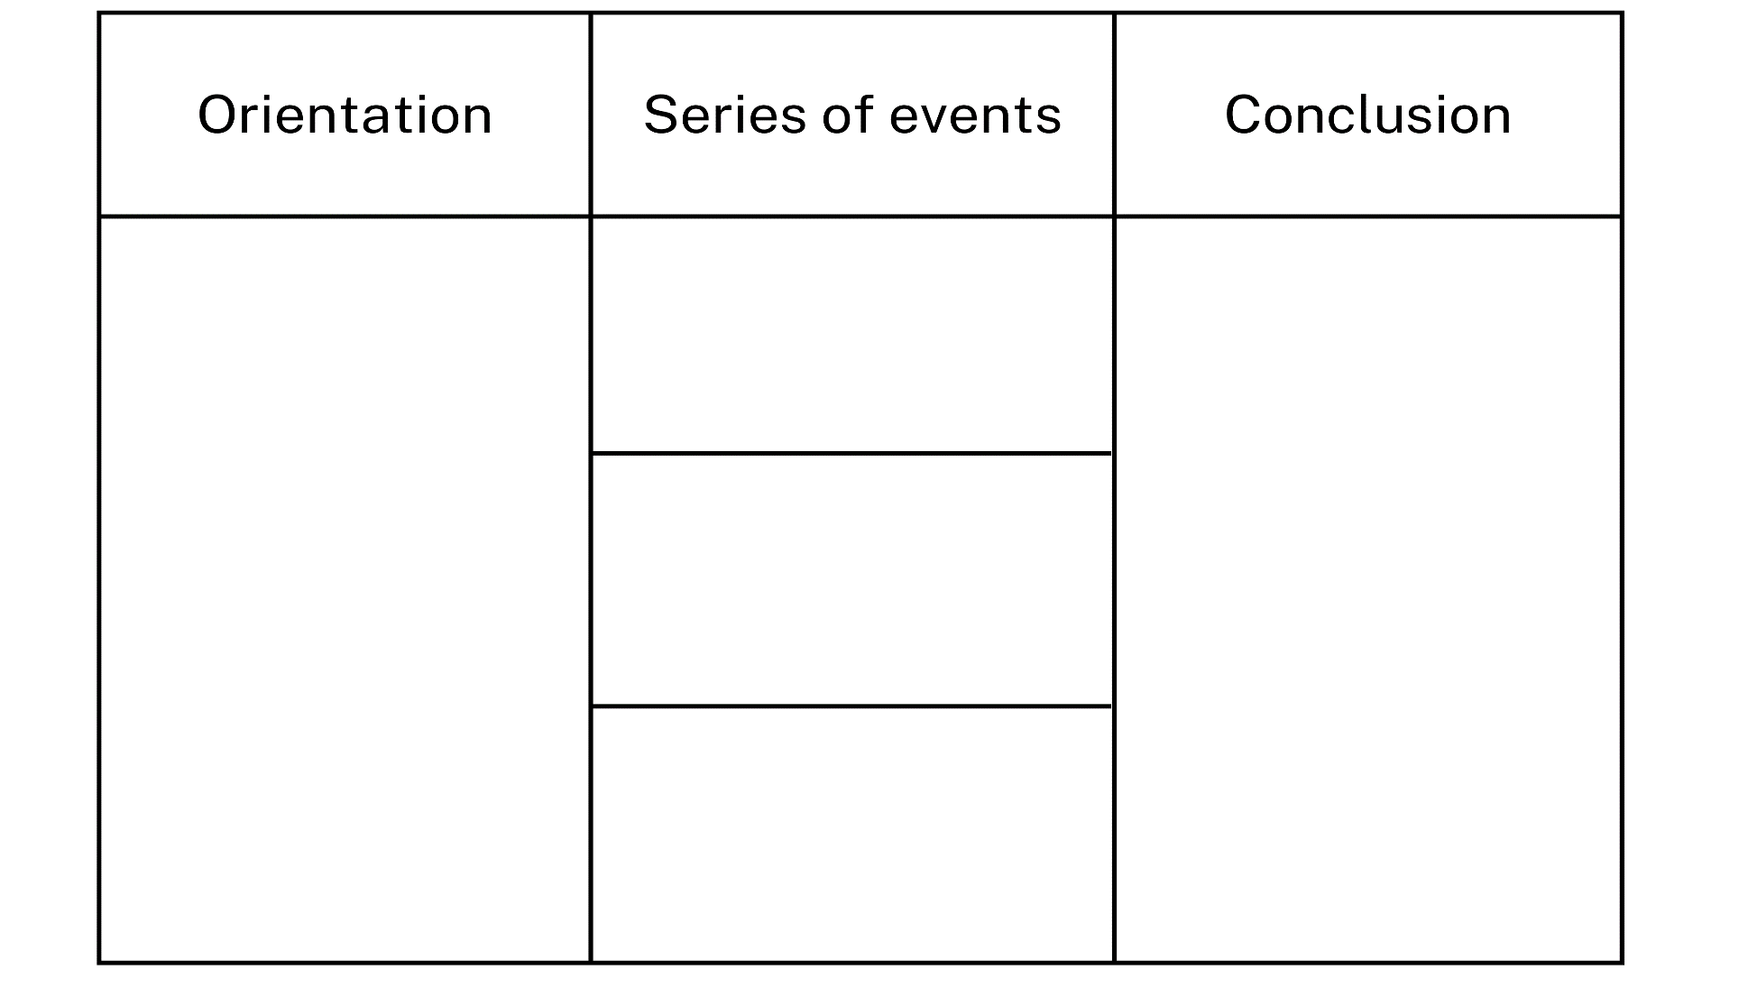

Resource 6: Narrative planning – Early Stage 1
Beginning | Middle | End

References
Links to third-party material and websites
Please note that the provided (reading/viewing material/list/links/texts) are a suggestion only and implies no endorsement, by the New South Wales Department of Education, of any author, publisher, or book title. School principals and teachers are best placed to assess the suitability of resources that would complement the curriculum and reflect the needs and interests of their students.
If you use the links provided in this document to access a third-party's website, you acknowledge that the terms of use, including licence terms set out on the third-party's website apply to the use which may be made of the materials on that third-party website or where permitted by the Copyright Act 1968 (Cth). The department accepts no responsibility for content on third-party websites.
Except as otherwise noted, all material is © State of New South Wales (Department of Education), 2023 and licensed under the Creative Commons Attribution 4.0 International License. All other material (third-party material) is used with permission or under licence. Where the copyright owner of third-party material has not licensed their material under a Creative Commons or similar licence, you should contact them directly for permission to reuse their material.
English K–10 Syllabus © 2022 NSW Education Standards Authority (NESA) for and on behalf of the Crown in right of the State of New South Wales.
Science and Technology K–6 Syllabus © 2017 NSW Education Standards Authority (NESA) for and on behalf of the Crown in right of the State of New South Wales.
© 2022 NSW Education Standards Authority. This document contains NSW Curriculum and syllabus content. The NSW Curriculum is developed by the NSW Education Standards Authority. This content is prepared by NESA for and on behalf of the Crown in right of the State of New South Wales. The material is protected by Crown copyright.
Please refer to the NESA Copyright Disclaimer for more information.
NESA holds the only official and up-to-date versions of the NSW Curriculum and syllabus documents. Please visit the NSW Education Standards Authority (NESA) website and the NSW Curriculum website.
National Literacy Learning Progression © Australian Curriculum, Assessment and Reporting Authority (ACARA) 2010 to present, unless otherwise indicated. This material was downloaded from the Australian Curriculum website (National Literacy Learning Progression) (accessed 26 September 2022) and was not modified. The material is licensed under CC BY 4.0. Version updates are tracked in the ‘Curriculum version history’ section on the 'About the Australian Curriculum' page of the Australian Curriculum website.
ACARA does not endorse any product that uses the Australian Curriculum or make any representations as to the quality of such products. Any product that uses material published on this website should not be taken to be affiliated with ACARA or have the sponsorship or approval of ACARA. It is up to each person to make their own assessment of the product, taking into account matters including, but not limited to, the version number and the degree to which the materials align with the content descriptions and achievement standards (where relevant). Where there is a claim of alignment, it is important to check that the materials align with the content descriptions and achievement standards (endorsed by all education Ministers), not the elaborations (examples provided by ACARA).
Cheng C (2022) The Imagineer (Masciullo L, illus.), National Library of Australia.
Dweck C (2008) Mindset: The New Psychology of Success, Random House, New York.
ETA (English Teachers Association) and NSW Department of Education (2016) The Textual Concepts and Processes resource, English Textual Concepts website, accessed 26 September 2022.
Spires A (2013) The Most Magnificent Thing, Kids Can Press, Canada.
The Works Museum (1 September 2019) ‘Inventions by Kids’, The Works Museum blog, accessed 26 September 2022.

Further reading
The New Yorker (13 November 2017) ‘11 Kid Inventors Break Down Their Greatest Inventions’ [video], The New Yorker, YouTube, accessed 26 September 2022.

