English – K-2 multi-age – Year A – Unit 16
Contents
Unit overview and instructions for use 3
Teacher notes 4
Outcomes and content – Component A 5
Outcomes and content – Component B 9
Week 1 13
Component A teaching and learning 13
Component B teaching and learning 14
Lesson 1: Text orientation 16
Lesson 2: Exploring vocabulary 18
Lesson 3: Verbs and tense 21
Lesson 4: Comparing texts 24
Lesson 5: Comparing texts continued 28
Week 2 31
Component A teaching and learning 31
Component B teaching and learning 32
Lesson 6: Word choices 33
Lesson 7: Planning 35
Lesson 8: Composing 37
Lesson 9: Feedback and editing 41
Lesson 10: Publishing and presenting 43
Resource 1: Stimulus of pollution 45
Resource 2: T-chart 46
Resource 3: Word mat 47
Resource 4: Verb cards 48
Resource 5: Tense table 49
Resource 6: Online text features and navigation pathways 50
Resource 7: Cause and effect 52
Resource 8: Word cards 53
Resource 9: 5 senses table 54
Resource 10: Planning template 55
Resource 11: Writing exemplar 56
References 57

Unit overview and instructions for use
This two-week unit is comprised of Component A and Component B. Connecting learning across both components is encouraged.
Teaching and learning | Component A | Component B
Suggested duration | 60 minutes | 45 minutes
Explicit teaching focus areas | - Phonological awareness (Early Stage 1)  - Print conventions (Early Stage 1)  - Phonic knowledge  - Reading fluency  - Reading comprehension  - Spelling  - Handwriting | - Oral language and communication  - Vocabulary  - Reading comprehension  - Creating written texts  - Understanding and responding to literature
To prepare for teaching and learning: | - Refer to Outcomes and content – Component A, K-2 – Instructional sequence – grapheme–phoneme correspondences [PDF 825 KB], and the teaching advice documents (hyperlinked in Component A teaching and learning table).  - Based on student needs identified through ongoing assessment data, plan and document how you will sequence teaching and learning in whole class and targeted teaching groups across the two-week cycle. | - Familiarise yourself with Outcomes and content – Component B, Textual concepts information and videos, English Textual Concepts and Learning Processes (2016), and the teaching and learning sequence.  - Based on student needs identified through ongoing assessment data, determine how you will support students in whole class and targeted teaching groups across the two-week cycle as required.
English Syllabus K–10 © 2022 NSW Education Standards Authority (NESA) for and on behalf of the Crown in right of the State of New South Wales.

Teacher notes
- Perspective is defined as a lens through which we learn to see the world. It shapes what we see and the way we see it. – English Textual Concepts and Learning Processes (2016).
- Argument is persuasion using the conventions of various forms, modes, and media. – English Textual Concepts and Learning Processes (2016).
- Understanding of perspective can be supported through watching the department’s video: Perspective (3:37).
- Understanding of argument can be supported through watching the department’s video: Argument (3:17).
- For information on visualising, tiered words, conjunctions, compound sentences, verbs, and tense refer to the NESA Glossary.
- Consider prior student learning about compound sentences, complex sentences, and paragraphs.
- Reflect on student learning and engagement in activities and record differentiation and adjustments within the unit to inform future teaching and learning. One way of doing this could be to add comments to the digital file.
- Content points are linked to the National Literacy Learning Progression version (3).
Levels and indicators sourced from National Literacy Learning Progression © Australian Curriculum, Assessment and Reporting Authority (ACARA), (accessed 14 September 2022) and was not modified. See references for more information.

Outcomes and content – Component A
The table below outlines the focus outcomes and content. Content is linked to the National Literacy Learning Progression version (3).
Early Stage 1 Focus area and outcome | Stage 1 Focus area and outcome
Phonological awareness  ENE-PHOAW-01 – identifies, blends, segments and manipulates phonological units in spoken words as a strategy for reading and creating texts (N/A) | N/A
Print conventions  ENE-PRINT-01 – tracks written text from left to right and from top to bottom of the page and identifies visual and spatial features of print (N/A) | N/A
Phonic knowledge  ENE-PHOKW-01 – uses single-letter grapheme–phoneme correspondences and common digraphs to decode and encode words when reading and creating texts  - decode words containing split digraphs and vowel digraphs (PKW5)  - experiment with encoding high-frequency words containing split digraphs and vowel digraphs | Phonic knowledge  EN1-PHOKW-01 – uses initial and extended phonics, including vowel digraphs, trigraphs to decode and encode words when reading and creating texts  - Year 1 – blend grapheme–phoneme correspondences to read CCVCC words, CCCVC words and CCCVCC words and apply this when reading texts (PKW7)  - segment and encode one-syllable high-frequency base words with split digraphs and apply this when creating texts (SpG6)  - blend and decode one-syllable words with taught extended vowel graphs and digraphs, including graphemes for r-controlled vowels and diphthongs, and apply this when reading texts (PKW6, PKW7)  - decode words with less common consonant digraphs and apply this when reading texts  - decode words with trigraphs and quadgraphs and apply this when reading texts  - Year 2 – blend and decode two-syllable words with taught extended vowel graphs and digraphs, including graphemes for r-controlled vowels and diphthongs, and apply this when reading texts (PKW6, PKW7)
Reading fluency  ENE-REFLU-01 – reads decodable texts aloud with automaticity  - know that fluent reading involves recognising and reading words accurately and automatically  - know that pace and expression vary when reading, according to the audience and purpose | Reading fluency  EN1-REFLU-01 – sustains reading unseen texts with automaticity and prosody and self-corrects errors  - self-correct when fluency and/or meaning is interrupted  - vary pace when reading according to the audience and purpose (FlY4)
Reading comprehension  ENE-RECOM-01 – comprehends independently read texts using background knowledge, word knowledge and understanding of how sentences connect  - ask or pause to clarify meaning of unknown words (UnT3)  - identify conjunctions (and, because, but, for, so) in a compound sentence, their meaning and purpose  - understand that informative and imaginative texts have different structures, features and forms (UnT5)  - use information or events from different parts of the text to form an opinion | Reading comprehension  EN1-RECOM-01 – comprehends independently read texts that require sustained reading by activating background and word knowledge, connecting and understanding sentences and whole text, and monitoring for meaning  - draw on sources to seek clarification for unknown words  - monitor understanding to ensure meaning is sustained and expanded through the whole text (UnT6)
Spelling  ENE-SPELL-01 – applies phonological, orthographic and morphological generalisations and strategies to spell taught familiar and high-frequency words when creating texts  - combine phonological, phonic, orthographic and morphemic knowledge to spell taught high-frequency irregular words comprising up to 3 phonemes (SpG5)  - segment multisyllabic words into syllables and phonemes as a strategy for spelling  - experiment with some vowel digraphs and split digraphs to spell taught high-frequency words and/or personally significant words | Spelling  EN1-SPELL-01 – applies phonological, orthographic and morphological generalisations and strategies when spelling words in a range of writing contexts  - Year 1 – segment single-syllable words into phonemes as a strategy for spelling (SpG4)  - explain that the consonant trigraphs, –tch and –dge, can end a base word immediately following a short vowel and apply this when spelling (SpG6)  - Year 2 – segment multisyllabic words into syllables and phonemes as a strategy for spelling (SpG5)  - use extended phonics code for taught consonant phonemes
Handwriting  ENE-HANDW-01 – produces all lower-case and upper-case letters to create texts  - correctly produce a clockwise ellipse, anticlockwise ellipse and downward diagonal stroke when forming letter shapes  - apply taught handwriting skills when creating texts | Handwriting  EN1-HANDW-01 – uses a legible, fluent and automatic handwriting style, and digital technology, including word-processing applications, when creating texts  - use taught software functions to create texts in a range of modes for different contexts, audiences and purposes

Outcomes and content – Component B
The table below outlines the focus outcomes and content. Content is linked to the National Literacy Learning Progression version (3).
Early Stage 1 Focus area and outcome | Stage 1 Focus area and outcome
Oral language and communication  ENE-OLC-01 – communicates effectively by using interpersonal conventions and language with familiar peers and adults  - listen for a purpose by agreeing or disagreeing, adding to the comments of others, or sharing thoughts and feelings  - use oral language to persuade, negotiate, give options or discuss ideas (InT4) | Oral language and communication  EN1-OLC-01 – communicates effectively by using interpersonal conventions and language to extend and elaborate ideas for social and learning interactions  - understand when a message is not clear and ask questions and/or gesture to elicit support and/or seek clarification (LiS4)  - interact to evaluate ideas and refine meaning (InT4, InT5)  - use tense correctly to discuss past, present and future events
Vocabulary  ENE-VOCAB-01 – understands and effectively uses Tier 1 and Tier 2 words in familiar contexts  - use vocabulary that is specific to key learning areas (SpK3, CrT3)  - use specific word choice to clarify meaning  - use and understand Tier 3 words that are of personal interest | Vocabulary  EN1-VOCAB-01 – understands and effectively uses Tier 1, taught Tier 2 and Tier 3 vocabulary to extend and elaborate ideas  - use taught morphemic knowledge to create word families  - use vocabulary to express cause and effect (SpK3)
Reading comprehension  ENE-RECOM-01 – comprehends independently read texts using background knowledge, word knowledge and understanding of how sentences connect  - ask or pause to clarify meaning of unknown words (UnT3)  - identify conjunctions (and, because, but, for, so) in a compound sentence, their meaning and purpose  - understand that informative and imaginative texts have different structures, features and forms (UnT5)  - use information or events from different parts of the text to form an opinion | Reading comprehension  EN1-RECOM-01 – comprehends independently read texts that require sustained reading by activating background and word knowledge, connecting and understanding sentences and whole text, and monitoring for meaning  - use navigation pathways, including hyperlinks, to extract essential information to support reading fluency and enhance meaning when reading digital texts  - coordinate information or events from different parts of the text to form an overall opinion  - make text-to-self, text-to-text or text-to-world connections when reading (UnT6)  - monitor understanding to ensure meaning is sustained and expanded through the whole text (UnT6)  - ask a clarifying question when more background knowledge is needed to make an inference
Creating written texts  ENE-CWT-01 – creates written texts that include at least 2 related ideas and correct simple sentences  - create a text including at least 2 related ideas (CrT5)  - include recognisable structural features for text purpose (CrT5)  - experiment with writing compound sentences and recognise that each clause makes meaning by itself (GrA4)  - identify different purposes for writing (CrT4)  - understand they can improve their writing based on feedback from teachers | Creating written texts  EN1-CWT-01 – plans, creates and revises texts written for different purposes, including paragraphs, using knowledge of vocabulary, text features and sentence structure  - write texts that describe, explain, give an opinion, recount an event, tell a story (CrT7)  - use a logical order to sequence ideas and events in sentences across a text (GrA4)  - use appropriate tense across a text (GrA4)  - use visual elements to expand meaning in own texts  - use action, saying, relating and sensing verbs to add detail and precision to writing (GrA2, GrA5)  - use modifying and qualifying words and words to indicate quantity  - re-read and edit their own texts after receiving feedback  - use different modes and media to enhance the presentation of texts they have created (CrT5, CrT6)
Understanding and responding to literature  ENE-UARL-01 – understands and responds to literature read to them  - compare opinions of a text or character with peers (InT2) | Understanding and responding to literature  EN1-UARL-01 – understands and responds to literature by creating texts using similar structures, intentional language choices and features appropriate to audience and purpose  - identify phrases in texts that project opinions  - identify how structure and images reinforce ideas  - create and re-create texts that include persuasive arguments, using knowledge of text and language features  - identify and share how their own experience and interests influence opinions and/or interpretations of texts

Week 1

Component A teaching and learning
The table below can be used to plan and document lessons that address Component A outcomes and content. Both the detailed example [DOC 529KB] of a two-week teaching and learning cycle and brief example [DOC 66KB] may support you in your planning.
Focus Areas | Lesson 1 | Lesson 2 | Lesson 3 | Lesson 4 | Lesson 5
Phonological awareness (Early Stage 1) and Phonic knowledge
15 minutes
Spelling and Handwriting
15 minutes
Print conventions (Early Stage 1), Reading comprehension and Reading fluency
30 minutes

Component B teaching and learning
The following teaching and learning sequence have been designed to address Component B outcomes and content. Adapt the sequence as required to best meet the needs of your students.

Learning intention and success criteria
Learning intentions and success criteria are best co-constructed with students. The table below contains suggested learning intentions and success criteria.
Element | Early Stage 1 | Stage 1
Learning intention | Students are learning to develop and express opinions. | Students are learning to compose multimodal texts that project opinions using appropriate structure and language features.
Success criteria | Students can:  - state an opinion based on ideas presented in texts  - use a learnt Tier 3 word in context  - experiment writing a compound sentence  - identify different purposes for writing  - identify and discuss features of informative and imaginative texts  - compare opinions of texts with peers. | Students can:  - state an opinion based on information presented in a text  - correctly identify past, present and future tense  - identify how images and word choices reinforce a text’s purpose  - use vocabulary to express cause and effect  - compare texts that present a similar perspective.

Resources
- Lord M (2020) The Mess That We Made (Blattman J, illus.), Flashlight Press, New York. ISBN: 9781947277144
- Godwin N (2020) Jelly-Boy (Nielsen C, illus.), Walker Books Australia, Newtown. ISBN: 9781760651237
- Resource 1: Stimulus of pollution
- Resource 2: T-chart
- Resource 3: Word mat
- Resource 4: Verb cards
- Resource 5: Tense table (one for each student and an enlarged class copy)
- Resource 6: Online text features and navigation pathways
- Resource 7: Cause and effect
- National Geographic Kids – Kids vs Plastic
- Masking tape
- Mini whiteboards

Lesson 1: Text orientation
The following teaching and learning activities support multi-age settings.

Whole
- Ask students what they know about pollution, what it looks like, and how it is made.
- View Resource 1: Stimulus of pollution. Ask what students can see, how it makes them feel, what it makes them think and how they think the rubbish got there.
- Introduce the mentor text The Mess That We Made by Michelle Lord, illustrated by Julia Blattman. Read the front and back covers. Ask students to make predictions about the book and discuss their predictions.
- Read The Mess That We Made. Ask students what they see, what it makes them think about, and what it makes them wonder. Record responses on a class See-Think-Wonder chart. Reflect on student predictions.
- Discuss the purpose of the text and explore what opinion the author may have about pollution. Introduce the concept of perspective. Perspective is shaped by our personal experiences and can influence our opinions and choices. Students turn and talk to discuss the following questions:
- Who is the ‘we’ in the title?
- What is ‘the mess’ the author is referring to?
- What is the author’s purpose?
- How do we know what the author’s perspective is?
- Has the text changed your opinion on pollution?
- Explain how visualising a text can support understanding. Students close their eyes and listen to the teacher read 2 pages of the text aloud. In pairs, students share what they ‘saw’ in their mind and draw a picture to represent this.
Note: Visualising is a comprehension strategy used by learners to create a mental image from a text read, viewed, or heard. To visualise is to bring the text to life, engage the imagination, and use a person’s senses.
- Using Resource 2: T-chart, ask students how they would feel about swimming in the ocean at the start of the story compared to the end of the story. Students draw pictures and write sentences using the T-chart and share their work in small groups.
Too hard? Students draw and verbally explain their drawings.
Too easy? Students write a paragraph to explain their opinion, making connections to the text.
- Ask students if their opinion about pollution is the same as the characters in the text and whether they think pollution is good or bad for the environment. Students turn and talk to share their opinion.
Early Stage 1 Assessment task 1 – Observations from this lesson allow students to demonstrate achievement towards the following syllabus outcomes and content points:
ENE-OLC-01 – communicates effectively by using interpersonal conventions and language with familiar peers and adults
- listen for a purpose by agreeing or disagreeing, adding to the comments of others, or sharing thoughts and feelings
- use oral language to persuade, negotiate, give options or discuss ideas.
ENE-UARL-01 – understands and responds to literature read to them
- compare opinions of a text or character with peers.
Stage 1 Assessment task 1 – Observations and work samples from this lesson allow students to demonstrate achievement towards the following syllabus outcomes and content points:
EN1-RECOM-01 – comprehends independently read texts that require sustained reading by activating background and word knowledge, connecting and understanding sentences and whole text, and monitoring for meaning
- coordinate information or events from different parts of the text to form an overall opinion
- make text-to-self, text-to-text or text-to-world connections when reading
- monitor understanding to ensure meaning is sustained and expanded through the whole text.
EN1-UARL-01 – understands and responds to literature by creating texts using similar structures, intentional language choices and features appropriate to audience and purpose
- identify how structure and images reinforce ideas
- identify and share how their own experience and interests influence opinions and/or interpretations of texts.

Lesson 2: Exploring vocabulary
The following teaching and learning activities support multi-age settings.

Whole
- Discuss the importance of learning new words with students. Explain that unfamiliar texts can present new vocabulary that can be used to add detail and precision to writing. Revise the 3 Tiers of vocabulary. Explain that Tier 1 words are basic words that we use every day, and Tier 2 words are more precise and powerful. Tier 3 words are used rarely and are specific to a topic.
- Re-read The Mess That We Made, including the ‘Ocean pollution and calls to action’ pages. During reading, students raise their hands when they hear an unfamiliar word. Record words on an anchor chart.
- Examples of Tier 2 words include: landfill, growing, spills, delay, haul, protects, swirls, current, reduce, recycle.
- Examples of Tier 3 words include: marine, microplastics, gyroscope, oceanographers, decompose, dispose, biodegradable.
- Use a dictionary or online dictionary to find meanings of some Tier 3 words that are of interest to students.

Part
The table below details the differentiated teaching and learning activities for each stage.
Early Stage 1 (independent) | Stage 1 (teacher guided)
- Students select a Tier 2 word from the chart and draw a pictorial representation of it.  - Students use their chosen Tier 2 word to write a sentence to accompany their drawing.  Too hard? Students verbally explain their drawing to a partner. | - Explain that authors use cause and effect to influence the reader and their emotions. Cause and effect are often used in texts that present opinions to show the direct link between 2 objects or events. For example, pollution in the ocean (cause) and its impact on animals (effect).  - Using vocabulary from the anchor chart, model composing a compound sentence that shows cause and effect and contains a Tier 2 word. For example, Pollution spills into the ocean and animals can get sick.

Part
The table below details the differentiated teaching and learning activities for each stage.
Early Stage 1 (teacher guided) | Stage 1 (independent)
- Revisit the meaning of Tier 3 words from the text that are of interest to the students.  - Model using Resource 3: Word mat to develop an understanding of Tier 3 vocabulary.  - Students choose a Tier 3 word and use Resource 3: Word mat to deepen their understanding of the word.  Too hard? Students verbally share sentences using their chosen Tier 3 word.  Too easy? Students write compound sentences using the Tier 3 word. | - Students use Tier 2 and/or 3 words from the text and anchor chart to compose compound sentences about the cause and effect of pollution.  Too hard? Students write simple sentences and draw a picture to enhance meaning.  Too easy? Students write compound or complex sentences using Tier 3 words.

Whole
- Gauge student understanding of Tier 2 and 3 words by labelling opposite sides of the room Tier 2 and Tier 3. Call out words from the text and ask students to move to the appropriate side of the room.
Early Stage 1 Assessment task 2 – Observations and work samples from this lesson allow students to demonstrate achievement towards the following syllabus outcomes and content points:
ENE-VOCAB-01 – understands and effectively uses Tier 1 and Tier 2 words in familiar contexts
- use specific word choice to clarify meaning
- use and understand Tier 3 words that are of personal interest.
ENE-RECOM-01 – comprehends independently read texts using background knowledge, word knowledge and understanding of how sentences connect
- ask or pause to clarify meaning of unknown words.

Lesson 3: Verbs and tense
The following teaching and learning activities support multi-age settings.

Whole
- Revise verbs including examples of action, saying, relating, and sensing verbs.
- Open The Mess That We Made to the double page with a container ship, the children in a dinghy on the left, and landfill on the right.
- Read the text on this page and ask students to identify the verbs. Record their responses. Ask if they are action, saying, relating, or sensing verbs.
- Students Think-Pair-Share a new sentence that uses one of the action verbs found in the text.

Part
The table below details the differentiated teaching and learning activities for each stage.
Early Stage 1 (independent) | Stage 1 (teacher guided/small groups)
- Students use Resource 4: Verb cards to select a verb and act it out.  - Students write their verb in a sentence and illustrate. | - Revise the concept of tense. Model how the tense of base words can be changed by adding the suffixes -s, -ing, or -ed. Start with a base word from text, for example, dump, spill, work, play or protest and add a tense marking suffix to show change in tense. Include further examples to strengthen student understanding. For example, when a verb ends in ‘e’ add -d with no change to base word or drop the ‘e’ and add -ing.  - Display an enlarged copy of Resource 5: Tense table. Select a base verb and model adding tense marking suffixes to the word to complete the table.

Part
The table below details the differentiated teaching and learning activities for each stage.
Early Stage 1 (teacher guided) | Stage 1 (independent)
- Revise conjunctions, their meaning and purpose.  - Model writing a compound sentence using ideas from the text. For example, The children are sad because the ocean is polluted, or The seal is swimming and it gets trapped in a net.  - Identify the conjunction, nouns, verbs, and clauses.  - Students write a compound sentence using ideas from the text.  Too easy? Students colour code the conjunctions, nouns, verbs and clauses in their compound sentences. | - Using Resource 5: Tense table, students independently complete a table of base words and create past and present verbs by adding the suffixes -s, -ing, or -ed.  Too easy? Students write sentences using past tense verbs.
Early Stage 1 Assessment task 3 – Observations and work samples from this lesson allow students to demonstrate achievement towards the following syllabus outcomes and content points:
ENE-RECOM-01 – comprehends independently read texts using background knowledge, word knowledge and understanding of how sentences connect
- identify conjunctions (and, because, but, for, so) in a compound sentence, their meaning and purpose.
ENE-CWT-01 – creates written texts that include at least 2 related ideas and correct simple sentences
- experiment with writing compound sentences and recognise that each clause makes meaning by itself.
Stage 1 Assessment task 2 – Observations and work samples from this lesson allow students to demonstrate achievement towards the following syllabus outcomes and content points:
EN1-OLC-01 – communicates effectively by using interpersonal conventions and language to extend and elaborate ideas for social and learning interactions
- use tense correctly to discuss past, present and future events.
EN1-VOCAB-01 – understands and effectively uses Tier 1, taught Tier 2 and Tier 3 vocabulary to extend and elaborate ideas
- use taught morphemic knowledge to create word families.

Lesson 4: Comparing texts
The following teaching and learning activities support multi-age settings.

Whole
- Revise Michelle Lord’s purpose for writing The Mess That We Made. Discuss how illustrations, images, and symbols in texts can support the author’s perspective and text’s purpose.
- View National Geographic Kids – Kids Vs Plastic. Explore the navigation pathways and tools on the page, including the use of embedded images and captions and the hyperlinked images to different areas of the website, located at the top of the page. Explain that National Geographic is a trusted source and that the website’s ‘site last updated’ information, located at the bottom of the page, indicates that the information is recent.
Note: For support in reading and viewing digital and online texts, see Digital and multimodal texts and Resource 6: Online text features and navigation pathways.
- Read through the website using the think aloud strategy to support understanding and establish the text’s purpose. Prompt students to ask clarifying questions to assist in their comprehension of the website text.
- Discuss the purpose of National Geographic Kids – Kids vs Plastic (informative) and The Mess That We Made (imaginative/informative) and how these convey a similar perspective. Explain how authors use different language features and images to support their purpose.
- Present images from the website and ask students if the pictures in this text align with the images from The Mess That We Made. Ask if the images make them feel the same way, if the images show the same message, and if the images support the author’s perspective.
- Students Think-Pair-Share about how each text made them feel. Discuss the key message within both texts, for example, humans need to clean up after themselves in order to protect the environment.
- Identify and discuss how each text demonstrates cause and effect and the way it influences the reader. For example, in The Mess That We Made, people threw their rubbish onto the beach (cause), it ran into the ocean and made the aquatic life sick (effect); or On the Kids vs Plastic website, people left rubbish bags on the beach and in the water (cause) which could then be eaten by the turtles (effect).

Part
The table below details the differentiated teaching and learning activities for each stage.
Early Stage 1 (independent/pairs) | Stage 1 (teacher guided)
- Provide students with a sentence starter, for example, ‘I can care for the environment by…’  - Students complete the sentence with their own ideas.  Too hard? Students work in pairs to complete the sentence.  Too easy? Students colour code the nouns and verbs in their writing. | - Model using Resource 7: Cause and effect to plan vocabulary that shows cause and effect based on images from each text. Model writing a sentence about the impact pollution has on the environment, using the plan to show cause and effect.  - Using Resource 7: Cause and effect, students create their own plan for writing.

Part
The table below details the differentiated teaching and learning activities for each stage.
Early Stage 1 (teacher guided) | Stage 1 (independent)
- Compare The Mess That We Made to National Geographic Kids – Kids Vs Plastic. Discuss the audience and purpose of the 2 texts.  - Students sit in a circle. On the floor construct a T-chart with masking tape, labelled ‘imaginative’ and ‘informative’. Distribute colour copy images of pictures from The Mess That We Made and National Geographic Kids – Kids Vs Plastic.  - Students select a picture and place it into the correct section, providing a reason for their choice.  Too easy? Students write their reason for the placement of the image on a mini whiteboard. | - Students write sentences about the impact pollution has on the environment, using planned vocabulary to show cause and effect. For example, Pollution is dreadful because ghost nets are left in the ocean and trap seals.  Too easy? Students write a solution to the problem stated in their sentences.
Early Stage 1 Assessment task 4 – Observations from this lesson allow students to demonstrate achievement towards the following syllabus outcomes and content points:
ENE-RECOM-01 – comprehends independently read texts using background knowledge, word knowledge and understanding of how sentences connect
- understand that informative and imaginative texts have different structures, features and forms.
ENE-CWT-01 - creates written texts that include at least 2 related ideas and correct simple sentences
- identify different purposes for writing.
Stage 1 Assessment task 3 – Observations and work samples from this lesson allow students to demonstrate achievement towards the following syllabus outcomes and content points:
EN1-VOCAB-01 – understands and effectively uses Tier 1, taught Tier 2 and Tier 3 vocabulary to extend and elaborate ideas
- use vocabulary to express cause and effect.
EN1-RECOM-01 – comprehends independently read texts that require sustained reading by activating background and word knowledge, connecting and understanding sentences and whole text, and monitoring for meaning
- use navigation pathways, including hyperlinks, to extract essential information to support reading fluency and enhance meaning when reading digital texts
- coordinate information or events from different parts of the text to form an overall opinion
- monitor understanding to ensure meaning is sustained and expanded through the whole text
- ask a clarifying question when more background knowledge is needed to make an inference.

Lesson 5: Comparing texts continued
The following teaching and learning activities support multi-age settings.

Whole
- Create and display a three-column table with the headings ‘The Mess That We Made’, ‘Kids vs Plastic’ and ‘Jelly-Boy’.
- Revise language features, structure and images in the texts The Mess That We Made and Kids vs Plastics. Highlight how each text contains phrases and images that project the opinion that pollution has a negative impact on the environment. Discuss and record student ideas under the first 2 headings on the table.
- Introduce the text Jelly-Boy. Look at the front and back cover of the text. Explain to students that this story is similar to the other texts as it focuses on pollution and how it impacts the environment. Read Jelly-Boy to identify how the author presents the perspective that pollution negatively impacts the environment.
- After reading the text, students Think-Pair-Share how the author presented their opinion (or perspective) about pollution. Collate student responses in the table under the final heading, ‘Jelly-Boy’.
- Discuss with students the similarities in the perspectives presented in the texts. Focus on text and language features, structure, and images.

Part
The table below details the differentiated teaching and learning activities for each stage.
Early Stage 1 (teacher guided/independent) | Stage 1 (independent)
- In pairs, students discuss their opinions of Jelly-Boy.  - Model writing a compound sentence to present an opinion about one of the texts. For example, ‘I like Jelly-Boy because he gets rescued by his family; or I like the website because it shares a lot of interesting information’.  - Students write a compound sentence to present their opinion of one of the texts.  Too hard? Students verbally share their opinion using a compound sentence.  Too easy? Students colour code conjunctions, nouns, verbs and clauses in their writing. | - Students write a paragraph explaining how the texts are similar, focusing on the perspective they each present about pollution and the environment. Display sentence starters to support student writing, for example:  - The texts are similar because...  - The Mess That We Made explains...  - Kids vs Plastics teaches us...  - Jelly-Boy shows...  Too hard? Students write simple and compound sentences showing some similarities between 2 of the texts.

Whole
- Students share their responses with the class.
Stage 1 Assessment task 4 – Collecting work samples from this lesson allows students to demonstrate achievement towards the following syllabus outcomes and content points:
EN1-RECOM-01 – comprehends independently read texts that require sustained reading by activating background and word knowledge, connecting and understanding sentences and whole text, and monitoring for meaning
- make text-to-self, text-to-text or text-to-world connections when reading.
EN1-CWT-01 – plans, creates and revises texts written for different purposes, including paragraphs, using knowledge of vocabulary, text features and sentence structure
- write texts that describe, explain, give an opinion, recount an event, tell a story
- use action, saying, relating and sensing verbs to add detail and precision to writing.
EN1-UARL-01 – understands and responds to literature by creating texts using similar structures, intentional language choices and features appropriate to audience and purpose
- identify phrases in texts that project opinions
- identify how structure and images reinforce ideas.

Week 2

Component A teaching and learning
The table below can be used to plan and document lessons that address Component A outcomes and content. Both the detailed example [DOC 529KB] of a two-week teaching and learning cycle and brief example [DOC 66KB] may support you in your planning.
Focus Areas | Lesson 6 | Lesson 7 | Lesson 8 | Lesson 9 | Lesson 10
Phonological awareness (Early Stage 1) and Phonic knowledge
15 minutes
Spelling and Handwriting
15 minutes
Print conventions (Early Stage 1), Reading comprehension and Reading fluency
30 minutes

Component B teaching and learning
The following teaching and learning sequence has been designed to address Component B outcomes and content. Adapt the sequence as required to best meet the needs of your students.

Learning intention and success criteria
Learning intentions and success criteria are best co-constructed with students. The table below contains suggested learning intentions and success criteria.
Element | Early Stage 1 | Stage 1
Learning intention | Students are learning to develop and express opinions. | Students are learning to compose multimodal texts that project opinions using appropriate structure and language features.
Success criteria | Students can:  - discuss the features of imaginative and informative texts  - write texts that include at least 2 related ideas  - experiment with writing compound sentences  - use visual elements to expand meaning  - re-read and edit own texts after receiving feedback. | Students can:  - use modifying and qualifying words to indicate quantity  - write texts that present information and give an opinion  - use a logical order to sequence ideas  - use verbs to add detail and precision  - use visual elements to expand meaning  - re-read and edit own texts after receiving feedback.

Resources
- Lord M (2020) The Mess That We Made (Blattman J, illus.), Flashlight Press, New York. ISBN: 9781947277144
- Resource 1: Stimulus of pollution
- Resource 8: Word cards
- Resource 9: 5 senses table (one per student and one enlarged class copy)
- Resource 10: Planning template
- Resource 11: Writing exemplar
- A range of informative and imaginative texts

Lesson 6: Word choices
The following teaching and learning activities support multi-age settings.

Whole
- Re-read The Mess That We Made.
- Revise the text’s purpose and how phrases, structure and images support the author’s perspective and project the opinion that pollution is harmful to the environment.

Part
The table below details the differentiated teaching and learning activities for each stage.
Early Stage 1 (small groups) | Stage 1 (teacher guided/small groups)
- Provide students with a range of texts, including informative texts and imaginative texts.  - Students sort texts according to purpose, then discuss the features of each text and how they determined the purpose. | - Explain that specific word choices can influence the strength of an opinion within a text. Explicitly teach how modifying and qualifying words can be used to indicate quantity. For example, very, every, many, some, a few, every, a lot, more. Create an anchor chart of modifying and qualifying words that indicate quantity.  - In small groups, provide students with Resource 8: Word cards. Students write sentences using the mentor text as a guide. For example:  - There are a few ways to help the environment.  - There are many ways to help the environment.  - There are a lot of ways to help the environment.  - Organise the sentences from those that have little impact, to those that have a greater impact.

Whole
- View Resource 1: Stimulus of pollution or illustrations from The Mess That We Made and ask students to visualise themselves standing on the beach. Discuss the different things the students may see, hear, smell, touch and taste while looking, using modifying words to show greater impact. Encourage students to consider the feelings they may have in this moment.
- Using an enlarged copy of Resource 9: 5 senses table, model writing key words or phrases that students shared under each sense heading.
- Students complete Resource 9: 5 senses table using their personal observations.
Too hard? Students complete Resource 9: 5 senses table in pairs using illustrations and simple phrases.
Too easy? Students write a paragraph summarising the information written on their table.

Lesson 7: Planning
The following teaching and learning activities support multi-age settings.

Whole
- Explain that students will be creating a multimodal text, for example a poster, that presents their opinion about pollution and how humans can reverse its impact on the environment. Students will use elements including images and content specific vocabulary that shows cause and effect.
Note: Multimodal texts are texts that combine 2 or more communication modes. For example, printed words and images, or spoken words and sound effects.
- Revise prior learning, including how images, text structure and vocabulary can be used to present an opinion or perspective.
- Review the completed Resource 9: 5 senses table from Lesson 6. Explain that this information to plan for and compose a text about pollution, its effect on the environment and the ways that humans might reverse its impact.
- Model using Resource 10: Planning template to generate ideas about the impact pollution has on the environment and the ways in which humans can prevent or reverse its effects.
- Co-construct success criteria for the multimodal text. See table below for an example.
Early Stage 1 success criteria | Stage 1 success criteria
- use The Mess That We Made and Kids vs Plastic to support idea generation  - create a text using at least 2 related ideas  - experiment with writing compound sentences  - select or draw images to support meaning  - use feedback to improve writing. | - use The Mess That We Made and Kids vs Plastic to support idea generation  - write an idea with relating information in each paragraph  - write compound and complex sentences  - use cause and effect language  - use modifying and qualifying words to indicate quantity  - use correct tense in writing  - select or draw images to expand meaning.
- Students work in pairs to generate ideas and complete Resource 10: Planning template.

Lesson 8: Composing
The following teaching and learning activities support multi-age settings.

Whole
- Revisit the co-constructed success criteria from Lesson 7. Ask students to describe the features of a successful multimodal text that projects an opinion.
- Explain that students will use their completed plans to compose a multimodal text that presents their opinion about pollution, including its impact on the environment and ways humans can prevent it. They should use a logical order to explain the cause of pollution and the effect it has on the environment. Students should also create or source images to support their ideas. Explain that the first section or paragraph of the text will focus on pollution and how it impacts the environment. The second section or paragraph will focus on preventing pollution and how this will help the environment.
- Model using the completed class Resource 10: Planning template and Resource 9: 5 senses table to compose 2 or more sentences (Early Stage 1) or a paragraph (Stage 1) about pollution and its impact on the environment, referring to the success criteria. See Resource 11: Writing exemplar. Ask students how the examples meet the success criteria.

Part
The table below details the differentiated teaching and learning activities for each stage.
Early Stage 1 (teacher guided/independent) | Stage 1 (independent)
- Support students to write 2 or more sentences about how pollution impacts the environment using ideas, opinions, and vocabulary from Resource 10: Planning template and Resource 9: 5 senses table.  - Students create or source images to support their ideas.  Too hard? Students write simple sentences about pollution and its impact on the environment.  Too easy? Students use Tier 2 vocabulary and compound sentences in their writing. | - Students write a paragraph about how pollution impacts the environment using ideas, opinions, and vocabulary from their Resource 10: Planning template and Resource 9: 5 senses table.  - Students create or source images that support their opinion.  Too hard? Students write simple sentences showing cause and effect.  Too easy? Students use Tier 3 vocabulary to extend and elaborate their ideas.
Whole
- Model using planned ideas, opinions, and vocabulary to compose a paragraph about preventing pollution and how this might help the environment. See Resource 11: Writing exemplar. Ask students how the examples meet the success criteria.

Part
The table below details the differentiated teaching and learning activities for each stage.
Early Stage 1 (teacher guided/independent) | Stage 1 (independent)
- Support students to write 2 or more sentences about how humans can prevent pollution using ideas, opinions and vocabulary from their Resource 10: Planning template and Resource 9: 5 senses table.  - Students create or source images to support their ideas.  Too hard? Students write simple sentences about how they can prevent pollution.  Too easy? Students use Tier 2 vocabulary and compound sentences in their writing. | - Students compose a paragraph about preventing pollution and how this might help the environment using ideas, opinions and vocabulary from their Resource 10: Planning template and Resource 9: 5 senses table.  - Students create or source images that support their opinion.  Too hard? Students write simple sentences showing cause and effect.  Too easy? Students use Tier 3 vocabulary to extend and elaborate their ideas.

Whole
- Allow students some time to reflect on their writing, referring to the success criteria. Ask what strategies they used to compose their sections or paragraphs and if they would use the same strategies again.
Early Stage 1 Assessment task 5 – Observations and work samples from this lesson allow students to demonstrate achievement towards the following syllabus outcomes and content points:
ENE-VOCAB-01 – understands and effectively uses Tier 1 and Tier 2 words in familiar contexts
- use vocabulary that is specific to key learning areas.
ENE-RECOM-01 – comprehends independently read texts using background knowledge, word knowledge and understanding of how sentences connect
- use information or events from different parts of the text to form an opinion.
ENE-CWT-01 – creates written texts that include at least 2 related ideas and correct simple sentences
- create a text including at least 2 related ideas
- include recognisable structural features for text purpose.
Stage 1 Assessment task 5 – Observations and work samples from this lesson allow students to demonstrate achievement towards the following syllabus outcomes and content points:
EN1-CWT-01 – plans, creates and revises texts written for different purposes, including paragraphs, using knowledge of vocabulary, text features and sentence structure
- write texts that describe, explain, give an opinion, recount an event, tell a story
- use a logical order to sequence ideas and events in sentences across a text
- use appropriate tense across a text
- use visual elements to expand meaning in own texts
- use action, saying, relating and sensing verbs to add detail and precision to writing
- use modifying and qualifying words and words to indicate quantity.
EN1-UARL-01 – understands and responds to literature by creating texts using similar structures, intentional language choices and features appropriate to audience and purpose
- create and re-create texts that include persuasive arguments, using knowledge of text and language features.

Lesson 9: Feedback and editing
The following teaching and learning activities support multi-age settings.

Whole
- Revise the co-constructed success criteria from Lesson 7.
- Model how to re-read and identify opinions (Early Stage 1) and cause and effect (Stage 1) using an Early Stage 1 and Stage 1 student text sample or Resource 11: Writing exemplar. Demonstrate using the think aloud strategy to identify cause and effect. Use coloured pencils to highlight conjunctions, as well as Tier 2 vocabulary (Early Stage 1) and modifying words, phrases or statements that show cause and effect (Stage 1).

Part
The table below details the differentiated teaching and learning activities for each stage.
Early Stage 1 (pairs) | Stage 1 (teacher guided)
- Students share their work with a peer and identify one idea that is the same and one idea that is different in their texts. | - Using the success criteria, model how to give and receive peer feedback in a respectful and constructive way.

Part
The table below details the differentiated teaching and learning activities for each stage.
Early Stage 1 (teacher guided) | Stage 1 (pairs)
- Provide students with teacher feedback on their writing and images.  - Model how to incorporate teacher feedback to improve writing. | - Students use the success criteria as a checklist to provide peer feedback. Encourage students to ask questions to seek clarification from their peers.
Whole
- Provide time for students to apply feedback to edit and improve their writing.
Early Stage 1 Assessment task 6 – Observations and work samples from this lesson allow students to demonstrate achievement towards the following syllabus outcomes and content points:
ENE-CWT-01 – creates written texts that include at least 2 related ideas and correct simple sentences
- understand they can improve their writing based on feedback from teachers.
Stage 1 Assessment task 6 – Observations and work samples from this lesson allow students to demonstrate achievement towards the following syllabus outcomes and content points
EN1-OLC-01 – communicates effectively by using interpersonal conventions and language to extend and elaborate ideas for social and learning interactions
- understand when a message is not clear and ask questions and/or gesture to elicit support and/or seek clarification
- interact to evaluate ideas and refine meaning.
EN1-CWT-01 – plans, creates and revises texts written for different purposes, including paragraphs, using knowledge of vocabulary, text features and sentence structure
- re-read and edit their own texts after receiving feedback
- use different modes and media to enhance the presentation of texts they have created.
EN1-UARL-01 – understands and responds to literature by creating texts using similar structures, intentional language choices and features appropriate to audience and purpose
- create and re-create texts that include persuasive arguments, using knowledge of text and language features.

Lesson 10: Publishing and presenting
The following teaching and learning activities support multi-age settings.

Whole
- Students publish their multimodal text and present it to the class or as part of a gallery walk. Suggested multimodal examples include:
- design a poster
- create a slide show with narration using PowerPoint
- use Google Slides in Google Workspace
- record a short video using a simple app or familiar software
- script and present a drama performance.

Resource 1: Stimulus of pollution
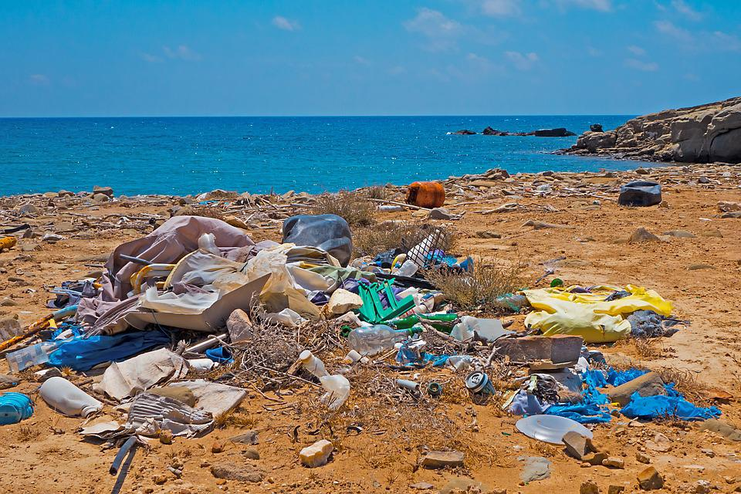
‘Garbage Plastic Waste Beach Environmental Sin’ by adage is used in accordance with the Pixabay License.

Resource 2: T-chart
Beginning of the story | End of the story

Resource 3: Word mat
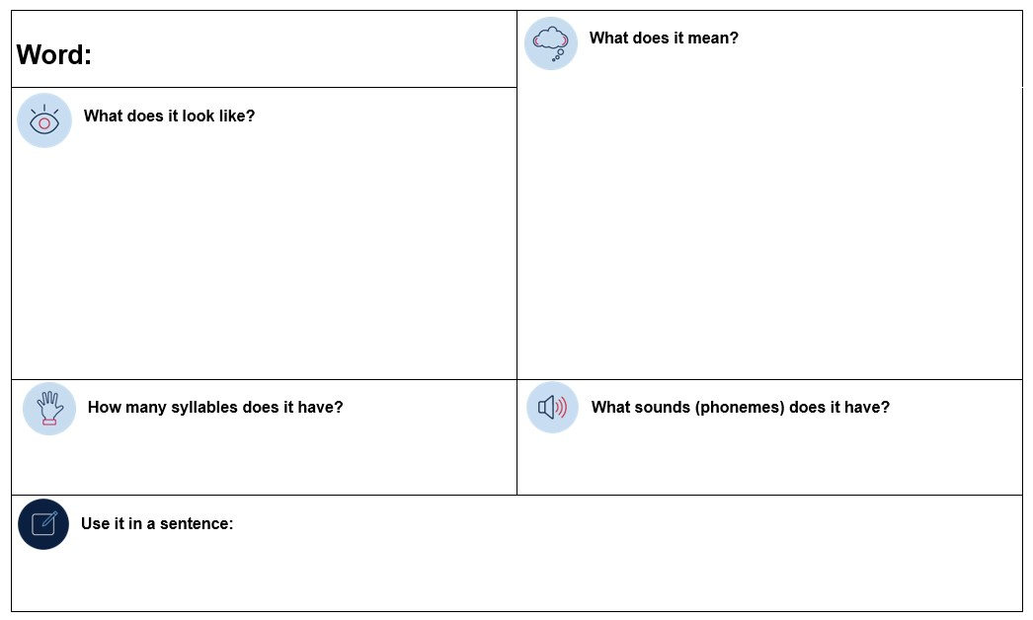

Resource 4: Verb cards
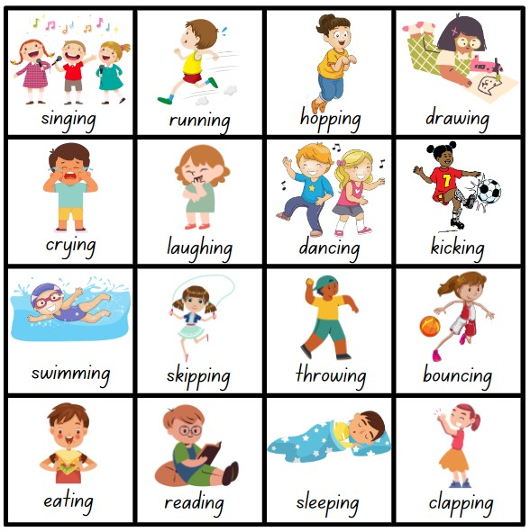
Images sourced from Canva and used in accordance with the Canva Content License Agreement.

Resource 5: Tense table
Base word | -s | -ing | -ed

Resource 6: Online text features and navigation pathways
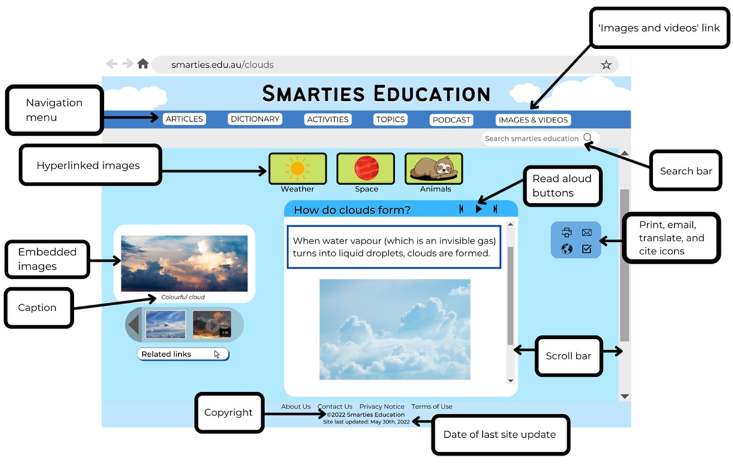
Images sourced from Canva and used in accordance with the Canva Content License Agreement.
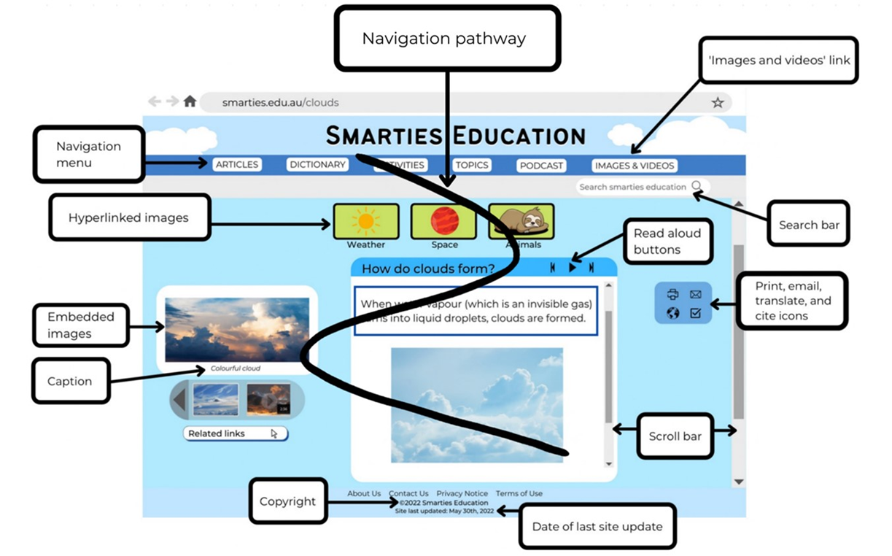
Images sourced from Canva and used in accordance with the Canva Content License Agreement.

Resource 7: Cause and effect
Text | Cause | Effect
The Mess That We Made
Kids vs Plastic

Resource 8: Word cards
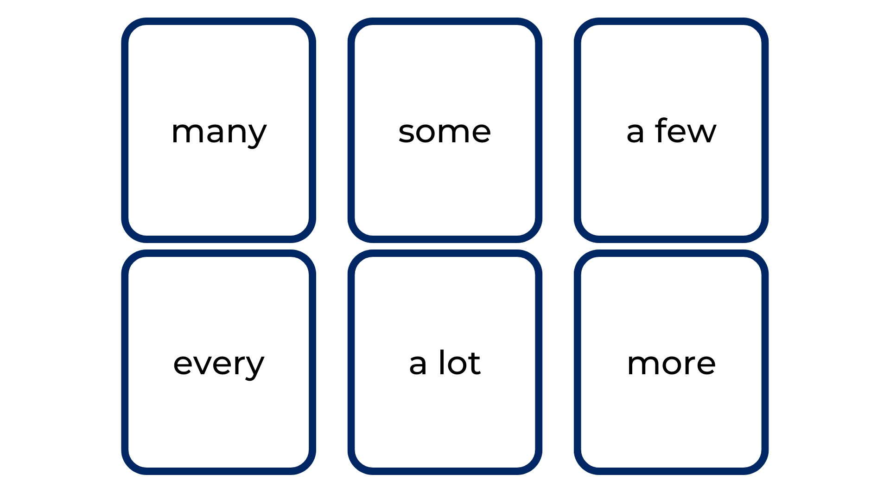

Resource 9: 5 senses table
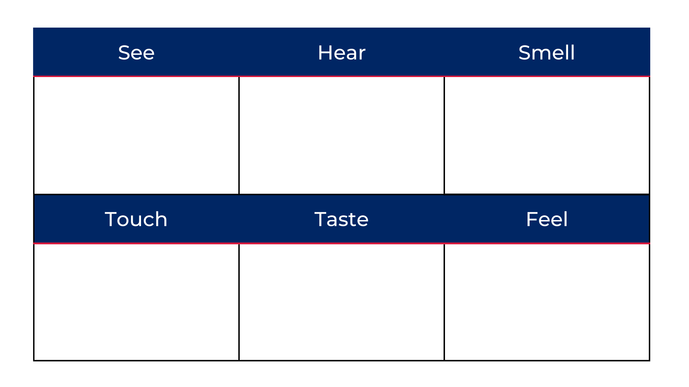

Resource 10: Planning template
Paragraph | Ideas/opinions | Impact | Images to support
Pollution
Prevention

Resource 11: Writing exemplar
Early Stage 1 | Stage 1
Idea 1 – Pollution  Pollution is bad for the environment because it gets washed into the ocean. Animals can eat plastic and they get very sick. | Paragraph 1 – Pollution  Too many used plastic bags are thrown away and end up going down the drain. These horrible plastic bags make their way to the ocean and are then eaten by the beautiful green and grey turtles. This causes the magnificent creatures to be in horrific pain and can even stop them from being able to eat.
Idea 2 – Prevention  Put your rubbish in the bin so it does not destroy the environment. Eat snacks like apples or bananas because they have no plastic wrappers. | Paragraph 2 – Prevention  Recycling our old plastic bags or using biodegradable bags is the answer. It will stop the dreaded bags spilling from the landfill and making their way into the marine areas. The turtles will no longer need to swim through the many plastic items floating and polluting our ocean.

References
Links to third-party material and websites
Please note that the provided (reading/viewing material/list/links/texts) are a suggestion only and implies no endorsement, by the New South Wales Department of Education, of any author, publisher, or book title. School principals and teachers are best placed to assess the suitability of resources that would complement the curriculum and reflect the needs and interests of their students.
If you use the links provided in this document to access a third-party's website, you acknowledge that the terms of use, including licence terms set out on the third-party's website apply to the use which may be made of the materials on that third-party website or where permitted by the Copyright Act 1968 (Cth). The department accepts no responsibility for content on third-party websites.
Except as otherwise noted, all material is © State of New South Wales (Department of Education), 2023 and licensed under the Creative Commons Attribution 4.0 International License. All other material (third-party material) is used with permission or under licence. Where the copyright owner of third-party material has not licensed their material under a Creative Commons or similar licence, you should contact them directly for permission to reuse their material.
English K–10 Syllabus © 2022 NSW Education Standards Authority (NESA) for and on behalf of the Crown in right of the State of New South Wales.
© 2022 NSW Education Standards Authority. This document contains NSW Curriculum and syllabus content. The NSW Curriculum is developed by the NSW Education Standards Authority. This content is prepared by NESA for and on behalf of the Crown in right of the State of New South Wales. The material is protected by Crown copyright.
Please refer to the NESA Copyright Disclaimer for more information.
NESA holds the only official and up-to-date versions of the NSW Curriculum and syllabus documents. Please visit the NSW Education Standards Authority (NESA) website and the NSW Curriculum website.
National Literacy Learning Progression © Australian Curriculum, Assessment and Reporting Authority (ACARA) 2010 to present, unless otherwise indicated. This material was downloaded from the Australian Curriculum website (National Literacy Learning Progression) (accessed 14 September 2022) and was not modified. The material is licensed under CC BY 4.0. Version updates are tracked in the ‘Curriculum version history’ section on the 'About the Australian Curriculum' page of the Australian Curriculum website.
ACARA does not endorse any product that uses the Australian Curriculum or make any representations as to the quality of such products. Any product that uses material published on this website should not be taken to be affiliated with ACARA or have the sponsorship or approval of ACARA. It is up to each person to make their own assessment of the product, taking into account matters including, but not limited to, the version number and the degree to which the materials align with the content descriptions and achievement standards (where relevant). Where there is a claim of alignment, it is important to check that the materials align with the content descriptions and achievement standards (endorsed by all education Ministers), not the elaborations (examples provided by ACARA).
ETA (English Teachers Association) and NSW Department of Education (2016) The Textual Concepts and Processes resource, English Textual Concepts website, accessed 14 September 2022.
ETA (English Teachers Association) and NSW Department of Education (2016) Perspective, English Textual Concepts website, accessed 14 September 2022.
ETA (English Teachers Association) and NSW Department of Education (2016) Argument, English Textual Concepts website, accessed 14 September 2022.
Godwin N (2020) Jelly-Boy (Nielson C, illus.), Walker Books Australia, Newtown.
Lord M (2020) The Mess That We Made (Blattman J, illus.), Flashlight Press, New York.
National Geographic Society (2022) ‘Kids vs Plastic – Plastic Pollution’, Nature, National Geographic Kids website, accessed 14 September 2022.

