English – K-2 multi-age – Year A – Unit 14
Contents
Unit overview and instructions for use 3
Teacher notes 4
Outcomes and content – Component A 5
Outcomes and content – Component B 9
Week 1 14
Component A teaching and learning 14
Component B teaching and learning 15
Lesson 1: Text introduction – Tilly 16
Lesson 2: Exploring vocabulary to describe special objects 20
Lesson 3: Using adjectives, adverbs and noun groups to describe memories 23
Lesson 4: Vocabulary and paragraphs 27
Lesson 5: Writing a character profile 30
Week 2 33
Component A teaching and learning 33
Component B teaching and learning 34
Lesson 6: Personal pronouns and possessive apostrophes 35
Lesson 7: Oral language and descriptions 38
Lesson 8: Prepositional phrases and features of a letter 43
Lesson 9: Sending, receiving and writing letters 45
Lesson 10: Editing and publishing letters 47
Resource 1: Traffic light paragraphs 51
Resource 2: Tilly and me 52
Resource 3: Treasure table 53
Resource 4: Character talking strips 54
Resource 5: Treasure talking strips 55
Resource 6: Annotated sample letter 56
Resource 7: Sample letter 57
Resource 8: Teddy is hiding cards 58
References 59

Unit overview and instructions for use
This two-week unit is comprised of Component A and Component B. Connecting learning across both components is encouraged.
Teaching and learning | Component A | Component B
Suggested duration | 60 minutes | 45 minutes
Explicit teaching focus areas | - Phonological awareness (Early Stage 1)  - Print conventions (Early Stage 1)  - Phonic knowledge  - Reading fluency  - Reading comprehension  - Spelling  - Handwriting | - Oral language and communication  - Vocabulary  - Reading comprehension  - Creating written texts  - Understanding and responding to literature
To prepare for teaching and learning: | - Refer to Outcomes and content – Component A, K-2 – Instructional sequence – grapheme–phoneme correspondences [PDF 825 KB], and the teaching advice documents (hyperlinked in Component A teaching and learning table).  - Based on student needs identified through ongoing assessment data, plan and document how you will sequence teaching and learning in whole class and targeted teaching groups across the two-week cycle. | - Familiarise yourself with Outcomes and content – Component B, Textual concepts information and videos, English Textual Concepts and Learning Processes (2016), and the teaching and learning sequence.  - Based on student needs identified through ongoing assessment data, determine how you will support students in whole class and targeted teaching groups across the two-week cycle as required.
English K–10 Syllabus © 2022 NSW Education Standards Authority (NESA) for and on behalf of the Crown in right of the State of New South Wales.

Teacher notes
- Distribute a note to parents and carers, outlining a request for students to each bring a small ‘treasure’ to school of low monetary but high personal value. Students bring their ‘treasure’ to school. You may like to bring in a treasure to use as an example throughout the unit.
- Narrative is defined as the communication of a sequence of related events into a story. A narrative is usually structured in such a way to invite responder involvement. Narrative helps us make sense of our lives. – English Textual Concepts and Learning Processes (2016).
- While ‘narrative’ is the mentor concept for this unit, the supporting concept of ‘character’ can also be explored using the mentor text, Tilly by Jane Godwin.
- For information on noun groups, sentences, adjectives, commas, adverbs, visualising, Tier 1, 2 and 3 words, paragraphs, topic sentences, personal pronouns, and apostrophes refer to NESA glossary.
- Suggested additional activity to complement this unit throughout Week 2: Students make or decorate a treasure box for their personal treasure and a published letter to take home.
- This unit could enhance student learning towards achievement of outcomes from the Creative Arts syllabus regarding drama.
- This unit provides scope to explore various forms of drama. Act Ease, developed by the NSW Department of Education, provides teaching advice and learning sequences to explore quality children’s literature through drama.
- Reflect on student learning and engagement in activities and record differentiation and adjustments within the unit to inform future teaching and learning. One way of doing this could be to add comments to the digital file.
- Content are points are linked to the National Literacy Learning Progression version (3).
Levels and indicators sourced from National Literacy Learning Progression © Australian Curriculum, Assessment and Reporting Authority (ACARA), (accessed 1 February 2023) and was not modified. See references for more information.

Outcomes and content – Component A
The table below outlines the focus outcomes and content. Content is linked to the National Literacy Learning Progression version (3).
Early Stage 1 Focus area and outcome | Stage 1 Focus area and outcome
Phonological awareness  ENE-PHOAW-01 – identifies, blends, segments and manipulates phonological units in spoken words as a strategy for reading and creating texts  - blend aloud all phonemes when asked to delete, add or substitute a final phoneme  - blend aloud all phonemes when asked to substitute a medial vowel phoneme | N/A
Print conventions  - N/A | Print conventions  - N/A
Phonic knowledge  ENE-PHOKW-01 – uses single-letter grapheme–phoneme correspondences and common digraphs to decode and encode words when reading and creating texts  - decode words containing split digraphs and vowel digraphs (PkW5)  - experiment with encoding high-frequency words containing split digraphs and vowel digraphs | Phonic knowledge  ENE-PHOKW-01 – uses initial and extended phonics, including vowel digraphs, trigraphs to decode and encode words when reading and creating texts  - blend and decode one-syllable words with taught extended vowel graphs and digraphs, including graphemes for r-controlled vowels and diphthongs, and apply this when reading texts (PKW6, PKW7)  - segment and encode one-syllable words with taught vowel graphs, digraphs and trigraphs and apply this when creating texts  - blend and decode 2-syllable words with taught vowel graphs, digraphs, trigraphs and quadgraphs, including graphemes for r-controlled vowels and diphthongs and apply this when reading texts (PKW6, PKW7)
Reading fluency  ENE-REFLU-01 – reads decodable texts aloud with automaticity  - read words automatically then apply to texts  - know that pace and expression vary when reading, according to the audience and purpose  - regulate their voice to respond to punctuation such as question marks and exclamation marks (FlY4) | Reading fluency  EN1-REFLU-01 – sustains reading unseen texts with automaticity and prosody and self-corrects errors  - read aloud with an easy speech rhythm (FlY4)
Reading comprehension  ENE-RECOM-01 – comprehends independently read texts using background knowledge, word knowledge and understanding of how sentences connect  - ask or pause to clarify meaning of unknown words (UnT3)  - identify conjunctions (and, because, but, for, so) in a compound sentence, their meaning and purpose  - understand how adjectives describe a noun and verbs identify actions in a sentence  - stop reading when a break in comprehension is registered (UnT5)  - ask a question or make a statement to clarify meaning (UnT3, UnT4)  - recall key characters, events and / or information in the text | Reading comprehension  ENE-RECOM-01 – comprehends independently read texts that require sustained reading by activating background and word knowledge, connecting and understanding sentences and whole text, and monitoring for meaning  - use known morphemes and known vocabulary in the text to work out or refine the meaning of unknown words (UnT4)  - draw on sources to seek clarification for unknown words  - coordinate information or events from different parts of the text to form an overall opinion  - use knowledge of text structure, type of text, author, and forms of writing to predict and confirm meaning (UnT6)  - use a mental model to confirm predictions  - confirm meaning by sequencing and explaining events and information
Spelling  ENE-SPELL-01 – applies phonological, orthographic and morphological generalisations and strategies to spell taught familiar and high-frequency words when creating texts  - combine phonological, phonic, orthographic and morphemic knowledge to spell taught high-frequency irregular words comprising up to 3 phonemes (SpG5)  - experiment with some vowel digraphs and split digraphs to spell taught high-frequency words and/or personally significant words | Spelling  ENE-SPELL-01 – applies phonological, orthographic and morphological generalisations and strategies when spelling words in a range of writing contexts  - spell high-frequency base words with taught vowel graphs, digraphs, split digraphs, trigraphs and quadgraphs  - explain that the consonant trigraphs, –tch and –dge, can end a base word immediately following a short vowel and apply this when spelling  - spell nouns ending in the suffix –er to indicate a person (SpG9)
Handwriting  ENE-HANDW-01 – produces all lower-case and upper-case letters to create texts  - apply taught handwriting skills when creating texts | Handwriting  ENE-HANDW-01 – uses a legible, fluent and automatic handwriting style, and digital technology, including word-processing applications, when creating texts  - use taught software functions to create texts in a range of modes for different contexts, audiences and purposes

Outcomes and content – Component B
The table below outlines the focus outcomes and content. Content is linked to the National Literacy Learning Progression version (3).
Early Stage 1 Focus area and outcome | Stage 1 Focus area and outcome
Oral language and communication  ENE-OLC-01 – communicates effectively by using interpersonal conventions and language with familiar peers and adults  - start a conversation with a peer and/or adult, staying on topic (InT3)  - use connectives such as and, but and because when speaking (SpK2)  - use a combination of sentences to elaborate and connect ideas (SpK3)  - recall details of events or stories using who, what, when, where, why and how (SpK2) | Oral language and communication  ENE-OLC-01 – communicates effectively by using interpersonal conventions and language to extend and elaborate ideas for social and learning interactions  - use a range of strategies for effective dialogue and manage digression from a topic  - organise key ideas in logical sequence  - use adjectives and adverbs to elaborate and/or provide some supporting details or justifications and express causal relationships  - adapt a narrative for a particular audience
Vocabulary  ENE-VOCAB-01 – understands and effectively uses Tier 1 and Tier 2 words in familiar contexts  - use vocabulary that is personal  - identify, name and describe a range of objects, characters, animals, people and places when given visual and/or auditory prompts (GrA1) | Vocabulary  ENE-VOCAB-01 – understands and effectively uses Tier 1, taught Tier 2 and Tier 3 vocabulary to extend and elaborate ideas  - understand and intentionally choose subject-specific vocabulary to enhance precision and for effect
Reading comprehension  ENE-RECOM-01 – comprehends independently read texts using background knowledge, word knowledge and understanding of how sentences connect  - ask or pause to clarify meaning of unknown words (UnT3)  - identify conjunctions (and, because, but, for, so) in a compound sentence, their meaning and purpose  - understand how adjectives describe a noun and verbs identify actions in a sentence  - ask a question or make a statement to clarify meaning (UnT3, UnT4)  - recall key characters, events and/or information in text | Reading comprehension  ENE-RECOM-01 – comprehends independently read texts that require sustained reading by activating background and word knowledge, connecting and understanding sentences and whole text, and monitoring for meaning  - use known morphemes and known vocabulary in the text to work out or refine the meaning of unknown words (UnT4)  - draw on sources to seek clarification for unknown words  - use knowledge of text structure, type of text, author, and forms of writing to predict and confirm meaning (UnT6)  - use a mental model to confirm predictions  - confirm meaning by sequencing and explaining events and information
Creating written texts  ENE-CWT-01 – creates written texts that include at least 2 related ideas and correct simple sentences  - sequence ideas in a text (GrA4)  - identify and use nouns in simple sentences, including in own writing (GrA1)  - use personal pronouns in own writing (CrT7)  - use prepositional phrases to indicate time or place (GrA2)  - identify and use time connectives to sequence information and events (GrA4)  - use a capital letter to start a sentence and a full stop to end a sentence (PuN2, CrT5)  - use drawing, images or mind maps to support planning and writing | Creating written texts  EN1-CWT-01 – plans, creates and revises texts written for different purposes, including paragraphs, using knowledge of vocabulary, text features and sentence structure  - use a logical order to sequence ideas and events in sentences across a text (GrA4)  - group sentences into paragraphs commencing with a topic sentence, followed by other sentences with related ideas (CrT7)  - use noun groups to build descriptions of people and things (CrT6)  - use adverbs to modify the meaning of verbs and adjectives (GrA3)  - use contextually precise prepositional phrases when creating texts (GrA4)  - use commas to separate ideas, lists and/or dependent clauses in a sentence (PuN4, PuN6)  - use possessive apostrophes in own writing (PuN4)  - use a variety of planning strategies and tools for creating texts  - re-read and edit their own texts after receiving feedback
Understanding and responding to literature  ENE-UARL-01 – understands and responds to literature read to them  - identify narratives told through a range of modes and media  - experiment with using parts and/or features of a narrative, innovating from a mentor text | Understanding and responding to literature  EN1-UARL-01 – understands and responds to literature by creating texts using similar structures, intentional language choices and features appropriate to audience and purpose  - identify patterns in narratives that set up expectation and aid prediction of actions and attitudes  - identify and appreciate how key messages in narratives evoke feelings

Week 1

Component A teaching and learning
The table below can be used to plan and document lessons that address Component A outcomes and content. Both the detailed example [DOC 529KB] of a two-week teaching and learning cycle and brief example [DOC 66KB] may support you in your planning.
Focus Areas | Lesson 1 | Lesson 2 | Lesson 3 | Lesson 4 | Lesson 5
Phonological awareness (Early Stage 1) and Phonic knowledge
15 minutes
Spelling and Handwriting
15 minutes
Print conventions (Early Stage 1), Reading comprehension and Reading fluency
30 minutes

Component B teaching and learning
The following teaching and learning sequence has been designed to address Component B outcomes and content. Adapt the sequence as required to best meet the needs of your students.

Learning intention and success criteria
Learning intentions and success criteria are best co-constructed with students. The table below contains suggested learning intentions and success criteria.
Element | Early Stage 1 | Stage 1
Learning intentions | Students are learning to respond to narrative picture books, and use nouns, adjectives, basic punctuation, and conjunctions when writing. | Students are learning to respond to narrative picture books, and use commas, noun groups, and paragraphs when writing.
Success criteria | Students can:  - use nouns in simple sentences  - use capital letters and full stops correctly  - identify and use conjunctions and verbs  - use adjectives to describe a noun  - identify key characters in texts. | Students can:  - use noun groups to describe people and things  - use commas in a list  - use adjectives and adverbs to add details  - group sentences about the same topic into paragraphs  - identify the feelings of the characters.

Resources
- Godwin J (2019) Tilly (Walker A, illus.), Scholastic Australia Pty Ltd. ISBN: 9781760663728
- Resource 1: Traffic light paragraphs (enlarged copy)
- Resource 2: Tilly and me (enlarged copy and individual copies for students)
- Jane Godwin: Tilly
- NASA Space Place – All About Earth
- Blank pages for writing and drawing
- Mini whiteboards or paper
- Teacher’s treasure
- Students’ personal treasures

Lesson 1: Text introduction – Tilly
The following teaching and learning activities support multi-age settings.

Whole
- Introduce the text, Tilly. Refer to the second double page that shows the stairs and Tilly sitting under the table. Students Think-Pair-Share to answer the following:
- What is happening?
- Which character do you think Tilly is? Why?
- What can we tell about the text by looking at these pages?
- Guide students to make predictions about the type of text using the front and back covers, title, and illustrations. Discuss the relationship that may exist between the characters.
- Read Tilly. Revisit the Think-Pair-Share answers and confirm text predictions.
- Explain that Tilly is based on a true story. Read the first 3 paragraphs of the true story of Tilly on Jane Godwin’s website. Model pausing the reading to clarify any unknown vocabulary, for example, Godwin describes Cait’s hiding place for her treasure using complex vocabulary.
- Provide opportunities for students to make text-to-self connections. Ask students if anything from Tilly’s house reminds them of something in their house. For example, the shoes in the hallway, family photos, scattered books, toys, and pets. Students share a description of their homes using nouns and adjectives (Early Stage 1) and combine these to make noun groups like ‘the noisy pets’ (Stage 1). List student responses on an anchor chart, for example:
- nouns: shoes, pets, books, teddy, photos
- adjectives: smelly, noisy, little, fluffy, family
- noun groups: smelly shoes, noisy pets, little books, fluffy teddy, family photos.

Part
The table below details the differentiated teaching and learning activities for each stage.
Early Stage 1 (teacher guided) | Stage 1 (independent)
- Review Tilly and her list of treasures and discuss why they might be important to her.  - Show your teacher treasure and discuss why it’s important.  - Ask students to share details and ask each other questions about special treasures they have.  - Explain to students that they will be drawing their treasure, including as much detail as possible. | - Students draw a detailed picture of a scene from their home.

Part
The table below details the differentiated teaching and learning activities for each stage.
Early Stage 1 (independent) | Stage 1 (teacher guided)
- Students draw an item or items they treasure and label them with a noun, referring to the anchor chart as needed.  Too easy? Students expand their labels to create a sentence. | - Model writing sentences using noun groups to add informative labels to a drawing, referring to the anchor chart. For example, ‘The smelly shoe was laying on the clean floor.’  - Students label their drawing, creating sentences including noun groups.  Too easy? Students use a Venn diagram to write sentences including noun groups to identify similarities and differences between their house and Tilly's.

Whole
- In small groups, students share their work.
Early Stage 1 Assessment task 1 – Observations and work samples from this lesson allow students to demonstrate achievement towards the following syllabus outcomes and content points:
ENE-RECOM-01 – comprehends independently read texts using background knowledge, word knowledge and understanding of how sentences connect
- ask or pause to clarify meaning of unknown words
- ask a question or make a statement to clarify meaning
- recall key characters, events and/or information in text.
ENE-UARL-01 – understands and responds to literature read to them
- identify narratives told through a range of modes and media.
Stage 1 Assessment task 1 – Observations and work samples from this lesson allow students to demonstrate achievement towards the following syllabus outcomes and content points:
EN1-RECOM-01 – comprehends independently read texts that require sustained reading by activating background and word knowledge, connecting and understanding sentences and whole text, and monitoring for meaning
- use knowledge of text structure, type of text, author, and forms of writing to predict and confirm meaning
- use a mental model to confirm predictions
- confirm meaning by sequencing and explaining events and information.
EN1-UARL-01 – understands and responds to literature by creating texts using similar structures, intentional language choices and features appropriate to audience and purpose
- identify patterns in narratives that set up expectation and aid prediction of actions and attitudes.

Lesson 2: Exploring vocabulary to describe special objects
The following teaching and learning activities support multi-age settings.

Whole
- Revisit Tilly and discuss the structure of a narrative, referring to key vocabulary previously taught. For example, narrative, beginning, middle, and end (Early Stage 1) and sequence of events (Stage 1), imagined, feelings, prediction, cause and effect (Stage 1). Focus on ‘who, what, where’ and consider the messages of family, memories, and emotion.
- Display the page where Tilly is lying on her bed with her feet on the wall. Read the page and ask students what they think the word ‘precious’ means.
- Display the double page where Tilly is looking at her hiding place under the newly laid carpet. Discuss the meaning of the word ‘treasure’. Early Stage 1 students share their labelled drawings from Lesson 1.
- As a class, brainstorm ideas to explore the word ‘precious’. Take student responses and record the definition of ‘precious’. Co-construct a sentence using the word ‘precious’. For example, ‘My teddy is precious because it was given to me by someone special.’ Repeat using the word ‘treasure’.
- Students turn and talk to describe their treasure using the words ‘precious’ and ‘treasure’. For example, ‘My treasure is a colourful feather’; ‘It is precious because it came from my budgie.’
- Display the page with the list of Tilly’s treasures. Ask:
- What are Tilly’s treasures?
- What words have been used to describe them? For example, special, best, smooth, stripy, silver, little wooden. Review descriptive adjectives.
- Why might these treasures be important to Tilly?
- Refer to Tilly’s list of treasures. Explicitly teach writing lists using commas to separate items (words, phrases, or numbers) in a series. Model rewriting Tilly’s list using commas to separate the items. For example, ‘Tilly’s treasures were a special book of lists, her best drawing of a bird, a smooth stone she found by the sea, a silver ball with a tiny bell inside, stripy sweets, a letter she had never delivered, and 4 little wooden dolls.’

Part
The table below details the differentiated teaching and learning activities for each stage.
Early Stage 1 (teacher guided) | Stage 1 (independent)
- Display your teacher treasure and review the words ‘precious’ and ‘treasure’.  - Refer to the whole class co-constructed sentence: ‘My teddy is precious because it was given to me by someone special.’ Review use of a capital letter to start a sentence and a full stop to end.  - Model writing a simple sentence using a capital letter, full stop, and the word ‘treasure’ or ‘precious’. For example, ‘My treasure is a brown teddy bear. My brown teddy bear is precious.’  - Students turn and talk to share a sentence using the word ‘treasure’ or ‘precious’.  - Students write a sentence to accompany their treasure drawing from Lesson 1, using a capital letter at the beginning and a full stop at the end.  Too hard? Students verbalise a sentence, using the word ‘treasure’. Write the sentence without correct punctuation. Students identify the errors and write the capital letter and full stop in the correct places.  Too easy? Students write a compound sentence using both words. | - Students draw their treasures and write an accompanying sentence listing their precious items, using descriptive adjectives and commas to separate them.  Too hard? Provide students with the anchor chart from Lesson 1.  Too easy? Students list their treasures using extended noun groups. For example, a small, speckled shell that looks like a pearl on the inside.

Lesson 3: Using adjectives, adverbs and noun groups to describe memories
The following teaching and learning activities support multi-age settings.

Whole
- Discuss the concept of ‘memories’. Define a memory as something at a point of time that we remember. Discuss how the audience knows that Tilly has lots of memories in her house. Refer to the illustrations showing family and baby photos, and the children’s paintings on the walls. Discuss how these represent memories.
- Students turn and talk and describe a memory that Tilly has. Share memories as a class.
- Revise that adjectives are words that describe or identify a noun or pronoun. Explain that an adverb is a word that tells something about a verb, adjective or another verb. They indicate things like manner (how), place (where) or time (when). Adverbs commonly end in -ly.
- Brainstorm and list adverbs to describe the way Tilly has played with her treasures. For example, quietly, secretly, carefully, nicely, happily, calmly. Highlight how each adverb contains a base word (free morpheme) that is built on by the suffix (bound morpheme) -ly.
- Display the dark page where Tilly is in bed. Discuss the text and its meaning. Explore the vocabulary ‘That night in bed, Tilly imagined her treasures, holding each one in her mind.’ Explain that Tilly’s treasures are also memories and that when Tilly makes pictures of her treasures in her mind, she is visualising. Explicitly teach the importance of using noun groups and descriptive adjectives when writing to create a picture to help readers visualise a scene.
- Discuss adjectives that describe Tilly’s treasures. For example, sweets: stripy, colourful; ball: silver, tiny bell inside. Add to the anchor chart from Lesson 1.
- Students close their eyes and visualise a memory of their own. To encourage deeper thinking, ask:
- Who is in your memory?
- Where were you?
- What time was it?
- What happened?
- How does your memory make you feel?
Too hard? Provide students with topics to help them think of a memory. For example, a soccer game where they kicked a goal, a feather they found, their favourite book, a place they have been, a school memory, or a favourite toy.
- Model writing compound sentences about a personal memory using a conjunction. For example, ‘My birthday party was in February and my friends had lots of fun. The day was very hot, so we played games in the shade.’ Refer to the anchor chart from Lesson 1 for nouns, adjectives and noun groups.

Part
The table below details the differentiated teaching and learning activities for each stage.
Early Stage 1 (teacher guided) | Stage 1 (independent)
- Review conjunctions and verbs.  - Refer to the modelled compound sentence in activity 8 and identify and list the conjunctions and verbs.  - Identify and list conjunctions and verbs in Tilly and discuss their meaning and purpose. For example:  - People walked on it, her brothers and sisters even sat on it, but they didn’t know that Tilly had the best hiding place of all.  - Tilly tried to lift up the carpet that covered the step, but it was so thick and strong underneath that sandy softness.  - Model talking about memories using conjunctions and verbs in compound sentences. For example, ‘I made a sandcastle at the beach, but the waves knocked it over.’  - Students share a memory using conjunctions and verbs.  - Students draw their memory and write an accompanying compound sentence.  Too hard? Students draw and label their memory. | - Students write compound sentences to describe a memory they have, including noun groups, adjectives, and adverbs.  - In pairs, students read their sentences while their partner draws the read memory. Students swap and repeat this process.  - Students provide feedback to each other on the connection between the writing and the drawing, then apply the feedback to improve their writing.  Too easy? Students predict what could happen next in their partner’s memory. Write sentences to describe their prediction using noun groups, adjectives, and adverbs. Repeat the last 2 activities.

Whole
- Select students to share their work and learning.
Early Stage 1 Assessment task 2 – Observations and work samples from this lesson allow students to demonstrate achievement towards the following syllabus outcomes and content points:
ENE-OLC-01 – communicates effectively by using interpersonal conventions and language with familiar peers and adults
- use connectives such as and, but and because when speaking
- use a combination of sentences to elaborate and connect ideas.
ENE-RECOM-01 – comprehends independently read texts using background knowledge, word knowledge and understanding of how sentences connect
- identify conjunctions (and, because, but, for, so) in a compound sentence, their meaning and purpose
- understand how adjectives describe a noun and verbs identify actions in a sentence.
ENE-CWT-01 – creates written texts that include at least 2 related ideas and correct simple sentences
- identify and use nouns in simple sentences, including in own writing.
Stage 1 Assessment task 2 – Observations and work samples from this lesson allow students to demonstrate achievement towards the following syllabus outcomes and content points:
EN1-OLC-01 – communicates effectively by using interpersonal conventions and language to extend and elaborate ideas for social and learning interactions
- use adjectives and adverbs to elaborate and/or provide some supporting details or justifications and express causal relationships.
EN1-CWT-01 – plans, creates and revises texts written for different purposes, including paragraphs, using knowledge of vocabulary, text features and sentence structure
- use noun groups to build descriptions of people and things
- use adverbs to modify the meaning of verbs and adjectives.

Lesson 4: Vocabulary and paragraphs
The following teaching and learning activities support multi-age settings.

Whole
- Display the page where Tilly opens the window and looks at the stars. Share the language of the text ‘Tilly opened the window. The last drops of silvery summer fell into the palm of her hand. The air was warm outside. It was very dark between the stars.’ Discuss what Tilly may be seeing.
- Write the word ‘silvery’ on the board. Discuss how this word is precise and powerful (Tier 2). Ask students to share words they associate with 'silvery'. For example, shiny and reflective. Write these words on the board next to 'silvery'.
- Students work in small groups to create a sentence using each of the words on the board to help students understand the meaning of the word and the words related to it.
- Brainstorm and categorise students’ ideas about what Tilly may be seeing ‘between the stars’ into the three-column table, for example:
- everyday words (Tier 1): small, hand
- precise and powerful (Tier 2): silvery, atmosphere, planets
- topic specific words (Tier 3): meteoroids.
- Select words from the Tier 1 and 2 lists. Repeat activity 2 and 3.

Part
The table below details the differentiated teaching and learning activities for each stage.
Early Stage 1 (independent) | Stage 1 (teacher guided)
- Students draw a night sky or space scene. For example, the Earth and Sun, some stars, and an asteroid.  - Students complete a barrier activity in pairs: Student A describes their scene while Student B draws the scene from the description.  - Students compare their drawings with the initial images and discuss the differences.  - Students write a simple sentence to describe their scene using adjectives, a capital letter, and a full stop.  Too hard? Students label the pictures. For example, small and rocky Earth, bright Sun.  Too easy? Students refer to the tier words and write more detailed sentences about their scene. For example, ‘The Earth is a rocky planet with mountains and valleys.’ | - Introduce paragraphs. Explicitly teach that a paragraph is a sequence of sentences, grouped together and focused on a specific theme. Explain that a paragraph starts with a topic sentence, which is followed by other sentences that elaborate on the topic and include details that support a specific point or topic.  - Display the webpage NASA Space Place and click on the heading ‘All about Earth’.  - Refer to the webpage and locate the paragraph features using Resource 1: Traffic light paragraphs:  - topic sentence – green  - sentences with related ideas – middle of the paragraph – orange  - closing sentence – red.  - Students review the webpage, locating Tier 2 and 3 vocabulary to add to the three-column table. Encourage students to draw on knowledge of known words and morphemes when defining unknown words.  - Co-construct a topic sentence. For example, ‘Tilly could see exciting and wondrous things in the night sky.’  - Students Think-Pair-Share ideas about what Tilly could see between the stars referring to the Tier 2 and 3 words. In pairs, students record a sentence describing one of their ideas on mini whiteboards.  - Discuss, select, and record sentences with related ideas.  - Sequence the sentences to write a paragraph.  - Read and review the paragraph using Resource 1: Traffic light paragraphs. Where appropriate, co-construct the closing sentence.
Stage 1 Assessment task 3 – Observations from this lesson allow students to demonstrate achievement towards the following syllabus outcome and content points:
EN1-RECOM-01 – comprehends independently read texts that require sustained reading by activating background and word knowledge, connecting and understanding sentences and whole text, and monitoring for meaning
- use known morphemes and known vocabulary in the text to work out or refine the meaning of unknown words
- draw on sources to seek clarification for unknown words.

Lesson 5: Writing a character profile
The following teaching and learning activities support multi-age settings.

Whole
- Revisit Tilly, focusing on the illustrations of Tilly, specifically her appearance and emotions. Explore Tilly’s secret and how her feelings, emotions, and facial expressions about the secret change throughout the text.
- To build a mental model of the character and her emotions, students engage in the drama activity mirroring. Organise students into pairs, facing each other, then read key sentences from the text and ask ‘Student A’ to respond using facial expressions and body language. ‘Student B’ mirrors their actions. For example, read:
- Sometimes there was no room for Tilly
- Tilly liked to take these treasures out of the step, one by one.
- But something was wrong
- How could she rescue them?
- Students swap roles and repeat with different key sentences.
- To further explore the character of Tilly, display an enlarged copy of Resource 2: Tilly and me. Refer to the page that shows Tilly standing with her treasures. Model completing the Venn diagram in the resource by comparing Tilly and the teacher. For example, Tilly: girl, long hair, yellow dress, likes birds; Teacher: man, short hair, likes cooking; similarities: collects treasures, likes sweets.
- Students complete their own copy of Resource 2: Tilly and me. Students draw a picture of themselves and a separate picture of Tilly. Students identify similarities and differences between Tilly and themselves, writing nouns and adjectives (Early Stage 1) or noun groups and adverbs (Stage 1) in the Venn diagram.
- Students write sentences to match the aspects of the Venn diagram. For example, ‘I wear shiny, silver glasses’; ‘Tilly has long hair’; ‘We both have a very special secret.’
Too hard? Students use text-to-speech technology or audio or video recording to produce the text.
Too easy? Students write a paragraph to describe the similarities and differences.
- Students identify memorable moments and related emotions within the text, for example:
- Collecting the treasures – excitement
- Hiding the treasures – secretive
- House/carpet renovation and lost treasures – sad
- Remembering treasures – reflecting
- New treasures hidden – happy.
- In small groups, students engage in the drama activity ‘Freeze’. Allocate a memorable moment to each group. Students create frozen tableaus of moments from the text. Tell the students that you have a magic remote control and, when you press the play button, the moment comes to life. Allow time for students to plan and rehearse their moment.
- Students present their moment to the class and discuss Tilly’s feelings.

Week 2

Component A teaching and learning
The table below can be used to plan and document lessons that address Component A outcomes and content. Both the detailed example [DOC 529KB] of a two-week teaching and learning cycle and brief example [DOC 66KB] may support you in your planning.
Focus Areas | Lesson 6 | Lesson 7 | Lesson 8 | Lesson 9 | Lesson 10
Phonological awareness (Early Stage 1) and Phonic knowledge
15 minutes
Spelling and Handwriting
15 minutes
Print conventions (Early Stage 1), Reading comprehension and Reading fluency
30 minutes

Component B teaching and learning
The following teaching and learning sequence has been designed to address Component B outcomes and content. Adapt the sequence as required to best meet the needs of your students.

Learning intention and success criteria
Learning intentions and success criteria are best co-constructed with students. The table below contains suggested learning intentions and success criteria.
Element | Early Stage 1 | Stage 1
Learning intentions | Students are learning to create written texts that include related ideas and personal vocabulary in correct simple sentences. | Students are learning to respond to narrative picture books, use possessive apostrophes and paragraphs, and apply feedback when writing.
Success criteria | Students can:  - use personal pronouns  - identify, name, and describe characters  - use prepositional phrases  - use drawings and images to plan writing  - use vocabulary that is personal. | Students can:  - use possessive apostrophes accurately  - plan for speaking and writing  - identify and write prepositional phrases accurately  - write a paragraph that contains a topic sentence, related ideas, and a closing sentence  - use feedback to edit and improve own texts.

Resources
- Fox M (1992) Wilfrid Gordon McDonald Partridge (Vivas J, illus.), Puffin, London. ISBN: 9780140505863
- Godwin J (2019) Tilly (Walker A, illus.), Scholastic Australia Pty Ltd. ISBN: 9781760663728
- Resource 3: Treasure table
- Resource 4: Character talking strips
- Resource 5: Treasure talking strips
- Resource 6: Annotated sample letter
- Resource 7: Sample letter (individual copies for Stage 1 students)
- Resource 8: Teddy is hiding cards (enlarged teacher copy; individual sets (cut out) for Early Stage 1 students to use)
- T-chart
- Highlighters (Stage 1)
- Selection of rich, familiar texts with multiple characters (teacher sourced). For example, The Gruffalo, Who Sank the Boat
- Teacher’s treasure

Lesson 6: Personal pronouns and possessive apostrophes
The following teaching and learning activities support multi-age settings.

Whole
- Introduce the text, Wilfrid Gordon McDonald Partridge. Guide students to make predictions about what type of text it is using the front and back covers, title, and illustrations.
- Read Wilfrid Gordon McDonald Partridge. Revisit the text predictions and provide an opportunity for students to make text-to-self connections. Discuss the words ‘memory’ and ‘precious’ and prompt students to make text-to-text connections with Tilly.
- Display the pages that describe what Wilfrid placed into the basket. Create a T-chart with the headings ‘Wilfrid Gordon McDonald Partridge’ and ‘Tilly’. List treasures Wilfrid placed in the basket for Miss Nancy.
- Display the pages that describe Tilly’s treasures. List the treasures Tilly keeps in her secret step.
- Explain Resource 3: Treasure table.

Part
The table below details the differentiated teaching and learning activities for each stage.
Early Stage 1 (independent) | Stage 1 (teacher guided)
- Provide students with Resource 3: Treasure table. Students draw a treasure for Tilly, Wilfrid, and themselves, and ask a friend to draw their treasure. | - Identify and record possessive apostrophes in Wilfrid Gordon McDonald Partridge. Explain that their purpose is to show ownership, and model correct placement of the apostrophe.  - Model using possessive apostrophes relevant to the students. For example, ‘This is Bill’s pencil case.’  - Model writing a sentence about the characters’ treasure using possessive apostrophes. For example, ‘Tilly’s treasure is some stripy sweets; The puppet on strings is Wilfrid’s treasure.’

Part
The table below details the differentiated teaching and learning activities for each stage.
Early Stage 1 (teacher guided) | Stage 1 (independent)
- Introduce personal pronouns. Identify and list personal pronouns in Wilfrid Gordon McDonald Partridge.  - Discuss personal pronouns relevant to the students. For example, her school jumper is blue. Students take turns describing a person or thing using personal pronouns.  - Display the second double page of Wilfrid Gordon McDonald Partridge. Choose a character and identify the personal pronouns that match their object. For example, ‘Mrs Jordan liked to play her organ’.  - Using Resource 3: Treasure table, model writing a sentence about the characters’ treasures using personal pronouns. For example, ‘This is Tilly. She has some stripey sweets. This is Wilfrid. He has a puppet on string. This is me. I have a fluffy teddy. This is Leon. He has a red car.’  - Students write sentences to accompany their treasured pictures using personal pronouns.  Too hard? Students write personal pronouns to accompany their pictures. | - Provide students with Resource 3: Treasure table. Students draw a treasure for Tilly, Wilfrid, and themselves, and ask a friend to draw their treasure.  - Students write sentences to accompany their treasure pictures using possessive apostrophes. For example, ‘Tilly’s treasure is some stripy sweets. Wilfrid’s treasure is a puppet on a string. Leon’s treasure is a red car. My teddy’s ears are fluffy.’  Too easy? Students view the second double page of Wilfrid Gordon McDonald Partridge and write sentences using possessive apostrophes to match the characters to their object. For example, ‘Mr Tippett’s cricket bat is old and battered.’

Whole
- Students share their writing.

Lesson 7: Oral language and descriptions
The following teaching and learning activities support multi-age settings.

Whole
- Display Wilfrid Gordon McDonald Partridge and refer to the page where Wilfrid is hanging from a bar in his backyard. Model describing Wilfrid’s physical features and personal characteristics. For example, ‘Wilfred is hanging from a bar in his backyard. He has fuzzy red hair and he’s wearing blue shorts and a light blue T-shirt. He looks like he’s having fun and is happy because he’s smiling.’
- Explain the importance of staying on topic (keeping to talking points and not digressing). Model an example of digressing when describing Wilfrid. For example, ‘Wilfrid is hanging from a bar in his backyard. When I was little, I had a swing set and I used to hang from the bar, too. My little sister liked the small swing best.’ Students identify the digression.
- Display another page and select students to provide a description of a different character. Encourage students to stay on topic.

Part
The table below details the differentiated teaching and learning activities for each stage.
Early Stage 1 (independent) | Stage 1 (teacher guided)
- In pairs, students choose a familiar text with multiple characters (sourced by the teacher). Students review the text with their partner and discuss the features of the various characters.  - In pairs, students play ‘Who am I?’ Student A chooses one character from the book and describes the character to Student B. For example, ‘My character is a man who is wearing a dressing gown, with baggy pants and a red hat.’ Student B guesses the character. For example, ‘Is your character Mr Tippett?’ Students swap and repeat this process. | - Display and discuss Resource 4: Character talking strips as a planning tool for an oral description.  - Display the page with Wilfrid and Miss Nancy both sitting in chairs. Students turn and talk to discuss the physical features and personal characteristics of Miss Nancy. Share the pen to create a description of Miss Nancy, using Resource 4: Character talking strips and the anchor chart from Lesson 1. For example, ‘Miss Nancy has messy, grey hair. She is wearing a colourful dress and has a blanket around her shoulders. She is wearing baggy, pink socks with slippers.’  - Students close their eyes while the description of Miss Nancy is being read. Students use ‘thumbs up or thumbs down’ to indicate how accurately they could visualise Miss Nancy. Discuss improvements to the description, for example, ‘Miss Nancy looks interested in Wilfrid’s basket.’  - Using Resource 5: Treasure talking strips, co-construct a plan for an oral description of the teacher’s treasure. For example, ‘This is my picture of a magpie. The picture is black and white, and it has been hand-painted. This was given to me as a gift, and it’s special because the person who gave it to me knows how much I love magpies. I wanted to share this with you because it is my favourite picture.’ Retain this resource for Lesson 8.

Part
The table below details the differentiated teaching and learning activities for each stage.
Early Stage 1 (teacher guided) | Stage 1 (independent)
- Model writing a short description of a character. For example, ‘Miss Jordan is wearing a colourful, stripy beanie and round glasses.’  - Students choose one character from the game to draw and write a sentence to provide a description. For example, ‘My character is Wilfrid and he is wearing blue shorts and a light blue T-shirt.’  - Students practise an oral description of their character using their written description.  Too hard? Students draw their character picture and label it. For example, Wilfrid, blue shorts, light blue T-shirt.  Too easy? Students write an additional sentence describing what their character is doing. For example, ‘Wilfrid is hanging from a shiny bar.’ | - Provide students with a copy of Resource 5: Treasure talking strips. Students develop their talking points to describe their treasure.  Too hard? Facilitate use of text-to-speech technology or audio or video recording to produce the text.  Too easy? Students write their text, using extended or complex noun groups to build the reader’s visualisation of the treasure.  - In pairs, students practise using their talking points and remaining on topic. Students use ‘thumbs up or thumbs down’ to provide feedback about staying on topic, keeping to talking points, and not digressing. Students apply feedback.

Whole
- Select students to present their description to the class.
Early Stage 1 Assessment task 3 – Observations and work samples from this lesson allow students to demonstrate achievement towards the following syllabus outcomes and content points:
ENE-OLC-01 – communicates effectively by using interpersonal conventions and language with familiar peers and adults
- start a conversation with a peer and/or adult, staying on topic
- recall details of events or stories using who, what, when, where, why and how.
ENE-VOCAB-01 – understands and effectively uses Tier 1 and Tier 2 words in familiar contexts
- identify, name and describe a range of objects, characters, animals, people and places when given visual and/or auditory prompts.
ENE-UARL-01 – understands and responds to literature read to them
- experiment with using parts and/or features of a narrative, innovating from a mentor text.
Stage 1 Assessment task 4 – Observations and work samples from this lesson allow students to demonstrate achievement towards the following syllabus outcomes and content points:
EN1-OLC-01 – communicates effectively by using interpersonal conventions and language to extend and elaborate ideas for social and learning interactions
- use a range of strategies for effective dialogue and manage digression from a topic
- organise key ideas in logical sequence
- adapt a narrative for a particular audience.
EN1-CWT-01 – plans, creates and revises texts written for different purposes, including paragraphs, using knowledge of vocabulary, text features and sentence structure
- use noun groups to build descriptions of people and things
- use a varietyy of planning strategies and tools for creating texts.

Lesson 8: Prepositional phrases and features of a letter
The following teaching and learning activities support multi-age settings.

Whole
- Refer to Tilly's treasure list. Discuss the letter and ask:
- Who do you think Tilly wrote her letter to?
- What do you think was in the letter?
- Why do you think the letter wasn't delivered?
- Display and read Resource 6: Annotated sample letter. Highlight and discuss its features:
- Salutation or beginning: Dear (Early Stage 1/Stage 1)
- paragraph (Stage 1)
- topic sentence (Stage 1)
- logical order to sequence ideas (Early Stage 1/Stage 1)
- ending or sign off: From (Early Stage 1/Stage 1).
- Review prior learning of prepositional phrases. Discuss and list examples of prepositional phrases related to the classroom. For example, in the cupboard, under the desk, on the floor.
- Identify prepositional phrases within Resource 6: Annotated sample letter and review whether the phrase indicates when or where. For example, in a large, holiday house (where); every day this week (when).

Part
The table below details the differentiated teaching and learning activities for each stage.
Early Stage 1 (teacher guided) | Stage 1 (independent)
- Display an enlarged set of Resource 8: Teddy is hiding cards. Discuss the images and words.  - Model arranging the cards by selecting Teddy, a hiding place for Teddy, and the appropriate preposition.  - Model writing a simple sentence using a prepositional phrase. For example, ‘Teddy is hiding under the table.’  - Explain to students that they will be gluing the cards into their books or on paper and writing sentences including prepositional phrases. | - Students review individual copies of Resource 7: Sample letter and highlight prepositional phrases and any additional text structures and language features.  - Students highlight paragraphs and topic sentences within the sample letter.

Part
The table below details the differentiated teaching and learning activities for each stage.
Early Stage 1 (independent) | Stage 1 (teacher guided)
- Provide students with individual sets of Resource 8: Teddy is hiding cards.  - Students arrange the cards by selecting Teddy, a hiding place for Teddy, and the appropriate preposition.  - Students paste the cards into their book or paper and write the sentence under the cards. For example, ‘Teddy is hiding under the table.’  Too hard? In pairs, students arrange the cards and orally share a sentence identifying a prepositional phrase.  Too easy? Students write a compound sentence. For example, ‘Teddy is hiding under the table, so I can’t see him.’ | - Explain that students write a letter describing their treasure to a member of their family.  - Model planning the letter, referring to the co-constructed teacher Resource 5: Treasure talking strips from Lesson 7. Discuss and record ideas for each paragraph.  - Co-construct success criteria for writing a letter, including text structure, paragraphs, commas, possessive apostrophes, and prepositional phrases.  - Share the pen to co-construct the teacher’s treasure letter on a blank A3 sheet of paper. Address it to the class. Use the ‘think aloud’ strategy to model letter writing, referring to the text structure and the language features in Resource 7: Sample letter.  - At completion, revise using the success criteria and place in an envelope to be delivered in Lesson 9.

Lesson 9: Sending, receiving and writing letters
The following teaching and learning activities support multi-age settings.

Whole
- Share with the students a real or imagined story about receiving a letter. Explain who wrote the letter, what the letter was about and your feelings when you received the letter.
- Discuss alternate types of ‘letters’, for example, postcards, emails, or text messages; and methods of delivery, for example, hand-delivered, postal delivery, courier delivery and digital delivery including text-to-voice.
- Students turn and talk with a thinking partner about a time when they received a letter. Ask:
- Who was the author?
- What was the letter about?
- How was it delivered?
- How did it make you feel?
- In a mock scenario, present the envelope from Lesson 8 as mail ‘just delivered’ to the classroom. Read the teacher’s treasure letter, noting your excitement at the delivery of this unexpected letter.
- Explain students’ letter writing tasks:
- Early Stage 1: Write a letter about their work in this unit, explaining the tasks they completed and noting which task they think was the most interesting and why.
- Stage 1: Write a letter about their treasure, explaining why the treasure is special, how it makes them feel, and why they want other people to know about their treasure.

Part
The table below details the differentiated teaching and learning activities for each stage.
Early Stage 1 (teacher guided) | Stage 1 (independent)
- Brainstorm words to support student letter writing. List these on the board for reference.  - Model writing a letter about the tasks and activities completed throughout the unit. Encourage students to use vocabulary that is personal and that identifies and describes their treasures. For example, ‘Dear Nan, I made a book about my treasures. I glued them on the page. They are a pink feather, a colourful drawing of my family, and a picture of an Xbox from a magazine. I liked the teddy game best because it was fun. Love from Ayesha.’  - Students begin writing their letter.  Too hard? Facilitate use of text-to-speech technology or audio or video recording to produce this text. | - Students write a draft letter about their treasure with reference to the co-constructed teacher letter and success criteria from Lesson 8.

Lesson 10: Editing and publishing letters
The following teaching and learning activities support multi-age settings.

Part
The table below details the differentiated teaching and learning activities for each stage.
Early Stage 1 (independent) | Stage 1 (teacher guided)
- Students finalise writing their letter and publish including an illustration.  Too hard? Facilitate use of text-to-speech technology or audio or video recording to produce this text. | - In pairs, students provide feedback on their partner’s draft letter using the co-constructed success criteria.  - Provide time for students to apply feedback on their writing.  - Students publish their letters.  Too hard? Facilitate use of text-to-speech technology or audio or video recording to produce this text.
Note: Students take home their work or treasure and their published letter in their box (if created) to share with family members.
Early Stage 1 Assessment task 4 – Collecting work samples from this lesson allows students to demonstrate achievement towards the following syllabus outcomes and content points:
ENE-VOCAB-01 – understands and effectively uses Tier 1 and Tier 2 words in familiar contexts
- use vocabulary that is personal.
ENE-CWT-01 – creates written texts that include at least 2 related ideas and correct simple sentences
- sequence ideas in a text
- use a capital letter to start a sentence and a full stop to end a sentence
- use personal pronouns in own writing
- use prepositional phrases to indicate time or place
- identify and use time connectives to sequence information and events
- use drawing, images or mind maps to support planning and writing.
Stage 1 Assessment task 5 – Collecting work samples from this lesson 4 allows students to demonstrate achievement towards the following syllabus outcomes and content points:
EN1-VOCAB-01 – understands and effectively uses Tier 1, taught Tier 2 and Tier 3 vocabulary to extend and elaborate ideas
- understand and intentionally choose subject-specific vocabulary to enhance precision and for effect.
EN1-CWT-01 – plans, creates and revises texts written for different purposes, including paragraphs, using knowledge of vocabulary, text features and sentence structure
- use a logical order to sequence ideas and events in sentences across a text
- group sentences into paragraphs commencing with a topic sentence, followed by other sentences with related ideas
- use contextually precise prepositional phrases when creating texts
- use commas to separate ideas, lists and/or dependent clauses in a sentence
- use possessive apostrophes in own writing
- re-read and edit their own texts after receiving feedback.
EN1-UARL-01 – understands and responds to literature by creating texts using similar structures, intentional language choices and features appropriate to audience and purpose
- identify and appreciate how key messages in narratives evoke feelings.

Resource 1: Traffic light paragraphs
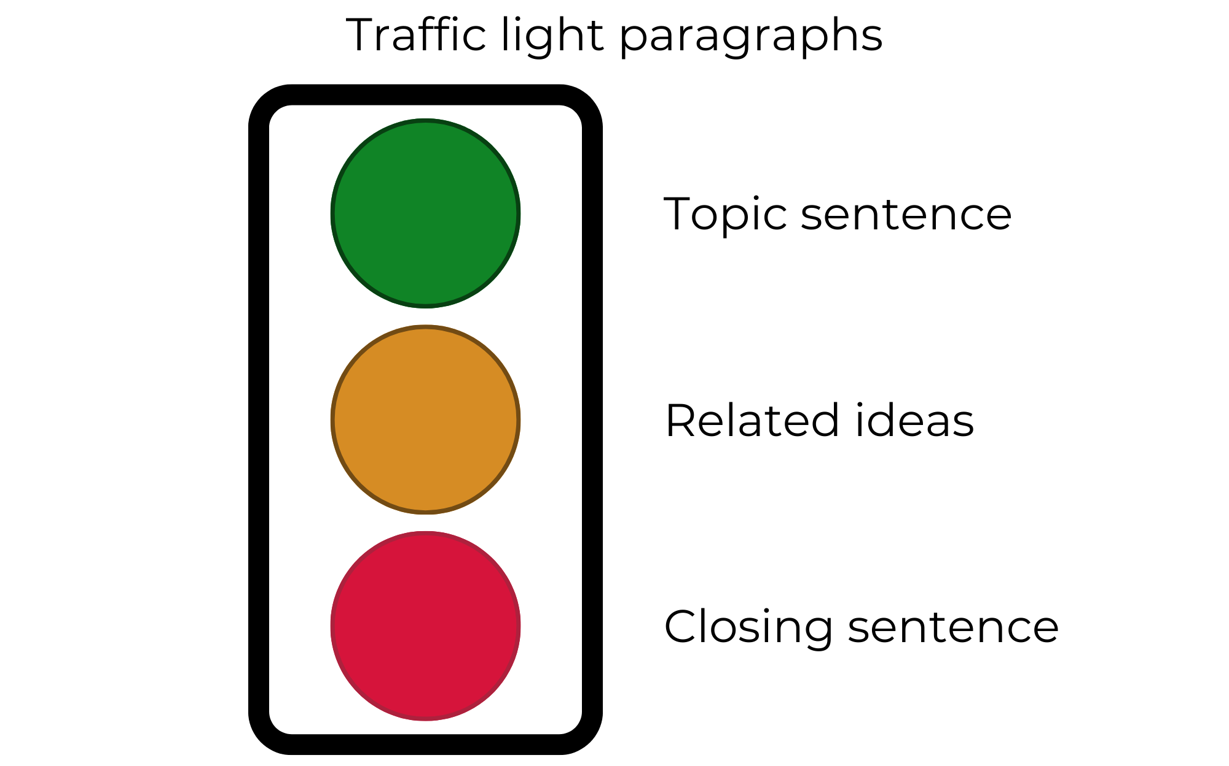

Resource 2: Tilly and me
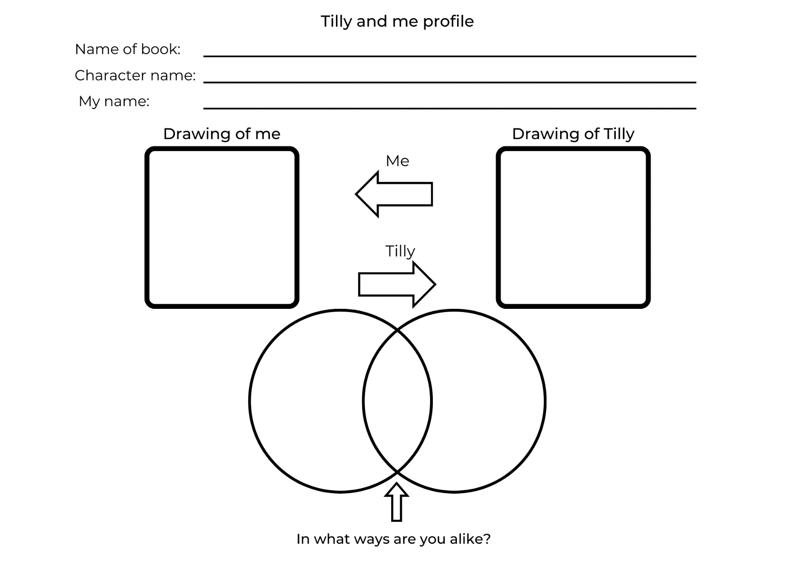

Resource 3: Treasure table
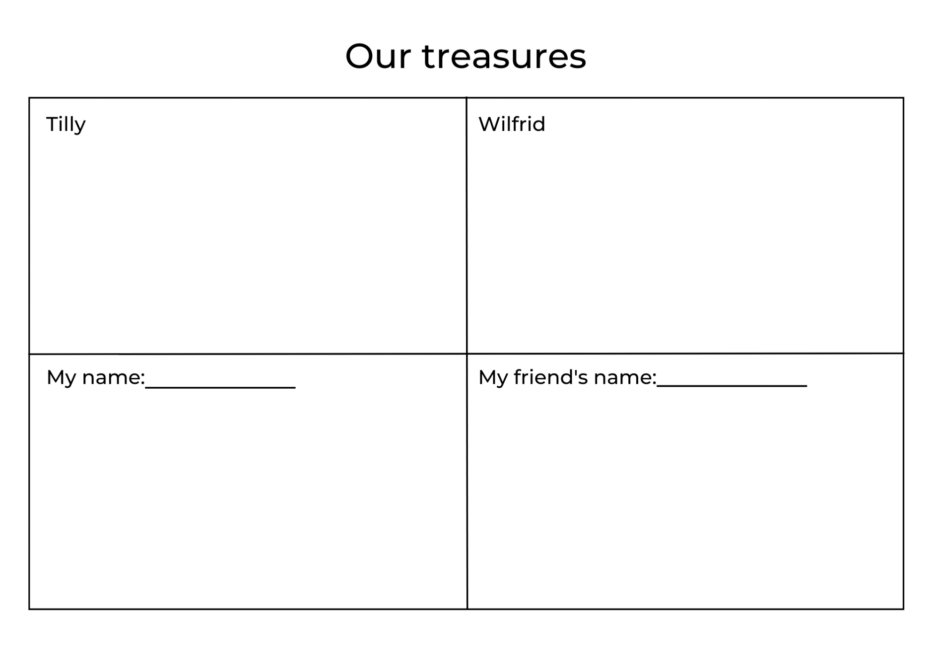

Resource 4: Character talking strips
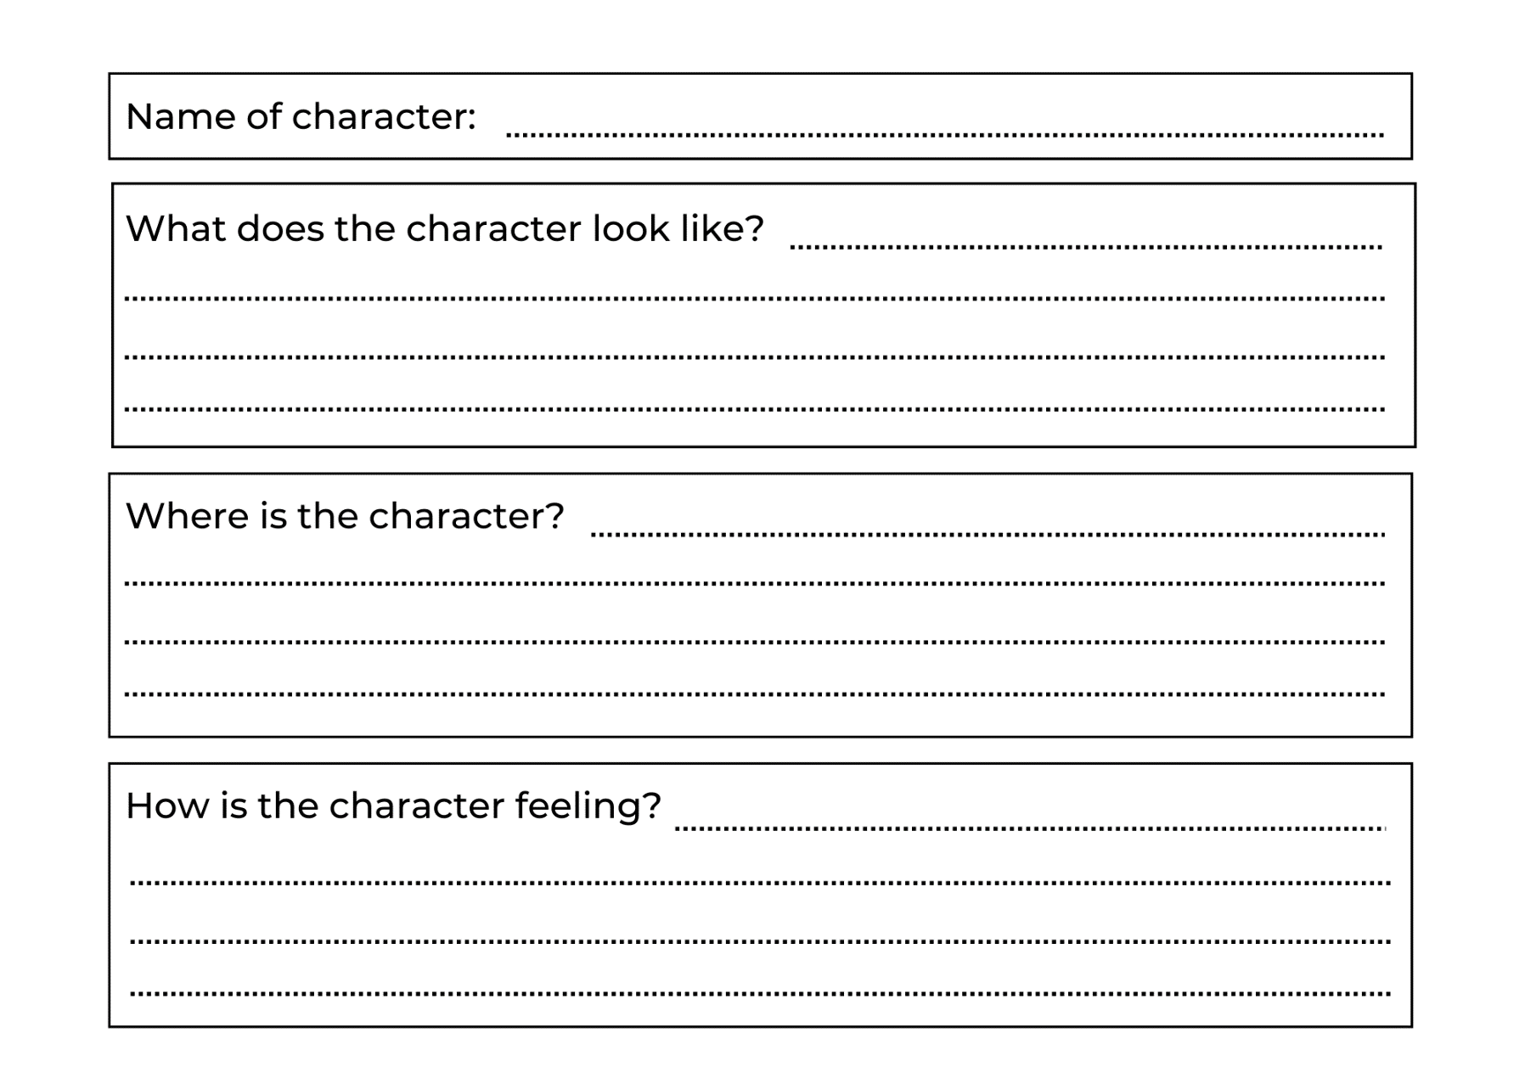

Resource 5: Treasure talking strips
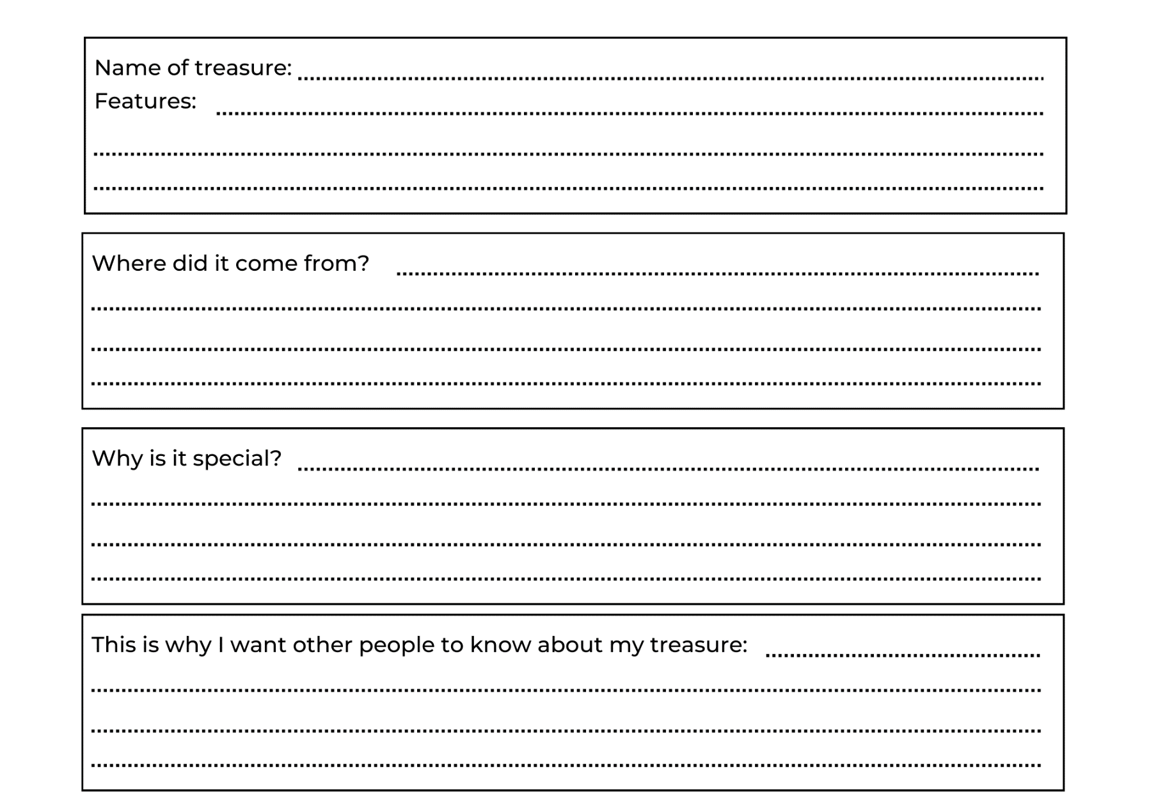

Resource 6: Annotated sample letter
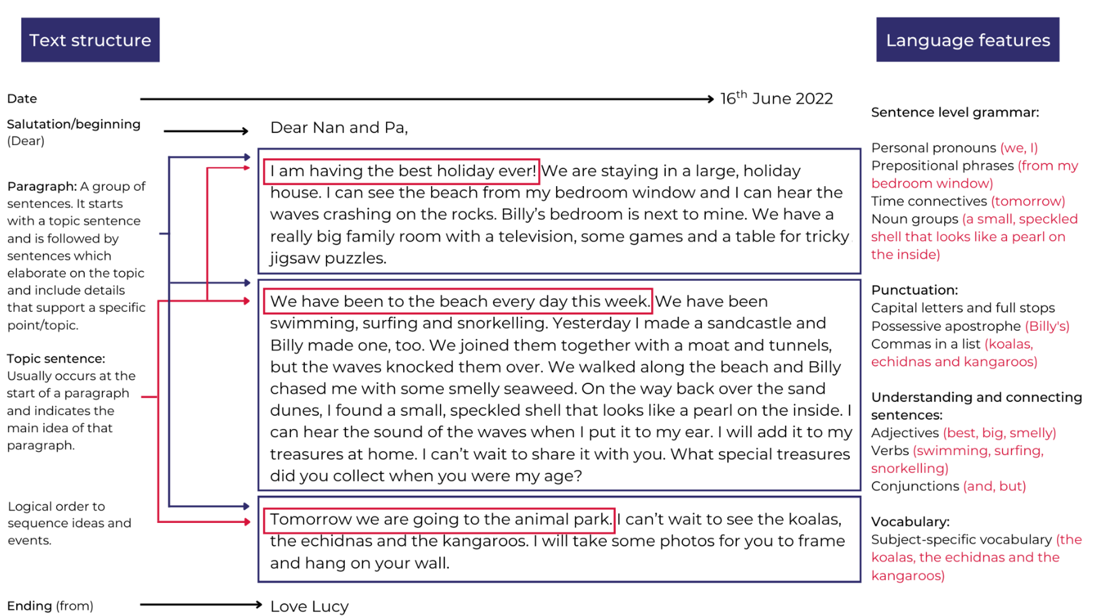

Resource 7: Sample letter
16th June 2022
Dear Nan and Pa,
I am having the best holiday ever! We are staying in a large, holiday house. I can see the beach from my bedroom window and I can hear the waves crashing on the rocks. Billy’s bedroom is next to mine. We have a really big family room with a television, some games and a table for tricky jigsaw puzzles.
We have been to the beach every day this week. We have been swimming, surfing and snorkelling. Yesterday I made a sandcastle and Billy made one, too. We joined them together with a moat and tunnels, but the waves knocked them over. We walked along the beach and Billy chased me with some smelly seaweed. On the way back over the sand dunes, I found a small, speckled shell that looks like a pearl on the inside. I can hear the sound of the waves when I put it to my ear. I will add it to my treasures at home. I can’t wait to share it with you. What special treasures did you collect when you were my age?
Tomorrow we are going to the animal park. I can’t wait to see the koalas, the echidnas and the kangaroos. I will take some photos for you to frame and hang on your wall.
Love Lucy

Resource 8: Teddy is hiding cards
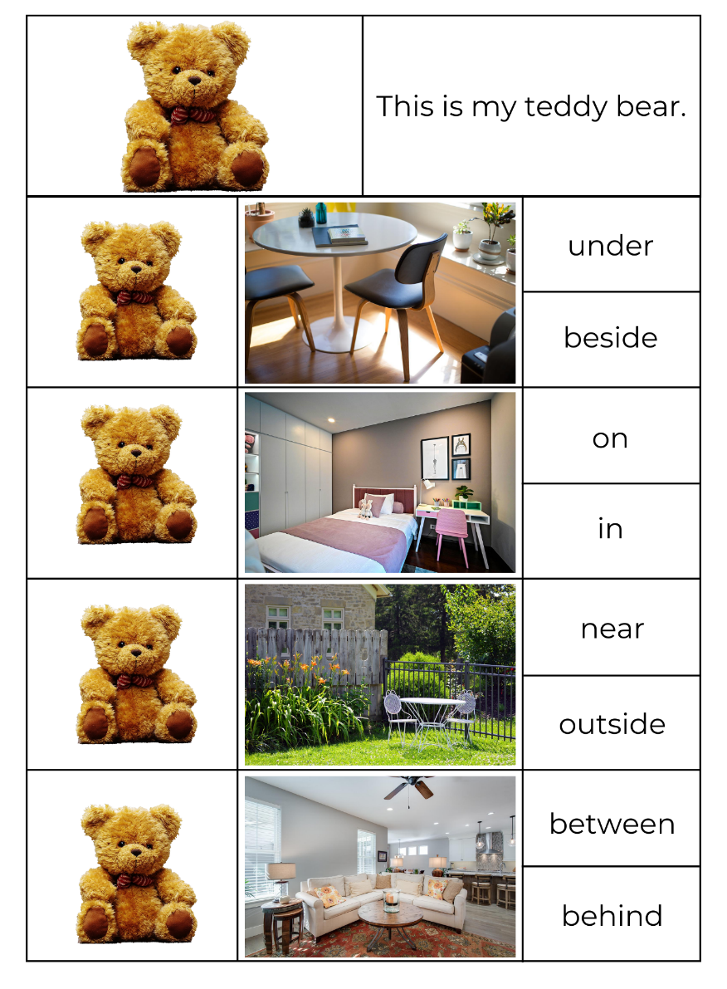
Images sourced from Pixabay and used in accordance with the Pixabay Licence.

References
Links to third-party material and websites
Please note that the provided (reading/viewing material/list/links/texts) are a suggestion only and implies no endorsement, by the New South Wales Department of Education, of any author, publisher, or book title. School principals and teachers are best placed to assess the suitability of resources that would complement the curriculum and reflect the needs and interests of their students.
If you use the links provided in this document to access a third-party's website, you acknowledge that the terms of use, including licence terms set out on the third-party's website apply to the use which may be made of the materials on that third-party website or where permitted by the Copyright Act 1968 (Cth). The department accepts no responsibility for content on third-party websites.
Except as otherwise noted, all material is © State of New South Wales (Department of Education), 2023 and licensed under the Creative Commons Attribution 4.0 International License. All other material (third-party material) is used with permission or under licence. Where the copyright owner of third-party material has not licensed their material under a Creative Commons or similar licence, you should contact them directly for permission to reuse their material.
English K–10 Syllabus © 2022 NSW Education Standards Authority (NESA) for and on behalf of the Crown in right of the State of New South Wales.
Creative Arts K–6 Syllabus © 2006 NSW Education Standards Authority (NESA) for and on behalf of the Crown in right of the State of New South Wales.
© 2022 NSW Education Standards Authority. This document contains NSW Curriculum and syllabus content. The NSW Curriculum is developed by the NSW Education Standards Authority. This content is prepared by NESA for and on behalf of the Crown in right of the State of New South Wales. The material is protected by Crown copyright.
Please refer to the NESA Copyright Disclaimer for more information.
NESA holds the only official and up-to-date versions of the NSW Curriculum and syllabus documents. Please visit the NSW Education Standards Authority (NESA) website and the NSW Curriculum website.
National Literacy Learning Progression © Australian Curriculum, Assessment and Reporting Authority (ACARA) 2010 to present, unless otherwise indicated. This material was downloaded from the Australian Curriculum website (National Literacy Learning Progression) (accessed 1 February 2023) and was not modified. The material is licensed under CC BY 4.0. Version updates are tracked in the ‘Curriculum version history’ section on the 'About the Australian Curriculum' page of the Australian Curriculum website.
ACARA does not endorse any product that uses the Australian Curriculum or make any representations as to the quality of such products. Any product that uses material published on this website should not be taken to be affiliated with ACARA or have the sponsorship or approval of ACARA. It is up to each person to make their own assessment of the product, taking into account matters including, but not limited to, the version number and the degree to which the materials align with the content descriptions and achievement standards (where relevant). Where there is a claim of alignment, it is important to check that the materials align with the content descriptions and achievement standards (endorsed by all education Ministers), not the elaborations (examples provided by ACARA).
ETA (English Teachers Association) and NSW Department of Education (2016) The Textual Concepts and Processes resource, English Textual Concepts website, accessed 1 February 2023
Fox M (1992) Wilfrid Gordon McDonald Partridge (Vivas J, illus.), Puffin, London (original work published 1984).
Godwin J (n.d.) Tilly, Jane Godwin website, accessed 1 February 2023.
Godwin J (2019) Tilly (Walker A, illus.), Scholastic Australia Pty Ltd.
NASA (National Aeronautics and Space Administration) (2023) Earth, NASA Space Place website, accessed 1 February 2023.

