English – K-2 multi-age – Year A – Unit 13
Contents
Unit overview and instructions for use 3
Teacher notes 4
Outcomes and content – Component A 5
Outcomes and content – Component B 9
Week 1 13
Component A teaching and learning 13
Component B teaching and learning 14
Lesson 1: Text orientation – Boy 16
Lesson 2: Verbs 19
Lesson 3: Tense 21
Lesson 4: Vocabulary 24
Lesson 5: Digital texts and punctuation 27
Week 2 31
Component A teaching and learning 31
Component B teaching and learning 32
Lesson 6: The Black Book of Colours – Context and text orientation 34
Lesson 7: Non-verbal communication modes 35
Lesson 8: Creating written texts 37
Lesson 9: Creating multimodal texts 39
Lesson 10: Showcasing student learning 41
Resource 1: Morphology chart teacher model 42
Resource 2: Verbs 43
Resource 3: Verbs from Boy 44
Resource 4: Verb dictionary template 45
Resource 5: Word mat 46
Resource 6: Speech bubbles for comic strip 47
Resource 7: Comic strip conversation 48
Resource 8: Using quotation marks for dialogue 49
Resource 9: Dialogue checklist 50
Resource 10: Planning scaffold 51
Resource 11: Storyboard 52
References 53

Unit overview and instructions for use
This two-week unit is comprised of Component A and Component B. Connecting learning across both components is encouraged.
Teaching and learning | Component A | Component B
Suggested duration | 60 minutes | 45 minutes
Explicit teaching focus areas | - Phonological awareness (Early Stage 1)  - Print conventions (Early Stage 1)  - Phonic knowledge  - Reading fluency  - Reading comprehension  - Spelling  - Handwriting | - Oral language and communication  - Vocabulary  - Reading comprehension  - Creating written texts  - Understanding and responding to literature
To prepare for teaching and learning: | - Refer to Outcomes and content – Component A, K-2 – Instructional sequence – grapheme–phoneme correspondences [PDF 825 KB], and the teaching advice documents (hyperlinked in Component A teaching and learning table).  - Based on student needs identified through ongoing assessment data, plan and document how you will sequence teaching and learning in whole class and targeted teaching groups across the two-week cycle. | - Familiarise yourself with Outcomes and content – Component B, Textual concepts information and videos, English Textual Concepts and Learning Processes (2016), and the teaching and learning sequence.  - Based on student needs identified through ongoing assessment data, determine how you will support students in whole class and targeted teaching groups across the two-week cycle as required.
English K–10 Syllabus © 2022 NSW Education Standards Authority (NESA) for and on behalf of the Crown in right of the State of New South Wales.

Teacher notes
- Context is defined as a culturally or socially situated circumstance that may give rise to a particular register (NESA Glossary). To understand context, we look beyond the text to consider the world in which it was produced and the worlds of its reception. – English Textual Concepts and Learning Processes (2016).
- While context is the mentor concept for the conceptual component of this unit, the supporting concept of narrative can be explored using the mentor text Boy by Phil Cummings.
- This unit could enhance student learning towards achievement of outcomes from the Creative Arts syllabus regarding drama and visual arts. Digital technologies are also incorporated through the explicit teaching of website and digital text navigation.
- For information on verbs, morphemes, tiers of vocabulary, navigation pathways and Australian sign language (Auslan), refer to the NESA Glossary.
- For information, definitions, and terminology related to Deaf, deaf and hard of hearing persons; blind and low vision persons; refer to the Inclusive Practice Hub.
- Reflect on student learning and engagement in activities and record adjustments, differentiation and modifications within the unit to inform future teaching and learning. One way of doing this could be to add comments to the digital file.
- Content points are linked to the National Literacy Learning Progression version (3).
Levels and indicators sourced from National Literacy Learning Progression © Australian Curriculum, Assessment and Reporting Authority (ACARA), (accessed 1 February 2022 and was not modified). See references for more information.

Outcomes and content – Component A
The table below outlines the focus outcomes and content. Content is linked to the National Literacy Learning Progression version (3).
Early Stage 1 Focus area and outcome | Stage 1 Focus area and outcome
Phonological awareness  ENE-PHOAW-01 – identifies, blends, segments and manipulates phonological units in spoken words as a strategy for reading and creating texts  - blend aloud all phonemes when asked to delete, add or substitute an initial phoneme (PhA4)  - blend aloud all phonemes when asked to delete, add or substitute a final phoneme | N/A
Print conventions  ENE-PRINT-01 – tracks written text from left to right and from top to bottom of the page and identifies visual and spatial features of print  - as needed | N/A
Phonic knowledge  ENE-PHOKW-01 – uses single-letter grapheme–phoneme correspondences and common digraphs to decode and encode words when reading and creating texts  - decode words containing split digraphs and vowel digraphs (PKW5)  - experiment with encoding high-frequency words containing split digraphs and vowel digraphs | Phonic knowledge  EN1-PHOKW-01 – uses initial and extended phonics, including vowel digraphs, trigraphs to decode and encode words when reading and creating texts  - blend and decode one-syllable words with taught extended vowel graphs, digraphs, including graphemes for r-controlled vowels and dipthongs, and apply this when reading texts (PKW6, PKW7)  - segment and encode one-syllable words with taught vowel graphs, digraphs and trigraphs and apply this when creating texts  - decode words with trigraphs and quadgraphs and apply this when reading texts  - blend and decode two-syllable words with taught vowel digraphs, digraphs, trigraphs and quadgraphs, including graphemes for r-controlled vowels and dipthongs, and apply this when reading texts (PKW6, PKW7)
Reading fluency  ENE-REFLU-01 – reads decodable texts aloud with automaticity  - know that fluent reading involves recognising and reading words accurately and automatically  - regulate their voice to respond to punctuation such as question marks and exclamation marks (FIY4) | Reading fluency  EN1-REFLU-01 – sustains reading unseen texts with automaticity and prosody and self-corrects errors  - use sentence punctuation to enhance reading in a conversational manner (FIY3, FIY4)
Reading comprehension  ENE-RECOM-01 – comprehends independently read texts using background knowledge, word knowledge and understanding of how sentences connect  - ask or pause to clarify meaning of unknown words (UnT3)  - re-read to check if an error was made  - self-correct error using phonic knowledge (UnT5) | Reading comprehension  EN1-RECOM-01 – comprehends independently read texts that require sustained reading by activating background and word knowledge, connecting and understanding sentences and whole text, and monitoring for meaning  - use known morphemes and known vocabulary in the text to work out or refine the meaning of unknown words (UnT4)  - monitor understanding to ensure meaning is sustained and expanded through the whole text (UnT6)
Spelling  ENE-SPELL-01 – applies phonological, orthographic and morphological generalisations and strategies to spell taught familiar and high-frequency words when creating texts  - experiment with some vowel digraphs and split digraphs to spell taught high-frequency words and/or personally significant words  - experiment with the tense-marking suffixes to spell familiar base verbs (SpG5)  - spell high-frequency compound words and homophones comprising taught graphemes | Spelling  EN1-SPELL-01 – applies phonological, orthographic and morphological generalisations and strategies when spelling words in a range of writing contexts  - segment multisyllabic words into syllables and phonemes as a strategy for spelling (SpG5)  - spell high-frequency base words with taught vowel digraphs, digraphs, split digraphs, trigraphs and quadgraphs (SpG6)  - use spelling conventions when adding tense-marking suffixes (SpG9)  - use the suffixes -ful, -y, and -ly to spell taught high-frequency words (SpG9)
Handwriting  ENE-HANDW-01 – produces all lower-case and upper-case letters to create texts  - use writing implements with a stable and relaxed pencil grasp (HwK2). | Handwriting  EN1-HANDW-01 – uses a legible, fluent and automatic handwriting style, and digital technology, including word-processing applications, when creating texts  - recognise and use keys to show more complex punctuation or symbols (HwK5)  - type up to 5 familiar words per minute.

Outcomes and content – Component B
The table below outlines the focus outcomes and content. Content is linked to the National Literacy Learning Progression version (3).
Early Stage 1 Focus area and outcome | Stage 1 Focus area and outcome
Oral language and communication  ENE-OLC-01 – communicates effectively by using interpersonal conventions and language with familiar peers and adults  - recognise how nonverbal language can contribute to meaning in spoken communication (LiS3)  - understand how the most common inflected word forms affect the meanings of words  - contribute to group conversations (InT3)  - use regular past tense verbs when speaking  - use irregular past tense verbs when speaking | Oral language and communication  EN1-OLC-01 – communicates effectively by using interpersonal conventions and language to extend and elaborate ideas for social and learning interactions  - understand that oral language can be used in combination with nonverbal communication  - respond to information by asking relevant questions to extend their own and others' knowledge (LiS4, LiS6)  - initiate, listen and/or respond in partner and group conversations (InT3, InT5)  - use tense correctly to discuss past, present and future events
Vocabulary  ENE-VOCAB-01 – understands and effectively uses Tier 1 and Tier 2 words in familiar contexts  - recognise and understand taught Tier 1 and Tier 2 words (PKW3, SpK3)  - use vocabulary to select, match and provide categories for groups of images or words | Vocabulary  EN1-VOCAB-01 – understands and effectively uses Tier 1, taught Tier 2 and Tier 3 vocabulary to extend and elaborate ideas  - use taught morphemic knowledge to create word families
Reading comprehension  ENE-RECOM-01 – comprehends independently read texts using background knowledge, word knowledge and understanding of how sentences connect  - understand how adjectives describe a noun and verbs identify actions in a sentence | Reading comprehension  EN1-RECOM-01 – comprehends independently read texts that require sustained reading by activating background and word knowledge, connecting and understanding sentences and whole text, and monitoring for meaning  - use known morphemes and known vocabulary in the text to work out or refine the meaning of unknown words (UnT4)  - draw on sources to seek clarification for unknown words  - make an inference by connecting the meaning of words across sentences and/or paragraphs  - combine multiple sources of information within a text to make meaning  - use navigation pathways, including hyperlinks, to extract essential information to support reading fluency and enhance meaning when reading digital texts  - coordinate information or events from different parts of the text to form an overall opinion  - confirm meaning by sequencing and explaining events and information
Creating written texts  ENE-CWT-01 – creates written texts that include at least 2 related ideas and correct simple sentences  - create a text including at least 2 related ideas (CrT5)  - identify and use verbs in simple sentences, including in own writing (GrA2)  - use question marks and exclamation marks (PuN3)  - use personal vocabulary, words on display and in mentor texts when constructing sentences  - identify differences between spoken and written language  - understand they can improve their writing based on feedback from teachers  - edit their texts after receiving feedback | Creating written texts  EN1-CWT-01 – plans, creates and revises texts written for different purposes, including paragraphs, using knowledge of vocabulary, text features and sentence structure  - use appropriate tense across a text (GrA4)  - use action, saying, relating and sensing verbs to add detail and precision to writing (GrA2, GrA5)  - use quotation marks for simple dialogue (PuN5)  - make intentional word choices to enhance precision of meaning and ideas in a text (CrT5)  - identify the context, audience and purpose for own texts (CrT5, CrT6)  - re-read and edit their own texts after receiving feedback
Understanding and responding to literature  ENE-UARL-01 – understands and responds to literature read to them  - identify texts that are composed for specific audiences and purposes  - identify and contrast features of texts that inform, persuade and/or entertain (UnT5)  - create imaginative and/or informative texts relating to their own experience, the world and/or other texts (CrT3). | Understanding and responding to literature  EN1-UARL-01 – understands and responds to literature by creating texts using similar structures, intentional language choices and features appropriate to audience and purpose  - identify how the language and form of a text vary according to purpose, audience and mode (UnT5)  - recognise ways that settings and situations are represented within texts  - create and re-create texts in a range of modes and media using understanding of context (CrT5)

Week 1

Component A teaching and learning
The table below can be used to plan and document lessons that address Component A outcomes and content. Both the detailed example [DOC 529KB] of a two-week teaching and learning cycle and brief example [DOC 66KB] may support you in your planning.
Focus Areas | Lesson 1 | Lesson 2 | Lesson 3 | Lesson 4 | Lesson 5
Phonological awareness (Early Stage 1) and Phonic knowledge
15 minutes
Spelling and Handwriting
15 minutes
Print conventions (Early Stage 1), Reading comprehension and Reading fluency
30 minutes

Component B teaching and learning
The following teaching and learning sequence has been designed to address Component B outcomes and content. Adapt the sequence as required to best meet the needs of your students.

Learning intention and success criteria
Learning intentions and success criteria are best co-constructed with students. The table below contains suggested learning intentions and success criteria.
Element | Early Stage 1 | Stage 1
Learning intentions | Students are learning how texts can be created for audiences with different communication needs. | Students are learning to understand that the form and features of texts vary depending on the audience.
Success criteria | Students can:  - identify the audience and purpose of different texts  - make text-to-self, text-to-text and/or text-to-world connections  - understand that Auslan is a non-verbal language  - use past tense verbs correctly when speaking  - understand and use new vocabulary  - identify and use verbs in writing  - effectively use question marks and exclamation marks in dialogue. | Students can:  - identify the context, purpose, audience and mode of a text  - understand that oral language and non-verbal communication can be used to convey a message  - make inferences about a text  - describe how settings and situations are represented within texts  - identify morphemes in verbs  - use correct tense when speaking  - use consistent tense in own writing  - identify navigation pathways that support meaning when reading digital texts.

Resources
- Cummings P (2022) Boy (Devries S, illus) Scholastic Australia Pty Ltd, Sydney. ISBN: 9781761124891
- Resource 1: Morphology chart teacher model
- Resource 2: Verbs
- Resource 3: Verbs from Boy
- Resource 4: Verb dictionary template
- Resource 5: Word mat
- Resource 6: Speech bubbles for comic strip
- Resource 7: Comic strip conversation
- Resource 8: Using quotation marks for dialogue
- Resource 9: Dialogue checklist
- Video: Bluey episode Turtleboy (7:00) (in Auslan) on ABC Kids
- City of Sydney: Auslan and English storytime online
- Auslan Signbank Dictionary
- Dictionaries
- Early Stage 1 – a range of familiar texts with corresponding play boxes including a variety of tactile resources for acting out stories, for example, puppets, dress ups, small toys, building blocks
- Large dice
- Mini whiteboards
- Sticky notes

Lesson 1: Text orientation – Boy
The following teaching and learning activities support multi-age settings.

Whole
- View a text in Auslan from City of Sydney: Auslan and English storytime online.
- Scaffold and record student thinking about the video using the Think, Puzzle, Explore strategy:
- Think – What do you think you know about Auslan?
- Puzzle – What questions or puzzles do you have?
- Explore – How might you explore the questions or puzzles you have? Prompt students to consider what tools and resources they will need to explore their questions.
- Read Boy by Phil Cummings. Ask students what it means to be deaf or hard of hearing.
- Turn to the page with the text ‘He spoke with dancing hands.’ Explain that Auslan is a language with its own culturally influenced phrases, grammatical rules, and features. Discuss the different ways people communicate and the relationship between communication and understanding.
- Use questioning to scaffold student discussion about the text. For example:
- How did Boy communicate so that he was understood?
- How did Boy know his parents didn’t like the fighting that was going on around them?
- Why did Boy run into the middle of the battle? What characteristics did this show?
- How did Boy’s actions change how the people in the village treated him?
- Revisit the textual concept, context. Explain that Boy was based on author Phil Cumming’s experiences with a deaf family member.

Part
The table below details the differentiated teaching and learning activities for each stage.
Early Stage 1 (teacher guided/independent) | Stage 1 (small groups/teacher guided)
- Students make text-to-self, text-to-text, or text-to-world connections. Using the Draw, Talk, Share, Write strategy students describe how the text, Boy, relates to their own experiences, the world and/or other texts. | - In small groups, students use a Y-chart to explore what the world looks like, feels like and sounds like for Boy.  - Ask students to identify the different situations represented in Boy and how.

Whole
- Discuss how groups and situations are represented within and across texts and how people’s experiences and knowledge influence how they create and respond to texts.
Early Stage 1 Assessment task 1 – Observations and work samples from this lesson allow students to demonstrate achievement towards the following syllabus outcomes and content points:
ENE-OLC-01 – communicates effectively by using interpersonal conventions and language with familiar peers and adults
- recognise how nonverbal language can contribute to meaning in spoken communication.
Stage 1 Assessment task 1– Observations and work samples from this lesson allow students to demonstrate achievement towards the following syllabus outcomes and content points:
EN1-RECOM-01 – comprehends independently read texts that require sustained reading by activating background and word knowledge, connecting and understanding sentences and whole text, and monitoring for meaning
- make an inference by connecting the meaning of words across sentences and/or paragraphs
- coordinate information or events from different parts of the text to form an overall opinion
- confirm meaning by sequencing and explaining events and information.
EN1-UARL-01 – understands and responds to literature by creating texts using similar structures, intentional language choices and features appropriate to audience and purpose
- identify how the language and form of a text vary according to purpose, audience and mode
- recognise ways that settings and situations are represented within texts.

Lesson 2: Verbs
The following teaching and learning activities support multi-age settings.

Whole
- Search the Auslan Signbank Dictionary for a simple greeting to teach the class.
- Review students’ prior knowledge about verbs, reiterating that they are action, saying, relating or sensing words. Discuss the purpose of verbs.
- Select students to act out different types of saying, action or sensing verbs, for example, shouted (saying), stroking (action). Students guess the word, write it and use a dictionary to explore word meaning.
- Explain that a morpheme is the smallest unit of meaning in a word. For example, ‘pointed’ has 2 morphemes, the base word ‘point’ plus tense marking suffix ‘-ed’. Refer to Resource 1: Morphology chart teacher model.
- Use the text, Boy, to identify verbs. Select a verb and identify the morphemes. Discuss how the morphemes help to build meaning.

Part
The table below details the differentiated teaching and learning activities for each stage.
Early Stage 1 (small groups/teacher guided/independent) | Stage 1 (teacher guided/pairs)
- In small groups, students choose verbs from Resource 2: Verbs and take turns acting them out while other students guess the verb.  - Model and co-construct written sentences using verbs from the resource.  - Students use words from Resource 2: Verbs to write sentences.  Too hard? Students work with a partner to co-construct sentences using verbs.  Too easy? Students identify if the verbs in their sentences are action, saying or sensing verbs. | - Compare the features and purpose of hard copy and digital dictionaries. Explain that students will co-construct a dictionary of verbs from the text, Boy. Display Resource 3: Verbs from Boy.  - Model completing Resource 4: Verb dictionary template.  - Prepare a space large enough to display multiple copies of Resource 4: Verb dictionary template in alphabetical order. Sticky notes with each letter of the alphabet may be helpful here.  - In pairs, students choose interesting or unfamiliar verbs from Resource 3: Verbs from Boy and use a dictionary to complete their own copy of Resource 4: Verb dictionary template.  - Students collate their verb dictionary templates in alphabetical order to create a class dictionary.  Too hard? Co-construct definitions for the verbs.  Too easy? Students compare the word meanings found in different dictionaries.

Whole
- Students reflect on their learning using exit tickets.
Early Stage 1 Assessment task 2 – Observations and collecting work samples from this lesson allow students to demonstrate achievement towards the following syllabus outcomes and content points:
ENE-RECOM-01 – comprehends independently read texts using background knowledge, word knowledge and understanding of how sentences connect
- understand how adjectives describe a noun and verbs identify actions in a sentence.
ENE-CWT-01 – creates written texts that include at least 2 related ideas and correct simple sentences
- identify and use verbs in simple sentences, including in own writing.
Stage 1 Assessment task 2 – Observations and collecting work samples from this lesson allow students to demonstrate achievement towards the following syllabus outcome and content points:
EN1-RECOM-01– comprehends independently read texts that require sustained reading by activating background and word knowledge, connecting and understanding sentences and whole text, and monitoring for meaning
- use known morphemes and known vocabulary in the text to work out or refine the meaning of unknown words
- draw on sources to seek clarification for unknown words.

Lesson 3: Tense
The following teaching and learning activities support multi-age settings.

Whole
- Search the Auslan Signbank Dictionary to locate a new sign to learn.
- Revise the purpose of verbs in texts as outlined in Lesson 2. Explain that tense indicates when something is happening.
- Re-read Boy. While reading, pause to identify the use of verbs and tense-marking indicators throughout the text. Explicitly teach the use of suffixes -ed and -ing to show tense for regular verbs. Explain that not all verbs are suffixed to show tense. Draw attention to irregular verbs in the text, for example, draw becomes drew.

Part
The table below details the differentiated teaching and learning activities for each stage.
Early Stage 1 (small groups) | Stage 1 (teacher guided/pairs)
- Provide students with themed texts and play boxes, for example, fairy tales. In small groups, students create their own stories using role play.  - Label the face of a large die with present tense verbs. Students take turns to roll the die, say the verb, change it to past tense and write it in a sentence. | - Display the pages in the text, Boy, where the characters are pointing at each other. Highlight the verbs and suffixes that indicate past tense.  - Remind students that tense-marking suffixes are morphemes, the smallest unit of meaning in a word. Brainstorm tense-marking suffixes.  - Create a three-column chart with the headings: past, present and future. Select verbs from the class dictionary created in Lesson 2 and add them to the appropriate column. Model identifying and modifying tense.  - In pairs, students select a verb from the chart and practise using the correct verb tense in oral sentences.  - Using the same pages from the text, discuss why each character is pointing. Ask students if they have ever jumped to a conclusion and assumed something. Ask students what they learned from that experience. Students share their experience with a partner.

Part
The table below details the differentiated teaching and learning activities for each stage.
Early Stage 1 (teacher guided) | Stage 1 (independent/pairs)
- Ask students a range of questions to encourage the correct use of regular and irregular past tense verbs. For example, what did your character do? How did your character move? Rephrase student answers if incorrect tense is used. | - Students write an account of their experience, focusing on the consistent use of tense (past).  - In pairs, students re-read and edit their texts.

Whole
- Call out verbs and have students change the tense. Discuss whether it is a regular verb with a tense marking suffix, or an irregular verb with different sounds and spelling. Ask students to identify the tense used.
Early Stage 1 Assessment task 3 – Observations and work samples from this lesson allow students to demonstrate achievement towards the following syllabus outcome and content points:
ENE-OLC-01 – communicates effectively by using interpersonal conventions and language with familiar peers and adults
- understand how the most common inflected word forms affect the meanings of words
- contribute to group conversations
- use regular past tense verbs when speaking
- use irregular past tense verbs when speaking.

Lesson 4: Vocabulary
The following teaching and learning activities support multi-age settings.

Whole
- Explain that good authors carefully consider their vocabulary and language.
- Identify examples of Tier 2 words (words that add power and precision) from the text, Boy, and record the base word. Refer to Resource 1: Morphology chart teacher model as needed.
- Select a Tier 2 word and model using Resource 5: Word mat to explore vocabulary.

Part
The table below details the differentiated teaching and learning activities for each stage.
Early Stage 1 (small groups/independent) | Stage 1 (teacher guided/independent)
- Students select another of the listed words to explore using Resource 5: Word mat.  Too hard? Modify Resource 5: Word mat and co-construct sentences.  Too easy? Students apply their understanding of Tier 2 words to write more complex sentences. | - Revise morphemes as the smallest meaningful unit in a word. This could be a base word, prefix, or suffix. When a prefix or suffix is added to a base word it can make a new word. For example, the base word ‘happy’ can be made into unhappy, happier, or happiest. Model how to add prefixes and suffixes to base words.  - Students write new words by adding prefixes and suffixes to known base words.  - Co-create an anchor chart with the terms: morphemes, base word, prefix and suffix.  - Flick through the text Boy and find words that have a base word and a suffix. Add words to the co-created anchor chart.  - Students choose morphemes from the anchor chart and write sentences to show the different tense of the base word. For example, ‘The boy points at the dragon’; ‘The boy pointed at the dragon’; ‘The boy is pointing at the dragon’.

Whole
- Use the Auslan Signbank Dictionary to locate and learn some of the vocabulary used in the text.
Early Stage 1 Assessment task 4 – Observations and work samples from this lesson allow students to demonstrate achievement towards the following syllabus outcomes and content points:
ENE-VOCAB-01 – understands and effectively uses Tier 1 and Tier 2 words in familiar contexts
- recognise and understand taught Tier 1 and Tier 2 words
- use vocabulary to select, match and provide categories for groups of images or words.
ENE-CWT-01 – creates written texts that include at least 2 related ideas and correct simple sentences
- use personal vocabulary, words on display and in mentor texts when constructing sentences.
Stage 1 Assessment task 3 – Observations and work samples from this lesson allow students to demonstrate achievement towards the following syllabus outcomes and content points:
EN1-OLC-01 – communicates effectively by using interpersonal conventions and language to extend and elaborate ideas for social and learning interactions
- use tense correctly to discuss past, present and future events.
EN1-VOCAB-01 – understands and effectively uses Tier 1, taught Tier 2 and Tier 3 vocabulary to extend and elaborate ideas
- use taught morphemic knowledge to create word families.
EN1-CWT-01 – plans, creates, and revises texts written for different purposes, including paragraphs, using knowledge of vocabulary, text features and sentence structure
- use appropriate tense across a text.

Lesson 5: Digital texts and punctuation
The following teaching and learning activities support multi-age settings.

Whole
- Remind students that texts take many forms, including online and digital. Ask students what they know about online and digital texts and their purposes.
- Open the ABC Kids website. Explain that the Australian Broadcasting Corporation (ABC) is a trusted site. Model the navigation pathways used to access videos on the website. Pause to identify and discuss key terminology used when navigating the website. For example, hyperlinks, images, videos, and captions.
- Navigate to Bluey and locate the episode Turtleboy (7:00) in Auslan. Discuss the features of the webpage including closed captioning (CC) and why it would be used. Discuss why it is important to communicate information in different modes, including non-verbal.
- View the episode. Discuss the purpose and audience.
- Discuss the similarities and differences between Boy and Bluey: Turtleboy.
- Identify and revise the author’s use of punctuation marks to show the interaction between characters in Boy.

Part
The table below details the differentiated teaching and learning activities for each stage.
Early Stage 1 (small groups/pairs) | Stage 1 (teacher guided)
- Provide students with a range of familiar texts.  - In pairs or small groups, students look for punctuation marks and record on mini whiteboards.  - Students discuss how they think the punctuation marks affect meaning. | - Model use of Resource 8: Using quotation marks for dialogue to draw a comic strip and write a conversation between 2 characters from Turtleboy. Explain that a new line and a new set of quotation marks are needed for each speaker. Use ‘think aloud’ strategy to highlight use of speaking verbs and draw attention to tense.

Part
The table below details the differentiated teaching and learning activities for each stage.
Early Stage 1 (teacher guided/small groups/pairs/independent) | Stage 1 (pairs/independent)
- Revise how exclamation and question marks affect meaning. Model the use of speech bubbles that include questions and a statement with an exclamation mark. Cut out speech bubbles from Resource 6: Speech bubbles for comic strip and glue onto Resource 7: Comic strip conversation to create a comic strip with dialogue.  - Model and discuss how a reader’s voice changes when they encounter these punctuation marks.  - Revise how to form a question mark and an exclamation mark.  - Explain that students will draw and write a conversation between 2 characters from Turtleboy using question marks and exclamation marks. Encourage students to talk about their drawings and share their thinking as they complete the resources. | - Students use Resource 8: Using quotation marks for dialogue to draw a short comic strip and write a conversation using quotation marks and speaking verbs.  - Students reflect on their written dialogue using Resource 10: Dialogue checklist and make any necessary edits.  - In pairs, students roleplay their conversation.

Whole
- Students swap their comic strips in pairs to read an unfamiliar text, changing their voices to match the punctuation marks in the written dialogue.
Early Stage 1 Assessment task 5 – Collecting work samples from this lesson allow students to demonstrate achievement towards the following syllabus outcomes and content points:
ENE-CWT-01 – creates written texts that include at least 2 related ideas and correct simple sentences
- use question marks and exclamation marks
- identify differences between spoken and written language.
ENE-UARL-01 – understands and responds to literature read to them
- identify texts that are composed for specific audiences and purposes.
Stage 1 Assessment task 4 – Observations and work samples from this lesson allow students to demonstrate achievement towards the following syllabus outcomes and content points:
EN1-CWT-01 – plans, creates and revises texts written for different purposes, including paragraphs, using knowledge of vocabulary, text features and sentence structure
- use quotation marks for simple dialogue.

Week 2

Component A teaching and learning
The table below can be used to plan and document lessons that address Component A outcomes and content. Both the detailed example [DOC 529KB] of a two-week teaching and learning cycle and brief example [DOC 66KB] may support you in your planning.
Focus Areas | Lesson 6 | Lesson 7 | Lesson 8 | Lesson 9 | Lesson 10
Phonological awareness (Early Stage 1) and Phonic knowledge
15 minutes
Spelling and Handwriting
15 minutes
Print conventions (Early Stage 1), Reading comprehension and Reading fluency
30 minutes

Component B teaching and learning
The following teaching and learning sequence has been designed to address Component B outcomes and content. Adapt the sequence as required to best meet the needs of your students.

Learning intention and success criteria
Learning intentions and success criteria are best co-constructed with students. The table below contains suggested learning intentions and success criteria.
Element | Early Stage 1 | Stage 1
Learning intentions | Students are learning to create a text that includes verbal and non-verbal forms of communication. | Students are learning to collaboratively plan, create and present inclusive multimodal texts using their understanding of context.
Success criteria | Students can:  - identify the audience and purpose of different texts  - compare texts that inform or entertain  - understand how adjectives describe a noun and verbs identify actions  - create a text including at least 2 related ideas  - share ideas and listen to others when working in a group  - edit their texts after receiving feedback  - create a multimodal text including spoken, written and non-verbal language. | Students can:  - identify the context, purpose, audience and mode of a text  - understand that oral language and non-verbal communication can be used to convey a message  - identify navigation pathways to read digital texts  - use action, saying, relating and sensing verbs to add detail to writing  - re-read and edit their own texts after receiving feedback  - ask questions to clarify inferred meaning.

Resources
- Cottin M (2010) The Black Book of Colours (Faria R, illus.), Walker Books Australia, Newtown. ISBN: 9781406322187
- Resource 10: Planning scaffold
- Resource 11: Storyboard
- Video: Great Inventors: Louis Braille (4:22)
- Braille Translator and Braille Alphabet
- Graphic organiser (for example, a Y-chart or Five senses chart)
- Materials to create Braille. For example, card, sticky dots, push pins, and/or modelling clay.
- Student copies of Braille alphabet
- Teacher-created sensory stations for Lesson 6. Examples of items include iced water, feathers, aromatic herbs such as rosemary, empty chip packets, licorice, and bird seed. Students should not be able to see the objects in each station. Label each station with how students should interact with the object. For example, ‘Smell me, feel me, taste me’.

Lesson 6: The Black Book of Colours – Context and text orientation
The following teaching and learning activities support multi-age settings.

Whole
- Introduce The Black Book of Colours. Display the front and back cover. Use the See-Think-Wonder strategy to guide discussion, ask:
- What can you see? What details stand out?
- What do you think this book will be about? What makes you think that?
- What does this text make you wonder? What questions do you have?
- Before reading, use questioning to scaffold student thinking and discussion. Ask:
- What does it mean to be blind or have low vision?
- What do you think the title The Black Book of Colours means?
- How might it feel to be blind? Explain that people who are blind or have low vision use their touch and other senses to navigate the world.
- How do our senses give us information?
- How do you understand and describe colours if you have never seen them with your eyes? How would you know what red looked like?
- Read The Black Book of Colours.
- Discuss how the text has been composed for a specific audience and purpose.
- Ask students how Thomas understands and describes colour. Explain that Braille is a system of writing that allows people who are blind or have low vision to read and write using their fingers and sense of touch.
- Set up sensory stations for students to interact with. Model using adjectives to describe the sensory items. In pairs, students take turns interacting with the different objects and use their senses to describe them to their partner, without naming the object. Students guess the object described by their partner.
- In the text, Thomas ‘likes all the colours because he can hear them, smell them, touch them, and taste them’. Use the text to model how the author describes how a colour feels, tastes, smells, and sounds. Highlight the author’s use of adjectives to add detail to the descriptions.
- Model use of a graphic organiser such as a Y-chart or Five senses chart to record words and phrases that describe how a colour looks, feels, sounds, smells and tastes. For example, ‘Yellow’ might include taste: frozen pineapple; feel: hot sand; smell: my sister’s blonde hair after she washes it. Point out that the senses are verbs and explain that adjectives can be used to enhance descriptions.
- Students choose a colour and use a graphic organiser to record words and phrases that describe how the colour looks, feels, sounds, smells and tastes like. Support students to make intentional word choices that enhance detail and precision. The completed graphic organiser will be used in Lesson 7 and Lesson 8.

Lesson 7: Non-verbal communication modes
The following teaching and learning activities support multi-age settings.

Whole
- Review the use of Braille as a system of writing that allows people who are blind, or vision impaired to read and write using their fingers and sense of touch.
- View an informative text about Louis Braille, for example, Great Inventors: Louis Braille (4:22) to learn how and why he invented Braille.
- Identify and contrast the features of the informative text with the imaginative text, The Black Book of Colours. Discuss how the texts are similar and different. Draw attention to how the language and form of each text varies according to purpose and audience.
- Visit the Braille Translator website and revise student learning about navigation pathways. Use the think-aloud strategy to model the features and purpose of the digital text. Model how to type a word in the translator box. Discuss the braille representation of the word. Identify and discuss the Tier 1, 2, and 3 words on the website.
- Provide students with a copy of the Braille Alphabet or access to the Braille Translator website.
- Students use the translator to create the braille words for their colour from Lesson 6, using sticky dots, push pins on card or modelling clay. Students could also learn the Auslan sign for the colour.
Early Stage 1 Assessment task 6 – Observations and work samples from this lesson allow students to demonstrate achievement towards the following syllabus outcomes and content points:
ENE-UARL-01 – understands and responds to literature read to them
- identify texts that are composed for specific audiences and purposes
- identify and contrast features of texts that inform, persuade and/or entertain.
Stage 1 Assessment task 5 – Observations and work samples from this lesson allow students to demonstrate achievement towards the following syllabus outcomes and content points:
EN1-RECOM-01 – comprehends independently read texts that require sustained reading by activating background and word knowledge, connecting and understanding sentences and whole text, and monitoring for meaning
- combine multiple sources of information within a text to make meaning
- use navigation pathways, including hyperlinks, to extract essential information to support reading fluency and enhance meaning when reading digital texts.
EN1-UARL-01 – understands and responds to literature by creating texts using similar structures, intentional language choices and features appropriate to audience and purpose
- identify how the language and form of a text vary according to purpose, audience and mode.

Lesson 8: Creating written texts
The following teaching and learning activities support multi-age settings.

Whole
- Re-read the text, The Black Book of Colours. Ask students to share their opinions and thoughts about the text.
- Revisit a completed graphic organiser from Lesson 6. Ask why colours make people feel differently. Discuss how colours can create a range of feelings, memories, and emotions. Explain that a person’s context is unique to them and is shaped by their experiences and knowledge. Context affects the way we think, feel, speak, and write.
- Display the modelled graphic organiser from Lesson 6.
- Referring to ideas planned on the graphic organiser, model writing descriptive sentences about a colour. Focus on how the colour feels, smells, sounds and tastes. Use the ‘think aloud’ strategy to draw attention to use of action, relating and sensing verbs, and adjectives. For example, ‘Yellow tastes like perfect rings of frozen pineapple. It feels like hot sand under my feet on a summer’s day. It smells like my sister’s freshly washed hair. It is the sun gently kissing my skin on a quiet spring morning.’
- Discuss how each students’ context, including their experiences and memories, will shape how they describe their colour.
- Students use ideas planned on the graphic organiser from Lesson 6 to write descriptive sentences about their chosen colour, using verbs and adjectives.
Too hard? Co-construct text with students. Provide sentence starters.
Too easy? Students experiment with word play and the complexity of vocabulary to elaborate on their ideas and add precision to their writing.
- Students share peer to peer feedback, then edit their writing. Provide opportunities for teacher feedback.
Early Stage 1 Assessment task 7 – Observations and collecting work samples from this lesson allow students to demonstrate achievement towards the following syllabus outcomes and content points:
ENE-RECOM-01 – comprehends independently read texts using background knowledge, word knowledge and understanding of how sentences connect
- understand how adjectives describe a noun and verbs identify actions in a sentence.
ENE-CWT-01 – creates written texts that include at least 2 related ideas and correct simple sentences
- create a text including at least 2 related ideas
- use personal vocabulary, words on display and in mentor texts when constructing sentences
- understand they can improve their writing based on feedback from teachers
- edit their texts after receiving feedback.
ENE-UARL-01 – understands and responds to literature read to them
- create imaginative and/or informative texts relating to their own experience, the world and/or other texts.

Lesson 9: Creating multimodal texts
The following teaching and learning activities support multi-age settings.

Whole
- Explain that students will apply their understanding of non-verbal communication to plan, create and deliver an inclusive multimodal presentation about their chosen colour. The multimodal presentation should include students’ writing, Auslan and a technique that will include people with low vision or who are blind.
- Discuss the specific context, audience and purpose for the multimodal presentation.
- Model using Resource 10: Planning scaffold and Resource 11: Storyboard to plan ideas for the presentation. Use the think aloud strategy to make connections in learning. Draw attention to how colours can be represented with words, using Auslan and with Braille.
- Co-construct success criteria for the multimodal presentation. For example, an inclusive and engaging multimodal presentation includes:
- descriptive writing using the 5 senses
- words represented in Auslan
- a technique that will include people with low vision or who are blind.
- In groups or pairs, students work collaboratively to plan and create an inclusive multimodal presentation about a chosen colour using Resource 10: Planning scaffold and Resource 11: Storyboard.
- Model how to ask clarifying questions when giving and receiving feedback. Students pair up with another group and provide feedback using the co-constructed success criteria.
- Provide time for students to apply peer feedback to refine their presentation.
Stage 1 Assessment task 6 – Observations and work samples from this lesson allow students to demonstrate achievement towards the following syllabus outcomes and content points:
EN1-OLC-01 – communicates effectively by using interpersonal conventions and language to extend and elaborate ideas for social and learning interactions
- understand that oral language can be used in combination with nonverbal communication
- respond to information by asking relevant questions to extend their own and others' knowledge
- initiate, listen and/or respond in partner and group conversations.
EN1-RECOM-01 – comprehends independently read texts that require sustained reading by activating background and word knowledge, connecting and understanding sentences and whole text, and monitoring for meaning
- ask a clarifying question when more background knowledge is needed to make an inference.
EN1-CWT-01 – plans, creates and revises texts written for different purposes, including paragraphs, using knowledge of vocabulary, text features and sentence structure
- use action, saying, relating and sensing verbs to add detail and precision to writing
- make intentional word choices to enhance precision of meaning and ideas in a text
- identify the context, audience and purpose for own texts
- re-read and edit their own texts after receiving feedback.
EN1-UARL-01 – understands and responds to literature by creating texts using similar structures, intentional language choices and features appropriate to audience and purpose
- create and re-create texts in a range of modes and media using an understanding of context.

Lesson 10: Showcasing student learning
The following teaching and learning activities support multi-age settings.

Whole
- Students share their multimodal presentations. Invite a live audience, for example, another class, or record presentations to share.
- Encourage each group to invite the audience to ask clarifying questions.
- Allow time for students to reflect on their learning using exit tickets.

Resource 1: Morphology chart teacher model
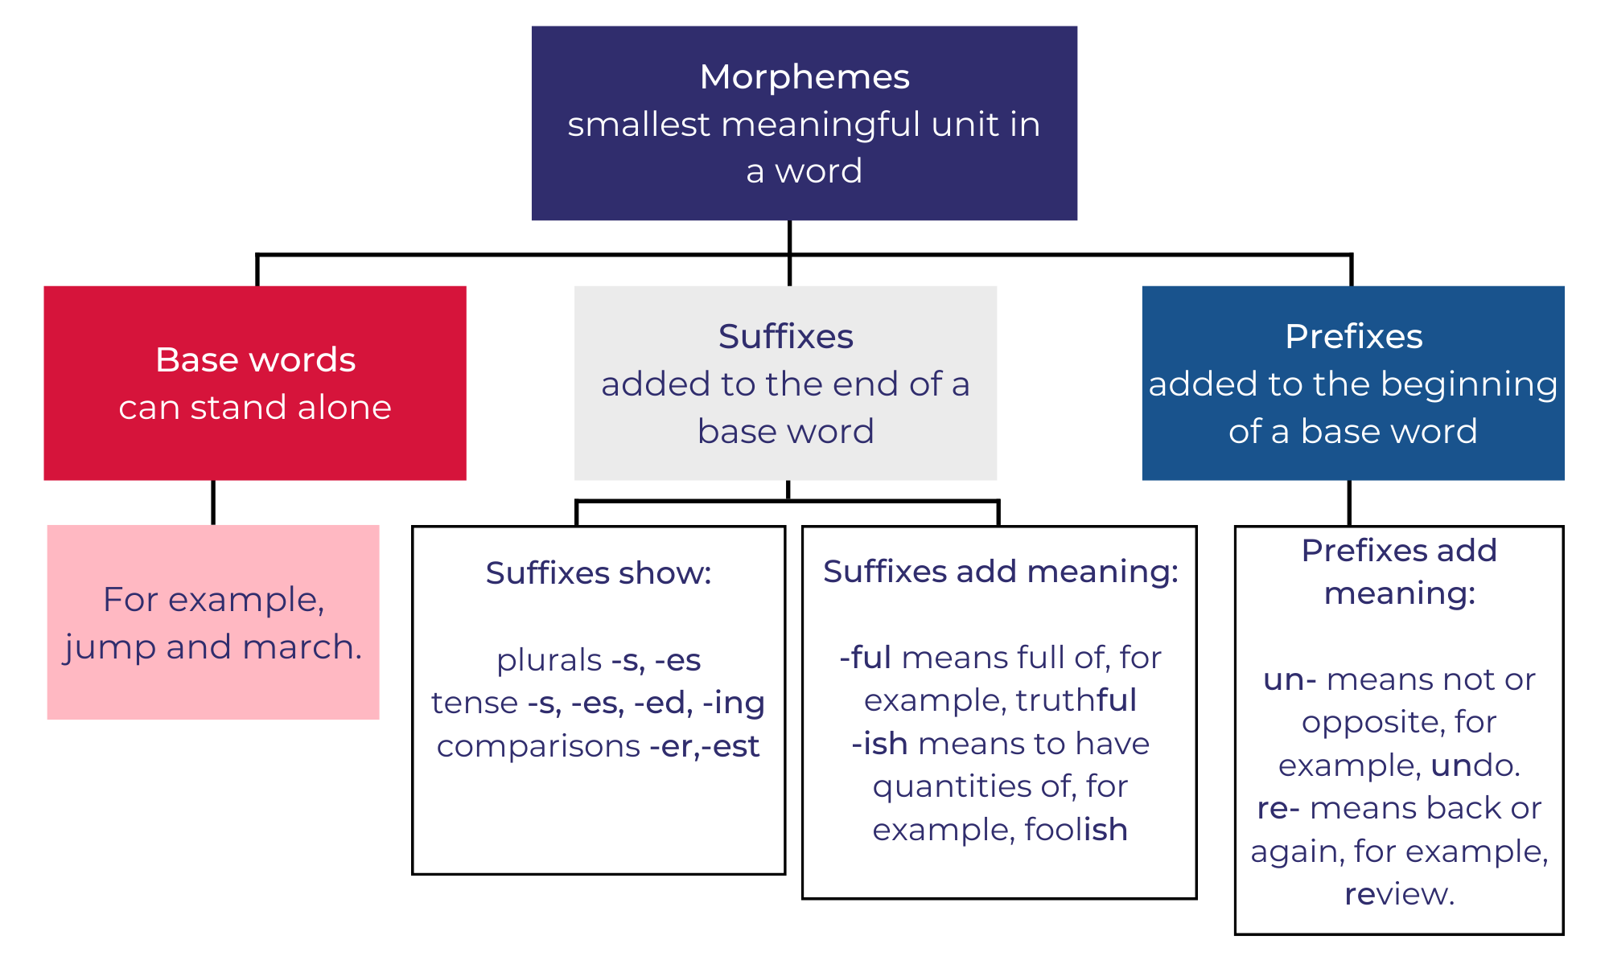

Resource 2: Verbs
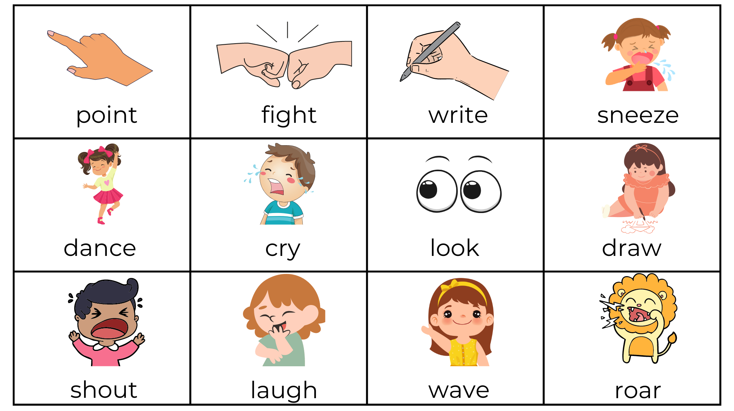
Images sourced from Canva and used in accordance with the Canva Content License Agreement.

Resource 3: Verbs from Boy
pointed | fighting | wrote | listening
chased | cried | looked | drew
chatting | laughing | waved | marched
shouting | dodging | weaving | hiding
roaring | walked | dancing | destroyed
spoke | fought | held | battling
move | ordered | hear | bellowed
watched | sneezed | replied | chorused

Resource 4: Verb dictionary template
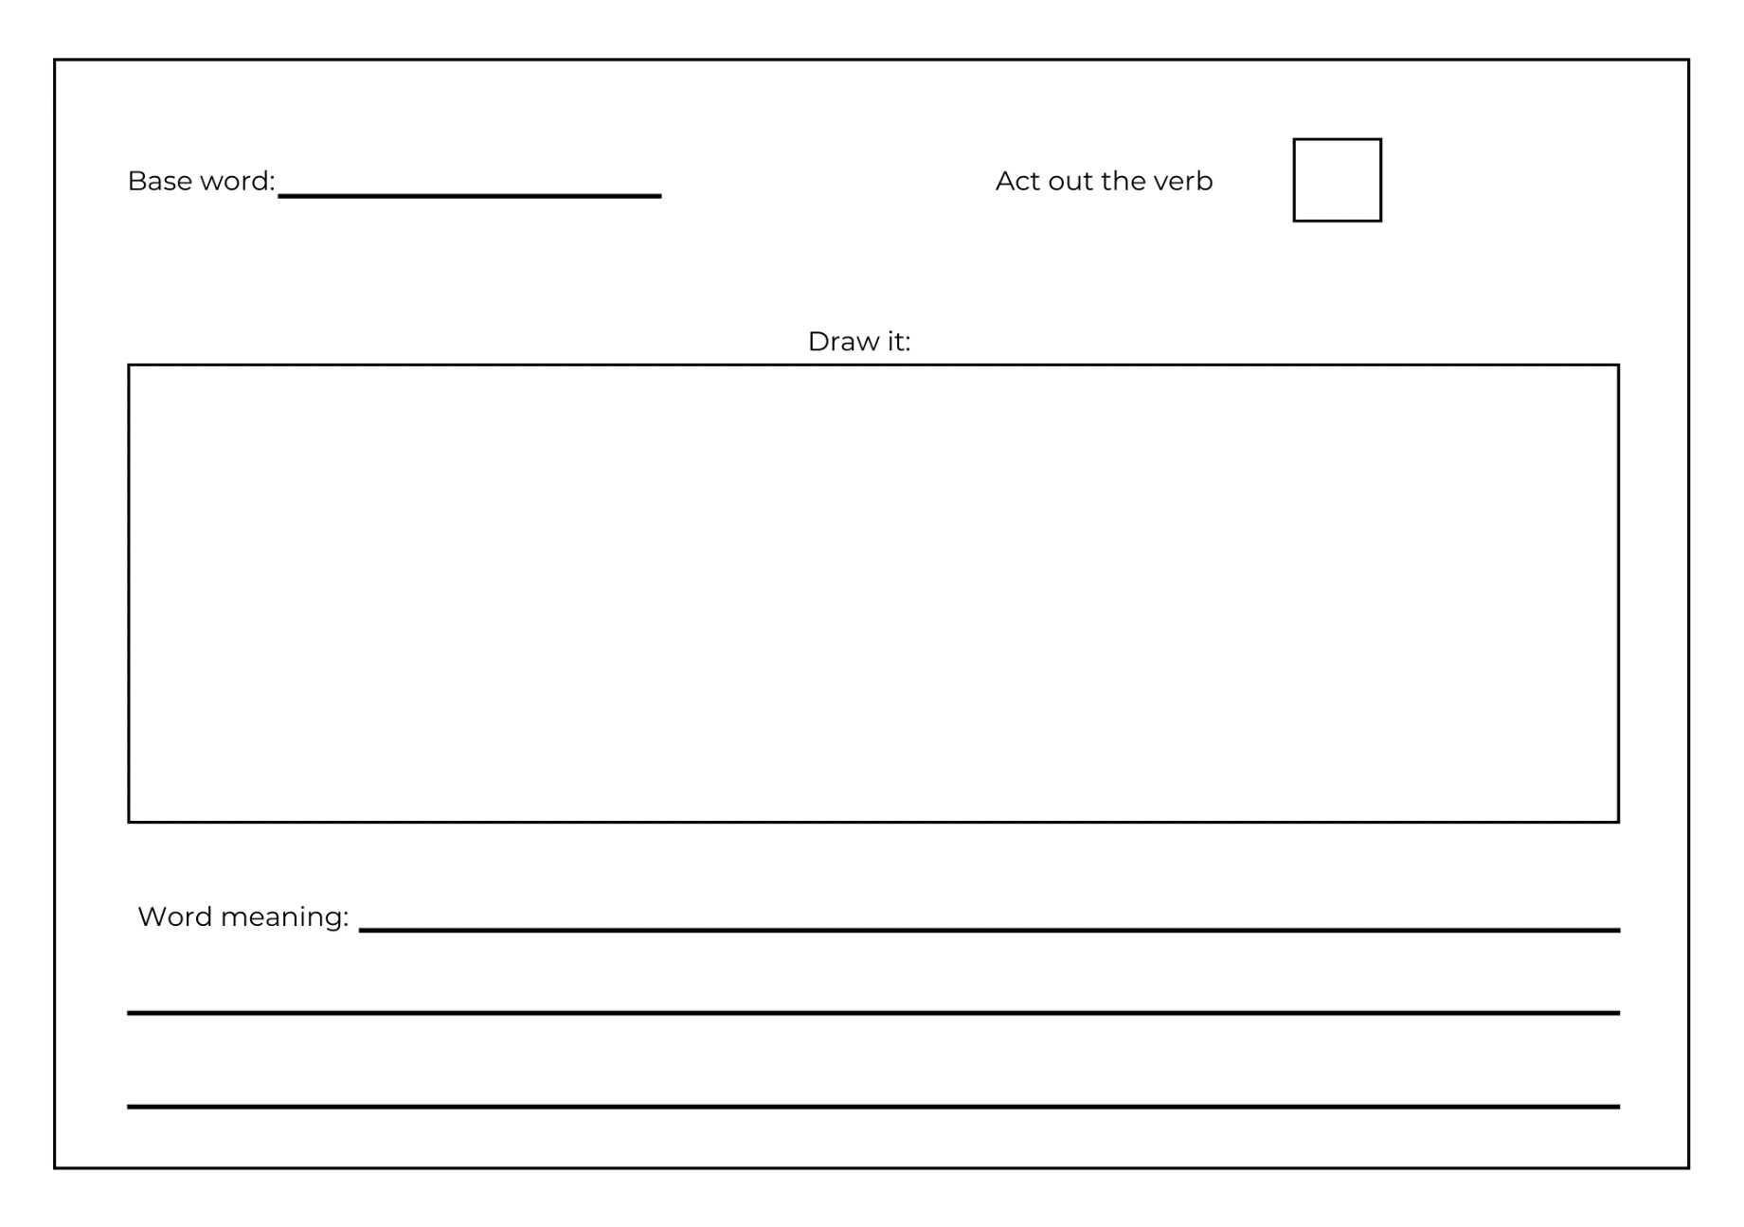

Resource 5: Word mat

Resource 6: Speech bubbles for comic strip
Images sourced from Canva and used in accordance with the Canva Content License Agreement.

Resource 7: Comic strip conversation

Resource 8: Using quotation marks for dialogue
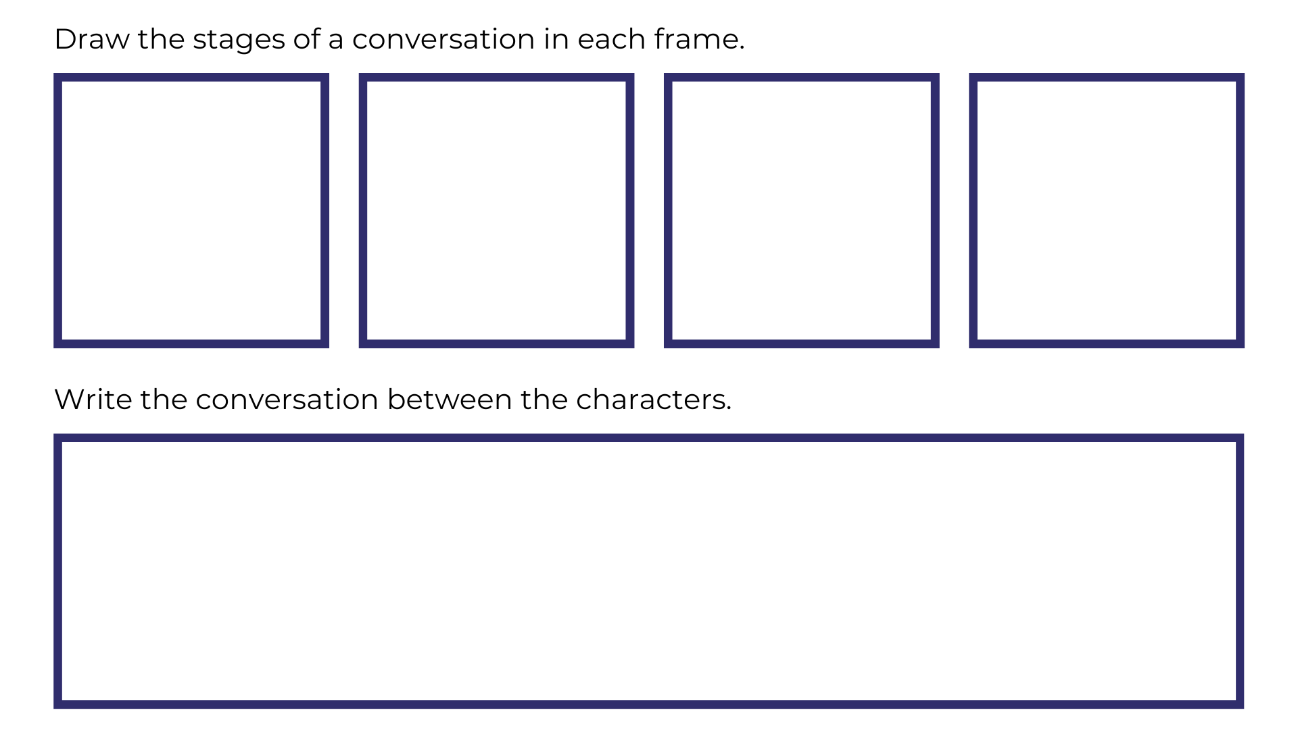

Resource 9: Dialogue checklist
Dialogue Checklist | Dialogue Checklist
- Quotation marks go around exactly what is spoken.  - A capital letter is used at the start of what is spoken.  - There is a punctuation mark before the close of quotation marks.  - Saying verbs are used to describe how the speech is spoken.  - A new line is used when each new character speaks. | - Quotation marks go around exactly what is spoken.  - A capital letter is used at the start of what is spoken.  - There is a punctuation mark before the close of quotation marks.  - Saying verbs are used to describe how the speech is spoken.  - A new line is used when each new character speaks.

Resource 10: Planning scaffold
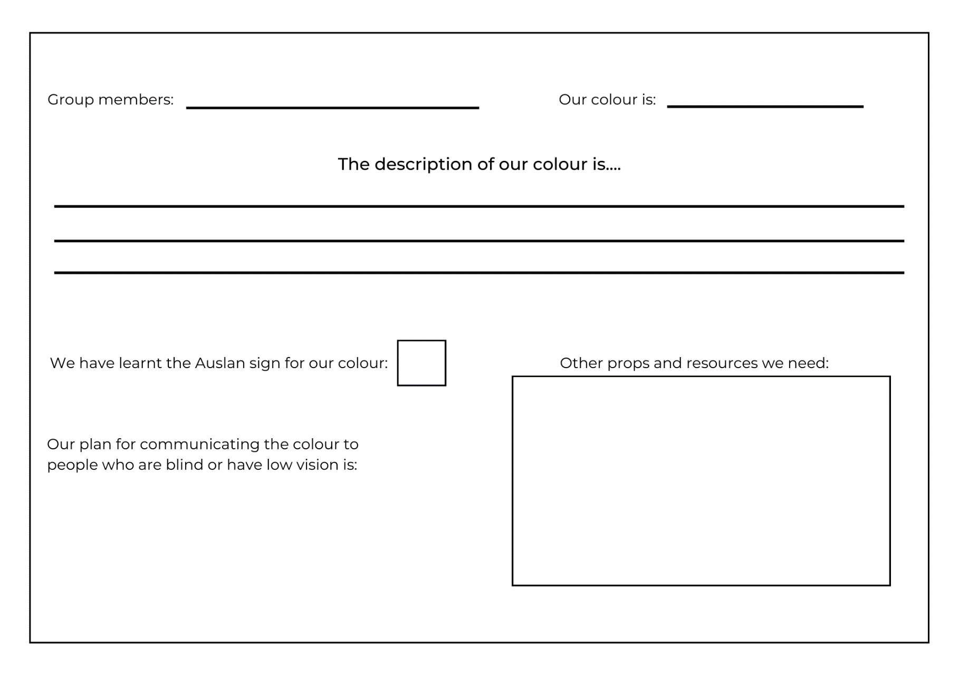

Resource 11: Storyboard
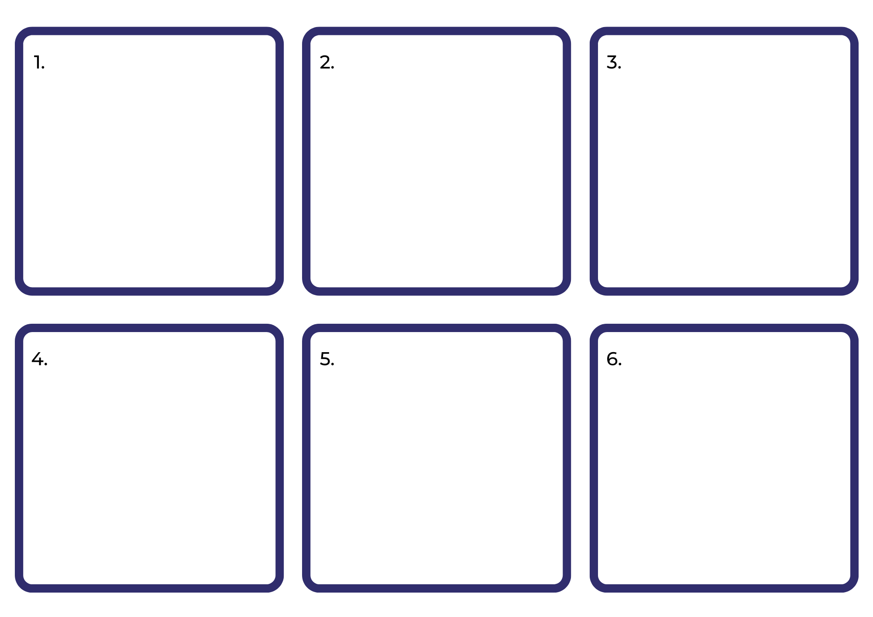

References
Links to third-party material and websites
Please note that the provided (reading/viewing material/list/links/texts) are a suggestion only and implies no endorsement, by the New South Wales Department of Education, of any author, publisher, or book title. School principals and teachers are best placed to assess the suitability of resources that would complement the curriculum and reflect the needs and interests of their students.
If you use the links provided in this document to access a third-party's website, you acknowledge that the terms of use, including licence terms set out on the third-party's website apply to the use which may be made of the materials on that third-party website or where permitted by the Copyright Act 1968 (Cth). The department accepts no responsibility for content on third-party websites.
Except as otherwise noted, all material is © State of New South Wales (Department of Education), 2023 and licensed under the Creative Commons Attribution 4.0 International License. All other material (third-party material) is used with permission or under licence. Where the copyright owner of third-party material has not licensed their material under a Creative Commons or similar licence, you should contact them directly for permission to reuse their material.
English K–10 Syllabus © 2022 NSW Education Standards Authority (NESA) for and on behalf of the Crown in right of the State of New South Wales.
Creative Arts K–6 Syllabus © 2006 NSW Education Standards Authority (NESA) for and on behalf of the Crown in right of the State of New South Wales.
© 2022 NSW Education Standards Authority. This document contains NSW Curriculum and syllabus content. The NSW Curriculum is developed by the NSW Education Standards Authority. This content is prepared by NESA for and on behalf of the Crown in right of the State of New South Wales. The material is protected by Crown copyright.
Please refer to the NESA Copyright Disclaimer for more information.
NESA holds the only official and up-to-date versions of the NSW Curriculum and syllabus documents. Please visit the NSW Education Standards Authority (NESA) website and the NSW Curriculum website.
National Literacy Learning Progression © Australian Curriculum, Assessment and Reporting Authority (ACARA) 2010 to present, unless otherwise indicated. This material was downloaded from the Australian Curriculum website (National Literacy Learning Progression) (accessed 1 February 2023) and was not modified. The material is licensed under CC BY 4.0. Version updates are tracked in the ‘Curriculum version history’ section on the 'About the Australian Curriculum' page of the Australian Curriculum website.
ACARA does not endorse any product that uses the Australian Curriculum or make any representations as to the quality of such products. Any product that uses material published on this website should not be taken to be affiliated with ACARA or have the sponsorship or approval of ACARA. It is up to each person to make their own assessment of the product, taking into account matters including, but not limited to, the version number and the degree to which the materials align with the content descriptions and achievement standards (where relevant). Where there is a claim of alignment, it is important to check that the materials align with the content descriptions and achievement standards (endorsed by all education Ministers), not the elaborations (examples provided by ACARA).
ABC (Australian Broadcasting Corporation) (2023) ABC Kids, ABC website, accessed 1 February 2023.
Adventure Academy (9 April 2020) ‘Great Inventors: Louis Braille’ [video], Adventure Academy, YouTube, accessed 1 February 2023.
Aspinwall C and Pearson D (executive producers) (2022) ‘Turtleboy (Auslan)’ [television program], Bluey (series 3, episode 30), ABC iview, Brisbane, accessed 1 February 2023.
Auslan Signbank (n.d.) Dictionary, Auslan Signbank website, accessed 1 February 2023.
Cottin M (2010) The Black Book of Colours (Faria R, illus.), Walker Books Australia.
Cummings P (2022) Boy (Devries S, illus.), Scholastic Australia Pty Ltd.
ETA (English Teachers Association) and NSW Department of Education (2016) Context, English Textual Concepts website, accessed 1 February 2023.
ETA (English Teachers Association) and NSW Department of Education (2016) The Textual Concepts and Processes resource, accessed 1 February 2023.
Pierce R (2022) Braille, Maths is Fun website, accessed 1 February 2023.
Pierce R (2022) Braille Translator, Maths is Fun website, accessed 1 February 2023.
The Council of the City of the Sydney (n.d) City of Sydney Library: Auslan and English storytime online, City of Sydney website, accessed 1 February 2023.

