English – K-2 multi-age – Year A – Unit 11
Contents
Unit overview and instructions for use 3
Teacher notes 4
Outcomes and content – Component A 5
Outcomes and content – Component B 10
Week 1 15
Component A teaching and learning 15
Component B teaching and learning 16
Lesson 1: Introducing opinions and perspective 17
Lesson 2: Exploring perspective 20
Lesson 3: Vocabulary as a persuasive device 25
Lesson 4: Vocabulary and punctuation 29
Lesson 5: Identifying different perspectives 32
Week 2 34
Component A teaching and learning 34
Component B teaching and learning 35
Lesson 6: Compound and complex sentences 36
Lesson 7: Expressing opinions about characters and exploring paragraphs 41
Lesson 8: Using personal perspectives to write 46
Lesson 9: Publishing writing 48
Lesson 10: Multimodal presentation and unit reflection 50
Resource 1: Persuasive poster 52
Resource 2: Would you rather cards (Early Stage 1) 53
Resource 3: Drawing template (Early Stage 1) 54
Resource 4: Sentence scaffold (Early Stage 1) 55
Resource 5: Sentence strips teacher model (Stage 1) 56
Resource 6: Sentence strips for students (Stage 1) 57
Resource 7: Subordinating conjunctions (Stage 1) 58
Resource 8: Exemplar paragraph (Stage 1) 59
Resource 9: Ordering sentences in a paragraph (Stage 1) 60
References 61

Unit overview and instructions for use
This two-week unit is comprised of Component A and Component B. Connecting learning across both components is encouraged.
Teaching and learning | Component A | Component B
Suggested duration | 60 minutes | 45 minutes
Explicit teaching focus areas | - Phonological awareness (Early Stage 1)  - Print conventions (Early Stage 1)  - Phonic knowledge  - Reading fluency  - Reading comprehension  - Spelling  - Handwriting | - Oral language and communication  - Vocabulary  - Reading comprehension  - Creating written texts  - Understanding and responding to literature
To prepare for teaching and learning: | - Refer to Outcomes and content – Component A, K-2 – Instructional sequence – grapheme–phoneme correspondences [PDF 825 KB], and the teaching advice documents (hyperlinked in Component A teaching and learning table).  - Based on student needs identified through ongoing assessment data, plan and document how you will sequence teaching and learning in whole class and targeted teaching groups across the two-week cycle. | - Familiarise yourself with Outcomes and content – Component B, Textual concepts information and videos, English Textual Concepts and Learning Processes (2016), and the teaching and learning sequence.  - Based on student needs identified through ongoing assessment data, determine how you will support students in whole class and targeted teaching groups across the two-week cycle as required.
English K–10 Syllabus © 2022 NSW Education Standards Authority (NESA) for and on behalf of the Crown in right of the State of New South Wales.

Teacher notes
- Perspective is defined as a lens through which we learn to see the world; it shapes what we see and the way we see it. – English Textual Concepts and Learning Processes (2016).
- Argument is persuasion using the conventions of various forms, modes, and media. Arguments can have a range of purposes including clarification of ideas, searching for truth, resolving disputes, defending a point of view or for entertainment. – English Textual Concepts and Learning Processes (2016).
- For information on argument, the 3 tiers of vocabulary, clauses, compound sentences, coordinating conjunctions, complex sentences, subordinating conjunctions, paragraphs, commas, nouns, adjectives, verbs, adverbs, multimodal texts refer to the NESA Glossary.
- Vocabulary Tier 2 words, sometimes referred to as ‘academic vocabulary’, appear more frequently in text than in oral language. Students in Early Stage 1 are less likely to learn these words without explicit instruction (NESA Teaching advice (additional): Early Stage 1 – Vocabulary).
- A compound sentence is a sentence comprising of 2 or more independent clauses joined by a connective. A complex sentence is formed by adding one or more dependent (subordinate) clauses to a main (independent) clause using a conjunction. A subordinating conjunction is a word that links a dependent clause to an independent clause, for example: when, because, although, unless. Subordinating conjunctions must be at the start of the dependent clause. When the subordinating conjunction is at the start of the dependent clause, the order of the clauses does not alter the meaning of the sentence.
- This unit could enhance student learning towards achievement of outcomes from the Creative Arts syllabus. Digital technologies are also incorporated when reading and creating multimodal texts.
- Reflect on student learning and engagement in activities and record differentiation and adjustments within the unit to inform future teaching and learning. One way of doing this could be to add comments to the digital file.
- Content points are linked to the National Literacy Learning Progression version (3).
Levels and indicators sourced from National Literacy Learning Progression © Australian Curriculum, Assessment and Reporting Authority (ACARA), (accessed 30 January 2023) and was not modified. See references for more information.

Outcomes and content – Component A
The table below outlines the focus outcomes and content. Content is linked to the National Literacy Learning Progression version (3).
Early Stage 1 Focus area and outcome | Stage 1 Focus area and outcome
Phonological awareness  ENE-PHOAW-01 – identifies, blends, segments and manipulates phonological units in spoken words as a strategy for reading and creating texts  - identify the number of phonemes that make up a spoken one-syllable word comprising fewer than 4 phonemes (PhA4)  - identify the difference between voiced phoneme and an unvoiced phoneme | N/A
Print conventions  ENE-PRINT-01 – tracks written text from left to right and from top to bottom of the page and identifies visual and spatial features of print  - distinguish between punctuation, letters, words and numerals in numbers (PKW2)  - identify spaces between words (PKW2) | N/A
Phonic knowledge  ENE-PHOKW-01 – uses single-letter grapheme–phoneme correspondences and common digraphs to decode and encode words when reading and creating texts  - blend single-letter grapheme–phoneme correspondences to decode VC and CVC words, and apply this knowledge when reading, including decodable texts (PKW3, PKW4)  - segment and encode single-letter VC and CVC words, and apply this knowledge when writing words and creating texts (PKW4)  - decode and blend words containing consonant digraphs and apply this when reading texts, including decodable texts (PKW5)  - segment and encode CVC words containing consonant digraphs (PKW4, PKW5) | Phonic knowledge  EN1-PHOKW-01 – uses initial and extended phonics, including vowel digraphs, trigraphs to decode and encode words when reading and creating texts  - blend grapheme–phoneme correspondences to read CCVCC words, CCCVC words and CCCVCC words and apply this when reading texts (PKW7)  - segment and encode CCVCC words, CCCVC words and CCCVCC words and apply this when creating texts (SpG8)  - blend and decode one-syllable words with taught extended vowel graphs and digraphs, including graphemes for r-controlled vowels and diphthongs, and apply this when creating texts (PKW6, PKW7)  - decode words with less common consonant digraphs and apply this when reading texts  - decode words with trigraphs and quadgraphs and apply this when reading texts
Reading fluency  ENE-REFLU-01 – reads decodable texts aloud with automaticity  - read phrases comprising 2 or 3 words aloud, in a rhythmic manner (FIY2, FIY3) | Reading fluency  EN1-REFLU-01 – sustains reading unseen texts with automaticity and prosody and self-corrects errors  - self-correct when fluency and/or meaning is interrupted  - vary pace when reading according to the audience and purpose (FIY4)
Reading comprehension  ENE-RECOM-01 – comprehends independently read texts using background knowledge, word knowledge and understanding of how sentences connect  - use known vocabulary to build a mental model of the content of a text  - understand how adjectives describe a noun and verbs identify actions in a sentence  - identify conjunctions in a compound sentence, their meaning and purpose  - predict purpose, type of text or topic from the title, illustration, image and/or form (UnT4)  - use information or events from different parts of the text to form an opinion. | Reading comprehension  EN1-RECOM-01 – comprehends independently read texts that require sustained reading by activating background and word knowledge, connecting and understanding sentences and whole text, and monitoring for meaning  - know the meaning and purpose of coordinating and subordinating conjunctions and identify them in a complex sentence  - coordinate information or events from different parts of the text to form an overall opinion  - use visual and/or auditory features in multimodal texts to build meaning (UnT5)  - monitor understanding to ensure meaning is sustained and expanded through the whole text (UnT6)
Spelling  ENE-SPELL-01 – applies phonological, orthographic and morphological generalisations and strategies to spell taught familiar and high-frequency words when creating texts  - segment single-syllable words into phonemes as a strategy for spelling (SpG1, SpG4)  - know that words do not usually end with the letter v, and that ve is commonly used  - spell high-frequency compound words and homophones comprising taught graphemes | Spelling  EN1-SPELL-01 – applies phonological, orthographic and morphological generalisations and strategies when spelling words in a range of writing contexts  - spell taught high-frequency contractions (SpG6)  - use extended phonic code for taught consonant phoneme  - use spelling conventions when adding plural-making suffixes (SpG9)  - use the suffixes –ful, –y and –ly to spell taught high-frequency words (SpG9)  - use common prefixes such as un–, re– and dis– (SpG9)
Handwriting  ENE-HANDW-01 – produces all lower-case and upper-case letters to create texts  - form all handwritten letters in NSW Foundation Style when given a verbal prompt from the correct starting point and continue in the correct direction (HwK4)  - apply appropriate pressure when handwriting to produce legible writing. | Handwriting  EN1-HANDW-01 – uses a legible, fluent and automatic handwriting style, and digital technology, including word-processing applications, when creating texts  - use taught software functions to create texts in a range of modes for different contexts, audiences and purposes.

Outcomes and content – Component B
The table below outlines the focus outcomes and content. Content is linked to the National Literacy Learning Progression version (3).
Early Stage 1 Focus area and outcome | Stage 1 Focus area and outcome
Oral language and communication  ENE-OLC-01 – communicates effectively by using interpersonal conventions and language with familiar peers and adults  - recognise how nonverbal language can contribute to meaning in spoken communication  - use oral language to reason when speaking  - use oral language to persuade, negotiate, give opinions or discuss ideas (InT4)  - use connectives such as and, but and because when speaking (SpK2) | Oral language and communication  EN1-OLC-01 – communicates effectively by using interpersonal conventions and language to extend and elaborate ideas for social and learning interactions  - follow extended instructions that contain connectives and conjunctions (LiS4)  - use a range of strategies for effective dialogue and manage digression from a topic  - incorporate extended sentences (simple, compound, complex) during dialogue (SpK3)  - use adjectives and adverbs to elaborate and/or provide some supporting details or justifications and express causal relationships (SpK3)
Vocabulary  ENE-VOCAB-01 – understands and effectively uses Tier 1 and Tier 2 words in familiar contexts  - use specific word choice to clarify meaning  - recognise and understand taught Tier 1 and Tier 2 words | Vocabulary  EN1-VOCAB-01 – understands and effectively uses Tier 1, taught Tier 2 and Tier 3 vocabulary to extend and elaborate ideas  - understand and intentionally choose subject-specific vocabulary to enhance precision and for effect
Reading comprehension  ENE-RECOM-01 – comprehends independently read texts using background knowledge, word knowledge and understanding of how sentences connect  - use known vocabulary to build a mental model of the content of a text  - understand how adjectives describe a noun and verbs identify actions in a sentence  - identify conjunctions in a compound sentence, their meaning and purpose  - use background knowledge when identifying connections between a text, own life, other texts and/or the world (UnT4)  - predict purpose, type of text or topic from the title, illustration, image and/or form (UnT4) | Reading comprehension  EN1-RECOM-01 – comprehends independently read texts that require sustained reading by activating background and word knowledge, connecting and understanding sentences and whole text, and monitoring for meaning  - know that a complex sentence includes a clause for expressing a main message and one or more clauses that elaborate on that message  - know the meaning and purpose of coordinating and subordinating conjunctions and identify them in a complex sentence  - combine multiple sources of information within a text to make meaning  - coordinate information or events from different parts of the text to form an overall opinion  - use a mental model to confirm predictions  - use visual and/or auditory features in multimodal texts to build meaning (UnT5)  - monitor understanding to ensure meaning is sustained and expanded through the whole text (UnT6)
Creating written texts  ENE-CWT-01 – creates written texts that include at least 2 related ideas and correct simple sentences  - create written texts that describe, give an opinion, recount an event, convey a story  - identify and use verbs in simple sentences, including in own writing (GrA2)  - experiment with writing compound sentences and recognise that each clause makes meaning by itself (GrA4)  - use a capital letter to start a sentence and a full stop to end a sentence (PuN2, CrT5)  - understand that punctuation is a feature of written language and how it impacts meaning  - use personal vocabulary, words on display and in mentor texts when constructing sentences  - identify different purposes for writing (CrT4)  - edit their texts after receiving feedback | Creating written texts  EN1-CWT-01 – plans, creates and revises texts written for different purposes, including paragraphs, using knowledge of vocabulary, text features and sentence structure  - group sentences into paragraphs commencing with a topic sentence, followed by other sentences with related ideas (CrT7)  - experiment with writing complex sentences which include a clause for the main message and dependent clause to elaborate or modify the message (GrA5)  - use commas to separate ideas, lists and/or dependent clauses in a sentence (PuN4, PuN6)  - make intentional word choices to enhance precision of meaning and ideas in a text (CrT5)  - use knowledge of similarities and differences between imaginative, informative and persuasive texts when planning for writing  - use different modes and media to enhance the presentation of texts they have created (CrT5, CrT6)  - understand that their own texts can be improved by incorporating feedback and editing
Understanding and responding to literature  ENE-UARL-01 – understands and responds to literature read to them  - expresses likes and dislikes about a text (UnT5)  - compares opinions of a text or characters with peers (InT2). | Understanding and responding to literature  EN1-UARL-01 – understands and responds to literature by creating texts using similar structures, intentional language choices and features appropriate to audience and purpose  - identify phrases in texts that project opinions  - identify arguments and the intended audience  - create paragraphs that contain a simple idea, beginning with a topic sentence and including supporting evidence with elaborations (CrT7).

Week 1

Component A teaching and learning
The table below can be used to plan and document lessons that address Component A outcomes and content. Both the detailed example [DOC 529KB] of a two-week teaching and learning cycle and brief example [DOC 66KB] may support you in your planning.
Focus Areas | Lesson 1 | Lesson 2 | Lesson 3 | Lesson 4 | Lesson 5
Phonological awareness (Early Stage 1) and Phonic knowledge
15 minutes
Spelling and Handwriting
15 minutes
Print conventions (Early Stage 1), Reading comprehension and Reading fluency
30 minutes

Component B teaching and learning
The following teaching and learning sequence has been designed to address Component B outcomes and content. Adapt the sequence as required to best meet the needs of your students.

Learning intention and success criteria
Learning intentions and success criteria are best co-constructed with students. The table below contains suggested learning intentions and success criteria.
Element | Early Stage | Stage 1
Learning intentions | Students are learning to express their opinion of a text or character from their own perspective. | Students are learning how authors persuade an audience.
Success criteria | Students can:  - use oral language to express opinions, likes and dislikes  - reason using ‘because’ statements  - express an opinion about a text or character  - understand and use Tier 1 and Tier 2 words accurately in sentences  - identify conjunctions in compound sentences. | Students can:  - identify the audience and purpose of persuasive texts  - use reasoning to support arguments  - recognise phrases in texts that project opinions  - reason using ‘because’ statements  - use commas to separate ideas and lists in a sentence  - identify arguments from different perspectives.

Resources
- Hoose P and Hoose H (2004) Hey, Little Ant (Tilley D, illus.), Random House, US. ISBN: 9781883672546.
- Resource 1: Persuasive poster
- Resource 2: Would you rather cards (Early Stage 1)
- Resource 3: Drawing template (Early Stage 1)
- Art and craft materials for character creation

Lesson 1: Introducing opinions and perspective
The following teaching and learning activities support multi-age settings.

Whole
- Ask students to draw a picture of a cat. Compare student drawings and discuss their opinions of cats.
- Display an image depicting a cat as a predator. Students Think-Pair-Share whether a mouse would share the same opinion of a cat as them. Ask students what opinion a mouse might have of the cat and why. Introduce the concept of ‘perspective’. Discuss how our opinion is influenced by background knowledge and experiences.
- View and read Resource 1: Persuasive poster. Discuss the intended audience and purpose of the text. Ask students how the poster is similar and different to other texts they have read. Discuss how authors use arguments to persuade their audience. These can be expressed through different types of texts, modes, and media, and may be spoken, visual, written, and performative. For example, a review, poem, story, documentary, poster, speech, or image.
- Ask students if they would choose to save the bees or not. Model how to provide a reason for your opinion using a ‘because’ statement. For example, ‘I would save the bees because bees are very important to our environment.’ Ask students to turn to a partner and share their opinion and a reason by using a ‘because’ statement. Explain an opinion is a way of expressing a point of view. Opinions can be shared, developed, and questioned.
- Select students to share reasons to support their opinion. Discuss why people may have different opinions, and how people may have the same opinion but different reasons.
- Write the words ‘fact’ and ‘opinion’ on the board. Ask students to share what they know about these words. Explain that a fact is something that is based on truth and can be proven. An opinion is what someone may believe or think. When trying to persuade an intended audience, supporting an opinion using facts can help to strengthen an argument.
- Use Resource 1: Persuasive poster to model how the author has used facts to support their arguments.

Part
The table below details the differentiated teaching and learning activities for each stage.
Early Stage 1 (pairs/independent) | Stage 1 (teacher guided/independent)
- In pairs, students use Resource 2: Would you rather cards (Early Stage 1) to orally share their opinions on which animal they would like to have as a pet using a ‘because’ statement.  - Students choose one animal and use Resource 3: Drawing template (Early Stage 1) to draw 3 different reasons to support their opinion about why this animal would make a good pet. Students share their reasoning with a partner as they draw.  - Students use their drawing to write a short text to express their opinion of the best pet using the sentence frame, ‘I would rather a _ because _.’  - Students share their writing with a partner.  Too hard? Students draw one reason and verbalise their thinking to co-construct a sentence.  Too easy? Students use their drawings from activity 9 to write a text that includes all their reasons. | - Display Resource 1: Persuasive poster. Ask:  - What is the opinion of the author?  - What is the author trying to persuade you to do, think, or feel, and how?  - What arguments are presented to persuade you?’  - Identify and explain the ‘call to action’ and how vocabulary has been used as a persuasive device.  - Write the sentence ‘We should save bees because they are cute.’ Ask:  - What is the opinion presented in this sentence?  - What argument is given to support the opinion?  - Is the argument fact or opinion? How do you know?  - Compare the sentence from activity 14 to those in the poster. Ask students which arguments are more persuasive and why.  - Write the sentence starter, ‘I think we should plant a bee friendly garden because _.’ Identify the phrase in the text that projects an opinion. Ask students to suggest other ways they could start this sentence using a different phrase. For example, ‘I believe’; ‘It is important that we’; ‘Everyone should plant a bee-friendly garden because’. Ask students to consider whether some phrases are more persuasive than others and why.  - Students write an argument to persuade a targeted audience to plant a bee friendly garden, for example, a school community. Students share their argument with the class. Prompt peer discussions using the prompts:  - What is your argument?  - Why did you choose that argument?  - What makes it persuasive?  - What could you add to your argument or change to make it more convincing?
Stage 1 Assessment task 1 – Observations from this lesson allow students to demonstrate achievement towards the following syllabus outcome and content point:
EN1-UARL-01 – understands and responds to literature by creating texts using similar structures, intentional language choices and features appropriate to audience and purpose
- identify phrases in texts that project opinions.

Lesson 2: Exploring perspective
The following teaching and learning activities support multi-age settings.

Whole
- Read the front and back cover of the text, Hey, Little Ant by Phillip and Hannah Hoose. Encourage students to make careful observations, predictions, and thoughtful interpretations about the text using the See-Think-Wonder routine. For example, ‘I can see a tiny ant; I think he may be talking to the boy; I wonder if the boy can hear him.’ Students draw or write their predictions about the text on individual whiteboards.
- Read Hey, Little Ant and reflect on student predictions. Discuss the purpose of the text and who the intended audience might be. Highlight how the author has used illustrations to help us understand what each character is thinking and feeling.
- Invite a student to share their opinion of the text. Model placing a sticky note with a smiley face on the cover of the book and say, for example, ‘I liked this book because Ant stood up to Kid.’
- Ask students to share their opinion of the text by drawing a smiley, frowning, or neutral face and orally justify their opinion using the sentence starters:
- I liked this book because _.
- I did not like this book because _.

Part
The table below details the differentiated teaching and learning activities for each stage.
Early Stage 1 (small groups/pairs/independent) | Stage 1 (teacher guided/independent)
- Provide groups of students with sticky notes and a familiar book that has been read and discussed previously, such as Three by Stephen Michael King or Little Cloud by Eric Carle.  - Students express their opinion of the text by drawing a smiley, frowning, or neutral face on their sticky note.  - Students take turns to orally share their opinion with the group using a ‘because’ statement to justify their thinking.  - Students talk about their favourite part of the text and write their opinion of the text using a ‘because’ statement. | - Discuss the purpose of the text and explore how the authors present the different perspectives of the 2 characters.  - Say and write the word ‘perspective’ on the board. Ask students to re-state the word and clap the syllables. Discuss what students think the word ‘perspective’ means. Explain that perspective is a point of view, and that it is what people may think or believe to be true. Perspective is shaped by personal experiences and can influence opinions and choices.  - In the text, the characters Kid and Ant share different perspectives about whether Ant should be squished. Provide opportunities for students to think about how the personal experiences of each character may have shaped their perspective on the issue. Discuss how the perspective of Kid is different to that of Ant. Use the text to explore Ant’s perspective. Read selected pages, pausing to discuss how both the text and illustrations are used to convey Ant’s perspective. Ask:  - What might Ant be thinking? How do you know?  - How do the images and text on these pages support your understanding of Ant’s perspective?  - Model how the author has used the images of Ant with his family to influence the reader to feel empathy for Ant.  - Use the text to model writing a sentence that expresses Ant’s perspective using a ‘because’ statement to provide reasoning. For example, ‘Ant feels scared because Kid is so big.’  - Ask students to imagine how they would feel if they were Ant and write sentences from the perspective of Ant. Remind students to use a ‘because’ statement to provide reasoning. For example, ‘Do not squish me because I clean up after you eat.’
Early Stage 1 Assessment task 1 – Observations and work samples from this lesson allows students to demonstrate achievement towards the following syllabus outcomes and content points:
ENE-OLC-01 – communicates effectively by using interpersonal conventions and language with familiar peers and adults
- recognise how nonverbal language can contribute to meaning in spoken communication
- use oral language to reason when speaking
- use oral language to persuade, negotiate, give opinions or discuss ideas
- use connectives such as and, but and because when speaking.
ENE-RECOM-01 – comprehends independently read texts using background knowledge, word knowledge and understanding of how sentences connect
- use background knowledge when identifying connections between a text, own life, other texts and/or the world
- predict purpose, type of text or topic from the title, illustration, image and/or form.
ENE-CWT-01 – creates written texts that include at least 2 related ideas and correct simple sentences
- create written texts that describe, give an opinion, recount an event, convey a story.
ENE-UARL-01 – understands and responds to literature read to them
- expresses likes and dislikes about a text
- compares opinions of a text or characters with peers.
Stage 1 Assessment task 2 – Observations and work samples from activities this lesson allows students to demonstrate achievement towards the following syllabus outcome and content points:
EN1–RECOM–01 – comprehends independently read texts that require sustained reading by activating background and word knowledge, connecting and understanding sentences and whole text, and monitoring for meaning
- coordinate information or events from different parts of the text to form an overall opinion.
- use a mental model to confirm predictions
- monitor understanding to ensure meaning is sustained and expanded through the whole text.

Lesson 3: Vocabulary as a persuasive device
The following teaching and learning activities support multi-age settings.

Whole
- Explain that good authors carefully consider their vocabulary and language choices in texts.
- Revisit Resource 1: Persuasive poster and draw students’ attention to the author’s use of vocabulary (survive, protect, pollinate, pollinator, lavender, sunflowers).
- Explicitly teach the meaning of the Tier 2 and Tier 3 words found in the Save the bees! poster by providing a student friendly definition and images to support understanding.
- Substitute less precise vocabulary to demonstrate the difference word choice makes to the text. For example, ‘Bees are very important because they collect yellow grains of pollen from plants and carry it to other plants, which helps the plants make seeds so they can grow new plants.’ Re-read the text from the Save the bees! poster. For example, ‘Bees are very important because they pollinate our plants.’
- Explain that when an author uses a more precise word such as ‘pollinate’, they can tell the reader something specific using less words.
- Flick through Hey, Little Ant and highlight an example of where the author has used vocabulary words with precision. For example, nest, steal, crook. Explicitly teach identified Tier 2 vocabulary words.
- Provide students with a phrase that could be substituted with one of the taught vocabulary words. For example, ‘What is a word for a person who takes something that doesn’t belong to them?’ Students Think-Pair-Share their answer with a partner. Ask students to share their answers.
Note: Provide opportunities to review and reinforce new words on multiple occasions throughout the week.

Part
The table below details the differentiated teaching and learning activities for each stage.
Early Stage 1 (pairs/independent) | Stage 1 (teacher guided/independent)
- In pairs or independently, students select a taught Tier 2 and Tier 3 word and discuss how it could be used in a sentence.  - Students draw a picture to explain what each word means, then write sentences defining the word to match their picture.  Too hard? Students refer to vocabulary wall to copy taught word and draw a picture to illustrate word meaning.  Too easy? Students write the selected Tier 2 and Tier 3 words in sentences. | - Discuss how, through careful word choice, an author has the power to influence the reader and enhance their understanding of meaning and ideas. Explicitly teach that when writing to persuade, the author is trying to make the reader do something, think something, feel something or buy something. Explain how modality can be used to be more persuasive by adding greater certainty to what is said and written.  - Draw a T-chart and label the left column ‘High modality’ and the right column ‘Low modality’. List examples of modal verbs for students. For example, must, won’t, might, could, would, think, should, will, can’t, can, may, need to, have to. Provide students with sticky notes to write a modality verb and add it to the T-chart under the correct heading.  - Use the text to model writing a sentence from Ant’s perspective. For example, ‘I must not die beneath your shoe. Substitute the modal verb using another example from the T-chart to change the certainty of the statement.’  - Ask students to re-write the sentence, ‘I should squish a crook like you’ using different modal verbs. For example, ‘I could squish a crook like you’; ‘I might squish a crook like you’; ‘I must squish a crook like you.’  Too hard? Make cards with the words ‘might’ and ‘must’. Write the sentence ‘I _ squish a crook like you’, leaving a space for the modality word. Students physically place the word into the sentence, then read aloud. Support students to write sentences with the highest modality words.  Too easy? Introduce more complex modality words to students to use in sentences. For example, ‘ought to’, ‘absolutely’, ‘definitely’.

Note: Modal verbs give the reader information about the degree of obligation or certainty involved in the action. Modality can be demonstrated through careful word choice, and may include selective use of verbs, adverbs, adjectives (especially with ‘existing verbs’, such as ‘is vital’, where ‘is’ is the existing verb), or nouns to strengthen or reduce potency. Low modality shows less certainty, obligation, probability, importance, frequency, extent, intensity, confidence, or emphasis. High modality shows a high degree of these.
Early Stage 1 Assessment task 2 – Observations and work samples from this lesson allows students to demonstrate achievement towards the following syllabus outcomes and content points:
ENE-VOCAB-01 – understands and effectively uses Tier 1 and Tier 2 words in familiar contexts
- use specific word choice to clarify meaning
- recognise and understand taught Tier 1 and Tier 2 words.
ENE-RECOM-01 – comprehends independently read texts using background knowledge, word knowledge and understanding of how sentences connect
- use known vocabulary to build a mental model of the content of a text.
ENE-CWT-01 – creates written texts that include at least 2 related ideas and correct simple sentences
- use personal vocabulary, words on display and in mentor texts when constructing sentences.
Stage 1 Assessment task 3 – Observations and work samples from this lesson allows students to demonstrate achievement towards the following syllabus outcomes and content points:
EN1-VOCAB-01 – understands and effectively uses Tier 1, taught Tier 2 and Tier 3 vocabulary to extend and elaborate ideas
- understand and intentionally choose subject-specific vocabulary to enhance precision and for effect.
EN1-CWT-01 – plans, creates and revises texts written for different purposes, including paragraphs, using knowledge of vocabulary, text features and sentence structure
- make intentional word choices to enhance precision of meaning and ideas in a text.

Lesson 4: Vocabulary and punctuation
The following teaching and learning activities support multi-age settings.

Whole
- Review Tier 2 and Tier 3 words from the previous lesson. Revise how authors make intentional word choices to enhance the precision of meaning in a text. Discuss how readers can use this vocabulary to help build a mental model of characters in texts.
- Select students to read aloud the sentences from Lesson 3. Record a selection of these on the board. Highlight the use of punctuation in the recorded sentences.
- Identify proper nouns and commas used in Hey, Little Ant, reviewing prior learning on the use of capitals for proper nouns. Explain that in this text, Kid and Ant are proper nouns.

Part
The table below details the differentiated teaching and learning activities for each stage.
Early Stage 1 (independent) | Stage 1 (teacher guided/pairs)
- Students Think-Pair-Share their favourite character from Hey, Little Ant.  - Students create an artwork of their favourite character. Suggested artworks may include: a finger puppet, illustration, painting or collage. Student artworks will be used again in Lesson 8 as a stimulus for their writing.  - Students write a sentence to describe the character chosen using the sentence frame, ‘My favourite character is _ because _.’ | - Ask students what good readers do when they see a comma. For example, pause, take a breath, or change tone or inflection. Define what a comma is.  - Write the sentence, ‘Kid is bigger, stronger, and smarter than Ant.’ Ask students what the punctuation marker is in the sentence and what its purpose is. Explicitly teach the use of commas to separate ideas and lists.  - Write the sentence, ‘Ants are tiny, black, fast and strong’ with the commas omitted on the board. Encourage students to read the sentence aloud and explain what they notice about the sentence. Ask if the sentence makes sense and why or why not. Select students to write the commas in the correct positions in the sentence. Explain that in this sentence, the adjectives form a list.  - The characters in the text Hey, Little Ant use arguments to persuade one another of their point of view. Use the text to identify 3 arguments Kid presents about why he should squish Ant. Model writing these as a list, using commas to separate each idea. For example, ‘The ant should be squished because it is tiny, it can’t feel, and it steals food.’  - Explain the importance of staying on topic, keeping to talking points and not digressing. Model an example of digressing when listing arguments about why Ant should not be squished. For example, ‘Ant takes food because he is trying to feed his town. I love eating ice cream. Rainbow ice cream is my favourite flavour.’ Students identify the digression.  - In pairs, students identify and share 3 arguments that Ant uses in the text to persuade Kid not to squish him, ensuring they remain on topic. Students use ‘thumbs up/thumbs down’ to provide feedback about staying on topic, keeping to talking points and not digressing.  - Students write their 3 arguments in a sentence, using commas to separate the ideas.
Stage 1 Assessment task 4 – Collecting work samples from this lesson allows students to demonstrate achievement towards the following syllabus outcomes and content points:
EN1-OLC-01 – communicates effectively by using interpersonal conventions and language to extend and elaborate ideas for social and learning interactions
- use a range of strategies for effective dialogue and manage digression from a topic.
EN1-CWT-01 – plans, creates and revises texts written for different purposes, including paragraphs, using knowledge of vocabulary, text features and sentence structure
- use commas to separate ideas, lists and/or dependent clauses in a sentence.

Lesson 5: Identifying different perspectives
The following teaching and learning activities support multi-age settings.

Whole
- Open Hey, Little Ant to the double page spread with 4 kids’ faces and highlight the phrase, ‘squishing ants is a game we play’. Ask students if Kid should squish Ant just because his friends tell him to. Provide students with some quiet thinking time. Ask:
- What would you do?
- How would you persuade someone to squish Ant or not?
- Students share their opinion and reasons with a partner using a ‘because’ statement.
- Draw a T-chart on the board. In the first column, write the heading ‘Kid’s reasons to squish Ant’, and in the second column, write the heading ‘Ant’s reasons he shouldn’t be squished.’ Using the T-chart, model recording a reason Kid gives Ant as to why he should squish him.

Part
The table below details the differentiated teaching and learning activities for each stage.
Early Stage 1 (teacher guided/independent) | Stage 1 (pairs)
- Model writing a compound sentence to describe a reason Ant gives Kid for why he should not be squished. For example, ‘Ant does not want to be squished because he needs to feed his nest mates.’  - Explicitly teach that ‘because’ is a conjunction and that a conjunction connects 2 independent clauses.  - Introduce the conjunctions ‘and, because, but, for, so’. Record this list and display for reference in Lesson 6.  - Deconstruct the compound sentence from activity 4 by underlining each independent clause and circling the conjunction. Model how each independent clause makes sense by itself and could be a simple sentence.  - Co-construct compound sentences about the characters Ant and Kid. For example, ‘Ant is tiny but he is strong’; ‘Kid looks big and he is mean’. As each sentence is written, underline the independent clauses and circle the conjunction. | - In pairs, students draw a T-chart and use the text to continue identifying and recording Kid’s reasons to squish Ant. Repeat from the perspective of Ant.  - Students use Hot seat to explore the perspectives of Kid and Ant, using the T-chart to scaffold their thinking and provide strong reasoning. For example, ‘Ant must be stopped! He is a crook who always steals our picnic food. The only way to save picnics is to squish Ant!’

Week 2

Component A teaching and learning
The table below can be used to plan and document lessons that address Component A outcomes and content. Both the detailed example [DOC 529KB] of a two-week teaching and learning cycle and brief example [DOC 66KB] may support you in your planning.
Focus Areas | Lesson 6 | Lesson 7 | Lesson 8 | Lesson 9 | Lesson 10
Phonological awareness (Early Stage 1) and Phonic knowledge
15 minutes
Spelling and Handwriting
15 minutes
Print conventions (Early Stage 1), Reading comprehension and Reading fluency
30 minutes

Component B teaching and learning
The following teaching and learning sequence has been designed to address Component B outcomes and content. Adapt the sequence as required to best meet the needs of your students.

Learning intention and success criteria
Learning intentions and success criteria are best co-constructed with students. The table below contains suggested learning intentions and success criteria.
Element | Early Stage 1 | Stage 1
Learning intentions | Students are learning to express their opinion of a text or character from their own perspective. | Students are learning how authors persuade an audience.
Success criteria | Students can:  - identify conjunctions in compound sentences  - use information from a text to express an opinion  - reason using ‘because’ statements  - identify adjectives and verbs in own writing  - compare opinions of a text or character with peers. | Students can:  - support an argument using reasoning  - experiment with writing complex sentences  - write a paragraph that begins with a topic sentence and includes supporting evidence  - edit and refine writing using feedback  - create a multimodal text.

Resources
- Hoose P and Hoose H (2004) Hey, Little Ant (Tilley D, illus.), Random House, US. ISBN: 9781883672546.
- Resource 1: Persuasive poster
- Resource 4: Sentence scaffold (Early Stage 1)
- Resource 5: Sentence strips teacher model (Stage 1)
- Resource 6: Sentence strips for students (Stage 1)
- Resource 7: Subordinating conjunctions (Stage 1)
- Resource 8: Exemplar paragraph (Stage 1)
- Resource 9: Ordering sentences in a paragraph (Stage 1)
- Video: ABC Education: Bee Heroes – Meet the European honey bee (2:26)
- 2 large sheets of paper
- Art and craft materials for character creation
- Selection of familiar texts that have characters with opposing traits.

Lesson 6: Compound and complex sentences
The following teaching and learning activities support multi-age settings.

Whole
- Remind students that perspective is a point of view. It is shaped by personal experiences ad can influence opinions and choices. Revisit Resource 1: Persuasive poster. Discuss the different perspectives people may have about bees. Watch Bee Heroes: Meet the European honey bee (2:26). Discuss the perspective shown in the video about bees and why honeybees are important.
- Explain how authors use language that can persuade a reader of a particular perspective. Discuss the vocabulary used in the poster and video and identify text purpose and grammatical features used.
- Students Think-Pair-Share what they know about sentences.
- Dictate 2 simple sentences to students. In pairs, students write the sentences on a mini whiteboard and identify grammatical features.
- Co-construct writing criteria for a compound sentence. Ensure sentence punctuation is included. Students use the conjunctions list from Lesson 5 to turn their simple sentences from the previous activity into a compound sentence.

Part
The table below details the differentiated teaching and learning activities for each stage.
Early Stage 1 (independent) | Stage 1 (teacher guided/independent)
- Students use Resource 6: Sentence scaffold to experiment using different conjunctions to create compound sentences that project their opinions of Ant and Kid. For example, ‘I think Ant is clever but I don’t like that he steals food; Kid is my favourite character because I like to squish ants.’  Too hard? Attach conjunctions to a large die. Roll the die and read the conjunction. Provide one clause. Students verbalise the conjunction and a second clause.  Too easy? Students use vocabulary identified in Lesson 3 to write their own compound sentence that projects their opinion.  - Students reflect on their writing using the writing criteria. | - Review previous learning on sentences. Explain that a complex sentence is formed by adding one or more dependent (subordinate) clauses to a main (independent) clause using a conjunction.  - Identify sentences in Resource 1: Persuasive poster and discuss whether each sentence is simple, compound, or complex.  - Read and deconstruct a complex sentence from the poster. Circle the conjunctions. Explain that some conjunctions can be used at the start of a sentence.  - Model using subordinating conjunctions in complex sentences using Resource 5: Sentence strips teacher model (Stage 1). Use the sentence strip to demonstrate how to identify and label the grammatical features in the sentence.  - In pairs, students use the first sentence in Resource 6: Sentence strips for students (Stage 1) to manipulate, label, and discuss the grammatical features.  - Ask students to read aloud the first sentence and explain its grammatical features. Ask questions to help students to rephrase any errors. For example:  - What is a word that joins clauses together called?  - Where is a subordinating conjunction used?  - Students independently repeat activities 11 and 12 with the remaining sentence strips.  - Jointly construct a complex sentence about bees. For example, ‘Everyone laughed when the bees chased me; Although it rained, the bees still buzzed about; Even though they sting, I will still protect the bees.’  - Students refer to the content in Resource 1: Persuasive poster, the Bee Heroes (2:26) video, and Resource 7: Subordinating conjunctions (Stage 1) to write their own complex sentences about bees.  Too hard? Co-construct complex sentences.  Too easy? Students experiment with clause order after writing a complex sentence.
Early Stage 1 Assessment task 3 – Collecting work samples from this lesson allows students to demonstrate achievement towards the following syllabus outcomes and content points:
ENE-RECOM-01 – comprehends independently read texts using background knowledge, word knowledge and understanding of how sentences connect
- identify conjunctions in a compound sentence, their meaning and purpose.
ENE-CWT-01 – creates written texts that include at least 2 related ideas and correct simple sentences
- experiment with writing compound sentences and recognise that each clause makes meaning by itself
- use a capital letter to start a sentence and a full stop to end a sentence
- understand that punctuation is a feature of written language and how it impacts meaning.
Stage 1 Assessment task 5 – Observations and work samples from this lesson allows students to demonstrate achievement towards the following syllabus outcomes and content points:
EN1-OLC-01 – communicates effectively by using interpersonal conventions and language to extend and elaborate ideas for social and learning interactions
- follow extended instructions that contain connectives and conjunctions
- incorporate extended sentences (simple, compound, complex) during dialogue.
EN1-RECOM-01 – comprehends independently read texts that require sustained reading by activating background and word knowledge, connecting and understanding sentences and whole text, and monitoring for meaning
- know that a complex sentence includes a clause for expressing a main message and one or more clauses that elaborate on that message
- know the meaning and purpose of coordinating and subordinating conjunctions and identify them in a complex sentence
- combine multiple sources of information within a text to make meaning.
EN1-CWT-01 – plans, creates and revises texts written for different purposes, including paragraphs, using knowledge of vocabulary, text features and sentence structure
- experiment with writing complex sentences which include a clause for the main message and dependent clause to elaborate or modify the message.

Lesson 7: Expressing opinions about characters and exploring paragraphs
The following teaching and learning activities support multi-age settings.

Whole
- Using 2 large sheets of paper, draw 2 T-charts, one for Ant and one for Kid. For each T-chart, label one column ‘I like’ and the other column ‘I don’t like’.
- Flick through Hey, Little Ant stopping periodically to record students’ likes and dislikes about the characters’ personality and actions on the T-charts.
- Discuss how the text and illustrations influence our opinions about characters. For example, when Kid says, ‘You’re just a speck that runs around’, this may make students dislike Kid as he has no respect for animals. When Ant says, ‘Please don’t hurt me, don’t make me die’, students may have empathy for Ant. Continue adding likes and dislikes to the T-charts.
- Select students to share their opinion about one of the characters. Encourage students to use statements such as ‘I think’; ‘I feel’; ‘My opinion is’, at the start of each sentence, a ‘because’ statement, and adjectives to elaborate. For example, ‘My opinion is that Ant is kind and caring because he gathers lots of food for his nest mates.’

Part
The table below details the differentiated teaching and learning activities for each stage.
Early Stage 1 (teacher guided/independent) | Stage 1 (independent/pairs)
- Revise the terms nouns, adjectives and verbs, explaining that adjectives describe a noun and verbs identify actions in a sentence.  - Display images of Ant and model writing the sentence, ‘Ant is small and speaks politely.’ Using the think aloud strategy, identify the subject in the sentence, ‘Ant’. Using different coloured markers, highlight the adjective and verb.  - Brainstorm and list examples of adjectives and verbs to describe Kid and Ant on an anchor chart. For example:  - Kid: giant, mean, bossy, squish, shout, stomp  - Ant: tiny, strong, brave, dig, carry, feed.  - List adjectives and verbs to describe other characters from familiar texts.  - Co-construct sentences to describe a character from Hey, Little Ant. Underline or circle the adjectives and verbs used in the sentences. For example, ‘Kid is a giant who likes to squish ants; Ant can carry food and is strong.’ | - Students select their favourite character from Hey, Little Ant.  - In pairs, students orally share and justify/explain their opinion about their favourite character. Encourage students to use adjectives and adverbs to add detail, and complex and compound sentences to extend ideas.  - Students write a description of their favourite character using adverbs, adjectives, compound and complex sentences. For example, ‘Kid is my favourite character because he is a giant and is very bossy; If I was Kid, I would squish ants quickly every day.’

Part
The table below details the differentiated teaching and learning activities for each stage.
Early Stage 1 (independent/pairs) | Stage 1 (teacher guided)
- Provide students with a selection of familiar texts that have characters with opposing traits. For example, Jack and the Beanstalk, Little Red Riding Hood, The Gruffalo by Julia Donaldson.  - Students draw their favourite character and share their opinions about the character, discussing why they like or dislike them.  - Students label their illustration using adjectives and verbs to describe the character.  - Students write simple sentences expressing an opinion about and describing their favourite character, identifying the adjectives and verbs used.  Too easy? Students write a compound sentence about their favourite character, identifying the adjectives and verbs in their writing.  - Students share their work with a partner. | - Explain that when writing to persuade, thoughts can organised into paragraphs. Paragraphs contain related ideas, begin with a topic sentence, and include clear reasoning.  - Deconstruct Resource 8: Exemplar paragraph (Stage 1) to create success criteria for writing a paragraph. Highlight the topic sentence, main ideas, grammatical features, persuasive language, and complex sentences which illustrate reasoning. The success criteria will also be used in Lesson 8.  - Using Resource 9: Ordering sentences in a paragraph (Stage 1), students manipulate and glue sentences onto card or paper to compose a persuasive paragraph.  - Students use the success criteria to deconstruct the paragraph. Underline the arguments and discuss how persuasive they are. Circle the conjunctions and colour adjectives, verbs, and adverbs. Draw a box around the commas.

Whole
- Students complete an Exit ticket: ‘Today I learnt…’
Early Stage 1 Assessment task 4 – Observations and work samples from this lesson allows students to demonstrate achievement towards the following syllabus outcomes and content points:
ENE-RECOM-01 – comprehends independently read texts using background knowledge, word knowledge and understanding of how sentences connect
- understand how adjectives describe a noun and verbs identify actions in a sentence.
ENE-CWT-01 – creates written texts that include at least 2 related ideas and correct simple sentences
- create written texts that describe, give an opinion, recount an event, convey a story
- identify and use verbs in simple sentences, including in own writing.
ENE-UARL-01 – understands and responds to literature read to them
- expresses likes and dislikes about a text
- compares opinions of a text or characters with peers.
Stage 1 Assessment task 6 – Observations and work samples from this lesson allows students to demonstrate achievement towards the following syllabus outcomes and content points:
EN1-OLC-01 – communicates effectively by using interpersonal conventions and language to extend and elaborate ideas for social and learning interactions
- use adjectives and adverbs to elaborate and/or provide some supporting details or justifications and express causal relationships.
EN1-RECOM-01 – comprehends independently read texts that require sustained reading by activating background and word knowledge, connecting and understanding sentences and whole text, and monitoring for meaning
- coordinate information or events from different parts of the text to form an overall opinion
- monitor understanding to ensure meaning is sustained and expanded through the whole text.
EN1-CWT-01 – plans, creates and revises texts written for different purposes, including paragraphs, using knowledge of vocabulary, text features and sentence structure
- group sentences into paragraphs commencing with a topic sentence, followed by other sentences with related ideas.
EN1-UARL-01 – understands and responds to literature by creating texts using similar structures, intentional language choices and features appropriate to audience and purpose
- identify phrases in texts that project opinions
- identify arguments and the intended audience.

Lesson 8: Using personal perspectives to write
The following teaching and learning activities support multi-age settings.

Whole
- Discuss how people have different perspectives. Remind students that perspective is an opinion; it is shaped by personal experiences and can influence opinions and choices.

Part
The table below details the differentiated teaching and learning activities for each stage.
Early Stage 1 (pairs/independent) | Stage 1 (teacher guided/independent)
- Using the character artwork created in Lesson 4, students share their reasons for why it is their favourite character from Hey, Little Ant.  - Students write a short text that contains compound sentences to express their opinion about their created character.  - Students explain their reasons using one of the conjunctions and, because, but, for, so. For example, ‘I like Ant because he is brave and he helps his family.’  - Students reflect on their writing using the criteria co-constructed from Lesson 6. This writing will be published as a multimodal text in Lesson 9.  Too hard? Students use speech-to-text technology, audio, or video recording to produce the text.  Too easy? Students use synonyms to enhance sentences. | - Read the final page in the text Hey, Little Ant. Ask students what they would do in this situation. Students turn and talk to share their perspective.  - Explain that students need to present their argument as a paragraph featuring a topic sentence, followed by other sentences outlining related ideas.  - Students write a paragraph to persuade an audience of their perspective. Refer to the success criteria from Lesson 7 to highlight what should be included in a well-constructed paragraph. This paragraph will be edited and published in Lesson 9 and Lesson 10.  Too hard? Students use speech-to-text technology.  Too easy? Students write a paragraph using subordinate conjunctions to start 2-3 sentences.

Whole
- Select a student writing sample and model how to provide peer feedback by using a strategy such as the feedback bun to highlight a positive aspect of writing, an area that could be improved, and another positive.
- Early Stage 1 students use the writing criteria developed in Lesson 6, and Stage 1 students use the success criteria developed in Lesson 7, to provide peer to peer feedback.
Early Stage 1 Assessment task 5 – Observations and work samples from this lesson allows students to demonstrate achievement towards the following syllabus outcome and content points:
ENE-CWT-01 – creates written texts that include at least 2 related ideas and correct simple sentences
- create written texts that describe, give an opinion, recount an event, convey a story
- identify different purposes for writing
- edit their texts after receiving feedback.
Stage 1 Assessment task 7 – Collecting work samples from this lesson allows students to demonstrate achievement towards the following syllabus outcomes and content points:
EN1-CWT-01 – plans, creates and revises texts written for different purposes, including paragraphs, using knowledge of vocabulary, text features and sentence structure
- group sentences into paragraphs connecting with a topic sentence, followed by other sentences with related ideas
- experiment with writing complex sentences which include a clause for the main message and dependent clause to elaborate or modify the message
- use commas to separate ideas, lists and/or dependent clauses in a sentence
- make intentional word choices to enhance precision of meaning and ideas in a text
- use knowledge of similarities and differences between imaginative, informative and persuasive texts when planning for writing
- understand that their own texts can be improved by incorporating feedback and editing.
EN1-UARL-01 – understands and responds to literature by creating texts using similar structures, intentional language choices and features appropriate to audience and purpose
- create paragraphs that contain a simple idea, beginning with a topic sentence and including supporting evidence with elaborations.

Lesson 9: Publishing writing
The following teaching and learning activities support multi-age settings.

Whole
- Model a multimodal text creation by using visuals, written and/or spoken text together to create meaning. Suggested examples students can use to publish their work include:
- recording a slide show with narration using PowerPoint
- creating a short video using stop motion animation or Flip
- devising a performance
- designing a poster.
Note: Multimodal texts are texts that combine 2 or more communication modes. For example, printed words and images, or spoken words and sound effects.

Part
The table below details the differentiated teaching and learning activities for each stage.
Early Stage 1 (teacher guided/pairs) | Stage 1 (pairs/independent)
- In pairs, students use their writing from Lesson 8 and artwork from Lesson 4 to publish their multimodal text. | - Students create a finger puppet, illustration, or 3D model of themselves to support their paragraph text. This character will be used to engage the audience and enhance meaning as part of their multimodal text creation.  - Each student finds a partner who has created a text with a different perspective. Students use their finger puppets, illustrations, or 3D models to publish their writing as a multimodal text.
Stage 1 Assessment task 8 – Collecting work samples from this lesson allows students to demonstrate achievement towards the following syllabus outcomes and content points:
EN1-RECOM-01 – comprehends independently read texts that require sustained reading by activating background and word knowledge, connecting and understanding sentences and whole text, and monitoring for meaning
- use visual and/or auditory features in multimodal texts to build meaning.
EN1-CWT-01 – plans, creates and revises texts written for different purposes, including paragraphs, using knowledge of vocabulary, text features and sentence structure
- use different modes and media to enhance the presentation of texts they have created.

Lesson 10: Multimodal presentation and unit reflection
The following teaching and learning activities support multi-age settings.

Whole
- Provide the opportunity for students to complete and share their multimodal texts with an authentic audience.
- Students reflect on their learning throughout the unit and complete an exit ticket using one or more sentence starters. For example:
- ‘An opinion is…’
- ‘An argument is…’
- ‘Perspective is…’
- ‘I used to think…now I know…’

Resource 1: Persuasive poster
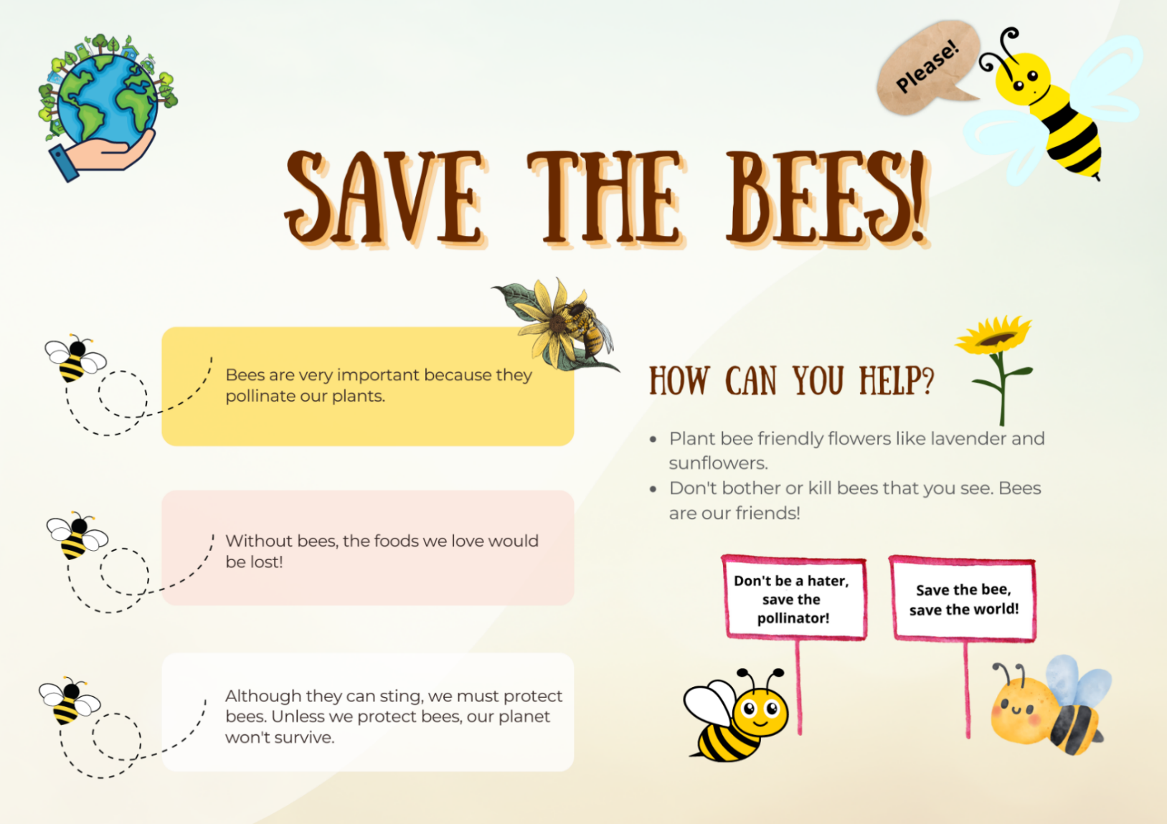
Images sourced from Canva and used in accordance with the Canva Content License Agreement.

Resource 2: Would you rather cards (Early Stage 1)
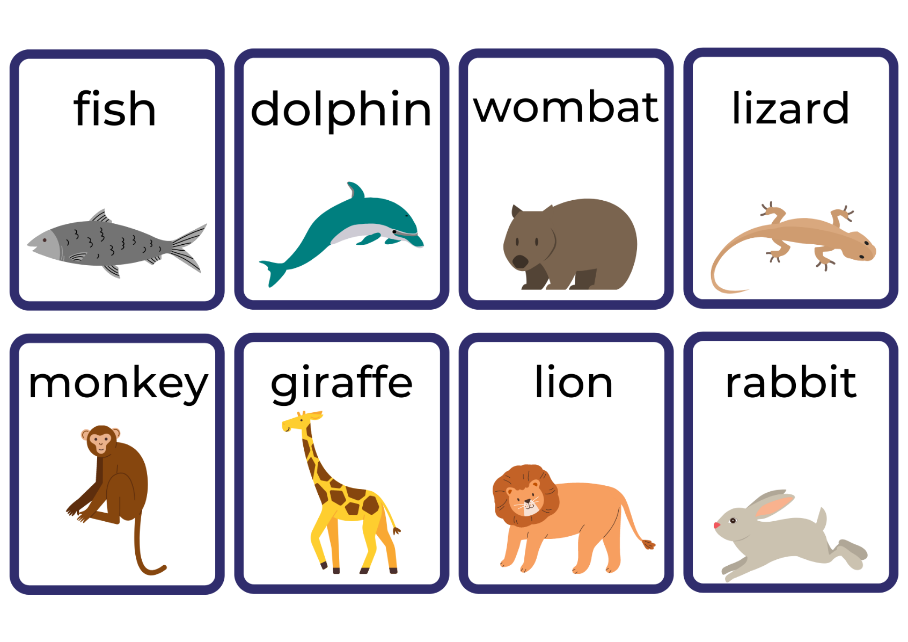
Images sourced from Canva and used in accordance with the Canva Content License Agreement.

Resource 3: Drawing template (Early Stage 1)
Choose an animal and draw and talk with a partner about 3 different reasons why you think this animal would make a good pet.

Resource 4: Sentence scaffold (Early Stage 1)
I think Ant is clever but,

Ant is my favourite character because

Kid thinks it’s ok to squish Ant so

Kid is mean and

Ant took food from the picnic for

Resource 5: Sentence strips teacher model (Stage 1)
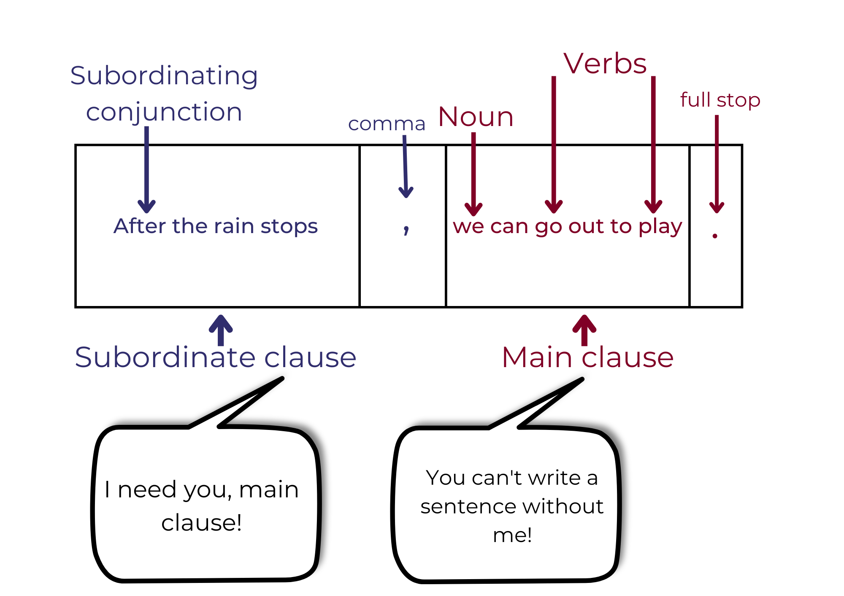

Resource 6: Sentence strips for students (Stage 1)
Student sentences
Cut and order the complex sentences. Label the grammatical features.
we protect bees | Unless | they will disappear | , | .

you must take care of them | you see bees in the garden | When | , | .

bees don’t have as many flowers to pollinate | Since | there are more buildings | , | .

Resource 7: Subordinating conjunctions (Stage 1)
after | even though | unless
although | if | until
as | since | whenever
because | that | wherever
before | though | while

Resource 8: Exemplar paragraph (Stage 1)
Ant is the best character in the book. Although Ant is small, he is still an important creature that deserves to live. He is kind, helpful and caring because he looks after his family by collecting food for them. Ant is brave because he stands up to Kid who wants to hurt him. You must agree, Ant is the best!

Resource 9: Ordering sentences in a paragraph (Stage 1)
Cut out each sentence and glue into the correct order.
You must agree Kid is the worst character.

In my opinion, Kid is the worst character in the book.

He is big, strong and mean as he uses his size to bully Ant.

Although Ant begged and pleaded, Kid still wanted to squish Ant.

References
Links to third-party material and websites
Please note that the provided (reading/viewing material/list/links/texts) are a suggestion only and implies no endorsement, by the New South Wales Department of Education, of any author, publisher, or book title. School principals and teachers are best placed to assess the suitability of resources that would complement the curriculum and reflect the needs and interests of their students.
If you use the links provided in this document to access a third-party's website, you acknowledge that the terms of use, including licence terms set out on the third-party's website apply to the use which may be made of the materials on that third-party website or where permitted by the Copyright Act 1968 (Cth). The department accepts no responsibility for content on third-party websites.
Except as otherwise noted, all material is © State of New South Wales (Department of Education), 2023 and licensed under the Creative Commons Attribution 4.0 International License. All other material (third-party material) is used with permission or under licence. Where the copyright owner of third-party material has not licensed their material under a Creative Commons or similar licence, you should contact them directly for permission to reuse their material.
English K–10 Syllabus © 2022 NSW Education Standards Authority (NESA) for and on behalf of the Crown in right of the State of New South Wales.
Creative Arts K–6 Syllabus © 2006 NSW Education Standards Authority (NESA) for and on behalf of the Crown in right of the State of New South Wales.
© 2022 NSW Education Standards Authority. This document contains NSW Curriculum and syllabus content. The NSW Curriculum is developed by the NSW Education Standards Authority. This content is prepared by NESA for and on behalf of the Crown in right of the State of New South Wales. The material is protected by Crown copyright.
Please refer to the NESA Copyright Disclaimer for more information.
NESA holds the only official and up-to-date versions of the NSW Curriculum and syllabus documents. Please visit the NSW Education Standards Authority (NESA) website and the NSW Curriculum website.
National Literacy Learning Progression © Australian Curriculum, Assessment and Reporting Authority (ACARA) 2010 to present, unless otherwise indicated. This material was downloaded from the Australian Curriculum website (National Literacy Learning Progression) (accessed 30 January 2023) and was not modified. The material is licensed under CC BY 4.0. Version updates are tracked in the ‘Curriculum version history’ section on the 'About the Australian Curriculum' page of the Australian Curriculum website.
ACARA does not endorse any product that uses the Australian Curriculum or make any representations as to the quality of such products. Any product that uses material published on this website should not be taken to be affiliated with ACARA or have the sponsorship or approval of ACARA. It is up to each person to make their own assessment of the product, taking into account matters including, but not limited to, the version number and the degree to which the materials align with the content descriptions and achievement standards (where relevant). Where there is a claim of alignment, it is important to check that the materials align with the content descriptions and achievement standards (endorsed by all education Ministers), not the elaborations (examples provided by ACARA).
ABC (Australian Broadcasting Corporation) (15 December 2022) ‘Bee Heroes: Meet the European honey bee' [video], ABC Education, ABC website, accessed 30 January 2023.
ETA (English Teachers Association) and NSW Department of Education (2016) The Textual Concepts and Processes resource, English Textual Concepts website, accessed 30 January 2023.
Hoose P and Hoose H (2004) Hey, Little Ant (Tilley D, illus.), Random House, US.
NESA (NSW Education Standards Authority) (2023a) ‘Teaching advice (additional): Early Stage 1 – Vocabulary’, English K-2: Teaching and learning support, NESA website, accessed 30 January 2023.
NESA (NSW Education Standards Authority) (2023b) ‘Teaching advice (additional): Stage 1 – Creating written texts’, English K-2: Teaching and learning support, NESA website, accessed 30 January 2023.

