English – K-2 multi-age – Year A – Unit 10
Contents
Unit overview and instructions for use 3
Teacher notes 4
Outcomes and content – Component A 5
Outcomes and content – Component B 10
Week 1 14
Component A teaching and learning 14
Component B teaching and learning 15
Lesson 1: Understanding Amy & Louis 17
Lesson 2: Sequencing events and understanding proper nouns 20
Lesson 3: Amy & Louis continued 24
Lesson 4: Planning and designing multimodal texts 26
Lesson 5: Composing and sharing multimodal texts 28
Week 2 31
Component A teaching and learning 31
Component B teaching and learning 32
Lesson 6: Little Cloud 34
Lesson 7: Creating tiny poems 36
Lesson 8: Navigation pathways 41
Lesson 9: Multimodal informative texts 43
Lesson 10: Composing and sharing multimodal informative texts 45
Resource 1: Conversation bear 49
Resource 2: Amy & Louis text analysis 50
Resource 3: Narrative mountain 52
Resource 4: Blank – Image, symbol, and emotion 53
Resource 5: Amy & Louis – Image, symbol, and emotion teacher model 54
Resource 6: Pronoun cloze passage 56
Resource 7: Multimodal text planning 58
Resource 8: FANBOYS 59
Resource 9: Tiny poems by Sally Murphy 60
Resource 10: Online text features and navigation pathways 61
Resource 11: Navigation word cards 63
Resource 12: Smarties Education webpage 64
References 65

Unit overview and instructions for use
This two-week unit is comprised of Component A and Component B. Connecting learning across both components is encouraged.
Teaching and learning | Component A | Component B
Suggested duration | 60 minutes | 45 minutes
Explicit teaching focus areas | - Phonological awareness (Early Stage 1)  - Print conventions (Early Stage 1)  - Phonic knowledge  - Reading fluency  - Reading comprehension  - Spelling  - Handwriting | - Oral language and communication  - Vocabulary  - Reading comprehension  - Creating written texts  - Understanding and responding to literature
To prepare for teaching and learning: | - Refer to Outcomes and content – Component A, K-2 – Instructional sequence – grapheme–phoneme correspondences [PDF 825 KB], and the teaching advice documents (hyperlinked in Component A teaching and learning table).  - Based on student needs identified through ongoing assessment data, plan and document how you will sequence teaching and learning in whole class and targeted teaching groups across the two-week cycle. | - Familiarise yourself with Outcomes and content – Component B, Textual concepts information and videos, English Textual Concepts and Learning Processes (2016), and the teaching and learning sequence.  - Based on student needs identified through ongoing assessment data, determine how you will support students in whole class and targeted teaching groups across the two-week cycle as required.
English K–10 Syllabus © 2022 NSW Education Standards Authority (NESA) for and on behalf of the Crown in right of the State of New South Wales.

Teacher notes
- Connotation, imagery and symbol is defined as words and images that extend beyond their literal meaning. – English Textual Concepts and Learning Processes (2016).
- Understanding of connotation, imagery and symbol can be supported through watching the department’s video: Connotation, imagery and symbol (6:07).
- While connotation, imagery and symbol is the mentor concept for the conceptual component of this unit, the supporting concepts of narrative and character can be explored using the mentor text Amy & Louis by Libby Gleeson.
- For information on Aboriginal English, Standard Australian English, nouns, pronouns, simple sentences, multimodal texts, fluency, prosody, rhyme, figurative language, wordplay, adjectives, subject, verb, object, compound sentences, coordinating conjunctions, navigation pathways, and Tiers 1 to 3 words refer to the NESA Glossary.
- Inflected word forms are a word form that marks a distinction in tense (jump-jumps-jumping-jumped), plurality (cat-cats), and comparatives and superlatives (big-bigger-biggest).
- This unit could enhance student learning towards achievement of outcomes from the Creative Arts, Science and Technology, and PDHPE syllabuses. Online texts could be substituted to enhance student learning across key learning areas.
- Reflect on student learning and engagement in activities and record differentiation and adjustments within the unit to inform future teaching and learning. One way of doing this could be to add comments to the digital file.
- Content points are linked to the National Literacy Learning Progression version (3).
Levels and indicators sourced from National Literacy Learning Progression © Australian Curriculum, Assessment and Reporting Authority (ACARA), (accessed 22 December 2022) and was not modified. See references for more information.

Outcomes and content – Component A
The table below outlines the focus outcomes and content. Content is linked to the National Literacy Learning Progression version (3).
Early Stage 1 Focus area and outcome | Stage 1 Focus area and outcome
Phonological awareness  ENE-PHOAW-01 – identifies, blends, segments and manipulates phonological units in spoken words as a strategy for reading and creating texts  - blend onset and rime to say a one-syllable word (PhA2)  - provide a word when given a starting phoneme (PhA2)  - identify the first, middle and final phoneme in a one-syllable word (PhA4)  - identify the difference between a voiced phoneme and an unvoiced phoneme | N/A
Print conventions  ENE-PRINT-01 – tracks written text from left to right and from top to bottom of the page and identifies visual and spatial features of print  - recognise symbols, icons and personally significant words in everyday situations and texts (UnT2)  - show awareness of appropriate orientation of the text being read (UnT2)  - track text left to right and use return sweep (UnT4) | N/A
Phonic knowledge  ENE-PHOKW-01 – uses single-letter grapheme–phoneme correspondences and common digraphs to decode and encode words when reading and creating texts  - blend common single-letter grapheme–phoneme correspondences to read CCVC and CVCC words, and apply this when reading texts, including decodable texts (PKW5)  - segment common, single-letter grapheme–phoneme correspondences to encode CCVC and CVCC words (PKW5)  - decode and blend words containing consonant digraphs and apply this when reading texts, including decodable texts (PKW5)  - segment and encode CVC words containing consonant digraphs (PKW4, PKW5) | Phonic knowledge  EN1-PHOKW-01 – uses initial and extended phonics, including vowel digraphs, trigraphs to decode and encode words when reading and creating texts  - blend and decode one-syllable words with taught extended vowel graphs and digraphs, including graphemes for r-controlled vowels and diphthongs, and apply this when creating texts (PKW6, PKW7)  - decode words with trigraphs and quadgraphs and apply this when reading texts
Reading fluency  ENE-REFLU-01 – reads decodable texts aloud with automaticity  - know that fluent reading involves recognising and reading words accurately and automatically  - read phrases comprising 2 or 3 words aloud, in a rhythmic manner (FIY2, FIY3) | Reading fluency  EN1-REFLU-01 – sustains reading unseen texts with automaticity and prosody and self-corrects errors  - adjust phrasing, intonation, volume or rate to maintain fluency when reading aloud (FlY4)  - vary pace when reading according to the audience and purpose (FlY4)
Reading comprehension  ENE-RECOM-01 – comprehends independently read texts using background knowledge, word knowledge and understanding of how sentences connect  - use known vocabulary to build a mental model of the content of a text  - understand how adjectives describe a noun and verbs identify actions in a sentence  - understand that informative and imaginative texts have different structures, features and forms (UnT5)  - use background knowledge when identifying connections between a text, own life, other texts and/or the world (UnT4)  - predict purpose, type of text or topic from the title, illustration, image and/or form (UnT4)  - use visual cues in multimodal texts to interpret meaning (UnT5)  - recall the sequence of events/information in texts (UnT5) | Reading comprehension  EN1-RECOM-01 – comprehends independently read texts that require sustained reading by activating background and word knowledge, connecting and understanding sentences and whole text, and monitoring for meaning  - register a break in comprehension when reading (UnT5)  - use knowledge of text structure, type of text, author, and forms of writing to predict and confirm meaning (UnT6)  - use visual and/or auditory features in multimodal texts to build meaning (SpK7)  - make text-to-self, text-to-text or text-to-world connections when reading (UnT6)  - use information read in texts to enhance learning across key learning areas
Spelling  ENE-SPELL-01 – applies phonological, orthographic and morphological generalisations and strategies to spell taught familiar and high-frequency words when creating texts  - combine phonological, phonic, orthographic and morphemic knowledge to spell taught high-frequency irregular words comprising up to 3 phonemes  - experiment with the tense-marking suffixes to spell familiar base verbs (SpG5) | Spelling  EN1-SPELL-01 – applies phonological, orthographic and morphological generalisations and strategies when spelling words in a range of writing contexts  - use suffixes -ful, -y and -ly to spell taught high-frequency words  - use knowledge of morphemes to spell taught compound words and homophones with taught single-letter graphemes, digraphs, split digraphs, trigraphs and quadgraphs (SpG7)
Handwriting  ENE-HANDW-01 – produces all lower-case and upper-case letters to create texts  - use a stable posture when handwriting or drawing by sitting comfortably with feet flat on the floor, the writing arm resting on the table, with the opposite hand resting on the paper, and shoulders relaxed. | Handwriting  EN1-HANDW-01 – uses a legible, fluent and automatic handwriting style, and digital technology, including word-processing applications, when creating texts  - type up to 5 familiar words per minute.

Outcomes and content – Component B
The table below outlines the focus outcomes and content. Content is linked to the National Literacy Learning Progression version (3).
Early Stage 1 Focus area and outcome | Stage 1 Focus area and outcome
Oral language and communication  ENE-OLC-01 – communicates effectively by using interpersonal conventions and language with familiar peers and adults  - understand how the most common inflected word forms affect the meaning of words  - take turns when speaking during structured and unstructured play (InT3)  - use imaginative, verbal language in structured and unstructured activities  - tell a story or information to peers or adults using oral language (SpK3) | Oral language and communication  EN1-OLC-01 – communicates effectively by using interpersonal conventions and language to extend and elaborate ideas for social and learning interactions  - initiate, listen and/or respond in partner and group conversations (InT3, InT5)  - organise key ideas in a logical sequence (SpK3)  - recite poems and rhymes
Vocabulary  ENE-VOCAB-01 – understands and effectively uses Tier 1 and Tier 2 words in familiar contexts  - recognise and understand taught Tier 1 and Tier 2 words (PKW3, SpK3)  - experiment with and create wordplay and poems | Vocabulary  EN1-VOCAB-01 – understands and effectively uses Tier 1, taught Tier 2 and Tier 3 vocabulary to extend and elaborate ideas  - identify, understand and use wordplay and rhyme in a range of texts
Reading comprehension  ENE-RECOM-01 – comprehends independently read texts using background knowledge, word knowledge and understanding of how sentences connect  - use known vocabulary to build a mental model of the content of a text  - understand how adjectives describe a noun and verbs identify actions in a sentence  - understand that informative and imaginative texts have different structures, features and forms (UnT5)  - use background knowledge when identifying connections between a text, own life, other texts and/or the world (UnT4)  - predict purpose, type of text or topic from the title, illustration, image and/or form (UnT4)  - use visual cues in multimodal texts to interpret meaning (UnT5)  - recall the sequence of events/information in texts (UnT5) | Reading comprehension  EN1-RECOM-01 – comprehends independently read texts that require sustained reading by activating background and word knowledge, connecting and understanding sentences and whole text, and monitoring for meaning  - understand vocabulary that signals humorous wordplay in texts  - use navigation pathways, including hyperlinks, to extract essential information to support reading fluency and enhance meaning when reading digital texts (UnT7)  - use knowledge of text structure, type of text, author, and forms of writing to predict and confirm meaning (UnT6)  - use visual and/or auditory features in multimodal texts to build meaning (UnT5)  - make text-to-self, text-to-text or text-to-world connections when reading (UnT6)  - use information read in texts to enhance learning across key learning areas
Creating written texts  ENE-CWT-01 – creates written texts that include at least 2 related ideas and correct simple sentences  - include recognisable structural features for text purpose (CrT5)  - create written texts that describe, give an opinion, recount an event, convey a story  - use personal pronouns in own writing (CrT7)  - write a simple sentence with correct subject-verb-object structure to convey an idea (GrA2, GrA3, CrT4)  - use capital letters when writing proper nouns (PuN3, CrT5)  - use personal vocabulary, words on display and in mentor texts when constructing sentences  - identify different purposes for writing (CrT4)  - use drawing, images or mind maps to support planning and writing (CrT4) | Creating written texts  EN1-CWT-01 – plans, creates and revises texts written for different purposes, including paragraphs, using knowledge of vocabulary, text features and sentence structure  - write texts that describe, explain, give an opinion, recount an event, tell a story (CrT5)  - use visual elements to expand meaning in own texts  - accurately use articles and pronouns in own writing (CrT8)  - use time connectives to sequence information and events in texts (GrA4)  - use creative wordplay to affect the reader  - identify the context, audience and purpose for own texts  - use knowledge of similarities and differences between imaginative, informative and persuasive texts when planning for writing
Understanding and responding to literature  ENE-UARL-01 – understands and responds to literature read to them  - identify and discuss how creative language and/or symbols enhance enjoyment in texts  - identify how visual cues contribute to the meaning of a text  - experiment with creative play with language in own texts. | Understanding and responding to literature  EN1-UARL-01 – understands and responds to literature by creating texts using similar structures, intentional language choices and features appropriate to audience and purpose  - identify figurative language and wordplay in texts (UnT7)  - identify symbols and images in texts, and how they bring deeper meaning  - create texts that include symbols, wordplay and figurative language.

Week 1

Component A teaching and learning
The table below can be used to plan and document lessons that address Component A outcomes and content. Both the detailed example [DOC 529KB] of a two-week teaching and learning cycle and brief example [DOC 66KB] may support you in your planning.
Focus Areas | Lesson 1 | Lesson 2 | Lesson 3 | Lesson 4 | Lesson 5
Phonological awareness (Early Stage 1) and Phonic knowledge
15 minutes
Spelling and Handwriting
15 minutes
Print conventions (Early Stage 1), Reading comprehension and Reading fluency
30 minutes

Component B teaching and learning
The following teaching and learning sequence has been designed to address Component B outcomes and content. Adapt the sequence as required to best meet the needs of your students.

Learning intention and success criteria
Learning intentions and success criteria are best co-constructed with students. The table below contains suggested learning intentions and success criteria.
Element | Early Stage 1 | Stage 1
Learning intentions | Students are learning to use vocabulary and colour to respond to picture books and create a multimodal text. | Students are learning to understand how images and symbols impact on a narrative and use these features when creating a multimodal text.
Success criteria | Students can:  - take turns when speaking in partner and group conversations  - use capital letters when writing proper nouns  - sequence events in familiar texts  - use personal pronouns in writing  - use drawing or images to plan writing  - use images or sounds in multimodal texts to show feelings. | Students can:  - join in partner and group conversations  - sequence information and events in texts  - identify symbols and images in texts, and describe how they make them feel  - accurately use pronouns in writing  - plan a text using written and visual elements  - use images or sounds in multimodal texts to show feelings.

Resources
- Gleeson L (2006) Amy & Louis (Blackwood F, illus.) Scholastic Australia Pty Ltd, Sydney. ISBN: 9781865049366
- Resource 1: Conversation bear (individual copy and counters for each student)
- Resource 2: Amy & Louis text analysis
- Resource 3: Narrative mountain (enlarged copy and individual copies for students)
- Resource 4: Blank – Image, symbol, and emotion (enlarged copy and individual copies for students)
- Resource 5: Amy & Louis – Image, symbol, and emotion teacher model
- Resource 6: Pronoun cloze passage
- Resource 7: Multimodal text planning (enlarged copy and individual copies for students)
- A4 paper
- Individual whiteboards
- Resources to support the production of multimodal texts, for example, tablets/computers with camera or audio recording capacity, or art supplies, including pencil and paper, print and sculpture materials
- Student copies of 3 pictures from Amy & Louis for sequencing (one picture each from beginning, middle and end)

Lesson 1: Understanding Amy & Louis
The following teaching and learning activities support multi-age settings.

Whole
- Mime the greeting ‘hello’ using a hand wave. Ask students to demonstrate other ways of greeting without speaking, for example: handshake, high five, hug. Discuss ways people greet or say hello to others, including home language and known languages other than Standard Australian English. Discuss the greeting ‘cooee’, derived from Dharug, which is used as a call over distances and means ‘come here’.
- Introduce the text Amy & Louis. Guide students to make predictions about what type of text it is, using the front and back covers, title, and illustrations. Discuss narrative elements and the relationship that may exist between the characters. Explain that the ampersand in the title is a logogram, which is a symbol representing a word. In this case, the word represented is ‘and’.
- Read Amy & Louis. Revisit the text predictions and provide the opportunity for students to make text-to-self connections. Draw attention to the meaning of the word ‘cooee’ (come here) and its relevance to the story.
- Explain how the reader can draw meaning from a text’s words and illustrations, as well as their own experiences (connotation). Highlight how symbols and images are sometimes used in texts to bring deeper meaning.
- Organise students into small groups. Explain that students are going to engage in conversations about the text. As part of this, students will focus on developing their awareness of initiating and responding in conversations.
- Provide all students with a copy of Resource 1: Conversation bear. Model having a short conversation with 2 students. When each person contributes, show how to place a counter on the bear. Highlight the importance of including all people in a conversation.
- Students turn and talk, using the conversation bear, to discuss colours that relate to feelings. For example, discuss the colours that make you feel happy, sad, and angry.
- Discuss the activities Amy and Louis did when they were together and the colour that was used in these illustrations. Ask:
- What happens to the colour in the illustrations when Amy moves away?
- Why do you think the colours changed?
- Explain that Amy and Louis are friends and were happy playing together every day (brightly coloured illustrations). Then, when Amy moved, they missed each other and were sad (dull coloured illustrations). Create a T-chart with the headings ‘happy colours’ and ‘sad colours’. Ask students what other colours might symbolise happiness and sadness. Write student responses on the chart.

Part
The table below details the differentiated teaching and learning activities for each stage.
Early Stage 1 (independent) | Stage 1 (teacher guided)
- Students fold a piece of A4 paper in half and draw a happy moment from the text on one side of the paper and a sad moment on the other. Students refer to the T-chart to select appropriate ‘happy’ and ‘sad’ colours to use in their illustrations.  - Students share and discuss their drawings, feelings, and colour selection.  Too easy? Students draw happy and sad moments from a different text. | - Discuss the symbols and images in the text and how they contribute to the overall meaning of the story. Examples to guide this conversation are provided in Resource 2: Amy & Louis text analysis.  - Explore how vocabulary is used to evoke happy and sad feelings. Create a T-chart with the headings ‘Happy’ and ‘Sad’.  - Using the mentor text, identify words and phrases that connote each emotion, and share the pen to list words under each heading. For example:  - Happy: magical creatures; secrets to share; lovely dream; wild, wild dragons  - Sad: long, long way away; other side of the world; stopped; nowhere.  - Students select an emotion and write sentences describing how the text represents it. For example, Amy & Louis shows happiness through bright colours, the characters playing games and cool cloud drawings.
Early Stage 1 Assessment task 1 – Observations from this lesson allow students to demonstrate achievement towards the following syllabus outcomes and content points:
ENE-OLC-01 – communicates effectively by using interpersonal conventions and language with familiar peers and adults
- take turns when speaking during structured and unstructured play
- use imaginative, verbal language in structured and unstructured activities.
ENE-RECOM-01 – comprehends independently read texts using background knowledge, word knowledge and understanding of how sentences connect
- predict purpose, type of text or topic from the title, illustration, image and/or form.
Stage 1 Assessment task 1 – Observations from this lesson allow students to demonstrate achievement towards the following syllabus outcomes and content points:
EN1-OLC-03 – communicates effectively by using interpersonal conventions and language to extend and elaborate ideas for social and learning interactions
- initiate, listen and/or respond in partner and group conversations
- organise key ideas in a logical sequence.
EN1-RECOM-01 – comprehends independently read texts that require sustained reading by activating background and word knowledge, connecting and understanding sentences and whole text, and monitoring for meaning
- use knowledge of text structure, type of text, author, and forms of writing to predict and confirm meaning.

Lesson 2: Sequencing events and understanding proper nouns
The following teaching and learning activities support multi-age settings.

Whole
- Ask students what a narrative is. Discuss concepts and key vocabulary previously taught, for example, narrative, story, beginning, middle, end, imagined, prediction, sequence of events. Leave words on display to refer to throughout the unit.
- Explain that events in a narrative occur in the beginning, middle and end and can be sequenced using time connective words. Display the sequencing words: ‘first, then, next, after that, in the end, and finally’. Retell Amy & Louis, using only the images in the text. Students take turns telling part of the story as the page is displayed using sequencing words to connect events.
- Display an enlarged copy of Resource 3: Narrative mountain, labelling the first, third and’ fifth boxes as ‘beginning, ‘middle’ and ‘end’ respectively. Discuss and record key events that occurred in the beginning, middle, and end of Amy & Louis. Refer specifically to these as the sequence of events. Keep this on display.

Part
The table below details the differentiated teaching and learning activities for each stage.
Early Stage 1 (independent) | Stage 1 (teacher guided)
- Students turn and talk to retell key events that occurred in the beginning, middle and end of Amy & Louis.  - Students draw a picture of an event that occurred in the beginning, middle or end of the text and write a simple sentence to match it.  Too hard? Students write simple phrases or words to describe their illustration.  Too easy? Students draw and write about an event from each stage of the text, sequencing them in the correct order. | - Display the enlarged copy of the narrative mountain.  - Model verbalising and writing 2 sentences describing key events that occurred in Amy & Louis. For example, ‘At the start, Amy and Louis played together; Then Amy moved away and Louis was sad.’ Remind students that sequencing words are used to join ideas.  - Students turn and talk to retell Amy & Louis using the completed Resource 3: Narrative mountain and sequencing words on display. Repeat this process to support language development.

Part
The table below details the differentiated teaching and learning activities for each stage.
Early Stage 1 (teacher guided/independent) | Stage 1 (independent)
- Flick through Amy & Louis, stopping periodically to identify the use of verbs and tense-marking indicators, including suffixes throughout the text. For example, built, called, climbing, moved, stared.  - Explain that inflected word forms are used when the tense changes in a text. Explicitly teach the 3 ways the past tense suffix -ed is voiced. For example, pronounced with a ‘d’ or ‘t’ sound in moved and jumped; or as an added syllable of ‘ed’ in landed.  - Orally state a range of past tense verbs with an -ed suffix. For example, called, played, wished, skipped, shouted, ended. Using mini whiteboards, students write the suffix sound of ‘d’, ‘t’, or ‘ed’ that they hear.  - Display a list of nouns and proper nouns from the text. Discuss the reason why some nouns are capitalised.  - Using the names ‘Amy’ and ‘Louis’ as examples, students take turns to state a familiar proper noun.  - Display the sentence ‘Amy and Louis built towers as high as the sky.’ Students locate and circle the proper nouns.  - Model writing a sentence about friends in the class, using their names.  - Students draw a picture of their friends and write a sentence using their friends’ names.  Too hard? Students draw a picture of their friends and label each person with their name. | - Students use the completed Resource 3: Narrative mountain to write a retell of Amy & Louis using sequencing words from activity 2 and ideas generated from the lesson.  - Students draw an image to enhance their writing.  Too hard? Students work in pairs to write a retell.  Too easy? Students write a sequenced narrative starting from when the clouds got to Amy.
Early Stage 1 Assessment task 2 – Observations and work samples from this lesson allows students to demonstrate achievement towards the following syllabus outcomes and content points:
ENE-OLC-01 – communicates effectively by using interpersonal conventions and language with familiar peers and adults
- understand how the most common inflected word forms affect the meaning of words.
ENE-RECOM-01 – comprehends independently read texts using background knowledge, word knowledge and understanding of how sentences connect
- recall the sequence of events/information in texts.
ENE-CWT-01 – creates written texts that include at least 2 related ideas and correct simple sentences
create written texts that describe, give an opinion, recount an event, convey a story
- use capital letters when writing proper nouns.
Stage 1 Assessment task 2 – Work samples from this lesson allows students to demonstrate achievement towards the following syllabus outcome and content points:
ENE-CWT-01 – plans, creates and revises texts written for different purposes, including paragraphs, using knowledge of vocabulary, text features and sentence structure
- write texts that describe, explain, give an opinion, recount an event, tell a story
- use time connectives to sequence information and events in texts.

Lesson 3: Amy & Louis continued
The following teaching and learning activities support multi-age settings.

Part
The table below details the differentiated teaching and learning activities for each stage.
Early Stage 1 (independent/pairs) | Stage 1 (teacher guided)
- Provide pairs with 3 pictures from the beginning, middle and end of Amy & Louis.  - Students sequence the pictures. In pairs, students write a simple sentence to describe what is happening in each image. Encourage students to use a capital letter when writing ‘Amy’ or ‘Louis’.  Too hard? Work with a partner to sequence the pictures and label with relevant words.  Too easy? Place the pictures in a different sequence and write sentences to describe how the story is now different. | - Revise how colour and symbol influence a reader’s feelings.  - Display an enlarged copy of Resource 4: Blank – Image, symbol, and emotion. A completed example is provided in Resource 5: Amy & Louis – Image, symbol, and emotion teacher model.  - Model writing sentences retelling the beginning of the story. Include the emotions felt, and the images and symbols used to convey them. Ask students to share ideas about the emotions, symbols/imagery, and key events in the text.  - In guided groups or individually, students complete their own copy of Resource 4: Blank – Image, symbol, and emotion.  Too hard? Complete the entire task as a whole group with varying degrees of scaffolded support.

Whole
- Revise articles and personal pronouns. Explain that an article is placed before a noun when referring to a specific person or thing, for example, a, an, the. Explain that a personal pronoun is a word used in place of a noun or proper noun. Explicitly teach the use of pronouns in relation to people or characters in a story, such as plural and singular pronouns.
- Display the sentences: ‘Louis sent a cloud to his friend Amy. She saw the cloud from her window.’ Ask students to identify the pronouns and articles and circle them. Students turn and talk about the noun or proper noun that each pronoun refers to. Draw an arrow from the circled pronoun to the noun or proper noun it represents. For example, draw an arrow from the word ‘his’ to Louis.
- In pairs, groups or individually, students complete Resource 6: Pronoun cloze passage. Passages have been taken directly from the text for reference. Students complete either cloze passage A or cloze passage B, depending on their learning needs.
Stage 1 Assessment task 3 – Collecting work samples from this lesson allows students to demonstrate achievement towards the following syllabus outcomes and content points:
EN1-CWT-01 – plans, creates and revises texts written for different purposes, including paragraphs, using knowledge of vocabulary, text features and sentence structure
- accurately use articles and pronouns in own writing.
EN1-UARL-01 – understands and responds to literature by creating texts using similar structures, intentional language choices and features appropriate to audience and purpose
- create texts that include symbols, wordplay and figurative language.

Lesson 4: Planning and designing multimodal texts
The following teaching and learning activities support multi-age settings.

Whole
- Revisit Amy & Louis, scanning the text for events or activities that made the characters feel happy or sad. Revisit the T-charts from Lesson 1.
- Explain that students will be planning and writing a short multimodal text about their own happy or sad memory. The multimodal text may include visual elements and auditory features. It could be a series of short videos that include colour and sepia tones, or drawings with audio recording or sound effects.
Note: A multimodal text combines 2 or more communication modes. For example, printed words and images, as in a picture book; or spoken words and sound effects, as in a film. Most texts that early readers encounter are multimodal.
- As a model for students' writing, use an enlarged copy of Resource 7: Multimodal text planning to plan a re-creation of the mentor text from the point of view of Amy following the pattern of ‘A sad thing happened’, ‘Something else happened’, and ‘I felt happy’. In the first row, draw simple images of Amy feeling sad in the city, Louis with clouds, Amy looking out the window and smiling, using appropriate colour. Revise colours that represent happy and sad feelings.
- In the second row of the plan, model writing sentences, focusing on the proper nouns and personal pronouns:
- First, I moved far away to another country and felt really sad.
- Then Louis sent the dragon clouds to me.
- I dreamt about him and finally felt happy.
- In small groups, students focus on the point of view of Louis and share ideas before completing their own copy of Resource 7: Multimodal text planning. Encourage students to engage in turn-taking while sharing ideas.
Too hard? Support students in small groups to complete the planning template.
Too easy? Students go beyond the template to produce a storyboard for a complete narrative.
- Students share their planning with the class or other groups to gain feedback.

Lesson 5: Composing and sharing multimodal texts
The following teaching and learning activities support multi-age settings.

Whole
- Revisit the teacher modelled multimodal text planning from Lesson 4. Model making minor changes, for example, updating the plan to replace simple images with brightly-coloured photographs.
- Co-construct success criteria to further guide students’ text creation. See table below as an example.
Early Stage 1 success criteria | Stage 1 success criteria
- write simple sentences to convey an idea  - organise ideas in the correct sequence  - use personal pronouns  - use colours that represent happy and sad feelings. | - write simple sentences with a clear message  - use time connectives to sequence ideas  - use colour and visual elements to bring deeper meaning  - include 2 or more emotions  - use words and phrases to represent emotions.
- In groups, students review their planning. Provide prompts, including:
- How can colour be used to represent different emotions in this text?
- How could a line or a symbol, like the arrow in Amy & Louis, help to tell this story?
- How can personal pronouns be used to improve the flow of writing?
- Students produce their multimodal text. Groups may need support to manage the technology being used.
- Students reflect on and share their work with another group or as a gallery walk.
Early Stage 1 Assessment task 3 – Observations and work samples from this lesson allows students to demonstrate achievement towards the following syllabus outcomes and content points:
ENE-OLC-01 – communicates effectively by using interpersonal conventions and language with familiar peers and adults
- tell a story or information to peers or adults using oral language.
ENE-CWT-01 – creates written texts that include at least 2 related ideas and correct simple sentences
- create written texts that describe, give an opinion, recount an event, convey a story
- use personal pronouns in own writing
- use drawing, images or mind maps to support planning and writing.
ENE-UARL-01 – understands and responds to literature read to them
- identify how visual cues contribute to the meaning of a text.
Stage 1 Assessment task 4 – Observations and work samples from this lesson allows students to demonstrate achievement towards the following syllabus outcomes and content points:
EN1-CWT-01 – plans, creates and revises texts written for different purposes, including paragraphs, using knowledge of vocabulary, text features and sentence structure
- write texts that describe, explain, give an opinion, recount an event, tell a story
- use visual elements to expand meaning in own texts.
EN1-UARL-01 – understands and responds to literature by creating texts using similar structures, intentional language choices and features appropriate to audience and purpose
- identify symbols and images in texts, and how they bring deeper meaning
- create texts that include symbols, wordplay and figurative language.

Week 2

Component A teaching and learning
The table below can be used to plan and document lessons that address Component A outcomes and content. Both the detailed example [DOC 529KB] of a two-week teaching and learning cycle and brief example [DOC 66KB] may support you in your planning.
Focus Areas | Lesson 6 | Lesson 7 | Lesson 8 | Lesson 9 | Lesson 10
Phonological awareness (Early Stage 1) and Phonic knowledge
15 minutes
Spelling and Handwriting
15 minutes
Print conventions (Early Stage 1), Reading comprehension and Reading fluency
30 minutes

Component B teaching and learning
The following teaching and learning sequence has been designed to address Component B outcomes and content. Adapt the sequence as required to best meet the needs of your students.

Learning intention and success criteria
Learning intentions and success criteria are best co-constructed with students. The table below contains suggested learning intentions and success criteria.
Element | Early Stage 1 | Stage 1
Learning intentions | Students are learning to use rhyme in poetry and respond to digital texts. | Students are learning to respond to poetry and digital texts, using rhyme and deliberate vocabulary choice to write poems and create labelled diagrams.
Success criteria | Students can:  - use drawings to add detail to writing  - write a simple sentence with a subject-verb-object structure  - write poems using rhyme  - compare informative and imaginative texts  - identify and use Tier 1 and 2 words  - use artworks and written words to explain facts. | Students can:  - identify rhyme in poems  - read poetry aloud using expression  - write poems using wordplay  - navigate and read digital texts that use images, text and hyperlinks  - identify and use Tier 1, 2, and 3 vocabulary  - use artworks and written words to explain facts.

Resources
- Carle E (2001) Little Cloud, Picture Puffins, US. ISBN: 9780698118300
- Resource 8: FANBOYS
- Resource 9: Tiny poems by Sally Murphy
- Resource 10: Online text features and navigation pathways
- Resource 11: Navigation word cards
- Resource 12: Smarties Education webpage
- NASA Climate Kids – How Do Clouds Form?
- University of Illinois: Treehouse Weather Kids – Cumulus, Stratus, and Cirrus
- Colour copies of pages from Little Cloud
- Art supplies – blue paper, cotton wool, and glue
- Resources to support the production of multimodal texts, for example, tablets/computers with camera or audio recording capacity, or art supplies, including pencil and paper, print and sculpture materials.
- Two hoops

Lesson 6: Little Cloud
The following teaching and learning activities support multi-age settings.

Whole
- Take students outside to look at the clouds. Ask students to name and describe the things and imaginative creatures they can ‘see’ in the clouds. Videos of clouds could be used as a substitute.
- Introduce the text Little Cloud. Guide students to make predictions about what type of text it is, using the front and back covers, title, and illustrations. Discuss narrative elements and the events that take place in the text.
- Read Little Cloud. Revisit the text predictions and provide the opportunity for students to make text-to-self connections. Draw attention to the repetition of the words ‘Little Cloud, Little Cloud’. Discuss why the author may have included this repetition.
- Students Think-Pair-Share to recall the different things the cloud changed into during the text. Repeat this process to support language development. Discuss why the little cloud frequently changed its appearance.
- Encourage students to share their own experiences of ‘seeing’ shapes and animals in the clouds. Make connections to the things Amy and Louis saw in the clouds. Ensure students are involved in turn-taking and listening to one another’s ideas.
- List the things that students ‘saw’ in the clouds and adjectives to describe them, listing ideas on an anchor chart.
- Explain that simple sentences can use subject-verb-object structure to convey an idea. Model writing sentences describing the things students ‘saw’ in the clouds using this structure. For example, ‘A dinosaur stomped home; The penguin ate a fish.’ Identify the subject, verb, and object in each sentence.
Note: The subject is the word(s) in a clause that convey who or what the clause is about, for example, ‘The girl threw the ball.'
The object is the noun, noun group or pronoun in a sentence that is affected by an action, for example, ‘The girl threw the ball.’

Part
The table below details the differentiated teaching and learning activities for each stage.
Early Stage 1 (independent) | Stage 1 (teacher guided)
- Students independently draw what they saw in the clouds.  - Students write a simple sentence with a subject-verb-object structure. Encourage students to use an adjective in their sentence to describe the size, shape or colour of what they saw in the clouds.  Too hard? Students draw what they saw. Ask students to use size, colour, and shape labels to enhance their drawing.  - Students share their work with a partner. | - Introduce coordinating conjunctions using Resource 8: FANBOYS.  - Remind students that 2 simple sentences can be joined by a coordinating conjunction to form a compound sentence.  - Using the listed objects/animals and adjectives from activity 6, model writing compound sentences. For example, ‘I saw a puffy dinosaur stomping in the blue sky and it was chasing the blazing sun.’  - Students write compound sentences describing the things they saw in the sky or the clouds in Little Cloud.  - Students draw an image to represent their written text, using colour and symbol to expand meaning.
Early Stage 1 Assessment task 4 – Observations and work samples from this lesson allows students to demonstrate achievement towards the following syllabus outcomes and content points:
ENE-RECOM-01 – comprehends independently read texts using background knowledge, word knowledge and understanding of how sentences connect
- use known vocabulary to build a mental model of the content of a text
- understand how adjectives describe a noun and verbs identify actions in a sentence
- use background knowledge when identifying connections between a text, own life, other texts and/or the world
- use visual cues in multimodal texts to interpret meaning.
ENE-CWT-01 – creates written texts that include at least 2 related ideas and correct simple sentences
- write a simple sentence with correct subject-verb-object structure to convey an idea.

Lesson 7: Creating tiny poems
The following teaching and learning activities support multi-age settings.

Whole
- Introduce Resource 9: Tiny poems by Sally Murphy. Discuss the rhyme and representation that has been used in each poem, for example, ‘bubbles’ and ‘balls of magic’. Students close their eyes, listen to the poems, and share what they ‘see’. Explain how visualising the text can help to support understanding.
- Explicitly teach that some poems do not use punctuation, but the reader often pauses at the end of each line. Explain that poets use wordplay, rhyme, and figurative language for effect. Discuss the figurative language and symbols in the poems, for example, the use of ice cream and bubbles as symbols for clouds. Encourage students to make text-to-text connections between the tiny poems and the picture book, Amy & Louis, where the clouds were described as ‘strange seahorses’ and ‘wild, wild dragons’.
- Re-read the poems several times with students, focusing on reading fluency, including prosody.
Note: Prosody is reading with expression using correct phrasing, intonation, and attention to punctuation.
- Play a rhyming game where a word is provided, and students are asked to state words that rhyme. For example, ask students to tell you a word that rhymes with ‘four’.
- Explicitly teach the ABCB rhyme scheme where the second and fourth lines rhyme. Refer to Resource 9: Tiny Poems by Sally Murphy and explain that the tiny poem structure consists of:
- Line 1 (A) – 2 words describing an image or visualisation (noun)
- Line 2 (B) – phrase saying where the noun is, how it moves, or what it looks like
- Line 3 (C) – compares line 1 (the noun) with something else
- Line 4 (B) – links with line 3 and rhymes with line 2.
- Revise the objects or animals students saw in the clouds during Lesson 6. Jointly create a list of words that may be used in a poem about clouds (Stage 1) or the sky (Early Stage 1). Write these on an anchor chart. For example, sky, rain, drop. Find rhyming pairs that may work semantically, such as sky/high, rain/drain, drop/stop, sun/fun.
- Model writing tiny poems using the ABCB structure, wordplay, rhyme, figurative language, and vocabulary from the anchor chart. For example:
Stormy clouds
Are dark and grey
Angry monsters
On a rainy day
Wispy clouds
Above my head
Fluffy pillows
On my bed

Part
The table below details the differentiated teaching and learning activities for each stage.
Early Stage 1 (teacher guided) | Stage 1 (independent/pairs)
- Examine Resource 9: Tiny poems by Sally Murphy and the modelled examples to discuss the rhyme and wordplay used.  - Explain that students will be writing a tiny poem about the sky. Revise the list of words from activity 6. Discuss words that may rhyme but may not be useful in a poem on this topic, such as car/jar.  - Model writing rhyming couplets using vocabulary from the list, for example:  The birds in the sky  Fly very high  When clouds drop rain  The water goes down the drain  - Create a list of words that rhyme with ‘sun’.  - Co-construct a rhyming couplet using ‘sun’ and a rhyming word.  - Students draw a picture to accompany the rhyming couplet. | - In pairs or individually, students write a tiny poem using the modelled examples as a scaffold.  - Students add multimodal text elements by selecting a hand-drawn or online image to accompany their poem, or by making a sound or video recording.  Too easy? Write an ABAB poem, where the first and third lines rhyme, and the second and fourth lines rhyme.

Whole
- Students recite their poems to the class.
Early Stage 1 Assessment task 5 – Observations and work samples from this lesson allows students to demonstrate achievement towards the following syllabus outcomes and content points:
ENE-VOCAB-01 – understands and effectively uses Tier 1 and Tier 2 words in familiar contexts
- experiment with and create wordplay and poems.
ENE-CWT-01 – creates written texts that include at least 2 related ideas and correct simple sentences
- use personal vocabulary, words on display and in mentor texts when constructing sentences.
ENE-UARL-01 – understands and responds to literature read to them
- identify and discuss how creative language and/or symbols enhance enjoyment in texts
- experiment with creative play with language in own texts.
Stage 1 Assessment task 5 – Observations and work samples from this lesson allows students to demonstrate achievement towards the following syllabus outcomes and content points:
EN1-OLC-03 – communicates effectively by using interpersonal conventions and language to extend and elaborate ideas for social and learning interactions
- recite poems and rhymes.
EN1-VOCAB-01 – understands and effectively uses Tier 1, taught Tier 2 and Tier 3 vocabulary to extend and elaborate ideas
- identify, understand and use wordplay and rhyme in a range of texts.
EN1-RECOM-01 – comprehends independently read texts that require sustained reading by activating background and word knowledge, connecting and understanding sentences and whole text, and monitoring for meaning
- understand vocabulary that signals humorous wordplay in texts.
EN1-CWT-01 – plans, creates and revises texts written for different purposes, including paragraphs, using knowledge of vocabulary, text features and sentence structure
- write texts that describe, explain, give an opinion, recount an event, tell a story
- use visual elements to expand meaning in own texts
- use creative wordplay to affect the reader.
EN1-UARL-01 – understands and responds to literature by creating texts using similar structures, intentional language choices and features appropriate to audience and purpose
- identify figurative language and wordplay in texts
- create texts that include symbols, wordplay and figurative language.

Lesson 8: Navigation pathways
The following teaching and learning activities support multi-age settings.

Whole
- Ask students how digital texts are the same as printed texts and how they are different. List student responses.
- View NASA Climate Kids – How Do Clouds Form? and use the ‘think aloud’ strategy to describe how informative texts are read. Explain that an informative text does not always need to be read from beginning to end.
- Discuss the features which draw the students’ attention and why this is the case. Ask:
- What is the purpose of the website?
- How is it different to Little Cloud?
- Explore the navigation pathways and tools on the page, including the use of embedded images and captions, and the hyperlinked images to ‘Big Questions’, and ‘Weather & Climate’, located at the top of the page. Explain that NASA is a trusted source and that the website’s ‘Site last updated’ information, located at the bottom of the page, indicates that the information is recent.
Note: For support in reading and viewing digital texts, see Resource 10: Online text features and navigation pathways.
- Display Resource 11: Navigation word cards. Explain to students that these words are used for features that appear on websites. Discuss the different features in relation to the website.
- Introduce a table with the headings ‘Tier 1 words’, ‘Tier 2 words’, and ‘Tier 3 words’. Explain that Tier 1 words are basic words that people use every day and Tier 2 words are more precise and powerful. Tier 3 words are used rarely and are specific to a topic. Write the examples ‘white’ and ‘cloud’ in the Tier 1 column, and the examples ‘billowy’ and ‘wispy’ in the Tier 2 column. Leave the Tier 3 column blank.
- Read the first paragraph on NASA Climate Kids – How Do Clouds Form? to the class, pausing to discuss targeted words and how images support understanding.
- Generate ideas for words that may be included in each tier on the table. Add Tier 1 words from the online text to the table, for example, clouds, water. Add Tier 2 words from the online text to the table, for example, drifted, cools. Add Tier 3 words, for example, molecules, evaporated. Take turns with students to add individual words to the table.

Part
The table below details the differentiated teaching and learning activities for each stage.
Early Stage 1 (teacher guided) | Stage 1 (small groups/pairs/independent)
- Compare Little Cloud to NASA Climate Kids – How Do Clouds Form?. Discuss the audience and purpose. For example, Little Cloud is a narrative about clouds and its purpose is to entertain; the NASA Climate Kids website is informative and its purpose is to provide information.  - Students sit in a circle. Place 2 hoops on the floor in the middle of the circle, labelled ‘Narrative’ or ‘Informative’. Scatter colour copies of images from Little Cloud and NASA Climate Kids – How Do Clouds Form? around the hoops.  - Students select an image and place it in the correct hoop, providing a reason for their choice. | - In pairs, students review the features of NASA Climate Kids – How Do Clouds Form?.  - Students use Resource 11: Navigation word cards to locate and label the website's features on Resource 12: Smarties Education webpage.  Too hard? Students work in small groups to label the key features of the website.  Too easy? Compare the features of 2 trusted websites using the navigation word cards.

Whole
- Students share new vocabulary learned during this lesson. Add words to the appropriate tier on the table.

Lesson 9: Multimodal informative texts
The following teaching and learning activities support multi-age settings.

Whole
- Display University of Illinois: Treehouse Weather Kids – Cumulus, Stratus, and Cirrus. Prompt students to consider the audience of this text and what features and vocabulary they would expect to see specific to the topic of clouds (Tier 2 and Tier 3 words). Discuss if an informative text could use wordplay and why/why not.
- Explore navigation pathways and tools on the webpage and how these differ from NASA Climate Kids – How Do Clouds Form?. Highlight the language translation to Spanish (Español) located at the bottom of the webpage and discuss why this option may have been included. Discuss how the 2022 copyright shows the University of Illinois is a trusted source of recent information. Ask:
- Who would use this text?
- How does it organise information?
- How do the headings or images help you find information?
- Examine how words and visual elements work together to build deeper meaning in both informative and imaginative texts. Make text-to-text connections to Amy & Louis, Little Cloud, and the NASA Climate Kids website to describe the different images and written text used to build meaning for the reader.
- Read the information about the 3 different types of clouds: cumulus, stratus, and cirrus. Discuss each cloud type’s features and how they differ from one another. View the enlarged images and discuss how this feature assists the audience’s understanding.
- Using the table from the previous lesson, add new Tier 1, 2, and 3 words from University of Illinois: Treehouse Weather Kids – Cumulus, Stratus, and Cirrus to the table, discussing their definitions. Take turns with students to add individual words to the class table.
- Students create an image of each cloud type using cotton wool and glue, on blue paper.
- Students turn and talk to describe the clouds using vocabulary from the table.

Part
The table below details the differentiated teaching and learning activities for each stage.
Early Stage 1 (teacher guided/independent) | Stage 1 (independent)
- Students select words to label each cloud type. For example, cumulus: puffy, stratus: flat, cirrus: feathery.  Too easy? Students write a simple sentence describing clouds using Tier 2 words. | - Students label each cloud type with its scientific name of cumulus, stratus, or cirrus, and write a short caption to describe its appearance.  Too easy? Students write a sentence describing the appearance of each cloud type using Tier 2 and 3 vocabulary.

Whole
- Provide time for students to go outside and make text-to-world connections by identifying the types of clouds in the sky.

Lesson 10: Composing and sharing multimodal informative texts
The following teaching and learning activities support multi-age settings.

Whole
- Revisit University of Illinois: Treehouse Weather Kids – Cumulus, Stratus, and Cirrus, discussing the key features of each cloud type.
- Identify the context, audience, and purpose for the creation of an informative text about clouds. Explain that students will be using their cloud art from Lesson 9 as the visual element of their multimodal informative text.
- Model writing a simple sentence describing cumulus clouds using tiered words from the class table.

Part
The table below details the differentiated teaching and learning activities for each stage.
Early Stage 1 (pairs/independent) | Stage 1 (teacher guided/independent)
- In pairs or individually, students write a simple sentence describing the main features of cumulus, stratus and/or cirrus clouds, using Tier 1 and 2 words from the class table.  - Students attach the sentences to their cloud art creation.  Too hard? Students work in small groups to write each sentence. | - Model expanding the simple sentence about cumulus clouds into a short text. Discuss how words from each tier inform different audiences.  - Students write a short text about the main features of cumulus, stratus and/or cirrus clouds. Ask students to use technical language from the Tier 2 and 3 word lists in the class table.  - Students attach the sentences to their cloud art creation.  Too hard? Write a simple sentence to describe stratus and cirrus clouds.  Too easy? Students write an informative tiny poem – see Lesson 7 – about one or more of the 3 main cloud types.

Whole
- Students share their multimodal texts as a gallery walk or as a short presentation to the class.
Early Stage 1 Assessment task 6 – Observations and work samples from this lesson allows students to demonstrate achievement towards the following syllabus outcomes and content points:
ENE-VOCAB-01 – understands and effectively uses Tier 1 and Tier 2 words in familiar contexts
- recognise and understand taught Tier 1 and Tier 2 words.
ENE-RECOM-01 – comprehends independently read texts using background knowledge, word knowledge and understanding of how sentences connect
- use known vocabulary to build a mental model of the content of a text
- understand that informative and imaginative texts have different structures, features and forms.
ENE-CWT-01 – creates written texts that include at least 2 related ideas and correct simple sentences
- include recognisable structural features for text purpose
- identify different purposes for writing.
Stage 1 Assessment task 6 – Observations and work samples from this lesson allows students to demonstrate achievement towards the following syllabus outcomes and content points:
EN1-RECOM-01 – comprehends independently read texts that require sustained reading by activating background and word knowledge, connecting and understanding sentences and whole text, and monitoring for meaning
- use navigation pathways, including hyperlinks, to extract essential information to support reading fluency and enhance meaning when reading digital texts
- use visual and/or auditory features in multimodal texts to build meaning
- make text-to-self, text-to-text or text-to-world connections when reading
- use information read in texts to enhance learning across key learning areas.
EN1-CWT-01 – plans, creates and revises texts written for different purposes, including paragraphs, using knowledge of vocabulary, text features and sentence structure
- write texts that describe, explain, give an opinion, recount an event, tell a story
- identify the context, audience and purpose for own texts
- use knowledge of similarities and differences between imaginative, informative and persuasive texts when planning for writing.

Resource 1: Conversation bear
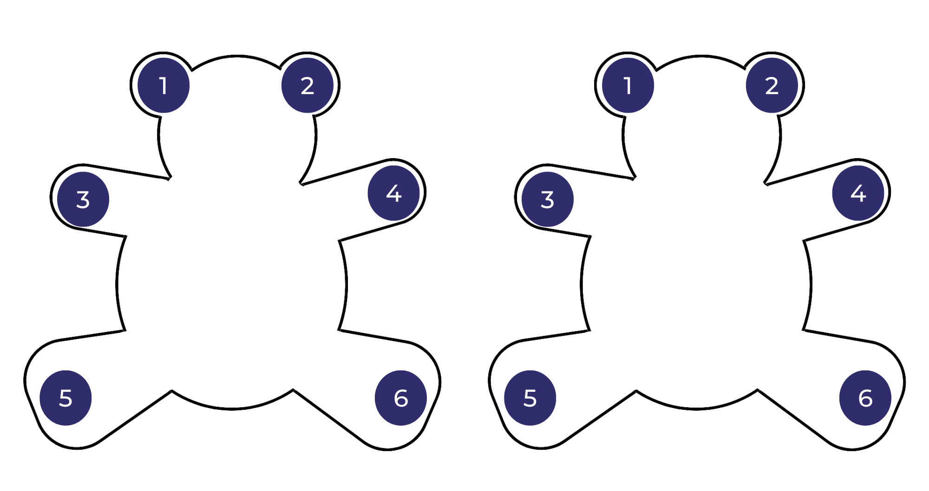

Resource 2: Amy & Louis text analysis
Page | Visual image, symbol and connotation
1, 2, 3, 4 | The characters are positioned close together and they are often shown looking at each other. This shows a strong connection and friendship between Amy and Louis.
1, 2, 3, 4 | Light, bright colours are used at the beginning of the text to depict the happiness and joy in the characters’ lives.
All | The colour red is often used to show love or affection. This colour has been used strategically on each double page and is always worn by both Amy and Louis.
1 | The image shows Amy and Louis lying on the sea of green grass looking at the sky. This is foregrounding their shared connection with the sky and the clouds that are invisible, at this point, to the reader’s eye.
5, 6, 8 | Sepia is used when Amy moves away to ‘the other side of the world’. Colour drains out of the lives of Amy and Louis. The darker tones symbolise sadness.
5, 6 | The symbol of an arrow is used on the removals truck to show the impact of Amy moving away and the distance between the 2 friends.
6 | A worm’s eye view is used when Amy is in the city, making the buildings seem taller and in stark contrast to her old home. This image is also very different to the earlier bird’s-eye view of Amy and Louis lying on the grass, looking up at the sky.
6 | The long, vertical lines of the buildings in the 'place where Amy was’ contrast with the soft, rounded lines used in the story’s beginning.
8 | The use of rain and clouds that ‘held only raindrops’ are symbolic of sadness and gloom.
All | Amy and Louis’ body language, facial expressions and gaze display their changing emotions throughout the text.
10 | When Louis cries out to Amy, the text ‘Coo-ee Am-ee' overlays the illustration and becomes larger than the setting that separates the 2 friends. This is highlighted further through using a bird’s-eye view of Louis’ yard, street and then ‘the edge of the town’.
12, 13, 14, 15 | The light colour of the blue sky with white clouds signifies a sense of hope. Louis’ gaze and the skyward angle provides an uplifting shift in mood. The stillness of the ocean that separates the friends also signifies calmness and the lighthouse gives a feeling of safety.
12, 13, 14 | The clouds shaped like ‘strange seahorses’ and ‘wild, wild dragons’ are symbolic of creatures carrying a message from Louis to Amy. The clouds’ wispy movements and broad placement across the sky add to the whimsical, imaginative passing of the message between friends.
15 | The light, bright colours that were part of Amy’s life in the beginning of the story have returned, symbolising the beauty of a memory.
15 | The framing of Amy within her window, along with the reflection of the city, brings her back into reality. This time, however, the rain has cleared, and a dream has been carried through the clouds.

Resource 3: Narrative mountain
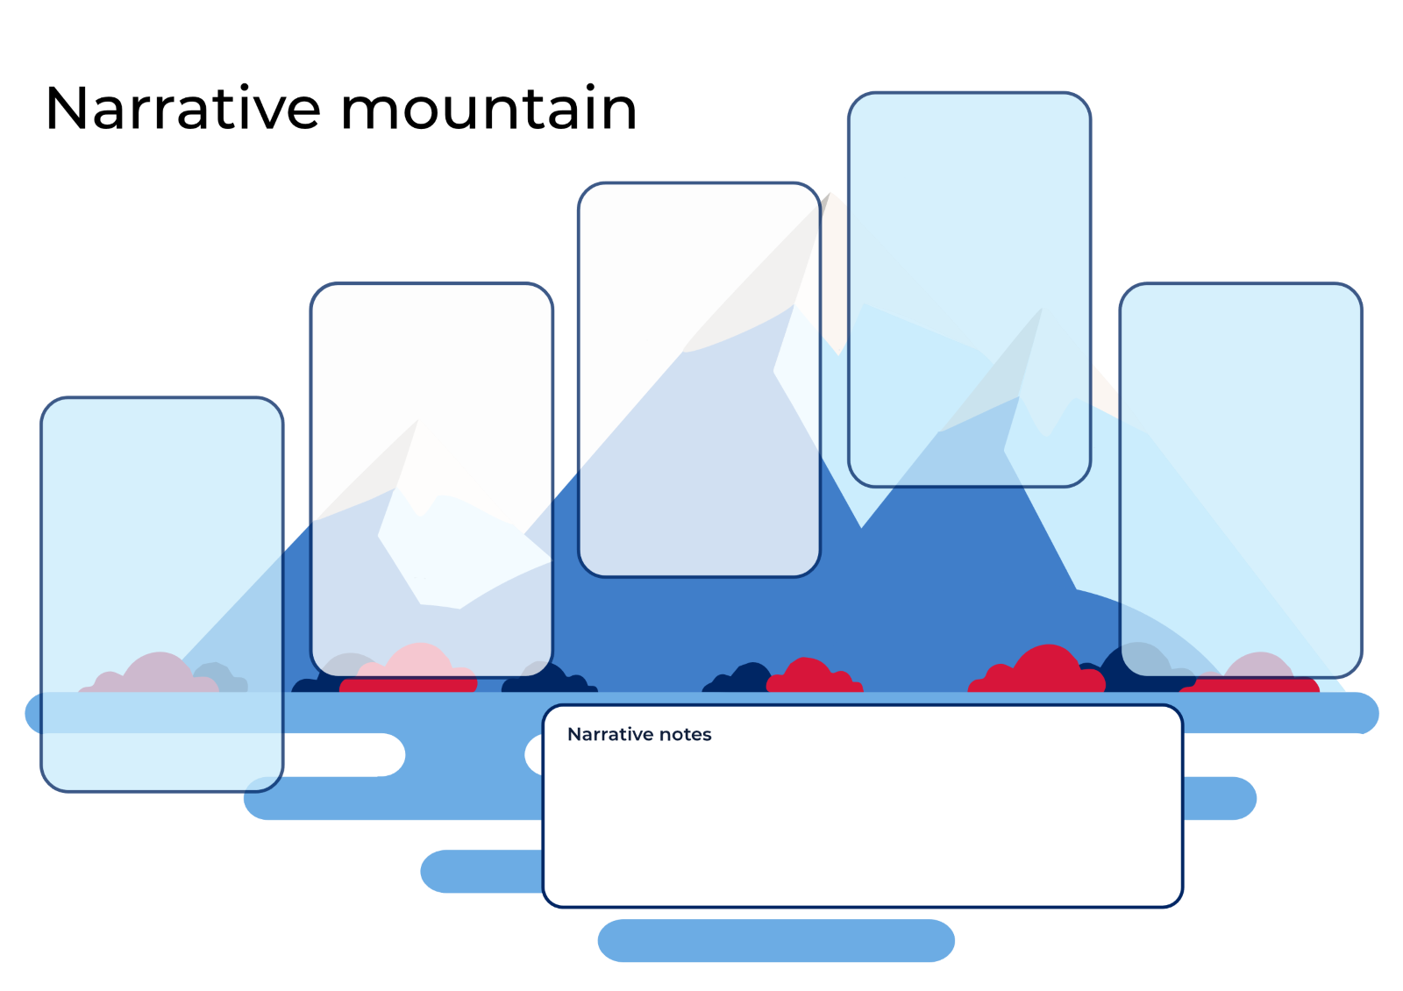

Resource 4: Blank – Image, symbol, and emotion
Title and authors of text:
Beginning | Emotion | Image/symbol | Retell
What is the setting?
Who are the characters?
Middle | Emotion | Image/symbol | Retell
What happens?
How do the characters respond?
End | Emotion | Image/symbol | Retell
How is the problem solved?

Resource 5: Amy & Louis – Image, symbol, and emotion teacher model
Amy & Louis by Libby Gleeson and Freya Blackwood
Beginning | Emotion | Image/symbol | Retell
What is the setting?  Who are the characters? | happiness | bright colours  characters close together | Amy and Louis are best friends.  They play together and always go to each other when the other calls ‘Cooee’.
Middle | Emotion | Image/symbol | Retell
What happens?  How do the characters respond? | sadness  loneliness | sepia tones  arrow on truck | But Amy moved a long way away. She felt lost in the new city.  Louis was left feeling lonely. He stopped doing all the things they used to do together.
End | Emotion | Image/symbol | Retell
How is the problem solved? | determination  hope | large ‘Coo-ee Am-ee’ text  creatures in the clouds | Louis asked if Amy could hear him if he shouted.  He called out with all his might. Louis saw creatures in the clouds that carried his message to Amy.  Amy heard his cry on the other side of the world. She saw the creatures in the clouds too.

Resource 6: Pronoun cloze passage
A. Select a proper noun or pronoun from the list below and fill in the missing words.
Amy | Louis | she | he | they | them
Amy was in the sandpit and _______________ called out to Louis.
Louis was on the swing and _______________ called out to Amy.
When they were at home _______________ called to each other across the fence.
One day _______________ and her family moved a long, long way away.

B. Select a proper noun or pronoun from the list below and fill in the missing words.
Amy | Louis | she | he | they | them
me | I | her | his | you | grandma
When Amy was in the dressing-up corner and Louis was with the playdough, _______________ called to _______________ across the room with the same special word.
‘If I call Amy loudly, she’ll hear _______________, won’t she?’
‘Maybe’, his grandma said, ‘______________ can only try.’
‘I had a lovely dream,’ she said. ‘I dreamt about ______________ and he called _____________.’

Resource 7: Multimodal text planning
Element | A sad thing happened | Something else happened | I felt happy
Visual
Writing

Resource 8: FANBOYS
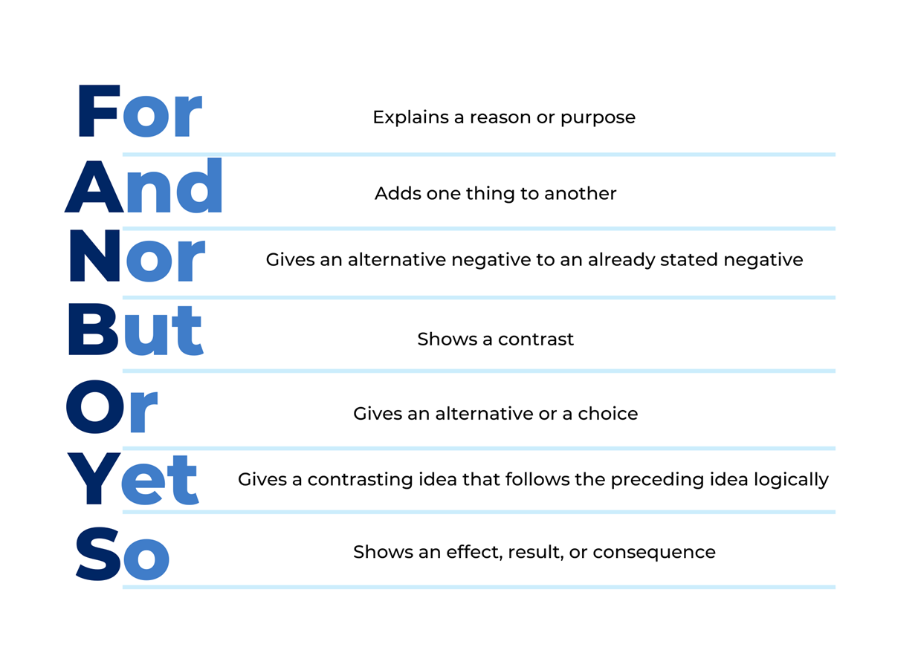

Resource 9: Tiny poems by Sally Murphy
Blowing bubbles | Clouds | Rainbow
Bubbles floating  In the air  Balls of magic  Everywhere | Fluffy clouds  Are floating by  Mounds of ice cream  In the sky | Rainbow gleaming  In the sun  Bridge of joy  For everyone
Tiny Poems from Teaching Poetry for Pleasure and Purpose by Sally Murphy (2021).
This material has been copied and communicated to you in accordance with the educational use provisions of the Copyright Act. Any further reproduction or communication of this material by you may be the subject of copyright protection under the Act. Do not remove this notice – 17 May 2022.

Resource 10: Online text features and navigation pathways
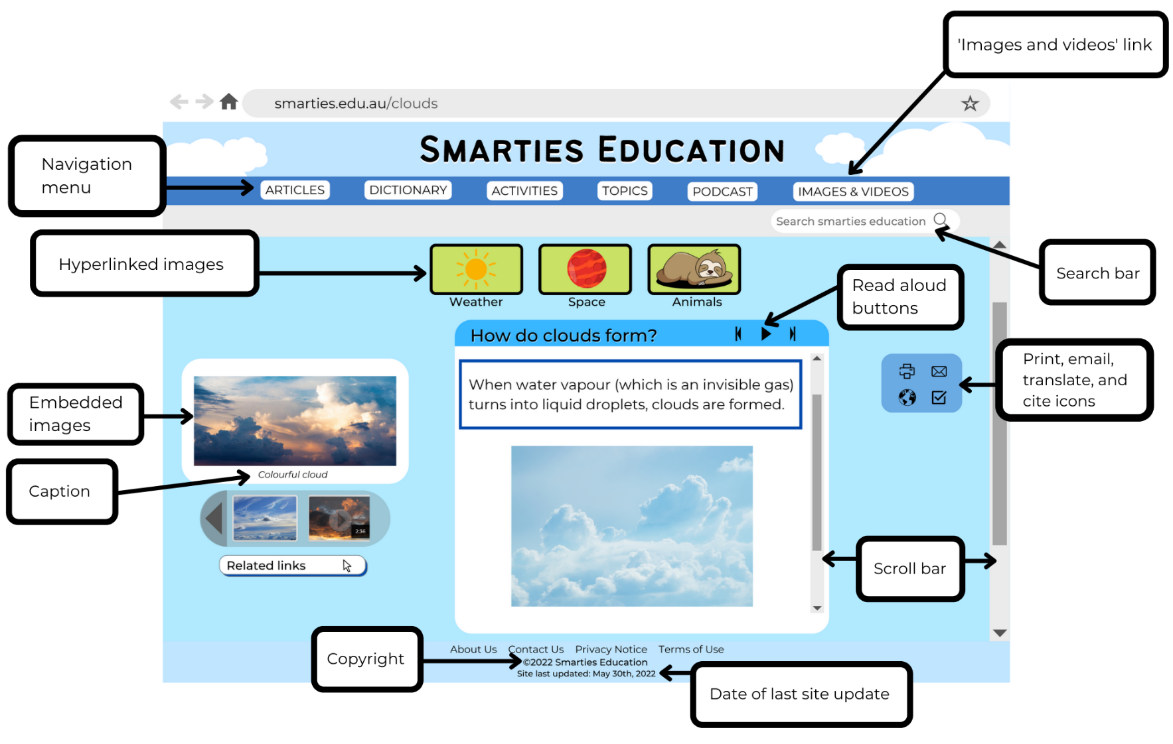
Images sourced from Canva and used in accordance with the Canva Content License Agreement.
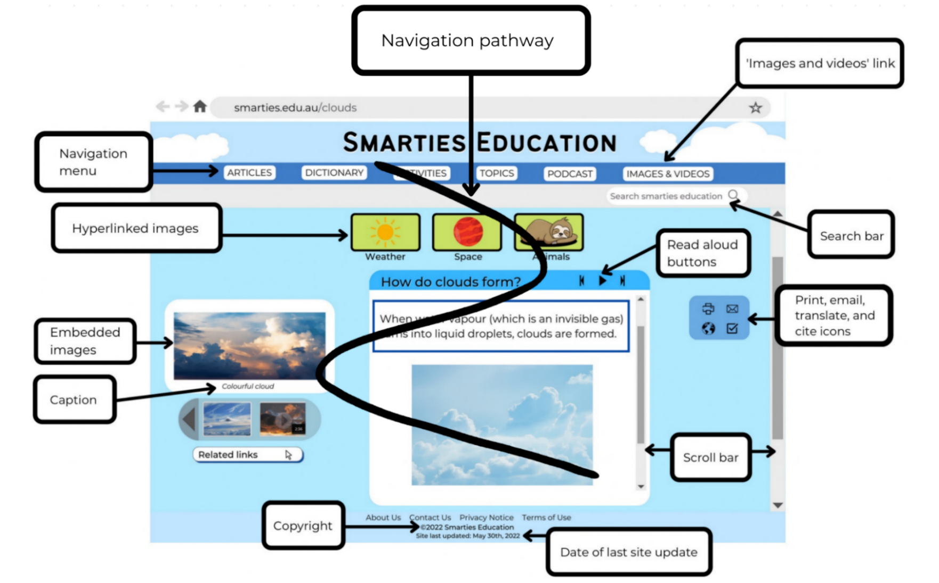
Images sourced from Canva and used in accordance with the Canva Content License Agreement.

Resource 11: Navigation word cards
website title | heading | search bar | scroll bar | links
image | caption | text | navigation menu | background

Resource 12: Smarties Education webpage
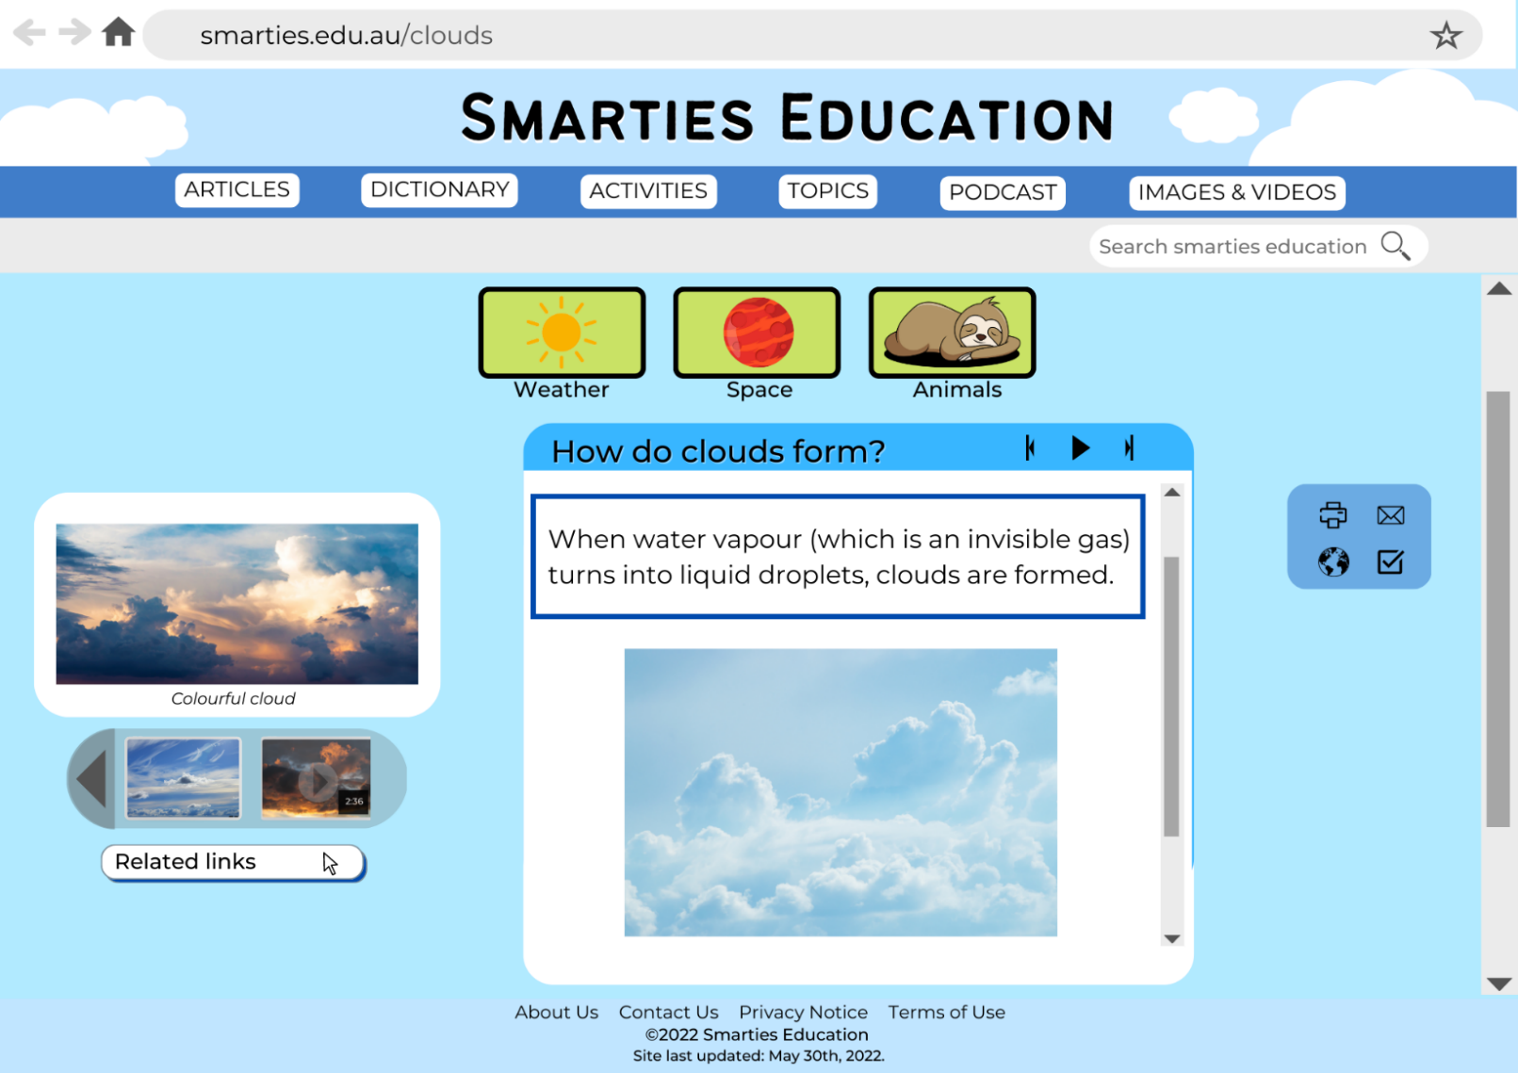
Images sourced from Canva and used in accordance with the Canva Content License Agreement.

References
Links to third-party material and websites
Please note that the provided (reading/viewing material/list/links/texts) are a suggestion only and implies no endorsement, by the New South Wales Department of Education, of any author, publisher or book title. School principals and teachers are best placed to assess the suitability of resources that would complement the curriculum and reflect the needs and interests of their students.
If you use the links provided in this document to access a third party's website, you acknowledge that the terms of use, including licence terms set out on the third party's website, apply to the use which may be made of the materials on that third-party website or where permitted by the Copyright Act 1968 (Cth). The department accepts no responsibility for content on third-party websites.
Except as otherwise noted, all material is © State of New South Wales (Department of Education), 2021 and licensed under the Creative Commons Attribution 4.0 International License. All other material (third-party material) is used with permission or under licence. Where the copyright owner of third-party material has not licensed their material under a Creative Commons or similar licence, you should contact them directly for permission to reuse their material.
English K–10 Syllabus © 2022 NSW Education Standards Authority (NESA) for and on behalf of the Crown in right of the State of New South Wales.
Creative Arts K-6 Syllabus © 2006 NSW Education Standards Authority (NESA) for and on behalf of the Crown in right of the State of New South Wales.
PDHPE K-10 Syllabus © 2018 NSW Education Standards Authority (NESA) for and on behalf of the Crown in right of the State of New South Wales.
Science and Technology K-6 Syllabus © 2017 NSW Education Standards Authority (NESA) for and on behalf of the Crown in right of the State of New South Wales.
© 2021 NSW Education Standards Authority. This document contains NSW Curriculum and syllabus content. The NSW Curriculum is developed by the NSW Education Standards Authority. This content is prepared by NESA for and on behalf of the Crown in right of the State of New South Wales. The material is protected by Crown copyright.
Please refer to the NESA Copyright Disclaimer for more information.
NESA holds the only official and up-to-date versions of the NSW Curriculum and syllabus documents. Please visit the NSW Education Standards Authority (NESA) website and the NSW Curriculum website.
National Literacy Learning Progression © Australian Curriculum, Assessment and Reporting Authority (ACARA) 2010 to present, unless otherwise indicated. This material was downloaded from the Australian Curriculum website (National Literacy Learning Progression) (accessed 22 December 2022) and was not modified. The material is licensed under CC BY 4.0. Version updates are tracked in the ‘Curriculum version history’ section on the 'About the Australian Curriculum' page of the Australian Curriculum website.
ACARA does not endorse any product that uses the Australian Curriculum or make any representations as to the quality of such products. Any product that uses material published on this website should not be taken to be affiliated with ACARA or have the sponsorship or approval of ACARA. It is up to each person to make their own assessment of the product, taking into account matters including, but not limited to, the version number and the degree to which the materials align with the content descriptions and achievement standards (where relevant). Where there is a claim of alignment, it is important to check that the materials align with the content descriptions and achievement standards (endorsed by all education Ministers), not the elaborations (examples provided by ACARA).
Carle E (2001) Little Cloud, Picture Puffin, US.
ETA (English Teachers Association) and NSW Department of Education (2016) The Textual Concepts and Processes resource, English Textual Concepts website, accessed 22 December 2022.
Gleeson L (2006) Amy & Louis (F Blackwood, illus.), Scholastic Australia Pty Ltd.
Murphy S (2021) Teaching Poetry for Pleasure and Purpose, PETAA (Primary English Teaching Association Australia).
NASA Jet Propulsion Laboratory (Earth Science Communications Team) (2022) How Do Clouds Form?, NASA Climate Kids website, accessed 22 December 2022.
NASA Jet Propulsion Laboratory (Earth Science Communications Team) (2022) Climate Kids [website], accessed 22 December 2022.
University of Illinois Board of Trustees (2022) Cumulus, Stratus and Cirrus, University of Illinois Extension Tree House Weather Kids website, accessed 22 December 2022.

