# English – K-2 multi-age – Year A – Unit 9



Contents

Unit overview and instructions for use 3

Teacher notes 4

Outcomes and content – Component A 6

Outcomes and content – Component B 10

Week 1 14

Component A teaching and learning 14

Component B teaching and learning 15

Lesson 1: Understanding character 17

Lesson 2: Exploring Three’s character 20

Lesson 3: Exploring Fern’s character 24

Lesson 4: Using adjectives to describe characters 29

Lesson 5: Making text-to-self connections 31

Week 2 34

Component A teaching and learning 34

Component B teaching and learning 35

Lesson 6: Developing character descriptions using nouns and noun groups 36

Lesson 7: Developing character descriptions – physical features 40

Lesson 8: Developing character descriptions – character actions 44

Lesson 9: Revising and editing written texts 48

Lesson 10: Sharing learning 50

Resource 1: Emoji emotions 52

Resource 2: Character descriptions 53

Resource 3: Characteristic cards 54

Resource 4: Question chart 55

Resource 5: Adverbs of time 56

Resource 6: Sentence parts 57

Resource 7: Character questionnaire 58

Resource 8: Writing scaffolds 59

References 61

## Unit overview and instructions for use

This two-week unit is comprised of Component A and Component B. Connecting learning across both components is encouraged.

|  |  |  |
| --- | --- | --- |
| Teaching and learning | Component A | Component B |
| Suggested duration | 60 minutes | 45 minutes |
| Explicit teaching focus areas | * Phonological awareness (Early Stage 1) * Print conventions (Early Stage 1) * Phonic knowledge * Reading fluency * Reading comprehension * Spelling * Handwriting | * Oral language and communication * Vocabulary * Reading comprehension * Creating written texts * Understanding and responding to literature |
| To prepare for teaching and learning: | 1. Refer to Outcomes and content – Component A, [K-2 – Instructional sequence – grapheme–phoneme correspondences [PDF 825 KB]](https://education.nsw.gov.au/content/dam/main-education/teaching-and-learning/curriculum/key-learning-areas/english/media/documents/english-k-2-GPC-instructional-sequence.pdf), and the teaching advice documents (hyperlinked in Component A teaching and learning table). 2. Based on student needs identified through ongoing assessment data, plan and document how you will sequence teaching and learning in whole class and targeted teaching groups across the two-week cycle. | 1. Familiarise yourself with Outcomes and content – Component B, [Textual concepts information and videos](https://education.nsw.gov.au/teaching-and-learning/curriculum/key-learning-areas/english/ES1S3/textual-concepts), [English Textual Concepts and Learning Processes (2016)](http://englishtextualconcepts.nsw.edu.au/content/textual-concepts-and-processes-resource), and the teaching and learning sequence. 2. Based on student needs identified through ongoing assessment data, determine how you will support students in whole class and targeted teaching groups across the two-week cycle as required. |

[English K–10 Syllabus](https://curriculum.nsw.edu.au/learning-areas/english/english-k-10) © 2022 NSW Education Standards Authority (NESA) for and on behalf of the Crown in right of the State of New South Wales.

### Teacher notes

1. Character is a construct of verbal and visual statements about a fictional identity. The analysis of characters contributes to our own personal judgements about self, morals, and values. – [English Textual Concepts and Learning Processes (2016)](http://englishtextualconcepts.nsw.edu.au/content/character).
2. Understanding the concept of character can be supported through watching the department’s video: [Character (2:31)](https://education.nsw.gov.au/teaching-and-learning/curriculum/english/textual-concepts#/asset14).
3. While character is the mentor concept for this unit, the supporting concepts of perspective and narrative can also be explored using the mentor text, *Three* by Stephen Michael King.
4. For information on pronouns, adjectives, adverbs, verbs, nouns, noun groups, prosody, and morphemes refer to the [NESA Glossary](https://curriculum.nsw.edu.au/learning-areas/english/english-k-10?tab=glossary).
5. This unit could enhance student learning towards achievement of outcomes from the PDHPE syllabus regarding personal development, and Creative arts regarding drama and visual art.
6. Reflect on student learning and engagement in activities and record differentiation and adjustments within the unit to inform future teaching and learning. One way of doing this could be to add comments to the digital file.
7. Content points are linked to the National Literacy Learning Progression version (3).

Levels and indicators sourced from [National Literacy Learning Progression](https://www.australiancurriculum.edu.au/resources/national-literacy-and-numeracy-learning-progressions/version-3-of-national-literacy-and-numeracy-learning-progressions/) © Australian Curriculum, Assessment and Reporting Authority (ACARA), (accessed 23 December 2022) and was not modified. See references for more information.

### Outcomes and content – Component A

The table below outlines the focus outcomes and content. Content is linked to the National Literacy Learning Progression version (3).

|  |  |
| --- | --- |
| Early Stage 1 Focus area and outcome | Stage 1 Focus area and outcome |
| **Phonological awareness**  **ENE-PHOAW-01 –** identifies, blends, segments and manipulates phonological units in spoken words as a strategy for reading and creating texts   * complete familiar spoken phrases in texts, including chants, rhymes, songs and poems (PhA1) * identify the number of phonemes that make up a spoken one-syllable word comprising fewer than 4 phonemes (PhA4) * identify the difference between a voiced phoneme and an unvoiced phoneme | **N/A** |
| **Print conventions**  **ENE-PRINT-01 –** tracks written text from left to right and from top to bottom of the page and identifies visual and spatial features of print   * begin reading at the top of the page and conclude reading at the bottom of the page (UnT3) * track text left to right and use return sweep (UnT4) * consistently read left page before right page (UnT4) | **N/A** |
| **Phonic knowledge**  **ENE-PHOKW-01 –** uses single-letter grapheme–phoneme correspondences and common digraphs to decode and encode words when reading and creating texts   * blend common single-letter grapheme–phoneme correspondences to read CCVC and CVCC words, and apply this when reading texts, including decodable texts (PKW5) * segment common, single-letter grapheme–phoneme correspondences to encode CCVC and CVCC words (PKW5) * decode and blend words containing consonant digraphs and apply this when reading texts, including decodable texts (PKW5) * segment and encode CVC words containing consonant digraphs (PKW4, PKW5) | **Phonic knowledge**  **EN1-PHOKW-01 –** uses initial and extended phonics, including vowel digraphs, trigraphs to decode and encode words when reading and creating texts   * **Year 1 –** blend and decode one-syllable words with taught extended vowel graphs and digraphs, including graphemes for r-controlled vowels and diphthongs, and apply this when reading texts (PKW6, PKW7) * **decode words with trigraphs and quadgraphs and apply this when reading texts** * **Year 2 – decode words with less common consonant digraphs and apply this when reading texts** |
| **Reading fluency**  **ENE-REFLU-01 –** reads decodable texts aloud with automaticity   * read phrases comprising 2 or 3 words aloud, in a rhythmic manner (FIY2, FIY3) | **Reading fluency**  **EN1-REFLU-01 –** sustains reading unseen texts with automaticity and prosody and self-corrects errors   * read aloud with an easy speech rhythm (FIY3) * adjust phrasing, intonation, volume or rate to maintain fluency when reading aloud (FIY4) |
| **Reading comprehension**  **ENE-RECOM-01 –** comprehends independently read texts using background knowledge, word knowledge and understanding of how sentences connect   * use known vocabulary to build a mental model of the content of a text * understand how adjectives describe a noun and verbs identify actions in a sentence * use visual cues in multimodal texts to interpret meaning (UnT5) * use background knowledge when identifying connections between a text, own life, other texts and/or the world (UnT4) | **Reading comprehension**  **EN1-RECOM-01 –** comprehends independently read texts that require sustained reading by activating background and word knowledge, connecting and understanding sentences and whole text, and monitoring for meaning   * use known morphemes and known vocabulary in the text to work out or refine the meaning of unknown words * identify pronouns linked to nouns within and across sentences and/or paragraphs * register a break in comprehension when reading (UnT5) * use visual and/or auditory features in multimodal texts to build meaning (UnT5) * make text-to-self, text-to-text or text-to-world connections when reading (UnT6) |
| **Spelling**  **ENE-SPELL-01 –** applies phonological, orthographic and morphological generalisations and strategies to spell taught familiar and high-frequency words when creating texts   * segment single-syllable words into phonemes as a strategy for spelling (SpG4) * add the plural suffix (s) to base nouns that require no change when suffixed (SpG5) * experiment with the tense-marking suffixes to spell familiar base verbs (SpG5) | **Spelling**  **EN1-SPELL-01 –** applies phonological, orthographic and morphological generalisations and strategies when spelling words in a range of writing contexts   * **Year 1 –** segment single-syllable words into phonemes as a strategy for spelling (SpG4) * **use spelling conventions when adding tense-marking suffixes (SpG9)** * use the suffixes -ful, -y and -ly to spell taught high-frequency words * **Year 2 –** use extended phonic code for taught consonant phonemes |
| **Handwriting**  **ENE-HANDW-01 –** produces all lower-case and upper-case letters to create texts   * form all handwritten letters in NSW Foundation Style when given a verbal prompt from the correct starting position and continue in the correct direction (HwK4) | **Handwriting**  **EN1-HANDW-01 –** uses a legible, fluent and automatic handwriting style, and digital technology, including word-processing applications, when creating texts   * form all letters with consistent size and slope in NSW Foundation Style from memory (HwK5) * type up to 5 familiar words per minute (HwK4) |

### Outcomes and content – Component B

The table below outlines the focus outcomes and content. Content is linked to the National Literacy Learning Progression version (3).

|  |  |
| --- | --- |
| Early Stage 1 Focus area and outcome | Stage 1 Focus area and outcome |
| **Oral language and communication**  **ENE-OLC-01 –** communicates effectively by using interpersonal conventions and language with familiar peers and adults   * understand how pronouns can be linked to nouns to support meaning * ask questions using who, what, when, where, why or how * start a conversation with a peer and/or adult, staying on topic (InT3) * retell favourite stories, poems, songs and rhymes with some parts as exact repetition and some in their own words (SpK2) | **Oral language and communication**  **EN1-OLC-01 –** communicates effectively by using interpersonal conventions and language to extend and elaborate ideas for social and learning interactions   * listen to or engage with texts for enjoyment and recognise that their own experience can shape their ideas and opinions of texts * use adjectives and adverbs to elaborate and/or provide some supporting details or justifications and express causal relationships (SpK3) * recite poems and rhymes |
| **Vocabulary**  **ENE-VOCAB-01 –** understands and effectively uses Tier 1 and Tier 2 words in familiar contexts   * identify, name and describe a range of objects, characters, animals, people and places when given visual and/or auditory prompts (GrA1) | **Vocabulary**  **EN1-VOCAB-01 –** understands and effectively uses Tier 1, taught Tier 2 and Tier 3 vocabulary to extend and elaborate ideas   * use taught morphemic knowledge to create word families |
| **Reading comprehension**  **ENE-RECOM-01 –** comprehends independently read texts using background knowledge, word knowledge and understanding of how sentences connect   * use known vocabulary to build a mental model of the content of a text * understand how adjectives describe a noun and verbs identify actions in a sentence * use visual cues in multimodal texts to interpret meaning (UnT5) * use background knowledge when identifying connections between a text, own life, other texts and/or the world (UnT4) | **Reading comprehension**  **EN1-RECOM-01 –** comprehends independently read texts that require sustained reading by activating background and word knowledge, connecting and understanding sentences and whole text, and monitoring for meaning   * use known morphemes and known vocabulary in the text to work out or refine the meaning of unknown words * identify pronouns linked to nouns within and across sentences and/or paragraphs * use visual and/or auditory features in multimodal texts to build meaning (UnT5) * make text-to-self, text-to-text or text-to-world connections when reading (UnT6) |
| **Creating written texts**  **ENE-CWT-01 –** creates written texts that include at least 2 related ideas and correct simple sentences   * create written texts that describe, give an opinion, recount an event, convey a story * recognise a simple sentence in own writing (GrA3) * identify and use nouns in simple sentences, including in own writing (GrA1) * use capital letters when writing proper nouns (PuN3, CrT5) * use drawing, images or mind maps to support planning and writing (CrT4) | **Creating written texts**  **EN1-CWT-01 –** plans, creates and revises texts written for different purposes, including paragraphs, using knowledge of vocabulary, text features and sentence structure   * use noun/pronoun-referencing across a text (CrT7) * use noun groups to build descriptions of people and things (CrT6) * use adverbs to modify the meaning of verbs and adjectives (CrT6) * use knowledge of similarities and differences between imaginative, informative and persuasive texts when planning for writing |
| **Understanding and responding to literature**  **ENE-UARL-01 –** understands and responds to literature read to them   * identify and discuss language used to describe characters in narratives * understand that characters in texts are represented by how they look, what they say and do, and their thoughts * use background knowledge to support understanding of characters’ actions in a text | **Understanding and responding to literature**  **EN1-UARL-01 –** understands and responds to literature by creating texts using similar structures, intentional language choices and features appropriate to audience and purpose   * identify how characters can invite positive and negative responses * identify the language, dialogue, actions, images or music that create a reader response to a character * **create and re-create characters in texts that demonstrate understanding of character traits** |

## Week 1

### Component A teaching and learning

The table below can be used to plan and document lessons that address Component A outcomes and content. Both the [detailed example [DOC 529KB]](https://education.nsw.gov.au/content/dam/main-education/teaching-and-learning/curriculum/key-learning-areas/english/media/documents/english-K-2-multiage-foundational-teaching-and-learning-sample.docx) of a two-week teaching and learning cycle and [brief example [DOC 66KB]](https://education.nsw.gov.au/content/dam/main-education/teaching-and-learning/curriculum/key-learning-areas/english/media/documents/english-K-2-multiage-foundational-teaching-and-learning-sample-brief-example.docx) may support you in your planning.

|  |  |  |  |  |  |
| --- | --- | --- | --- | --- | --- |
| Focus Areas | Lesson 1 | Lesson 2 | Lesson 3 | Lesson 4 | Lesson 5 |
| [**Phonological awareness**](https://education.nsw.gov.au/teaching-and-learning/curriculum/literacy-and-numeracy/teaching-and-learning-resources/literacy/lesson-advice-guides) **(Early Stage 1) and** [**Phonic knowledge**](https://education.nsw.gov.au/teaching-and-learning/curriculum/literacy-and-numeracy/teaching-and-learning-resources/literacy/lesson-advice-guides)  15 minutes |  |  |  |  |  |
| [**Spelling**](https://education.nsw.gov.au/teaching-and-learning/curriculum/literacy-and-numeracy/teaching-and-learning-resources/literacy/lesson-advice-guides) **and** [**Handwriting**](https://education.nsw.gov.au/teaching-and-learning/curriculum/literacy-and-numeracy/teaching-and-learning-resources/literacy/lesson-advice-guides)  15 minutes |  |  |  |  |  |
| [**Print conventions**](https://education.nsw.gov.au/teaching-and-learning/curriculum/literacy-and-numeracy/teaching-and-learning-resources/literacy/lesson-advice-guides) **(Early Stage 1),** [**Reading comprehension**](https://education.nsw.gov.au/teaching-and-learning/curriculum/literacy-and-numeracy/teaching-and-learning-resources/literacy/lesson-advice-guides) **and** [**Reading fluency**](https://education.nsw.gov.au/teaching-and-learning/curriculum/literacy-and-numeracy/teaching-and-learning-resources/literacy/lesson-advice-guides)  30 minutes |  |  |  |  |  |

### Component B teaching and learning

The following teaching and learning sequence has been designed to address Component B outcomes and content. Adapt the sequence as required to best meet the needs of your students.

#### Learning intention and success criteria

Learning intentions and success criteria are best co-constructed with students. The table below contains suggested learning intentions and success criteria.

|  |  |  |
| --- | --- | --- |
| Element | Early Stage 1 | Stage 1 |
| Learning intentions | Students are learning to understand how authors describe characters. | Students are learning to understand how authors develop characters. |
| Success criteria | Students can:   * identify characters in texts and describe what they look like, what they say and do, and their thoughts * write a simple sentence to describe a character * use capital letters when writing proper nouns * ask questions starting with who, what, when, where, why, or how * stay on topic during conversations. | Students can:   * identify characters in texts and describe their traits * infer characters’ feelings from their words and actions * compare characters in a text * identify how characters influence a reader’s feelings * identify the author’s purpose in creating a character. |

#### Resources

* King SM (2019) *Three*, Scholastic Australia Pty Ltd, Sydney. ISBN: 9780823449231
* Resource 1: Emoji emotions
* Resource 2: Character descriptions
* Resource 3: Characteristic cards
* Resource 4: Question chart
* Resource 5: Adverbs of time
* Video – [Disney Music – Lava (Official Lyric Video from ‘Lava’) (5:43)](https://www.youtube.com/watch?v=uh4dTLJ9q9o)
* Website – [Stephen Michael King’s website](https://www.stephenmichaelking.com/books/three/)
* Poem – [The Wizard](https://childrens.poetryarchive.org/poem/the-wizard/)
* Poem – [Crayon Poem](https://childrens.poetryarchive.org/poem/crayon-poem/)
* Coloured markers
* Large sheets of paper per student group (large enough to trace student outlines)
* Mini whiteboards
* Modelling clay and/or drawing materials.

### Lesson 1: Understanding character

The following teaching and learning activities support multi-age settings.

#### Whole

1. Prompt students to think about characters they are familiar with from a favourite book or movie. Support discussion through asking questions such as:

* What types of texts include characters?
* Why do authors create characters?
* Why are characters important to a narrative?
* Are all characters people?
* Do characters stay the same all the way through a text?
* Are characters fictional, or can they be real?

1. View Disney Pixar’s short film, [Lava (5:43)](https://www.youtube.com/watch?v=uh4dTLJ9q9o) to show how characters can be a fictional person or thing with an identity, including personality, wants, emotions, and feelings. Make text-to-text connections to previously studied books where an inanimate object is a character and possesses its own personality, such as Spoon by Amy Krouse Rosenthal or The Good Egg by Jory John.
2. Discuss how the film creators have used images, music and dialogue to create an identity for the 2 volcano characters. Explicitly highlight the use of wordplay in the song lyrics, ‘I wish that the earth, sea and the sky up above will send me someone to lava’, ‘Altogether now their lava grew and grew’ and ‘I lava you’.
3. Ask students what the film tells the audience about each volcano’s physical appearance (external traits), and personality, wants, emotions and feelings (internal traits).
4. Consider how the characters changed throughout the film. Brainstorm words and phrases that describe the volcanoes’ wants, emotions and personalities in the orientation (beginning), during the series of events (middle), and at the conclusion (end). Record responses.
5. Ask students to decide how they felt about the characters. This can be done by displaying Resource 1: Emoji emotions and having students select and describe the emotion that best fits their response to the characters. Provide the opportunity for students to describe how the language, images and music impacted their response to the characters.

#### Part

The table below details the differentiated teaching and learning activities for each stage.

|  |  |
| --- | --- |
| Early Stage 1 (guided/independent) | Stage 1 (independent/guided) |
| 1. Pause the film to display an image/s from Lava to use as a stimulus for discussion. 2. Explain that, when talking about characters, the speaker may not always use their own name or the character’s name. Introduce the term pronoun and describe as a word that is used in place of a noun. For example, he, she, they, I, we. 3. Encourage students to describe the characters using a range of pronoun sentence prompts. For example:  * Appearance: He has__. She has __. They __. * Actions: He __. She __. They __. * Wants/Needs: He wants __. She wants __. They __. * Opinion: I think __. I like __.  1. Model writing a simple sentence that describes one of the characters or a student’s response to the characters. For example, ‘The volcanoes like to sing.’ 2. Identify the subject of the sentence and the verb (verb phrase). Reinforce the need for a sentence to be a complete idea with a capital letter at the beginning and full stop at the end. 3. Support students to write the model sentence or one of their own. 4. Provide pairs of students with modelling clay and/or drawing materials to represent the 2 volcanoes using the features described in the group discussion.   **Too hard? Students copy keywords related to the topic.**  **Too easy? Students write 2 simple sentences and then join them using a conjunction. For example, I like the girl volcano because she has long hair.** | 1. Provide pairs of students with modelling clay and/or drawing materials to represent the 2 volcanoes at a point in the clip, such as when they were longing for each other, or when they had been united. 2. Model writing sentences that describe the volcano characters. Explicitly draw attention to the use of noun groups to build descriptions and pronouns that refer to each character. For example, ‘The boy volcano had a big smile and he was happy to see the girl volcano rise above the water. She was beautiful and had long flowing hair. They held each other and sang sweet songs. The volcanoes were not lonely anymore.’ 3. Using mini whiteboards, students write sentences describing the characters using correct pronoun referencing.   **Too easy?** Students fold a page into 3 and visually represent the characters at 3 different points. Students write detailed descriptions of the characters at each point to show how their appearance, wants and feelings changed throughout the film. |

**Early Stage 1 Assessment task 1 –** Observations from this lesson allow students to demonstrate achievement towards the following syllabus outcome and content point:

**ENE-OLC-01 – communicates effectively by using interpersonal conventions and language with familiar peers and adults**

* **understand how pronouns can be linked to nouns to support meaning.**

**Stage 1 Assessment task 1 –** Observations and work samples from this lesson allow students to demonstrate achievement towards the following syllabus outcomes and content points:

**EN1-RECOM-01 –** comprehends independently read texts that require sustained reading by activating background and word knowledge, connecting and understanding sentences and whole text, and monitoring for meaning

* use visual and/or auditory features in multimodal texts to build meaning.

**EN1-UARL-01 –** understands and responds to literature by creating texts using similar structures, intentional language choices and features appropriate to audience purpose

* identify the language, dialogue, actions, images or music that create a reader response to a character.

### Lesson 2: Exploring Three’s character

The following teaching and learning activities support multi-age settings.

#### Whole

1. Introduce the text *Three* displaying the front and back covers. Encourage students to make careful observations and interpretations about the text using the [See-Think-Wonder](https://app.education.nsw.gov.au/digital-learning-selector/LearningActivity/Card/638) routine. For example, I can **see** a dog with 3 legs; I **think** that he might be friendly because he is smiling; I **wonder** why he has 3 legs.
2. Read *Three.* Ask students to consider why the main character was given his name and how this relates to the way he refers to other characters. For example, he calls humans ‘two legs’.
3. Students [Think-Pair-Share](https://app.education.nsw.gov.au/digital-learning-selector/LearningActivity/Card/645) and list the different characters on mini whiteboards. Identify and describe how the character, Three, refers to the other characters he meets. Exemplify the use of adjectives that describe a noun (noun groups). For example, ‘He met **a pink four leg** that snorted through **its flat, friendly nose**.’ Support students to create a mental model of each character that is introduced and described. A list of characters and their descriptions is available in Resource 2: Character descriptions.
4. Explain that the author has displayed Three’s personality through both the words and illustrations in the text.
5. Show the first double page in the book and discuss which words and images provide information about Three’s personality. For example, ‘skip, hop, warm, clean and waggily tail’ indicate positive connotations. Three is also smiling in all pictures, even when sheltered by an umbrella in the rain. Bright, light colours are used, and readers can see Three interacting in a playful way with different people and insects in several of the illustrations.
6. Using Resource 3: Characteristic cards, select a word that describes what we know about Three’s personality and character at this point in the text.

**Note:** The words in this resource have been grouped to support conversations about morphemes, or individual units of meaning, and how they can be used to work out or refine the meaning of unknown words.

1. Display the double page beginning with the text, ‘Three sniffed his way and found a six leg.’ Focus on the sentence, ‘Three was happy that little six legs had underground homes, far away from busy feet.’ Ask students to talk with a partner about what this shows about Three’s personality and character. For example, Three is caring and kind because he does not want the six legs to get stepped on. Using Resource 3: Characteristic cards, students select and justify a word such as ‘caring’ that pairs with how Stephen Michael King has represented Three on these pages.
2. In groups, students continue studying Three’s character, looking carefully at the text and illustrations that reveal more about his traits and the way he looks. Character traits can be matched with characteristic cards throughout. Additional cards can be made based on student suggestions.
3. Draw attention to the final page of the book which states, ‘Three was thankful for everything.’ Discuss the term thankful and how it is reflected throughout the entire text. Highlight that the morpheme -ful means ‘full of’. Compare with other words, such as fearful, wonderful, careful.

#### Part

The table below details the differentiated teaching and learning activities for each stage.

|  |  |
| --- | --- |
| Early Stage 1 (teacher guided/independent) | Stage 1 (pairs/teacher guided/independent) |
| 1. Highlight that the character’s name is Three and when his name is written it is a proper noun with a capital letter. Highlight the difference between the numeral 3, the word when written and the word when written as a proper noun. 2. Make comparisons with students’ names and how they are written. 3. Ask students to identify if other characters are given a name in the text. Explain that the word ‘Fern’ is also a proper noun because it is a character’s name. Locate where names have been written throughout the text. Emphasise that a capital is used for a proper noun when written anywhere in the sentence (not just at the start). 4. Co-construct with students a range of simple sentences that include character names and the names of students (proper nouns). For example, Three and Fern are friends. The family was nice to Three. James likes Three. Abigail likes Fern. 5. Students copy or write a simple sentence that includes a proper noun. 6. Students can create an illustration that matches their sentence, or they can look through familiar decodable texts to locate and write character names that have a capital letter. | 1. With a partner, students draw a large outline of the character, Three. Students identify Three’s physical characteristics and record these on the outside of the drawing. 2. Students identify Three’s personal characteristics, such as his personality traits, wants, emotions, feelings and record these on the inside of the drawing. 3. Share responses as a group. 4. Co-construct a range of sentences that describe Three. Draw attention to the use of pronoun referencing between sentences and its role in providing cohesion. For example, Three is a small dog with 3 legs. **He** is thankful **he** only has 3 legs and **they** can take **him** wherever **he** wants. Three loves adventure and **he** is thankful for everything. 5. Using the co-constructed sentences and their character outline as a guide, students write sentences to describe Three’s outside and inside characteristics.   **Too easy?** Students write compound and complex sentences describing Three’s external and internal character traits.   1. Direct students to re-read their sentences and highlight the noun/pronoun references that they have included. 2. Students create an illustration that visually represents Three’s appearance and character traits. |

#### Whole

1. As a class, reflect on the importance of the main character’s internal characteristics in this text, even though the title refers to the external characteristic of Three only having 3 legs.

**Early Stage 1 Assessment task 2** **–** Observations and work samples from this lesson allow students to demonstrate achievement towards the following syllabus outcomes and content points:

**ENE-RECOM-01 – comprehends independently read texts using background knowledge, word knowledge and understanding of how sentences connect**

* use known vocabulary to build a mental model of the content of a text
* use visual cues in multimodal texts to interpret meaning.

**ENE-UARL-01 –** understands and responds to literature read to them

* identify and discuss language used to describe characters in narratives
* understand that characters in texts are represented by how they look, what they say and do, and their thoughts
* use background knowledge to support understanding of characters’ actions in a text.

### Lesson 3: Exploring Fern’s character

The following teaching and learning activities support multi-age settings.

#### Whole

1. Review the character description of Three from Lesson 2 and how it was constructed by looking closely at information in the text’s words and illustrations.
2. Explain that students will now look at how the author/illustrator has created the character, Fern. Display the double page which starts with the text, ‘She poured him a glass of milk and shared her biscuits.’ Ask:

* What can you see in the picture?
* What do you think about Fern and her personality?
* How do the illustrations and text help to expand your understanding of Fern?

1. Display the words on Resource 3: Characteristic cards and ask students to select which best describes Fern on this double page.
2. In groups, students complete the same activity with the other pages that include Fern. Encourage students to identify the language, actions and images that create a reader response.
3. As a class, identify similarities between Three and Fern. Include both external features, for example, they are both always smiling; and internal character traits, such as being friendly and kind.
4. Display the page where Fern makes Three his own ‘special curl-up-place’. Identify the character names and pronoun references that are used across the text. Identify where the pronoun ‘they’ is used to describe Fern’s family, which is related to the illustration rather than the words in the text.
5. Have students identify characteristics that they have in common with Fern and others that are different. For example, ‘I am imaginative like Fern, but I am also adventurous.’
6. Organise students into groups to discuss what they, and their family, would do if Three came to their house. Model asking a student who, what, when, where, why and how questions using Resource 4: Question chart (Early Stage 1) and answering questions with adjectives and adverbs to elaborate and provide detail (Stage 1). For example, where would you let Three sleep? I would make him a cosy bed and put it next to my bed so that he could sleep near me.
7. Model drawing an illustration of yourself with Three. Include aspects of your own context as well as images that reflect your personality and interests.

#### Part

The table below details the differentiated teaching and learning activities for each stage.

|  |  |
| --- | --- |
| Early Stage 1 (independent) | Stage 1 (teacher guided) |
| 1. Students draw themselves as a character in the text, representing how they look and what they might do with Three. 2. With a partner, students describe their illustration. | 1. Revise that adverbs of manner tell **how** something is done. For example, Three walked **slowly** through the countryside. 2. Re-read the sentence several times using an alternative adverb each time. For example, quickly, silently, angrily, warily. Discuss the impact the adverbs have on the sentence. Highlight how each adverb contains a base word (free morpheme) that is built on by the suffix (bound morpheme) -ly. For example, slow/slowly, quick/quickly, angry/angrily. 3. Consider how adverbs provide information about the movements, mood, mannerisms and body language of the subject (character) being described. Highlight the use of adverbs in the following sentences and how they impact on our understanding of Fern’s character:  * Fern **lovingly**made a bed for Three out of her old t-shirts and a box. * Fern spoke **kindly** to Three and told him all about the interesting creatures in her yard.  1. Jointly construct with students sentences that describe your illustration from activity 9. Explicitly include the use of adverbs, adjectives to describe nouns, as well as continued reinforcement of noun/pronoun referencing. Explain that because each person is adding themselves as a character in the book, they will need to use their name rather than the personal pronoun ‘I’. For example, ‘David made Three a cosy bed from his favourite old shirt, and he placed it carefully next to his bed so they could always be together. Each weekend, Three and David would set off on exciting adventures in the bush. They would come home muddy and tired, but very happy.’ |

#### Part

The table below details the differentiated teaching and learning activities for each stage.

|  |  |
| --- | --- |
| Early Stage 1 (teacher guided) | Stage 1 (independent) |
| 1. Model writing a simple sentence about your own illustration. Identify the subject and predicate in the sentence. Highlight the use of a capital letter for any proper nouns. For example, I (subject) made a bed for **T**hree (predicate). 2. Support students to write a simple sentence about their illustration. With students, identify the parts of their simple sentence, ensuring that it is a complete idea. Ask students to identify any proper nouns they have used. | 1. Using the co-constructed model as a guide, students independently draw an illustration and write sentences to recreate themselves as a character in the text. |

#### Whole

1. Provide time for students to share their writing and illustration with a partner. Discuss specific ways that students have demonstrated an understanding of character traits in their texts.

**Early Stage 1 Assessment task 3** **–** Observations and work samples from this lesson allow students to demonstrate achievement towards the following syllabus outcome and content points:

**ENE-CWT-01 –** creates written texts that include at least 2 related ideas and correct simple sentences

* use capital letters when writing proper nouns
* recognise a simple sentence in own writing.

**Stage 1 Assessment task 2 –** Observations and work samples from this lesson allow students to demonstrate achievement towards the following syllabus outcome and content point:

**EN1-CWT-01 – plans, creates and revises texts written for different purposes, including paragraphs, using knowledge of vocabulary, text features and sentence structure**

* use adverbs to modify the meaning of verbs and adjectives.

### Lesson 4: Using adjectives to describe characters

The following teaching and learning activities support multi-age settings.

#### Whole

1. Introduce students to a poem that includes a character description, such as the [Crayon Poem](https://childrens.poetryarchive.org/poem/crayon-poem/). Consider the use of descriptive language. For example, an orange mouse with yellow cheese.
2. Listen to the online recording and then read the poem together several times adjusting the pace, use of pauses and emphasis (loud and soft) on different words and phrases, including rhyming pairs. Discuss the effect on meaning and engagement.
3. Place students in groups and ask them to decide how they will use their expressive voices to read parts of the poem to the rest of the class. Guide groups to focus on reading fluency, including prosody.

**Note:** Prosody is reading with expression using correct phrasing, intonation, and attention to punctuation.

**Too easy?** Support students in a targeted teaching group to recite a simple four-line poem.

**Too easy?** Students develop poetry reading skills with a more advanced poem. For example, [The Wizard](https://childrens.poetryarchive.org/poem/the-wizard/).

1. Look at the map in the text to see Three’s journey. Discuss the characters that Three meets. Using the text and Resource 2: Character descriptions, look at how the author has described the characters, including the use of adjectives to describe nouns. For example, a chicken is described as ‘a winged two leg that laid eggs.’ Consider why a description of features, rather than the name of the animal is used.
2. Model drawing an animal and writing a sentence that describes it without using the animal’s name. For example, ‘Three met a four leg with a woolly coat.’ Ask students to identify the noun that is being described, for example, ‘sheep’.
3. To plan for writing, students draw an animal that is not a character in the story and describe its characteristics to a partner using the modelled language. For example, students might describe what the animal looks like, how they move and what sound they make.
4. Students write a descriptive text about an animal including noun groups/nouns and adjectives to describe what it looks like, how it moves, and the sounds it makes. To show understanding, students underline the noun (Early Stage 1) or noun groups (Stage 1) in their writing.
5. Students read their descriptive sentences to the class without showing the matching image. Listeners try to identify the animal. If needed, students ask who, what, when, where, why, or how questions for additional clues.
6. Discuss the effectiveness of the descriptions and elements that could be revised or added if the animal was unable to be identified. Students can also view the matching visual and how the illustration adds meaning to the written text.

**Early Stage 1 Assessment task 4 –** Observations and work samples from this lesson allow students to demonstrate achievement towards the following syllabus outcomes and content points:

**ENE-VOCAB-01 –** understands and effectively uses Tier 1 and Tier 2 words in familiar contexts

* identify, name and describe a range of objects, characters, animals, people and places when given visual and/or auditory prompts.

**ENE-RECOM-01 –** comprehends independently read texts using background knowledge, word knowledge and understanding of how sentences connect

* understand how adjectives describe a noun and verbs identify actions in a sentence.

**ENE-CWT-01 –** creates written texts that include at least 2 related ideas and correct simple sentences

* identify and use nouns in simple sentences, including in own writing.

### Lesson 5: Making text-to-self connections

The following teaching and learning activities support multi-age settings.

#### Whole

1. Visit [Stephen Michael King’s website](https://www.stephenmichaelking.com/books/three/) to learn about the creator’s journey and motivation for writing this book, including the role that his brother played. Discuss his idea about ‘finding the familiar’ and the story of *Three* becoming one of ‘understanding, acceptance, empathy, being thankful and following your own path’.
2. Highlight that individual experiences can shape a reader’s ideas and opinions of texts and how they connect with them. Explain that students will make connections with their own lives and instances where they have experienced similar traits.
3. Organise students into groups. Model starting a discussion with a group by describing an experience from your life. Purposefully use adverbs that create a context for ‘when’ events occurred. Refer to Resource 5: Adverbs of time as a scaffold (focus for Stage 1). Provide the opportunity for various students to use Resource 4: Question chart (focus for Early Stage 1) as a prompt for asking who, what, when, where, why and how questions. Explain the importance of staying on topic in conversations. Provide explicit examples and non-examples of questions related to the topic.
4. Provide time for students to share experiences in their group. Scaffold oral language interactions and strategy development with groups as needed. This may include asking questions to elicit further information or clarification, reinforcing what a student has communicated or recasting.

**Note:** Recasting is a teaching strategy to support students in their oral language development. A recast occurs when the teacher modifies a learner’s utterance by adding new or different grammar (syntax) or by using precise words.

1. Reflect on the group conversations and list other adverbs of time that were used during discussions and/or questions that promoted interesting responses.
2. Revisit that, in the text, Fern is thankful for Three and Three is thankful for everything.
3. Model writing sentences that describe your own experiences with feeling thankful. Explicitly include sentences containing adverbs of time, noun/pronoun referencing as well as noun groups that build descriptions of people and things. For example, ‘I am thankful for my mum and dad. I am thankful for always having my kind friends. I am thankful for the yummy food in my lunchbox today. I am thankful for my cosy bed.’
4. Ask students to orally share and draw things they are thankful for in their own life. Support students to create descriptive sentences that pair with their illustrations.

**Too hard?** Provide students with the sentence starter, ‘I am thankful for __’ to support their writing.

**Early Stage 1 Assessment task 5 –** Observations from this lesson allow students to demonstrate achievement towards the following syllabus outcome and content points:

**ENE-OLC-01 –** communicates effectively by using interpersonal conventions and language with familiar peers and adults

* ask questions using who, what, when, where, why or how
* start a conversation with a peer and/or adult, staying on topic
* use background knowledge when identifying connections between a text, own life, other texts and/or the world.

**Stage 1 Assessment task 3 –** Observations from this lesson allow students to demonstrate achievement towards the following syllabus outcomes and content points:

**EN1-OLC-01 –** communicates effectively by using interpersonal conventions and language to extend and elaborate ideas for social and learning interactions

* listen to or engage with texts for enjoyment and recognise that their own experience can shape their ideas and opinions of texts
* use adjectives and adverbs to elaborate and/or provide some supporting details or justifications and express causal relationships.

**EN1-RECOM-01 –** comprehends independently read texts that require sustained reading by activating background and word knowledge, connecting and understanding sentences and whole text, and monitoring for meaning

* make text-to-self, text-to-text or text-to-world connections when reading.

## Week 2

### Component A teaching and learning

The table below can be used to plan and document lessons that address Component A outcomes and content. Both the [detailed example [DOC 529KB]](https://education.nsw.gov.au/content/dam/main-education/teaching-and-learning/curriculum/key-learning-areas/english/media/documents/english-K-2-multiage-foundational-teaching-and-learning-sample.docx) of a two-week teaching and learning cycle and [brief example [DOC 66KB]](https://education.nsw.gov.au/content/dam/main-education/teaching-and-learning/curriculum/key-learning-areas/english/media/documents/english-K-2-multiage-foundational-teaching-and-learning-sample-brief-example.docx) may support you in your planning.

|  |  |  |  |  |  |
| --- | --- | --- | --- | --- | --- |
| Focus Areas | Lesson 6 | Lesson 7 | Lesson 8 | Lesson 9 | Lesson 10 |
| [**Phonological awareness**](https://education.nsw.gov.au/teaching-and-learning/curriculum/literacy-and-numeracy/teaching-and-learning-resources/literacy/lesson-advice-guides) **(Early Stage 1) and** [**Phonic knowledge**](https://education.nsw.gov.au/teaching-and-learning/curriculum/literacy-and-numeracy/teaching-and-learning-resources/literacy/lesson-advice-guides)  15 minutes |  |  |  |  |  |
| [**Spelling**](https://education.nsw.gov.au/teaching-and-learning/curriculum/literacy-and-numeracy/teaching-and-learning-resources/literacy/lesson-advice-guides) **and** [**Handwriting**](https://education.nsw.gov.au/teaching-and-learning/curriculum/literacy-and-numeracy/teaching-and-learning-resources/literacy/lesson-advice-guides)  15 minutes |  |  |  |  |  |
| [**Print conventions**](https://education.nsw.gov.au/teaching-and-learning/curriculum/literacy-and-numeracy/teaching-and-learning-resources/literacy/lesson-advice-guides) **(Early Stage 1),** [**Reading comprehension**](https://education.nsw.gov.au/teaching-and-learning/curriculum/literacy-and-numeracy/teaching-and-learning-resources/literacy/lesson-advice-guides) **and** [**Reading fluency**](https://education.nsw.gov.au/teaching-and-learning/curriculum/literacy-and-numeracy/teaching-and-learning-resources/literacy/lesson-advice-guides)  30 minutes |  |  |  |  |  |

### Component B teaching and learning

The following teaching and learning sequence has been designed to address Component B outcomes and content. Adapt the sequence as required to best meet the needs of your students.

#### Learning intention and success criteria

Learning intentions and success criteria are best co-constructed with students. The table below contains suggested learning intentions and success criteria.

|  |  |  |
| --- | --- | --- |
| Element | Early Stage 1 | Stage 1 |
| Learning intentions | Students are learning to create and describe a character’s physical traits and personal characteristics. | Students are learning to create a fictional character with a personality, wants, emotions, and feelings. |
| Success criteria | Students can:   * identify adjectives that describe a noun * recognise a simple sentence in own writing * use drawings to support writing * identify a character’s personal and physical characteristics * create a written text with 2 related ideas to describe a character. | Students can:   * plan for descriptive writing * use noun groups to build descriptions * use noun/pronoun references when writing * create a text that describes a character’s personal and physical traits * apply feedback to improve writing. |

#### Resources

* Donaldson J (2006) *The Gruffalo*, Penguin Young Readers Group, London. ISBN: 9781509804757
* King SM (2019) *Three*, Scholastic Australia Pty Ltd, Sydney. ISBN: 9780823449231
* Resource 1: Emoji emotions
* Resource 4: Question chart
* Resource 6: Sentence parts
* Resource 7: Character questionnaire
* Resource 8: Writing scaffolds
* Website – [Alligator Pie](https://childrens.poetryarchive.org/poem/alligator-pie/)
* A4 paper (one per student)
* Drawing materials.

### Lesson 6: Developing character descriptions using nouns and noun groups

The following teaching and learning activities support multi-age settings.

#### Whole

1. Revise that characters are represented by how they look, what they say and do, and their thoughts. Revise how authors create characters by describing their personality, wants, emotions, and feelings.
2. Read *The Gruffalo*.
3. Discuss if the Gruffalo, or alternative character, invites a positive or negative response. Students select and describe the emotion that best fits their response to the character using Resource 1: Emoji emotions. Students consider their response to other characters in the text. Explore the techniques used by the author to elicit these feelings or emotions from the reader.
4. Turn to the page where the mouse finally sees the Gruffalo and is describing his physical features in a list. Model reading the page using appropriate fluency, including prosody. Chorally read the character description as a class. Share examples of alliteration in the description and explore how emphasising these beginning sounds when reciting can enhance enjoyment.
5. Model drawing a picture of the Gruffalo.
6. Revise that a noun group is a group of words that are built on a noun and include a pointer (such as his, her, the, a, an, that or its) and one or more adjectives or adverbs (Stage 1) or nouns can be described with an adjective (Early Stage 1).
7. Use the model text to identify the main noun and any words that come before (or after) it that build description. Identify the position of the adjectives that were explored in activity 4:

* He has terrible **tusks**, and terrible **claws**, And terrible **teeth** in his terrible **jaws**.
* He has knobbly **knees**, and turned-out **toes**, And a poisonous **wart** at the end of his **nose**.
* His **eyes** are orange, his **tongue** is black, He has purple **prickles** all over his **back**.

1. Label the picture from activity 5 with the noun groups that were used to describe the character’s physical features.
2. Discuss and list other noun groups not used in the text that could be used to describe the character.

#### Part

The table below details the differentiated teaching and learning activities for each stage.

|  |  |
| --- | --- |
| Early Stage 1 (independent) | Stage 1 (teacher guided/independent) |
| 1. Students draw a detailed illustration of the Gruffalo based on the images in the text and the descriptions used. Students label their drawing of the Gruffalo using the nouns listed in activity 7. | 1. Explore adjectives from the text that contain base words with common morphemes added. Draw attention to how the meaning of a word can be worked out through understanding individual units in the word. For example:  * terrible/terror (-ible: able to) – the terrible tusks are able to cause terror * knobbly/knob (-ly: has the quality of) – his knee looks like a knob * poisonous/poison (-ous: full of) – his wart is full of poison. |

#### Part

The table below details the differentiated teaching and learning activities for each stage.

|  |  |
| --- | --- |
| Early Stage 1 (teacher guided) | Stage 1 (pairs/independent) |
| 1. Display an enlarged copy of Resource 6: Sentence parts. 2. Revise that a simple sentence contains a subject (who) and a verb or object (what) using the example in the resource. Explain that the sentences written about the Gruffalo also include information about where the external features are positioned. 3. Model writing sentence parts into the table. Ask students if the sentence makes sense and is a complete idea. 4. Students complete their own copy of Resource 6: Sentence parts about the Gruffalo and his features. Support students to identify sentence parts, including the subject (The Gruffalo), verb (has), adjectives that are describing a noun (terrible claws) and information about the position of features/where/prepositions (on his fingers). | 1. In pairs, students use A4 paper to draw the Gruffalo using their prior knowledge and the description used in the narrative. Students label the character’s physical features using adjectives and noun groups. 2. Students use their labelled drawing to write sentences to describe the Gruffalo. For example, ‘The Gruffalo has a black tongue. He has terrible claws and purple prickles down his spine.’ 3. Students read their sentences in small groups using appropriate fluency, including prosody. |

**Early Stage 1 Assessment task 6 –** Observations and work samples from this lesson allow students to demonstrate achievement towards the following syllabus outcomes and content points:

**ENE-RECOM-01 –** comprehends independently read texts using background knowledge, word knowledge and understanding of how sentences connect

* understand how adjectives describe a noun and verbs identify actions in a sentence.

**ENE-CWT-01 –** creates written texts that include at least 2 related ideas and correct simple sentences

* identify and use nouns in simple sentences, including in own writing.

**Stage 1 Assessment task 4 –** Observations and work samples from this lesson allow students to demonstrate achievement towards the following syllabus outcome and content point:

**EN1-CWT-01 – plans, creates and revises texts written for different purposes, including paragraphs, using knowledge of vocabulary, text features and sentence structure**

* **use noun groups to build descriptions of people and things.**

### Lesson 7: Developing character descriptions – physical features

The following teaching and learning activities support multi-age settings.

#### Whole

1. Explain that students will create their own character with distinctive physical features. When creating a character, students will need to consider the response they would like from readers. Place a copy of Resource 1: Emoji emotions in a visible location and brainstorm character ideas that may evoke some of the emotions presented.
2. Provide students with a piece of A4 paper folded into quarters to generate ideas for 4 different characters in 4 minutes. Set a timer for one minute. Students sketch one character idea into one box in one minute. Remind students to focus on their ideas for characters, not the detail in their drawing. Repeat this step 4 times until students have 4 different ideas sketched.
3. Students share their ideas with a partner, including the emotions they would like to evoke. Encourage students to describe their characters with adjectives, and to provide supporting details or justifications about why their character would be interesting.
4. Students choose one character to create. If time permits, students can work in small groups to develop characterisation further with the use of Resource 7: Character questionnaire.
5. Develop or show an exemplar text to model the features of a character description in a narrative text. For example, the description of when the mouse has finally seen the Gruffalo. Co-construct writing criteria for students to refer to as they write their own narrative character description. The table below sets out example writing critiera:

|  |  |
| --- | --- |
| Early Stage 1 writing criteria | Stage 1 writing criteria |
| * write a sentence to describe how the character looks * write a sentence to describe an inside trait of a character * include adjectives to describe nouns * use pronouns to refer to the character * use capital letters when writing proper nouns. | * write sentences to describe the physical features of a character * write sentences to describe the personal traits of a character * include noun groups in descriptions * use pronouns to refer to the character throughout the text * use adjectives and adverbs to build meaning. |

#### Part

The table below details the differentiated teaching and learning activities for each stage.

|  |  |
| --- | --- |
| Early Stage 1 (independent) | Stage 1 (teacher guided) |
| 1. Students draw a picture of their character and label its physical features using adjectives and nouns. Encourage students to refer to word banks and modelled writing examples from previous lessons as a support. | 1. Provide students with a copy of one of the scaffolds on Resource 8: Writing scaffolds. Explain that this plan will help to support the planning of an imaginative text. Discuss the elements of the plan and how it may be similar or different to a plan for an informative or persuasive text. |

#### Part

The table below details the differentiated teaching and learning activities for each stage.

|  |  |
| --- | --- |
| Early Stage 1 (teacher guided) | Stage 1 (independent) |
| 1. Support students to create a written text that contains 2 related ideas on their character’s external appearance. 2. In pairs, students share their writing and explain sentence parts that are related to the criteria. For example:  * I have used adjectives to describe the character’s hair. * I used a capital letter when I wrote the character’s name. | 1. Students create a labelled diagram of their new character and then use the exemplar and success criteria to write a description of their character’s external appearance.   **Too hard?** Students work in a targeted teaching group to create a collaborative draft.  **Too easy?** Students create 2 characters that will interact as part of their character description.   1. Using coloured markers, ask students to underline or circle the writing criteria represented in the example. |

**Early Stage 1 Assessment task 7 –** Observations and work samples from this lesson allow students to demonstrate achievement towards the following syllabus outcome and content point:

**ENE-CWT-01 –** creates written texts that include at least 2 related ideas and correct simple sentences

* use drawing, images or mind maps to support planning and writing.

**Stage 1 Assessment task 5 –** Observations and work samples from this lesson allow students to demonstrate achievement towards the following syllabus outcome and content points:

**EN1-CWT-01 –** plans, creates, and revises texts written for different purposes, including paragraphs, using knowledge of vocabulary, text features and sentence structure

* use noun groups to build descriptions of people and things
* use knowledge of similarities and differences between imaginative, informative and persuasive texts when planning for writing.

### Lesson 8: Developing character descriptions – character actions

The following teaching and learning activities support multi-age settings.

#### Whole

1. Review the character description success criteria for each stage.
2. Outline that students will now consider their character’s actions and what they might do or say. Ask students what verbs do. Explain that they are used to form a clear image in the reader’s mind of the actions that are taking place. Verbs also inform the reader’s understanding of the character and their personality. By giving details about how a character moves, writers can make a character appear kind, angry, happy or sad. For Stage 1 students, highlight that writers can include adverbs to tell readers about manner (how), place (where) and time (when).
3. Support student idea generation for how their own character will move by creating a word bank of verbs. Create simple word families by adding morphemic endings as required for verbs to be in past tense. For example:

* Action verbs: run/ran, stomp/stomped, jump/jumped, hop/hopped, flee/fled, leap/leapt, explore/explored
* Saying verbs: yell/yelled, bellow/bellowed, growl/growled, whisper/whispered.

#### Part

The table below details the differentiated teaching and learning activities for each stage.

|  |  |
| --- | --- |
| Early Stage 1 (pairs) | Stage 1 (teacher guided) |
| 1. Provide pairs of students with Resource 4: Question chart. Students work together to create and answer questions that will support idea generation for each of their character’s actions. | 1. Students listen and imagine the Gruffalo when given descriptions containing verbs and adverbs of manner (how). For example:  * The Gruffalo **looked** at the mouse and **smiled**. * The Gruffalo **followed** the mouse, **bursting** with laughter. * The Gruffalo **stomped noisily** through the dark woods, and the mouse **quickly scurried** under the nearest rock. * The Gruffalo **glared hungrily** at the mouse, **smiled** and **slowly licked** his lips.  1. Provide time for students to identify the difference between the examples and the scenes they are describing. Use Resource 1: Emoji emotions to promote discussion on the different reactions to the characters that may come from each description. 2. Students consider what they can infer about the characters and their personalities in these examples. For example, whether the Gruffalo sounds welcoming or menacing and scary. 3. Highlight the verbs and adverbs, discussing their effectiveness in creating a strong character. Consider if there are even better words that could be used to enhance characterisation. 4. Referring to the verbs constructed in activity 5, revisit how authors use adverbs to modify the meaning of verbs. Use students’ knowledge of adjectives and the addition of the morpheme -ly to create word families. For example, quick/quickly, slow/slowly, loud/loudly. |

#### Part

The table below details the differentiated teaching and learning activities for each stage.

|  |  |
| --- | --- |
| Early Stage 1 (teacher guided) | Stage 1 (independent) |
| 1. Support students to draft a written text with 2 related ideas describing their character’s actions.   **Too hard?** Students create a written text with one idea.  **Too easy?** Students elaborate on their descriptive writing with more complex vocabulary, including adverbs.   1. In pairs, students share their writing and explain sentence parts that are related to the criteria. For example:  * I have used 2 verbs. They are ‘ran’ and ‘looked’. * I used the pronoun ‘she’. | 1. Students use the writing criteria and modelled learning to create a description of their character that includes actions which demonstrate something about their internal characteristics, wants or needs.   **Too easy?** Students continue writing about their 2 characters, showing how they will interact. |

**Stage 1 Assessment task 6 –** Observations from this lesson allow students to demonstrate achievement towards the following syllabus outcomes and content points:

**EN1-VOCAB-01 –** understands and effectively uses Tier 1, taught Tier 2 and Tier 3 vocabulary to extend and elaborate ideas

* use taught morphemic knowledge to create word families.

**EN1-RECOM-01 –** comprehends independently read texts that require sustained reading by activating background and word knowledge, connecting and understanding sentences and whole text, and monitoring for meaning

* use known morphemes and known vocabulary in the text to work out or refine the meaning of unknown words.

**EN1-UARL-01 –** understands and responds to literature by creating texts using similar structures, intentional language choices and features appropriate to audience and purpose

* identify how characters can invite positive and negative responses.

### Lesson 9: Revising and editing written texts

The following teaching and learning activities support multi-age settings.

#### Whole

1. Introduce students to a new poem, such as [Alligator Pie.](https://childrens.poetryarchive.org/poem/alligator-pie/) Listen to the online recording and then read the poem together several times adjusting the pace, use of pauses and emphasis (loud and soft) on different words and phrases, including rhyming pairs. Discuss the effect on meaning and engagement.
2. Place students in groups and direct them to decide how they will use their expressive voices to read parts of the poem to the rest of the class. Guide groups while focusing on reading fluency, including prosody.

#### Part

The table below details the differentiated teaching and learning activities for each stage.

|  |  |
| --- | --- |
| Early Stage 1 (teacher guided/pairs) | Stage 1 (independent/teacher guided) |
| 1. Explicitly support students to review and edit their writing from Lesson 8 in pairs, with a focus on the co-constructed writing criteria. | 1. Students finalise their draft writing about a new character. |

#### Part

The table below details the differentiated teaching and learning activities for each stage.

|  |  |
| --- | --- |
| Early Stage 1 (teacher guided/pairs) | Stage 1 (independent/teacher guided) |
| 1. Students create illustrations to ‘bring their characters to life’ and enhance audience understanding. | 1. Guide students through using the co-constructed writing criteria from Lesson 8 as a focus for [peer and self-assessment](https://education.nsw.gov.au/teaching-and-learning/professional-learning/teacher-quality-and-accreditation/strong-start-great-teachers/refining-practice/peer-and-self-assessment-for-students). This can include facilitating book-on-book feedback, where students sit in pairs, with one student’s writing book or writing sample sitting on top of the other. The writer talks about their own writing with reference to the writing criteria, outlining what they think they did well and what they would improve on. Their partner then provides feedback. The students swap which book is on top and repeat the process. At the end of this process, debrief as a group about the success of the peer and self-assessment process. 2. Provide time for students to apply feedback to their writing.   **Too easy?** Students use a dialogue checklist to review conventions for dialogue between characters. |

#### Whole

1. Discuss the writing process and the way that writers can move throughout different stages including planning, writing and editing.
2. Provide the opportunity for students to show and discuss their text creation at different stages and its impact.

**Early Stage 1 Assessment task 8 –** Collecting work samples from this lesson allow students to demonstrate achievement towards the following syllabus outcome and content point:

**ENE-OLC-01 –** communicates effectively by using interpersonal conventions and language with familiar peers and adults

* retell favourite stories, poems, songs and rhymes with some parts as exact repetition and some in their own words.

**Stage 1 Assessment task 7 –** Observations and work samples from this lesson allow students to demonstrate achievement towards the following syllabus outcome and content point:

**EN1-OLC-01 –** communicates effectively by using interpersonal connections and language to extend and elaborate ideas for social and learning interactions

* recite poems and rhymes.

### Lesson 10: Sharing learning

The following teaching and learning activities support multi-age settings.

#### Whole

1. Revisit the poems that have been shared in previous lessons to continue refining students’ understanding and use of expressive reading.
2. Students publish their writing and create a detailed illustration of their new character.
3. Students share their work in small groups or as a [gallery walk](https://app.education.nsw.gov.au/digital-learning-selector/LearningActivity/Card/555).
4. Students reflect on what they have learned about the textual concept of character. This may be completed orally or using an [exit slip](https://app.education.nsw.gov.au/digital-learning-selector/LearningActivity/Card/543), in response to the prompts:

* Characters are important because __.
* Authors create characters by __.

**Early Stage 1 Assessment task 9 –** Collecting work samples from this lesson allow students to demonstrate achievement towards the following syllabus outcome and content point:

**ENE-CWT-01 –** creates written texts that include at least 2 related ideas and correct simple sentences

* create written texts that describe, give an opinion, recount an event, convey a story.

**Stage 1 Assessment task 8 –** Collecting work samples from this lesson allow students to demonstrate achievement towards the following syllabus outcomes and content points:

**EN1-CWT-01 –** plans, creates, and revises texts written for different purposes, including paragraphs, using knowledge of vocabulary, text features and sentence structure

* use noun/pronoun-referencing across a text
* use noun groups to build descriptions of people and things
* use adverbs to modify the meaning of verbs and adjectives.

**EN1-UARL-01 –** understands and responds to literature by creating texts using similar structures, intentional language choices and features appropriate to audience and purpose

* create and re-create characters in texts that demonstrate understanding of character traits.

## Resource 1: Emoji emotions

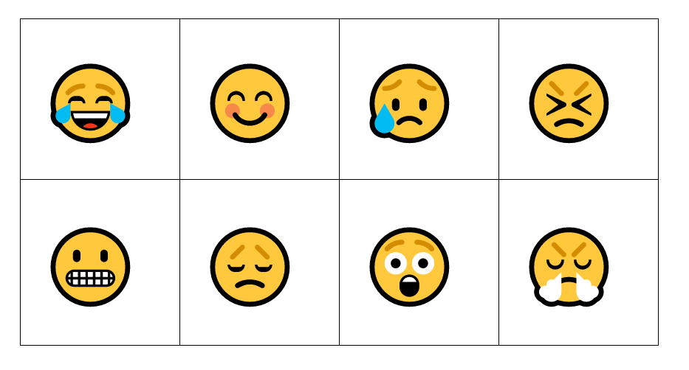

Emojis from Microsoft Word for the Web.

## Resource 2: Character descriptions

|  |  |  |  |
| --- | --- | --- | --- |
| **insect** | a six leg | **spider** | an eight leg |
| **human** | a two leg | **country** | a place where the green rolled slowly and the cars were not so many |
| **cow** | a four leg with two spikes on its head | **chicken** | a winged two leg, that laid eggs |
| **pig** | a pink four leg that snorted through its flat, friendly nose | **rabbit** | a little something that had two big ears and two big feet |
| **Fern** | a two leg pretending to be a three leg | **frog** | a hopping four legs |
| **bugs** | a flying six legs | **snail** | a sliding no legs |
| **Mum and Fern** | a one-legged and a twelve-legged creature | **family** | a perfect four |

## Resource 3: Characteristic cards

|  |  |  |  |
| --- | --- | --- | --- |
| **calm** | **angry** | **happy** | **grateful** |
| **curious** | **tired** | **intrigued** | **scared** |
| **inquisitive** | **excited** | **worried** | **safe** |
| **thankful** | **miserable** | **sad** | **kind** |
| **caring** | **rude** | **brave** | **lonely** |

## Resource 4: Question chart

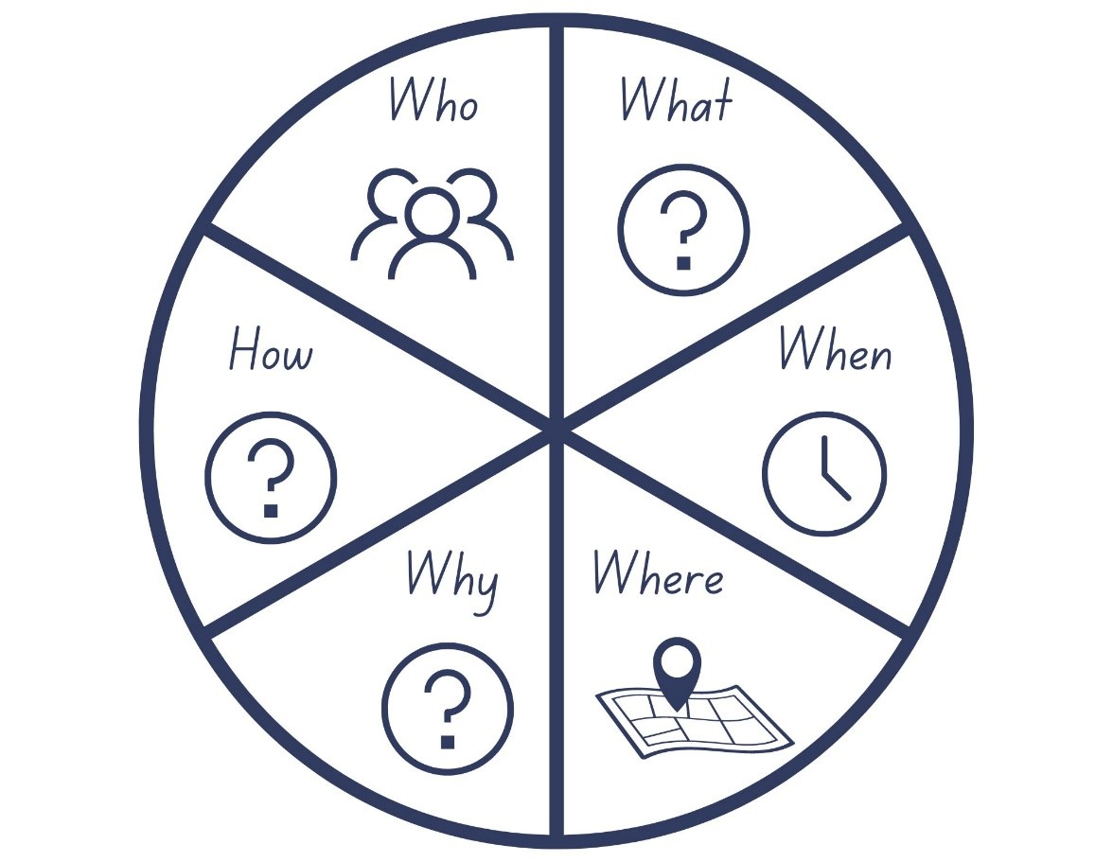

Images sourced from [Canva](https://www.canva.com/) and used in accordance with the [Canva Content License Agreement](https://www.canva.com/policies/content-license-agreement/).

## Resource 5: Adverbs of time

|  |  |
| --- | --- |
| Tell us **when**  things happen | These tell us **how often**  things happen |
| yesterday  a long time ago  on Tuesday  last year | sometimes  occasionally  usually  always |

## Resource 6: Sentence parts

Table showing the sentence parts under the headings Who? What? Where? The example is provided of The Gruffalo (Who?) terrible teeth (What?) in his terrible jaws (Where?)
The next row in the table provides the sentence: The Gruffalo has terrible tusks in his terrible jaws. Space then provided for students to write their own sentence parts.

## Resource 7: Character questionnaire

1. What is your name?
2. Where do you live?
3. What is a problem you are facing, or a goal you are working towards?
4. What 3 words would you use to describe yourself?
5. How do you help other people or other characters?
6. What is one thing you are afraid of?
7. If you had a superpower, what would it be?
8. Who is one person or animal you really like, and why do you like them?
9. What is your best quality?

## Resource 8: Writing scaffolds

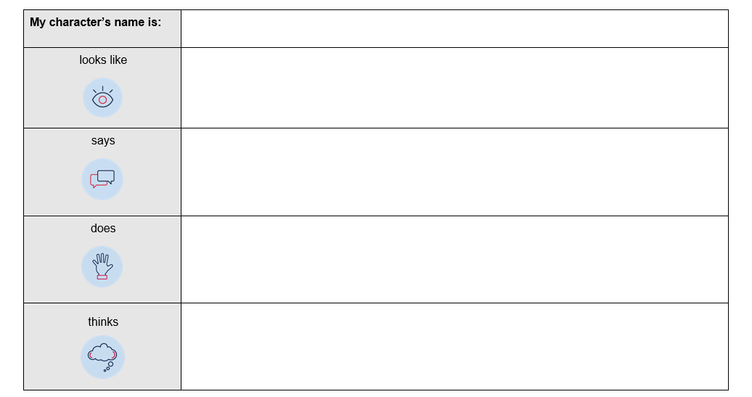

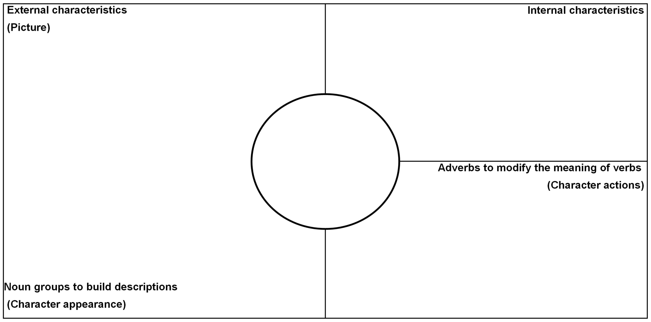

## References

**Links to third-party material and websites**

Please note that the provided (reading/viewing material/list/links/texts) are a suggestion only and implies no endorsement, by the New South Wales Department of Education, of any author, publisher, or book title. School principals and teachers are best placed to assess the suitability of resources that would complement the curriculum and reflect the needs and interests of their students.

If you use the links provided in this document to access a third-party's website, you acknowledge that the terms of use, including licence terms set out on the third-party's website apply to the use which may be made of the materials on that third-party website or where permitted by the *Copyright Act 1968* (Cth). The department accepts no responsibility for content on third-party websites.

Except as otherwise noted, all material is [© State of New South Wales (Department of Education), 2021](https://education.nsw.gov.au/about-us/copyright) and licensed under the [Creative Commons Attribution 4.0 International License](https://creativecommons.org/licenses/by/4.0/). All other material (third-party material) is used with permission or under licence. Where the copyright owner of third-party material has not licensed their material under a Creative Commons or similar licence, you should contact them directly for permission to reuse their material.

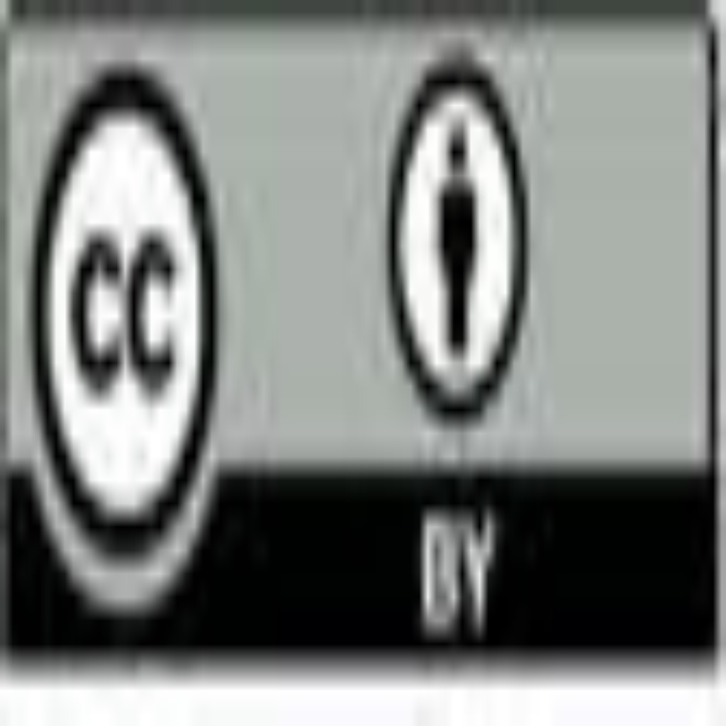

[English K–10 Syllabus](https://curriculum.nsw.edu.au/learning-areas/english/english-k-10) © 2022 NSW Education Standards Authority (NESA) for and on behalf of the Crown in right of the State of New South Wales.

[© 2021 NSW Education Standards Authority](https://educationstandards.nsw.edu.au/wps/portal/nesa/mini-footer/copyright). This document contains NSW Curriculum and syllabus content. The NSW Curriculum is developed by the NSW Education Standards Authority. This content is prepared by NESA for and on behalf of the Crown in right of the State of New South Wales. The material is protected by Crown copyright.

Please refer to the [NESA Copyright Disclaimer](https://educationstandards.nsw.edu.au/wps/portal/nesa/mini-footer/copyright) for more information.

NESA holds the only official and up-to-date versions of the NSW Curriculum and syllabus documents. Please visit the [NSW Education Standards Authority (NESA)](https://educationstandards.nsw.edu.au/) website and the [NSW Curriculum](https://curriculum.nsw.edu.au/home) website.

[National Literacy Learning Progression](https://www.australiancurriculum.edu.au/resources/national-literacy-and-numeracy-learning-progressions/version-3-of-national-literacy-and-numeracy-learning-progressions/) © Australian Curriculum, Assessment and Reporting Authority (ACARA) 2010 to present, unless otherwise indicated. This material was downloaded from the [Australian Curriculum](http://www.australiancurriculum.edu.au/) website (National Literacy Learning Progression) (accessed 23 December 2022) and was not modified. The material is licensed under [CC BY 4.0](https://creativecommons.org/licenses/by/4.0). Version updates are tracked in the ‘Curriculum version history’ section on the ['About the Australian Curriculum'](http://australiancurriculum.edu.au/about-the-australian-curriculum/) page of the Australian Curriculum website.

ACARA does not endorse any product that uses the Australian Curriculum or make any representations as to the quality of such products. Any product that uses material published on this website should not be taken to be affiliated with ACARA or have the sponsorship or approval of ACARA. It is up to each person to make their own assessment of the product, taking into account matters including, but not limited to, the version number and the degree to which the materials align with the content descriptions and achievement standards (where relevant). Where there is a claim of alignment, it is important to check that the materials align with the content descriptions and achievement standards (endorsed by all education Ministers), not the elaborations (examples provided by ACARA).

Carter J (2011) ‘[Crayon Poem](https://childrens.poetryarchive.org/poem/crayon-poem/)*’*, *Hey, Little Bug! Poems for Little Creatures*, Frances Lincoln Publishers Ltd, London, reproduced on The Children’s Poetry Archive website, accessed 23 December 2022.

DisneyMusicVEVO (16 September 2015) ['Disney Music – Lava (Official Lyric Video from “Lava”)' [video]](https://www.youtube.com/watch?v=uh4dTLJ9q9o), DisneyMusicVEVO, YouTube, accessed 23 December 2022.

Donaldson J (2006) The Gruffalo (Scheffler A, illus), Penguin Young Readers Group, London.

ETA (English Teachers Association) and NSW Department of Education (2016) [*The Textual Concepts and Processes resource*](http://www.englishtextualconcepts.nsw.edu.au/content/textual-concepts-and-processes-resource), English Textual Concepts website, accessed 23 December 2022.

John J (2019) *The Good Egg,* (Oswald P, illus), HarperCollins Publishers, US.

King SM (2019) Three, Scholastic Australia Pty Ltd, Sydney.

King SM (2022) [Stephen Michael King: Three](https://www.stephenmichaelking.com/books/three/) [website], accessed 23 December 2022.

Lee D (2012) ‘[Alligator Pie](https://childrens.poetryarchive.org/poem/alligator-pie/)’, *Alligator Pie,* Harper Collins, Australia, reproduced on The Children’s Poetry Archive website, accessed 23 December 2022.

Lee D (2015) ‘[The Wizard](https://childrens.poetryarchive.org/poem/the-wizard/)’, *Melvis and Elvis*, Harper Collins, Australia, reproduced on The Children’s Poetry Archive website, accessed 23 December 2022.

Rosenthal AK (2010) *Spoon*, (Magoon S, illus), Disney Hyperion, US.