English – K-2 multi-age – Year A – Unit 6
Contents
Unit overview and instructions for use 3
Teacher notes 4
Outcomes and content – Component A 5
Outcomes and content – Component B 8
Week 1 12
Component A teaching and learning 12
Component B teaching and learning 13
Lesson 1: ‘Imagined world’ representation 14
Lesson 2: Retelling and sequencing 17
Lesson 3: Visual features 20
Lesson 4: Text comparison 22
Lesson 5: Introduction to prepositional phrases 25
Week 2 27
Component A teaching and learning 27
Component B teaching and learning 28
Lesson 6: Expanding on prepositional phrases 29
Lesson 7: Simple dialogue 32
Lesson 8: Character, representation and dialogue 34
Lesson 9: Factual texts about ants 37
Lesson 10: Factual texts about ants (continued) 39
Resource 1: Online text features and navigation pathways 41
Resource 2: Dialogue checklist 43
Resource 3: Speech bubble 44
Resource 4: Sentences 45
Resource 5: Ant habitats 46
References 47

Unit overview and instructions for use
This two-week unit is comprised of Component A and Component B. Connecting learning across both components is encouraged.
Teaching and learning | Component A | Component B
Suggested duration | 60 minutes | 45 minutes
Explicit teaching focus areas | - Phonological awareness (Early Stage 1)  - Print conventions (Early Stage 1)  - Phonic knowledge  - Reading fluency  - Reading comprehension  - Spelling  - Handwriting | - Oral language and communication  - Vocabulary  - Reading comprehension  - Creating written texts  - Understanding and responding to literature
To prepare for teaching and learning: | - Refer to Outcomes and content – Component A, K-2 – Instructional sequence – grapheme–phoneme correspondences [PDF 825 KB], and the teaching advice documents (hyperlinked in Component A teaching and learning table).  - Based on student needs identified through ongoing assessment data, plan and document how you will sequence teaching and learning in whole class and targeted teaching groups across the two-week cycle. | - Familiarise yourself with Outcomes and content – Component B, Textual concepts information and videos, English Textual Concepts and Learning Processes (2016), and the teaching and learning sequence.  - Based on student needs identified through ongoing assessment data, determine how you will support students in whole class and targeted teaching groups across the two-week cycle as required.
English K–10 Syllabus © 2022 NSW Education Standards Authority (NESA) for and on behalf of the Crown in right of the State of New South Wales.

Teacher notes
- Representation is defined as ‘the depiction of a thing, person, or ideas in written, visual, digital, performed or spoken language conventions’. – English Textual Concepts and Learning Processes (2016)
- Understanding of representation can be supported through watching the departments video: Representation (2:46).
- While character (Early Stage 1) and representation (Stage 1) are the mentor concepts for the conceptual component of this unit, the supporting concept of ‘context’ can be explored using the mentor text The March of the Ants by Ursula Dubosarsky.
- For information on narrative, symbol, prepositions, dialogue, and quotation marks refer to the NESA Glossary.
- Reflect on student learning and engagement in activities and record differentiation and adjustments within the unit to inform future teaching and learning. One way of doing this could be to add comments to the digital file.
- Content points are linked to the National Learning Progression version (3).
Levels and indicators sourced from National Literacy Learning Progression © Australian Curriculum, Assessment and Reporting Authority (ACARA), (accessed 11 November 2022) and was not modified. See references for more information.

Outcomes and content – Component A
The table below outlines the focus outcomes and content. Content is linked to the National Literacy Learning Progression version (3).
Early Stage 1 Focus area and outcome | Stage 1 Focus area and outcome
Phonological awareness  ENE-PHOAW-01 – identifies, blends, segments and manipulates phonological units in spoken words as a strategy for reading and creating texts  - segment a spoken sentence of 3 to 5 words into separate spoken words (PhA2)  - provide a word when given a starting phoneme (PhA2) | N/A
Print conventions  ENE-PRINT-01 – tracks written text from left to right and from top to bottom of the page and identifies visual and spatial features of print  - begin reading at the top of the page and conclude reading at the bottom of the page (UnT3) | N/A
Phonic knowledge  ENE-PHOKW-01 – uses single-letter grapheme–phoneme correspondences and common digraphs to decode and encode words when reading and creating texts  - blend single-letter grapheme–phoneme correspondences to decode VC and CVC words, and apply this knowledge when reading, including decodable texts (PKW4)  - blend common single-letter grapheme–phoneme correspondences to read CCVC and CVCC words, and apply this when reading texts, including decodable texts (PKW5)  - segment common, single-letter grapheme–phoneme correspondences to encode CCVC and CVCC words (PKW5) | Phonic knowledge  EN1-PHOKW-01 – uses initial and extended phonics, including vowel digraphs, trigraphs to decode and encode words when reading and creating texts  - Year 1 – blend and decode one-syllable words with taught extended vowel graphs and digraphs, including graphemes for r-controlled vowels and diphthongs, and apply this when reading texts (PKW6, PKW7)  - Year 2 – blend and decode two-syllable words with taught extended vowel graphs and digraphs, including graphemes for r-controlled vowels and diphthongs, and apply this when reading texts (PKW6, PKW7)
Reading fluency  ENE-REFLU-01 – reads decodable texts aloud with automaticity  - stop at the end of a sentence in response to a full stop (FIY3) | Reading fluency  EN1-REFLU-01 – sustains reading unseen texts with automaticity and prosody and self-corrects errors  - use sentence punctuation to enhance reading in a conversational manner (FIY3, FIY4)  - vary pace when reading according to audience and purpose (FIY4)
Reading comprehension  ENE-RECOM-01 – comprehends independently read texts using background knowledge, word knowledge and understanding of how sentences connect  - understand that informative and imaginative texts have different structures, features and forms (UnT5)  - predict purpose, type of text or topic from title, illustration, image and/or form (UnT4)  - recall the sequence of events/information in texts (UnT5) | Reading comprehension  EN1-RECOM-01 – comprehends independently read texts that require sustained reading by activating background and word knowledge, connecting and understanding sentences and whole text, and monitoring for meaning  - identify how creative visual features are used to expand meaning  - use knowledge of text structure, type of text, author, and forms of writing to predict and confirm meaning (UnT6)  - confirm meaning by sequencing and explaining events and information
Spelling  ENE-SPELL-01 – applies phonological, orthographic and morphological generalisations and strategies to spell taught familiar and high-frequency words when creating texts  - segment single-syllable words into phonemes as a strategy for spelling (SpG4) | Spelling  EN1-SPELL-01 – applies phonological, orthographic and morphological generalisations and strategies when spelling words in a range of writing contexts  - segment single-syllable words into phonemes as a strategy for spelling (SpG4)  - use spelling conventions when adding tense-marking suffixes (SpG9)
Handwriting  ENE-HANDW-01 – produces all lower-case and upper-case letters to create texts  - form all handwritten letters in NSW Foundation Style when given a verbal prompt from the correct starting point and continue in the correct direction | Handwriting  EN1-HANDW-01 – uses a legible, fluent and automatic handwriting style, and digital technology, including word-processing applications, when creating texts  - form all letters with consistent size and slope in NSW Foundation Style from memory (HwK5)

Outcomes and content – Component B
The table below outlines the focus outcomes and content. Content is linked to the National Literacy Learning Progression version (3).
Early Stage 1 Focus area and outcome | Stage 1 Focus area and outcome
Oral language and communication  ENE-OLC-01 – communicates effectively by using interpersonal conventions and language with familiar peers and adults  - use short phrases and simple sentences when speaking (SpK1)  - tell a story or information to peers or adults using oral language (SpK3) | Oral language and communication  EN1-OLC-01 – communicates effectively by using interpersonal conventions and language to extend and elaborate ideas for social and learning interactions  - use tense correctly to discuss past, present and future events  - incorporate extended sentences (simple, compound, complex) during dialogue (SpK3)  - recount narratives with key components (SpK3)
Vocabulary  ENE-VOCAB-01 – understands and effectively uses Tier 1 words and Tier 2 words in familiar contexts  - identify, name and describe a range of objects, characters, animals, people and places when given visual and/or auditory prompts (GrA1) | Vocabulary  EN1-VOCAB-01 – understands and effectively uses Tier 1, taught Tier 2 and Tier 3 vocabulary to extend and elaborate ideas  - use morphemic knowledge to create word families (SpK3)
Reading comprehension  ENE-RECOM-01 – comprehends independently read texts using background knowledge, word knowledge and understanding of how sentences connect  - understand that informative and imaginative texts have different structures, features and forms (UnT5)  - predict purpose, type of text or topic from title, illustration, image and/or form (UnT4)  - recall the sequence of events/information in texts (UnT5) | Reading comprehension  EN1-RECOM-01 – comprehends independently read texts that require sustained reading by activating background and word knowledge, connecting and understanding sentences and whole text, and monitoring for meaning  - use navigation pathways, including hyperlinks, to extract essential information to support reading fluency and enhance meaning when reading digital texts  - identify how creative visual features are used to expand meaning  - use knowledge of text structure, type of text, author, and forms of writing to predict and confirm meaning (UnT6)  - confirm meaning by sequencing and explaining events and information
Creating written texts  ENE-CWT-01 – creates written texts that include at least 2 related ideas and correct simple sentences  - include recognisable structural features for text purpose (CrT5)  - use prepositional phrases to indicate time or place (GrA2)  - use a capital letter to start a sentence and a full stop to end a sentence (PuN2, CrT5)  - identify different purposes for writing (CrT4)  - use drawings, images or mind maps to support planning and writing (CrT4) | Creating written texts  EN1-CWT-01 – plans, creates and revises texts written for different purposes, including paragraphs, using knowledge of vocabulary, text features and sentence structure  - use a logical order to sequence ideas and events in sentences across a text (GrA4)  - use contextually precise prepositional phrases when creating texts (GrA4)  - use quotation marks for simple dialogue (PuN5)  - identify the context, audience and purpose for own texts (CrT5, CrT6)  - use a variety of planning strategies and tools for creating texts
Understanding and responding to literature  ENE-UARL-01 – understands and responds to literature read to them  - identify and discuss character features and actions (UnT3)  - share feelings and thoughts in response to characters and actions in texts  - understand that characters in texts are represented by how they look, what they say and do, and their thoughts | Understanding and responding to literature  EN1-UARL-01 – understands and responds to literature by creating texts using similar structures, intentional language choices and features appropriate to audience and purpose  - express personal responses to the real and imagined worlds that are represented in texts  - adapt a well-known text for a different audience and/or purpose  - identify how the language and form of a text vary according to purpose, audience and mode (UnT5)

Week 1

Component A teaching and learning
The table below can be used to plan and document lessons that address Component A outcomes and content. Both the detailed example [DOC 529KB] of a two-week teaching and learning cycle and brief example [DOC 66KB] may support you in your planning.
Focus Areas | Lesson 1 | Lesson 2 | Lesson 3 | Lesson 4 | Lesson 5
Phonological awareness (Early Stage 1) and Phonic knowledge
15 minutes
Spelling and Handwriting
15 minutes
Print conventions (Early Stage 1), Reading comprehension and Reading fluency
30 minutes

Component B teaching and learning
The following teaching and learning sequence has been designed to address Component B outcomes and content. Adapt the sequence as required to best meet the needs of your students.

Learning intention and success criteria
Learning intentions and success criteria are best co-constructed with students. The table below contains suggested learning intentions and success criteria.
Element | Early Stage 1 | Stage 1
Learning intentions | Students are learning to understand that characters can be represented in different ways in texts. | Students are learning to understand that information and ideas can be represented differently in texts.
Success criteria | Students can:  - identify, discuss, and compare characters and their actions  - organise ideas and events in order  - use drawing and writing to demonstrate learning  - compare real and imagined worlds  - experiment using prepositional phrases in writing. | Students can:  - describe how characters can be represented  - share personal responses to texts  - use knowledge of text structure and visual images to predict and confirm meaning  - identify and write using prepositional phrases  - use illustrations and words to represent characters  - sequence ideas and events in a logical order.

Resources
- Dubosarsky U (2021) The March of the Ants (Riddle T, illus.), Book Trail Press, Australia. ISBN: 9780648498919
- Resource 1: Online text features and navigation pathways
- Amazing Animals
- Video: Flik Takes Flight | A Bugs Life | Disney Channel UK (1:10)
- Video: Amazing Animals: Army Ant (1:46)
- T-chart
- Mini whiteboards
- Soft toy to be used in preposition game
- Sticky notes or slips of paper

Lesson 1: ‘Imagined world’ representation
The following teaching and learning activities support multi-age settings.

Whole
- Introduce the concept of representation. Explain that students will be reading and viewing texts to learn about how the same thing – an ant – can be represented for a range of purposes in a variety of modes.
Note: Representation is the depiction of a thing, person or idea in written, visual, digital, performed or spoken language and conventions.
- Display the text The March of the Ants. Encourage students to make predictions about the text using the front and back covers, title, and illustrations.
- Read The March of the Ants. Identify the text’s audience (children) and purpose (to entertain). Highlight that this text is a narrative, and the ants are represented as characters in an ‘imagined world’.
- Using sticky notes, students write words, sentences or draw pictures to show how the ants have been represented in the text. Place each piece of information inside a large hoop that is labelled ‘imagined world’. For example, the ants have 2 large eyes, they have 6 legs, the ants walk upright on 2 legs, they have 3 main parts to their bodies, the ants can carry things with their ‘arms’, they are black, they live with other ants, the ants walk in a line. Encourage students to make connections with the way the ants have been represented with human characteristics.
- Reread the written text to find additional information about how the ants are represented. Add to the previous examples. Points may include, the ants can talk; they have feelings such as hope, fear and sadness; the ants can read; they belong to an ant army; the ants march day and night; there is a chief ant.
- Review pages that show how different personality characteristics and feelings are represented through a range of creative visual features. Include examples such as:
- the chief ant is larger than the other ants and is standing on a rock pointing to show he is the leader
- drooped eyelids and a red squiggle above the littlest ant’s head are used to show she is unhappy
- the ants have slumped body language and fearful expressions on the page where it is explained that they are sad and want to give up hope; the background is also dark and there are large menacing grasshoppers in the background
- the ants are smiling on the final page to show they had hope in their hearts; the background is also light, and the sun is shining.
- Provide students with paper and drawing materials to create an ‘imagined world’ illustration of an ant in the same style as the illustrator Tohby Riddle. Encourage students to consider human characteristics such as how the ant’s emotions are being represented, as well as features that are typical of ants in the ‘real world’.
- Students write short captions near their illustration to identify the features they are representing. Provide the opportunity for students to share their representations in small groups.
Too hard? Students orally describe their illustration to a peer.
Too easy? Students write a sentence to describe their ant illustration.
Early Stage 1 Assessment task 1 – Observations from this lesson allow students to demonstrate achievement towards the following syllabus outcomes and content points:
ENE-RECOM-01 – comprehends independently read texts using background knowledge, word knowledge and understanding of how sentences connect
- predict purpose, type of text or topic from title, illustration, image and/or form.
ENE-UARL-01 – understands and responds to literature read to them
- identify and discuss character features and actions
- share feelings and thoughts in response to characters and actions in texts.
Stage 1 Assessment task 1 – Observations from this lesson allow students to demonstrate achievement towards the following syllabus outcome and content point:
EN1-RECOM-01– comprehends independently read texts that require sustained reading by activating background and word knowledge, connecting and understanding sentences and whole text, and monitoring for meaning
- use knowledge of text structure, type of text, author, and forms of writing to predict and confirm meaning.

Lesson 2: Retelling and sequencing
The following teaching and learning activities support multi-age settings.

Whole
- Re-read The March of the Ants.
- Use a storyboard or story map scaffold to draw the story sequence. Use the think aloud strategy to retell the narrative as you draw.
- Display and define sequencing words and phrases, for example, first, then, next, after that, in the end. In small groups, students take turns to orally retell The March of the Ants, recounting key elements and using sequencing words and phrases.
- Model using written language to retell each part of The March of the Ants. Write a sentence to match the first image on the story map. Use the share the pen strategy to annotate the second image on the story map. Highlight how a logical order is used. Use questioning to elicit deeper understanding. Ask students how they knew which part belonged at the beginning and how the story might change if events were placed in a different order.

Part
The table below details the differentiated teaching and learning activities for each stage.
Early Stage 1 (teacher guided) | Stage 1 (pairs)
- Explicitly teach the concept of character. Discuss the different ways authors and illustrators tell readers about the characters. Draw students’ attention to colour, size, emotions, facial expressions, and gestures.  - Looking at the characters in the text and the items they chose to take on the expedition, ask students what they have learnt about each of their personalities.  - Display the image of the 4 ants carrying their important items. Model how to describe the characters using words and short phrases. For example, the ant has 6 legs, the ant is standing on 2 legs like a person, the ant won’t go hungry because he has food, the ant is prepared because he has a map. | - Using the co-constructed story map, students continue to write sentences in a logical order to sequence ideas from the text.  Too hard? Students draw images in logical order to sequence ideas and label these with key words or simple sentences.  Too easy? Students sequence ideas in logical order using compound or complex sentences. Students use key sequencing terms, for example: first, then, next, after that, in the end or finally.

Part
The table below details the differentiated teaching and learning activities for each stage.
Early Stage 1 (pairs) | Stage 1 (teacher guided)
- Students choose one ant to draw then write words or phrases to describe it and the item it chose. | - Display the sentence, ‘They marched and marched for days and nights.’ Model identifying the verb ‘marched’ and changing the suffix to change its tense.  - Explore the present, past, and future tense for ‘march’.  - Students use their own writing from activity 9 to identify verbs and use their knowledge of word families to determine and change its tense.
Early Stage 1 Assessment 2 – Observations from this lesson allow students to demonstrate achievement towards the following syllabus outcome and content point:
ENE-RECOM-01 – comprehends independently read texts using background knowledge, word knowledge and understanding of how sentences connect
- recall the sequence of events/information in texts.
Stage 1 Assessment task 2 – Observations and work samples from this lesson allow students to demonstrate achievement towards the following syllabus outcomes and content points:
EN1-OLC-01 – communicates effectively by using interpersonal conventions and language to extend and elaborate ideas for social and learning interactions
- use tense correctly to discuss past, present and future events
- recount narratives with key components.
EN1-VOCAB-01 – understands and effectively uses Tier 1, taught Tier 2 and Tier 3 vocabulary to extend and elaborate ideas
- use morphemic knowledge to create word families.
EN1-RECOM-01 – comprehends independently read texts that require sustained reading by activating background and word knowledge, connecting and understanding sentences and whole text, and monitoring for meaning
- confirm meaning by sequencing and explaining events and information.

Lesson 3: Visual features
- Revise some emotions humans experience and discuss situations that elicit certain feelings. For example, students may feel excitement on their birthday, fear during a thunderstorm, happiness to see their friends at school, sadness when they hurt themselves.
- Discuss how the author has used colour, symbols, and illustrations to represent the ants feeling ‘afraid’ in The March of the Ants. For example, the darkened page colour, the symbolism of the large grasshoppers in the background, and the ants slumped body language and fearful expressions. Discuss and model different ways the emotion of fear can be represented. Highlight how there can be different representations of the same emotion, subject matter, object, or idea.
- Ask students if they would feel the same way as the ants in this moment. Revisit vocabulary such as determined, brave, tired, afraid, sad. Flick through the text discussing how the illustrations represent these feelings and emotions in the ants, through facial expressions and body language.
- Read page 2. Students imagine they are an ant in the story. Ask what special item they would choose to take on the expedition and how the item would be useful for the journey. Encourage verbal responses in simple sentences (Early Stage 1) or extended sentences (Stage 1), for example, I would bring a sleeping bag because __.

Part
The table below details the differentiated teaching and learning activities for each stage.
Early Stage 1 (independent/teacher guided) | Stage 1 (independent/teacher guided)
- Students write a simple sentence stating what they would bring, for example, I would bring a sleeping bag.  Too hard? Provide a sentence starter, for example, ‘I would bring a __’ to support students’ writing. Students can write the name of the item and/or draw it.  Too easy? Write an extended sentence including a subordinating conjunction such as ‘because’. For example, I would bring a sleeping bag because __.  - Students draw themselves as an ant, with their chosen item, in the style of the illustrations from The March of the Ants. | - Students write an extended sentence including a subordinating conjunction such as ‘because’. For example, I would bring a sleeping bag because __.  - Students draw themselves as an ant, with their chosen item, in the style of the illustrations from The March of the Ants.

Whole
- Revise elements of character and representation in narrative texts. Students share examples of their sentences explaining why they chose their item for the expedition.

Lesson 4: Text comparison
The following teaching and learning activities support multi-age settings.

Whole
- Watch Amazing Animals: Army Ant (1:46) reminding students of the purpose of informative texts.
- Create a T-chart with the headings ‘Real world’ and ‘Imagined world’.
- Discuss the video exploring new vocabulary. Begin a word wall, adding vocabulary from the video. Discuss the meaning of unknown words, for example, march, colony, army, permanent, nest. Highlight that different ants have different jobs, each ant knows what their role is, and they don’t have a permanent nest.
- Identify information from the text. For example, ants are always moving, ants have no permanent home and go on expeditions (this links to the mentor text and introduces the idea that the ants are on an expedition but never reach a destination). Write the facts on the T-chart under the ‘Real world’ heading.
- View the video, Flik Takes Flight | A Bugs Life | Disney Channel UK (1:10).
- Ask students what they noticed about how the ants were represented in this video. Record ideas on the T-chart under the heading ‘Imagined world’. For example, the ants can talk, they are like people, the ant is wearing a hat and backpack, the ant can fly, he is adventurous and brave.
- Students share additional ideas to be added to chart based on how ants were represented in The March of the Ants.

Part
The table below details the differentiated teaching and learning activities for each stage.
Early Stage 1 (independent) | Stage 1 (teacher guided)
- Using mini whiteboards, students draw a picture of an ant (real or imagined) and write a simple fact that they have learnt.  Too hard? Students write key words to describe their real or imagined ant.  - Students share their illustration and fact in pairs or small groups. | - Open the Amazing Animals webpage and explore the navigation pathways and tools on the page, including the use of embedded images and captions, and the hyperlinked images located at the top of the page along with the search feature. Explain that National Geographic Kids is a trusted source, and that the website is updated regularly.  - Display Resource 1: Online text features and navigation pathways to support students’ understanding when reading digital texts.  - Explore other features within the National Geographic Kids website, searching ‘ants’ to discover more information about the insect.  - Ask students how ants have been represented in this text and whether it is real or imagined.  - Students state an opinion or perspective about the texts or facts presented and use a conjunction to justify their point of view. For example, ‘I’ve found this text interesting, so I am going to try and learn more about ants; I don't like ants because they bite.’
Early Stage 1 Assessment task 3 – Observations from this lesson allow students to demonstrate achievement towards the following syllabus outcomes and content points:
ENE-RECOM-01 – comprehends independently read texts using background knowledge, word knowledge and understanding of how sentences connect
- understand that informative and imaginative texts have different structures, features and forms.
ENE-UARL-01 – understands and responds to literature read to them
- understand that characters in texts are represented by how they look, what they say and do, and their thoughts.
Stage 1 Assessment task 3 – Observations and work samples from this lesson allow students to demonstrate achievement towards the following syllabus outcomes and content points:
EN1-OLC-01 – communicates effectively by using interpersonal conventions and language to extend and elaborate ideas for social and learning interactions.
- incorporate extended sentences (simple, compound, complex) during dialogue.
EN1-RECOM-01 – comprehends independently read texts that require sustained reading by activating background and word knowledge, connecting and understanding sentences and whole text, and monitoring for meaning
- use navigation pathways, including hyperlinks, to extract essential information to support reading fluency and enhance meaning when reading digital texts
- identify how creative visual features are used to expand meaning.
EN1-UARL-01 – understands and responds to literature by creating texts using similar structures, intentional language choices and features appropriate to audience and purpose
- express personal responses to the real and imagined worlds that are represented in texts.

Lesson 5: Introduction to prepositional phrases
The following teaching and learning activities support multi-age settings.

Whole
- Play a game such as ‘throw the toy’. Gently throw a soft toy into different positions and have students verbalise the position. For example, the teddy is at the door, the teddy is in the box, the teddy is on the table.
Note: A preposition is a word that begins an adverbial phrase or an adjectival phrase to indicate a circumstance such as time, place, manner or causality, for example, in, on, after, before, by, under, over, of. A prepositional phrase consists of a preposition followed by a noun or pronoun, for example, in ‘the teddy has landed under the table’ – ‘under the table’ is the prepositional phrase.
- Refer to the first page in The March of the Ants. Write the sentence ‘The ants were heading off on a very important expedition’ on the board. Ask students to identify the phrase that includes the preposition. Explain that ‘on’ is the preposition and ‘on a very important expedition’ is a prepositional phrase.
- Flick through the text and brainstorm and list what other positional words and prepositional phrases could be used to describe what the ants are doing. For example, the ants marched on the bridge; the littlest ant sat on the rock. Underline the prepositional phrases.
- Model how to write simple sentences with a prepositional phrase describing something the ants did in the story. Share the pen, allowing students to highlight the prepositional phrase by underlining the words of time and place.
- Students draw a picture to represent one of the modelled sentences, depicting the ant in the correct time and place that the prepositional phrase describes.
Too hard? Students work in pairs to draw a picture to represent one of the modelled sentences.
Too easy? Students write compound or complex sentences with a prepositional phrase to describe their illustration.

Week 2

Component A teaching and learning
The table below can be used to plan and document lessons that address Component A outcomes and content. Both the detailed example [DOC 529KB] of a two-week teaching and learning cycle and brief example [DOC 66KB] may support you in your planning.
Focus Areas | Lesson 6 | Lesson 7 | Lesson 8 | Lesson 9 | Lesson 10
Phonological awareness (Early Stage 1) and Phonic knowledge
15 minutes
Spelling and Handwriting
15 minutes
Print conventions (Early Stage 1), Reading comprehension and Reading fluency
30 minutes

Component B teaching and learning
The following teaching and learning sequence has been designed to address Component B outcomes and content. Adapt the sequence as required to best meet the needs of your students.

Learning intention and success criteria
Learning intentions and success criteria are best co-constructed with students. The table below contains suggested learning intentions and success criteria.
Element | Early Stage 1 | Stage 1
Learning intentions | Students are learning to understand that characters can be represented in different ways in texts. | Students are learning to understand that information and ideas can be represented differently in texts.
Success criteria | Students can:  - represent characters using words and images  - write what a character says  - use a capital letter to start a sentence and a full stop to end a sentence  - use prepositional phrases when creating texts. | Students can:  - navigate digital texts that include images, text, and hyperlinks  - use quotation marks for simple dialogue  - represent real and imagined characters using words and images  - compare different representations of animals and characters  - use prepositional phrases when creating texts.

Resources
- Dubosarsky U (2021) The March of the Ants (Riddle T, illus.), Book Trail Press, Australia. ISBN: 9780648498919
- Resource 2: Dialogue checklist
- Resource 3: Speech bubble
- Resource 4: Sentences
- Resource 5: Ant habitats
- Video: Amazing Animals: Army Ant (1:46)
- Range of narrative texts suitable for Early Stage 1
- Student copies of page 2 from The March of the Ants with text removed and speech bubbles drawn in (teacher to create).

Lesson 6: Expanding on prepositional phrases
The following teaching and learning activities support multi-age settings.

Whole
- Revise the teaching of prepositions and prepositional phrases from Lesson 5.
- In pairs or small groups, students write a simple sentence that includes a prepositional phrase to describe something the ants did in the text and where in The March of the Ants. For example, the ants marched over the hill. Students share their writing with another group before sharing with the class.
- Model writing student sentences on the board. Highlight the prepositional phrases by underlining the words that indicate place.
- Explicitly teach that prepositional phrases can also add detail to the time that events occur. Flick through the text, pausing to highlight prepositional phrases of time. For example, until at last, for days and nights, one night, all night long, as the sun was rising, after listening to the story.

Part
The table below details the differentiated teaching and learning activities for each stage.
Early Stage 1 (independent/pairs) | Stage 1 (teacher guided/pairs)
- Students draw a picture to represent one of the modelled sentences, depicting the ant in the correct time and place that the prepositional phrase describes.  - Students write the sentence and underline the prepositional phrase.  Too easy? Students write a new sentence using a prepositional phrase to describe an activity the ants did within the text and draw a picture to illustrate it.  - Students describe their illustration/read their sentence to a peer. | - Model writing a short text that includes prepositional phrases of time and place. Highlight or underline the prepositional phrases. For example, ants march during the day. Some ants live in colonies under the ground, while others live in mounds above the ground. Ants walk in lines along the ground.  - Using The March of the Ants as inspiration, students write sentences including prepositional phrases of time and place about activities the ants may have done after the story ends.  - Students underline the prepositional phrases in their sentences.
- Re-watch Amazing Animals: Army Ant (1:46) asking students to raise their hand when they hear a prepositional phrase used. For example, march over the jungle floor, killing everything in their path, found in tropical rainforests, forager ants look for food, everything revolves around her (the queen), they keep it (the nest) together until the queen lays her egg.
Early Stage 1 Assessment task 4 – Observations and collecting work samples from this lesson allows students to demonstrate achievement towards the following syllabus outcomes and content points:
ENE-VOCAB-01 – understands and effectively uses Tier 1 words and Tier 2 words in familiar contexts
- identify, name and describe a range of objects, characters, animals, people and places when given visual and/or auditory prompts.
ENE-CWT-01 – creates written texts that include at least 2 related ideas and correct simple sentences
- use prepositional phrases to indicate time or place.
Stage 1 Assessment task 4 – Observations collecting work samples from this lesson allows students to demonstrate achievement towards the following syllabus outcome and content point:
EN1-CWT-01 – plans, creates and revises texts written for different purposes, including paragraphs, using knowledge of vocabulary, text features and sentence structure
- use a logical order to sequence ideas and events in sentences across a text
- use contextually precise prepositional phrases when creating texts.

Lesson 7: Simple dialogue
The following teaching and learning activities support multi-age settings.

Whole
- Reread The March of the Ants.
- Revise the first 2 pages of the text where each ant chooses something to bring on the expedition. Display an enlarged copy of Resource 2: Dialogue checklist. Model using the checklist to assess dialogue conventions used in the text.
- Students imagine they are an ant in the story. Ask what special item they would choose to take on the expedition and how the item would be useful for the journey. Allow students time to generate ideas and respond. Encourage Stage 1 students to use a ‘because’ statement. For example, I would bring a torch because it would help me see at night. Students share their responses in pairs before sharing with the class. List student ideas on the board.
- Using the ideas generated, students act out a scene with the Chief Ant (student or teacher) asking each ant what they are going to bring.
- Highlight why students do not need to say ‘said the first ant’ or ‘he said’ during the scenes. Explicitly model which words are being said by a character in the scene.
- Draw an ant with a speech bubble and write examples of direct speech from the scenes to visually represent spoken language.

Part
The table below details the differentiated teaching and learning activities for each stage.
Early Stage 1 (independent) | Stage 1 (teacher guided/independent)
- Using Resource 3: Speech bubble, students write the name of the item they would bring on the expedition.  Too hard? Students orally state what item they would take on an expedition and draw a picture of it inside the speech bubble.  Too easy? Students write what item they would bring on the expedition as if they are responding to being asked. For example, I’m bringing a map.  - In small groups, students act out their ‘scene’ with peers stating what item they will take on the expedition. | - Revise dialogue conventions from The March of the Ants using Resource 2: Dialogue checklist.  - Using Resource 3: Speech bubble, students write what item they would bring on the expedition as if they are responding to being asked. For example, ‘I’m bringing a map, I’m bringing a torch, I’m bringing some snacks.’  - Referring to Resource 2: Dialogue checklist, model writing direct speech, including quotation marks. For example, “I’m bringing my hat,” said Jacob the ant.  - Students use their writing plan to rewrite their dialogue in a sentence with quotation marks.  - Share work samples and provide feedback about the correct placement and formation of quotation marks.  Too hard? Provide students with sentences including direct speech and have them add quotation marks in the correct position.  Too easy? Students write dialogue showing a conversation between 2 or more characters.

Lesson 8: Character, representation and dialogue
The following teaching and learning activities support multi-age settings.

Whole
- Discuss the role of dialogue. Look at page 2 from the mentor text where the ants are stating what item they are taking on the expedition. Explain to students which words would be heard aloud and which words the author needs to include for the text to make sense.
- Ask students:
- Does the ant say, ‘said the first ant’?
- Who is speaking?
- How do you know?
- Would we know who is speaking if the author did not include this?
- Why is it important to indicate who is speaking?

Part
The table below details the differentiated teaching and learning activities for each stage.
Early Stage 1 (teacher guided/small groups) | Stage 1 (pairs)
- Using a range of narrative texts, support students to discuss and identify ways authors have shown the feelings and personalities of the characters.  - Students choose a character, draw an illustration, and write a simple sentence describing the feelings of that character for example, ‘The rainbow fish was sad.’  Too hard? Students orally describe their illustration to a peer. | - Provide pairs with the pre-prepared copies of page 2 from The March of the Ants with text removed and speech bubbles drawn in.  - Students write dialogue in the speech bubbles to show what the ants could be saying.

Part
The table below details the differentiated teaching and learning activities for each stage.
Early Stage 1 (pairs) | Stage 1 (teacher guided)
- Using Resource 4: Sentences, students check for the correct use of capital letters at the start of each sentence and full stops at the end.  - Students sort examples into correct and incorrect sentences.  - Students add necessary punctuation to the incorrect sentences.  Too easy? Students rewrite the incorrect sentences using appropriate punctuation. | - Using one student’s sample, model writing the dialogue from a speech bubble in a sentence using quotation marks.  - Students write the dialogue from a speech bubble in a sentence using quotation marks.

Whole
- Remind students of the importance of using correct punctuation. Support students to recognise and discuss that meaning is lost, sentences do not make sense, readers will not know to take a breath and cannot recognise when characters are speaking without correct punctuation.
Early Stage 1 Assessment task 5 – Observations and collecting work samples from this lesson allows students to demonstrate achievement towards the following syllabus outcomes and content points:
ENE-OLC-01 – communicates effectively by using interpersonal conventions and language with familiar peers and adults
- use short phrases and simple sentences when speaking
- tell a story or information to peers or adults using oral language.
ENE-CWT-01 – creates written texts that include at least 2 related ideas and correct simple sentences
- use a capital letter to start a sentence and a full stop to end a sentence
- identify different purposes for writing.
Stage 1 Assessment task 5 – Observations and collecting work samples from this lesson allows students to demonstrate achievement towards the following syllabus outcomes and content points:
EN1-CWT-01 – plans, creates and revises texts written for different purposes, including paragraphs, using knowledge of vocabulary, text features and sentence structure
- use quotation marks for simple dialogue.

Lesson 9: Factual texts about ants
The following teaching and learning activities support multi-age settings.

Whole
- Revise prepositional phrases and their role in providing additional information about circumstances such as time and place. Remind students of how prepositional phrases were used in The March of the Ants to describe the characters’ journey.
- Outline that prepositional phrases are used in factual texts to add specific details about a topic. Show students the modelled text in Resource 5: Ant habitats. Identify the prepositional language that has been used to describe ant habitats. Reinforce the use of present tense and how the information has been organised in a logical order.
- Explain to students that they will create their own fact file about ants. Discuss the context and purpose of this text and ensure that students identify a target audience for sharing. For example, another class, as an assembly item, or in a digital application to be shared with family members.
- Model writing a series of succinct facts about ants that incorporate background knowledge gained during previous lessons. Model drawing and labelling an informative illustration to accompany the text. Explain that the purpose this writing is to teach another class about ants. For example:
- There are a lot of ants in the world. They live in all countries except for in Antarctica.
- Ants don’t have ears, and some of them don’t have eyes.
- Ants are very strong. They can carry heavy things on their neck.
- Ants hibernate under the ground during winter.
- Ants walk in lines along the ground. This is because they can smell each other.
- Create a criterion for writing, including items, such as a title, a logical order or sequence and prepositional phrases. Differentiate criteria as required to meet the needs of Early Stage 1 and Stage 1 students.
- To plan for writing, organise students into small groups or pairs. Support students to orally provide facts in present tense, and to expand on ideas using a range of sentence types. Students may choose to quickly draft ideas or key words using mini whiteboards when participating in this planning activity.
- Students use their developing knowledge of ants to write their first 1-2 facts and add a labelled illustration.
Too hard? Support students in small groups as required.
Too easy? Students create extended facts with the use of Tier 2 and 3 vocabulary and a range of sentence types.
- Students work with a partner to review their writing by reading each fact aloud and identifying if the text meets the criterion.
Early Stage 1 Assessment task 6 – Observations and work samples from this lesson allow students to demonstrate achievement towards the following syllabus outcome and content points:
ENE-CWT-01 – creates written texts that include at least 2 related ideas and correct simple sentences
- include recognisable structural features for text purpose
- use drawings, images or mind maps to support planning and writing.
Stage 1 Assessment task 6 – Observations and work samples from this lesson allow students to demonstrate achievement towards the following syllabus outcomes and content points:
EN1-CWT-01 – plans, creates, and revises texts written for different purposes, including paragraphs, using knowledge of vocabulary, text features and sentence structure
- identify the context, audience and purpose for own texts
- use a variety of planning strategies and tools for creating texts.
EN1-UARL-01 – understands and responds to literature by creating texts using similar structures, intentional language choices and features appropriate to audience and purpose
- adapt a well-known text for a different audience and/or purpose
- identify how the language and form of a text vary according to purpose, audience and mode.

Lesson 10: Factual texts about ants (continued)
The following teaching and learning activities support multi-age settings.

Whole
- Review the factual writing task from Lesson 9. Discuss and display student examples that will further support idea generation and the construction of factual sentences and illustrations.
- Provide time for students to practise skills by adding an additional 2-3 facts to their text and another labelled illustration.
- Students provide peer feedback referring to the success criteria, then improve their text based on the feedback provided to them.
Too hard? Support students in small groups as required.
Too easy? Students create extended facts with the use of Tier 2 or 3 vocabulary and a range of sentence types.
- Students share their work in small groups or as a gallery walk prior to sharing with their identified target audience.

Resource 1: Online text features and navigation pathways
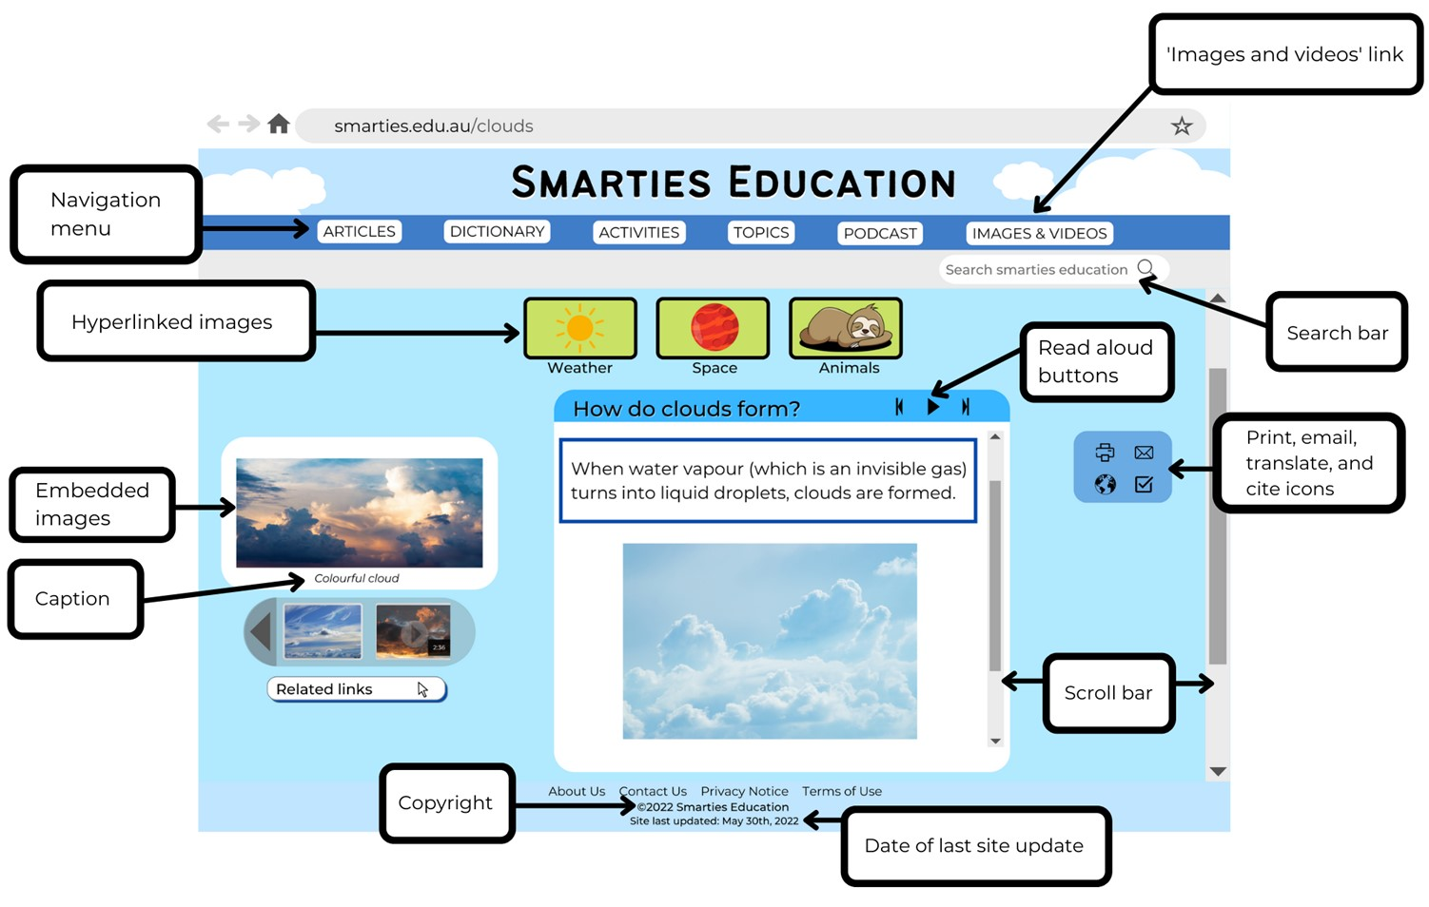
Images sourced from Canva and used in accordance with the Canva Content License Agreement.
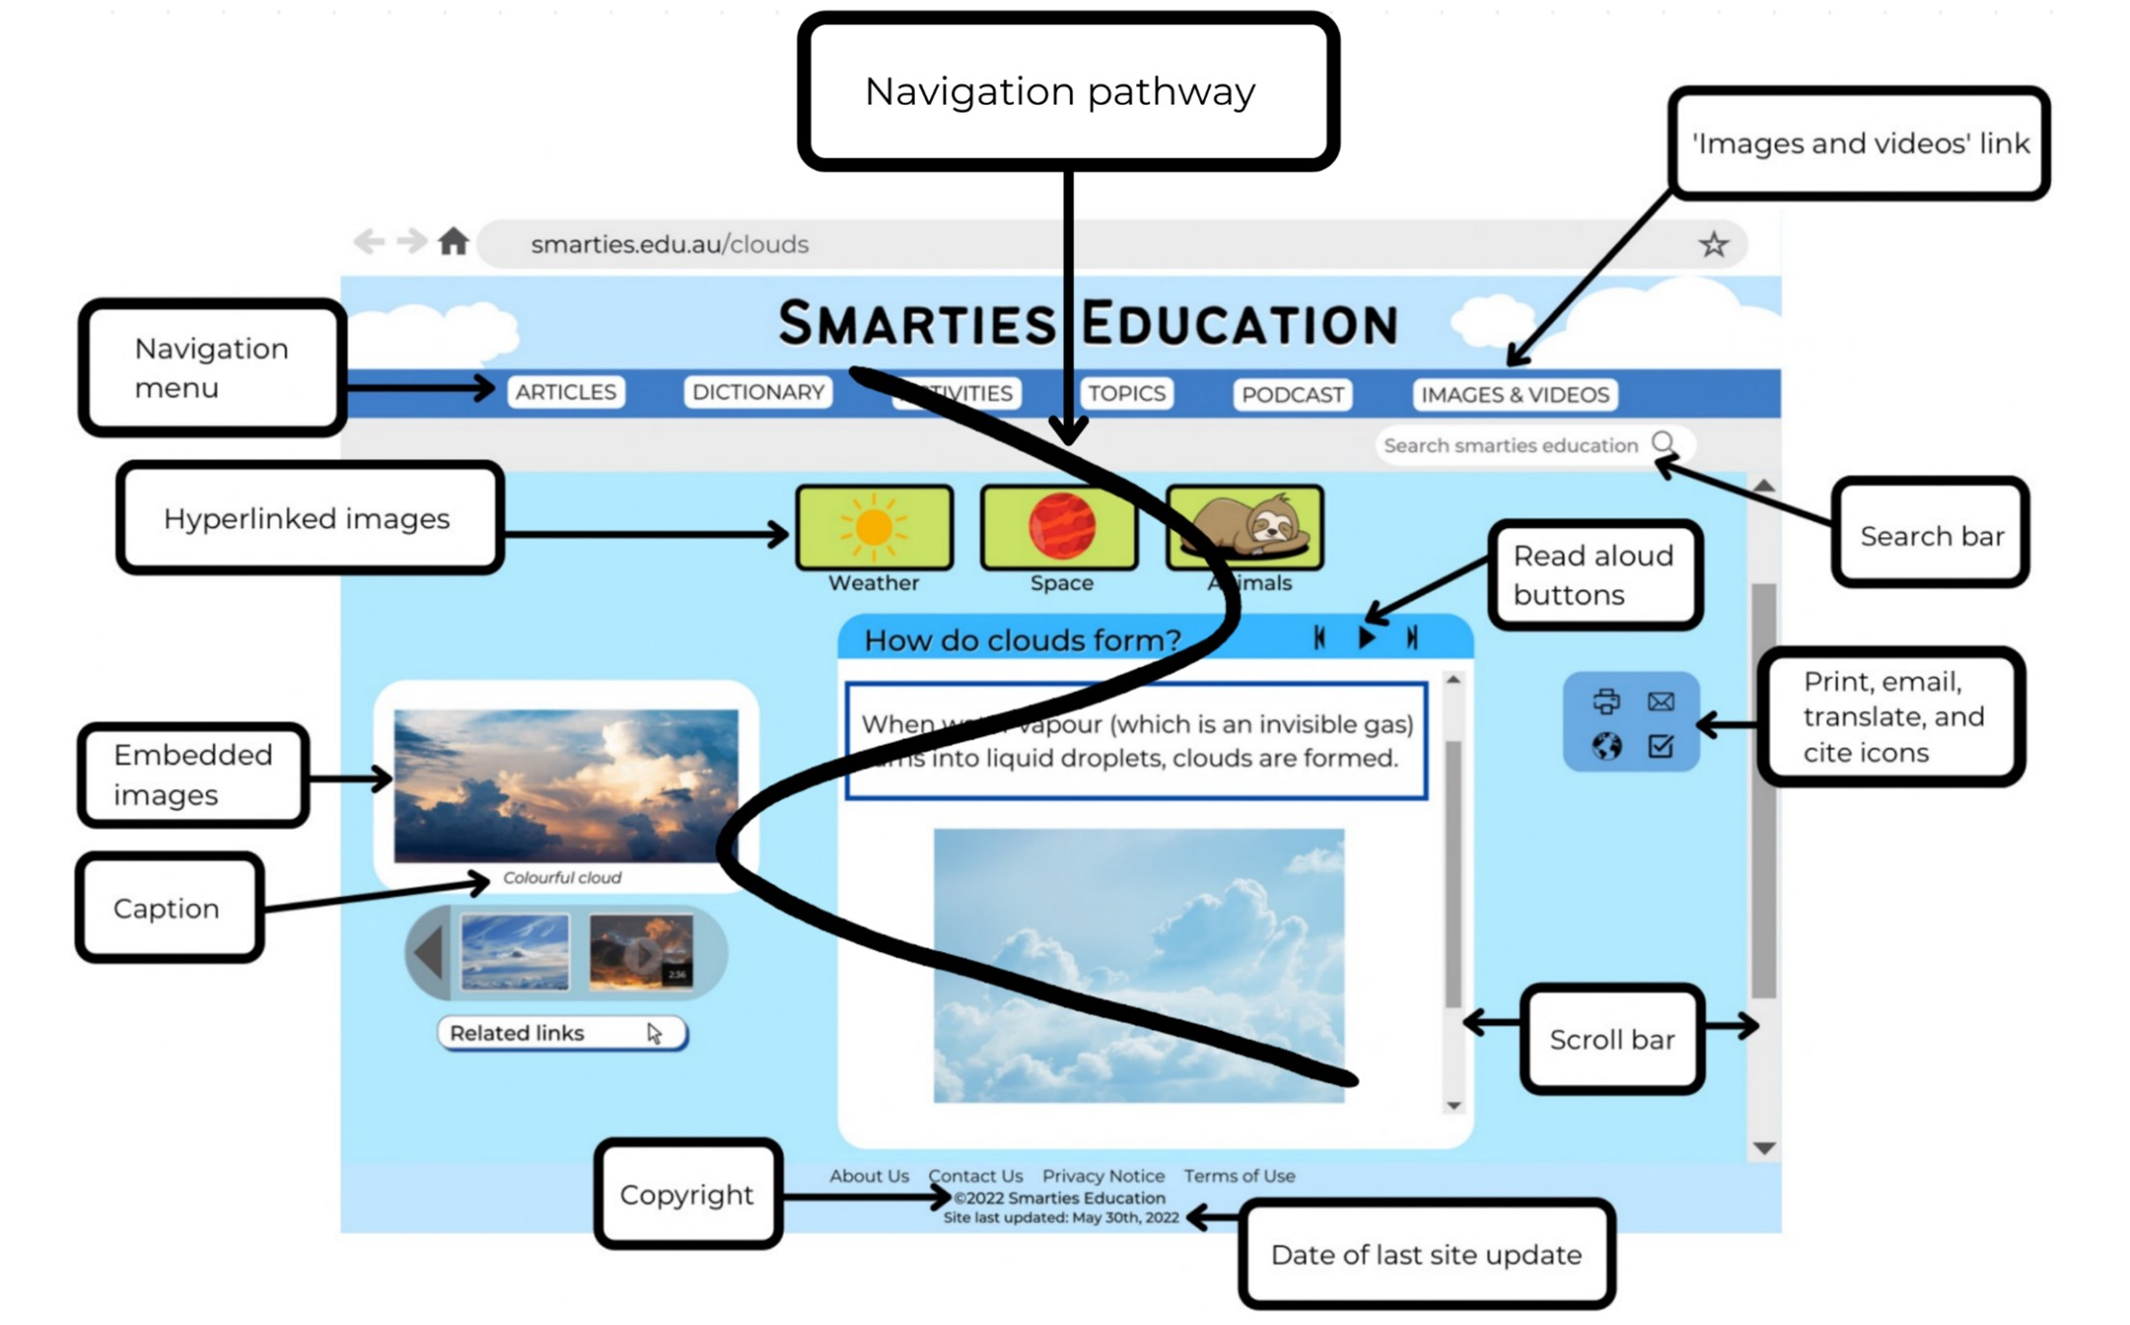
Images sourced from Canva and used in accordance with the Canva Content License Agreement.

Resource 2: Dialogue checklist
Dialogue Checklist | Dialogue Checklist
- Speech marks go around exactly what is spoken.  - A capital letter is used at the start of what is spoken.  - There is a piece of punctuation before the close of quotation marks.  - Saying verbs are used to describe how the speech is spoken.  - A new line is used when each new character speaks. | - Speech marks go around exactly what is spoken.  - A capital letter is used at the start of what is spoken.  - There is a piece of punctuation before the close of quotation marks.  - Saying verbs are used to describe how the speech is spoken.  - A new line is used when each new character speaks.

Resource 3: Speech bubble
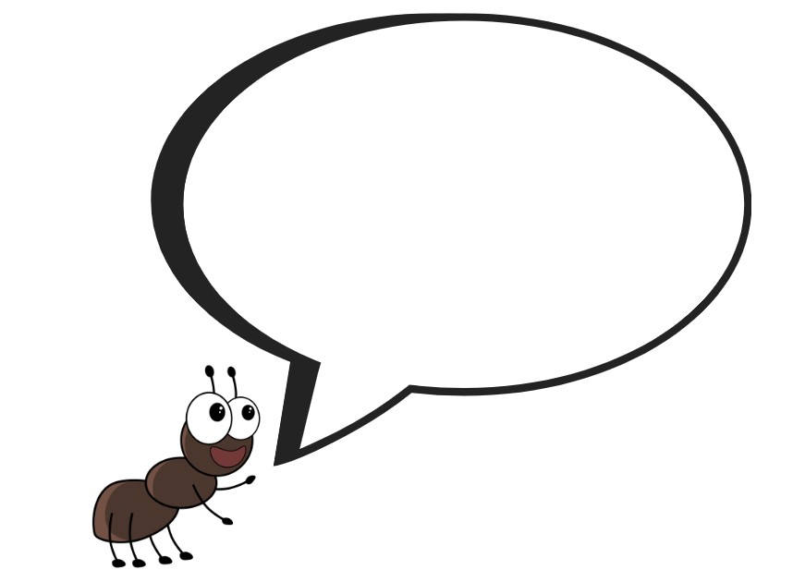
Images sourced from Canva and used in accordance with the Canva Content License Agreement.

Resource 4: Sentences
The ants were heading off on an important expedition.
the chief ant sighed
the ant army set out
The ants became so tired.
Some of them became sad.
they listened all night long

Resource 5: Ant habitats
Ants are found almost everywhere on the planet. They mostly live in nests that are made from soil, sand, wood and leaves.
Some ants build anthills. Anthills are made from the dirt that ants have dug underneath the ground for their nest. An ant’s nest has many tunnels. These tunnels link to chambers or rooms where the ants live.
Different species of ants dig chambers and passages in the ground. Others locate their nests under rocks, in trees, or in logs. The nests may be built of paper, twigs, sand, gravel, or other materials.
Ants like warmth and when it is sunny, they will swarm out of their nests into the sunshine. In winter when it is cold, some ants huddle together in tight bunches, others lie under plant roots or in shallow nests underground.

References
Links to third-party material and websites
Please note that the provided (reading/viewing material/list/links/texts) are a suggestion only and implies no endorsement, by the New South Wales Department of Education, of any author, publisher, or book title. School principals and teachers are best placed to assess the suitability of resources that would complement the curriculum and reflect the needs and interests of their students.
If you use the links provided in this document to access a third-party's website, you acknowledge that the terms of use, including licence terms set out on the third-party's website apply to the use which may be made of the materials on that third-party website or where permitted by the Copyright Act 1968 (Cth). The department accepts no responsibility for content on third-party websites.
Except as otherwise noted, all material is © State of New South Wales (Department of Education), 2021 and licensed under the Creative Commons Attribution 4.0 International License. All other material (third-party material) is used with permission or under licence. Where the copyright owner of third-party material has not licensed their material under a Creative Commons or similar licence, you should contact them directly for permission to reuse their material.
English K–10 Syllabus © 2022 NSW Education Standards Authority (NESA) for and on behalf of the Crown in right of the State of New South Wales.
© 2021 NSW Education Standards Authority. This document contains NSW Curriculum and syllabus content. The NSW Curriculum is developed by the NSW Education Standards Authority. This content is prepared by NESA for and on behalf of the Crown in right of the State of New South Wales. The material is protected by Crown copyright.
Please refer to the NESA Copyright Disclaimer for more information.
NESA holds the only official and up-to-date versions of the NSW Curriculum and syllabus documents. Please visit the NSW Education Standards Authority (NESA) website and the NSW Curriculum website.
National Literacy Learning Progression © Australian Curriculum, Assessment and Reporting Authority (ACARA) 2010 to present, unless otherwise indicated. This material was downloaded from the Australian Curriculum website (National Literacy Learning Progression) (accessed 11 November 2022) and was not modified. The material is licensed under CC BY 4.0. Version updates are tracked in the ‘Curriculum version history’ section on the 'About the Australian Curriculum' page of the Australian Curriculum website.
ACARA does not endorse any product that uses the Australian Curriculum or make any representations as to the quality of such products. Any product that uses material published on this website should not be taken to be affiliated with ACARA or have the sponsorship or approval of ACARA. It is up to each person to make their own assessment of the product, taking into account matters including, but not limited to, the version number and the degree to which the materials align with the content descriptions and achievement standards (where relevant). Where there is a claim of alignment, it is important to check that the materials align with the content descriptions and achievement standards (endorsed by all education Ministers), not the elaborations (examples provided by ACARA).
Disney Channel UK (23 January 2021) 'Flik Takes Flight | A Bugs Life | Disney Channel UK' [video], DisneyChannelUK, YouTube, accessed 11 November 2022.
Dubosarsky U (2021) The March of the Ants (Riddle T, illus.), Book Trail Press, Australia.
ETA (English Teachers Association) and NSW Department of Education (2016) The Textual Concepts and Processes resource, English Textual Concepts website, accessed 11 November 2022.
National Geographic Partners, LLC (2020) Amazing Animals, National Geographics Kids website, accessed 11 November 2022.
National Geographic Partners, LLC (2020) National Geographic Kids [website], accessed 10 November 2022.
Rigney E (producer) (2015) ‘Army Ant’ [television program], Amazing Animals (season 2, episode 10), National Geographic Studios, accessed 11 November 2022.

