English – K-2 multi-age – Year A – Unit 5

Contents
Unit overview and instructions for use 3
Teacher notes 4
Outcomes and content – Component A 5
Outcomes and content – Component B 9
Week 1 13
Component A teaching and learning 13
Component B teaching and learning 14
Lesson 1: Texts that talk to the reader 15
Lesson 2: Persuasive sentences 20
Lesson 3: Character dialogue 24
Lesson 4: Planning for text creation 28
Lesson 5: Creating a class book 32
Week 2 35
Component A teaching and learning 35
Component B teaching and learning 36
Lesson 6: Text comparison 38
Lesson 7: Understanding sentences that persuade 42
Lesson 8: Being persuasive with words and actions 45
Lesson 9: Comic strip – Plan 49
Lesson 10: Comic strip – Publish 51
Resource 1: ‘Is it a sentence?’ retrieval chart 54
Resource 2: Puppets – Early Stage 1 55
Resource 3: Dialogue checklist 58
Resource 4: Saying verbs 59
Resource 5: Four-frame storyboard 60
Resource 6: Six-frame storyboard 61
Resource 7: Class book 62
Resource 8: Speech and thought bubbles 64
Resource 9: My favourite book and character 65
Resource 10: Venn diagram 66
Resource 11: Verb cards 67
Resource 12: FANBOYS 68
Resource 13: Comic strip plan 69
Resource 14: Comic strip template 70
References 71

Unit overview and instructions for use
This two-week unit is comprised of Component A and Component B. Connecting learning across both components is encouraged.
Teaching and learning | Component A | Component B
Suggested duration | 60 minutes | 45 minutes
Explicit teaching focus areas | - Phonological awareness (Early Stage 1)  - Print conventions (Early Stage 1)  - Phonic knowledge  - Reading fluency  - Reading comprehension  - Spelling  - Handwriting | - Oral language and communication  - Vocabulary  - Reading comprehension  - Creating written texts  - Understanding and responding to literature
To prepare for teaching and learning: | - Refer to Outcomes and content – Component A, K-2 – Instructional sequence – grapheme–phoneme correspondences [PDF 825 KB], and the teaching advice documents (hyperlinked in Component A teaching and learning table).  - Based on student needs identified through ongoing assessment data, plan and document how you will sequence teaching and learning in whole class and targeted teaching groups across the two-week cycle. | - Familiarise yourself with Outcomes and content – Component B, Textual concepts information and videos, English Textual Concepts and Learning Processes (2016), and the teaching and learning sequence.  - Based on student needs identified through ongoing assessment data, determine how you will support students in whole class and targeted teaching groups across the two-week cycle as required.
English K–10 Syllabus © 2022 NSW Education Standards Authority (NESA) for and on behalf of the Crown in right of the State of New South Wales.

Teacher notes
- ‘Argument is using persuasion to produce a position or resolution supported by evidence. Argument doesn’t need to be combative; it can build collaboratively to solve complex problems’. – English Textual Concepts and Learning Processes (2016)
- Understanding of argument can be supported through watching the department’s video: Argument (3:17).
- For information on argument, perspective, simple sentences, verbs, contractions, quotation marks, dialogue, question marks, and compound sentences refer to the NESA Glossary.
- Reflect on student learning and engagement in activities and record differentiation and adjustments within the unit to inform future teaching and learning. One way of doing this could be to add comments to the digital file.
- Content points are linked to the National Literacy Learning Progression version (3).
Levels and indicators sourced from National Literacy Learning Progression © Australian Curriculum, Assessment and Reporting Authority (ACARA), (accessed 20 October 2022) and was not modified. See references for more information.

Outcomes and content – Component A
The table below outlines the focus outcomes and content. Content is linked to the National Literacy Learning Progression version (3).
Early Stage 1 Focus area and outcome | Stage 1 Focus area and outcome
Phonological awareness  ENE-PHOAW-01 – identifies, blends, segments and manipulates phonological units in spoken words as a strategy for reading and creating texts  - repeat words and phrases  - consistently say the first phoneme of a spoken one-syllable word (PhA2) | N/A
Print conventions  ENE-PRINT-01 – tracks written text from left to right and from top to bottom of the page and identifies visual and spatial features of print  - understand that print contains a message  - distinguish between punctuation, letters, words and numerals in texts (PKW2)  - identify numerals in texts (PKW2) | N/A
Phonic knowledge  ENE-PHOKW-01 – uses single-letter grapheme–phoneme correspondences and common digraphs to decode and encode words when reading and creating texts  - match a single-letter grapheme with a phoneme  - say the most common phoneme for single-letter graphemes (graphs) (PKW3)  - blend single-letter grapheme–phoneme correspondences to decode VC and CVC words, and apply this knowledge when reading, including decodable texts (PKW3, PKW4)  - segment and encode single-letter VC and CVC words, and apply this knowledge when writing words and creating texts (PKW4) | Phonic knowledge  EN1-PHOKW-01 – uses initial and extended phonics, including vowel digraphs, trigraphs to decode and encode words when reading and creating texts  - blend grapheme–phoneme correspondences to read CCVCC words, CCCVC words and CCCVCC words and apply this when reading texts (PKW7)  - segment and encode CCVCC words, CCCVC words and CCCVCC words and apply this when creating texts (SpG8)  - segment and encode one-syllable high-frequency base words with split digraphs and apply this when creating texts (SpG6)  - segment and encode one-syllable words with taught vowel graphs, digraphs and trigraphs and apply this when creating texts  - decode words with less common consonant digraphs and apply this when reading texts
Reading fluency  ENE-REFLU-01 – reads decodable texts aloud with automaticity  - read words automatically then apply to texts  - stop at the end of a sentence in response to a full stop (FlY3) | Reading fluency  EN1-REFLU-01 – sustains reading unseen texts with automaticity and prosody and self-corrects errors  - apply grapheme–phoneme correspondence to read words with automaticity (FlY1)  - use sentence punctuation to enhance reading in a conversational manner (FlY3, FlY4)
Reading comprehension  ENE-RECOM-01 – comprehends independently read texts using background knowledge, word knowledge and understanding of how sentences connect  - recall key characters, events and/or information in text (UnT5) | Reading comprehension  EN1-RECOM-01 – comprehends independently read texts that require sustained reading by activating background and word knowledge, connecting and understanding sentences and whole text, and monitoring for meaning  - make text-to-self, text-to-text or text-to-world connections when reading (UnT6)  - recount relevant ideas from texts in the form of a written, visual or oral summary (UnT6)
Spelling  ENE-SPELL-01 – applies phonological, orthographic and morphological generalisations and strategies to spell taught familiar and high-frequency words when creating texts  - combine phonological, phonic, orthographic and morphemic knowledge to spell taught high-frequency irregular words comprising up to 3 phonemes (SpG5)  - segment single-syllable words into phonemes as a strategy for spelling (SpG4)  - add the plural-marking suffix (s) to base nouns that require no change when suffixed (SpG5) | Spelling  EN1-SPELL-01 – applies phonological, orthographic and morphological generalisations and strategies when spelling words in a range of writing contexts  - segment single-syllable words into phonemes as a strategy for spelling (SpG4)  - spell high-frequency base words with taught vowel graphs, digraphs, split digraphs, trigraphs and quadgraphs (SpG6)  - spell taught high-frequency contractions (SpG6)  - use spelling conventions when adding plural-marking suffixes (SpG9)  - use spelling conventions when adding tense-marking suffixes (SpG9)
Handwriting  ENE-HANDW-01 – produces all lower-case and upper-case letters to create texts  - apply appropriate pressure when handwriting to produce legible writing (HwK2)  - apply taught handwriting skills when creating texts | Handwriting  EN1-HANDW-01 – uses a legible, fluent and automatic handwriting style, and digital technology, including word-processing applications, when creating texts  - position all letters correctly on the line with appropriate spacing between words (HwK5)

Outcomes and content – Component B
The table below outlines the focus outcomes and content. Content is linked to the National Literacy Learning Progression version (3).
Early Stage 1 Focus area and outcome | Stage 1 Focus area and outcome
Oral language and communication  ENE-OLC-01 – communicates effectively by using interpersonal conventions and language with familiar peers and adults  - follow up to 3-part spoken instructions (LiS3)  - contribute to group conversations (InT3)  - retell favourite stories, poems, songs and rhymes with some parts as exact repetition and some in their own words (SpK2) | Oral language and communication  EN1-OLC-01 – communicates effectively by using interpersonal conventions and language to extend and elaborate ideas for social and learning interactions  - follow extended instructions that contain connectives and conjunctions (LiS5)  - listen to or engage with texts for enjoyment and recognise that their own experience can shape their ideas and opinions of texts  - incorporate extended sentences (simple, compound, complex) during dialogue (SpK3)
Vocabulary  ENE-VOCAB-01 – understands and effectively uses Tier 1 and Tier 2 words in familiar contexts  - recognise and understand taught Tier 1 and Tier 2 words (PKW3, SpK3) | Vocabulary  EN1-VOCAB-01 – understands and effectively uses Tier 1, taught Tier 2 and Tier 3 vocabulary to extend and elaborate ideas  - use vocabulary to express cause and effect (SpK3)
Reading fluency  N/A | Reading fluency  EN1-REFLU-01 – sustains reading unseen texts with automaticity and prosody and self-corrects errors  - use sentence punctuation to enhance reading in a conversational manner (FlY3, FlY4)  - adjust phrasing, intonation, volume or rate to maintain fluency when reading aloud (FlY4)
Reading comprehension  ENE-RECOM-01 – comprehends independently read texts using background knowledge, word knowledge and understanding of how sentences connect  - understand how adjectives describe a noun and verbs identify actions in a sentence  - use visual cues in multimodal texts to interpret meaning (UnT5)  - use background knowledge when identifying connections between a text, own life, other texts and/or the world (UnT4)  - recall key characters, events and/or information in text (UnT5) | Reading comprehension  EN1-RECOM-01 – comprehends independently read texts that require sustained reading by activating background and word knowledge, connecting and understanding sentences and whole text, and monitoring for meaning  - make an inference by connecting the meaning of words across sentences and/or paragraphs  - identify how creative visual features are used to expand meaning  - make text-to-self, text-to-text or text-to-world connections when reading (UnT6)
Creating written texts  ENE-CWT-01 – creates written texts that include at least 2 related ideas and correct simple sentences  - create written texts that describe, give an opinion, recount an event, convey a story  - use personal vocabulary, words on display and in mentor texts when constructing sentences  - know that a simple sentence makes sense by itself and is a complete thought represented by a subject and verb (GrA3)  - understand that punctuation is a feature of written language and how it impacts meaning  - use a capital letter to start a sentence and a full stop to end a sentence (PuN2) (CrT5)  - use drawing, images or mind maps to support planning and writing (CrT4)  - identify differences between spoken and written language | Creating written texts  EN1-CWT-01 – plans, creates and revises texts written for different purposes, including paragraphs, using knowledge of vocabulary, text features and sentence structure  - write texts that describe, explain, give an opinion, recount an event, tell a story (CrT7)  - select and use a range of conjunctions to create cohesive texts (GrA5)  - use visual elements to expand meaning in own texts  - write compound sentences using coordinating conjunctions (GrA4, CrT5)  - use action, saying, relating and sensing verbs to add detail and precision to writing (GrA2, GrA5)  - use quotation marks for simple dialogue (PuN5)  - use punctuation, including question marks and exclamation marks, accurately and for effect (PuN3)  - understand that their own texts can be improved by incorporating feedback and editing
Understanding and responding to literature  ENE-UARL-01 – understands and responds to literature read to them  - express likes and dislikes about a text (UnT5)  - identify favourite stories and/or characters in texts using verbal and/or nonverbal modes  - identify and discuss how creative language and/or symbols enhance enjoyment in texts | Understanding and responding to literature  EN1-UARL-01 – understands and responds to literature by creating texts using similar structures, intentional language choices and features appropriate to audience and purpose  - identify how structure and images reinforce ideas  - create and re-create texts that include persuasive arguments, using knowledge of text and language features

Week 1

Component A teaching and learning
The table below can be used to plan and document lessons that address Component A outcomes and content. Both the detailed example [DOC 529KB] of a two-week teaching and learning cycle and brief example [DOC 66KB] may support you in your planning.
Focus Areas | Lesson 1 | Lesson 2 | Lesson 3 | Lesson 4 | Lesson 5
Phonological awareness (Early Stage 1) and Phonic knowledge
15 minutes
Spelling and Handwriting
15 minutes
Print conventions (Early Stage 1), Reading comprehension and Reading fluency
30 minutes

Component B teaching and learning
The following teaching and learning sequence has been designed to address Component B outcomes and content. Adapt the sequence as required to best meet the needs of your students.

Learning intention and success criteria
Learning intentions and success criteria are best co-constructed with students. The table below contains suggested learning intentions and success criteria.
Element | Early Stage 1 | Stage 1
Learning intentions | Students are learning to use a range of written and visual techniques when creating persuasive texts. | Students are learning to identify arguments and use a range of written and visual techniques when creating persuasive texts.
Success criteria | Students can:  - join in conversations with others  - know that a sentence is a complete idea that makes sense  - retell a story using some words from the text and their own words  - use pictures and symbols to understand texts  - listen to and follow spoken instructions. | Students can:  - identify language and visual effects that persuade the reader  - use punctuation for effect  - write dialogue correctly  - plan and write a persuasive argument  - create illustrations to enhance writing.

Resources
- Willems M (2005) Don’t Let the Pigeon Drive the Bus!, Walker Books, Australia. ISBN: 9781844285136
- Resource 1: ‘Is it a sentence?’ retrieval chart
- Resource 2: Puppets – Early Stage 1 (student copies, scissors, 3 craft sticks for each student, sticky tape)
- Resource 3: Dialogue checklist
- Resource 4: Saying verbs
- Resource 5: Four-frame storyboard
- Resource 6: Six-frame storyboard
- Resource 7: Class book (teacher and individual A3 copies)
- Resource 8: Speech and thought bubbles (teacher and individual A3 copies)
- For each student: A4 paper, drawing pencils

Lesson 1: Texts that talk to the reader
The following teaching and learning activities support multi-age settings.

Whole
- Introduce Don’t Let the Pigeon Drive the Bus! Display the first 3 double-page spreads that show Pigeon with thought bubbles, the driver and the bus, and the driver walking away. Read the driver’s speech bubble. Students make text predictions using Think-Pair-Share to answer the following questions:
- Who is the bus driver talking to?
- What is the relationship between the driver and the pigeon?
- What type of text do you think this might be?
- What can we tell about the whole text just from these pages?
- Read the text Don’t Let the Pigeon Drive the Bus! Discuss how characters talk directly to the reader throughout the book and how this makes the reader part of the story. Explain that the narrative style of Don’t Let the Pigeon Drive the Bus! is metafiction.
Note: Metafiction is a style of narrative where the character/s or narrator speaks directly to the audience.
- Display the double-page spread at the end of the text where Pigeon is dreaming of driving a truck. Ask students to infer what the pigeon is thinking based on what they have learnt about Pigeon throughout the text.
- Display the word ‘persuade’. Discuss and define its meaning. Explain the importance of persuasive arguments. Note that persuasive arguments provide a clear reason why someone acts or thinks in a particular way.
- Identify and discuss the persuasive arguments and language used by the author. Identify the use of persuasive techniques including begging, getting angry, providing reasoning, offering a bribe and reverse psychology (pretending that it did not matter).
- Discuss the use of visual elements in Don’t Let the Pigeon Drive the Bus! that persuade and show emotion. For example:
- colour – background, thought clouds
- font – capitalisation, bold and size
- images – size, shape and position of characters and speech bubbles; vector lines to show movement.
- Students turn and talk to discuss text-to-self connections about when they, or a member of their family, have used similar techniques to persuade.
- As a whole class, share and discuss perspectives on whether Pigeon should be able to drive the bus. Encourage students to provide reasons for their point of view.
Part
The table below details the differentiated teaching and learning activities for each stage.
Early Stage 1 (pairs) | Stage 1 (teacher guided)
- In pairs, students discuss their likes and dislikes about the text, including their opinion on Pigeon as a character and the way that images have been used.  - Students select their favourite page from the text and explain to a partner why it is their favourite. Prompt them to consider how the creative language and illustrations influence their opinion. | - Draw an illustration that represents your point of view on whether Pigeon should be able to drive the bus. For example, students may draw a pigeon sitting in the driver’s seat and its feet not reaching the pedals and its wings not turning the wheel.  - Model writing simple sentences to explain why Pigeon shouldn’t drive. For example, ‘The pigeon cannot drive the bus. His legs are too short.’ Highlight the impact of providing reasoning when presenting an argument.
Part
The table below details the differentiated teaching and learning activities for each stage.
Early Stage 1 (teacher guided) | Stage 1 (independent)
- Model writing a sentence which expresses your own opinion about the text and its characters. For example, ‘I like Pigeon because he is funny.’  - Explicitly teach that the sentence is a complete idea that makes sense by itself. Explain that a sentence requires a capital letter at the beginning and a piece of punctuation, such as a full stop at the end.  - Compare the complete sentence example with incomplete sentences or words. For example, ‘Pigeon blue, like because funny’. Support students to identify that a sentence requires a subject and verb. | - Students create a series of illustrations and sentences to present their opinion on Pigeon driving the bus.  Too hard? Students provide one reason to support their opinion.  Too easy? Students include a range of compound and complex sentences when writing their point of view.
Early Stage 1 Assessment task 1 – Observations from this lesson allow students to demonstrate achievement towards the following syllabus outcomes and content points:
ENE-OLC-01 – communicates effectively by using interpersonal conventions and language with familiar peers and adults
- contribute to group conversations.
ENE-RECOM-01 – comprehends independently read texts using background knowledge, word knowledge and understanding of how sentences connect
- use background knowledge when identifying connections between a text, own life, other texts and/or the world
- recall key characters, events and/or information in text.
ENE-UARL-01 – understands and responds to literature read to them
- identify and discuss how creative language and/or symbols enhance enjoyment in texts.
Stage 1 Assessment task 1 – Observations from this lesson allow students to demonstrate achievement towards the following syllabus outcomes and content points:
EN1-OLC-01 – communicates effectively by using interpersonal conventions and language to extend and elaborate ideas for social and learning interactions
- listen to or engage with texts for enjoyment and recognise that their own experience can shape their ideas and opinions of texts.
EN1-RECOM-01 – comprehends independently read texts that require sustained reading by activating background and word knowledge, connecting and understanding sentences and whole text, and monitoring for meaning
- make an inference by connecting the meaning of words across sentences and/or paragraphs
- identify how creative visual features are used to expand meaning
- make text-to-self, text-to-text or text-to-world connections when reading.

Lesson 2: Persuasive sentences
The following teaching and learning activities support multi-age settings.

Whole
- Display the double-page spread in Don’t Let the Pigeon Drive the Bus!, divided into 8 squares, which shows Pigeon talking. Highlight the punctuation and discuss the effect of combined punctuation marks.
- Read sections of the text and model adjusting phrasing, intonation, and volume to respond to sentence punctuation.

Part
The table below details the differentiated teaching and learning activities for each stage.
Early Stage 1 (teacher guided) | Stage 1 (pairs/small groups)
- Review the structure of a simple sentence using Resource 1: ‘Is it a sentence?’ retrieval chart.  - Create a T-chart with two columns labelled as ‘These are sentences’, and ‘These are not sentences’. Select words and phrases from the book, or create your own, for students to categorise under the two headings.  - Support students’ reasoning by providing sentence starters and prompts, including:  - This is a sentence because…  - This is not a sentence because…  - There is a subject in this sentence. It is…  - There is not a subject in this sentence.  - Select one or more of the examples that are not a sentence and model writing it as a sentence. For example, ‘No fair!’ could be changed to ‘I don’t think that is fair.’ Continue to identify the subject (who or what) as well as the verb (what are they doing) in each sentence. | - In pairs or small groups, students act out scenes from the text pretending to be the pigeon or the bus driver. Encourage students to use appropriate phrasing, intonation, and volume.  - Students perform several scenes, alternating between characters in the text.  - If available, students may read and act out scenes from other Pigeon books by Mo Willems.

Part
The table below details the differentiated teaching and learning activities for each stage.
Early Stage 1 (independent) | Stage 1 (teacher guided)
- With a partner, students construct a sentence orally that Pigeon might say. Explain to students that we can turn our spoken language into written language. Once students have orally constructed their sentence, support them to count the number of words in their sentence and mark this number of dots at the top of their page. Students can then write one word for each dot.  - Students draw Pigeon with a speech bubble coming from his mouth. Using words from the text and around the classroom, students write their sentence inside the speech bubble.  Too hard? Facilitate use of text-to-speech technology or audio or video recording to produce the text.  Too easy? Students write multiple sentences that show Pigeon’s different persuasive techniques. | - Explain that contractions are frequently used when speaking. Browse the text with students and pause to identify contractions. For example:  - Don’t let the pigeon drive the bus.  - I’m the bus driver.  - Listen, I’ve got to leave for a while.  - I thought he’d never leave.  - Read the examples without contractions and discuss how the text becomes more formal when words are in complete form. For example:  - I am the bus driver.  - Listen, I have got to leave for a while.  - I thought he would never leave.  - Discuss the author’s choice to use contractions to make the text like a spoken conversation.  - Explain that students are participants in the story Don’t Let the Pigeon Drive the Bus! Explain that they are going to write a response to Pigeon to let him know that he can, or cannot, drive the bus.  - Model drawing a cartoon version of yourself in the story with speech bubbles on the board.  - Model writing a response in the speech bubble. Use think aloud to show deliberate decision-making about the use of persuasive language, contractions, font style and punctuation. For example, ‘Pigeons don’t have hands. You can’t drive the bus. EVER!’  - Students draw themselves and write a persuasive response in a speech bubble.
Early Stage 1 Assessment task 3 – Observations from this lesson allow students to demonstrate achievement towards the following syllabus outcome and content point:
ENE-CWT-01 – creates written texts that include at least 2 related ideas and correct simple sentences
- know that a simple sentence makes sense by itself and is a complete thought represented by a subject and verb
- identify differences between spoken and written language.

Lesson 3: Character dialogue
The following teaching and learning activities support multi-age settings.

Whole
- Re-read Don’t Let the Pigeon Drive the Bus! Highlight the use of speech and thought bubbles that show what the characters are saying and thinking. Discuss how the visual features add to the meaning of the text.

Part
The table below details the differentiated teaching and learning activities for each stage.
Early Stage 1 (independent) | Stage 1 (teacher guided)
- Distribute student copies of Resource 2: Puppets – Early Stage 1 and necessary resources.  - Students assemble the pigeon, bus and driver puppets.  - In pairs, students retell Don’t Let the Pigeon Drive the Bus!, using exact repetition and/or their own words.  - If available, students may engage with and act out scenes from other Pigeon books by Mo Willems.  - Where possible, students can use technology-to-video to record their retell. | - Display a page in a familiar text that demonstrates the use of dialogue and compare it to the use of speech bubbles in Don’t Let the Pigeon Drive the Bus! Identify the quotation marks. Explicitly teach that authors use quotation marks to indicate when characters are speaking.  - Explain that good writers apply rules to ensure punctuation is correctly used when they write dialogue. Display and discuss Resource 3: Dialogue checklist.  - In pairs, students examine classroom texts as ‘dialogue detectives’, identifying the use of dialogue.  - Display Resource 4: Saying verbs and define as verbs that indicate when and how someone is speaking. Discuss the difference between each saying verb and when it might be used. For example, the verb ‘shouted’ may be used in anger in an argument, or as encouragement at a football game.  - Brainstorm saying verbs that would best match the pigeon’s dialogue from Don’t Let the Pigeon Drive the Bus! Students demonstrate the effect of various saying verbs. For example:  - ‘Hey, can I drive the bus?’ – matches with asked.  - ‘I know what, I’ll just steer.’ – matches with whispered.  - ‘My cousin Harry drives a bus almost every day!’ – matches with explained.  - ‘Fine!’ – matches with huffed.  - Display a page from the book and model writing the text using dialogue rules. For example, ‘My cousin Harry drives a bus almost every day!’ explained the pigeon. Refer to Resource 3: Dialogue checklist to model reviewing and editing writing.

Part
The table below details the differentiated teaching and learning activities for each stage.
Early Stage 1 (teacher guided) | Stage 1 (independent)
- Ask students to think of a time when they have tried to persuade their parents, family members or teacher to let them do something. Discuss: What did they say? Were they successful or not? What happened?  - Model drawing a picture of yourself in a cartoon style with a speech bubble. Inside the speech bubble write a simple sentence stating what you want to do. For example, ‘I want to stay up late!’  - Identify the subject and the verb in the sentence and highlight that it is a complete idea that makes sense. Explain that a sentence begins with a capital letter and ends with a full stop. Trace over these with coloured marker to highlight their positioning.  - Students share things that they want. List these on an anchor chart.  - Students select an option from the chart and draw themselves with a speech bubble. Students use words from the model and anchor chart to write what they want or where they want to go.  Too easy? Using the sentence starter ‘I want __’, students select a word from the chart to complete the sentence. | - Using the correct conventions, students write dialogue from the perspective of the pigeon or the bus driver. Encourage students to add contractions to make the text sound like spoken language.  Too hard? Provide an individual copy of Resource 4: Saying verbs to support verb selection.  Too easy? Students select more complex verbs, for example, assured.  - Students review and edit their writing using Resource 3: Dialogue checklist.  - Students review their writing with a partner.
Early Stage 1 Assessment task 2 – Observations and work samples from this lesson allow students to demonstrate achievement towards the following syllabus outcomes and content points:
ENE-OLC-01 – communicates effectively by using interpersonal conventions and language with familiar peers and adults
- retell favourite stories, poems, songs and rhymes with some parts as exact repetition and some in their own words.
ENE-RECOM-01 – comprehends independently read texts using background knowledge, word knowledge and understanding of how sentences connect
- understand how adjectives describe a noun and verbs identify actions in a sentence.
ENE-CWT-01 – creates written texts that include at least 2 related ideas and correct simple sentences
- understand that punctuation is a feature of written language and how it impacts meaning
- use a capital letter to start a sentence and a full stop to end a sentence.
Stage 1 Assessment task 2 – Collecting work samples from this lesson allows students to demonstrate achievement towards the following syllabus outcomes and content points:
EN1-CWT-01 – plans, creates and revises texts written for different purposes, including paragraphs, using knowledge of vocabulary, text features and sentence structure
- use action, saying, relating and sensing verbs to add detail and precision to writing
- use quotation marks for simple dialogue
- understand that their own texts can be improved by incorporating feedback and editing.
EN1-UARL-01 – understands and responds to literature by creating texts using similar structures, intentional language choices and features appropriate to audience and purpose
- identify how structure and images reinforce ideas.

Lesson 4: Planning for text creation
The following teaching and learning activities support multi-age settings.

Whole
- Explain that students will be planning a class book about an activity that Pigeon would like to do. Brainstorm ideas, for example, Don’t Let the Pigeon… teach the class, cook dinner, go shopping.
- As a class, select a topic and share arguments that Pigeon would make to persuade. List the arguments on sticky notes.
- Discuss a humorous ending where Pigeon changes his mind. For example, instead of being the teacher, Pigeon decides that he wants to be the principal instead. Compare to the ending of Don’t Let the Pigeon Drive the Bus! where Pigeon dreams of driving a truck.

Part
The table below details the differentiated teaching and learning activities for each stage.
Early Stage 1 (teacher guided) | Stage 1 (pairs/small groups)
- Model planning a new story using an enlarged copy of Resource 5: Four-frame storyboard to draw and label:  - Frame 1: introduce the character who will set the story in motion. For example, the teacher (replaces the bus driver)  - Frame 2: Pigeon asks a direct question to the reader  - Frame 3: Pigeon says a persuasive argument  - Frame 4: Pigeon changes his mind. For example, he now wants to be the principal. | - Students turn and talk to develop ideas for persuasive arguments for the class book.  - In pairs, students write their ideas on sticky notes.

Part
The table below details the differentiated teaching and learning activities for each stage.
Early Stage 1 (independent) | Stage 1 (teacher guided)
- Students select a different activity that Pigeon would want or like to do. Using the modelled plan as a guide, students create their own story plan using Resource 5: Four-frame storyboard.  Too hard? Students draw pictures to plan.  Too easy? Students use Resource 6: Six-frame storyboard. | - Write a question mark and an exclamation mark on the board. Ask students what these symbols are used for and why they are important.  - Open Don’t Let the Pigeon Drive the Bus! and locate pages where question marks and exclamation marks have been used. Highlight how these tell the reader how to read the page in a particular way. Read several pages with and without expression to demonstrate the difference.  - Explain that students will need to consider their punctuation choices when writing their own text.  - Display an enlarged copy of Resource 6: Six-frame storyboard or a digital storyboard. Discuss and model the development of a story plan that innovates on the original:  - Frame 1: Introduce the character who will set the story in motion. For example, the teacher (replaces the bus driver)  - Frame 2: Pigeon asks a direct question to the reader  - Frame 3: Pigeon says a persuasive argument  - Frame 4: Pigeon says another persuasive argument  - Frame 5: Return of a character. For example, the teacher  - Frame 6: Pigeon reimagines his goals. For example, now he wants to be the principal.  - Model:  - adding ideas on sticky notes  - moving, discarding, amending or recreating the notes as the ideas change or develop  - adding question marks and exclamation marks to writing  - including sketches or keywords on the sticky notes to explain how words and images may work together.  - Students plan their writing for a different activity that Pigeon would want or like to do using a student copy of Resource 6: Six-frame storyboard and sticky notes.  Too hard? Students use Resource 5: Four-frame storyboard.  Too easy? Students plan for a longer text using multiple persuasive techniques.

Lesson 5: Creating a class book
The following teaching and learning activities support multi-age settings.

Whole
- Explain that students will be writing and illustrating an A3 copy of Resource 7: Class book about Pigeon’s new activity.
- To illustrate the new text, students will learn how to draw Pigeon just like Mo Willems – by following a set of oral instructions.
- Discuss strategies for following oral instructions. For example:
- look at the person who is giving the instructions
- look at their hand movements and gestures
- listen for words that provide exact details
- know that when connectives or conjunctions (linking words) are used, more information is going to be given or a particular sequence is required. For example, first, next, then, after that, now, because, but.
- Read the instructions The Pigeon: How to Draw the Pigeon! while students follow the steps to draw Pigeon.
- Identify instructions that are easy to follow, and others that are more difficult.
Too hard? Display the written instructions with visuals and/or read the instructions in small chunks.
- Explain that each frame on the storyboard matches the squares on the class book.
Note: Early Stage 1 students will use the four-frame structure and Stage 1 will use the six-frame.
- Model completing Resource 7: Class book using:
- pigeon drawings
- completed storyboard from Lesson 4.
- hand-drawn speech bubbles or Resource 8: Speech and thought bubbles.
- Students write and illustrate their new text for the class book.
Too hard? In a small group or individually, teacher guides the development of a four-frame class page. Scribe for students where necessary.
- Students discuss the written and visual persuasive techniques that have been used in their text. Consider which techniques were used the most and/or least frequently.
- Collate the pages into a class book for students to share in the class library.
Early Stage 1 Assessment task 3 – Observations from this lesson allow students to demonstrate achievement towards the following syllabus outcome and content points:
ENE-CWT-01 – creates written texts that include at least 2 related ideas and correct simple sentences
- create written texts that describe, give an opinion, recount an event, convey a story
- use drawing, images or mind maps to support planning and writing
- use personal vocabulary, words on display and in mentor texts when constructing sentences.
Stage 1 Assessment task 3 – Observations and work samples from this lesson allow students to demonstrate achievement towards the following syllabus outcomes and content points:
EN1-OLC-01 – communicates effectively by using interpersonal conventions and language to extend and elaborate ideas for social and learning interactions
- follow extended instructions that contain connectives and conjunctions.
EN1-CWT-01 – plans, creates and revises texts written for different purposes, including paragraphs, using knowledge of vocabulary, text features and sentence structure
- write texts that describe, explain, give an opinion, recount an event, tell a story
- use visual elements to expand meaning in own texts.

Week 2

Component A teaching and learning
The table below can be used to plan and document lessons that address Component A outcomes and content. Both the detailed example [DOC 529KB] of a two-week teaching and learning cycle and brief example [DOC 66KB] may support you in your planning.
Focus Areas | Lesson 6 | Lesson 7 | Lesson 8 | Lesson 9 | Lesson 10
Phonological awareness (Early Stage 1) and Phonic knowledge
15 minutes
Spelling and Handwriting
15 minutes
Print conventions (Early Stage 1), Reading comprehension and Reading fluency
30 minutes

Component B teaching and learning
The following teaching and learning sequence has been designed to address Component B outcomes and content. Adapt the sequence as required to best meet the needs of your students.

Learning intention and success criteria
Learning intentions and success criteria are best co-constructed with students. The table below contains suggested learning intentions and success criteria.
Element | Early Stage 1 | Stage 1
Learning intentions | Students are learning to express opinions about stories and discuss how different text elements add to enjoyment. | Students are learning to identify arguments and use a range of written and visual techniques when creating persuasive texts.
Success criteria | Students can:  - describe likes and dislikes about a text  - identify verbs that tell us what is happening  - use new and known vocabulary  - plan writing using drawings and labels. | Students can:  - compare texts that persuade  - use a variety of sentences in writing  - use written and visual text features to support acting out a text  - provide feedback based on a criterion  - write and illustrate a persuasive argument.

Resources
- Lee A (2016) Do Not Open this Book (McKenzie H, illus.), Lake Press, Australia. ISBN ‎9781760451486
- Willems M (2005) Don’t Let the Pigeon Drive the Bus!, Walker Books, Australia. ISBN: 9781844285136
- Resource 5: Four-frame storyboard
- Resource 8: Speech and thought bubbles
- Resource 9: My favourite book and character
- Resource 10: Venn diagram
- Resource 11: Verb cards
- Resource 12: FANBOYS
- Resource 13: Comic strip plan
- Resource 14: Comic strip template
- Sentence strips, sticky notes (for Stage 1 students)
- Copies for each group: orange double-page spread from Don’t Let the Pigeon Drive the Bus! and red double-page spread from Do Not Open this Book
- Copies for Early Stage 1 pairs of 3 double-page spreads of wordless pages from Do Not Open this Book
- A4 paper

Lesson 6: Text comparison
The following teaching and learning activities support multi-age settings.
- Display the cover of Do Not Open this Book. Ask students to make predictions about the book using:
- what the words tell us
- what the images show us
- links to students’ background experiences
- links to other texts.
- Read Do Not Open this Book.
- Review students’ understanding of persuasive language from Lesson 1 and make comparisons with the metafiction text Don’t Let the Pigeon Drive the Bus!
- Compare pages in each text where the characters have used the same persuasive techniques. For example, begging, getting angry, providing reasoning, offering a bribe, reverse psychology (pretending that it didn’t matter to them).

Part
The table below details the differentiated teaching and learning activities for each stage.
Early Stage 1 (teacher guided) | Stage 1 (small groups/independent)
- Discuss students’ likes and dislikes about the text. For example, some students may not like the witch at the end, some may like the crazy expressions on the characters’ faces.  - Share your favourite books and characters, giving reasons for your personal choice. Discuss that personal opinions about books and characters vary and should be respected.  - Display a T-chart with the headings ‘Favourite book’ and ‘Favourite character’. Students identify their favourites and justify their selection.  - List student responses and note keywords for their reasons. For example, favourite book – funny, scary, real; favourite characters – friendly, cheeky, kind.  - Discuss how the same book or character may be a favourite for many students, but the reasons may vary according to personal experiences and text preferences. | - In groups, provide students with paired images from each text. For example:  - Don’t Let the Pigeon Drive the Bus!: orange double-page spread with the text ‘LET ME DRIVE THE BUS!!’  - Do Not Open this Book: red double-page spread with the text ‘ARGHHHH!!! You turned again!!!’  - Distribute one colour of sticky notes for all students to use with Don’t Let the Pigeon Drive the Bus!, for example, yellow. Distribute a second colour for all students to use for Do Not Open this Book, for example, blue.  - Students compare the paired images, using the corresponding colour sticky note for each text, noting the visual elements, including colour, images and font size, type and positioning.

Part
The table below details the differentiated teaching and learning activities for each stage.
Early Stage 1 (independent) | Stage 1 (teacher guided)
- Students use Resource 9: My favourite book and character to draw a scene to depict their favourite book and character.  - Students use the sentence starters in Resource 9: My favourite book and character and refer to the T-chart to write either words or simple sentences that describe their favourite text and character. For example, ‘My favourite book is Diary of a Wombat. My favourite character is Mothball. This book is my favourite because I like the pictures of Mothball.’  Too hard? Facilitate use of text-to-speech technology or audio or video recording to produce the text.  Too easy? Students add a greater amount of detail about their favourite book and character.  - Students share their text with a peer. | - Model using an enlarged copy of Resource 10: Venn diagram and sticky notes to compare the texts.  - In small groups, students use Resource 10: Venn diagram to organise their sticky notes.  - Students share their observations about the features of the 2 texts. For example, the orange page has the words in capital letters and there are many vector lines to show movement.  - Students make generalisations about the similarities and differences between the texts.  Note: Cause and effect explains the connection between events or things in the text when one is the result of the other. It adds meaning to the storyline.  - To understand cause and effect:  - display the final page of Do Not Open this Book and discuss what has happened to the blue character at the end of the book – the blue character turned into a frog (effect)  - display the previous black page and discuss what the blue character told the reader – that the witch warned the blue character about the outcome of turning the last page of the book  - ask students what happened in between the 2 pages – the reader turned the last page of the book (cause).  - Review Don’t Let the Pigeon Drive the Bus! to identify examples of cause and an effect. For example, the driver returned, so the pigeon did not drive the bus.
Early Stage 1 Assessment task 4 – Observations and work samples from this lesson allow students to demonstrate achievement towards the following syllabus outcome and content points:
ENE-UARL-01 – understands and responds to literature read to them
- express likes and dislikes about a text
- identify favourite stories and/or characters in texts using verbal and/or nonverbal modes.
Stage 1 Assessment task 4 – Observations and work samples from this lesson allow students to demonstrate achievement towards the following syllabus outcomes and content points:
EN1-VOCAB-01 – understands and effectively uses Tier 1, taught Tier 2 and Tier 3 vocabulary to extend and elaborate ideas
- use vocabulary to express cause and effect.
EN1-RECOM-01 – comprehends independently read texts that require sustained reading by activating background and word knowledge, connecting and understanding sentences and whole text, and monitoring for meaning
- make an inference by connecting the meaning of words across sentences and/or paragraphs
- identify how creative visual features are used to expand meaning
- make text-to-self, text-to-text or text-to-world connections when reading.

Lesson 7: Understanding sentences that persuade

Part
The table below details the differentiated teaching and learning activities for each stage.
Early Stage 1 (teacher guided) | Stage 1 (pairs/independent)
- Model a game of ‘Who am I?’ using verbs. For example, using the actions of a favourite character from a text, ask, ‘Who am I? I like to dig long tunnels and eat carrots’. Answer: I am Mothball from Diary of a Wombat. Note the action verbs dig and eat.  - Support students to lead the ‘Who Am I?’ game using their character descriptions from Lesson 6.  - Display Resource 11: Verb cards. Model identifying the image and reading the words.  - Play ‘Who Am I?’ using the verb cards. For example, using the dog card, ask, Who am I? I can sleep. I can bark. Answer: I am a dog. Identify the verbs.  - Model writing simple sentences using the ‘Who am I?’ verbs and nouns. For example, I am a dog. I can bark. | - Provide students with copies of Do Not Open this Book and Resource 12: FANBOYS.  - Students work with a partner to identify simple and compound sentences in the text.  Too hard? Students find simple sentences only.  Too easy? Students find simple, compound and complex sentences.

Part
The table below details the differentiated teaching and learning activities for each stage.
Early Stage 1 (pairs/independent) | Stage 1 (teacher guided)
- In pairs, students discuss Resource 11: Verb cards to identify the picture and read the verbs.  - Students are provided with sentence starters ‘I am a __. I can __.’ Students complete the sentences by writing a noun and a verb. For example, I am a baby. I can cry.  - Students take turns to read their sentences and play ‘Who am I?’  Too hard? Students draw a picture in the blank space and verbalise their sentences.  Too easy? Students use multiple adjectives and verbs to describe the image on the verb card. | - Discuss the author’s use of a range of simple and compound sentences. Explain that compound sentences are an important feature of persuasive texts as they help the author to share their opinion and/or provide additional information and reasoning.  - Write compound sentences on the board, for example, I know you want to ride your motorbike, but you will get hurt. Revise that a compound sentence contains 2 simple sentences joined by a coordinating conjunction.  - Model turning a compound sentence into 2 simple sentences.  - Discuss that an independent clause can stand alone as a complete sentence. Identify the independent clauses and the coordinating conjunction.  - Share the pen and underline the 2 independent clauses and highlight the coordinating conjunction in the displayed sentences.  - Using the modelled examples as a guide, students write 2 simple sentences onto 2 different coloured sentence strips and a conjunction on a sticky note. Students combine the sentences with the sticky note to form a persuasive compound sentence and paste their strips/sticky notes onto A4 paper.  Too hard? Students work in pairs to orally share 2 simple sentences and select a conjunction to create a compound sentence.  Too easy? Students use conjunctions to write a compound statement, question, command and exclamation.
Stage 1 Assessment task 5 – Observations and work samples from this lesson allow students to demonstrate achievement towards the following syllabus outcome and content points:
EN1-CWT-01 – plans, creates and revises texts written for different purposes, including paragraphs, using knowledge of vocabulary, text features and sentence structure
- select and use a range of conjunctions to create cohesive texts
- write compound sentences using coordinating conjunctions.

Lesson 8: Being persuasive with words and actions
The following teaching and learning activities support multi-age settings.

Whole
- Re-read Do Not Open This Book.
Note: An interjection is a word or phrase that usually expresses a feeling or a reaction. It can be followed by an exclamation mark.
- Discuss the use of interjections as another language device used to make text sound like it is spoken. Identify interjections from the text and alternative ways of saying them. For example:
- ‘Oh, good golly!’ could be ‘Oh my goodness’ or ‘Oh dear’.
- ‘Okay, okay!’ could be ‘It is alright’.
- ‘Honest to Charlie!’ could be ‘I’m being honest’.
- ‘WOW!’ could be ‘Amazing’.
- Without using expression, read the third double-page spread with the black background that begins with ‘What are you doing?’ Re-read with expression. Display the page and discuss how meaning is added to the text using the following features:
- images – blue character’s body language and gestures
- colour choice
- font size and changes in size
- page layout.
- Select a wordless page and discuss how the visual elements tell the story.

Part
The table below details the differentiated teaching and learning activities for each stage.
Early Stage 1 (pairs) | Stage 1 (teacher guided)
- In pairs, students receive a copy of the 3 double-page spreads of wordless pages.  - Students discuss the actions of the blue character and orally identify verbs. For example, stared, turned away, yelled, glared.  - Students innovate on the text, acting out the actions and adding simple dialogue to retell the pages. | - Model reading persuasive arguments that include interjections and contractions. Explicitly teach the use of phrasing, intonation and volume. For example, ‘Seriously, I can see you. I’ve got eyes in the back of my head, you know.’  - Ask students to read persuasive arguments from the text that include interjections and contractions. Support students by offering suggestions around phrasing, intonation, or volume to enhance their presentation. For example, ‘I like how you spoke clearly and shook your head to show you were angry’, or ‘I think you could speak louder because there are a lot of capital letters and exclamation marks in the text’.

Part
The table below details the differentiated teaching and learning activities for each stage.
Early Stage 1 (teacher guided/small groups/pairs) | Stage 1 (pairs/independent)
- Brainstorm and list the verbs that the students used in their retell of the blue character’s actions.  - Play ‘Simon says’ to act out the verbs.  - Re-read the text. Students identify new or difficult vocabulary by placing their hands on their head. For example, reasonable, thinking straight, the silent treatment, confiscate.  - Discuss the meanings and add to the brainstorm word list.  - In groups or pairs, students select words to act out the actions and add dialogue where necessary. | - In pairs, distribute the copies of the double-page spreads of wordless pages from Early Stage 1 activity 5 along with sticky notes.  - Students select a page and write persuasive arguments that align with the visuals.  - In pairs, students develop a role-play of their persuasive arguments using appropriate phrasing, intonation, and volume.
- Early Stage 1 students present their actions to the class and Stage 1 students present their role-play.
Early Stage 1 Assessment task 5 – Observations and work samples from this lesson allow students to demonstrate achievement towards the following syllabus outcomes and content points:
ENE-VOCAB-01 – understands and effectively uses Tier 1 and Tier 2 words in familiar contexts
- recognise and understand taught Tier 1 and Tier 2 words.
ENE-RECOM-01 – comprehends independently read texts using background knowledge, word knowledge and understanding of how sentences connect
- use visual cues in multimodal texts to interpret meaning.
ENE-CWT-01 – creates written texts that include at least 2 related ideas and correct simple sentences
- use personal vocabulary, words on display and in mentor texts when constructing sentences
- know that a simple sentence makes sense by itself and is a complete thought represented by a subject and verb
- use drawing, images or mind maps to support planning and writing.
Stage 1 Assessment task 6 – Observations and work samples from this lesson allow students to demonstrate achievement towards the following syllabus outcomes and content points:
EN1-OLC-01 – communicates effectively by using interpersonal conventions and language to extend and elaborate ideas for social and learning interactions
- incorporate extended sentences (simple, compound, complex) during dialogue.
EN1-REFLU-01 – sustains reading unseen texts with automaticity and prosody and self-corrects errors
- use sentence punctuation to enhance reading in a conversational manner
- adjust phrasing, intonation, volume or rate to maintain fluency when reading aloud.
EN1-CWT-01 – plans, creates and revises texts written for different purposes, including paragraphs, using knowledge of vocabulary, text features and sentence structure
- understand that their own texts can be improved by incorporating feedback and editing.

Lesson 9: Comic strip – Plan
The following teaching and learning activities support multi-age settings.

Whole
- Present a scenario that a new pet store has just opened. Describe the wide variety of pets in the store, for example, noisy parrots, quiet kittens, rabbits with soft, floppy ears, fish with big, round eyes, puppies that are very playful, sleepy lizards.
- Explain that students are going to write a comic strip to persuade their parents/carers to buy a new pet. Students choose a pet.
- Brainstorm ideas for students’ choice of pet. Discuss arguments students may use to persuade their parents to buy a new pet from the store.
- Co-construct differentiated Early Stage 1 and Stage 1 success criteria for the comic strip.

Part
The table below details the differentiated teaching and learning activities for each stage.
Early Stage 1 (teacher guided) | Stage 1 (pairs/independent)
- Review the co-constructed success criteria. Model using Resource 5: Four-frame storyboard to draw and label:  - Frame 1: Hey! I really want a puppy because…  - Frame 2: Persuasive argument 1  - Frame 3: Persuasive argument 2  - Frame 4: Actually, I think I want a … (alternative to a puppy). | - Students turn and talk to develop ideas for persuasive arguments to convince their parent/carers.  - Students write their ideas on sticky notes.

Part
The table below details the differentiated teaching and learning activities for each stage.
Early Stage 1(small groups/independent) | Stage 1 (teacher guided/independent)
- Students plan their writing using Resource 5: Four-frame storyboard and the modelled example. | - Share the pen to plan the comic strip using an enlarged copy of Resource 13: Comic strip plan:  - Frame 1: Hey, I REALLY want a __ because...  - Frame 2: I promise that I’ll... Persuasive argument 1  - Frame 3: Persuasive argument 2  - Frame 4: Persuasive argument 3  - Frame 5: Uh-oh! A __ sounds like a lot of work.  - Frame 6: Actually, I think I want a …. (alternative).  - Provide students with Resource 13: Comic strip plan. Students plan their writing, using their sticky notes. Remind students to use question marks and exclamation marks in their writing.  - Students share their plan with a buddy who provides feedback based on the success criteria.  - Students edit their plan using peer feedback.

Lesson 10: Comic strip – Publish
The following teaching and learning activities support multi-age settings.

Whole
- Review the modelled writing plans and co-constructed success criteria from Lesson 9.
- Display Resource 14: Comic strip template and explain that each frame on the writing plan matches a shape on the comic strip. Note: Early Stage 1 students will use 4 of the frames.
- Model publishing a persuasive text using a modelled plan. Include speech bubbles, either hand-drawn or from Resource 8: Speech and thought bubbles. Model illustrating to add meaning.
- Students publish their persuasive comic strip using creative visual features to expand meaning including:
- speech bubbles
- facial expression
- colour choice
- vectors of movement
- punctuation effect.
- Students share their work with a partner who identifies the most effective persuasive features.
Early Stage 1 Assessment task 6 – Observations and work samples from this lesson allow students to demonstrate achievement towards the following syllabus outcome and content points:
ENE-CWT-01 – creates written texts that include at least 2 related ideas and correct simple sentences
- use personal vocabulary, words on display and in mentor texts when constructing sentences
- know that a simple sentence makes sense by itself and is a complete thought represented by a subject and verb
- use drawing, images or mind maps to support planning and writing.
Stage 1 Assessment task 7 – Observations and work samples from this lesson allow students to demonstrate achievement towards the following syllabus outcomes and content points:
EN1-UARL-01 – understands and responds to literature by creating texts using similar structures, intentional language choices and features appropriate to audience and purpose
- identify how structure and images reinforce ideas
- create and re-create texts that include persuasive arguments, using knowledge of text and language features.
EN1-CWT-01 – plans, creates and revises texts written for different purposes, including paragraphs, using knowledge of vocabulary, text features and sentence structure
- use punctuation, including question marks and exclamation marks, accurately and for effect.

Resource 1: ‘Is it a sentence?’ retrieval chart
Share the criteria for sentence construction with students by recording symbols in the retrieval chart. For example:
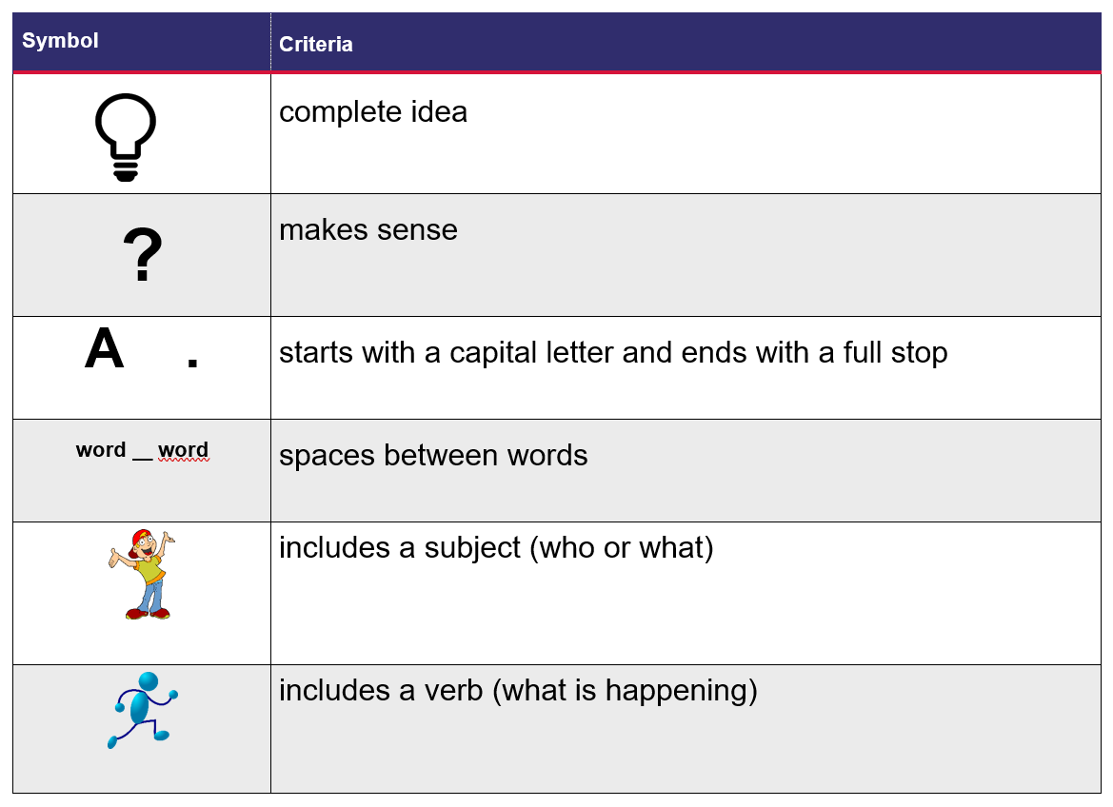
Adapted from Cameron S and Dempsey L. (2013) The Writing Book.
‘Cartoon boy’ by OpenClipart-Vectors and ‘Running stickman’ by Clker-Free-Vector-Images are used in accordance with the Pixabay License.

Resource 2: Puppets – Early Stage 1
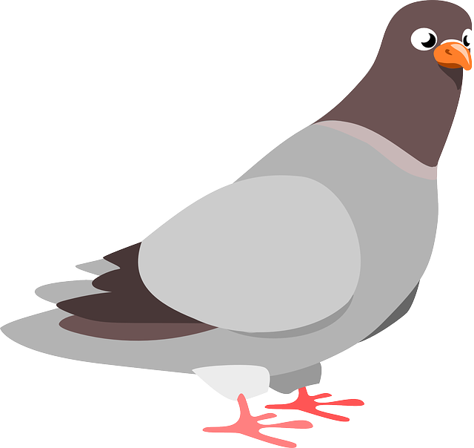
‘Pigeon’ by OpenClipart-Vectors is used in accordance with the Pixabay License.
‘School bus’ by Josy_Dom_Alexis is used in accordance with the Pixabay License.

‘Bus driver’ by MostafaElTurkey36 is used in accordance with the Pixabay License.

Resource 3: Dialogue checklist
Dialogue Checklist | Dialogue Checklist
- Speech marks go around exactly what is spoken.  - A capital letter is used at the start of what is spoken.  - There is a piece of punctuation before the close of quotation marks.  - ‘Saying verbs’ are used to describe how the speech is spoken.  - A new line is used when each new character speaks. | - Speech marks go around exactly what is spoken.  - A capital letter is used at the start of what is spoken.  - There is a piece of punctuation before the close of quotation marks.  - ‘Saying verbs’ are used to describe how the speech is spoken.  - A new line is used when each new character speaks.

Resource 4: Saying verbs
called | explained
said | asked
cried | huffed
pleaded | screamed
begged | replied
whispered | shouted

Resource 5: Four-frame storyboard
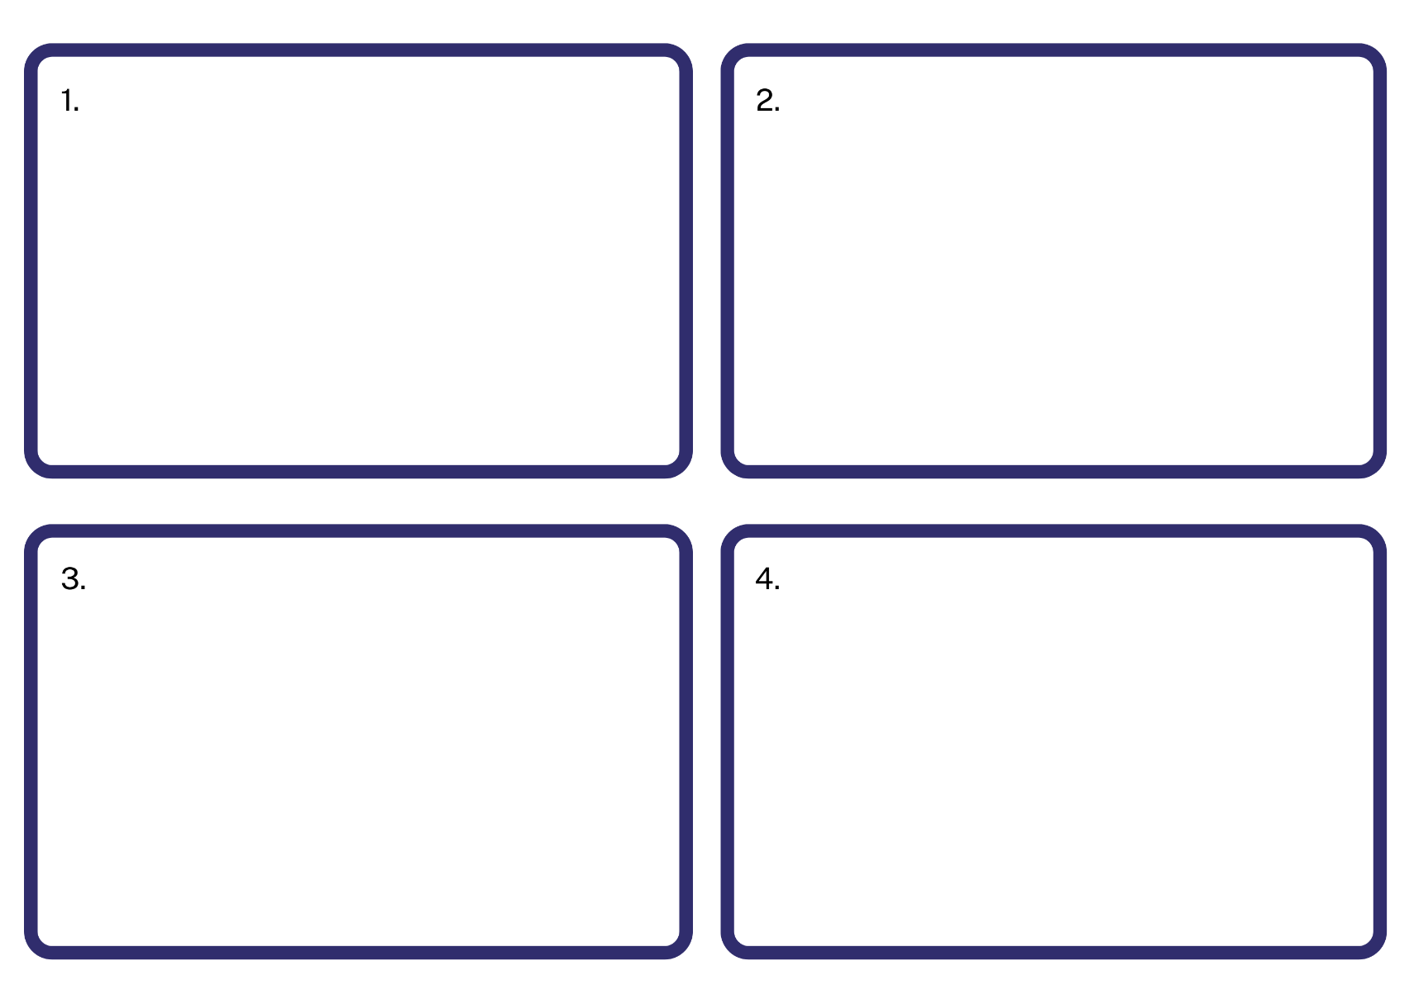

Resource 6: Six-frame storyboard
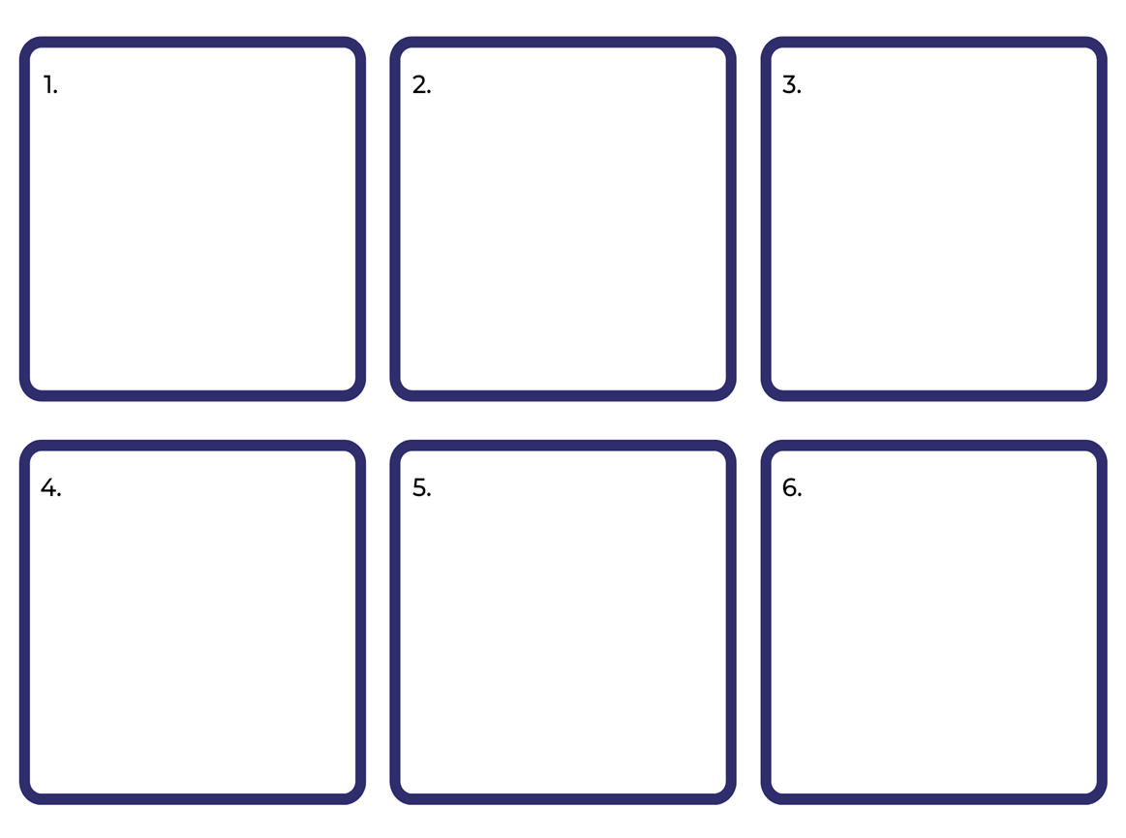

Resource 7: Class book

Resource 8: Speech and thought bubbles
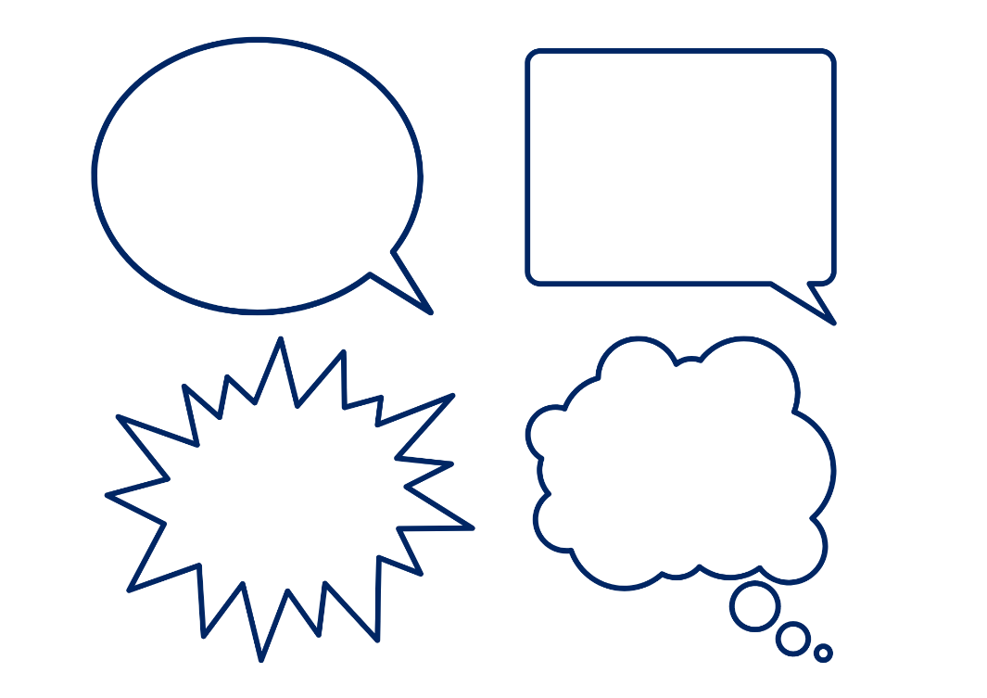

Resource 9: My favourite book and character
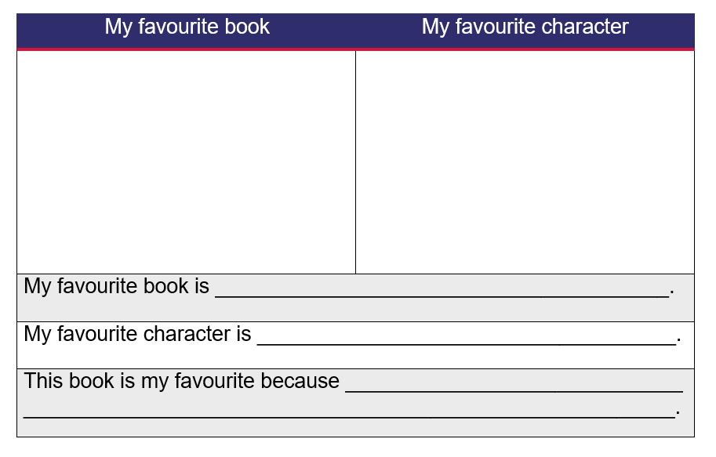

Resource 10: Venn diagram
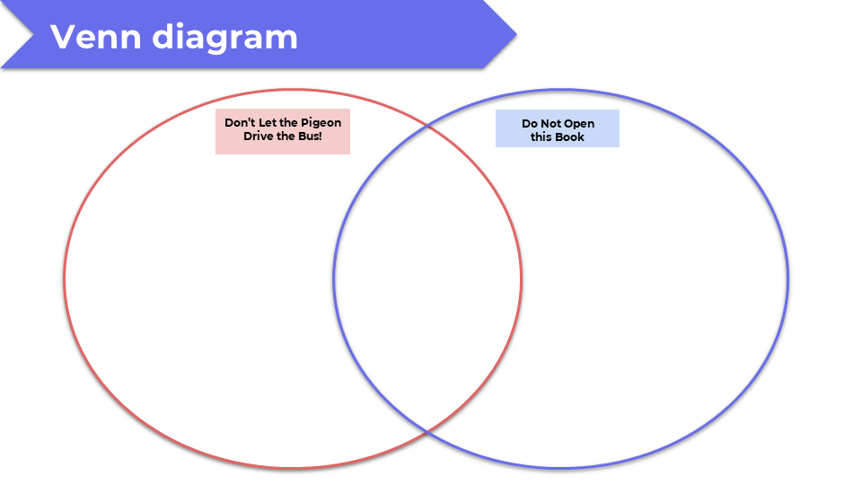

Resource 11: Verb cards
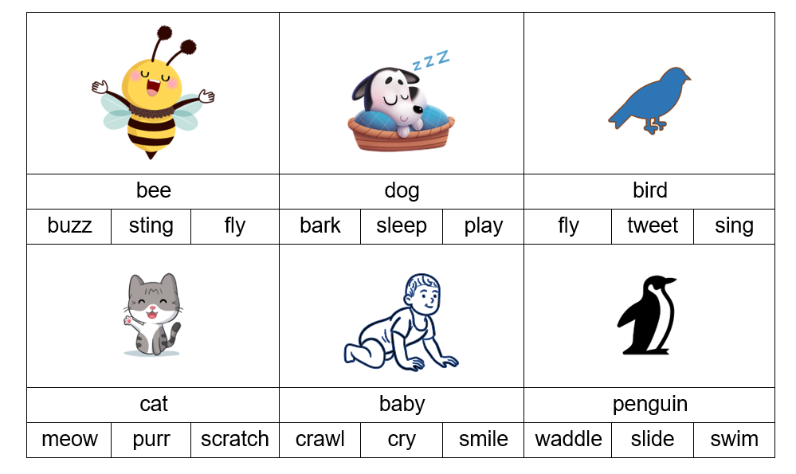
Images sourced from Canva and used in accordance with the Canva Content License Agreement.

Resource 12: FANBOYS
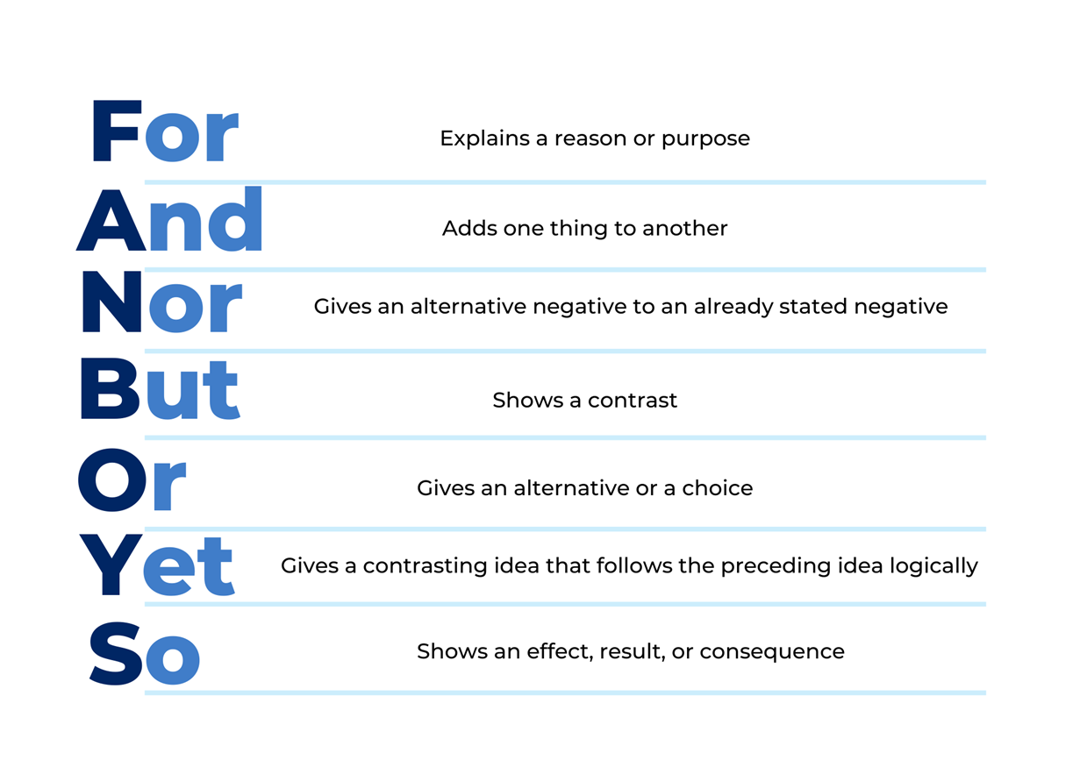

Resource 13: Comic strip plan
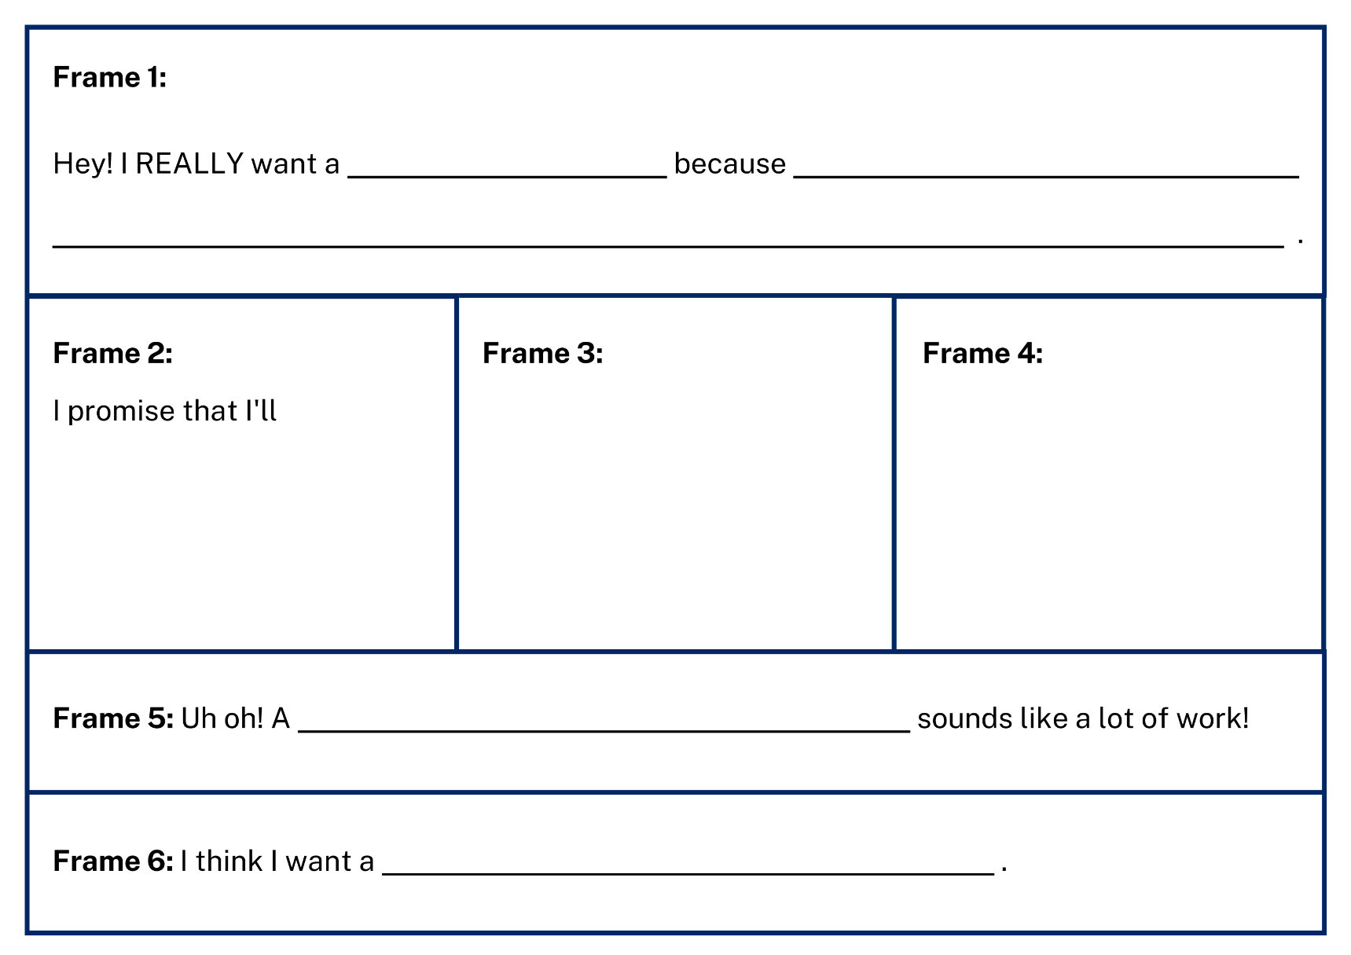

Resource 14: Comic strip template
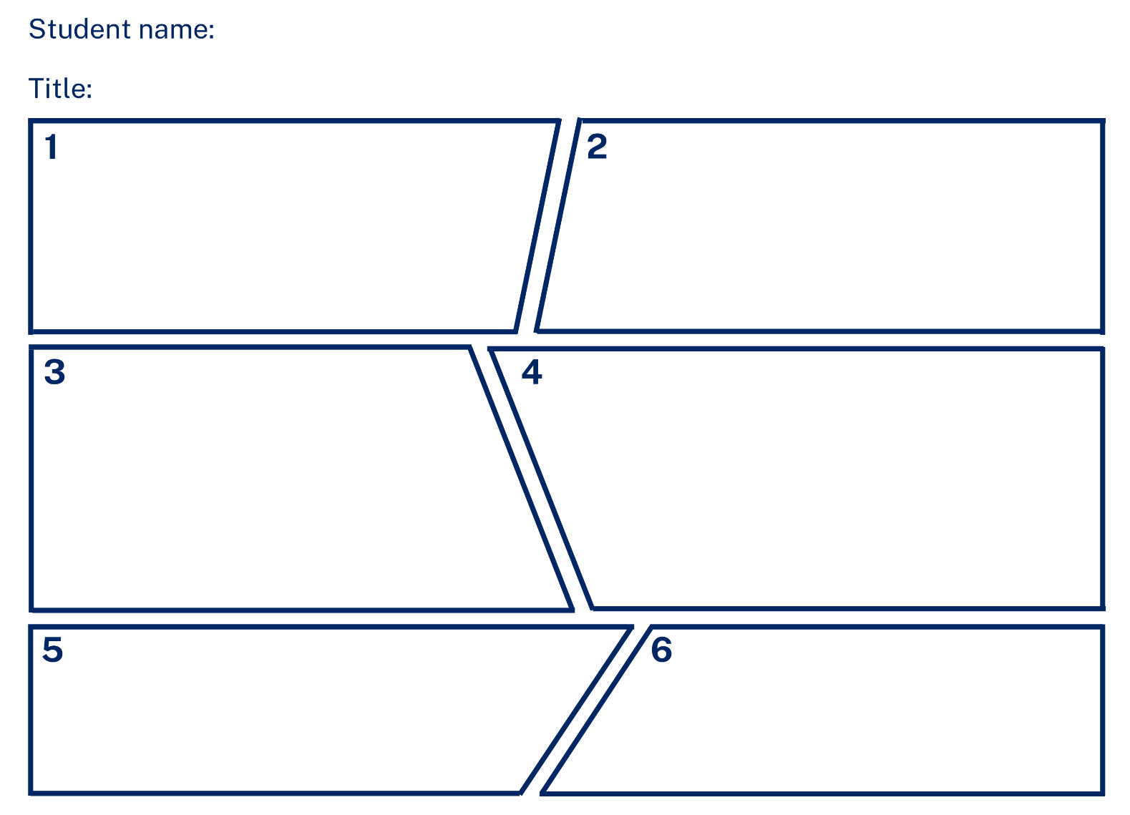

References
Links to third-party material and websites
Please note that the provided (reading/viewing material/list/links/texts) are a suggestion only and implies no endorsement, by the New South Wales Department of Education, of any author, publisher, or book title. School principals and teachers are best placed to assess the suitability of resources that would complement the curriculum and reflect the needs and interests of their students.
If you use the links provided in this document to access a third-party's website, you acknowledge that the terms of use, including licence terms set out on the third-party's website apply to the use which may be made of the materials on that third-party website or where permitted by the Copyright Act 1968 (Cth). The department accepts no responsibility for content on third-party websites.
Except as otherwise noted, all material is © State of New South Wales (Department of Education), 2021 and licensed under the Creative Commons Attribution 4.0 International License. All other material (third-party material) is used with permission or under licence. Where the copyright owner of third-party material has not licensed their material under a Creative Commons or similar licence, you should contact them directly for permission to reuse their material.
English K–10 Syllabus © 2022 NSW Education Standards Authority (NESA) for and on behalf of the Crown in right of the State of New South Wales.
© 2021 NSW Education Standards Authority. This document contains NSW Curriculum and syllabus content. The NSW Curriculum is developed by the NSW Education Standards Authority. This content is prepared by NESA for and on behalf of the Crown in right of the State of New South Wales. The material is protected by Crown copyright.
Please refer to the NESA Copyright Disclaimer for more information.
NESA holds the only official and up-to-date versions of the NSW Curriculum and syllabus documents. Please visit the NSW Education Standards Authority (NESA) website and the NSW Curriculum website.
National Literacy Learning Progression © Australian Curriculum, Assessment and Reporting Authority (ACARA) 2010 to present, unless otherwise indicated. This material was downloaded from the Australian Curriculum website (National Literacy Learning Progression) (accessed 20 October 2022 and was not modified. The material is licensed under CC BY 4.0. Version updates are tracked in the ‘Curriculum version history’ section on the 'About the Australian Curriculum' page of the Australian Curriculum website.
ACARA does not endorse any product that uses the Australian Curriculum or make any representations as to the quality of such products. Any product that uses material published on this website should not be taken to be affiliated with ACARA or have the sponsorship or approval of ACARA. It is up to each person to make their own assessment of the product, taking into account matters including, but not limited to, the version number and the degree to which the materials align with the content descriptions and achievement standards (where relevant). Where there is a claim of alignment, it is important to check that the materials align with the content descriptions and achievement standards (endorsed by all education Ministers), not the elaborations (examples provided by ACARA).
Cameron S and Dempsey L (2013) The Writing Book: A practical guide for classroom teachers, Self-Published, Australia.
ETA (English Teachers Association) and NSW Department of Education (2016) The Textual Concepts and Processes resource, English Textual Concepts website, accessed 19 October 2022.
Lee A (2016) Do Not Open this Book (McKenzie H, illus.), Lake Press, Australia.
Willems M (2005) Don’t Let the Pigeon Drive the Bus!, Walker Books, Australia.
Willems M and Disney Hyperion (n.d.) ‘How to Draw the Pigeon!’, Downloadable Teacher’s Guide and Events Kit, Pigeon Presents website, accessed 19 October 2022.

