English – K-2 multi-age – Year A – Unit 4
Contents
Unit overview and instructions for use 3
Teacher notes 4
Outcomes and content – Component A 6
Outcomes and content – Component B 10
Week 1 14
Component A teaching and learning 14
Component B teaching and learning 15
Lesson 1: Making inferences 17
Lesson 2: Wordplay 20
Lesson 3: Comparing characters 23
Lesson 4: Character dialogue 26
Lesson 5: Create a character 29
Week 2 33
Component A teaching and learning 33
Component B teaching and learning 34
Lesson 6: The Good Egg 35
Lesson 7: Story retell and noun groups 38
Lesson 8: Character planning 41
Lesson 9: Story planning 42
Lesson 10: Composing 43
Resource 1: Kitchen utensils 46
Resource 2: Rhyme 47
Resource 3: Sentence frame 48
Resource 4: Dialogue checklist 49
Resource 5: Dialogue example 50
Resource 6: Speech bubble example 51
Resource 7: Egg puns 52
Resource 8: Retell spinner 53
Resource 9: Storyboard – Early Stage 1 54
Resource 10: Storyboard – Stage 1 55
References 56

Unit overview and instructions for use
This two-week unit is comprised of Component A and Component B. Connecting learning across both components is encouraged.
Teaching and learning | Component A | Component B
Suggested duration | 60 minutes | 45 minutes
Explicit teaching focus areas | - Phonological awareness (Early Stage 1)  - Print conventions (Early Stage 1)  - Phonic knowledge  - Reading fluency  - Reading comprehension  - Spelling  - Handwriting | - Oral language and communication  - Vocabulary  - Reading comprehension  - Creating written texts  - Understanding and responding to literature
To prepare for teaching and learning: | - Refer to Outcomes and content – Component A, K-2 – Instructional sequence – grapheme–phoneme correspondences [PDF 825 KB], and the teaching advice documents (hyperlinked in Component A teaching and learning table).  - Based on student needs identified through ongoing assessment data, plan and document how you will sequence teaching and learning in whole class and targeted teaching groups across the two-week cycle. | - Familiarise yourself with Outcomes and content – Component B, Textual concepts information and videos, English Textual Concepts and Learning Processes (2016), and the teaching and learning sequence.  - Based on student needs identified through ongoing assessment data, determine how you will support students in whole class and targeted teaching groups across the two-week cycle as required.
English K–10 Syllabus © 2022 NSW Education Standards Authority (NESA) for and on behalf of the Crown in right of the State of New South Wales.

Teacher notes
- The mentor concept for the conceptual component for Stage 1 is ‘Character’ with the supporting concept of ‘imagery, symbol and connotation’. The mentor concept for the conceptual component for Early Stage 1 is ‘Imagery, symbol and connotation’ with the supporting concept of ‘Character’.
- ‘Character is traditionally viewed as a description of a fictional identity. It is made up of verbal and visual statements about what a character does, says, and thinks and what other fictional characters and the author of the text say about them. Analysis of characters can contribute to our own personal judgements about self, morals, and values.’ – English Textual Concepts and Learning Processes (2016).
- Understanding of character can be supported through watching the department’s video: Character (2:31).
- ‘Imagery, symbol and connotation extend words and symbols beyond their literal meaning. They are used to provide deeper meaning, evoke emotion, and enhance enjoyment in texts.’ – English Textual Concepts and Learning Processes (2016).
- Understanding of imagery, symbol and connotation can be supported through watching the department’s video: Understanding connotation, imagery and symbol video (6:06).
- Other texts to supplement this unit could include: Straw by Amy Krouse Rosenthal, Chopsticks by Amy Krouse Rosenthal, The Bad Seed by Jory John, and The Day the Crayons Quit by Oliver Jeffers.
- A noun group is a group of words relating to, or building on, a noun. Noun groups usually consist of a pointer (the, a, an, this, that, these, those, my, your, his, her, its, our, mum’s, Mr Smith’s) plus one or more adjectives or adverbs. They are an important language resource for building descriptions.
- An idiom is an expression which means something different from its literal meaning. For example, ‘at the drop of a hat’.
- A pun is an amusing use of a word or phrase that has varied meaning or sounds like another word. For example, the egg is ‘egg-cited’.
- For information on quotation marks, wordplay and puns refer to the NESA Glossary.
- Reflect on student learning and engagement in activities and record differentiation and adjustments within the unit to inform future teaching and learning. One way of doing this could be to add comments to the digital file.
- Content points are linked to the National Literacy Learning Progression version (3).
Levels and indicators sourced from National Literacy Learning Progression © Australian Curriculum, Assessment and Reporting Authority (ACARA), (accessed 19 October 2022) and was not modified. See references for more information.

Outcomes and content – Component A
The table below outlines the focus outcomes and content. Content is linked to the National Literacy Learning Progression version (3).
Early Stage 1 Focus area and outcome | Stage 1 Focus area and outcome
Phonological awareness  ENE-PHOAW-01 – identifies, blends, segments and manipulates phonological units in spoken words as a strategy for reading and creating texts  - complete familiar spoken phrases in texts, including chants, rhymes, songs and poems (PhA1)  - consistently say the first phoneme of a spoken one-syllable word (PhA2)  - orally blend up to 4 phonemes together to make a one-syllable spoken word (PhA4)  - orally segment one syllable words comprised of up to 4 phonemes into separate phonemes (PhA4) | N/A
Print conventions  ENE-PRINT-01 – tracks written text from left to right and from top to bottom of the page and identifies visual and spatial features of print  - identify pictures in texts (PKW2)  - know the difference between a letter and a word (PKW1)  - identify spaces between words (PKW2)  - identify and name lower- and upper-case letters (PKW4)  - turn pages one at a time (UnT3)  - consistently read left page before right page (UnT4) | N/A
Phonic knowledge  ENE-PHOKW-01 – uses single-letter grapheme–phoneme correspondences and common digraphs to decode and encode words when reading and creating texts  - match single letter grapheme with a phoneme  - say the most common phoneme for single-letter graphemes (graphs) (PKW3)  - blend single-letter grapheme correspondences to decode VC and CVC words, and apply this knowledge when reading, including decodable texts (PKW3, PKW4)  - segment and encode single-letter VC and CVC words, and apply this knowledge when writing words and creating texts (PKW4) | Phonic knowledge  EN1-PHOKW-01 – uses initial and extended phonics, including vowel digraphs, trigraphs to decode and encode words when reading and creating texts  - segment and encode one-syllable high-frequency base words with split digraphs and apply this when creating texts (SpG6)  - blend and decode one-syllable words with taught extended vowel graphs and digraphs, including graphemes for r-controlled vowels and diphthongs, and apply this when reading texts (PKW6, PKW7)  - segment and encode one-syllable words with taught vowel graphs, digraphs and trigraphs and apply this when creating texts
Reading fluency  ENE-REFLU-01 – reads decodable texts aloud with automaticity  - read texts with taught grapheme–phoneme correspondences and taught high-frequency words with automaticity | Reading fluency  EN1-REFLU-01 – sustains reading unseen texts with automaticity and prosody and self-corrects errors  - apply grapheme–phoneme correspondence to read words with automaticity (FlY1)  - use sentence punctuation to enhance reading in a conversational manner (FlY3, FlY4)  - adjust phrasing, intonation, volume or rate to maintain fluency when reading aloud (FlY4)  - vary pace when reading according to the audience and purpose (FlY4)
Reading comprehension  ENE-RECOM-01 – comprehends independently read texts using background knowledge, word knowledge and understanding of how sentences connect  - recall key characters, events and/or information in text (UnT5) | Reading comprehension  EN1-RECOM-01 – comprehends independently read texts that require sustained reading by activating background and word knowledge, connecting and understanding sentences and whole text, and monitoring for meaning  - make text-to-self, text-to-text or text-to-world connections when reading (UnT6)  - recount relevant ideas from texts in the form of a written, visual or oral summary (UnT6)
Spelling  ENE-SPELL-01 – applies phonological, orthographic and morphological generalisations and strategies to spell taught familiar and high-frequency words when creating texts  - combine phonological, phonic, orthographic and morphemic knowledge to spell taught high-frequency irregular words comprising up to 3 phonemes (SpG5)  - segment single-syllable words into phonemes as a strategy for spelling (SpG4)  - add the plural-marking suffix (s) to base nouns that require no change when suffixed (SpG5)  - experiment with the tense-marking suffixes to spell familiar base verbs (SpG5) | Spelling  EN1-SPELL-01 – applies phonological, orthographic and morphological generalisations and strategies when spelling words in a range of writing contexts  - segment single-syllable words into phonemes as a strategy for spelling (SpG4)  - spell high-frequency base words with taught vowel graphs, digraphs, split digraphs, trigraphs and quadgraphs (SpG6)  - use spelling conventions when adding plural-marking suffixes (SpG9)  - use the comparative and superlative suffixes –er and –est (SpG9)  - use knowledge of morphemes to spell taught compound words and homophones with taught single-letter graphemes, digraphs, split digraphs, trigraphs and quadgraphs (SpG7)
Handwriting  ENE-HANDW-01 – produces all lower-case and upper-case letters to create texts  - form all handwritten letters in NSW Foundation Style when given a verbal prompt from the correct starting point and continue in the correct direction (HwK4)  - correctly produce a clockwise ellipse, anticlockwise ellipse and downward diagonal stroke when forming letter shapes | Handwriting  EN1-HANDW-01 – uses a legible, fluent and automatic handwriting style, and digital technology, including word-processing applications, when creating texts  - form all letters with consistent size and slope in NSW Foundation Style from memory (HwK5)  - position all letters correctly on the line with appropriate spacing between words (HwK5)

Outcomes and content – Component B
The table below outlines the focus outcomes and content. Content is linked to the National Literacy Learning Progression version (3).
Early Stage 1 Focus area and outcome | Stage 1 Focus area and outcome
Oral language and communication  ENE-OLC-01 – communicates effectively by using interpersonal conventions and language with familiar peers and adults  - respond to spoken questions  - follow up to 3-part spoken instructions (LiS3)  - take turns when speaking during structured and unstructured play (InT3)  - retell favourite stories, poems, songs and rhymes with some parts as exact repetition and some in their own words (SpK2) | Oral language and communication  EN1-OLC-01 – communicates effectively by using interpersonal conventions and language to extend and elaborate ideas for social and learning interactions  - initiate, listen and/or respond in partner and group conversations (InT3, InT5)  - recite poems and rhymes
Vocabulary  ENE-VOCAB-01 – understands and effectively uses Tier 1 words and Tier 2 words in familiar contexts  - experiment with and create wordplay and poems  - identify, name and describe a range of objects, characters, animals, people and places when given visual and/or auditory prompts (GrA1) | Vocabulary  EN1-VOCAB-01 – understands and effectively uses Tier 1, taught Tier 2 and Tier 3 vocabulary to extend and elaborate ideas  - understand and communicate jokes and riddles that play on words  - identify, understand and use wordplay and rhyme in a range of texts
Reading comprehension  ENE-RECOM-01 – comprehends independently read texts using background knowledge, word knowledge and understanding of how sentences connect  - identify words that represent who, what, when, where and why in texts  - understand how adjectives describe a noun and verbs identify actions in a sentence  - use visual cues in multimodal texts to interpret meaning (UnT5) | Reading comprehension  EN1-RECOM-01 – comprehends independently read texts that require sustained reading by activating background and word knowledge, connecting and understanding sentences and whole text, and monitoring for meaning  - understand vocabulary that signals humorous wordplay in texts  - make an inference by connecting the meaning of words across sentences and/or paragraphs  - identify how creative visual features are used to expand meaning  - use visual and/or auditory features in multimodal texts to build meaning (UnT5)
Creating written texts  ENE-CWT-01 – creates written texts that include at least 2 related ideas and correct simple sentences  - use personal vocabulary, words on display and in mentor texts when constructing sentences  - know that a simple sentence makes sense by itself and is a complete thought represented by a subject and verb (GrA3)  - identify and use verbs in simple sentences, including in own writing (GrA2)  - use drawing, images or mind maps to support planning and writing (CrT4) | Creating written texts  EN1-CWT-01 – plans, creates and revises texts written for different purposes, including paragraphs, using knowledge of vocabulary, text features and sentence structure  - use visual elements to expand meaning in own texts  - use a logical order to sequence ideas and events in sentences across a text (GrA4)  - use noun groups to build descriptions of people and things (CrT6)  - use quotation marks for simple dialogue (PuN5)  - use creative wordplay to affect the reader  - understand that their own texts can be improved by incorporating feedback and editing
Understanding and responding to literature  ENE-UARL-01 – understands and responds to literature read to them  - identify and discuss how creative language and/or symbols enhance enjoyment in texts  - experiment with creative play with language in own texts  - identify and discuss character features and actions (UnT3)  - identify and compare characters in a range of texts | Understanding and responding to literature  EN1-UARL-01 – understands and responds to literature by creating texts using similar structures, intentional language choices and features appropriate to audience and purpose  - compare and contrast characters in text  - create and re-create characters in texts that demonstrate understanding of character traits  - identify figurative language and wordplay in texts  - innovate from studied texts using wordplay and figurative language

Week 1

Component A teaching and learning
The table below can be used to plan and document lessons that address Component A outcomes and content. Both the detailed example [DOC 529KB] of a two-week teaching and learning cycle and brief example [DOC 66KB] may support you in your planning.
Focus Areas | Lesson 1 | Lesson 2 | Lesson 3 | Lesson 4 | Lesson 5
Phonological awareness (Early Stage 1) and Phonic knowledge
15 minutes
Spelling and Handwriting
15 minutes
Print conventions (Early Stage 1), Reading comprehension and Reading fluency
30 minutes

Component B teaching and learning
The following teaching and learning sequence has been designed to address Component B outcomes and content. Adapt the sequence as required to best meet the needs of your students.

Learning intention and success criteria
Learning intentions and success criteria are best co-constructed with students. The table below contains suggested learning intentions and success criteria.
Element | Early Stage 1 | Stage 1
Learning intentions | Students are learning to understand how authors use creative language to describe characters. | Students are learning to understand how authors create characters using a variety of language features and visual elements.
Success criteria | Students can:  - identify words that represent who, what, when, where and why in a text  - retell well-known poems  - identify and compare characters in a range of texts  - discuss character features. | Students can:  - make inferences about a text  - identify figurative language and wordplay in texts  - recite poems and rhymes  - compare and contrast characters  - use quotation marks for simple dialogue.

Resources
- Krouse Rosenthal A (2009) Spoon, (Magoon S, illus.) Little, Brown, New York. ISBN: 9781423106852
- Resource 1: Kitchen utensils
- Resource 2: Rhyme
- Resource 3: Sentence frame
- Resource 4: Dialogue checklist
- Resource 5: Dialogue example
- Resource 6: Speech bubble example
- Video: 'Hey diddle diddle' sung by Teddy Rock (1:38)
- Enlarged copy of a graphic organiser
- Venn diagram
- 2 hula hoops
- Art and craft materials for character creation
- Building materials, such as modelling clay or construction blocks
- Images of Spoon, Fork, Knife and Chopsticks
- Mini whiteboards
- Mystery bag of kitchen utensils
- Sticky notes

Lesson 1: Making inferences
The following teaching and learning activities support multi-age settings.

Whole
- Prompt students to think about characters they know from a favourite book or movie.
- Ask students:
- Are all characters people?
- In what types of texts do we read about characters?
- Why do authors create characters?
- Why are characters important to a narrative?
- Record student responses. During the lesson, revisit student responses and build on original ideas.
- Explain that character is a description of a fictional identity. It is made up of verbal and visual statements about what a character does, says, and thinks and what other fictional characters and the author of the text say about them.
- Display the book Spoon by Amy Krouse Rosenthal and Scott Magoon and identify who the main character is in the story. Students make predictions about what other characters may be in the book. Encourage students to use their background knowledge to make predictions.
- Explain that good viewers and readers build their understanding of a text by looking for hidden meanings in situations. They use clues from the context and their own background knowledge to understand the situation. These clues can be found in sounds, objects, images, and written text. Explain that when audiences do this, it is called making an inference.
- Read Spoon and stop at the text ‘“Nothing,” mumbled Spoon.’ Focus on Spoon’s facial expression and have students infer how Spoon is feeling and explain why. Ask students if they believe Spoon when he says that nothing is bothering him. Share student responses. Continue reading and stop at the text ‘It’s just that ...I don’t know...All my friends have it so much better than me’. Ask students if their inferences about how Spoon was feeling were correct. Introduce the term ‘jealous’ and discuss its meaning.
- Continue reading Spoon. Discuss the theme of the book and the importance of individuality.

Part
The table below details the differentiated teaching and learning activities for each stage.
Early Stage 1 (teacher guided) | Stage 1 (small groups)
- Display a page from Spoon and the words who, what, when, where and why. Ask students to identify key elements of the text and record ideas on an enlarged graphic organiser.  - Using the Think-Pair-Share strategy, students discuss what happened in the story. Encourage students to include information from the graphic organiser. Share student responses.  - Co-construct a sentence about the text including information about who, what, when, where and/or why. For example, Spoon was jealous of the other characters because he thought they could do more than him. | - Provide students with images of Fork, Knife and Chopsticks from the text. In small groups, students make inferences about why Spoon thinks Fork, Knife and Chopsticks are better than him. Students record their ideas on sticky notes or label their image using words and phrases. Encourage students to use their background knowledge to support inference making.

Part
The table below details the differentiated teaching and learning activities for each stage.
Early Stage 1 (independent) | Stage 1 (teacher guided)
- Students draw and write a sentence about the text. Encourage students to use modelled vocabulary from the graphic organiser.  Too hard? Students draw a picture of what happened in the story, labelling it with words or phrases.  Too easy? Students write sentences that compare how Spoon felt at the beginning to the end of the story. | - Students share their responses and compare ideas. Discuss ways students used clues from the text and their background knowledge to make inferences.

Lesson 2: Wordplay
The following teaching and learning activities support multi-age settings.

Whole
- Introduce the concept of imagery, symbol and connotation. Explain that imagery, symbol and connotation extend words and symbols beyond their literal meaning. They are used to provide deeper meaning, evoke emotion, and enhance enjoyment in texts.
- Introduce the term ‘wordplay’ and explain that authors experiment with language in a text to create humour and enhance enjoyment. Re-read the text Spoon and stop at the page with the text, ‘Lately though, Spoon had been feeling blue.’ Explain that the author has used an idiom to express how the character is feeling and that this statement cannot be taken literally. Ask students how they think Spoon is feeling. Explore the phrase, ‘You look a bit out of shape’ on the same page. Discuss the meaning of this phrase within the context of the story. Ask students to retell a time they have felt ‘a bit out of shape’.
- Re-read the phrase ‘Spoon likes to hear about his great grandmother who fell in love with a dish and ran off to a distant land.’ Explain that this phrase refers to a well-known nursery rhyme. Students Think-Pair-Share what nursery rhyme it is referring to. Watch 'Hey diddle diddle' sung by Teddy Rock (1:38). Explore the connection between the nursery rhyme and the text. For example, the dish ran away with the spoon. Explain that rhyme is the repetition of similar speech sounds in the final syllable of words. Discuss the use of rhyme in the nursery rhyme and identify rhyming words.
- Explain that students will re-create the nursery rhyme Hey diddle, diddle with 2 new kitchen utensils. Display Resource 1: Kitchen utensils and discuss the names and purpose of each item.
- Display Resource 2: Rhyme and read the text example by modelling how to substitute words. For example:
Hey diddle, diddle,
The cat and the fiddle,
The cow jumped over the fan;
The little dog laughed
To see such fun,
And the tongs ran away with the pan.
- In pairs, students brainstorm and discuss what kitchen utensils could be included in their nursery rhyme. Encourage students to use their background knowledge to identify kitchen utensils that could be paired together.

Part
The table below details the differentiated teaching and learning activities for each stage.
Early Stage 1 (teacher guided) | Stage 1 (independent)
- Recite the nursery rhyme Hey diddle, diddle as a group. Highlight the words that need to be substituted to create a new text.  - Display Resource 2: Rhyme. Co-construct a new version of Hey diddle, diddle. Ask students to identify 2 new kitchen utensils that could be included. Brainstorm rhyming words for one. Implement and complete the poem.  - Co-construct an image to match the new Hey diddle, diddle nursery rhyme.  Too easy? Students re-create their own nursery rhyme using Resource 2: Rhyme. | - Students use Resource 2: Rhyme to re-create their own version of Hey diddle, diddle.  - Students illustrate a scene from their nursery rhyme.

Whole
- Students recite their re-created nursery rhymes.
Early Stage 1 Assessment task 1 – Observations from this lesson allow students to demonstrate achievement towards the following syllabus outcome and content point:
ENE-OLC-01 – communicates effectively by using interpersonal conventions and language with familiar peers and adults
- retell favourite stories, poems, songs and rhymes with some parts as exact repetition and some in their own words.
Stage 1 Assessment task 1 – Observations and work samples from this lesson allow students to demonstrate achievement towards the following syllabus outcomes and content points:
EN1-OLC-01 – communicates effectively by using interpersonal conventions and language to extend and elaborate ideas for social and learning interactions
- recite poems and rhymes.
EN1-VOCAB-01 – understands and effectively uses Tier 1, taught Tier 2 and Tier 3 vocabulary to extend and elaborate ideas
- identify, understand and use wordplay and rhyme in a range of texts.
EN1-UARL-01 – understands and responds to literature by creating texts using similar structures, intentional language choices and features appropriate to audience and purpose
- identify figurative language and wordplay in texts.

Lesson 3: Comparing characters
The following teaching and learning activities support multi-age settings.

Whole
- Revise the concept of character. Play a game of ‘guess my character’. Provide students with clues about a character from the text Spoon. For example, this character is easy going and fun; he is independent because he goes places on his own.
- Display images of Fork, Knife, Spoon and Chopsticks from the text Spoon. Ask students to identify the human characteristics each character has, for example, arms and legs, a face, walks, talks, has feelings and a family. As a class, label the images with human characteristics.
- Students sit in a circle. Create a Venn diagram on the ground using 2 hula hoops with the headings ‘Fork’ and ‘Spoon’. Explain that students will compare and contrast the 2 characters. Ask students how Fork and Spoon are similar. Encourage students to provide reasoning using examples from the text. For example, Fork and Spoon are similar because they both help you to eat food. Model writing this information on a sticky note and placing it in the middle of the Venn diagram. Ask students how Fork and Spoon are different. For example, Spoon gets to measure things and is round, while Fork has sharp pointy ends and gets to go everywhere. Model writing ‘used for measuring’ on a sticky note and placing it under the heading ‘Spoon’. Model writing ‘gets to go everywhere’ and placing it under the heading ‘Fork’.

Part
The table below details the differentiated teaching and learning activities for each stage.
Early Stage 1 (teacher guided/independent) | Stage 1 (independent)
- Revise the terms noun, adjective, and verb. Display an image of Knife and model writing the sentence ‘The sharp knife cuts bread’. Use ‘thinking aloud’ to identify the subject (knife) and verb (cuts) in the sentence. Explain that this is a simple sentence because it has a subject and a verb and makes sense by itself.  - Using different coloured markers, highlight the nouns, adjective, and verb.  - Display Resource 3: Sentence frame. Model writing the sentence into the frame. Discuss each part of the sentence and how adjectives describe a noun and verbs identify actions in a sentence.  - Ask students to close their eyes and visualise a character from the text, Spoon. Provide students with three-part spoken instructions to draw their character. For example, first draw the character’s body, then draw the character’s facial expression and then give the character body parts. On mini whiteboards, students draw their character.  - Support students to use Resource 3: Sentence frame, to write a simple sentence about something their character might do. | - Students complete their own Venn diagram by selecting 2 new characters from the text Spoon. Encourage students to consider the characters’ skills, feelings, and emotions.  - In pairs, students share their Venn diagram.  Too hard? In pairs, students co–construct a Venn diagram for the characters Spoon and Fork using words and drawings.  Too easy? Students compare 3 characters using a Triple Venn diagram.
Early Stage 1 Assessment task 2 – Observations and work samples from this lesson allow students to demonstrate achievement towards the following syllabus outcomes and content points:
ENE-OLC-01 – communicates effectively by using interpersonal conventions and language with familiar peers and adults
- follow up to 3-part spoken instructions.
ENE-VOCAB-01 – understands and effectively uses Tier 1 words and Tier 2 words in familiar contexts
- identify, name and describe a range of objects, characters, animals, people and places when given visual and/or auditory prompts.
ENE-RECOM-01 – comprehends independently read texts using background knowledge, word knowledge and understanding of how sentences connect
- understand how adjectives describe a noun and verbs identify actions in a sentence.
ENE-CWT-01 – creates written texts that include at least 2 related ideas and correct simple sentences
- know that a simple sentence makes sense by itself and is a complete thought represented by a subject and verb.
ENE-UARL-01 – understands and responds to literature read to them
- identify and discuss character features and actions
- identify and compare characters in a range of texts.
Stage 1 Assessment task 2 – Observations and work samples from this lesson allow students to demonstrate achievement towards the following syllabus outcome and content point:
EN1-UARL-01 – understands and responds to literature by creating texts using similar structures, intentional language choices and features appropriate to audience and purpose
- compare and contrast characters in text.

Lesson 4: Character dialogue
The following teaching and learning activities support multi-age settings.

Whole
- Explain that a freeze frame involves using your body to retell parts of a story. Revise the theme of the story, Spoon and discuss the most important parts. In small groups, students create 3 freeze frames representing the beginning, middle, and end of the story.
The table below details the differentiated teaching and learning activities for each stage.
Early Stage 1 (small groups) | Stage 1 (teacher guided/independent)
- Provide students with building materials, such as modelling clay or construction blocks. In small groups, students build a significant event from the text Spoon. Encourage students to talk through their ideas and collaboratively build a scene from the text. | - Introduce the term dialogue and explain that it is a conversation between 2 or more characters in a text. Character dialogue helps readers to understand a character’s thoughts, feelings, and emotions. It helps readers to understand and relate to characters, even if they are an inanimate object like Spoon. Display an image of quotation marks and explain that they are punctuation marks used in a text to show when a character is talking.  - Re-read selected pages of the text Spoon that include examples of dialogue. For example, ‘“Nothing,” mumbled Spoon.’ Discuss who is speaking and how students know. Highlight or circle the words ‘mumbled Spoon’ and explain that identifying the saying verb is one way to find out who is speaking. This also gives the reader clues as to how the character is feeling. Discuss other ways the author uses dialogue to show who is speaking. For example, ‘Goodbye, darling! Ta, ta!’ Discuss how the reader needs to infer who is speaking using clues from the text such as images.  - Display Resource 4: Dialogue checklist. Discuss the dialogue conventions in the checklist.  - Display the passage, ‘“What’s wrong?” asked his mother. “You look a bit out of shape”. “Nothing”, mumbled Spoon.’ As a group, use the dialogue checklist to identify and circle the dialogue conventions from the checklist.  - Model drawing 2 characters from the text. For example, Spoon and Fork. Model using the dialogue checklist to write a conversation between the 2 characters using quotation marks. Explicitly discuss how the dialogue provides the reader with more information about the character. Refer to Resource 5: Dialogue example.

Part
The table below details the differentiated teaching and learning activities for each stage.
Early Stage 1 (teacher guided) | Stage 1 (independent)
- Students share their work and discuss any challenges faced. Provide students an opportunity to roam and view other groups’ creations. Encourage students to ask and respond to questions.  - Optional: Students photograph their creations and use narration to explain their work. | - Students choose 2 characters from the text. Using Resource 4: Dialogue checklist, students write a conversation between 2 characters.  Too hard? Students role play a conversation between 2 characters, considering body movements and facial expressions. Co-construct a conversation between the 2 characters using quotation marks.
Early Stage 1 Assessment task 3 – Observations from this lesson allow students to demonstrate achievement towards the following syllabus outcome and content points:
ENE-OLC-01 – communicates effectively by using interpersonal conventions and language with familiar peers and adults
- respond to spoken questions
- take turns when speaking during structured and unstructured play.

Lesson 5: Create a character
The following teaching and learning activities support multi-age settings.

Whole
- Create a mystery bag of kitchen utensils. Provide students with clues about the item before pulling it out of the mystery bag and encourage them to guess what it is. For example, this kitchen utensil has a handle and a pourer; it is helpful because it has units of measurement on the outside. Repeat with the rest of the items in the mystery bag.
- Ask students which kitchen utensil would make a good character in the text, Spoon. Encourage students to think of skills their new character could have and discuss what traits Spoon may feel jealous of. Share student responses.

Part
The table below details the differentiated teaching and learning activities for each stage.
Early Stage (pairs/independent) | Stage 1 (teacher guided)
- In pairs, students choose a utensil and describe their new character’s physical characteristics and personality traits.  - Provide students with a range of art and craft materials. Students create an artwork of their new character. Suggested artworks may include: a finger puppet, illustration, painting, or a three-dimensional model. | - Explain that students will create a new character for the text, Spoon and write dialogue between Spoon and their new character.  - Model drawing Spoon and a new character, for example, Tongs or a Frying Pan. Using Resource 4: Dialogue checklist, model writing a conversation between the 2 characters. Optional: create a cartoon using speech bubbles. Refer to Resource 6: Speech bubble example.  - On mini whiteboards, students draw their new character. Students list positive traits or skills their character might have that may would make Spoon jealous. Model expanding on students’ ideas and providing reasons why Spoon would be jealous. For example, Tongs always get invited to the best parties, Pan is so lucky because she always stays warm.  - In pairs, students take turns to role play a conversation between Spoon and their new character. Student A plays Spoon, while student B plays their new character from activity 2. Students take turns in each role.

Part
The table below details the differentiated teaching and learning activities for each stage.
Early Stage 1 (teacher guided) | Stage 1 (independent)
- Students share their new character and describe its features. Optional: students take a photo of their character and label it using written text such as the mark-up tool.  - Ask students how they created their new character and discuss any challenges students faced. | - Students draw and write a conversation between the Spoon and their new character, referring to the dialogue checklist. Optional: students create their character using images and recordings on a digital platform.
Stage 1 Assessment task 3 – Observations and collecting work samples from this lesson allows students to demonstrate achievement towards the following syllabus outcomes and content points:
EN1-OLC-01 – communicates effectively by using interpersonal conventions and language to extend and elaborate ideas for social and learning interactions
- initiate, listen and/or respond in partner and group conversations.
EN1-CWT-01 – plans, creates and revises texts written for different purposes, including paragraphs, using knowledge of vocabulary, text features and sentence structure
- use quotation marks for simple dialogue.
EN1-UARL-01 – understands and responds to literature by creating texts using similar structures, intentional language choices and features appropriate to audience and purpose
- create and re-create characters in texts that demonstrate understanding of character traits.

Week 2

Component A teaching and learning
The table below can be used to plan and document lessons that address Component A outcomes and content. Both the detailed example [DOC 529KB] of a two-week teaching and learning cycle and brief example [DOC 66KB] may support you in your planning.
Focus Areas | Lesson 6 | Lesson 7 | Lesson 8 | Lesson 9 | Lesson 10
Phonological awareness (Early Stage 1) and Phonic knowledge
15 minutes
Spelling and Handwriting
15 minutes
Print conventions (Early Stage 1), Reading comprehension and Reading fluency
30 minutes

Component B teaching and learning
The following teaching and learning sequence has been designed to address Component B outcomes and content. Adapt the sequence as required to best meet the needs of your students.

Learning intention and success criteria
Learning intentions and success criteria are best co-constructed with students. The table below contains suggested learning intentions and success criteria.
Element | Early Stage 1 | Stage 1
Learning intentions | Students are learning to understand how authors use creative language to describe characters. | Students are learning to understand how authors create characters using a variety of language features and visual elements.
Success criteria | Students can:  - experiment with creative wordplay  - identify words that represent who, what, when, where, and why in a text  - use drawings to plan ideas  - use personal vocabulary and words on display to construct sentences. | Students can:  - understand and communicate jokes and riddles that play on words  - use noun groups to build character descriptions  - create character traits for an inanimate object  - use feedback to improve writing.

Resources
- John J (2021) The Good Egg (Oswald P, illus.), HarperCollins, New York. ISBN: 9780063030763
- Resource 7: Egg puns
- Resource 8: Retell spinner
- Resource 9: Storyboard – Early Stage 1
- Resource 10: Storyboard – Stage 1
- Enlarged copy of a concept map and one copy per student
- Small ball or beanbag

Lesson 6: The Good Egg
The following teaching and learning activities support multi-age settings.

Whole
- Introduce the text The Good Egg by Jory John. Guide students to make predictions about what type of text it is and its purpose, using the front and back covers, title, and illustrations. Discuss narrative elements and who the main character of the story may be. Revise the concept of character and how authors use descriptive and figurative language to help the audience build a deeper understanding of a character’s actions and emotions. Explain that a character can be an inanimate object, but they must always have an identity.
- Revise the term ‘inferences’ and explain that, as students listen to the story, they will use clues from the text and their background knowledge to identify the hidden meaning or idea. Begin reading the text and stop reading when Good Egg leaves the dozen. Using clues from the text and background knowledge, students make inferences about how Good Egg was feeling. Encourage students to use evidence from the text to support their reasoning. Discuss how colour and facial expression has been used to convey emotions and feelings.
- Revise the terms ‘wordplay’ and ‘idiom’ and explicitly teach what a pun is. Explain that ‘being a good egg’ (idiom) means being a likeable person. Display the sentence ‘My head felt scrambled’ (idiom) and ask students how Good Egg was feeling. Explain that this is also a pun because the character is an egg and eggs can be scrambled. It is a play on words intended to be funny and entertain the reader. Using Resource 7: Egg puns as a guide, discuss other puns the author could use to create humour in the text.

Part
The table below details the differentiated teaching and learning activities for each stage.
Early Stage 1 (pairs/independent) | Stage 1 (teacher guided)
- In pairs, students discuss something ‘egg-citing’ Good Egg might do.  - Students draw a picture of Good Egg doing something ‘egg-citing’. | - Display an enlarged concept map and model drawing Good Egg in the centre. Using the Think-Pair-Share strategy, students discuss Good Egg’s character traits. Ask how he is a good egg? For example, brave, helpful, independent, patient, well mannered. Share student responses. Model writing some of Good Egg’s character traits around the outside of the concept map. Use ‘thinking aloud’ to explain that carrying groceries and watering plants are examples from the text and show that Good Egg’s character trait is being helpful.

Part
The table below details the differentiated teaching and learning activities for each stage.
Early Stage 1 (teacher guided/pairs/independent) | Stage 1 (independent)
- Model drawing and writing a sentence about Egg doing something egg-citing. Create a word wall of modelled vocabulary.  - In pairs, students orally share a sentence that matches their drawing. Students write their sentence under their drawing. Encourage them to use creative language and words on display. | - Students create their own concept map of Good Egg’s character traits.  Too hard? Students draw Good Egg’s character traits around the outside of their concept map. For example, showing Good Egg was brave by drawing an image of him rescuing a cat. Students orally share their ideas with a partner.  Too easy? Students list character traits and provide reasoning using examples from the text. For example, Good Egg was patient when the other eggs were misbehaving.
Early Stage 1 Assessment task 4 – Observations and work samples from this lesson allow students to demonstrate achievement towards the following syllabus outcomes and content points:
ENE-RECOM-01 – comprehends independently read texts using background knowledge, word knowledge and understanding of how sentences connect
- use visual cues in multimodal texts to interpret meaning.
ENE-CWT-01 – creates written texts that include at least 2 related ideas and correct simple sentences
- identify and use verbs in simple sentences, including in own writing.
ENE-UARL-01 – understands and responds to literature read to them
- identify and discuss how creative language and/or symbols enhance enjoyment in texts
- experiment with creative play with language in own texts.

Lesson 7: Story retell and noun groups
The following teaching and learning activities support multi-age settings.

Whole
- Re-read the text The Good Egg by Jory John and discuss the main events in the story.
- In small groups, students stand in a circle. Students share Good Egg’s character traits as they pass around a beanbag or soft ball. Encourage students to revisit their ideas from the previous lesson.

Part
The table below details the differentiated teaching and learning activities for each stage.
Early Stage 1 (pairs/independent) | Stage 1 (teacher guided)
- Provide students with a copy of Resource 8: Retell spinner. In pairs, students use the spinner to retell parts of the story. Students continue spinning until all parts of the story have been discussed.  - Students illustrate an event from the text. Encourage students to include images representing who, what, where, when and why. | - Revise noun groups and explain that they are a group of words that build on a noun. Authors use noun groups to create character descriptions. They include a pointer such as his, her, the, or our, plus one or more adjectives or adverbs and a noun. Identify the noun group used in the title of the text The Good Egg. Circle the pointer ‘The’, underline the adjective and circle the noun.  - Explain that students will create another title for the text The Good Egg. Using the concept map from Lesson 6, model choosing a character trait to create a new title. For example, The Brave Egg or The Patient Egg. Use ‘thinking aloud’ to explain why it is a good title for the text. For example, The Brave Egg is a good title for the text because Egg is not afraid to climb up the tall scary ladder and rescue the cat from the tree. Leaving friends and family behind is difficult and Egg was brave enough to go out on an amazing adventure on his own. Highlight the use of noun groups to build descriptions of characters and things.  - Using the text, find other noun groups that describe a character. Write these on a retrieval chart for ongoing reference.

Part
The table below details the differentiated teaching and learning activities for each stage.
Early Stage 1 (teacher guided) | Stage 1 (independent)
- In pairs, students describe their illustration.  - Create a word wall to support students writing.  - Students write a sentence about their drawing. Encourage students to use personal vocabulary and words on display.  Too hard? Co-construct a sentence about the text. | - Provide students with their concept map from the previous lesson. Students use their ideas to create a new title for the text and write sentences to explain why it is a good title.
Early Stage 1 Assessment task 5 – Observations and work samples from this lesson allow students to demonstrate achievement towards the following syllabus outcome and content point:
ENE-RECOM-01 – comprehends independently read texts using background knowledge, word knowledge and understanding of how sentences connect
- identify words that represent who, what, when, where and why in texts.

Lesson 8: Character planning
The following teaching and learning activities support multi-age settings.

Whole
- Discuss how Spoon and Egg are inanimate objects but are characters in the story because they have emotions, needs, and wants. Explain that students will create a narrative text, creating a character from an inanimate object.
- Display the concept map of Good Egg’s character traits from Lesson 6 and discuss the list of positive qualities. Explain that students will create a concept map for their own character (kitchen utensil or type of food). Model drawing an inanimate object such as a pot, strawberry, or a pair of tongs in the middle of a concept map. Model writing character traits around the outside.
- Provide students with a copy of their own concept map. Students draw an inanimate object in the middle and draw or list character traits around the outside.
- Explain that students will choose one character trait to include in the title of their text. For example, the polite pot, the responsible tongs, the helpful whisk, the brave broccoli. Students create a title for their text and write it at the top of their concept map.
- Explain that students will create a story board using visuals and text to replicate a day in the life of their character. Co-construct success criteria for the storyboard to use in Lesson 9.
The table below details suggested writing criteria for Early Stage 1 and Stage 1.
Suggested writing success criteria for Early Stage 1 | Suggested writing success criteria for Stage 1
Students can:  - use drawings to plan ideas  - use personal vocabulary and words on display  - include a beginning, middle, and end  - use visuals, such as colour and size to expand meaning. | Students can:  - create a character from an inanimate object  - sequence events in a logical order  - use wordplay in writing  - use noun groups to build descriptions  - use quotation marks for simple dialogue  - use visuals, such as colour and size to expand meaning  - use feedback to improve writing.

Lesson 9: Story planning
The following teaching and learning activities support multi-age settings.

Whole
- Revise the purpose for writing and review the success criteria from Lesson 8.
- Model using Resource 9: Storyboard – Early Stage 1 to draw a series of events from a character’s day. Use colour and detailed drawings to reflect what makes the character special. Discuss the importance of visual elements to expand meaning in a text.

Part
The table below details the differentiated teaching and learning activities for each stage.
Early Stage 1 (teacher guided/independent) | Stage 1 (independent)
- Students draw their ideas on Resource 9: Storyboard – Early Stage 1 in a logical sequence. | - Students draw their ideas on Resource 10: Storyboard – Stage 1 in a logical sequence. Encourage students to include detail showing what makes their character special.

Lesson 10: Composing
The following teaching and learning activities support multi-age settings.

Whole
- Make clear the purpose and audience for writing and review the success criteria from Lesson 8. Model using Resource 9: Storyboard – Early Stage 1 from Lesson 9 to write a narrative. Use ‘thinking aloud’ to reflect on and improve the writing, referring to the success criteria.

Part
The table below details the differentiated teaching and learning activities for each stage.
Early Stage 1 (teacher guided) | Stage 1 (independent)
- In pairs, students share their storyboard. Encourage students to explain what is happening in the beginning, middle, and end.  - Create a word wall of modelled vocabulary to support students’ writing. | - In pairs, students use their storyboard to explain the sequence of events.  - Students use their storyboard to write their narrative.

Part
The table below details the differentiated teaching and learning activities for each stage.
Early Stage 1 (independent) | Stage 1 (teacher guided)
- Students use their plan and personal vocabulary, and words on display, to write their narrative. Students draw illustrations to match each event. | - Model how to give and receive peer feedback in a respectful, constructive way. Students use the success criteria to provide peer feedback in pairs or small groups.  - Provide time for students to apply feedback to edit and improve their writing.
Early Stage 1 Assessment task 6 – Observations and work samples from this lesson allow students to demonstrate achievement towards the following syllabus outcome and content points:
ENE-CWT-01 – creates written texts that include at least 2 related ideas and correct simple sentences
- use personal vocabulary, words on display and in mentor texts when constructing sentences
- use drawing, images or mind maps to support planning and writing.
Stage 1 Assessment task 5 – Observations and work samples from this lesson allow students to demonstrate achievement towards the following syllabus outcomes and content points:
EN1-CWT-01 – plans, creates and revises texts written for different purposes, including paragraphs, using knowledge of vocabulary, text features and sentence structure
- use visual elements to expand meaning in own texts
- use a logical order to sequence ideas and events in sentences across a text
- use noun groups to build descriptions of people and things
- use creative wordplay to affect the reader
- understand that their own texts can be improved by incorporating feedback and editing.
EN1-UARL-01 – understands and responds to literature by creating texts using similar structures, intentional language choices and features appropriate to audience and purpose
- innovate from studied texts using wordplay and figurative language.

Resource 1: Kitchen utensils
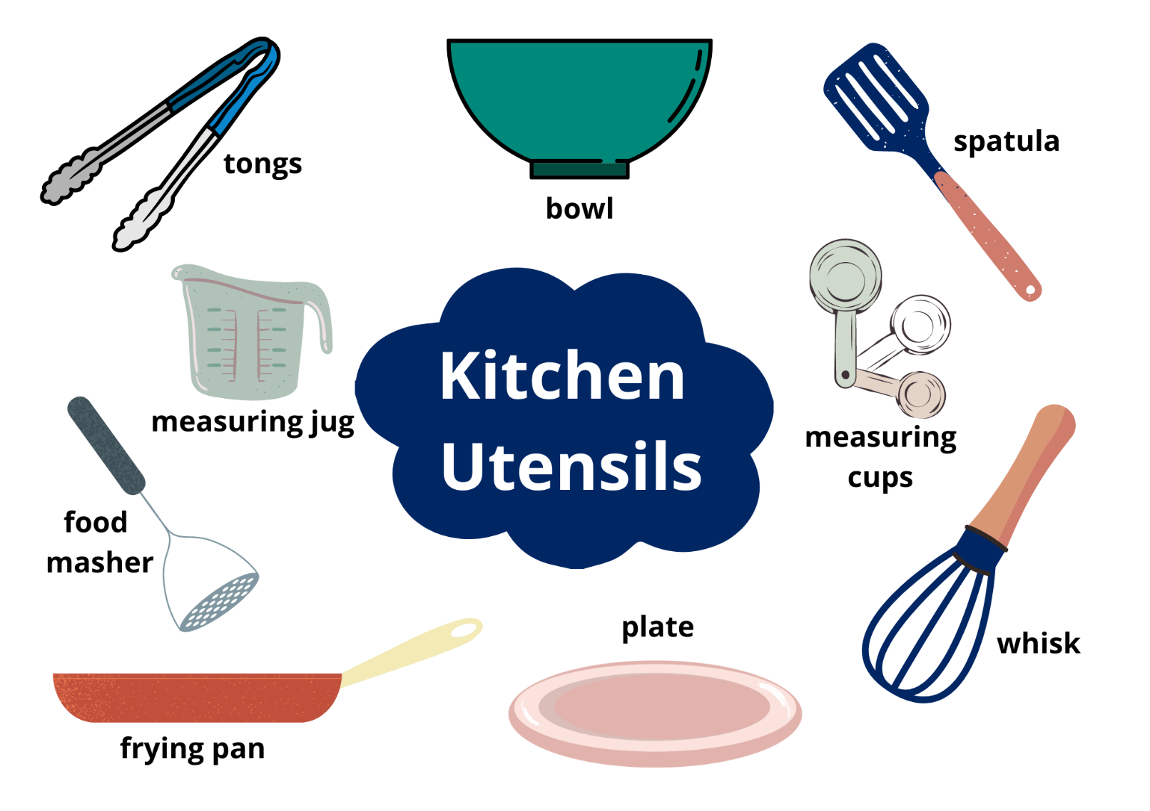
Images sourced from Canva and used in accordance with the Canva Content License Agreement.

Resource 2: Rhyme
Hey diddle, diddle,
The cat and the fiddle,
The cow jumped over the __;
The little dog laughed
To see such fun,
And the __ ran away with the __.

Resource 3: Sentence frame
Example:
Subject | Verb | Additional information
The sharp knife | cuts | the bread.
Use the sentence frame to create your own sentences.
Subject | Verb | Additional information

Resource 4: Dialogue checklist
Dialogue Checklist | Dialogue Checklist
- Speech marks go around exactly what is spoken.  - A capital letter is used at the start of what is spoken.  - There is a piece of punctuation before the close of quotation marks.  - ‘Saying verbs’ are used to describe how the speech is spoken.  - A new line is used when each new character speaks. | - Speech marks go around exactly what is spoken.  - A capital letter is used at the start of what is spoken.  - There is a piece of punctuation before the close of quotation marks.  - ‘Saying’ verbs are used to describe how the speech is spoken.  - A new line is used when each new character speaks.

Resource 5: Dialogue example
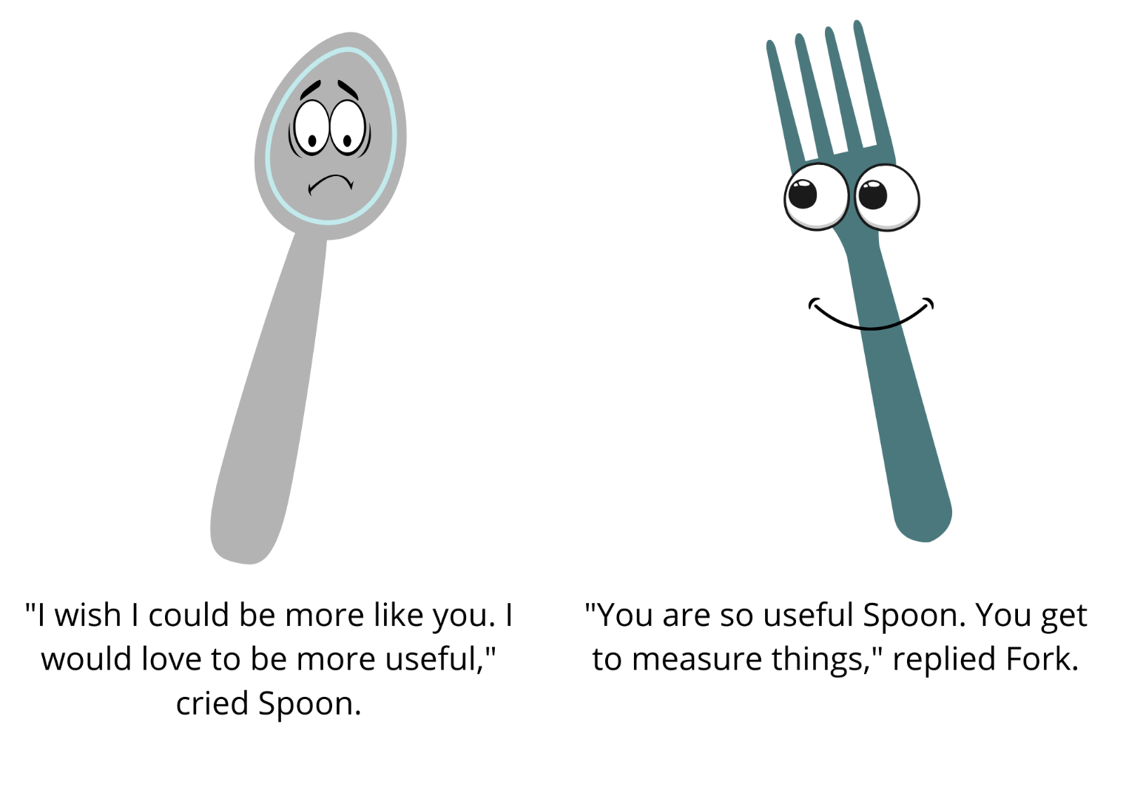
Images sourced from Canva and used in accordance with the Canva Content License Agreement.

Resource 6: Speech bubble example
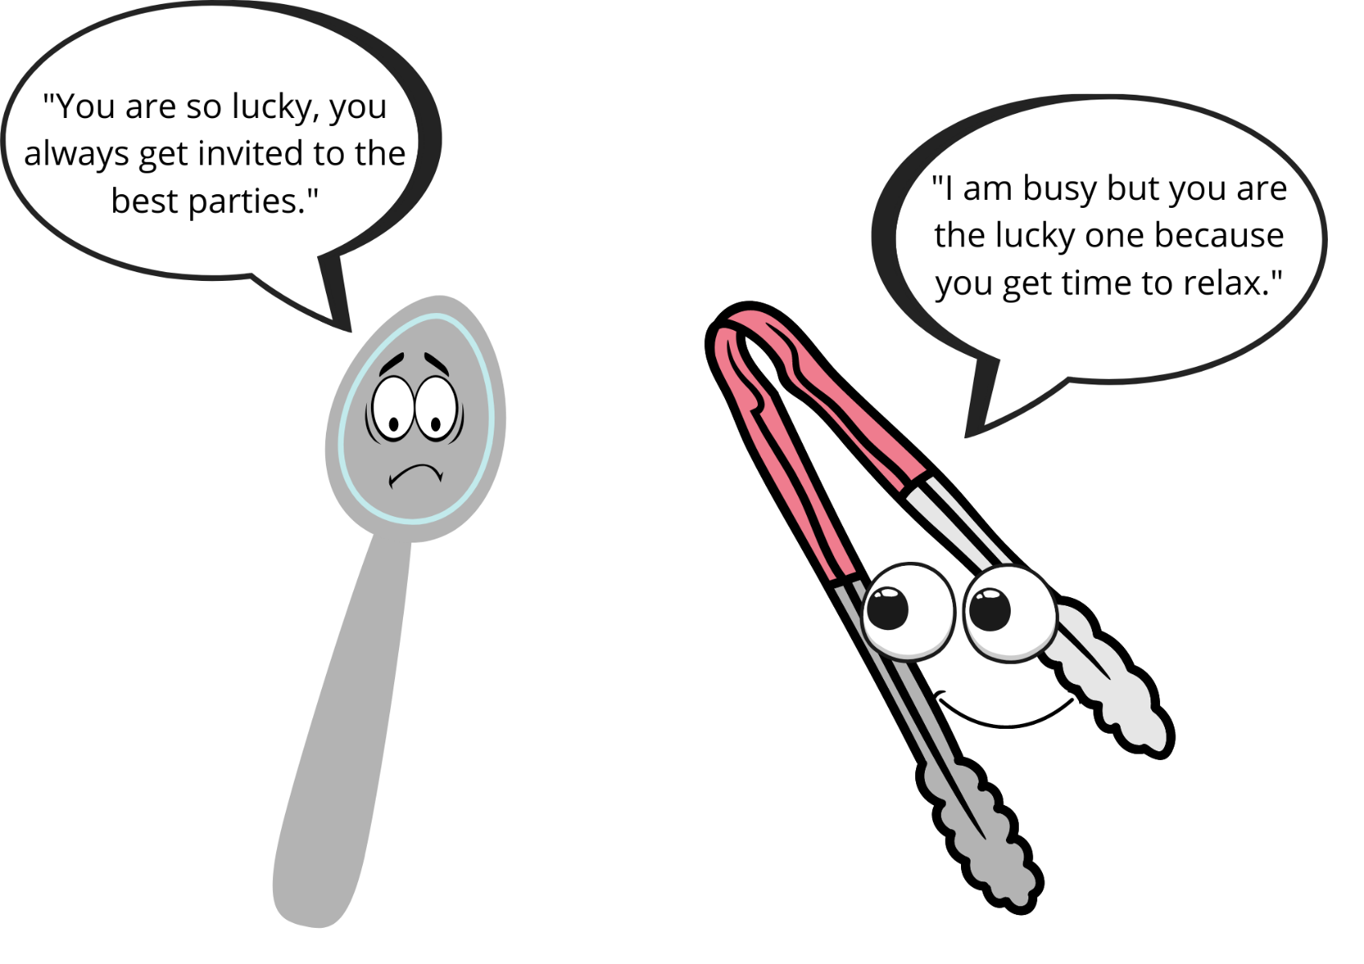
Images sourced from Canva and used in accordance with the Canva Content License Agreement.

Resource 7: Egg puns
- Egg went out on an adventure and felt terri-fried.
- Egg went out on an egg-citing adventure.
- Good Egg was upset when the other eggs were egg-noring him.
- Egg laughed so hard he started to crack up.
- Egg is well mannered and always says egg-scuse me.
- Egg rescued the cat on Fry-day.
- Egg stayed fit and healthy and loves to eggs-ercise.
- Egg felt eggs-hausted when the other Eggs were misbehaving.

Resource 8: Retell spinner
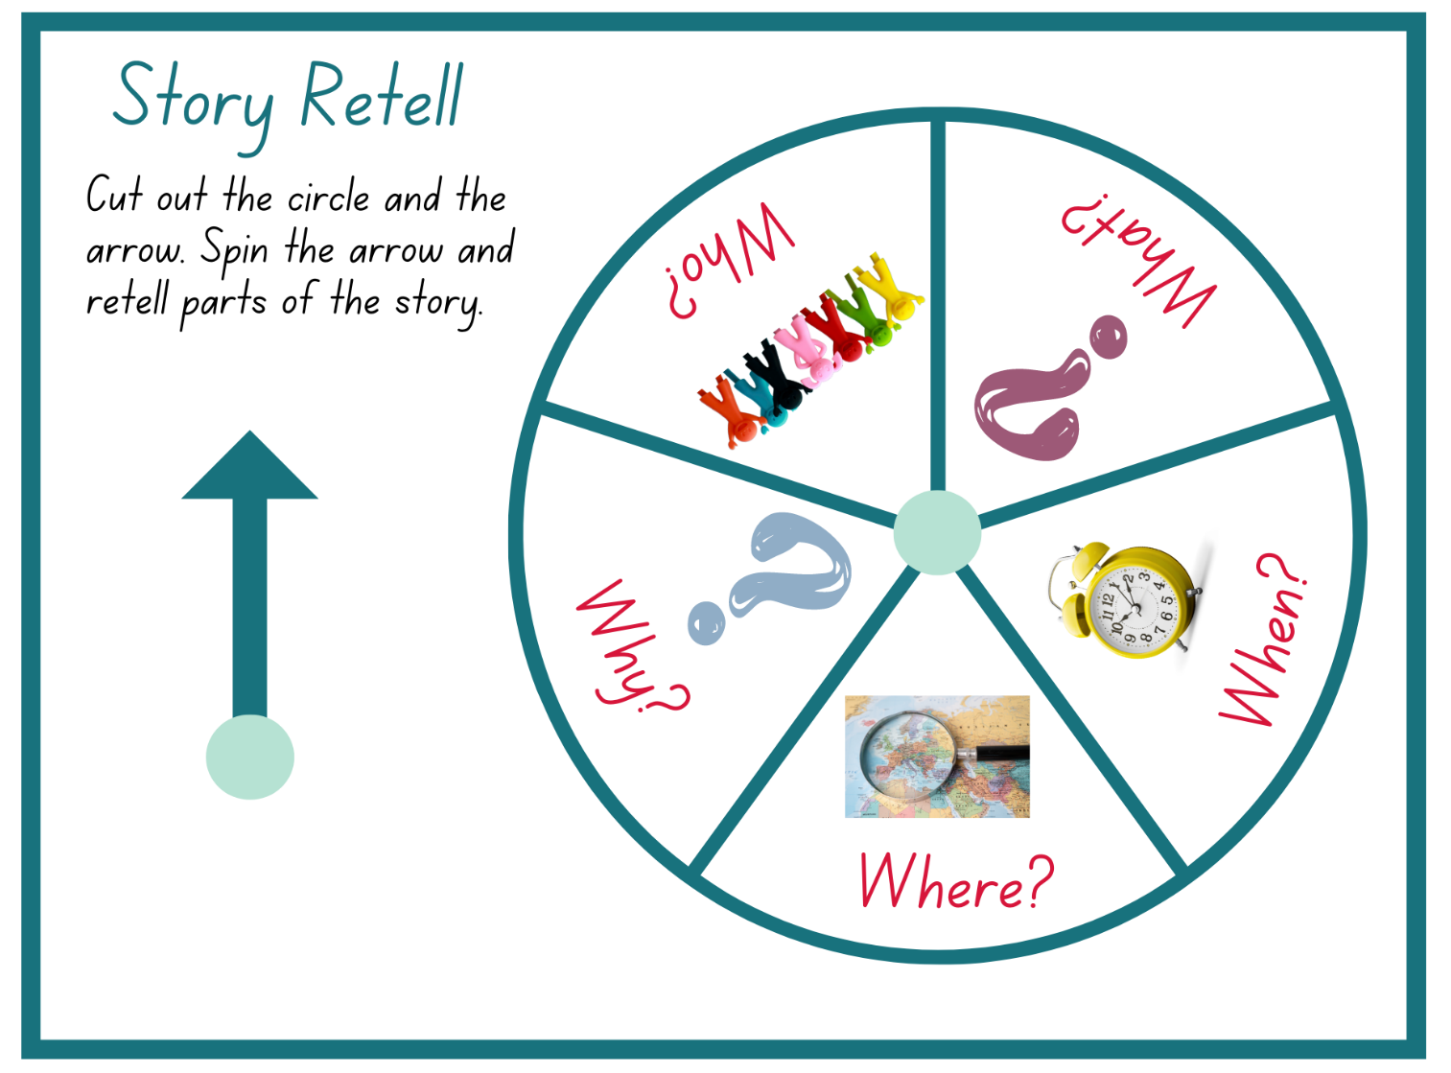
Images sourced from Canva and used in accordance with the Canva Content License Agreement.

Resource 9: Storyboard – Early Stage 1
Title:
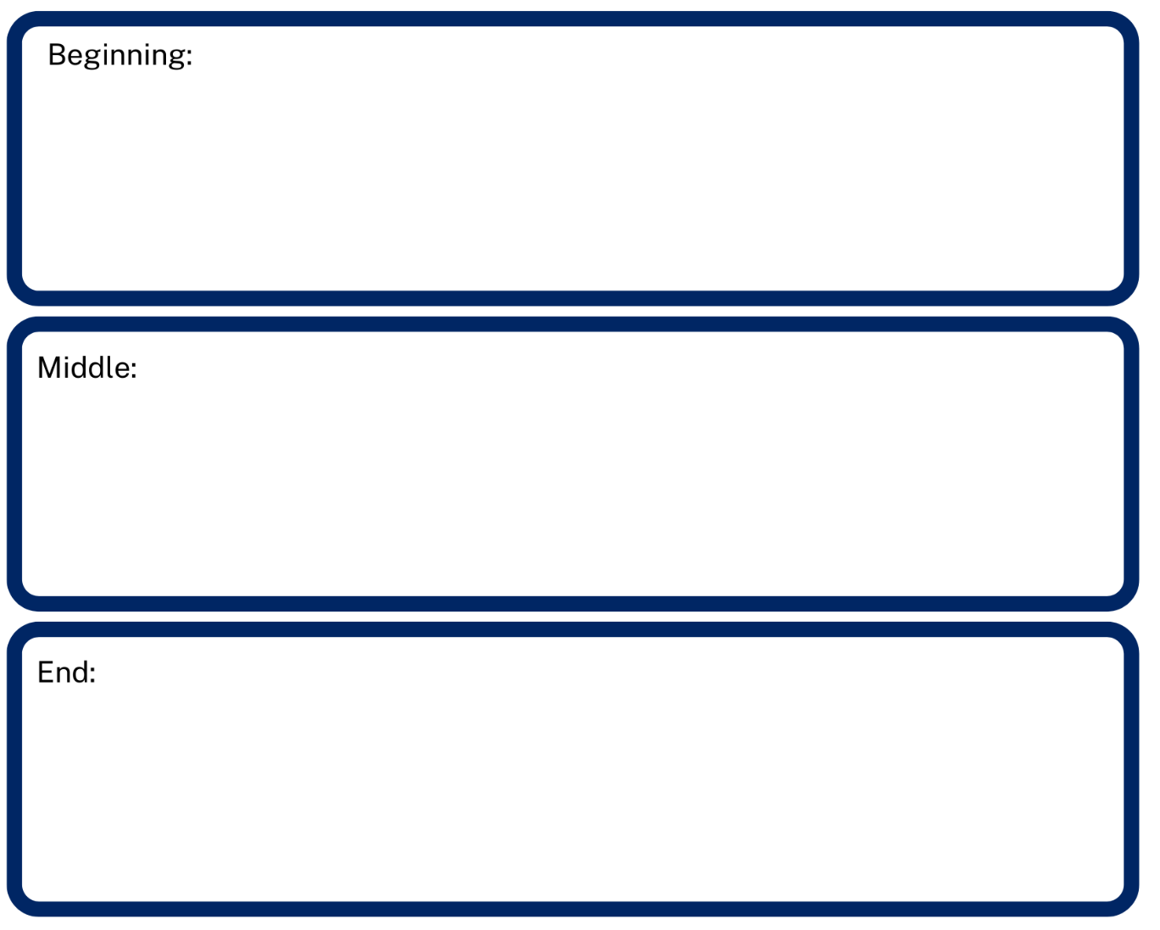

Resource 10: Storyboard – Stage 1
Title:
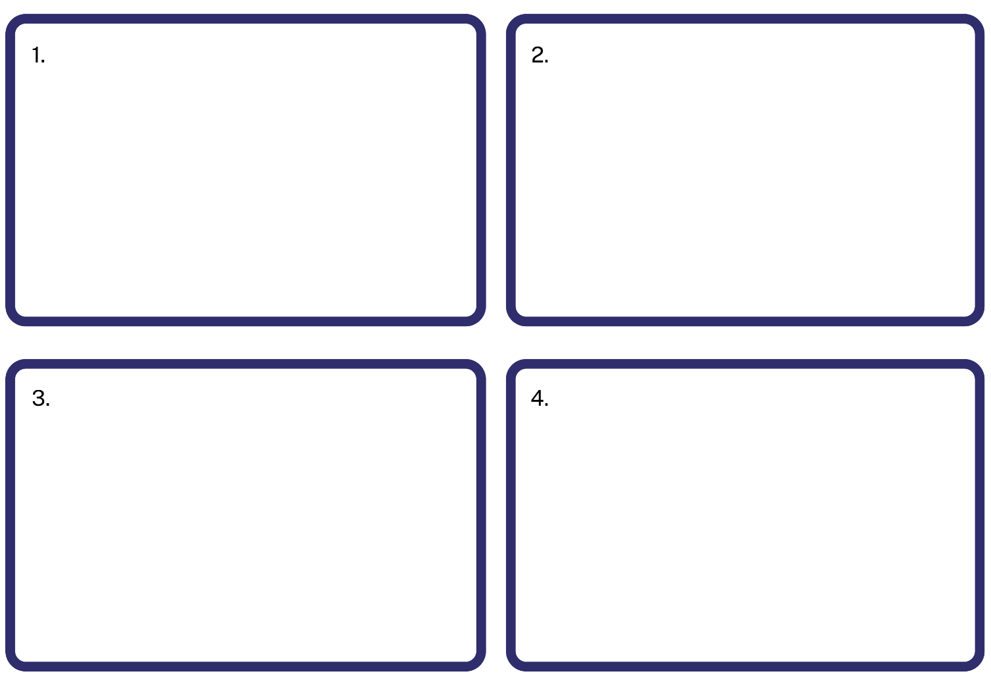

References
Links to third-party material and websites
Please note that the provided (reading/viewing material/list/links/texts) are a suggestion only and implies no endorsement, by the New South Wales Department of Education, of any author, publisher, or book title. School principals and teachers are best placed to assess the suitability of resources that would complement the curriculum and reflect the needs and interests of their students.
If you use the links provided in this document to access a third-party's website, you acknowledge that the terms of use, including licence terms set out on the third-party's website apply to the use which may be made of the materials on that third-party website or where permitted by the Copyright Act 1968 (Cth). The department accepts no responsibility for content on third-party websites.
Except as otherwise noted, all material is © State of New South Wales (Department of Education), 2021 and licensed under the Creative Commons Attribution 4.0 International License. All other material (third-party material) is used with permission or under licence. Where the copyright owner of third-party material has not licensed their material under a Creative Commons or similar licence, you should contact them directly for permission to reuse their material.
English K–10 Syllabus © 2022 NSW Education Standards Authority (NESA) for and on behalf of the Crown in right of the State of New South Wales.
© 2021 NSW Education Standards Authority. This document contains NSW Curriculum and syllabus content. The NSW Curriculum is developed by the NSW Education Standards Authority. This content is prepared by NESA for and on behalf of the Crown in right of the State of New South Wales. The material is protected by Crown copyright.
Please refer to the NESA Copyright Disclaimer for more information.
NESA holds the only official and up-to-date versions of the NSW Curriculum and syllabus documents. Please visit the NSW Education Standards Authority (NESA) website and the NSW Curriculum website.
National Literacy Learning Progression © Australian Curriculum, Assessment and Reporting Authority (ACARA) 2010 to present, unless otherwise indicated. This material was downloaded from the Australian Curriculum website (National Literacy Learning Progression) (accessed 17 October 2022) and was not modified. The material is licensed under CC BY 4.0. Version updates are tracked in the ‘Curriculum version history’ section on the 'About the Australian Curriculum' page of the Australian Curriculum website.
ACARA does not endorse any product that uses the Australian Curriculum or make any representations as to the quality of such products. Any product that uses material published on this website should not be taken to be affiliated with ACARA or have the sponsorship or approval of ACARA. It is up to each person to make their own assessment of the product, taking into account matters including, but not limited to, the version number and the degree to which the materials align with the content descriptions and achievement standards (where relevant). Where there is a claim of alignment, it is important to check that the materials align with the content descriptions and achievement standards (endorsed by all education Ministers), not the elaborations (examples provided by ACARA).
ABC (Australian Broadcasting Corporation) (2010) 'Hey diddle diddle' sung by Teddy Rock' [video], ABC Education, ABC website, accessed 17 October 2022.
ETA (English Teachers Association) and NSW Department of Education (2016) The Textual Concepts and Processes resource, English Textual Concepts website, accessed 17 October 2022.
ETA (English Teachers Association) and NSW Department of Education (2016) Character, English Textual Concepts website accessed 17 October 2022.
ETA (English Teachers Association) and NSW Department of Education (2016) Connotation, imagery and symbol, English Textual Concepts website accessed 17 October 2022.
John J (2021) The Good Egg (Oswald P, illus.), HarperCollins, New York.
Krouse Rosenthal A (2009) Spoon, (Magoon S, illus.), Little, Brown, New York.

