English – K-2 multi-age – Year A – Unit 3
Contents
Unit overview and instructions for use 3
Teacher notes 4
Outcomes and content – Component A 6
Outcomes and content – Component B 10
Week 1 14
Component A teaching and learning 14
Component B teaching and learning 15
Lesson 1: Introduction, audience, and purpose 17
Lesson 2: Nouns and noun groups 19
Lesson 3: Simple sentences and verbs 23
Lesson 4: Simple and compound sentences 26
Lesson 5: Using adjectives to describe and build a mental model 29
Week 2 34
Component A teaching and learning 34
Component B teaching and learning 35
Lesson 6: Recalling information and sequencing an information report 37
Lesson 7: Researching and planning 40
Lesson 8: Making models and composing texts 42
Lesson 9: Planning and editing 45
Lesson 10: Publishing 48
Resource 1: Is it a sentence? 49
Resource 2: Subject-verb sentences – Early Stage 1 50
Resource 3: Nouns and verbs – Early Stage 1 51
Resource 4: Zoom in – Stage 1 53
Resource 5: Read, cut, glue – Early Stage 1 54
Resource 6: Exemplar informative text – Stage 1 55
Resource 7: Sequencing activity – Stage 1 56
Resource 8: Labelled diagram – Stage 1 57
References 58

Unit overview and instructions for use
This two-week unit is comprised of Component A and Component B. Connecting learning across both components is encouraged.
Teaching and learning | Component A | Component B
Suggested duration | 60 minutes | 45 minutes
Explicit teaching focus areas | - Phonological awareness (Early Stage 1)  - Print conventions (Early Stage 1)  - Phonic knowledge  - Reading fluency  - Reading comprehension  - Spelling  - Handwriting | - Oral language and communication  - Vocabulary  - Reading comprehension  - Creating written texts  - Understanding and responding to literature
To prepare for teaching and learning: | - Refer to Outcomes and content – Component A, K-2 – Instructional sequence – grapheme–phoneme correspondences [PDF 825 KB], and the teaching advice documents (hyperlinked in Component A teaching and learning table).  - Based on student needs identified through ongoing assessment data, plan and document how you will sequence teaching and learning in whole class and targeted teaching groups across the two-week cycle. | - Familiarise yourself with Outcomes and content – Component B, Textual concepts information and videos, English Textual Concepts and Learning Processes (2016), and the teaching and learning sequence.  - Based on student needs identified through ongoing assessment data, determine how you will support students in whole class and targeted teaching groups across the two-week cycle as required.
English K–10 Syllabus © 2022 NSW Education Standards Authority (NESA) for and on behalf of the Crown in right of the State of New South Wales.

Teacher notes
- Context is defined as ‘a culturally or socially situated circumstance that may give rise to a particular register’ (NESA Glossary). To understand context, we look beyond the text to ‘consider the world in which it was produced and the worlds of its reception’ – English Textual Concepts and Learning Processes (2016).
- Representation is ‘the depiction of a thing, person or idea in written, visual, digital, performed or spoken language and conventions’ (NESA Glossary). Students need to understand that representations are not neutral. All representations carry personal and cultural meanings and have personal and social effects. – English Textual Concepts and Learning Processes (2016).
- The text Eric Carle’s Book of Amazing Animals is intended to be used in sections throughout Week 1 rather than reading the entire text.
- Students use a range of high utility words (Tier 2) and subject specific vocabulary (Tier 3) to add detail and authority to information. For example, adapt instead of change (Tier 2) and hibernate instead of sleep (Tier 3). For more information on Tier 1, 2 and 3 words, refer to the NESA Glossary.
- For information on noun groups refer to Teaching strategies.
- Early Stage 1 – Learning to write and learning to read should be treated as co-dependent processes. Mentor texts provide models for consolidating knowledge about different kinds of texts, sentence types, grammatical usage, vocabulary choice and punctuation. For more information, read NSW Curriculum – English – Teaching and learning support – Teaching advice – Early Stage 1 – Creating written texts.
- Early Stage 1 – Teachers can support the development of students’ writing through a variety of instructional strategies and with differing levels of scaffolds and support. When discussing word choices when creating a written text, encourage students to draw on both their personal vocabulary as well as words on display and in mentor texts. Students should have opportunities to practise, discuss, experiment with, edit, and apply their knowledge and skills in a widening variety of contexts as their writing develops. The aim should be to have students achieve increasing control over and confidence in using their writing. For further information refer to NSW Curriculum – Early Stage 1 – Teaching and learning support – Creating written texts.
- Stage 1 – Students should be provided with carefully scaffolded opportunities for students to create written texts for specific purposes. When writing to describe something that is real or imaginative, ideas need to be ordered in meaningful ways. When writing to explain, a description of how and why things happen is presented so that causes and effects are clearly linked. For further information, refer to NSW Curriculum – Stage 1 – Teaching and learning support – Creating written texts.
- This unit could enhance student learning towards achievement of outcomes from the Science and Technology and the Creative Arts syllabuses.
- The Book Creator app is a suggested activity in Lesson 10. All Department of Education schools have free access to Book Creator.
- Reflect on student learning and engagement in activities and record differentiation and adjustments within the unit to inform future teaching and learning. One way of doing this could be to add comments to the digital file.
- Content points are linked to the National Literacy Learning Progression version (3).
Levels and indicators sourced from National Literacy Learning Progression © Australian Curriculum, Assessment and Reporting Authority (ACARA), (accessed 29 September 2022) and was not modified. See references for more information.

Outcomes and content – Component A
The table below outlines the focus outcomes and content. Content is linked to the National Literacy Learning Progression version (3).
Early Stage 1 Focus area and outcome | Stage 1 Focus area and outcome
Phonological awareness  ENE-PHOAW-01 – identifies, blends, segments and manipulates phonological units in spoken words as a strategy for reading and creating texts  - orally blend and segment syllables in words comprising up to 3 syllables (PhA2)  - orally blend up to 4 phonemes together to make a one-syllable spoken word (PhA4)  - orally segment one-syllable words comprised of up to 4 phonemes into separate phonemes (PhA4) | N/A
Print conventions  ENE-PRINT-01 – tracks written text from left to right and from top to bottom of the page and identifies visual and spatial features of print  - understand that written Standard Australian English uses letters to represent sounds  - know the difference between a letter and a word (PKW1)  - identify and name lower- and upper-case letters (PKW4)  - turn pages one at a time (UnT3)  - consistently read left page before right page (UnT4) | N/A
Phonic knowledge  ENE-PHOKW-01 – uses single-letter grapheme–phoneme correspondences and common digraphs to decode and encode words when reading and creating texts  - match single letter grapheme with a phoneme  - say the most common phoneme for single-letter graphemes (graphs) (PKW4)  - blend single-letter grapheme correspondences to decode VC and CVC words, and apply this knowledge when reading, including decodable texts (PKW3, PKW4)  - segment and encode single-letter VC and CVC words, and apply this knowledge when writing words and creating texts (PKW4) | Phonic knowledge  EN1-PHOKW-01 – uses initial and extended phonics, including vowel digraphs, trigraphs to decode and encode words when reading and creating texts  - segment and encode one-syllable high-frequency base words with split digraphs and apply this when creating texts (SpG6)  - blend and decode one-syllable words with taught extended vowel graphs and digraphs, including graphemes for r-controlled vowels and diphthongs, and apply this when reading texts (PKW6, PKW7)  - segment and encode one-syllable words with taught vowel graphs, digraphs and trigraphs and apply this when creating texts
Reading fluency  ENE-REFLU-01 – reads decodable texts aloud with automaticity  - read texts with taught grapheme–phoneme correspondences and taught high-frequency words with automaticity | Reading fluency  EN1-REFLU-01 – sustains reading unseen texts with automaticity and prosody and self-corrects errors  - apply grapheme–phoneme correspondence to read words with automaticity (FIY1)  - vary pace when reading according to the audience and purpose (FIY4)
Reading comprehension  ENE-RECOM-01 – comprehends independently read texts using background knowledge, word knowledge and understanding of how sentences connect  - recall key characters, events and/or information in text (UnT5) | Reading comprehension  EN1-RECOM-01 – comprehends independently read texts that require sustained reading by activating background and word knowledge, connecting and understanding sentences and whole text, and monitoring for meaning  - make text-to-self, text-to-text or text-to-world connections when reading (UnT6)  - recount relevant ideas from texts in the form of a written, visual or oral summary (UnT6)
Spelling  ENE-SPELL-01 – applies phonological, orthographic and morphological generalisations and strategies to spell taught familiar and high-frequency words when creating texts  - combine phonological, phonic, orthographic and morphemic knowledge to spell taught high-frequency irregular words comprising up to 3 phonemes (SpG5)  - segment single-syllable words into phonemes as a strategy for spelling (SpG4)  - spell their own name (SpG1) | Spelling  EN1-SPELL-01 – applies phonological, orthographic and morphological generalisations and strategies when spelling words in a range of writing contexts  - segment single-syllable words into phonemes as a strategy for spelling (SpG4)  - spell high-frequency base words with taught vowel graphs, digraphs, split digraphs, trigraphs and quadgraphs (SpG6)  - use spelling conventions when adding plural-marking suffixes (SpG6)
Handwriting  ENE-HANDW-01 – produces all lower-case and upper-case letters to create texts  - use a stable posture when handwriting or drawing by sitting comfortably with feet flat on the floor, the writing arm resting on a table, with the opposite hand resting on the paper, and shoulders relaxed | Handwriting  EN1-HANDW-01 – uses a legible, fluent and automatic handwriting style, and digital technology, including word-processing applications, when creating texts  - position all letters correctly on the line with appropriate spacing between words (HwK5)

Outcomes and content – Component B
The table below outlines the focus outcomes and content. Content is linked to the National Literacy Learning Progression version (3).
Early Stage 1 Focus area and outcome | Stage 1 Focus area and outcome
Oral language and communication  ENE-OLC-01 – communicates effectively by using interpersonal conventions and language with familiar peers and adults  - respond to spoken questions  - contribute to group conversations (InT3)  - use imaginative, verbal language in structured and unstructured activities | Oral language and communication  EN1-OLC-01 – communicates effectively by using interpersonal conventions and language to extend and elaborate ideas for social and learning interactions  - follow extended instructions that contain connectives and conjunctions (LiS5)
Vocabulary  ENE-VOCAB-01 – understands and effectively uses Tier 1 and Tier 2 words in familiar contexts  - use vocabulary that is personal  - recognise and understand taught Tier 1 and Tier 2 words (PKW3, SpK3) | Vocabulary  EN1-VOCAB-01 – understands and effectively uses Tier 1, taught Tier 2 and Tier 3 vocabulary to extend and elaborate ideas  - use vocabulary to express cause and effect (SpK3)
Reading comprehension  ENE-RECOM-01 – comprehends independently read texts using background knowledge, word knowledge and understanding of how sentences connect  - understand how adjectives describe a noun and verbs identify actions in a sentence  - use background knowledge when identifying connections between a text, own life, other texts and/or the world (UnT4)  - use visual cues in multimodal texts to interpret meaning (UnT5)  - recall key characters, events and/or information in text (UnT5) | Reading comprehension  EN1-RECOM-01 – comprehends independently read texts that require sustained reading by activating background and word knowledge, connecting and understanding sentences and whole text, and monitoring for meaning  - use known vocabulary to build a mental model of the content of the text  - combine multiple sources of information within a text to make meaning  - identify how creative visual features are used to expand meaning  - use knowledge of text structure, type of text, author, and forms of writing to predict and confirm meaning (UnT6)
Creating written texts  ENE-CWT-01 – creates written texts that include at least 2 related ideas and correct simple sentences  - know that a simple sentence makes sense by itself and is a complete thought represented by a subject and a verb (GrA3)  - identify and use nouns in simple sentences, including in own writing (GrA1)  - use personal vocabulary, words on display and in mentor texts when constructing sentences  - use drawing, images or mind maps to support planning and writing (CrT4) | Creating written texts  EN1-CWT-01 – plans, creates and revises texts written for different purposes, including paragraphs, using knowledge of vocabulary, text features and sentence structure  - write texts that describe, explain, give an opinion, recount an event, tell a story (CrT7)  - select and use a range of conjunctions to create cohesive texts (GrA5)  - use appropriate tense across a text (GrA4)  - write compound sentences using coordinating conjunctions (GrA4, CrT5)  - recognise compound sentences in own writing, knowing that each clause has meaning by itself (CrT5, CrT5)  - use action, saying, relating and sensing verbs to add detail and precision to writing (GrA2, GrA5)  - use noun groups to build descriptions of people and things (CrT6)  - use a variety of planning strategies and tools for creating texts
Understanding and responding to literature  ENE-UARL-01 – understands and responds to literature read to them  - identify aspects of their own world represented in texts  - create imaginative and/or informative texts relating to their own experience, the world and/or other texts  - express likes and dislikes about a text | Understanding and responding to literature  EN1-UARL-01 – understands and responds to literature by creating texts using similar structures, intentional language choices and features appropriate to audience and purpose  - express personal responses to the real and imagined worlds that are represented in texts  - identify how the language and form of a text vary according to purpose, audience and mode (UnT5)

Week 1

Component A teaching and learning
The table below can be used to plan and document lessons that address Component A outcomes and content. Both the detailed example [DOC 529KB] of a two-week teaching and learning cycle and brief example [DOC 66KB] may support you in your planning.
Focus Areas | Lesson 1 | Lesson 2 | Lesson 3 | Lesson 4 | Lesson 5
Phonological awareness (Early Stage 1) and Phonic knowledge
15 minutes
Spelling and Handwriting
15 minutes
Print conventions (Early Stage 1), Reading comprehension and Reading fluency
30 minutes

Component B teaching and learning
The following teaching and learning sequence has been designed to address Component B outcomes and content. Adapt the sequence as required to best meet the needs of your students.

Learning intention and success criteria
Learning intentions and success criteria are best co-constructed with students. The table below contains suggested learning intentions and success criteria.
Element | Early Stage 1 | Stage 1
Learning intentions | Students are learning to identify aspects of their own world represented in texts. | Students are learning to respond to real and imagined worlds represented in texts.
Success criteria | Students can:  - compare informative and imaginative texts  - identify aspects of their own world in texts  - identify nouns in sentences  - know that a sentence is a group of words that make a complete message  - understand that a sentence has a subject and a verb  - understand that a verb is an action  - understand that an adjective describes a noun. | Students can:  - compare the purpose of informative and imaginative texts  - identify the features of an informative text  - identify how the language of a text varies according to audience  - identify and use noun groups  - use action verbs to add precision and detail to writing  - write compound sentences  - use conjunctions to show cause and effect  - follow extended instructions  - use descriptive vocabulary to build a mental model.

Resources
- Carle E (2021) Eric Carle’s Book of Amazing Animals, Puffin, London. ISBN: 9780241381670
- Resource 1: Is it a sentence? (enlarged copy)
- Resource 2: Subject-verb sentences – Early Stage 1
- Resource 3: Nouns and verbs – Early Stage 1 (enlarged and student copies for Early Stage 1)
- Resource 4: Zoom in – Stage 1
- Resource 5: Read, cut, glue – Early Stage 1
- Video: What is that Sound –Taronga Zoo Education (11:26)
- Video: Guess Who at the Zoo – What is that Tail? (21:41)
- A selection of informative and imaginative texts about animals for Lesson 3
- Mini whiteboards and markers
- Early Stage 1 – Enlarged photographs of different animals and magnifying glasses for Lesson 5

Lesson 1: Introduction, audience, and purpose
The following teaching and learning activities support multi-age settings.

Whole
- Read the front and back cover of the text Eric Carle’s Book of Amazing Animals. Make predictions about what the text will be about and the purpose of the text. Use Think, Puzzle, Explore to connect students’ background knowledge and generate ideas and curiosity about wild animals. Discuss the purpose and intended audience.
- Think – What do you think you know about wild animals on our planet?
- Puzzle – What questions or puzzles do you have about these animals?
- Explore – What would you like to explore further?
- Write student puzzles or questions on sticky notes for exploration as a purpose for reading.
- Read sections to sample the text and attempt to answer students’ puzzles and questions.
- Highlight how this text describes something that is real, not imaginative. Ask and discuss:
- Who would read an informative text and why?
- Why do people write informative texts?
- Create an anchor chart with the heading Informative texts. Ask students what text features might be found in an informative text. For example, information, facts, contents page, headings, page numbers and labels.
- Discuss how an informative text is similar or different to other texts students may have read.
- Discuss and compare the purpose of informative and imaginative texts. Ask students to consider the audience and purpose of Eric Carle’s Book of Amazing Animals and one of his other texts. For example, The Bad-Tempered Ladybird; Brown Bear, Brown Bear What Do You See? and The Very Hungry Caterpillar.
- Explain that information on topics, such as animals, can be represented in different ways depending on the intended audience and purpose of the text.
- Organise students into mixed aged and ability groups. Provide each group with one or more texts that they will discuss and classify into either imaginative or informative. With a sample text, model classifying and writing a justification. Each group nominates a scribe to record students’ reasoning. For example, our text is imaginative because it has characters that are not real.
- Place 2 hoops in the middle of the floor with labels, Imaginative texts, and Informative texts. In turn, each group places their texts into the appropriate hoops and shares their justification. Students’ written responses can be collated onto a retrieval chart.
- Consider the complexity of hybrid texts which may include both imaginative and informative features. To do this, position the hoops with an overlap and place the hybrid texts in the centre.
Note: Hybrid text is text made from stylistic elements from different types of texts. For example, infotainment and creative nonfiction.
- Revisit the idea of audience and purpose and discuss how readers can have preferences, such as likes or dislikes, for different texts. Provide the opportunity for students to discuss their personal preferences.
Early Stage 1 Assessment task 1 – Observations from this lesson allow students to demonstrate achievement towards the following syllabus outcome and content point:
ENE-UARL-01 – understands and responds to literature read to them
- identify aspects of their own world represented in texts.
Stage 1 Assessment task 1 – Observations from this lesson allow students to demonstrate achievement towards the following syllabus outcomes and content points:
EN1-RECOM-01 – comprehends independently read texts that require sustained reading by activating background and word knowledge, connecting and understanding sentences and whole text, and monitoring for meaning
- combine multiple sources of information within a text to make meaning
- use knowledge of text structure, type of text, author, and forms of writing to predict and confirm meaning.
EN1-UARL-01 – understands and responds to literature by creating texts using similar structures, intentional language choices and features appropriate to audience and purpose
- identify how the language and form of a text vary according to purpose, audience and mode
- express personal responses to the real and imagined worlds that are represented in texts.

Lesson 2: Nouns and noun groups
The following teaching and learning activities support multi-age settings.

Whole
- Discuss how factual texts provide details through the words, illustrations and/or images. Explain that the author of Eric Carle’s Book of Amazing Animals is deliberate in his choice of vocabulary and descriptive phrasing, to help the reader learn about their world.
- Read page 8, Fantastic Feathers section of the text. Draw students’ attention to the author’s use of Tier 2 vocabulary such as jagged, feathered and bill. Remind students that these words add precision and give the text authority.
- Define the word bill with students. Classify this word as a noun and ask students what they think a noun is. Explain what nouns are.
- Ask students to identify the other nouns on page 8. These will include toucan, body, fruit, insects, and friends.
- Select an illustration from the text and ask students to describe what they see. Write and collate the students’ words. Students sort words into informative (jagged, feathered, bill) and imaginative (pretty, beautiful). Discuss why they have chosen to place the words under each of the headings. Choose a response and model writing it as a sentence. For example, A toucan’s large bill is used for catching insects. Ask students to identify the nouns in the sentence and colour code them.

Part
The table below details the differentiated teaching and learning activities for each stage.
Early Stage 1 (in pairs/independent) | Stage 1 (teacher guided)
- Provide students with a selection of informative and imaginative texts about animals.  - In pairs, students look through the texts to identify the nouns.  - Students draw nouns from activity 7.  Too easy? Write labels for nouns. | - Revisit page 8. Ask students what they think an adjective is. Explain what adjectives are.  - Ask students to identify adjectives on page 8. These will include large, coloured, jagged, and feathered.  - Introduce noun groups as a group of words that relate to or build a description of a noun. Explain that noun groups consist of an article (the, a, an), one or more adjectives (or adverbs) and a noun. For example, the tiny mice, a silent owl, a colourful butterfly.  - Deconstruct the noun groups and colour code the sentence-level grammar features, for example, articles, adjectives, nouns. Teach the correct use of an article with a noun. For example, ‘an echidna’ not ‘a echidna’.  - Play a noun group game. Write an article and noun on the board. For example, a lizard. Ask students to write as many adjectives to describe the noun as they can in a set time. Highlight adjectives on the board. Repeat the game with several articles and nouns. The game can be played in teams competing against each other.

Part
The table below details the differentiated teaching and learning activities for each stage.
Early Stage 1 (teacher guided) | Stage 1 (independent)
- Share student responses. Draw popular responses on the board and write the noun underneath.  - Use a noun from the previous activity to model writing a simple sentence.  - Model reading sentences from activity 15 to students using one-to-one correspondence. Ask students to identify the noun/s and circle them. | - Students write informative sentences about different animals in the text using noun groups. Students deconstruct each sentence by colour coding sentence-level grammar features, such as articles, adjectives, and nouns.

Whole
- Read another page of the text. Ask students to identify the nouns and/or noun groups.
Early Stage 1 Assessment task 2 – Observations and work samples from this lesson allow students to demonstrate achievement towards the following syllabus outcome and content point:
ENE-CWT-01 – creates written texts that include at least 2 related ideas and correct simple sentences
- identify and use nouns in simple sentences, including own writing.
Stage 1 Assessment task 2 – Observations and work samples from this lesson allow students to demonstrate achievement towards the following syllabus outcome and content point:
EN1-CWT-01 – plans, creates and revises texts written for different purposes, including paragraphs, using knowledge of vocabulary text features and sentence structure
- use noun groups to build descriptions of people and things.

Lesson 3: Simple sentences and verbs
The following teaching and learning activities support multi-age settings.

Whole
- Select animals from the text and play several games of ‘Who am I?’ Give clues using action verbs for students to guess the animal. For example, ‘I hang and sleep in trees’.
- Using the clues from ‘Who am I?’ model writing complete sentences. For example, Sloths hang and sleep in trees.
- Ask students to explain their understanding of verbs and give examples. Using the modelled sentence from activity 2 ask students to identify the verbs and nouns.
- Display an enlarged copy of Resource 1 to review the structure of simple sentences represented by a subject and a verb.
- Select illustrations from the text Eric Carle’s Book of Amazing Animals and model writing simple sentences to describe what the animal is doing. For example, Butterflies slurp water from puddles. Identify the subject (who or what) and the verb (what are they doing) in each sentence. Highlight print conventions including use of a capital letter and a full stop.
- Write several examples of complete and incomplete sentences. For example, a sloth; A sloth is hanging in the tree. Ask students to identify if they are sentences using the oral prompts:
- This is a sentence because…
- This is not a sentence because…
- Provide students with further examples of incomplete sentences that only have an article and a subject.
- Organise students into mixed aged and ability groups. Students orally complete the sentences by adding a verb.
- Using student examples from activity 8, model writing complete sentences and select students to identify and colour code the subject and verb.

Part
The table below details the differentiated teaching and learning activities for each stage.
Early Stage 1 (independent /pairs) | Stage 1 (teacher guided/independent)
- Provide students with a selection of informative and imaginative texts about animals. Students use Resource 2 to draw an animal (subject) from a text and an action that the animal can do (verb). Share and describe drawings with a partner.  - In pairs, students use Resource 5 to practise verbalising a complete sentence with a subject and a verb.  Too easy? Students use a completed Resource 2 to write simple sentences. | - Remind students that verbs add precision and detail to writing.  - In small groups, students select an animal from the text then brainstorm and record verbs to describe the animal’s behaviours.  - Model writing an informative sentence about an animal from the text using action verbs. For example, Koalas have very sharp claws so that they can climb high into the eucalyptus trees. Identify the subject and underline the action verbs in the sentence.  - Students apply their background knowledge and information from the text to write informative sentences about an animal from the text using action verbs.  - Students identify the subject and action verbs in their writing.  Too hard? Students write a simple sentence with a subject and verb.  Too easy? Categorise the different verbs in sentences. For example, action, saying, relating, and sensing verbs.

Whole
- Select a student to act out a number of verbs related to an animal. For example, swim, dive, dip. Class members guess the animal based on the actions. Choose another student to verbalise a complete sentence using the subject and verb examples. For example, A duck dives and swims.
Early Stage 1 Assessment task 3 – Observations and work samples from this lesson allow students to demonstrate achievement towards the following syllabus outcomes and content points:
ENE-RECOM-01 – comprehends independently read texts using background knowledge, word knowledge and understanding of how sentences connect
- understand how adjectives describe a noun and verbs identify actions in a sentence.
ENE-CWT-01 – creates written texts that include at least 2 related ideas and correct simple sentences
- know that a simple sentence makes sense by itself and is a complete thought represented by a subject and a verb.
Stage 1 Assessment task 3 – Observations and work samples from this lesson allow students to demonstrate achievement towards the following syllabus outcome and content point:
EN1-CWT-01 – plans, creates and revises texts written for different purposes, including paragraphs, using knowledge of vocabulary, text features and sentence structure
- use action, saying, relating and sensing verbs to add detail and precision to writing.

Lesson 4: Simple and compound sentences
The following teaching and learning activities support multi-age settings.

Whole
- Watch the sections about the elephant and the meerkat in What is that Sound – Taronga Zoo Education (11:26). Watch the first part of the episode about elephants and then the meerkats. After each animal, pause the video and have students do the following activities:

Part
The table below details the differentiated teaching and learning activities for each stage.
Early Stage 1 (teacher guided) | Stage 1 (pairs)
- Revise learning about nouns and verbs by referring to the animals in the video.  - Students act out the animals from the video. With a thinking partner, students orally compose a sentence. For example, An elephant stomps. A meerkat screeches. | - In pairs, students discuss the reasons why animals in the video do what they do (cause and effect) using a conjunction (because, so). Display conjunctions for students to refer to.

Whole
- Read page 14 of the text Eric Carle’s Book of Amazing Animals, which explores elephants. Using students’ background knowledge, as well as information from the text and video, demonstrate the thoughts and actions of a proficient writer by modelling how to write a simple sentence. Chorally read the sentence. Ask students if the sentence is a complete message and to explain their reasoning. Circle the nouns and verbs.

Part
The table below details the differentiated teaching and learning activities for each stage.
Early Stage 1 (independent/pairs) | Stage 1 (teacher guided)
- Provide students with a copy of Resource 3. Students cut and glue the verbs to match the noun.  - In pairs, students read the simple sentences in the resource to practise oral reading. Encourage students to read with one-to-one correspondence. Identify the subject (nouns) and the verbs in the sentences.  - Students pretend to be a zookeeper and draw pictures of different animals (noun) and something it can do (verb). Students have a go at writing using their emerging phonic and spelling knowledge. For example, students might write about the sound an animal makes.  Too easy? Students write simple sentences to describe the actions of different animals. | - Explain how simple sentences can be expanded using a conjunction.  - Model writing a compound sentence to show cause and effect. For example, The herd can locate each other because the elephant trumpets loudly. Circle the conjunction. Colour code the cause and effect.  - Go to page 26 about penguins in Eric Carle’s Book of Amazing Animals. Look at the print and illustrations to discuss the behaviour of the penguins and identify the cause and effect. For example, the penguins are huddling so they can keep warm.  - Co-construct a compound sentence using a conjunction to show cause and effect with another animal from the video. Circle the conjunction. Discuss the cause (the elephant trumpets) and effect (the herd can locate each other).  - Explain that each clause in a compound sentence makes sense by itself.  - In pairs, students select an animal to discuss the cause and effect of its behaviour.  - Students use conjunctions to write compound sentences showing cause and effect. Circle the conjunction. Colour code the clauses.  Too hard? Use an interactive writing strategy to co-construct compound sentences that express cause and effect.  Too easy? Students write sentences with multiple clauses.
Stage 1 Assessment task 4 – Observations and work samples from this lesson allow students to demonstrate achievement towards the following syllabus outcomes and content points:
EN1-VOCAB-01 – understands and effectively uses Tier 1, taught Tier 2 and Tier 3 vocabulary to extend and elaborate ideas
- use vocabulary to express cause and effect.
EN1-CWT-01- plans, creates and revises texts written for different purposes, including paragraphs, using knowledge of vocabulary, text features and sentence structure
- write compound sentences using coordinating conjunctions
- select and use a range of conjunctions to create cohesive texts
- recognise compound sentences in own writing, knowing that each clause has meaning by itself.

Lesson 5: Using adjectives to describe and build a mental model
The following teaching and learning activities support multi-age settings.

Whole
- View 2-3 animal tails from Guess Who at the Zoo – What is that Tail? (21:41). Pause after each animal tail is introduced. Brainstorm words (adjectives) to describe the tails and record on a word wall. For example, long, stripy. Allow students to guess the animal that the tails belong to.
- Explain that adjectives describe nouns and can help the reader build a mental model.
Note: Early Stage 1 students may not be familiar with adjectives. An illustrative dialogue could be:
You: What words can we use to tell the reader what the tail looks like?
Student: long, stripy.
You: How can we put these words into a sentence?
- Revisit page 8 of the text Eric Carle’s Book of Amazing Animals, which was used in Lesson 2 to explicitly teach nouns. Add the adjectives from the page onto the word wall. Ask how these adjectives have described the toucan and have provided the reader with more precise information.

Part
The table below details the differentiated teaching and learning activities for each stage.
Early Stage 1 (independent/pairs) | Stage 1 (teacher guided)
- Provide students with a selection of enlarged photographs of wild animals and magnifying glasses. Allow students to use the magnifying glasses to observe the animals and details of their distinct physical features.  - Students select one animal from the photographs and zoom in on the image, closely observing different physical features of the animal.  - Students draw 3 close-up features of their chosen animal. For example, a student might draw the tail, trunk, and ears of an elephant.  - In pairs or small groups, students share their drawings. Students verbalise complete sentences to explain their drawings. | - Explain that students will be drawing an animal from instructions given to them. It is intended that students draw an elephant; however, it is anticipated that students will interpret the information differently. This will become a teaching point about descriptive vocabulary in informative texts. Provide students with a mini whiteboard and a marker. Explain:  - Before you start drawing, close your eyes so that you can visualise the clues you hear and what you will draw.  - First, draw a head with 2 large, floppy ears.  - In the middle of the head, draw a long, curled nose and then add 2 small eyes.  - Continue with similar instructions that use connectives and conjunctions until students have drawn a picture of an animal. Explain that the intended drawing was to be of an elephant.  - Compare drawings and discuss how students built a mental model of the animal. Ask how the description could have been improved to draw a more accurate picture of an elephant. Highlight the description ‘long, curled nose’. Prompt students to suggest more precise vocabulary (Tier 2 and 3 words).

Part
The table below details the differentiated teaching and learning activities for each stage.
Early Stage 1 (teacher guided) | Stage 1 (pairs/independent)
- Use a student’s drawing to co-construct simple sentences to describe an animal’s feature. For example, An elephant has a long trunk. | - In pairs, each partner takes turns to describe an animal’s feature so that the other student can guess the animal. Explain that students will need to focus on descriptive language to help their partner build a mental model of the animal.  - Students use Resource 4 to draw then write descriptive, factual sentences about each feature. This will support students as they independently write an informative text in Lesson 8 and Lesson 9.
Early Stage 1 Assessment task 4 – Observations and work samples from this lesson allow students to demonstrate achievement towards the following syllabus outcome and content point:
ENE-RECOM-01 – comprehends independently read texts using background knowledge, word knowledge and understanding of how sentences connect
- understand how adjectives describe a noun and verbs identify actions in a sentence.

Stage 1 Assessment task 5 – Observations and work samples from this lesson allow students to demonstrate achievement towards the following syllabus outcomes and content points:
EN1-OLC-01 – communicates effectively by using interpersonal conventions and language to extend and elaborate ideas for social and learning interactions
- follow extended instructions that contain connectives and conjunctions.
EN1-RECOM-01 – comprehends independently read texts that require sustained reading by activating background and word knowledge, connecting and understanding sentences and whole text, and monitoring for meaning
- use known vocabulary to build a mental model of the content of the text.

Week 2

Component A teaching and learning
The table below can be used to plan and document lessons that address Component A outcomes and content. Both the detailed example [DOC 529KB] of a two-week teaching and learning cycle and brief example [DOC 66KB] may support you in your planning.
Focus Areas | Lesson 6 | Lesson 7 | Lesson 8 | Lesson 9 | Lesson 10
Phonological awareness (Early Stage 1) and Phonic knowledge
15 minutes
Spelling and Handwriting
15 minutes
Print conventions (Early Stage 1), Reading comprehension and Reading fluency
30 minutes

Component B teaching and learning
The following teaching and learning sequence has been designed to address Component B outcomes and content. Adapt the sequence as required to best meet the needs of your students.

Learning intention and success criteria
Learning intentions and success criteria are best co-constructed with students. The table below contains suggested learning intentions and success criteria.
Element | Early Stage 1 | Stage 1
Learning intentions | Students are learning to create informative texts using their knowledge of the world and other texts. | Students are learning to represent information about the real world.
Success criteria | Students can:  - recall key information in texts  - use background knowledge to co-construct simple sentences  - use visual cues to make meaning  - express likes and dislikes about a text  - use Tier 1 and Tier 2 vocabulary  - use drawings and a Frayer diagram to support planning texts  - respond to questions and join in group conversations  - identify aspects of their own world represented in texts  - use a Frayer diagram to present an informative text  - create an informative text. | Students can:  - identify the features of an informative text  - sequence information in a logical order  - use Tier 2 and Tier 3 vocabulary  - research information using digital and non-digital texts  - use a Frayer diagram to plan writing  - use multiple sources of information to plan writing  - use diagrams to expand meaning in an informative text  - use appropriate tense across a text  - edit writing using feedback and success criteria  - publish an information report.

Resources
- Carle E (2021) Eric Carle’s Book of Amazing Animals, Puffin Books. ISBN: 9780241381670
- Resource 5: Read, cut, glue – Early Stage 1
- Resource 6: Exemplar informative text – Stage 1
- Resource 7: Sequencing activity – Stage 1
- Resource 8: Labelled diagram – Stage 1
- Video: Blue Whale (1:15)
- Website: National Geographic Kids: Animals
- Frayer diagram (one enlarged and multiple copies for students)
- Art materials for drawing or painting in Lesson 6
- Informative texts about animals – digital and non-digital for Lesson 7
- Informative and imaginative texts about animals for Lesson 8
- Access to Book Creator or other digital tool for Lesson 10

Lesson 6: Recalling information and sequencing an information report
The following teaching and learning activities support multi-age settings.

Whole
- Discuss what students already know about whales.
- Watch the video Blue Whale (1:15). Ask:
- What information did you learn from this video?
- What other information could have been included?
- What do you think was the most important information presented? Why?
- What was one thing you liked and did not like about the video? Why?
- Read the section of the text Eric Carle’s Book of Amazing Animals about blue whales, found on page 32. Ask:
- What new information did you learn about blue whales?
- How does the illustration support your understanding of blue whales?
- What is one thing you liked and do not like about the text? Why?

Part
The table below details the differentiated teaching and learning activities for each stage.
Early Stage 1 (independent) | Stage 1 (teacher guided)
- Provide materials for students to draw or paint a large blue whale. Students could use an A3 piece of paper.  - Turn and talk with a partner, recalling information about blue whales from the video and text.  - Students use Resource 5 to cut sentence strips and glue onto their drawing/painting. | - Use an enlarged copy of Resource 6 to read and discuss the purpose of the exemplar text. Explain that the text is written in a consistent tense. Highlight the use of present tense words such as have, are, is.  - Deconstruct and annotate the text features. Ask:  - How does the author introduce the topic?  - What information is important in the introduction?  - Are there subheadings? How do these help the reader?  - How does the labelled image support your understanding of the topic?

Part
The table below details the differentiated teaching and learning activities for each stage.
Early Stage 1 (teacher guided) | Stage 1 (independent)
- Co-construct simple sentences about blue whales using the information that students recall from the texts.  Too easy? Students write keywords or factual sentences about blue whales on sentence strips to add to their drawing/painting. | - Students use Resource 7 to sequence the information in a logical order and label the informative text features.  Too hard? Modify Resource 7 to focus on headings, subheadings, and diagrams.  Too easy? Think of additional subheadings that could be included. Students add further labels to the diagram.

Whole
- In mixed stage groups, Stage 1 students share new learning about informative texts and Early Stage 1 share their artwork, and whether they preferred the information presented in the video or book to learn about whales. Encourage Early Stage 1 students to use a ‘because’ statement to explain their thinking.
Early Stage 1 Assessment task 5 – Observations and work samples from this lesson allow students to demonstrate achievement towards the following syllabus outcomes and content points:
ENE-RECOM-01 – comprehends independently read texts using background knowledge, word knowledge and understanding of how sentences connect
- use background knowledge when identifying connections between a text, own life, other texts and/or the world
- use visual cues in multimodal texts to interpret meaning
- recall key characters, events and/or information in text.
ENE-UARL-01 – understands and responds to literature read to them
- express likes and dislikes about a text.

Lesson 7: Researching and planning
The following teaching and learning activities support multi-age settings.

Whole
- Display the website Kids National Geographic: Animals. Model how to navigate the page for information.
- Explain that students are going to use different sources of information/texts to gather information about a chosen animal.
- Select an animal from the text Eric Carle’s Book of Amazing Animals. Model using a Frayer diagram to record information about the animal through drawings, keywords and factual sentences. Draw students’ attention to the author’s use of Tier 2 vocabulary.

Part
The table below details the differentiated teaching and learning activities for each stage.
Early Stage 1 (pairs/independent) | Stage 1 (teacher guided)
- In pairs, students explore a selection of informative and imaginative texts and choose an animal to draw a detailed illustration.  - Students share their drawing and background knowledge about the animal with their partner.  - Students use a Frayer diagram to draw or write factual information about their chosen animal. | - Use Resource 6 to revise the structure of an information report. Explain that students will be writing an information report about an animal.  - Display an enlarged Frayer diagram with the subheadings: appearance, habitat, diet, behaviour, and other facts. Ask students where they might find more information to complete the Frayer diagram.  - Model how to use a range of resources, including websites and books, to gather information about a chosen animal. Model how to record facts and information under each subheading on the enlarged Frayer diagram. Keep the modelled Frayer diagram for Lesson 8.

Part
The table below details the differentiated teaching and learning activities for each stage.
Early Stage 1 (teacher guided) | Stage 1 (independent)
- As a whole group, selects students to verbalise sentences using the information they have drawn or written in the Frayer diagram. Encourage students to use Tier 2 vocabulary. Students can refer to the adjectives word wall from Lesson 5 and the text.  - Select a verbalised sentence to model writing and reinforce that a sentence is a complete message. Use Resource 1 as a success criteria to evaluate the modelled sentence.  Too easy? Students label their drawing and write keywords or factual sentences about their chosen animal. | - Provide students with a selection of informative texts, including online resources. Students research an animal of their choice and use a Frayer diagram to record keywords and information. Students will need their completed Frayer diagrams for Lesson 8.
Early Stage 1 Assessment task 6 – Observations and work samples from this lesson allow students to demonstrate achievement towards the following syllabus outcomes and content points:
ENE-VOCAB-01 – understands and effectively uses Tier 1 words and Tier 2 words in familiar contexts
- recognise and understand taught Tier 1 and Tier 2 words
- use vocabulary that is personal.
ENE-CWT-01 – creates written texts that include at least 2 related ideas and correct simple sentences
- use personal vocabulary, words on display and in mentor texts when constructing sentences
- use drawing, images or mind maps to support planning and writing.

Lesson 8: Making models and composing texts
The following teaching and learning activities support multi-age settings.

Whole
- Display the adjectives word wall started in Lesson 5. Select animals from Eric Carle’s Book of Amazing Animals and play several games of ‘Who am I?’ Give clues using adjectives to describe a noun for students to guess the animal. For example, ‘I have a furry tail, I have a jagged bill’. Students could continue to play this game in pairs or small groups.

Part
The table below details the differentiated teaching and learning activities for each stage.
Early Stage 1 (pairs/independent) | Stage 1 (teacher guided)
- Provide students with a selection of imaginative and informative texts about animals.  - In pairs, students select an image of an animal from a text and zoom in on its details.  - Provide students with materials such as modelling clay to make a model of the animal they drew in Lesson 7. Keep models to use in Lesson 9 and Lesson 10. | - Revise prior learning about noun groups, verbs, and compound sentences.  - Use Resource 6 as a text model and co-construct success criteria for students to create their own information reports. Include textual features such as a title, subheadings and a labelled diagram or illustration. Sentence-level grammar and text features, including compound sentences, present tense, verbs, and noun groups, should also be included. Keep the success criteria for Lesson 9.

Part
The table below details the differentiated teaching and learning activities for each stage.
Early Stage 1 (teacher guided) | Stage 1 (independent)
- Demonstrate how to ask questions to elicit information about a model. Explain how to give answers in full sentences, using adjectives to add detail. For example, My flamingo has long, thin legs and pink, fluffy feathers.  - In pairs, students ask questions about each other’s animal model. For example:  - What is the animal?  - What does it look like?  - What does it do?  - What does it eat?  - Where does the animal live?  - Select student models to co-construct a simple sentence to answer one of the questions from activity 8.  Too easy? Students write own sentences about their model. | - Students use their Frayer diagram from Lesson 7 to write an information report.
Early Stage 1 Assessment task 7 – Observations and work samples from this lesson allow students to demonstrate achievement towards the following syllabus outcome and content points:
ENE-OLC-01 – communicates effectively by using interpersonal conventions and language with familiar peers and adults
- respond to spoken questions
- contribute to group conversations
- use imaginative, verbal language in structured and unstructured activities.
Stage 1 Assessment task 6 – Observations and work samples from this lesson allow students to demonstrate achievement towards the following syllabus outcomes and content points:
EN1-RECOM-01 – comprehends independently read texts that require sustained reading by activating background and word knowledge, connecting and understanding sentences and whole text, and monitoring for meaning
- identify how creative visual features are used to expand meaning.
EN1-CWT-01 – plans, creates and revises texts written for different purposes, including paragraphs, using knowledge of vocabulary, text features and sentence structure
- write texts that describe, explain, give an opinion, recount an event, tell a story
- use appropriate tense across a text
- use a variety of planning strategies and tools for creating texts.

Lesson 9: Planning and editing
The following teaching and learning activities support multi-age settings.

Whole
- Use a text in Book Creator such as P5’s Animal Encyclopedia to discuss text features. Ask:
- What type of text is this? How do we know?
- Why do you think the text was made?
- What was needed to create the text? (information)
- What were some problems you noticed? What could you do to avoid these problems?
- Explain that students will be use the digital learning tool, Book Creator in Lesson 10 to publish their own text.

Part
The table below details the differentiated teaching and learning activities for each stage.
Early Stage 1 (teacher guided/small groups) | Stage 1 (pairs/independent)
- Model how to complete a sentence strip using the sentence starter: This is a … (insert animal name).  - Re-read the sentence. Ask students to find the noun.  - Model how to use the Frayer diagram to support a presentation. Use think alouds to model verbalising sentences for each section of the diagram, adding adjectives where appropriate. For example, I am looking at what my animal looks like, the sentence I could say is ‘The flamingo has pink, fluffy feathers.’ | - In pairs, students use the success criteria from Lesson 8 to provide peer feedback.  - Students apply feedback and edit their work.

Part
The table below details the differentiated teaching and learning activities for each stage.
Early Stage 1 (independent/in pairs) | Stage 1 (teacher guided/independent)
- Students complete sentence strip with the sentence starter: This is a … (insert animal name). The sentence strip will be needed for Lesson 10.  - In pairs, students practise their presentation using their Frayer diagram.  Too easy? Students write to describe information about the animal. | - Discuss the features of a labelled diagram using Resource 8 as a model. Ask how the labelled diagram or illustration helps to support understanding of a topic.  - Students draw, colour, and label a detailed diagram of their animal to enhance their informative text. This diagram will be used as part of their published text using Book Creator in Lesson 10.
Early Stage 1 Assessment task 8 – Observations and work samples from this lesson allow students to demonstrate achievement towards the following syllabus outcome and content point:
ENE-UARL-01 – understands and responds to literature read to them
- create imaginative and/or informative texts relating to their own experience, the world and/or other texts.

Lesson 10: Publishing
The following teaching and learning activities support multi-age settings.

Whole
- Model how to use Book Creator, including the microphone function to record voices to create a digital multimodal text. Alternatives to Book Creator could include creating a class book, using PowerPoint or Google Slides.
Too hard? Provide students with visual prompts to support the sequencing of ideas.
Early Stage 1 (teacher guided) | Stage 1 (independent)
- Take a photo of each Early Stage 1 model and the sentence strip from Lesson 9 and upload to Book Creator. Students record their voices to describe their model using their Frayer diagram to support them (as practised in Lesson 9). | - Students use Book Creator to publish their informative text and their diagram from Lesson 9.

Whole
- Students share their work with a larger audience. For example, post on a digital platform or share with another class.

Resource 1: Is it a sentence?
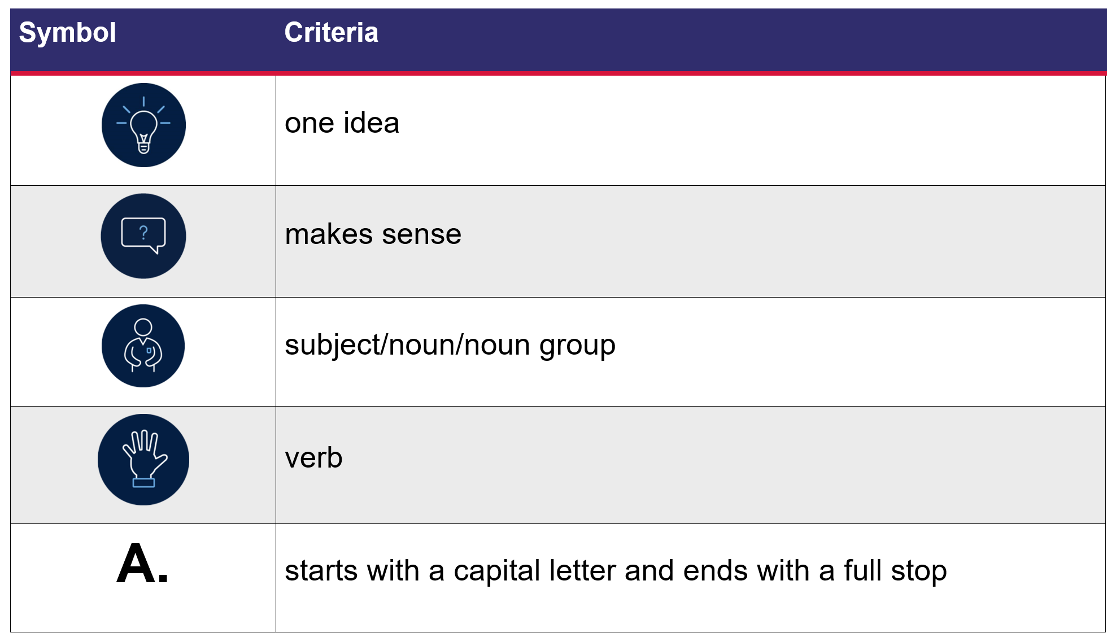

Resource 2: Subject-verb sentences – Early Stage 1
Subject (animal) | Verb (what the animal is doing)

Resource 3: Nouns and verbs – Early Stage 1
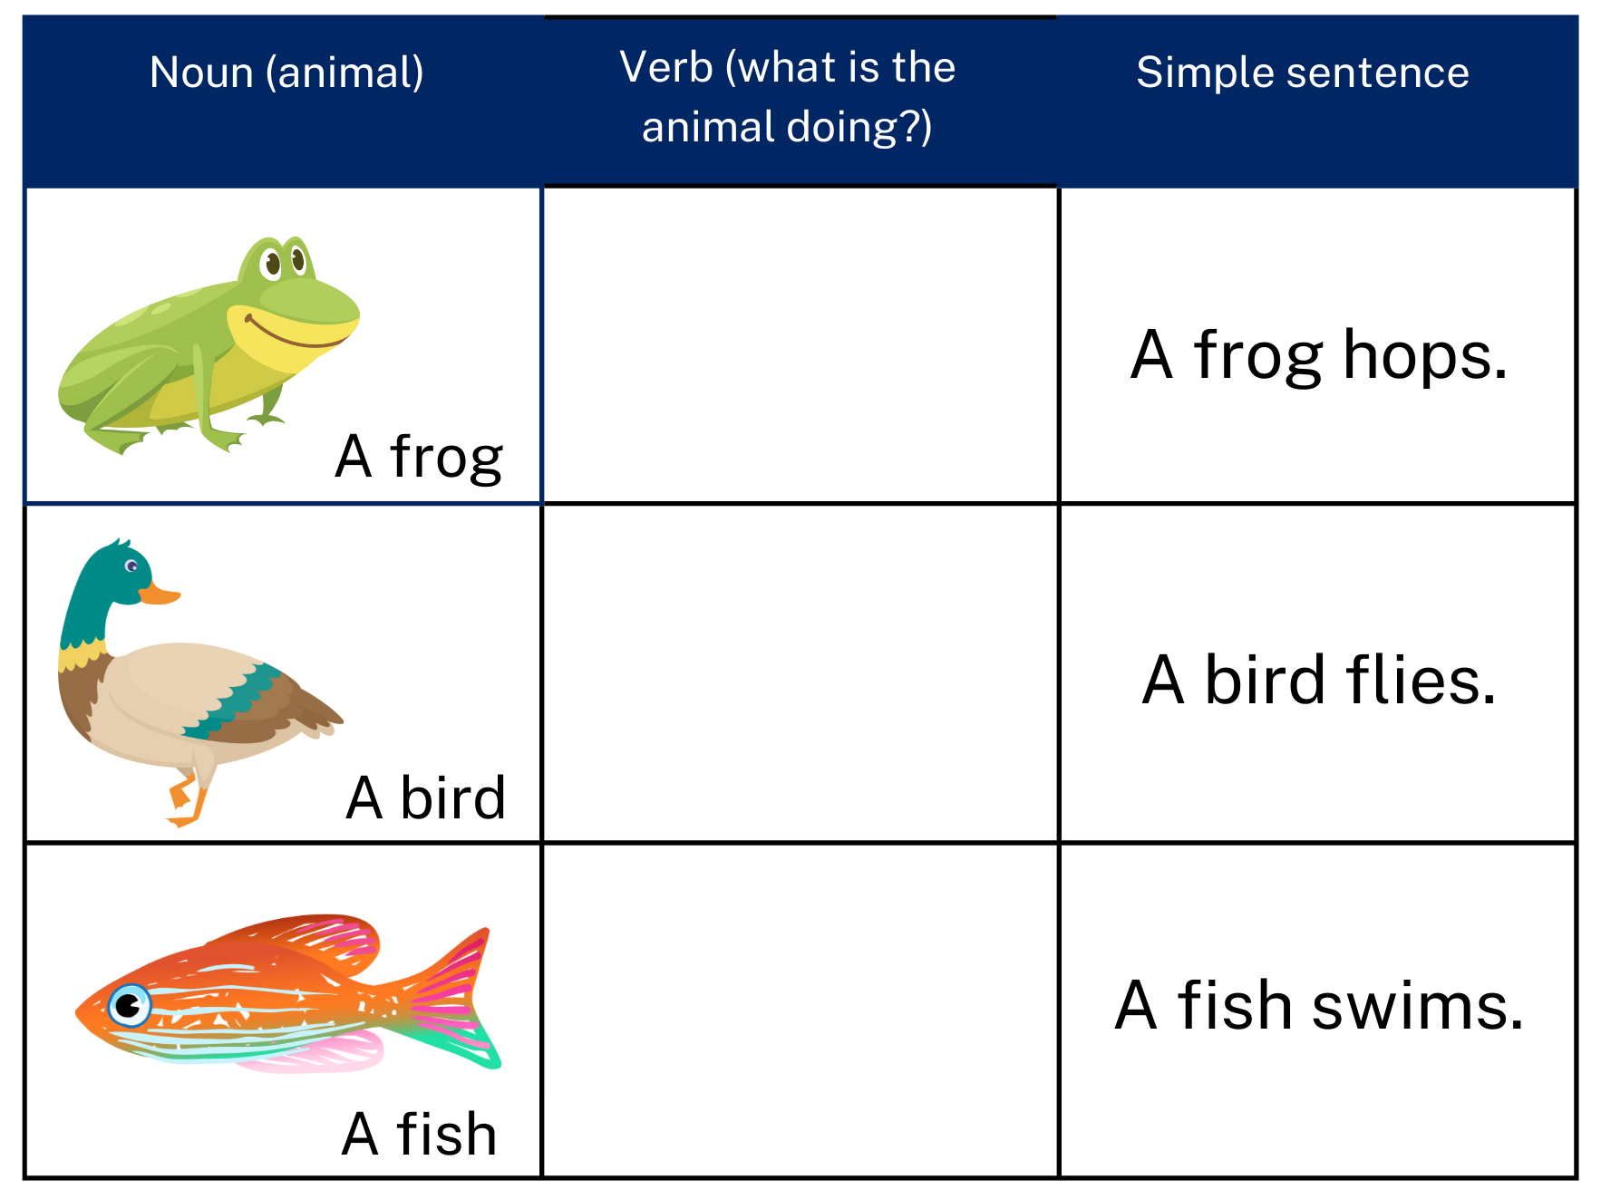
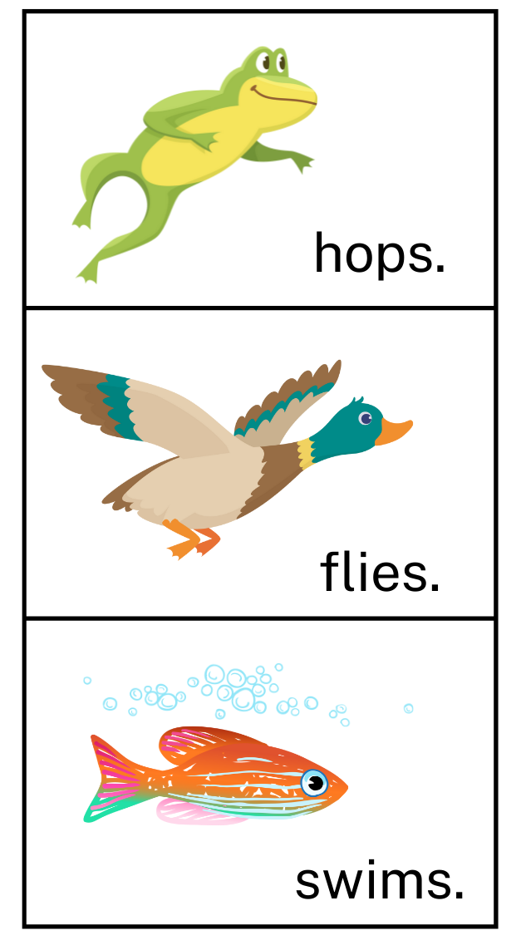
Images sourced from Canva and used in accordance with the Canva Content License Agreement.

Resource 4: Zoom in – Stage 1
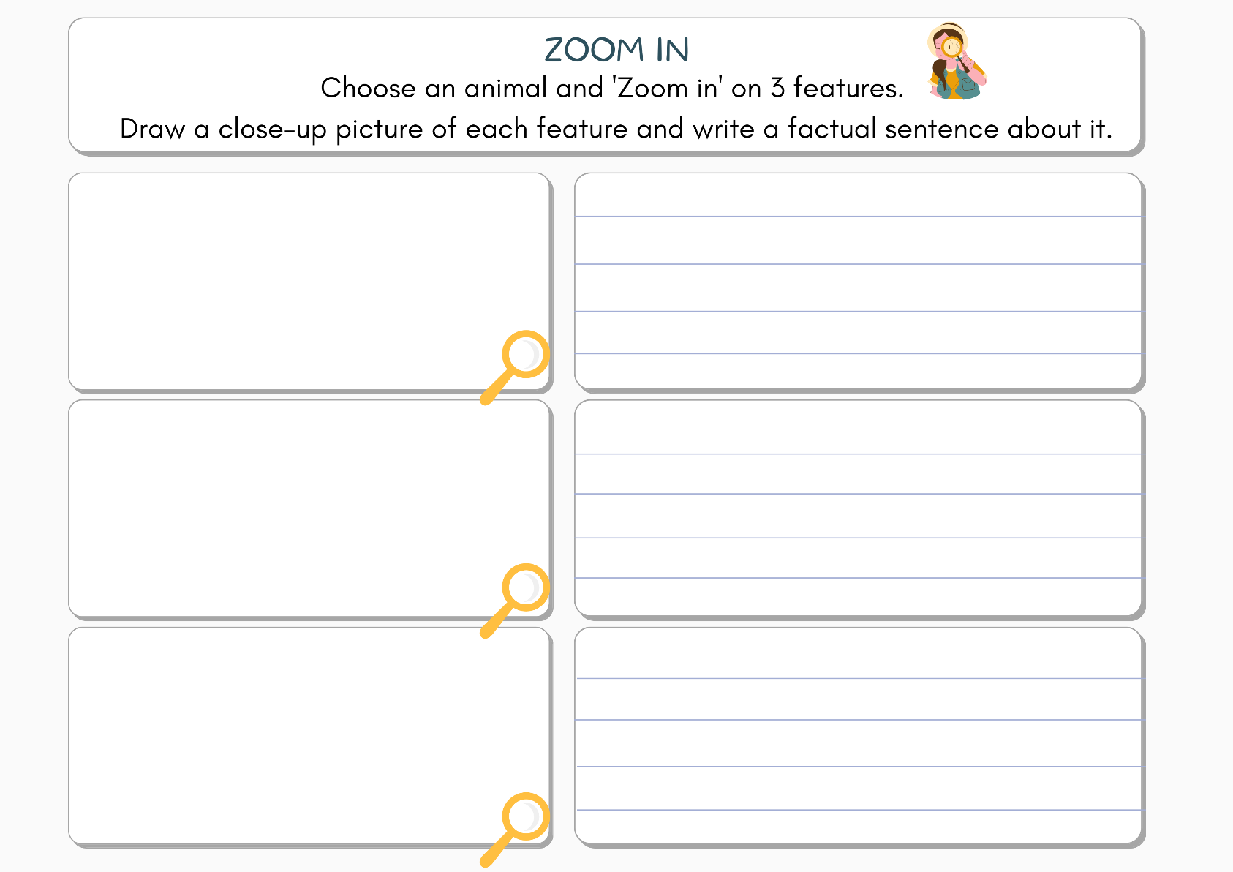
Images sourced from Canva and used in accordance with the Canva Content License Agreement.

Resource 5: Read, cut, glue – Early Stage 1
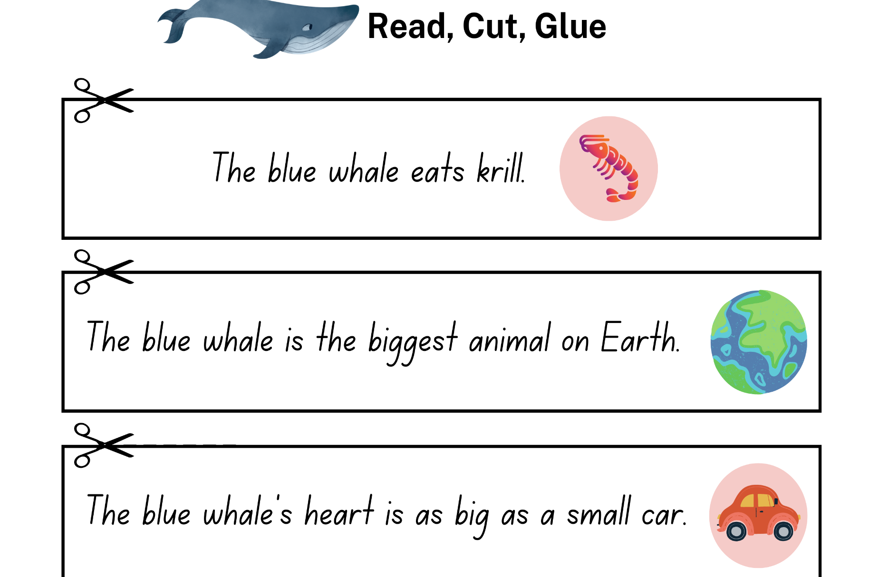
Images sourced from Canva and used in accordance with the Canva Content License Agreement.

Resource 6: Exemplar informative text – Stage 1
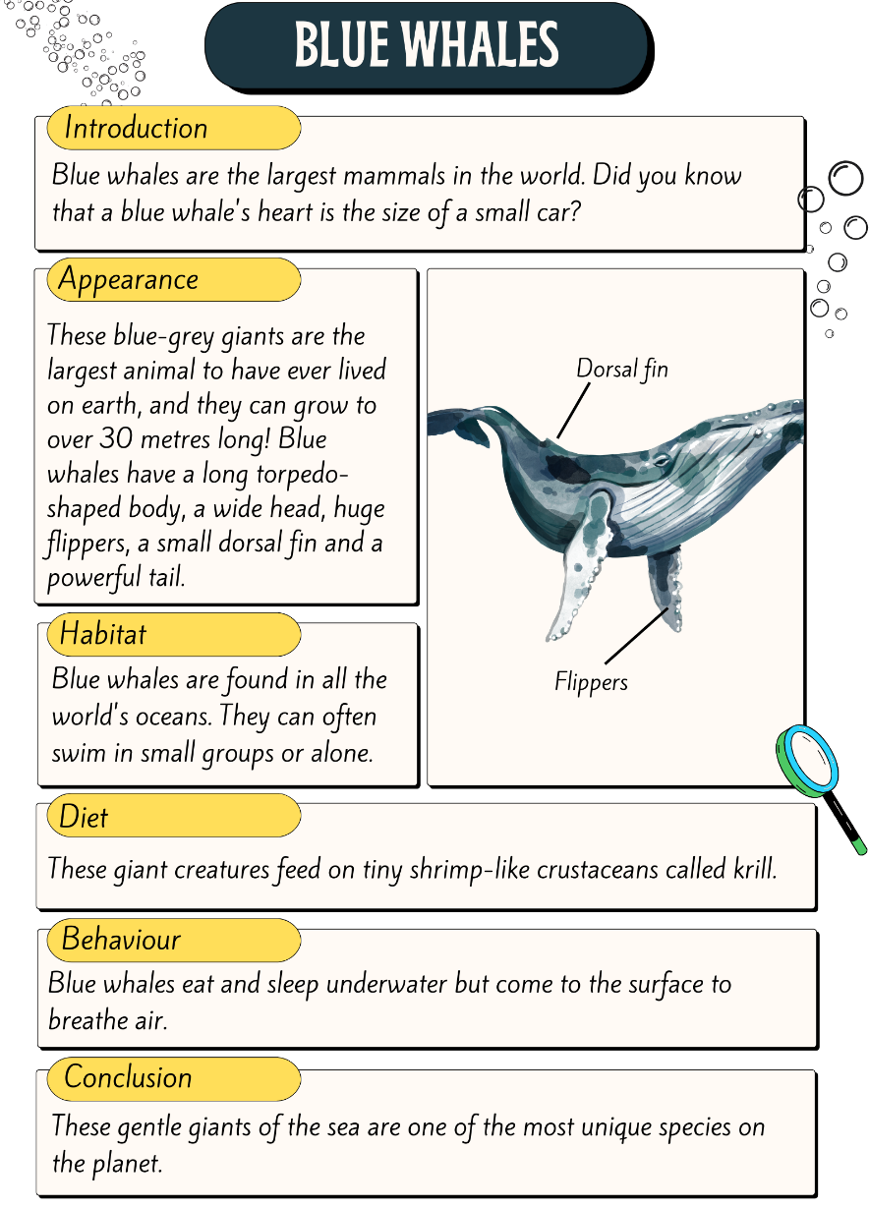
Images sourced from Canva and used in accordance with the Canva Content License Agreement.

Resource 7: Sequencing activity – Stage 1
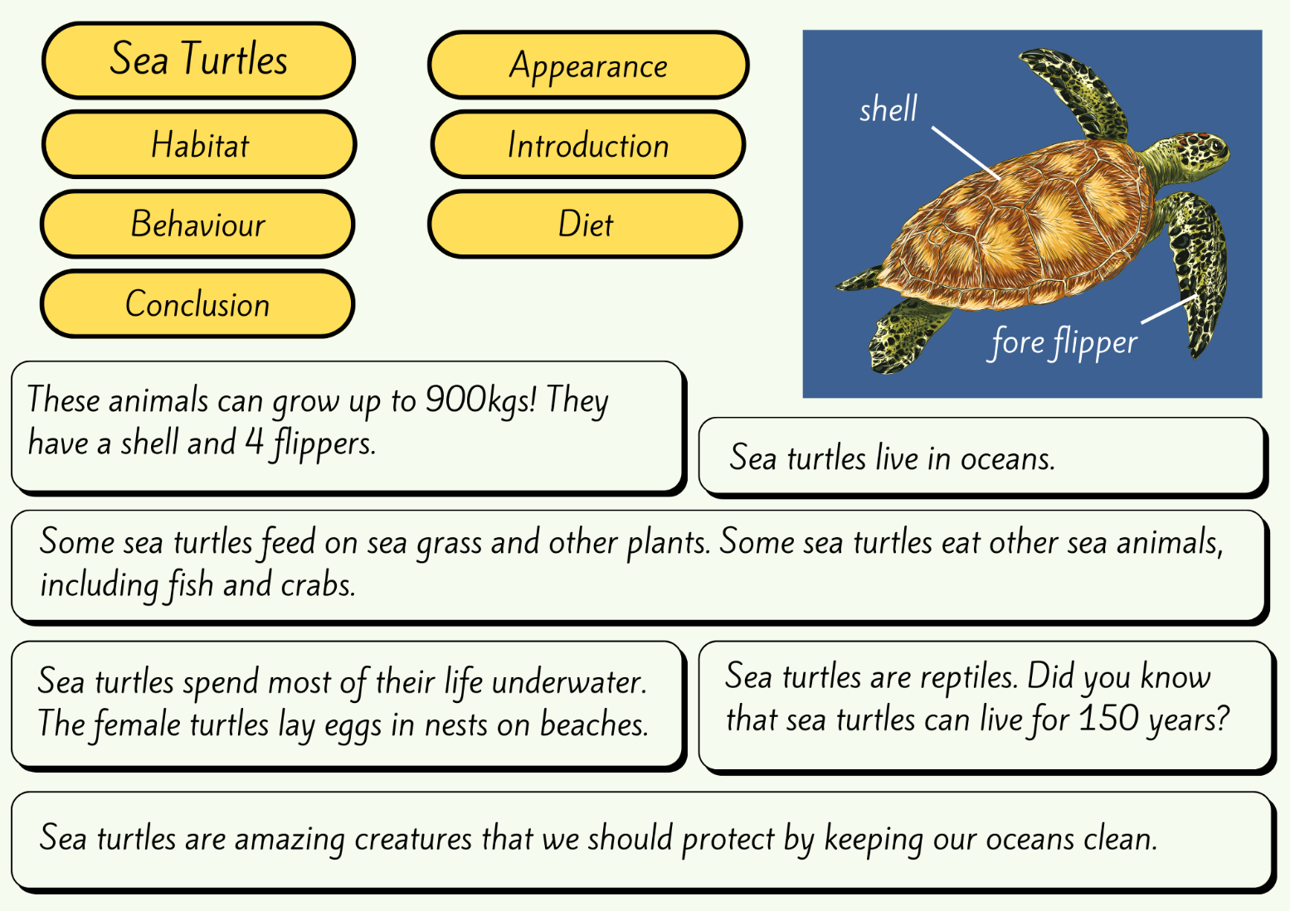
Images sourced from Canva and used in accordance with the Canva Content License Agreement.

Resource 8: Labelled diagram – Stage 1
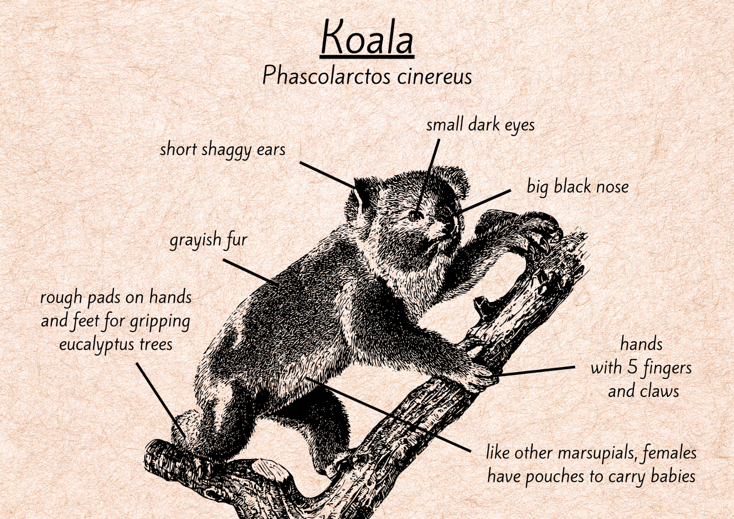
Images sourced from Canva and used in accordance with the Canva Content License Agreement.

References
Links to third-party material and websites
Please note that the provided (reading/viewing material/list/links/texts) are a suggestion only and implies no endorsement, by the New South Wales Department of Education, of any author, publisher, or book title. School principals and teachers are best placed to assess the suitability of resources that would complement the curriculum and reflect the needs and interests of their students.
If you use the links provided in this document to access a third-party's website, you acknowledge that the terms of use, including licence terms set out on the third-party's website apply to the use which may be made of the materials on that third-party website or where permitted by the Copyright Act 1968 (Cth). The department accepts no responsibility for content on third-party websites.
Except as otherwise noted, all material is © State of New South Wales (Department of Education), 2021 and licensed under the Creative Commons Attribution 4.0 International License. All other material (third-party material) is used with permission or under licence. Where the copyright owner of third-party material has not licensed their material under a Creative Commons or similar licence, you should contact them directly for permission to reuse their material.
English K–10 Syllabus © 2022 NSW Education Standards Authority (NESA) for and on behalf of the Crown in right of the State of New South Wales.
Creative Arts K–6 Syllabus © 2006 NSW Education Standards Authority (NESA) for and on behalf of the Crown in right of the State of New South Wales.
Science and Technology K–6 Syllabus © 2017 NSW Education Standards Authority (NESA) for and on behalf of the Crown in right of the State of New South Wales.
© 2021 NSW Education Standards Authority. This document contains NSW Curriculum and syllabus content. The NSW Curriculum is developed by the NSW Education Standards Authority. This content is prepared by NESA for and on behalf of the Crown in right of the State of New South Wales. The material is protected by Crown copyright.
Please refer to the NESA Copyright Disclaimer for more information.
NESA holds the only official and up-to-date versions of the NSW Curriculum and syllabus documents. Please visit the NSW Education Standards Authority (NESA) website and the NSW Curriculum website.
National Literacy Learning Progression © Australian Curriculum, Assessment and Reporting Authority (ACARA) 2010 to present, unless otherwise indicated. This material was downloaded from the Australian Curriculum website (National Literacy Learning Progression) (accessed 29 September 2022) and was not modified. The material is licensed under CC BY 4.0. Version updates are tracked in the ‘Curriculum version history’ section on the 'About the Australian Curriculum' page of the Australian Curriculum website.
ACARA does not endorse any product that uses the Australian Curriculum or make any representations as to the quality of such products. Any product that uses material published on this website should not be taken to be affiliated with ACARA or have the sponsorship or approval of ACARA. It is up to each person to make their own assessment of the product, taking into account matters including, but not limited to, the version number and the degree to which the materials align with the content descriptions and achievement standards (where relevant). Where there is a claim of alignment, it is important to check that the materials align with the content descriptions and achievement standards (endorsed by all education Ministers), not the elaborations (examples provided by ACARA).
ETA (English Teachers Association) and NSW Department of Education (2016) Context, English Textual Concepts website, accessed 29 September 2022.
ETA (English Teachers Association) and NSW Department of Education (2016) Representation, English Textual Concepts website, accessed 29 September 2022.
ETA (English Teachers Association) and NSW Department of Education (2016) The Textual Concepts and Processes resource, English Textual Concepts website, accessed 29 September 2022.
Carle E (2021) Eric Carle’s Book of Amazing Animals, Puffin, London.
National Geographic Kids (21 June 2016), ‘Blue Whale | Amazing Animals’ [video], Nat Geo Kids, YouTube, accessed 29 September 2022.
National Geographic Partners, LLC (2022), Animals, National Geographic Kids, accessed 29 September 2022.
President and Fellows of Harvard College and Harvard Graduate School of Education (2015) ‘Think, Puzzle, Explore’, Thinking Routine, Project Zero website, accessed 29 September 2022.
Primary 5 (2022) P5’s Animal Encyclopedia, Book Creator website, accessed 29 September 2022.
Taronga Zoo (7 September 2021) 'What is that Sound – Taronga Education’ [video], Taronga Education, Vimeo, accessed 29 September 2022.
Taronga Zoo (14 September 2021) 'Guess Who at the Zoo – What is that Tail? – Taronga Education’ [video], Taronga Education, Vimeo, accessed 29 September 2022.

