English – K-2 multi-age – Year A – Unit 2
Contents
Unit overview and instructions for use 3
Teacher notes 4
Outcomes and content – Component A 5
Outcomes and content – Component B 9
Week 1 13
Component A teaching and learning 13
Component B teaching and learning 14
Lesson 1: A narrative journey 16
Lesson 2: The setting 18
Lesson 3: A Bag and a Bird storyboard 20
Lesson 4: Prepositional phrases 24
Lesson 5: The Great Rabbit Chase 28
Week 2 31
Component A teaching and learning 31
Component B teaching and learning 32
Lesson 6: Creating a story map 33
Lesson 7: The Great Rabbit Chase storyboard 35
Lesson 8: Planning 38
Lesson 9: Composing 39
Lesson 10: Publishing 41
Resource 1: Sydney landmarks 43
Resource 2: Storyboard – Early Stage 1 44
Resource 3: Storyboard – Stage 1 45
Resource 4: Talking strip 46
Resource 5: Writing strip 47
Resource 6: Story map example 48
References 49
Further reading 51

Unit overview and instructions for use
This two-week unit is comprised of Component A and Component B. Connecting learning across both components is encouraged.
Teaching and learning | Component A | Component B
Suggested duration | 60 minutes | 45 minutes
Explicit teaching focus areas | - Phonological awareness (Early Stage 1)  - Print conventions (Early Stage 1)  - Phonic knowledge  - Reading fluency  - Reading comprehension  - Spelling  - Handwriting | - Oral language and communication  - Vocabulary  - Reading comprehension  - Creating written texts  - Understanding and responding to literature
To prepare for teaching and learning: | - Refer to Outcomes and content – Component A, K-2 – Instructional sequence – grapheme–phoneme correspondences [PDF 825 KB], and the teaching advice documents (hyperlinked in Component A teaching and learning table).  - Based on student needs identified through ongoing assessment data, plan and document how you will sequence teaching and learning in whole class and targeted teaching groups across the two-week cycle. | - Familiarise yourself with Outcomes and content – Component B, Textual concepts information and videos, English Textual Concepts and Learning Processes (2016), and the teaching and learning sequence.  - Based on student needs identified through ongoing assessment data, determine how you will support students in whole class and targeted teaching groups across the two-week cycle as required.
English K–10 Syllabus © 2022 NSW Education Standards Authority (NESA) for and on behalf of the Crown in right of the State of New South Wales.

Teacher notes
- Narrative is used to engage students in learning and support them to interpret their own lives. Through narrative they enter and create other worlds. Narrative is an enticing pathway for representing, understanding, and engaging with human experience and with ideas. – English Textual Concepts and Learning Processes (2016).
- Understanding of narrative can be supported through watching the department’s video: Understanding narrative video (3:51)
- For information on tiered words, suffixes, nouns, and prepositions refer to the NESA Glossary.
- A noun group is a group of words relating to, or building on, a noun. Noun groups usually consist of a pointer (the, a, an, this, that, these, those, my, your, his, her, its, our, mum’s, Mr Smith’s) plus one or more adjectives or adverbs. They are an important language resource for building descriptions.
- A prepositional phrase consists of a preposition followed by a noun or pronoun, for example, in the phrase ‘the teddy has landed under the table’, ‘under the table’ is the prepositional phrase.
- Other texts to supplement this unit could include: Hairy Maclary by Lynley Dodd, Knuffle Bunny by Mo Willems, The Great Rabbit Chase by Freya Blackwood, Possum Magic by Mem Fox, The Shopping Basket by John Burningham.
- Content points are linked to the National Literacy Learning Progression version (3).
Levels and indicators sourced from National Literacy Learning Progression © Australian Curriculum, Assessment and Reporting Authority (ACARA), (accessed 30 September 2022) and was not modified. See references for more information.

Outcomes and content – Component A
The table below outlines the focus outcomes and content. Content is linked to the National Literacy Learning Progression version (3).
Early Stage 1 Focus area and outcome | Stage 1 Focus area and outcome
Phonological awareness  ENE-PHOAW-01 – identifies, blends, segments and manipulates phonological units in spoken words as a strategy for reading and creating texts  - complete familiar spoken phrases in texts, including chants, rhymes, songs and poems (PhA1)  - segment a spoken sentence of 3 to 5 words into separate spoken words (PhA2)  - orally blend and segment syllables in words comprising up to 3 syllables (PHA2)  - orally blend up to 4 phonemes together to make a one-syllable spoken word (PhA4) | N/A
Print conventions  ENE-PRINT-01 – tracks written text from left to right and from top to bottom of the page and identifies visual and spatial features of print  - understand that Standard Australian English uses letters to represent sounds  - know the difference between a letter and a word (PKW1)  - turn pages one at a time (UnT3)  - begin reading at the top of the page and conclude reading at the bottom of the page (UnT3) | N/A
Phonic knowledge  ENE-PHOKW-01 – uses single-letter grapheme–phoneme correspondences and common digraphs to decode and encode words when reading and creating texts  - match a single-letter grapheme with a phoneme  - say the most common phoneme for a single-letter grapheme (graphs) (PKW3)  - blend single-letter grapheme correspondences to decode VC and CVC, and apply this knowledge when reading, including decodable texts. (PKW3) (PKW4) | Phonic knowledge  EN1-PHOKW-01 – uses initial and extended phonics, including vowel digraphs, trigraphs to decode and encode words when reading and creating texts  - segment and encode one-syllable high-frequency base words with split digraphs and apply this when creating texts (SpG6)  - blend and decode one-syllable words with taught extended vowel graphs and digraphs, including graphemes for r-controlled vowels and diphthongs, and apply this when reading texts (PKW6, PKW7)  - segment and encode one-syllable words with taught vowel graphs, digraphs and trigraphs and apply this when creating texts
Reading fluency  N/A | Reading fluency  EN1-REFLU-01 – sustains reading unseen texts with automaticity and prosody and self-corrects errors  - apply grapheme–phoneme correspondence to read words with automaticity (FlY1)  - use sentence punctuation to enhance reading in a conversational manner (FlY3, FlY4)
Reading comprehension  ENE-RECOM-01 – comprehends independently read texts using background knowledge, word knowledge and understanding of how sentences connect  - use background knowledge when identifying connections between a text, own life, other texts and/or the world (UnT4)  - recall key characters, events and/or information in text (UnT5) | Reading comprehension  EN1-RECOM-01 – comprehends independently read texts that require sustained reading by activating background and word knowledge, connecting and understanding sentences and whole text, and monitoring for meaning  - make text-to-self, text-to-text or text-to-world connections when reading (UnT6)  - recount relevant ideas from texts in the form of a written, visual or oral summary (UnT6)
Spelling  ENE-SPELL-01 – applies phonological, orthographic and morphological generalisations and strategies to spell taught familiar and high-frequency words when creating texts  - spell their own name (SpG1) | Spelling  EN1-SPELL-01 – applies phonological, orthographic and morphological generalisations and strategies when spelling words in a range of writing contexts  - segment single-syllable words into phonemes as a strategy for spelling (SpG4)  - spell high-frequency base words with taught vowel graphs, digraphs, split digraphs, trigraphs and quadgraphs (SpG6)  - use spelling conventions when adding tense-marking suffixes (SpG9)
Handwriting  ENE-HANDW-01 – produces all lower-case and upper-case letters to create texts  - use writing implements with a stable and relaxed pencil grip (HwK2)  - use stable posture when handwriting or drawing by sitting comfortably with feet flat on the floor, the writing arm resting on a table, with the opposite hand resting on the paper, and shoulders relaxed | Handwriting  EN1-HANDW-01 – uses a legible, fluent and automatic handwriting style, and digital technology, including word-processing applications, when creating texts  - form all letters with consistent size and slope in NSW Foundation Style from memory (HwK5)

Outcomes and content – Component B
The table below outlines the focus outcomes and content. Content is linked to the National Literacy Learning Progression version (3).
Early Stage 1 Focus area and outcome | Stage 1 Focus area and outcome
Oral language and communication  ENE-OLC-01 – communicates effectively by using interpersonal conventions and language with familiar peers and adults  - orientate self to the speaker (LiS1)  - contribute to group conversations (InT3)  - use oral language to make requests and express needs  - retell favourite stories, poems, songs and rhymes with some parts as exact repetition and some in their own words (SpK2) | Oral language and communication  EN1-OLC-01 – communicates effectively by using interpersonal conventions and language to extend and elaborate ideas for social and learning interactions  - initiate, listen and/or respond in partner and group conversations (InT3, InT5)  - organise key ideas in logical sequence
Vocabulary  ENE-VOCAB-01 – understands and effectively uses Tier 1 words and Tier 2 words in familiar contexts  - understand that texts in Standard Australian English are made up of words and groups of words that convey meaning  - recognise and understand taught Tier 1 and Tier 2 words (PKW3) (SpK3) | Vocabulary  EN1-VOCAB-01 – understands and effectively uses Tier 1, taught Tier 2 and Tier 3 vocabulary to extend and elaborate ideas  - use taught morphemic knowledge to create word families
Reading comprehension  ENE-RECOM-01 – comprehends independently read texts using background knowledge, word knowledge and understanding of how sentences connect  - use background knowledge when identifying connections between a text, own life, other texts and/or the world (UnT4)  - use visual cues in multimodal texts to interpret meaning (UnT5)  - recall key characters, events and/or information in text (UnT5) | Reading comprehension  EN1-RECOM-01 – comprehends independently read texts that require sustained reading by activating background and word knowledge, connecting and understanding sentences and whole text, and monitoring for meaning  - use known vocabulary to build a mental model of the content of the text  - make text-to-self, text-to-text or text-to-world connections when reading (UnT6)  - recount relevant ideas from texts in the form of a written, visual or oral summary (UnT6)
Creating written texts  ENE-CWT-01 – creates written texts that include at least 2 related ideas and correct simple sentences  - use personal vocabulary, words on display and in mentor texts when constructing sentences  - use drawing, images or mind maps to support planning and writing (CrT4) | Creating written texts  EN1-CWT-01 – plans, creates and revises texts written for different purposes, including paragraphs, using knowledge of vocabulary, text features and sentence structure  - write texts that describe, explain, give an opinion, recount an event, tell a story (CrT7)  - use a logical order to sequence ideas and events in sentences across a text (GrA4)  - use appropriate tense across a text (GrA4)  - use noun groups to build descriptions of people and things (CrT6)  - use contextually precise prepositional phrases when creating texts (GrA4)  - use time connectives to sequence information and events in texts (GrA4)  - use a variety of planning strategies and tools for creating texts
Understanding and responding to literature  ENE-UARL-01 – understands and responds to literature read to them  - identify, discuss and compare the beginning, middle and end in a range of narratives  - experiment with using parts and/or features of a narrative | Understanding and responding to literature  EN1-UARL-01 – understands and responds to literature by creating texts using similar structures, intentional language choices and features appropriate to audience and purpose  - identify the sequence of events that make up a narrative in own and others’ texts (UnT6)

Week 1

Component A teaching and learning
The table below can be used to plan and document lessons that address Component A outcomes and content. Both the detailed example [DOC 529KB] of a two-week teaching and learning cycle and brief example [DOC 66KB] may support you in your planning.
Focus Areas | Lesson 1 | Lesson 2 | Lesson 3 | Lesson 4 | Lesson 5
Phonological awareness (Early Stage 1) and Phonic knowledge
15 minutes
Spelling and Handwriting
15 minutes
Print conventions (Early Stage 1), Reading comprehension and Reading fluency
30 minutes

Component B teaching and learning
The following teaching and learning sequence has been designed to address Component B outcomes and content. Adapt the sequence as required to best meet the needs of your students.

Learning intention and success criteria
Learning intentions and success criteria are best co-constructed with students. The table below contains suggested learning intentions and success criteria.
Element | Early Stage 1 | Stage 1
Learning intentions | Students are learning to understand that narratives are a way of sharing life experiences and can identify their features. | Students are learning to identify narrative features and understand that authors convey messages through texts.
Success criteria | Students can:  - use background knowledge to make connections to a text  - recall characters and events in a text  - identify and discuss the beginning, middle and end in a narrative  - use drawings to retell events in a text  - use personal vocabulary and words on display to label images. | Students can:  - use background knowledge and personal experiences to make connections to a text  - use noun groups to build descriptions of people and places  - use past tense to retell familiar narratives  - use prepositional phrases  - identify the sequence of events that make up a narrative.

Resources
- Allen P (2019) A Bag and a Bird, Penguin Books Australia. ISBN: 9780143784289
- Blackwood F (2017) The Great Rabbit Chase, Scholastic Australia, Gosford. ISBN: 9781743811641
- Google Earth image of Sydney Opera House
- Resource 1: Sydney landmarks (student copies and cut outs of images for group activity)
- Resource 2: Storyboard – Early Stage 1
- Resource 3: Storyboard – Stage 1
- Resource 4: Talking strip
- Resource 5: Writing strip
- Props for story retelling, such as a plastic bag, a bucket for a bin, backpacks, hat
- Poster paper
- Copy of illustrations from the text
- Coloured markers
- Mini whiteboards
- Art and craft materials

Lesson 1: A narrative journey
The following teaching and learning activities support multi-age settings.

Whole
- Introduce the concept of narrative. Explain that narrative helps people interpret their own lives and share their life experiences. It is an enticing way to represent, understand, and engage with human experience and ideas. A narrative is an account of events which may be real or imagined and has features including characters, setting, and a sequence of events which usually lead to a problem being solved.
- Introduce the text A Bag and a Bird by Pamela Allen. Look at the images on the front cover and make predictions about who the characters are and where the story takes place. Students See, Think, Wonder using other visual elements on the front cover. On mini whiteboards, students write or draw predictions about what happens in the story. Encourage students to think about the problem and how it could be solved. Students share their predictions and explain their reasoning.
- Read the text, stopping at key points to predict what may happen next. Review students’ predictions and use thumbs up, down, or sideways to indicate how accurate their predictions were. Consider what made predictions more or less accurate.
- Identify Tier 2 vocabulary. Discuss the meaning of new or unknown words and create a list using visuals to support students understanding. For example, esplanade, harbour, ferry, parachute, waded, elderly and exhausted. Re-read phrases from the text and highlight how the illustrations help readers to understand the meaning and create a mental model of the word.
- Explore the narrative’s setting. Use the map from inside the text cover and Google Earth image of Sydney Opera House, to revisit the journey John and his mother take. Discuss where they travelled and what John and his mother saw. Explain that they were in Sydney Harbour, the traditional lands of the Gadigal peoples of the Eora Nation. Compare the 2 maps. Discuss any similarities to highlight text-to-world connections.
- Discuss the problem or complication (the bird being caught in the plastic bag) and a resolution (the man freeing the bird). Re-read the title of the text and discuss how the author has used the title to identify the importance of the story’s problem. Exemplify how authors use problems in narratives to entertain the audience and/or to teach a lesson. Discuss what the story would be like if did not include the problem and resolution. Identify the moral or lesson of the story. Discuss the environmental message in the story and how the author has used an engaging text to highlight the impact plastic has on the environment.

Part
The table below details the differentiated teaching and learning activities for each stage.
Early Stage 1 (teacher guided/independent) | Stage 1 (independent)
- Model drawing a picture of the problem in the story (the bird being caught in the plastic bag). Co-construct a sentence about the main message of the text and the importance of taking care of the environment.  - Explicitly describe the difference between letters and words. Count the number of words in the sentence and have students chorally say the sentence, reinforcing that it is a complete idea that make sense. Use ‘think alouds’ to identify simple punctuation. For example, the sentence begins with a capital letter and ends with a full stop. | - In pairs, students discuss the main message of the text and the importance of taking care of the environment.  - Students draw a scene from the text. Write about the main message and what the audience could learn from reading the text.

Lesson 2: The setting
The following teaching and learning activities support multi-age settings.

Whole
- Re-read the text A Bag and a Bird. Display Resource 1: Sydney landmarks and highlight how the text followed a journey around Sydney. Provide students an opportunity to make connections to the places visited in the text. Share students’ personal experiences.
- In small groups, provide students with cut out images from Resource 1: Sydney landmarks. Students discuss what happened in each place in the text. Encourage students to include details from the text, such as characters and key events. Students retell the story through role play. Provide props to enhance student retell. For example, a plastic bag, a bucket for a bin and back packs.
- Introduce the term ‘noun’ and explain that it is a word or group of words that name things. Create an anchor chart of nouns from the text under the headings ‘Person’, ‘Place’, and ‘Thing’. For example, John, Botanic Gardens, plastic bag. Display the anchor chart in the classroom.
- Explain that authors build descriptions of people and things using noun groups. Explain that noun groups are a group of words that build on a noun. Re-read parts of the text that describe the places visited. For example, ‘Circular Quay was full of boats and crowded with people; Noisy cars were whizzing across Harbour Bridge.’ Ask students to close their eyes to build a mental model of the content. Using the Think-Pair-Share strategy, students discuss the words that build descriptions of places from the text. Create an anchor chart of adjectives used to build descriptions and display in the classroom.

Part
The table below details the differentiated teaching and learning activities for each stage.
Early Stage 1 (independent) | Stage 1 (teacher guided)
- Students select one location from the story. Students draw a picture of the setting. Students use their background knowledge and descriptions from the text to add detail to their drawing. | - Explain that noun groups are a group of words that build on a noun and include a pointer such as his, her, the, our and one or more adjectives or adverbs. Model drawing a scene from the text. Label the drawing with noun groups. For example, a fast boat, the deep water, an elderly man.

Part
The table below details the differentiated teaching and learning activities for each stage.
Early Stage 1 (teacher guided/independent) | Stage 1 (independent)
- Display a modelled drawing of a place from the text. Model using personal vocabulary and words on display to label the picture.  - Students experiment using personal vocabulary and words on display to label their picture.  Too hard? Students orally describe their picture using personal and modelled vocabulary. Scribe a sentence for students.  Too easy? Students write sentences about their drawing. | - Students draw a scene from the text and label their drawing with noun groups.  - Students use noun groups to write a description about their place.  Too hard? Co-construct sentences using noun groups.  Too easy? Students write a short paragraph about the landmarks that are part of the story setting at Sydney Harbour. Students may need to locate additional information through online sources.
Early Stage 1 Assessment task 1 – Observations from this lesson allow students to demonstrate achievement towards the following syllabus outcome and content point:
ENE-RECOM-01 – comprehends independently read texts using background knowledge, word knowledge and understanding of how sentences connect
- use background knowledge when identifying connections between a text, own life, other texts and/or the world.
Stage 1 Assessment task 1 – Observations from this lesson allow students to demonstrate achievement towards the following syllabus outcome and content point:
EN1-RECOM-01 – comprehends independently read texts that require sustained reading by activating background and word knowledge, connecting and understanding sentences and whole text, and monitoring for meaning
- make text-to-self, text-to-text or text-to-world connections when reading.

Lesson 3: A Bag and a Bird storyboard
The following teaching and learning activities support multi-age settings.

Whole
- Re-read the text A Bag and a Bird. Review narrative features, including characters, setting, problem, sequence of events and resolution. For Early Stage 1 students, the story sequence can be described as the beginning, middle, and end.
- Display the map from the inside cover of the text and highlight the importance of the characters’ journey through the story setting.
- Explain that creating a storyboard is a useful strategy for understanding narratives, including their structure. Storyboards can be used to retell a narrative, or to plan a narrative sequence. Explain that students will use a storyboard to retell the story A Bag and a Bird.
- Using Resource 2: Storyboard – Early Stage 1, model drawing the beginning, middle, and end of the story. Use ‘think alouds’ to highlight the importance of including detailed illustrations to help readers build a mental model.

Part
The table below details the differentiated teaching and learning activities for each stage.
Early Stage 1 (independent/pairs) | Stage 1 (teacher guided/independent)
- Using Resource 2: Storyboard – Early Stage 1, students draw the beginning, middle, and end of the story. Encourage students to include detailed images, such as character facial expressions.  Too hard? Students use the modelled example to complete their storyboard. | - Explain that students will use Resource 3: Storyboard – Stage 1 to retell the story. Display the storyboard and ask students to think of the 4 main events in the story. Co-construct a written summary of the text. For example, ‘John and his mother went on an adventure to the city and took sandwiches in a plastic bag for lunch. They walked through the city to the Botanic Gardens. A gentle breeze blew the plastic bag away and the bag became caught on the bird and dragged the bird into the water. An elderly man rescued the bird and John put the bag in the bin.’  - Explain that past tense is used to retell events. Re-read the text and highlight the use of past tense verbs. For example, walked, caught, rescued.  - Discuss how students can use their morphemic knowledge to spell past tense verbs. Highlight the suffix ‘d’ or ‘ed’ to create past tense verbs. For example, walk/walked, drag/dragged, rescue/rescued. Discuss how other words change their spelling to show the past tense. For example, take/took, blow/blew, catch/caught.  - Create a list of past tense verbs and display in the classroom.

Part
The table below details the differentiated teaching and learning activities for each stage.
Early Stage 1 (pairs/teacher guided) | Stage 1 (independent)
- In pairs, students use their storyboard to describe the events from the text. Encourage students to use Tier 2 vocabulary from the mentor text. For example:  - John and his mother went to the gardens  - The bird became tangled in the bag  - The bird was rescued by the elderly man.  - Model writing a sentence that describes one of the events. Explicitly describe the difference between letters and words. Count the number of words in the sentence. Identify simple punctuation, such as a capital letter and full stop.  - Re-read the sentence and have students chorally say the sentence, reinforcing that it is a complete idea that makes sense. Ask students to identify letters, words, and simple punctuation. | - Students draw their ideas on Resource 3: Storyboard – Stage 1 in a logical sequence. Students write sentences to summarise the events in the story. Encourage students to use past tense verbs throughout their writing.  Too hard? Students draw the beginning, middle and end of the story and label their drawing.
Early Stage 1 Assessment task 2 – Observations and work samples from this lesson allow students to demonstrate achievement towards the following syllabus outcome and content points:
ENE-VOCAB-01 – understands and effectively uses Tier 1 and Tier 2 words in familiar contexts
- understand that texts in Standard Australian English are made up of words and groups of words that convey meaning
- recognise and understand taught Tier 1 and Tier 2 words.
Stage 1 Assessment task 2 – Observations from this lesson allow students to demonstrate achievement towards the following syllabus outcomes and content points:
EN1-VOCAB-01 – understands and effectively uses Tier 1, taught Tier 2 and Tier 3 vocabulary to extend and elaborate ideas
- use taught morphemic knowledge to create word families
EN1-RECOM-01 – comprehends independently read texts that require sustained reading by activating background and word knowledge, connecting and understanding sentences and whole text, and monitoring for meaning
- use known vocabulary to build a mental model of the content of the text.

Lesson 4: Prepositional phrases
The following teaching and learning activities support multi-age settings.

Whole
- Explain that authors use prepositions to tell the reader where (place) or when (time) something is in relation to something else. Create a class definition of prepositions on poster paper. Give students examples of prepositions that describe place, such as on, in, up, down, under. Ask students to brainstorm other prepositions. Record and add student responses to the class definition.
Note: A preposition is a word that begins an adverbial phrase or an adjectival phrase to indicate a circumstance such as time, place, manner or causality. For example, in, on, after, before, by, under, over, of. A prepositional phrase consists of a preposition followed by a noun or pronoun, for example, in the phrase ‘the teddy has landed under the table’, ‘under the table’ is the prepositional phrase.
- Read sections of the text, A Bag and a Bird that include prepositional phrases. Students place their hands on their head each time they hear a preposition. Create a class display of prepositions and prepositional phrases from the text. Discuss how the author has used prepositional phrases throughout the story to describe the journey of the characters. For example, onto the bridge, down the steps, past the Opera House, along the esplanade, beside the seawall, into the air, towards the shore, across the bridge, into the deep water.
- Write the sentence ‘They climbed the steps onto the bridge’. Using coloured markers, highlight the subject (they), verb (climbed), preposition (onto) and noun/object (the bridge). Repeat for the following sentences:
- He climbed over the wall.
- He waded into the water.
- Model using Resource 4: Talking strip to create a sentence with a prepositional phrase. Select and say a subject/noun group, for example ‘the dog’, then choose a verb/verb group ‘is running’, add a preposition or noun group ‘across the road.’ Complete the sentence as a whole, ‘The dog is running across the road.’
- Explicitly teach listening and responding with a partner by inviting 2 students to sit in the centre of large class circle and demonstrate how to use Resource 4: Talking strip. Explain that one student will be the listener and the other will be the speaker. Students sit knee to knee, looking at each other. The listener uses non-verbal cues to show that they are listening, such as small nods. The speaker uses voice, pitch, and pace to deliver their sentence in a clear voice. Students swap roles.
- In pairs, students use the talking strip to create sentences with a prepositional phrase. Encourage students to make requests and express needs if they are unable to hear or understand each other.
- Using an enlarged copy of the Resource 5: Writing strip, model writing student examples. For Early Stage 1 students, continue reinforcing that a sentence is a complete idea that makes sense.

Part
The table below details the differentiated teaching and learning activities for each stage.
Early Stage 1 (teacher guided/pairs) | Stage 1 (pairs/independent)
- Display the page in the text that has the illustration of John and his mother eating sandwiches while sitting on the bench in front of the birds. Model describing the position of items in the illustration. For example, ‘John is sitting on the seat.’  - In pairs, students take turns describing elements of the illustration using prepositional language.  - Model writing a sentence that describes the position of characters or key items in the illustration. Count the number of words in the sentence and have students chorally say the sentence, reinforcing that it is a complete idea that makes sense. | - Provide students with a copy of illustrations from the text, A Bag and a Bird. Students use the illustrations as a stimulus for identifying additional locations that could be described as part of the narrative journey. For example, ‘John stood on the grass and looked at the boats as they floated in the harbour.’ In pairs, students share responses.  - Using Resource 5: Writing strip, students write a series of sentences about additional locations that could be described as part of the narrative journey.  Too hard? Create a small, guided writing group and use interactive writing strategies to co-construct sentences.  Too easy? Students write sentences without the resource scaffold.

Part
The table below details the differentiated teaching and learning activities for each stage.
Early Stage 1 (independent) | Stage 1 (teacher guided)
- Students draw a picture of another event in the text. In pairs, students take turns describing their picture using prepositional language.  - Encourage students to use personal vocabulary and words on display to write words around their drawing.  Too hard? Students orally describe their picture.  Too easy? Students write their own sentences about their drawing. | - Students share their writing strips. Create a list of prepositional phrases and display in the classroom.
Early Stage 1 Assessment task 3 – Observations from this lesson allow students to demonstrate achievement towards the following syllabus outcome and content points:
ENE-OLC-01 – communicates effectively by using interpersonal conventions and language with familiar peers and adults
- use oral language to make requests and express needs
- orientate self to the speaker
- contribute to group conversations.
Stage 1 Assessment task 3 – Observations from this lesson allow students to demonstrate achievement towards the following syllabus outcome and content point:
EN1-OLC-01 – communicates effectively by using interpersonal conventions and language to extend and elaborate ideas for social and learning interactions
- initiate, listen and/or respond in partner and group conversations.

Lesson 5: The Great Rabbit Chase
The following teaching and learning activities support multi-age settings.

Whole
- Ask students what they know about rabbits. Encourage students to make connections to the topic and use their background knowledge to share any personal experiences. On mini whiteboards, students make connections to the topic by drawing images or writing associated words about rabbits. Discuss students’ connections and personal experiences. Create a concept map of ideas. Optional: Watch a video about rabbits.
- Display the text The Great Rabbit Chase. Ask students to think about what type of text this book might be by looking at the title and the illustrations on the front and back cover. Identify the characters in the text and predict what the text will be about.
- Read the text. Discuss the main message in the story and how the author has used a narrative to highlight the importance of community spirit. Encourage students to make personal connections to their own community.
- Identify Tier 2 vocabulary. Discuss the meaning of new or unknown words and create a list using visuals to support students understanding. For example, daydreaming, crinkled. Re-read the phrase ‘Mum says Edith can talk the leg off a horse.’ Ask students what they think this means. Share student responses.
- Explain that authors use descriptions to help the reader build a mental model of the characters and setting. Identify and list descriptive language from the text. For example, strong teeth, fancy black shoes, shiny blue car.

Part
The table below details the differentiated teaching and learning activities for each stage.
Early Stage 1 (pairs/independent) | Stage 1 (teacher guided/independent)
- In pairs, students describe Gumboots’s physical characteristics. Encourage students to use vocabulary from the text.  - Provide students with a range of art and craft materials. Students create an artwork of Gumboots. Suggested artworks may include: an illustration, painting, or a three-dimensional model.  - Students label their artwork to describe Gumboots. Encourage students to use personal vocabulary and words on display.  Too hard? Students orally describe Gumboots. | - Discuss how the author used the conjunction ‘for’ to add more detail to the text. For example, very sharp claws for scratching; very strong teeth for chewing.  - Students draw Gumboots in the middle of a concept map. Students label the character with noun groups from the text. Encourage students to include additional noun groups and add more information using conjunctions. For example, fast legs for running.

Whole
- Students share their work in small groups or participate in a gallery walk.

Week 2

Component A teaching and learning
The table below can be used to plan and document lessons that address Component A outcomes and content. Both the detailed example [DOC 529KB] of a two-week teaching and learning cycle and brief example [DOC 66KB] may support you in your planning.
Focus Areas | Lesson 6 | Lesson 7 | Lesson 8 | Lesson 9 | Lesson 10
Phonological awareness (Early Stage 1) and Phonic knowledge
15 minutes
Spelling and Handwriting
15 minutes
Print conventions (Early Stage 1), Reading comprehension and Reading fluency
30 minutes

Component B teaching and learning
The following teaching and learning sequence has been designed to address Component B outcomes and content. Adapt the sequence as required to best meet the needs of your students.

Learning intention and success criteria
Learning intentions and success criteria are best co-constructed with students. The table below contains suggested learning intentions and success criteria.
Element | Early Stage 1 | Stage 1
Learning intentions | Students are learning to understand that narratives are a way of sharing life experiences and can identify their features. | Students are learning to identify narrative features and understand that authors convey messages through texts.
Success criteria | Students can:  - recall characters and events in a text  - identify, discuss, and compare the beginning, middle and end in narratives  - use drawings to retell and plan a text  - use personal vocabulary and words on display to construct a sentence. | Students can:  - identify the sequence of events that make up a narrative  - compare the sequence of events in narratives  - use time connectives to sequence ideas in a logical order  - use planning strategies to create written texts  - use noun groups and prepositional phrases to build descriptions in texts.

Resources
- Blackwood F (2017) The Great Rabbit Chase, Scholastic Australia, Gosford. ISBN: 9781743811641
- Resource 2: Storyboard – Early Stage 1
- Resource 3: Storyboard – Stage 1
- Resource 6: Story map example
- Craft materials for finger puppet creation

Lesson 6: Creating a story map
The following teaching and learning activities support multi-age settings.

Whole
- Display the anchor chart of prepositions from Lesson 4. Revise the purpose of prepositions and prepositional phrases and how authors used them to describe the journey of characters. Re-read The Great Rabbit Chase and ask students to place their hands on their head when they hear a preposition or prepositional phrase. For example, down, into, through, across, in.
- Explain that students will be creating a story map of Gumboots’ journey. Create a list of places Gumboots visited and display in the classroom. Display Resource 6: Story map example. Students use visual cues, such as, the labels, images, or lines to identify the journey of Gumboots. Model drawing a story map and use ‘think alouds’ to explain the journey using prepositional phrases. For example, Gumboots went down the road, into the jungle of elm trees and through a broken paling fence.

Part
The table below details the differentiated teaching and learning activities for each stage.
Early Stage 1 (independent) | Stage 1 (teacher guided)
- Students create a story map of Gumboots’ journey. Encourage students to sequence places in order. | - Display the words before, first, then, and after and explain that these words are time connectives. Revise the purpose of time connectives to join phrases or sentences together to help understand when something is happening.  - Model using Resource 6: Story map example to write a summary of Gumboots’ journey. For example, ‘Gumboots escaped before Mum got in the shower. First, he went down a driveway and into a jungle of elm trees. Then, he ran across Mr Kirkpatrick’s backyard and over the zebra crossing. After, he ran up the main street and through the big park.’  - Highlight the use of time connectives and past tense verbs.

Part
The table below details the differentiated teaching and learning activities for each stage.
Early Stage 1 (small groups/teacher guided) | Stage 1 (independent)
- In small groups, students use their story map to retell the story in order. Encourage students to retell the story in their own words with some exact repetition from the mentor text. | - Students create their own story map and write a summary of Gumboots’ journey using time connectives and past tense verbs.  Too hard? Students orally retell the story using time connectives.
Early Stage 1 Assessment task 4 – Observations from this lesson allow students to demonstrate achievement towards the following syllabus outcomes and content points:
ENE-OLC-01 – communicates effectively by using interpersonal conventions and language with familiar peers and adults
- retell favourite stories, poems, songs, and rhymes with some parts as exact repetition and some in their own words
ENE-RECOM-01 – comprehends independently read texts using background knowledge, word knowledge and understanding of how sentences connect
- use visual cues in multimodal texts to interpret meaning.

Lesson 7: The Great Rabbit Chase storyboard
The following teaching and learning activities support multi-age settings.

Whole
- Display Resource 6: Story map example. As a class, co-construct an oral retell of the text, The Great Rabbit Chase. Explain that students will be retelling the story using a 3 or 4-part storyboard.

Part
The table below details the differentiated teaching and learning activities for each stage.
Early Stage 1 (independent/pairs) | Stage 1 (independent)
- Using Resource 2: Storyboard – Early Stage 1, students draw the beginning, middle, and end of the story. Encourage students to include detailed images, such as character facial expressions.  - In pairs, students use their storyboard to describe the events from the text. | - Using Resource 3: Storyboard – Stage 1, students draw their ideas in a logical sequence. Students write sentences to summarise the events in the story. Encourage students to use past tense verbs throughout their writing.

Whole
- Explain that the texts, A Bag and A Bird and The Great Rabbit Chase are both narratives that take the reader on a journey. In small groups, students use their storyboard from Lesson 3 to compare the 2 narrative texts. Discuss similarities between the texts. For example, both texts have animals as characters, and both take the reader on a journey. Discuss the differences between the texts. For example, one text highlights the impact plastic has on the environment and the other promotes community spirit. Share student responses.
Early Stage 1 Assessment task 5 – Observations from this lesson allow students to demonstrate achievement towards the following syllabus outcomes and content points:
ENE-RECOM-01 – comprehends independently read texts using background knowledge, word knowledge, and understanding of how sentences connect
- recall key characters, events and/or information in text
ENE-UARL-01 – understands and responds to literature read to them
- identify, discuss and compare the beginning, middle and end in a range of narratives.
Stage 1 Assessment task 4 – Observations and work samples from this lesson allow students to demonstrate achievement towards the following syllabus outcomes and content points:
EN1-OLC-01 – communicates effectively by using interpersonal conventions and language to extend and elaborate ideas for social and learning interactions
- organise key ideas in logical sequence
EN1-RECOM-01 – comprehends independently read texts that require sustained reading by activating background and word knowledge, connecting and understanding sentences and whole text, and monitoring for meaning
- recount relevant ideas from texts in the form of a written, visual or oral summary
EN1-CWT-01 – plans, creates and revises texts written for different purposes, including paragraphs, using knowledge of vocabulary, text features and sentence structure
- use appropriate tense across a text
- use time connectives to sequence information and events in texts.
EN1-UARL-01 – understands and responds to literature by creating texts using similar structures, intentional language choices and features appropriate to audience and purpose
- identify the sequence of events that make up a narrative in own and others’ texts.

Lesson 8: Planning
The following teaching and learning activities support multi-age settings.

Whole
- Explain that students will be creating their own narrative journey about an animal that escapes in their local area. Using the Think-Pair-Share strategy, students discuss what types of animals they could include in their story. For example, a pet such as a cat or fish or a zoo animal such as a monkey or giraffe.
- Students draw their character and label its features using noun groups. For example, fast legs, strong tail, fierce teeth.
Too hard? Students orally share their character descriptions.
- Display Resource 6: Story map example. Explain that Gumboots visited special places in his local area. Create a list of landmarks in your local area that the animal might see on its journey. For example, the town swimming pool, war memorial, lighthouse, lookout. Model drawing a story map of places in the local area. This will be used in Lesson 9.
- Students draw a story map of their local area. Encourage students to label their map using personal vocabulary and words on display.
- Provide students with craft materials to create a finger puppet for their character.
- Using the story map and finger puppet, students retell their animal’s journey. For example, ‘Before I got to school, my tiny puppy escaped from the backyard. First, he slid under the fence and crawled down the driveway. Then, he sprinted across the road and over the bridge. After, he ran past the shops and stopped to play at the dog park.’ Encourage Stage 1 students to sequence their ideas using time connectives.
Too easy? Students build descriptions of the setting and characters.

Lesson 9: Composing
The following teaching and learning activities support multi-age settings.

Whole
- Revise the purpose for writing, to create a narrative about an animal that escapes in the local area. Display the modelled story map from Lesson 8. Model using the example from the previous lesson to create a problem for the character. For example, ‘Before I got to school, my tiny puppy escaped from the backyard. First, he slid under the fence, but his tail got caught. Suddenly, the wind blew it open, and he quietly crawled down the driveway. Then, he sprinted across the road and over the bridge. After, he ran past the shops and stopped to play at the dog park.’

Part
The table below details the differentiated teaching and learning activities for each stage.
Early Stage 1 (independent) | Stage 1 (independent)
- Using Resource 2: Storyboard – Early Stage 1, students use their story map and retell from Lesson 8 to plan a beginning, middle, and end to their story.  - Students draw 3 events on their storyboard. | - Using Resource 3: Storyboard – Stage 1, students draw a sequence of events. Encourage students to include an interesting problem and resolution.

Part
The table below details the differentiated teaching and learning activities for each stage.
Early Stage 1 (teacher guided) | Stage 1 (pairs)
- Students share a sentence about their storyboard. Scribe sentences.  Too easy? Students label their drawing with words or phrases.  - Optional: Students record themselves saying their sentence or use voice-to-text technology. | - In pairs, students share their storyboards. Encourage students to ask clarifying questions about their partner’s story.  - Students provide peer feedback.
Early Stage 1 Assessment task 6 – Observations and work samples from this lesson allow students to demonstrate achievement towards the following syllabus outcomes and content points:
ENE-CWT-01 – creates written texts that include at least 2 related ideas and correct simple sentences
- use personal vocabulary, words on display and in mentor texts when constructing sentences
- use drawing, images or mind maps to support planning and writing
ENE-UARL-01 – understands and responds to literature read to them
- experiment with using parts and/or features of a narrative.

Lesson 10: Publishing
The following teaching and learning activities support multi-age settings.

Whole
- Revise the purpose for writing. Review students story maps from Lesson 8 and storyboards from Lesson 9.

Part
The table below details the differentiated teaching and learning activities for each stage.
Early Stage 1 (small groups) | Stage 1 (teacher guided/independent)
- In small groups, students share their storyboard and role play their story. Optional: use props to enhance the retell. | - Explain that students will be writing a text that tells a story about their animal escaping in their local area. Co-construct success criteria for writing. For example:  - sequence ideas in order  - use time connectives  - use noun groups to build descriptions  - use prepositional phrases.  - Using the storyboard from Lesson 9, students write a narrative about their animal escaping.
Stage 1 Assessment task 5 – Observations and work samples from this lesson allow students to demonstrate achievement towards the following syllabus outcome and content points:
EN1-CWT-01 – plans, creates and revises texts written for different purposes, including paragraphs, using knowledge of vocabulary, text features and sentence structure
- write texts that describe, explain, give an opinion, recount an event, tell a story
- use a logical order to sequence ideas and events in sentences across a text
- use noun groups to build descriptions of people and things
- use contextually precise prepositional phrases when creating texts
- use a variety of planning strategies and tools for creating texts.

Resource 1: Sydney landmarks
Images sourced from Canva and used in accordance with the Canva Content License Agreement.

Resource 2: Storyboard – Early Stage 1
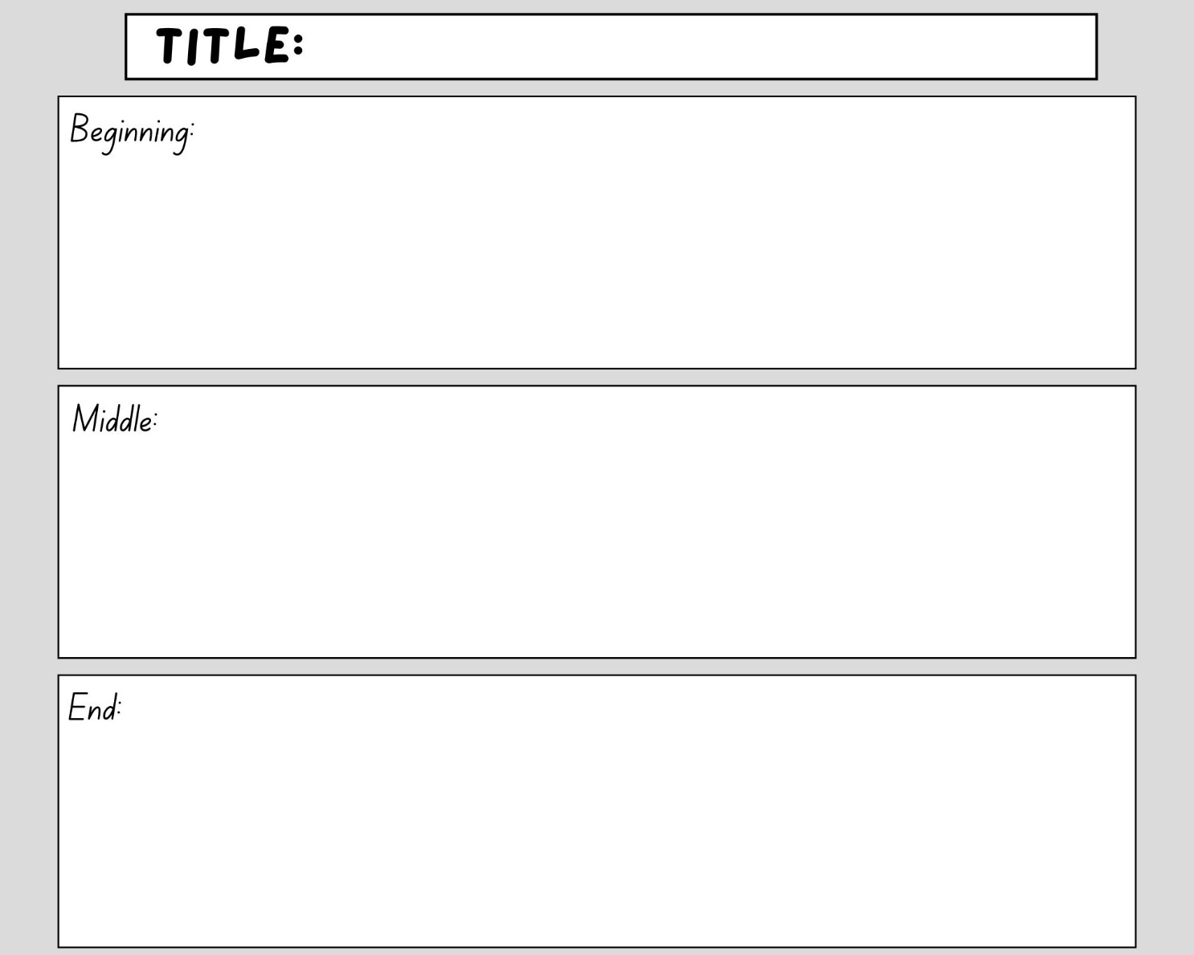

Resource 3: Storyboard – Stage 1

Resource 4: Talking strip
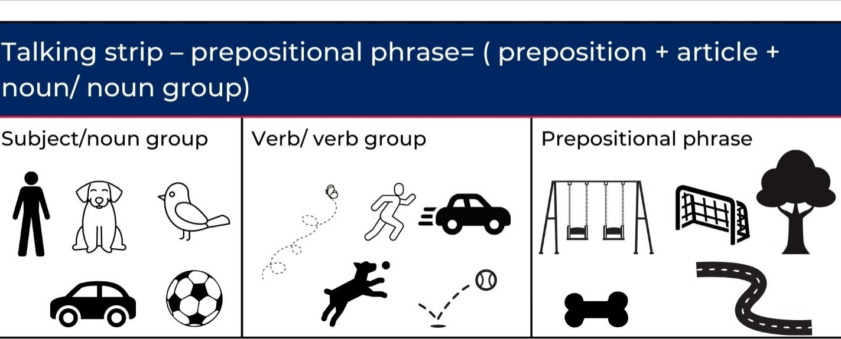
Images sourced from Canva and used in accordance with the Canva Content License Agreement.

Resource 5: Writing strip
Writing strip: Prepositional phrase = (preposition + article + noun/noun group)
Subject/noun group | Verb/verb group | Prepositional phrase

Resource 6: Story map example
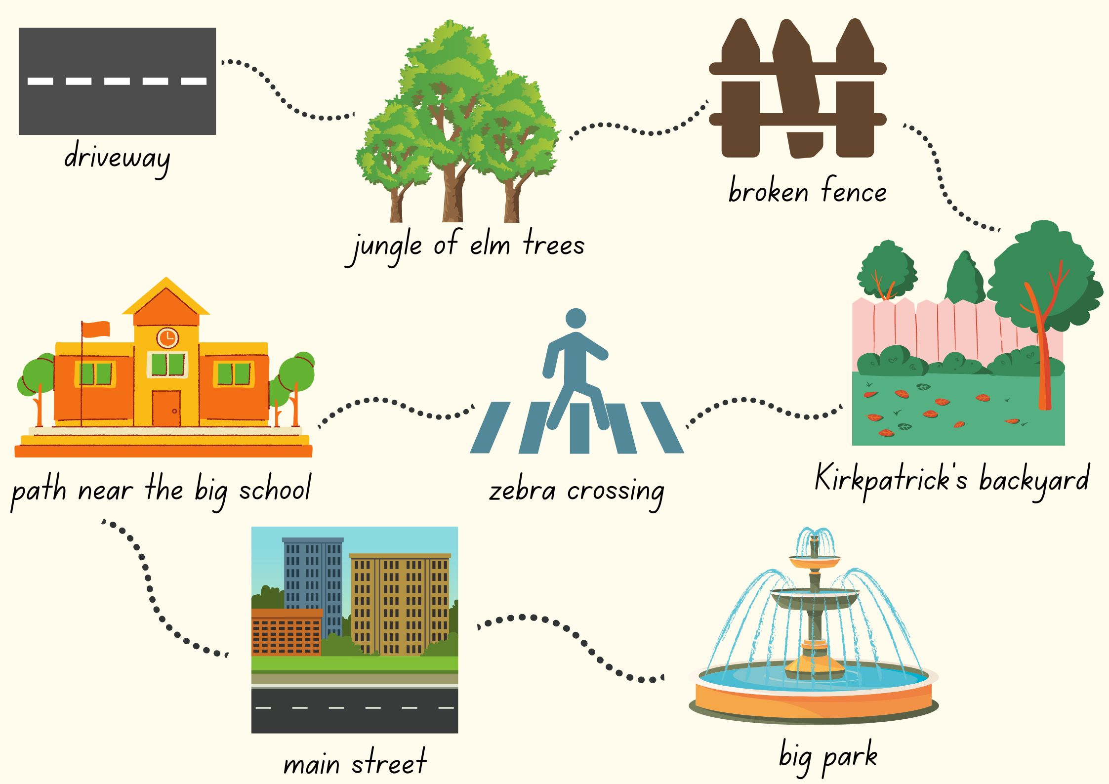
Images sourced from Canva and used in accordance with the Canva Content License Agreement.

References
Links to third-party material and websites
Please note that the provided (reading/viewing material/list/links/texts) are a suggestion only and implies no endorsement, by the New South Wales Department of Education, of any author, publisher, or book title. School principals and teachers are best placed to assess the suitability of resources that would complement the curriculum and reflect the needs and interests of their students.
If you use the links provided in this document to access a third-party's website, you acknowledge that the terms of use, including licence terms set out on the third-party's website apply to the use which may be made of the materials on that third-party website or where permitted by the Copyright Act 1968 (Cth). The department accepts no responsibility for content on third-party websites.
Except as otherwise noted, all material is © State of New South Wales (Department of Education), 2021 and licensed under the Creative Commons Attribution 4.0 International License. All other material (third-party material) is used with permission or under licence. Where the copyright owner of third-party material has not licensed their material under a Creative Commons or similar licence, you should contact them directly for permission to reuse their material.
English K–10 Syllabus © 2022 NSW Education Standards Authority (NESA) for and on behalf of the Crown in right of the State of New South Wales.
© 2021 NSW Education Standards Authority. This document contains NSW Curriculum and syllabus content. The NSW Curriculum is developed by the NSW Education Standards Authority. This content is prepared by NESA for and on behalf of the Crown in right of the State of New South Wales. The material is protected by Crown copyright.
Please refer to the NESA Copyright Disclaimer for more information.
NESA holds the only official and up-to-date versions of the NSW Curriculum and syllabus documents. Please visit the NSW Education Standards Authority (NESA) website and the NSW Curriculum website.
National Literacy Learning Progression © Australian Curriculum, Assessment and Reporting Authority (ACARA) 2010 to present, unless otherwise indicated. This material was downloaded from the Australian Curriculum website (National Literacy Learning Progression) (accessed 4 October 2022) and was not modified. The material is licensed under CC BY 4.0. Version updates are tracked in the ‘Curriculum version history’ section on the 'About the Australian Curriculum' page of the Australian Curriculum website.
ACARA does not endorse any product that uses the Australian Curriculum or make any representations as to the quality of such products. Any product that uses material published on this website should not be taken to be affiliated with ACARA or have the sponsorship or approval of ACARA. It is up to each person to make their own assessment of the product, taking into account matters including, but not limited to, the version number and the degree to which the materials align with the content descriptions and achievement standards (where relevant). Where there is a claim of alignment, it is important to check that the materials align with the content descriptions and achievement standards (endorsed by all education Ministers), not the elaborations (examples provided by ACARA).
Allen P (2019) A Bag and a Bird, Penguin Books Australia.
Blackwood F (2017) The Great Rabbit Chase, Scholastic Australia, Gosford.
ETA (English Teachers Association) and NSW Department of Education (2016) The Textual Concepts and Processes resource, English Textual Concepts website, accessed 4 October 2022.
ETA (English Teachers Association) and NSW Department of Education (2016) Narrative, English Textual Concepts website accessed 4 October 2022.
Google Earth (n.d.) Sydney Opera House, Sydney NSW [Google Earth map], accessed 4 October 2022.

Further reading
Burningham J (1993) The Shopping Basket, Red Fox, Australia.
Dodd L (2010) Hairy Maclary from Donaldson’s Dairy, Puffin, NZ.
Fox M (2013) Possum Magic (Vivas J, illus.) 30th anniversary edn, Scholastic, Australia (original work published in 1983).
Willems M (2005) Knuffle Bunny, Walker Books Australia.

