English – Early Stage 1 – Unit 20
Contents
Unit overview and instructions for use 3
Teacher notes 4
Outcomes and content – Component A 5
Outcomes and content – Component B 7
Week 1 10
Component A teaching and learning 10
Component B teaching and learning 11
Lesson 1: Forming an opinion 12
Lesson 2: Building vocabulary knowledge 14
Lesson 3: Understanding context and making connections to a text 16
Lesson 4: Exploring ideas presented in a text 17
Lesson 5: Forming opinions using compound sentences 20
Week 2 21
Component A teaching and learning 21
Component B teaching and learning 22
Lesson 6: Comparing texts to form an opinion 23
Lesson 7: Planning 25
Lesson 8: Composing 25
Lesson 9: Feedback and editing 27
Lesson 10: Publishing and reflecting 27
Resource 1: Similar or different 29
Resource 2: Images 30
Resource 3: Word cards 31
Resource 4: Different word meanings 32
Resource 5: My context 33
Resource 6: Intelligences 34
Resource 7: Planning template 35
References 36

Unit overview and instructions for use
This two-week unit is comprised of Component A and Component B. Connecting learning across both components is encouraged.
Teaching and learning | Component A | Component B
Suggested duration | 60 minutes | 45 minutes
Explicit teaching focus areas | - Phonological awareness  - Print conventions  - Phonic knowledge  - Reading fluency  - Reading comprehension  - Spelling  - Handwriting | - Oral language and communication  - Vocabulary  - Reading comprehension  - Creating written texts  - Understanding and responding to literature
To prepare for teaching and learning: | - Refer to Outcomes and content – Component A, K-2 – Instructional sequence – grapheme–phoneme correspondences [PDF 825 KB], and the teaching advice documents (hyperlinked in Component A teaching and learning table).  - Based on student needs identified through ongoing assessment data, plan and document how you will sequence teaching and learning in whole class and targeted teaching groups across the two-week cycle. | - Familiarise yourself with Outcomes and content – Component B, Textual concepts information and videos, English Textual Concepts and Learning Processes (2016), and the teaching and learning sequence.  - Based on student needs identified through ongoing assessment data, determine how you will support students in whole class and targeted teaching groups across the two-week cycle as required.
English Syllabus K–10 © 2022 NSW Education Standards Authority (NESA) for and on behalf of the Crown in right of the State of New South Wales.

Teacher notes
- Perspective is a lens through which people learn to see the world; it can clarify, magnify, distort or blur what they see. By adopting different perspectives, a responder can bring to light the underlying values in the text and construct meanings that may challenge, confirm or modify the original reading of a text. – English Textual Concepts and Learning Processes (2016).
- Understanding of perspective can be supported through watching the department’s video: Understanding perspective (3:37).
- While perspective is the mentor concept for the conceptual component of this unit, the supporting concept of context can be explored using the mentor text Same, but little bit diff’rent by Kylie Dunstan.
- For information on perspective refer to the NESA Glossary.
- Multiple Intelligences (MI) theory is explored through the supporting text All the Ways to be Smart. This theory describes different ways children learn and acquire information. These include Interpersonal, Intrapersonal, Logical-mathematical, Naturalist, Spatial, Bodily-kinesthetic, Linguistic, or Musical. For more information on multiple intelligences theory refer to Harvard Graduate School of Education.
- Reflect on student learning and engagement in activities and record differentiation and adjustments within the unit to inform future teaching and learning. One way of doing this could be to add comments to the digital file.
- Content points are linked to the National Literacy Learning Progression version (3).
Levels and indicators sourced from National Literacy Learning Progression © Australian Curriculum, Assessment and Reporting Authority (ACARA), (accessed 15 March 2023) and was not modified. See references for more information.

Outcomes and content – Component A
The table below outlines the focus outcomes and content. Content is linked to the National Literacy Learning Progression version (3).
Focus area and outcome | Content points and National Literacy Learning Progression
Phonological awareness  ENE-PHOAW-01 – identifies, blends, segments and manipulates phonological units in spoken words as a strategy for reading and creating texts  - As needed | N/A
Print conventions  ENE-PRINT-01 – tracks written text from left to right and from top to bottom of the page and identifies visual and spatial features of print  - As needed | N/A
Phonic knowledge  ENE-PHOKW-01 – uses single-letter grapheme–phoneme correspondences and common digraphs to decode and encode words when reading and creating texts | - decode words containing split digraphs and vowel digraphs (PKW5)  - experiment with encoding high-frequency words containing split digraphs and vowel digraphs
Reading fluency  ENE-REFLU-01 – reads decodable texts aloud with automaticity | - read words automatically then apply to texts  - know that pace and expression vary when reading, according to the audience and purpose
Reading comprehension  ENE-RECOM-01 – comprehends independently read texts using background knowledge, word knowledge and understanding of how sentences connect | - predict purpose, type of text or topic from title, illustration, image and/or form (UnT4)  - use background knowledge when identifying connections between a text, own life, other texts and/or the world (UnT4)  - use information or events from different parts of the text to form an opinion
Spelling  ENE-SPELL-01 – applies phonological, orthographic and morphological generalisations and strategies to spell taught familiar and high-frequency words when creating texts | - segment multisyllabic words into syllables and phonemes as a strategy for spelling  - experiment with some vowel digraphs and split digraphs to spell taught high-frequency words and/or personally significant words
Handwriting  ENE-HANDW-01 – produces all lower-case and upper-case letters to create texts | - use a stable posture when handwriting or drawing by sitting comfortably with feet flat on the floor, the writing arm resting on a table, with the opposite hand resting on the paper, and shoulders relaxed

Outcomes and content – Component B
The table below outlines the focus outcomes and content. Content is linked to the National Literacy Learning Progression version (3).
Focus area and outcome | Content points and National Literacy Learning Progression
Oral language and communication  ENE-OLC-01 – communicates effectively by using interpersonal conventions and language with familiar peers and adults | - listen for a purpose by agreeing or disagreeing, adding to the comment of others, or sharing thoughts and feelings  - use oral language to persuade, negotiate, give opinions or discuss ideas (InT4)  - use connectives such as and, but and because when speaking (SpK2)
Vocabulary  ENE-VOCAB-01 – understands and effectively uses Tier 1 words and Tier 2 words in familiar contexts | - understand words that have different meanings in different contexts  - use vocabulary that is personal  - use vocabulary that is specific to key learning areas (SpK3, CrT3)
Reading comprehension  ENE-RECOM-01 – comprehends independently read texts using background knowledge, word knowledge and understanding of how sentences connect | - identify conjunctions in a compound sentence, their meaning and purpose  - predict purpose, type of text or topic from title, illustration, image and/or form (UnT4)  - use background knowledge when identifying connections between a text, own life, other texts and/or the world (UnT4)  - recount the relevant ideas from the text (UnT5)  - use information or events from different parts of the text to form an opinion
Creating written texts  ENE-CWT-01 – creates written texts that include at least 2 related ideas and correct simple sentences | - create a text including at least 2 related ideas (CrT5)  - experiment with writing compound sentences and recognise that each clause makes meaning by itself (GrA4)  - understand that punctuation is a feature of written language and how it impacts meaning  - explain the purpose of a verb, a noun and an adjective in own writing (GrA2, GrA3)  - intentionally select nouns, verbs, adjectives and articles in own writing  - understand they can improve their writing based on feedback from teachers  - edit their texts after receiving feedback
Understanding and responding to literature  ENE-UARL-01 – understands and responds to literature read to them | - compare opinions of a text or characters with peers (InT2)  - express likes and dislikes about a text (UnT5)  - identify aspects of their own world represented in texts (UnT4)

Week 1

Component A teaching and learning
The table below can be used to plan and document lessons that address Component A outcomes and content. Both the detailed example [DOC 529KB] of a two-week teaching and learning cycle and brief example [DOC 66KB] may support you in your planning.
Focus Areas | Lesson 1 | Lesson 2 | Lesson 3 | Lesson 4 | Lesson 5
Phonological awareness and
Phonic knowledge
15 minutes
Spelling and Handwriting
15 minutes
Print conventions,
Reading comprehension and Reading fluency
30 minutes

Component B teaching and learning
The following teaching and learning sequence has been designed to address Component B outcomes and content. Adapt the sequence as required to best meet the needs of your students.

Learning intention and success criteria
Learning intentions and success criteria are best co-constructed with students.

Learning intention
Students are learning to understand the textual concept ‘perspective’ by developing and comparing opinions.

Success criteria
Students can:
- use information from texts to form opinions
- understand that words have different meanings in different contexts
- identify aspects of their own world represented in texts
- recount ideas presented in a text
- use conjunctions to form compound sentences.

Resources
- Dunstan K (2012) Same, but little bit diff’rent, Windy Hollow Books, Australia. ISBN:9781921136603
- Bell D (2018) All the Ways to be Smart (Colpoys A, illus.) Scribe Publications, Australia. ISBN: 9781925713435
- Resource 1: Similar or different
- Resource 2: Images
- Resource 3: Word cards
- Resource 4: Different word meanings
- Resource 5: My context
- Resource 6: Intelligences
- Enlarged Venn diagram
- Mini whiteboards
- Soft ball or beanbag

Lesson 1: Forming an opinion
- Place a label on either side of the classroom, one with the word ‘Similar’ and the other with the word ‘Different’. Explain that students will view 2 images and form an opinion about whether they think the images are similar or different. Display the first card from Resource 1: Similar or different. Students move to the side of the classroom with the label that reflects their opinion. In groups, students share what they think (their opinion) and provide a reason why. For example, I think the images are the same because both children are swimming. I think the images are different because one is at the river and the other is at a pool. Share student responses. Highlight the similarities and differences between students’ ideas.
- Display the second card from Resource 1: Similar or different. On mini whiteboards, students record their opinion using a ‘because’ statement. In small groups, students take turns sharing their opinion. Encourage students to add to the comment of others and build on their ideas. Repeat the activity with the last card from the resource.
Too hard? Students orally share their opinion using a ‘because’ statement.
Too easy? Students draw and write about 2 ideas that are similar and different. Students justify their opinion with elaborations to support their reasoning.
- Revise the concept of perspective as a lens through which people learn to see the world. Explain that developing and comparing opinions is one way to explore perspective. Discuss how students’ personal experiences and interests (their perspective) shape their opinions.
- Introduce the text, Same, but little bit diff’rent. Encourage students to make predictions about the text using the front and back covers, title and illustrations. Read the blurb. Provide time for students to share their ideas.
- Read the text. Identify new vocabulary and clarify the meaning of new or unknown words. For example, billabong, soar, wise, weaves.
- Discuss the purpose of the text (to entertain) and the author’s message. For example, the text celebrates diversity by highlighting ways people can be different while also sharing similarities. Identify ways that the author engages the reader. For example, illustrations (collage), language features (dialogue, repetition) and text layout. Review student predictions from activity 4.
- Students stand in a circle and take one step forward if they agree and one step backward if they disagree with a statement, such as:
- Your favourite colour is blue.
- You love playing outside.
- You have a pet at home.
- You love spending time with friends.
- You like rainy days.
- As a class, discuss the similarities and differences between students’ opinions.

Lesson 2: Building vocabulary knowledge
- Re-read the title of the text, Same, but little bit diff’rent. Identify the conjunction ‘but’ and discuss its meaning and purpose. For example, the word ‘but’ connects ideas that contrast.
- Display Resource 2: Images. Ask students what they think each image is and discuss student responses. Encourage students to use language from the text. For example, ‘This is an image of a flock of birds soaring overhead.’ Display Resource 3: Word cards. As a class, read the words. Explain that students will match the images to the word cards.
- Provide each student with one card from Resource 2: Images or Resource 3: Word cards. Students walk around the classroom to find the person with the corresponding card. Encourage students to ask questions to find their matching card. For example, students could ask if someone else has the card with the flock of birds.
- Re-read the text.
- Identify and record words from the text that have different meanings when used in different contexts. For example, ties, can, bit, leaves and plant. Re-read the sentences they are in and discuss the meaning of the word in the context of the book. For example, ‘She dyes the leaves special colours from berries and roots, then twists and ties the leaves into beautiful baskets, mats and bowls.’ Ask students what they know about the word ‘ties’. Write the word and use drawings to co-construct what the word could mean, emphasising that the meaning can change depending on context. For example, draw people wearing ties (plural noun) and people tying a knot (verb). Repeat with other appropriate words from the text.
- Display Resource 4: Different word meanings and read the examples from the text. Discuss the pictures on the resource and model writing a sentence to show how words can have different meanings when used in different contexts. For example, ‘My brother admired the colourful ties at the shop.’ Discuss the use of punctuation, including full stops and capital letters for the beginning of a sentence.
- Students Think-Pair-Share sentences using the pictures and words from the resource (ties, plant, can).
- Students complete Resource 4: Different word meanings.
Too hard? Students draw and orally share their sentences.
Too easy? Students write sentences using different words from the text, such as ‘plant’ and ‘bit’.
- As a class, share student’s sentences. Discuss the similarities and differences between ideas.
Early Stage 1 Assessment task 1 – Observations and work samples from this lesson allow students to demonstrate achievement towards the following syllabus outcomes and content points:
ENE-VOCAB-01 – understands and effectively uses Tier 1 words and Tier 2 words in familiar contexts
- understand words that have different meanings in different contexts.
ENE-RECOM-01 – comprehends independently read texts using background knowledge, word knowledge and understanding of how sentences connect
- identify conjunctions in a compound sentence, their meaning and purpose.

Lesson 3: Understanding context and making connections to a text
- Discuss where Same, but little bit diff’rent is set and use clues from the text to support students’ thinking. Re-read the sentence ‘Right up the very top of Australia there is a special place.’ Using an interactive map, such as Google Earth, locate the Northern Territory. Identify students’ location on the map and discuss similarities and differences between the 2 locations.
- Re-read the text and revise the concept of context. Explain that where someone lives, what they have done and what they know affects what they can speak and write about.
- As a class, identify the similarities between the lives, activities and interests of the characters presented in the text. For example, eating fish, swimming, pets, playing games. Record ideas in the middle of an enlarged Venn diagram.
- Students Think-Pair-Share the differences between the contexts presented in the text. For example, swimming in rivers or in a pool, having a pet dog or a pet crocodile, catching fish or buying fish at the markets. Record examples in the outside circles of the Venn diagram.
- In small groups, students make connections between the text and their own life. Students discuss how their context compares to the contexts presented in the text and what the similarities and differences are. Encourage students to consider their own culture, setting, activities or experiences. Share student responses.
- Display Resource 5: My context. Read the example as a class. Explain that students will use the ideas from activity 3 to identify things that are similar to their context. For example, pets. Students write a sentence about their experiences in their own context. For example, ‘My pet rabbit lives in a cage and eats carrots.’
- Students complete Resource 5: My context.
Too hard? Students draw and label similarities between their context and the context in the book.
Too easy? Students write about the similarities and differences between the 2 contexts presented in the text and their own context.
- In small groups, students share their responses and discuss similarities and differences between their contexts.
Early Stage 1 Assessment task 2 – Observations and work samples from this lesson allow students to demonstrate achievement towards the following syllabus outcomes and content points:
ENE-VOCAB-01 – understands and effectively uses Tier 1 words and Tier 2 words in familiar contexts
- use vocabulary that is personal.
ENE-RECOM-01 – comprehends independently read texts using background knowledge, word knowledge and understanding of how sentences connect
- use background knowledge when identifying connections between a text, own life, other texts and/or the world.
ENE-UARL-01 – understands and responds to literature read to them
- identify aspects of their own world represented in texts.

Lesson 4: Exploring ideas presented in a text
- Display the front cover of the text All the Ways to be Smart. Students predict the purpose of the text from the title and illustrations. As a class, brainstorm synonyms for ‘smart.’ For example, clever, bright, intelligent, wise.
- Students Think-Pair-Share different ways that someone can be ‘smart’. In pairs, students take turns performing a still image with their bodies or a freeze frame to show an example of what ‘smart’ could look like. For example, writing a story, playing an instrument. Share students’ ideas and record ways to be smart on an anchor chart.
- Read the text and discuss the meaning of new or unknown words. For example, cubbies, ukulele, prances, potions. Confirm students’ predictions about the purpose of the text (to entertain) and discuss ways the author engages readers. For example, language features (rhyme, repetition, use of lists) and illustrations.
- Compare the illustrations of the 2 children seated at their desk on the first and last page. Look closely at the illustrations and discuss the similarities and differences. Ask students if their opinion or perspective of the ways someone can be ‘smart’ has changed (from activity 2).
- Display Resource 6: Intelligences. Explain what intelligence means (the ability to learn and understand). Explain that Davina Bell, the author of All the Ways to be Smart, believes that every child has unique qualities and intelligences. Discuss the author’s message and how children can show their intelligence through different activities.
- Using Resource 6: Intelligences as a guide, discuss the different ways children can be ‘smart’ using examples from the text. For example:
- Self smart – ‘Floating off on daytime dreams’
- People smart – ‘Sharing, caring’
- Music smart – ‘Ukelele! “Finger clicking!”’
- Nature smart – ‘Flower picking’
- Body smart – ‘Crazy dances!’
- Picture smart – ‘Drawing things with claws’
- Number smart – ‘Counting all the way past forty’
- Word smart – ‘Reading, writing, spelling’
- Revisit the anchor chart from activity 2. Record any new ideas that are explored in the text. For example, smart at building cubbies from boxes, smart at sharing and caring.
- Explain that students will draw and write about the different ways children can be smart using examples from the text. Model writing a sentence using correct punctuation. For example, ‘Children can be smart at painting patterns and making up new games.’
- Students use other examples from the text to draw and write sentences about ways children can be smart. Encourage students to use correct punctuation and experiment with writing compound sentences to join ideas together.
Too hard? Students draw and label their ideas.
- In pairs, students share their sentences.
Early Stage 1 Assessment task 3 – Observations and work samples from this lesson allow students to demonstrate achievement towards the following syllabus outcomes and content points:
ENE-VOCAB-01 – understands and effectively uses Tier 1 words and Tier 2 words in familiar contexts
- use vocabulary that is specific to key learning areas.
ENE-RECOM-01 – comprehends independently read texts using background knowledge, word knowledge and understanding of how sentences connect
- predict purpose, type of text or topic from title, illustration, image and/or form
- recount the relevant ideas from the text.

Lesson 5: Forming opinions using compound sentences
- Read the following sentence from the text, ‘Every hour of every day, we’re smart in our own special way.’ Ask students to consider what makes them ‘smart’. Students stand and spread out around the classroom. Students share one way they are smart as they pass around a beanbag or a soft ball. Encourage students to think about different types of intelligences (refer to Resource 6: Intelligences), personal experiences, strengths and interests to shape their opinion and ideas. Continue passing the ball or beanbag until all students have shared.
- Using student ideas from activity 1, model writing a compound sentence about one way to be smart. For example, ‘I am music smart because I sing songs that make my family happy.’ Deconstruct the sentence. Highlight the use of punctuation and circle the conjunction (because). Discuss the purpose of the conjunction (to connect ideas and show reason) and highlight how each clause makes meaning by itself.
- Students draw and write about how they are smart. Encourage students to experiment with compound sentences, using the conjunction ‘because’ to include reasons why.
Too easy? Students elaborate on their ideas and provide examples to support their reasoning.
- As a class, compare students’ opinions about the ways they are smart and encourage students to celebrate each other’s diverse strengths and intelligences.

Week 2

Component A teaching and learning
The table below can be used to plan and document lessons that address Component A outcomes and content. Both the detailed example [DOC 529KB] of a two-week teaching and learning cycle and brief example [DOC 66KB] may support you in your planning.
Focus Areas | Lesson 6 | Lesson 7 | Lesson 8 | Lesson 9 | Lesson 10
Phonological awareness and
Phonic knowledge
15 minutes
Spelling and Handwriting
15 minutes
Print conventions,
Reading comprehension and Reading fluency
30 minutes

Component B teaching and learning
The following teaching and learning sequence has been designed to address Component B outcomes and content. Adapt the sequence as required to best meet the needs of your students.

Learning intention and success criteria
Learning intentions and success criteria are best co-constructed with students.

Learning intention
Students are learning to understand the textual concept of ‘perspective’ by developing and comparing opinions.

Success criteria
Students can:
- express likes and dislikes about a text
- use information from texts to form an opinion
- compare their opinions with their peers
- use compound sentences in own writing
- use feedback to edit and improve writing.

Resources
- Dunstan K (2012) Same, but little bit diff’rent, Windy Hollow Books, Australia. ISBN:9781921136603
- Bell D (2018) All the Ways to be Smart (Colpoys A, illus.) Scribe Publications, Australia. ISBN: 9781925713435
- Resource 6: Intelligences
- Resource 7: Planning template
- Enlarged T-chart (2 copies)

Lesson 6: Comparing texts to form an opinion
- Review the texts, Same, but little bit diff’rent and All the Ways to be Smart. Revise the intended purpose of each text (to entertain) and the authors’ messages.
- Display Same, but little bit diff’rent and an enlarged T-chart with the headings ‘liked’ and ‘disliked’. Ask students what they liked and disliked about the text. Ask guiding questions, such as:
- Did you like/dislike the language features the author used? For example, rhyme, repetition, dialogue between characters.
- Did you like/dislike the illustrations in the text? For example, the use of collage.
- Do you like/dislike the perspective of the characters in the text? Why or why not?
- Did you like/dislike the topic of the text? Were you able to make personal connections to this text?
Share and record student responses.
- Display All the Ways to be Smart and an enlarged T-chart with the headings ‘liked’ and ‘disliked’. Using the guiding questions from activity 2, ask students what they liked and disliked about the text. Record student responses.
- Place the 2 texts on opposite sides of the classroom. Ask students to consider which text they liked the most. Students move to the side of the classroom that reflects their opinion. In small groups, students discuss reasons why. Encourage students to use connectives to add to the comments of others and build on their ideas.
- Students draw and write about which book they liked the most and provide reasons why. Encourage students to use ideas recorded on the T-charts.
Too hard? Students draw their favourite book and orally share reasons why.
- In small groups, students compare their opinions, identifying similarities and differences between ideas.
Early Stage 1 Assessment task 4 – Observations and work samples from this lesson allow students to demonstrate achievement towards the following syllabus outcomes and content points:
ENE-OLC-01 – communicates effectively by using interpersonal conventions and language with familiar peers and adults
- listen for a purpose by agreeing or disagreeing, adding to the comment of others, or sharing thoughts and feelings
- use oral language to persuade, negotiate, give opinions or discuss ideas
- use connectives such as and, but and because when speaking.
ENE-RECOM-01 – comprehends independently read texts using background knowledge, word knowledge and understanding of how sentences connect
- use information or events from different parts of the text to form an opinion.
ENE-UARL-01 – understands and responds to literature read to them
- compare opinions of a text or characters with peers
- express likes and dislikes about a text.

Lesson 7: Planning
- Explain that students will contribute to a class book by adapting the text, All the Ways to be Smart. Students will write a short text about the different ways the class is ‘smart’. Discuss the purpose for writing (to convey an opinion about ways their class is ‘smart’).
- Using Resource 6: Intelligences as a guide, revise the different ways children can be ‘smart’. In pairs, students reflect on their learning and identify ways their class is smart. Share ideas as a class.
- Students use Resource 7: Planning template to record the different ways the class is smart.
- Co-construct success criteria for writing. For example:
- include 2 related ideas (give an opinion and provide a reason why)
- use compound sentences
- include punctuation (capital letters, full stops)
- use nouns, verbs, adjectives and articles.
- Display success criteria in the classroom to use in Lesson 8 and Lesson 9.

Lesson 8: Composing
- Revise the purpose for writing (to convey an opinion about the ways their class is ‘smart’). Review students’ planned ideas and success criteria from Lesson 7.
- Model using one of the planned ideas to write an opinion. For example, ‘Our class is smart because we paint interesting pictures.’ Revise the purpose of verbs, nouns and adjectives. In pairs, students deconstruct their sentences by identifying the nouns, verbs and adjectives and discussing the purpose of each.
- Students use their planned ideas to write an opinion about why their class is smart.
Too hard? Co-construct sentences about why the class is smart.
Too easy? Students elaborate on their ideas and provide examples to support their reasoning.
- In pairs, students share and deconstruct their sentences. Students identify the nouns, verbs and adjectives and explain the purpose of each.
Early Stage 1 Assessment task 5 – Observations and work samples from this lesson allow students to demonstrate achievement towards the following syllabus outcome and content points:
ENE-CWT-01 – creates written texts that include at least 2 related ideas and correct simple sentences
- create a text including at least 2 related ideas
- experiment with writing compound sentences and recognise that each clause makes meaning by itself
- understand that punctuation is a feature of written language and how it impacts meaning
- explain the purpose of a verb, a noun and an adjective in own writing
- intentionally select nouns, verbs, adjectives and articles in own writing.

Lesson 9: Feedback and editing
- Discuss the importance of using success criteria and feedback to edit and improve writing. Display success criteria from Lesson 7 and revise different peer feedback strategies.
- Sit students in a circle with their writing samples from Lesson 8. Read through each success criteria statement while students reflect on their writing. Discuss and share examples that meet the success criteria.
- Using the success criteria, students provide peer feedback. Provide time for students to apply feedback and edit their work.
Early Stage 1 Assessment task 6 – Observations and work samples from this lesson allow students to demonstrate achievement towards the following syllabus outcome and content points:
ENE-CWT-01 – creates written texts that include at least 2 related ideas and correct simple sentences
- understand they can improve their writing based on feedback from teachers
- edit their texts after receiving feedback.

Lesson 10: Publishing and reflecting
- Revise how authors use illustrations to represent their ideas and expand meaning. Explain that students will publish their writing for a class book and add illustrations.
- Provide time for students to publish and illustrate their section of the class book, then collate the published versions.
- Optional: add photos to the class book showcasing learning throughout the year and provide students with a copy to take home.
- Students reflect on their learning throughout the unit and complete an exit ticket using one or more of these sentence starters:
- An opinion is …
- Opinions can be different because…

Resource 1: Similar or different
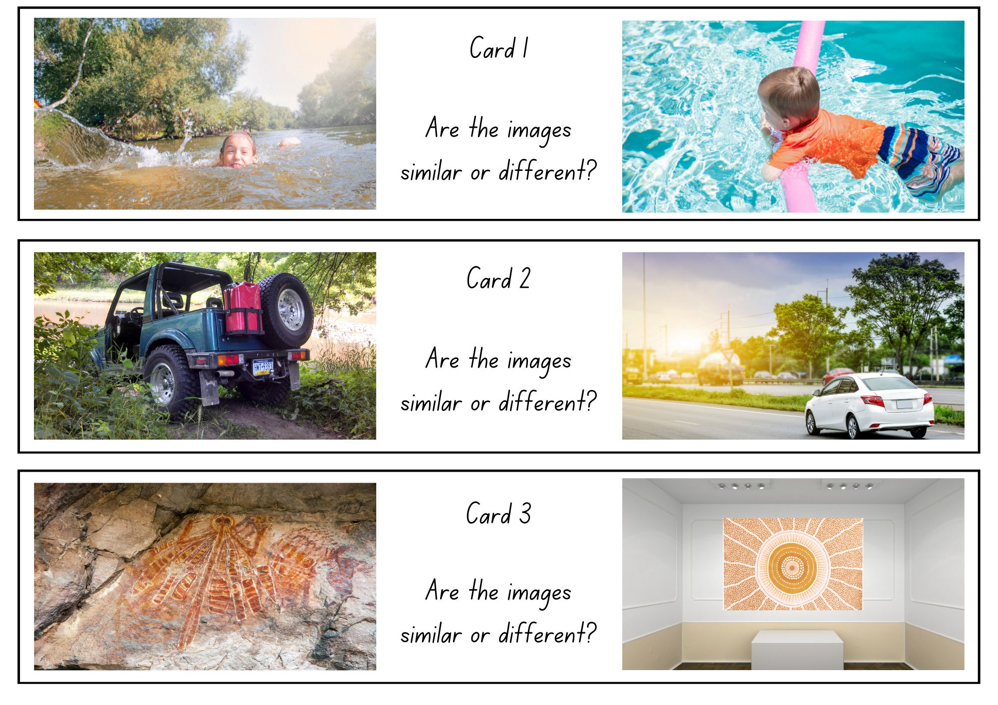
Images sourced from Canva and used in accordance with the Canva Content License Agreement.

Resource 2: Images
Images sourced from Canva and used in accordance with the Canva Content License Agreement.

Resource 3: Word cards
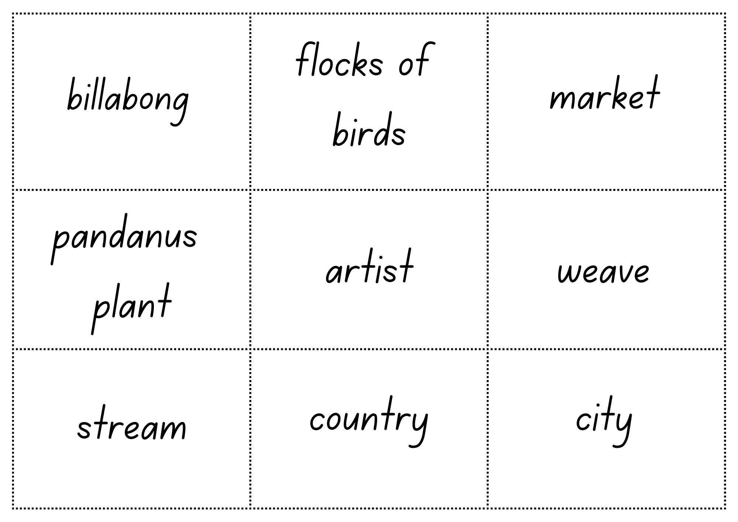

Resource 4: Different word meanings
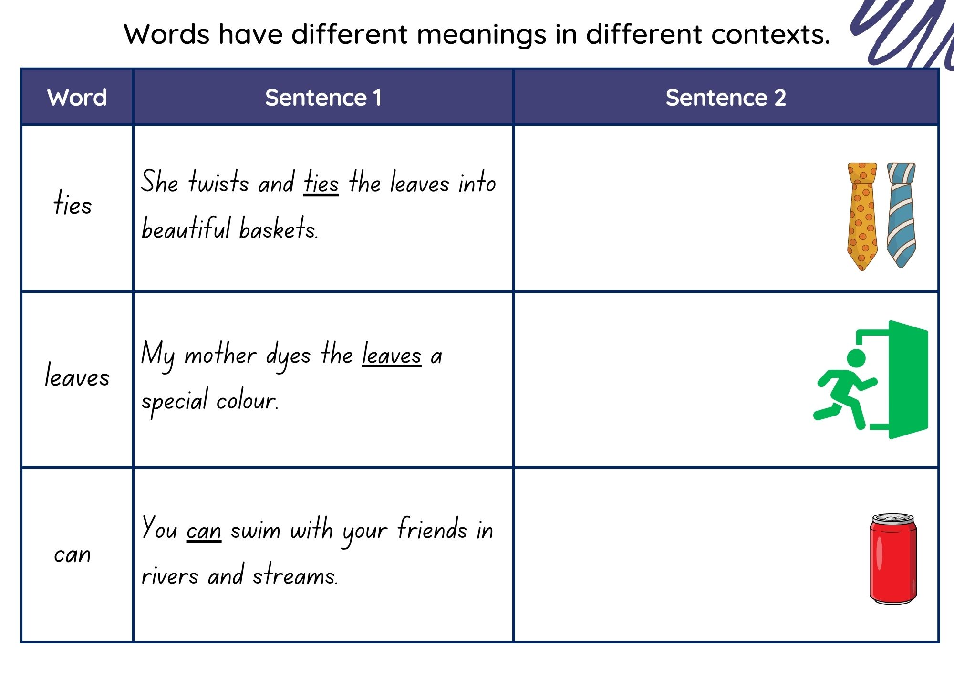
Images sourced from Canva and used in accordance with the Canva Content License Agreement.

Resource 5: My context
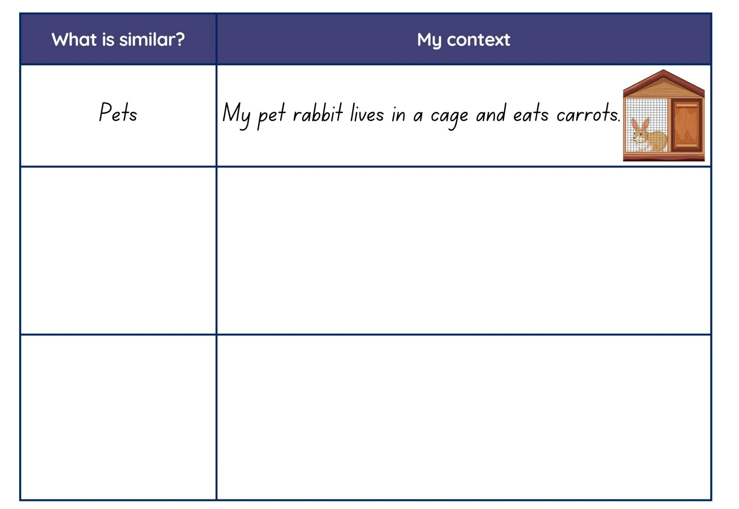
Images sourced from Canva and used in accordance with the Canva Content License Agreement.

Resource 6: Intelligences
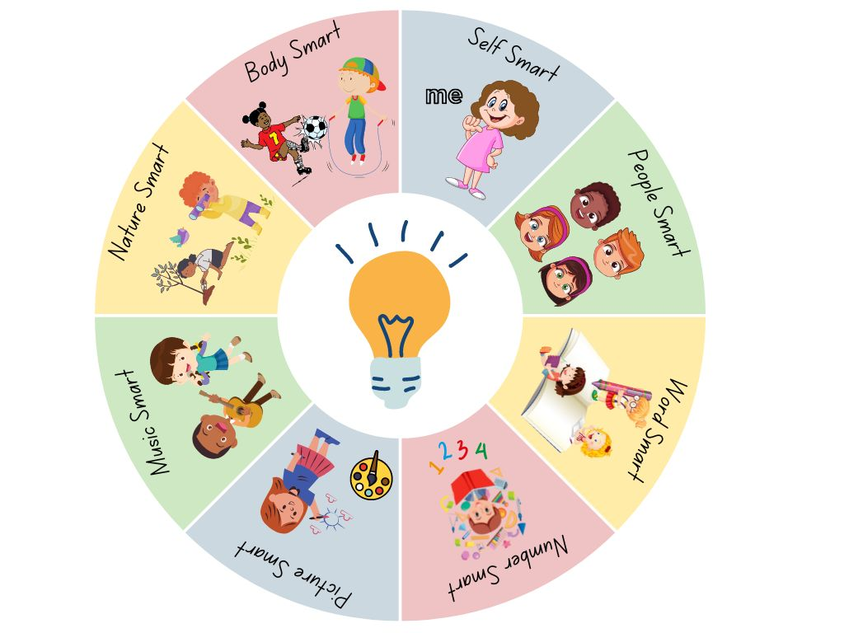
Images sourced from Canva and used in accordance with the Canva Content License Agreement. Adapted from Gardner’s Multiple Intelligences (MI) theory.

Resource 7: Planning template
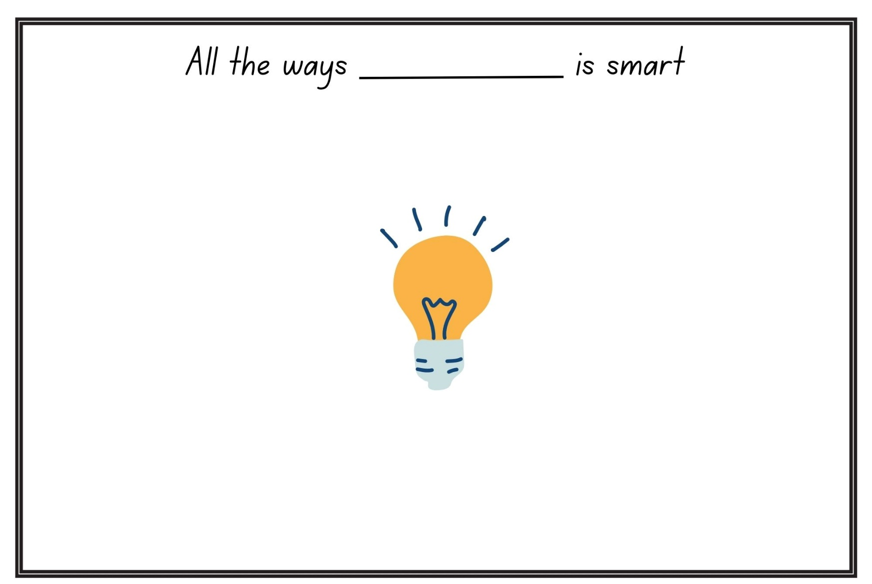
‘Light Bulb Bright Idea’ by iconsy sourced from Canva and used in accordance with the Canva Content License Agreement.

References
Links to third-party material and websites
Please note that the provided (reading/viewing material/list/links/texts) are a suggestion only and implies no endorsement, by the New South Wales Department of Education, of any author, publisher, or book title. School principals and teachers are best placed to assess the suitability of resources that would complement the curriculum and reflect the needs and interests of their students.
If you use the links provided in this document to access a third-party's website, you acknowledge that the terms of use, including licence terms set out on the third-party's website apply to the use which may be made of the materials on that third-party website or where permitted by the Copyright Act 1968 (Cth). The department accepts no responsibility for content on third-party websites.
Except as otherwise noted, all material is © State of New South Wales (Department of Education), 2023 and licensed under the Creative Commons Attribution 4.0 International License. All other material (third-party material) is used with permission or under licence. Where the copyright owner of third-party material has not licensed their material under a Creative Commons or similar licence, you should contact them directly for permission to reuse their material.
English K–10 Syllabus © 2022 NSW Education Standards Authority (NESA) for and on behalf of the Crown in right of the State of New South Wales.
© 2022 NSW Education Standards Authority. This document contains NSW Curriculum and syllabus content. The NSW Curriculum is developed by the NSW Education Standards Authority. This content is prepared by NESA for and on behalf of the Crown in right of the State of New South Wales. The material is protected by Crown copyright.
Please refer to the NESA Copyright Disclaimer for more information.
NESA holds the only official and up-to-date versions of the NSW Curriculum and syllabus documents. Please visit the NSW Education Standards Authority (NESA) website and the NSW Curriculum website.
National Literacy Learning Progression © Australian Curriculum, Assessment and Reporting Authority (ACARA) 2010 to present, unless otherwise indicated. This material was downloaded from the Australian Curriculum website (National Literacy Learning Progression) (accessed 15 March 2023) and was not modified. The material is licensed under CC BY 4.0. Version updates are tracked in the ‘Curriculum version history’ section on the 'About the Australian Curriculum' page of the Australian Curriculum website.
ACARA does not endorse any product that uses the Australian Curriculum or make any representations as to the quality of such products. Any product that uses material published on this website should not be taken to be affiliated with ACARA or have the sponsorship or approval of ACARA. It is up to each person to make their own assessment of the product, taking into account matters including, but not limited to, the version number and the degree to which the materials align with the content descriptions and achievement standards (where relevant). Where there is a claim of alignment, it is important to check that the materials align with the content descriptions and achievement standards (endorsed by all education Ministers), not the elaborations (examples provided by ACARA).
ETA (English Teachers Association) and NSW Department of Education (2016) The Textual Concepts and Processes resource, English Textual Concepts website, accessed 15 March 2023.
President and Fellows of Harvard College and Harvard Graduate School of Education (2022) 'Multiple Intelligences: Challenging the standard view of intelligence', Projects, Project Zero website, accessed 27 March 2023.
Bell D (2018) All the Ways to be Smart (Colpoys A, illus.) Scribe Publications, Australia.
Dunstan K (2012) Same, But Little Bit Different, Windy Hollow Books, Australia.

